**Undertake cross-border analysis of the gendered impacts of climate induced hazards in Malawi, Mozambique, Zimbabwe**

**Assessment Country: Zimbabwe**

**Prepared by Z M Sajjadul Islam**

**UN Women – International Consultant**

Contents

1.0 Introduction 6

1.1 Assessment Methodology 6

1.2 Multi-hazard Background of the study area ( Zimbabwe) 6

1.3 Historical background of the disaster impacts on Zimbabwe. 7

2.0 Existing Key DRR Frameworks and Approaches 9

2.1 What are the key policies/strategies frameworks in DRR in assessment countries ? (Challenges and recommendations) 9

2.2 With regards to Early Warning, Prevention, and preparedness information, how is this accessed at the community level ( Challenges of developing dissemination of timely and precision level early warnings ) 12

2.3 What are the existing DRM coordination structures (challenges and recommendations) 18

2.4 How is the UN/government supporting collection and access to SADD at: ; (challenges and recommendations) 22

2.5 UN engagement in DRM coordination 24

3.0 Engagement with Stakeholders 25

3.2 UN/Government structures engaging women and women-led organizations in DRR and resilience initiatives 29

4.0 Impacts of Climate-Induced Disasters [Cyclones, Floods, Drought] 31

4.1 How have climate-induced disasters impacted women and men differently? 31

4.2 The different coping mechanisms adopted by women and men to climate-induced disasters (challenges and recommendations) 36

4.3 key barriers to effective women’s engagement in DRR and resilience building 38

4.4 Recommendation on strengthening the resilience among vulnerable women and girls to climate-induced disasters 40

5. 0 Chapter: Focus Group Interview with the community 42

6.0 Chapter: Key Findings/ Recommendations on Women Resilience to Disaster (WRD) 56

6.1 Gendered DRR Frameworks and Approach 57

6.2 Development and deployment of Early warning for all : 59

6.3 Methodology, tools, and stakeholder coordination for Development SADD : 63

6.4 Improving UN , Government and multi-stakeholder Coordination Mechanism in DRM and DRR Functionaries 65

6.5 Community-level risk-informed gender development approach 65

6.6 SGBV tracking network and dissemination system (Proposed ) 67

**Acronym :**

|  |  |
| --- | --- |
| ADP | Annual Development Progarmme |
| AfDB | African Development Bank |
| AGRITEX | Agricultural Extension Services |
| CBFEWS | Community-Based Flood Early Warning Systems |
| *CBOs* | Community Based Organization |
| CFSVA | Comprehensive Food Security and Vulnerability Assessment |
| CPC | Civil Protection Committee |
| CERF | Central Emergency Response Fund |
| CRVA | Climate Risk and Vulnerability Assessment |
| CSO | Civil Society Organization |
| DCCMS | Department of Climate Change and Meteorological Services |
| DCP | Department of Civil Protection (DCP) |
| DCPCC | District Civil Protection Coordination Committee |
| DDPs | District Development Plans |
| DDRMC | District Disaster Risk Management Committee |
| DNA | Designated National Authority |
| DNCC | District Nutrition Coordination Committee |
| DRM | Disaster Risk Management |
| DRMA | Disaster Risk Management Act |
| DRMIS | Disaster Risk Management Information System |
| DRP Act. | Disaster Relief and Preparedness Act |
| DRR | Disaster Risk Reduction |
| DSWO | District Social Welfare Office |
| DWR | Department of Water Resources |
| EAD | Environmental Affairs Department |
| EOC | Emergency Operations Centre |
| EUMETCast | EUMETCast Europe |
| EWS | Early Warning System |
| FAO | Food and Agricultural Organization |
| FEWS | Flood Early Warning System |
| FEWSNET | Famine Early Warning System Network |
| FGD | Focus Group Discussion |
| FISP | Farm Input Subsidy Programme |
| INFORM | Index For Risk Management |
| GAM | Global Acute Malnutrition |
| GBV | Gender Based Violence |
| GCF | Green Climate Fund |
| GDP | Gross Domestic Product |
| GFDRR | Global Facility for Disaster Reduction and Recovery |
| GFS | Gravity Fed Systems |
| GHI | Global Hunger Index |
| GIS | Geographical Information System |
| GNI | Gross National Income |
| GSD | Geological Survey Department |
| GVH | Group Village Headmen |
| GVH | Group Village Headmen |
| HCT | Humanitarian Country Team |
| HIV | Human Immunodeficiency Virus |
| HIES | Household Income and Expenditure Survey |
| ICS | incidence command system |
| ICTZ | Inter-Tropical Convergence Zone |
| IDP | Internally Displaced Persons |
| IDSR | International Strategy for Disaster Reduction |
| IEC | Information Education and Communication |
| IFAD | International Fund for Agriculture |
| ILO | International Labor Organization |
| IOM | International Organization for Migration |
| IPCC | Intergovernmental Panel on Climate Change |
| IVR | Interactive Voice Response |
| KII | Key Informant Interview |
| MDG | Millennium Development Goals |
| MICS | Multiple Indicator Cluster Surveys, |
| MSD | Meteorological services Department |
| MSMEs | Micro Small and Medium Enterprises |
| NAP | National Adaptation Funds |
| NCPCC | National Civil Protection Coordination Committee |
| NDC | Nationally Determine Contribution |
| NEOC | National Emergency Operations Centre |
| NEC | national emery center |
| NGOs | Non-Governmental Organizations |
| NWP | Numerical Weather Prediction |
| PDNA | Post Disaster Needs Assessment |
| PiN | People in Need |
| REOC | Regional Emergency Operations Centre |
| RDC | Rural development council |
| SADD | Age, Sex , Disaggregated and Disability Data |
| SARCOF | Southern Africa Regional Climate Outlook Forum |
| SDGs | Sustainable Development Goals |
| SGBV | Sexual and Gender Based Violence |
| SME | Small and Medium Enterprise |
| SoD | standing orders on disaster |
| SoP | Standard Operating Procedures |
| TA or T/A | Traditional Authority |
| TWG | Technical Working Group |
| UHF | Ultra High Frequency |
| UN | United Nations |
| UN Women | United Nations Women Entity for Gender Equality and Empowerment of Women |
| UNDP | United Nations Development Programme |
| UNFPA | United Nations Population Fund |
| UNICEF | United Nation Children’s Fund |
| UNOPS | United Nations Office for Projects Services |
| UNRCO | United Nations Office of the Resident Coordinator’s Office. |
| VDC | Village Development Committee |
| VHF | Very High Frequency |
| VSLA | Village Savings and Loans Associations |
| WASH | Water, Sanitation and Hygiene |
| WLO | Women Led Organization |
| WMO | World Meteorological Organization |
| ZimVAC | Zimbabwe Vulnerability Assessment Committee |
| ZimStat | Zimbabwe National Statistics Agency |

# **Introduction**

The cross-border assessment being intended to analyze the gendered impacts of climate-induced hazards in Zimbabwe, Mozambique, Zimbabwe seeks to explore how gender groups ( women, girls, children, persons with disability, men, and elderly) those Southern Africa are differently impacted by climate change in terms of the physiological, political, economic and societal causes for the differences experienced; the current coping and adaptation strategies and capacities to climate-induced disasters and variability the group adopts; the capacity of women and men be strengthened to better adapt to climate change and climate variability; explore the role of women and women-led organizations in disaster preparedness and response planning and to; review key DRM policies in target countries and identify key entry points for gender integration.

## **1.1 Assessment Methodology**

The methodological approaches of assessment follow through several strategic tools e.g., semi-structured Key Informant Interview (KII) interviews with key stakeholders (sector *ministries/departments, UN Agencies, INGO, CSOs*) for investigating the Key DRR Frameworks and Structures in place, what are the stakeholder engagement and coordination mechanisms, the Impacts of Climate-Induced Disasters on the gendered group, etc. Comprehensive Desk reviews of all policy, strategy, and sectoral documents, reports, studies, etc., on DRM, DRR, and CCA.

Focus Group Discussion (FGD) with semi-structured conducted with climate frontline vulnerable community in remote vulnerable areas and investigate the Impacts of Climate-Induced Disasters on the gendered group (women, girls, children, persons with disability, men, and elderly), etc. Desk review of all policy strategies and Review of early warning ICT and MIS systems relating to disaster risk management and informed planning.

# **Multi-hazard Background of the study area ( Zimbabwe)**

The Zimbabwean geographical & geological settings, terrain topography, and positioning over the Sub-tropical climatological zone made the country highly vulnerable to hydrometeorological hazards. The part of the transboundary Zambezi River catchment also covered the Zimbabwean landscape areas and internally two basins, e.g., the Shire River catchment area and Lake Zimbabwean catchment area, a historically active flood-prone zone. Any given circumstances of the sudden occurrence of heavy rainfall are likely to trigger flash flooding in downstream settlements. The climate risk and vulnerability are factored in for the following reasons.

1. Proximity of the Indian west coast of the Indian Ocean: Vulnerability to western Indian Ocean tropical cyclones. The Indian Ocean is spawning strong and deadly tropical cyclones.
2. Positioning of Intertropical Convergence Zones or Doldrums area: Largely impacted by ICTZ, subtropical meteorology, Subtropical climatology, and El Nino. During the October-November-December (OND) season, erratic rainfall patterns alternated between below-average and above-average levels in the region. Several studies show that the warm Mozambique Channel becomes favorable for the development of TC because of synoptic conditions.

Buildup of settlements structures and other elements in lower flood prone areas causing the larger loss and damaged for the rapid onset

|  |  |
| --- | --- |
|  |  |
| Figure 1 : Map showing the transboundary river basins crossing over the Zimbabwe | |

# **Historical background of the disaster impacts on Zimbabwe.**

EM-Dat database (1975-2023) shows the country has endured various natural hazards, including droughts, epidemic diseases, floods, and storms over the past century. From 1900 to 2017, events captured in the database for Zimbabwe include 7 drought events, 22 epidemic episodes, 12 floods, and 5 storms, resulting in a total of 7,000 deaths, with more than 20 million people affected, and total damage estimates of $ 950 million USD. Major droughts have severely impacted the country’s GDP growth. The number of people affected and the economic loss caused by droughts have increased considerably. For instance, the drought episode in 2007 affected 6 million individuals, and the drought in 2013 caused economic damage of up to 500 million USD in addition to affecting over 4 million residents. Epidemic diseases, particularly bacterial and parasitic types, contribute to a significant portion of total deaths and total affected people by natural hazards. Floods also generate large human and economic losses. As of 2017, the EM-DAT database includes a total of 9 riverine floods, affecting over 300 thousand people, killing over 270 people, and leading to monetary loss of above 270 million USD. Moreover, analysis by Hallegatte et al. shows Zimbabwe is one of the six countries[1]. where the poor are overexposed (or 50% more likely) to the impacts of floods than nonpoor people

Drought in Zimbabwe is linked to the warm El Niño-Southern Oscillation (ENSO) in the Pacific Ocean, which has worsened since the 1980s[2]. Zimbabwe, drought occurs countrywide almost once every two years, but it is chronic in semi-arid agro-ecological regions IV and V, and slowly spreading to the rest of the country because of seasonal shifts and increased dryness.

Zimbabwe has experienced the most devastating natural disaster in the country’s recorded history. Cyclone Idai hit the eastern part of Zimbabwe on 15th March 2019[3]. Strong winds and heavy rain totaling 200mm to 600mm (equivalent to 1–2 seasons) caused flash flooding across parts of the provinces of Manicaland, Mashonaland East, and Masvingo, which are home to 44 % of the country’s population. At least 344 people have been recorded dead at least 257 people are still missing, and about 60,000 people have been displaced by the Cyclone.

Figure 2 : Zimbabwe, Disaster events (1975-2023) : Source EM-DAT

The above disaster distribution graph shows that over the last 48 years, Zimbabwe has experienced droughts, floods, and tropical cyclones, and, incidentally, the highest incidence of cholera/diarrheal outbreaks in the aftermath of heavy rainfall and cyclone-induced flooding, which represents inadequate disaster preparedness and response mechanisms at the last mile.

The Zimbabwean Population is estimated to be about 16.2 million(2023). 68% currently reside in rural areas, while only 32% live in urban areas (ZimStat, 2017). In the gender development index 2022, Zimbabwe ranked 159 out of 193, which shows that the country's largest female population lives in abject poverty, gender inequality, and inadequate gendered risk-informed development.

# **Existing Key DRR Frameworks and Approaches**

Assessment conducted with semi-structured Key Informant Interview (KII) interviews with key stakeholders (sector *ministries/departments, UN Agencies,* INGOs, CSOs engaged with DRM/DRR service deliveries ) through the following questionnaires ;

## What are the key policies/strategies frameworks in DRR in assessment countries ? (Challenges and recommendations)

**Respondent: Department of Civil Protection (DCP) of Ministry of Local Government of Zimbabwe ( DRM policies/strategies frameworks)**

The Government of Zimbabwe developed Zimbabwe National Contingency Plan December 2012-November 2013, the National Climate Policy (2016), the National Climate Change Response Strategy (NCCRS) (2015), the Zimbabwe National Farmwork for Climate Services 2019, Zimbabwe Crisis Response Plan 2022, Zimbabwe Civil Protection Act of 1989, Zimbabwe Crisis Response Plan 2020 – 2021, Disaster Risk Management Strategic Plan 2016–2020. In the Department of Civil Protection (DCP) of the Ministry of Local Government of Zimbabwe, the Deputy Director mentioned that the Disaster Risk Management Strategy was developed and is waiting for cabinet approval in June. The Disaster Risk Management Plan (WB) is still to be finalized; the National Disaster Risk Management Communication Plan was developed to communicate risk information with the community.

**Challenges of key DRM policies and strategies :**

The Deputy Director, on behalf of the Department of Civil Protection(DCP) of the Ministry of Local Government of Zimbabwe, The assessment being conducted with the semi-structured questionnaire on asking the key DRR/DRM policies/strategies, what are the level of gender inclusivity in planning and responsive budgeting(DRR/DRM) at the all levels, what are the current structure and process of the early warning system, what are the efficiency and efficacy of early warnings messages, how the community are understanding and receiving early warnings at the community level and what are the indicative gaps and recommendations on improvements. Exploring multistakeholder-led coordination mechanisms at district and local levels, gender participation in local DRR planning and decision-making process, risk data collection, etc., and recommendations on closing the gaps. The assessment focuses on DRR/DRM governance mechanisms, coordination structures, and gender integration in the local decision-making process, enhancing the role of women-led organizations (WLO) in local DRR and resilience-building initiatives. The assessment explores the indicative gender inequality gap and key recommendations for the gender empowerment DRR/DRM process.

* The GoZ is still to formulate strategy, guidelines, tools, and processes to comprehensively conduct the climate and risk and vulnerability assessment (CRVA) at the National, sub-national (District), and local levels (TA & Village Level), developing elements e.g. Geographical features, physical built-in infrastructures(communication network, household structures, basic utility services structures, institutes, core family shelters, market place, CSD, Clios, flood proofing structures, spatial elements, settlements etc.), nature resources, sectoral elements, land use, landcover, environmental resources, geomorphological, geological hydrological resources, etc., and finally developing CRVA database, customized GIS maps ( District, TA, Village level) showing elements specific risk and vulnerability, risk ranking.
* Historical Multi-hazard Risk atlas(types), risk ranking (administrative layer – national, sub-national, and local level) , admin layer-wise GIS map showing the risk pocket and hotspot of multi-hazard, e.g. river bank flooding prone areas, flash flooding, landslide, debris fall, mudslide, flood-prone wetlands, lower flood plain areas, flood-prone cropping areas, etc., for informing disaster preparedness and prevention measures, household settlements construction, installation of basic service delivery structure/infrastructure, etc.
* Information digitization process: The Government of Zimbabwe has not yet developed a database on disaster risk reduction, which is essential to inform the disaster risk management of the country (Prevention, Preparedness, response, and recovery)
* Gender equality in local legislation, policy planning, and decision-making process.
* Gender inclusivity in policies and strategies comes as gender affirmative or gender reactive (recognizing the role of gender) for mainstreaming gender empowerment in DRM/DRR Planning, policy, strategy, programming, and interventions at the national, subnational, and local levels.
* Gender-responsive budgeting process
* Insufficient allocation of the Fiscal year ADP budgets for ministries/departments and district councils to undertake DRR interventions at the community level.
* District-level budgets for emergency preparedness and response are not available.
* The National Civil Protection Committee (NCPC) has limited areas of intervention for disaster response, and they are also not active in all areas
* Insufficient structure and process (methodological, tools, and guidelines) stakeholder participation, coordination, needs assessment, technical working group ( NATWG) of Zimbabwe Vulnerability Assessment Committee (ZIMVAC) for conducting CRVA and PDNA, Rapid needs assessment, MICS, Clusters climate risk and vulnerability assessment
  + District councils have limited capacity to carry out climate risk and vulnerability assessments on time.

**Recommendation:**

* Standard Operating Procedure (SoP) for Provinces, Districts, and level Civil Protection Coordination Committees
* 60 Rural districts having DRM plans, Development of DRM plans for every 35000 villages
* Every district has a local authority ( local government) – an urban district, a district council in a rural district.
* Development of Disaster risk management and climate change adaptation plan
* Development of Terms of Reference ( 5W) all infused in the plan, every hazard management by certain hazard experts- EMA, every hazard management by specific experts,
* Gender—markers—plans—cross-cutting issues—planning team of Ministry of Women Affairs—help integrate issues of gender—DRM-Preparedness, hazards that women are more affected by.
* The Ministry of Women's Affairs needs to develop Gender markers/gender tools and mandates for gender-responsive DRR planning

**Respondent : Gender Department of Ministry of Women Affairs ( DRM policies/strategies frameworks)**

* Policies are gender reactive and affirmative, and Zimbabwe designated gender focal points at the district level.
* Inadequate level of consideration of the gender marker in key DRR/DRM policy and strategy development, exploring the level of gender integration in policy/strategy and local decision-making process, gender-responsive budgeting to address DRR/DRM resilience building, what are the indicative gaps and capturing the recommendations. Explore the level of women-led organizations developing women-led smallholder farming and entrepreneurship development. Exploring the gaps in the understandability of early warning by the local level committee, what are the key early warning message development and dissemination gaps, and recommendations? Exploring the coping mechanisms of differential gender groups in DRR/DRM at the local level and key recommendations.
* There are indicative gaps in gender mainstreaming in district and community-level policies and planning issues
* Although the government advised sector ministries for a 50-50 gender proportionate to local legislation, an inevitable gendered climate and risk-informed hurdles, gender-responsive community-level local DRM/DRR/CCA scheme design and implementation.
* Male domination in the local power structure and patriarchal domination at the household level left women isolated from participating in the decision-making process,
* Issues of resources—Women have no access to leadership, local agroecological, fertile agricultural land, barren land, and other environmental resources for sustainable utilization for IGA, and they don’t have access to control of resources.

Recommendations :

* Refresher training for the sectoral technical experts/leaseholders on climate risk-informed development and risk-informed gender-responsive planning and budgeting
* Gender focal person for facilitating the local authority Committee on the gender integration in DRM/DRR/CCA planning and integration issue
* Recommendations on gender response budget – sector departments are working at the district and ward levels.
* Strategy, tools, and methodology development for Gendered DRM Capacity building at the local authority level on gender-responsive budgeting, looking at issues for DRR, manuals, and guidelines to assist them in planning and budgeting
* Development of guidance on gendered DRM/DRR planning and budgeting allocation for the local authority

**Respondent : UNDP , Zimbabwe** **( DRM policies/strategies frameworks)**

**Background: The DRM Act, which kicked off in 2015, is under review. Now, parliament is approving it. The principles have already been approved. In the Zimbabwe context, parliament needs** to approve the policy, strategy, and law.

**Challenges & Recommendations :**

* The strict government control over the land, which is a key indicator barrier for marginalized climate-vulnerable women/households, is not able to do massive farming for DRR.
* Lack of context-specific evacuation plans is not an effective guide for evacuating populations.
* Inadequate climate risk and vulnerability assessment, post-disaster loss, damage, and Needs Assessment (PDNA)
* The DRM Act was drafted in 2015 and is now in parliament's approval process. However, even without DRM laws, the institutional barrier persists in mandating stakeholders to plan for DRM, define their responsibilities, and engage in DRM and DRR resilience building at the local level.
* Natural disaster – evacuation plan not effective

**Recommendations :**

* District-level local government needs to mandate DRR measures to identify its own hazards.
* In the Zimbabwe context, the parliament needs to approve the policy, strategy, and law. DPC's absence of laws already means actions are taking place at the national level.
* DCP needs to mandate every district to develop a contingency plan.
* DCPs need to govern the Rural Development Council (RDC), which gathers community data (a UNDP-developed template) to inform district-level decisions.
* After the DRM Act is approved, it would be much better for DCPs and other stakeholders to coordinate interventions to reduce disasters in Zimbabwe through Relationship Vulnerability/risk reduction, knowledge sharing, and early warning at the local level.
* DRM contingency plans need to be in Local knowledge for local-level understanding.
* Multi-stakeholder coordinated DRM plan.
* In terms of the level of policy translation to action on the ground, DCP needs to mandate the whole value chain of DRM, including recovery (newly set), in terms of the tools, partner supporting tools, disaster loss database tools, DCP locally using track losses, interventions, a thematic working group to update the database.
* DCP needs to coordinate a local, thematic working group on crop loss and crop damage in agriculture, weather trends from MSD, L&D, and regular updates to the DRMIS/ DMIS database.
* DCP needs to develop a standard operating procedure for the full-fledged operationalization of the Emergency Operations Center (EOC) at Harare, which the Higher Life Foundation-supported DCP installed, the cell phone company Econet-supported equipment, and computers so that DPC can track events in real-time, make evidence-based decision-making, and make information readily available by the different thematic working group. UNDP supported DCP in capacity enhancement. Kobo-toolbox developed forms/templates for L&D assessment after a disaster, building capacity in recovery.
* DCP needs to anchor ZimVAC and other regional early warning networks to support an integrated EWS for all to support DRM comprehensively, DRR, CCA-informed planning, and interventions of the country
* The Local Partner and stakeholder mapping are required.

**Respondent :** **Hope for a Child in Christ (HOCIC) Zimbabwe ( DRM policies/strategies frameworks)**

WLO needs to play a pivotal role in gender integration in DRR/DRM policy and strategy development and the local decision-making process. Gender-responsive budgeting to address DRR/DRM resilience building, identify indicative gaps, and capture recommendations. Explore the level of women-led organizations in supporting women-led smallholder farming and entrepreneurship development.

**Challenges:**

* The district has a gender focal person and committees to address gender issues, but it lacks gendered climate risk vulnerability datasets and disaggregated datasets for informing the DRM,DRR, and CCA planning and interventions process.
* Inadequate gender inclusivity to key DRR/DRM policies/strategies,
* understandability and receiving of early warnings at the community level
* Inadequate multistakeholder-led coordination mechanism at district and local level, gender participation in local DRR planning and decision-making process, risk data collection etc
* District planning meetings are mostly dominated by male decision-makers, female representation is inadequate, and gender disparity is mainly evident.

Recommendations :

* Develop Gender DRM Framework (Province, District, Ward, Village level),
* Develop a Gendered climate risk-informed network (online) for supporting government gender-responsive planning
* Provisioning gender access to the local decision-making process.
* Access to local agroecology and agricultural lands for women-led DRR and green entrepreneurship development.
* Capacity building of actors in gender-responsive sectoral planning

**Respondent : Zimbabwe Youth Council ( DRM policies/strategies frameworks)**

* Inadequate policy provision for engaging youths (girls/boys) in local-level DRR and DRM process,
* Systemic gaps of gender-sensitive DRR/DRM policy rather than gender responsive and program officer provide some key recommendations of gender integration in the local decision-making process.

Recommendations :

* Gendered DRM framework for youth group
* Ensure Youth group well representation in DRM planning and strategy development

## **With regards to Early Warning, Prevention, and preparedness information, how is this accessed at the community level ( Challenges of developing dissemination of timely and precision level early warnings )**

**Existing EWS system:**

The Meteorological Services Department (MSD) is not fully equipped with weather observation, developing impact forecasts, bulletins, and advisories. MSD has 47 synoptic stations, 12 of which provide data to the Global Telecommunication System (GTS), nine aviation stations, and one upper air station. MSD also operates almost 500 volunteer rainfall stations and 20 AWS, which are still inadequate for developing nowcasting services nationwide.

A general early warning system is in place with the MSD disseminating information on **daily, weekly, and seasonal weather predictions through mobile phones, radio,** and newspapers. Currently, the information dissemination is being carried out by the Agricultural Extension Services (AGRITEX) officers in organized emergency participatory meetings with the Civil Protection Coordination Committee (CPCC) at the local level. Educational institutions also play a role in informing students about their parents.

Information is transmitted across the relaying loop through cell phones, WhatsApp, group discussions, and people-to-people contacts. The major obstacle is that most of the time, the information is in English and the Shona language (there are other languages as well, which poses a challenge to different linguistic communities in understanding the message.

**The duration, timeliness, and accuracy of the information.**

The Postal and Telecommunications Authority of Zimbabwe (POTRAZ) has worked several times with mobile network operators to dispatch early warning or early action messages to at-risk people. While there is no legal basis to ensure the full participation of existing mobile network operators (Econet, NetOne, TelOne) in early warning and preparedness, the results of the voluntary cooperation model have been largely positive.

Currently, the government is disseminating weather bulletins over the following modalities;

* Early Warning Community Radios
* Social Media
* Virtual Weather Recording Studio
* WhatsApp
* Bulk Short Message Service
* Website
* Print and electronic media

**Challenges**

* Low appreciation of the socio-economic value of the Met services.
* Insufficient funding.
* Old and outdated equipment
* Low visibility of products and services
* Lack of effective mechanisms for collaboration with academic institutions.
* Reliance on external players (HPC, donated equipment ).
* The climate data gaps and the management system have data format compatibility problems.
* Attrition of trained staff.
* Bad debtors. Cost recovery issues.
* Customers want products and services for free.

**Respondent : UNDP ( Early Warning)**

Challenges :

* The current dissemination system takes time to inform the last-minute community about better preparedness, e.g., CPCCs, Early Warning Community Radios(broadcast limitations), social media, WhatsApp, Bulk Short Message Service, etc., which is inadequate in real-time, rapid-onset multi-hazard warning.
* Disaster Management Committees are not established at the District and Local levels to support early warning dissemination, forecast-based early actions, etc.
* Limited capacity and understandability of CPCCs on rapid onset disaster impacts

Recommendations :

Figure 3: Proposed coordination structure for improving early warning and functional EOC at Harare to play pivotal roles in DRM.

Recommendation :

* DCP needs to develop a standard operating procedure to full-fledged operationalization of the Emergency Operations Center (EOC) at Harare by linking national hydrometeorological services organizations (NMHS)for and developing impact-based weather forecasts, operational forecasts for the climate-vulnerable sectors
* MSD needs to improve its weather observation network, information generation, and development of precision-level impact forecasts for the sectors, vulnerable communities, and every Province/District/Ward/Village level to support contingency planning and enable contingency planning decision-makers to use impact forecasts rather than traditional and scientific knowledge to make informed decisions.
* Mandating National Media outlets ( Radio/TM), MSD, and NMHS in developing and disseminating special weather bulletins in case of impending cyclones that are likely to take trails over the eastern part of Zimbabwe, with heavy thundershowers and high winds that could cause Loss and damage.
* Impact-based weather forecasts of sudden onset multi-hazards (thereunder storm, heavy rainfall, damaging winds, tornadoes, depression-induced thundershower etc) for the sector, women-headed households,
* Risk-informed tools ZimVAC to support sectors
* Detailed disaster shelter mapping, Risk & resource atlas supported contingency plans, informed emergency evacuation guidelines for
* Contingency plans are district-level and need to be informed by GIS-based tools
* Forecast-based early warning
* An online platform is required for disseminating impact weather forecasts.
* Policy to provide information dissemination at the grassroots level, enabling the environment for the right time and the right time.
* DCP needs to anchor ZimVAC and other regional early warning networks to support an integrated EWS for all to support DRM comprehensively, DRR, CCA-informed planning, and interventions of the country

**Respondent : Department of Civil Protection ( Early Warning)**

Over the background discussing about the DRM structure and existing EWS system the DCP mentioned that the nodal agency standardizing the planning process, every province has provincial disaster risk management plan, every district has development plan and need standardized the plan, World Vision working with DCP for standardizing the local level plans, to date out of 60 rural districts only 21 districts standardized their plans, at local authority level 72 of local authorities (out of 92 local authorities) having plan. DCP is planning to develop the district-level disaster risk management and climate change adaptation plan. In government DRM planning, gender comes as a cross-cutting issue, but not in. DCP recommended that every ward have a properly constructed emergency evacuation center.

Challenges :

* Zimbabwe has a National Disaster Risk Communication plan – guidelines on how to communicate with the community, but it needs to be mobile app-based for wider use.
* National AM radio and TV still not being mandated to broadcast emergency weather bulletins and not having a broadcasting frequency for all aerographical coverage of Zimbabwe
* The cellphone operators still do not have network coverage of the whole country to transmit text messages to every geographic location. Still, a significant proportion of the population (urban 40% , rural 60%) is out of mobile coverage and to access SMS services in their own/understandable language. However, some private FM radios are broadcasting only in some urban centers.
* Current set of forecast dissemination and translating forecasts to multi-hazard impending risk is being followed through the techno-indigenousness system, which takes time to reach individual people living in remote and hard-to-reach areas. In normal circumstances, MSD develops, and the Agritex officer is present at the local level and interprets risk over the organized meeting with the civil protection coordination committees at the Province, district, ward, and village level (PCPCC, DCPCC, WCPCC, VCPCC), local chief/ local headman, and discusses forecasts and risks. Local radio station ( FM) and disseminate via WhatsApp phone group.
* Forecasts are noted broadcasting through national AM radio/TV with multilingual and as a special weather bulletin which is of utmost urgency to warn remote people instantly and/real-timely.
* Challenges of development precision level weather forecasts: Met agencies need to develop more specialization in developing high-resolution seasonal, decadal, weekly, 3-day, 5-day weather forecasts, need to develop dynamic and statistical downscale models rapidly developing thunderstorms (RDT of Météo-France) for predicting heavy rainfall and thunderstorms.
* The Met agency needs to develop high-resolution gridded forecasts and analysis of the damaging and beneficial impacts of impending weather parameters on lives and livelihoods( elements). The Met agency needs to develop a pool of Technical experts/specialists(agrometeorologists, hydrologists, geomorphologists, water resource engineers, Plant scientists, Agri engineers, drought experts, landslide experts, agroecologists, ecologists, meteorologists, synoptic engineers*, etc.*) for interpreting the extreme weather phenomena being forecasted. Developing methodology, tools, and guidelines on transplantation and interpretation of risk and vulnerabilities of predicted impending weather phenomena/parameters. Detailed analysis of Impacts and effects of ongoing onset weather events and developing bulletins. Developing special weather bulletins for women, the elderly, girls, and youth groups on the onset of tornadoes, thunderstorms, heavy rainfall, cyclones, flash flooding, landslides, etc.
* Challenges of developing consensus on technical specialists of sector departments to work with MSD for the interpretation of extreme/abnormal weather parameters triggered risks over the elements ( livelihood, natural, and hydrological ).
* Challenges: Developing operational forecasts for the sectors, women, and girls:
* Challenges of implementation of hybrid weather observation for event situation reporting, including what exactly the current conditions are, intensity of disasters on the ground
* Challenges of forecast broadcasting and transmission to audiences.
* Time delay of forecast dissemination through WhatsApp group, NCPC organized community discussions, megaphone, road show, school-based forecast dissemination, awaiting evacuations decisions from the Group Village Headmen (GVH), Village chief/NCPC organized meeting decisions, etc.

Recommendations :

* DCP, strongly recommend that users of national radio and TV media outlets use them to disseminate emergency early warning information to the community, which is currently going through WhatsApp groups and not timely reaching out to the remote community.
* Upgrading Zimbabwe National Disaster Risk communication plan with app-based Operability for instantly updating and event situation updating from about the impacts, mortality, L&D of the affected community by the CPCCs during disaster emergencies.
* National AM radio and TV need to be mandated to broadcast emergency weather bulletins and not have broadcasting frequencies covering all of Zimbabwe
* The government needs to mandate the cellphone operators to provide free SMS, IVR, and Cell broadcasts during disaster emergencies, similarly, private FM radio stations to broadcast emergency weather bulletins in every local language for community awareness.
* Developing a national protocol on impact-based weather forecasts for the sectors, valuable community, and disseminating through national Radio /TC for clear understanding of the weather bulletin, providing the weather advisories for every audience
* Capacity building of MSD, national media outlets, Ministry of Education, key government officials, Ministry of Health – disseminate disease and outbreaks, Ministry of Primary and Secondary Education, and Agricultural extension services ( Agritex) for developing and disseminating multi-hazard risk and vulnerabilities to remote communities.
* SoP for EOC at Harare for NMHS and other sector development to work coordinately for developing multi-hazard early warnings for the community.

**Respondent : Hope for a Child in Christ (HOCIC) ( Early Warning)**

Challenges identified :

* Current set of forecast dissemination and translating forecasts to advisories on impending anticipatory hazard risk to warn the vulnerable community, which is going through a civil protection committee-based warning rather than an ICT-driven EWS system. This process apparently takes time to reach individual people living in remote and hard-to-reach areas.
* In normal circumstances, MSD develops forecasts and Agritex officers (present at the local level ) interpret the risk, organize CPCCs ( PCPCC, DCPCC, WCPCC, VCPCC), local chief/ local headman, and discuss forecasts and risks. A local radio station (FM) with limited geographical coverage broadcasts, while the WhatsApp group CPCC disseminates information through community discussions. However, this process delays the delivery of warning messages, and people are not receiving warnings in a timely manner.
* Forecasts are noted broadcasting through national AM radio/TV with multilingual and as a special weather bulletin.

**Recommendations :**

* Special weather bulletin with local language broadcasting on national Radio/TV so that vulnerable people living in remote hard-to-reach areas and the most vulnerable areas can access the bulletin ( where no cell phone coverage)
* The government needs to regularly conduct mass media-based mass educational campaigns and awareness campaigns for the general public to understand the impacts of climate change and multi-hazard

**Respondent : Ministry of Women Affairs, Community, Small and Medium Enterprises Development ( Early Warning)**

Challenges :

* In the current EWS dissemination system, the remote community can access weather through the Civil Protection Coordination Committees (PCPCC, DCPCC, VCPCC) , local chief/ local head man, etc., which is coming in delay and not effective for rapid onset disasters (e.g. heavy rainfall induced flash flooding, cyclone etc.) , most vulnerable groups of the society ( women and persons with disabilities, girls, children, youth )still remain unaware about the devastating disasters and eventually there are contributing mortalities.

Recommendations :

* For the rapid onset disaster e.g. heavy rainfall-induced flash flooding, the government needs to circulate special weather bulletins with local language broadcasting on national Radio/TV so that every individual people are living in remote, hard-to-reach areas and most vulnerable areas can access them ( where no cell phone coverage)
* The government needs to regularly conduct mass media-based education and awareness campaigns for the general public to understand the impacts of climate change and multi-hazard
* The government needs to mandate the cellphone operators to provide free SMS, IVR, and Cell broadcasts during disaster emergencies, similarly, private FM radio stations to broadcast emergency weather bulletins in every local language for community awareness.

**Respondent : African Women in Leadership Network, Zimbabwe Chapter( Early Warning)**

Challenges:

* EWS – women getting information awareness raising from their community leaders, issues of cyclones, District and village Civil Protection Coordination Committee (DCPCC /VCPCC) relay information to men and women and person with disabilities, and also – CPC provincial and District, local level using media, platform radio, TV, social media -using community leader, school the parents.
* The current forecasting and designation modalities are not fully effective in warning of the rapid onset of flash flooding and tornadoes. The Current set of forecast dissemination and translating forecasts of impending multi-hazard risk is being developed by MSD and Agirtex officers at the local level, and interpret risk and organize CPCCs ( NCPCC, PCPCC, DCPCC, VCPCC) local chief/ local head man and discuss forecasts and risks. Local radio station ( FM) and disseminate via WhatsApp phone group.

Recommendations :

* Ministry recommendations to the government for improving national media in EWS dissemination,
* Mandating National radio/community radio to broadcast early warning
* DCP to advocate for more ICT tools-based system upgradation, and upgrading of national AM radio broadcasting coverage all over the country so that communities living in very remote areas can listen to the radio for weather bulletins in their own language.
* The government needs to broadcast regular radio-based mass educational programs for creating awareness about climate change, multi-hazards, etc.

**Respondent Zim Youth Group( Early Warning)**

National media outlets e.g. Radio, TV, news outlets, and social networks, need to broadcast early warning timely manner and social protection groups - NCPCCs (PCPCC, DCPCC, VCPCC) , local chief/ local head man, to timely disseminate early warning for reducing mortalities and risk-based critical information needs to be disseminated, resulting in high loss of life.

## **What are the existing DRM coordination structures (challenges and recommendations)**

The institutional framework for coordination mechanisms for DRM in Zimbabwe is guided by the Civil Protection Act of 1989**[4]**. Zimbabwe is still to develop an ICT-driven non-structural DRM coordination structure and governance system, as well as complete the national disaster risk management framework, stakeholder engagement mechanism, climate change and multi-hazard risk repository database, and tailor-made risk-informed planning tools ( national, provincial, district, Ward, and village level ).

The current set of DRM systems predominantly focuses on post-disaster response mechanisms only, in which disaster response mechanisms are being divided into two coordination structures anchored in two different institutions:

1. The National Civil Protection Committee, mainly responsible for flood response and other rapid-onset disasters of natural or man-made origin.
2. The National Civil Protection Committee, which comprises representatives from all line ministries, NGOs, and International Organizations.

The DCP, under the Ministry of Local Government, Public Works and National Housing, plays a secretariat role to the National Civil Protection Committee. The system includes some level of early warning issues, which are overseen by the National Food and Nutrition Council (NFNC), under the coordination of the Office of the President and Cabinet (OPC), for drought management and response. The NFNC works closely with the MSD, which provides early warning information, and the Ministry of Mines and Mining Development (MAMID), the implementing arm of drought management and response activities.

Currently, the institutional system comprises the following structures:

* National Civil Protection Committee;
* The Department of Civil Protection;
* The Food and Nutrition Council;
* The Zimbabwe Vulnerability Committee;
* Provincial Civil Protection Committee;
* District Civil Protection Committee.
* Emergency Services Subcommittee;
* National Food and Water Subcommittee;
* National Epidemics and Zoonotic Crisis Subcommittee;
* National Resource Mobilization Subcommittee.

1. **National level Coordination structure :**

The DCP under the Ministry of Local Government, Public Works, and National Housing is mandated to coordinate disaster risk management in the country through the Civil Protection Act of 1989. The DCP disaster risk management structure has some level of hierarchy, but the other sectoral coordination and role of DRM activities are not clearly defined and coordinated. The Civil Protection Act of 1989 does not provide for decentralized structures of DCP, nor does it make provisions for the civil protection Committees at the Ward and Village levels. The National Civil Protection Committee has an inadequate structure and process for coordinating and engaging multiple stakeholders.

The Department of Urban Local Authorities: Responsible for urban local authorities, which comprise city, municipality, town councils, and local boards. There are 32 urban local authorities in the country. The Department of Physical Planning in the same Ministry is responsible for spatial planning and development control.

1. **Provincial and District levels :**

DCP does not have designated officers at the Provincial and District levels, but the provincial and district administrators and provincial and district committee members are responsible for disaster risk management at the local authority level. The committees mostly coordinate the Drought Relief Committees or the Community Development Committees. This committee is still not well represented by the other nonstate local actors, and there is also a need to involve NGOs more, and their role in the coordination structure should be clear.

1. **The Village Development Committees:**

**The lowest admissive level having no designated DCP staffing, the Agitext is the technical focal point in coordination DRM at community level,** the local civil protection committees are the locally functional structures to date for taking care of DRM issues in terms of early warning dissemination and education decision making, They do not have any clear guidelines, methodology and tools for comprehensive disaster risk management and designing and implementation of community based DRR activities. There are many partner organizations (CSO) that are establishing DRM committees at the village and ward level, which are not aligned with Government institutions and are not coordinating the local CPCCs at the local level, which is one of the multi-stakeholder coordination gaps for driving the comprehensive DRR & DRR process at the community level and bridging the DRR interventions gaps.

**Challenges and Recommendations from KII with stakeholders:**

**Respondent : Department of Civil Protection (DCP) – Ministry of Local Government, Zimbabwe (DRM coordination structures)**

Department of Civil Protection (DCP) of the Ministry of Local Government of Zimbabwe is the nodal agency for disaster risk management. DCP is planning to develop a district-level disaster risk management and climate change adaptation plan, in which gender is identified as a cross-cutting issue. For mainstreaming gender in the DRM process, gendered risk-informed tools need to be developed.

Challenges :

* Lack of a Standard operating procedure (SOP) with defined ToR /Roles and responsibilities of stakeholders for coordinating DRR interventions.
* To provide data provinces with guidelines on how to do the local coordination, without the SoP of DRM coordination.
* The existing disaster response system does not include mandating other stakeholders /sector departments in coordinating the climate change and disaster risk management jobs at the local level for engaging multi-stakeholders.
* Lack of stakeholder engagement and coordination at the ground level, loss and damage (L&D)datasets collection is being hindered, although the community is already aware of who is affected in their locality by the onset of a major disaster that has already made landfall and is causing damage.
* Every ward level has an evacuation center, but it is still insufficient and hard for the community to evacuate to the shelter in any case of communication disruption.
* Cabinmate says – not to use the school and church, community hall for longer, as it disrupts education. So far, temporary tents are required for the IDP community to shelter until they are able to build better houses for living.
* In local level Local coordination and planning decision making (CPCCs) are male dominated as because of Women like to take care of children -not allocating time to spare, majority decline to be local member of local body, Women councilors – have lot of homework to join regular meeting, rural poor women to fetch firewood, collect water, taking care children and cannot spare time for the committee level meetings. In Zimbabwe, a patriarchal society at the community level, women cannot talk to men very frequently; the patriarchal society does not allow women to speak out more, and there is social discrimination. In community-level meetings, women keep quiet and cannot raise their voice because of male domination; all those attributes contribute to keeping women and girls away from the local planning and decision-making process.

**Recommendations**

* For improving disaster preparedness the DCP recommended Properly constructed emergency evacuation center, every ward should have an evacuation center considering the terrain landscape, poor communication structure.
* DPC recommended that all 35000 villages need to have plans for better DRM /DRR planning and interventions
* DPC recommended SOP and ToR ( 5W) of stakeholder’s coordination for better preparedness and disaster evacuations,
* Gender -marker – plans – cross-cutting issues – planning team of the Ministry of Women Affairs – help to integrate issues of gender – DRM-Preparedness, hazards that women are affected by more.
* Community conversant with who is affected in their locality and some information on Loss and Damage. In this case, CPCC needs to update EOC about the event situations and L&D of the locality.
* Development of Gender sensitive evacuation centers, multi-purpose, and other activities,
* Formulation of Gender sensitive humanitarian coordination structures by the UN/INGOs /CSOs

**Respondent : Ministry of Women Affairs (DRM coordination structures)**

**Challenges :**

* Civil protection committee, Ministry has participation in CPC, District development – there are some forms of coordination at the local level, CPC – ward level coordination committee at the community level, CPC to replicate at the community and ward level, issues of EWS.
* Coordination gap of pre-positing relief items, conducting climate risk and vulnerability assessment (CRVA)
* Capacity Gap( risk understanding, tools, techniques, volunteering process) CPCC committees – need that unity to be strengthened in preparedness, response, and rescue.
* Inadequate government sectoral roles, local level coordination overall DRM and DRR planning, project design, and the implementation process. A civil-military coordination mechanism (ICS) is required for better management of disaster emergency management.

**Recommendations :**

* UN-cluster system, the government needs to work together for better DRM/ DRR/CCA planning and interventions
* Improved institutional coordination, defined multi-stakeholder ( private sector) engagement structures for planning and implementation of DRR, and Gender mainstreaming at the national, Provincial, district, and community levels in Disaster preparedness, response, recovery, and prevention mechanisms.
* Forecast-based early actions/financing/ contingency (essential life-saving items) for supporting the female-headed household, children/single-mother-headed mother headed households,
* Develop a gender-responsive manual SoP/Standing orders on Disaster for the local level
* Multi-purpose disaster shelter- as silos, how you are addressing the issues, member of civil protection committees, inter-ministerial committee with local governments, provincial level, national level, raise the issue,
  + Activating local CPC at the local level for emergency rescue, volunteering structure and process are gendered responses (women-headed households) , gaps in emergency evacuation

**Respondent : Hope for Child in Christ” , Zimbabwe (DRM coordination structures)**

Challenges :

* Lack of Gender sensitive humanitarian coordination structures
* Inadequate structure of the national climate change coordination system/committee – for structure and priority settings of development planning and climate actions (sectoral)
* Gender equity and gender gaps in DRR coordination
* Civil protection committee, Ministry has participation in CPC, District development – there are some forms of coordination at the local level , CPC – ward level coordination committee at community level, CPC to replicate at community and ward level and functional to organizing emergency early warning meeting, but not organizing meeting for DRR coordination and DRR interventions related meetings.
* Government still to approve DRM laws, inadequate mandates, stakeholder coordination, and defined responsibilities, which can insufficiently mandate stakeholders to come up with a SoP of who will be doing what, where, when, and how, etc., as a result, the community gets inadequate support and becomes hopeless in having emergency evacuation and preparedness support.

**Recommendations :**

* Improvement of institutional coordination, multi-stakeholder (including private sector) engagement, and working together in terms of DRR.
* Capacity building( training, equipment, tools) of CPCCs at the local level for emergency rescue, volunteering structure and process for supporting responses (women-headed households) , and gaps in emergency evacuation
* Structured DRM process for fender mainstreaming at national, Provincial, district, and community levels in Disaster response, prioritizing the female-headed, children/single-mother-headed households, and develop a manual SoP/Standing orders on Disaster(SoD)
* Awareness-raising campaign ( education ) for women, girls, and children in the local language about the disaster and climate change impacts.
* Involvement of the civil-military coordination mechanism for overcoming institutional barriers and gaps for the comprehensive DRM process at the local level,

**Respondent : UNDP , Zimbabwe (DRM coordination structures)**

**Challenges:**

* Zimbabwe still needs to develop a national risk management framework with a multi-sectoral coordination structure, stakeholder maps, and responsibilities for improving national coordination in integrated DRM/DRR/CCA and NAP planning and interventions at the local level.
* Inadequate government disaster response coordination structure and gender responsive civil protection platform structures, and the capacity of CPCCs in disaster preparedness.
* Inadequate Coordination structure, stakeholder map, and not having stakeholder-specific roles and responsibilities of the disaster DRM process at the local level within the field of Disaster risk reduction and response, any phase of disaster preparedness and rehabilitation.
* Inadequate representation of gender to meet the individual needs of men and women is addressed in the plan, and resources are available for an effective response.
* Gaps in the effective coordination system of the government and the UN-OCHA, HCT, UN-clusters, coordination at the government level – local governments under directives of DCP leading the big disaster, technical working group(TWG) on DRM recently established for effective coordination during and after a disaster.
* Gender representations are enough at the committee, volunteering
* Post-disaster response and recovery interventions, DRR & development programme, and inadequate prioritization of the immediate needs and medium to long-term needs.
* Disaster risk management at mostly works on an ad-hoc basis
* Inadequate gendered climate risk-responsive and information tools for informing gendered DRR interventions.
* Inadequate gender dimension, informed tools coordination gaps, inadequate development of evidence-based advocacy gender tools, gender marker/indicator, gendered risk-informed datasets for inclusive DRR planning and budgeting process by the sector department
* Lack of methodology tools, guidelines, mandates of ZimVAC, sector department, and other organizations in conducting the Participatory Vulnerability and Capacity Assessment (PVCA) process, collection, and sectoral disaggregated multi-hazard risk information for DRR intervention prioritization

**Recommendations :**

* Structures coordination structures stakeholder map and defined responsibilities of stakeholders ( state and nonstate actors , sectors, private sectors ) for improving DRR service deliveries at the local level
* UNDP supports inclusive Women/girls participation, at the district and local levels, for all planning ( Contingency, local level, DRR, DRM at the local level). The online database required for tracking the needs of women, men, boys, girls, and the disabled at the District level includes bylaws for developing DRR measures at the district and community levels, as well as identifying their own hazards.
* Gender focal person – implement humanitarian programme
* HCT need to establish coordination on humanitarian coordination nexus of ( with DCP) to transitioning community from humanitarian assistant dependents to DRR inclusive livelihood development
* Forecast based contingency planning and resources allocations
* DCP to develop Short , medium and long term DRR programmes
* Improve risk communication
* UN Spider working to supporting the post disaster L & D /PDNA
* DRM laws /mandates are required for Collective stakeholder engagement and for DRM planning an interventions

**Respondent : Zimbabwe Youth Council (DRM coordination structures)**

* Development of youth group responsive DRM and DRR farmwork and responsibilities
* Improve stakeholder structures with youth group representation to DRM coordination functions at local level
* Youth engagement in District and local level in DRR planning and interventions

## **How is the UN/government supporting collection and access to SADD at: ; (challenges and recommendations)**

**Background status :**

For effectively mechanizing the DRM and DDR process the demographic disaggregated data namely age, sex, disability disaggregated Data (SADD) and other socioeconomic, HIES, climate vulnerable sector disaggregated data, tailormade informed tools is the most important imperatives for climate change impact and vulnerability informed, demand driven, most appropriate adaptive ICT tools/Apps/Software/online data collection apps/portal for supporting local participatory planning and DRR/CCA scheme implantation process.

Essentially, the Zimbabwe Vulnerability Assessment Committee (ZimVAC) is being initiated to support the Food and Nutrition Security Policy (FNSP), working as a focal point for vulnerability assessment along with ZimStat and some other UN/INGOs for supporting ZimVAC.

Although the SADD data collection can be entrusted to ZimStat for demographic, HIES, and socioeconomic disaggregated data collection, there appear to be strategic planning, methodology, and ICT tool gaps, as well as stakeholder coordination gaps, to govern the process. DCP, along with UN Agencies ( UN Women /UNFPA for protection & Gendered SADD), I-NGOs, ZimStat , ZimVAC, AgriTex, and other sector departments, need to mechanize the process for comprehensive SADD, sectoral disaggregated data, and climate risk and vulnerability assessment of the country.

**Respondent : UNDP (SADD )**

* After Idai, the Higher Life Foundation, in collaboration with the Ministry of Local Government and Public Works, has invested in building the National Emergency Operations Centre (NEOC) in Harare. The facility is designed to strengthen data collection, analysis, and presentation to better disseminate information and determine appropriate preparedness and response interventions.
* Setup of EOC/DMC at the province and district level for supporting ZimVAC, ZimStat, and other sector departments in SADD and other sectoral disaggregated data collection for informing DRM /DRR planning
* Development of Mobile apps for SADD and Sectoral climate risk data collection
* Develop a Policy to provide information dissemination at the grassroots level, enabling an environment for the right time and right time.
* SADD data collection from the camp to estimate the number of people sheltering in the School now, to relocate other tents for reopening the schooling
* Develop SADD-supported District-level contingency plan – GIS-based ( at national, provincial as well as district planning) participatory GIS maps, community inputs, anticipatory impacts of multi-hazards

**Respondent : Department of Civil Protection (DCP) – Ministry of Local Government, Zimbabwe (SADD )**

Challenges :

* The Zimbabwe Vulnerability Assessment Committee (ZimVAC) under the coordination of the Food and Nutrition Council is consortium of Government, Development Partners, UN, NGOs, Technical Agencies and the Academia which being designated to conduct the vulnerability assessment and collect SADD datasets which is being currently coordinated by few agencies ( food and nutrition council, UNDP, WFP, UNICEF, REACH ) which represent the inadequate effects of SADD data collections from the field level.
* Inadequate ZimStat leadership and inadequate government sector department mandates, coordination structures, and processes for the collection and collation of sector-specific age, sex, disability disaggregated data(SADD) and sectoral elements specific disaggregated data, socioeconomic data from sector departments/local government for risk-informed DRR planning and interventions.

Recommendations :

* The DCP, UN Agencies, I-NGOs, ZimStat , ZimVAC, AgriTex need to develop tools, methodology, guidelines, techniques, processes, and stakeholder coordination and engagement to conduct comprehensive risk and vulnerabilities at the national, provincial, District, TA, and village level.
* DCP, ZimStat , ZImVAC, AgriTex, CSOs, and other state and nonstate actors need to be fully equipped with methodology, guidelines, Tools, techniques, and processes, capacity development of state and non-state stakeholders, sector department management, coordination structure, and process for collection and collation of sector-specific age, sex, disability disaggregated data(SADD), and sectoral elements specific disaggregated data, socioeconomic data from sector department/local government for risk-informed DRR planning and interventions
* ZimVAC needs to develop clear roadmaps on stakeholder coordination structures, data and information collection, collation, and development of tailored, informed tools to support prioritized climate risk-informed and gender responsive DRM/DRR/CCA planning and scheme design and implementation at the local level.

**Respondent : Gender Department of Ministry of Women Affairs (SADD )**

**Challenges & recommendations :**

* Inadequate methodology, tools and process that hurdles the engagement of the DCP, UN Agencies, , I-NGOs, ZimStat , ZImVAC, AgriTex and other state and nonstate actors for conducting the SADD datasets form community level, district, provincial and national level. Lack of online apps to improve data collection, standard data collection tools for collecting data at the field level.
* ZimStat , ZimVAC, and other state and nonstate actors need to coordinate district-level actors, NCPCCs, and other CSOs for standardized data collection on SADD, female-headed households for risk-informed DRR planning, and scheme implementation.
* Lack of Engagement with stakeholders in disaster risk information collection and DRR-related interventions.
* DCP needs to coordinate ZimStat , ZimVAC, and other state and nonstate actors for conducting the SADD datasets from the community level, district, provincial, and national levels. MoLGRD, MoFA, CSOs working in, Women-led organizations(WLO) need to coordinate SADD and their risk information collection
* DCP ZimStat , ZImVAC need to conduct capacity development of other stakeholders in SADD data collections and repository development.

**Respondent : WLO on Musasa Project” (Women Led Organization) (SADD )**

**Challenges and recommendations :**

Inadequate capacity, tools of the local-level national civil protection coordination committee (NCPCC) for the collection of SADD from the community level. The designated disaster focal point DCP, sector departments ZimStat , ZimVAC, AgriTex, and other state and nonstate actors need to coordinate the SADD data collection from the field level so that every risk and vulnerability data is collected from the household level. DCP needs to coordinate ZimStat , ZImVAC and other state and nonstate actors for conducting the SADD datasets form the community level, district, provincial and national level. MoLGRD, MoFA, CSOs working in, Women-led organizations(WLO) need to coordinate SADD and the risk information collection process.

## **UN engagement in DRM coordination**

**Humanitarian Country Team (HCT) of the United Nations Country Team (UNCT) led by UN-OCHA**  is responsible for coordinating UN emergency preparedness and response in support of the Government plan. Under the guidance of the HC, the United Nations Country Team (UNCT) is responsible for the effective and efficient implementation of Inter-Agency disaster risk management activities. The UNCT allows for all UN entities with activities in Zimbabwe to work as a team in formulating common positions on strategic issues, ensuring coherence in action and advocacy. During disaster onset, the RC office , OCHA, and the Humanitarian Country Team (HCT) act as the secretariat of the HCT and support the Humanitarian Coordinator (HC) in all aspects related to HCT issues. HCT operates the UN cluster system, mobilizes Emergency Response Fund (ERF) or the Central Emergency Response Fund (CERF), and supports the government in the PDNA process and humanitarian response mobilization to high-impact areas.

**The following is the coordination support from UN Agencies**

**UNDP** :

* Supporting development council (RDC) with templates to gather data from the community for informed decisions.
* Supporting HCT/UNOCHA in mobilizing the CERF
* Supporting MSD in improving Community-Based Flood Early Warning Systems
* Support DCP, ZimVAC , ZimStat, and their stakeholders in conducting PDNA, Rapid Impact and Needs Assessment (RINA), and Operationalizing the Emergency Operations Center (EOC)
* Risk Management Functions for Local Authorities

**UN -OCHA :**

* Coordinate the national DRM platform and Operationalize the Central Emergency Response Fund (CERF) through conducting emergency humanitarian assistance through the UN Cluster system.

**UNCEF**

Coordinate Education cluster for school-based DRM ( early warning dissemination)

* Coordinate the WASH Cluster for supporting WASH facilities at the school and the nearby community level.
* Supporting ZimVAC for vulnerability assessment

**UN Protection cluster ( UN Women, UNFPA, UNHCR, IOM) :**

* Coordinate Camp based PSEA, ESA, SGBV during disaster emergency

**UN Health Cluster :**

* Coordinate Camp-based health care support during a disaster emergency

**UN Women :**

* Gender Coordinating gender Empowerment issues

**WFP:**

* Coordinate post-disaster rapid need assessment
* Supporting ZimVAC for vulnerability assessment
* WFP conducts emergency food security progarmme in vulnerable Districts
* Supporting the Food Security Cluster
* Support anticipation action on DRR based on the weather forecast
* Leading food security and logistics, and Flood cyclone response
* Response to crisis – national level food security /logistics / preparedness and response to flood, cyclone,
* Improving the rapid assessment and evaluation tools and system, disaster-prone district, Warehouse – district level
* Supporting the government in the emergency food programme

# **3.0 Engagement with Stakeholders**

Under the current Disaster Risk Management (DRM) structure and process, the DCP works as a nodal agency under the Disaster Risk Management (DRM) institutional framework for Zimbabwe[5] is guided by the Civil Protection Act of 1989.

Structure of Zimbabwe’s Disaster Response System

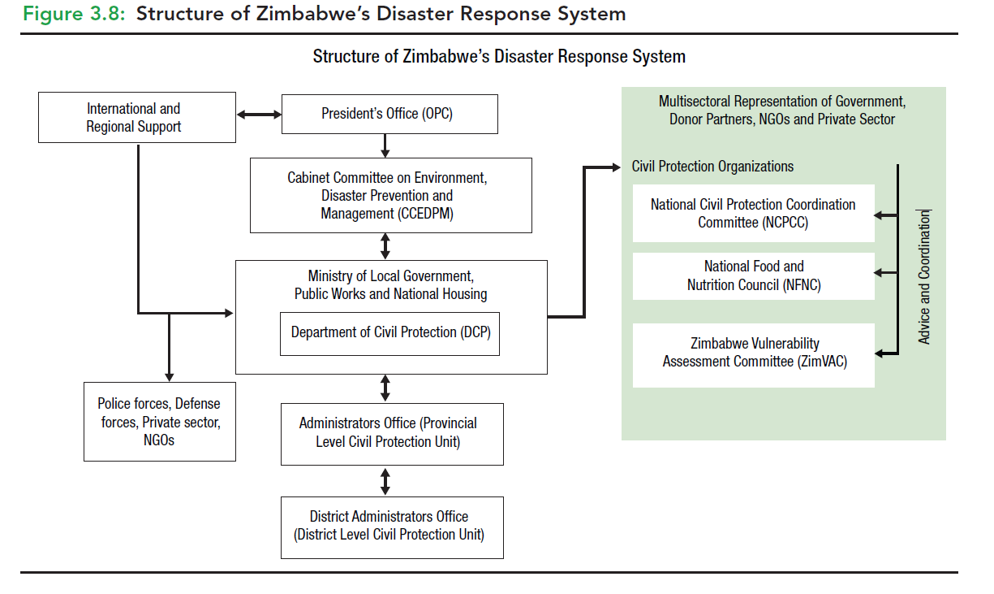

Figure 4 : Existing Structure of Zimbabwe’s Disaster Response System

The current set of DRM systems predominantly focuses on post-disaster response mechanism, e.g, emergency humanitarian support and operationalizing the Emergency Social Cash Transfers (ESCT) to vulnerable households, in which the disaster response mechanisms is being divided into two coordination structures anchored in two different institutions:

1. The National Civil Protection Committee, mainly responsible for flood response and other rapid-onset disasters of natural or man-made origin.
2. The National Civil Protection Committee, which comprises representatives from all line ministries, NGOs, and International Organizations.

Currently, the institutional system comprises the following structures:

* National Civil Protection Committee;
* The Department of Civil Protection;
* The Food and Nutrition Council;
* The Zimbabwe Vulnerability Committee;
* Provincial Civil Protection Committee;
* District Civil Protection Committee.
* Emergency Services Subcommittee;
* National Food and Water Subcommittee;
* National Epidemics and Zoonotic Crisis Subcommittee;
* National Resource Mobilization Subcommittee.

The challenges and gap in coordination and recommendations:

1. Challenges :

* lack of gender machinery and inadequate gender integration to DRM, DRR, and resilience building process
* inadequate methodology, tools, guidelines, process, and stakeholder engagement in comprehensive climate and multi-hazard risk and vulnerabilities at national, district, province, ward, and village.
* Lack of a gendered climate and multi-hazard risk information management network, data repository, information management, tailored and gendered climate and multi-hazard risk information for supporting gender response DRM, DRR planning, and scheme design at the local level
* The lack of a developed gender response and multi-stakeholder coordination DRM framework at all levels (national, district, province, ward, village). Strong multi-stakeholder coordinated and gender response DRM structures for gendered DRR and resilience building Challenges.
* Paradigm shift and transitioning from the current paradigm, DRM coordination structure of onset of an emergency, ad-hoc response-based interventions by the Civil Protection Committee to risk-informed, multistakeholder coordinated DRM and DRR for local level gender empowerment and development
* Improving DRM governance at all levels (national, district, province, ward, village) -Develop a gender response and multi-stakeholder coordination DRM framework at all levels (national, district, province, ward, village).
* Strong multi-stakeholder coordination and gender response DRM structures for gendered DRR and resilience building.
* Improving DRM governance at the Provincial and district levels with staffing and capacity building in DRM.
* Develop DRM planning at the Provincial and district level with a clearly defined multi-stakeholder map ( state, non-state, UN agencies, INGOs, national NGOS, CSOs, Charities, Private Sectors, Local Institutions, academia, youth groups, WLO, local charities, etc)
* Installation of Emergency Operations Center and SOP for supporting all early warning, operational forecasts, EWS for women, girls, youth groups, children, disabilities
* Sector and sectoral elements specific, farmers, women-led entrepreneurs, special impact weather forecasts, operational forecasts.
* Structural DRM support for the women small holder farmers ( water access, drainage system, access to agricultural land, access to surface water /irrigation, access to solar PV powered irrigation, access to AVC inputs, horticulture supports, access to market etc) . Develop Local agroecology-based DRM and DRR projects and pilot demonstrations in every village and community-level horticulture for supplying all agricultural inputs for promoting a community-based DRR scheme.
* Installation of Multi-hazard early warning system: Development precision level weather forecasts: Met agency needs to develop more specialization in developing high-resolution seasonal, decadal, weekly, 3-day, 5-day weather forecasts, needs to develop a dynamic and statistical downscale model rapidly developing thunderstorm (RDT of meteo France) for predicting heavy rainfall and thunderstorm.
* Improving surface observation system: Upgrading MSD weather observation system, acquisition of 5km grid data sets on surface observation, install more AWS with synoptic conditions tracking sensors, drone radar, laser ceilometer, radiosonde, rain gauging instrument, uses of EUMETCast lightning sensor data for tracking thunderstorm, Flood level gauging from the river system, flood forecasting and modeling. Improving Cyclone and Flood Forecasting and Early Warning:
* Development of impact based weather forecasts and operational forecasts: Develop methodology and guidelines on how to organize forecast briefing with guidelines on who will be the participants, how to interpret the risks by organizing discussion and analyzing weather model/outlook subject matter specialists ( Agrometeorologist, hydrologist, geomorphologist, water resource engineer, Plant scientist, Agri engineer, drought experts, landslide expert, agroecologist, ecologists, meteorologist, synoptic engineers, geomorphologist, etc.) along with forecasters( long, medium, short range), Numerical Weather Prediction(NWP) engineers/specialists, Synoptic Engineer and organize the forecast beliefs/discussion about the anticipatory impacts, risk and vulnerability and eventually developing impact forecasts. The multi-hazard risk analysis over the elements( is not a designated responsibility of EOC operators) is group work, and the outlined specialists need to develop customized tools, methodology, guidelines on impact-based forecasts and operational forecasts for the sector, sectoral elements, lives, and livelihood elements on the ground. Analysis of weather phenomena and interpretation of risks and vulnerabilities.
* Installation of ICT tools-based emergency operations center at the national, district, provincial, and ward levels
* Develop a national risk financing framework for DRR, inclusive budgetary support, and gender response DRR scheme planning and budgeting at the local level.

**Respondent : Department of Civil Protection (DCP) – Ministry of Local Government, Zimbabwe ( Engagement with Stakeholders)**

Challenges and recommendations :

* The existing disaster response system does not mandate other stakeholders /sector departments to coordinate climate change and disaster risk management jobs at the local level for engaging multi-stakeholders.
* Lack of stakeholder engagement and coordination at the ground level, the loss and damage datasets collection is being hindered, although the community is already aware of who is affected by the onset of a major disaster, which has already made landfall and is causing damage. Develop a Standard operating procedure (SOP) with defined ToR /Roles and responsibilities of stakeholders.
* Develop a temporary community-based camp for the displaced people until they build their houses back, use a school and church, and a community hall for the longer term, as it disrupts education
* For improving disaster preparedness the DCP recommended Properly constructed emergency evacuation center, every ward should have an evacuation center considering the terrain landscape, poor communication structure.
* Develop 35000 village-level gender response DRM /DRR planning, scheme design, and pilot demonstration for the community to replicate the intervention.

**Respondent : “Hope for Child in Christ” , Zimbabwe( Engagement with Stakeholders)**

**Recommendations**

* Improvement of institutional coordination, multi-stakeholder ( private sector) engagement, working together in terms of DRR.
* Guidelines and tools for local CPCC at the local level for performing the emergency preparedness, volunteering structures and process are gender response (women-headed households) , gaps in emergency evacuation
* Gender mainstreaming at the national, Provincial, district, and community levels in Disaster response, prioritizing the female-headed, children/single-mother-headed households, develop a manual SoP/Standing orders on Disaster.
* Awareness-raising campaign for women, girls, and children in the local language
* Implementation of civil-military coordination mechanism(ICS) , institutional barrier and gaps for comprehensive DRM

**Respondent : UNDP ( Engagement with Stakeholders)**

**Challenges and recommendations :**

* Inadequate state and non-state actors' coordination structure, management structure to civil protection platform structures for integrating both of state and non-state actors in DRM and DRR actions to the community level
* Inadequate Coordination structure, stakeholder map, and not having stakeholder-specific roles and responsibilities of the disaster DRM process at the local level within the field of Disaster risk reduction and response, any phase of disaster preparedness and rehabilitation.
* Develop a national risk management framework with multi-stakeholder and multisectoral coordination structures, stakeholder engagement maps ( 4W/ SoP), and responsibilities for improving national coordination in integrated DRR planning and interventions at the local level.
* Restructuring all civil protection committees with well gender participation for disaster emergency preparedness, volunteering humanitarian response, gendered responsive camp management, and coordination for reducing SGBV incidents.
* Update methodology tools, guidelines, mandates of ZimVAC, sector department, and other organizations in conducting Participatory Vulnerability and Capacity Assessment (PVCA) process, collection, and sectoral disaggregated multi-hazard risk information for DRR intervention prioritization

**Respondent : Gender Department of the Ministry of Women's Affairs ( Engagement with Stakeholders)**

**Recommendations :**

* Gender department, DCP, and other local government sector departments, UN-cluster system, INGOs, NGOs, and CSO private sectors need to work together to develop a structured DRM/DRR coordination and stakeholders engagement structure at all administrative levels with the defined roles and responsibilities.
* Improved institutional coordination, defined multi-stakeholder ( private sector) engagement structures for planning and implementation of DRR/CCA.
* Inventory development on the Socio-cultural background of the community for need-based DRM/DRR.
* Lands, Agriculture, Fisheries, and Rural Development need liberalization of the government land control policy and land tenure for the marginalized rural poor women-headed households.

## **3.2 UN/Government structures engaging women and women-led organizations in DRR and resilience initiatives**

From the above discussions, it can be outlined that there are root causes and challenges that persist in the UN/Government structures' engagement with women and women-led organizations in DRR and resilience initiatives. The assessment identified some key challenges related to government and multi-stakeholder coordination and partnership mechanisms. The policy instruments are typically top-down policy, strategy, and action planning of Gendered DRR and resilience building. Following root causes, challenges, and gaps can be outlined along the DRM/DRR Policy/Strategy, programmatic structure:

* Inadequate gender machinery, women's representation in the local power structure, planning, and decision-making system, and inadequate women-led organizations at the local level,
* Lack of gendered climate risk information management network, tailormade gender climate and multi-hazard risk and vulnerability information to influence masculinity of bureaucracies over the male dominated decision-making system that around 60% and above workforce are female in local productive sectors (agriculture, livestock, fisheries, agroforestry, food processing SMEs etc.) and they need to be well taken care off with providing inclusive development finances.
* Lack of a gender development network led by women-led organizations at the district, ward, and village levels to advocate for the government system to remove all discrimination against gender in accessing local basic service deliveries.

**Recommendations**

* Engagement of WLO in CBDRM planning processes
* Gender sensitive humanitarian coordination structures
* Women’s leadership and participation in decision-making in the public and private sectors.
* Revising the National Gender Policy (2014-2019) and the engagement mechanism of WLO at the local level
* Promote and engage more WLO for gender mainstreaming in all line ministries, including in relation to DRM.
* Develop women-led green entrepreneurship with women-led cooperatives, access to GCF, and other finances.
* Develop and promote more WLO and enable WLO in the women-led and broad-based Women’s Economic Empowerment Policy, the Community Development Policy, and the strategy developed at the local level.

The following sector ministries and departments need to work together to develop gender machinery at the national and sub-national level ;

* Ministry of Finance and Economic Development
* Zimbabwe National Statistics Agency (Zim Stat)
* Ministry of Lands, Agriculture, Water, Climate, and Rural Resettlement
* Ministry of Public Service, Labor, and Social Welfare
* Ministry of Health and Child Care
* Ministry of Local Government, Public Works and National Housing
* Ministry of Women Affairs, Community, Small and Medium Enterprise Development
* Ministry of Justice
* Department of Social Welfare under the Ministry of Labor, Public Service and Social Welfare; Ministry of Water, Environment and Climate.

# **4.0 Impacts of Climate-Induced Disasters [Cyclones, Floods, Drought]**

# **4.1 How have climate-induced disasters impacted women and men differently?**

| **Persistent vulnerability factors** | **Vulnerable Gender Group** | **Differential Impacts** | | | **Recommendations** |
| --- | --- | --- | --- | --- | --- |
|  |  | **Cyclones** | **Floods** | **Drought** |  |
| Disaster-induced displacement/emergency evacuation | Women and Girls | Not having gender privacy-friendly provisions/facilities in evacuation shelters and shared accommodations for accessing ablution and bathing facilities with men and boys, and the risk of sexual abuse. | Not having gender privacy-friendly provisions/facilities in evacuation shelters and shared accommodations for accessing ablution and bathing facilities with men and boys, and the risk of sexual abuse. |  |  |
|  |  | Pregnant women do experience challenges accessing clinics as a result of impassable roads, flooded rivers, and this has resulted in home births with untrained birth attendants, increasing the risk of complications in birth, aftercare of the mother, and newborn babies | Pregnant women do experience challenges accessing clinics as a result of impassable roads, flooded rivers, and this has resulted in home births with untrained birth attendants, increasing the risk of complications in birth, aftercare of the mother, and newborn babies. |  |  |
|  | Women and Children | Some women and children are travelling multiple times a week and long distances, averaging 10km to access food packs and Non-Food Items (NFIs), and are abused. |  |  |  |
|  | Women, single mothers, widows, and adolescent girls | Without having adequate privacy and protection, living and basic utility services, girls are systematically falling victim to Gender Based Violence, Sexual exploitation by their male partners |  |  |  |
| Pushing evacuees from the schools just after 2-3 weeks for reopening the school and stopping the emergency humanitarian food supply | Women, single mothers, widows, and adolescent girls | Systemic discriminatory approaches from the stakeholders will not continue humanitarian food support after 2/3 weeks, and also pushing from the schools to go back home, while their shelters are completely /partially destroyed and cannot build back better until they get any financial support. Those systemic discriminatory approaches push Women, single mothers, widows, and adolescent girls to engage in transactional sex in exchange for money. | Systemic discriminatory approaches from the stakeholders will not continue humanitarian food support after 2/3 weeks, and also pushing from the schools to go back home, while their shelters are completely /partially destroyed and cannot build back better until they get any financial support. Those systemic discriminatory approaches push Women, single mothers, widows, and adolescent girls to engage in transactional sex in exchange for money. |  |  |
| Accessing humanitarian assistance | Women, Children, and Adolescent Girls | Difficult for women, single mothers, and widows to have emergency humanitarian support from crowded service trigger points, and subsequently being deprived and pushed to adopt transactional sex for having emergency food and NFI items from the emergency trigger points | Difficult for women, single mothers, and widows to have emergency humanitarian support from crowded service trigger points, and subsequently being deprived and pushed to adopt transactional sex for having emergency food and NFI items from the emergency trigger points |  |  |
| Cultural norms, male domination over the household, and irresponsibility of male family members to stay away from home, and letting the pain fall on female members of the family | Women, Girls, and Children | The irresponsibility of male members to support their family members in difficult times, and the hopelessness and trauma experienced by female members when it comes to emergency preparedness and evacuations, just ahead of the disaster trail starting in the locality. | The irresponsibility of male members to support their family members in difficult times, and the hopelessness and trauma experienced by female members when it comes to emergency preparedness and evacuations, just ahead of the disaster trail starting in the locality. |  |  |
| Cultural norms, irresponsibility of male family members to stay away from home for a longer time every week/month aftermath of disaster events | Women, Girls, and Children | Stay away from home for long, sometimes not supporting, sometimes living alone with the family forever, and let every mother become the custodian running the family with no means of livelihood, pushing the family into persistent poverty and hunger. | Stay away from home for long, sometimes not supporting, sometimes living alone with the family forever, and let every mother become the custodian running the family with no means of livelihood, pushing the family into persistent poverty and hunger. |  | Rapid Gender Analysis (RGA) |
| Drop in schooling | Girls and Children | After the aftermath of a cyclonic disaster, the family falls into another vicious cycle of poverty and hunger. As a result, school-going children need to support their families to ensure food and water security, often leading them to become child laborers to feed themselves throughout the year. | After the aftermath of a flood disaster, the family falls into another vicious cycle of poverty and hunger. As a result, school-going children need to support their families to ensure food and water security, forcing them to become child labor to feed themselves throughout the year |  |  |
| Recently became a victim of an incident of SGBV | Single mother, widow, adolescent mother, children, adolescent girls, disabled. | After the aftermath of the cyclone-induced trail of disaster destroyed the basic lifeline services (drinking water, WASH, Healthcare, food, etc.), the adolescent girls and women need to travel a long way to get drinking water every day and are being sexually abused. | After the flood, the aftermath of the flood induced a trail of disaster that destroyed the basic lifeline services (drinking water, WASH, Healthcare, food, etc.). The adolescent girls and women need to travel a long way to get drinking water every day and are being sexually abused. |  |  |
| Falling in epidemic, outbreaks/diseases/infections, and loss of lives | Single mother, widow, adolescent mother, children, adolescent girls, youth, disabled group. | After the aftermath of a cyclone-induced trail of disaster, another ripple effect of the epidemic starts, destroying all drinking water resources. As a result, people are forced to drink polluted water, which causes epidemic outbreaks/diseases/, and infections, leading to loss of life.  The most vulnerable members of the family, e.g., children, youth, and women, are the largest victims, followed by youth and men, because of a lack of immunity and malnutrition, a lack of awareness, and a lack of water treatment kits at the household level. Public healthcare services are essential for saving lives. | After the aftermath of a cyclone-induced trail of disaster, another ripple effect of the epidemic starts, destroying all drinking water resources. As a result, people are forced to drink polluted water, which causes epidemic outbreaks/diseases/, and infections, leading to loss of life.  The most vulnerable members of the family, e.g., children, youth, and women, are the largest victims, followed by youth and men, because of a lack of immunity and malnutrition, a lack of awareness, and a lack of water treatment kits at the household level. Public healthcare services are essential for saving lives. |  |  |
| Discrimination in accessing post-disaster humanitarian assistance | Single mother, widow, adolescent mother, children, adolescent girls, youth, disabled group. | The social norms, patriarchal dominion, irresponsible paternity, sometimes lead male members to sell relief items and stay away from home unethically. Subsequently, the female heads become hopeless and fall into extreme hunger and poverty. | The social norms, patriarchal dominion, irresponsible paternity, sometimes lead male members to sell relief items and stay away from home unethically. Subsequently, the female heads become hopeless and fall into extreme hunger and poverty. |  |  |
| Male ownership of agricultural lands | Single mother, widow, adolescent mother, children, adolescent girls, youth, disabled group. | Since all control of assets is falling in male hands and leaving females powerless, as a result, systemic laws and norms put women in peril of poverty tangles and encourage a persistent culture of male domination over females. | Since all control of assets is falling in male hands and leaving females powerless, as a result, systemic laws and norms put women in peril of poverty tangles and encourage a persistent culture of male domination over females. | Since all control of assets is falling in male hands and leaving females powerless, as a result, systemic laws and norms put women in peril of poverty tangles and encourage a persistent culture of male domination over females. |  |
| Loan defaulter | Single mother, widow, adolescent mother, children, adolescent girls, youth, disabled group. | In most cases, the aftermath of a cyclone disaster, families need to depend on microcredit facilities and access mobile money. In this case, the male member withdraws the money and leaves home, leaving the family in a state of hunger and poverty, which ultimately leads to the women being labeled as loan defaulters. | In most cases, the aftermath of a cyclone disaster, families need to depend on microcredit facilities and access mobile money. In this case, the male member withdraws the money and leaves home, leaving the family in a state of hunger and poverty, which ultimately leads to the women being labeled as loan defaulters. | In most cases, the aftermath of a cyclone disaster, families need to depend on microcredit facilities and access mobile money. In this case, the male member withdraws the money and leaves home, leaving the family in a state of hunger and poverty, which ultimately leads to the women being labeled as loan defaulters. |  |
| Discrimination in accessing government sector department services | Single mother, widow, adolescent mother, children, adolescent girls, youth, disabled group. | Systemic institutional description for Single mothers, widows to access government subsidies, agriculture input facilities, and get market prices for the women small holder farmers. | Systemic institutional description for Single mothers, widows to access government subsidies, agriculture input facilities, and get market prices for the women small holder farmers. | Systemic institutional description for Single mothers, widows to access government subsidies, agriculture input facilities, and get market prices for the women small holder farmers. |  |
| Inadequate access to inclusive finance for homestead-based IGA | Single mother, widow, single mother, adolescent mother, children and adolescent girls, youth | The baking system and credit operators ask for collateral guarantees for access loans, in which poor Single mothers and widows are not able to access the services and become entrepreneurs | The baking system and credit operators ask for collateral guarantees for access loans, in which poor Single mothers, widows are not able to access the services and become entrepreneurs | The baking system and credit operators ask for collateral guarantees for access loans, in which poor Single mothers, widows are not able to access the services and become entrepreneurs |  |
| Limited scope and access to education, access to agricultural lands, agroecology, and restricted access to other governmental services due to having climate refuge status. | Single mother, widow, single mother, adolescent mother, children and adolescent girls, youth | The recurrent disaster incidence creates persistent poverty, tangled social issues, persistent internal displacement, and a climate refugee status, without access to education and agricultural land, making livelihoods resilient to climatic shocks. | The recurrent disaster incidence creates persistent poverty, tangled social issues, persistent internal displacement, and a climate refugee status, without access to education and agricultural land, making livelihoods resilient to climatic shocks. | The recurrent disaster incidence creates persistent poverty, tangled social issues, persistent internal displacement, and a climate refugee status, without access to education and agricultural land, making livelihoods resilient to climatic shocks. |  |

## **4.2 The different coping mechanisms adopted by women and men to climate-induced disasters (challenges and recommendations)**

Cyclone Idai affected 270,000 people in Zimbabwe, out of which 51,000 were displaced, more than 340 died, and many others went missing. Children were orphaned, while female survivors faced gender-based violence. 68% of the households got information about the approach of Cyclone Idai from the media, while more than 31% were caught unaware[6].

**Respondent: Department of Civil Protection (DCP) – Ministry of Local Government (coping mechanisms)**

Coping mechanism in climate-induced disasters:

* Peace work, business
* Remittance from male member
* Selling productive assets
* Selling homestead agricultural outputs
* Emergency Social Cash Transfers (ESCT) by the UN/INGOs and other CSOs
* Charcoal making and selling firewood
* SMEs support
* VSLAS (Village Saving & Loan Associations) support for starting agriculture
* Women Development Funds (WDF) Microfinance and Women Empowerment in Zimbabwe
* The positive coping mechanism

Negative coping mechanism:

* Cutting trees and making charcoal, selling firewood, etc.
* Selling productive assets, belongings, etc.
* Transactional sex
* Adolescent girls are being forced into early marriage
* Trafficking of girls and children
* Migration

**Respondent : UNDP (coping mechanisms)**

**The positive coping mechanism :**

* Piecework - Day labor, Casual labor, mining workers South Africa to feed the households
* Emergency Social Cash Transfers (ESCT) by the UN/INGOs and other CSOs
* Running a Small business
* Remittance from male member
* Support from relatives
* Selling productive assets, selling some of the household belongings
* Selling of humanitarian assistance,

**Negative coping mechanism:**

* Cutting trees and making charcoal, selling firewood, etc.
* Transactional sex
* Adolescent girls are being forced into early marriage
* Trafficking of girls and children
* Migration
* Recommendations – aftermath of cyclone Idai, women work for casual labor, part-time jobs.
* Drought /flooding impacted crop failure. The marginalized community looks for alternative livelihoods, casual labor, and seeks SMEs for livestock, poultry, fisheries farming, running small businesses, etc.
* Access to some sources of funding for women-led household livelihoods, e.g., Women Development Funds (WDF), Community Development Funds(CDF), loans for small business and entrepreneurship development, on condition of meeting the collateral deposits.
* For accessing green climate facilities and Mobile finances, Econet is doing mobile banking for Zimbabwean women in accessing microfinances
* Accessing green finances for climate-smart income-generating activities (IGA)
* Provide Gender transformative training for gender inequality ( removing) ,
* The need for capacity building is equal to the development program
* Planning – preparedness and response,
* Zimbabwe Red Cross Society (ZRCS)

This can be substantiated by other national projects which the government implemented, such as the Land Reform Program (LRP),

**Respondent : “Hope for Child in Christ” , Zimbabwe(coping mechanisms)**

Copping mechanism:

**The positive coping mechanism :**

* Remittance form male member
* Piecework - Day labor, Casual labor, mining workers South Africa to feed the households
* Emergency Social Cash Transfers (ESCT) by the UN/INGOs and other CSOs
* Running a Small business
* Remittance from male member
* Support from relatives
* Selling productive assets, selling some of the household belongings
* Selling of humanitarian assistance,
* Selling homestead agricultural outputs
* Emergency Social Cash Transfers (ESCT) by the UN/INGOs and other CSOs
* SMEs support
* VSLAS (Village Saving & Loan Associations) support for starting agriculture
* Women Development Funds (WDF) Microfinance and Women Empowerment in Zimbabwe

**Negative coping mechanism:**

* Cutting trees and making charcoal, selling firewood etc.
* Transactional sex
* Adolescent girls are being forced into early marriage
* Trafficking of girls and children

**Respondent: Gender Department of the Ministry of Women's Affairs (coping mechanisms)**

**The positive coping mechanism :**

* Part-time job
* Remittance form male member
* Piecework - Day labor, Casual labor, mining workers South Africa to feed the households
* Emergency Social Cash Transfers (ESCT) by the UN/INGOs and other CSOs
* Running a Small business
* Remittance from male member
* Support from relatives
* Selling productive assets, selling some of the household belongings
* Selling of humanitarian assistance,
* Selling homestead agricultural outputs
* Emergency Social Cash Transfers (ESCT) by the UN/INGOs and other CSOs
* SMEs support
* VSLAS (Village Saving & Loan Associations) support for starting agriculture
* Women Development Funds (WDF) Microfinance and Women Empowerment in Zimbabwe

**Negative coping mechanism:**

* Cutting trees and making charcoal, selling firewood, etc.
* Transactional sex
* Adolescent girls are being forced into early marriage
* Trafficking of girls and children

## **4.3 key barriers to effective women’s engagement in DRR and resilience building**

**Respondent UNDP ( barriers to DRR and resilience building)**

* Inadequate DRM governance at all levels ( national, provincial, district, ward, and village levels)
* Inadequate gendered disaggregated data and tailormade informed tools for informing gender responsive DRM
* Inadequate Gendered climate risk and vulnerability-informed tools, information network, MIS system, gendered elements-wise GIS risk and vulnerability map, GIS-based map at all administrative levels ( national, provincial, district, ward, and village level) for supporting DRM/DRR/CCA-related project/scheme design and implementation at the local level
* Inadequate local government DRM structure, stakeholder coordination mechanism, stakeholder responsibilities for the DRM and DRR process
* Inadequate gender machinery, lack of participatory local government system, lack of sectoral coordination at all levels ( national, provincial, district, ward, and village level), and inadequate women and gender access to existing local government planning and decision-making processes.
* Lack of AAP Framework, collective action plans for HCT/INGOs, and other state and non-state actors' coordination structure and process, and effective DRM and DRR interventions
* Lack of a gendered climate and disaster risk financing framework for allocating gendered DRM and DRR schemes at the local level
* Inadequate gendered disaggregated data and tailored informed tools for developing gendered ( women, girls, and youth )needs and priority inclusive disaster emergency preparedness, contingency plan, and humanitarian assistance mobilization.
* Inadequate gendered disaggregated data ( women, girls, and youth ) , localized climate and multi-hazard risk and vulnerability information for quantifying the climate risk and vulnerability over the gender group, women-headed households, and livelihood assets.
* Lack of an AAP Framework for monitoring and creating accountability of actors /stakeholders in sectoral DRR interventions
* Inadequate climate risk information for the gender group, lack of operational forecasts for women, girls, and youth. children, the elderly, and the disabled age group, to prepare them for the impending multi-hazards
* Insufficient gendered climate risk and vulnerable information, informed tools to define gender entry point in risk-informed DRR /LDP planning because of sector departments inadequately being informed by the gender disagreed and gender differentiated climate and multi-hazard risk and vulnerability information
* Inadequate tailor-made informed tools on multi-hazard risk and vulnerability information on differential gendered impacts and developing risk-informed GiHA in EAP, EWEA, Forecast-based early schemes and interventions
* Activation of Forecast-based SGBV, PSEA, SEA incidence reporting
* WRD (Gender DRR and Resilience Farmwork ) framework, stakeholder coordination, and action plan for improving Gender Machinery addressing the DRM, DRR, NAP, and NDC
* Inadequate methodology, tools and guidelines and stakeholder engagement(MVAC and other relevant stakeholders ) in Assessment of socioeconomic vulnerability of women headed household
* Implementation of DRR projects for 5 years to harmonize the impacts of interventions
* People's mindset, Culture, religion, and patriarchal paradigm discourage women from speaking and let their voice be heard. Women's participation in the local-level decision-making process, Women is being discouraged, and Women are less influential
* Promoting Women's education, developing a legal framework mandating women's education, and providing cash for female-headed households
* Involvement of more women-led organizations in DRM & DRR planning and intervention at the local level
* Inadequate women's households, single mothers, limited access to assets, agricultural lands, women should own the agricultural lands, empowering women's economic decision of use of land for DRR and CCA-based scheme implementation, and green entrepreneurship development.

**Respondent : Department of Civil Protection (DCP) – Ministry of Local Government (barrier DRR and resilience building)**

Challenges :

* The national fiscal budget system focuses on the social cash transfer program for food security.
* Multilingual improved early warning system being disseminated through national Radio broadcasts, development of forecast-based early action for women, and operational forecast for women.
* women DRM network at the district level to inform local level DRM/DRR planning and interventions.
* Gender responsive/inclusive local DRM/DRR/CCA/climate resilient plans (GiHA, Emergency preparedness, Response, recovery, CCA
* Women like to take care of children, not allocating time to spare. The majority decline to be local members of the local body. Women councilors have a lot of household work to spare time regularly for decision-making, so they need to promote a digital governance system.
* Women have to fetch firewood, collect water, take care of children, and can not regularly attend the committee meetings.
* Zimbabwe is a patriarchal society, and women cannot talk to men very frequently, keep quiet, can not raise their voice - patriarchal society does not allow women to speak out more, and women are falling in more social discrimination.
* Inadequate CRVA-informed tools to support the Planning process, GIS-based maps /informed tools for local-level planning.
* The Ministry of Agriculture and Social Development needs to provide support to smallholder farmers
* Develop a stakeholder Coordination platform, improve coordination and enforcement, provide recommendations, improve weather monitoring system /equipment, and accessories
* Civil protection funds for emergency rescue operations

**Respondent : Gender Department of the Ministry of Women Affairs (barrier DRR and resilience building)**

* Gender sensitive humanitarian coordination structures and GiHA
* District development officer to conduct strong monitoring of SGBV, Lack of tracking issues intensifying the events, male and female policing for tracking, and SGBV
* Women volunteer engagement in the search and rescue process to reduce gender based violence
* Women policing the camp level, gender friendly evacuation center, and food security for women until they are able to build their livelihood better and productive.
* Promote more women-led organizations, women entrepreneurship in the productive sector, women-led value chain operators, and the elimination of discrimination at all levels.
* Installation and promoting horticulture center at every village level with demonstration of all adaptive agriculture, IFM, livestock and poultry farming, agroforestry development, etc., for more women's contribution to GDP growth.
* Econet to promote green microfinance for women, Credit facility for green entrepreneurships development, women-led small holder farming development
* Structured fiscal framework for the affected community from the ministry, required – ( SafetyNet) Local Government Finance Committee is the structured system for district-level allocation

## **4.4 Recommendation on strengthening the resilience among vulnerable women and girls to climate-induced disasters**

**Respondent: UNDP ( strengthen resilience)**

* Every district needs to be mandated to develop contingency
* Vulnerability/risk reduction, knowledge sharing, and early warning at the local level.
* DCP, ZImVAC, UN Agency, and sector departments need to work together to develop a district-level early action protocol(EAP), forecast-based early action, and forecast-based preposition of humanitarian assistance for the sector/cluster for better preparedness.
* Improving and transitioning from traditional weather forecasting and alerting systems to impact-based forecasts for livelihoods, sectors, and operational forecasts for women-headed households, small-holder farming, and entrepreneurs.
* More SafetyNet program for ensuring food security
* Community-based contingency plans for emergency, resilience project, rehabilitation projects, resilience cash for work, IGA, climate information on seasonal forecasting, access to market(package ), host emergency assessment, tree plantation along the river bank, IGA
* Digitizing SLS, VSLS – Ministry of Agriculture (WFP), access
* Access to financing, capital, and key barriers to women's resilience to disasters
* Improving income, strengthening market access, IGA, key value chain, Women on Agriculture, and children's medication.

**Respondent – Department of Civil Protection (DCP) – Ministry of Local Government ( strengthen resilience)**

* More rights-based approach in the elimination of all forms of discrimination against women
* Gender Access to planning and decision making
* Strengthening gender machinery and risk-integrated local climate governance process
* Gender access to the local level DRM/DRR planning and decision-making process
* Climate risk financing framework for gendered DRM and DRR development at the local level
* Women's access to development finance, green climate finance, green entrepreneurship development finance
* Gender ( women, girls, children, youth, disabled population ) access to climate risk information, impact-based weather forecast for gendered groups, sector-specific operational forecasts for the sector, etc.
* Gender inclusive GiHA, DRR, DRM
* Inadequate tailor-made informed tools on multi-hazard risk and vulnerability information on differential gendered impacts and developing risk-informed GiHA in EAP, EWEA, Forecast-based early schemes and interventions
* Activation of Forecast-based SGBV, PSEA, SEA incidence reporting
* WRD (Gender DRR and Resilience Farmwork ) framework, stakeholder coordination, and action plan for improving Gender Machinery addressing the DRM, DRR, NAP, and NDC
* Inadequate methodology, tools and guidelines and stakeholder engagement(MVAC and other relevant stakeholders ) in Assessment of socioeconomic vulnerability of women headed household
* Implementation of DRR projects for 5 years to harmonize the impacts of interventions
* People's mindset, Culture, religion, and patriarchal paradigm discourage women from speaking and let their voice be heard. Women's participation in the local-level decision-making process is being discouraged, and Women are less influential
* Promoting Women's education, developing a legal framework mandating women's education, and cash for female-headed households
* Involvement of more women-led organizations in DRM & DRR planning and intervention at the local level
* Inadequate women's households, single mothers, limited access to assets, agricultural lands, women should own the agricultural lands, empowering women's economic decision of use of land for DRR and CCA-based scheme implementation and green entrepreneurship development.

**Respondent : Gender Department of the Ministry of Women's Affairs ( strengthen resilience)**

* Reform of land tenure policy and Women's access to agricultural lands, wetland, agroecology, agroforestry, and fellow lands for women led to GDP growth from the productive sector ( agriculture, fisheries, livestock, agroforestry development)
* Gender representation at the local government level planning and decision-making process
* Elimination of all violence against women, girls, and children
* Gender ( women, girls, children, youth, disabled population ) access to climate risk information, impact-based weather forecast for gendered groups, sector-specific operational forecasts for the sector, etc.
* Gender focused GiHA, DRR , DRM
* Gendered climate risk-informed tools on multi-hazard risk and vulnerability information on differential gendered impacts and developing risk-informed GiHA in EAP, EWEA, Forecast-based early schemes and interventions
* Activation of Forecast-based SGBV, PSEA, SEA incidence reporting
* Promoting Women's education( distant learning), developing a legal framework against SGBV, mandating women's education and climate risk awareness with distant learning ( National Radio/TV)
* Women, girls, and youth access to the local level DRR/DRM planning and decision-making process
* Green financing framework for women marginalized farmers, smallholder farmers, women-led cooperatives, and women-led green entrepreneurships development

**Respondent : Youth Group:**

1. Provisioning climate change impact, disaster risk, and vulnerability-related education in secondary and post-secondary curriculum and extracurricular IEC for the students and non-schooling girls and women
2. Developing and disseminating impact-based weather forecasts for girls /adolescent mothers
3. Girls, adolescent mothers' access to local-level DRR, civil protection planning and decision-making process

**Respondent : “Hope for Child in Christ” , Zimbabwe ( strengthen resilience)**

* National media outlets need to broadcast special weather bulletins in the local language for undereating forecasts by all vulnerable groups
* The government needs to liberalize the land tenure/management policy and provide access to women in agricultural lands, wetland, agroecology, agroforestry, and fellow lands for women-led GDP growth from the productive sector ( agriculture, fisheries, livestock, agroforestry development)
* Women-led agriculture value chain development, women-led community-based cooperative development for climate-adaptive IFM farming, high-value agriculture cropping, fisheries, livestock, and agroforestry development.
* Agritex needs to develop horticulture in every village with the development of integrated farm management, seedling, sapling for the farmers, water management, irrigation, plot demonstration of climate-tolerant cropping, fisheries, livestock, and agroforestry development

# **5. 0 Chapter: Focus Group Interview with the community**

Organized a field visit to Ward 15 of Cimanimani District and conducted the 1st Focus Group Discussion (FGD)in the Ward 15 Ward-level village civil protection coordination committee (VCPCC) semi-structured focus group interview questionnaire. The FGD session was attended by around 30 CPC members. The CPC discussed several issues relating to DRM and DRR, and the community provided feedback on the multi-hazard early warning, their understanding of the warning message (by differential gender and age group), the indicative challenges in emergency evacuations, receiving emergency food and NFI support, and community recommendations for improving service delivery. After the disaster, what are the differential impacts that the community experiences individually by the women, children, youth, and disabled population? What are the urgent needs and priorities, and coping mechanisms for surviving the disaster shocks? In the Recovery phase, what are the priority that the community understand for building back better from the last cyclone and flood disaster? Explore the responsibilities of VCPCC in DRR and DRM resilience building at the community and individual levels.

**In the second Focus Group Discussion (FGD)** conducted at Ward 21 (Cimanimani District), small-holder women farmers/individuals also demanded a higher precision level and instant national radio and TV broadcasts for the dissemination of early warning, supply a solar-powered radio set, and a wind-up Radio set to every household to instantly receive early warning messages. VCPCC demanded a gender-friendly, flood-proof designated evacuation center. Prepositioning lifesaving NFIs to the most vulnerable households so that the remote community can timely receive emergency food and NFI supports. In the Recovery phase, the community demanded more inclusive financial packages for undertaking household-level IGA-generating activities ( livestock, homestead integrated firm management -IFM, poultry farming, etc.), developing women-led entrepreneurship, and promoting market value-chain.

|  |  |
| --- | --- |
|  |  |
| 1st Focus Group Meeting Discussion (FGD) with Cimanimani District, Ward 15(Eastern-Zimbabwe) | |

|  |
| --- |
|  |
| 2nd Focus Group Meeting Discussion (FGD) with Cimanimani District, Ward 21(Eastern-Zimbabwe) |

1. **How community receive early warning of cyclone, flood and drought and is the information understandable?**

The committee mentioned the receiving of early warning through Chimanimai community Radio, because Ward 15 has close proximity to Chimanimai township and other sources, such as WhatsApp groups of VCPCC, and the traditional method of whistle-blowing/Megaphone by the volunteers, Women getting warning messages from school children, etc. But the VCPCC mentioned about the barrier of early warning dissemination process which is cascading, push messing style and the warning sensitization process coming across the domino effect over the group based interaction process(Civil protection committee) which result delay, inefficient and ineffective awareness to the vast people living out of mobile network coverage and out of community radio frequency range. The traditional and cascading human channel-driven multi-hazard and disaster warning system creates confusion about the warning.

National media outlets (Radio, TV) can broadcast swiftly /in real-time, playing a crucial role in mass awareness of impending multi-hazards and extreme weather events through special weather bulletins that frequently report cyclones, heavy rain, tornadoes, and thunderstorms. The critical complaints from the community are that the national media outlets broadcast cyclone early warnings after the news, which leads to mass mortality in the vulnerable community, not aware of the intensity of the cyclone, and accompanied by thunderstorms, triggering immediate flash flooding and immediate consequences for households and settlements located along the water runoff drainage channel and downstream. Community demanded understandable impact-based multi-hazard early warning being broadcast through national electronic media( Radio/TV/SMS/ Cell Broadcast/IVR, etc).

The committee demanded a free radio set, a precision level, and timely early warning. The committee demanded household-based inclusive finances for disaster recovery and household income-generating activities, food, and livelihood security.

**The VCPCC ( Village Civil Protection Coordination Committee) recommendations on EWS & disseminations ;**

* National AM Radio, TV, Community radio, SMS, IVR message during cyclone impeding situation special weather bulletins every 20/30 minutes, hourly information dissemination with impact-based forecasts and advisories on what to do and when to evacuate.
* Impact-based weather forecasts for the sector, operational forecasts for women, girls on impending multi-hazards.
* National AM Radio, TV, Community radio to broadcast on mass education about climate change impacts, multi-hazards, climate adaptive living, adaptive practice, resilience practices, etc., for mass awareness.

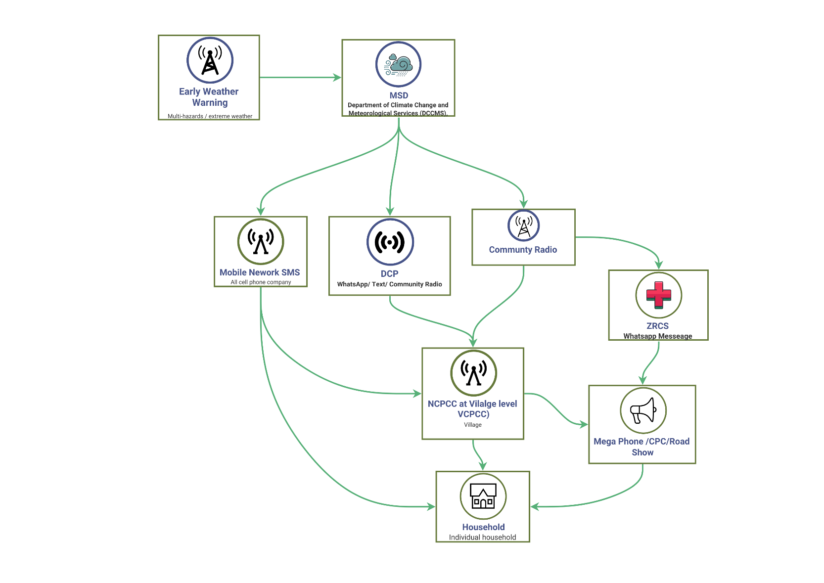

Figure: Existing warning dissemination process

* Requirements of the designated multi-purpose disaster shelter.
* Community needs multi-purpose, gender friendly, utility services enabled disaster shelter with secured storage facilities to keep their belongings.
* Providing transport facilities, emergency lifesaving food-NFI items, and other facilities for the gender group (women, children, girls, elderly, and disabled population)
* emergency forecast /early warning based early preparation training and mock drill on before the hazard makes landfall/disasters are highly likely to take place.
* VCPCC to constantly provide feedback with their UHF/VHF radio to EOC about the community level preparedness measures, emergency evacuation status, energy, humanitarian needs, and priorities of relief and other NFIs, etc.
* Feedback mechanism of community preparedness
* Village headwomen, women members of the CPC, and other social council women members to report to the District civil protection coordination committee (DCPCC) and District EOC about the needs and priorities of women-headed households.
* Event situations update on women-headed households
* Emergency preparedness drill.
* Emergency Evacuation support
* Community understandable impact-based forecasts, weather warnings, alerting on rapid-onset multi-hazards, e.g., heavy rainfall, thunderstorm, cyclone, flash flooding, landslide, mudslide, etc.
* Government to mandate national Radio /TV and relevant agencies/actors to frequently broadcast special weather bulletins on cyclones, heavy rainfall, thunderstorms, their intensity, anticipatory impacts, loss and damage, and advisories for the high-impact areas.
* Instant Messing with Local Language
* Interactive Voice response, Cell Broadcast, SMS etc., so that the community can understand the intensity of hazards

**The VCPCC recommendations on community-based DRM :**

Figure : Proposed **community based DRM structures**

**Developing on real-time radio broadcasts and advisories :**

The traditional participatory consultation process (Chieftainship) is being practiced for forecasted weather risk interpretation and early warning dissemination until the village headman calls the CPCC meeting. The Village headman decides on evacuation to safe ground/evacuation center. In the traditional warning dissemination system, the Meteorological Service Department (MSD) and the Ministry of Water Resources Development and Management jointly analyze the multi-hazard risk and vulnerabilities of the met agency to issue bad weather forecasts, and accordingly, deliver the early warning message through community radio, social networks (WhatsApp, Facebook).

Over the next step, the local CPCC, DRM, and volunteer group organize the VCPCC-level meeting and disseminate early warnings, creating an understanding of risk perception regarding the impending multi-hazards. As a result, there are mortalities of women, children, girls, and youth. Ironically, another social stigma of patriarchal domination over the household level critical decision making in which women entirely need to depend on male members and remain as the last person( women, children, girls, disable population) to take shelter at a safe ground along with belongings/asserts in normal circumstances that the male member are away from home. The most indicative early warning dissemination and evacuation barrier that the VCPCC decides and advises on for sheltering in the group meeting.

Vulnerable communities need a precision-level cyclone early warning. These communities were deliberately ignored and were not aware of cyclone Idai's early warning, which contributed to high mortality for the following reasons;

* The VCPCC member mentioned getting a message in delay because messages are being transmitted through the nested loop.
* Vulnerable community having less understanding of the intensity, frequency, and anticipatory loss and damage level of the warnings they are receiving.
* National AM Radio/FM Radio/TV need to broadcast the special weather bulletin every 10-15 minutes during the cyclone, which has already made landfall on the Mozambican coast and is heading towards the locality, and need to broadcast in all local languages.
* The government needs to mandate the national cell phone to transmit SMS very frequently in most local languages.
* The early warning for heavy rainfall triggered flash flooding recently, being activated in only the riverine flood-prone districts of Zimbabwe.

1. **Provide Flood Forecasts:**

**Challenges:** Community-based flood forecasts and early warnings are in place in most flood-vulnerable districts, but still, impact-based flood forecasts, forecast-based anticipatory action, and preparedness are required.

**Recommendations:**

* Household and Community demanded a free radio set (solar PV power, winding) for accessing radio broadcasts based on early warning
* Community radio/ National radio to broadcast multi-hazard early warning in all local languages.
* Demanded tool-free cell phone communication/message by CPCC members.
* Toll-free IVR/ cell broadcasts
* Livestock and Fisheries disaggregated climate impact data.
* Community to listen to Radio /TV broadcasts for emergency preparedness until the VCPCC in the group meeting advises on sheltering
* Technical capacity of understanding the warning
* Women and girls are understandably concerned about the early warning
* Women need to decide when, where, and how to take shelter to safe ground.
* Community radio, National radio, Toll-free cell phone communication, IVR, Cell broadcasts on humanitarian situations, awareness about SGBV, **etc.**

1. **VCPCC Suggestions/recommendations to the government about (improving) early warnings for cyclone, floods, flash floods, heavy rainfall and drought**

**Preparedness:**

* Installation of a gender-friendly multi-purpose evacuation center
* Transport facility for emergency evacuation
* Emergency prepositioning of Food during difficult situations ( energy biscuits, dry foods, etc.)
* Emergency water treatment tablets, WASH kits, and a rainwater harvesting system in every household
* Provide training and mock drill on emergency evacuation for sudden onset disasters ( heavy rainfall, flash flooding, landslide, thunderstorm, tornadoes, etc.) .
* Emergency forecast /early warning based on early preparation, related training, and mock drill before the hazard makes landfall/disasters are highly likely to take place.
* CPCCs to constantly provide feedback with their UHF/VHF radio to EOC about the community level preparedness measures, emergency evacuation status, energy, humanitarian needs, and priorities of relief and other NFIs, etc.
* Village headwomen, women members of the CPCCs, and other social council women members  to report to the District CPCC /EOC about the needs and priorities of women-headed households
* The community needs multi-purpose, gender friendly, utility services, an enabled disaster shelter with   secured storage facilities to keep their belongings

**Early Earning:**

* Community understandable impact-based forecasts, weather warnings, and alerts on rapid-onset multi-hazards, e.g.,  heavy rainfall, thunderstorm, cyclone, flash flooding, landslide, mudslide, etc.
* Interactive Voice response, Cell Broadcast, SMS, etc., so that the community can understand the intensity of hazards
* Government to mandate national Radio /TV and relevant agencies/actors to frequently broadcast special weather bulletins on cyclones, heavy rainfall, thunderstorms, their intensity, anticipatory impacts, loss and damage, and advisories for the high-impact areas.
* Mobile network operator Econet to provide free SMS in the local language to the community
* Households and communities demanded a free radio set ( solar PV power, winding ) for accessing radio broadcasts based on early warning
* Mandating national radio and Community radio stations to broadcast cyclone early warning, broadcast multi-hazard early warning on time in all local languages. The government mandates the media outlets to broadcast special weather bulletins on heavy rainfall and anticipatory flash flooding
* Civil Protection Coordination Committees (CPCCs) demanded tool-free cell phone communication/message - Toll-free IVR/ cell broadcasts.
* The community needs to access emergency weather bulletins recurrently coming from national radio/TV media outlets about extreme weather events (heavy rainfall and induced flash flooding and landslide ) for swift and preemptive evacuation and preparedness ( individual and group-based). Emergency decisions should be exclusively followed by the forecast-based early actions, and should be delegated by the Chieftaincy, with decisions being agreed upon by the energy community meetings.

**Emergency Excavation Drill**

* Emergency evacuation drills need to be conducted at the village and TA community levels. Given the circumstances, flash floods are likely to trigger the aftermath of heavy rainfall accumulation and cause flash flooding through slope and lower drainage changes. Consequently, adjacent settlements are likely to be damaged.

**Transportation support:**

* Providing transport facilities, emergency lifesaving food-NFI items, and other facilities for the gender group ( women, children, girls, elderly, and disabled population )

**Prepositioning of lifesaving emergency food and NFI :**

Zimbabwe Red Cross Society (ZRCS), DCP, UN agencies, INGOs, NGSs, and CSOs supply the most urgent lifesaving kits considering the physical road/waterways communication disruption.

1. **In what ways climate induced disasters impact?**

**Overall impacts of all gender groups:**

* **Direct impacts of climate shocks:** Due to terrain topography( eastern, western, and northern districts ), geographical settings, and recurrent rent incidence of extreme weather events and already persisted extreme poverty fact, which increased the hydrometeorological hazards and impacts, most of the respondents mentioned food and livelihood insecurity. The anomaly of weather patterns (drought, flash-droughts, agricultural drought, hydrometeorological drought, flooding, heatwave, thunderstorm, etc.) impacts agriculture and recurrent incidence of crop failure, yield loss, drought, sometimes flash floods, and thunderstorms are continuing to hamper agricultural cropping and leave households with food insecurity.
* **Ripple/domino/residual effects of cyclone, flood, drought-induced hazards /disaster:** Aftermath of flooding, flash flooding, cyclones, heatwaves, etc., there is another wave of hazards that trigger drinking water crisis-induced outbreaks of cholera, diarrheal and other waterborne diseases, vector-borne infectious diseases, and viral infections. Malaria, infectious fever, etc., those causes of significant mortalities, and incidentally, the large victims are women, children, and girls.
* Drought causes agricultural yield loss, food insecurity, and famine
* Chronic Food insecurity: There are multiple levels of multi-hazard events, flood, flash floods, drought, heatwaves, damaging crops, delaying cropping season, yield loss, etc., stress over surface and groundwater bodies, etc.
* Water is scarce for home gardening
* Protracted Poverty, Hunger, Famine:
* Internal displacement (IDP), climate refugee status entitles less access to state and non-state-run basic service deliveries

**a] Impact over Women ______________________________:**

* Longer time living in a Tent/shelter (until rebuilding/repair of houses): The Community demanded a longer time livable camp/shelter for the vulnerable group, because the government intended to reopen schools weeks after the disaster events, where most of the marooned community sheltered and disrupted schooling and education.
* Social insecurity, victim of SGBV and psychosocial trauma:
* Being forced to use a negative coping mechanism:
* Vulnerable to human trafficking
* Living as a single mother due to her husbands left away
* Highest level of divorces
* Highest level of child marriage
* Highest level of adolescent motherhood ( after Cyclone Freddy )
* Highest level of child trafficking
* Highest level of SGBV, PSEA, SEA, transactional sex for survival
* The highest level of women loan defaulters because their husband take all their wallet ( mobile money) money and away from home and systematically put them in peril
* highest level of public health disaster due to poor and no access to WASH facilities, drinking water access (during flooding) which leads the higher level of female and children mortality.
* The highest level of social, political, and economic discrimination against women, as they are being systematically exploited by the social power structure group, the social elite, and socially constricted norms and inequalities.
* All those persistent and recurrent climates induced crisis, protected poverty, social inequalities, social injustice, patriarchal dominion, led to deprivation, a socially constructed inequality paradigm putting women in peril and entangling them unequivocally.
* Women's access to agricultural, livestock, and fisheries value chain input supplies, government-led subsidies, and support are inadequate, and the built-in patriarchal-masculinity muscle, sociocultural norms, and discriminatory approaches largely hinder/deprive women and single mothers from accessing services.
* **Ripple/domino/residual effects of cyclone, flood, drought-induced hazards /disaster:** Aftermath of flooding, flash flooding, cyclones, heatwaves, etc., there is another wave of hazards that trigger drinking water crisis-induced outbreaks of cholera, diarrheal and other waterborne diseases, vector-borne infectious diseases, and viral infections. Malaria, infectious fever, etc., those causes of significant mortalities, and incidentally, the large victims are women, children, and girls.
* Pregnant women face a difficult situation during disaster-induced forced displacement and living in an evacuation center without having neonatal services, healthcare services, nutrition, food assistance, etc.
* Drought causes agricultural yield loss, food insecurity, and famine
* Chronic Food insecurity: There are multiple level of multi-hazards events, flood, flash floods, drought, heatwaves damaging crops, delaying cropping season, yield lost etc., stress over surface and ground waterbody etc.
* Water is scarce for home gardening
* Protracted Poverty, Hunger, Famine:

**SGBV Paradigm triggers the aftermath of a disaster**

* The persistent poverty, hunger, famine, and inbuilt social inequality, cultural factors already ( single mother, widow, single adolescent mother) in tangles of all discrimination, and additionally the climate change impacts further worsening them over the fragile livelihood cycle contribute to the incidence of SGBV events.
* After the disaster, those most vulnerable groups become completely hopeless because of losing every asset due to the disaster to take care of a number of dependents, and then being systematically pushed to transactional sex and being systematically harassed by the social elites and economically enabled group.
* Due to disturbance of natural ecosystems, polluted surface waterbodies/water sources, women-headed families need to travel longer to fetch drinking water, other necessities, and become victims of SGBV, and the highest level of unwanted adolescent pregnancies.

**b] Impact over adolescent girls ______________________________:**

* The highest level of unwanted adolescent pregnancies is due to the above reasons.
* Pregnant women face a difficult situation during disaster-induced forced displacement and living in an evacuation center without having neonatal services, healthcare services, nutrition, food, etc.
* Early marriage, divorces, birth-related complications, maternal mortality, malnutrition, single motherhood
* Mortality due to health disasters due to poor and no access to WASH facilities, drinking water access (during flooding), which leads to a higher level of female and child mortality.
* **Drop of Education:** Highest level of educational dropouts of secondary and postsecondary and element level of students because of climate crises, supporting family for food and water security, famine, poverty & inequality, SGBV, human trafficking etc.

1. **Persistent dependency on lifesaving humanitarian assistance and IDP shelters/tents**

* Lack of adolescent girls' friendly emergency Shelter: Gender friendly emergency safe shelter for the most vulnerable group( Women, children, girls, youth, elderly, persons with disability).
* Protracted food insecurity and hunger
* The multiple factors tangled and trapping into the Protracted and vicious cycle food insecurity and hunger in round the year
* The anomaly of the rainy season seriously impacts cropping, yield losses, and puts households in famine, hunger, and uncertainties of food security.
* State, nonstate food supplies are inadequate and followed by the disaster recovery external assistance, and not come as regular interventions, so far frontline community needs to depend on the growing season

c] The Men __________________________________________________

* Pushed to migrate as labor for a long time to feed their family as migrant workers/casual labor – less time for taking care of family,
* Climate refuge, IDP status, and for longer period
* **Longer term dependency on humanitarian support:** In most cases, the community is not able to rebuild their livelihoods for better poverty reduction, Loss, and damage to their houses and belongings, and return to their homes. Extreme poverty stricken women headed households particularly single mother, widow, divorces does have any means of livelihood assets, productive livelihood asserts to feed their family and other dependable member of the family in the given situation of colossal level damaging disaster ( cyclone, flooding) the community demanded humanitarian support and startup capital for building back their houses and starting IGA.

d] Persons with disability _________________________________________

* Lack of disability friendly shelter, lack of transport for evacuations, inadequate government support for disability IGA

d] The Elderly __________________________________________________

* Lack of elderly friendly shelter, lack of transport for evacuations, and lack of adequate government support for IGA. Lack of startup capital for home-based IGA activities ( crafting, small business )

1. **In what ways can the protection of women after disasters be enhanced**

* Access to inclusive finance for startup livelihood activities
* Training on productive assets development farming
* Technical and vocational training ( animal husbandry, poultry rearing, fruit growing)
* Technical Training in SMES development ( food processing, small business, marketing, input value chain supplies for livestock, agriculture, poultry, vegetables, fruits, etc.)
* Technical and vocational training for the lean period works
* Startup capital for running a small business
* Engaging women in the agriculture value chain development
* Inclusive financial support for group/cooperative women-led green entrepreneurship development(Integrated Farm Management, Fenced area development for livestock farming, Poultry farming, mini-pond-based fish farming, Fruit gardening, agroforestry development, high-value cropping, etc.)
* Technical training on climate adaptive farming, rainwater harvesting, soil health improvements, IFM, FYM, INM, etc., for round-the-year cropping.
* Vocational training on agroforestry development
* Green financing for groups/cooperatives based on green entrepreneurship development
* Support for Women rebuilding their destroyed houses within weeks/months and having no other place to leave.
* Longer-term recovery support for Women in food security, social security, and startup capital for starting an IGA :
* Protection from SGBV, social security, psychosocial support for IDPs
* Inclusive financial support for the startup of IGA (bank account for women, social cash transfer, cash grant, VLSA, microcredits, mobile money for development, etc.), agriculture inputs supply, support for livestock and poultry, fish culture, etc, for livelihood restoration, starting household-based IGA for generating productive assets,
* Capacity building training for IGA activities, group/cooperative-based small holder farming, green shed for round-the-year homestead-based gardening,
* Access to agricultural land, surface irrigation facilities, drip irrigation facilities, rainwater harvesting facilities, veterinary services for poultry/livestock, seedling/sapling support
* Agritex and other NGOSs/CSOs to set up Farmers Field school for the climate vulnerable community, women lead farmers, women small holder farmers to access them in all agricultural input supplies ( seeds, seedling, saplings, drip irrigation, organic fertilization, IFM, etc) , plot demonstrations of climate tolerant varieties, early harvesting varieties, high-value cropping, livestock farming, poultry farming, fish culture etc.
* Setup climate kiosk for women small holder framers.
* Crop Diversification, Cropping intensification
* Value chain promotion
* Livelihood diversification
* Livestock
* Solar irrigation
* SGBV alerting system
* Solar PV Borehole
* Green shed cropping
* Value chain access
* Agroforestry development
* Banana cropping
* Supplement irrigation /IWRM

1. **What coping mechanisms were adopted by**

Positive coping mechanism:

* Peace work – from casual labor, seasonal labor, construction workers, technician jobs, to other countries
* Staring livelihood income-generating activities (maize cropping, fruit trees, poultry, livestock, to some extent, etc.
* Depends on the government running the food supply (Mazie of bag) in the aftermath of cyclone and floods.
* Depend Emergency Social Cash Transfers (ESCT)
* VSLA (Village Saving and Loan Association) savings maximum 20 USD for the household for six months
* Banana cropping

Negative coping mechanism:

* Sales of productive assets (poultry, livestock, belongings )
* Transactional sex in exchange for money, support
* Cutting trees and making charcoal, selling charcoal, and Selling firewood are contributing to deforestation

Recommendations :

* Need technical and vocational training for income-generating support: Welding, electrician, plumbing, mechanical technician training,
* Agriculture support – Seasonal cropping, seedling, sapling of winter vegetables
* Support for small businesses
* Support for growing season ( Winter season ) cropping – Input supply ( irrigation, fertilizer )
* Financial/seedling/sapling Support for livelihood productive assets
* AIP support
* Rainy season farming

Table: Seasonal hazard calendar (to be maintained by herders )

|  |  |  |  |  |  |  |  |  |  |  |  |  |  |
| --- | --- | --- | --- | --- | --- | --- | --- | --- | --- | --- | --- | --- | --- |
| **Types of Hazards** | **Month Name** | | | | | | | | | | | | **Impacts** |
|  | Jan | Feb | Mar | Apr | May | Jun | Jul | Aug | Sep | Oct | Nov | Dec |  |
| Day labor |  |  |  |  |  |  |  |  |  |  |  |  |  |
| Farming land as labor |  |  |  |  |  |  |  |  |  |  |  |  |  |
| Homestead agriculture |  |  |  |  |  |  |  |  |  |  |  |  |  |
| Making charcoal |  |  |  |  |  |  |  |  |  |  |  |  |  |
| Construction works in town |  |  |  |  |  |  |  |  |  |  |  |  |  |
| Food insecurity/hunger |  |  |  |  |  |  |  |  |  |  |  |  |  |
| Rainy Season Cropping |  |  |  |  |  |  |  |  |  |  |  |  |  |
| Banana cropping |  |  |  |  |  |  |  |  |  |  |  |  |  |
| Others |  |  |  |  |  |  |  |  |  |  |  |  |  |

* Agriculture support – Seasonal cropping, seedling, sapling of winter vegetables
* Support for small businesses
* Support for farming – Input supply ( irrigation, fertilizer )
* Financial/seedling/sapling Support for livelihood productive assets
* Agritex support for productive farming

**a] Women ______________________________**

Positive coping mechanism:

1. Peace work – from casual labor, part-time work
2. Negative coping mechanism:

* Sales of productive assets (poultry, livestock, belongings )
* Transactional sex in exchange for money, support
* Cutting trees and making charcoal, selling charcoal, selling firewood are contributing to deforestation and environmental degradation

**b] Men _________________________________**

Positive coping mechanism:

1. Peace work – from casual labor, can hardly purchase maize for everyday meals.

Negative coping mechanism:

* Sales of productive assets (poultry, livestock, belongings)
* Cutting trees and making charcoal, selling charcoal, and Selling firewood are contributing to deforestation

Recommendations :

* Need technical and vocational training for income-generating support: Welding, electrician, plumbing, mechanical technician training,
* Extra care for children
* Pregnant women – water cholera, diarrheal, emotional distress of losing everything
* A person with disability needs support
* Normally, over 200 people shelter in a makeshift shelter, houses collapse and

1. **How were the needy families and individuals identified after a disaster such as Idai ?**

Zimbabwe has experienced the most devastating natural disaster in the country’s recorded history. Cyclone Idai hit the eastern part of Zimbabwe on 15th March 2019 . Strong winds and heavy rain totaling 200mm to 600mm (equivalent to 1–2 seasons) caused flash flooding across parts of the provinces of Manicaland, Mashonaland East, and Masvingo, which are home to 44 % of the country’s population. At least 344 people have been recorded dead, and at least 257 people are still missing, and about 60,000 people have been displaced by Cyclone Idai.

1. **To enable affected communities to recover faster, what would your priority needs be?**

* Capacity development of Human capital
* Access Financial capital
* Access to Natural capital
* Access to inclusive finance for startup livelihood activities
* Training on productive assets development farming
* Technical and vocational training ( animal husbandry, poultry rearing, fruit growing)
* Technical Training in SME development ( food processing, small business, marketing, input value chain supplies for livestock, agriculture, poultry, vegetables, fruits etc.)
* Technical and vocational training for the lean period works
* Startup capital for running a small business
* Engaging women in the agriculture value chain development
* Inclusive financial support for group/cooperative women-led green entrepreneurship development( Integrated Farm Management, Fenced area development for livestock farming, Poultry farming, mini-pond-based fish farming, Fruit gardening, agroforestry development, high-value cropping, etc.)
* Technical training on climate adaptive farming, rainwater harvesting, soil health improvements, IFM, FYM, INM, etc., for round-the-year cropping.
* Vocational training on high-value cropping, livestock farming, poultry farming, household green shed-based round-the-year cropping, and agroforestry development

1. **What are the key barriers in recovery here at the community level?**
2. **Government regulatory measures over the land and water management :**

* Inadequate institutional decentralized technical supports for the remote rural community for boosting growth from the productive rural sector, e.g., Water supply and irrigation for Agriculture and drinking, Livestock farming, Poultry farming and fish culture, agroforestry development, homestead gardening, value chain development, etc.
* Government control over land management, land ownership, and land control policies is the most institutional barrier for getting rural community access to agricultural land for cropping, fallow land for agroforestry development and fruit gardening, and other productive farming.
* Most indicative barrier against the inadequate irrigation infrastructures, integrated water resource management infrastructure and services, drainage network for producing surface irrigation access to rural farming
* Inadequate rainwater harvesting structures, rural water control structures, drainage network, and services for the rural community for access to surface irrigation for boosting rural agriculture.

1. **Access to finance :**

* Inclusive financial support for group/cooperative women-led green entrepreneurship development( Integrated Farm Management, Fenced area development for livestock farming, Poultry farming, mini-pond-based fish farming, Fruit gardening, agroforestry development, high-value cropping, etc.)
* Startup capital for running a small business
* Engaging women in the agriculture value chain development
* Access to inclusive finance for startup livelihood activities
* Access Financial capital
* Access to Natural capital

1. **Inadequate disaster recovery framework for the rural productive sector :**

* Inadequate intervention package for the individual farmers, smallholder farmers
* Inadequate sectoral climate risk and vulnerability assessment, local agroecology, soil health, ecology-based DRR/CCA scheme design, plot demonstration, and commercial farming
* Inadequate/insufficient DAE/Agriculture/water sector initiative for essential irrigation support
* Inadequate farmers' field school (FFS) and horticulture development in every village, and supporting individual and stallholder farmers for round-the-year subsistence and conservational farming
* Inadequate disaster risk finance, incentives, subsidies, financial package, green shed/greenhouse structure support for marginalized farmers for round-the-year cropping, etc.

1. **Inadequate Sectoral support for the productive farming :**

* Lack of farmers' field school, horticulture, and agriculture input supply trigger points for supplying seeding and saplings to remote rural communities for subsistence and conservative farming.

1. **IGA Capacity building:**

* Technical Training in SMES development ( food processing, small business, marketing, input value chain supplies for livestock, agriculture, poultry, vegetables, fruits, etc.)
* Training on productive assets development farming
* Technical and vocational training ( animal husbandry, poultry rearing, fruit growing)
* Technical and vocational training for the lean period works
* Technical training on climate adaptive farming, rainwater harvesting, soil health improvements, IFM, FYM, INM, etc., for round-the-year cropping.
* Vocational training on agroforestry development
* Technical training for the development of Human capital

1. **Inadequate knowledge and understanding of the changing climate and impending multi-hazards**

* Lack of a government mass education campaign (media outlet – Radio /TV-based) for knowledge and awareness raising of the marginalized rural community for DRR/CCA and resilience building.

1. **Inadequate Gender Resilience Framework :**

* Lack of organizational interventions for marginalized women in scheme design, scheme financing, value chain development, and cooperatives framing for more GDP contribution from the productive rural growth sector ( *Agriculture, Livestock and Fisheries, Poultry farming, small business and entrepreneurship development*)

1. **The level of climate-induced disaster impacts women, men, girls, and boys differently ( with justification) .**

From Cyclone Idai, at least 344 people have been recorded dead, and at least 257 people are still missing, and about 60,000 people have been displaced, largely affecting Women, children, girls, boys, and people with disabilities compared to men.

The respondents mentioned the following root causes for differential impacts

* Lessons from TCF reveal that patriarchal domination over the critical evacuation also contributed to larger casualties among women and children.
* women and vulnerable members have a lack of awareness and understanding about the intensity and destructive nature of cyclones, flash floods in their locality as because of government /organization-driven awareness campaigns are quite insufficient
* Inadequate warning message and untimely dissemination factored the high impacts, loss, and damages of livelihoods, properties, and mortality.

1. What are your key recommendations for enhancing resilience opportunities for women and girls?

* **The Gender in Humanitarian Action (GiHA) :** Development of a forecast-based GiHA protocol for women/single mothers and girl-headed households
* **Financial collateral issues** are a barrier for poor women/girls accessing smallholder farming loans from commercial banking for smallholder farming, poultry farming, livestock farming, fish-culture, etc.
* Encouraging farmers to group-based farming
* Green shed/greenhouse for farmers
* Access to startup capital from green climate funds, women resilience funds (WRF)
* AVC and market linkage for the smallholder farmers
* Community Bank for agri-loan
* Access to the climate and multi-hazard risk information system
* Access to DRR/CCA planning and decision-making process
* Access to inclusive finance
* Access to Agroecology, agricultural land, and farming
* Access to the Farming value chain and inputs
* Access to the Disaster and Climate Risk management Governance system
* Social Protection, reducing SGBV and Safety Nets
* Access to climate change and multi-hazard education and knowledge
* Development of the Gender climate risk network
* Development and implantation of GiHA

* Access to climate and multi-hazard risk-information system – Access to c
* Access to DRR/CCA planning and decision-making process -
* Access to inclusive finance
* Access to Agroecology, agricultural land, and farming
* Access to the Farming value chain and inputs
* Access to the Disaster and Climate Risk management Governance system
* Social Protection, reducing SGBV and Safety Nets
* Access to climate change and multi-hazard education and knowledge
* Development of the Gender climate risk network
* Development and implantation of GiHA

1. What would you like to suggest to the government for making your household resilient to disasters and climate change?

* Village Savings and Loan Associations – access to microcredit facilities :
* Improved farming methodologies :
* Strengthen WLOs :
* Enhance access and linkages to market :
* Enhance access to clean energy facilities at the domestic level :
* Social Protection and Safety Nets :
* Development and implantation of GiHA

1. **In what ways can your voice be better heard by the authorities to enhance the prevention of disasters?**

* Development of Women DRM network and action plan
* Development of impact weather forecasts, operational forecasts for women, children, and girls
* Development of evidence-based tools and dissemination: Develop impact-based extreme weather forecasts, develop a bulletin and sensitize the stakeholders, agencies, and actors about the consequences of impending multi-hazards, spill effects, secondary shocks, outbreaks, and anticipatory human disaster. Loss and damage are likely.
* Developing forecast-based early action protocol: Let government , humanitarian actors understand the level of gender groups are vulnerable to impending cyclone, floods, flash floods, drought, landslide, outbreaks and diseases (cholera, diarrhea, infectious disease, malaria, yellow fever, and other communicable diseases)
* Developing a forecast-based financing protocol and sensitizing humanitarian actors about the anticipatory finance and humanitarian assistance that needs to be mobilized.
* Develop a forecast on medium slow onset hazards, e.g., hydrometeorological drought, agricultural drought, flash drought, water stress situation, and drinking water crisis, etc., for early actions.
* Development of a gender DRM network/framework for supplying tailored information to sector ministries, departments, and other state and non-state actors for risk-informed gendered DRM/DRR/CAA action planning targeting the most vulnerable women-headed rural households.
* Emergency Food Supply, NFI, social security, psychosocial support for IDPs : ZRCS, Charity, CSO, INGOs, Government to run the emergency gruel kitchen for feeding the vulnerable community until they are able to build themselves better for starting income-generating activities.
* Gender security, social security, psychosocial support for IDPs.
* Gender friendly Camp setup, camp management, security, pre-positioning lifesaving Food/NFI, and need-based supplies of assistance for the gender group.
* Emergency WASH facility, drinking water, nutrition for children, etc.

# **Chapter: Key Findings/ Recommendations on Women Resilience to Disaster (WRD)**

Females are disproportionately the larger part of society and contribute to the agricultural domestic GDP( In 2022, agriculture contributed around 26.73 percent to the GDP of Mozambique, Malawi 22.1%, and Zimbabwe 7.19%) to the local economy, which is still significant in the given climate change hardship context, and women are living on the climate frontline. The state and non-state actors' insignificant efforts to lift women from the protracted poverty tangles, food and livelihood insecurity induced largely by the climate change impacts.

The process of decentralization mostly to handing over the governments administrative layers/post and some sector departments at district level, however the persistent centralized governance tangles still to decentralized budget and fiscal autonomy at district level government development perception still need stronger political vide, and commitment and budgetary and fiscal facility for gender empowerment, gender engaged individual and stakeholder farming, local agroecology based rural economy development and boosting local resilience.

Typically, districts are recognized as local development domains; however, the local governments in the given countries are not fully decentralized and lack a local electoral government body to govern local government machinery and simultaneously legislate on local development, planning, budgeting, resource allocation, and government functions. However, the colonial bureaucracies are still controlling the local government system and, to some level, have set up at the province level and not being fully decentralized, resulting in a Distinct level, which results in a lack of structure of stakeholder coordination gap to mastermind the district-centric multi-stakeholder coordinated DRM and DRR actionable and coordinated planning and interventions being hindered. On the other hand, local-level planning decisions are being biased by central bureaucracies and power-structured political elites, as well as by masculinity. In these given circumstances, with the absence of structured gender machineries, gender dimensions, gender DRM/DRR framework, gendered climate risk-informed tools, gendered socioeconomic vulnerability-tailored and evidence-based informed tools to inevitably influence the government planning and budgeting entities to identify the entry point of inclusivity of gendered responsive DRM/DRR planning and inclusive budgetary process. However, to date the central government strides in gender inclusivity to local planning and DRR development process comes as generic and reactive manner with some narratives not as indispensable agenda of considerations of the larger size of population and potential the GDP contribution from the rural growth sector (*agriculture, aquaculture, fisheries, livestock, agroforestry, SMEs, food processing etc.*) to contribute hugely to local and national economy.

However only designating the gender professionals at some sectoral level can hardly influence the persistent bureaucratic dimension of power and decision making process at the District and down level, rather the gender machinery, government mandates, climate risk-informed tools, gender socioeconomic vulnerability, climate risk information network and gender DRR/DRM network can advocate gender fitness all administrative process, local development planning, DRM, DRR, CCA planning process.

Creating the sense of ownership in the central(National/Provincial) and local level(Province/District/Ward/Village) level over the paradoxical bureaucratic governance pattern, where women's voices are hard to hear, we need clear evidence, and gendered climate risk-informed tools for fostering the planning and budgeting processes.

## **6.1 Gendered DRR Frameworks and Approach**

1. Establish DRM gender framework :

Without having the gendered DRM framework supported by the gendered climate risk information, it is apparently being difficult to find the entry point and advocacy tools of making tangled bureaucratic system understand the importance of gender dimension in local economy devilment, potential gendered productive sector eg., agriculture, livestock, poultry, fisheries, agroforestry, high value cropping, food process enterprises, local green entrepreneurship, NAP localization and full scale climate adaptive rural growths can largely be driven by the large women population living at the frontline.

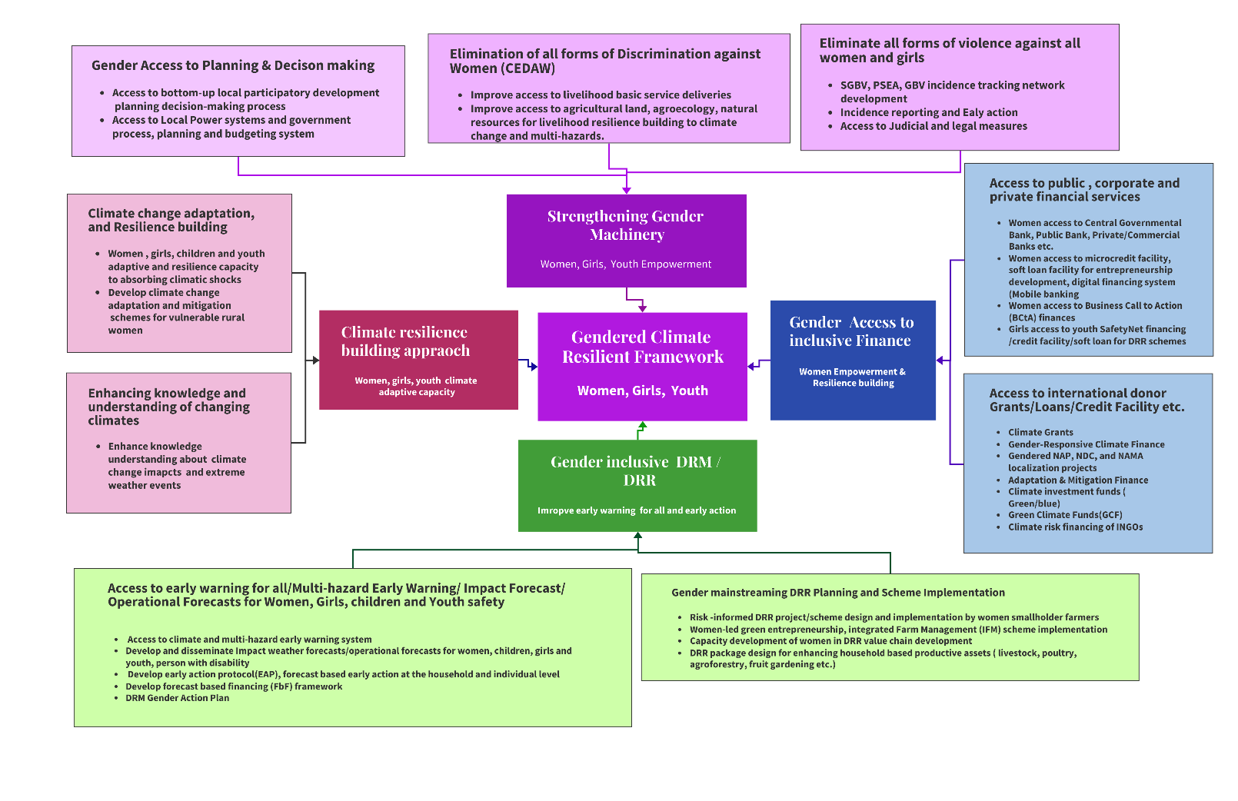

Figure: The Proposed gendered climate resilient framework outlines the functional components of local level functionaries

* Establishment of Gendered Risk Management Network-Web-based (Framework)
* Improving Gender machinery, Gendered DRM coordination at the local level
* District-level Gendered DRM Information Network
* District-level SGBV information network

1. **Capacity enhancement of the government planning Ministry, the Planning Commission in risk-informed planning, strategy development, and the decision-making process**

* Risk-informed Policy, strategy, planning, and institutional capacity of the Planning Ministry, Planning Commission, and planning officials.
* DRR/CCA program planning by relevant line ministries, sector line departments.
* Identification of the Entry point for the Differential gendered impact of multi-hazard and climate risk and vulnerability integration in the planning process

1. **Formulation of District Gender Risk Management Framework/ District Women Resilience Framework**
2. **Gendered risk-informed Responsive District Development Plan Framework (DDPF)**

* Transforming and transitioning from ad-hoc-based disaster emergency interventions to long-term disaster risk reductions for enhancing actors and vulnerable community capacity for averting the slow onset ripple effects aftermath of major hazards and disasters
* Improve coordination and decentralized structure of comprehensive community engagement in local DRM/DRR process
* District DRM program (DRMP) essentially has to be a five-year strategy and needs to address/ consider the recurrent and persistent multi-hazard risks and vulnerabilities, residual/cascading and ripple effects of major disasters ( floods, landslides, induced water-borne disease, and epidemics ).
* DRMP needs to articulate the legal framework to tackle SGBV. The DRM laws also need to mandate state and non-state actors to strictly follow the legal procedures against SGBV during disaster emergencies.
* District-level Annual development programming ( ADP) and interventions from the government DDP/DRMP and budgeting allocations need to set the annual targets of community-based DRR with a pivotal milestone in the council’s commitment to enhancing resilience, preparedness, and response capacities of women-headed households.
* Unique District council coordination structure and functionaries for developing DDP/DRMP/Contingency Planning at the district level
* District risk management governance needs to establish a stakeholder-integrated M&E framework for regular reporting and progress tracking of all stakeholders on DRR and resilience building(women-headed households).

1. **Women Resilience Framework :/** **DRM governance pattern**

* Risk considerations in Resilient Physical infrastructure (climate, multi-hazard, and disaster proof) , basic service delivery, structural development planning
* Level planning process strongly considering the magnitude, frequency, intensity, and damage level of basic infrastructure, services, critical structures, and facilities that were heavily damaged in the past disaster through CRVA/PDNA risk ranking, considering the Highest Flooding level and damage level.
* District development plan, Village development plan, District and Village level sectoral development plan
* Standard Operating Procedure (SOP), Standing Orders on Disaster (SOD)
* DRM Plan, Risk contingency plans at the national and sub-national level

## **6.2 Development and deployment of Early warning for all :**

The assessment country does not have clear road map of Sendai framework of Early warning for all functional process development, as result impact forecast development, forecast broadcasting, transmission and dissemination is being done haphazardly which leading to some level of untimely dissemination, and precision level detailed advisories also an improvement issues that being entrusted to NMHS and other sector department to work together to develop integrated forecasting. The proposed roadmap of EWS for all working in the following diagram ;

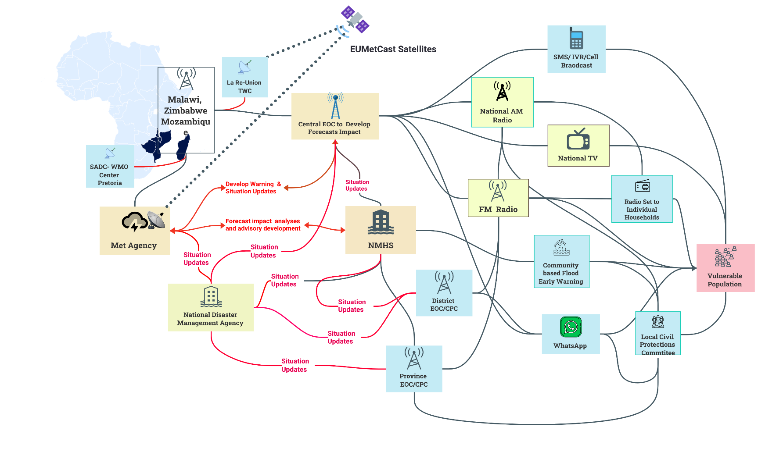

Figure : Diagram of EWS for all

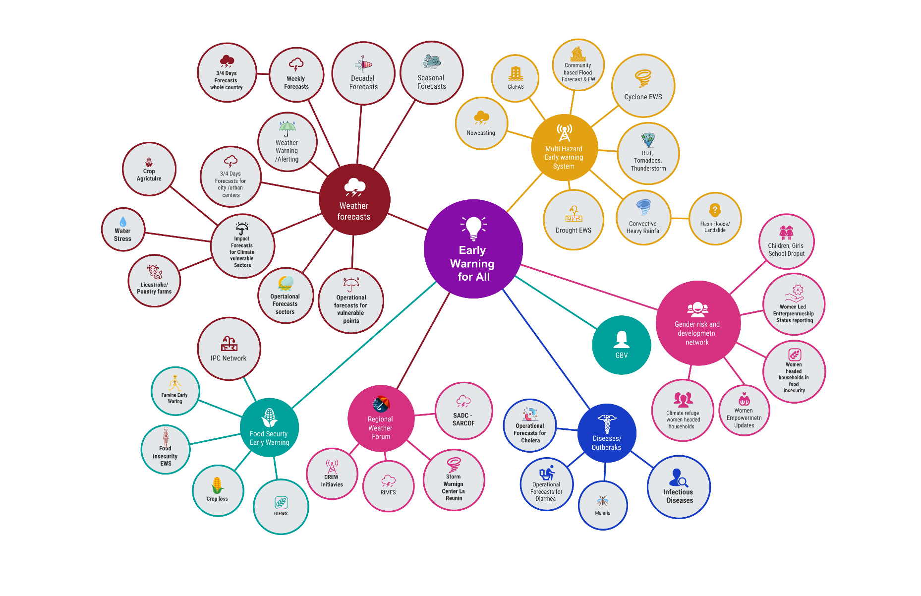

Figure : Proposed EWS for all value chain to be handled jointly by EoC/Met Agency /NMHS /DCP and other sectoral ICT Units

1. **Improving ICT-driven DRM governance at all levels (national, district, province, ward, village) :**

The current DRM governance mechanism is managing a disaster emergency response paradigm, which is inadequate to function in the integrated multi-hazards, disaster, changing climate impacts, DRR, CCA, NAP portfolios, and multi-stakeholder coordination.

* The lack of a developed gender response and multi-stakeholder coordination DRM framework at all levels (national, district, province, ward, village). Strong multi-stakeholder coordination and gender response DRM structures for gendered DRR and resilience building. Challenges :
* Paradigm shift and transitioning from the existing DRM coordination process to undertake post-disaster emergency response based ad-hoc interventions by Civil Protection Committee to risk-informed multistakeholder coordination DRM and DRR for local level gender empowerment and development
* Enhancing the capacity of DCP based on the current mandate (civil protection/ emergency preparedness and response)
* Improving DRM governance at the Provincial and district levels with DRM staffing and capacity building in DRM.
* Develop DRM planning at the Provincial and district level with a clearly defined multi-stakeholder map ( state, non-state, UN agencies, INGOs, national NGOS, CSOs, Charities, Private Sectors, Local Institutions, academia, youth girls organization, WLO, local charities, etc.)
* Installation of Emergency Operations Center and SOP for supporting all early warnings, operational forecasts, EWS for women, girls/ youth group, children, and people with disabilities
* Sector and sectoral elements specific, farmers, Women-led category of entrepreneurs, special impact weather forecast, operational forecasts.
* Structural DRM support for the women small holder farmers ( water access, drainage system, access to agricultural land, access to surface water /irrigation, access to solar PV powered irrigation, access to AVC inputs, horticulture supports, access to market, etc.) . Develop Local agroecology-based DRM and DRR projects and pilot demonstrations in every village and community-level horticulture for supplying all agricultural inputs for promoting a community-based DRR scheme.

1. **Set up EOCs at the province and district levels and improve of Multi-hazard early warning system:**

* Development precision-level weather forecasts: The Met agency needs to specialize more in developing high-resolution seasonal, decadal, weekly, 3-day, and 5-day weather forecasts. It also needs to develop a dynamic and statistical downscale model rapidly developing thunderstorms (RDT of Meteo France) for predicting heavy rainfall and thunderstorms.
* Improving surface observation system: Upgrading MSD weather oversedations system, acquiring 5km grid data sets on surface observation, installing more AWS with synoptic conditions tracking sensors, drone radar, laser ceilometer, radiosonde, and rain gauging instrument, using EUMETCast lightning sensor data for tracking thunderstorms, Flood level gauging from the river system, and flood forecasting and modeling.
* Development of impact-based weather forecasts and operational forecasts: Develop methodology and guidelines on how to organize forecast briefing with guidelines on who will be the participants, how to interpret the risks by organizing discussion and analyzing weather model/outlook subject matter specialists ( *Agrometeorologist, hydrologist, geomorphologist, water resource engineer, Plant scientist, Agri engineer, drought experts, landslide expert, agroecologist, ecologists, meteorologist, synoptic engineers, geomorphologist, etc.*) along with forecasters( long, medium, short range), Numerical Weather Prediction(NWP) engineers/specialists, Synoptic Engineer and organize the forecast beliefs/discussion about the anticipatory impacts, risk and vulnerability and eventually developing impact forecasts. The multi-hazard risk analysis over the elements (which is not a designated responsibility of EOC operators) is a group work effort, and the outlined specialists need to develop customized tools, methodologies, and guidelines on impact-based forecasts and operational forecasts for the sector, sectoral elements, lives, and livelihoods on the ground. Analysis of weather phenomena and interpretation of risks and vulnerabilities.
* MSD needs to develop high-resolution gridded forecasts and analyze the damaging and beneficial impacts of impending weather parameters on the lives and livelihoods( elements). The Met agency needs to establish a pool of Technical experts/specialists(agrometeorologists, hydrologists, geomorphologists, water resource engineers, Plant scientists, Agri engineers, drought experts, landslide experts, agroecologists, ecologists, meteorologists, synoptic engineers*, etc.*) for interpreting the extreme weather phenomena being forecasted. Developing methodology, tools, and guidelines on transplantation and interpretation of risk and vulnerabilities of predicted impending weather phenomena/parameters. Detailed analysis of Impacts and effects of ongoing onset weather events and developing bulletins. Developing special weather bulletins for women, the elderly, girls, and youth groups on the onset of tornadoes, thunderstorms, heavy rainfall, cyclones, flash flooding, landslides, etc.

1. **Emergency Operations Center (EOC) to develop Early Action Protocol (EAP) :**

* Develop a forecast-based early action protocol, anticipatory loss and damage(L&D), and impacts level, and instantly broadcast the messages so that every women-headed household is adequately warned /alerted. National media outlets need to play a pivotal role ( in the local language) by broadcasting the distant learning education program ( radio/TV) for awareness
* EOC to develop early warning-based anticipatory early actions advisories/bulletins for the women-headed households about what to do in the given early warnings and impending hazard conditions so that they are well alerted and well prepared.

1. **The Gender in Humanitarian Action (GiHA) :** Development of a forecast-based GiHA protocol for women/single mothers and girl-headed households
2. **Develop national risk financing framework ( gender focused) : The** Ministry of Finance and Economic Affairs needs to develop a National risk financing framework and DRR budgetary allocation in every fiscal year's budget ( with gender based allocations)
3. **Develop a national risk financing framework**

* Lack of national risk financing framework: Government budget is managed through the Budgets Department of the **Ministry of Finance and Economic Development,** which has a mandate to consolidate and analyze budget requests submitted from state institutions, communicate approved budgets, and monitor the implementation of approved budgets.
* In 2017, the DCP under the Ministry of Local Government, Public Works and National Housing received an **annual regular budget** of USD 286.000 (representing 0,004 per cent[7] of the Ministry allocated budget. This amount is insufficient for implementing DRM activities.
* **Mandating Local authorities’ planning and budgets: Local authorities' budgets are separate from the central Government budget; these are** composed of local revenue.

1. **Strengthen National DRM Framework**

* Apply an integrated approach from response, recovery, reconstruction, to risk reduction and preparedness based on
* sound disaster risk assessment, and to mainstream DRM in all sectors, through formulation/revision and enactment of the DRM Bill, development of the DRM Policy and the DRM Strategy in line with the Sendai Framework for Disaster Risk Reduction.
* **Institutional Strengthening and Capacity Development:** Enhancing the capacity of DCP based on the DRM, recovery, and resilience mandate (emergency preparedness, response, risk reduction, recovery, and resilience). This entails increasing capacities at the central level in terms of staff, technical capacity, and resources; and reinforcing.
* **Improving Cyclone and Flood Forecasting and Early Warning**: Enhance forecasting and early warning for cyclone and flood events through a strengthened real-time observation network, an early warning system, and capacity development for ZINWA and MSD.
* **Anchoring SARCOF** Southern Africa Region Climate Outlook Forum with MSD and EOC at Harare

## **6.3 Methodology, tools, and stakeholder coordination for Development SADD :**

SADD on demographic , socioeconomic, and sectoral multi-hazard and climate risk information data collection, collocation, and developing tailored informed tools is an essential component for risk-informed DRM, DRR, and CCA planning projects. Zimbabwe does not have a clear roadmap, methodology, guidelines, or tools for systematically collecting data from households. A clear roadmap, stakeholder map, and responsibilities headed by the ZimVAC, ZimStat, DCP, and other local government organs and CSOs need to mobilize the SADD data collections for support of gender-responsive and risk-informed development. The following proposed diagram shows the stakeholder coordinating structure for governing the SADD process.

Figure: SADD Data Collection Mechanism

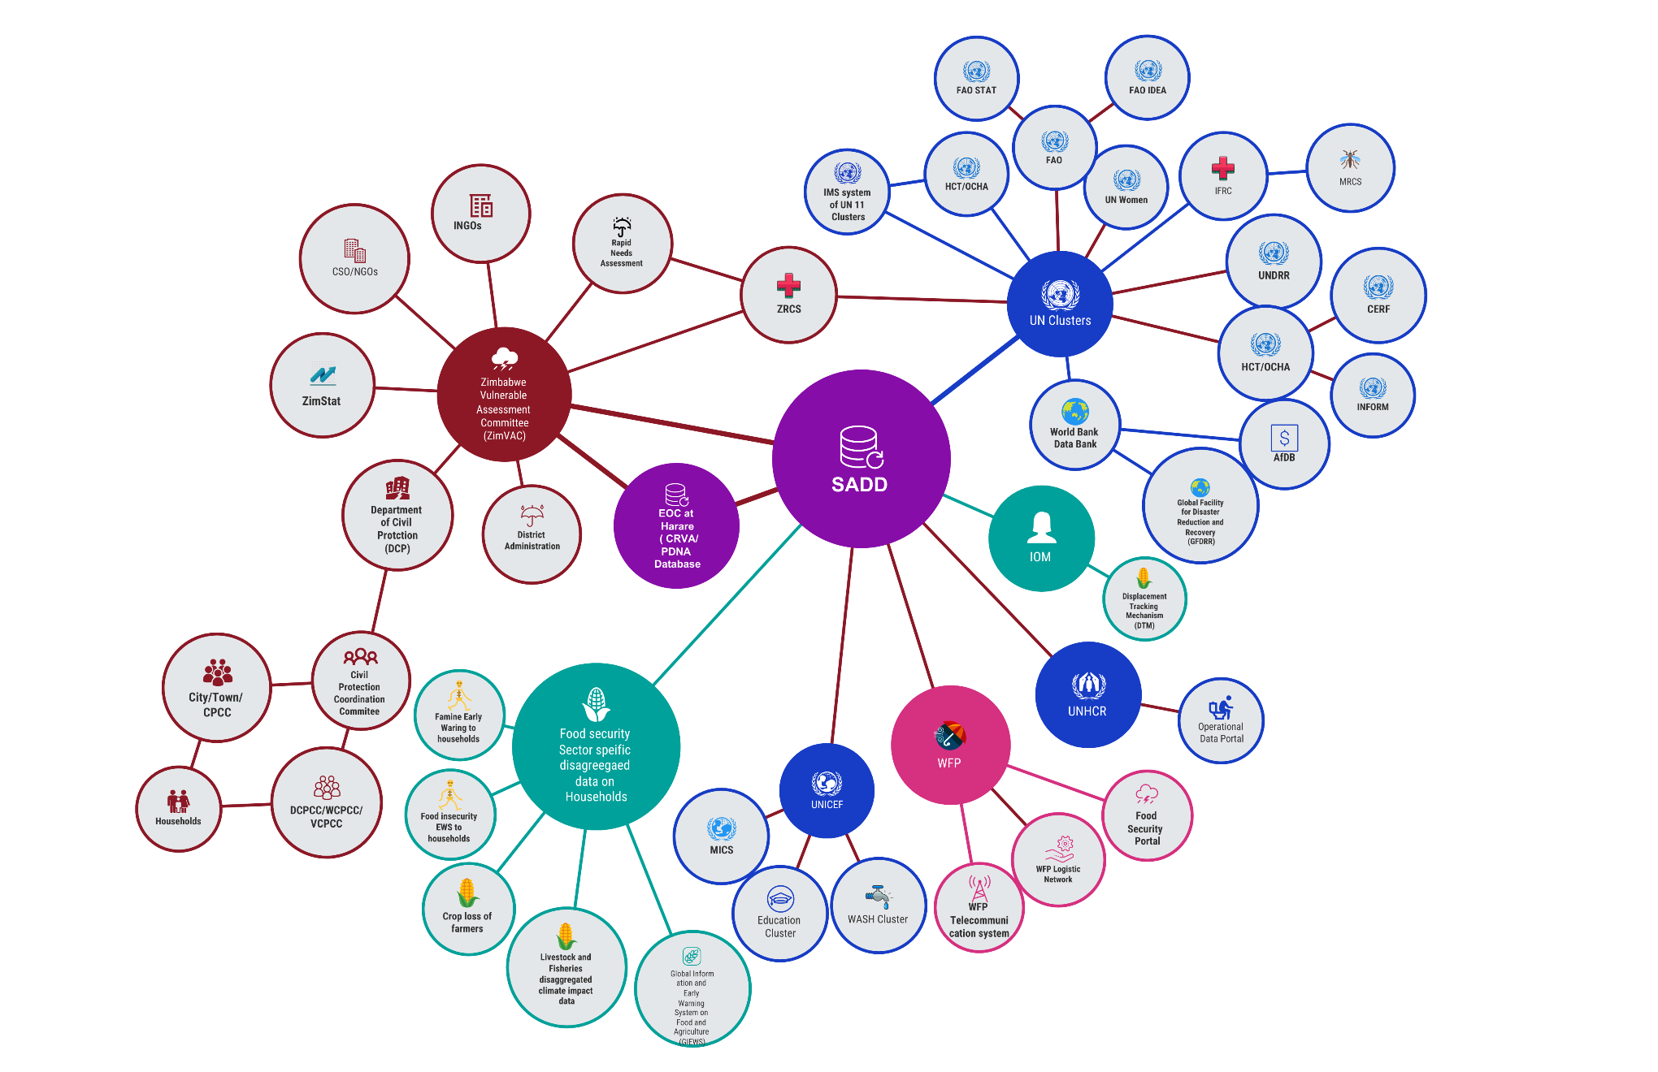

Figure : Proposed Stakeholder coordination, data and information exchange mechanism, and SADD data collection functional process

Recommendations:

* Informed tools for gender analysis in sectoral assessment and DRR/DRM/CCA planning, considering the gender inequalities in government sectoral basic services delivery at the local level
* Develop Methodology, tools and guidelines of CRVA, community risk assessment, PDNA, JNA, Rapid Impact and Needs Assessment (RINA) & Initial assessment by NDMO/Sector department/humanitarian agency in first 1-6 hours, 12 hours, 24 hours, 48 hours for saving lives (utilization of drone, satellite image, UAV, GIS maps, CRVA maps and elements database)
* Methodology, tools, process for analyzing gender impacts after conducting CRVA, PDNA, RINA, JNA, and other assessments using SADD , tools, and process for clearly defining the differential impacts on exposure, risk, vulnerability, and sensitivity over gender for better preparedness, operational planning, and capacity building.
* Capacity of the national Statistical Office, sector departments, and relevant R&D organizations in gender impacts disaster and multi-hazard and climate risk and vulnerability SADDD data collection, and GIS-based informed tools processing, identifying where informed tools are needed and generating additional data that captures gender issues, including by organizational and household surveys.
* Evidence-based planning and gender responsive planning capacity of the planning department, sector department
* Capacity development of the National Statistical Office, Ministry for development planning, relevant line ministries and government officials at national and subnational levels to understand the importance of collection, analysis and use of disaggregated data for DRR policy and planning; and (UN Women in collaboration with the UNDRR ) develop the capacity of governments to collect, analyze and report on sex, age and disability disaggregated data) ( Without gender analysis and SADDD, the disaster vulnerabilities and impacts of disasters on women and girls are often rendered invisible, and this deprioritizes their needs and capacities in disaster risk management and humanitarian response.
* Tailormade SADDD for gender analysis in the necessary information to integrate gender perspectives into disaster risk reduction, climate change, risk-informed development, and resilience laws, policies, strategies, plans, programmes, and projects
* Utilization of SADDD data in planning efficient disaster risk reduction, resilience, and risk-informed development strategies, programs, and projects that address both men’s and women’s needs and reduce inequalities.

## **6.4 Improving UN , Government and multi-stakeholder Coordination Mechanism in DRM and DRR Functionaries**

The assessment identified key gaps in UN , Government, and multi-stakeholder coordination mechanisms in DRM, DRR, CCA-related action planning, programming, intervention design, and implementation. The UN HCT coordination is mainly limited to mobilizing the emergency post-disaster humanitarian assistance. The government is still to develop a climate risk management framework , an actionable coronation structure, and localization of gender responsive DRM, DRR, and CCA interventions at the local last-mile.

Proposed diagram showing the coordination structure and risk-informed tools to be incorporated for gender responsive planning and intervention implementation.

Figure : Diagram Proposed UN- Coordination with Department of Civil Protection (DCP)

## **6.5 Community-level risk-informed gender development approach**

To sketch a roadmap to WRD process from the assessment that have been thoroughly investigated the existing systemic government structure, long term perspective planning, medium term planning and strategies( 5 years) and actionable shot-term planning( Annual Development Program -ADP) , strategies and identified that the in place government system and top-down approaches are inadequately gender responsive and been strategic approaches in policy, planning and multi-stakeholder engagement. However, for bridging the last-mile bottom-up participatory gendered risk-governance gap, the assessment proposes the following risk-informed community-level gendered climate governance and actional interventions implementation process.

Figure : Community-level risk-informed gender development approach

* Climate-resilient green entrepreneurship development
* Women's Access to Green Finances
* Women's Access to forecast-based finances
* Women/single mothers/adolescent girls leadership role in local civil protection and DRM community
* State, nonstate, and CSOs’ roles/responsibilities, accountability to the affected population (AAP) at the local level
* Women’s leadership in local-level DRR/CCA intervention planning and scheme implementation
* State, nonstate, and CSOs running GBV reporting network
* Women-led agricultural value chain development
* Women improve access to local government sectoral services deliveries
* Climate information network and information services for women entrepreneurship, awareness raising of girls, and youth groups.
* Access to impact-based weather forecasts, forecast-based early action services
* Distance learning mass media-based climate education, adaptive/conservative and subsistence agricultural practices locally.
* Climate-resilient green entrepreneurship development

## **6.6 SGBV tracking network and dissemination system (Proposed )**

**Robust information management network & violence reporting (web-based/geospatial), Social monitoring, networking, women-led policing for reducing PESA and SGBV incidence**

* **National media outlet( Radio/TV) based on constant broadcasting on humanitarian situations and GBV incidence**

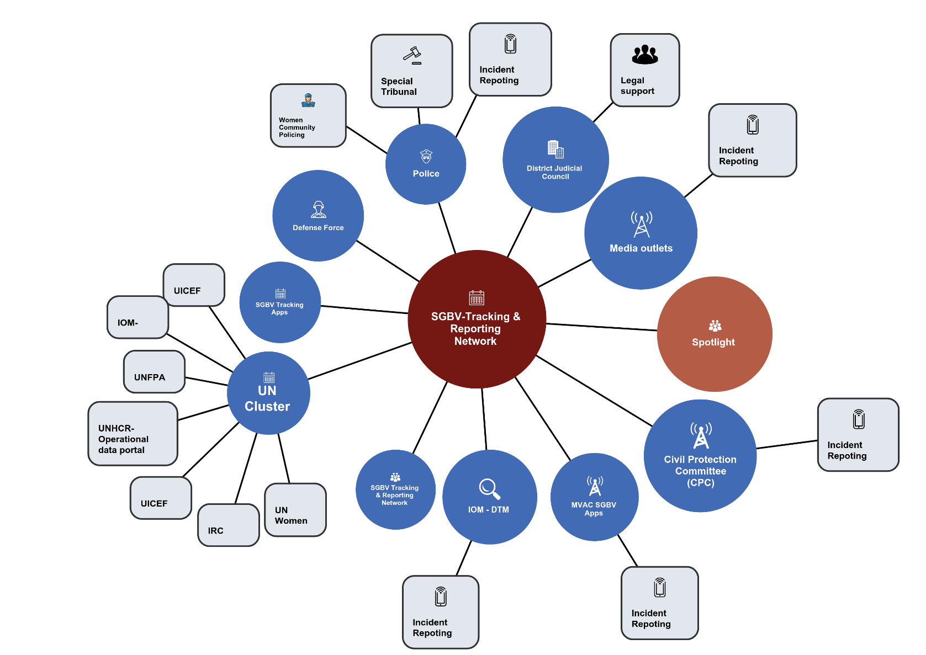

Figure : Proposed SGBV tracking and reporting network

**Annexure :**

Day 1(19 February 2024):

1. Organize virtual meeting with Mrs. Sunga Mzeche, Director of “Hope for Child in Christ” , Zimbabwe
2. Meeting with Civil Protection Department (CPD) – Ministry of Local Government, Zimbabwe

* Mrs. Sibanda, Deputy-Director of CPD
* Mr. Farai Hokonya

Day 2 (20 February 2024):

1. Meeting with Miss. Lungani- Program Officer of Zimbabwe Youth Council
2. Meeting with Mrs. Elizabeth Katumba, Principal Administrative Office Gender Department of Ministry of Women Affairs

Day 3 (21 February 2024):

1. Meeting with Mrs. Vimbainashe S. Mutendereki, Executive Project Director of “Musasa Project” (Women Led Organization)
2. Meeting with Mrs. Chido Nayaruwata, Member of African Women in Leadership Network, Zimbabwe Chapter
3. Meeting with Ministry of Labour, Public Service and Social Affairs

Day 4 (22 February 2024):

Organize 1st Focus Group Meeting Discussion (FGD) with Cimanimani District, Ward 15(Eastern-Zimbabwe)

Day 5 (23 February 2024):

1. Virtual meeting with UNDP Zimbabwe

* Mr. Titus Kuuyuor, Programme Manager for Zimbabwe Resilience Building Fund-DRR, UNDP
* Mr. Vhusomuzi Sithole, IT/GIS Analyst, UNDP

Pictures on Community Focus Group Discussion FGD

|  |  |
| --- | --- |
|  |  |
| 1st Focus Group Meeting Discussion (FGD) with Cimanimani District, Ward 15(Eastern-Zimbabwe) | |

|  |
| --- |
|  |
| 2nd Focus Group Meeting Discussion (FGD) with Cimanimani District, Ward 21(Eastern-Zimbabwe) |

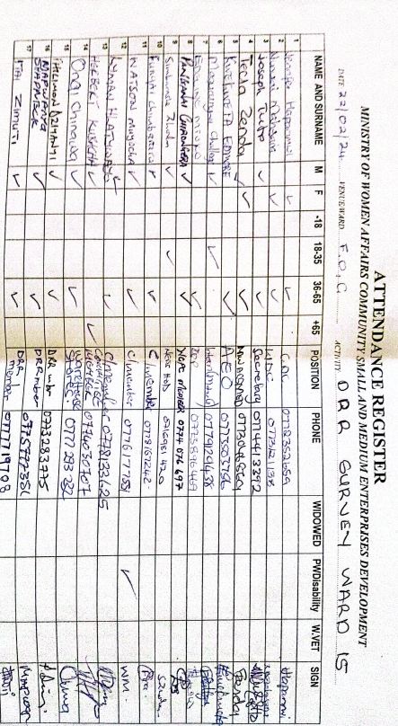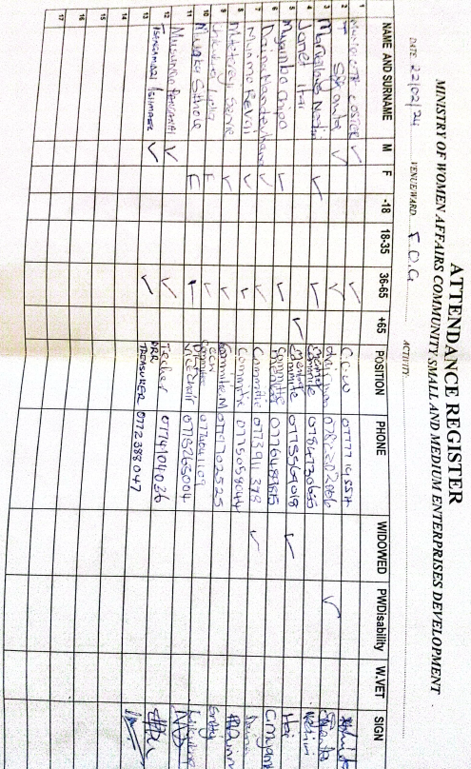

Organize 2nd Focus Group Meeting Discussion (FGD) with Cimanimani District, Ward 21(Eastern-Zimbabwe)

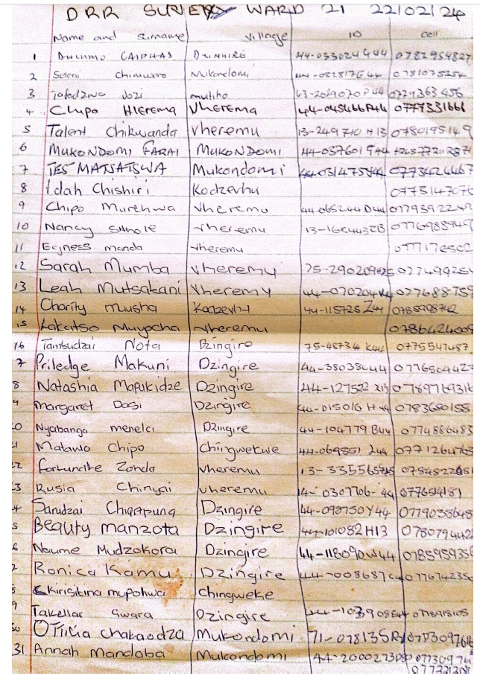

**UN WOMEN ESARO - Joint Assessment on the Gendered Impacts of Climate Induced Disasters in Malawi, Mozambique and Zimbabwe**

**Key Informant Interview**

**Purpose: This assessment seeks to explore: a]** how women and men in Southern Africa are differently impacted by climate change; **b]** the physiological, political, economic and societal causes for the differences experienced; **c]** the current coping and adaptation strategies and capacities to climate induced disasters and variability; **d]** the capacity of women and men be strengthened to better adapt to climate change and climate variability; e] explore the role of women and women led organizations in disaster preparedness and response planning and to**; f]** review key DRM policies in target countries and identify key entry points for gender integration

***Tool Notes:*** *This tool uses the format of semi-structured interviews.*

**Geographic Location: Name (optional):**

**Interview date: Place of interview:**

**Translation necessary for the interview:**

**Introduction**

1. Thank the participant(s) for the interview
2. Explain the objectives and expectations of the interview
3. Outline the amount of time interview will take
4. Obtain the informant’s consent to record the interview and/or take pictures

**Sex of key informant**: Male Female **Institution of key informant**:

**Key informant’s role in the Institution**:

**Part 1: Key DRR Frameworks and Structures**

**Question 1:** **What are the key policies/strategies frameworks in DRR in Mozambique? (Gender responsive DRR policy and strategies – challenges and recommendations)**

a] ­­­­­­­­­­­­­­­­­­­­_____________________________________________

b] _____________________________________________

c] _____________________________________________

**Question 2:** **With regards to Early Warning, Prevention and preparedness information, how is this accessed at community level by; ( Challenges of developing disseminations of timely and precision level early warnings )**

a] Women ______________________________

b] Men _________________________________

c] Persons with disability _________________________________________

d] The Elderly __________________________________________________

**Question 3:** **What are the existing coordination structures at; (challenges and recommendations)**

a] National level ______________________________

b] District level _______________________________

c] TA level ___________________________________

**Question 4:** **How is the UN engaged at these levels?**

a] National level ______________________________

b] District level _______________________________

c] TA level ___________________________________

**Question 5: How is the UN/government supporting collection and access to SADDD at: ; (challenges and recommendations)**

a] National level ______________________________

b] District level _______________________________

c] TA level ___________________________________

**Part 2: Engagement with Stakeholders**

**Question 6: In your opinion who are the main stakeholders in the DRR sector in Mozambique in order of priority?**

a] ­­­­­­­­­­­­­­­­­­­­_____________________________________________

b] _____________________________________________

c] _____________________________________________

**Question 7: How are the UN/Government structures engaging women and women led organizations in DRR and resilience initiatives? ; (challenges and recommendations)**

a] ­­­­­­­­­­­­­­­­­­­­_____________________________________________

b] _____________________________________________

c] _____________________________________________

**Question 8: What do you consider are the key gaps in gender integration within DRR and resilience building initiatives? ; (challenges and recommendations)**

a] ­­­­­­­­­­­­­­­­­­­­_____________________________________________

b] _____________________________________________

c] _____________________________________________

**Part 3: Impacts of Climate Induced Disasters [Cyclones, Floods, Drought]**

**Question 9: How have climate induced disaster impacted women and men differently?**

**Women**

a] ­­­­­­­­­­­­­­­­­­­­_____________________________________________

b] _____________________________________________

c] _____________________________________________

**Men**

a] ­­­­­­­­­­­­­­­­­­­­_____________________________________________

b] _____________________________________________

c] _____________________________________________

**Question 10: What are the different coping mechanisms adopted women and men to climate induced disasters? ; (challenges and recommendations)**

**Women**

a] ­­­­­­­­­­­­­­­­­­­­_____________________________________________

b] _____________________________________________

c] _____________________________________________

**Men**

a] ­­­­­­­­­­­­­­­­­­­­_____________________________________________

b] _____________________________________________

c] _____________________________________________

**Question 11: What are the key barriers effective women’s engagement in DRR and resilience building?**

**; (challenges and recommendations)**

a] ­­­­­­­­­­­­­­­­­­­­_____________________________________________

b] _____________________________________________

c] _____________________________________________

**Question 12:** **What would you recommend strengthen resilience among vulnerable women and girls to climate induced disasters?**

a] ­­­­­­­­­­­­­­­­­­­­_____________________________________________

b] _____________________________________________

c] _____________________________________________

1. Hallegatte et al. (2017): Unbreakable. Building the Resilience of the Poor in the Face of Natural Disasters. URL: https:// openknowledge.worldbank.org/handle/10986/25335
2. ZIMBABWE NATIONAL CONTINGENCY PLAN December 2012-November 2013
3. Zimbabwe Rapid Impact and Needs Assessment (RINA), 20219
4. Capacity Assessment of the Disaster Risk Management System in Zimbabwe, UN May 2017
5. <https://www.cadri.net/system/files/2021-06/Zimbabwe-Report-May-2017.pdf>
6. <https://link.springer.com/article/10.1007/s13753-021-00370-6>
7. Capacity Assessment of the Disaster Risk Management System in Zimbabwe, UN May 2017