



Methodology, Tools, and Guidelines
on
Impact-Based Forecasting (IBF)

(New IBF Concept)

Developed by : Z M Sajjadul Islam

UNDP - International Consultant (Team Leader)

Acronym

AI | Artificial Intelligence
ALAGaC/ | Administration of Land Affairs, Geodesy and Cartography
ALAMGaC | Agency for Land Administration and Management, Geodesy and Cartography
AWS | Automatic Weather Station
5W | Who will do what, where, when, and how
BTS | Base transceiver station
CRVA | climate risk and vulnerability assessment
CSV Excel file | comma-separated values
CAP | Common Alerting Protocol
CBO/CSO | Community-based organization / Community services organizations
CMA, | China Meteorological Administration
IBFWS | Impact-based Forecast and Warning Services
CRVA | Climate Risk and Vulnerability Assessment
DIMA | National Rangeland Monitoring Database
EM-DAT | Emergency Events Database
DCPC | Data Collection and Processing Center
DTM/DEM | Digital Terrain Models (DTM)/ Digital Elevation Models (DEM)
EAP | early action protocol
EOC | Emergency Operations Center
FAO | Food and Agriculture Organization
AM/FM Radio | Amplitude Modulation/Frequency Modulation
FBF | forecast based Financing
FTP | File Transfer Protocol
FGD | Focus Group Discussion
GIS | Geographic Information System
GPS | Global Positioning System
HCT | Humanitarian Country Team
HPC | high processing power computing
IBF | impact-based forecasting
ICS | Incidence Command System
ICT | Information and Communication Technology
IFRC | International Federation of Red Cross and Red
IM | Information Management
IP | Internet Protocol
I-NGOs | International /National Non-Governmental Organization
IRIMHE | Information and Research Institute of Meteorology, Hydrology, and Environment
IVR | Interactive Voice Response
JMA, | Japan Meteorological Agency
KMA | Korea Meteorological Administration
KII | Key Informant Interviews
KML/KMZ | Keyhole Markup Language
LEMA | Local Emergency Management Agency
L & D | Loss and Damage
MET | Ministry of Environment and Tourism
MIS | Management Information System
MHEWS | multi-hazard early warning system
MODIS | Moderate Resolution Imaging Spectroradiometer
MoED | Ministry of Economy and Development
MOU | Memorandum of understanding
MoFALI | Ministry of Food, Agriculture and Light Industry
MRCS | Mongolian Red Cross Society
NAMEM | National Agency Meteorology and the Environmental Monitoring
NDVI | Normalized difference vegetation index
NEC | National Emergency Commission
NEMA | National Emergency Management Agency
NMHS | National Meteorological and Hydrological Services
NOAA | National Oceanic and Atmospheric Administration
ODBC/JDBC | Open Database Connectivity/ Java Database Connectivity
PDNA | post-disaster damage, loss and needs assessment
NSO | National statistics office
PIU | Project Implementation Unit
PSTN | Public switched telephone network
REST | RESTful Application Programming Interface( API)
RIMES | Regional Integrated Early Warning System for Africa and Asia
R & D | Research & Development
SMS | Short Message/Messaging Service
SME | Small and Medium Enterprise
SoD | standing orders on disaster
TWG | Technical Working Group
WCS | Web Coverage Services
WMS | Web Map Service
WFS | Web Feature Service
WPS | Web programming service
UHF | Ultra-high frequency
UNDP | United Nations Development Programme
UNEP | United Nations Environment Programme
UNFPA | United Nations Population Fund
UNICEF | United Nations International Children's Emergency Fund
VHF | Very high frequency
WFP | UN World Food Program
WMO | World Meteorological Organization

Contents
1.0 Chapter : Introduction of Impact-Based Forecasting : 6
1.1 Importance of developing an integrated IBF platform : 6
1.2 Framework of integrated impact forecasting, weather warning, and MHEWS 7
1.3 The expected benefits of an integrated IBF platform: 7
2.0 Chapter: Stakeholder Partnership & Communication 8
2.1 Rationale of Partnership ( both formal and virtual context) : 8
2.2 Data Coordination and Exchange Mechanism 9
2.3 Mandating partnership for data coordination, exchange, and risk communication 10
2. 4 Technical Working Group for forecast Impact analysis : 16
2.5 Process of translating traditional forecast/weather outlook to impact forecasts : 33
2.6 Defined roles of partners during multi-hazard emergencies : 35
2.7 Partnership capacity building Process : 44
2.7.1 Organize regular Workshop/Consultation/Seminar/Meetings to improve service delivery: 44
2.7.2 Removing the Barriers to partnership building : 44
2.7.3 Strengthening integrated partnerships for getting multi-hazard situation updates from the local level. 44
2.7.4 Improving IBF and warning systems efficiency and Efficacy. 45
3.0 Chapter: ICT Structures of IBF Platform : 46
3.1 Implementation of Opensource Geospatial Platform : 46
3.1.1 Component of Opensource Geospatial Platform: 46
3.1.2 Installation of Geoserver : 48
3.1.3 Anchoring google mapping tools : 48
3.1.4 Installation and Configuring surveying apps. 48
3.1.5 Deploying File-Sharing Tools : 48
3.1.6 Implementing Web converting common alerting protocol (CAP )apps : 48
3.2 Rationale of integrating ICT with the IBF platform : 49
3.3 Software & Tools Proposed for the ICT-integrated IBF Platform 50
3.4 IBF internal and external data acquisition and coordination system ( maintaining data sensitivity and privacy). 51
3.4.1 Data workflow and data archive structures ( at IBF central level ) : 51
3.4.2 Centralization of Database Archive and Services by IBF Platform 53
3.4.2.1 Develop databases with PostgreSQL server : 53
3.4.2.2 Impact forecast manufacturing tools, input datasets, and Process: 55
4.0 Chapter: Data Coordination and Exchange Mechanisms 59
4.1 Data Coordination and Exchange Mechanisms at Aimag level : 59
5.0 Chapter : Aimag Emergency Operations Center (EOC) / Situation Room 65
5.1 Mandating an Emergency Operations Center (EOC) / Situation Room at the Aimag Center: 65
5.2 Aimag level NAMEM human resources : 66
5.3 Structure of the Aimag EOC / Situation Room 67
5.4 Functions of EOC / Situation Room : 67
5.4.1 Technical Functions of EOC / Situation Room : 68
6.0 Chapter : IBF Forecasting Process 71
6.1 Undertake operational shift from traditional forecast to integrated Impact-based forecasting (IBF ) , warning, and alerting. 71
6.2 The IBF Value Chain: 72
6.3 IBF preparation and forecasting process (New methodology) : 73
6.4 Converting traditional forecast to IBF 83
6.4.1 Analyze impacts over the seasonal forecasts : 85
6.4.2 Processing monthly IBF : 85
6.4.3 Preparing medium-range Forecast : 87
6.4.4 Preparing short range Forecast : 88
6.4.5 The short-range forecasts usability : 88
6.5 Short range impact forecast preparation 90
7.0 Chapter : Operational Forecasts : 92
8.0 Chapter : The multi-hazard early warning system 95
8. 1 Improved and hybrid weather observation mechanism : 97
8.2. Process of developing an Early Warning : 99
8.3 The multi-hazard early warning process: 100
8.4 Anchoring NEMA Early Warning System with IBF: 100
8.5 Integrated IBF, Warnings, Alerting, and energy hazard early warnings & Advisories : 101
8.6 Convective weather condition-induced hazards early warning : 106
8.7 Convective weather condition screening mechanism 107
8.8 Strong/Damaging Wind induced hazards warning : 108
8.9 Hazardous winter weather early warning : 111
8.10 Template: Winter weather emergency advisory 113
8.11 IBF Flood Impact Forecasting: 113
9.0 Chapter: Impact Forecasting and Warning for Livestock Sector : 116
9.1 Impact analysis methodology : 117
9.2 Risk repository development process : 122
9.3 Advisory on Integrated Pasture Monitoring System: 128
9.4 Alert and warning services for livestock & Crop agriculture 128
9.5 Develop dzud risk profile : 129
9.6 Web-based MIS system for Dzud risk management : 130
9.7 Develop Dzud Early warning protocol. 130

1.0 Chapter : Introduction of Impact-Based Forecasting :

The impact-based forecasting (IBF) is a technical & operational shift from traditional forecasting (‘what the weather will be ) to impact forecasting (‘what the weather can do’). It encompasses transformative and structural changes from the traditional forecasts to IT database & GIS tool-based analytics of color-coded thresholds of impacts, exposure, risks, vulnerabilities of the ground, anticipatory losses & damages likely to be impending over the forecast lead time. Therefore, the humanitarian community and vulnerable sectors will be informed about the impact level and be able to develop an early action protocol (EAP) for better preparedness. ICT-driven integrated impact-based weather forecasting, warning, alerting, and multi-hazard early warning system( MHEWS) is a WMO’s new approach to coming up with a one-stop solution to improved weather and climate information services starting from baseline climate risk and vulnerability assessment, risk repository, and atlas preparation so that any impending hazards weather events being well screened, predicted with spatiotemporal scale and anticipatory loss & damages (L & D) being well advised over the forecast lead-time until hazardous weather events being dissipated.

Traditional weather forecasting provides limited information on weather conditions, including temperature, precipitation, wind speed, and other atmospheric factors. Still, IBF takes it further by providing information on how those conditions could impact ground elements in general. For example, an IBF forecast intends to provide information on frequency, the intensity of weather events, the threshold of impacts at the spatiotemporal scale of the impending hazardous weather, anticipatory risk and vulnerability, loss & damages(L & D) are likely, how to develop an early action protocol (EAP), early warning based early action ( EWEA) detailed contingency plans and anticipatory budgeting to be allocated for better preparedness, etc.

1.1 Importance of developing an integrated IBF platform :

Addressing Mongolia's diverse and rapidly changing weather phenomena, the IBF system is intended to bridge the structural, process, and forecast product manufacturing gaps of NAMEM/IRIMHE. A robust integrated IBF platform methodology is proposed for linking and mandating other essential partners to contribute interactively to the system. The IBF implementation and operational process is intended to reciprocate and correlate the impact calculation process of forecasted impending high-impact weather conditions with existing baseline risks and vulnerabilities of the elements on the ground.

- The essential input ingredients for the IBF process are a readily available sector-specific comprehensive baseline risk and vulnerability assessed repository, corresponding risk and vulnerability attribute database, and risk atlas analysis with GIS tools for forecast impact analysis.
- The ICT-enabled IBF platform has an interface for real-time information tracking of crowdsourcing and ICT-based hybrid surface weather observation (automated system) on the current hazardous weather conditions,
- Weather and climate risk-informed planning tools for the sectors
- Dashboard on tailormade impending weather and climate information services for sectoral planning.
- Ealy action protocol (EAP), early warning, early action planning, anticipatory loss, and damage scenarios for humanitarian response planning.
- The GIS tools-based IBF platform has the provision for analyzing threshold-based weather warnings and developing a standard alerting protocol in the event of severe weather that is expected to trigger a disaster. The platform able to provide Multi-hazard Impact-based Forecast and Warning Services and national meteorological and hydrological services (NMHS) agencies be able to directly communicate with vulnerable communities, sectors, and end-users with group-based apps and can provide any useful situational updates for informing common alerting.
- IBF structured information system on impact forecasting, hazard warning, tailor-made exposure, and vulnerability information to identify risk and support for humanitarian decision-making, provide a way forward to undertake early action that reduces damages and loss of life from natural hazards.
- Traditional weather forecasts indicate what the weather will be, for example, 70mm/hourly rain in a given location. However, IBF considers the vulnerability of elements and vulnerable populations and their assets to heavy rainfall-triggered flooding and flash flooding impacts, such as loss of life and properties.
- The main benefit of the IBF is that it combines hazard forecasts, like heavy rainfall, severe wind, or temperature, with the elements exposed to the hazard, such as buildings, transport routes, and population distribution, and the vulnerability of individuals, properties, or infrastructure.
- The IBF enables an integrated, authoritative message to be delivered to all parts of society so that everyone can take appropriate action to ensure personal safety and protect property.

1.2 Framework of integrated impact forecasting, weather warning, and MHEWS

The intended design aspect of an integrated IBF is to provide a one-stop solution for weather and climate information services. This robust Mongolian IBF system essentially complements the WMO’s global efforts of transitioning from traditional weather forecasts to integrated impact forecasting, weather warning, alerting, and multi-hazard early warning system (MHEWS), extensively covering the last mile. The proposed IBF system is also imperative for the Sendai Framework to implement fully and access MHEWS and disaster risk information and assessments on the climate frontline.

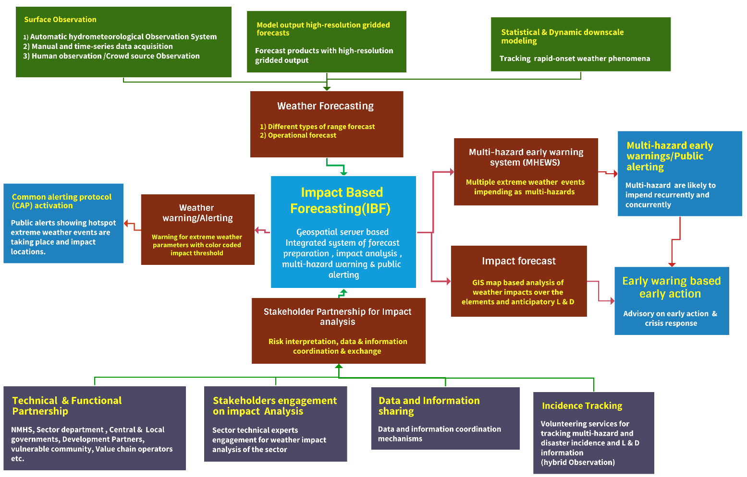
Figure 1: Framework of impact-based forecasting, warning, alerting, and MHEWS( Source: Z M Sajjadul Islam, UNDP-GCF)

1.3 The expected benefits of an integrated IBF platform:

- Impact-based forecasts and warnings provide a roadmap of anticipatory actions, an early action protocol (EAP) that enables preparedness measures for saving lives, properties, and livelihoods.
- Impact-based forecasts and warnings communicate information that allows those at risk to make effective decisions to safeguard against the impact of forecast extreme weather or climate events.
- Developing impact-based forecasts and warnings builds strong, collaborative partnerships between national meteorological and hydrological services and disaster risk reduction and management sectors.
- Impact-based forecasting communicates uncertainties. Decision makers can factor the uncertainties into choosing appropriate actions.
- Forecast producers and users of Impact-based forecasting and warnings should be able to share data, best practices, and critical information before, during, and after weather and climate events to improve the quality of forecast and warning information. Forecasts can also support strategic planning in the county, such as using them to inform sectoral annual plans and related budgets, raising awareness of potential climate risks, and mobilizing resources for early action.

2.0 Chapter: Stakeholder Partnership & Communication

Core objective: The principal objective is to develop a stronger commitment, mandating coherent coordination of partners and stakeholders by networking to a hybrid partnership mechanism of data/information coordination, exchange, and risk communication.

IBF regularly processes the multifaceted functional and proactive coordination mechanism. The data-sharing paradigm is inextricably linked to the IBF process. We need to classify the stakeholder category and the responsibilities related to the onset of multi-hazards and disasters.

State-of-the-art ICT-enabled interface artificial intelligence (AI) and IT program-driven functional systems with robust traceability capacity over 24/7 proactiveness can predict what weather will do and impact level, anticipatory intensity and frequency, and scalability of extreme weather parameters turning to disaster, and they need to be well addressed.

2.1 Rationale of Partnership ( both formal and virtual context) :

The IBF has indispensable features and service delivery capacities for mandating the connectedness of stakeholders with the system and remains operational for demand-driven service deliveries. The engineering aspect of the IBF platform is designed with an ICT-enabled robust architecture for optimum operability with interfacing multiple sources of information and recurrent processability, and the IBF product output system optimally works on an interactive partnership of stakeholders across the country. The sector-specific impact level analysis of the hazardous weather parameters sought the involvement of designated specialized government national hydrometeorological organizations (NMHS), sectoral departments, R&D organizations & specialists, academia, mandated partners, commercial stakeholders, herders, and the vulnerable community to contribute inputs for making IBF readily available and on time.

Mandating the stakeholders above through a set of standard operating procedures (SoP ) viably to a common consensus of a proactive, time-critical partnership and collaboration amongst the wide range of technical partners and agencies engaged in meteorology, climatology, hydrology, disaster risk management, local government sectors, pre-disaster risk assessment group, post-disaster damage, loss, and needs assessment (PDNA) group, disaster first-responders, vulnerable community, herders group, etc., for the contribution. The IBF system thus ensures functional partnership by encouraging stakeholders to access the platform with a sense of ownership, imperatively to demand-driven weather information service delivery for the IBF-related data/information process, informed tools development, and deliverables to climate & disaster emergency management.

The IBF process depends on the multifaceted, interactive, functional, regular proactive coordination mechanism amongst all stakeholders. The data-sharing protocol for the IBF process. The IBF needs to classify the stakeholder categories, the responsibilities over risk information coordination, risks, and impending impact interpretation over the impending onset of extreme weather events, and manage the risk and vulnerabilities of induced disasters.

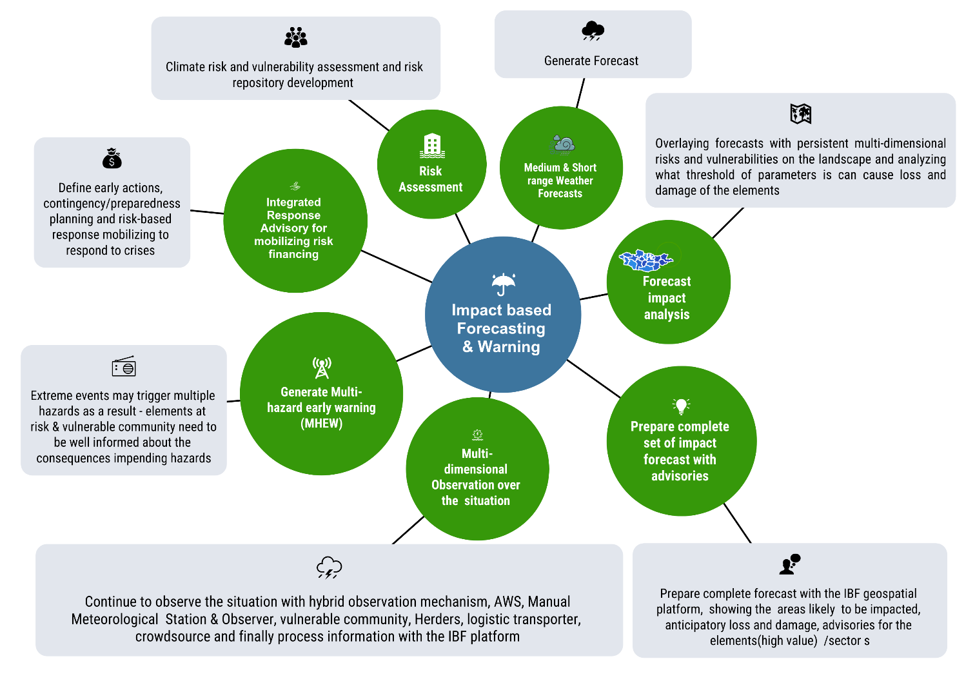
Figure 2: Integrated IBF system overview ( Source: Z M Sajjadul Islam , UNDP-GCF)

2.2 Data Coordination and Exchange Mechanism
The initial IBF workflow is to analyze the impacts of impending extreme weather that has just been forecasted. Still, the entire IBF mechanism requires multiple layers of information; for example, the requisites of background risk & vulnerability datasets are essential. The IBF process comes across over the steps and primarily to do a background check of the persistent risk and vulnerabilities being inherited from the landscape, local weather & climate system, and inbuilt environmental context, and secondly to estimate the risk, vulnerability, exposure, and sensitivity over the standing elements(annexure 1) at the event of impending extreme /hazardous weather are likely to be interacting with the ground, thirdly, stakeholders need to know how and what level of frequencies of the extreme weather events are turning multi-hazards. Finally, the whole IBF mechanism needs to track hazardous events until they dissipate and take stock of the trail of L&D being yielded by the localized disaster.
Considering the above functional steps, the IBF workflow process (discussed in Figures 3 & and 4 ) is segmented into several workstreams, and at any given stage, stakeholder engagement is critical. The IBF process needs to depend on an input system of data capture, repository, and archives of root-level sectoral and element risk and vulnerability data for the purpose-driven IBF process. The partners and stakeholders are mandated to supply their climate risk and vulnerability (CRVA) data and information to review the persistent risks and vulnerabilities and push for recurrently updating information to the IBF system.
In any given case of rapidly changing weather(spatiotemporal and hourly/diurnally changed ) patterns, e.g., an incidental case of cold fronts induced a storm on 26 May 2008, which caused a massive amount of damage, and it claimed 52 human tolls and about 600,000 livestock were lost (UNDP 2008). Unlike this type of weather, uncertainty and very fast onset weather conditions are recurrently taking a lot of toll on livestock. Herders, smallholder farmers, and sector departments need to develop an event repository of high-impact, loss, and damage scenarios, an important baseline archive for analyzing the impacts in further impact analysis.
For analyzing the high-impacts, the IBF impact analysts(meteorologists) team always needs to do the background checks (from the impact database) for similar sorts of weather events being anticipated and impending as high-impact weather conditions. The partnership process to be mandated by the essential background (risk repository development and understanding) works need to be done by the partners for strengthening the IBF process, as it is such a hybrid process that forecasters, sector/elements risk & vulnerability analysts always need to be well concerted with climate change impacts, climate variables/parameters, weather, impending multi-hazards, spatiotemporal impact interpretation, weather risk and vulnerability assessment and risk prioritizations.
All participating stakeholders/partners/authorities/vulnerable communities are to be mandated to contribute elements specific to baseline risk and vulnerability information for the effectiveness and efficiency of the system- IBF partnership mechanism. The partnership mechanism(figure 3 ) renders two-way communication, e.g., giving the inputs baseline risk, vulnerability geolocation information of every element, and harmonizing the risk-informed tools, benefiting the sectoral planning process, which continues even after the development and implementation of impact-based forecasting services. Members of the partnership can be tasked with monitoring the effectiveness of forecasts and warnings and providing feedback for improvement.
Partners have important roles in risk communication and analyzing the impact on the forecasts and warnings. Essential partners are to be mandated with responsibilities for early actions to prepare for and respond to hazardous weather and climate events. These actions include advising vulnerable communities on what to do in extreme weather or climate events, combining the partner’s anticipatory advice with impact-based advice.

2.3 Mandating partnership for data coordination, exchange, and risk communication

Considering the types of workflows and mandating partners' responsibilities for interacting and integrating with the IBF platform for weather and Climate risk information communication, sharing data and information repositories on sector-specific risk and vulnerability, all these are administrative processes. Essentially, NEMA & NAMEM jointly play a pivotal role by mandating partners to adhere to defined standard operating procedures (SOPs) in information coordination and communication mechanisms, from the local to the central level.

- The sector department is to be mandated to conduct Climate and weather risk and vulnerability and risk repository. For harmonizing external data from the partners/ Stakeholder/sector departments, several tools have been proposed e.g. google drive, dorpbox, Microsoft SharePoint(useful) , IBF FTP server, IBF geonode server, and from crowdsource to use Kobo-toolbox, SurveyMonkey, WhatsApp, Twitter, Facebook, Telegram, mobile apps, etc., all those tools for instantly capturing any event situation, circulated news, social journalism, for capturing pictures, video clips on situation updates on multi-hazards, disaster incidence from the field level for alerting and situational update about the on-going hazardous events at the frontline.

- Conducting climate and weather risk and vulnerability assessment (CRVA) and risk repository development: Sector department e.g. Livestock & crop agriculture, water, soil & land department, Municipality/urban local governments, ( aimag, soum, bag), communication and transport sector, industries & mining sector, private sector ( value chain operators ), etc., organization and entities to be mandated to conduct CRVA for their sector, share risk information with IBF platform and contribute for the forecast impact analysis and event situation reporting.

- Weather and climate information services: Autonomously, NAMEM/IRIMHE is being mandated to generate weather forecasts, weather warnings, alerting, surface weather observation, and climate information services to supply as input devices for impact-based forecasting and forecast-based financing process.

- Multi-hazard risk information collection, hazardous situation, and disaster incidence tracking: The National Emergency Management Agency (NEMA) & Local Emergency Management Agency (LEMA) are the nodal agencies of Mongolia to play the leading role and mandate the local government actors, local humanitarian actors, MRCS volunteers for dealing with the multi-hazards and mandating Local Government Sector departments, community volunteers, herders, and sector field technicians to capture weather risk phenomena e.g., impending thunderstorm/lighting/heavy rainfall, strong wind, dust storm/haze, cold rain, snowstorm onset, extreme cold & high temperature, winter storm, high-density snowfall, etc. data with geolocation(lat./long.), picture and video. Similarly, to capture ongoing multi-hazard and disaster incidence information( pictures, video clips), loss and damage information on the onset of hazardous conditions. INGO/UN Agency project offices at the local level can play a coordinating role in fostering the process.

- Weather factored Dzud risk information tracking and analysis: The Technical Working Group (TWG) to coordinate the Livestock, and crop Agriculture sector to mandate for conducting CRVA, risk repository development, and analyzing impacts of extreme weather on the sector, sectoral elements ( annexure 1) as a specialist sector partner; following special responsibilities also need to be carried out.
- Acquisition of datasets of the biomass pasture conditions over the seasons with data collection from the Rangeland health monitoring station, biomass pasture monitoring through the photo points, available pasture biomass plants, grass over the boreal ecosystem, commercial pasture/forage cropper and yield data, etc.
- Repository (maintains event register/diary) on herder indigenous knowledge and coping capacity of livelihood and livestock to the severe & extreme weather conditions, climate tolerant Livestock husbandry management, weather/climate risk/vulnerabilities on livestock value chain operations, etc, for impact analysis.
- Sustainable pasture management information system: Regular stock-taking, pasture budgeting (surplus & shortage ), biomass pasture productivity monitoring, ecological health monitoring, Integrated farm management (IFM) practices, DTM management, etc., how risk logging of how weather and climate causing detrimental factors and affecting this value chain management.
- Constantly monitoring and logging risks of the weather and climate change-induced impact indicators over the whole sectoral value chain operations. This is essential for defining the dzud indices for both the climatic and non-climatic indexes/indices and tracking how indicators are contributing to combined dzud factors.
- Jointly set collaboration between the Land Administration department( ALAGaC/ALAMGaC) and the agrometeorological research division to conduct rangeland health monitoring ( 1516 sites data tracking and photographing from photo point monitoring sites ) system, biomass growth monitoring, vegetation types and coverage, soil thawing/degradation, soil health, soil temperature, soil moisture, ice thickness over the soil, snow density, individual dzud factor on pasture grazing barriers( impenetrable ice), drought monitoring(agricultural Hydrometeorological, environmental) needs to contribute data on weekly basis and share GIS maps with IBF platform for pasture/ forage related risk analysis.
- Conduct a survey ( Kobo Toolbox, GPS data logger, GPS essential ) and digitally track the herder's socio-economic condition, livestock size, livelihood assets of herders, HIES statistical datasets the sector, age-sex disaggregated vulnerability data of the herder household population, livestock age/class data (calf, young, matured ), livestock health/body-condition/weight data (required for dzud risk analysis).
- Record keeping on rapid onset convective weather conditions (thunderstorm, heavy rainfall, lightning, hailstorm) from each herder to send via Kobo-toolbox apps, WhatsApp group, social media to aimag EOC/Situation room/IBF central server via IBF portal converting IBF mobile apps for risk and impact analysis.

- Data and Information coordination with the IBF platform :

Partner-level CRVA database/information management (with Annexure – 3 & discussed next chapter): Input indicators and variables for livestock impact analysis ) to be linked and uploaded to the IBF database server which is an important input for the IBF impact & risk analysis process.

- Archive Sector elements database and risk & vulnerability information repository, multi-hazard risk information, disaster impact, loss, and damage database.
- Mandating Stakeholders working areas ( 5W – Who will do what, where, when, and how), service deliveries, beneficiaries, vulnerable populations, utilization of risk-informed tools in the sectoral development planning process.

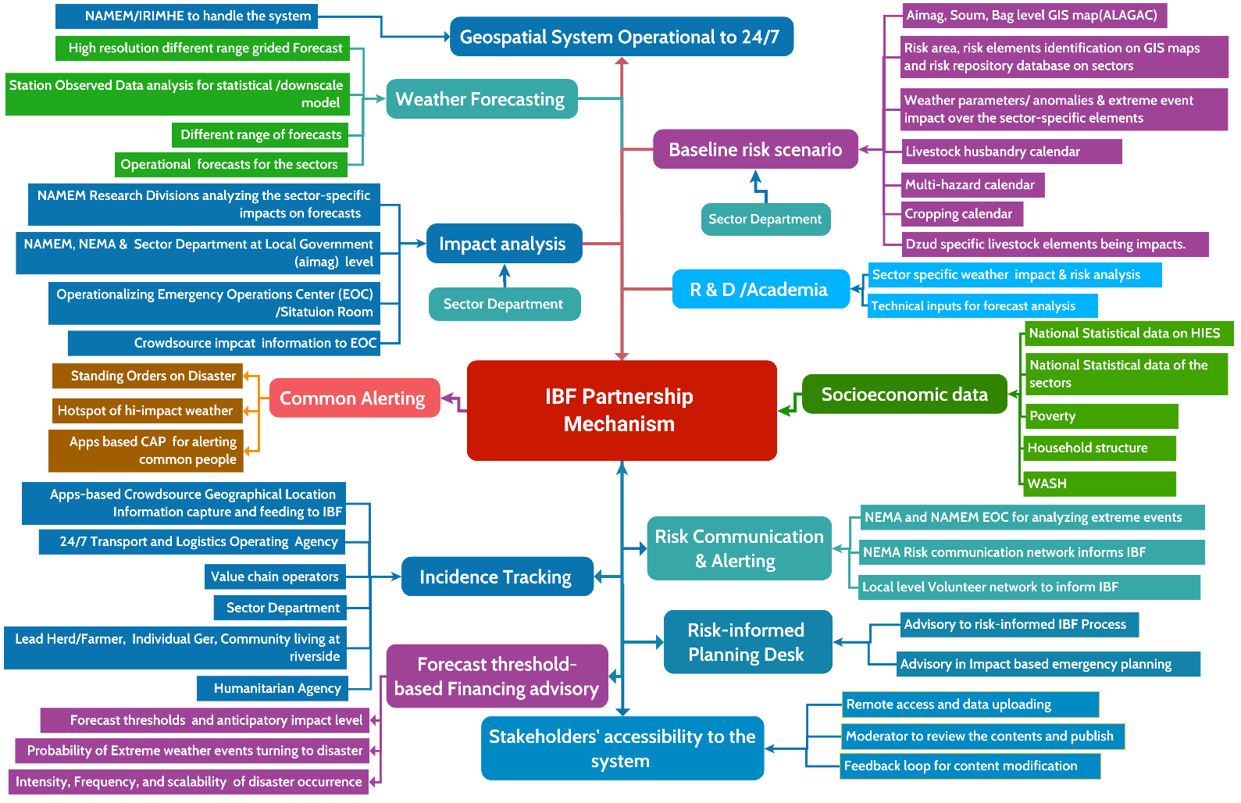

Figure 3: IBF Data coordination, exchange, and partnership mechanism ( Source: Z M Sajjadul Islam , UNDP-GCF)

Table 1: Partner’s Checklist and major role in the IBF Process
Partner | Technical actors | Major Role
IBF Technical Working Group (TWG) | TWG for livestock sector impact (risk and vulnerability analyses ) | Impact forecast preparation for the livestock sector
IBF Technical Working Group (TWG) | TWG for Dzud risk analysis and Dzud early warning, Dzud alerting | Impact forecast preparation for the Dzud early warning
IBF Technical Working Group (TWG) | TWG for Agriculture sector( crop agriculture) impact (risk and vulnerability analyses ) | Impact forecast preparation for the livestock-agriculture sector( crop agriculture) sector
IBF Technical Working Group (TWG) | TWG for Soil and Land sector impact (risk and vulnerability analyses ) | Impact forecast preparation for the Soil and Land sector
IBF Technical Working Group (TWG) | TWG for the water/hydrological sector | Impact forecast preparation for the environmental sector
IBF Technical Working Group (TWG) | TWG for environmental sector impact (risk and vulnerability analyses ) | Impact forecast preparation for the priority sector
IBF Technical Working Group (TWG) | TWG for Weather data acquisition( from multiple sources ( station Observation data, AWS, crowdsource source) data analysis | Weather data acquisition from hybrid sources ( figure 9)
IBF Technical Working Group (TWG) | TWG for rapidly developing weather conditions monitoring, warning, and common alerting protocol | Impact forecast- warning and common alerting protocol
IBF Technical Working Group (TWG) | TWG for data communication | Impact forecast preparation for the priority sector
IBF Technical Working Group (TWG) | TWG for Geospatial server and service development | Geospatial server and service development
IBF Technical Working Group (TWG) | TWG for database development, data coordination, and exchange | Database development, data coordination, and exchange
Technical Partners | - MoFALI /Livestock Department and other research wings, veterinary service  - Administration of Land Affairs, Geodesy and Cartography(ALAGAC)  - Sector departments  - Social Welfare  - National Registration and Statistical Office  - MRCS  - Forest Research and Development Centre  - National University of Mongolia  - Mongolian University of Science and Technology  - Mongolian University of Life Sciences  - Institute of Geography and Geo-ecology  - River Basin Authority  - Drought Watch-Mongolia  - Ministry of Health  - Ministry of Education and Science of Mongolia  - Energy resource company | Spatial risk and vulnerability database, information GIS Map
Aimag Government, Sector Departments | - State Administration Department.  - Legal Department.  - Production, Trade, Agriculture and Environmental Department.  - Financial and Economic Policy Department.  - Social Policy Department.  - Environmental and Agricultural ( livestock and crop agriculture)  - Head of Governor’s Office.  - Social Development Officer (education, health care).  - Agriculture and Environmental Officer.  - Social Care Officer (Poverty reduction, employment, and social care).  - Operations Officer.  - BPO- Border Protection Organization | Conduct Climate Risk and vulnerability assessment, forecast impact analysis, work with incidence command system, operationalize Emergency Operations Center (EOC) or Situation Room
Government Sector Ministry / Departments | - CSoG-Cabinet Secretariat of the Government MoF- Ministry of Finance  - FRC-Financial Regulatory Commission of Mongolia  - IPTTA- Information, Post, Telecommunications and Technology Authority,  - MAS- Mongolian Academy of Science  - MASM-Mongolian Agency for Standardization and Metrology  - MECS- Ministry of Education, Culture, and Science  - MoFALI – Ministry of Food, Agriculture and Light Industry  - MoET- Ministry of Environment and Tourism  - MSPL- Ministry of Social Protection and Labor  - NEMA- National Emergency Management Agency  - MoFA- Ministry of Foreign Affairs | Conduct Climate Risk and vulnerability assessment, forecast impact analysis, work with incidence command system, operationalize Emergency Operations Center (EOC) or Situation Room
Partnership with WMO regional hubs | - Regional Forum( JMA, CMA, KMA)  - DCPC Beijing / Hong Kong  - Regional Integrated Early Warning System for Africa and Asia (RIMES) | Regional climate model, outlook sharing
CBO/CSO | - Community-based organization  - Community services organizations  - Private Sector Entity,  - Value chain operators  - Logistic transporter  - Multilateral Organization,  - National Committee,  - Working Group | Conduct a survey and provide Climate Risk and vulnerability data, risk information communication with EOC or Situation Room
Humanitarian Country Team | - 11 UN clusters in Mongolia e.g Early Recovery, Education, ETC, Food Security, Health, Logistics, Nutrition, Protection, Shelter, and WASH  - Humanitarian Country Team ( UNDP, FAO, WFP, IFRC, WHO, WMO, UNHCR, )  - Humanitarian actor ( MRCS, NEMA volunteers)  - UNICEF Risk Communication and community engagement (RCCE) | Climate Risk and vulnerability data, risk information communication with EOC or Situation Room
NEMA | - National Emergency Commission/NEC  - National Center for Communicable Diseases/NCCD,  - National Center for Public Health/NPHC etc.  - Institute of Astronomy and Geophysics (IAG) Emergency Operations and Warning Center of the National Emergency Management Agency (EOWC)  - National Center for Emergency and Disaster Relief (NCEDR) | - Operationalizing Incidence Command System (ICS) during emergencies and linking with aimag EOC or Situation Room  - The military serves as first responders for earthquakes, wildfires, forest fires, contagious diseases, snow and dust storms, and severe winters.  - Sharing Climate risk and vulnerability information.  Forecast impact analysis with aimag EOC or Situation Room.
NEMA | - State Reserves Units  - Firefighting and Rescue Units  - Rescue Units and Teams  - Emergency Management  - Divisions of Districts  - Rescue Units  - Firefighting and Rescue Units  - DDR Training Center  - Supply, Logistics, and Services Unit  - Retraining and Rehabilitation Center  - Building №3  - Fuel Reserve Unit  - Food Reserve Unit | Activities on search and rescue unit, rescue and firefighting unit, and state reserve unit in Tuvshuruuleh soum. 68 personnel.  - support of local police agencies and local governors’ offices.  - National Police Agency (NPA) and  - General Authority for Border Protection  - Emergency services by 9,000 active-duty troops  - National Incident Management System’s Incident Command System (ICS) platform. In 2004, Mongolia adopted ICS as the primary guide.  - Public Emergency service ( Earthquake, Fire Forest fire, First aid, Acute infectious diseases, Snow and dust storms. Dzud dangers, Flood and water hazards)
National Media & Broadcasting network | - Mongolian National Public Radio (AM/FM) and TV  - Mongolian TV Broadcasters Association  - National Radio Community radio  - National electronic media  - National Optical fiber network, PSTN operator  • Government Media and Public Relations Department (Cabinet Secretariat)  • Public Council under the IAAC  • National Emergency Commission (NEC), NEMA, UB Health Authority, National Center for Public Health, National Center for Communicable Diseases  • Media and Information Council  • Press Institute  - Mongolian Websites Association  - Mongolian Newspapers Association | - Dissemination of emergency weather warning  - Organize live Radio/TV shows on weather emergencies and interactive sessions with vulnerable communities for getting situation updates.  - Impact forecasts dissemination to the target audiences  - Incorporate media monitor updates, pictures, and videos into the IBF platform.
Crowdsource | - Herders (Basecamp)  - Aimag Center  - Soum Center  - Bag Center  - Farmers (lead)  - Logistic transporter  - Tourism operators, hotels, motels, restaurants  - Commercial installations ( SME/Enterprises/Shops)  - Educational institutes  - Gasoline/Petrol pumps  - Healthcare centers, local governments departments  - Volunteers (MRCS/LEMA/NEMA/Community)  - Vulnerable communities living at climate frontline ( riverside, lower floodplain, etc.)  - Value chain operators  - Aviators  - Transporters  - Social media operators  - Open Street Collaborative mapping | - Event reporting/situation reporting of multi-hazards.  - Weather condition monitoring and updating to EOC/IBF platform.  - Sharing local-level multi-hazard risks and vulnerabilities  - Provide risk information to Incidence Command System (ICS) during emergencies and link with aimag EOC or Situation Room  - Sharing Climate Risk and vulnerability information
Telecommunications network | - Cell phone operators  - National telecom authority  - National electronic media  - National Optical fiber network, PSTN operator | - Utilizing cell phone tower ( BTS) for setting up AWS( weather monitoring instrument )  - Being mandated by the government - provide free SMS, Interactive Voice Response (IVR), Cell Broadcasting, and Toll-free calling for dedicated cell phones ( frontline vulnerable community ( herders/farmers/community/rescuer/emergency response team/ logistics transport/volunteers) for facilitating emergency data /risk communication and  - Supporting livestock department in tracking herders' GPS location by using free internet data services for a few designated times.  - Support for emergency risk communication and dissemination.
Social network | - Social network operators  - Crowdsource communication group- Facebook, WhatsApp, Telegram, Viber, CallPro Mongolia  - Collaborative mapping Qfield of OpenStreetMap, Open layer, survey 123,  - Online survey /data collection apps: Kobo Toolbox, survey monkey etc | - Social media – i.e., information sharing through platforms.  - Crowdsensing – i.e., citizens on the Web or equipped with smartphones using dedicated applications to register and share observations (e.g., citizen observatories);  - Collaborative mapping – using Qfield apps of OpenStreetMap, the Open layer creates internet-based interactive maps (e.g., OpenStreetMap).

2. 4 Technical Working Group for forecast Impact analysis :

For facilitating the IBF process, technical working groups ( TWG) and designated responsibilities need to be mainstreamed for setting out a cross-functional IBF working modality. The table below outlined the workflows of TWGs.

Table 2: Technical Working Group for the IBF Impact Analysis

Technical working group for the IBF process | Partnering organizations | Member/Department | Responsibilities of the Technical Working Group (TWG) for contributing IBF process | Requirement of ICT tools/Interface /IBF Platform
TWG for livestock sector impact (risk and vulnerability analyses ) analysis | Forecasting Division (IRIMHE/NAMEM) | - Forecasters  - Synoptic Engineers  - Data archive team | - Develop forecast CSV files, forecast briefings, impact threshold area delineation, analyze impact thresholds with GIS software for the country as a whole, and aimag/soum level CSV/Shapefile for the local level impact forecast.  - Upload to Geonode Server for other groups and users to interpret and utilize | - Access to Geonode server and upload datasets/files and create a map of the forecasts and forecast briefings.  - Access to SharePoint Server and upload files  - Access to FTP File server
TWG for livestock sector impact (risk and vulnerability analyses ) analysis | Operational forecast team for the livestock sector (IRIMHE/NAMEM) | - Forecasters  - Synoptic Engineers  - Agrometeorology experts  - Rangeland health monitoring experts  - Forage crop production Cooperative society  - Data archive team | - Operational forecast team to analyze weather impacts ( hi-impact weather ) on the livestock( types) over the next 7-10 days (weekly/decadal) and what types of impacts are being triggered by anomalies, and extreme parameters of seasons.  - Advisory on adverse effects of weather
TWG for livestock sector impact (risk and vulnerability analyses ) analysis | MoFALI /Livestock Department and other research wings, veterinary service | - Livestock Department  - Veterinary department  - Breeding department | - Sector department offices at the local level open the forecast by logging in to Geonode server, then open the map and provide each parameter-specific impact ( Snowstorm/Winter Strom, heat wave, cold rain, thunderstorm, flood/landslide/mudslide ) likely to cause of sickness, death, starvation, disease, weight loss, etc.  - Briefing about livestock adaptive management coping with adverse weather being forecasted  - Develop a livestock management calendar | - Upload all datasets to the IBF PostgreSQL server /MSSQL server.
TWG for livestock sector impact (risk and vulnerability analyses ) analysis | Agrometeorological division(IRIMHE/NAMEM) | Agrometeorological division | - Engaged jointly with the operational forecast team.  - Traditional livestock husbandry is affected by natural hazards very often and has experienced significant impact.  - Collect fodder/forage biomass conditions data every weekly interval from 1516 representative sample collection points.  - Develop a livestock husbandry calendar.  - Develop a calendar on livestock grazing days with open biomass.  - Collect soil moisture, and soil temperature data in week intervals.  - Collect ice/snow thickness from the 1516 representative sample collection points.  - Collect soil thawing data from the local level.  - Collect multi-hazard impacts on livestock and agriculture.  - Create WhatsApp groups of all field-level technicians (members of the 1516 team, soil-related data collectors, and field surveyors) | - Prepare all attribute/layers datasets (geocoordinate lat./long, parameter readings, attribute data ) and upload to SharePoint Server and other servers necessarily
TWG for livestock sector impact (risk and vulnerability analyses ) analysis | NEMA | - LEMA at aimag level (LEMA) | NEMA/LEMA to provide emergency information management services and risk and vulnerability assessment.  - Multi-hazard risk, vulnerability, and exposure database  - Past Disaster event map (area of extent where it occurred )  - Past Disaster Hotspot (GPS location / Placemark) Map a) Where disaster occurred? b) Death tolls, injured, affected, displaced? :  - Multi-hazard risk atlas (National, Aimag Level)  - Aimag-wise GIS Base maps showing infrastructures (buildings, institutes, physical structures, socio-economic structures, dzud response trigger point, emergency shelters for livestock and population, marketplace, location of NEMA office building, Hospital, health care center, emergency relief storage facilities, commercial installation, )  - Sample of contingency plan for national level, Aimag, and Bag level | Using ArcGIS/QGIS and logging in to IBF geospatial platform for developing GIS map and information services
TWG for livestock sector impact (risk and vulnerability analyses ) analysis | The Administration of Land Affairs, Geodesy, and Cartography (ALAGAC) | - Urban development  - Land Management  - Geodesy and Cartography (Geospatial Services) | - ALAGAC/ALaMGAC to provide GIS shapefile and access to https://geoportal.nsdi.gov.mn enable REST API WCS, WFS, WPS services and provide GIS shapefiles at Geonode/GeoServer for elements risk and vulnerability analysis.  - Access to IBF geospatial platform, download weather forecast CSV files, and analyze risk and vulnerabilities of impending extreme weather over to elements of urban land management system.  - During normal times conduct an assessment of the climate/multi-hazard risk and vulnerabilities to urban/rural built-in infrastructures /structures /installations, urban critical infrastructures, and utility service structures for risk repository development.  - Database on the elements of urban infrastructures and basic services, settlements, high-value elements, and essential unity services ( power Plant, Power distribution point, hot water supply network, power supply network, gas supply network )  - Provide anticipatory advisory on the high impact to urban, settlements, land use, industry, enterprise, urban services deliveries, and other elements narrated above | Using ArcGIS/QGIS and logging in to IBF geospatial platform for developing GIS map and information services
TWG for livestock sector impact (risk and vulnerability analyses ) analysis | Aimag/Soum/Bag level agriculture and livestock department | - Agricultural office  - Livestock office | - Conduct CRVA assessment on herder's camp, pastureland, permanent and seasonal grazing areas, and forage crop areas prepare database and geolocation ( lat./long.) on number & types of livestock, transport, and vehicle, livelihood assets, economic conditions, the communication device ( android cell, Radio, TV, wireless, forecast radio, season wise camp geolocation, etc.  - Prepare a calendar on the multi-hazards impactful to livestock.  - Prepare Livestock husbandry daily event calendar.  - Prepare Fodder crisis days on the calendar.  - Prepare calendar supplement feeding days purchased from insurance.  - Prepare calendar supplement feeding days purchased with your own money.  - inventorying of animal death records  - Daily inventorying of the impactful weather conditions for the livestock ( 24/7 ).  - Daily inventorying of animal diseases, outbreaks  - Inventorying geolocation, preparing cartographic maps, showing biomass pasture growing areas, identifying the areas where forage cropping is possible, identifying where natural water resources are available for irrigation  - Maintain all log sheets/registers mentioned in Annexure 4 | Using ArcGIS/QGIS and logging in to IBF geospatial platform for developing GIS map and information services
TWG for livestock sector impact (risk and vulnerability analyses ) analysis | Remote sensing division (IRIMHE/NAMEM) | - Agrometeorological division  - Climate Change division.  - Environmental Information Center | - Maps on Vegetation coverage ( every 10 days)  - Maps on Snow coverage, density, the thickness of snow, thickness of icing over the ground  - Prepare vegetation coverage maps ( MODIS satellite image)  - Maps on agriculture, meteorological and hydrological drought  - Maps on environmental protection areas, reserve land/forest, Agricultural land, and land cover map. | Using ArcGIS/QGIS software and logging in to IBF geospatial platform for developing GIS map and information services
TWG for livestock sector impact (risk and vulnerability analyses ) analysis | Environmental information divisions (IRIMHE/NAMEM) | - Agrometeorological division  - Climate Change division.  Environmental Information Center | Analysis of high-impact weather and calculate impacts. | Using ArcGIS/QGIS and logging in to IBF geospatial platform for developing GIS map and information services
TWG for livestock sector impact (risk and vulnerability analyses ) analysis | MRCS ( Mongolian Recross Society) | - Community Volunteer  - Humanitarian Volunteers | - Anchoring MRCS/IFRC dzud risk management tools to the IBF platform  - Linking MRCS emergency preparedness and response management network with IBF risk communication network and platform  - Support service by MRCS volunteers’ access to the country and linking with the IBF risk communication network to contribute to emergencies, events taking place, tolls, loss and damage scenarios, and incidence records (geolocation, pictures, video and incidence placemark and technical briefings) | Using ArcGIS/QGIS and logging in to IBF geospatial platform for developing GIS map and information services
TWG for livestock sector impact (risk and vulnerability analyses ) analysis | FAO | FAO country project office/ field Unit/volunteer/stakeholder | - Anchoring Early Warning Early Action (EWEA) with IBF Platform to address dzud early warning and early action, FbF  - Anchoring FAO Anticipatory Action (AA) or Forecast-based Financing (FbF) to IBF  - Conduct Dzud risk assessment in the socio-economic conditions of herders and incorporate it into IBF.  - Conduct livestock risk and vulnerabilities to impeding extreme weather conditions and high impacts and support the IBF team for interpreting impacts of hi-impact weather on livestock.  - FAO volunteers to support the IBF team about the sensitivity, risk, exposure, and vulnerability situations of extreme weather events. Weather risk and vulnerabilities over livestock management. | Using ArcGIS/QGIS and logging in to IBF geospatial platform for developing GIS map and information services
TWG for livestock sector impact (risk and vulnerability analyses ) analysis | HCT ( Humanitarian Country Team) | UN Agency project offices at Aimag level | - Anchoring with IBF and FBF platforms for informing humanitarian coordination and response decision-making mechanism.  - Anchoring functional linkage with IBF & FBF and providing contributions for IBF & FBF functionaries.  - Support services analyzing extreme weather impacts to Climate vulnerable sectors (livestock and agriculture), support for Climate and extreme weather impact warnings.  - Climate and weather impacts on (i) animal breeding, feeding, health conditions, husbandry practices, (ii) pasture management, (iii) manure management, (iv) plant production, protection, and health, (v) soil health and fertility, and (vi) public health.  - Provide information on national e-agriculture strategy and pilot selected ICT solutions for enhanced monitoring and management of food systems. | Using ArcGIS/QGIS and logging in to IBF geospatial platform for developing GIS map and information services
TWG for livestock sector impact (risk and vulnerability analyses ) analysis | NSO ( National Statistical Organization) | Aimag/Soum level | Anchoring NSO datasets over the ODBC (Opens source database connectivity ) for accessing NSO socio-economic vulnerability, HIES data, and sector-specific databases ( updated) | Using ArcGIS/QGIS and looking at IBF geospatial platform for developing GIS map and information services
TWG for livestock sector impact (risk and vulnerability analyses ) analysis | WFP | Project office at Central & Aimag/Soum level | Anchoring WFP emergency management network with IBF & FBF  Support IBF for livestock risk management | Using ArcGIS/QGIS and logging in to IBF geospatial platform for developing GIS map and information services
TWG for livestock sector impact (risk and vulnerability analyses ) analysis | UNDP | Project office at Central & Aimag/Soum level | Provide relevant data/information exchange and coordination support for assessing extreme weather impacts over the livestock sector and analyzing weather impacts. | - Using ArcGIS/QGIS and logging on with IBF geospatial platform for developing GIS map and information services  - Using IBF WhatsApp, telegram, Facebook group
TWG for livestock sector impact (risk and vulnerability analyses ) analysis | Livestock value chain operator | Country level | - Provide information and data on any risk and vulnerabilities being created by the impending extreme weather-induced multi-hazards and impacts on the Livestock value chain operations.  - Track record of impending multi-hazards impacts over livestock value chain operations ( storing, input supply, processing ).  - Network with the IBF platform and exchange information (geolocation) on extreme weather situations, risks, livestock tolls, loss, and damage of the sectors | Using IBF WhatsApp, telegram, Facebook group
TWG for livestock sector impact (risk and vulnerability analyses ) analysis | Livestock feed processing industries | Country level | - Provide information and data on livestock output supply-oriented food processing industries (milk, meat, cashmere, lather ) do experience impacts of extreme weather conductions.  - Keep a track record of impending multi-hazard impacts over food processing value chain operations (storing, input supply, processing ).  - Network with the IBF platform and exchange information (geolocation) on extreme weather situations, risks, livestock tolls, loss, and damage of the processing cycle. | Using IBF WhatsApp, telegram, Facebook group
TWG for livestock sector impact (risk and vulnerability analyses ) analysis | Commercial Forage crop cultivators | - Smallholder farmers  - Commercial agro-farm  - Pasture/forage crop production/supply group  - Livestock herder group  - Pasture management and utilization group  - Rangeland health monitoring group  - Local government  - Agriculture department  - Livestock department | - Provide climate risk and vulnerability data on crop agriculture, weather impacts over the forage cultivation cycle.  - Provide a multi-hazard calendar irrespective of types for forage crop productions.  - Provide information on selected perennial forages, including oats and alfalfa. The second phase of the project focuses more on capacity building, growing maize for silage, and other fodder conservation methodologies. | Using IBF WhatsApp, telegram, Facebook group
TWG for Dzud risk analysis and Dzud early warning, Dzud alerting | IRIMHE/NAMEM | - Forecasting Division  - NWP  - Remote sensing research div.  - Climate change research div.  - Environmental research div | - Always remain connected with TWGs, provide forecast CSV files and briefings, and update emergency weather warning /alert services ahead of impending events  - Data acquisition, calibration, assimilation, the process of surface weather observation data, and uploading to PostgreSQL server, FTP server, etc.  - Develop algorithms on nowcasting services, emergency operational forecasts on rapidly developing weather conditions, running statistical and Dynamical downscale models on the real-time, time-series weather data.  - Running automated Linux cronjobs/running scripts to operationalize emergency weather forecast/outlook/updates/watch form real-time gathered data from hybrid observation system( figure 9), prepare instant weather map ( automated process),  - Prepare automated common alerting protocol( CAP), and weather warning with IBF geospatial tools, services, API, and programs.  - Develop an algorithm for running Statistical /Dynamical model analysis on live observation data to show the live weather phenomena with nowcasting, generate warnings, prevailing weather conditions, and live incidence plotting with warning maps.  - Regularly review extreme weather parameters, impending impact intensity, lead-time to be impending, prepare different types of demand drive forecasts ( daily/operational, point-based, high-value element based ) impact analysis and develop anticipatory loss and damage scenarios and eventually issue impact warning (color-coded)for the sector.  - Prepare multi-hazard incidence maps from the crowdsource data, process and reflect multi-hazard incidence, the severe situation at the ground, prevailing severity, and continuity of ongoing weather conditions over a bad weather system.  - Review observation outlook provides advisories over the trend.  - Acquisition of livestock-sensitive weather indicators datasets from weather station( temp, precipitation, wind speed/direction, RH, cold front, convective weather conditions, dust/haze storm, snowstorm, etc.) parameters. | - Hybrid observation tools, crowdsource observation( figure 9)  - Customized and readily usable forecast software  - Forecast CSV file & weather briefing,  - Statistical and Dynamical weather modeling software for processing station data  - Realtime data capture, data calibration, and assimilation software  - Data repository to PostgreSQL server  - Accessing geonode & geoserver  - IBF Internal /External geospatial services  - ArcGIS / QGIS software with data-capturing apps from field-level volunteers  - Placing IP webcam at the high raised ground for the monitoring the high-value elements( urban centers ) for landscape observation, open-eye observations of cloud conditions/convective conditions
TWG for Dzud risk analysis and Dzud early warning, Dzud alerting | LEMA at aimag/soum/bag level | - Emergency response team  - Humanitarian & Emergency volunteers | - Support IBF with energy situational information, hazard incidence report, and conduct an immediate needs assessment of livestock during emergency onset.  - Networking of all humanitarian actors/volunteers at the local level and mandating them to provide information to the IBF platform.  - Dissemination of emergency warnings through the NEMA network | - Using IBF WhatsApp, telegram, Facebook group  - IBF surveying Kobo Toolbox apps, hotspot mapping apps (IBF Platform) , GPS logger /GPS essential apps
TWG for Dzud risk analysis and Dzud early warning, Dzud alerting | IRIMHE/NAMEM | Synoptic Engineer with NAMEM aimag /soum level (Table 4: Aiamg Team )  - Operational forecast team for the livestock sector (IRIMHE/NAMEM) | - Constant review of the weather forecast cycle and review of the parameters are sensitive and impactful to livestock lifecycle based on the growing season.  - Provide warnings and advisories on high-impact weather being forecasted and anticipatory impacts over the livestock lifecycle. | - Forecast software,  - Statistical and Dynamical weather modeling software for processing station data  - Data calibration and assimilation software  - Accessing to PostgreSQL server  - Accessing geonode & geoserver  - IBF geospatial services  - ArcGIS / QGIS software
TWG for Dzud risk analysis and Dzud early warning, Dzud alerting | MoFALI | MoFALI /Livestock Department and other research wings, veterinary service | - Livestock database and geolocation of every camp to provide the point base weather forecasts for the livestock, pasture conditions in every season, pasture shortage time, animal diseases, animal breeding, veterinary services for weather-related diseases, forage crop production, and fodder biomass degradation areas.  - Register/log sheet on high weather extreme parameters/conditions impacting livestock herding.  - Fodder biomass area identification on map and fodder biomass condition  - Temperature impacts on the calf, tender animals.  - Storage of hay/fodder for animals, without drinking water, animals are treating snow,  - Sudden onset weather events – Cold rain, convective thunderstorms, High winds/dust storm-related disease. | - Using IBF WhatsApp, telegram, Facebook group  - IBF surveying Kobo Toolbox apps, hotspot mapping apps (IBF Platform) , GPS logger /GPS essential apps  - Accessing to PostgreSQL server  - Accessing geonode & geoserver  - IBF geospatial services  - ArcGIS / QGIS software
TWG for Dzud risk analysis and Dzud early warning, Dzud alerting | IRIMHE/NAMEM | - Agrometeorological division  - Remote sensing research division.  - Climate change research division.  - Environmental research division  - Forecasting & NWP Division  - Aimag LEMA/NAMEM | - Every 10 days forage/pasture status, soil moisture condition, soil icing, soil health conditions, soil thawing incidence, desertification warning, forage crisis warning.  - Rangeland's health condition every 10 days(times series )  - Biomass pasture condition every 10 days(times series )  - Drought/flash drought conditions every 10 days(times series )  - DroughtWatch Mongolia every 10 days(times series )  - Pasture degradation map (times series )  - Drinking water access point (times series )  - Livestock drinking water points and conditions ( season-specific)  - Herders level pasture stock/destocking condition updates every 10 days(times series )  - Maps on agricultural cropping areas in every season (times series )  - Forage crop maps on every season (times series )  - Nomadic ger location and hard size( number of livestock) | - Accessing to PostgreSQL server  - Accessing geonode & geoserver  - IBF geospatial services  - REST API, WCS, WMS, WFS with ArcGIS and QGIS  - Pasture soil moisture EM50  - DataTrack 3  - ECH20 Utility software  - DIMA Software, Photo point monitoring software  - Software Paste user group management.  - Software Ecological site group management  - STM model
TWG for Dzud risk analysis and Dzud early warning, Dzud alerting | ALAGAC/ALAMGaC | The Administration of Land Affairs, Geodesy, and Cartography (ALAGAC) | - ALAGAC local offices to maintain track records of multi-hazard incidence are taking place at the local level.  - Track record of basic infrastructures and services being impacted by extreme weather events e.g., transport, logistics, emergency service trigger points, storage facilities, market infrastructures, and basic services.  - Keep track records on weather impacts over the designated pasture lands, pastureland management, maintain user group, operational and management of pastureland.  - Analyze with GIS tools how many infrastructures/structures and elements are likely to be impacted by the impending hazardous weather events.  - Analyze the loss and damage of the elements being impacted by the hazardous weather. | - REST API, WCS, WMS, WFS with ArcGIS and QGIS  - Accessing to PostgreSQL server  - Accessing geonode & geoserver
TWG for Dzud risk analysis and Dzud early warning, Dzud alerting | Local Government | Aimag/Soum/Bag level sector department | - Track record of high-impact weather events induced any incidence taking place at any herds level, track record of forage demand and availability during disaster onset.  - Provide voluntary information on any incidence | - Accessing to PostgreSQL server  - REST API, WCS, WMS, WFS with ArcGIS and QGIS  - Accessing to PostgreSQL server  - Accessing geonode & geoserver
TWG for Dzud risk analysis and Dzud early warning, Dzud alerting | IRIMHE/NAMEM | Remote sensing research division | - Forest fire incidence Snowfall coverage, snow thickness map, and datasets  - Drought incidence with spatiotemporal level data to IBF | - REST API , WCS, WMS, WFS with ArcGIS and QGIS  - Accessing to PostgreSQL server  - Accessing geonode & geoserver
TWG for Dzud risk analysis and Dzud early warning, Dzud alerting | IRIMHE/NAMEM | - Environmental information divisions  - Agrometeorological division  - Agrometeorological research division  - Remote sensing research division  - Climate change research division.  - Mongolian Drought watch team  - ALAGAC  - FAO  - Drought Watch Mongolia | Support IBF for analyzing the impacts of the environmental, agricultural, soil, and land sectors by processing the following tools.;  - Vegetation coverage map /information of every 10 days map  - Drought condition map of every 10 days map  - Drought map  - Dzud ( snow Cover) map  - Wildfire incidence of 1-24 hrs incidence tracking  - Vegetation coverage for pasture forecasting  - Pasture Anomaly map  - Pasture Biomass map  - Pasture Trend map  - Snow cover maps ( using MODIS terra-aqua ) map with 250m resolution with an average thickness of snow ( cm) and average density of snow ( g/cm cubic) from the station data. The map is useful for monitoring agriculture, livestock, transport, livelihood sectors, and dzud analysis.  - Taking support from the global domain on forest fire hotspot monitoring (web. )Fire Information for Resource Management System (FIRMS) with Landsat, VIIRS( S-NPP, NOAA 20, MODIS ( Aqua, Terra) Fire incidence of 1-24 hrs  - World Forest Fire Watch web-based on the thermal anomaly ( day & night ) acquired by MODIS aqua image on fore and a thermal anomaly  - Vegetation outlook on every 10 days map by using MODIS ( aqua) satellite image.  - Vegetation changes in % of values of multi-year average NDVI index subtracting by NDVI with 10 days average and representing with maps with maximum increase green color and max decrease in red color.  - A drought outlook map produces every 10 Days interval for supporting environmental monitoring. | - REST API , WCS, WMS, WFS with ArcGIS and QGIS  - Accessing to PostgreSQL server  - Accessing geonode & geoserver
TWG for Dzud risk analysis and Dzud early warning, Dzud alerting | Mongolian Recross Society | MRCS aimag level setup | Emergencies induced by high-impact wearer conditions and incidence information | - REST API , WCS, WMS, WFS with ArcGIS and QGIS  - Using IBF WhatsApp, telegram, Facebook group  - IBF surveying Kobo Toolbox apps, hotspot mapping apps (IBF Platform) , GPS logger /GPS essential apps
TWG for Dzud risk analysis and Dzud early warning, Dzud alerting | FAO at the country level | FAO Dzud early warning system | Anchoring FAO early warning to IBF and issuing any weather emergency in the livestock sectors | - REST API , WCS, WMS, WFS with ArcGIS and QGIS  - Using IBF WhatsApp, telegram, Facebook group  - IBF surveying Kobo Toolbox apps, hotspot mapping apps (IBF Platform) , GPS logger /GPS essential apps
TWG for Dzud risk analysis and Dzud early warning, Dzud alerting | Humanitarian Country Team | HCT ( Humanitarian Country Team) |  | - REST API , WCS, WMS, WFS with ArcGIS and QGIS  - Using IBF WhatsApp , telegram, Facebook group  - IBF surveying Kobo Toolbox apps, hotspot mapping apps (IBF Platform) , GPS logger /GPS essential apps
TWG for Dzud risk analysis and Dzud early warning, Dzud alerting | NSO | NSO ( National Statistical Organization) at the country and local level | Vulnerable herders and the number of livelihoods | - IBF surveying Kobo Toolbox apps, hotspot mapping apps (IBF Platform) , GPS logger /GPS essential apps
TWG for Dzud risk analysis and Dzud early warning, Dzud alerting | WFP | WFP project offices | Anchoring WFP early warning system | - REST API , WCS, WMS, WFS with ArcGIS and QGIS  - Using IBF WhatsApp , telegram, Facebook group  - IBF surveying Kobo Toolbox apps, hotspot mapping apps (IBF Platform) , GPS logger /GPS essential apps
TWG for Dzud risk analysis and Dzud early warning, Dzud alerting | UNDP | UNDP project offices | Contribution by the field level experts to IBF early warning | - REST API , WCS, WMS, WFS with ArcGIS and QGIS  - Using IBF WhatsApp , telegram, Facebook group  - IBF surveying Kobo Toolbox apps, hotspot mapping apps (IBF Platform) , GPS logger /GPS essential apps
TWG for Dzud risk analysis and Dzud early warning, Dzud alerting | Private sector (Promoter ) | Livestock value chain operator | Provide information on any hazardous event over the Livestock value chain with geolocation | - Using IBF WhatsApp , telegram, Facebook group  - IBF surveying Kobo Toolbox apps, hotspot mapping apps (IBF Platform) , GPS logger /GPS essential apps
TWG for Dzud risk analysis and Dzud early warning, Dzud alerting | Promoter/SME | Livestock-related food processing industries | Provide information on any hazardous event in the food processing industries with geolocation | - Using IBF WhatsApp , telegram, Facebook group  - IBF surveying Kobo Toolbox apps, hotspot mapping apps (IBF Platform) , GPS logger /GPS essential apps
TWG for Dzud risk analysis and Dzud early warning, Dzud alerting | Private sector (Promoter ) | Commercial Forage crop cultivators | Provide information on any hazardous event over the Livestock value chain with geolocation | - Using IBF WhatsApp , telegram, Facebook group  - IBF surveying Kobo Toolbox apps, hotspot mapping apps (IBF Platform) , GPS logger /GPS essential apps.
TWG for Agriculture sector( crop agriculture) impact (risk and vulnerability analyses ) | IRIMHE/NAMEM | - Agrometeorological research division  - Remote sensing research division  - Climate change research division | By using an Operational forecast for agriculture – prepare risks and vulneraries of the sector;  - Crop calendar  - Hazard calendar  - Climate norms map  - Climate anomaly Map  - Historical anomaly track record of the season  - Corps planning decision-making based on Agroclimatic threshold based / severity.  - Calculate risk over crop cycle 0-90, 0-120 days.  - Determine the weather parameters that are likely to impact agriculture cropping in every growing season.  - Pasture and rangeland health monitoring every 10 days and mapping. | Operational forecast team for the livestock sector  - Statistical and Dynamical weather modeling software for processing station data  - Data calibration and assimilation software  - Accessing to PostgreSQL server  - Accessing geonode & geo server  - IBF geospatial services  - ArcGIS / QGIS software  - IP web cam
TWG for Soil and Land sector impact (risk and vulnerability analyses ) | IRIMHE/NAMEM | - Agrometeorological research division  - Remote sensing research division  - Climate change research division.  - Mongolian Drought watch team  - ALAGAC | - Prepare forecast for soil and land sector Using soil data from the station prepare soil sector climate risk map.  - Soil thawing map  - Soil temperature and moisture map  - Agroecology map | - Accessing to PostgreSQL server  - Accessing geonode & geo server  - IBF geospatial services  - REST API , WCS, WMS, WFS with ArcGIS and QGIS  - Pasture soil moisture EM50  - DataTrack 3  - ECH20 Utility software  - DIMA software , Photo point monitoring software  - Software Paste user group management.  - Software Ecological site group management  - STM model
TWG for Soil and Land sector impact (risk and vulnerability analyses ) | The Administration of Land Affairs, Geodesy, and Cartography | The Administration of Land Affairs, Geodesy, and Cartography (ALAGAC) | Land cover map and soil /land classification map | - REST API , WCS, WMS, WFS with ArcGIS and QGIS  - Using IBF WhatsApp , telegram, Facebook group  - IBF surveying Kobo Toolbox apps, hotspot mapping apps (IBF Platform) , GPS logger /GPS essential apps.
TWG for Soil and Land sector impact (risk and vulnerability) analyses | Local Government at aimag/soum/bag level | Aimag/Soum/Bag level sector department | Soil degradation, Desertification maps | - REST API , WCS, WMS, WFS with ArcGIS and QGIS  - Using IBF WhatsApp , telegram, Facebook group  - IBF surveying Kobo Toolbox apps, hotspot mapping apps (IBF Platform) , GPS logger /GPS essential apps.
TWG for Soil and Land sector impact (risk and vulnerability) analyses |  | - Remote sensing division  - Environmental information divisions | Prepare drought map, vegetation cover map  Extreme weather impacts on environment and plant species | - REST API , WCS, WMS, WFS with ArcGIS and QGIS  - Using IBF WhatsApp , telegram, Facebook group  - IBF surveying Kobo Toolbox apps, hotspot mapping apps (IBF Platform) , GPS logger /GPS essential apps.
TWG for the water/hydrological sector (risk and vulnerability) analyses | The hydrological research division of IRIMHE/NAMEM | - Hydrological research division  - Forecasting and NWP division  - River Basin Authority  - Remote sensing division  Environmental information divisions | Impact analyses of hydrologic hazards flood, flash floods, landslide, mudslides, debris falls, water pollution, etc | - REST API , WCS, WMS, WFS with ArcGIS and QGIS  - DTM/DEM modeling tools  - Flood Modelling tools  - Drainage basin management tools  - Using IBF WhatsApp , telegram, Facebook group  - IBF surveying Kobo Toolbox apps, hotspot mapping apps (IBF Platform) , GPS logger /GPS essential apps
TWG for environmental sector impact (risk and vulnerability analyses ) | - NAMEM  - ALAGAC  - MET | - Environmental information center  - Agrometeorological division  - Agrometeorological research division  - Remote sensing research division  - Climate change research division.  - Mongolian Drought watch team  - ALAGAC  - FAO  - Drought Watch Mongolia | Support IBF for analyzing the impacts of the environmental, agricultural, soil, and land sectors by processing and preparing the following tools ;  - Vegetation coverage map /information of every 10 days map  - Drought condition map of every 10 days map  - Drought map  - Dzud ( snow Cover) map  - Wildfire incidence of 1-24 hrs incidence tracking  - Vegetation coverage for pasture forecasting  - Vegetation coverage for pasture forecasting  - Pasture Anomaly map  - Pasture Biomass map  - Pasture Trend map  - Snow cover maps ( using MODIS terra-aqua ) map with 250m resolution with an average thickness of snow ( cm) and average density of snow ( g/cm cubic) from the station data. The map is useful for monitoring agriculture, livestock, transport, livelihood sectors, and dzud analysis.  - Taking support from the global domain on forest fire hotspot monitoring (web. )Fire Information for Resource Management System (FIRMS) with Landsat, VIIRS( S-NPP, NOAA 20, MODIS ( Aqua, Terra) Fire incidence of 1-24 hrs  - World Forest Fire Watch web-based on the thermal anomaly ( day & night ) acquired by MODIS aqua image on fore and a thermal anomaly  - Vegetation outlook on every 10 days map by using MODIS ( aqua) satellite image.  - Vegetation changes in % of values of multi-year average NDVI index subtracting by NDVI with 10 days average and representing with maps with maximum increase green color and max decrease in red color.  - A drought outlook map produces every 10 Days interval for supporting environmental monitoring. | - Accessing to PostgreSQL server  - Accessing geonode & geo server  - IBF geospatial services  - REST API , WCS, WMS, WFS with ArcGIS and QGIS  - Pasture soil moisture EM50 software  - DataTrack 3  - ECH20 Utility software  - DIMA Software, Photo point monitoring software  - Software Paste user group management.  - Software Ecological site group management  - STM model
TWG for Weather data acquisition( from multiple sources ( station Observation data, AWS, crowdsource source) data analysis | - NAMEM at the local level  - NEMA emergency communication team | - Climate change research division.  - Weather forecasting division | - Improve observation capacity of exiting the manual met station.  - Set up Automatic weather stations to monitor high-value elements  - Improve flood and flash flood warning system.  - Develop crowdsource data communication open-source maps, google clouds, open source geonode server-based open layer, GPS logger, GPS Essential and other surveys, event capture, and placemark capturing tool on impending and ongoing multi-hazard events.  - NEMA emergency communication team | - REST API , WCS, WMS, WFS with ArcGIS and QGIS  - Using IBF WhatsApp, telegram, Facebook group  - IBF surveying Kobo Toolbox apps, hotspot mapping apps (IBF Platform) , GPS logger /GPS essential apps  - IBF Apps for hotspot data capture
TWG for rapidly developing weather conditions warning and common alerting protocol | - NAMEM | - NAMEM at HQ ( IBF Platform)  - NEMA at HQ  - LEMA/NEMA at aimag level | Using Google's public alerting system, CAP system alerting the hazardous impending events can potentially do loss and damage | - REST API , WCS, WMS, WFS with ArcGIS and QGIS  - Using IBF groups on WhatsApp, Viber, Telegram, Facebook group/page, national AM radio, TV  - IBF live web telecasts using customized tools /social network.  - IBF surveying Kobo Toolbox apps, hotspot mapping apps (IBF Platform), GPS logger /GPS essential apps  - IBF Apps for hotspot data capture
Emergency weather warning | - NEMA | LEMA, NAMEM at aimag, soum level | NEMA/LEMA to provide emergency information management services and risk and vulnerability assessment.  - Multi-hazard risk, vulnerability, and exposure database  - Past Disaster event map ( area of extent where it occurred )  - Past Disaster Hotspot ( Placemark ) Map a) Where disaster occurred? b) How many people died, were injured, affected, or displaced? :  - Multi-hazard risk atlas ( National, Aimag Level)  - Aimag-wise GIS Base maps showing infrastructures (buildings, institutes, physical structures, socio-economic structures, dzud response trigger points, emergency shelters for livestock and population, marketplace, location of NEMA office building, Hospital, health care center, emergency relief storage facilities, commercial installation, )  - Sample of contingency plan for national level, Aimag, and Bag level  - , | - Using IBF groups on WhatsApp, Viber, Telegram, Facebook group/page, national AM radio, TV  - IBF live web telecasts using customized tools /social network.  - Access with IBF geospatial geonode server with REST API, WCS, WMS, WFS with ArcGIS and QGIS  - Uses of IBF WhatsApp, telegram, Facebook group/page  - IBF surveying Kobo Toolbox apps, hotspot mapping apps (IBF Platform), GPS logger /GPS essential apps  - IBF Apps for hotspot data capture
Emergency weather data collection and transmission to IBF | - Herders  - Farmers  - Logistic transporter  - Tourism operators, hotels, motels, restaurants  - Commercial installations  - Petrol pumps  - Healthcare centers, local governments departments  - Volunteers (MRCS/LEMA/NEMA)  - Aimag Center  - Soum Center  - Bag Center | - MRCS/NEMA/LEMA/NAMEM and Local government to maintain, and organize the functional group | - Mandating Local herders provide real-time weather conditions ( current wind speed, temperature, cloud conditions, precipitation conditions  - Mandating responsible authority/group to of aimag/soum/bag to provide real-time weather conditions ( current wind speed, temperature, cloud conditions, precipitation conditions  - Mandating Logistic transporter, Logistic transporter, Tourism operators, hotels, motels, restaurants, Commercial installations, Petrol pumps, Healthcare centers, local governments departments, volunteers (MRCS/LEMA/NEMA), individuals/responsible persons of the locality, and Volunteers bag to provide real-time weather conditions ( current wind speed, temperature, cloud conditions, precipitation conditions during the onset of extreme weather events already impacting and damaging over the elements. | - Using IBF groups on WhatsApp, Viber, Telegram, Facebook group/page, national AM radio, TV  - IBF live web telecasts using customized tools /social network.  - IBF surveying Kobo Toolbox apps, hotspot mapping apps (IBF Platform), GPS logger /GPS essential apps  - IBF Apps for hotspot data capture  - Connectged with Aimag EOC  - Connected with national radio service  - Connected with Facebook live service  - Connected with National TV service  - Connected with IBF web TV/Web Radio service.  - Connected with WhatsApp user group, and Facebook page for live broadcasting
 | - MRCS | MRCS/NEMA/LEMA/NAMEM and Local government to maintain and organize the functional group and mandate primary data collection. | - Anchoring MRCS/IFRC dzud risk management tools to the IBF platform  - Linking MRCS emergency preparedness and response management network with IBF risk communication network and platform  - Support service by MRCS volunteers’ access to the country and linking with the IBF risk communication network to contribute to emergencies, events taking place, tolls, loss and damage scenarios, and incidence records ( geolocation, pictures, video, and incidence placemark and technical briefings ) | - REST API , WCS, WMS, WFS with ArcGIS and QGIS  - Using IBF WhatsApp, telegram, Facebook group  - IBF surveying Kobo Toolbox apps, hotspot mapping apps (IBF Platform) , GPS logger /GPS essential apps  - IBF Apps for hotspot data capture
 | - FAO | FAO/MRCS/NEMA/LEMA/NAMEM and Local government to maintain, and organize the functional group | - Anchoring Early Warning Early Action (EWEA) for to IBF Platform to address dzud  - Anchoring FAO Anticipatory Action (AA) or Forecast-based Financing (FbF) to IBF  - Conduct Dzud risk assessment in the socio-economic conditions of herders and incorporate it into IBF.  - Conduct livestock risk and vulnerabilities to impeding extreme weather conditions and high impacts and support the IBF team for interpreting impacts of hi-impact weather on livestock.  FAO volunteers to support the IBF team about the sensitivity, risk, exposure, and vulnerability situations of extreme weather events. Weather risk and vulnerabilities over to livestock management, | - REST API , WCS, WMS, WFS with ArcGIS and QGIS  - Using IBF WhatsApp, telegram, Facebook group  - IBF surveying Kobo Toolbox apps, hotspot mapping apps (IBF Platform) , GPS logger /GPS essential apps  - IBF Apps for hotspot data capture
 | - WFP | WFP/MRCS/NEMA/LEMA/NAMEM and Local government to maintain, and organize the functional group | Emergency fodder early warning system livestock and Emergency food early warning system herder’s household | - REST API , WCS, WMS, WFS with ArcGIS and QGIS  - Using IBF WhatsApp, telegram, Facebook group  - IBF surveying Kobo Toolbox apps, hotspot mapping apps (IBF Platform) , GPS logger /GPS essential apps  - IBF Apps for hotspot data capture
 | - Land Administration | Local Offices | Incidence of any flooding, flash flooding, mudslide, debris fall, or avalanches information to IBF platform | - REST API , WCS, WMS, WFS with ArcGIS and QGIS  - Using IBF WhatsApp, telegram, Facebook group  - IBF surveying Kobo Toolbox apps, hotspot mapping apps (IBF Platform) , GPS logger /GPS essential apps  - IBF Apps for hotspot data capture
 | - Aimag government | - Sector department offices  - Local Administration  - Pasture Management Group | Emergency fodder management, allocation of reserves fodder for the herders, incentives for forage crop cultivation, shelter | - REST API , WCS, WMS, WFS with ArcGIS and QGIS  - Using IBF WhatsApp, telegram, Facebook group  - IBF surveying Kobo Toolbox apps, hotspot mapping apps (IBF Platform) , GPS logger /GPS essential apps  - IBF Apps for hotspot data capture
TWG for data communication | - NAMEM | - NAMEM at HQ ( IBF Platform) Department of Meteorological Communication and Information Division  - NEMA at HQ  - LEMA/NEMA at aimag level EOC/Situation room | - Communicate with partners and collect sector specific Climate risk and vulnerability data of the local level sector and elements.  - Multi-hazard incidence data from the local level communication with Crowdsource networking and data analysis | - Configure PostgreSQL as the data source for data synchronization uploading the CSV, Excel file.  - GIS shapefile
TWG for data communication | NEMA | Local NEMA and LEMA office, technical unit, communication hub,  Installation | NEMA/LEMA to provide emergency information management services and risk and vulnerability assessment.  - Multi-hazard risk, vulnerability, and exposure database  - Past Disaster event map ( area of extent where it occurred )  - Past Disaster Hotspot ( Placemark ) Map a) Where disaster occurred? b) How many people died, were injured, affected, or displaced? :  - Multi-hazard risk atlas ( National, Aimag Level)  - Aimag-wise GIS Base maps showing infrastructures (buildings, institutes, physical structures, socio-economic structures, dzud response trigger point, emergency shelters for livestock and population, marketplace, location of NEMA office building, Hospital, health care center, emergency relief storage facilities, commercial installation, )  - Sample of contingency plan for national level, Aimag, and Bag level | - REST API , WCS, WMS, WFS with ArcGIS and QGIS  - Using IBF WhatsApp, telegram, Facebook group  - IBF surveying Kobo Toolbox apps, hotspot mapping apps (IBF Platform) , GPS logger /GPS essential apps  - IBF Apps for hotspot data capture
TWG for data communication | MRCS | - Local MRCS coordination Offices  - Volunteers | - Anchoring MRCS/IFRC dzud risk management tools to IBF platform  - Linking MRCS emergency preparedness and response management network with IBF risk communication network and platform  - Support service by MRCS volunteers’ access to the country and linking with the IBF risk communication network to contribute to emergency situations, events are taking place, tolls, loss and damage scenario and incidence records ( geolocation, pictures, video and incidence placemark and technical briefings ) | - REST API , WCS, WMS, WFS with ArcGIS and QGIS  - Using IBF WhatsApp , telegram, Facebook group  - IBF surveying Kobo Toolbox apps, hotspot mapping apps (IBF Platform) , GPS logger /GPS essential apps  - IBF Apps for hotspot data capture
TWG for data communication | FAO | Local Project Offices | - Anchoring Early Warning Early Action (EWEA) for to IBF Platform to address dzud  - Anchoring FAO Anticipatory Action (AA) or Forecast-based Financing (FbF) to IBF  - Conduct Dzud risk assessment in the socio-economic conditions of herders and incorporate it into IBF.  - Conduct livestock risk and vulnerabilities to impending extreme weather conditions and high impacts and support IBF team for interpreting impacts of hi-impact weather on livestock.  FAO volunteers to support IBF team about the sensitivity, risk, exposure, and vulnerability situations of extreme weather events. Weather risk and vulnerabilities over to livestock management, | - REST API , WCS, WMS, WFS with ArcGIS and QGIS  - Using IBF WhatsApp , telegram, Facebook group  - IBF surveying Kobo Toolbox apps, hotspot mapping apps (IBF Platform) , GPS logger /GPS essential apps  - IBF Apps for hotspot data capture
TWG for data communication | WFP | Local Project Offices | Emergency fodder early warning system livestock and Emergency food early warning system herder’s household | - REST API , WCS, WMS, WFS with ArcGIS and QGIS  - Using IBF WhatsApp , telegram, Facebook group  - IBF surveying Kobo Toolbox apps, hotspot mapping apps (IBF Platform) , GPS logger /GPS essential apps  - IBF Apps for hotspot data capture
TWG for data communication | Land Administration | Local level offices | Incidence of any flooding, flash flooding, mudslide, debris fall, or avalanches information to IBF platform | - REST API , WCS, WMS, WFS with ArcGIS and QGIS  - Using IBF WhatsApp , telegram, Facebook group  - IBF surveying Kobo Toolbox apps, hotspot mapping apps (IBF Platform) , GPS logger /GPS essential apps  - IBF Apps for hotspot data capture
TWG for data communication | Aimag government | Local level offices | Emergency fodder management, allocation of reserves fodder for the herders, incentives for forage crop cultivation, shelter | - REST API , WCS, WMS, WFS with ArcGIS and QGIS  - Using IBF WhatsApp , telegram, Facebook group  - IBF surveying Kobo Toolbox apps, hotspot mapping apps (IBF Platform) , GPS logger /GPS essential apps  - IBF Apps for hotspot data capture
MoFALI /Livestock Department and other research wings, veterinary service | MoFALI | Livestock Department and other research wings, | Track record of every extreme weather-related impact on livestock sectors | - REST API , WCS, WMS, WFS with ArcGIS and QGIS  - Using IBF WhatsApp , telegram, Facebook group  - IBF surveying Kobo Toolbox apps, hotspot mapping apps (IBF Platform) , GPS logger /GPS essential apps  - IBF Apps for hotspot data capture

2.5 Process of translating traditional forecast/weather outlook to impact forecasts :

NAMEM/IRIMHE been entitled as a principal partner to prepare forecasts (e.g. lang range outlooks, anomalies monthly, seasonal, yearly) relating to regional, and global weather/climate factors affecting technical analysis of trend, screening weather/Climate risk and vulnerability from the trends.

Types emergency functions | Prioritized activities (Traditional Forecast preparation ) | Data sources need to be archived | Responsible divisions | Input data for IBF forecasting
Weekly/Decadal outlook | - Prepare complete outlook with designated template/formats to bring the narrations of the outlook using GIS analytics.  - Prepare Technical briefings of forecast verification - what has been forecasted, anomaly predicted, and concurrently compared with climatic norms and station observed data with spatiotemporal discussion. | - Model outputs to 5km grid resolution CSV files, map  - Downscale model output | - Forecasting Divisions  - NWP | - Systemically archive CSV and shape file of weekly forecast/outlook so that in any given case of forecast investigation those resources can easily be accessed from geonode server and SharePoint server.
Monthly outlook | - Acquisitions of weather parameters from the global domain ( precipitation, temperature, and wind) for the production of monthly outputs.  - Conduct multi-model ensembles and model output to higher resolution ( currently 27km grid resolution.  - Prepare complete monthly analysis of anomalies, weather trends, spatiotemporal resolution, and complete illustrations of designated outlook format.  - Technical briefings of forecast verification - what has been forecasted, anomaly predicted and concurrently compared with climatic norms and station observed data with spatiotemporal discussion.  - Each parameter-specific separate analysis | - Model outputs to 5km grid resolution CSV files, map  Downscale model output | NWP  Long-range forecasting division | - Systemically archive CSV and shape file of weekly forecast/outlook so that in any given case of forecast investigation those resources can easily be accessed from geonode server and SharePoint server.
Seasonal outlook | - Conduct multi-model ensembles and model output to higher resolution ( currently 30km grid resolution.  - Prepare complete monthly analysis of anomalies, weather trends, spatiotemporal resolution, and complete illustrations of designated outlook format.  - Technical briefings of forecast verification - what has been forecasted, anomaly predicted and concurrently compared with climatic norms and station observed data with spatiotemporal discussion.  - Each parameter-specific separate analysis | - Model outputs to 5km grid resolution CSV files, map  Downscale model output | NWP  Long-range forecasting division | - Systemically archive CSV and shape file of weekly forecast/outlook so that in any given case of forecast investigation those resources can easily be accessed from geonode server and SharePoint server.
Yearly outlook | - Illustrate yearly atlas of weather anomalies, illustration of the climatology of the country.  - Analysis of yearly weather and climatological trends in comparison with climatic norms  - Technical profile and comparative analysis of whole climatology, anomalies of Mongolia.  - Illustrate areas/sectors/elements being largely impacted by the type of anomalies. | - Model outputs to 5km grid resolution CSV files, map  Downscale model output | NWP  Long-range forecasting division | - Systemically archive CSV and shape file of weekly forecast/outlook so that in any given case of forecast investigation those resources can easily be accessed from geonode server and SharePoint server.
Climatology of the season and yearly

- Utilizing forecast model data, surface observation time-series data, crowdsource observation data, and preparing weather warnings:

Types emergency functions | Responsible divisions | Prioritized activities
- Operational forecasts for high-value elements ( the hazards ) | TWG | Operational Forecast impact analysis
- Nowcasting and Weather Alerts | TWG | Develop programming scripts e.g., python, java scripts and develop wireframes on multi-hazards, weather alerts
- Prepare weather warning /multi-hazard early warning | TWG | Develop Forecast impact analysis
- Conduct Research and analysis on impending multi-hazards that potentially can trigger disasters | TWG | Develop statistical and Dynamical models for providing multi-hazard early warnings
- Sector-specific operational forecasting | TWG | Forecast impact analysis

2.6 Defined roles of partners during multi-hazard emergencies :

 | Partner | Department/  Division/Wing | Functional role | Coordination role | Data Collection & Exchange | IBF Process
 | NAMEM | Forecast Division | - The forecasting division's operational mundi would be like operationalizing air traffic control over the 24/7 mode to prepare forecasts.  - Constantly monitoring forecast parameters, synoptic conditions, and overall weather conditions over the lead-time forecasting duration/cycle.  - Forecast verification - Any given case of weather anomalies is much higher, fluctuating, and transforming to hazardous phenomena -then reflect the current situation with hourly, daily forecasts.  - Prepare operational forecasts for high-value elements (socio-economic sectors, communication, critical service delivery, urban, mining & industries, etc.)  - Prepare point-based forecasts. | Provide Technical support services to the sector-specific forecast impact analyzing team. | - Develop and upload CSV, Shapefile of the high-resolution forecasts ( at least 5 km grid resolution)  - Technical cooperation and coordination with NEMA, MRCS, HCT agencies at aimag level, I-NGOs, and all other partners participating with IB. Collect information on hazardous hazard incidence, any losses, and damages.  - Technical cooperation and coordination with sector departments for the acquisition of sector elements-wise multi-hazard risk and vulnerable data contribute to the IBF platform at regular intervals.  - NEMA and NAMEM forecasting division to establish communication protocol with all relevant partners during weather emergencies being declared. | Remain connected with IBF and functional to the following.  - Remain alerted about the updates are providing the risk communication network on impending and ongoing weather hazardous events.  - Constant monitoring of weather observation network( stations)  - Constant monitoring of ground-level eye-observed situations with pictures, video clips, and weather parameters manually recorded.  - Constant monitoring crowdsources provided pictures, video clips, hotspots tracked by mapping apps, location /placemark tracker apps ( kml, kmz other formats), geolocations etc., and incorporating information to categorized IBF warning and alerting tools.  - Establish emergency conference calls(audio/video) with EOC/Situation room at aimag level, met observers, NEMA emergency teams, NEMA volunteers, MRCS volunteers, sector volunteers, remote herders, lead farmers, emergency logistic operators, HCT aimag level agencies, I-NGOs, and other coordinating partners during emergencies.
 | NAMEM | Long-range forecasting divisions/ Numerical Weather Forecasting Division and | - Prepare high-resolution monthly and seasonal forecasts with aimage level CSV file, technical briefing on the country as a whole, weather/climate region, aimag wise and uploading to IBF platform and sending to aimag EOC/Situation room.  - In coordination with Forecasting, NWP, and Long-range forecasting divisions - prepare operational forecasts on high-value elements( lovelock value chain, agricultural value chain) , installations( communication works) , structures ( mine, industries, power plants, heating system etc) | - Forecast briefing, threshold settings, risk interpretations, and communicating with IBF platform.  - Provide Technical support services to the sector-specific forecast impact analyzing team.  - Provide Technical support to aimag EOC/ Situation room for developing aimag resolution Impact forecasts for the sectors/elements | Develop and upload CSV, Shapefile of the high-resolution forecasts ( at least 5 km grid resolution) | - Constant monitoring of ground-level eye-observed situations with pictures, video clips, and weather parameters manually recorded.  - Constant monitoring crowdsources provided pictures, video clips, hotspots tracked by mapping apps, location /placemark tracker apps ( kml, kmz other formats), geolocations etc. and incorporating information to categorized IBF warning and alerting tools.
 | NAMEM | Hydrological research division | - Download CSV, GIS shapefile from forecast link of IBF geonode/GeoServer  - Data acquisition from hydrological monitoring stations, river gauging stations, runoff gauging stations, permafrost monitoring stations, and flood level monitoring stations.  - Search from IBF risk communication interfaces, crowdsource repository, met station manually overserved datasets, volunteers provided data/information on ongoing flooding situations, event location, impact level loss, and damage scenarios.  - Analyze forecasted precipitation thresholds(red, orange, yellow ), intensity and frequency, and time-series accumulated rainfall amount from the ground observations.  - Analyze the impact level of the forecasts with the elements that are likely to be impacting(quantitively), location, and elements that are likely to be falling under red-covered thresholds, orange zone, and yellow zone.  - Remain alert for any convective weather conditions are developed, monitor Doppler radar ( UB ), connective clouds from satellite images, signals are throwing from AWS, and manual, human-driven observations from the ground.  - Remain alert for issuing any convective rain-induced flash flood, river floods, landslide, or mudslide warning and provide technical briefings to the IBF platform on impending hydrological hazards and disasters. | - Interactive technical coordination with local-level partners for monitoring and maintenance of all hydrological monitoring stations.  - Provide relevant GIS shapefile on river basin, catchment areas, current locations of hydrological monitoring/gauging stations, and river network, and propose GIS locations over the river, lake, spring, and drainage networks those points need to be monitored by crowdsource observers(vulnerable community residing over the riverbank, flood-prone areas and other potential volunteers mentioned above.  - Coordination and communication with ground-level met stations, hydrological stations, and crowdsource observers for fostering constant data/information communications | Develop and upload CSV, GIS shapefile | - Establishment and mobilizing crowdsource-based hybrid monitoring ( figure 9) mechanisms that would be responsible for sending hydrological data, e.g. river runoff level, flood level information, flash flooding situations, areas, and elements that are inundated, flooded, landslide, mudslide, avalanche, infrastructure collapse, water logging, loss and damage pictures, information, etc.  - Remain well interacted with aimag level EOC/Situation room for providing technical supports for GIS mapping of hydrological/water sector risk and vulnerability assessment.
 | NAMEM | Agrometeorological research division | - Develop & update time-series agrometeorological database, develop CSV , GIS shapefiles of all observations being conducted by Agrometeorological field level technicians ( biomass conditions, soil thawing, soil dryness, soil moisture, soil water holding capacity, living plant species, natural pasture growing areas, forage /pasture cropping areas, agricultural drought-prone areas, meteorological drought-prone areas, hydrological, drought-prone areas, irrigation access cultivable areas, cropping maps.  - Data logging ( weekly ) of weather factors that affect agriculture, types of crops, and over the planting seasons, crop-specific and season-specific weather parameters those impact corps and develop GIS map.  - Develop GIS analytical maps on every observed dataset on bag/soum/aimag level and upload them to the IBF platform.  - Develop agroecology zone map, soil map, land cover map, and agriculture/cultivable area map on bag/soum/aimag level and upload to IBF platform.  - Upload /Provide CSV, GIS shapefiles of all 1516 rangeland health monitoring stations, pasture monitoring points, soil moisture measuring station, soil thawing, ground icing conditions, and agrometeorological stations logged data.  - Conduct GIS analyses of bag/soum/aimag level on up-to-date pasture conditions on the ground,  - Collect datasets on soil ice data, and pasture conditions /biomass data( % covered by ice, % are still grazable, % decayed ) every week by engaging 1516 rangeland health monitoring stations and developing CSV files, and GIS shapefile for impact analysis.  - CSV and GIS shape files on herder-specific fodder storage and demand conditions, Herder specific animals drinking water crises. | - Recurrent communication with bag, soum, aimag level monitoring technician/experts, sector volunteers, livestock department, agriculture department, ALAGAC, herders, lead farmer, smallholder commercial farmers, and commercial forage producers for regular interval data collection and processing.  - Prepare impact forecast on livestock sectors, agricultural sector, land, and soil sector and upload to IBF geonode server.  - Prepare weekly dzud situation updates/dzud operational forecasts and upload them to the IBF geonode server.  - By analyzing all dzud contributing weather and land observations-based indicators, indices, ground level weekly motoring datasets - develop a dzud risk situation update map and upload it to IBF geonode server.  - Prepare every type of dzud map of the falling seasons and upload it to the IBF geonode server.  - Prepare dzud warning maps and situation reports by calculating the aggregated and combined indices to a large extent dzud. and upload to the IBF geonode server | Develop and upload CSV , GIS shapefile
 | NAMEM | Environmental information Center | - Technical support and leading the IBF teams for the ICT support, and IBF platform information management.  - Analyze the extreme weather impacts on the environment, agriculture, soil, and land sectors by analyzing the EIC-developed 18 databases. | Provide technical support for IBF functional process | Develop CSV, shape file, and upload to the IBF platform
 | NAMEM | Remote sensing division | - Snow cover maps ( using MODIS terra-aqua ) map with 250m resolution with an average thickness of snow ( cm) and average density of snow ( g/cm cubic) from the station data. The map is useful for monitoring agriculture, livestock, transport, livelihood sectors, and dzud analysis.  - Taking support from the global domain on forest fire hotspot monitoring (web. )Fire Information for Resource Management System (FIRMS) with Landsat, VIIRS( S-NPP, NOAA 20, MODIS ( Aqua, Terra) Fire incidence of 1-24 hrs  - World Forest Fire Watch web-based on the thermal anomaly ( day & night ) acquired by MODIS aqua image on fore and a thermal anomaly  - Vegetation outlook on every 10 days map by using MODIS ( aqua) satellite image.  - Vegetation changes in % of values of multi-year average NDVI index subtracting by NDVI with 10 days average and representing with maps with maximum increase green color and max decrease in red color  - A drought outlook map produces every 10 Days interval to support environmental monitoring. | Provide all remote sensing products and update to the IBF platform. | Develop CSV, shape file, and upload to the IBF platform
 | NAMEM | Climate change division | - The climate change division is the custodian of maintenance of weather stations, and data acquisition from the met station.  - Conduct research work and produce 30 years of mean climate data Maps using met station data as baseline Climate norms of the country.  - Develop the SPEI index by analyzing WMO tools.  - The climate change division runs a statistical model with meteorological observation data and converts it to the high spatial resolution of 1-25 km using the data was used as peripheral and initial condition data for the statistical model (ANUSPLIN), and the climate norm map production using the NCL /NCAR Command Language/ from the calculated grid data.  - Sector-specific risk and vulnerability analysis for decision-making of climate resilient project planning by using forecasts and station observed data.  - Climate change research division in collaboration with NEMA ICT team/GIS team engaging to develop GIS maps, and situation reports on prevailing high-impact hazardous events impacting at ground level and with anticipatory and incidence on the ground-based loss and damage analyses e.g. multi-hazard incidence location maps, multi-hazard hotspot map, flood-prone area, flash flood-prone area, current river discharge level, flood level,  • Preparation of good weather conditions over the season for climate-sensitive sectors.  •Projection of climate change trends over the seasons and variability for analyzing the impacts. | Provide all spatiotemporal observation data acquisition from multiple sources( weather stations, automatic weather stations, weather posts, weather observers, technical volunteers, herders, health workers, community volunteers, lead farmers, sector departments, value chain operators, etc. all relevant partners | Constant monitoring of the data acquisition stations and data access governance to classified users. | Support forecast division over the data acquisition, and sector/stakeholders’ coordination by using the tools above ( forecast division)
 | NEMA | Local Emergency Management Agency (LEMA) | - NEMA conducts multi-hazard risk assessment, contingency planning, disaster emergency response, emergency risk communication, disaster risk management, capacity building, etc.  - Develop aimag level standing orders on disaster ( SoD) and 5W workplan ( who will do what, when, where, and how ) for the onset of high-impact weather forecast being issued and forecasted high threshold impact areas to be well taken care of.  - Anchoring NEMA emergency wireless communication loop with IBF platform and plotting geo-location of emergency incidence placemark, pictures of incidence for warning, and alerting. | - Establish a functional partnership with NEMA and make the IBF platform a highly powerful risk-informed tool for dzud emergency management and response mechanism and sectoral development.  - Anchoring NEMA ICT & GIS mapping team, emergency telecommunication/wireless network for volunteering supports, …………. with IBF and facilities, the emergency information during weather emergency onset.  - Functioning and operationalizing IBF aimag level multi-hazard emergency operations ( situation room )  - Establish data coordination and contribution support to the IBF platform by using IBF apps, communication tools, google cloud, surveying apps, hotspot place marking apps, emergency service trigger points, and social networking tools ( Facebook group/page, WhatsApp, Telegram, Twitter group).  - Delegation of NEMA field level offices (LEMA), NEMA stakeholders, and humanitarian actors to coordinate aimag EOC/Situation room for interpreting of high impacts for image level impact forecasting.  - Anchoring NEMA's existing communication tool-based Early Warning System (EWS) (text messaging, IVR, cell broadcasts, CallPro, etc) to herders, and remote communities during an emergency. This warning system is to function quickly around the support of Forecast based Financing (FBF).  - Anchoring NEMA Post-disaster needs assessment (PDNA) survey techniques with IBF compatibility and strengthening surveying techniques with GPS/GIS tools for spatiotemporal impact analysis.  - Aimag-wise GIS Base maps showing infrastructures (buildings, institutes, physical structures, socio-economic structures, dzud response trigger point, emergency shelters for livestock and population, marketplace, location of NEMA office building, Hospital, health care center, emergency relief storage facilities, commercial installation)  - Linking Provincial Emergency Management Departments (EMDs) with aimag level EOC/Situation room. | - Support for preparing high-impact forecasts at central and aimag levels,  - Utilizing CallPro IP telephone , PSTN services for emergency messaging, phone call | - Remain connected with IBF and functional.  - Remain alerted about the updates are providing the risk communication network on impending and ongoing weather hazardous events.  - Constant monitoring of weather observation network( stations)  - Constant monitoring of ground-level eye-observed situations with pictures, video clips, and weather parameters manually recorded.  - Constant monitoring crowdsources provided pictures, video clips, hotspots tracked by mapping apps, location /placemark tracker apps ( kml, kmz other formats), geolocations, etc., and incorporating information to categorized IBF warning and alerting tools.  - Establish emergency conference calls(audio/video) with EOC/Situation room at aimag level, met observers, NEMA emergency teams, NEMA volunteers, MRCS volunteers, sector volunteers, remote herders, lead farmers, emergency logistic operators, HCT aimag level agencies, I-NGOs, and other coordinating partners during emergencies.
 | Administration of Land Affairs, Geodesy and Cartography(ALAGAC) |  | - ALAGAC will access the IBF Web-based GIS platform with ArcGIS and QGIS API, e.g., REST, WCS, and WFS service to download/access all available GIS Shapefiles developed by ALAGAC.  - Using GIS Shapefiles and overlaying forecasts, impact forecasters can easily estimate the number of elements that fall under the red, orange, and yellow threshold areas and anticipate impacts.  - By overlaying climate risk information to whole GIS shapefiles of land management, land cover, the land utilization database developed by ALAGAC, and socio-economic features, stakeholders can conduct an assessment of the climate/multi-hazard risk and vulnerabilities of built-in infrastructures /structures /installations for impact forecasting. | - Develop risk and vulnerability information and GIS Shapefile on Soil condition/degradation, Land management, land cover, land use,  - Flood-prone urban areas, vulnerable agricultural(pasture/crop) land, ecology, natural and environmental resources, etc., to extreme weather events and Climate change. | - GIS shapefile  - Land cover and land use GIS shapefile  - Attribute information database of ALAGAC | Provide time series data and updates
 | Sector departments | Agriculture, livestock, water resource, soil and land management, environment, etc | Conduct climate risk and vulnerability assessment ( CRVA) and develop a CRVA repository of the sector. | Designate field technician with data collection template, or use Kobo-Toolbox for electronically developing risks and vulnerability information | Using IBF online surveying | Provide time series data and updates
 | Social Welfare sector | Sectoral data | Provide relevant data ( disaggregated) | Supply datasets on Social Welfare activities and source mobilization | Linking with IBF via crowdsource network | Provide time series data and updates
 | National Registration and Statistical Office |  | - Generate age-sex disaggregated data on socio-economic vulnerability to Climate change  - Access HIES data on socio-economic infrastructures, critical basic infrastructures(Household structures, Water supply, WASH, heating system, etc.), and services disaggregated sectoral data on risk and vulnerability to multi-hazards. | NSO will use crowdsourcing to develop SOPs at the local level ( aimag, soum, bag, community) for the electronic census(Kobo-Toolbox, Survey Monkey). | Liking IBF platform with NSO data sharing services (ODBC/JDBC) and accessing time-series datasets | Provide time series data and updates
 | MRCS |  | Disaster emergency response management | - Anchoring MRCS(IFRC) emergency volunteering information services with IBF risk communication tools, public alerting tools  - Setup an ICT protocol linking MRCS volunteers with IBF |  | Provide time series data and updates
 | Forest Research and Development Centre |  | - Forest Resources data  - Forest fire  - Forest degradation  - Climate change impact. | This department developed a common protocol to collect data and build their database | - Linking with IBF via crowdsource network.  - IBF FTP server, data storage facility | Provide time series data and updates
 | National University of Mongolia |  | - Conduct R & D on Climate change and extreme weather impacts on the agricultural & livestock and other socio-economic sectors. | Develop an expert pool to analyze the forecasted weather impacts and advisories | Logging in to the IBF platform and providing technical notes on impacts over the impending weather being forecasted with the threshold. | Provide time series data and updates
 | Mongolian University of Science and Technology |  | - Conduct R & D on Climate change and extreme weather impacts on the agricultural & livestock and other socio-economic sectors. | Develop an expert pool to analyze the forecasted weather impacts and advisories | Logging in to the IBF platform and providing technical notes on impacts over the impending weather being forecasted with the threshold. | Provide time series data and updates
 | Mongolian University of Life Sciences |  | - Conduct R & D on Climate change and extreme weather impacts on the agricultural & livestock and other socio-economic sectors. | Develop an expert pool to analyze the forecasted weather impacts and advisories | Logging in to the IBF platform and providing technical notes on impacts over the impending weather being forecasted with the threshold. | Provide time series data and updates
 | Institute of Geography and Geo-ecology, MAS |  | - Conduct R & D on climate change and extreme weather impacts on the agricultural & livestock and other socio-economic sectors. | Develop an expert pool to analyze the forecasted weather impacts and advisories | Logging in to the IBF platform and providing technical notes on impacts over the impending weather being forecasted with the threshold. | Provide time series data and updates
 | River Basin  Administrations |  | - Climate change and extreme weather impacts on the hydrological reassures | Develop an expert pool to analyze the forecasted weather impacts and advisories | Logging in to the IBF platform and providing technical notes on impacts over the impending weather being forecasted with the threshold. | Provide time series data and updates
 | Drought Watch-Mongolia |  | - Using remote sensing satellite images to determine drought factors in Mongolia | To provide real-time and wide-range drought information for disaster prevention and mitigation departments in Mongolia. | Provide GIS shapefile on the distribution of types of droughts, desertification trends, drought-related indicators, and indices for impact analysis | Provide time series data and updates
 | Ministry of Health |  | - Climate change and extreme weather impacts on human health. | Provide health-related statistics to aimag EOC/Situation room | GIS shape file of any health hazards related information. | Provide time series data and updates
 | Ministry of Education and Science of Mongolia |  | - R & D on climate change and extreme weather impacts | - | - | Provide time series data and updates
 | Energy resource company |  | - Provide information on large, medium, small, and micro-hydro projects, water reservoirs, water level and rainfall variability impacts on reservoir | - | - | Provide time series data and updates

Partnership capacity building Process :

2.7.1 Organize regular Workshop/Consultation/Seminar/Meetings to improve service delivery:

The IBF process encompasses interactive, concerted, and coordinated efforts of a set of hydrometeorological forecasters, sector experts, and climate risk assessment experts, DRM experts to work together with an integrated system, the recurrent consultations required for the improvement of the IBF process, information requirements, quality data acquisitions, real-time observation data, event situation data with geo-location, incidence data, etc are an imperative for quality IBF deliveries.

Regularly organized online webinars, Facebook group/page discussions, WhatsApp group discussions, etc tools expected to provide excellent event organization facilitates for discussion on how to gather, analyze info and develop user requirements, such as workshops, surveys, interviews, and technical working groups to analyze and develop requirements into impact-based forecasting. It is essential to keep users' (herds, vulnerable communities) comments and recommendations heard about the impact of forecast quality improvements.

The critical observations and performance assessment of the impact forecast, weather warning, and common alerting protocol stakeholders need to be incorporated for product improvements.

2.7.2 Removing the Barriers to partnership building :

- Mandating stakeholders, and partners to proactively provide information, recurrently updating.
- Facilitate unlimited sessions on particular GIS maps with impact interpretations at different capital stages of high-impact forecasted lead-time and lifecycles with advisors, warnings, and alerting by plotting hotspots over map and record keeping for future uses.
- Online data communication and sharing facility.
- Constant monitoring of stakeholder's activities who providing what type of information
- Volunteers and herders living in remote areas, even without cell networks, can capture information in offline mode and transmit it while accessing cell phone networks.
- Social networks support round-the-clock data and information communication facilities.
- Powerful networking platform in which any individual likes to volunteer disaster incidence information with geolocation.
- Every stakeholder be able to easily understand the roles and responsibilities of risk data captures, impact interpretation, technical briefings, information update/upload and dissemination,
- An established online forum group allows experts/specialists/crowdsource to provide useful inputs, exchange of knowledge, ideas, expertise, intelligence, and best practice concerning natural hazards.
- Process-centric Standard Operating Procedures (SoP) risk information communication, input data access, GIS-based interpretation, and direct uploading to the platform for dissemination is the one-stop solution for IBF
- Provide a timely, common, and consistent source of advice to government and emergency responders for civil contingencies and disaster response.
- IBF is a process-friendly multi-hazard risk and climate change risk information management platform that supports the government's risk-informed local development planning process.
- Create an environment for developing new services to assist in disaster response.
- Create a user feedback loop for receiving comments.
- Agreement among stakeholders and partners on what constitutes utility and cooperation in analyzing and evaluating events to improve the warning system.

2.7.3 Strengthening integrated partnerships for getting multi-hazard situation updates from the local level.

Mandated partnership( figure 3) protocol for acquisition and transmitting local level (hard-to-reach areas) hazard incidence tracking to facilitate an integrated early warning system by using IBF risk communication crowdsource tools etc., for tracking hazard incidence from any remote corner of the country.

2.7.4 Improving IBF and warning systems efficiency and Efficacy.

The emphasis is on the utility of the forecast, not just the accuracy of the underlying meteorological or hydrological prediction. The IBF and warning system being intended to capture the last-mile risk information, NAMEM /IRIMHE current observation mechanism is not sufficient for the complete acquisition of hazard incidence information from very local and remote levels. The aimag EOC to be operational to facilitate communication with last mile risk so that during multi-hazard onset the remote herder/ger can provide emergency information.

3.0 Chapter: ICT Structures of IBF Platform :

Integrated ICT Structures for IBF Platform: An integrated information and communication technology-based IBF platform is required to deal with impact forecasting, data coordination, partnership development, expertise opening sharing, integrated collaboration efforts of partners, etc.
ICT-enabled open-source GIS platform would be suitable for weather data acquisition from a hybrid system( figure 9), extreme weather-induced multi-hazard incidence tracking, forecasting, impact analysis, and delivery/dissemination of classified and useful climate information services to the end users, and climate frontline community. Given the circumstances that Mongolian has a diverse weather pattern, Mongolia is highly impacted by global climate perturbations ( land, sea, polar climate ) and local diverse climatic conditions(Gobi Desert, arid steppe, semi-arid steeper, mountains, terrain landscape factors contributing to the impact level. The climate is such diverse that seasonal variability, interseason variability, and overall anomalies are at the fastest pace. The diurnal variability of weather parameters is rapidly changing and triggering multi-hazards in many localities.

3.1 Implementation of Opensource Geospatial Platform :

The functional paradigm of IBF is to establish a digital relationship among the partners, with easy plug & play interfaces that allow partners/ sector departments to directly access forecast data(publicly available) with opensource GIS software( QGIS/ArcGIS), overlaying CSV/Shapefile of weather( snowfall, temperature, precipitation, wind, and other multi-hazard parameters/variables) impact threshold with color-coded areas with sector & elements( water, livestock’s, agriculture, soil, land management, infrastructures, and communication elements are falling under the pink color, red, orange, yellow and green zone with numerical/amount of yield interact over the ground and impacting of types of elements and with spatiotemporal level.

It is, however imperative that some of the Mongolian government agencies use Opensource Geospatial Platform for availing benefits of data sharing, online mapping, flexibility, and cost efficiency with very least cost solutions ( purchasing some APIs e.g., Google Earth, google earth engine, leaflet, Open Layer, open street map, etc. ) those can be anchored with the integrated IBF platform quite easily and complete hassle-free, the figure 4 in below.

3.1.1 Component of Opensource Geospatial Platform:

- Installation of Geonode Server

GeoNode is a web-based application and platform for GIS maps and web-based mapping services. It allows for the integrated creation of GIS feature shapefiles, data, metadata, and map visualization. Each dataset in the system can be shared publicly or restricted to allow access to only specific users(partners /aimag EOC). Features like user profiles, proving technical narratives, file uploading, commenting, rating systems, etc., allow for quick input from partners/users.

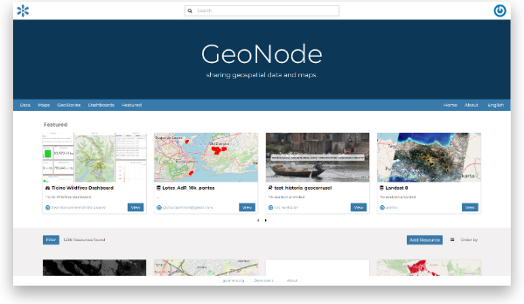

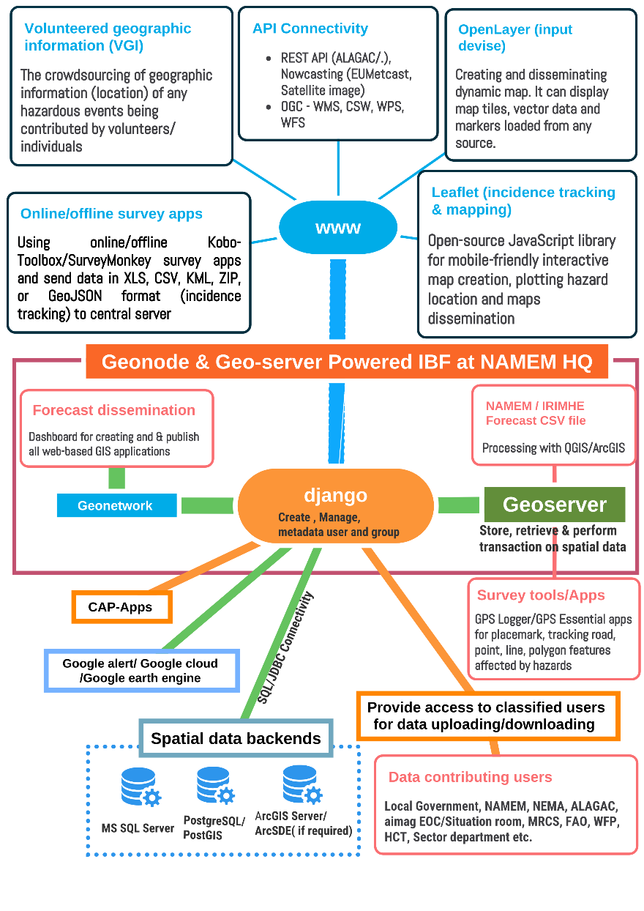

Figure 4 : ICT Structures for Developing the IBF Platform(Source: Z M Sajjadul Islam , UNDP-GCF)

3.1.2 Installation of Geoserver :

GeoServer is an open-source geospatial tool. Implementing the system will significantly lower the financial barrier to entry when compared to proprietary GIS products. In addition, GeoServer is not only available free of charge but also open source. Bug fixes and feature improvements in open-source software occur transparently, often at an accelerated pace compared to closed software solutions. GeoServer is a Java-based server that allows users to view and edit geospatial data. Integrate With Mapping APIs. Using open standards set forth by the Open Geospatial Consortium (OGC), GeoServer allows for great flexibility in map creation and data sharing.

GeoServer allows us to display spatial information to the world. Implementing the Web Map Service (WMS) standard, GeoServer can create maps in a variety of output formats. The server supports most of the available tools e.g. OpenLayer, leaflet, Google Maps, Google Earth, Microsoft Bing Maps, and MapBox, etc., and can connect with ESRI ArcGIS and QGIS software.

3.1.3 Anchoring google mapping tools :

- Google Earth: For accessing Google map resources with very few subscriptions paying to Google, the IBF platform will be able to utilize all Google GIS features accessed by Geoserver, geonede server, user end desktop QGIS and ArcGIS software( free) for analyzing the impact of all elements, calculate/estimate impact number and types of elements are likely to impact, select particular elements are damaged, hotspot location of multi-hazards and publishing all impacts through IBF platform.

- Google Earth Engine: Most powerful and up-to-date satellite images are included to analyze all the necessary features of agriculture (livestock ) , water resources, soil & land resources, land cover, land use, agroecology, soil degradation, desertification, etc., can be created by using the readily available code and necessary customization. By using this tool, the sector department will be able to define pasture biomass conditions, delineate pastureland areas with classification, and select cultivable forage cropping areas, water resources, etc for weather and Climate-related risk and vulnerability analysis.

- Google CAP – Public alert (Freeware) : Using the location information in a CAP alert allows Google Public Alerts to focus the display of an alert to users in a particular area. In addition to the user's search term, the display is governed within Google Public Alerts by a relative priority based on CAP alert values such as Severity, Urgency, and Certainty as well as date/time values. Users interested in all active alerts in an area can use the homepage at http://www.google.org/publicalerts.

3.1.4 Installation and Configuring surveying apps.

- Open Layer: Open Layer is a client mapping web GIS application. IBF volunteer/surveyor can use open layer apps for capturing location and on-the-fly mapping, incorporating pictures, and geolocation placemark to GeoServer for publishing.

- GPS data logger and GPS essential apps are alternatives to Open Layer and the most useful surveying tools. It can capture any placemark(point), line (road network), and polygon features ( Ger Location, grazing areas, Pasture location, river cross-section, can track vulnerable road, road network ) and save as kmz, kml format. In the given case, IBF the team (NAMEM HQ or aimag EOC/Situation room) asked any volunteers to send the placemark of ger location/herder grazing areas, multi-hazard affected areas e.g. flood/flash flood incidence place with geolocation captured photograph to send via WhatsApp/google drive, etc. for impact analyses, anticipatory action planning, contingency planning and, response financing.

3.1.5 Deploying File-Sharing Tools :

The best option is implementing Microsoft SharePoint(costly and subscription required ), Google Drive, dropbox, Google Cloud, FTP server, and other HTTP sharing services. But the partners can directly upload any picture and documents to geonode server.

3.1.6 Implementing Web converting common alerting protocol (CAP )apps :

There are several tools available for developing CAP on marking the location of multi-hazards with thresholds of impact ( both in point and polygon shape feathers ) that can be plotted with the map with some technical briefing of color-coded thresholds over the map. The CAP-enabled emergency alerting system e.g. Google Public Alerts freeware, paid service like ESRI ArcGIS platform, etc.

3.2 Rationale of integrating ICT with the IBF platform :

ICT System: The basic principle of the IBF system is to make a paradigm shift from the regular pattern of weather forecasters ( what weather would be) to translating the weather phenomena to what weather will do and how it will interact with the ground. The complete functional system will be able to catch weather inputs process with ICT engineered system capacity to interpret weather-induced advisories, anticipatory impacts, the severity of impending risks and vulnerabilities, and anticipatory loss and damage sceneries with the higher spatial and temporal resolution for the vulnerable sectors, elements, community.
- Functioning real-time(spatial and temporal) weather updates :
- Providing customized forecasts for the target audience:
- Leverage a national dashboard of multifaced climate risk information.
- Risk-informed weather advisories, warning for the sectors
- Operational forecast for the round-the-clock functioning business process of Mongolia
- Temporal and spatial updates of ongoing extreme weather phenomena to sectors with a weather warning, common alerting protocol, multi-hazard early warning, and advisories for the local level.

- Installation of ground-level hybrid observation mechanism :
- Considering the multiple functionalities of the IBF system, from capturing the wide range of impact information from the ground, processing big data, inclusive participation of a wide range of stakeholders, and keeping the target audience updated about ongoing weather hazardous phenomena informed, IBF need to well interface with ground level hybrid observations( figure 9) by engaging the community, sectoral technical experts working at the last-mile, volunteers, NEMA designated technical and volunteering teams at the last-mile
- ICT IBF can leverage to deploy and activate crowd source-based observation mechanisms for getting comprehensive and higher resolution of ground-level weather parameters, characteristic of extreme weather parameters on the prevailing conditions for better impact analysis and bringing detailed risk scenarios of the grounds e.g. which elements are impacting at what level, etc.
- Weather-induced risk and vulnerability tracking, interpretation, and dissemination :
A hybrid (figure 9) surface observation mechanism (AWS, manual met stations, crowdsource observations) essentially has a comprehensive observation for understanding the trend of weather patterns, extreme characteristics, frequency, and intensity. Based on every decadal (10 days), monthly, sub-seasonal, and seasonal anomalies, and the incidence of multi-hazards events, develop a complete GIS map-based analysis with Soum, Aimag level, and county level GIS base map to keep the planning desk informed. This is an important informed tool for planning tasks at every level so that every audience can understand the weather pattern, extreme characteristics, frequency, and intensity of weather-related hazards quite comprehensively for planning the SOP and business community plan for next season/ year accordingly.
- Multi-hazard and disaster incidence and situation tracking and archive:
- IBF needs to have a track record of how hazardous weather phenomena turn into multi-hazards and disasters and the incidence of loss and damage ( L & D) information required.
- Leveraging the record keeping and dissemination of all range of forecasting products, outlook, and advisories on weather and simultaneously to the similar interpretation of observed weather.
- Effective inputs for developing annual climatology, climate change paradigm from systematic surface observation, global and regional climate change model outputs, and developing comprehensive reports.
- Scope of verification and retrofitting and correctness of Dynamical downscaling model:
- Ground-level compressive observed, weather phenomena, elements level impacts, sectoral level impacts, and loss and damage scenarios will be able to provide attribute information for model fitness, forecast verification, and bias correctness at the end of the day.
- Leverage to develop the statistical model with the spatial and temporal resolution, high-resolution Dynamic downscale model on rapidly developing weather systems, e.g., cold front, convective weather events (heavy rain, thunderstorm, hailstorm, lightning), severe snowstorms, blizzards, high wind-induced impacts, heatwave, sand/dust storm) that have already taken huge tolls (human lives, lost livestock).

- Effective risk communication and sectoral coordination :
Leveraged to develop a complete culture of compliance to mandatory stakeholders’ interactivity to provide risk and vulnerability data inputs, risk interpretation of risk on every forecast, risk data coordination, and exchange of all relevant stakeholders.

3.3 Software & Tools Proposed for the ICT-integrated IBF Platform

Table 3: Checklist of Software & Tools

SL | Software /Tools | Features | Usability
 | QGIS/ArcGIS | Desktop GIS software is used to visualize, create, edit, manage, and analyze spatial data and create maps and other cartographic products. | - Forecast threshold, impact level, anticipatory loss, and damage estimation.  - Risk and vulnerability analysis, Risk area identification, impact calculation, estimation
 | Google Earth Pro | Desktop software to visualize spatial data, satellite images, and maps and produce 3D images and videos for presentations and reports. | GIS shapefile Geospatial gazetteer/elements of the Google map.
 | Google Earth Engine | An online platform for visualizing geospatial data and conducting large-scale scientific analyses of large datasets. It contains a historical series of satellite images. | - Google Earth Engine remote sensing satellite images useful for landscape, environmental, hydrological, landcover, geospatial, landscape, land use, natural resource management, risk and vulnerabilities analysis, and land use mapping by using a built-in cooking library.  - Anchoring earth engineer built-in features/tools with IBF.
 | Real Flight using UAV(Drone ) | - Drones are essentially for spatial data capture, land uses vulnerability mapping, data collection, conducting CRVA, mapping, multi-hazard risk napping, location tracking, spatial mapping aerial survey, etc.  - Weather drone for convective cloud detection, lighting detection, etc. | Mapping and data collection
 | Online Mapping and survey | Open Layer, QFiend, | Geospatial surveying tools are used to capture multi-hazard incidence and feed it into the IBF Online Platform.
 | Online survey | Kobo-Toolbox (Socioeconomic Surveying)  GIS Logger ( Placemark, geolocation capturing, road network surveying )  GPS Essential | Socioeconomic Surveying of herders, community, sectoral elements, sectoral progress review, elements geolocation capturing with GPS coordinates, etc essential for the IBF impact analysis and FBF decision support.
 | PostgreSQL / PostGIS | Open-source database management, with an extension of PostGIS – Spatial database extender for accessing geospatial databases. | Open-source database management, with an extension of PostGIS – Spatial database extender for accessing geospatial databases.
 | Geonode & Geoserver | Open-source online mapping and map sharing platform. Having interfaces with Web Map Service (WMS), Web Feature Service (WFS), and Web Coverage Service (WCS), among others. | Online mapping facility, mapping services with QGIS and ArcGIS software
 | ArcGIS Server (Subscription/licensing required) | ArcGIS Server is a back-end server software component of ArcGIS Enterprise that makes your geographic information available to others in your organization and, optionally, anyone with an internet connection. This is accomplished through GIS services, which allow a server computer to receive and process requests for information sent by other devices | ESRI Enterprise GIS mapping and WebGIS solution https://enterprise.arcgis.com/en/

IBF internal and external data acquisition and coordination system ( maintaining data sensitivity and privacy).

3.4.1 Data workflow and data archive structures ( at IBF central level ) :
The ICT structure of the IBF system is the clustered database servers at backends to handle database services. The geonode and geoserver function through an integrated process of database and online mapping services. For IBF purposes geonode and geoserver provide an online map publishing facility in which primarily the forecast CSV file is used to produce impact forecasts with QGIS and ArcGIS mapping software and then directly publish the forecasts map using WCS, WPS, and WFS API interface with geonode and geoserver. After creating the impact forecast maps and inserting the technical narratives of anticipatory impacts of the thresholds of the forecasts for dissemination online. However, IBF is an integrated forecast impact analysis and publishing tool with an online GIS system. The IBF geonode/Geoserver architect with the relational database fetches data & information programmatically from multiple sources and gives output. As a result, a dependent data hub needs to be installed for facilitating an independent workflow with recurrent intervals. Removing the data/information exchange and coordination barrier and bureaucracies and centralizing the data archive provide a trusted solution.
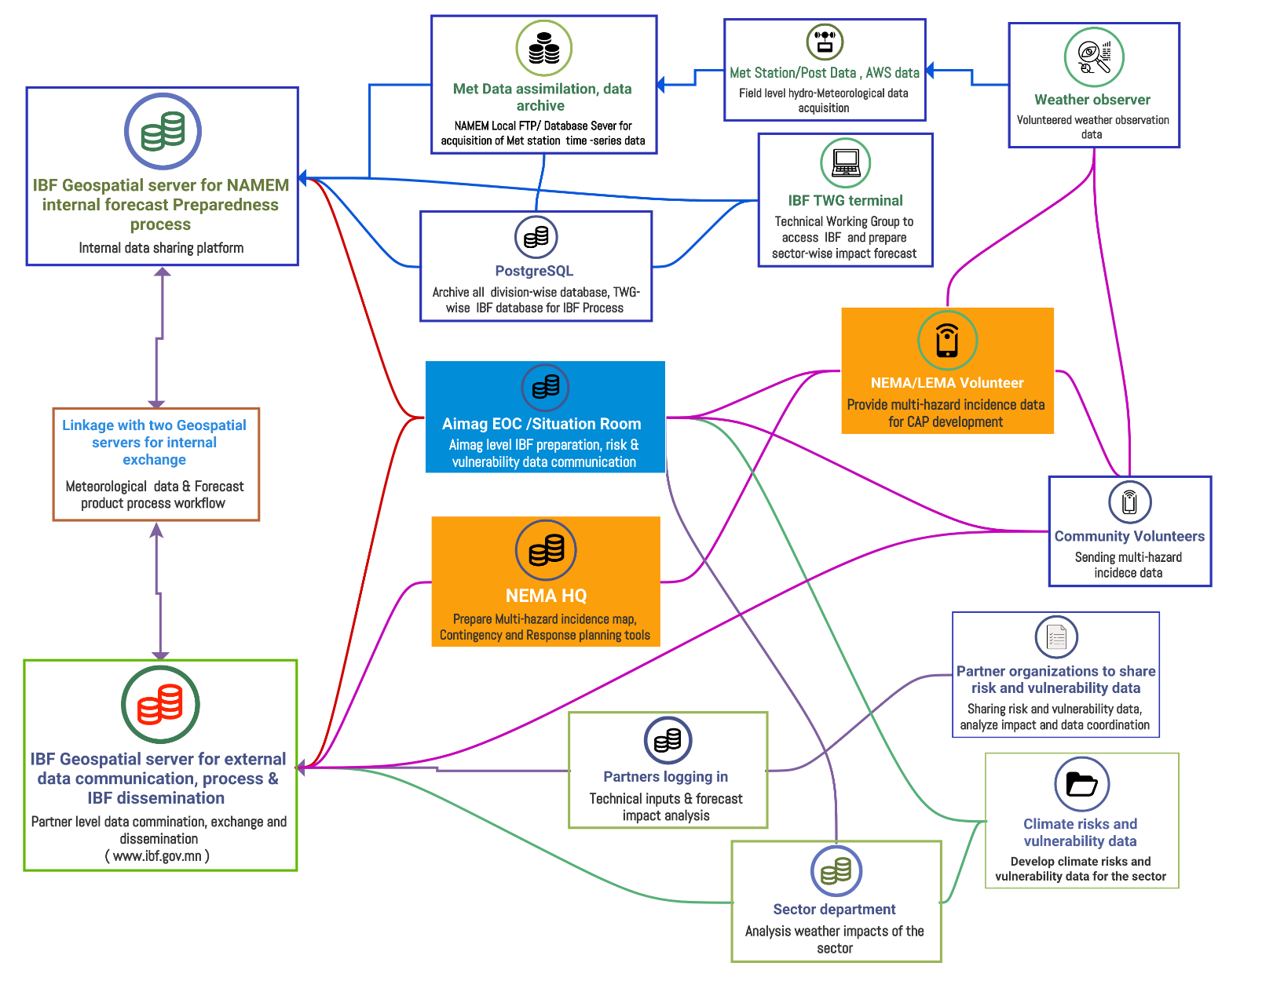
Figure 5: The typical architecture and data flow diagram of the IBF Open-Source platform (Source: Z M Sajjadul Islam, UNDP-GCF)

Considering weather data security, the IBF ICT structures are being integrated by two geospatial platforms (geonode/geoserver). Figure 3 above shows that the two IBF NAMEM/IRIMHE geospatial servers are concurrently functioning: the internal server facilitates internal data organization, assimilation, storage, and the internal research division's daily functioning and workflow handling, and the external geoserver disseminates web-based public geospatial services and acquires stakeholder data.
a)Diagnose existing System :
Currently, NAMEM has a Microsoft Windows-based intranet system installed for acquiring local meteorological datasets from the met station and weather posts, which are transmitted through an FTP server. The data are then calibrated, assimilated, and processed, and made available to the local area network (LAN) via intranet web services. The integrated IBF system is intended to be upgraded to an automated system.
b) System upgradation:
1) Automated data acquisition from a hybrid observation system ( figure 9)
- Automated weather station (AWS)
- The remote community handled Modular weather instruments-based data acquisition.
- Deploying crowdsource-based nested ground observation by positioning as many grid compatibility observations as possible, handled by crowdsource from the ground, by setting up modular weather observation instruments.
- Capturing multi-hazard incidence, loss, and damage statistics from the crowdsource.

- Required data workflow for an integrated IBF process :
The integrated impact forecasting and warning system is to be designed to function with various IT applications programmatically. The proposed IBF system is an ICT-integrated process governed and powered by the partner's interactive process. The IBF system needs real-time(time series) surface observed weather data, eye-observed weather phenomena data, and running statistical and Dynamical downscaling for predicting hazardous events. The spatiotemporal resolution data works fine for this sort of modeling and analysis. Analyzing the hazardous weather moving trends/fluctuation of impact levels etc., severe cold temperature, high-density snowfall, strong winds, and snowstorms, etc., those cases we need to track every situation on the ground over the already issued forecast lifecycle & lead-timings and analyze the back-and-forth intensity frequency and scalability of the prevailing conditions and how long it will likely do the damage until it dissipates.
- Impact analysis with ground-level risk and vulnerability data:
The automatic weather station (AWS) dataset is an essential input for developing nowcasting algorithms, as well as statistical and Dynamic downscaling for rapidly developing weather conditions. Crowdsource event situation updates are needed to measure loss and damage (L&D) and tolls from the weather-hazardous incident (crowdsource data). For functioning those processes, the IBF platform needs to be equipped with ICT instruments ( database, data capturing apps, interface with crowdsource network, social network, communication tools, and even tracking android apps, etc) for storing big datasets.
Conducting risk and vulnerability analysis of previous/past weather synopsis of the country and local administrative level ( aimag, soum, bag) above-mentioned spatiotemporal resolution weather data, situational data ( with pictures and video clip), and incidence tracking data, leverages an important input for risk and vulnerability analysis of the impacted sectors and elements.

- Supporting forecast-based financing: Tailor-made past weather Risk-informed data, GIS-based interpretation maps, and scientific and technical elaborations of weather risk over the elements need to be regularly archived and disseminated, which will hugely leverage to risk-informed planning decision-making, multi-hazard contingency planning ( ahead), and it hugely supports as advocacy tools for pledging humanitarian funds ahead of impending extreme weather resource mobilization.

3.4.2 Centralization of Database Archive and Services by IBF Platform

- Operationalizing the IBF Database server for partner-level data coordination and exchange mechanism :
The objective of the process is to digitally link partners/stakeholders, mandating data generation, coordination, and exchange mechanisms with an automated process. A robust IBF process requires retail-time, interactive, and functional data coordination and exchange mechanisms in place. The cross-functional process is intended to function automatically to minimize the recurrent manually driven process.
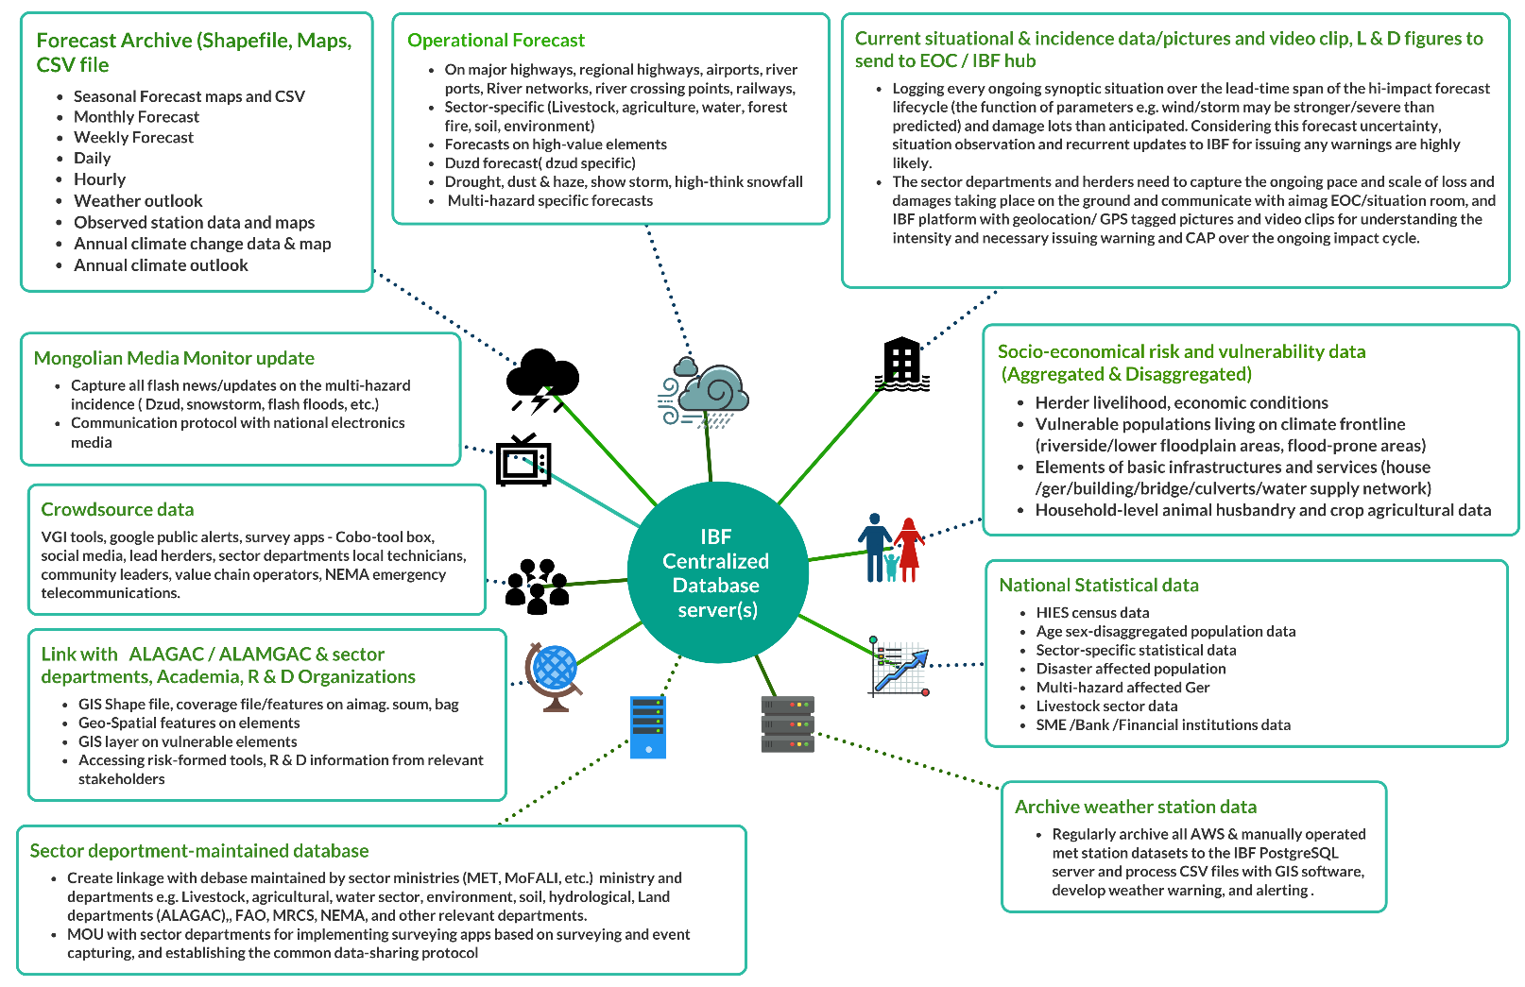
Figure 6: IBF Database server for partner-level data coordination and exchange mechanism ( Source: Z M Sajjadul Islam, UNDP-GCF)

The diagram illustrates the databases, data field types, components, data acquisition, and methodologies for systematically capturing, coordinating, exchanging, and reporting data to centralized IBF platforms.

3.4.2.1 Develop databases with PostgreSQL server :

Types of databases/archives | Data processing and ICT systems | Input and Output Methodology
National met agency weather data ( AWS/Manual/Post ) on time series needs to be archived | All process weather parameters data needs to be archived to the appropriate SQL servers for any time-based uses | - Database system for automatic archive  - Manually archive using API, e.g. REST, WCS, WFS, WPS
Short-range forecast data archive | All CSV files, forecast image files, and GIS shapefiles need to be stored in the Geonode server at regular intervals | Integrated system for automatic archive
National Statistical data | - There are some ways to access NSO datasets regularly by downloading from NSO website ( www.1212.mn  - Download all Excel/CSV files from 1212.mn server and upload to PostgreSQL/MySQL server.  - Sign an MOU with NSO so that during the conduct of surveying at the local level, an advisory for capturing the geolocation of the elements to be surveyed. | - Copying data using ODBC connectivity with the designated server of the departments belonging to  - Manually collect data with Excel/CSV and upload to SQL server
Population, households(ger), Socio-economic sectors risk and vulnerability data ( aggregated and disaggregated ) | - By using Kobo-toolbox survey apps, the NSO, NEMA, NAMEM, and Sector departments, I-NGO need to conduct surveys and develop disaggregated data on the sector, elements, specific risk, and vulnerabilities. That data will directly go to the server. | Stakeholders are to use surveying apps, such as Kobo-Toolbox, GPS logger apps (for capturing GPS locations and placemarks), and GPS Essentials apps for geo-tagging pictures of the vulnerable elements.
Capturing and archiving Current situational & incident data/pictures and video clips, Loss & Damage figures | - Using geonode and geoserver uploading options, the remote volunteers, sector department technicians, field-level experts, humanitarian actors, and other classified users  - Creating a social network ( Facebook group, Twitter, Telegram, WhatsApp ) and letting individuals ( logistic operators, students, researchers, herders, value chain operators, farmers, livestock, individuals ) send event pictures & geocoordinates (lat /long) of the incidence, some impact info’s, some loss and damage figures, etc will support response planning and decision making. | Social networks can be widely used for crowdsourcing data collection
Database on Loss and damage(L&D) statistics, scenarios, pictures, and videos. | Develop a database with a PostgreSQL server, develop an interface with geonode/geoserver server, and provide user access for uploading documents, video, and pictures for risk interpretation | All impacts, L & D datasets to store with SQL server for risk-informed tools development
Operational Forecast | - Using the Geonode server REST API and directly connecting with QGIS/ArcGIS desktop software, the user can create every forecast-based coverage file/shapefile and develop need-based maps.  - Using QGIS/ArcGIS software, develop a forecast shapefile, adding it as a layer/adding a server geonode server | Develop an operational forecast GIS map by using a forecast CSV file ( Annexure 5) and upload it to geonode server for dissemination to the public.
All forecast bulletins and maps are to archive with the IBF platform ( geonode & geoserver) . | - Using QGIS/ArcGIS desktop application and connecting with Geonode server REST API to create a Shapefile of every forecast on the Geonode server for archive and giving access to end-users for further use.  - The sector departments will be able to access the forecast map and shapefile for further analysis, send back all those shape files to the geonode server, and create sector risk from the desk.  - NEMA will be able to create GIS maps for disaster preparedness, response planning, and contingency planning by using QGIS/ArcGIS software. | Using REST, WCS, WFS, and WPS API the experts/specialists can directly archive their forecast products ( GIS shapefile, CSV, GIS maps, technical narratives, etc.) and can directly upload to geonode server.
Crowdsource data capture by QField survey tools ( with geonode server), Kobo-Toolbox, GeoExt, ExtJS, OpenLayers, Leaflet, GeoJSON using API of ArcGIS and QGIS sending to geonode server. | Connection with Geonode server using GeoExt, ExtJS, OpenLayers, and GeoJSON apps which is Open Source and can build desktop-like GIS applications by using geonode API | Volunteers of the different organizations
Google public alerts (multi-hazards) Common alerting protocol (CAP) | Develop a common alerting protocol on multi-hazards | Configure Google Public alert for live(real-time) alerting of the multi-hazard incidence hotspot ( just prevailing hazardous conditions at the local level ) location.
Google Cloud | Partner-level data sharing and exchange tool | Web-based Google Clouds
Volunteered geographic information (VGI) for incidence tracking by the volunteers/general people | - The crowdsourcing of geographic information addresses(location) of any hazardous events, where geospatial data is contributed by volunteers/individuals (on the fly) by WPS and WFS  - VGI can be seen as an extension of critical and participatory approaches to geographic information systems. Some examples of this phenomenon are WikiMapia, OpenStreetMap,

3.4.2.2 Impact forecast manufacturing tools, input datasets, and Process:

Organization /Partners | Data type | Data capturing/Processing tools | Forecast Data accessing & sharing protocol | Data Process for IBF platform
NAMEM | Forecast CSV file, GIS shapefile | - High-performance computing (HPC) Supercomputers for preparing 1-5 km gridded forecasts outlook/CSV.  - The weather station data calibration, assimilation, and processing software show the current weather situation prevailing on the ground. | The CSV files of long-range, medium-range, and short-range forecasts/outlook/watch/advisories and NWP output are to be made available at the IBF platform and subsequently give access to aimag EOC/Situation room experts, sectoral department technical partners, academia, hydro-meteorological R & D organizations, scientists, sector specialist ( water, livestock, agriculture, soil & land, etc.,) to be engaged for sector-specific impact/risk/vulnerability/sensitivity when hihg0imapct weather be forecasted and need impact analysis ( High-resolution gridded data ) for the sector and elements | Connecting from desktop QGIS/ArcGIS software to Geonode server with WCS, WFS, REST API and creating maps on impact forecasts, and impact analysis.
NAMEM/IRIMHE | - Station observed times-series weather station/ weather-post/human observer/telematic station and other gauzing, observation points, etc datasets to be collected, assimilated, and processed. All that data to upload to the PostgreSQL server for programming automatically and developing Common Alerting Protocol (CAP) / MHEWS ( on flash floods, heavy participation, heatwave, snowstorm, etc ) for the common people. | - Programming with Google public alert, GitHub code, ArcGIS disaster alerts (https://www.esri.com/en-us/arcgis/products/arcgis-geoevent-server ).  - Third-party CAP using GitHub coding.  - Programming with Google Earth engine for geospatial risk analysis, landcover mapping, agricultural planning, etc.  - Remtoe sensing ERDAS Imagine, ER Mapper etc sofware  - Mike 11 for flood risk mapping  - Other paid software NAMEM is currently using for impact analysis and risk mapping. | Geonode and geoserver integrated IBF geospatial platform deployment for the total IBF process.  (www.ibf.gov.mn www.weather.gov.mn ) | Connecting from desktop QGIS/ArcGIS software to Geonode server with WCS, WFS, REST API and creating maps on impact forecasts
- NEMA at HQ  - LEMA at aimag/soum/bag level  - NAMEM/NEMA running EOC/Situation room at aimag level | Field-level technicians, and volunteers, aimag EOC to use mobile apps and Prepare CSV/kmz/kml files of Geolocation/Placemark where critical and emergency response services are required. | - GPS data logger and GPS essential apps of disaster incidence hotspot location (kmz/kml) and pictures.  - Using QField( QFieldSync plugin) and QGIS installed in Android devise and prepare a survey area GIS shapefile of disaster incidence hotspot location   - Open layer  - VGI tools  - KoboTool box installed with android device for giving input the details about the survey required for response planning.  - Survey123 of ArcGIS platform ( subscription required) | Using QGIS/ArcGIS software, process the incidence data, create a shapefile, and directly upload and create a map with narratives to the geonode server for public access. | Connecting from desktop QGIS/ArcGIS software to Geonode server with WCS, WFS, REST API, and creating maps on multi-hazard incidence, situation alert map
ALAGAC/ ALAMGaC ( land administration department ) | Provide access to necessary Shapefile/kmz/kml file by delineating the impact areas that are likely from the CSV forecast file e.g. flood-prone, flash flood-prone, water logging, landside areas, drought-prone areas, land use /land cover, etc, and quantitative anticipatory L & D data | - QGIS/ArcGIS desktop software and accessing the geospatial server(IBF).  - Field technical/surveyor to install GPS data logger and GPS essential apps of disaster incidence hotspot location (kmz/kml) and pictures.  - Using QField( QFieldSync plugin) and QGIS installed in android devise and prepare survey area GIS shapefile of disaster incidence hotspot location.  - Open layer with Android mobile mapping  - VGI tools with android mobile mapping  - Kobo Toolbox to be installed with android device for giving input the details about the survey required for response planning ( with geolocation).  - Survey123 of ArcGIS platform ( subscription required) | Using QGIS/ArcGIS software process the incidence data, crate shapefile, and directly upload and create a map with narratives to geonode server for public access. | Connecting from desktop QGIS/ArcGIS software to Geonode server with WCS, WFS, REST API and creating maps
NAMEM/NEMA running EOC/Situation room at aimag level | - Develop Aimag/Soum/bag level GIS base maps with GIS shapefile ( annexure 5.)  - Conduct climate risk and vulnerability Assessment (CRVA) and develop GIS shapefile, GIS maps on CRVA atlas.  - Conduct field survey with QField, GPS data logger and GPS essential, KoboTool box, etc., apps, capture sector-specific risk and vulnerability(Ger/camp location, pasture area, degraded area, water access points etc.) datasets( excel/dbf/csv)  - Excel sheet on anticipatory loss and damage calculations and narratives of impacts over the forecast thresholds. | Analyze weather forecast CSV file of designated aimag with ArcGIS/QGIS software and analyze detailed risk, vulnerability, exposure, anticipatory loss, and damage impact calculations with ArcGIS/QGIS software. | Using QGIS/ArcGIS software process the incidence data, crate shapefile, and directly upload and create map with narratives to geonode server for public access. | Connecting from desktop QGIS/ArcGIS software to Geonode server with API’s -WCS, WFS, REST API, and creating maps.
Sector Department at aimag/UB level | - Develop Aimag/Soum/bag level GIS base maps with GIS shapefile ( annexure 5 )  - Conduct climate risk and vulnerability Assessment (CRVA) and develop GIS shapefile, GIS maps on CRVA atlas.  - Conduct field survey with QField, GPS data logger and GPS essential, KoboTool box, etc. apps, capture sector-specific risk and vulnerability(Ger/camp location, pasture area, degraded area, water access points etc.) datasets( excel/dbf/csv)  Excel sheet on anticipatory loss and damage calculations and narratives of impacts over the forecast thresholds. | Analyze weather forecast CSV file of designated aimag with ArcGIS/QGIS software and analyze detailed risk, vulnerability, exposure, anticipatory loss, and damage impact calculations with ArcGIS/QGIS software | Using QGIS/ArcGIS software process the incidence data, crate shapefile, and directly upload and create map with narratives to geonode server for public access. | Connecting from desktop QGIS/ArcGIS software to Geonode server with WCS, WFS, REST API, and creating maps.
R & D organizations and academia | Develop a repository on research elements impacted by extreme weather events/climate change ( plant species, soil health, soil type, land type, livestock complexities on extreme weather, zoonotically affected diseases, human health, water quality, pollution, agriculture cropping, desertification, drought tolerant agriculture/plant species etc. ). | - Logging on to geonode server and analyzing the weather forecasts and accessing the forecasts maps  - Analyses the extreme weather parameters temperature, extreme cold temperate, snowstorm, winter storm, strong winds, cold & warm front, heavy rainfall, hailstorm, etc. parameters of spatiotemporal scale effects on forecasted areas and provide a technical briefing on anticipatory impacts, L & D of the elements any logging on to geonode server and write | Using QGIS/ArcGIS software process the incidence data, crate shapefile, and directly upload and create a map with narratives to geonode server for public access. | Connecting from desktop QGIS/ArcGIS software to Geonode server with WCS, WFS, REST API, and creating maps.
NEMA volunteers, MRCS volunteers,  Logistic transporter, herders, rangeland health monitor, pasture photo point monitor, sector department technicians, weather observer, land administration technician,  Crowdsource and other useful volunteers | - Placemark - CSV, kmz, kml files  - GPS-tagged pictures, video clips | GPS data logger and GPS essential, google maps, VGI android apps and capture the placemark and some narratives of the hazard events | - | Use IBF big data sharing platform, Google Drive, WhatsApp group, Facebook group etc., and upload files
National Broadcasting Agencies/ news media outlets ( discussed next chapter) | Communicating any news updates and video clips of multi-hazards with IBF media monitoring tools/ platform | Risk information(news, video clips, pictures) communication with IBF media monitor tools/ platform | Uploading news, video clips, and pictures to the IBF data-sharing platform | MoU with the broadcasters and news outlets for recurrent news updates

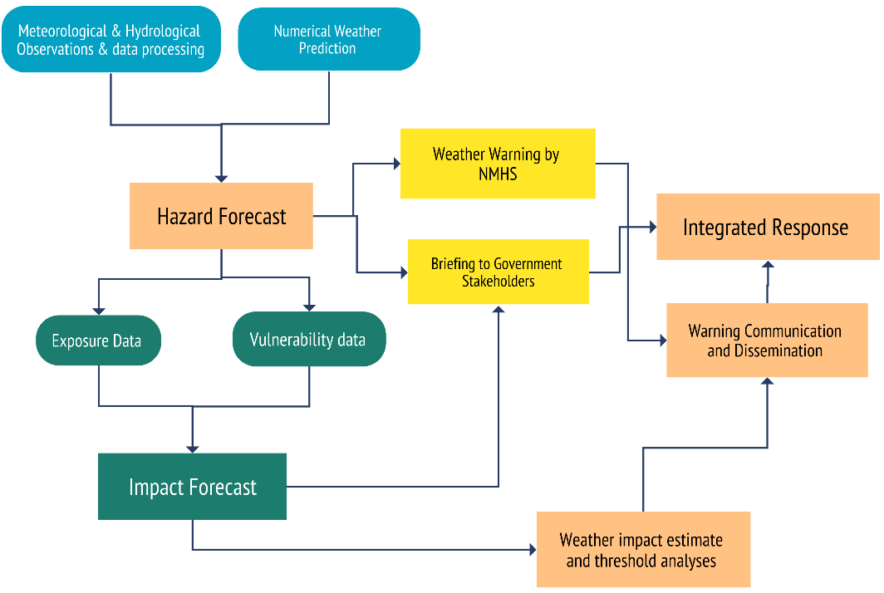
Figure 7 : National hydrometeorological service (NMHS) workflow diagram for IBF(Source: Z M Sajjadul Islam, UNDP-GCF)

4.0 Chapter: Data Coordination and Exchange Mechanisms

4.1 Data Coordination and Exchange Mechanisms at Aimag level :

The objectives of this exclusive coordination and exchange mechanism are to strengthen the IBF's pivotal roles in establishing and improving dataflows required for ongoing forecast impact analysis, weather warning, alerting, multi-hazard early warning, severe weather forecasts dissemination, facilitating interactive and effective communication, functioning coordination for exchange of disaster emergency data and information on on-set disaster events at the local level, and subsequently preparing early action protocol(EAP), early warning early actions and event situation report on the occasion of disaster being declared by the government.
The IBF mandate is to Improve the disaster risk management governance at multiple levels following through the top-down & bottom-up approach with the following technical objectives :
- Delegating process, guidelines, strategies to aimag/soum/bag local government ( EOC /situation room at aimag), NHMS organizations (NEMA, Met Agency, vulnerable sector departments, hydrological organizations, local governments ) on conducting multi-hazards risk & vulnerabilities analysis, the repository of multi-hazard risk database & corresponding GIS Map at all administrative level.
IBF at the UB needs to delegate and propagate strategy, process, and activities to conduct comprehensive risk and vulnerability assessment at national, regional/aimag /soum/bag level and to develop risk repository and informed tools which are essentially required for having risk scenario/phenomena, GIS multi-hazard risk & vulnerability distribution map readily available in hand. These mandatory tools are necessary for impact analysis of the multi-hazard triggered by extreme weather events.
- Develop GIS base map on aimag/soum/bag jobs to aimag EOC( Situation room) for supporting IBF hub :

IBF forecasting team to supply the forecast CSV files on a regular interval. The synoptic engineer/forecasters at aimag EOC ( Situation room) need to call a briefing session over the supplied CSV /forecasted map and organize forecast briefings about the high impact of impending hazards over the sectors, sectoral elements, herders, livestock, etc.

Interpret impacts of weather with GIS maps of aimag : IBF central( NAMEM HQ) to delegate responsibilities to aimag level emergency operations center ( EOC) /Situation room for preparing impact forecasts ahead of 5 days and giving the threshold of 5 days amount of precipitation accumulation with the projection of rainfall color-coded level of warnings and advisories, temperature anomalies, advisories of strong winds and other multi-hazards.

- Functioning EOC/Situation room under SOP:

- Establish a coherent coordination mechanism over the standing orders on disaster (SoD) for the engagement of stakeholders at the local level.
- Conduct multi-hazard risk screening, assessment of disaster damage and needs, data capture, and information coordination.
- Utilizing an open-source GIS platform( geonode and geoserver) Aimag EOC/Situation room to remain operational in risk screening, data & information capture, and coordinating the datasets, and information to NAMEM HQ.

- Developing & conducting interactive forums over the social networks

- Utilize the social networking platform for inclusive interactive participation of audiences.
- Taking feedback from stakeholders, focal points, and vulnerable communities for further customization and improvement of products and services for meeting the demand.
- The development, access, and use of the best science and new ICT technologies underpin all components of multi-hazard early warning systems.
- The feedback that learning from good practices of understanding & receiving early warnings by the vulnerable community from the remote & hard-to-reach areas.
- Strengthening the Early Warning for Early Action (EWEA) chain, taking on an impact-based forecasting approach in early warning to enable organizations and communities to formulate understandable and actionable messages and take respective preparedness and response measures.
- Upgrading the web portal for customization to capture disaster event information at the up-to-date level.

- AWS weather station set up with telecommunication BTS for uninterrupted data transmission: Singing MoU with cell phone companies and using their BTS for installing a few instruments and using the network for data transmission.

Figure 8 : The typical architecture and data flow diagram of the IBF Open-Source platform (Source: Z M Sajjadul Islam, UNDP-GCF)

- Crowdsourced observation :
The crowdsourced observation can play a significant role as an informal weather station observer while supplying them weather parameter observation instruments e.g. thermometers, handheld anemometers, rain/snow gauging instruments (modular, handheld ), and those are installed at tourist resorts, community houses, offices buildings at the riverside ( lower flood plain areas), the permanent settlement at hard reach areas, logistics transporter, herders, livestock office, agricultural office, forest office( forest ranger), local government office, and fixed installations ( telephone/ cell phone towers), etc.
On the other hand, volunteer groups are mandated to provide weather and hazard incidence information via Android phone apps to the IBF server. On many occasions, comprehensive ground-level observations are required to understand what type of impact and L & D are taking place on the ground, the potentiality of turning impending extreme weather events into multi-hazards( e.g., severe cold temperate and winter storms), and induced disaster on the ground, the extended lead-time for dissipation, etc. The crowdsourced network is to be utilized to capture up-to-date incidence and scenarios of the trail of damage level and extent areas where extreme/hazardous events are prevailing, the magnitudes and intensity, and the level of impacts over the livelihoods and elements.
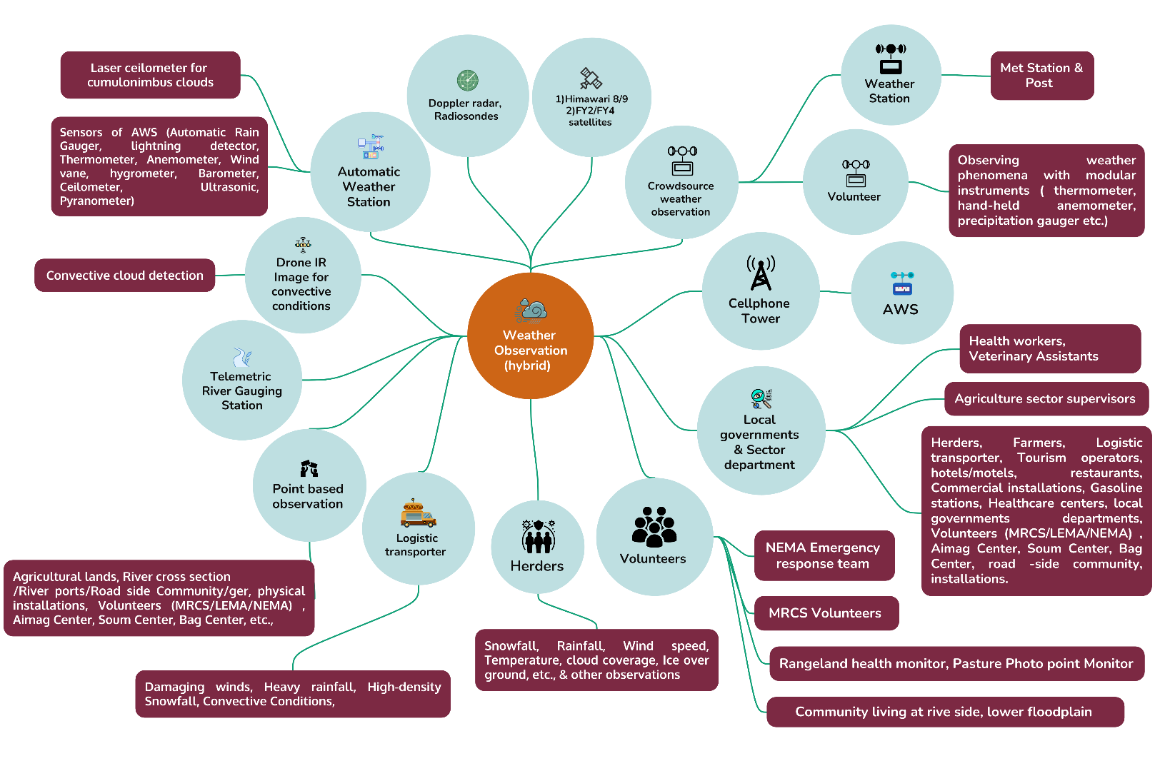
Figure 9 : Proposed hybrid - high-density, nested, and crowdsource-based surface weather observation and incidence monitoring system(Source: Z M Sajjadul Islam, UNDP-GCF)
.
However, crowdsource observation is to function as a strong communication medium by enabling social journalism to provide wider coverage of observations to inform NMHS about the scale, intensity , frequency and the pattern of impacts, L & D, facts, and figures. This volunteered social-observation process can essentially track the situation and to provide input for real-time early warning, alerting about the whole cycle of the extreme and hazardous weather observations to wider geographic magnitude and intensity over the prevailing onset weather situation, tracking any incidence, loss & damage scenarios, etc.
IBF TWG to organize the crowdsource observation team, conduct orientation and provide the necessary apps, and tools to be provided for the information feeds. The table below illustrates the ICT tools and process of the IBF system with open-source and interactive information access and sharing mechanism.
Table 4: Crowdsourced observation methodology :
Crowdsourced observation of the events | Designated observer | Devices & apps to be utilized | Types of data need to send IBF platform | Interactive crowdsource data collection tools
Herder camp location (base camp and other seasonal camps) | Herders / Community | - Thermometers, handheld anemometers, rain/snow gauging instruments  - Android GPS Logger  - GPS Essential apps for location  - Map layer apps  - Leaflet apps  - Mobile apps ( GPS logger, Kobo toolbox, GPS essential, leaflet, open layer, QField)  - Google cloud apps | Sharing geolocation, pictures of hazards side, description notes on impacts, loss and damage any elements | - WhatsApp group, Viber, Telegram  - Facebook Page/Group
Livestock forage shortage | - Herders  - Pasture management committee  - Rangeland health monitor | - Thermometers, handheld anemometers, rain/snow gauging instruments  - Android GPS Logger  - GPS Essential apps for location  - Map layer apps  - Leaflet apps  - Mobile apps ( GPS logger, Kobo toolbox, GPS essential, leaflet, open layer, QField)  - Google cloud apps | Sharing geolocation, pictures of hazards side, description notes on impacts, loss, and damage of any elements | - WhatsApp group, Viber, Telegram  - Facebook Page/Group
High-density snowfall and thick snow over the ground | - Herders  - Pasture management committee  - Rangeland health monitor  - Aimag, Soum, Bag centers | - Thermometers, handheld anemometers, rain/snow gauging instruments  - Android GPS Logger  - GPS Essential apps for location  - Map layer apps  - Leaflet apps  - Mobile apps ( GPS logger, Kobo toolbox, GPS essential, leaflet, open layer, QField)  - Google cloud apps | Sharing geolocation, pictures of hazards side, description notes on impacts, loss and damage any elements | - WhatsApp group, Viber, Telegram  - Facebook Page/Group
Depth of Icing over the biomass pastureland | - Herders  - Pasture management committee  - Rangeland health monitor  - Community | - Thermometers, handheld anemometers, rain/snow gauging instruments  - Android GPS Logger  - GPS Essential apps for location  - Map layer apps  - Leaflet apps  - Mobile apps ( GPS logger, Kobo toolbox, GPS essential, leaflet, open layer, QField)  - Google cloud apps  - Ice measuring instrument | Sharing geolocation, pictures of hazards side, description notes on impacts, loss and damage any elements | - WhatsApp group, Viber, Telegram  - Facebook Page/Group
Avalanche | Herders,  MRCS volunteers, LEMA/NEMA volunteers/ emergency rescue team, sector department technicians, Rangeland health monitors, Weather station observers,  Logistic operators( driver) | - Android GPS Logger  - GPS Essential apps for location  - Map layer apps  - Leaflet apps  - Mobile apps ( GPS logger, Kobo toolbox, GPS essential, leaflet, open layer, QField)  - Google cloud apps | Sharing geolocation, pictures of hazards side, description notes on impacts, loss and damage any elements | - WhatsApp group, Viber, Telegram  - Facebook Page/Group
Flooding | Community living on the riverbank & lower flood plain areas, Herders, MRCS volunteers, LEMA/NEMA volunteers/ emergency rescue team, sector department technicians, Rangeland health monitors, Weather station observers, Aimag, Soum, Bag centers | - Water level measuring scale  - Thermometers, handheld anemometers, rain/snow gauging instruments  - Android GPS Logger  - GPS Essential apps for location  - Map layer apps  - Leaflet apps  - Mobile apps ( GPS logger, Kobo toolbox, GPS essential, leaflet, open layer, QField)  - Google cloud apps  - Ice measuring instrument | Sharing geolocation, pictures of hazards side, description notes on impacts, loss and damage any elements | - WhatsApp group, Viber, Telegram  - Facebook Page/Group
Thunderstorms are likely | Herders,  Aimag, Soum, Bag centers  MRCS. LEMA/NEMA, sector department technicians, Rangeland health monitors, Weather station observers,  Logistic transporters ( driver)  Community living on the riverbank & lower floodplain areas | - Lighting detector  - Thermometers, handheld anemometers, rain/snow gauging instruments  - Android GPS Logger  - GPS Essential apps for location  - Map layer apps  - Leaflet apps  - Mobile apps ( GPS logger, Kobo toolbox, GPS essential, leaflet, open layer, QField)  - Google cloud apps  Ice measuring instrument | Sharing geolocation, pictures of hazards side, description notes on impacts, loss and damage any elements | - WhatsApp group, Viber, Telegram  - Facebook Page/Group
Thunderstorm just started | Herders,  Aimag, Soum, Bag centers  MRCS volunteers, LEMA/NEMA volunteers/ emergency rescue team, sector department technicians, Rangeland health monitors, Weather station observers,  Logistic operators( driver), sector department technicians, Rangeland health monitors, Weather station observers,  Logistic operators( driver) | - Lighting detector  - Thermometers, handheld anemometers, rain/snow gauging instruments  - Android GPS Logger  - GPS Essential apps for location  - Map layer apps  - Leaflet apps  - Mobile apps ( GPS logger, Kobo toolbox, GPS essential, leaflet, open layer, QField)  - Google cloud apps  Ice measuring instrument | Sharing geolocation, pictures of hazards side, description notes on impacts, loss and damage any elements | - WhatsApp group, Viber, Telegram  Facebook Page/Group
Convective weather conditions developed | Weather observers, Herders, MRCS, LEMA/NEMA, NAMEM technicians, sector department technicians, Rangeland health monitors, Weather station observers,  Logistic transporters (drivers), river port operators, Fuel stations, roadside settlements, farmers, value chain operators, fishermen | - Lighting detector  - Drone radar launched from aimag center  - Thermometers, handheld anemometers, rain/snow gauging instruments  - Android GPS Logger  - GPS Essential apps for location  - Map layer apps  - Leaflet apps  - Mobile apps ( GPS logger, Kobo toolbox, GPS essential, leaflet, open layer, QField)  - Google cloud apps  - Ice measuring instrument | - Sharing geolocation, pictures of hazards side, description notes on impacts, loss and damage any elements  - Sharing geolocation, pictures of hazards side, description notes on impacts, loss and damage any elements | - WhatsApp group, Viber, Telegram  - Facebook Page/Group  - Modular weather observation runs by herders, volunteers, farmers, tourism operators, and logistic transporter
Heavy rainfall started | Weather observers, Herders,  Aimag/Soum & Bag centers, MRCS, LEMA/NEMA, NAMEM technicians, sector department technicians, Rangeland health monitors, Weather station observers,  Logistic transporters (drivers), river port operators, Fuel stations, roadside settlements, farmers, value chain operators, fishermen | - Thermometers, handheld anemometers, rain/snow gauging instruments  - Android GPS Logger  - GPS Essential apps for location  - Map layer apps  - Leaflet apps  - Mobile apps ( GPS logger, Kobo toolbox, GPS essential, leaflet, open layer, QField)  - Google cloud apps  Ice measuring instrument | - Sharing geolocation, pictures of hazards side, description notes on impacts, loss and damage any elements.  - Sharing geolocation, pictures of hazards side, description notes on impacts, loss and damage any elements | - WhatsApp group, Viber, Telegram  - Facebook Page/Group
Heatwave | Weather station observers, Herders, MRCS, LEMA/NEMA, NAMEM technicians, sector department technicians, Rangeland health monitors, Weather station observers,  Logistic transporters (drivers), river port operators, Fuel stations, roadside settlements, farmers, value chain operators, fishermen | - Android GPS Logger  - GPS Essential apps for location  - Map layer apps  - Leaflet apps  - VGI apps  Google cloud apps | - Sharing geolocation, pictures of hazards side, description notes on impacts, loss and damage any elements.  - Sharing geolocation, pictures of hazards side, description notes on impacts, loss and damage any elements | - WhatsApp group, Viber, Telegram  - Facebook Page/Group
Snowstorm started | Weather station observers, Aimag, Soum, Bag centers , Herders, MRCS, LEMA/NEMA, NAMEM technicians, sector department technicians, Rangeland health monitors, Weather station observers,  Logistic transporters (drivers), river port operators, Fuel stations, roadside settlements, farmers, value chain operators, fishermen | - Android GPS Logger  - GPS Essential apps for location  - Map layer apps  - Leaflet apps  - VGI apps  Google cloud apps | - Sharing geolocation, pictures of hazards side, description notes on impacts, loss and damage any elements.  - Sharing geolocation, pictures of hazards side, description notes on impacts, loss and damage any elements | - WhatsApp group, Viber, Telegram  - Facebook Page/Group
Vehicle stranded, structure collapsed, water control structure damaged, road damaged | Logistic transporters, Herders, MRCS, LEMA/NEMA volunteers/emergency rescuers, NAMEM technicians, community volunteers | - Android GPS Logger  - GPS Essential apps for location  - Map layer apps  - Leaflet apps  - VGI apps  Google cloud apps | - Sharing geolocation, pictures of hazards side, description notes on impacts, loss and damage any elements | - WhatsApp group, Viber, Telegram  - Facebook Page/Group
Strong winds(wind speed exceeds 24 m/s in the mountainous areas and 28 m/s in the plains, is a catastrophic weather phenomenon) , dust storms, and snow storms. |  | - Android GPS Logger  - GPS Essential apps for location  - Map layer apps  - Leaflet apps  - VGI apps  Google cloud apps | - Sharing geolocation, pictures of hazards side, description notes on impacts, loss and damage any elements | - WhatsApp group, Viber, Telegram  - Facebook Page/Group

- Mandating aimag/soum for conducting risk and vulnerability survey (CRVA) and Repository/ Database/ atlas development :
Develop baseline risk and vulnerability tools.

- Develop a repository on previous loss and damage scenarios, socioeconomic vulnerability data ( in terms of structures of households, coping capacity, disaggregated vulnerable group of the population, exposed livelihood assets, elements at risk data, geolocation, and vulnerability information/data
- Develop a repository on Previous damage scenarios of infrastructures and hotspot locations (recurrently damaged/affected)
- Develop a repository on the exposure, risk, and Vulnerability of elements inventoried in Annexure 1
- Develop a repository for loss/damage and hotspot locations of physical infrastructure( communication and other structures) induced by floods and landslides.
- Develop a repository on the Hotspot location of the riverbank, drainage channel erosion (riverbank erosion, road, and rail track line erosion/damage, road damage/erosion, paved road flooding, segment of road/rail flooding, built-up/built-in elements/structures/infrastructures folding and damaging)
- Develop a flood-prone area risk map, safe ground for the evacuation, floodproof and stable high ground, and location of flood shelter for evacuation.

Chapter : Aimag Emergency Operations Center (EOC) / Situation Room

Aimag center is the most functional local government setup at the province level, and aimag works as capital for the frontline local government entities e.g. 330 soums and 1,630 bags at the local level. Most of the central government service deliveries have been decentralized to aimag. All the 21 aimag’s are well connected with the national physical communication and telecommunications and with optical fiber networks.
The central body of local government is the Governor. The Governors are the representatives of the State and directly report to the respective higher-level Governors. The Governor of the aimag and city is proposed by the respective khurals/hural and appointed by the Prime Minister. The governor’s office in each aimag consists of the following units in addition to Governor and Vice-Governor:
- State Administration Department.
- Legal Department.
- Production, Trade, Agriculture and Environmental Department.
- Financial and Economic Policy Department.
- Social Policy Department.
- Environmental and Agricultural ( livestock and crop agriculture)
- Head of Governor’s Office.
- Social Development Officer (education, health care).
- Agriculture and Environmental Officer.
- Social Care Officer (Poverty reduction, employment, and social care).
- Operations Officer.

In any given prevailing critical hazardous weather conditions, e.g., snowstorms, blizzards, flooding, flash-flooding, can severely impact physical mobility at hard-to-reach/ remote locations to township being hampered and severe onset conditions and local level communication breakdown completely as a result of reaching the remote community hardly possible. Given this situation, emergency radio and telecommunication(NEMA) became the only means to reach out to the marooned people in danger.
The triggers of IBF with anticipatory and assumptive impact & loss and damage assessment ultimate goals to facilitate early action protocol of FBF over the issued hi-impact weather forecasts and mobilizing resources to the remote victim, vulnerable herders, community, and sectoral elements. For triggering FBF protocol and mobilizing resources to the remote victims, Mongolia needs an IBF-informed FBF decision support dashboard for risk financing at the fastest onset of extreme weather events.

Mandating an Emergency Operations Center (EOC) / Situation Room at the Aimag Center:

- EOC to play the decentralized and localized mandating role of conducting CRVA, risk repository, database development, GIS risk atlas preparation and update, operationalizing, coordination, and communication role for the collection, collation, and tailoring of the localized weather information services. Considering that the Climate front-line vulnerable group the local populations and elements the local governments can play a pivotal role in delegating, coordinating, and sector-integrated roles for conducting CRVA, risk repository development, local impact analysis based on the weather forecasts, forecast verification, etc., based on the geographical settings, dispersedly locating the segments and herding communities, settlements, local elements.
- Aimag level NEMA , NAMEM, MRCS, and Sector departments to jointly operationalize EOC, impact forecast preparations, provide weather warning, incident tracking, operationalizing ICS, multi-hazards hotspot location tracking, operationalizing crowdsource network for weather information collection and communication with centralized IBF platform at Ulan Bator.
- Mandating EOC’s functional paradigm to be based on the 4 Climatic regions of Mongolia, the varying weather patterns and overall impacts of the weather phenomena be impacting differently with weather and climatic regions. For the meteorological diversity and varying risk and vulnerability phenomena from region to region, IBF platform need localized CRVA datasets for aligning localized weather impacts while high-resolution gridded forecasts to be supplied to aimag for analyzing IBF for the whole geographical area of aimag/soum/bag are likely to be impacting.
- The EOC to capture real-time situations on the ground and multi-hazard incidence tracking over the forecasted hi-impacts weather stated doing the damage, level of impacts, loss and damages of the elements, even keeping every track record of post-disaster aftershocks e.g., pandemic, diseases, for both human, livestock and other vulnerable elements damaged by the disaster.
- The Emergency Operations Center needs to be mandated to provide tailored, informed tools to disaster response teams during disaster onset, gathering incidence and event situation updates and crisis information for quick, efficient decision-making and communication with local, internal, and external stakeholders.
- The EOC is to be linked with IBF early-warning systems and real-time communication through a common online platform.
- The EOC utilizes technology/apps/software that allows emergency responders to share various details about any incident, including the GPS location and images via mobile devices.

5.2 Aimag level NAMEM human resources :
Typically, manpower varies from 45 – 100 depending on the size and economic performance of aimag . For functioning the IBF - the whole team, other sector departments, local stakeholders need collaborative activities.
Table 5: NAMEM Aiamg Team
Province name | Position / All/
Province name | Position / All/ | Number
Meteorological office for Bayan-Olgii | General director | 1
Meteorological office for Bayan-Olgii | Head of Finance | 1
Meteorological office for Bayan-Olgii | Head of Meteorology and environment division | 1
Meteorological office for Bayan-Olgii | Head of Information and service division | 1
Meteorological office for Bayan-Olgii | Synoptic engineer | 1
Meteorological office for Bayan-Olgii | Coordinator of Archive and Information | 1
Meteorological office for Bayan-Olgii | Engineer for Network technology | 1
Meteorological office for Bayan-Olgii | Engineer for Cloud seeding | 1
Meteorological office for Bayan-Olgii | Engineer for weather and climate | 1
Meteorological office for Bayan-Olgii | Senior engineer for weather and climate | 1
Meteorological office for Bayan-Olgii | Engineer for Agrometeorology | 1
Meteorological office for Bayan-Olgii | Manager for Laboratory of nature environment | 1
Meteorological office for Bayan-Olgii | Engineer for water technology | 1
Meteorological office for Bayan-Olgii | Engineer for researching frost | 1
Meteorological office for Bayan-Olgii | Senior engineer for researching frost | 1
Meteorological office for Bayan-Olgii | Sinoptic engineer | 4
Meteorological office for Bayan-Olgii | Senior engineer for weather and climate | 1
Meteorological office for Bayan-Olgii | Senior engineer for Agrometeorology | 1
Meteorological office for Bayan-Olgii | Senior manager for Laborotary of nature environment | 1
Meteorological office for Bayan-Olgii | Senior engineer for water technology | 1
Meteorological office for Bayan-Olgii | Senior coordinator of Archive and Information | 1
Meteorological office for Bayan-Olgii | Senior engineer for Aviation meteorology | 1
Meteorological office for Bayan-Olgii | Seniour engineer for Cloud seeding | 1
Meteorological office for Bayan-Olgii | Manager for Laborotary of nature environment | 1
Meteorological office for Bayan-Olgii | Seniour engineer | 7
Meteorological office for Bayan-Olgii | Engineer for Aviation meteorology | 2
Meteorological office for Bayan-Olgii | Engineer for Network | 1
Meteorological office for Bayan-Olgii | Engineer for Shift work | 4
Meteorological office for Bayan-Olgii | Observer for Sagsai-Buyant water post | 1
Meteorological office for Bayan-Olgii | Paymaster | 1
Meteorological office for Bayan-Olgii | Document/human resources officer | 1
Meteorological office for Bayan-Olgii | Driver | 1
Meteorological office for Bayan-Olgii | Guard | 1
Meteorological office for Bayan-Olgii | Clearer | 1
Total |  | 47

5.3 Structure of the Aimag EOC / Situation Room

Typically, the aimag ( Province) is the nerve center of the Local Governments of Mongolia with decentralized local governments sector departments, and installations.
NAMEM and NEMA( LEMA) at the aimag level will jointly operate the situation room (emergency operations center—EOC ) with decentralized functions for impending hazardous weather emergencies.
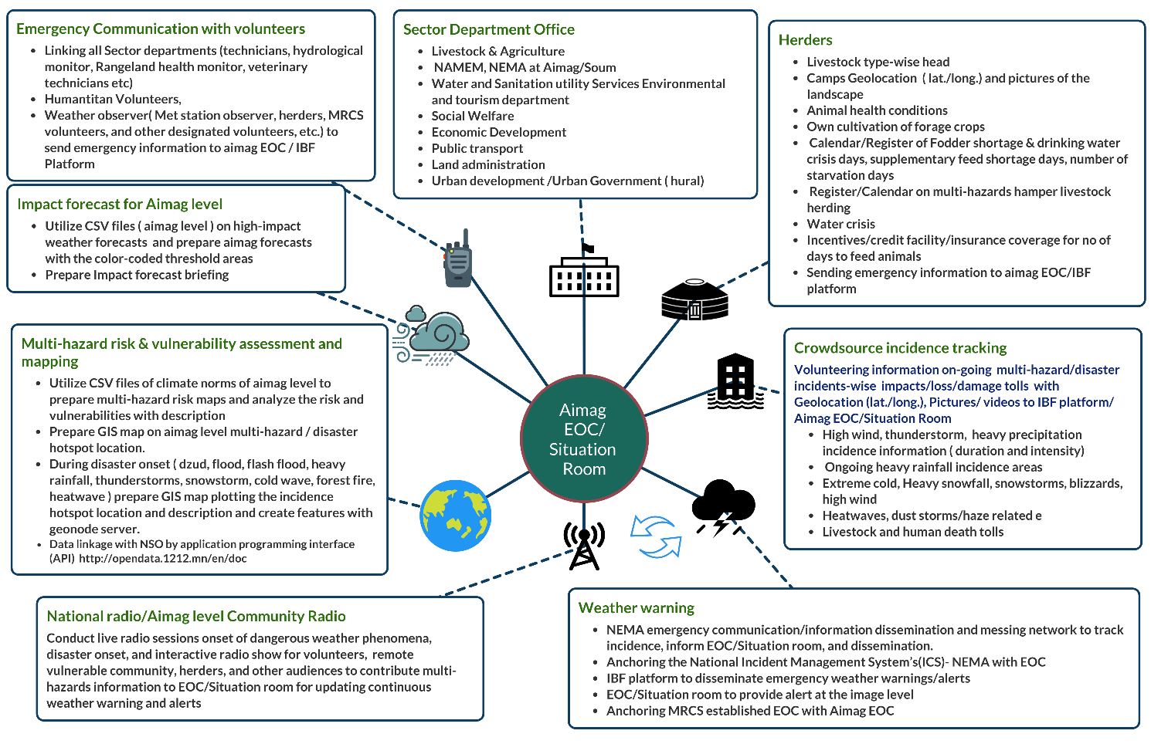
Figure 10: Aimag level IBF functionaries, data coordination structures of the EOC/situation room(Source: Z M Sajjadul Islam, UNDP-GCF)

Functions of EOC / Situation Room :

- During Normal Time :

- The IBF process prerequisites are an extensive ground risk and vulnerability repository and risk atlas ( GIS map) of the element’s checklist with Annexure 1.
- The sector department will prepare a climate risk and vulnerability database, multi-hazard risks of the sectoral elements, and a disaster incidence database. It will also identify the most vulnerable pockets for analyzing IBF and forecasting hazardous weather events, which will translate to Impact forecasts.
- Prepare a repository on the sectoral elements specific weather and climate exposure, risk, vulnerabilities, and sensitivity ( crop agriculture elements, livestock elements, livelihood, water resources, natural resources, etc.) so that the impact can be assessed at the precision level in given cases of weather extremes (extreme cold and high temperature, snowstorm, damaging winds, precipitation anomalies, temperature anomalies, etc.)

- The onset of hazardous weather events :

- Data gathering from Crowdsources for weather Emergency Management: Communication with aimag volunteers, to communicate disaster response priorities, and getting the situational awareness for operationalizing FBF
- Enhancing Hazard Prediction and Monitoring Capability: By implementing an effective observation system and a nested volunteering network, EOC will be able to collect multi-hazard information for the remote corner.
- Develop MIS database on Crisis Information Management System: maintain the multi-hazard database.
- Develop Standard Operating Procedures (SoP) : Develop SoP for the aimag local government actors, sector departments, stakeholders, etc, for data and information coordination.
- Develop Incident Action Planning: Constantly to monitor the situation, Develop the emergency response plan, Incident Action Plans for managing disaster emergencies. The triggering/issuing IBF with anticipatory and assumptive, hypothesis-based impact & loss and damage assessment to facilitate early action protocol to support FBF decisions over the issued hi-impact weather forecasts and mobilizing resources to the remote victim, and vulnerable herders, community, and sectoral elements. For triggering FBF protocol and mobilizing resources to the remote victims, Mongolia needs an informed FBF protocol for the fastest onset of extreme weather events.
- Activate emergency communication and information dissemination at front line community: Prevailing hazardous weather conditions e.g. snowstorms, blizzards, flooding, flash-flooding ( the remote physical mobilizing being hampered and reaching remote communities sometimes not possible. Given this situation emergency radio, wireless and telecommunication tools become the only means to reach the people in danger.

- Comprehensively support Post-disaster response and recovery

- Mandatory aimag NEMA (LEMA) and NAMEM jointly operationalizing EOC to capture post-disaster L & D scenarios and the number of vulnerable people affected( hard-to-reach ) areas.
- Conduct joint post-disaster needs assessment(PDNA) for mobilizing finances for rehabilitation and risk-informed local development planning.

5.4.1 Technical Functions of EOC / Situation Room :
- The core responsibility to analyze forest impacts with high-resolution ( 1-5km) gridded forecasts from the NAMEM HQ).
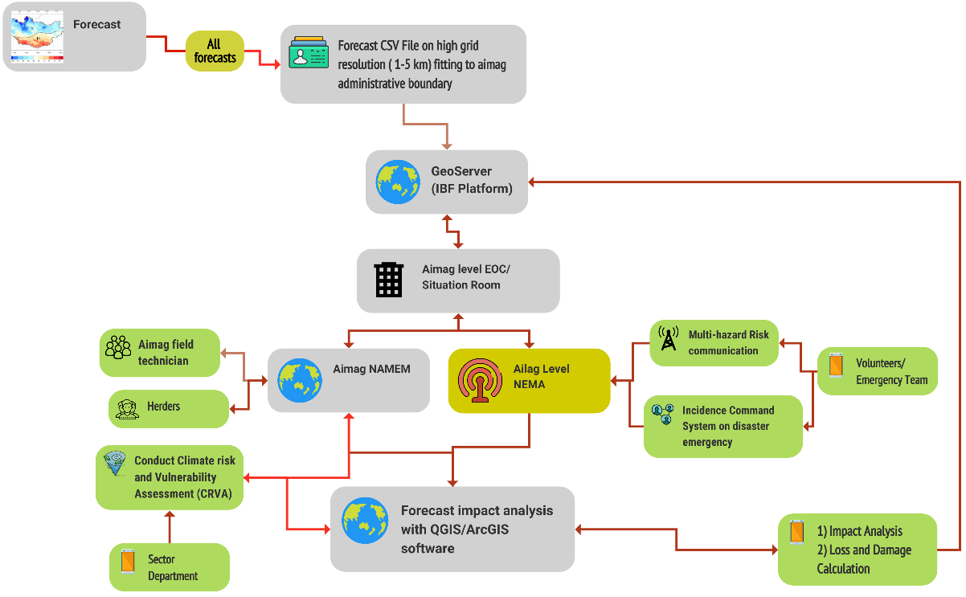
Figure 11: Forecast impact analysis of the Aimag level(Source: Z M Sajjadul Islam, UNDP-GCF)
.

- Mandate Crowdsource information coordination and information gathering during weather emergencies: Developing aimag level crowdsource network ( WhatsApp, Telegram, Facebook, CallPro, Kobo-toolbox, survey monkey, GPS logger, GPS essential) connecting all vulnerable herders, community, stakeholders, enterprises, I-NGO projects, lead farmers, financing institutions, credit operators, insurance companies, etc., for collecting risk information, risk communication, event situation updates, etc.
- Tracking of every multi-hazard on the ground e.g. strong winds, damaging winds, cold front, warm front, forest fire, thunderstorm, , dust Strom, strong winds, snowstorm, blizzards, heavy rainfall, etc. induced prevailing cold front conditions, ongoing situation, loss & damage figures.
- Conduct ground-level observations of any slow-medium onset hazards heatwave, drought, snow icing, cold wave, etc.
- Activating hybrid observations for instantly tracking a convective weather system /rapidly developing weather conditions in any given season, damaging winds ( area of extent) induced storm, constant windspeed, snowstorm, thick of snowfall, coldest temperate, dust storms, etc., monitoring,
- Providing modular weather instruments e.g. thermometer, precipitation gauging, and hand-held anemometer to be given to every ger, volunteer.
- Setting up lighting detector and other AWS sensors to high-value elements ( aimag/soum/bag center)
- Mandating crowdsourced volunteers to remain alerted to provide weather emergency information( to the network with geolocation) in given cases of extreme weather events are likely to impend or just started.
- Provide geolocation of livestock access to drinking water in harsh weather conditions

- Establish Constant communication and monitoring of the herders/farmers/frontline community :
- Mandating cell phone companies for leveraging herders( volunteers) a free internet hour in every day to herders/emergency volunteers, remotely located MRCS, community volunteers, and another android phone for sending emergency data/information to IBF for updates.
- Mandate Herders/volunteers to provide quick updates of weather conditions to WhatsApp group: mandate herders for Sending sample pictures of herd size and health conditions, forage conditions, camp side conditions ( vulnerable to hazards - avalanche/floods/flash floods/landslide/debris fall/mudslide ?), landscape pictures of pastureland, the water access point for drinking water, etc.
- Organize group discussions with social network groups and ask herders for Sending pictures of multi-hazards anytime they face an emergency shelter.

- Conducting live radio show for the vulnerable community during disaster onset
- Coordinating with national AM radio or Aimage-level AM radio broadcasts and organizing live radio talk shows to get situation and incidence updates from remote communities.
- Support national radio team for preparing broadcast advisories for herders travelers, value chain operators, herders, farmers, etc.

- Liaising with NEMA-driven incidence command system (ICS ) for the event situation updates
- Incidence command system (ICS) : national & level, anchoring and integrating ICS with IBF, humanitarian network, sector network, NEMA CAP etc
- Anchoring NEMA emergency preparedness and response with IBF
- Pasture alert
- Forage shortage alert

6.0 Chapter : IBF Forecasting Process

Due to rapidly changing climates the global and particularly the Mongolian weather pattern are Dynamical, and varying. The weather phenomena are rapidly changing (every 15-30 minutes, hourly and diurnally) and extremely spatiotemporal level eventful those conditions are yielding multiple hazardous events e.g. diversified dzuds, flooding, flash flooding, drought, severe winter induced snowstorms, blizzards, and high-thick snowfall, etc. impacting and costing the loss and damage costs to livelihoods and socioeconomic sectors. Mongolia’s livestock and agricultural contribution to GDP largely being impacted by climate extreme events.

The daunting challenges are Mongolian facing that to deal with the rapidly changing (hourly and diurnally) weather need the whole meteorological and forecasting system upgradation, bridging the ground level observations gaps by installing more automated weather observation systems, standalone, modular, handy instruments to the frontline , capturing high density weather and incidence data , developing algorithm , Dynamical downscale model etc to track sudden onset weather phenomena, and more improved NWP, operational forecasts for high-value elements, etc.

6.1 Undertake operational shift from traditional forecast to integrated Impact-based forecasting (IBF ) , warning, and alerting.

Notably, the second largest GDP-contributing agriculture(livestock ) sector is hardest hit by the most varying extreme weather patterns in Mongolia. The need for robust, effective, and precision-level real-time Climate information services is now the cornerstone for informing climate-proof sectoral development planning, budgeting, choosing climate-adaptive projects/schemes, and boosting the rural economy. However, the current set of forecasts mechanism ( weather observation, data acquisition, processing, and real-time warning ) is insufficient to meet the demands of decentralized, localized, sector-specific, operational forecasts, weather warning and operationalized multi-hazard early warning system, etc., those essentially to leverage an imperative and useful informed tools for mobilizing forecast-based finances, risk-informed local development and sectoral planning, etc.

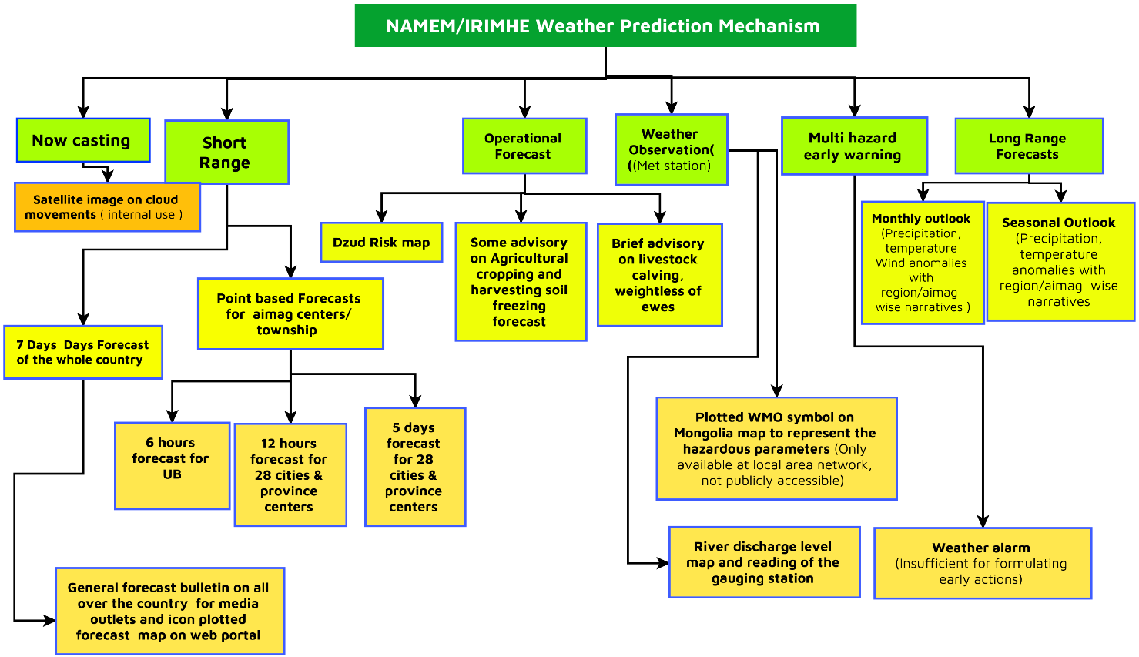
Figure 12: Current set of forecasting mechanism ( MANEM)

Transitioning the paradigm shift from traditional centralized forecasts( whole country ) to decentralized local-level impact-based forecasts normally requires some operational shift of the forecast value chain highlights the process;
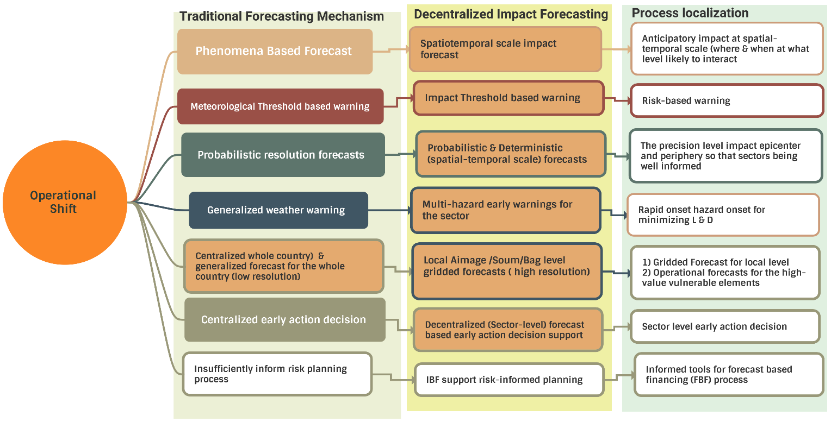
Figure 13: Operational shift from traditional forecasting to IBF process (Source: Z M Sajjadul Islam, UNDP-GCF)

6.2 The IBF Value Chain:

Considering local and remote level multi-hazard & climate vulnerabilities and warning services, the demand-driven weather information services for the Mongolian context over to an impact-based forecasting platform are being envisaged. The IBF proposed structure comprises a multi-faceted and ICT-driven integrated process from generating high-resolution forecasts to sector-level warning and anticipatory and early action decision-making for forecast-based finance mobilization to vulnerable communities.

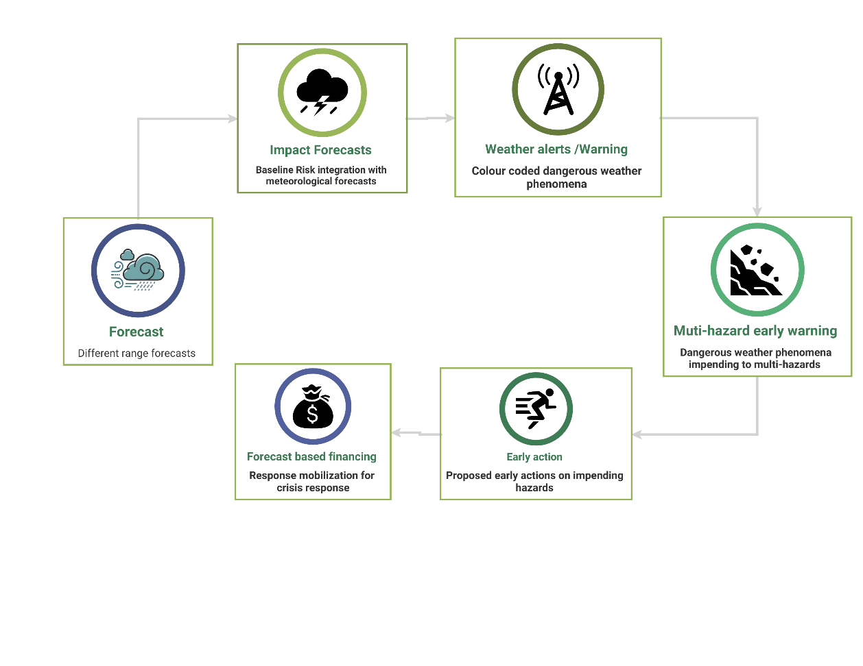
Figure 14 : IBF value chain (Source: Z M Sajjadul Islam, UNDP-GCF)

Requirement for long-rage weather outlook for initiating the IBF process :

The primary step of the IBF process is to prepare seasonal forecast and provide a general overview of the seasonal weather fluctuations/anomalies with a spatiotemporal scale.
Carefully review the weather anomalies and , corresponding threshold levels and diagnose the anomalies that lead to any impending hazards. IBF TWG to analyze CSV file and identify the impact thresholds of the priority sector for preparedness and sustainable sectoral planning. The IBF-based weather information services being intended to inform anticipatory decisions for the sectoral preparedness planning on hazardous events likely to be damaging e.g., heavy rainfall, or less rainfall leading to droughts etc. IBF Information services tools to support decision-making regarding what threshold and intensity level when a hazard will interact with the ground and where it will impact at what level and anticipatory loss and damage can be done.
Methodology :

- interpretation of baseline climate risk scenarios of Mongolia ( 30 years climate norms) and analyzing each forecast parameter anomaly with GIS software color-coded threshold ( red, orange, yellow ) of the parameters spanning over the area of extent likely to be impacted.
- Prepare a checklist of aimag/ bag/soum falling under the color-coded threshold and determine the amount of precipitation projected, degree of temperature likely to be high/low in comparison with the climate norms and calculate the elements likely to impact ( positively- if good weather and negatively -if bad weather)
- Prepare operational forecasts/Climate Information services of priority sectors (agriculture, livestock, water, soil & land management)
- GIS based estimation of Anticipatory gross assessment of exposure, sensitivity, risk, and vulnerability of the elements of the priority sector
- Organizing the briefing session on the outlook of the season ahead and discussing the season pattern, and anomalies issues.
- Scanning the overall seasonal weather outlook and providing a range of possible climate changes that are likely to occur in the season ahead.

6.3 IBF preparation and forecasting process (New methodology) :

Step 1 : Prepare baseline weather /climate risk, vulnerability, and exposure database

Baselining the risk repository is the preliminary tool for the forecast impact analysis process. Comprehensively need to conduct Climate risk and vulnerability assessment (CRVA) of the elements ( annexure 1) using ICT and a participatory process conducted by the local governments, sector department technical experts, partner agency designated field level experts/technicians, herders, farmers, stakeholders, value chain operators, etc. The CRVA repository database and atlas to facilitate determining the climate vulnerability index (CVI) of elements( annexure 1), geographical area ( aimag/soum/bag/commune), landscape etc.,
- The CRV assessment can be conducted by the NAMEM aimag level technical team, comprising the sector departments officials, field technicians, NEMA/LEMA technical experts, volunteers, aimag/soum/bag level local government officials, etc., by conducting the climate risk and vulnerability (CRVA) process.
- Assessment of geophysical vulnerability, based on the annexure 1 elements checklist developed.
- Assessment of Socio-economic vulnerability: Using NSO statistical datasets identify the vulnerable age group ( children, old age, and disabled population ) and GIS mapping with spatial analysis showing the distribution of poverty area, vulnerable age group, and underprivileged group, camp location, and attribute datasets on herder’s livelihood assets, livestock number, animal husbandry management tools, capacity, etc.
- Vulnerable ( children, disabled population, women, old aged ) population database and GIS maps on population/settlements falling in vulnerable zones, e.g., flood, landslide, mudslide, avalanche, waterlogging, strong wind impact areas.
- Prepare hazard, livelihood, animal husbandry, agriculture cropping, value chain operation, etc. calendars for the month for event tracking.

- Acquisition of socio-economic data :

Conduct focus group discussions, Key informant interviews (KII), household survey, and NSO Household Income and Expenditure Survey (HIES) data on socio-economic indicators such as poverty, literacy levels, population density, household(hh) structures, household monetary resources (i.e., disposable household income), to understand coping capacities in crises. Statistical data shows that the number of persons with disabilities (PWD) in Mongolia is just under 4% of the population(varying from 100,000 to 118,000 persons). The poverty rate among households with PWD is more than double that of households without PWD. Among PWD of working age, 70% are not working compared to 36% of working-age people without disabilities. Among children 6-18 years old, almost 50% of children with disabilities cannot read compared to 4% of children without disabilities. Approximately 64% of children with disabilities who are 3-5 years old do not attend kindergarten versus 32% of young children without disabilities.

- Analyze of historical climate risk and vulnerability assessment (CRVA)
 | GIS tools-based analysis | Purpose
 | - Develop GIS maps of a historical disaster with the illustration of hotspot location, the extent of impacted areas, and types of damage done. | Develop a multi-hazard destitution atlas.
 | - Analyze past disasters and multi-hazard events with GIS software, overlying weather data, synoptic chats, and forecasts and analysis the forecasting accuracy and verify forecasts. | Verification of forecasts and Analysis of the forecasting gaps( observation )
 | - Develop guidelines on how to develop past disaster location and impact maps map with aimag ( soum/bag) GIS coverage ( shapefile) in coronation with sector departments, NAMEM, NEMA, MRCS, and other actors of aimag/soum/bag local governments. Analyze the cause of taking tolls, loss and damage. | Guideline for developing multi-hazard risk map on aimag GIS coverage.
 | Organize multi-stakeholder consultation on developing past disaster risk atlas | GIS disaster incidence map on aimag

- Conduct agriculture sector-specific risk assessment and repository development

 | CRVA Process of Crop Agriculture | Purpose & output
 | Agriculture sector
 | 1)Organize a consultation meeting/Focus Group Discussion (FGD) with the following group and inventory the weather-related exposure, risks, and vulnerabilities regularly impacts the agriculture sector ;  - herders, lead farmers, smallholder farmers, agricultural value chain operators ( input suppliers, market players, process industries, )  - All cooperative group  - Haymaking group, Rangeland health mentoring group, Soum/Bag level local government.  - Value chain operators/ agriculture input suppliers  - Conduct key informant interviews (KII) with agriculture sector project development, research, and development organizations and identify the risk areas where multi-hazard incidences are recurrent.  - Inventory of weather anomaly impacts over the cropping cycle (seedling, sapling, plantation, irrigation, harvesting stage ) with spatial and temporal resolution.  - Develop risk, vulnerability, and exposure database, link with GIS map and delineation of multi-hazard exposure, risk, and vulnerability areas over the map, elements wise risk raking.  - Through FGD and KII - Identifying the level of weather impact observations are required to track agriculture-related anomalies, type of high-resolution forecasts ( spatial and temporal scale) is still needed to cover the last-mile impact-based forecast.  - Develop a multi-hazards calendar monthly / seasonally to track the hazards of the locality.  - Develop a cropping calendar on planting, growing stage, and track record of weather anomalies.  - Risk logging of every weather-related impact over the crop lifecycle. | - Inventory of risk, vulnerability, and exposure to extreme weather events induced multi-hazards recurrently impacting the agriculture sector.  - Making risk, vulnerability, exposure, and sensitivity repository database readily available for analyzing the impacts over issued forecasts at the aimag/soum level.

- Conduct livestock sector-specific disasters.

c | CRVA Process of livestock | Purpose & output
 | Livestock sector
 | 1)Organize a consultation meeting/Focus Group Discussion (FGD) with the following group and inventory the weather-related exposure, risks, and vulnerabilities regularly impacts the livestock sector;  - herders, lead farmers, smallholder farmers, commercial herders, livestock value chain operators( input suppliers, market players, process industries, )  - All cooperative groups are involved with livestock sectors.  - Haymaking group, Rangeland health mentoring group, Soum/Bag level local government cooperative body.  - Livestock insurance/credit operators, technical support service providers of Bag/soug/aimag level for livestock husbandry/breeding/ vigenary group.  - Livestock Value chain operators/input suppliers  - Conduct key informant interviews (KII) with livestock sector project development, research, and development organizations and identify the risk areas where multi-hazard incidence is recurrent.  - Design log sheet/calendar/register book/apps-based software and inventorying of weather anomaly-related impacts over the livestock husbandry life-cycle (breeding, calf rearing, feeding, drinking, disease outbreaks, taking care of disease, animals death tolls, etc, observing difficulties that animals are facing over the diurnal changes of weather and harsh impacts, animals attitude to diurnally changes of weather and copping capacity ) in which herders need to log/maintain a diary of every day's weather-related incidence/impacts, and livestock management-related problem on the particular type of animals.  - Design log-sheet/calendar/register book/apps-based software for inventorying of animal health conditions soon after absorbing extreme and high-impact weather shocks in correspondence with a) feeding/non-feeding days, b)losing of weight, c) body health conditions, d) infected by any diseases, etc. ( logging weather factor)  - Maintain calendar of grazing days, pasture available days, and non-feeding days of the season( logging weather factor)  - Maintain log sheet/calendar/register book to register fodder market price, supplementary pasture serving days to meet the crisis, and corresponding non-feeding days. ( Logging weather factor that hampered grazing )  - Logging animals drinking water crisis days, days facing difficulties to access drinking water due to changes in weather situation (depletion of the groundwater table and deep tube well are not working ). Geolocation of deep tube well, animal drinking water points- functional, not functional.  - Develop livestock management calendar and track record of weather anomalies ( snowing days, snow storm days, blizzard days, high wind days, raining days, heat wave days, dry spell days, thunderstorm, heavy rainfall, convective thunderstorm days, dust and haze days, forest & wildfire days, etc.)  - Assessment of risk, and vulnerabilities of herders relating to the seasonal transition from place to place in pursuit of pasture. What is the risk of movement, animal health conditions, disease, etc., and logging all risks, and vulnerabilities for impact analysis in terms of the weather conditions of the season?  - Maintain log sheet/calendar/register book/apps-based software by herders on snow depth, icing, and impenetrable icing days for livestock. Tracking record of every dzud conditions day.  - Develop risk, vulnerability, and exposure database, link with GIS map and delineation of multi-hazard exposure, risk, and vulnerability areas over the map, livestock elements wise risk-raking.  - Through FGD and KII Identifying the level of downscale, spatial, and temporal scale resolution are requirements to cover the last-mile impact-based forecast. | - Inventory of risk, vulnerability, and exposure of extreme weather events induced multi-hazards recurrently impacting the livestock sector.  - Develop risk, vulnerability, exposure, and sensitivity repository database readily available for analyzing the impacts over issued forecasts at aimag/soum level.  - Aimage-wise multi-hazard-prone area map : Showing livestock paddock, climate-proof livestock shelter, drinking water facility point near the paddock, deep tube well water access point, open-source water body ( perennial, seasonal, dried ) etc.

- Conduct WASH sector-specific disaster.

c | CRVA Process of WASH | Purpose & output
 | WASH sector
 | Tools :  - Organize consultation meeting/Focus Group Discussion (FGD) with WASH ( water, sanitation, and hygiene sector), surface water management sector stakeholders, water service providers, users, rural herder, Ger, etc.  - Conduct key informant interviews (KII), transact walk to most vulnerable sites for stock taking.  - Baseline Database develops with Excel sheet/access.  - Risk Mapping with GIS aimag, soum  Assessment procedures :  - Inventorying surface waterbody at the local level ( bag, soum, aimag), identifying the seasonal, perennial waterbody, dried waterbody, river, canal, pond, excavated pond for rainwater harvesting, water drainage canal, water reservoir, etc, and risk logging of those waterbodies being affected by what type of weather events, time and duration of weather stress. Inventory how many waterbodies converted from perennial to seasonal and seasonal to dried waterbody for what type of weather and climatic phenomena.  - Identify waterbody polluted by flash flooding, river flooding, landslide, mudslide, Mineralization of surface and groundwater, Groundwater pollution sources, waterbody being silted, and debris deposited in the event of heavy rainfall.  - Inventorying the local level mechanized tube well, dug well, deep tube well with geo coordinates, and risk logging of how many water service structures elements are being impacted by water stress, what type of stress, and how many are functional and not functional.  - Inventorying of Surface waterbody for irrigation, industrial water use, livestock drinking, etc, and the underlying weather and climate change factors impacting the waterbodies. Pollution of the waterbody, Siltation of the waterbody, decreasing of the depth of river network, Impact of groundwater table recharging,  - Conduct key informant interviews (KII) with Hydro basin/lake authority, water sector project development, the establishment of river basin authorities (RBAs), river basin councils (RBCs), Surface waterbody management authority, Integrated Water resources development authority, surface, and groundwater research and development organizations and identify the extreme weather risk and vulnerable areas where multi-hazards incidence is recurrent.  - Inventorying track records of extreme weather events induced impacts level over the utility services relating to drinking water supply.  - Keep a track record of extreme weather events-induced impacts level over the utility services relating to Public WASH facility.  - Maintain daily/monthly logs of weather events' impacts on the WASH facility.  - Indicative Risk logging on extreme weather events being impacted with frequency and intensity. | - Inventory of risk, vulnerability, and exposure to extreme weather events induced multi-hazards recurrently impacting the water sector.  - Develop risk, vulnerability, exposure, and sensitivity repository database readily available for analyzing the impacts over issued forecasts at aimag/soum level.

- Conduct CRVA of the urban sector

c | CRVA Process of urban sector | Purpose & output
 | Urban sector
 | Tools :  - Organize consultation meetings/Focus Group Discussions (FGD) with urban local governments ( aimag, soum, bag )  - Android apps software for tracking geo-location, and placemark of the Climate vulnerable elements.  - GIS land use and planning map on a municipality/urban areas  - Conduct key informant interviews (KII) with urban service sectors and stakeholders, transact walk to most vulnerable areas that are frequently impacted by multi-hazards  - Baseline Database develops with Excel sheet/access.  - Risk Mapping with GIS aimag, soum  Assessment procedures :  - Develop a GIS base map of all useful layers ( admin boundary, communication network, land cover/land use layer, physical infrastructure, installed structures, utility services network, types of settlements, and other elements) and identify the elements that are at risk, vulnerable, and having exposure.  - Risk and vulnerability ranking of the elements with corresponding disaster ( e.g. flood, flash flood, landslide, mudslide, water logging, avalanche, etc) | - Developing risk and vulnerability atlas in urban areas.  - Developing risk, vulnerability, exposure, and sensitivity repository database readily available for analyzing the impacts over issued forecasts at aimag/soum /bag level.

- Conduct CRVA of the Soil sector

c | CRVA Process of Soil sector | Purpose & output
 | Soil sector
 | Tools :  - Develop country, aimag, Soum, Bag level Soil type, and land cover map.  - Inventory of climate drivers /weather parameters impacts soil health and soil degradation with geo-location for in-depth interpretation. | - Complete risk and vulnerability atlas on soil and Land cover.  - Developing risk, vulnerability, exposure, and sensitivity repository database on soil fertility, Soil water holding capacity, land cover and agroecology etc., atlas, which will facilities analyzing weather impacts over the soil conditions. Aimag NAMEM office can develop aimag/soum wise soil map.
  Elements | Identify the weather factors that affect soil quality in Mongolia | GIS shape file of Geolocation
  Trend of desertification | Underlying weather and climate change factors | Geolocation, GIS Shape file
  Semi-arid soil | Soil regeneration and soil degradation | Geolocation , GIS Shape file
  Grazing land | What type of extreme weather impact soil health, and contributes to soil degradation? | Geolocation , GIS Shape file
  Steppe forest ecosystems | The root cause of significant drying last decades by what type of weather parameters and Climate change factors | Geolocation , GIS Shape file
  Desertification areas | Weather factors contribute for desertification | Geolocation , GIS Shape file
  - Soil drying factors. | Underlying weather and climate change factors | Geolocation , GIS Shape file
  - Soil properties decline. | Underlying weather and climate change factors | Geolocation , GIS Shape file
  - Morphological characteristics | Underlying weather and climate change factors | Geolocation , GIS Shape file
  - Soil horizon thickness | Underlying weather and climate change factors | Geolocation , GIS Shape file
  - Soil thawing | Underlying weather and climate change factors | Geolocation , GIS Shape file
  - Wetland decline | Underlying weather and climate change factors | Geolocation , GIS Shape file
  Soil Water holding capacity and wilting point, Soil organic content, Soil infiltration rate and bulk density | Underlying weather and climate change factors | Geolocation , GIS Shape file
  Steppe soil | Underlying weather and climate change factors | Geolocation , GIS Shape file
  Middle steppe soil | Underlying weather and climate change factors | Geolocation , GIS Shape file
  South steppe soil | Underlying weather and climate change factors | Geolocation , GIS Shape file
  Floodplain soil | Underlying weather and climate change factors | Geolocation , GIS Shape file
  Soil organic matter | Underlying weather and climate change factors | Geolocation , GIS Shape file

- Conduct CRVA of the WASH ( Water, sanitation, and hygiene) sector.

 | CRVA Process of WASH sector | Purpose & output
 | WASH sector
 | Water and Sanitation utility Services  Drinking Water  - Database on infrastructures and utility services being damaged, hampered and impacted by extreme weather events and historical disasters.  - Hotspot mapping with the extent of areas where loss and damage occurred.  - Extreme weather events and changing climate impact Infrastructures and utility service delivery channels.  Local map, list of utility services installed, people served, and functional & non-functional supply points. | - Complete risk and vulnerability atlas on WASH sub-sectors  - Developing risk, vulnerability, exposure, and sensitivity repository database readily available for analyzing the impacts over issued forecasts at aimag/soum /bag level.
Public WASH

- Public WASH ( Water and sanitation and health), hygiene, street cleaning, waste removal Infrastructures development
- Improvement & Maintenance Utility services
- Database on WASH structures and utility services being damaged, hampered and impacted by extreme weather events and historical disasters already occurred.
- Hotspot mapping with the extent of areas where loss and damage occurred.
- Indicative Risk logging on extreme weather events being impacted with frequency and intensity.
- Extreme weather events and changing climate impacts on WASH structures and utility service delivery channels.
- Local map, list of utility services installed, people served, and functional & non-functional supply points.
- Track record of extreme weather events induced impacts level over the utility services relating to Public WASH facility.
  - Maintain daily/monthly logs of weather events' impacts on the WASH facility.
- Indicative Risk logging on extreme weather events being impacted with frequency and intensity.

Health - Primary Healthcare

- Risk logging of types of health hazards based on extreme weather events.
- List and location maps of service trigger points
- Keep a track record of diseases, outbreaks caused by extreme weather events.

- Record keeping of types of Hazards impacts livestock: Aimage EOC(Situation room) will be responsible for developing multi-hazards event calendars, placemarks of the geolocation of hazard indecent place, inventory of impact level, loss, and damage.

Table 6 : Monthly hazard calendar to be maintained by priority sectors
Hazard | Month Name |  |  |  |  |  |  |  |  |  |  |  |  |  |  |  |  |  |  |  |  |  |  |  |  |  |  |  |  |  |  | Death tools of livestock /L & D
Days of the month | 1 | 2 | 3 | 4 | 5 | 6 | 7 | 8 | 9 | 10 | 11 | 12 | 13 | 14 | 15 | 16 | 17 | 18 | 19 | 20 | 21 | 22 | 23 | 24 | 25 | 26 | 27 | 28 | 29 | 30 | 31
Extreme cold days ( -30c to -50c and above)
Severe Cold days ( -20c to -30c and above)
Snowstorm days
Gale force wind
Dust storm
Tornadoes
Thunderstorm /nor wester
Dry spells
Hot Spells
Heavy rainfall & Flooding
Landslide
Wild/Forest fire
Lightening
Snowstorm
Winter Strom
Thick of snowfall
Blizzards
Flood/flash floods/landslide/mudslide/debris fall/Avalanches
drought,
heavy snow, ice
storms and wind,
extreme overgrazing
summer drought
Heavy drought in late summer followed by intense snow storms

- Prepare Aimag wise GIS map: The base map on distribution of geographical & physical features, socio-economic layers, commination networks, river system etc.
- Surveying and inserting placemark of camp location and tagging a ger number - voluntarily sending geolocation by herders, veterinary technicians, health workers, credit operators and other support staff are frequently visiting the herders’ camp.
- Plotting camp location and develop a GIS attribute file of herder’s livestock number and other livelihood related. data.
- Develop GIS map on aimag and soum level on Rangeland health monitoring health. Utilize DIMA database and upload GIS shapefile to the IBF geonode server for preparing rangeland health monitoring status weekly, bi-monthly, and monthly.
- Land use map showing pasture biomass growing areas, desert steppe areas, and desert areas, which would be informed tools for management from overgrazing,
- Geo Location of the camp where most of the livestock died during 2000-2003, 2010 dzud incidence :
- Soum/aimag wise pasture condition, forage crop areas, pasture degraded area map of every month/season and prepare atlas profile in fodder cropping risk and vulnerabilities, Pastureland risk, and vulnerabilities.
- Geographical and geophysical and topographical, environmental vulnerability
- Inventorying Combined drought and dzud risk phenomena over the animal husbandry

Step 2 : Prepare short-range weather forecast CSV /shapefile :
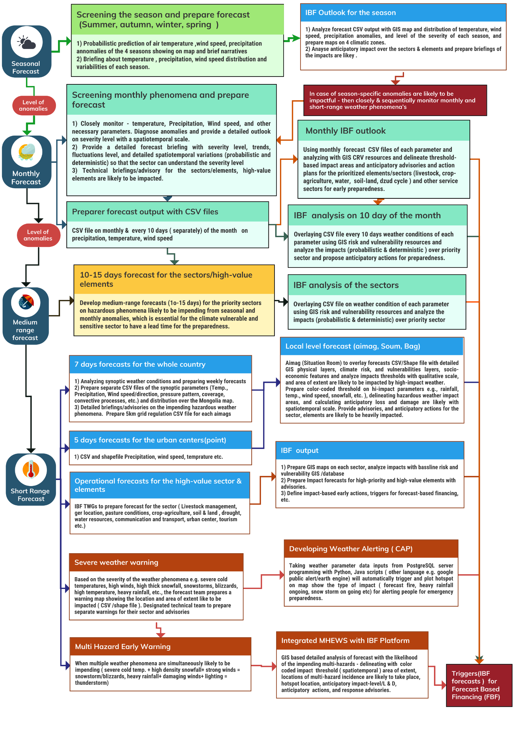
Figure 15 : Preparing short-range weather forecast CSV /shapefile(Source: Z M Sajjadul Islam, UNDP-GCF)
.

- Prepare CSV /shapefile of the hazardous forecast parameter(s) likely to impend a hi-impact, e.g., heavy snowfall/precipitation, severe cold temperature.
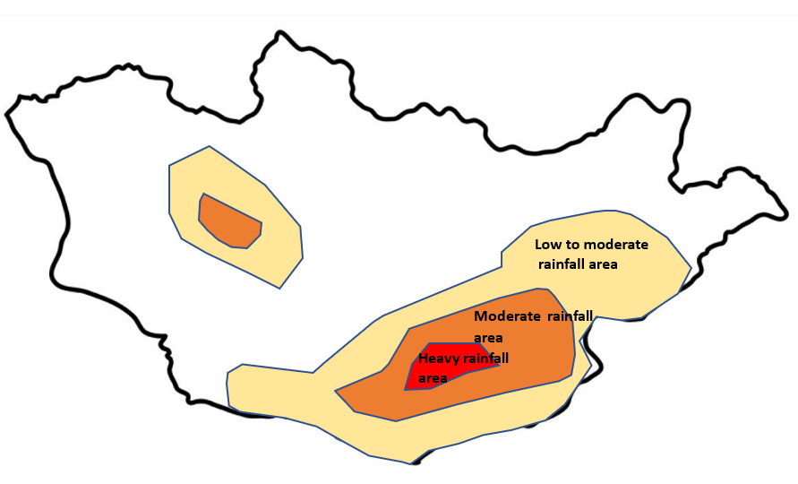
Figure 16 : Sample Forecast threshold map

Step 3: Review of already developed Climate risk and vulnerability from the baseline repository that is archived with the IBF geospatial portal :

- Tools preparation: GIS layer ( annexure 5) :
- Baseline risk and vulnerability( survey) GIS map and shapefile
- Physical GIS layer
- Socio-economic GIS Layer ( Poverty, disabled population, herders ger location/ basecamp location
- Pasture map, Rangelands health condition map, land use and land cover map, drought map, drinking water sources location/access point map.

- Methodology: Impact analysis over the geographic location and severity of the weather parameters( spatiotemporal ) with GIS software :
- Overlaying forecast shapefile(coverage ) over the baseline GIS layers of the elements, risk and vulnerability attribute information/database, and socio-economic structures( ger, pasture grazing location, vulnerable population, remoteness, etc.). Calculate exposure, risk, vulnerabilities, and risk raking of the elements by analyzing multi-variables.
- Calculate and analyze how many elements fall under the red color extent of areas based on already having built-in exposure, risk, vulnerability, and calculated risk rank of the element.
- Prepare a checklist of the high risks ranked elements calculated by historical risk data and aggregate the impact with forecasted thresholds ( amount of rainfall) of red-colored areas, and calculate the anticipatory impact, loss, damage, and advisories of the high risks ranked elements.

Step 4: Screening rapidly developing weather conditions ( convective weather system, downscale model based on updated data and develop warning and CAP )

Statistical and Dynamical downscaling of cold/warm front is likely to impend any given time ( in spring, summer, and autumn seasons) and NAMEM needs to provide spatiotemporal scale forecasts and operational forecasts for the high-value elements( livestock, urban settlements ).

Step 5: Establish nested hi-impact Situational observation system :

In a given situation like multiple extreme weather conditions e.g., extreme cold temperature, high wind, and snowstorms are concurrently occurring for a longer period e.g., week(s), there are likely to occur multi-hazards with combined hybrid conditions on the ground. Only meteorological station-based observations and forecast model output datasets are not enough to capture all events and precision level forecasting. Implementation of the proposed hybrid surface observation ( figure 9) is essential for integrated forecasting and warning systems. A multi-hazard early warning and common alerting need to trigger simultaneously with impact forecasts to save livestock, livelihoods, crop agriculture, etc.

Step 6: Capturing geolocation of ongoing hazardous weather-induced multi-hazard incidence, hotspots/location of loss, and damage are taking place and data for situation reporting:

In given circumstances, multiple weather events are simultaneously occurring and turning into worst-case scenarios, which are often the cause of impending hazards and disaster in terms of the L & D figure. In this case, the extent of disasters causes large-scale damage if early warning, emergency preparedness, and response is not undertaken timely. So far there needs to be a hybrid ( figure 9) observation ( weather, hazard incidence) and geolocation data acquisition for event situation reporting, common alerting, and multi-hazard early warning.

Step 7: Issue Multi-hazard early warning necessarily

Again, the multiple hazardous weather events are likely to impend or already the prevailing weather phenomena to yield multi-hazards e.g., severe cold temperatures, high-density snowfall, snowstorms, thunderstorms, damaging winds are taking livestock tolls, human tolls, disrupting sector value chain, etc.

Step 8: Preparer Operational forecasts for sectors

- Conducting hybrid observation( figure 9), preparing operational forecasts for high-value elements over the hi-impact and sudden onset, subsequently developing weather warnings and common alerting to highly vulnerable high-value elements on daily operational duty.
- Prepare a roadmap of emergency coordination mechanism and engaged stakeholders and anticipatory actions for reducing impacts, L & D.

Converting traditional forecast to IBF

- Review Long-range Forecasting :

- Review Seasonal Outlook :

The technical function of IBF starts with the production of long rage outlooks as the primary input device for analyzing forecast impacts. The long-range forecasts should inform what weather conditions for the upcoming season are and overview of impeding nature to the Climate sensitive high-value sectors and elements ( livestock, urban settlements, crop-agriculture, water & soil, and land management). A seasonal forecast can be utilized as a tool for screening the seasonal anomalies ( 3 months ) for Mongolia and giving an impression of directions of weather conditions of the season ahead is going to be above normal ( impact level ) or below normal ( impact level) or near to/normal conditions and the gross anticipatory impacts. Providing an anticipatory advisory for preparedness, adaptation, and mitigation measures.

Monthly forecasts of the season are designed to closely screen/observe the atmospheric conditions( temperature, precipitation, wind speed).

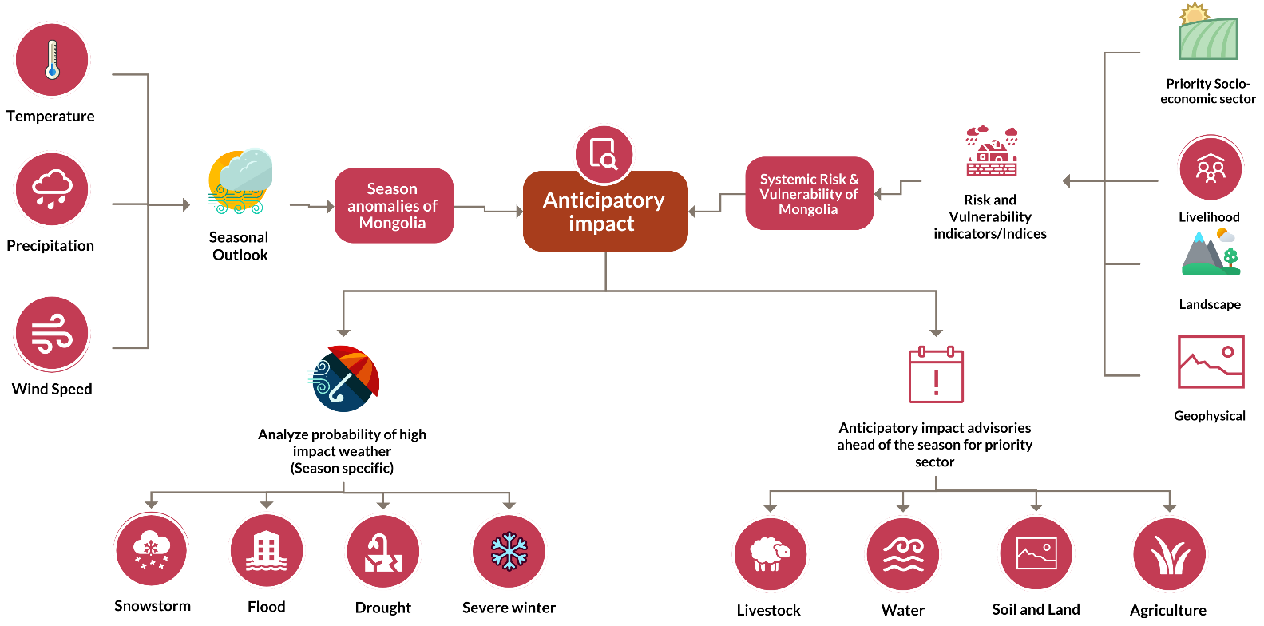

Figure 17 : Workflow of the current forecasts to transfer to impact base forecasts(Source: Z M Sajjadul Islam, UNDP-GCF)
.

For monthly and seasonal outlook IRIMHE follows the following multi-models and ensemble system (MME) for developing two products being developed monthly outlook and seasonal outlook.

The current forecast mechanism of NAMEM/IRIMHE is mainly point based targeting urban centers and townships and 7 days forecasts/outlook for the whole with precipitation, temperature, wind speed, sunshine condition, etc. The seasonal forecast covers temperature and precipitation and monthly covers the temperature, precipitation, and wind speed with a 27km grid resolution.

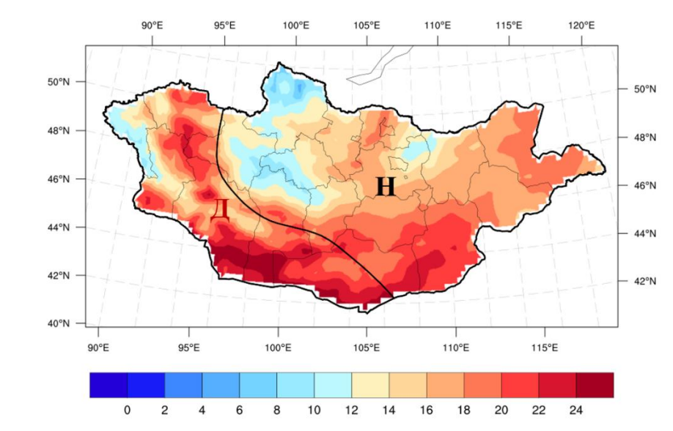 | 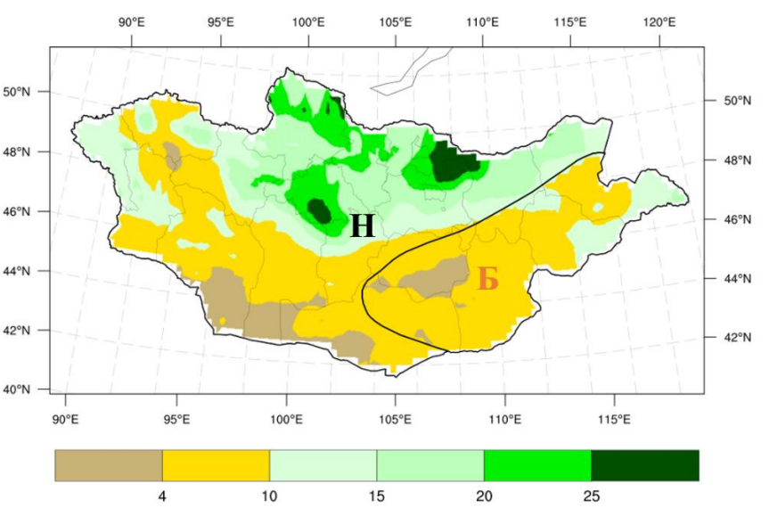
Temperature | Precipitation

The above map shows the color-coded threshold of temperature & precipitation distribution of the whole country. By utilizing the CSV files with GIS software, the TWG to analyze the impact of the month and season ahead and what will go wrong at spatiotemporal scale. The monthly and seasonal IBF would the primary input devise for the short-range forecasts to understand the weekly weather conditions in advanced.

Season | Type of anomalies | Determine what type of impacts/hazards are anticipated over the season & month | What would be the season preparedness /advisories for the priority sector
Summer | Spatiotemporal distribution of Temp/Precipitation/Wind speed like to incase | Heavy rainfall, floods/flash floods, Hot spell, dry spell, thunderstorms, damaging windstorms | What type of gross preparedness will undertake herders /farmers, livestock /agri-value chain operators
 | Spatiotemporal distribution of Temp/Precipitation/Wind speed is like to be normal near normal & normal
 | Spatiotemporal distribution of Temp/Precipitation/Wind speed like to decrease | the intensity of the Agri, hydrological, and hydrological droughts
Autumn | Spatiotemporal distribution of Temp/Precipitation/Wind speed like to incase | Heavy rainfall, floods/flash floods, dry spell, thunderstorm, damaging windstorms, Cold front thunderstorms | What type of gross preparedness will undertake herders /farmers, livestock /agri value chain operators
 | Spatiotemporal distribution of Temp/Precipitation/Wind speed is like to be normal near normal & normal
 | Spatiotemporal distribution of Temp/Precipitation/Wind speed like to decrease | the intensity of the Agri, hydrological, and meteorological droughts
Winter | Extreme cold temperatures, strong winds, high precipitation(snowfall), | Snowstorms, blizzards, extreme cold temp, high thick snowfall, | What type of gross preparedness will undertake herders /farmers, livestock /agri value chain operators
Spring | Fluctuations/anomalies of temperature, wind speed, precipitation, | Fastest onset multi-hazards ( cold front, warm front, cold rain, high winds, thunderstorm) | What type of gross preparedness will undertake herders /farmers, livestock /agri value chain operators

6.4.1 Analyze impacts over the seasonal forecasts :

- Using GIS software, comparing baseline climate scenarios of Mongolia ( 30 years climate norms) and analyzing each forecast with anomalies with the color-coded threshold of the parameters spanning over the area of extent likely to be impacted.
- Prepare a checklist of bag/soum falling under the color-coded threshold and determine the amount of precipitation projected, and the temperature likely to be severe to be high/low in comparison with the Climate norms and calculate the elements likely to impact ( positively and negatively)
- Prepare operational forecasts/ Climate Information services of priority sectors ( agriculture, livestock, water, soil & land management,)
- Anticipatory gross assessment of exposure, sensitivity, risk, and vulnerability of the elements of the priority sector
- Organizing the briefing session on the outlook of the season ahead and discussing the season pattern, anomalies issues, and of degree days.
- Scanning the overall seasonal weather outlook provides a range of possible climate changes that are likely to occur in the season ahead.

6.4.2 Processing monthly IBF :

Forecast file | Parameter | Baseline risk and vulnerabilities |  |  | Impending multi-hazards
 |  | Risk and vulnerability GIS repository and risk atlas | Distribution of socioeconomic vulnerability | Sector-specific elements are falling into risk and vulnerability | If lead time in impending hazardous conditions is prolonged, then what would be the impact?
Seasonal /Monthly  forecast | Temperature above normal | - GIS maps on sowing high-value elements and database  - Elements are susceptibility, sensitivity, risks, and vulnerable to high temperatures and hot days.  - Drought map  - Time-series Pasture biomass /rangeland health maps  - Water/hydrological resource map  - Agroecology maps | - Atlas of the distribution of poverty population, poor herders(income poverty, livelihood assets, animal husbandry management logistics, and capacity, etc.) | - Climate risk and vulnerability assessment and repository of livestock, agriculture, water, soil health, environmental & natural resource sector, drought.  - Indicators of high-temperature sensitivity, exposure, risk, and vulnerability to the elements of the priority sectors  - Crop agriculture ( seedling, sapling, planting, flowering & pollen stage, growth stage, harvesting stage ).  - Incidence of drought  - Forest coverage | - If hot days are prolonged,  - multi-hazard would be triggered? Agricultural, ecological, and meteorological droughts.
 | Extreme cold temperature | Assessment of the number of elements over the following impact situation.  - are sensitive to extremely cold temperatures and consequences e.g. crop yield loss, stagnating mature stage, pest manifestation, plant growth stagnated ) will be exposed to temp and impact yields.  - Risk elements e.g. animal fall in sick, calf becoming weak and dying, soil moister evaporating losing soil health, desertification, degradation of pasture biomass.  - Icing/freezing Surface waterbody, depletion of groundwater level, reduction of hydropower,  - Thick snow on the ground for a longer period causes degradation of pasture biomass, vegetation coverage, standing crops, seedlings & saplings for the crop plantations. | - Atlas of the distribution of poverty population, poor herders( income poverty, livelihood assets, animal husbandry management logistics, and capacity, etc.)  - Indicator of hard-to-reach areas  - Indicators of transport and communication season-wise  - Areas of economic activity | - Types of agriculture, livestock, water resources and structures, soil and land, natural & environmental resources, physical communication, transport, and logistic system are vulnerable to high temperatures and conduct an anticipatory estimation of impacts at a large scale.  - From the map estimate how much surface waterbody is likely to dry up Surface waterbody, depletion of groundwater level, reducing of hydropower,  - Degradation of pasture biomass, vegetation coverage, standing crops, seedlings & saplings for the crop plantations. | If extreme and severe cold days are prolonged, then what type of multi-hazard would be triggered, and the consequences
 | Heavy precipitation | Assessment of the number of elements is sensitive to heavy precipitation and flash flooding consequences e.g. crop yield loss | - GIS maps and database of the distribution of flood-prone areas, aimag, soum, bag centers vulnerable to flush floodings, number of the population is exposed, risk and vulnerable to floodings.  - Poor structures and basic utility services, households, and business installations are vulnerable to flooding.  - Poverty population, poor herders( income poverty, livelihood assets, animal husbandry management logistics, capacity, etc.  - Vulnerable Indicators over the hard-to-reach areas( agri land, ger, pasture standing crops at lower floodplain areas  - Indicators of transport and communication season-wise  - Areas of economic activity | How many agricultures, livestock, water resources and structures, soil and land, natural & environmental resources, physical communication, transport, and logistic system are vulnerable to high temperatures and conduct an anticipatory estimation of impacts at large scale | Impeding heavy precipitation cases anticipatory L & D
 | Less precipitation | How many elements are sensitive to rainfall variability( less rainfall) and consequences e.g. crop yield loss, stagnating mature stage, pest manifestation, plant growth stagnation, losing soil fertility, flash droughts and desertification etc. | - Atlas of the distribution of poverty population, poor herders( income poverty, livelihood assets, animal husbandry management logistics and capacity, etc.)  - Indicator of hard-to-reach areas  - Indicators of transport and communication season-wise  - Areas of economic activity | How many agricultures, livestock, water resources and structures, soil and land, natural & environmental resources, physical communication, transport, and logistic system are vulnerable to high temperatures and conduct an anticipatory estimation of impacts at large scale | If hot days are prolonged, then what type of multi-hazard would be triggered

6.4.3 Preparing medium-range Forecast :

Considering the Mongolian diverse and rapidly changing weather conditions medium range (figure 18) weather forecast ( 10-15 Days lead time ) is required for bridging the forecast gap between monthly to weekly forecasts, which will provide early direction for the sectors with closer way observing weather anomalies hazardous events are likely to impend over the weeks ahead for better preparedness. The priority sectors and humanitarian agencies will be well informed for preparedness planning, humanitarian planning, and initializing action planning for impending hazards .

6.4.4 Preparing short range Forecast :
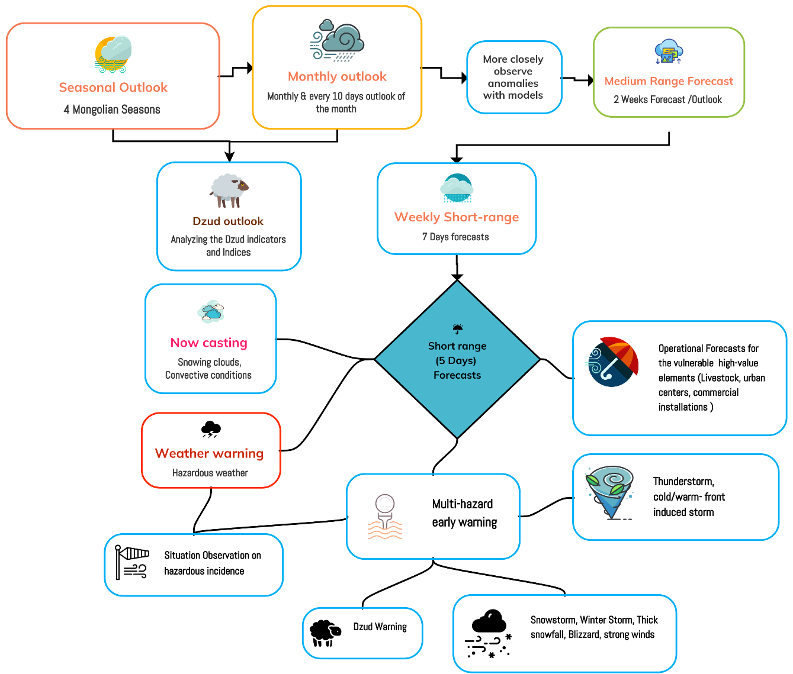
Figure 18: Short-range forecast workflow and integrated IBF ( applicable for winter season ) (Source: Z M Sajjadul Islam, UNDP-GCF)

NAMEM currently developing a set of the short-range forecast by analyzing the 4 Dynamical models, 8 classical statistical methods, ensemble of 2 models, etc., for predicting the ranges of 3, days, 5 days, and extending two days to a total of 7 days of weather forecasts. On the other hand, 21 statistical methods or models output can also be incorporated into the short-range forecast development processes.
However, considering the rapidly changing, diurnally varying, plausible weather variation ( in every hour) in the entire Mongolia and rapidly changing Mongolian weather patterns the IBF process needs to track rapidly developing weather conditions (which can turn into the fastest onset hazardous event) requires a robust forecasting cycle, and the ability to provide real-time (spatial and temporal ) and precision level monitoring, situational updates and overall capturing all weather conditions under the forecasting need improved ground surface observations ( Figure 9) , real-time model output to the IBF system traceability to ongoing rapidly developing weather conditions( heavy rainfall, thunderstorm, hailstorm, lightning, snowstorms, high winds/damaging winds, blizzards, heatwave, dust/haze storm, cold front driven storm in spring/early summer, cold rainfall, etc.).

6.4.5 The short-range forecasts usability :
Types of weather synopsis considered for weekly short-range forecasts prepared by the forecasting division | Climate Season | Hazard specific interpretation | Usability for IBF Analysis | End users
Temperature (⁰C) | Winter | Alerting severe cold days aimag/soum level over the next 7 days | Duration of impact level of severity of coldest temperature over the winter season  - Livestock herder (fodder availability, biomass, pasture, standing crops, seedling, sapling, storage/warehousing, wholesaling etc.)  - Agriculture (biomass, pasture, standing crops, seedlings, saplings, storage/warehousing, wholesaling etc.)  - Disruption of Lifeline service providers( hot water, surface water access for the livestock and deep tube well, room heating, amount of coal to be burnt by isolated/scattered ger’s, market, and other settlements/installations.  - Market operators  - SME business continuity  - Transport and communication( disruption of waterways, national highways, paved roads, etc.  - People’s mobility ( to the urban center, wholesale market, schooling, etc) | - Headers  - Ger  - Sector Department  - Transport sector  - Urban utility service department  - Herders  - Farmers  - Agriculture sector  - Logistic transporter  - Transport sector  - Travel takers  - Tourism operators, hotels, motels, restaurants  - Commercial installations  - Petrol pumps  - Healthcare centers, local governments departments  - Volunteers (MRCS/LEMA/NEMA)  - Aimag Center  - Soum Center  - Bag Center  - Sector departments  - Business operators  - Mining operators  - SME/enterprises operators  Farmers/ Herders  Farmers/ Herders  Farmers/ Herders  Farmers/ Herders
Temperature (⁰C) | Spring | Alerting severe weather for the spring season | Duration of impact level over the prevailing severity of temperature over the season.  Livestock(fodder availability, biomass, pasture, standing crops, seedling, sapling, storage/warehousing, wholesaling, etc.)  - Agriculture ( biomass, pasture, standing crops, seedlings, sapling, storage/warehousing, wholesaling, etc.)  - Disruption of Lifeline service providers( heating system, surface water access for the livestock and deep tube well, room heating, amount of coal to be burnt by isolated/scattered ger’s, market, and other settlements/installations.  - Market operators  - SME business continuity  - Transport and communication( disruption of waterways, national highways, paved roads, etc.  - People’s mobility ( to urban centers, wholesale market, schooling etc)
Temperature (⁰C) | Summer | Alerting severe weather for the summer season | Duration of impact level over the prevailing severity of temperature over the season.  - Livestock(fodder availability, biomass, pasture, standing crops, seedling, sapling, storage/warehousing, wholesaling etc.)  - Agriculture ( agricultural drought and impact over the biomass, pasture, standing crops, seedling, sapling, storage/warehousing, wholesaling etc.)  - Disruption of Lifeline service providers( hot water, surface water access for the livestock and deep tube well, room heating, amount of coal to be burnt by isolated/scattered ger’s, market, and other settlements/installations.  - Market operators  - SME operations  - Transport and communication( disruption of waterways, national highways, paved roads, etc.  - People’s mobility ( to urban centers, wholesale market, schooling, etc)
Temperature (⁰C) | Autumn | Alerting severe weather for the Autumn season | Extreme events and impact level.
Precipitation (mm) | Winter | Alerting moderate to high snowfall/cold rain impact at aimag/soum level over the next 7 days | Extreme events and impact level;  - Snowfall and impact level over the elements /sectors  - Cold rainfall and impact level over the elements /sectors
Precipitation (mm) | Spring | Alerting moderate to high cold rain/ snowfall | Extreme events and impact level;  - cold rain/ snowfall impacts the level of the elements /sectors  - Cold rainfall and impact level over the elements /sectors
Precipitation (mm) | Summer | Alerting high to heavy rainfall | Extreme events and impact level;  - Heavy rainfall impacts the level of the elements /sectors
Precipitation (mm) | Autumn | Alerting high to heavy rainfall | Extreme events and impact level;  - Heavy rainfall impacts the level of the elements /sectors
Wind Speed ( m/s), | Winter | Alerting moderate to high wind impact at aimag/soum level over the next 7 days | Duration of impact level of severity of medium to high wind speed accompanied by coldest temperature for the next 7 days over the following elements ;  - Livestock grazing, suffering from cold injury, disturbing daily lifecycle pattern.  - Agriculture(biomass, pasture, standing crops, seedlings, sapling, storage/warehousing, wholesaling etc.)  - Disruption of Lifeline service providers( hot water, surface water access for the livestock and deep tube well, room heating, amount of coal to be burnt by isolated/scattered ger’s, market and other settlements/installations.  - Market operators  - SME  - Transport and communication( disruption of waterways, national highways, paved road, etc.  - People’s mobility ( to urban center, wholesale market, schooling etc)
Wind Speed ( m/s), | Spring |  | High Wind Impacts over the season
Wind Speed ( m/s), | Summer |  | High wind Impacts over the season
Wind Speed ( m/s), | Autumn |  | High wind Impacts over the season
Wind direction( NW) | Winter |  | Wind direction over the vulnerable sector

6.5 Short range impact forecast preparation

- Heavy snowfall/precipitation analysis :

Following the IBF process outlined above develop a color-coded threshold of precipitation over the geographical areas that are likely to receive the cumulative amount of rainfall ( mm/ hour/12 hourly/24 hourly)

- Anticipatory impact illustration scale :

• Likelihood of occurrence is classified into five levels (very unlikely, unlikely, moderately likely, likely, and very likely). The term likelihood applies to the probability that, within the period considered, either a new disaster risk or a significant deterioration of the situation will occur.

• Potential impact is classified into five levels (negligible, minor, moderate, severe, and critical). The impact can be analyzed both in terms of magnitude (the number of potentially affected people and/or geographical extent of the impact on agriculture, livelihoods, and food security) and severity (the gravity of the impact on agriculture/livestock, livelihoods, and food security, especially concerning pre-existing vulnerability and food insecurity).

7.0 Chapter : Operational Forecasts :
The high spatiotemporal level variation and unstable weather conditions of Mongolia causing a high impact on the sectors, and livelihoods. The nature of Mongolian multi-hazards at mostly sudden onset is illustrated in Figure 19. The operational weather forecasts for Mongolian climate frontline sectors can supply effective Climate information services for sector-level preparedness against impending hazards. Conducting demand driven Ensemble Prediction Systems (EPS) for operational seasonal forecasting for the high value elements and sectors.

Table: Sector and High-value events specific operational forecast :

Operational Forecast | Tools | Usability | Technical requisites for IBF
Winter Weather/Cold Weather  - Extreme cold temperature  - Severe Snowstorm Watch/ Warning  - High thick snowfallWatch/ Warning  - Winter Storm Watch/ Warning  - Blizzard Watch/Advisory/ Warning  - Winter Weather Advisory  - Wind Chill Watch/ Advisory/ Warning  - Ice Storm Warning  - Wind Chill Advisory /Warning | - Real-time data acquisition from the met station and crowdsources.  - The developing algorithm, the model for preparing an operational forecast for the weather anomaly event. | - Sustainable animal husbandry and preparedness from severe winter-induced multi-hazards.  - Early preparedness for the Livelihood activities  - Early preparation for livestock to prevent zoonotic disease/outbreaks.  - Livestock sheltering, water provisioning.  - Livestock sector management  - Early stocking of necessities | - NAMEM/IRIMHE Numerical Weather Prediction (NWP) to develop algorithms for the production of each of the operational forecasts
Spring weather  - Cold front Watch, warning  - Cold- front induced cold storm warning  - Cold rainfall watches & warning  - Strong & damaging winds Watch, Warning, Advisory  - Severe Thunderstorm Watch, Warning  - Dust/haze storm watch and warning  - Severe Weather Statement  - Special Weather Statement  - Tornado Watch, Warning | - Real-time data acquisition from the met station and crowdsources.  - Developing indicators, algorithms, index, and indices of the weather events  - Develop a statistical and Dynamical downscale model for the production of high value elements.  - Develop algorithm, Statistical and Dynamical downscale model for the production of severe weather events tracking, watching, forecasting, and warning e.g., damaging wind, flood /flash flood watch, forecasts, advisories for the high-value elements e.g. urban areas, market, physical inbuilt-up installations, emergency services network, communication network, livestock’s, agriculture sector.
Summer severe weather :  - Convective weather condition watch  - Convective weather induced heavy rainfall watch and warning.  - Lighting watch and warning  - Severe Thunderstorm Watch, Warning  - River Flooding/ Flash Floods Watch Warning  - Hydrological Outlook  - Flash Flood Watch, Warning  - Drought(agricultural, meteorological , hydrological ) watches and warning  - Heatwave watch and warning.  - Forest fire watch and warning | - Real-time data acquisition from the met station and crowdsources. Developing indicators, algorithms, indexes, and indices for tracking weather events and providing very short time forecasts for the sudden onset and rapidly developing weather events.  - Develop a statistical and Dynamical downscale model to produce high-value elements.  - Develop algorithm, Statistical and Dynamical downscale model to produce severe weather events tracking, watching, forecasting, and warning e.g. damaging wind, flood /flash flood watch, forecasts, advisories for the high-value elements e.g. urban areas, market, physical inbuilt-up installations, emergency services network, communication network, livestock’s, agriculture sector
Autumn severe weather :  - Damaging Winds / Gale force wind(strong wind gust) watch and warning  - Early snowfall watch and warning  - Convective weather condition watch  - Convective weather induced heavy rainfall watch and warning.  - Cold rain watch /warning  - Convective Thunderstorm  - Tornadoes /nor wester  - Dust storm | - Real-time data acquisition from the met station and crowdsources. Developing indicators, algorithms, indexes, and indices for tracking weather events and providing very short time forecasts for the sudden onset and rapidly developing weather events.  - Develop algorithm, Statistical & Dynamical downscale model for the production of severe weather events tracking, watching, forecasting, and warning e.g. damaging wind, cold front induce storm, flood /flash flood watch, forecasts, advisories for the high-value elements e.g. urban areas, market place, physical inbuilt-up installations, Ger, emergency utility services network, communication network, livestock’s, agriculture sector, logistic operators, tourism sector.
Misc  - Weather advisory, warning for the highway, regional highway, and rural road network.  - Weather advisory, warning for the river crossing point river navigation point.  - Air quality  - Dense Smoke Advisory | Real-time weather and non-weather data acquisition from the met station and crowdsources. Developing indicators, algorithms, index, and indices with statistical and Dynamical downscaling models for tracking, watching, and forecasts the weather hazards for communication networks.
Livestock and agriculture  - The operational forecast during crop plantation time  - Operational forecast during harvest  - Pasture condition in every 10 days-15days /Monthly  - Pasture crop yield watch, forecasts and advisory  - Advisory/watch of Weight gain profile of sheep  - Wheat and potato crop forecast, advisory  - Predictions of the period of appearance of the stage of wheat  - Winter-spring grazing capacity forecasts  - Operational forecast for the livestock water adaptation  - Vegetation coverage (NDVI) watch and advisory.  - Pasture Anomaly watch  - Pasture Biomass watch  - Pasture Trend watch  - Summer condition, summer days watch  - Watch Pasture carrying capacity.  - Livestock density watch  - Livestock body conditions watch, warning, and advisory.  - Degradation of biomass of pasture watch and advisory  - The Soil Moisture watch , warning and advisory  • Evapotranspiration (SPEI) watch  • Watch Precipitation days and the cumulative amount | Real-time weather and non-weather data acquisition from the met station and crowdsources. Developing indicators, algorithms, index, and indices with statistical and Dynamical downscaling models for track, watch , forecasts the weather hazards for the livestock and crop agriculture.

- Statistical & Dynamical downscaling Model-based operational forecasts :

- NAMEM NWP division to develop operational forecasts by developing Ensemble Prediction Systems (EPS) for the high-value elements.
- Season-specific Dzud operational forecasts and combined dzud operational forecasts

- Operational forecasts for rapidly developing weather conditions :

Convective-scale EPS Convective-scale NWP, with model grid lengths of 1–4 km run over relatively small domains. These models can predict the convective systems and thus can attempt to predict details such as the location and intensity of thunderstorms. Ensemble Prediction Systems are highly relevant to convective-scale NWP, because convective instability adds a new scale of forecast uncertainty not resolved by the lower-resolution models, and with much shorter timescales.

- Point-based Operational forecasts for rapidly developing weather conditions :

- Point based heavy rainfall for predicting flash flooding likely to impend over the aimag, soum , bag center
- Point based Snowstorms/blizzards/extreme temperature/cold waves are likely to impend over the aimag, soum center.
- Point based damaging winds are likely to impend over the aimag, soum , bag center
- Point based thunderstorm/hailstorm are likely to impend over the aimag, soum , bag center
- Point based heatwave likely to impend over the aimag, soum , bag center
- Agro-ecological zone based operational forecasts

8.0 Chapter : The multi-hazard early warning system

Mongolian geographical positioning as landlock country with the most diversified geological, topographical, environmental, physiographical, and geomorphic settings, and diverse weather patterns characterized the country as the diversity in the world. Mongolian diversity combines the factors of; a) 4 geographical landscapes and topographical settings are different, b) the factor of diversified weather patterns is affected also by the 4 different climatic zones( Wast, Khangai, Central, and East) in Mongolia. Furthermore, the great Gobi Desert, the mountainous and northern vast Siberian landscape locked Mongolia and contributed to the rapidly changing climate system ( hourly & diurnally changing ) which turns Mongolia the Climate vulnerable country.

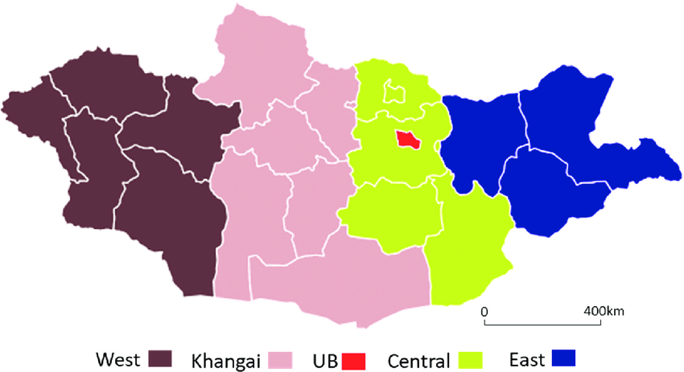 | 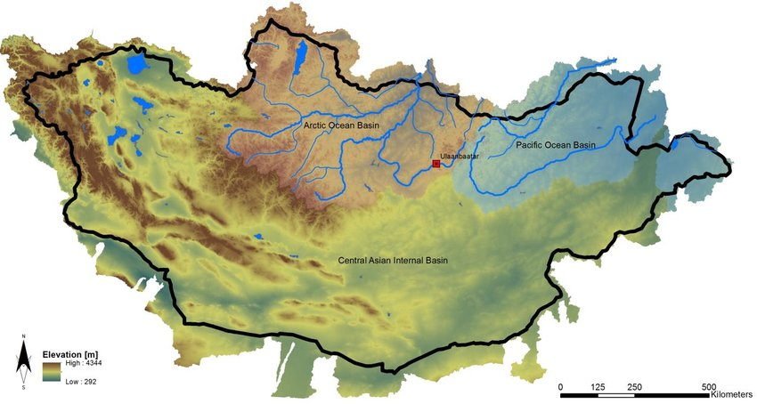
Mongolian climate region. | Mongolian Topography

The extreme weather conditions observation /forecasting (local spatiotemporal scale) and muti-hazard early warning required hybrid and high-density surface ( figure 9) observations( latest sensors based) to track the ground-level multi-hazard events, disasters, and incidents, because of very rapidly changing weather settings. Diurnal weather conditions in Spring, Autumn, and sometimes summer season look at all 4 seasons reflecting in a single day. As a result, generalized (one size fitting for all) weather forecast and forecast impact analysis is insufficient and Mongolia needs to provide a variety of weather infuriation services, e.g., Long, medium, and short-range weather forecasts, impact forecasts for the sectors, operational forecasts for high-value elements, weather warning, advisory, multi-hazard early warning system, etc.

For tracking rapidly developing weather conditions, NAMEM needs to upgrade its Surface-meteorology observational instruments to measure every 15 minutes weather conditions over the surface. The most commonly deployable instruments are to monitor weather parameters such as pressure, temperature, moisture, wind, and radiation. For hydrological applications, additional instruments may be deployed to measure the amount, type, and size distribution of rain and snow, as well as the heat and water content of the soil. The latest advancements in GPS technology have also allowed for estimates of atmospheric water vapor to be obtained from a single surface-based receiver( mobile and modular to be handled by the volunteers, herders, community, commercial installations, etc. for measuring atmospheric turbulence are also sometimes used to monitor the exchange (or flux) of heat, momentum, and moisture between the atmosphere and the Earth's surface.
As the winter season is severe, extreme, and characterized by extreme events which yield the highest intensity and frequency within the winter weather phenomena. The spring weather is more diverse in onset, which is diurnally varying ( sometimes spring, sometimes wet, and suddenly harsh winter), the magnitude of extreme weather conditions poses to extreme winter although it already transitioned to spring conditions, which means the unpredictably the outdoor activities are interrupted by sudden onset extreme conditions and impactful that prevails until the pre-summer season. Summer & Autumn season is also characterized by high variability of weather events; drought, hot spell, dry spell, convective thunderstorms, heavy rainfall, flooding, dust and sandstorms, wildfires, and dzuds.

The rapidly changing and diversified surface weather pattern is affected by the diverse landcover & topographical context, as a result, the traditional weather observations insufficiently meet the demand for wider surface observation and vastly diagnose the rapidly changing weather systems and develop high-resolution Climate norms.

According to the hydrometeorological multi-hazards calendar and potential incidence of disaster events, the figure below shows that the impending extreme weather is highly spatiotemporal and mostly sudden onset and inducing sudden-onset events. The outset of comprehensive weather predictability cannot be fully met by the time series numerical weather prediction(NWP). The most nested and high-density robustly designed hybrid weather observation mechanism (Figure 9), automated data calibration, and assimilation with recurrently running statistical and Dynamical downscaling models in the wake of the impending stage are highly demanded as a part of improving weather forecasting process and prior to meeting the demand of IBF.
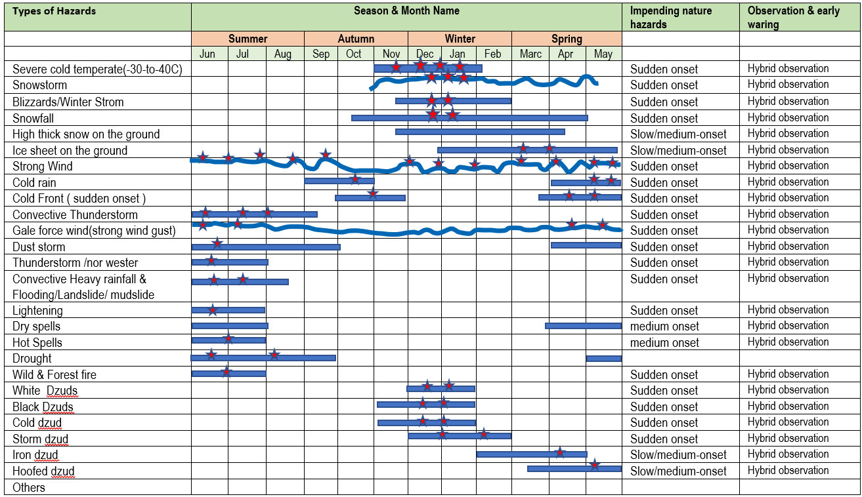
Figure 19 : Calendar of trends of multi-hazards and incidence of disaster

Additionally, the multi-hazard early warning is also dependent on hybrid weather observations( figure 9), impeding and ongoing situation observations ( crowdsource), multi-hazard and disaster incidence tracking, anticipatory loss and damage estimation, early warning based early action designing, etc. to facilitate the comprehensive humanitarian response mechanism.

Table : Examples of multi-hazards induced disaster Impacts
Hydrometeorological Hazard | Cascading hazards | Primary impacts | Secondary impacts
Extreme cold temperatures | - Cold wave | - Danger to human and livestock health  - Damage to and loss of crops | - Low temperatures exacerbate existing health conditions.  - Weight loss, sick and death tolls of livestock
Snowstorm | - Snow drift  - Avalanche  - Thick snow over the communication and transport network  - Thick snowfall over the ground( pastureland, agricultural and etc.) | - Transport networks inoperable  - Damage to property from the weight of snow  - Pasture inaccessible  - Crop damage  - Weight loss, sick and death tolls of livestock | - Loss of livestock  - Loss of services: power, water, communications  - Loss of livelihood  - Access to health care, education, food, and medical supplies  - Loss of industrial production  - Road traffic collisions
Heavy Rain | - Flash floods  - River Floods  - Landslide/mudslide  - Debris fall.  - Excessive erosion  - Flooding (flash flood, river flood,  - waterlogging)  - Silt deposit  - Water pollution  - Structure and basic services damage/disruption  - Damage of pasture, standing crops, agricultural lands, lower flood plan areas etc | - Damage of properties, infrastructure  - Damage to certain crops and loss of livestock  - Death by drowning  - Damage of topsoil  - Damage of properties, buildings, ger, households , commercial installations, urban infrastructure & basic services delivery  - Damage certain crops, especially tubers  - Dangerous travelling conditions | - Houses inhabitable.  - Loss of services: power, water, communications, health care  - Health issues/deaths:  - waterborne diseases etc.  - Loss of livelihood  - Loss of industrial production  - Displacement/Migration:  - long and short term
Strong Wind | - Damaging winds and waves | - Danger to life from flying debris  - Damage to properties, buildings and other manmade structures  - Trees, forests, and orchards damaged or uprooted.  - Destroys some standing crops, especially basic grains.  - Dangerous travelling conditions  - Dangerous river states  - Damage and disruption to transport networks (trees on railway lines and roads, ferry ports inaccessible) | - Loss of services: power, water, communications  - Loss of livelihoods  - Injuries  - Houses inhabitable
Icing over the ground | - Ice accretion on cables | - Damage to power lines  - Power outages  - Transport networks inoperable  - Damage to crops | - Road traffic collisions  - Loss of services: power, water, communications  - Access to health care, education, food, and medical supplies
Thunderstorm |  | - Damage to property  - Danger to life  - Severe crop losses  - Water shortages  - Dangerous driving conditions  - Damage to and loss of crops and livestock Danger to life  - Damage to property  - Power outages  - Delays to rail and air travel | - Loss of services, power, communications  - Loss of livelihood
Low rainfall( Drought) | - Droughts  - Desertification  - Dust storms | - Loss of biomass | - Loss of livelihood(agriculture )  - Loss of livestock  - Soil erosion  - Food shortages  - Increased hunger and malnutrition  - Disease  - Displacement/Migration:
High temperatures | - Heatwave | - Danger to human and livestock health  - Power outages  - Interruptions to public transport (rail) | - High temperatures exacerbate existing health conditions.  - Death

8. 1 Improved and hybrid weather observation mechanism :

- The Doppler radar mosaics provide accurate prediction inputs, but it is costly, and a radar drone can be an alternative with a limited extent to observe convective conditions.
- Improvement of Lighting detection networks, calculation of Lightning density, and its temporal evolution can serve as useful predictors for the classification of storm intensity and its further development. data show good potential in thunderstorm verification. Lightning data can be used as observations in different ways, from the most direct, verifying a forecast also expressed in terms of lightning to more indirect, for example, by verifying a predicted thunderstorm cell.
- Crowdsource-based thunderstorm observations.
- Geostationary Lightning Imager (or Lightning Mapping Imager) by FY-4 satellite(CMA) Provides measurements of the total lightning activity with a resolution of about 6 km at the subsatellite point.
- NAMEM needs to upgrade its nowcasting algorithms for tracking convective rainfall, lighting, thunderstorm ( temp, wind, dew point temp, precipitation, lighting, etc.) phenomena like tornadoes, etc., by using Satellite Himawari 8- identification and analysis of cloud masks, cloud type Himwawari 9 satellite – cloud visualization tools, FY 2/FY4 satellites.
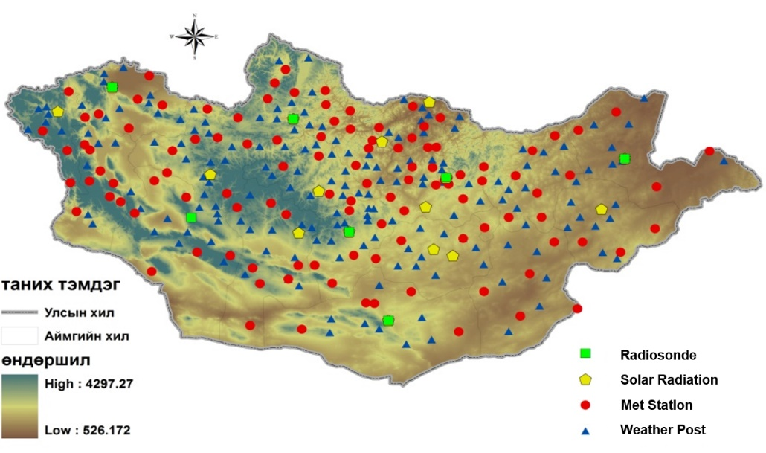
Figure 20 : Distribution of Meteorological stations ( existing weather stations/weather posts)
Figure 21 : Proposed hybrid - high-density, nested, and crowdsource-based surface weather observation and incidence monitoring system(Source: Z M Sajjadul Islam, UNDP-GCF) .

Table: Extracting Impact Indicators from seasonal forecasts :

Category | Level | Meaning | Applicable to impending hazards
Green | 0 | No Elevated Risk
Yellow | 1 | Low Risk | Snowstorm, Winter storm, Cold front induced storm, Thunderstorm, heatwave, flood, flash floods
Orange | 2 | Moderate Risk | Snowstorm, Winter storm, Cold front induced storm, Thunderstorm, heatwave, flood, flash floods
Red | 3 | Very High Risk | Snowstorm, Winter storm, Cold front induced storm, Thunderstorm, heatwave, flood, flash floods
Magenta | 4 | Extremely High Risk | Snowstorm, Winter storm, Cold front induced storm, Thunderstorm, heatwave, flood, flash floods

8.2. Process of developing an Early Warning :

Reviewing the above( figure 19) multi-hazard incidence and stressed timespan likely to be impending, it is quite obvious that Mongolia essentially needs to do the paradigm shift from a traditional forecast to the most updated multi-hazard(s) early warning system, real-time alerting to inform frontline most climate vulnerable herder, farmer, and living community.
The robust implementation of integrated impact forecasting & multi-hazard early warning is the substantive solution to the Mongolian unstable hazardous weather prediction. Typically, the IBF system is integrated with an autonomous and ICT-driven automatic multi-hazard warning process.
Anchoring impact forecast is the first step of the process initiating with a certain lead-time span, and afterward the 2nd step to putting strong hybrid observation( figure 9) of ongoing/prevailing weather conditions to screen carefully over the likelihood of turning to multi-hazards. Following the prevailing critical weather conditions being screened/observed at real-time and spatiotemporal scale, now prepare emergency hazard warnings and advisories to inform the humanitarian program cycle about the level of response that needs to be mobilizing. Over the 3rd step process, the IBF system needs to trigger early warning programmatically (IT) plotting over the map that where loss & damages ( L & D) are taking place and placemark of the other hotspot where potential L & D can take place, subsequently to provide advisory on undertaking early actions & contingencies and mobilizing humanitarian response based on forecasts & warnings. However, the most important duty of the IBF system is to provide timely forecasts and warning for saving lives and properties when the situation is intensifying to sudden onset and rapidly developing weather conditions are likely to impend convective rain and potentiality to trigger flash flooding to cause L & D of lives and properties, in this case, common alerting and warning essentially need to deploy. Since weather events are sudden onset the CAP & warning has to be automatically operational with IT programs ( CAP programme with python, JAVA scripts ) and using other tools e.g. Google public alerts other sub-set of process.
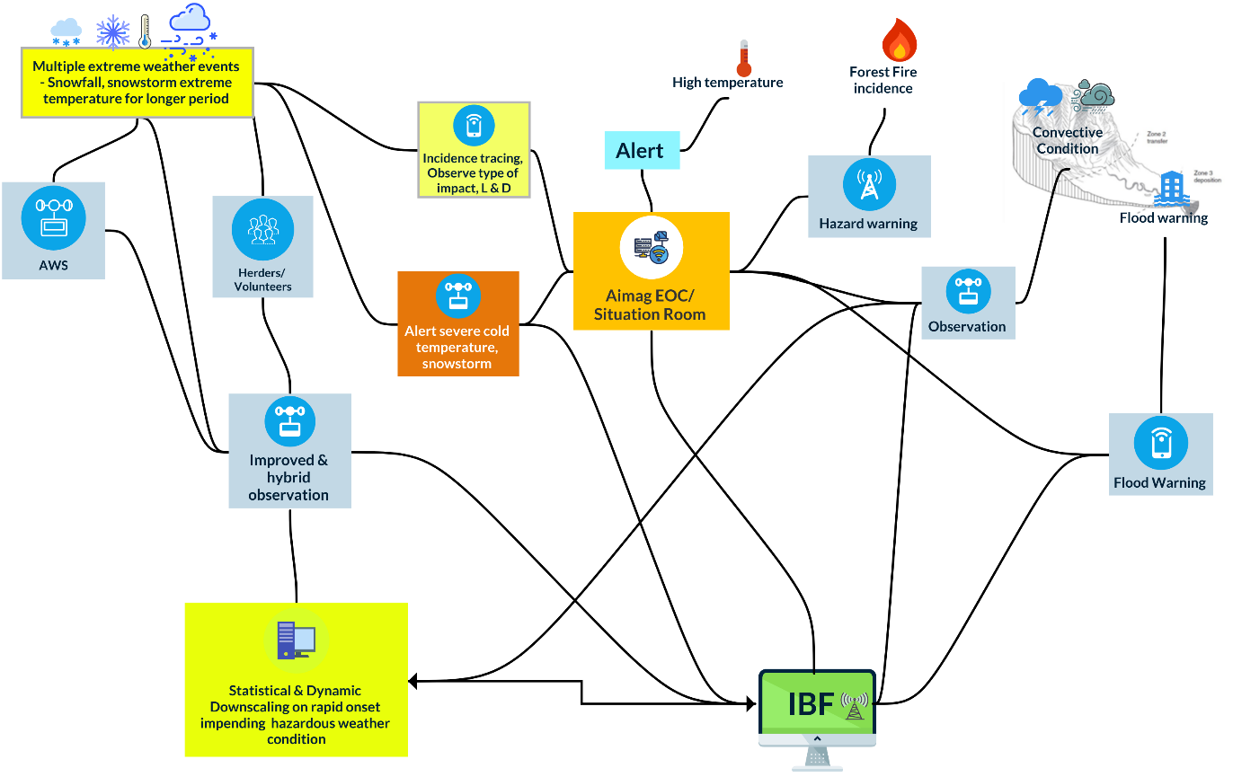

Figure 22 : Nowcasting, hourly & daily IBF to provide a multi-hazard early warning (Source: Z M Sajjadul Islam, UNDP-GCF)

8.3 The multi-hazard early warning process:

- Improving nowcasting to hourly IBF on hazardous weather phenomena :
Mongolian high-impact weather conditions diurnally and rapidly changing ( cold/ warm front, trough, convection, CAPE, high pressure etc ), sometimes 4 seasons are observed in a single day and hazards do impend suddenly. The current observation mechanism for hourly, daily hazardous weather forecast for the very local level still has a degree of uncertainty, as a result, the frontline vulnerable livelihood sectors are largely victimized because of forecast uncertainty. High-density weather monitoring and prediction need to be upgraded and the predictivity mechanism has to be robustly instrumentalized. The most important components of the seamless prediction system, nowcasting, which is the weather analysis and forecast for the next few hours, need to improve significantly.
- Develop Automated nowcasting workflow to facilitate hourly impact forecast :
As new HPC ( supercomputing) capacity is improving at NAMEM, side-by -side instrumentalizing high-density hybrid ( instrumental and crowdsource base) observation system( figure 9 ) will enhance NAMEM capacity in providing more accurate data acquisition, more effective data-assimilation methods with higher temporal and spatial resolutions, better representation of complex physical processes, better model initialization, precision level hourly forecast and nowcasting at bag level will facilitate frontline climate-vulnerable herders and community to understand the varying weather phenomena in any given minutely, hourly and diurnally synopsis ( atmospheric and surface level to tack fronts, convection, CAPE etc. )

8.4 Anchoring NEMA Early Warning System with IBF:

Early Warning Systems (EWS) are operational and transmit information about seismic activity and weather forecasts through different platforms, including the Internet, and mobile phones. services, national radio, and television. NEMA disseminates warning messages to aimags and soums; however, it is difficult to reach remote herder communities. Several EWS have been developed jointly with other stakeholders. Mongolia has an Earthquake Disaster Warning System, funded by the GoM to disseminate warnings via siren towers in Ulaanbaatar, television networks, and radio stations. If EWS becomes inoperable, a mobile control center will be utilized. In addition, earthquake sensor devices connected with satellites provide a backup. Warnings may be directly delivered by mobile phone service providers and radio stations.
Anchoring/linking the following web applications with the IBF platform.
- A platform for Real-time Impact and Situation Monitoring (PRISM) : Geospatial portal for https://prism-mongolia.org/
- Disaster Spatial Information System https://map.nema.gov.mn/ https://map.nema.gov.mn/map/

8.5 Integrated IBF, Warnings, Alerting, and energy hazard early warnings & Advisories :

Extreme weather events | IBF | Warning | Alerting | Emergency hazard(s) early warnings (multi-hazards) | Advisory
Extreme cold temperate(-30 to - 40C) | 7/5 days ago, issue IBF by narrating color-coded thresholds with quantitative impact level and corresponding areas with anticipatory impacts on ……….elements and anticipatory amount on L & D. | Over the daily forecasts and more accurately project the level of L & D ( spatiotemporal scale ) with color-coded thresholds | Severely impacted areas Particular elements like to be severely affected ( very short duration hourly/6 hourly/daily ) | - A high probability of extreme cold temperature can trigger hazard(s) and do a significant level of L & D .  - Provide MHEWS with the color-coded threshold of L & D.  Provide advisory on emergency preparedness, and advise the humanitarian actions. | - Separate advisory (IBF . Weather warning, Alerting, MHEWS ) on anticipatory Impact/L & D  - Advising preparedness, and contingency.  - Advising early actions based on severity/magnitude and anticipatory L & D  - Advising anticipatorily estimated impacts and humanitarian assistance to mobilize for whom, where, when, and how.
Extreme cold temperate(-30 to - 40C) | Extreme coldest ( -40c and above )temp. | Extreme coldest ( -40c and above )temp.
Extreme cold temperate(-30 to - 40C) | Severe coldest ( -30c to -40c)temp. | Severe coldest ( -30c to -40c)temp.
Extreme cold temperate(-30 to - 40C) | Coldest Temperature ( -20c to -30c)temp. | Coldest Temperature ( -20c to -30c)temp.
Extreme cold temperate(-30 to - 40C) | Moderate Cold Temperature ( -10c to -20c)temp. | Moderate Cold Temperature ( -10c to -20c)temp.
Snowstorm | 7/5 days ago, issue IBF by narrating color-coded thresholds with quantitative impact level and corresponding areas with anticipatory impacts on ……….elements and anticipatory amount on L & D. | Color-coded threshold with spatiotemporal scale | Alerting placemark/hotspot where Snowstorm can happen within a short time( daily alerting) | - High probability of occurrence of Snowstorms and likely to do a significant level of L & D .  - Provide MHEW with the color-coded threshold of L & D.  - Provide advisory on emergency preparedness and advise the humanitarian actions.
Blizzards/Winter Strom | Advising in 5/7 days forecasts where ( over the color-coded threshold) areas the event is likely and what level of L/D can take place | Color-coded threshold with spatiotemporal and short range (hourly/6 hourly/daily ) warning, the scale of impacts, and L & D. | Alerting placemark/hotspot can fall under high impacts of Blizzards/Winter Strom Areas ( daily alerts ) | - High probability of occurrence of Blizzards/Winter Strom and likely to do a significant level of L & D .  - Provide MHEW with the color-coded threshold of L & D.  - Provide advisory on emergency preparedness and advise the humanitarian actions.
High-density snowfall | Color-coded thresholds with the anticipatory amount of snowfall g/mm3 are likely ……….and can potentially do impacts which elements e.g. grazing, damage standing pasture/crops, death tolls of types of animals, interrupt communications at ……placemark ……………… at ….level ( location and amount ) | Color-coded threshold with spatiotemporal (hourly/6 hourly/daily ), scale of impacts, and L & D. | Alerting placemark/hotspot of high-density snowfall are likely Strom what………. Areas ( daily alerts ) | The probability of occurrence of density snowfall and likely to do the significant level of L & D.
High thick snow on the ground | Color-coded thresholds with the anticipatory amount(range) of snowfall (cm) are likely ……….and can potentially do impacts which elements e.g. grazing, damage standing pasture/crops, death tolls of types of animals, an interrupt of communications at ……placemark ……………… at ….level ( location and amount ) | Color-coded threshold with spatiotemporal (hourly/6 hourly/daily) scale impacts, L & D | Alerting placemark where high thick snowfall can occur within next …..duration | Warning about the type of hazards that can be caused by high thick snow on the ground and level of L & D .
The ice sheet on the ground | Color-coded thresholds with anticipatory areas area coved and thickness (range) of ice (mm) are likely ……….and can potentially do impacts which elements e.g. grazing, damage standing pasture/crops, death tolls of types of animals, interrupt communications at ……placemark ……………… at ….level ( location and amount ) mm | Color-coded threshold with spatiotemporal ( very short range daily/24 hrs alerts ) scale impacts, L & D | Alerting placemark/hotspot where high-density ice sheets are prevailing ( daily alerts ) | Warning about the type of hazard(s) that can be caused by high thick ice on the ground and level of L & D .
Strong Winds | Color-coded thresholds (range of speed in m/s) with areas are likely to be impacted by strong winds and can potentially do impacts …… elements likely to be impacted ( e.g. grazing, damage standing pasture/crops, livestock tolls and types, interruption of communications at ……placemark ……………… at ….level ( location and amount ) | Color-coded thresholds of areas falling under high winds with (short-range daily/24 hrs alerts ) with impact thresholds and anticipatory L & D | Alerting placemark/hotspot where high winds ( m/s) likely to occur and currently occurring ( daily alerts ) | Warning about the type of hazard(s) that can be caused by Strong Winds on the ground and level of L & D .
Damaging Winds / Gale force wind(strong wind gust) | Color-coded thresholds (range of speed in m/s) with areas are likely to be impacted by damaging winds and can potentially do impacts …… elements likely to be impacted ( e.g. grazing, damage standing pasture/crops, livestock tolls and types, interruptions of communication at ……placemark ……………… at ….level ( location and amount ) | Color-coded thresholds over the areas are falling under Damaging Winds with (short-range daily/24 hrs warnings ) with impact thresholds and anticipatory L & D | Alerting placemark/hotspot where damaging winds ( m/s) likely to occur and currently occurring ( daily alerts ) | Warning about the type of hazard(s) that can be caused by Damaging Winds on the ground and level of L & D .
Cold rain | Sudden onset hazard events can be predicted by the operational forecast | Color-coded thresholds over the area falling under Cold rain (mm) with (short range warnings minutes/1hr/3hr/6hourly/daily/24hrs) with impact thresholds and anticipatory L & D | Alerting placemark/hotspot where Cold rain ( mm) is likely to occur or currently occurring ( daily alerts ) | Warning about the type of hazard(s) that can be caused by Cold rain on the ground and level of L & D .
Cold Front ( sudden onset ) induced storm ( spring) | Sudden onset hazard events can be predicted by the operational forecast | Color-coded thresholds over the areas are falling under cold Front induced storm (very short range – warning e.g., minutes/1hr/3hr/6hourly/daily/24hrs with impact thresholds(m/s) and anticipatory L & D | Alerting placemark/hotspot where cold Front induced storm ( m/s) likely to occur ( daily alerts ) | Warning about the type of hazard(s) that can be caused by Cold Front on the ground and level of L & D .
Convective Thunderstorm | Sudden onset hazard events can be predicted by the operational forecast | Color-coded thresholds over the areas are falling under Convective Thunderstorm (very short range – warning e.g., minutes/1hr/3hr/6hourly/daily/24hrs) with impact thresholds(m/s) and anticipatory L & D | Alerting placemark/hotspot where Thunderstorm ( m/s) likely to occur, alerting frequencies (minutes/1hr/3hr/6hourly/daily/24hrs) | Warning about the type of hazard(s) that can be caused by Convective Thunderstorms on the ground and level of L & D .
Tornadoes /nor wester | Sudden onset hazard events can be predicted by the operational forecast | Color-coded thresholds of areas are falling under cold front induced storm (very short range – warning e.g., minutes/hourly/6 hourly) with impact thresholds(m/s) and anticipatory L & D | Alerting placemark/hotspot where Tornadoes ( m/s) likely to occur, alerting frequencies (minutes/1hr/3hr/6hourly/daily/24hrs) | Warning about the type of hazard(s) can be caused by Tornadoes /nor wester on the ground and level of L & D .
Dust storm | Sudden onset hazard events can be predicted by the operational forecast | Color-coded thresholds of areas falling under Dust storm-induced storm (very short range – warning e.g., hourly-6 hourly) with impact thresholds(m/s) and anticipatory L & D | Alerting placemark/hotspot where Dust storm ( m/s) likely to occur, alerting frequencies (minutes/1hr/3hr/6hourly/daily/24hrs) | Warning about the type of hazard(s) that can be caused by Dust storms on the ground and level of L & D .
Convective Heavy rainfall causing Flooding/Landslide/ mudslide | Sudden onset hazard events can be predicted by the operational forecast | Color-coded thresholds of areas falling under heavy rainfall flooding (very short range – warning e.g., minutes/1hr/3hr/6hourly/daily/24hrs) with impact thresholds(m/s) and anticipatory L & D | Alerting placemark/hotspot where Heavy rainfall ( mm/hr) is likely to occur, alerting frequencies (minutes/1hr/3hr/6hourly/daily/24hrs) | Warning about multi-hazards e.g. flash floods, fiver floods/ water logging/ landslide /mudslide /debris fall the ground location /placemark and level of L & D are likely.
Lightening | Sudden onset hazard events can be predicted by the operational forecast |  | Alerting placemark/hotspot where Lightening likely to occur, alerting frequencies (minutes/1hr/3hr/6hourly/daily/24hrs) | -
Dry spells | Analyzing appropriate parameters and preparing IBF with color-coded thresholds can potentially do impacts to…… elements e.g. grazing, damage standing pasture/crops, livestock tolls and types, interruptions of communication at ……placemark ……………… at ….level ( location and amount ) | Color-coded thresholds of areas are falling dry spells condition with impact thresholds and anticipatory L & D |  | -
Heatwave | IBF color-coded thresholds with areas are likely to be impacted by high temperature and impacting …. elements ( e.g. grazing, damage standing pasture/crops, livestock tolls and types, interruptions and types communication at ……placemark ) ……………… at ….level ( location and amount ) | Color-coded thresholds of areas are falling Heatwave conditions with impact thresholds and anticipatory L & D |  | Warning about Heatwave can cause L & D .
Drought | IBF with color-coded thresholds with areas are likely to be impacted by drought( types e.g. agricultural, meteorological, hydrological) and impacting elements e.g. grazing, damage standing pasture/crops, livestock tolls, agriculture yield loss ) ……………… at ….level ( location and amount ) | Color-coded thresholds of areas are falling Drought conditions with impact thresholds and anticipatory L & D |  | Warning about drought can cause L & D .
Wild & Forest fire | Can be covered by IBF and also can be predicted by the operational forecast | Color-coded thresholds of areas falling under heatwave (very short range – warning for the incidence of forest fire (warning frequency - minutes/1hr/3hr/6hourly/daily/24hrs) with impact thresholds(m/s) and anticipatory L & D | Alerting placemark/hotspot where Wild & Forest fire likely to occur, alerting frequencies (minutes/1hr/3hr/6hourly/daily/24hrs) | Warning about drought can cause L & D .
White Dzud | Analyzing a) weather variables /indicators/indices, b) on-set weather variables /indicators/indices( sustainable animal husbandry management capacity, pasture condition over the ground, difficult days feeding capacity, feed storage per sheep units,  snow density, intensity, thickens, days, covering areas etc.) and calculate the white Dzuds intensity to show the color-coded thresholds over the map |  | Alerting placemark/hotspot where White Dzud can cause intensive L & D | Warning about multi-hazards e.g. flash floods, fiver floods/ water logging/ landslide /mudslide /debris fall the ground location /placemark and level of L & D are likely.
Black Dzud | Analyzing a) weather variables /indicators/indices, b) on-weather variables /indicators/indices and developing Black Dzud impact area risk map, and providing IBF on Black dzud . |  | Alerting placemark/hotspot where Black Dzud can cause intensive L & D | Warning about multi-hazards e.g. flash floods, fiver floods/ water logging/ landslide /mudslide /debris fall the ground location /placemark and level of L & D are likely.
Cold dzud | Analyzing a) weather variables /indicators/indices, b) on-weather variables /indicators/indices ( temp, windspeed, ) and developing Cold Dzud impact area risk map, and providing IBF on Cold dzud . |  | Alerting placemark/hotspot where Cold Dzud can cause intensive L & D | Warning about multi-hazards e.g. flash floods, fiver floods/ water logging/ landslide /mudslide /debris fall the ground location /placemark and level of L & D are likely.
Storm dzud | Analyzing a) weather variables /indicators/indices, b) on-weather variables /indicators/indices and developing Storm Dzud impact area risk map, and providing IBF on Storm dzud . |  | Alerting placemark/hotspot where Storm Dzud can cause intensive L & D | Warning about multi-hazards e.g. flash floods, fiver floods/ water logging/ landslide /mudslide /debris fall the ground location /placemark and level of L & D are likely.
Iron dzud | Analyzing a) weather variables /indicators/indices, b) on-weather variables /indicators/indices and developing Iron Dzud impact area risk map, and providing IBF on Iron dzud . |  | Alerting placemark/hotspot where Iron Dzud can cause intensive L & D | Warning about multi-hazards e.g. flash floods, fiver floods/ water logging/ landslide /mudslide /debris fall the ground location /placemark and level of L & D are likely.
Hoofed dzud | Analyzing a) weather variables /indicators/indices, b) on-weather variables /indicators/indices and developing Hoofed Dzud impact area risk map, and providing IBF on Hoofed dzud . |  | Alerting placemark/hotspot where Hoofed Dzud can cause intensive L & D | Warning about multi-hazards e.g. flash floods, fiver floods/ water logging/ landslide /mudslide /debris fall the ground location /placemark and level of L & D are likely.
Combined dzuds | Analyzing all dzud factors and developing an algorithm for sequentially combing all dzud factors, to sum up the severity of combined dzud factor  Develop IBF advisory on combining dzud |  | Alerting placemark/hotspot where Combined Dzuds can cause intensive L & D

8.6 Convective weather condition-induced hazards early warning :

Mongolian convective weather events recurrently increasing with the pace of global, regional, and local climate change phenomena. Most of the herder’s livestock-based livelihood is damaged by the convective thunderstorm, short-time heavy rainfall, lighting, etc., those are impeding sudden onset and remote rural communities are experiencing badly. Those events are taking livestock as well as human tolls, but NAMEM still needs to provide early warnings for the events. Essentially Mongolia now needs to install high-density and hybrid surface observation ( figure 9) ( putting instruments at high-value elements ) for screening and tracking and providing early warning for the hi-impact convective weather conditions in which the current 137 weather stations and 181 weather posts, and other hydrological gauging stations are still insufficient.
- Tools and process :

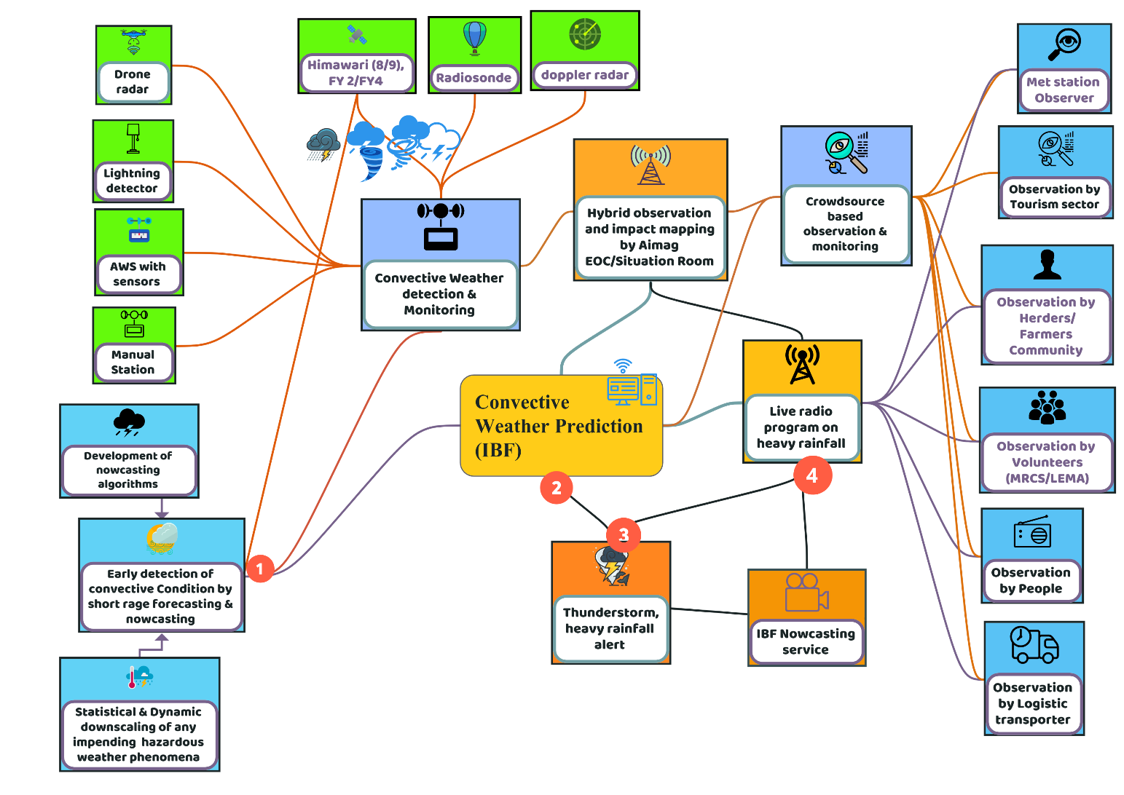

Figure 23 : Convective weather condition-induced hazards early warning system(Source: Z M Sajjadul Islam, UNDP-GCF)

- Baseline risk review

- Calculating the risk of flash flooding, landslide, mudslide, fallen rocks/debris, etc. for assessment of convective rainfall-induced flash flooding
- Mapping the populated areas ( Cities, towns, ger, markets, etc), highways where mobility is highly recurrent and essential.
Table : Screening of rapidly developing convective weather conditions:
Tools | Automatic Weather Station | Nowcasting
Dynamical /Statistical downscaling ( grided data) over the special area of interest ( determining rapidly developing weather conditions ) | - Installation of Automated weather observing system (AWOS)  - Installation of All-weather precipitation accumulation gauge (AWPAG)  - Installation of temperature/dew point sensor hygrothermometer.  - Develop short-range forecasting, Rapid Update Cycle (RUC), which provides NWP-based forecasts at the 0–6h timescale updated every 15–60 min | Algorithm development for the Severe convective high-impact forecasting and nowcasting
Analyze the most updated IR image of Himawari-8/9 satellites, FY 2/FY4 satellites and provide nowcasting services through the IBF platform | - Acquisition of temperature and dew point in degrees Fahrenheit/ Celsius, present weather, icing, lightning, sea level pressure, and precipitation accumulation | - Input from Geostationary Lightning Imager (or Lightning Mapping Imager) by FY-4 (CMA) which provides measurements of the total lightning activity with a resolution of about 6 km at the subsatellite point.  - Satellite data: Himawari-8 geostationary satellite imagery, Himawari Standard Data (HSD) which observes every 10 minutes.  - Satellite Himawari 8 for identification and analysis of cloud masks  - Himwawari 9 for cloud visualization, identification of cloud type  - Utilization of Geostationary Lightning Imager (or Lightning Mapping Imager) by FY-4 (CMA) which provides measurements of the total lightning activity with a resolution of about 6 km at the subsatellite point.  - Utilization of FY 2/FY4 satellite images for Cloud convergence, Cloud identification, Cloud motion, Convective clouds, Dust storm  - Geostationary Lightning Imager (or Lightning Mapping Imager) by FY-4 (CMA) > Provides measurements of the total lightning activity with a resolution of about 6 km at the subsatellite point.
Acquisition of heavy rainfall, thunderstorm, hailstorm, etc. data from AWS instrument | - Automatic Rain Gauger  - Automatic lightning detector  - Automatic Thermometer  - Automatic Anemometer  - Automatic Wind vane  - Automatic Hygrometer  - Automatic Barometer  - Automatic Ceilometer  - Automatic Rain gauge  - Automatic Ultrasonic  - Automatic Pyranometer | IBF platform to disseminate nowcasting services by providing the above tools and information services.

- Algorithm development for the Severe convective high-impact forecasting and nowcasting :

8.7 Convective weather condition screening mechanism

Method | Pre-convective environment tracking | Convective Initiation tracking | Mature Convective Storm tracking
Nowcasting weather monitoring sensors | NWP data, aircraft measurements, UAV/Glider sensor, Weather radar drone, and observation of other synoptic parameters from met station | - Rader, UAV, Drone capture data, Lightening data  - Cloud type  - Cloud top temperate and height  - Cloud microphysics  - Convection initiation  - Optimal cloud analysis  - Convective Cloud Outflows | - Radar, lightning data  - Clouds type, storm tracking  - CRR (Convective Rainfall Rate) Product – precipitation  - Lightning Density
 | Convective Cloud Outflows | Various parameters were calculated to characterize the size distributions, including rainfall rate, liquid water content, and median volume diameter.
Analyze CAPE | Convective available potential energy (CAPE)
Lighting detection networks | Geostationary Lightning Imager (or Lightning Mapping Imager) by regional satellites | - Measurements of the total lightning activity with a resolution of about 6 km at the subsatellite point.  - Calculate Lightning density and its temporal evolution can serve as a useful predictor for the classification of storm intensity and its further development. Significant use of radar mosaics/radiosondes or drone radar, to evaluate convective and precipitation forecasts.
Development of own nowcasting algorithms. | Appropriate high-resolution nowcasting, cumulative rainfall model, etc., the model developed by NAMEM-NWP. A few examples are given in below ;  - Dynamical Downscaling using MM5 certainly improves the spatial and temporal variations of wind and temperature in Mongolia.  - Regional weather forecast models—standard 5 × 5 km resolution, provide up to three days forecast.  - Calculation of Rainfall accumulation of 9km, 5km, 3km, and 1 km grid-point spacing from the model output of 1 to 6 hourly precipitation accumulation distribution maps for the highly localized flooding conditions  - Cumulative rainfall predicted by the WRF model with 1 km of spatial grid resolution. | - Tracking convective rainfall, lighting, and thunderstorm ( temperature, wind, dew point temp, participation, lighting, etc.)  - Calculate various weather parameters were calculated to characterize the size distributions, including rainfall rate, liquid water content, and median volume diameter

- Anticipatory loss and damage assessment :

Hazard | Agriculture | Settlement | Commercial installations | Livestock | Communication network
Heavy rainfall | Standing crops | UB , Aimag center, soum center, bag center | Marketplace | Herders’ tender livestock(calf) | Damage Road network
 | Seedling | Towns | Processing industries | Ger | Damage and waterlogging of earthen road/paved road,
 | Sapling | Soum town | SME/Enterprise | Livestock shed | Damage structures at River crossing points
 |  | Bag settlements | Warehouse | Water logging to pastureland
 |  | Other installations

8.8 Strong/Damaging Wind induced hazards warning :

The Wind is the most influential weather parameter and mostly affects the whole weather system in Mongolia in any given season. The seasonal wind speed on ridge-crest locations varies from eastern and central Mongolia to western Mongolia. The eastern and central ridge-crest locations have a similar seasonal distribution of wind resources to sites in the plains and other low-elevation areas. The speed reaches a maximum in April and May and in October and November. The diurnal wind speed distribution, or wind speed versus time of day, is strongly influenced by site elevation and topography.

- Wind speeds fluctuated between 18 and 24 m/s (-17 degrees Celsius wind chill factor2) and reached 28 to 30 m/s (-24 degrees Celsius wind chill factor), in Altai, Tonkhil, and Sharga soums of Govi-Altai province, and Jinst soum of Bayankhongor province.
- Damaging winds occur in spring, summer, autumn, and winter as well
- Wind speed highly varies diurnally e.g. according to the herders morning looks calm and the animal is taken outside for grazing even sudden changes in the weather occurred within 30 to 40 minutes and animals died.
- High wind speed caused by snowdrifts and blowing snow induced poor visibility of fewer than 0.5 kilometers (as stated by herders) and disrupted movement between cities due to road closures in many areas. The wind-induced weather hazards force livestock into running indiscriminately and severely affected the herdsmen.

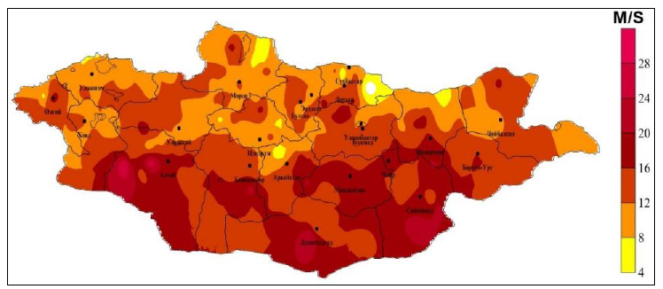
Figure 24: High wind speed between 6 May – 13 May 2019. (Map: NAMEM)

1) Tools and process :
- Running statistical & Dynamical downscale model when there is likelihood of anomalies to track the impending event. The NWP division remains alerted for the analyzing the situation.
- Access to baseline CRV information which being collected by aimag EOC and risk mapping on strong wind phenomena: GIS map on wind hazards prone areas.
- Assessment of socio-economic, priority sectoral risk and vulnerabilities to wind hazards.
- GIS map in an event situation report on winter weather-related disasters already happened.
- GIS maps and risk information on geophysical, geological, geomorphological, and hydrometeorological factors affect and intensify the strong wind-induced hazards in Mongolia.
- Assessment of exposure, risk, and vulnerabilities of the elements annexure 1 caused by winter hazards.
- Develop algorithms, and models based on Mongolian wind speed and develop forecasts.

Wind-hazard tracking and early warning mechanism :

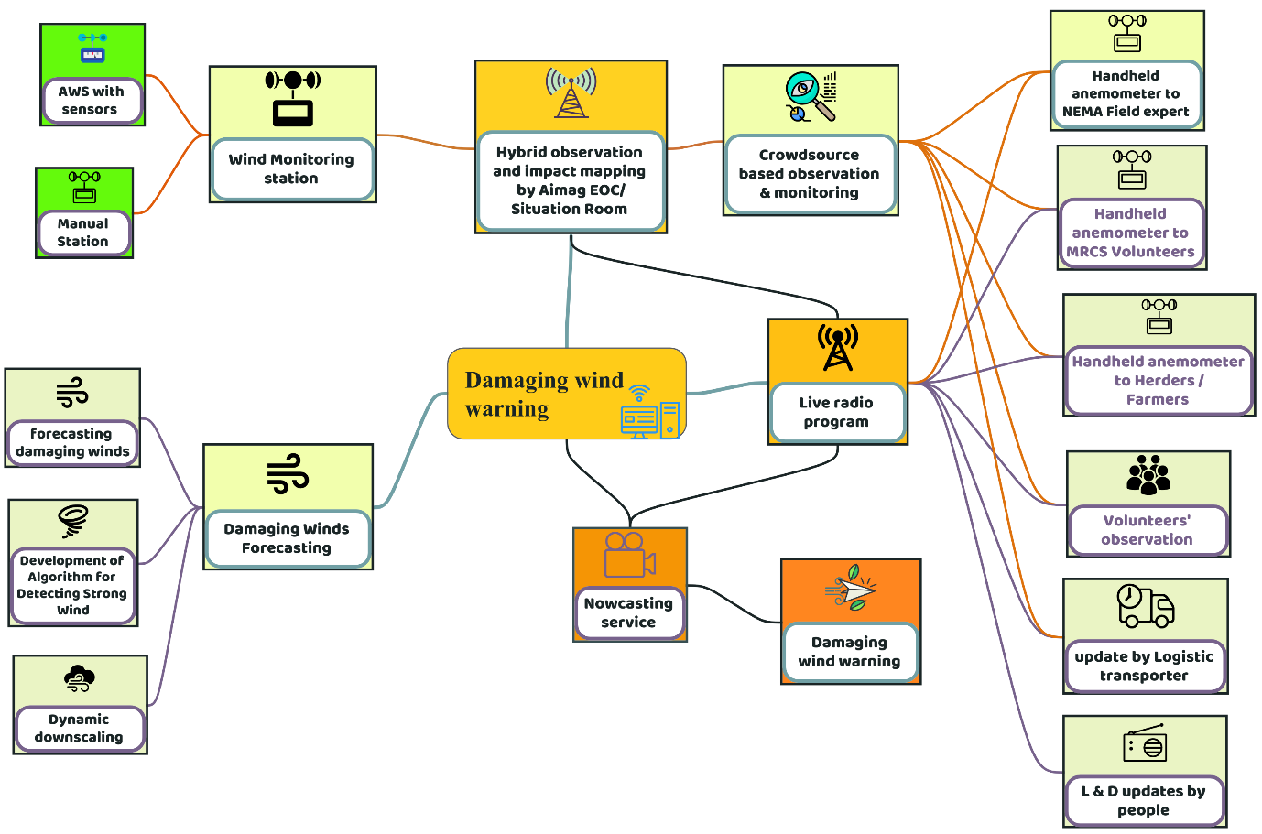
Figure 25: Wind-hazard tracking and early warning mechanism(Source: Z M Sajjadul Islam, UNDP-GCF).

Table: Impacts by damaging winds
Wind-induced hazards | Elements | Impacts | Hybrid ( climatic & non-climatic) observation ( figure 9)
- Sudden onset winter storm.  - Contribute to severe cold temperature.  - Wind speed contributes Chills factor.  - Snowstorm  - Cold front-induced storm  - Dust storm  - Poor visibility | - Livestock  - Agriculture  - Rural settlements  - Urban centers  - Tourism facility  - Small & medium enterprises  - Transport and communication  - Damage power lines  - Damage ger  - Damage livestock  - Damage livestock shelter  - Damage standing pasture crops.  - Dust/sandstorms can claim lives, accidents, livestock | - Transport accident  - High winds cause significant loss of topsoil and nutrients from agricultural land, which can negatively impact the ability to grow crops in the future.  - Mongolian steppe and desert-steppe regions are very windy. The annual average wind speed in the mentioned regions is 4-6 m/s. The average wind speed is 1-2 m/s in the Altai, Khangai, Khuvsgul, and Khentii mountains. 2-3 m/s in the valleys of mountains and other areas  - Mostly, west, northwest, and northerly winds dominate.  - Wind depends very much on local orography and landscape, and mountain-valley breeze wind often could occur.  - Mongolian dust storms are one of the main sources of “yellow dust”.  - Sandstorms are about 10 days during the year in the mountain areas such as Altai, Khangai, Khuvsgul, and Khentii,.  - Around 61% of dust storms occur in March during spring, while 7% occur in summer.  - Ground level physiographic/topographic condition, Soil Type, Soil Properties, Mining areas, Estimation of pastureland degradation, Desertification, Road erosion, Soil erosion of arable land, deforestation, mining, soil pollution, and road erosion, environmental impact, dusting, pollution.  - Pasture degradation, land degradation, and soil ecology.  - Soil health degradation | - High-density observation  - Nowcasting and operational forecast on damaging winds

Strong wind forecast - contribution by Local Team :

8.9 Hazardous winter weather early warning :

Winter starts early in November and lasts about 110 days until March. Sometimes it snows in September and November, but the heaviest snowfalls usually occur at the beginning of November. January is the coldest winter month in Mongolia. The average temperature is -35°C in Khangai's mountainous regions. Snow covers on the ground exist for as maximum as 150 days in Mongolia. Snow cover, coldest temperature, and strong winds are the catalyst of contributing to and intensifying sudden hazards, e.g. snowstorm, winter storm, blizzard, cold wave, and cold front-induced cold storm. Followings are the winter weather-induced hazards in Mongolia largely caused by loss and damage largely of the livestock and other sectors and early warnings are essential.
- Extreme cold temperature
- Heavy snowfall
- Snowstorm
- Extreme cold (wind chill)
- Blizzards (snow with strong winds and reduced visibility
- Freezing rain/drizzle
- Multi-Dzud factor
- Cold front-induced storm

1) Tools and process :
- Baseline information collection and risk mapping: GIS map on the climatology of Mongolia( 30 years mean) with the distribution of extreme cold temperature zone, Heavy snowfall zone, Snowstorm risk areas, high-thick snow areas, snow-icy ground areas, etc.
- Using MODIS snow mapping (Snow-map) and ice mapping (Ice-map) algorithms, calculate the Normalized Difference Snow Index (NDSI) and prepare separate maps of snow and ice for dzud risk analysis.
- Assessment of socio-economic, priority sectoral risk and vulnerabilities to winter hazards.
- GIS map in an event situation report on winter weather-related disasters already happened.
- GIS maps and risk information on geophysical, geological, geomorphological, and hydrometeorological factors affect and intensify the winter hazards in Mongolia.
- Assessment of exposure, risk, and vulnerabilities of the elements annexure1 caused by historical winter hazards.
- For winter hazardous weather forecasting, winter hazard early warning -develop algorithms, the high-resolution model for tracking impending hazards.
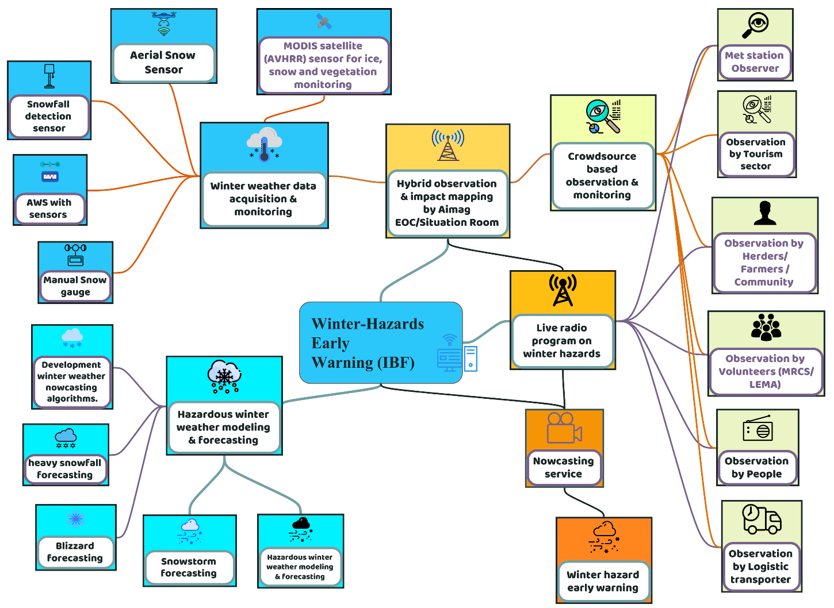
Figure 26 : Winter hazard early warnings(Source: Z M Sajjadul Islam, UNDP-GCF).
Table : Extreme winter weather impacts for the priority sectors
Hazard | Livestock | Agriculture | Water | Soil and Land
• Extreme cold temperature  • Heavy snowfall  • Snowstorm  • Extreme cold (wind chill)  • Blizzards (snow with strong winds and reduced visibility  • Freezing rain/drizzle  • Multi-Dzud factor  • Cold front-induced storm | - Contribute dzud factor and potentially can perish millions of livestock population.  - Pasture degradation, shortage, and perish millions of livestock.  - Sudden onset heavy snowfall, snowstorms, blizzards, cold rain, and cloud Strom take a toll on livestock and human. | - Standing crops, pasture damage  - Food insecurity  - Seedling and sapling damage, planting time delay, crop yield loss, etc. | Frozen waterbody, lakes, rivers, and waterway communication interrupted | Soil thawing

Considering the winter multi-hazards, the following information services need to be provided through integrated IBF & multi-hazard early warning platforms.
- Blizzard warning
- Winter storm warning
- Ice storm warning
- Winter storm watch
- Winter weather advisory
- Lake effect snow warning
- Snow squall warning
- Heavy snow warning
- Snow advisory
- Blowing snow advisory
- Snow and blowing snow advisory.
- Extreme cold watch
- Extreme cold warning
- Lake effect snow watch
- Freezing rain advisory
- Blizzard watch

8.10 Template: Winter weather emergency advisory

Advisory :

Winter weather emergency :

National Impact-based Weather Forecasting and Multi-Hard Early Earning Division NAMEM

Circular 01 :
Warning Issue Date : (2023-…….) Valid for …………Date………………Date …
Warning areas : the whole country

Winter storm warning from 10AM Sunday to 6 PM Monday, December 02, 2023

* What type of server condition (?) ... Winter storm expected. Total snow accumulations amount
of 10 to 16 inches are likely. Winds gusting as high as 25m/s.

* Where it can happen (?) ...Nort-western Arkhangai area………..aimag(s) ……………soum(s) are under red colored alerts because of high intensity, high density, and thick of snow (20cm-25 cm) are expected over the red threshold alerted areas, 15-20cm expected at orange alerted areas and 0-10cm are yellow alerted areas.

* When...From 10 AM Sunday to 6 AM Mongolia time Monday.

* Impacts/Anticipatory Loss & Damage (L&D) ... Livestock is likely to be attacked by frostbite, low body temperature, likely to fall sick( hyperthermia), and the likelihood of perishing calves.

* Additional detailed ...The worst conditions should be during the daytime on Sunday.

Prepared Actions…

Herders are being advised to provide a warm place for the livestock with warm jackets, provide high-energy feeds, and remain vigilant to detect any livestock falling sick and becoming weak. Outdoor activities are completely prohibited for the red color-coded hi-impacted areas. Travel should be restricted to emergencies only in orange-colored coded areas. For unavoidable shot-distance traveling over the orange zone, travelers are being advised to gear a winter survival kit. If you get stranded, stay with your vehicle.

The latest road snow conditions can be obtained by accessing IBF web-based wither hazard early warning system, which can be listed by national AM radio broadcasts.

8.11 IBF Flood Impact Forecasting:

Current context : Mongolia and about 20-60 percent of annual runoff forms during the spring flood depending on geographical location. In Mongolia most of the annual runoff up to 70-80 percent forms during rainfall floods in the summer period. Rainfall floods occur when daily rainfall exceeds 40- 110 mm. The intensity of rainfall depends on many factors such as rainfall intensity and duration, relief, vegetation covers antecedent soil moisture condition etc. Rainfall starts from mid June till mid of September and has several peaks. Historically mentioned that in 1613, 1623, 1695, 1696, 1701, 1715, 1716, 1830, 1838, and 1868 years in Mongolia have occurred several high (D.Tsedevsuren,1987). Flood discharge in Khalkhin gol River in eastern Mongolia in 1985 reached 300-400 cumec while rainfall floods along the Selenge River 1971-1973 produced flood discharge up to 2000-4000 cumecs. One biggest rainfall in the modern era is the rainfall flood in 1966 in the Tuul River basin. On10-11th of July 1966, in Ulaanbaatar area, recorded 103.5 mm rainfall which was about 43 percent of the total annual precipitation. Due to this rainfall Tuul and other small tributaries of the river as Selbe, Uliastai.
- Flood Risk, Vulnerability, and Exposure Assessment :

Conduct comprehensive flood risk assessment based on historic flood hazard data and Delineating flood risk areas, develop flood risk map, Risk calculation of river catchment areas, Land use pattern over the basin areas /downstream areas.
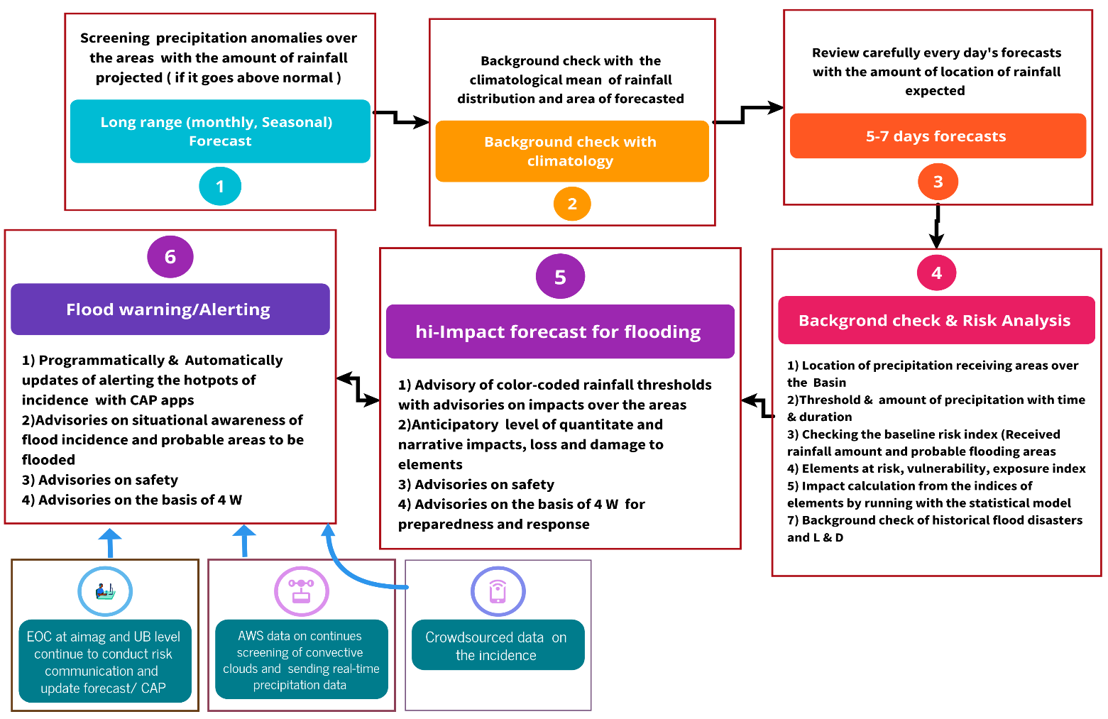

Figure 27 : Flood impact forecasting process (Source: Z M Sajjadul Islam, UNDP-GCF)

- Develop a suitable flood impact assessment model based on the Mongolian context by the hydrological authority (hydro-morphological characteristic types of river basis, DEM, DTM, drainage network, rainfall regime, and other relevant parameters ) on flood risk index (FRI), combining flood hazard index (FHI) and infrastructure vulnerability index (VI).
- Rainfall: First, identify the flood-prone areas of the whole of Mongolia. Rainfall spatial variability changes dynamically from a high evapotranspiration zone to a semi-arid and arid zone. As a result, any convective system can be developed in any given atmospheric climatic conditions and characteristics of the land surface. The current Data acquisition that exists is also spatially biased toward airports and urban areas in general, where these locations may not represent flood-prone areas.
- Setting-up rainfall gauging stations based on the periphery of the basin areas that will receive the rainfall, accumulation and triggering the runoff to drainage and river system. As a result, a virtual flood model needs to develop considering the input of 1-10 days of accumulation of rainfall and the probable extent of catchment areas flooding.
- Developing a hydrological and flood risk and vulnerability calculating model/hypothesize based on Mongolian context :
- The hydrological research division to develop a flood risk and vulnerability model based on hydrological resources, system, river, and drainage DEM & morphological system, discharge level, of river and waterbodies, existing water control structures, reservoirs, water retention, integrated water resources management, precipitation regime, ice melting level, and heavy precipitation areas.
- Develop a flood Risk & Vulnerability statistical model with the given intensity of heavy rainfall ( 30-50 mm/hour, 50-70mm/hr, 70 & above mm/hour ) and calculate the flooding intensity based on all parameters ( size and extent of areas receiving rainfall, runoff/drainage direction/channel, number of elements under lower floodplain areas can potentially be impacted, damaged & lost)
- Calculation of accumulation of total rainfall over the 6 hours/12 hours/24 hours………few days/weeks( with intensity/frequency) and intensity
- Calculate the flood risk index and identify risk areas on GIS map and identify the elements inventoried in Annexure 5 based on the flood risk index (FRI) combining flood hazard index (FHI) and building vulnerability index (VI)
- The first step is to define the area (spatial) and time (temporal) period of data to be downloaded. After the spatial and temporal boundaries of the WRF data are specified, a complete WRF data-generating package for Windows-based computers is downloaded WRF-Hydro model.
- Automatically incorporating forecast output to IBF geospatial platform of Cumulative rainfall predicted by the WRF mode for mesoscale numerical prediction model. It gives hourly, three-dimensional, gridded, meteorological data, called WRF data.
- Spatial distribution of cumulative rainfall on the highest rainfall day from Cumulative rainfall from the model output.
- Calculation from the model ( NAMEM ) of Rainfall accumulation of 9km, 5km, 3km, and 1 km grid-point spacing from the model output on 1 to 6 hourly precipitation accumulation distribution maps for the highly localized flooding conditions.
- Analyze cumulative rainfall predicted by the WRF model with 1 km of spatial grid resolution and compared the grid points close to the same weather stations.
- Calculation rainfall accumulation from the Station received rainfall accumulation data for the ground truthing of model prediction and instantly develop with higher grid resolution and bag, soum, aimag levels are required to project flooding.

- Impact analysis for the Floods
- Follow the seasonal and monthly forecasts in case of rainfall anomalies above normal with the forecasted amount of rainfall and location/regions and conduct diagnoses on the baseline climatology of the forecasted region ( area of interest ) , background checks of previous anomalies of long-range forecasts, and annual climatology of the country.
- Conduct a review of the season, ground level hydro-morphological context, flood level water bodies, and drainage system, and cross-check risk and vulnerability indices of the area of inserts in terms of elements at risk.
- Follow the 5-7 days forecasts on the cumulative precipitin amount being projected over the area of interest and other areas.
- Forecast division to run appropriate forecast model and downscale forecast to ( 5km grid resolution ) convert the model output to two CSV files e.g the country and the aimag’s/Soum falling under heavy precipitation forecasts.
- The impact forecasting team ( at NAMEN HQ and aimage level ) is headed by the hydrological research division and is designated for the “flood & heavy rainfall forests” to start the next level impact forecast preparations by using the CSV files with ArcGIS / QGIS software and working in the country shape files and aimag shape files.
- Importing all available GIS layers from the geondoe and geoserver by using REST API, WCS, and WFS and importing all relevant GIS shape files to desktop
- Customize and analyze the impacts by overlaying the forecast CSV files to all relevant GIS features, risk and vulnerable elements, social economic vulnerability GIS features, sector-specific GIS layers, point features of GIS gazetteers from an opensource open street map(API) , Google map(API), customized maps of ALAGAC, ALAMGAC geoserver, sector developed GIS maps, etc. and calculate the impacts of forecasted precipitation thresholds and featuring color-coded impacts of the key elements ( township, communication network, settlements, agricultural lands ) with anticipatory loss and damage scenarios.
- Consider the physiographic, topographic, ecological, environmental, soil, and earth surface conditions, and develop predictability of flood and landslide probability.
- Corresponding risk vulnerability of elements in correspondence with landscape vulnerability.
- Aimag, Soum, bag level distribution of vulnerable population groups.
- Develop a flood vulnerability model classifying the elements that can potentially fall to exposure, risk, and vulnerability.

- Providing flood warning & alerting :

- IBF hydrological technical working group to remain operational for situational awareness.

- Running statistical and DynamicalDynamical downscale models for measuring spatial and temporal resolution of precipitation conditions
- Analyze the time series satellite image of convective conditions, analyze clouds from IR images, cloud movement, etc, and provide synoptic updates on heavy rainfall likely.
- Comprehensively monitor the rainfall condition from ground (figure 9) observations( all AWS instruments on rain gauging, measuring clouds, lighting monitoring instrument, dew point temperature, wind velocity, temperature, humidity, RH, pressure, etc ), consecutive raining probability ( spatial & temporal scale ).
- In a given situation where heavy rainfall is forecasted then the IBF hydrological team is to be operational for continued updates on rainfall status, the cumulative amount received and concurrently running flood forecast model for the downstream elements.
- Acquisition of real-time datasets of runoff level, flooding level of draining channel, and the water level of large waterbodies from different modes of tools e.g. AWS, telemetric river gauging, and flood level measuring stations.
- Aimag level EOC to gather information for producing impact maps, the data can be transmitted by NEMA wireless network, MRCS, FAO, WFP, I/NGO networks, cell phone BTS transmitted data, Ger/settlements affected by floods, logistic operators, and other volunteered group narrated in hybrid observation system( figure 9), etc.
- Crowdsource big data from survey apps google public Alerts, survey apps - Cobo-tool box, social media, lead herders, sector departments local technicians, community leaders, value chain operators, NEMA emergency telecommunications.

- IBF TWG to develop the following advisories and information services:
- Develop situation reports on flooding :
- Develop weather advisories on flood.
- Landslide warning/advisories
- Mudslide warning/advisories

9.0 Chapter: Impact Forecasting and Warning for Livestock Sector :

Currently, Mongolia has around 90 million livestock across the country which contributes 25% of the GDP(2021). The massive mortality of livestock caused by Dzud disaster typically combined the factors of the extreme climate events affecting ecological( soil health and biomass productivity, agriculture, water, etc.) productivity along with the adaptive livestock and livelihood sectors, socio-economic conditions, high-impact weather over the livestock value chain and sustainable management of animal husbandry to cope with extreme weather events. However, weather information services with impact-based forecasts are intended to remove weather information service barriers. Mongolia has a world-diverse weather system that hourly, diurnally, and weekly changes from season to season, and impending as rapid onset hazardous events on the ground.

Impact weather forecasting and anticipatory impact assessment for the Mongolian context for the high-density livestock populations need a concerted effort of NMHS actors, e.g. forecasters, meteorologists, agro meteorologists, livestock and agricultural sector experts, humanitarian actors, livestock and agriculture value chain operators, and more importantly the marginalized herders are taking care of animal husbandries at the last-mile climate frontline. The largest livestock tolls taker dzud is illustrated on the below diagram for giving NMHS and sector at what level the IBF mechanism needs to be implemented.

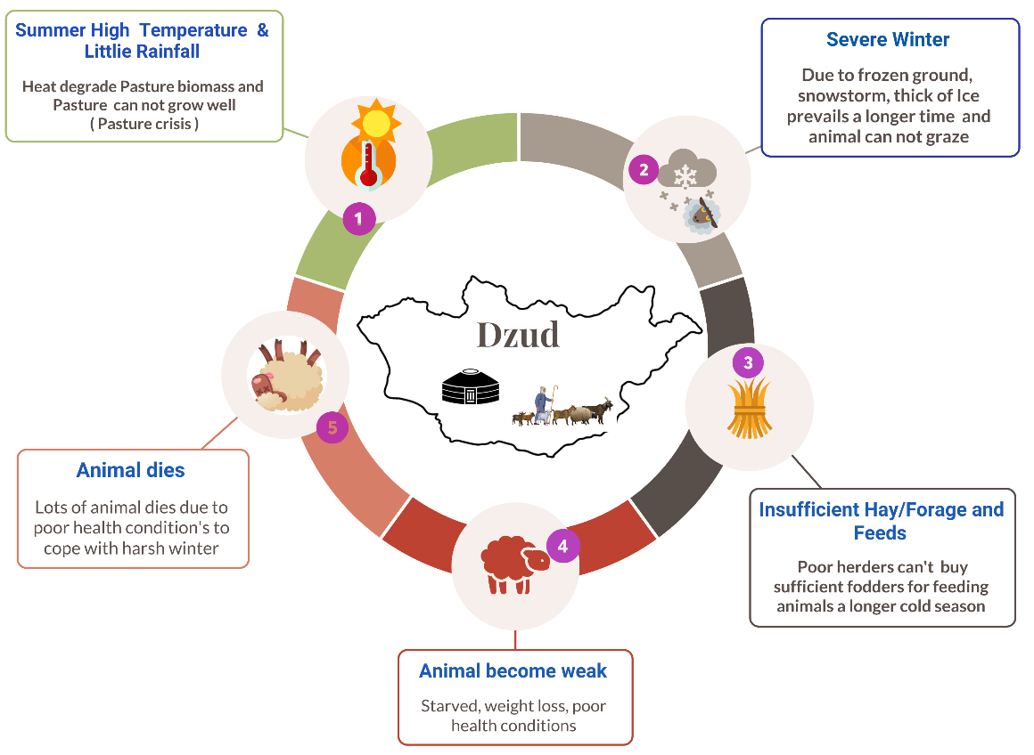

Figure 28: Traditional Dzud factor diagram (Source: Z M Sajjadul Islam, UNDP-GCF)

For analyzing the high impact on livestock and agriculture, to some extent, following the methodology being proposed ;

9.1 Impact analysis methodology :

Climate information services needed for sustainable livestock management :

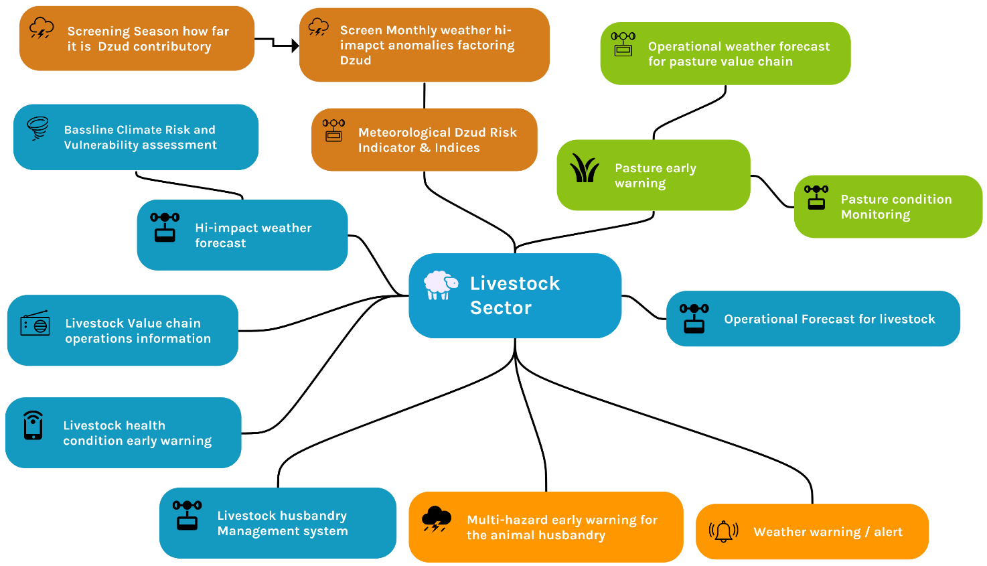

Figure 29 : Climate information services needed for sustainable livestock management.

Step 1 : Prepare baseline weather /climate risk, vulnerability, and exposure database on the type of livestock and climatic region of Mongolia.

- Assessment of Physical vulnerability: Based on the Annexure 1 elements checklist.

- Assessment of Socio-economic vulnerability: Using NSO statistical datasets identify the vulnerable age group ( children, old age, and disabled population ) and GIS mapping with spatial analysis showing poverty, vulnerable age group and underprivileged group, herders livelihood assets, livestock number, herd management tools, etc,

- Base map showing all physical features: Following the GIS layer checklist with Annexure 4

- Aimage-wise multi-hazard-prone area map: Showing livestock paddock, climate-proof livestock shelter, drinking water facility point near the paddock, deep tube well water access point, open-source water body ( perennial, seasonal, dried ), etc.
- Prepare Aimag-wise GIS map: Develop The base map showing all physical layers, socio-economic layers, networks, rivers, etc.
- Surveying and inserting placemark of camp location and tagging a ger number - voluntarily sending geolocation by herders, veterinary technicians, health workers, credit operators, and other support staff are frequently visiting the herders’ camp.
- Plotting camp location and developing a GIS attribute file of herder’s livestock number and other livelihood related. data.
- Cell phone networks connected herders to provide emergency information.
- Develop GIS map on aimag and soum level on Rangeland health monitoring health.
- Utilize the DIMA database and upload the GIS shapefile to the IBF geonode server for preparing rangeland health monitoring status weekly, bi-monthly, and monthly.
- Land use map showing pasture biomass growing areas which would be informed tools for management from overgrazing,
- Geo Location of the camp, Number of livestock died during 2000-2003, 2010 :
- Soum/aimag wise pasture condition, forage crop areas, pasture degraded area map of every month/season and prepare atlas profile in fodder cropping risk and vulnerabilities, Pastureland risk, and vulnerabilities.
- Geographical and geophysical and topographical, environmental vulnerability
- Inventorying Combined drought and dzud risk phenomena over the animal husbandry

Step 2 : Forecast products required for livestock sector impact analysis.

- Prepare short-range ( 1-5/7 Days) and operational forecasts analyzing severe weather parameters that are likely to impend as hi-impact phenomena e.g., heavy snowfall/precipitation, severe cold temperature, etc., and impacts over the livestock sector.

Step 3: Impact analysis over the geographic location and severity of the weather parameters( spatiotemporal ) with GIS software :

Tools: GIS layer ( annexure 5 ) :
- Baseline risk and vulnerability( survey) GIS map and shapefile
- Physical GIS layer
- Socio-economic GIS Layer ( Poverty, disabled population, herders ger location/ basecamp location
- Pasture map, Rangelands health condition map, land use and land cover map, drought map, drinking water sources location/access point map.

Methodology: Overlaying forecast CSV file on GIS base layers (risk, exposure, and vulnerability of elements ) and analyze the color-coded thresholds of precipitation intensity and calculate impacts over the livestock husbandry elements analyzed in the below table;

Figure 30 : Convective precipitation impact map

Table: Impact analysis matrix

Season | Hi-impact weather | Impact over Livestock | Impact over Grazing /pasture availability | Impact over the Water access point | Impact over Hay/fodder storage | Impact over Value chain services
Summer | Hot days/heat wave | - The tender animal( Calf) likely gets dehydrated  - In hot conditions likely to suffer from vector-borne disease.  - Likelihood of suffering from zoonotic/vector-borne diseases | Reducing of soil moisture and pasture growth | - Likelihood …no/volume of waterbody drying of the Surface waterbody.  - Depletion of groundwater table ………areas | Tender pasture dry/degraded and damaged….. locations | Veterinary services for zoonotic/vector-borne diseases
Summer | Convective heavy rainfall/thunderstorm | Ger like to damage and wash-out of……..riverside/locations | - Likelihood of Water logging at pastureland in …….locations  - Flash flood pastureland…….locations. | Likelihood of polluting flood water and mudslide | Likelihood of Water logging to lower floodplain pasture land and damaging …..areas/acres of pasture. | Service was disrupted due to communication failure
Summer | Dust storm | Death of livestock | - Damaging standing pasture | Likelihood of polluting drinking water sources | Damaging pasture | Service was disrupted due to lower visibility and communication failure
Autumn | Cold front induced storm | - Death of livestock being early combed/ sheared wools.  - Likelihood to be perished by server cold storm | Damaging standing pasture |  | Likelihood of damaging storage facilities | Service was disrupted due to communication failure
Autumn | Cold rain | Death of livestock just combed/ sheared wools | Damaging standing pasture |  | Likelihood of damaging storage facilities | Service was disrupted due to communication failure
Autumn | Thick snowfall | Weight loss, falling sickness of calves | Damaging standing pasture | Likelihood of inaccessible water access points/resource | Likelihood of Damaging storage facilities | Service was disrupted due to communication failure
Winter | Snowstorm | Likelihood Weight loss, falling sickness of the calf. | Thick snow cover and damaging grazable standing pressure | Likelihood of inaccessible to the animal drinking water point | Likelihood of damaging storage facilities | Service was disrupted due to hazardous weather
Winter | Extreme cold temperature | Reduce body temperature, sickness of animal, Weight loss, zoonotic disease | Animals cannot graze for ……………..days and supplemental feeds/hays are required | Likelihood of inaccessible water access points/ waterbody not utilizable | Depletion of storage hays. Destocking of Supplement pasture | Service disrupted due
Spring | Cold front-induced storm | - Death of livestock being early combed/ sheared wools.  Likelihood to be perished by server cold storm | Damaging standing pressure |  | Likelihood of damaging storage facilities | Service was disrupted due to communication failure
Spring | Dust storm | Death of livestock | Damaging standing pasture | Likelihood of polluting drinking water sources | Damaging pasture | Death of livestock

Table : Anticipatory impact estimation

Overlaying color-coded extreme weather impact threshold ( Magenta, Red, Orange, Yellow, Green) over all elements with GIS software and analyze impact of thresholds with % risks, %vulnerability, %exposure, % sensitivity of elements with anticipatory L & D.

Hazard |  | Rick and Vulnerability |  |  |  | Weather Thresholds | Total Impacts
 | Elements | Risk | Vulnerability | Exposure | Elements Standing conditions
Heavy rainfall ( mmm/hr) | Wheat | 50% of cropping is likely to be damaged by heavy rainfall-induced flash floods | - 20% of gers are likely to (having flood control structures of the locality ) be damaged by the flooding and water logging.  - Due to improving drainage and water control protection wall 20% may be damaged | % of the whether field may be affected by heavy rainfall | - Growth stage -sensitive to waterlogging  - waterlogging is likely to damage the crops | Over 30mm/hourly rainfall forecasted over…….location | - Over 50% of standing crops are likely to damage,  - ….mt/per…..acres yield loss per/acres …….(volume)
High thick snowfall ( cm/hour) | Pastureland | 95% pasture covered by thick snowfall ….cm/daily | 30 % of herders have forage/hay/feeds storage for the month | Snowfall occurred in 60% of the region | 10% of pasture are grazable over the …….days | Over ……….cm of the thickness of snowfall are forecasted | Approximately …….% areas are not grazable
Snowstorm ( m/s or km/h) | Livestock | ……….herders and ……….number of animals are likely to lose weight for the weather conditions and shortage of fodder for ………..days ….% may be sick for the frost-bite and …..% like to have perished | Total herders- economically well-off herders = vulnerable herders are likely to be impacted | Geographic regions experience the snowfall of the…..period. | % of Livestock are likely to lose the weight

Step 4: Prepare an advisory for the impact forecasts.

Annexure template Annexure 6 for Winter weather emergency advisory

Step 5: Tracking multi-hazards over the ongoing hazardous weather conditions likely to impend as multi-hazards.

- Screening rapidly developing weather conditions ( convective weather system, downscale model based on updated data and development warning and CAP )
- Dynamical downscaling of any cold/warm front is likely to impend any given time ( in spring, summer, and autumn seasons) and provides spatiotemporal scale forecasts and operational forecasts for the high-value elements( livestock, urban settlements ).

Step 6: Establish nested hi-impact Situational observation system :

In each situation when multiple extreme weather conditions are simultaneously occurring e.g., extreme cold temperature, high winds/damaging winds, and snowstorm concurrently impending for two weeks, there would be multi-hazard conditions on the ground. The forecast cycle is not enough to capture all events, in this case, ground-level situation updates. A multi-hazard early warning and common alerting need to trigger simultaneously with impact forecasts to save livestock.

Step 7: Capturing geolocation of incidence, loss, and damage data for situation reporting:

Step 8 : Multi-hazard early warning

Outlined with Chapter 7

Step 9: Preparer Operational forecasts for livestock and analyze the threshold of severity with a lead time

Input Indicators and Variables for livestock impact analysis. Annexure 3 Input Indicators and Variables for livestock impact analysis

Step 10: Preparer dzud MIS system and dzud early warning system

Illustrated in figure 31

Risk repository development process :

- Prepare Grazing, feeding, and drinking water Calendar :
Preparing every month-wise calendar by the herders which is required for preparing the severity triggers for mobilizing emergency finances based on high-impact weather levels and impact thresholds.
- Weather Factors: Pasture covered by the depth of snow
- Socio-economic factors: Unable to buy sufficient fodder/forage/feeds
- Drinking water crisis: Annexed waterbody and conditions over the seasons, distance to the deep tube well from pasture land
- Weather factors affecting the drinking water :
- Herds size - ( livestock population) of each herder
- Determine and develop What type of weather information is required and what types of services are required for meeting the water crisis

Types of elements | Month Name |  |  |  |  |  |  |  |  |  |  |  |  |  |  |  |  |  |  |  |  |  |  |  |  |  |  |  |  |  |  | Total days
 | 1 | 2 | 3 | 4 | 5 | 6 | 7 | 8 | 9 | 10 | 11 | 12 | 13 | 14 | 15 | 16 | 17 | 18 | 19 | 20 | 21 | 22 | 23 | 24 | 25 | 26 | 27 | 28 | 29 | 30 | 31
Biomass pasture (there are on average 12-30 species in dry steppe and 12-20 species in desert steppe) |  | C | O | V | E | R |  |  |  |  | B | Y |  | S | N | O | W |  |  |  |  |  |  |  |  |  |  |  |  |  |  | 30Days
Reserved hay/fodder |  |  |  |  |  |  |  |  |  |  |  |  |  |  |  |  |  |  |  |  |  |  |  |  |  |  |  |  |  |  |  | 9Days
Supplementary commercial feeds |  |  |  |  |  |  |  |  |  |  |  |  |  |  |  |  |  |  |  |  |  |  |  |  |  |  |  |  |  |  |  | 6Days
Non-feeding days |  |  |  |  |  |  |  |  |  |  |  |  |  |  |  |  |  |  |  |  |  |  |  |  |  |  |  |  |  |  |  | 15Days
Drinking water crisis

- Livestock event calendar ( monthly) :
Preparing every moth-wise calendar by the herders which is required for preparing the severity triggers for mobilizing emergency finances based on high-impact weather level and impact thresholds.
Items | Month Name |  |  |  |  |  |  |  |  |  |  |  |  |  |  |  |  |  |  |  |  |  |  |  |  |  |  |  |  |  |  | Total number
 | 1 | 2 | 3 | 4 | 5 | 6 | 7 | 8 | 9 | 10 | 11 | 12 | 13 | 14 | 15 | 16 | 17 | 18 | 19 | 20 | 21 | 22 | 23 | 24 | 25 | 26 | 27 | 28 | 29 | 30 | 31
Livestock mortality (Due to lack of weatherproof livestock shelter annexed to Ger/Camp how many animals dies including Calf dies )
Death tolls caused by disease
Death tolls by muti-hazard incidence ( hailstorm, cold rain, Flash flood, dust storm etc.)
Death tolls due to camp migration
Rearing calf
Other causes

- Analyzing socio-economic elements :

- Prepare a calendar of diseases and outbreaks: Inventory track record of diseases and outbreaks incidence in any location, assessment of weather factors causing the diseases and outbreaks.
- Prepare calendar on sudden onset-set hazards hazardous weather conditions takes animal tolls: Thunderstorm, cold front, dust storm ( with geolocation )
- Socio-economic factors: Poverty, remoteness, lack of communication, and mobilization-related logistic support.
- Correlation and regression analysis of the factors; e.g. extreme weather factors, livestock mortality as a push factor, to sell large number of livestock for minimizing L & D.
- Tracking livestock inputs(feeds/veterinaries) product price and output products market access and value chain conditions
- Livestock husbandry capacity: Number of livestock, logistics for animal husbandry, paddock, warm shelter for livestock(in case of extreme cold temp. -30⁰C /-40⁰C and above ), water access for livestock, hay/fodder storage facility, etc.
- Pasture shortage forecasts
- Weather advisory and real-time information on the delivery of humanitarian aid over the hard-to-reach areas for the people/header family in need. ( Government, through the Ministry of Labor and Social Protection (MLSP) in Mongolia Fodder market price, value chain
- The herder households’ stock of animal feed, Soum-level emergency reserves

- Maintain Livestock database for common situational alerting :

- Maintain database on exposure to harsh weather such as drought, rains, extreme temperature, and snow – how many vulnerable households and livestock are impacted. Example- Until Feb 2023 there were 13,000 households are at risk of losing their livelihoods due to Dzud and are considered vulnerable.
- Supplementary hay concentrated feed to selected households/herders giving a timeline.
- Emergency care kits to protect their animal’s supplementary food for children in dormitories essential healthcare services for herder households living in Dzud risk areas health care services and loss of lives during the Dzud period.
- Essential medicines need to be restocked at health facilities in Dzud risk areas to ensure continuity of services for the herder house.
- Increase access of vulnerable herders to primary healthcare services, especially in Dzud-affected areas

- Improve health care services for the herders' facility.
  - Provision of reproductive healthcare services to children , women living at the hard-to-reach areas during extreme weather emergencies
  - Support the mental health of herders and herder households in Dzud-affected hard-to-reach areas
  - Improve emergency care and rescue services at Soum and bag level and hard-to-reach areas

- Prepare operational forecast/ multi-hazard early warning for livestock husbandry.

- The operational forecast required for within the short duration the livestock sector need to be updated about longer duration prevailing extreme weather conditions of the season and updating to the end user Advisory for the immediate actions and preparedness of whole livestock husbandry to combat the climate crisis, support the Camp Coordination and Camp Management (CCCM) Sector to regulate the Population movements, support for FBF early actions e.g. cash transfers) in-kind support such as hay, fodder, and vitamins for livestock.
- Operational forecasts/ Weather Early warning for the livestock for March-April is also a very Climate sensitive breeding time for livestock bad weather takes livestock tolls, by early 2023 February around 416,560 livestock have already perished due to prolonged malnutrition and cold stress.
- Weather watch/advisory services on the season migration, prevention of zoonotic diseases monthly Displacement Tracking Matrix (DTM), risk group monitoring and profiling in displacement sites
- Carry out data collection, analyses, and sharing of information products including reports generated from DTM, Vulnerability Analyses, IDPs Demographics Information, Case details of Incidences of Displacements, Site Management Reports, etc.
- Advisory on forage crop cultivation ( maize, wheat, Napier grass, etc, less water consuming fodder plants in arid/semi-arid areas .) (Cereal crops, sorghum, wheat, alfalfa, legumes, grains, and corn

- Linking Pasture/rangeland related datasets DIMA with IBF Platform :

- Data compilation: Soum technicians collect the primary data yearly. Aimag engineers ensure quality control and enter the monitoring data into the National Rangeland Monitoring Database (DIMA) on Rangeland health monitoring 1516 sites.
- Photo point monitoring system by ALMGaC for assessing grazing management impacts. The photo point monitoring system covers 4200 sites in total representing different pasture user groups (PUGs 278 Soums) and different seasonal pastures.

- Inventorying types of Hazards impact livestock: Aimage EOC(Situation room) will be responsible for developing multi-hazards event calendars, placemarks of the geolocation of hazard indecent place, and inventory of impact level, loss, and damage (using hazard calendar).

Table : Monthly hazard calendar to be maintained by herders
Hazard | Month Name |  |  |  |  |  |  |  |  |  |  |  |  |  |  |  |  |  |  |  |  |  |  |  |  |  |  |  |  |  |  | Death tools of livestock /L & D
Days of the month | 1 | 2 | 3 | 4 | 5 | 6 | 7 | 8 | 9 | 10 | 11 | 12 | 13 | 14 | 15 | 16 | 17 | 18 | 19 | 20 | 21 | 22 | 23 | 24 | 25 | 26 | 27 | 28 | 29 | 30 | 31
Extreme cold days ( -30c to -50c and above)
Severe Cold days ( -20c to -30c and above)
Snowstorm days
Gale force wind
Dust storm
Tornadoes
Thunderstorm /nor wester
Dry spells
Hot Spells
Heavy rainfall & Flooding
Landslide
Wild/Forest fire
Lightening
Snowstorm
Winter Strom
Thick of snowfall
Blizzards
Flood/flash floods/landslide/mudslide/debris fall/Avalanches
drought,
heavy snow, ice
storms and wind,
extreme overgrazing
summer drought
Heavy drought in late summer followed by intense snow storms

Table : Seasonal hazard calendar (to be maintained by herders )

Types of Hazards | Month Name |  |  |  |  |  |  |  |  |  |  |  | Impacts | Loss and damage/death tolls of animals
 | Summer |  |  | Autumn |  |  | Winter |  |  | Spring
 | Jun | Jul | Aug | Sep | Oct | Nov | Dec | Jan | Feb | Marc | Apr | May
Black Dzuds
White Dzuds
Combined dzud
Storm dzud
Iron dzud
Gale force wind
Dust storm
Tornadoes
Thunderstorm /nor wester
Dry spells
Hot Spells
Heavy rainfall & Flooding
Landslide
Wild/Forest fire
Lightening
Snowstorm
Early snowing and thawing, frozen as ice cover
Winter Strom
Thick of snowfall
Blizzards
Flood/flash floods/landslide
/mudslide/debris all/Avalanches
Others

Table : Monthly herder/animal husbandry value chain calendar to be maintained by herders
herder/animal husbandry value chain | Month Name |  |  |  |  |  |  |  |  |  |  |  |  |  |  |  |  |  |  |  |  |  |  |  |  |  |  |  |  |  |  | Required climate and value chain information
Days of the month | 1 | 2 | 3 | 4 | 5 | 6 | 7 | 8 | 9 | 10 | 11 | 12 | 13 | 14 | 15 | 16 | 17 | 18 | 19 | 20 | 21 | 22 | 23 | 24 | 25 | 26 | 27 | 28 | 29 | 30 | 31
Meat sale
Milk sale
Animal Sale
Cashmere sale
Skin sale
Process Dairy’s
Price on Agricultural Products (monthly)

Table: Monthly Pasture Calendar to be maintained by herders
Pasture type | Month Name |  |  |  |  |  |  |  |  |  |  |  |  |  |  |  |  |  |  |  |  |  |  |  |  |  |  |  |  |  |  | Required climate and value chain information
Days of the month | 1 | 2 | 3 | 4 | 5 | 6 | 7 | 8 | 9 | 10 | 11 | 12 | 13 | 14 | 15 | 16 | 17 | 18 | 19 | 20 | 21 | 22 | 23 | 24 | 25 | 26 | 27 | 28 | 29 | 30 | 31
Types of pasture
Hay
Agricultural residues
Crop forage
Cereal feeds
Vitamins
Other Feeds
observed High-thick snow days hampered grazing
observed Snowstorm days hampered grazing
observed Extreme cold days hampered grazing
Impenetrable Ice over the ground hampered grazing
Cold front-induced hampered grazing
Animal insemination
Animal insemination
Fallow land
Number and utilization of wells
Techniques readiness for soil cultivation and sowing
Irrigation point
Techniques readiness for hay work
Haymaking, pasture, and grassland protection 9. Techniques readiness for crop 5. Intensified animal husbandry
The available seed for forage cropping
Fodder collection/harvest time:
Determining the weather and climatic factors, Drought factors of fodder/hays yielding loss and animal weight loss ( case 2009 of drought factors for fodder reduction)
Determining climatic /weather factors, and multi-hazard factors for impacting fodder yields
Determine the factors affecting the dramatic growth of livestock and pasture stress.
Aimag/soum/bag Wise fodder livestock /fodder rational,( livestock and pasture carrying capacity)
Hazar/disaster-related casualties of herds/livestock

Table : Monthly disease and outbreaks calendar to be maintained by herders
disease and outbreaks | Month Name |  |  |  |  |  |  |  |  |  |  |  |  |  |  |  |  |  |  |  |  |  |  |  |  |  |  |  |  |  |  | Required climate and value chain information
Days of the month | 1 | 2 | 3 | 4 | 5 | 6 | 7 | 8 | 9 | 10 | 11 | 12 | 13 | 14 | 15 | 16 | 17 | 18 | 19 | 20 | 21 | 22 | 23 | 24 | 25 | 26 | 27 | 28 | 29 | 30 | 31
Meat sale
Milk sale
Animal Sale
Cashmere sale

- Screening high-impact Weather related Mortality ( season-wise) :

- Fodder shortage early warning (watch/warning ) :
- Season-specific forage shortage alert (watch/warning )
- Weather-specific disease early warning (watch/warning )
- Water shortage/crisis early warning(watch/warning ):
- High wind/dust early warning (watch/warning ):
- Provide an alert of a potential risk of dzud and its severity (watch/warning with medium rage forecasts ):

- Herder’s pasture-related migration and mandate of pasture access rules/laws

- Review dzud severity index of the aimag/soum/bag :
- Assessment of Strong wind induced Hazards for Hampering/impacting livestock management :

- Advisory for setting up Camp ( based on season and pasture availability) : Based on the Aimag GIS risk and vulnerability maps.

- Sheep and Goat Combing/ shearing weather advisory/alert (operational forecasts) :
- Depending on the weather conditions e.g., the bad weather has passed conditions alert/advisory on to move the sheep to a paddock with adequate shelter and continue to provide supplementary feed.
- Alert for cold weather and sheep weather alerts for at least four weeks after shearing. After shearing, sheep need to be fed to cope with cold stress, so if a sheep weather alert is given, start feeding before the storm arrives.
- Weather alert is received during shearing, discontinue shearing if it is not possible to shed all shorn sheep. If a weather alert has been received at the end of shearing, shed as many sheep as possible and provide hay for the duration. Once the bad weather has passed, move the sheep to a paddock with adequate shelter and continue to provide supplementary feed.
- Extreme cold/ Severe cold temperature advisory/alert: Bad weatherproof livestock shelter to avoid cold injury, sheep hypothermia, etc. becoming ill, getting frostbite and causes can sustain serious injuries and even become handicapped, losses of new-born and adult animals,
- Sample event of March 2023, heavy snow and strong wind had impacts, especially on pregnant animals resulting in miscarriage.

9.3 Advisory on Integrated Pasture Monitoring System:

Herds typically move seasonally for better pastures, because of poor pasture conditions for overgrazing, drought, and other extreme weather conditions (Humphrey and Sneath 1999). Herders use their knowledge of the seasonal availability of water, snow, and locations of available pasture areas to determine where and when to move their herds among traditional seasonal grazing areas.

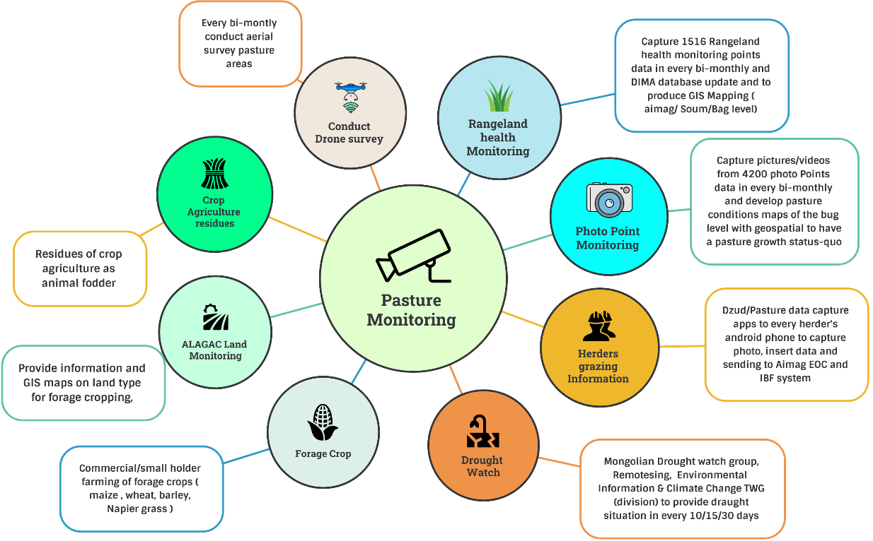
Figure 32 : Integrated Pasture monitoring system (Source: Z M Sajjadul Islam, UNDP-GCF)

9.4 Alert and warning services for livestock & Crop agriculture
- Heavy rainfall advisory/alert :
- The supplementary feed should be continued for up to one week after bad weather as rain causes the feed to become less palatable, and without supplements, sheep may not receive adequate nutrition.
- Be prepared to relocate animals to a shed or land on higher ground with shelter in the event of very heavy rainfall and likely flooding. Sheep may be reluctant to move once they have become wet and cold. Giving shelter to the most vulnerable such as the ewes and lambs and those newly shorn.

- Strong/damaging wind(watch/advisory/alert) :
- Cold front weather (watch/advisory/alert) (spring, autumn ) :
- High temperatures (watch/advisory/alert):
- Drinking water crises, (watch/advisory/alert)
- Water uses advisories :
- Frequent heavy snowfall (watch/advisory/alert):
- Drying up of rivers and springs, and fewer drinking water resources(watch/advisory/alert) :
- Severe drought (watch/advisory/alert):
- Impacts of meteorological drought (watch/advisory/alert) :
- Impacts of hydrological drought (watch/advisory/alert) :
- Occurrence of river Floods/ flash Floods (watch/advisory/alert):
- Heatwave (watch/advisory/alert):
- Weather advisories over the breeding:

9.5 Develop dzud risk profile :

- Develop bi-monthly and monthly Dzud Risk profile:
- Develop Dzud risk integration protocol :

Table : Tracking weather anomalies of over the indicators being considered for dzud risk ranking /mapping :

Indicators | Acquisition of data(Parameters on climatic/non-climatic ) | Inputs for Impact forecasting & Operational Forecasting
Summer condition; | Temperature | Current temperature impacts on the type of livestock and livestock husbandry
Summer days; | Number of hot days | Distribution of the number of hot days with GIS map and develop
Pasture carrying capacity; | Pasture height/growth and Number of animals grazing days | GIS maps of pasture carrying the capacity status of the week/10 days/30 days
livestock density; | Number of livestock per community /bag/size of pastureland | GIS map on camp and grading location
livestock body conditions; | Gross health conditions and weight loss of animals | GIS maps on the distribution of livestock health conditions( based on livestock location data)
Biomass of pasture measured in 1516 sites representing all ecological zones: | Every 10 days observation of the pasture growth ( height and density) from the National Rangeland Monitoring Database ( DIMA) by NAMEM | Every 10/15 days prepare GIS maps on Rangeland's health status
Anomaly precipitation; | Number of rainy/precipitation days and amount | Number of precipitation days and accumulation ( mm) 10 days/monthly, seasonal, yearly
Anomaly temperature; | Tmax , Tmin and Tmean the weekly/decadal
Develop drought index | Yearly drought index
Snow depth | Show the depth of the running week | Precision level GIS maps by using data from the met station, volunteers, and crowdsource in daily 10days accumulations of thickness
Snow cover days | Number of snowing days
Snow density | Snow kg per m-3 | Precision level GIS maps by using snow thickness data every 10 days.
Thick Icy ground | Herders provide the grazing location covered by the thick ice. Difficulties of livestock to reach grass and Injuries of animals. | GIS map’s thick icy location of the pasture grazing areas every 10 days
Severe Cold temperatures | Acquisition of Severe Cold temperatures from the herder’s location, met stations, and high-value elements. | GIS maps on distribution of cold wave ( aimag, soum level )

- Develop bi-monthly and monthly Dzud Risk profile: Dzud risk integration process: Tracking weather anomalies of over the selected indicators being considered for dzud risk ranking /mapping.
- Provide combined dzud watch, warning, and outlook ( figure 31).

9.6 Web-based MIS system for Dzud risk management :

Conduct a comprehensive dzud risk assessment by developing season specific dzud risk mapping algorithm based on the below schematic diagram. The diagram outlined the season-specific dzud risk assessment mechanism and tools and finally a combined dzud risk assessment process.

The whole process encompasses weather indexes and indices for tracking season-specific dzud. Web-based software needs to be installed and input datasets to interface with the IBF platform for the acquisition of process weather variables, socioeconomic, CRVA repository of the country. The web-based Dzud MIS ( management information system ) would be the enterprise-level solution for managing dzud at a large scale in Mongolia. The MIS database architecture

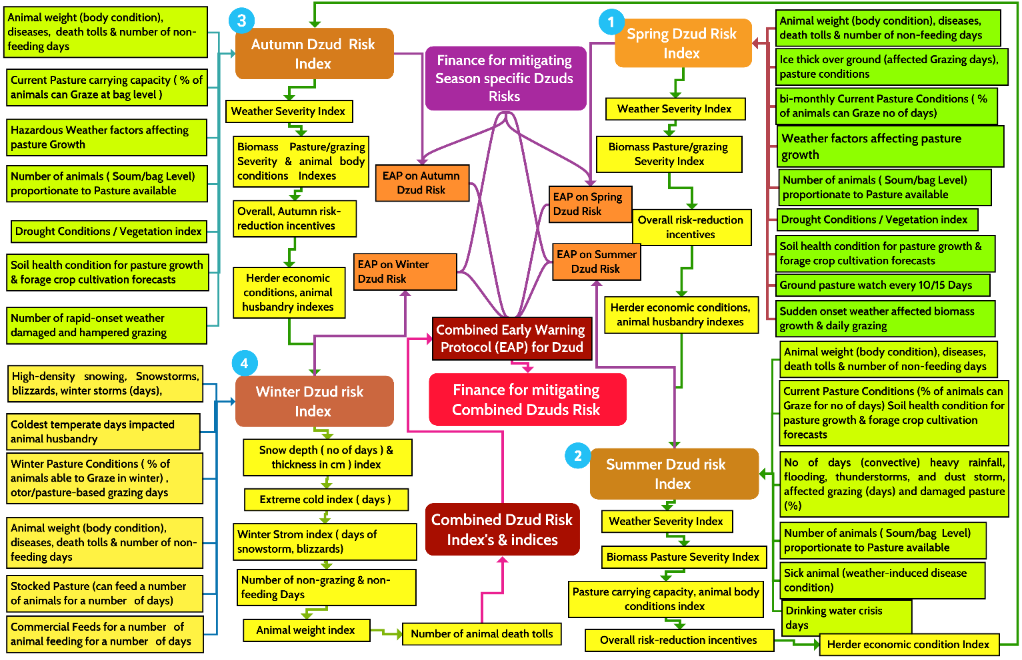

Figure 31 : Season-specific & combined dzud risk assessment and prediction system, and develop combined dzud early action protocol (EAP) (Source: Z M Sajjadul Islam, UNDP-GCF)

Figure showing the steps on dzud risk assessment, seasonal dzud risk indexing and develop combined dzud early action protocol (EAP). In every step field level seasonal risk indicators being considered and analzye with GIS Multi-Criteria Decision Analysis (MCDA) for developing combined zdu risks indexes’ and indices.

9.7 Develop Dzud Early warning protocol.

Season | Variable | Indexes/Indices to investigate | Season-specific dzud watch, severity warning and advisory | Status of season-specific dzud early warning
Spring | - High-impact weather conditions of the spring season e.g., cold front, convective thunderstorm, strong wind-induced storms, cold rain, heavy rainfall, wet snowing, hailstorm etc., impacts normal grazing.  - Number of operational forecasts relating to animal husbandry and biomass pasture conditions of the Spring season  - Animal body conditions, body weight, sickness, number of non-feeding days  - Animal death tolls(causes from inventory)  - Thick ice over the ground impacts grazing  - Current pasture condition ( % of animals can graze ) on the ground proportionate to number of animals at the lowest administrative level.  - IBF for the medium and short-range hazardous weather likely to impact animal husbandry, pasture growth, grazing and forage cropping.  - Soil health conditions are impacted by rainfall variability, temperate, evapotranspiration, vegetation index, surface hydrology etc.  - Biomass pasture carrying capacity gaps proportionate to lowest administrative level livestock population | - No of operational forecasts for reducing risk of the livestock and crop agriculture sectors  - Index & indices for tracking Spring season weather anomalies( Temperature, Precipitation, wind speed, Relative humidity, dew point temp., evapotranspiration rate, agricultural droughts, flash-droughts, convective conditions, localized storms, hydrometeorological droughts ) for determining Spring season weather severity.  - Animal body condition ( % of weight loss)  - Non-grazing days (rank)  - Pasture carrying capacity & grading days (rank)  - Soil moisture condition, pasture growth level ( rank) | Based on indexes and indices – prepare dzud watch, severity warning and advisory for the spring season. The following indexes and indices can be investigated.  - Weather severity ( index)  - Animal body condition severity ( index)  - Non-grazing days ( index)  - Pasture availability ( index)  - Animal death toll index  - Biomass pasture carrying index. | Dzud risk management online software ( enterprise solution) / MIS system for providing information services on Dzud watch, severity warning and advisory for the season
Summer | - High-impact weather conditions of the summer season e.g., wind/precipitation/ temperature anomalies, warm front, convective thunderstorm, hailstorm, convective heavy rainfall, strong wind induced storms, hailstorm, high-temperature, dry spell, etc., impacts biomass pasture conditions, normal grazing, impacts over the animal husbandry.  - Number of operational forecasts relating to above weather conditions, animal husbandry, surface hydrology, hydrometeorological droughts, agricultural droughts, heatwave, wildfire, crop agriculture etc.  - Animal body conditions, body weight, sickness, number of non-feeding days, death tolls(causes from inventory)  - Drought conditions impact over pasture conditions and growth  - Current pasture condition ( % of animals can graze ) on the ground proportionate to number of animals at the lowest administrative level.  - IBF for the medium and short-range hazardous weather likely to impact animal husbandry, pasture growth, grazing and forage cropping.  - Soil health conditions are impacted by rainfall variability, temperate, evapotranspiration, vegetation index, surface hydrology etc.  - Biomass pasture carrying capacity gaps proportionate to lowest administrative level livestock population | - No of operational forecasts for reducing risk of the livestock and crop agriculture sectors  - Index & indices for tracking Spring season weather anomalies( Temperature, Precipitation, wind speed, Relative humidity, dew point temp., evapotranspiration rate, agricultural droughts, flash-droughts, convective conditions, localized storms, hydrometeorological droughts ) for determining Spring season weather severity.  - Animal body condition ( % of weight loss)  - Non-grazing days (rank)  - Pasture carrying capacity & grading days (rank)  - Soil moisture condition, pasture growth level ( rank) | Based on indexes and indices – prepare dzud watch, severity warning and advisory for the spring season. The following indexes and indices can be investigated.  - Weather severity  - Animal body condition severity  - Non-grazing days  - Pasture availability  - Animal death toll  - Biomass pasture carrying capacity. | Dzud risk management online-software ( enterprise solution) / MIS system for providing information services on Dzud watch, severity warning and advisory for the season
Autumn | - High-impact weather conditions of the Autumn season e.g., temperature/wind/ precipitation anomalies, strong wind induced storms, snowfall, cold-front, convective conditions, etc., impacts biomass pasture conditions, normal grazing, impacts over the animal husbandry.  - Number of operational forecasts relating to above weather conditions, animal husbandry and crop agriculture etc.  - Animal body conditions, body weight, sickness, number of non-feeding days, death tolls(causes from inventory)  - Drought conditions impact over pasture conditions and growth  - Current pasture condition ( % of animals can graze ) on the ground proportionate to number of animals at the lowest administrative level.  - IBF for the medium and short-range hazardous weather likely to impact husbandry, pasture growth, grazing and forage cropping.  - Soil health conditions are impacted by rainfall variability, temperate, evapotranspiration, vegetation index, surface hydrology etc.  - Biomass pasture carrying capacity gaps proportionate to lowest administrative level livestock population | - No of operational forecasts for reducing risk of the livestock and crop agriculture sectors  - Index & indices for tracking Spring season weather anomalies( Temperature, Precipitation, wind speed, Relative humidity, dew point temp., evapotranspiration rate, agricultural droughts, flash-droughts, convective conditions, localized storms, hydrometeorological droughts ) for determining Spring season weather severity.  - Animal body condition ( % of weight loss)  - Non-grazing days (rank)  - Pasture carrying capacity & grading days (rank)  - Soil moisture condition, pasture growth level ( rank) | Based on indexes and indices – prepare dzud watch, severity warning and advisory for the spring season. The following indexes and indices can be investigated.  - Weather severity  - Animal body condition severity  - Non-grazing days  - Pasture availability  - Animal death toll  - Biomass pasture carrying capacity. | Dzud risk management online-software ( enterprise solution) / MIS system for providing information services on Dzud watch, severity warning and advisory for the season
Winter | - High-impact weather conditions of the Winter season e.g., temperature/wind/precipitation anomalies, winter storm, snowstorm, blizzards, extreme cold temperature, high density snowfall, , etc., impacts on animal husbandry, biomass pasture conditions.  - Number of operational forecasts relating to above weather conditions, stocking & destocking of hays/forage crop/pasture, herder specific feeds, animal husbandry of the season.  - Animal body conditions, body weight, sickness, number of non-feeding( starved) days, death tolls(causes from inventory)  - IBF for the medium and short-range hazardous weather likely to impact animal husbandry, pasture growth, grazing and forage cropping of the season.  - Soil ice condition , soil thawing etc. | - No of operational forecasts for reducing risk of the livestock and crop agriculture sectors  - Index & indices for tracking extreme weather conditions of the winter season.  - Animal body condition ( % of weight loss)  - Non-grazing days (rank)  - Stocking and destocking hays/forage crop/pasture (rank)  - Animal non-feeding ( starved ) days  - Death tolls of animals | Based on indexes and indices – prepare winter dzud watch, severity warning and advisory for the Winter season. The following indexes and indices can be investigated.  - Weather severity  - Animal body condition severity  - Non-grazing / non-feeding days  - Herder specific stocking/destocking of Hays/forage crop/pasture, animal feeds  - Animal death toll | Dzud risk management online-software ( enterprise solution) / MIS system for providing information services on Dzud watch, severity warning and advisory for the season

Based on figure 31 dzud watch, risk warning and advisory mechanisms as well as investigating variables/indexes/indices etc., narrated at the above table, the season specific early warning and combined dzud early warnings protocol (EAP) can be developed.

…………………………………………End…………………………………………………….

Please send your comments to Team Leader , Z M Sajjadul Islam (UNDP-GCF) at zmsajjad@gmail.com , WhatsApp : +88 01711 979179

https://openlayers.org/
https://leafletjs.com/
https://developers.google.com/public-alerts/reference/google-cap-requirements
Proposed IBF web-based platform ( www.weather.gov.mn , www.ibf.gov.mn)
2018, Mongolia’s poverty rate was 28.4%.
WMO Guidelines for Nowcasting Techniques, 2017 edition
Local team to develop algorithm , defining weather variables(dzud/operational forecasts ), develop indexes , indices for the sector specific operational forecast, short-rage weather forecasts, tracking multi-hazards etc.

