Early Warning for All (EW4ALL) Design & Implementation Strategy

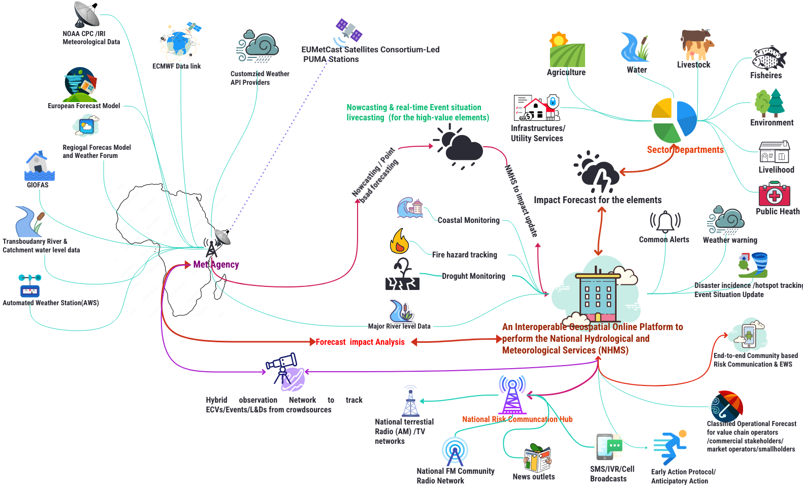

Developed by Z M Sajjadul Islam
Early Warning for All (EW4ALL) Coordinator for Somalia, UNDRR-ROAS
April 2025

Acronym

AA | Anticipatory Action
AM | Amplitude Modulation
AMM | Africa Media Monitor
APIs | Application programming interfaces
ARC | African Risk Capacity
AWD | Acute Watery Diarrhea
AWS | automated weather station
BCPs | Business Continuity Plans
CAP | Common Alerting Protocol
CB | Cell-Broadcast
CBDRM | Community Based Disaster Risk Management
CBO | Community-based organization
CBS | Central Bank of Somalia
CCA | Climate Change Adaptation
CCM | Convention on Cluster Munitions
CIMA | International Centre for Environmental Monitoring
CPC | Civil protection committee
CREWS | Climate Risk and Early Warning Systems
CRVA | Climate risk and vulnerability assessments
CSO | Civil Services Organization
DDMT | Disaster Management Team
DFID | Department for International Development Government of the United Kingdom
DINA | Drought Impact and Needs Assessment
DM | Disaster Management
DMA | Disaster Management Agency
DMC | Disaster Management Committee
DRM | Disaster Risk Management
DRMCG | Disaster Risk Management Coordination Group
DRR | Disaster Risk Reduction
DTM | Displacement Tracking Matrix
DTS | Disaster Tracking System
EOC | Emergency Operation Centre
ETT | Emergency Tracking Tools
EW | Early Warning
EW4ALL | Early warning for all
FAO | Food and Agriculture Organization
FEWSNET | Famine Early Warning Systems Network
FGS | Federal Government of Somalia
FM | Frequency Modulation
FSNAU | Food Security and Nutrition Analysis Unit
GDP | Gross domestic product
GIS | geographic information system
GMAS | Global Multi-hazard Alert System
GPS | The Global Positioning System
GSM | Global System Mobile
GTOS | Global Terrestrial Observing System
HC | Humanitarian Coordinator
HCT | Humanitarian Country Team
HPC | High-performance Computer
IBF | Impact-based Forecast
ICPAC | IGAD Climate Prediction and Applications Centre
ICS | Incident Command System
ICT | Information and Communications Technology
IDP | Internally Displaced Person
IDRR | International Day for Disaster Reduction
IFAD | International Fund for Agricultural Development
IFRC | International Federation of Red Cross and Red Crescent Societies
IGAD | Intergovernmental Authority on Development
IGADD | Intergovernmental Authority on Drought and Development
LITK | local, indigenous and traditional knowledge
ILK | Indigenous and local knowledge
INGO | International Non Government Organization
IOM | International Organization for Migration
IPCC | Intergovernmental Panel on Climate Change
ITCZ | Inter-Tropical Convergence Zone
ITU | International Telecommunication Union
IRV | Interactive Voice Response
L & D | Loss and Damage
LB-SMS | Location-based SMS
LCG-DER | local coordination group on disaster emergency response
LNHAs | Local National Humanitarian Actors
LNNGOs | Local and National NGOs
MoAI | Ministry for Agriculture and Irrigation
MoFBE | Ministry of Fisheries and Blue Economy
MOLFR | Ministry of Livestock, Forestry And Range
MoPIED | Ministry of Planning, Investment and Economic Development
MoEWR | Ministry of Energy & Water Resources
MoHADM | Ministry of Humanitarian Affairs and Disaster Management
MTR | Mid Term Review
NAPA | National Adaptation Plan of Action
NCA | National Community Authority
NDMF | National Disaster Management Fund
NDRMC | National Disaster Risk Management Council
NDVI | Normalized Difference Vegetation Index
NMHEWC | National Multi-hazard Early Warning Center
NMHEWS | National Multi-hazard Early Warning System(Online)
MHEWS | Multi-hazard Early Warning System(Online)
NGO | Non-Government Organization
NMHSs | National Meteorological and Hydrological Services
NSO | National Statistical Office
OCHA | Office for the Coordination of Humanitarian Affairs
OI | Officer In-charge
OPM | Office of the Prime Minister
PDNA | Post-disaster loss, damage, and needs assessment
Q&A | Questions and answers
RPDNA | Rapid Post-Disaster Needs Assessment
RVAC | Risk and Vulnerability Assessment Committee
RS | Remote Sensing
RMC | Regional Meteorological Center
RSMCs | Regional Specialist Meteorological Center
SADD | sex, age, disability disaggregated data
SDG | Sustainable Development Goals
SDRMCG | Somalia Disaster Risk Management Coordination Group
SFDRR | Sendai Framework on Disaster Risk Reduction
SMS | Short Message Service
SNDMP | Somalia National Disaster Management Policy
SNDP | Somalia National Development Plan
SoDMA | Somalia Disaster Management Agency
SoD | Standing orders in Disaster
SoP | Standard Operating Procedure
SRCS | Somalia Red Crescent Society
SWALIM | Somalia Water and Land Information Management
SWALIM | Somalia Water and Land Information Management
TWG | Technical Working Group
UAV | Unmanned aerial vehicle
UHF | Ultra-high frequency
UN | United Nations
UNCCA | United Nations Convention against Corruption
UNCDF | UN Capital Development Fund
UNDP | United Nations Development Programme
UNDRR | United Nations Office for Disaster Risk Reduction
UNFPA | United Nations Population Fund
UNHCR | United Nations High Commissioner for Refugees
UNICEF | United nations international children's emergency fund
UNRCO | United Nations Resident Coordinator Office
UNV | UN Volunteers
VAC | Vulnerability Assessment Committee
WASH | Water, sanitation, and hygiene
WFP | UN World Food Programme
WHO | World Health Organization
WMO | World Meteorological Organization

Contents
1.0 Introduction 9
1.1 Objective of the Assessment and Full-scale EW4ALL Implementation Strategy Development: 9
1.2 Assessment Methodology 9
1.3 Consultation Process: 12
2.0 Challenges of Multi-hazard Risk Management Governance in the Somalin FCV context 14
2.1 Recommendations for Overcoming the Indicative Challenges and exploring an ICT-driven multi-hazard risk management system can be implemented in the Somalia FCV context 17
2.1.1 Proposed ICT Tools, system, platform to address the gaps 19
2.2 Objective of the Interoperable NMHEWS for Somalia: 21
2.3 Urgency of Implementation of ICT-based Multi-Hazard Risk Management Governance: 21
2.4 Key indicators of ICT-driven EW4ALL action priorities for Somalia in FCV context. 22
3.0 Pillar 1 Implementation Strategy (Improving Disaster Risk Knowledge): 25
3.1 The ongoing SoDMA Structure : 25
3.2 The NMHEWC ongoing operational structure : 26
3.3 Proposed Interoperable NMHEWS : 28
3.3.1 Establish a digital partnership among the stakeholders and prime actors: 29
3.3.2 Design and implementation of an Interoperability Online geospatial system: 30
3.6 Implementation of Geospatial Platform ( Open-Source/ ESRI Licensed ) : 34
3.6.1 Component of Open-Source Geospatial Platform: 35
3.6.2 Installation of Geoserver for NMHS interoperability : 36
3.6.3 Anchoring Opensource( Open street map) and Google mapping tools : 37
3.6.4 Installation and Configuration of the interoperable Geospatial Platform, linking with maps and Surveying Apps. 37
3.6.5 Deploying Web based data sharing platform with apps : 39
3.6.6 Implementing Web converting common alerting protocol (CAP )apps : 39
3.7 Rationale of ICT-integrated Interoperable Online NMHEWS platform to support impact-based forecast (IBF): 40
3.8 Improving Risk Knowledge of stakeholders 42
3.9 Improving Risk Knowledge of Sector Value Chain Operators: 43
3.10 The following are the recommendations for Disaster Risk Knowledge Management Governance 44
3.11 Review Stakeholder Partnership & Coordination Mechanism 48
3.12 Partnership for Data Coordination and Exchange Mechanism 49
3.13 Upgrade and Activation of an Interoperable Situation Room and NMHEWS at SoDMA-NMHEWC : 50
3.14 NMHEWS service deliverability for improving risk knowledge: 53
3.14.1 Understanding Disaster Risk of the Locality 53
3.14.2 Frontline community needs to understand Disaster Risk in their Locality : 54
3.14.3 Enhancing the risk knowledge of Smallholder crop farmers: 54
3.14.4 Climate Vulnerable Productive Sector Departments: 60
3.14.5 Improving risk knowledge of Civil Protection Committee(CPC)/Disaster management Committee : 64
3.14.6 Improving risk knowledge of Humanitarian actors: 66
3.14.7 Improving risk knowledge of entrepreneurs & Value Chain Operators 67
3.14.8 Improving risk knowledge of Local Governments (City, Municipality, Urban councils) actors to deal with the climate crisis 68
3.14.9 Improving risk knowledge of Duty Bearer/Local Disaster Management Committee (DMC)/Civil Protection Committee : 69
4.0 Pillar 2 : Improving surface observation, Monitoring, and Forecasting 70
4.1 The existing hydro met services- Somalia faces daunting challenges in implementing the Pillar 70
4.1 Current forecasting mechanism of Somalia : 71
4.2 Indicative challenges in national forecasting service delivery : 71
4.3 Recommendations on improving the national forecasting service delivery: 72
4.4 Recommendations on improving the sector-specific national forecasting service delivery : 73
4.5 Recommendations on improving hydrometeorological services: 74
4.5.1 Establishment of an Independent National Meteorological Agency (NMA) 74
4.5.2 Improving homegrown short-range forecasting Capacity: 75
4.5.3 Improving Impact Forecasting Capacity : 76
4.5.4 Improving Sector-level Impact Forecast and Operational Forecast: 80
4.5.5 Improving the borehole/water monitoring system: 80
4.5.6 Sector datasets for IBF impact analysis: Water points and WASH elements 81
4.5.7 Improving Water sector Operational & impact-based forecasting: 85
4.5.7.1 Develop Climate Risk and Vulnerability Assessment (CRVA) workflow : 86
4.5.8 Operationalize an integrated hydro-meteorological EWS through the interoperable MHEWS 86
4.5.9 Improving Livestock Sector Impact Forecasting 87
5.5.10 Livestock Sector and Value Chain Elements Matrix for IBF 89
5.5.11 Livestock Value Chain Elements (market and service continuity) 90
5.5.12 Improving the Fisheries Sector Impact Forecasting 91
5.5.13 Improving the Health Sector Multi-Hazard Early Warning 92
5.6 Establish a Hybrid Observation Network (AWS , Sector-level Technical Observer, Extension Officer, Value chain Operators, Crowdsourcing, and community ) 94
5.0 Pillar 3 Implementation Strategy ( Warning dissemination and communication) 97
5.1 Indicative Challenges of Warning Dissemination and Communication 98
5.2 Developing a Common Alerting Protocol(CAP) : 102
5.3 Interoperable risk communication and feedback system with NMHEWS ( CREWS Initiative Support ) 103
5.4 Develop and disseminate a common alerting protocol (CAP) on imminent hazards, weather : 104
5.5 Improving terrestrial Broadcasting 106
5.6 Stakeholders’ responsibility metrics on Risk Communication and disaster Event situation updates 108
5.7 NCA Mandates National Broadcasters, News Outlets for dissemination 110
5.8 UN Clusters data contribution for impact forecasting 111
5.9 Installation of hybrid surface observation and organizing a Live radio/TV show during Hazard spells is going 112
6.0 Pillar 4 : Improving Preparedness and Response Capabilities 115
6.1 Central Objectives for Improving Preparedness and Response Capabilities 115
6.2 Recommendations on a Coherent Sector-Level Actionable Policy Framework 115
6.3 Improving Forecast-based Anticipatory Action Planning Capacity: 115
6.4 Implementation functional Civil Protection Committee(CPC)/Disaster management Committee(DMC) : 116
6.5 Hazard risk-informed Humanitarian actions 117
6.6 Improving the community-level volunteering network for emergency preparedness and Response mechanism 117
6.7 Improving Last-Mile Disaster Preparedness Capacity 119
6.8 Improving Community-based Early Warning Capacity 120
6.9 How to develop the Anticipatory Action (AA) Framework 122
6.10 Improve the disaster risk financing system: 128
6.11 Supporting the implementation of risk-informed DRM and DRR 130
6.12 Improve DRM Planning at the local level : 130
6.13 Gender responsive DRR framework : 130
7.0 Way forward 135

Executive Summary

The proposed Early Warning for All(EW4ALL) implementation strategy considers Somalia’s existing disaster/climate risk, fragility, conflict, and vulnerability (FCV) context. A robust Information and Communication Technology (ICT) approach to multi-hazard/disaster risk management governance is considered the most appropriate response to the governance paradox. It enables practical pathways to address governance fragility while bridging persistent coordination gaps among last-mile non-state development actors, the private sector, and federal and state government institutions within the disaster risk management (DRM) governance system. A critical enabling condition is Somalia’s high mobile-phone penetration, estimated at 80% of the population, which provides a strong foundation for an ICT-enabled, agile online platform. The platform is conceived as an open-ended system to support the implementation of the EW4ALL pillar actions in Somalia.

The proposed ICT tools-driven online platform for the National Multi-Hazard Early Warning System (NMHEWS) highlights the technical and institutional nexus required to foster digital partnerships across all actors, strengthen risk-informed governance, and improve hydrometeorological services and end-to-end early warning systems. This report provides insights into the design and implementation of ICT-enabled early warning systems (EWS) in affected and FCV contexts facing intensifying natural hazards. It outlines technical risk-governance considerations and identifies entry points for an ICT-supported mechanism that links climate frontline stakeholders, communities, and smallholder entrepreneurs as last-mile key informants and enables structured interaction with the EW4ALL system. The approach aims to enhance last-mile digital coordination, optimize multi-hazard risk-informed and climate-resilient local development planning and resource allocation, and strengthen community readiness for preparedness, response, and longer-term resilience to impending hazards.

The EW4ALL implementation strategy is informed by a field mission to Somalia, stakeholder consultations, and in-person engagements with relevant government entities.

Introduction

Considering Somalia’s disaster and climate risk profile and its fragility, conflict, and vulnerability (FCV) context, Somalia would benefit from implementing an ICT-enabled online platform for a National Multi-Hazard Early Warning System (NMHEWS). Such a system is critical to deliver timely and accurate hazard warnings, impact-based forecasting, weather alerts, and sector-specific advisories, while also enabling risk-informed and climate-resilient planning and strengthening disaster risk management (DRM) governance. The system is intended to improve preparedness, response, and recovery capacities for climate frontline (last mile) stakeholders affected by extreme weather events and other hazards.

This implementation strategy is informed by a field mission conducted to support the institutional assessment and stakeholder consultations for Early Warnings for All (EW4ALL) implementation in Somalia. The mission assessed existing institutional capacity for hydrometeorological service delivery, including its operational modalities and multi-dimensional requirements across key national and subnational stakeholders.

The assessment’s primary objective was to evaluate the institutional capacity required to fully implement EW4ALL, including structures, methodologies, tools, and processes. It also examined the capacity of core stakeholders to implement EW4ALL pillar actions and to identify practical implementation strategies that reflect Somalia’s FCV realities.

A key component of the assessment included technical review missions to the Somalia Disaster Management Agency (SoDMA) National Multi-Hazard Early Warning Centre (NMHEWC) to examine operational readiness and service delivery capacity. The review covered ICT infrastructure and systems, including databases, hardware, and software environments, system architecture, network topology, internet backbone, data connectivity, and human resource capacity for disaster risk information management.

In addition, the assessment examined the system-level interoperability requirements for operationalizing EW4ALL pillar actions, which depend on effective coordination and partnership mechanisms. This included reviewing capabilities related to hazard detection, forecasting, impact analysis, risk communication, and preparedness and response functions.

UNDRR has supported Somalia to strengthen national capacity for EW4ALL implementation through a roadmap and associated action plans. Accordingly, the assessment also reviewed broader DRM governance capacity, including the presence and functionality of local government DRM systems, with reference to typical multi-hazard early warning system structures applied in African country contexts.

1.1 Objective of the Assessment and Full-scale EW4ALL Implementation Strategy Development:

- Assess institutional capacity: Evaluate Somalia’s institutional capacity to strengthen multi-hazard risk knowledge, enhance preparedness for multi-hazard early warnings, and improve warning dissemination to last-mile stakeholders.
- Diagnose NMHEWS performance and governance gaps: Review the current multi-hazard early warning system, identify operational bottlenecks and gaps in inclusive risk governance, and propose recommendations and a prioritized way forward.
- Consult stakeholders and define implementation entry points: Through stakeholder consultations, assess and diagnose:

- risk knowledge management and data flows;
- hazard detection, forecasting, and delivery of precision/impact-based warnings;
- multi-hazard risk communication gaps and requirements for systemic improvement;
- institutional mandates, operating procedures, and interoperability mechanisms;
- partnership, coordination, and preparedness/response management capacity.
- Based on these findings, identify underlying constraints, recommend corrective actions, and develop an EW4ALL implementation strategy tailored to Somalia’s FCV context.

1.2 Assessment Methodology

The assessment applied a mixed-methods approach combining stakeholder consultations, technical site inspections, and desk-based reviews. The mission was conducted in March 2025 with Key Informant Interviews (KIIs) with priority stakeholders, including relevant sector ministries/departments and UN agencies, to examine institutional capacity and readiness to implement EW4ALL pillar actions.

In parallel, the team conducted physical visits to the National Multi-Hazard Early Warning Centre (NMHEWC) to review operational and ICT readiness, including infrastructure, hardware, and software environments, communication tools, databases, servers, storage systems, internet connectivity, and the status of digital partnerships and data exchange arrangements with other key actors.

A complementary desk review assessed publicly available information and service delivery practices, including institutional websites, information disclosure policies, relevant strategies, and NMHEWC products and services intended for end users. The assessment further reviewed the current stakeholder coordination and partnership arrangements supporting multi-hazard early warning service delivery, including the extent and quality of last-mile stakeholder engagement across Disaster Risk Management (DRM) functions and EW4ALL pillar activities.

Stakeholder interactions were guided by structured questionnaires and interview guides to identify indicative gaps, constraints, and priority actions to strengthen the system.

Data collection instruments and methods
- Key Informant Interviews (KIIs) with government, sector actors, and UN agencies
- Technical site inspection of NMHEWC ICT and operational systems
- Review of EWS products/services and dissemination mechanisms
- Mapping/review of coordination and partnership mechanisms
- Structured questionnaires/interview guides to capture gaps and recommendations

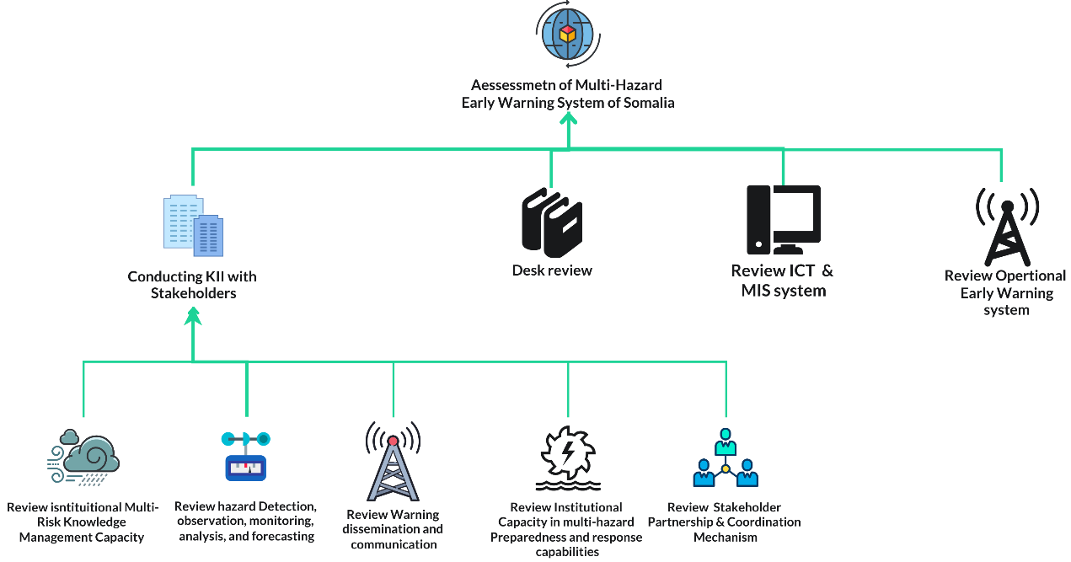
Figure 1: Institutional Assessment Methodology

- NMHEWC operations and EW4ALL alignment
- What operational structure and service delivery capacity gaps exist at the NMHEWC in relation to the EW4ALL Roadmap, and what are the indicative challenges/barriers?
- To what extent do NMHEWC mandates, SOPs, workflows, and products support end-to-end delivery (detection > forecasting > communication > response)?

- ICT systems infrastructure, IT Applications & ICT Governance, and human resources ( MoEWR , SoDMA, NCA, and sector institutions)
- What is the current status of ICT systems across MoEWR-hydrmet services, SoDMA, NCA, and key sector departments, challenges, barriers (Hardware, High Computing System, software, Optical Fiber connectivity, cybersecurity, interoperability, and IT-capable human resources)?
- What are the principal constraints affecting service delivery (systems reliability, hosting, data management, maintenance, staffing, and sustainability)?

- Level of Geospatial Services, GIS-based mapping, remote sensing analytics, and geospatial field data acquisition and processing systems
- What is the current functional capacity of the GIS & Remote Sensing unit (hardware/software, staffing, workflows, field-level GIS data collection, sectoral elements level data collation, and sector level GIS map production)?
- What tools and processes exist to support geospatial data-driven decision-making (e.g., hazard/risk maps, atlases, dashboards, reporting products), and what are the gaps?

- Risk Knowledge, Data Systems, and Assessment Capacity - Key Questions

- NHMS/EWS minimum capabilities: What is the current status of minimum NHMS/EWS capacity for hazard and risk data collection, risk data management, and development/maintenance of national and sectoral risk data repositories?
- Loss and Damage and post-disaster assessments: What mechanisms exist for Loss and Damage (L&D) data collection and reporting, and what is the institutional capacity to conduct PDNA/RPDNA (including coordination arrangements, methodologies, tools, staffing, and data availability)?
- Sector capacity for climate and multi-hazard risk assessments: What is the existing capacity of climate-vulnerable sector ministries/departments to undertake climate and multi-hazard risk assessments (methodologies, guidelines, tools, data inputs, workflows, and quality assurance), and what are the priority gaps and recommendations?
- CRVA and sectoral risk datasets: What is the capacity for sector-level Climate and Risk/Vulnerability Assessment (CRVA), including:
  - collection and management of hazard, exposure, and vulnerability data;
  - availability and quality of statistical datasets on built infrastructure and basic services (asset registries and service-attribute databases);
  - systems for collecting, storing, and using socio-economic and demographic datasets, including age-, sex-, and disability-disaggregated data (SADD);
  - existence and functionality of databases/archives and repositories; and
  - capability to produce decision-support products (e.g., maps, atlases, profiles, dashboards, and analytical reports).
- District/field-level risk knowledge management: What is the status and effectiveness of risk knowledge management systems operated by sector extension departments at district and field levels, including community-level understanding of multi-hazard and climate risks affecting livelihoods and livelihood assets?
- Indigenous knowledge and local coping mechanisms: To what extent are local and indigenous coping knowledge systems documented and mainstreamed into risk-informed community-level DRM/DRR/CCA planning and implementation (including participatory processes, inclusion and safeguarding measures, and feedback loops)?

- Hydrometeorological services and observation networks
- What is the current level of national hydrometeorological service capacity, including the status of observation stations(Automated weather station, Manual station, weather observer level data collection, crowdsourced data collection, overall data transmission, collation, quality control, and processing mechanisms?
- What is the functional capacity for forecasting (deterministic/probabilistic), impact-based forecasting, bulletin preparation, and forecast verification?

- Weather and multi-hazard impact Forecasting systems, transboundary information/data exchange, and operational protocols
- What data-sharing and information exchange mechanisms exist with upper-riparian/transboundary countries (e.g., Ethiopia, Kenya) for flood, flash flooding, and heavy rainfall forecasting?
- What is the level of hydromet data sharing protocol from the hydromet stations of transboundary countries
- What is the current status of inland flood forecasting, heavy rainfall outlook systems, operational forecasting systems, impact forecasting systems, and overall forecasting capability?
- What is the status of Forecast-based Early Action protocols, triggers, and SOPs (including roles, thresholds, and decision-making processes)?

- Risk communication and dissemination systems (national to last-mile)
- What is the current national risk communication framework (roadmap, structures, processes, and responsibilities), and what gaps constrain performance?
- What is the current risk dissemination framework channels, workflows, and governance and how effective is it in reaching last-mile stakeholders?
- What is the status of collaboration with national media outlets (radio/TV), including mandates, MoUs, airtime arrangements, and accountability mechanisms for broadcasting routine forecasts and emergency bulletins?
- How do last-mile communities in off-grid, remote, or hard-to-reach areas receive warnings, and what barriers affect accessibility and timeliness?
- What are the key dissemination bottlenecks (technical, institutional, linguistic, trust-related, security/access constraints), and what measures could address them?
- To what extent are warnings understandable and actionable for frontline communities (language, format, lead time, relevance, and feedback loops)?

- Partnerships, coordination, and governance (national to local)
- What stakeholder partnership and coordination framework currently exists, challenges/barriers for DRM governance, risk/vulnerability assessment, and risk-informed sector planning?
- How can national structures be effectively partnered with CERWS GHA and EW4ALL for full-scale implementation (roles, data exchange, coordination protocols, and governance arrangements)?
- What is the level of ICT/GIS and remote sensing capacity within FAO-SWALIM / MoEWR, including map production systems and data services, and how can it integrate with NMHEWS?

- Local governance, DRM structures, and community-based mechanisms
- What is the current DRM structure and risk governance mechanism at national and local levels, including the functional status, challenges of Civil Protection Committees (CPC) / Disaster Management Committees (DMC)?
- What is the status and quality of disaster preparedness, response, and recovery planning processes, including local-level DRM plans (district/village)?
- How effective is the Disaster Emergency Declaration process, including UN/INGO-led cluster coordination, response mobilization, and humanitarian action linkages?
- How are sector-level DRR actions coordinated at local level, and how do state and non-state actors engage in gender-inclusive, participatory local/clan-level development planning and gender-inclusive DRR planning?

1.3 Consultation Process:

The consultation process comprised structured meetings and technical discussions with key national institutions, sector ministries, UN agencies, and service delivery partners to validate the assessment scope, gather operational insights, and identify gaps and priorities for EW4ALL implementation.
- SoDMA / NMHEWC consultations: Meetings were held with the SoDMA NMHEWC team and relevant departments, including the ICT Department, Hazard/Risk Analysis Team, DRR Department, Humanitarian Affairs Department, Planning Unit, and Monitoring & Evaluation (M&E), as well as other relevant officials and stakeholders.
- Sector ministry consultations: Consultations were undertaken with sector ministries and departments responsible for climate-sensitive livelihoods and essential services, including Livestock, Agriculture, and Water Resources.
- UN agency consultations: Technical consultations were conducted with UN agencies supporting early warning, anticipatory action, and resilience programming, including UNDP, FAO, and WFP.
- Hydromet technical working group consultations: Engagements were conducted with the national hydrometeorological services technical working group under the Ministry of Energy and Water Resources (MoEWR), including discussions related to the Somalia Water Sources Information Management System (SWIMS/SWALIM, as applicable) and associated data and service delivery arrangements.
- Media and communications consultations: Meetings were held with the National Communications Authority (NCA) and national broadcasters to discuss constraints affecting weather forecasting dissemination, bulletin preparation, and public alerting arrangements.

2.0 Challenges of Multi-hazard Risk Management Governance in the Somalin FCV context

- Political fragility and a centralized governance system for risk-informed development:

Climate/multi-hazard risk management governance processes encompass a concerted approach among sectors and stakeholders that need to address all cross-cutting issues. Systematic and cohesive policy alignments, as well as inclusive & concerted programmatic interventions, are undertaken by the sectors. Inter- and intra-institutional partnership and coordination mechanisms are also in place. However, it also requires a holistic sectoral agreed consensus on risk assessment & information sharing, coordination, collaboration, an inclusive level of participatory last-mile local climate governance system is in place, local resource mobilization for the climate resilient local development actions, service delivery capacity stakeholders, and inclusive and finally the participatory engagement of last-mile stakeholders and frontline community with the localized risk-informed development initiatives.

In Somalia, federal and state actors-led service deliveries to the last mile are hindered by fragmented and self-proclaimed governance, clan-based fragility, a territorially fragmented governance system, conflicts, and a largely siloed approach to CSO-led local development service deliveries. The diagram below illustrates that Somalia has a limited extent of nexus between the centralized nature of federal, member state governance systems, poorly functioning district local governments, and sector departments, hindering the expansion of risk-informed service delivery at the last mile. On the other hand, the most prominent last-mile development actors are INGO-led CSOs and UN Agencies, which mostly adopt a siloed approach and are less partnered with government actors to bring up an inclusive climate risk governance management system for Somalia.

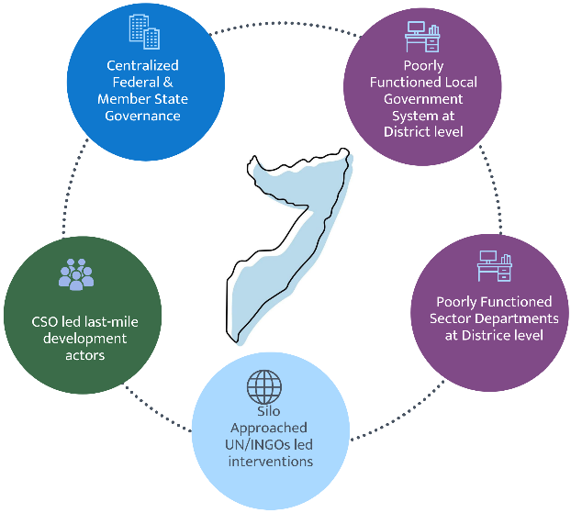
Figure 2: Political fragility and a centralized governance system

In this paradoxical context, binding all relevant stakeholders digitally /remotely, mandating them with ICT-driven strategic partnership and coordination, avoiding the looming governance fragility, and transforming them into ICT-enabled stakeholder-partnered, inclusive multi-hazard early warning systems and risk-informed local development will be leveraged to distantly nexus the platform to the virtually centralized and decentralized functioned digital multi-hazard risk governance system.

Unlocking all fragmented governance paradoxes to create a digitally functioning and level playing field with nexus functional partnerships that hold all stakeholders, sectoral actors, local government entities, CSOs, and frontline communities accountable to the affected population(digitally) out of the box, and eliminating the already suffering from FCV paradigms of governance.

- Current practices of the Silo-approach implementation modality:

Most federal and member-state actors (sector ministries, sector departments, and district administrations), as well as non-state actors (INGOs and CSOs), engaged in risk-informed development in Somalia, often operating through siloed modalities with limited coordination, partnerships, and systematic information disclosure. This fragmentation constrains the interactive, multi-stakeholder processes required to operationalize EW4ALL pillar actions, particularly those that depend on participatory planning, shared risk information, and coordinated last-mile implementation.

In principle, effective multi-hazard and climate risk management governance depends on an agreed framework for coordination and partnership, functional local governance arrangements, local resource mobilization for climate-resilient development actions, adequate service delivery capacity across stakeholders, and inclusive, participatory engagement of frontline communities and last-mile actors in localized risk-informed initiatives. However, as illustrated in Figure 2, Somalia’s sector ministries and departments have a limited partnership nexus across the centralized federal and member-state governance structures, weak district-level administrations, and sector delivery units. This weak institutional linkage constrains consistent risk-informed service delivery at the last mile. In parallel, UN agencies and INGOs often deliver regional and local development assistance through largely parallel systems, frequently relying on CSOs and maintaining limited structured integration with government-led governance and coordination mechanisms.

- Sector-level minimal level of data coordination, exchange, and disclosure:

Despite Somalia’s high mobile-phone penetration (estimated at approximately 80% of the population), many climate-vulnerable government sector departments at federal, member-state, and district levels continue to demonstrate limited adoption and effective use of ICT systems (hardware, software, and communications tools). In most cases, Management Information Systems (MIS) are either absent or underutilized for the systematic collection, inventorying, and management of multi-hazard and climate risk information. In parallel, tailored risk information products are seldom published through institutional websites or other routine public-facing channels, constraining transparency and limiting the usability of risk information for planning and decision-making.

These limitations are compounded by weak or non-existent data-sharing protocols and Memoranda of Understanding (MoUs), and by insufficient mandates and standard operating procedures to institutionalize multi-hazard risk assessment, repository development, and web-based data disclosure. Strengthening governance arrangements for data coordination, including agreed data standards, interoperability requirements, access and disclosure protocols, and formalized roles and responsibilities across central and subnational institutions, is essential to enable impact-based forecasting and to support risk-informed DRM and climate-resilient local development planning.

- Inadequate sector-level risk assessment, systematic risk repository development:

Effective disaster risk management (DRM) planning depends on timely, tailored, and localized risk information to inform preparedness, response, and recovery planning at district and community levels. Sector departments require consistent access to hazard, exposure, vulnerability, and impact data, supported by standardized methodologies and routinely updated repositories, to translate risk knowledge into actionable plans, budget allocations, and early-action triggers.

In Somalia, sector-level risk assessment capacity and systematic risk repository development remain limited. Risk information is often fragmented, project-based, and not institutionalized within government systems, which constrains access by sector departments for routine planning and decision-making. As a result, last-mile development and service delivery are frequently led by non-state actors, particularly local NGOs and other civil society organizations, who may generate useful localized datasets but often do so through parallel systems with limited integration into government-led repositories and planning processes. This undermines consistency, continuity, and the ability to scale risk-informed DRM actions across districts and sectors.

- Inadequate surface weather observation:

Somalia’s surface observation network remains largely manual, and time-series data are not acquired, quality-controlled, and transmitted in a systematic and regular manner. This undermines the ability to deliver point-based nowcasting, constrains the production of timely operational products, and limits forecast verification and continuous service improvement. As a result, national capacity for hydrometeorological monitoring, real-time tracking, and forecasting remains limited.

Key constraints include an insufficient number of automatic hydrometeorological stations, persistent challenges in data transmission, and limited provision for routine operation and maintenance (O&M). These gaps reduce the availability of reliable, timely observations required for improved forecasting, impact-based warning services, and downstream risk-informed DRM planning.

Closing Somalia’s observation gap is therefore a priority under EW4ALL Pillar 2 (detection, observation, monitoring, analysis, and forecasting). In coordination with national counterparts, WMO, UNDP, and UNEP should prioritize mobilization of the Systematic Observations Financing Facility (SOFF) to provide long-term financial and technical assistance to generate and internationally share basic weather and climate observations in line with Global Basic Observing Network (GBON) requirements.

- Inadequate local-level Disaster Risk Management capacity

Somalia’s climate risk profile is intensifying under a changing climate regime, with increasing frequency and severity of both rapid-onset and slow-onset hazards. Over the period 1975-2024, recorded disaster events indicate that many shocks are sudden and high-impact (e.g., floods, cyclones, disease outbreaks), while slow, protracted droughts remain severe and recurrent. These compounded hazard patterns continue to generate significant loss and damage across livelihoods and productive sectors and further erode household coping capacity.
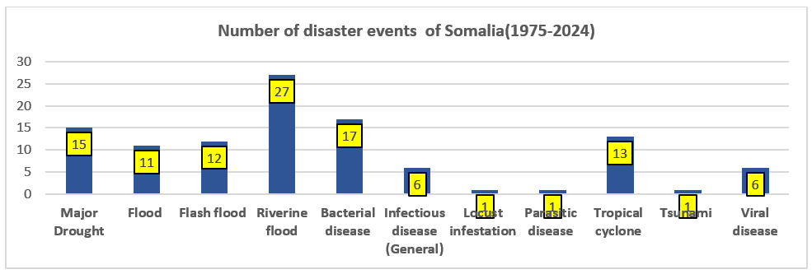

Figure 3: Somalia Disaster events (1975-2024): Source EM-DAT Apr 2024 ( 48 years Disaster incidence dataset for Somalia)

As reflected in Figure 3 (Somalia disaster events, 1975-2024), the trend and diversity of hazard incidence reinforce the need for a functional, end-to-end early warning system supported by ICT-enabled coordination, information management, and last-mile service delivery. Climate change-driven internal and cross-border displacement also increases demographic and socioeconomic risk factors, placing additional stress on local administrations, basic services, and community coping mechanisms.

Local-level DRM capacity is constrained by limited access to timely, actionable risk information and by weak operational systems that translate warnings into preparedness and early action. These limitations are reinforced by gaps in hydrometeorological observing and forecasting capacity: real-time monitoring, data exchange, and forecasting remain limited due to an insufficient number of automatic hydrometeorological stations, reliance on manual observations, data transmission constraints, inadequate operation and maintenance (O&M), and limited technical capacity for hydrological forecasting.

To enable robust weather forecasting and impact-based Early Warning Systems (EWS), Somalia requires strengthened real-time monitoring of meteorological and hydrological conditions. This includes automating existing stations, installing additional automated stations, improving real-time data transmission (including for flood monitoring), expanding spatial coverage, and upgrading the quality, timeliness, and usability of observation and forecast products to better inform local preparedness, response, and recovery planning.

- Inadequately tailored, risk-informed planning and interventions

Somalia lacks adequate sector-level institutional capacity to conduct systematic climate and multi-hazard risk assessments, develop and maintain risk repositories, and apply tailored risk-informed planning tools. As a result, sector planning and interventions are often not sufficiently grounded in localized hazard, exposure, vulnerability, and impact evidence, limiting the effectiveness and sustainability of climate-resilient development investments.

This capacity gap is reinforced by weak institutional accountability and the absence of key enabling conditions, including clear mandates, an information management system, and an operational policy framework. In many cases, standardized methodologies, tools, and guidelines for sector-level risk assessment are not in place, and dedicated institutional arrangements (e.g., a task force or technical working group) to lead and quality-assure risk assessments are either missing or non-functional.

At a minimum, sector departments require a structured risk database and basic GIS capability to establish and manage sectoral risk repositories that can inform project identification, design, prioritization, implementation, and monitoring. Without these foundational elements, risk-informed planning remains fragmented and largely project-based, undermining coherence across sectors and limiting the ability to scale evidence-based DRM and climate adaptation actions.

- Inadequate tailored, risk-informed planning and intervention:
The country has not yet established adequate sector-level institutional capacity to conduct systematic climate and multi-hazard risk assessments, develop and maintain risk repositories, or apply tailored risk-informed planning tools. Consequently, sector planning and interventions are often not consistently grounded in localized evidence on hazards, exposure, vulnerability, and impacts, which limits the effectiveness and resilience of development investments.

This gap is reinforced by weak institutional accountability and the absence of core enabling conditions, including clear mandates, an information management system, and an operational policy framework. In addition, standardized methodologies, tools, and guidelines for sector-level risk assessment are limited or not institutionalized, and dedicated arrangements, such as a task force or technical working group to lead and quality-assure sector risk assessments, are generally missing.

At a minimum, sector departments require a structured risk database and basic GIS capability to establish and manage sector risk repositories that can support project identification, design, prioritization, implementation, and monitoring. Without these foundational elements, risk-informed planning remains fragmented and largely ad hoc, undermining coherence across sectors and constraining scale-up of evidence-based DRM and climate adaptation actions.

2.1 Recommendations for Overcoming the Indicative Challenges and exploring an ICT-driven multi-hazard risk management system can be implemented in the Somalia FCV context

- Improving ICT-based risk governance at central, member state, regional, district, and village levels:

Somalia’s FCV context constrains both bottom-up and top-down planning and weakens institutional linkages across federal, member state, district, and community levels. At the same time, disaster risk management (DRM) must operate under conditions where rapid-onset hazards can create immediate life-safety consequences. An ICT-enabled risk governance system designed as a whole-of-society platform can help bridge these structural constraints by enabling coordinated risk information management, real-time event reporting, inclusive last-mile participation, and faster decision-making for early action and response.
i) Community-first, whole-of-society risk information generation and ground-truthing
- Enable frontline communities as first responders and key informants through mobile and offline-capable tools linked to a national online risk database.
- Integrate field data collection tools (e.g., Kobo Toolbox) and GPS-enabled applications to capture georeferenced exposure, impacts, and situational updates during hazard onset and escalation.
- Operationalize a structured approach for community-based actors to report:
- hazard observations (rainfall, river levels, inundation, wind impacts);
- impacts on people and assets (shelter damage, access constraints, displacement);
- urgent needs and service disruptions (WASH, health, food security, protection).
ii) Formalize local actor participation and reporting responsibilities
- Digitally enable local governance and community structures, including CPC/DMCs, village-level administration/clan-based leadership structures, mosque-based committees, local charities, youth groups, and volunteers to conduct app-based:
- multi-hazard exposure mapping;
- rapid risk and vulnerability screening;
- event hotspot reporting and localized situation awareness updates.
- Establish simple reporting standards (minimum variables, location accuracy, update frequency) to ensure data quality and comparability.
iii) Expand the key informant network beyond formal structures
- Include CSOs/NGOs, academia, students, R&D organizations, value chain operators, entrepreneurs, and private-sector actors as designated “key informants” to:
- provide periodic updates on sector-specific exposure and impacts;
- support verification of community reports; and
- expand coverage in hard-to-reach and off-grid areas.
iv) Mandate sector departments to contribute routine, georeferenced risk data
- Require climate-vulnerable sector departments (e.g., crop agriculture, livestock, WASH/water, health, fisheries) to submit standardized, georeferenced exposure, vulnerability, and impact information into a central repository via the online database system.
- Ensure sector departments can access and interpret these datasets alongside high-resolution, spatiotemporal weather warnings to translate forecasts into sector-specific advisories and actions.
v) Strengthen observation and forecasting services to enable impact-based decision-making
- Support a shift toward high-density, point-based observation and ICT-enabled impact forecasting to generate:
- sectoral element-level operational and impact forecasts;
- operational forecasts for critical service delivery infrastructure (e.g., power systems, healthcare facilities, lifeline utilities); and
- localized point forecasts for high-value/high-risk areas (cities, municipalities, urban centers, IDP sites, and rural settlements).
vi) Deliver multi-channel, last-mile warning dissemination with actionable guidance
- Disseminate alerts via mobile applications, WhatsApp, SMS, IVR, and cell broadcast, using consistent alert levels and simple protective action statements.
- Provide location-based guidance through geospatial mobile applications, including map-based preparedness and evacuation advisories, identification of safe routes (where feasible), and guidance on emergency shelter locations.
vii) Digitize emergency management for coordination, accountability, and coverage
- Use the ICT-based DRM platform to issue and track standing instructions for disaster operations (e.g., Standing Orders on Disaster/SoD, as applicable), and digitally bind/coordinate grassroots actors (CPC/DMCs, volunteers, charities, youth groups).
- Apply a 5W tracking approach (Who, What, Where, When, for Whom) to:
- prevent duplication of assistance;
- identify gaps and underserved locations;
- improve tasking, monitoring, and operational oversight; and
- document interventions for accountability and learning.
viii) Enable rapid post-event assessment, Loss & Damage, and early recovery planning
- Configure the system to support RPDNA and rapid initial Loss & Damage (L&D) estimation by capturing:
- life-safety impacts and immediate humanitarian needs;
- livelihood and productive sector damages/losses;
- priority response actions and resource gaps; and
- early recovery priorities for affected areas.
ix) Support Pillar 4: preparedness and anticipatory action planning
- Enable CPC/DMCs to manage end-to-end community-based early warning locally and to develop forecast-based anticipatory action protocols tailored to locality-specific risks.
- Use an online dashboard to support humanitarian and government actors in:
- scenario planning and trigger-based early action;
- pre-positioning and resource allocation; and
- coordination of preparedness, response, and recovery plans through shared digital workflows.

- An ICT-enabled Loss and Damage (L&D) reporting system to function as embedded within the NMHEWS/EW4ALL platform to enable structured, community-level capture of impacts in near real time. Mobile and web-based applications can support rapid reporting of hazard impacts and evolving needs from frontline communities, while enabling verification and aggregation at district, member-state, and national levels. This approach strengthens situational awareness during hazard onset and provides the evidence base for escalation decisions, anticipatory action, and humanitarian mobilization.

i) Community-based L&D reporting and incident tracking
- Deploy simple, standardized reporting forms (mobile app, USSD, IVR, and web) to capture event-based L&D at household and community levels, including:
- affected people (injuries, deaths, displacement);
- damage to shelters and basic service facilities (health, water points, schools);
- livelihood and productive sector impacts (livestock losses, crop damage, market disruption);
- access constraints and priority needs.
- Ensure records are georeferenced, time-stamped, and tagged by hazard type and severity level.

ii) Validation through triangulation and “crowdsourced” evidence
- Validate community reports by triangulating multiple sources, including:
- duplicate/independent community submissions (crowd-confirmation);
- photos or short videos where safe and appropriate (with safeguarding controls);
- satellite/remote sensing indicators (e.g., flood extent proxies);
- reports from CSOs/NGOs, sector extension workers, and local authorities.
- Introduce a basic “confidence score” system (e.g., unverified/partially verified/verified) to improve trust and usability for decision-makers.

iii) Turning incident updates into actionable impact analysis
- Use rolling incident updates and L&D trends to estimate dynamic impacts as hazard intensity, duration, and geographic coverage change (e.g., flood propagation, cyclone track impacts).
- Link incident/L&D data with exposure layers (settlements, IDP sites, health facilities, water infrastructure) to generate next-level impact estimates and priority area rankings.

iv) Enabling impact forecasting and forecast-based early action
- Integrate L&D and incident trends into operational workflows to support:
- refinement of impact-based forecasts and advisories;
- trigger setting and threshold calibration for Forecast-based Early Action (FbEA) protocols;
- rapid evidence-based decisions on pre-positioning, evacuation advisories, and targeted assistance.
- Provide a shared dashboard for SoDMA, sector ministries, and humanitarian partners to support coordinated planning and response.

v) Reducing silos through a centralized, governed process
- Implement a centralized L&D intake and management process with defined roles, access controls, and data-sharing protocols to ensure all actors report into a common system rather than maintaining parallel datasets.
- Establish SOPs for: data submission, verification, escalation, reporting cycles, and post-event consolidation for RPDNA/PDNA and lessons learned.

2.1.1 Proposed ICT Tools, system, platform to address the gaps
    - Maintain a dual-database approach to balance legacy constraints with operational performance. Oracle should be retained for any existing government enterprise workloads that are already Oracle-dependent and cannot be migrated without significant risk or cost. PostgreSQL/PostGIS should serve as the primary operational database for NMHEWS, given its strong geospatial capabilities, open standards support, and suitability for real-time and analytical workloads.

    - Integration between Oracle and PostgreSQL/PostGIS should be implemented through one of two controlled mechanisms:

- API-based exchange (preferred): Implement near-real-time interoperability through secure REST APIs, allowing systems to publish and consume validated datasets without tight coupling. This approach supports incremental updates, reduces duplication, and improves governance through role-based access controls, logging, and standardized schemas.
- ETL (Extract-Transform-Load) pipeline: Establish a governed pipeline that extracts data from multiple sources (mobile apps, sensors, partner databases, CAP feeds, and—where needed—Oracle repositories), transforms it through standardization and quality controls (schema mapping, unit conversions, geocoding, deduplication, and QC flagging), and loads it into the NMHEWS PostgreSQL/PostGIS environment and/or a data warehouse for analytics, mapping, and reporting. ETL is typically batch-based (hourly/daily) but can be configured for near-real-time replication where operational requirements demand it.

    - Minimum core components to add (so the database actually enables EW4ALL operations)

    - Data ingestion layer (to avoid manual uploads)

A dedicated data-ingestion layer should be established to eliminate manual uploads and enable near-real-time integration of multi-source inputs into the NMHEWS/IBF platform. Core ingestion streams should include: (i) Kobo Toolbox/ODK submissions for community-level loss and damage (L&D) reporting and rapid assessments; (ii) station telemetry feeds where available (AWS, river gauges, groundwater, and borehole sensors); (iii) partner datasets from FAO/SWALIM, sector ministries, and UN agencies; and (iv) structured SMS/IVR/USSD inputs where implemented to support low-connectivity reporting. All ingested data must be systematically time-stamped, geo-referenced, and subjected to basic validation and quality-assurance rules (e.g., completeness checks, coordinate validation, duplicate detection, and role-based verification) before being promoted to operational repositories for forecasting, impact analysis, and CAP dissemination.

2) API and interoperability services
A secure interoperability layer is required to connect all NMHEWS/IBF stakeholders and systems. This includes: (i) a REST API gateway to standardize and secure data exchange across institutions and partners; (ii) geospatial interoperability using OGC services (WMS/WFS) to support GIS-based access and publishing; and (iii) CAP-compatible alert outputs to enable consistent, multi-channel warning dissemination through broadcasters, telecom operators, apps, and other communication platforms.
    - Front-end: Standing orders on Disaster (SoD) interface as an operational module :

The SoD front-end must function as an operational command module (not just a dashboard). It should support: (1) role-based Standing Orders and tasking workflows; (2) 5W tracking (Who/What/Where/When/For Whom) to prevent duplication and reveal gaps; (3) incident and Loss & Damage (L&D) reporting with verification status and confidence levels; (4) forecast/warning bulletin workflows from draft to approval to publication; and (5) situation reporting with a full audit trail.

- Practical data model (high-level) for centralized database :

Design and installation of practical centralized NMHEWS database model (preferably PostgreSQL/PostGIS) should cover: administrative units; users/organizations/roles (Role-based access control for government/partner/community tiers) and audit logs; observations (station metadata, time series, QA flags); forecasts/bulletins (issuance, validity, spatial footprints, thresholds); alerts (CAP objects) and dissemination logs; incidents and L&D (reports, needs, verification states); exposure/assets inventories (settlements, IDP sites, facilities, lifeline infrastructure); vulnerability layers and SADD-ready population structures; and SoD operational objects (Standing Orders, tasks, and 5W actions).

ii) Operational safeguards you should specify up front (FCV-critical)

implement tiered role-based access control (government/partner/community) with least-privilege and separation of duties for CAP/warning approvals; maintain tamper-evident audit logs for all edits, approvals, and dissemination actions; design offline-tolerant “store-and-forward” mobile workflows with validation, encryption, and verification status states; establish backup and disaster recovery with daily backups, offsite/immutable storage, defined RPO/RTO, and routine restore tests; and enforce clear data governance rules that classify what is public, partner-only, or restricted, including privacy protections and controlled disclosure criteria.

2.2 Objective of the Interoperable NMHEWS for Somalia:

The objective of an interoperable National Multi-Hazard Early Warning System (NMHEWS) for Somalia is to establish an ICT-enabled, evidence-based risk information management and coordination platform that improves risk governance and enables end-to-end early warning from detection and forecasting to dissemination, anticipatory action, response coordination, and post-event impact tracking.

i) Develop an online multi-hazard risk information management system for building-back-better(BBB) coordinated action
In traditional emergency preparedness and humanitarian coordination, roles and responsibilities are often unclear, particularly regarding who is responsible for what, where, and when. This leads to coordination gaps during crisis situations and limits the ability to mandate, task, and track actors consistently during disaster response. The interoperable NMHEWS will address this challenge by providing a shared operational platform that supports coordinated planning, tasking, accountability, and information exchange across federal, member-state, district, and community levels.

ii) Enable anticipatory action through precision-level risk information and interoperability
Multi-hazard risk management requires coordinated action not only at the point of warning issuance but also in translating forecast risk into anticipatory actions. This translation depends on strong local-level coordination and timely access to actionable information. The interoperable system will enable an integrated, evidence-based operating model so that stakeholders can align on what actions will be taken, by whom, where, and when, creating synergies for inclusive local participation and effective early action. The system will also support operational functions, including:
- assessing the likelihood and severity of anticipated impacts before landfall; and
- tracking observed impacts and evolving conditions at the frontline during and after hazard onset, including intensity, geographic trajectory, and affected elements.

iii) Strengthen ICT-enabled disaster risk governance through last-mile engagement
Improving risk governance requires meaningful last-mile participation. The ICT-enabled and interoperable early warning platform will keep local Civil Protection Committees (CPCs) and community actors informed of evolving hazard conditions, enabling them to interpret likely magnitude and intensity and to initiate appropriate protective actions. This strengthens end-to-end early warning by linking technical warning services with locally led preparedness, response, and community resilience measures.

iv) Close last-mile risk information gaps through inclusive digital participation
The interoperable NMHEWS will close last-mile information gaps by deploying online and Android-based applications that enable frontline stakeholders, including smallholder enterprises, humanitarian actors, and CPC volunteers, to function as grassroots-level informants. Through structured digital reporting, these stakeholders can contribute localized risk and vulnerability information and element-specific exposure and impact data, strengthening situational awareness, improving the relevance of advisories, and enabling more targeted anticipatory action and response

2.3 Urgency of Implementation of ICT-based Multi-Hazard Risk Management Governance:

Climate change-induced multi-hazard risk management requires a systemic and structured approach that can operate across institutions, sectors, and administrative levels. In practice, robust multi-hazard risk governance increasingly depends on ICT-enabled structures and functional processes that can operationalize the four EW4ALL pillars risk knowledge, detection/forecasting, warning dissemination, and preparedness/response through integrated planning, task management, coordination, and risk mitigation.

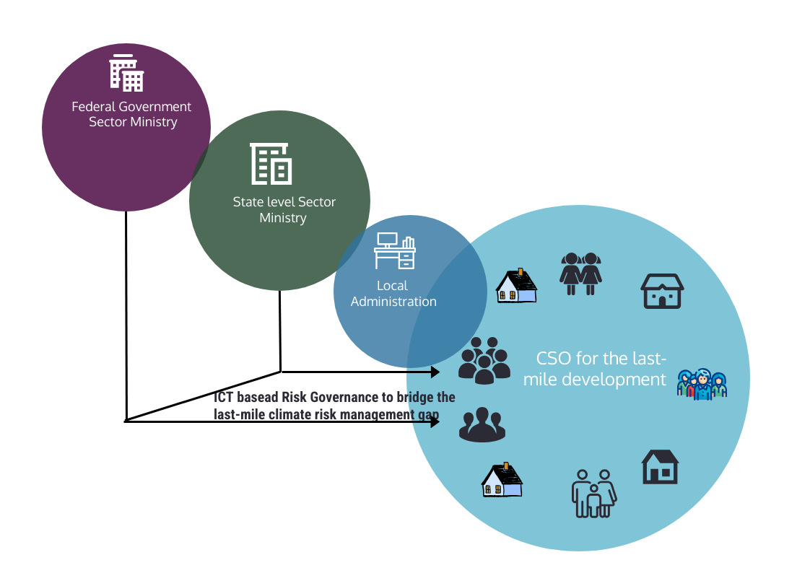
Figure 4: ICT-based Risk Governance to bridge the last-mile climate risk management

Figure 4 highlights that Somalia’s current multi-hazard risk governance is shaped by divergent and fragmented governance patterns. Federal and member-state institutions often operate through centralized policy and programmatic silos, while district-level local government systems remain weak and inconsistently functional. At the same time, last-mile service delivery and risk-informed development are largely driven by CSO and INGO-led modalities that frequently operate through parallel systems with limited structured integration into government-led DRM governance. This fragmentation constrains consistent information exchange, weakens accountability, and limits the translation of early warnings into coordinated anticipatory action and response.

In Somalia’s FCV context, the urgency of ICT-based risk governance is therefore twofold. First, the scale, frequency, and complexity of climate-related hazards demand faster and more precise end-to-end early warning and operational decision-making. Second, the existing institutional landscape requires a mechanism that can bridge fragmented actors and enable predictable coordination across federal, member-state, district, and community levels. An ICT-driven risk governance management system provides this bridging function by enabling shared situational awareness, role clarity, tasking, and tracking (e.g., who does what, where, and when), and routine data disclosure and feedback loops.

Given that INGO-led local NGOs and CSOs remain the most prominent last-mile actors for risk-informed development, federal and member-state sector ministries and departments must close the coordination and service delivery gap by adopting an ICT-enabled multi-hazard risk governance platform. As depicted in Figure 4, the limited partnership nexus between government institutions and last-mile CSO actors and the associated deficiencies in coordination and information sharing reinforce the need to operationalize ICT-based risk governance as a core enabling condition for full-scale EW4ALL implementation in Somalia.

2.4 Key indicators of ICT-driven EW4ALL action priorities for Somalia in FCV context.

In Somalia’s FCV setting, “key indicators” should emphasize operational functionality, interoperability, last-mile reach, accountability, and resilience to disruption (connectivity gaps, insecurity, institutional fragmentation). The indicator set below is structured around the EW4ALL pillars plus cross-cutting ICT and governance enablers.

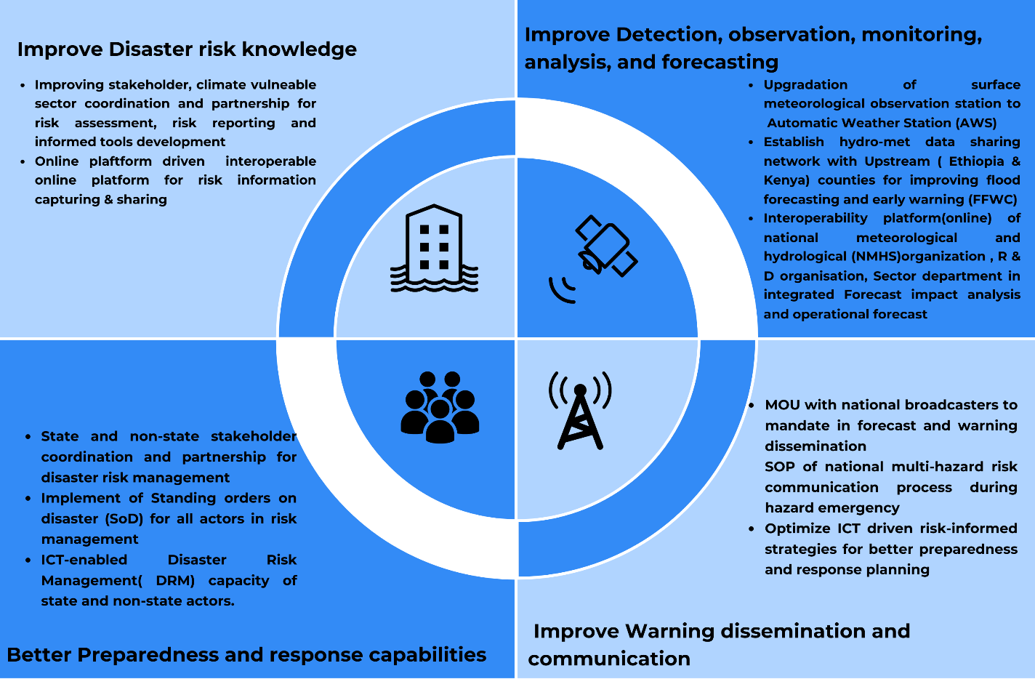
Figure 5: Key indicators of ICT-driven EW4ALL action priorities

A. Cross-cutting enablers for ICT-driven risk governance (system-wide)
- Operational governance established: NMHEWS/EW4ALL Steering Committee and Pillar TWGs functional (ToR approved; meetings held; action tracking in place).
- Data-sharing governance: Number of active data-sharing MoUs/SOPs (federal-member state-sector-partners) with defined datasets, update frequency, and access rules.
- Interoperability compliance: Proportion of partner institutions connected through standardized APIs/OGC services and using agreed data/metadata standards.
- Role clarity and tasking (“5W”): Percentage of emergencies where response tasks are logged and tracked digitally (Who/What/Where/When/For Whom).
- Platform uptime and resilience: System availability (% uptime), backup success rate, restore test frequency, and offline data capture/sync performance.
B. Pillar 1 Risk knowledge and risk information management
- National risk repository operational: Existence and active use of a centralized (or federated) risk repository with sector/state workspaces.
- Core datasets completeness: Availability and update status of minimum datasets (hazard layers, exposure/assets, vulnerability indicators, historical impacts/L&D).
- Sector CRVA production: Number/percentage of priority sectors producing updated CRVA/risk profiles using standardized methodology and publishing decision-support outputs (maps/atlases/reports).
- SADD integration: Proportion of relevant risk datasets and assessments incorporating age, sex, and disability-disaggregated data (SADD).
- Community risk knowledge captured: Number of districts/villages submitting community-level risk and vulnerability profiles through digital tools; frequency of updates.
C. Pillar 2 Detection, observation, monitoring, and forecasting
- Observation network coverage: Number of operational automatic met/hydro stations; spatial coverage in priority risk corridors; station data completeness (% reporting days).
- Data transmission latency: Median time from observation to central database availability (minutes/hours), by station type/location.
- Forecast production routine: Frequency of routine forecasts and hazard-specific bulletins produced and published (daily/weekly/seasonal).
- Impact-based forecasting capability: Number of hazards and priority locations with impact-based products (linking hazard to exposure/vulnerability layers).
- Forecast verification in place: Verification metrics produced routinely (e.g., hit rate/false alarms/lead time) and used in continuous improvement cycles.
D. Pillar 3 Warning dissemination and risk communication (last-mile reach)
- Multi-channel dissemination operational: Alerts disseminated through at least three channels (e.g., SMS/cell broadcast, IVR, radio/TV, WhatsApp) with documented SOPs.
- Dissemination coverage: Share of targeted population reached within defined time thresholds (e.g., within 30-60 minutes of issuance), including off-grid areas.
- Broadcast partnership effectiveness: Number of broadcasters with active MoUs; compliance with emergency bulletin broadcasting requirements (broadcast logs).
- Warning understandability/actionability: Proportion of sampled communities reporting warnings is understandable and includes clear protective actions (post-alert surveys).
- Two-way feedback loop: Percentage of warning events with community feedback captured and incorporated into after-action reviews.
E. Pillar 4 Preparedness, anticipatory action, response, and recovery support
- CPC/DMC functionality: Number/percentage of districts with CPC/DMCs active and digitally connected; frequency of drills/simulations.
- Forecast-based early action triggers: Number of hazards with agreed triggers, SOPs, and pre-agreed actions operationalized (including pre-positioning).
- Incident/L&D reporting in real time: Volume and completeness of georeferenced incident/L&D reports submitted during events; validation rate (triangulated/verified).
- RPDNA/PDNA readiness: Time to generate initial rapid damage/loss estimates after onset; availability of standardized RPDNA/PDNA templates and trained teams.
- Response gap identification: Percentage of emergencies where digital 5W tracking identifies underserved/hard-to-reach areas and informs re-tasking.
F. FCV-specific safeguards (quality, neutrality, inclusion, protection)
- Access control and auditability: Role-based access implemented; audit logs enabled for edits/approvals (warnings, L&D, tasking).
- Do-no-harm and neutrality measures: Warning issuance protocols separated from political messaging; documented procedures for contested-access areas.
- Inclusion and accessibility: Proportion of warning products available in local languages and accessible formats (voice/IVR for low literacy).
- Sustainability/O&M: Budget line(s) for O&M; trained maintenance cadre; mean time to repair (MTTR) for stations and ICT components.

3.0 Pillar 1 Implementation Strategy (Improving Disaster Risk Knowledge):

Improving risk knowledge at the last mile

Communities at the climate frontline require a clear understanding of both persistent and emerging risk drivers in their localities, including multi-hazard exposure, underlying socioeconomic vulnerabilities, and compounding stressors. Strengthening localized risk knowledge through accessible, online risk information can improve risk perception and enable households and communities to take timely, protective actions.

An ICT-enabled risk knowledge approach should combine digital information management with participatory and community-led methods, including app-based data collection and analysis, participatory risk and vulnerability assessments, focus group discussions, social vulnerability mapping, and element-specific risk profiling. These processes can support risk ranking and prioritization and help communities continuously monitor, interpret, and learn about climate change impacts and evolving multi-hazard risks. They also provide a basis to anticipate potential Loss and Damage (L&D) and to identify feasible preparedness, response, and mitigation measures tailored to local conditions.

Linking risk knowledge to risk financing and anticipatory action

Closing risk knowledge and capacity gaps also requires predictable financing mechanisms to invest in the infrastructure, operations, and maintenance needed for a functional Multi-Hazard Early Warning System (MHEWS). Risk transfer and pre-arranged financing instruments can complement institutional capacity by enabling timely, trigger-based action and supporting forecast-based Anticipatory Action (AA).

For example, multi-hazard informed social protection can be integrated with disaster risk management and climate change adaptation measures to strengthen shock preparedness and responsiveness. When aligned with risk information and early warning triggers, such mechanisms can help households and communities absorb shocks, protect livelihoods, and recover faster from recurring hazards.

3.1 The ongoing SoDMA Structure :

The current SoDMA organogram does not yet position the National Multi-Hazard Early Warning Centre (NMHEWC) as a dedicated center of excellence for multi-hazard risk management and early warning service delivery. The organizational structure indicates that NMHEWC is not established as a distinct functional unit with a clear mandate, authority, and operational accountability for end-to-end early warning services.

From a human resources perspective, NMHEWC currently has some technical staff; however, full-scale operationalization will require strengthening staffing levels and competencies across key disciplines. Priority roles include thematic forecasters, meteorologists, hydrologists, numerical weather prediction (NWP) specialists, impact forecasters, GIS and remote sensing/mapping specialists, hazard and risk analysts, database programmers, web and geospatial application developers, ICT specialists, DRR specialists, and risk communication specialists.

In addition to staffing, NMHEWC requires significant strengthening of ICT and operational infrastructure to meet the requirements of a multi-hazard early warning service. Key needs include robust ICT architecture, a reliable data center environment, and high-speed internet connectivity aligned with Tier 3 or Tier 4 reliability targets. Operationalization will also require specialized technical capabilities and equipment, including higher-performance computing (HPC) capacity for data processing and modeling, mechanisms for multi-channel dissemination (e.g., GSM modems and/or integration with telecom gateways for mobile messaging), and tools to ingest, manage, and analyze big data and crowdsourced observations to improve hazard detection, situational awareness, and impact analysis.

Collectively, these institutional and technical investments are necessary to enable NMHEWC to provide reliable, timely, and actionable multi-hazard early warning products and services on the national scale.
.

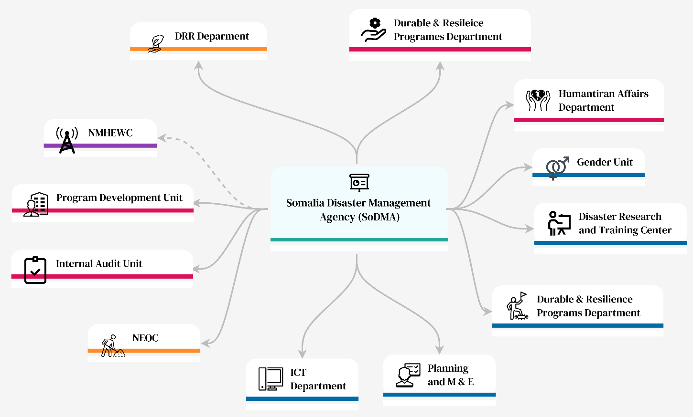
Figure 6 : Ongoing SoDMA Structure

3.2 The NMHEWC ongoing operational structure :

Under the existing arrangement, NMHEWC has limited operational capacity. Its ICT architecture and operational processes remain at a basic level and are not sufficient to support multi-tasking, multi-user service delivery, or end-to-end early warning operations at national scale.

At present, NMHEWC operates largely as an isolated, intranet-based workstation environment intended for internal SoDMA use. Sector ministries and other stakeholders are unable to digitally access forecast outputs, bulletins, datasets, or related resources because there is no functional online data center and no operational web-based service delivery platform. Apart from the SoDMA public portal which primarily provides institutional information and highlights online systems for early warning service delivery are not operational. Consequently, NMHEWC products and services remain largely confined to internal SoDMA use, limiting cross-institutional interoperability and last-mile dissemination potential.

The following section summarizes the current workstations and basic service delivery setup in place at NMHEWC.
.

- 7 HP PRODESK (Processor i5, RAM 8GB, Windows 10 Pro): These computers are low-configured and have little processing power for multitasking. The workstation-specific tasks are designated as follows;

- HP PRODESK-1 Running the Zoom Earth live weather map
- HP PRODESK-2 Maintain an Excel sheet on Rain Gauge data of 40 rain gauge stations (decadal dataset)
- HP PRODESK-3 Running GFS weekly forecast
- HP PRODESK-4 Running WFP PRISM System on the climate risk monitoring system. The system shows 10-day rainfall forecasts (GFS Global decadal forecasts), rainfall anomaly, SPI, last rain days, temperature, phase classification, earthquake disaster assistance global system, customized global system cascading data used social economic vulnerability data ground truth Layers, rainfall, temperature, NDVI, SPI. Social economic vulnerability etc.
- HP PRODESK-5 Running ICPAC East Africa hazard watch and weather forecasts
- HP PRODESK-6 Running Drought Monitor portal
- HP PRODESK-7 Running myDEWETRA global platform of CIMA Research Foundation

- 4 HP Desktop Computers (Processor i7 8Gen, RAM 16GB, Windows Home) : Uses for hazard analysis

- 1 PC Running DesInveter online database: Update and maintenance DesInventer online database

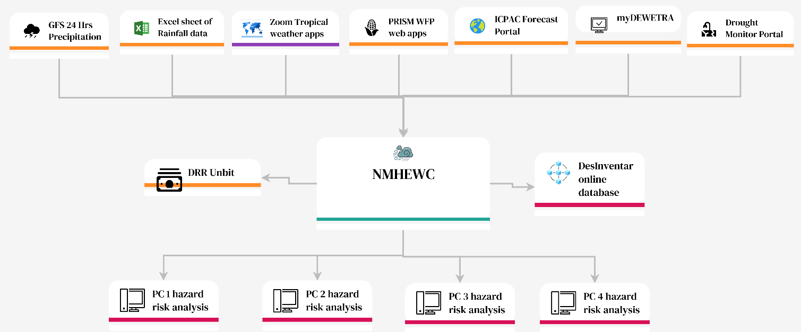
Figure 7 : Ongoing NMHEWC structure

Figure 7 indicates that NMHEWC currently maintains only a preliminary capacity for multi-hazard risk management and early warning service delivery. Key gaps are evident across infrastructure, systems, and institutional coordination functions.
- Data center capability: The center does not have dedicated servers for operational data processing, modeling, or analytics.
- Data storage: There are no server-based storage systems or enterprise storage devices to support structured data archiving, retrieval, and backup.
- Software: Available software includes ArcGIS 10.4 and QGIS, indicating basic GIS capability but not a complete end-to-end early warning service environment.
- Internet backbone: Connectivity relies on a local broadband cable with limited bandwidth that supports largely one-way traffic. The center lacks a functional online database server and therefore cannot provide external stakeholder access to data, products, or services.
- Data exchange, coordination, and partnerships: There is no ICT-enabled online dissemination system and no formal MoUs/mandates with sector ministries or non-state actors for structured information exchange and coordination. In addition, there is no formally designated risk and vulnerability assessment committee, nor standardized methodologies or tools for Post-Disaster Damage, Loss, and Needs Assessments (PDNA). Instead, information collection appears to rely on ad hoc arrangements, including local enumerators and mosque imams as key informants transmitting information to district administrations.
- DesInventar database: NMHEWC updates and maintains Loss and Damage information in the DesInventar database; however, archived L&D statistics reportedly extend only to 2021, indicating limitations in recency and/or completeness.
- National Emergency Operations Center (NEOC): NEOC operates separately from NMHEWC and is physically located outside the SoDMA complex. It supports preparedness and coordination functions but currently operates outside an integrated, end-to-end early warning and incident management workflow.

The existing Risk Management Structure lacks of following system ;

a) Lack of National Climate Risk and Vulnerability Assessment (CRVA) Framework
b) Lack of Multi-Hazard Risk Atlas and GIS-Based Data Platform
c) Lack of Local Risk Data Collection and Community Repositories
d) Lack of Socio-Economic and Infrastructure Surveys
e) Desinventar contents Historical Disaster Catalogue and Event Database from 2021 to the present, but access restriction to SoDMA only.

3.3 Proposed Interoperable NMHEWS :

The proposed National Multi-Hazard Early Warning System (NMHEWS) represents an operational shift from the current centralized, internally oriented, and capacity-constrained NMHEWC modality to a robust, ICT-enabled, interoperable Multi-Hazard Early Warning System (MHEWS). The system is designed to support concurrent multi-tasking operations, structured data management, and end-to-end service delivery through a Relational Database Management System (RDBMS), an online portal, and mobile applications. It will also enable “big data” and crowdsourced information capture through user-friendly mobile reporting tools, including survey-based data collection and georeferenced placemark tracking using tools such as ESRI Survey123, GPS Logger, and field GIS applications (e.g., QField), as appropriate.

i) Whole-of-society digital connectivity and interoperability

The NMHEWS will function as an online platform that digitally connects government institutions at federal and member-state levels with district administrations and sector departments, and integrates non-state actors (CSOs/NGOs), humanitarian partners, enterprises, private sector actors, and last-mile stakeholders, including communities and individuals. By enabling shared access to risk information, standardized reporting, and interoperable data exchange, the platform is intended to foster an inclusive and integrated digital ecosystem that reduces procedural fragmentation and institutional barriers that currently constrain Somalia’s DRM governance system.

ii) Multi-layered information architecture for operational decision-making

Operationally, the proposed NMHEWS will function as a command-and-control and coordination platform, underpinned by structured, multi-source risk information flows:

- Primary informants: households and frontline communities providing direct, georeferenced observations, impacts, and needs information.
- Secondary informants: last-mile service providers and stakeholders (e.g., CPC/DMC, local CSOs, extension workers, volunteers) providing verified updates and sector-relevant information.
- Tertiary informants: district administrations, sector extension departments, municipalities/cities, and other urban-level actors consolidating and validating information and coordinating response actions.

This layered informant architecture enables rapid ground-truthing, improved situational awareness, and decision support across preparedness, anticipatory action, response coordination, and early recovery planning.

iii) Real-time visibility, traceability, and web-map-based operations

The NMHEWS will include a web-based operational interface with traceability features (role-based access, audit logs, and workflow controls) to provide:
- real-time oversight of last-mile reporting and incident updates;
- hazard and event tracking across locations; and
- dissemination of web-map-based information products, alerts, and advisories to relevant stakeholders.

iv) Rationale for the proposed shift

By institutionalizing digital information exchange and enabling standard operating workflows across stakeholders, the proposed NMHEWS is intended to overcome barriers to partnership and coordination in climate and multi-hazard risk information management, and to support the mandating of routine risk data submission, verification, and dissemination.

3.3.1 Establish a digital partnership among the stakeholders and prime actors:

To enable an interoperable NMHEWS in Somalia’s FCV context, a formalized “digital partnership” model is required to institutionalize routine data contribution, shared situational awareness, and coordinated decision-making across government, non-state actors, and last-mile stakeholders. This partnership should combine mandated participation, standardized workflows, and practical digital tools to support end-to-end early warning and impact-based forecasting.
Key actions and functional requirements
- Mandate routine data contribution and updates: Establish clear obligations for designated stakeholders and partners to submit risk, exposure, and incident information proactively and to update it at agreed frequencies (routine and event-based).
- Enable GIS-based impact interpretation across forecast lifecycles: Provide the ability to run repeated GIS map sessions at different forecast lead times (advisory > watch > warning > alert), including hotspot plotting, impact interpretation notes, and archival of map products and decisions for future reference and learning.
- Provide an online data communication and sharing facility: Implement a secure web-based platform (portal , APIs as applicable) to enable structured information exchange, controlled access, and timely dissemination of products and datasets.
- Deploy an operational dashboard for oversight and accountability: Establish a dashboard/control panel that enables continuous monitoring of stakeholder inputs and activities, including who submitted what information, when, where, and in what format, to strengthen coordination and reduce duplication.
- Support offline-to-online reporting for remote communities: Enable volunteers, smallholder farmers, and pastoralist/herder communities to capture reports offline (store-and-forward) and transmit them once mobile connectivity becomes available.
- Integrate crowdsourced incident intelligence: Configure the platform to ingest and triage crowd-sourced incident data from social networks and other open sources to enhance real-time situational awareness (with validation and confidence scoring mechanisms).
- Enable household-level georeferenced reporting: Provide simple mobile reporting tools that allow households to submit geotagged incident information (e.g., flood extent, damage indicators, access constraints) with time stamps and basic supporting details.
- Clarify roles and responsibilities for all partners: Ensure that each stakeholder understands and can operationalize their responsibilities across:
  - risk data capture and validation;
  - impact interpretation and technical briefings;
  - information updates/uploads; and
  - dissemination and feedback loops.
- Create an expert forum for knowledge exchange and peer support: Establish an online forum or community of practice where specialists and qualified contributors can share insights, best practices, and technical inputs related to multi-hazard monitoring, forecasting, and impacts (with moderation protocols).
- Institutionalize process-centric SOPs for one-stop information workflows: Develop and enforce SOPs covering risk information communication, input data access, GIS-based interpretation, approval workflows, and direct uploading/publishing to the platform enabling a streamlined “one-stop” operational model for impact-based forecasting and warning services.
- Provide consistent advisory support to responders and decision-makers: Ensure the system functions as a reliable and consistent source of advice and operational products for government and emergency responders, supporting civil contingency planning and disaster response decision-making.

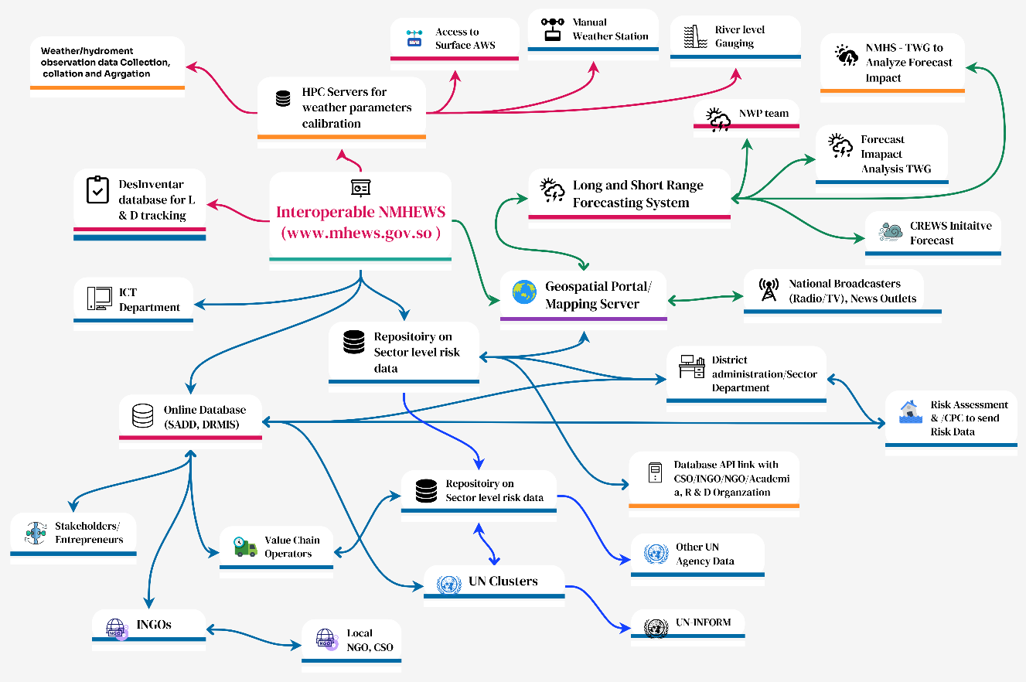

Figure 8: Diagram of proposed digital Partnership and Coordination with the Sector agency, INGOs, UN Agencies

3.3.2 Design and implementation of an Interoperability Online geospatial system:

To enable an interoperable NMHEWS in Somalia’s FCV context, a formalized “digital partnership” model is required to institutionalize routine data contribution, shared situational awareness, and coordinated decision-making across government, non-state actors, and last-mile stakeholders. This partnership should combine mandated participation, standardized workflows, and practical digital tools to support end-to-end early warning and impact-based forecasting.

Key actions and functional requirements

- Mandate routine data contribution and updates: Establish clear obligations for designated stakeholders and partners to submit risk, exposure, and incident information proactively and to update it at agreed frequencies (routine and event-based).
- Enable GIS-based impact interpretation across forecast lifecycles: Provide the ability to run repeated GIS map sessions at different forecast lead times (advisory > watch > warning > alert), including hotspot plotting, impact interpretation notes, and archival of map products and decisions for future reference and learning.
- Provide an online data communication and sharing facility: Implement a secure web-based platform (portal , APIs as applicable) to enable structured information exchange, controlled access, and timely dissemination of products and datasets.
- Deploy an operational dashboard for oversight and accountability: Establish a dashboard/control panel that enables continuous monitoring of stakeholder inputs and activities, including who submitted what information, when, where, and in what format, to strengthen coordination and reduce duplication.
- Support offline-to-online reporting for remote communities: Enable volunteers, smallholder farmers, and pastoralist/herder communities to capture reports offline (store-and-forward) and transmit them once mobile connectivity becomes available.
- Integrate crowdsourced incident intelligence: Configure the platform to ingest and triage crowd-sourced incident data from social networks and other open sources to enhance real-time situational awareness (with validation and confidence scoring mechanisms).
- Enable household-level georeferenced reporting: Provide simple mobile reporting tools that allow households to submit geotagged incident information (e.g., flood extent, damage indicators, access constraints) with time stamps and basic supporting details.
- Clarify roles and responsibilities for all partners: Ensure that each stakeholder understands and can operationalize their responsibilities across:
  - risk data capture and validation;
  - impact interpretation and technical briefings;
  - information updates/uploads; and
  - dissemination and feedback loops.
- Create an expert forum for knowledge exchange and peer support: Establish an online forum or community of practice where specialists and qualified contributors can share insights, best practices, and technical inputs related to multi-hazard monitoring, forecasting, and impacts (with moderation protocols).
- Institutionalize process-centric SOPs for one-stop information workflows: Develop and enforce SOPs covering risk information communication, input data access, GIS-based interpretation, approval workflows, and direct uploading/publishing to the platform enabling a streamlined “one-stop” operational model for impact-based forecasting and warning services.
- Provide consistent advisory support to responders and decision-makers: Ensure the system functions as a reliable and consistent source of advice and operational products for government and emergency responders, supporting civil contingency planning and disaster response decision-making.

3.4 : ICT Structures of Interoperable Online NMHEWS Platform:

Integrated ICT structures for an Impact-Based Forecasting (IBF) platform

An integrated Information and Communication Technology (ICT) architecture is required to operationalize an interoperable NMHEWS capable of delivering Impact-Based Forecasting (IBF) and supporting multi-stakeholder coordination in Somalia’s FCV context. The platform should enable end-to-end functions including: data acquisition and management, impact forecasting and analysis, partner coordination and data exchange, expert knowledge sharing, and integrated collaboration across government, non-state actors, and last-mile stakeholders.

ICT-enabled open-source GIS platform for end-to-end early warning

An ICT-enabled, open-source GIS-based platform is recommended to support:
- acquisition of weather and climate data through a hybrid observation system (Figure 18), including automatic stations, manual observations where required, remote sensing, and community/crowdsourced inputs;
- tracking and forecasting of extreme weather-induced multi-hazard incidents;
- impact analysis linking hazards to exposure and vulnerability layers; and
- delivery and dissemination of risk-classified, actionable climate information services to institutional users, sector actors, and climate frontline communities.

Figure 9.a): Diagram of ICT system structure and process for an interoperable MHEWS

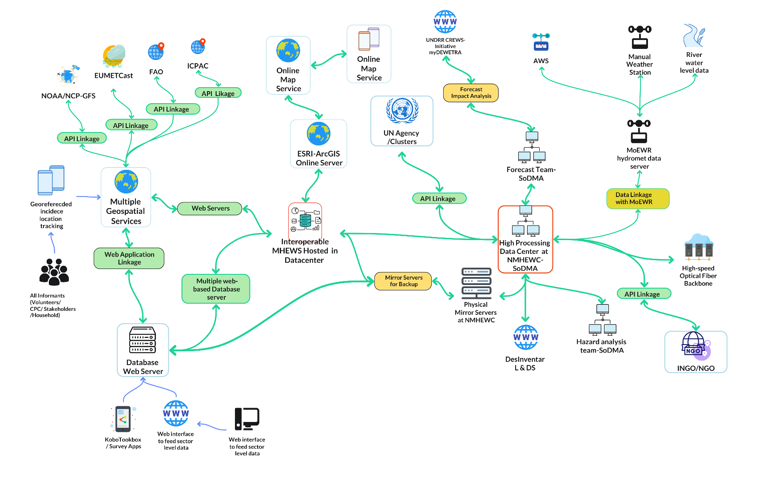

Figure 9.b): Diagram of ICT system structure and process for an interoperable MHEWS, Core structural components to be reflected in Figure 8 & 9:

- Data acquisition layer
  - AWS/manual observation feeds, hydrological gauges (where available)
  - Remote sensing and gridded datasets
  - Community/mobile reporting (Kobo/Survey123/QField)
  - Partner feeds (sector ministries, FAO/SWALIM, UN agencies)
- Data management and repository layer
  - Central RDBMS with geospatial capability (e.g., PostgreSQL/PostGIS)
  - Metadata standards, quality control, validation, and versioning
  - Role-based access and tiered disclosure (public/partner/restricted)
- Analytics and forecasting layer
  - Forecast ingestion (e.g., myDEWETRA outputs where applicable)
  - Nowcasting/monitoring dashboards
  - Impact analysis engine (hazard × exposure × vulnerability)
  - Verification and performance monitoring
- Operational workflow and coordination layer
  - Bulletin preparation and approval workflows (audit trails)
  - Incident/event management and 5W tasking/tracking
  - Partner coordination workspace and document repository (MoUs, SOPs)
- Dissemination and communication layer
  - CAP-compatible alert generation
  - Multi-channel dissemination gateway (SMS/Cell Broadcast/IVR/WhatsApp/Radio-TV integration)
  - Community feedback and reporting loops
- User interfaces
  - Web portal and GIS map services (institutional users)
  - Mobile apps for reporting and receiving alerts (last mile)
  - Public-facing dashboards and bulletins (risk communication)

3.5 Proposed capacity-building plan for technical experts :

UNDRR’s CREWS support has already initiated capacity building for relevant institutions as part of the EW4ALL operationalization process. In particular, Tabletop Exercise (TTX) training is being delivered to SoDMA NMHEWC technical staff to strengthen their ability to operationalize and assess Multi-Hazard Early Warning and Early Action Systems (EW-EAS), including decision-making workflows, coordination protocols, and response readiness.

Building on this foundation, additional capacity development should be extended to other relevant institutions and departments that contribute to end-to-end early warning, impact-based forecasting, dissemination, and preparedness/response. A structured Training of Trainers (ToT) programme is recommended to develop a sustainable national training cadre and to scale technical competencies across federal, member-state, and district levels. The ToT should focus on strengthening practical capabilities in Impact-Based Forecasting (IBF), multi-hazard risk information management, and operational use of the interoperable NMHEWS platform.

Proposed CREWS Initiative Training Participants

A multi-stakeholder training cohort is recommended to reflect the operational value chain of EW4ALL and NMHEWS, including:
- SoDMA / NMHEWC: forecasting operations, incident management, risk analysis, GIS, ICT, and risk communication staff
- NHMS / MoEWR hydromet technical working group: observation network, data management, forecasting and verification staff
- Sector ministries and departments (climate-vulnerable sectors): agriculture, livestock, water/WASH, health, fisheries, environment/planning units
- District-level administrations and CPC/DMC structures: DRM focal points and emergency coordination staff
- Key implementing and technical partners: UN agencies (e.g., UNDP, FAO, WFP) and select CSOs/INGOs supporting last-mile delivery and community-based early warning
- Private sector enabling partners (as applicable): mobile network operators, broadcasters, and technology service providers supporting dissemination and data services
- Academic/research institutions (as applicable): to support sustaining analytical skills, research linkages, and future workforce development

Sector Ministry /Department | Type of Staff | Type of Training
Ministry of Energy & Water Resources | - Hydrologists (2)  - Meteorologists (1)  - GIS &RS Expert (3)  - Water Resources | TOT/TTX
Ministry of Agriculture and Irrigation | - Technical Expert  - IT Expert  - Computer Programmer | TOT/TTX
Ministry of Livestock, Forestry, and Range | - IT/MIS Expert | TOT/TTX
Ministry of Health and Human Services | - District health information system (DHIS2) expert  - IT Expert | TOT/TTX
Ministry of Environment and Climate Change | - IT Expert | TOT/TTX
Ministry of Fisheries and Blue Economy | - Technical staff of the Department of Information & Technology | TOT/TTX
Ministry of Planning, Investment, and Economic Development | - Management Information System (MIS) Officer | TOT/TTX
National Communication Authority (NCA) | - ICT experts | TOT/TTX
FM Radio/Satellite TV Broadcasters/News Agency | - Weather Forecaster/Meteorologist  - IT Expert | TOT/TTX
FAO | - GIS Experts ( 5)  - Remote Sensing Experts (2)  - GNSS Surveyor (engineering survey) ( 2) | TOT/TTX
WFP | - GIS Experts  - Remote Sensing Experts | TOT/TTX
UNDP | - GIS Experts  - IT Expert | TOT/TTX
University, Academia, R&D organization | - Faculty member of hydrology, meteorology/geography, Water resource engineering/ civil engineering/ agriculture engineering, etc. | TOT/TTX

3.6 Implementation of Geospatial Platform ( Open-Source/ ESRI Licensed ) :

Impact-Based Forecasting (IBF) requires a practical, operational “digital relationship” among partners in which sector departments and authorized stakeholders can seamlessly access forecast products and translate them into sector- and element-specific impact insights. This can be achieved through a geospatial platform model that is interoperable, plug-and-play, and usable with both open-source GIS tools (e.g., QGIS) and ESRI-licensed tools (e.g., ArcGIS), depending on institutional capacity and licensing availability.

i) Functional paradigm: plug-and-play access to forecast and hazard data

The geospatial platform should enable stakeholders to directly access and visualize forecast and hazard datasets (preferably through standardized services and APIs) and to overlay them with sector-relevant layers to interpret potential impacts. Core functions include:
- Direct access to forecast layers (e.g., precipitation, temperature, wind, flood indicators, and other hazard parameters) through public or partner-access endpoints, as appropriate.
- Layer overlay and analysis using common formats such as CSV, GeoJSON, Shapefile, and GeoTIFF, and/or web services (WMS/WFS/tiles).
- Impact threshold analysis by applying sector-defined trigger thresholds and visualizing results through standardized alert categories (e.g., green/yellow/orange/red) and location-specific summaries.
- Element-specific impact interpretation, linking forecast intensity/duration/lead time to exposed elements such as water infrastructure, livestock, agriculture, land/soil management, critical infrastructure, and communications assets at appropriate spatial and temporal scales.

ii) Sector enablement: institutionalize geospatial use for risk-informed planning
Sector departments should be capacitated to routinely use the geospatial platform for:
- risk screening and project design (risk-informed planning and investment decisions);
- preparedness and anticipatory action planning (trigger setting, pre-positioning, targeted advisories); and
- post-event mapping and rapid impact assessment (situational awareness, RPDNA inputs, and response prioritization).

This requires not only software access but also standard operating workflows, minimum datasets, and sustained technical support.

iii) Technology approach: open-source Geospatial platform(QGIS), ESRI, where it adds value

A practical implementation model in Somalia’s FCV context is to adopt an open-source-first approach to maximize sustainability and reduce dependence on licensing, while enabling ESRI integration where it is already in use or adds operational value.
- Open-source baseline: QGIS for desktop analysis; PostGIS-enabled geodatabase; web mapping via OpenLayers/Leaflet; base layers via OpenStreetMap and Qfield feeds from the frontline where suitable.
- ESRI integration (optional/where available): ArcGIS Pro/ArcGIS Online/Survey123 integration for field workflows, structured mobile collection, and institutional environments already standardized on ESRI.

iv) Integrations and external services

Where beneficial, the platform can integrate third-party or external services (subject to applicable terms of use, cost, and connectivity constraints), including:
- satellite and remote sensing data API pipelines ( EUMETCast, IRI library, ECMWF, Google Earth, Google API) ;
- web map tile services (OpenStreet map, Google, Bing map; and
- cloud-based analysis services where feasible.

These should be implemented through controlled APIs and governance arrangements to avoid unmanaged dependencies and ensure continuity of service delivery.

v) Implementation requirements for “hassle-free” adoption

To make the platform operationally usable across institutions, the following are essential:
- Standardized data publishing: agreed naming conventions, metadata, update frequency, and quality control rules for forecast and risk layers.
- User access and tiered disclosure: clear rules on what is public, partner-only, and restricted (including audit trails for operational decisions).
- Pre-built map templates and sector dashboards: common symbology, threshold classes, and ready-to-use sector workspaces to reduce analytical burden.
- Training and SOPs: short, role-based training (QGIS basics, interpreting forecast layers, applying thresholds, exporting products) and SOPs for publishing and using outputs.

3.6.1 Component of Open-Source Geospatial Platform:
- Installation of a GeoNode Server

GeoNode is a web-based geospatial content management platform that enables institutions to create, manage, and publish GIS datasets and web maps through a browser-based interface. It supports the integrated management of spatial data, metadata, and map visualizations, and provides web mapping services that can be consumed by partner systems and desktop GIS applications.

Key functions and value for NMHEWS/IBF implementation include:

- Centralized map and data management: Upload, store, and manage spatial datasets (e.g., shapefiles, GeoJSON, GeoTIFF) and associated metadata within a single institutional platform.
- Web-based mapping services: Publish layers and maps as interoperable web services for use by sector departments and partners (e.g., for overlay analysis and impact interpretation).
- Controlled data sharing: Configure each dataset and map to be public or restricted to specific user groups (e.g., authorized partners and sector departments), supporting tiered disclosure aligned to data governance requirements.
- Collaboration features: User accounts and profiles, technical narratives/description fields, file upload workflows, commenting, and rating/feedback features can facilitate rapid input, peer review, and iterative improvement of map products.
- Operational support for IBF: By serving as the shared geospatial layer repository and visualization interface, GeoNode can enable stakeholders to access hazard/forecast layers and overlay sector exposure/vulnerability layers for impact-based analysis and decision support.

Implementation note (for operational readiness): GeoNode should be deployed with clear governance rules (roles, permissions, metadata standards, update frequency, and quality control procedures) and aligned to the NMHEWS data architecture (e.g., integration with the central geospatial database and the IBF workflow).

3.6.2 Installation of Geoserver for NMHS interoperability :

GeoServer is an open-source, Java-based geospatial server that publishes, manages, and serves spatial data through widely adopted interoperability standards. In an NMHEWS/IBF context, GeoServer reduces the financial barrier associated with proprietary GIS solutions while enabling standards-based data sharing and integration across government, partners, and last-mile applications to support interoperable National Meteorological and Hydrological Services (NMHS).

Key value and functions

- Creating role-based access to the NMHS Technical Working Group to analyze the forecast impacts, weather warnings, and alerts, and provide impact on elements with color-coded thresholds of impact level and advisories. NMHS TWG is responsible for analyzing forecast impact.
- GeoServer enables the NMHEWS/IBF platform to publish and share authoritative hazard, exposure, vulnerability, and impact layers through OGC standards (e.g., WMS), ensuring interoperable access for government, partners, and last-mile applications. It is cost-effective and sustainable because it is free and open-source, and it supports broad compatibility with common web and desktop GIS tools (e.g., OpenLayers/Leaflet, QGIS/ArcGIS). Role-based access should be configured so the NMHS Technical Working Group can securely analyze forecasts, generate color-coded impact thresholds, issue validated advisories, and publish approved warning and impact products for dissemination and decision-making.
NMHEWC installed GeoServer services can be integrated into common web and desktop GIS environments, including:
- Web mapping frameworks: OpenLayers, Leaflet (consuming GeoServer OGC services such as WMS/WFS/Web Map Tile Service).
- Basemap and visualization ecosystems: Google Earth/Google Maps, Bing Maps, and Mapbox, subject to licensing, API keys, and applicable usage terms.
- Desktop GIS tools: QGIS and ESRI ArcGIS (direct connections to GeoServer services for visualization, querying, and analysis).

Implementation note :

For operational deployment under NMHEWS, GeoServer can be configured with:
- standardized layer naming, metadata, symbology guidance, and update schedules;
- role-based access controls aligned to the NMHEWS data disclosure model (public/partner/restricted); and
- performance and reliability measures (caching/tiling where appropriate, backups, and monitoring) to support time-sensitive early warning operations.

Somalia’s national system will connect with regional and continental early warning networks to enhance data exchange and forecasting capability, including:

- WMO Global Telecommunication System (GTS) for global forecast data sharing.
- ECMWF forecast charts
- EUMETCast weather REST API data link
- CREWS West Africa and ECOWAS EWS platforms for regional forecast coordination.
- Space for Early Warning in Africa (SEWA) for satellite-derived hazard analysis.

Regional Hydromet Centres (ACMAD, AGRHYMET) for ensemble modeling and capacity support

3.6.3 Anchoring Opensource( Open street map) and Google mapping tools :

To expand analytical capability and public reach while keeping the core NMHEWS stack interoperable and sustainable, open-source geospatial tools-based mapping, Google’s mapping and alerting ecosystem can be integrated as optional external services. This should be implemented in a way that respects licensing/terms, minimizes recurrent costs, and avoids creating single-vendor dependencies.

a) Open-source baseline: OpenStreetMap as the default basemap

- Use OSM as the primary basemap for NMHEWS web maps and dashboards (via Leaflet/OpenLayers and GeoServer/GeoNode services) to keep the core platform vendor-neutral and low-cost.
- OSM provides the basemap context; the authoritative operational layers (warnings, hazards, exposure, impacts, L&D) are served from NMHEWS (GeoServer/GeoNode , geodatabase) and overlaid on top ensuring the NMHEWS remains the system of record.

b) Google Earth Engine (GEE) for satellite-derived risk and impact analytics
- Purpose: Generate satellite-derived indicators and event analytics that strengthen IBF and sector impact interpretation (e.g., vegetation condition, surface water extent, land cover, drought proxies).
- GEE provides a cloud-based geospatial analytics environment and large public imagery archives suitable for producing derived products (e.g., NDVI/vegetation stress, flood extent proxies, land cover classification) that can be exported as GeoTIFF/GeoJSON and anchored into the NMHEWS repository and map services.
- Licensing and sustainability: Noncommercial use is offered free of charge for eligible users (e.g., nonprofits/academia), while commercial/operational workloads may require a paid model (subscription/usage-based).

Recommended operational pattern:

- produce “decision layers” (e.g., pasture biomass condition, vegetation anomalies, flood extent snapshots, waterbody dynamics) on an agreed update schedule;
- publish outputs into the NMHEWS geospatial database and GeoServer as authoritative layers; and
- document methodologies and thresholds in the platform (metadata, technical notes) to ensure reproducibility and institutional learning.

3.6.4 Installation and Configuration of the interoperable Geospatial Platform, linking with maps and Surveying Apps.

- The online geospatial platform
The online geospatial platform should be designed as an interoperable “system-of-systems”, underpinned by a REST API-based data integration layer that enables routine, governed exchange of risk information with sector departments and external hydrometeorological providers. Specifically, the platform should:
- Integrate sector risk databases via REST APIs: Establish secure, role-based API connections with sector ministries/departments to ingest and synchronize exposure, vulnerability, asset registries, SADD datasets, incident/L&D records, and sector risk repositories into the NMHEWS geodatabase.
- Connect to global and regional hydromet data sources through standardized interfaces: Implement dedicated connectors to access satellite observations, weather charts, model guidance, and processed datasets from:
  - EUMETCast (through its applicable dissemination mechanism) and ECMWF (via available service interfaces and permitted data access pathways);
  - ICPAC and other African regional WMO DCPC hubs for regional outlooks, advisories, and complementary forecast guidance; and
  - Transboundary hydromet services (e.g., upstream riparian countries) to support flood- and rainfall-relevant information exchange and coordinated forecasting.
- Use an integration architecture that supports multiple feed types: While REST APIs should be the default, the platform should also support adapters for other common delivery modalities (e.g., file feeds, scheduled pulls, push mechanisms) to accommodate provider constraints and FCV connectivity realities.

This interoperability design will allow NMHEWS to consolidate authoritative sector risk data and external hydromet products into a single operational picture, enabling impact-based forecasting, warning dissemination, and anticipatory action planning across institutions and administrative levels.

- Open Layer:

OpenLayers can be used to build interactive web GIS applications for the NMHEWS/IBF platform, enabling users to view, edit, and interact with geospatial layers in a browser and supporting map-based reporting, visualization, and dissemination of hazard and impact information.

In an FCV context, OpenLayers can strengthen field-to-platform reporting by enabling local volunteers and surveyors to capture and share georeferenced observations and impacts. When combined with mobile data collection tools (e.g., QField, Survey123, KoboToolbox/ODK) and simple messaging channels (e.g., WhatsApp), local informants can submit location-tagged information for rapid validation and impact analysis.
Key operational uses include:
- On-the-fly mapping and georeferenced reporting: Volunteers can capture locations and basic attributes, attach photos, and record geolocation placemarks for ingestion into the NMHEWS geospatial repository and publication through GeoServer services.
- Multi-feature capture: Field tools can record points (e.g., houses, water points, health facilities, IDP sites), lines (e.g., road networks, access routes, river cross-sections), and polygons (e.g., grazing/pasture areas, inundation footprints, affected settlements, cultivable forage zones).
- Standard exchange formats: Captured data can be exported in common GIS formats (e.g., GeoJSON, Shapefile, and, where relevant, KML/KMZ) and uploaded or synchronized to the central platform for analysis and map production.

Local-level workflow for impact analysis and planning: Sector department technical teams can task local volunteers to submit georeferenced evidence such as IDP/settlement locations, herder grazing areas, and hazard-affected sites (e.g., flood/flash flood incidence points) with geo-tagged photos through customized mobile apps or simple channels (survey apps, WhatsApp, or controlled file submission workflows). These inputs can then support:
  - impact analysis and hotspot mapping;
  - anticipatory action planning and trigger refinement;
  - contingency planning and evacuation advisories; and
  - response financing decisions and rapid assessment processes.

3.6.5 Deploying Web based data sharing platform with apps :

A web-based data sharing platform integrated with mobile applications should be deployed to operationalize end-to-end warning issuance, impact-based mapping, and multi-channel dissemination. A key requirement is a CAP-enabled alerting workflow, where each alert is created as a standardized Common Alerting Protocol (CAP) message, linked to a defined geographic area and validated thresholds, and then published for dissemination and partner consumption.

Core functional requirements :

- CAP authoring and publishing: Enable authorized users (NMHEWC/SoDMA and designated partners) to create CAP alerts containing hazard type, severity/urgency/certainty, protective actions, and validity windows, and to publish alerts as a structured feed for downstream systems.
- Geographic targeting (points and polygons): Support location-based alerting by associating CAP alerts with affected areas (e.g., point locations and polygon footprints) and visualizing them on the operational map interface for hotspot and impact zone interpretation.
- Map-based impact threshold visualization: Provide a GIS interface that overlays hazard parameters and sector exposure layers, presenting color-coded threshold zones (e.g., green/yellow/orange/red) with short technical briefings to support impact interpretation and decision-making (IBF).
- Mobile reporting and feedback loop: Integrate mobile apps (online/offline) for community reporting and validation (incident/L&D, observations, impacts) and link these inputs to the same operational dashboard to improve situational awareness and support trigger refinement for anticipatory action.
- Multi-channel dissemination gateway: Disseminate CAP-derived warnings via SMS/Cell Broadcast/IVR/WhatsApp and broadcasters, while maintaining audit trails (who approved, when issued, where targeted, which channels delivered).

Tooling options :

Open-source CAP authoring tools: CAP editors can be deployed to support standardized alert creation and publishing as web feeds, with authentication and an alert archive.
- Google Public Alerts (optional external channel): Google provides an integration pathway for partner organizations that publish CAP feeds, with Google-specific CAP requirements and onboarding guidance. This should be treated as an augmenting distribution channel, not a primary dependency for national warning delivery.
- ESRI-enabled environments (where licensed): ArcGIS ecosystems can consume, visualize, and operationalize CAP feeds and alert layers (e.g., CAP alert feed layers), which can complement open-source services where ESRI licenses already exist.
- Implementation note for governance: CAP publishing should be restricted to designated alerting authorities, with SOPs for thresholds, approvals, and message templates, and with clear rules for what is public versus partner-restricted ensuring consistency, accountability, and operational integrity.

3.6.6 Implementing Web converting common alerting protocol (CAP )apps :

Several tools are available for developing CAP by marking the location of multi-hazards with thresholds of impact (in both point and polygon shape files) that can be plotted on the map, along with a technical briefing on color-coded thresholds overlaid on the map. The CAP-enabled emergency alerting system, e.g., Customized CAP alerts being generated by a national CAP aggregator, Google Public Alerts freeware, paid service like ESRI ArcGIS platform, etc.

    - CAP-based public alerting

Purpose: Standardize alert messages for multi-channel dissemination and, where feasible, extend reach through additional digital channels.

- The NMHEWS alerting engine should generate CAP (Common Alerting Protocol) messages as the standard alert object for interoperability across channels and partners. CAP is an internationally used format for exchanging all-hazard alerts. The NMHEWS design should treat this as an enhancement channel, not the primary dissemination mechanism, so national broadcasters, telecom dissemination (SMS/Cell Broadcast/IVR), and community-based channels remain reliable even if external platform integration is delayed or unavailable.

1.a) Activation of CAP Aggregator Services :

The NCA should manage and regulate cell phone operators’ CAP Aggregator services as a centralized national capability to trigger and distribute alerts. The CAP Aggregator will collect CAP v1.2 alerts from multiple authorized sources, validate them, standardize and de-duplicate content, and republish alerts as a single trusted national feed for dissemination and decision-making.

Functions: ingestion (pull/push from issuers), validation (CAP compliance and policy rules), normalization (taxonomy, language, geocodes), de-duplication (avoid repeated/conflicting alerts), lifecycle control (update/cancel handling), and publishing (CAP XML, RSS/Atom, REST APIs, webhooks, GIS layers).

In the Somalia NMHEWS context, the aggregator enables one authoritative alert stream that can be reliably consumed by telecom operators (SMS/IVR/cell broadcast/USSD), broadcasters (radio/TV), government/UN partners, and the NMHEWS geospatial portal, improving speed, consistency, and accountability in last-mile warning dissemination.

1.b) Activation of CAP Aggregator Services:

Google Public Alerts on the Google platform to disseminate emergency messages and can integrate with Google services (e.g., Search, Maps, and notifications). Google provides guidance for registered clients on creating and sharing CAP feeds, including CAP-specific requirements and integration steps. In Somalia, a Google Cloud-based CAP alert service and CAP Hub can be configured and linked to the national CAP Aggregator to enable location-based CAP alerts to be distributed to affected settlements and populations in impacted areas.

3.7 Rationale of ICT-integrated Interoperable Online NMHEWS platform to support impact-based forecast (IBF):

The core rationale for an ICT-integrated, interoperable NMHEWS is to enable Impact-Based Forecasting (IBF), a shift from conventional forecasting that describes what the weather will be to operational forecasting that explains what the weather will do and how it will affect people, livelihoods, assets, and services on the ground.

A fully functional IBF platform can ingest weather and climate inputs and process them through an ICT-engineered system that integrates hazard information with exposure and vulnerability data. This enables the system to generate actionable advisories, quantify likely impacts, and assess the severity of impending risks and vulnerabilities, including anticipatory Loss and Damage (L&D) scenarios. By producing these outputs at higher spatial and temporal resolutions, the platform supports vulnerable sectors, critical elements, and climate frontline communities in translating forecasts into preparedness, anticipatory action, and response decisions.

- Installation of a ground-level hybrid observation mechanism

Given the operational requirements of an Impact-Based Forecasting (IBF) system capturing diverse impact information from the ground, processing large and heterogeneous datasets, enabling broad stakeholder participation, and keeping target audiences continuously informed the IBF platform must be tightly integrated with a ground-level hybrid observation mechanism (Figure 18). This hybrid mechanism should combine automated and community-based observation streams and be operationalized through structured engagement of frontline communities, sector technical experts working at the last mile, trained volunteers, and SoDMA-designated technical and volunteer teams.

An ICT-enabled MHEWS IBF platform can then deploy and activate crowdsourced observation mechanisms to strengthen spatial coverage and resolution of ground-level parameters and to better characterize extreme weather conditions as they unfold. By integrating these observations with formal datasets (e.g., AWS and manual station data), the platform can improve impact analysis and generate more detailed risk scenarios such as identifying which elements are being affected, where, and at what severity levels thereby enabling more precise advisories, anticipatory action triggers, and targeted preparedness and response measures.

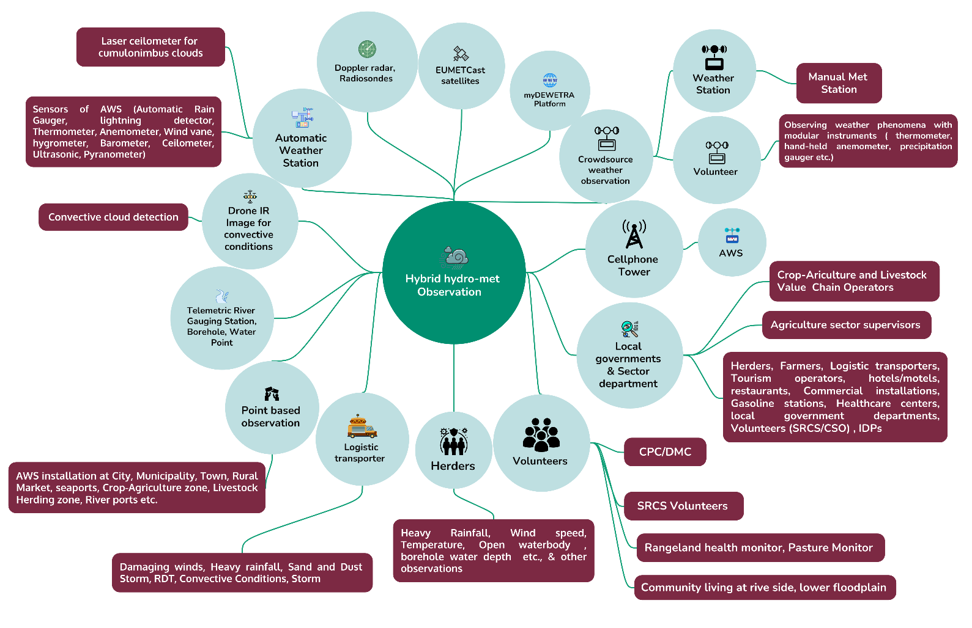
Figure 10 (Proposed hybrid observation mechanism) should illustrate how automated sensors and structured community reporting streams converge into the NMHEWS platform to support nowcasting, IBF product generation, and multi-channel dissemination.

b) Weather-induced risk and vulnerability tracking, interpretation, and dissemination:

A hybrid surface observation mechanism (Figure 10) integrating AWS, manual meteorological stations, and crowdsourced observations provides a more comprehensive basis for monitoring weather patterns and identifying extremes, including their frequency, intensity, and spatial distribution. Building on these observation streams, the NMHEWS IBF platform should operationalize routine analytical products that translate observed and forecast conditions into actionable risk information.

Specifically, the system should generate weekly, monthly, sub-seasonal, and seasonal anomaly analyses and link these to the incidence and evolution of multi-hazard events. These outputs should be translated into GIS map-based analyses (e.g., anomaly maps, hotspot maps, exposure overlays, sector impact zones) and disseminated through the online geospatial portal to ensure that national and subnational planning desks remain continuously informed.

This capability is essential for planning and coordination at all levels. It enables diverse user groups government planners, sector departments, humanitarian actors, and private sector stakeholders to understand weather trends and extremes in a consistent and evidence-based manner. Such understanding supports the development and refinement of SOPs, preparedness measures, and business continuity plans, and informs seasonal planning and resource allocation for the next season or year.

c)multi-hazard and disaster incident and situation tracking and archive:

Impact-Based Forecasting (IBF) requires a systematic track record of how hazardous weather phenomena evolve into multi-hazard events and disasters, and how these translate into observed impacts, including Loss and Damage (L&D). The interoperable NMHEWS platform should therefore establish an incident and impact archive that captures, for each event, the full operational sequence forecast signals, warning products, observed conditions, reported impacts, response actions, and post-event outcomes.

Key functions include:
- Incident and situation tracking: Maintain a structured, georeferenced log of multi-hazard incidents and evolving event situations, including hazard footprints, affected locations, disruption of services, displacement, and priority needs.
- L&D information capture and consolidation: Record and update L&D information during and after events using standardized categories and validation workflows so that the data can support rapid assessment (RPDNA) and longer-term PDNA processes.
- Forecast-observation interpretation linkage: Archive and disseminate forecasting products (daily forecasts, outlooks, advisories, warnings) alongside comparable interpretation of observed weather and impacts, enabling learning and iterative improvement of thresholds and messages.
- Evidence base for climatology and climate change analysis: Over time, the incident archive combined with systematic surface observations and relevant global and regional model outputs provides the analytical foundation for developing annual climatologies, trend analyses, and climate change narratives, supported by comprehensive technical reports and sector-relevant summaries.

This incident-to-impact archive strengthens operational accountability, supports forecast verification and improvement, and enables evidence-based planning and investment for risk reduction and resilience-building.

d)Scope of verification and retrofitting, and correctness of the Dynamical downscaling model:

Comprehensive ground-level observations combined with element-level impacts, sectoral impacts, and Loss and Damage (L&D) scenarios provide the empirical evidence required to assess model fitness, conduct forecast verification, and implement bias correction. By systematically linking observed weather phenomena to documented impacts, the NMHEWS-IBF platform can strengthen verification practices and support continuous improvement of forecasting products and impact thresholds.
Over time, these datasets also enable the development and refinement of higher-resolution modeling approaches, including:

- statistical downscaling and bias-adjusted products that improve spatial and temporal resolution; and
- high-resolution dynamical downscaling to better represent rapidly evolving weather systems.

This is particularly relevant for high-impact, fast-developing hazards that are frequently associated with loss of life and livestock in Somalia, including sand and dust storms, heatwaves, dry spells, and convective events (e.g., heavy rainfall, thunderstorms, hailstorms, lightning, and severe winds). By strengthening verification and downscaling capability for these hazard types, the system improves the accuracy and usefulness of impact forecasts and supports more reliable anticipatory action and preparedness planning.

e) Effective risk communication and sectoral coordination:
Effective risk communication and sectoral coordination should be leveraged to institutionalize a culture of compliance in which mandated stakeholders routinely interact with the NMHEWS platform to contribute risk and vulnerability data, interpret forecast impacts, and exchange information in a structured and timely manner. This requires standardized communication workflows and clear accountability mechanisms so that all relevant actors consistently (i) provide required data inputs, (ii) translate each forecast into sector- and locality-specific risk interpretations, and (iii) coordinate the dissemination of risk information and the activation of preparedness and response actions across sectors and administrative levels.

3.8 Improving Risk Knowledge of stakeholders

Somalia’s fragmented governance landscape, complex multi-hazard risk profile, climate impacts, and conflict dynamics combined with climate- and shock-induced internal displacement create multi-layered risks and vulnerabilities for last-mile populations, particularly in relation to food security and livelihoods. The climate frontline population is predominantly agropastoral and is therefore highly sensitive to extreme weather events. However, frontline communities continue to face limited access to timely and actionable climate and early warning information.

Within this FCV context, ICT-enabled disaster risk governance provides a practical pathway to bridge institutional and geographic service delivery gaps. By directly connecting early warning services to the climate frontline, communities can be engaged as key informants to provide structured, georeferenced information on multi-hazard exposure, risk, vulnerability, and impacts. This two-way information exchange increases risk perception, strengthens situational awareness, and enables communities to take appropriate anticipatory and crisis management actions. The field assessment further identified that DRM service delivery remains largely siloed across actors and institutions, while CSOs continue to function as the principal last-mile implementers reinforcing the need for harmonized mechanisms that link community-generated information with national and sectoral early warning and planning systems.

Options to bridge last-mile multi-hazard risk knowledge gaps
- Deploy MHEWS-connected interactive mobile tools: Implement ICT-enabled mobile applications for two-way engagement with last-mile communities, including GPS-enabled survey tools, KoboToolbox/ODK workflows, and GIS-based survey applications integrated with the MHEWS platform.
- Conduct app-based exposure, risk, and vulnerability assessments: Use mobile workflows to support routine and event-based assessments of climate exposure, risk, and vulnerability, ensuring standardized variables, georeferenced reporting, and quality control.
- Enable app-based VAC and RPDNA processes: Develop mobile modules for vulnerability and capacity assessment (VAC), actor mapping, and Rapid Post-Disaster Needs Assessment (RPDNA) data collection to strengthen preparedness, response prioritization, and early recovery planning.
- Develop sector-specific tools for crop agriculture: Establish a crop-agriculture mobile application that enables farmers, as primary informants, to report georeferenced element-specific data standing crops, water availability and stress, rainfall variability, crop losses, yields, pest outbreaks, market prices, and Loss & Damage (L&D). The same channel should provide farmers with classified, actionable advisories to support risk management and resilience-building.
- Strengthen national broadcasting for risk knowledge and preparedness: Improve the reach, frequency, and quality of national and local broadcasting (radio/TV and allied channels) to reinforce disaster risk knowledge, early warning interpretation, preparedness actions, response guidance, recovery support, and emergency evacuation information, aligned with standardized warning messages and locally relevant protective actions.

3.9 Improving Risk Knowledge of Sector Value Chain Operators:

Improving risk knowledge among sector value chain operators (e.g., producers, traders, aggregators, transporters, input suppliers, market actors, and service providers) requires a governance shift toward an ICT-enabled model that institutionalizes risk information management, strengthens coordination, and translates forecasts and risk assessments into actionable guidance for economic and livelihood systems. The following constraints identified through the assessment justify this transition:
- Limited institutional risk information management capacity: State actors particularly those responsible for planning and development coordination (e.g., MoPIED) have limited ICT-enabled capacity to manage risk knowledge, facilitate inter-sector coordination, and establish functional partnerships for climate and multi-hazard information sharing. Institutional mechanisms for systematic risk information inventorying (MIS) are either absent or underdeveloped.
- Weak information management systems and enabling resources: Poor information management practices, inadequate staffing patterns, limited ICT equipment, and lack of operational MIS tools constrain the ability to inventory exposed elements and track hazard impacts across sectors and geographic areas.
- Insufficient post-disaster assessment quality and georeferenced impact data: Post-disaster Loss and Damage (L&D) assessments are often conducted through temporary enumerators and ad hoc arrangements, with limited standardized tools, methodologies, and processes. Element-specific, georeferenced impact information is not consistently captured, limiting the evidence required to improve impact-based forecasting and to refine triggers for anticipatory action.
- Need for formalized digital coordination across government, non-state, and private actors: Establishing structured digital coordination and partnerships among state institutions, non-state actors, and the private sector is critical to enable last-mile risk information management and to develop tailored planning tools that support DRR/CCA scheme design and implementation.
- Accountability gaps for broadcasters and telecom operators: Existing MoUs and mandates governing private broadcasters and telephone companies lack a clear accountability framework for early warning dissemination. While the National Communications Authority (NCA) has a regulatory role, enforcement mechanisms and performance obligations (e.g., routine forecast broadcasting, emergency bulletins, warning message dissemination, and reporting) remain insufficiently defined and operationalized.
- Absence of risk-informed decision-support tools and fiscal accountability: There is limited availability and use of risk-informed, evidence-based tools that can strengthen policy implementation, clarify mandates, improve institutional accountability, and support mobilization and allocation of fiscal resources for last-mile climate-resilient development, including DRR, CCA, and Nature-based Solutions (NbS).
- Over-reliance on humanitarian assistance and limited investment incentives: Government reliance on humanitarian assistance (e.g., food support) is not matched by adequate budgetary incentives or predictable financing to implement climate-adaptive livelihood interventions for frontline communities, reducing the capacity to shift from response to resilience-building.

3.10 The following are the recommendations for Disaster Risk Knowledge Management Governance

The proposed online MHEWS platform should be adopted as the core mechanism for strengthening disaster risk knowledge management governance in Somalia. The platform is designed with multifaceted, multi-user, and multi-tasking capability, enabling stakeholders to work remotely and to contribute data, information, and operational updates on a routine and event-driven basis. This functionality is critical in an FCV context where physical access, institutional fragmentation, and coordination constraints routinely disrupt traditional information flows.
By institutionalizing a shared digital environment, the system will support the development and maintenance of a multi-hazard risk repository and a structured risk knowledge bank. These are foundational prerequisites for operationalizing EW4ALL pillar actions particularly Pillar 1 (risk knowledge) and the cross-pillar functions that depend on reliable information exchange, traceability, and coordinated task management. In practical terms, the platform will help Somalia address persistent institutional barriers related to tasking, monitoring, accountability, and coordinated service delivery by providing a common operational picture and standard workflows for risk information capture, validation, interpretation, and dissemination.
.
a) Improving data-driven decision-making

Climate-vulnerable sector ministries including MoHADM/SoDMA, MoEWR, MoAI, MoLFR, MoH, and MoFBE should establish a National Climate Risk and Vulnerability Assessment Committee (VAC)/Task Force composed of sector technical experts and key partners, with representation from CPC/DMC structures and frontline communities. This body should serve as the national mechanism for harmonizing methodologies, setting minimum datasets, quality-assuring outputs, and coordinating the production and use of climate and multi-hazard risk information.

A national consensus framework is required among state actors, humanitarian partners, UN agencies, INGOs, local NGOs, and CSOs to standardize climate and multi-hazard risk assessment processes and to strengthen ownership of locally sourced data collection and dissemination. The interoperable ICT platform including the online database, mobile applications, and operational workflows should function as a national data backbone that enables routine submission, validation, and use of risk data. Where appropriate, it can also support a statistical data clearinghouse function to enable census-style surveys and systematic collection of sex-, age-, and disability-disaggregated (SADD) data at household and community levels, subject to applicable governance, safeguarding, and privacy protocols.

b) Mandating accountability for disaggregated risk datasets and repository development (revised)
A roadmap should be adopted to formalize institutional and stakeholder accountability for collecting and maintaining disaggregated climate risk and vulnerability datasets across priority sectors, including agriculture, water, livestock, fisheries, agroforestry, WASH, health, physical infrastructure and communications, municipalities and urban centers, commercial hubs, IDP sites, human settlements, and housing. These datasets are required to develop climate and multi-hazard risk maps, conduct risk and vulnerability profiling, and build and sustain national and sectoral risk repositories.

To strengthen coherence and reduce duplication, the roadmap should also align with humanitarian coordination mechanisms (including the UN cluster system) so that partner-generated data and assessments contribute systematically to government disaster risk management and development frameworks, support state-led humanitarian action, and reinforce a unified national risk management coordination framework.
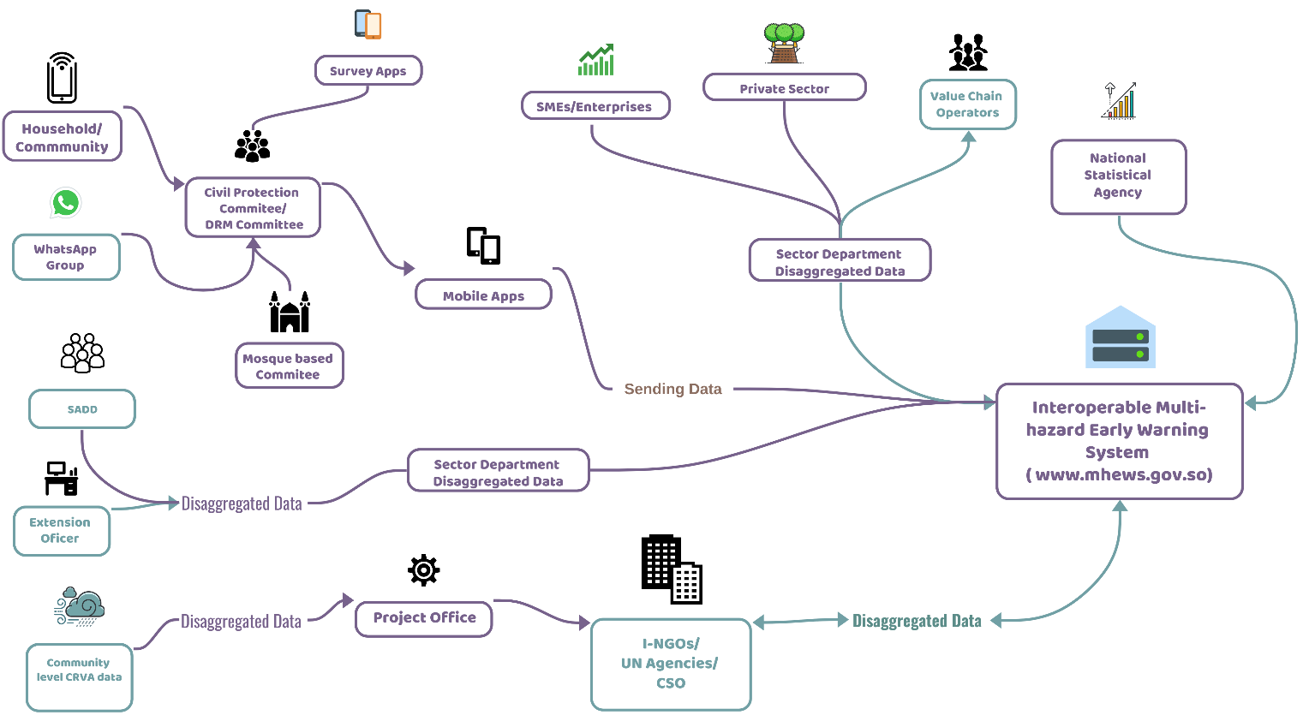

Figure 11: Disaggregated data collection framework for the collection of Age, sex, and disability disaggregated data(SADD) , sector-level elements specific attribute data ( Source: Z M Sajjadul Islam)

1) Establish digital partnerships and coordination mechanisms
- The interoperable NMHEWS/MHEWS platform should be used to formalize digital partnerships and strengthen coordination across state institutions, humanitarian partners, CSOs, and the private sector. By enabling routine data submission, traceability, and shared situational awareness, the platform will improve accountability for conducting multi-hazard risk assessments and managing risk knowledge at national and local levels. It should also serve as a common operational environment for RPDNA/PDNA processes and for continuous risk knowledge management.
- To operationalize this, Somalia should establish a clear consensus and agreement framework among state actors, humanitarian actors, UN agencies, INGO and local NGO consortia, and CSOs on: (i) risk assessment methodologies and minimum datasets; (ii) locally sourced climate and hazard data collection protocols; (iii) validation and quality assurance procedures; and (iv) data-sharing and disclosure arrangements.
2) Develop a GIS-based risk atlas and geospatial database
- Climate-vulnerable sector departments should coordinate and standardize essential inputs to develop:
- a national geospatial risk database (hazard, exposure, vulnerability, impacts);
- district-level GIS layers and operational maps; and
- a consolidated risk atlas to support multi-hazard risk and vulnerability analysis and the development of decision-support tools for preparedness, anticipatory action, and humanitarian response planning.
- This should include the establishment of a structured hazard database and agreed symbology/threshold classes to ensure consistency across sectors and locations.
3) Establish MIS and GIS capability at district and sector levels
- Install and operationalize MIS and GIS capacity within district administrations and sector departments to enable routine analysis and use of multi-hazard risk information for local planning and response. This should include minimum hardware/software, connectivity arrangements, user roles, and SOPs so that districts can:
- access and interpret hazard/forecast products;
- maintain district-level risk profiles and priority asset registries; and
- produce and use GIS-based informed tools for preparedness, response, and early recovery planning.
4) Establish the Climate Risk and Vulnerability Assessment Committee (RVAC/VAC)
- A Climate Risk and Vulnerability Assessment Committee (RVAC/VAC) should be established urgently as the national coordinating body for risk assessment and risk knowledge governance. The committee should include representatives from relevant ministries and departments, humanitarian partners, UN agencies, INGOs, local NGOs, CSOs, and appropriate local governance structures.
- The online database and mobile applications should be used to manage RVAC operations and workflows, including tasking, document repositories, map products, and approval processes. Frontline representative groups smallholder farmers, fishers, herders, IDPs, and other livelihood groups should be institutionalized as primary informants, contributing element-specific, georeferenced information through customized survey applications (e.g., KoboToolbox), consistent with a community-level climate and multi-hazard risk and vulnerability assessment framework that can be implemented remotely when required.

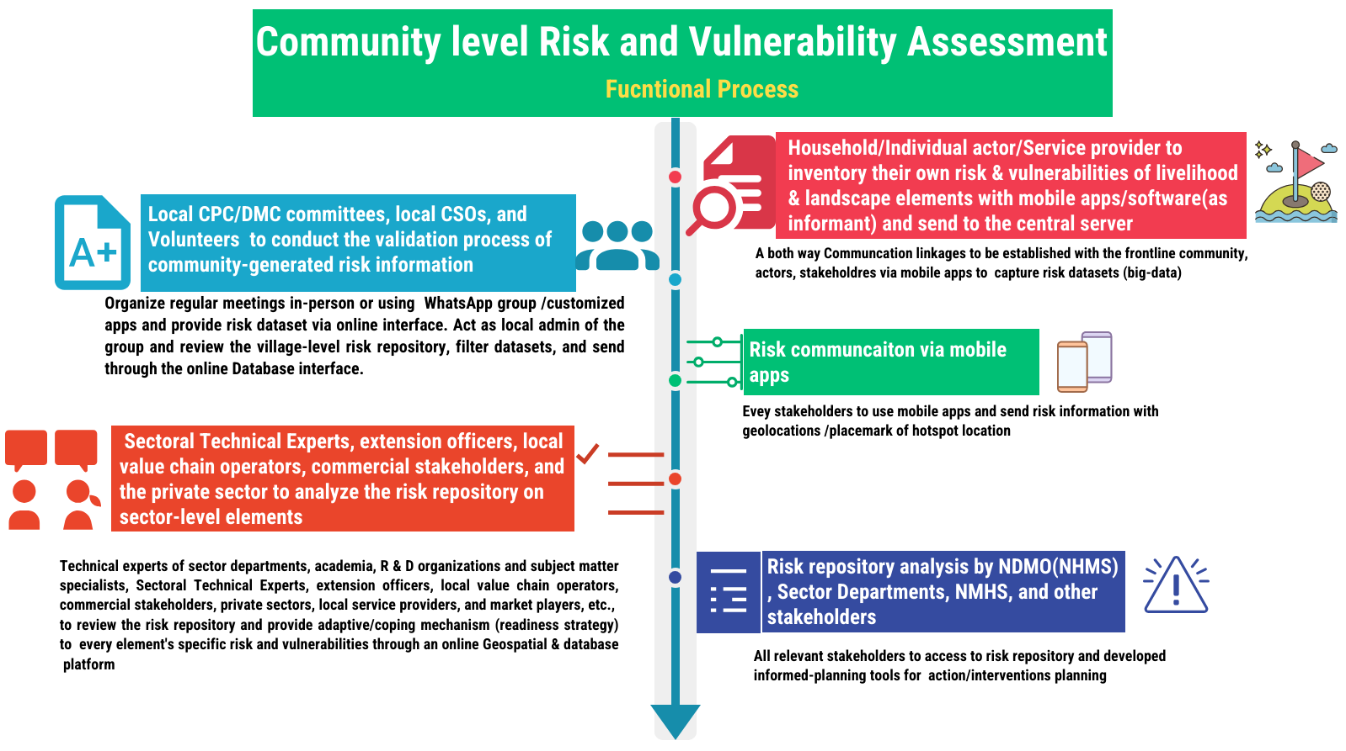
Figure 12: Remotely conducting - Community Risk Assessment Framework (for Somalia FCV context) - which is to be undertaken by the frontline community/local stakeholders (Source: Z M Sajjadul Islam )

Table: Tools to facilitate the RVAC team to conduct the assessment

Element-specific dataset | Mapping Supports | Technical Training Support to RVAC | Local CPC at the City, Municipality, and community level | Areas of Assessment
Sector-specific elements | - UN Agencies  Technical assistance, data/products sharing, anticipatory action, humanitarian coordination, capacity building.  - International NGOs (INGOs)  Last-mile implementation support, community engagement, risk communication support, rapid assessments, field reporting.  - Local governance structures (City Corporations, Municipalities, District Administrations, and community/clan-based structures as applicable)  Local coordination, preparedness planning, community-based early warning, verification of incidents/impacts, support to CPC/DMC functions.  - Sub-national government sector departments  Sector-specific exposure/vulnerability data, risk assessments, service disruption reporting, sector advisories and response actions.  - Universities and students  Data collection support (surveys, mapping), analytics, field validation, research and innovation support, surge capacity.  - Commercial entrepreneurs and value chain operators  Market and logistics disruption reporting, commodity price signals, service continuity planning, private-sector early action.  - Telecommunications companies  Dissemination channels (SMS/Cell Broadcast/IVR), connectivity support, platform integration, operational MoUs and service-level arrangements.  - Colleges and TVET institutions  Skills development pipeline for GIS/ICT, support for community outreach, technical field support.  - Local IT companies  Platform development and maintenance, integrations, hosting/operations support, user support and training.  - IT experts working with CSOs  Field deployment support, app configuration, training, troubleshooting, community reporting enablement.  - Other relevant agencies/actors  Broadcasters/media houses; private data providers; research organizations; national regulatory bodies (e.g., communications); and specialized technical partners supporting observation, forecasting, and risk communication. | - • OpenStreetMap (OSM) community mapping training participants  Target trainees for technical training on online community mapping using OpenStreetMap (OSM) to strengthen baseline geospatial datasets, exposure mapping, and last-mile data capture.  - Somali diaspora technical expert pool (remote support)  Establish a roster of Somali technical experts residing in the USA, Canada, Europe, and other locations to provide remote surge support for data analysis, model/product interpretation, quality assurance, mentoring, and specialized troubleshooting.  - Sector and academic GIS specialists  GIS specialists and analysts from sector departments, universities, and colleges (including faculty members and qualified individual experts) to support sector risk layers, exposure/vulnerability mapping, and impact interpretation workflows.  - Local IT companies (implementation and O&M support)  Local technology firms to provide platform development support, system integration, hosting/operations, user support, and ongoing maintenance of the NMHEWS/IBF digital ecosystem.  - UN agencies’ IT/GIS experts  Technical staff from UN agencies to support interoperability, data standards, platform configuration, remote sensing products, and capacity building aligned to EW4ALL pillars.  - INGO IT/GIS experts  INGO technical teams to support last-mile tool deployment (mobile apps, reporting workflows), field training, rapid assessments, and integration of partner datasets into the platform.  - CSO IT/GIS experts  CSO technical staff to support community mapping, grassroots reporting enablement, local validation, and sustained community-level use of digital tools. | CPC/DMC structures at city, municipality, and community levels should be systematically engaged as frontline facilitators to support community-driven inventorying of key elements related to livelihood security, food security, and the built environment. Using standardized, mobile-enabled tools (e.g., KoboToolbox/ODK, GPS-enabled survey applications, and simple GIS mapping workflows), CPC/DMC teams can coordinate household- and community-level mapping and data collection to document:  - Livelihood and food security elements: crops, grazing/rangeland areas, livestock assets, water points, markets and supply routes, storage facilities, and livelihood service nodes.  - Built environment and critical services: housing and shelters, schools, health facilities, WASH infrastructure, roads/bridges, power/telecom assets, and other lifeline infrastructure.  - Exposure and vulnerability attributes: hazard-prone locations, seasonal risk patterns, displacement/IDP concentrations, and priority needs indicators (including SADD where applicable).  This structured inventory provides the baseline datasets required for localized risk profiling, impact-based forecasting interpretation, preparedness and anticipatory action planning, and rapid post-event assessment at the last mile. | - MIRA,  - RPDNA  - PDNA  - DINA, Community  - CRVA,  - Sector level CRCV

3.11 Review Stakeholder Partnership & Coordination Mechanism

Full-scale implementation of EW4ALL pillar actions requires strong coordination and service delivery capacities to ensure that sector ministries and sector-engaged stakeholders remain connected to the system and that services are delivered in a demand-driven and operationally reliable manner. From an engineering perspective, the MHEWS platform must be designed as an ICT-enabled, robust architecture that ensures optimal operability, interfaces with multiple information sources, and enforces accountability through standardized processes and traceable workflows. The Impact-Based Forecasting (IBF) function, in particular, performs optimally when it is supported by interactive nationwide partnerships that enable sector-specific interpretation of hazardous weather parameters against exposed sectoral elements. Accordingly, the platform should leverage interoperability and digital partnerships among national meteorological and hydrological services (NMHS) entities, sector departments, research and development organizations, technical specialists, academia, mandated partners, commercial stakeholders and value chain operators, herders, and vulnerable communities so that IBF products are generated and disseminated in a timely and actionable manner.

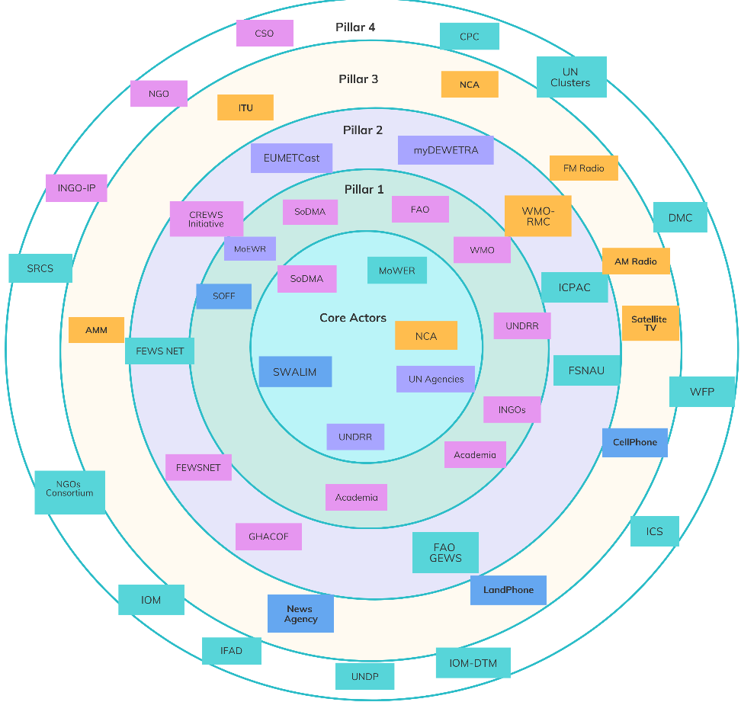

Figure 13: Stakeholder map (Proposed)

Figure 13 (Proposed Stakeholder Map) should therefore be operationalized through a set of Standard Operating Procedures (SOPs) that mandate a proactive, time-critical partnership and collaboration among key technical partners and agencies engaged in meteorology, climatology, hydrology, disaster risk management, and local government functions. This includes pre-disaster risk assessment groups, post-disaster damage, loss, and needs assessment (PDNA) teams, disaster first responders, and representative community groups (including herders and other livelihood groups). By establishing shared procedures and minimum obligations, the IBF system can promote a functional partnership model in which stakeholders access and contribute to the platform with a sense of ownership. This, in turn, enables tailored weather and climate information services aligned to MHEWS operational requirements, supports informed tool development, and strengthens deliverables for climate risk management and disaster emergency operations.

The IBF process relies on a multifaceted, interactive, routine, and proactive coordination mechanism among stakeholders, supported by formal data-sharing protocols that define minimum datasets, submission frequency, access rules, and validation responsibilities. To institutionalize this model, the MHEWS should classify stakeholder categories and assign clear roles for (i) coordinating risk information, (ii) interpreting forecast implications and sectoral impacts, (iii) assessing impending impacts during hazard onset, and (iv) managing risks and vulnerabilities associated with hazard-induced disasters.

SOPs should govern both operational and technical components to ensure coordinated action across disciplines during emergencies. These procedures promote a uniform and standardized response by clarifying decision points, thresholds, communication pathways, and responsibilities for warning issuance, dissemination, early action activation, and incident tracking. SOPs should be aligned with applicable legislative and regulatory frameworks and should be consistent with national and subnational DRM policies and plans to ensure enforceability, accountability, and continuity of operations

3.12 Partnership for Data Coordination and Exchange Mechanism

The initial MHEWS-IBF workflow assesses the likely impacts of forecasted extreme weather; however, a fully functional Impact-Based Forecasting (IBF) mechanism requires multiple layers of information beyond the hazard forecast itself. In particular, background risk and vulnerability datasets are essential to translate meteorological information into actionable sector- and location-specific impact insights.

In operational terms, the IBF process follows four core steps. First, it conducts a background review of persistent risks and vulnerabilities embedded in the local landscape, weather and climate systems, and environmental context. Second, it estimates exposure, sensitivity, vulnerability, and risk across identified “standing elements” (Annex 1) that are likely to be affected as impending hazardous weather interacts with the ground. Third, it assesses how and at what frequency extreme weather conditions evolve into multi-hazard events and cascading impacts. Finally, the MHEWS tracks hazardous events throughout their lifecycle until dissipation and documents the resulting trail of Loss and Damage (L&D) generated by localized disasters.

Given these functional steps, the IBF workflow should be segmented into coordinated workstreams, each requiring active stakeholder engagement and predictable data exchange. The integrated IBF process therefore depends on an input system that captures, stores, and archives sector- and element-level risk and vulnerability information to support purpose-driven impact analysis and decision-making. Partners and stakeholders must routinely provide and update their Climate Risk and Vulnerability Assessment (CRVA) datasets to enable continuous review of persistent risks and vulnerabilities and to keep the IBF system current and operationally reliable.
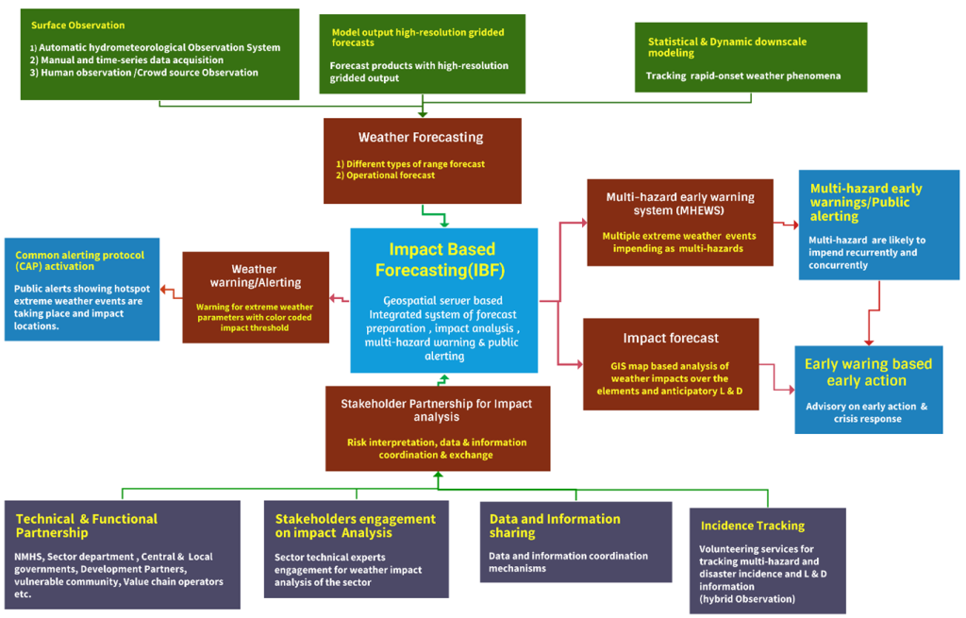

Figure 14 (IBF Framework) should illustrate how this information flows, and workstreams connect across the hazard-to-impact lifecycle and define the stakeholder input points.(Source: Z M Sajjadul Islam )

For high-impact events, IBF analysts (including meteorologists and impact analysts) must also conduct background checks using the impact database and risk repository to reference historical analog events and comparable hazard patterns. This enables better calibration of expected impacts and improves the quality of advisories. Accordingly, the partnership mechanism must explicitly mandate partners to develop and regularly update foundational risk repositories, as effective IBF is inherently hybrid system for forecasters and sector/element risk analysts must jointly interpret climate variables, weather parameters, spatiotemporal exposure, and vulnerability profiles to prioritize risks and refine triggers for early action.

All participating stakeholders including government entities, partners, authorities, and representative vulnerable community groups should be formally required to contribute element-specific baseline risk and vulnerability information to improve the effectiveness and efficiency of the IBF partnership mechanism. This two-way partnership enables: (i) provision of georeferenced baseline information for key elements; (ii) harmonization of risk-informed tools and sector planning products that remain relevant beyond forecast issuance; and (iii) continuous improvement through feedback loops that allow partners to monitor forecast and warning performance and recommend refinements.

Finally, partners play essential roles in risk communication and in translating IBF outputs into early action and response measures. Mandated partners should have defined responsibilities for anticipatory and early actions, including advising vulnerable communities on protective measures during extreme weather and climate events and ensuring that partner-specific anticipatory guidance is aligned with standardized impact-based advisories disseminated through the MHEWS platform.

3.13 Upgrade and Activation of an Interoperable Situation Room and NMHEWS at SoDMA-NMHEWC :

The upgrade and activation of an interoperable Situation Room at the SoDMA NMHEWC is intended to transform the Center into a digitally connected, multi-source operational hub for end-to-end multi-hazard early warning and Impact-Based Forecasting (IBF). The proposed design should ensure secure, reliable connectivity with internal and external data sources, enabling routine acquisition, processing, analysis, and dissemination of actionable products across the EW4ALL pillars.
Figure 15: Diagram of ICT system structure and process for an interoperable MHEWS

3.13.1 Objective and operating concept

The interoperable Situation Room will function as the national “common operational picture” (COP) environment integrating hazard monitoring, forecast ingestion, impact analysis, incident tracking, and coordination workflows. It will support time-critical operations by enabling:
- continuous monitoring of meteorological and hydrological conditions;
- integration of regional and global forecast guidance and satellite products;
- rapid generation of hazard and impact maps, bulletins, and alerts; and
- coordinated tasking and information exchange with sector ministries, member states, districts, and humanitarian partners.

3.13.2 Core ICT and data-management functions
The upgraded NMHEWS environment should be configured to provide the following operational capabilities:
- National observation ingestion and management: Establish a robust online NMHEWS system to ingest Somalia’s terrestrial meteorological and hydrometeorological observations and generate time-series archives of Essential Climate Variables (ECVs) and operational parameters. This includes quality control, calibration, collation, aggregation, and standardized storage within a central data repository.
- Interoperability and API integration layer: Implement an API gateway and data integration services to connect multiple external sources through secure, role-based access, with logging and traceability for operational use.
- Operational analytics for IBF: Enable real-time and near-real-time workflows for hazard detection, monitoring, forecast interpretation, impact analysis (hazard × exposure × vulnerability), and bulletin/alert preparation with approval workflows.

3.13.3 Priority external data linkages and integrations
To strengthen forecasting, situational awareness, and impact interpretation, the Situation Room should establish structured linkages (API-based where available, or via alternative secure mechanisms where needed) with the following:

A) Regional climate and forecast hubs
- ICPAC and related regional weather/climate information hubs to support advisories, outlooks, and regional-scale early warning guidance relevant to Somalia.

B) Transboundary hydrometeorological data exchange
- Establish data-sharing and technical linkages with transboundary upstream and neighboring observation networks (e.g., Ethiopia and Kenya) to access relevant real-time or near-real-time parameters, including:
  - heavy rainfall observations and gridded rainfall products;
  - river and flood level datasets;
  - catchment and hydrological datasets supporting flood forecasting;
  - wind/storm indicators; and
  - drought-relevant datasets.

C) WMO and global meteorological infrastructure
- Establish integration pathways to:
  - WMO regional centers (DCPCs), RSMCs, and other designated hubs;
  - WMO Information System (WIS) services and associated information exchange networks; and
  - GTS-linked or equivalent operational exchange mechanisms where applicable.

- Integrate EUMETCast and ECMWF products through appropriate access modalities to strengthen forecast guidance, model outputs, and satellite-derived products used for national warning services.

D) Tsunami and coastal hazard alerting
- Establish formal linkage and operational protocol integration with the Indian Ocean Tsunami Warning/Alert mechanisms (including the Jakarta-based center as applicable) to support coastal hazard early warning and consistent national dissemination procedures.

3.13.4 Anchoring partner-produced risk repositories and sector intelligence
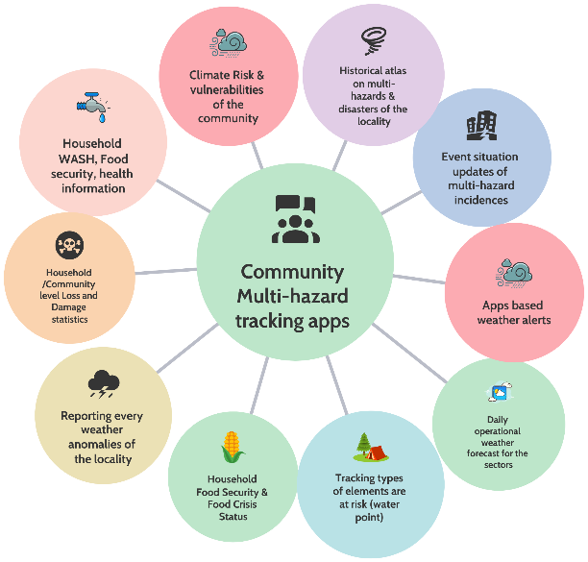
To enable impact analysis and risk-informed decision-making, the interoperable Situation Room should be able to ingest and reference partner datasets and operational repositories as supporting layers for IBF, planning, and response. Priority sources include, as applicable:
- FAO-related risk and water information systems (including SWALIM products where relevant);
- displacement and mobility datasets (e.g., IOM DTM; UNHCR operational datasets);
- food security and livelihoods analytics (e.g., WFP food security; FSNAU/FAO analysis where applicable);
- logistics and telecom operational datasets (e.g., WFP logistics networks);
- cluster databases (WASH, Education, etc.);
- anticipatory action and risk modeling platforms (e.g., IFRC anticipatory action resources; FEWS NET and similar);
- humanitarian risk analytics (e.g., OCHA risk/information products such as INFORM where relevant);
- CREWS-supported tools and IBF products (including myDEWETRA outputs and other CREWS technical components); and
- development datasets and risk finance/DRM resources (e.g., World Bank/GFDRR datasets where relevant).

Implementation principle: partner data should be anchored through governed ingestion and metadata standards, with clear rules for access, reuse, and disclosure within NMHEWS.

3.13.5 Satellite reception and atmospheric observation systems
To improve timeliness and coverage, the Situation Room should enable access to real-time satellite-based atmospheric products through appropriate systems and services. Where feasible, this includes:
- integrating EUMETCast-enabled products and other satellite dissemination services;
- leveraging regional/basic climatological and hydrological observation networks and river monitoring datasets relevant to Somalia; and
- ensuring that satellite-derived products are archived and published through the NMHEWS geospatial services for operational use.

3.13.6 Operational safeguards and sustainability requirements
Given Somalia’s FCV context, the Situation Room design should include:
- redundant connectivity and caching (to maintain continuity during internet disruptions);
- role-based access control and audit logs (particularly for warnings, bulletins, and L&D/incident records);
- SOP-aligned workflows for data ingestion, validation, product generation, approvals, dissemination, and after-action review;
- cybersecurity and backup/restore procedures suitable for critical public service operations; and an explicit O&M model (staffing, maintenance, hosting, and support) to sustain 24/7 or near-continuous operations during hazard seasons.

3.13.7 Contribution to EW4ALL pillar actions
The EW4ALL interoperable Situation Room is intended to directly enable all four pillars by:
- strengthening risk knowledge through integrated repositories and exposure/vulnerability layers;
- improving detection, monitoring, analysis, and forecasting via expanded observation and external data integration;
- enhancing dissemination through standardized products and interoperability-ready alerting mechanisms; and
- enabling preparedness and response through shared situational awareness, coordinated tasking, and event/L&D tracking that supports anticipatory action and post-event assessment.

3.14 NMHEWS service deliverability for improving risk knowledge:

3.14.1 Understanding Disaster Risk of the Locality

All crucial stakeholders engaged in last-mile disaster risk management must have a clear and shared understanding of the landscape-level vulnerability of their locality and the persistent residual risks and vulnerabilities that exist under Somalia’s multi-hazard conditions. Where hazards are already affecting the landscape with varying intensities, local actors must be able to identify and interpret: (i) which elements are exposed; (ii) which groups, assets, and services are most vulnerable; (iii) where the highest-risk hotspots are located; and (iv) the likely pathways of Loss and Damage (L&D) affecting livelihoods, food security, and the built environment.
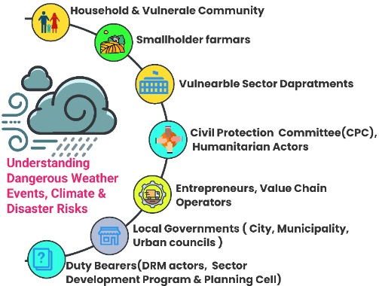
Figure 16: Local stakeholders to understand the persistent risk and vulnerability of elements of their locality

As illustrated in Figure 16(Local stakeholders’ understanding of persistent risk and vulnerability of local elements), this risk knowledge should be routinely understood and updated by last-mile stakeholders and representative community groups, local stakeholders and leaders, sector extension departments, local CPC/DMC structures, and other relevant actors responsible for preparedness, response, and recovery. Strengthened risk knowledge at these levels is essential to translate early warnings into anticipatory actions, prioritize emergency response, and support risk-informed local development planning.

To enable this, frontline stakeholders and communities should be digitally connected through web-based and mobile applications that provide access to localized GIS map-based, element-specific risk information. These tools should support two-way engagement, allowing communities to access localized advisories and risk profiles while also contributing georeferenced updates on exposure, impacts, and evolving vulnerabilities.

3.14.2 Frontline community needs to understand Disaster Risk in their Locality :

All crucial stakeholders engaged in last-mile disaster risk management must have a clear and shared understanding of the landscape-level vulnerability of their locality and the persistent residual risks and vulnerabilities that exist under Somalia’s multi-hazard conditions. Where hazards are already affecting the landscape with varying intensities, local actors must be able to identify and interpret: (i) which elements are exposed; (ii) which groups, assets, and services are most vulnerable; (iii) where the highest-risk hotspots are located; and (iv) the likely pathways of Loss and Damage (L&D) affecting livelihoods, food security, and the built environment.

As illustrated in Figure 16 (Local stakeholders’ understanding of persistent risk and vulnerability of local elements), this risk knowledge should be routinely understood and updated by last-mile stakeholders and representative community groups, local stakeholders and leaders, sector extension departments, local CPC/DMC structures, and other relevant actors responsible for preparedness, response, and recovery. Strengthened risk knowledge at these levels is essential to translate early warnings into anticipatory actions, prioritize emergency response, and support risk-informed local development planning.

To enable this, frontline stakeholders and communities should be digitally connected through web-based and mobile applications that provide access to localized GIS map-based, element-specific risk information. These tools should support two-way engagement, allowing communities to access localized advisories and risk profiles while also contributing georeferenced updates on exposure, impacts, and evolving vulnerabilities.

3.14.3 Enhancing the risk knowledge of Smallholder crop farmers:

Somalia’s economy is strongly anchored in livestock, crop agriculture, and fisheries, which collectively sustain rural livelihoods and local market systems. However, smallholder farmers often have limited access to tailored weather and climate information and to precision-level multi-hazard early warnings that would enable them to prepare for, respond to, and recover from hazardous weather. Over time, protecting livelihood assets, such as cropping systems, livestock holdings, fisheries-related activities, agroforestry, and horticulture, requires localized, actionable, and timely early warning services linked to feasible anticipatory actions.

To support risk-informed decision-making, smallholder and commercial farmers and their value chain operators must be able to interpret localized weather anomalies and translate forecasts into practical choices on planting, harvesting, irrigation scheduling, pest management, storage, and market timing. Precision-level forecasts and alerting combined with clear impact-based advisories enable anticipatory actions and longer-term adaptation measures that reduce losses and improve resilience.

Anticipatory action planners, value chain operators, commercial entrepreneurs, market facilitators, and sector extension officers also require reliable ground-level time-series information contributed by farmers and livestock herders. Systematically capturing farmer-reported observations (rainfall variability, soil moisture condition, crop stage, pest outbreaks, water stress, localized damages, and yield signals) strengthens situational awareness and improves the relevance of advisories and early action triggers. When integrated into the NMHEWS platform through mobile reporting tools and extension networks, this two-way information exchange improves forecast interpretation, supports targeted early action, and strengthens livelihood resilience at the last mile.

Table : with consistent terminology, clearer prompts, and improved structure (without introducing any unverified numbers).

Elements | What would be the case in the event of hazardous impending weather? | What would be climatic shocks, residual impacts on the elements |  |  |  | Proposed Anticipatory Action | Data ingestion from frontline stakeholders
 |  | Exposure | Sensitivity | Vulnerability | Risk
Crops (maize, bananas, sugarcane, rice, cotton, vegetables, grapefruit, mangoes, papayas) | Dry spell forecasted | - Estimate % of crop land/area exposed (by district/irrigated vs rainfed)  - Identify hotspot locations and crop stage (planting/vegetative/flowering/harvest) | - Are the dominant varieties sensitive to dry spells?  - What is the crop stage-specific sensitivity (e.g., flowering/fruiting critical windows)? | - What is the availability of supplemental irrigation and water access after ~2-3 weeks?  - Which varieties are drought-tolerant (withstand ~3 weeks)?  - Rank withstanding capacity by crop/variety and locality | - Estimate % yield loss (by crop, stage, locality)  - Secondary impacts: soil moisture depletion, pest/disease escalation, market supply reduction | - Issue precision advisories by crop stage and locality (irrigation scheduling, mulching, water rationing, early harvesting where appropriate)  - Trigger contingency irrigation support after defined thresholds (e.g., 2-3 weeks without effective rainfall)  - Promote drought-tolerant varieties and adaptive agronomy where feasible | - Two-way mobile advisory and reporting app (farmers as primary informants)  - - GPS-enabled field reporting (crop stage, water stress, losses)  - - Integration with geospatial portal (impact maps, hotspot tracking)  - - SMS/WhatsApp/IVR for advisories and confirmation feedback  - Sector-level weather and climate data, impact-level data, and Loss and Damage (L&D) information should be acquired through a structured pipeline that ingests automated ground-sensor observations and field reports into centralized servers to power a risk management decision-support system. This requires end-to-end integration from observation to storage, quality control, analytics, and dissemination.  - In parallel, customized mobile applications should be developed for frontline farmers and livestock herders to submit georeferenced weather and impact observations (e.g., rainfall anomalies, water stress, crop stage, pest outbreaks, livestock heat stress, mortality/morbidity, local damages). This will institutionalize farmers and herders as primary informants within the NMHEWS/IBF ecosystem and enable two-way communication allowing the platform to both receive ground-truth data and deliver tailored advisories, alerts, and anticipatory action guidance back to users in a timely manner.
Livestock (cattle) | Heatwave and/or dry spell forecasted | - Estimate number of cattle exposed in hotspot areas  - Identify water-point/rangeland stress zones and herd movement patterns | - Based on temperature/humidity thresholds, estimate % likely to experience heat stress (by age/condition)  - Identify sensitivity linked to body condition and disease prevalence | - Availability of supplementary feed, water trucking options, and shade/shelter (livestock yards/sheds)  - Access to veterinary support and disease surveillance capacity | - Estimate % Loss & Damage (mortality, morbidity, productivity decline)  - Secondary impacts: distress sales, conflict over water/pasture, displacement triggers | - Issue precision advisories (watering frequency, shaded resting, movement restrictions during peak heat)  - Trigger supplementary feed/water support and temporary shelters in priority areas  - Activate veterinary surveillance and rapid response protocols | - - Two-way mobile reporting by herders (water access, animal health, mortality/morbidity)  - Geo-tagged reporting of pasture/water conditions  - Dashboards for hotspot monitoring and targeted support planning  - Multi-channel dissemination (SMS/IVR/WhatsApp , Community radio)

All georeferenced, tailor-made information should be disseminated through the NMHEWS online portal and mobile apps, using GIS map-based products that visualize the spatial impacts of evolving weather conditions and forecast thresholds. In this way, ICT-enabled tools can provide timely, evidence-based decision support for anticipatory action planning enabling stakeholders to take protective measures that reduce Loss and Damage to productive assets and livelihood elements on the ground..

Table: Sensor Data ingestion from the sector and sectoral elements for facilitating IBF

Climate vulnerable sector and sectoral elements on the ground | Climatic shocks on elements | Residual impacts on elements | Data ingestions from sensors
Crops and horticulture (maize, rice, bananas, vegetables, fruit) | - Dry spells/drought; heatwaves  - Erratic rainfall onset/cessation; intra-seasonal rainfall gaps  - Intense rainfall causing waterlogging; floods  - Strong winds/cyclones; saline intrusion in coastal areas | - Yield reduction and crop failure; quality loss (smaller grains/fruit, spoilage)  - Soil moisture depletion; soil fertility decline; increased salinity (coastal/irrigated areas)  - Pest and disease surges (often following stress or humidity shifts)  - Seed system disruption and reduced planting for next season; farmer debt and distress sales  - Post-harvest losses due to dampness, mold, storage damage, or access constraints | Crop Type | Priority Sensors | Key Purpose
 |  |  | Maize & Rice | Soil VWC (Multi-depth), Weather Station, NDVI | Irrigation timing & Nitrogen management
 |  |  | Bananas | Soil pH, Dendrometers, Ethylene (Storage) | Nutrient uptake, growth stress, & ripening control
 |  |  | Vegetables | Tensiometers, Leaf Wetness, PAR | Disease prevention (fungal) & precise watering
 |  |  | Fruit Trees | Dendrometers, Soil VWC, Temperature | Water stress monitoring & frost protection
Livestock (cattle, goats, sheep, camels) | - Heatwaves and prolonged dry spells  - Drought-driven pasture and water scarcity  - Flooding that contaminates water points and restricts movement  - Disease outbreaks linked to climate conditions (vector expansion, stress) | - Reduced body condition; lower milk production; fertility decline; increased mortality risk  - Depleted rangeland biomass and slow pasture recovery; longer migration routes  - Higher veterinary costs; increased disease prevalence (diarrheal, respiratory, vector-borne)  - Distress sales, herd depletion, reduced household income and asset base  - Social tensions/conflict over pasture and water; displacement triggers | Animal | Necessary Sensors | Key Purpose
Livestock (cattle, goats, sheep, camels) |  |  | Cattle | Smart Collars (GPS), Rumen Bolus, THI Sensors | Theft prevention, heat stress management, & estrus detection.
Livestock (cattle, goats, sheep, camels) |  |  | Goats | Virtual Fencing Collars, Ammonia Sensors | Preventing crop destruction (containment) & respiratory health in housing.
Livestock (cattle, goats, sheep, camels) |  |  | Sheep | EID Ear Tags, Lambing Sensors | Tracking parentage/genetics & reducing lamb mortality.
Livestock (cattle, goats, sheep, camels) |  |  | Camels | GPS Trackers (Long-range), Water Trough Cameras | Tracking in vast arid areas & monitoring hydration/lameness.
Fisheries and coastal livelihoods | - Cyclones, storm surges, rough seas  - Coastal flooding and saltwater intrusion  - Temperature anomalies affecting fish distribution; harmful algal blooms (where applicable) | - Damage to boats/gear and landing sites; disrupted fishing days and incomes  - Reduced catch availability or shifts in fishing grounds; higher operational risk/cost  - Market disruptions and spoilage due to power/cold chain interruptions | Sector | Priority Sensors | Key Purpose
Fisheries and coastal livelihoods |  |  | Pond Aquaculture | Dissolved Oxygen, Ammonia, pH | Preventing suffocation & toxic spikes (mass mortality).
Fisheries and coastal livelihoods |  |  | Seaweed Farming | Current Speed, Temperature, Light | Optimizing placement for growth & storm avoidance.
Fisheries and coastal livelihoods |  |  | Small-Scale Fishing | GPS/AIS, Echo Sounder | Fuel efficiency (finding fish fast) & collision avoidance.
Fisheries and coastal livelihoods |  |  | Coastal Safety | Tide Gauge, Surge Alert | Early warning for floods and storms.
Water resources and WASH systems | - Drought and prolonged dry spells  - Floods and heavy rainfall events  - Salinity intrusion (coastal aquifers) and contamination | - Lower groundwater recharge; dried/declining boreholes and shallow wells  - Contamination of water sources; increased waterborne disease risk  - Damage to latrines, drainage, water points; higher O&M burden and service downtime  - Increased water collection time/cost, disproportionately affecting women and children | Hazard Context | Critical Sensor | Trigger/Action (IBF)
Water resources and WASH systems |  |  | Flash Flood | Radar Level ,Rain Gauge | Rate of rise > Threshold > Evacuation Siren
Water resources and WASH systems |  |  | Cholera Risk | TLF (Fluorescence) | Bio-activity spike >"Boil Water" SMS
Water resources and WASH systems |  |  | Drought | Groundwater Diverger | Aquifer low >Release Anticipatory Funds
Water resources and WASH systems |  |  | Urban Flood | Septic Level Monitor | Tank full >Dispatch truck (Prevent overflow)
Health and nutrition | - Heatwaves; drought-induced food insecurity  - Flooding and stagnant water  - Climate-sensitive disease outbreaks (cholera/diarrhea, malaria/dengue risks where present) | - Acute malnutrition spikes; reduced dietary diversity  - Increased diarrheal disease burden; outbreak persistence due to WASH disruption  - Heat-related illness; reduced health service access during floods  - Mental health stress and protection risks linked to displacement and livelihood loss | Sector | Priority Sensor/Tool | Key Purpose
Health and nutrition |  |  | Child Growth | AI Optical Scan (Smartphone) | Rapid, error-free malnutrition screening (Stunting/Wasting).
Health and nutrition |  |  | Disease/Vitals | Digital RDT Reader , GPS | Real-time epidemic mapping (Malaria/Cholera).
Health and nutrition |  |  | Anemia | Non-invasive Optical Sensor | Screening without needles/blood risks.
Health and nutrition |  |  | Food Supply | Handheld NIR Spectrometer | Detecting fake/unfortified food & toxic grain.
Built environment and critical infrastructure (roads, bridges, schools, clinics, telecom/power) | - Floods, flash floods, landslides (where terrain permits)  - Cyclones/strong winds; coastal storm surge  - Extreme heat stressing materials and power demand | - Structural damage and accelerated deterioration; higher maintenance costs  - Service outages (power, telecom); disrupted emergency communications  - Access constraints for markets and humanitarian response; prolonged recovery timelines  - School and clinic disruptions; reduced service continuity | - Sonar sensors mounted on the pier underwater measure the riverbed depth continuously.  - Extension officers L&Ds data sending via mobile apps
Settlements and IDP sites | - Flooding and storm impacts; heatwaves  - Drought-driven displacement and resource stress | - Shelter damage and overcrowding; increased protection and health risks  - Water scarcity and WASH failure; persistent disease vulnerability  - Longer-term displacement, loss of livelihoods, and reduced coping capacity | Risk Sector | Priority Sensor | Key Purpose
Settlements and IDP sites |  |  | Fire Safety | Rate-of-Rise Heat Detector | Detecting tent fires without false alarms from cooking smoke.
Settlements and IDP sites |  |  | Crowd Control | ToF Counter (Overhead) | Managing queues at food distribution/clinics.
Settlements and IDP sites |  |  | Health | PM2.5 Sensor | Monitoring smoke pollution to reduce respiratory illness.
Settlements and IDP sites |  |  | Drainage | Ultrasonic Level Sensor | Preventing localized flooding of shelters.
Markets and value chains (transport, storage, trade, prices) | - Drought/heat affecting production; floods disrupting transport corridors  - Cyclones disrupting ports/coastal roads | - Price spikes, supply shortages, and reduced purchasing power  - Increased post-harvest losses and storage damage  - Reduced market access and income; longer-term livelihood erosion | Logistics Stage | Priority Sensor | Key Purpose
Markets and value chains (transport, storage, trade, prices) |  |  | Transport | BLE Temp Logger | Prevent spoilage of perishables (Cold Chain).
Markets and value chains (transport, storage, trade, prices) |  |  | Fleet | GPS | Route optimization & fuel theft prevention.
Markets and value chains (transport, storage, trade, prices) |  |  | Grain Storage | Temp/Moisture Cable | Prevent mold/insects in silos (Post-Harvest Loss).
Markets and value chains (transport, storage, trade, prices) |  |  | Trade | Digital Scale | Ensure fair payment & prevent weighing fraud.

3.14.4 Climate Vulnerable Productive Sector Departments:

Climate-vulnerable productive sector departments must be able to routinely understand and manage the Exposure, Sensitivity, Vulnerability, and Risk of sector-specific elements on the ground, based on locality-level risk assessments and continuously updated operational information. To support risk-informed planning and service delivery, sector departments should receive timely updates on weather anomalies, advisories, watches, warnings, and alerts translated into sector-relevant implications through the NMHEWS/IBF platform.
Accordingly, each sector department should institutionalize a structured package of risk knowledge functions, including:
- Sector Climate Risk and Vulnerability Assessment (CRVA): Conduct regular CRVA of sectoral elements (assets, services, livelihood systems) using standardized methods, georeferenced datasets, and agreed thresholds.
- Sector risk repository development: Maintain a sector risk database and GIS layers (exposure, vulnerability, historical impacts/L&D, priority assets) and publish/update these through the NMHEWS platform under defined data governance rules.
- Weather hazard calendar: Develop and update a hazard calendar capturing seasonal patterns, historical extremes, and locality-specific hazard windows to guide preparedness, early action triggers, and operational planning.
- Sector planning calendars: Develop sector-specific calendars (e.g., crop calendar for agriculture and aligned calendars for livestock, fisheries, WASH, health, etc.) to synchronize advisories, extension messaging, and preparedness measures with seasonal cycles and forecast outlooks.

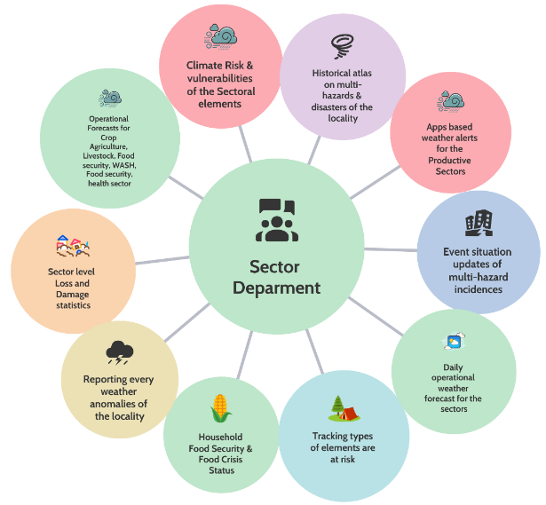
Figure 17: Sectoral risk information data collection

The most climate-vulnerable productive sectors in Somalia include livestock, crop agriculture, water, fisheries, public health, WASH, and value chain sectors. Strengthening risk knowledge for these sectors requires systematic contribution of sector- and locality-specific exposure, vulnerability, and impact information from last-mile stakeholders.

Accordingly, sector-level stakeholders such as lead farmers, smallholder and commercial farmers, value chain operators, CSOs, community leaders, Mosque Imams, and other trusted local informants should be formally engaged through the NMHEWS/MHEWS platform to provide georeferenced sector risk and vulnerability inputs. These inputs should include, as relevant: livelihood and asset inventories, seasonal hazard calendars, water availability and quality conditions, crop and livestock stress indicators, market and access disruptions, and event-based Loss and Damage (L&D) observations. This structured, two-way information exchange will improve sector risk profiling, increase the relevance of impact-based advisories, and strengthen anticipatory action and preparedness planning at the last mile.

Sectoral Elements Risk/Vulnerability and L&D Assessment Matrix (Template)
Sector | Elements | Geolocation of elements (Lat/Long) | Historical disaster damage (type of damage) | Climate exposure (current/forecast condition) | Risk rank | Vulnerabilities (withstanding capacity/drivers) | L&D statistics (routine updates) | How to conduct the assessment
Crop agriculture | - All types of crops  - Agroecology-based croplands  - Seasonal and perennial rivers (surface irrigation)  - Surface irrigation points/intakes  - Underground boreholes  - Dug wells  - Water bodies for irrigation  - Irrigation canals  - Lakes (irrigation sources)  - Ponds (irrigation)  - Water points (boreholes) for irrigation  - Springs (irrigation)  - Dug wells for irrigation | Record GPS coordinates for: cropland blocks, irrigation sources, intakes, canals, wells/boreholes, storage ponds/lakes, springs | For each element: record past event(s), date/season, hazard type (drought/flood/wind/storm), damage type (crop loss, intake failure, siltation, contamination, drying) | Describe present condition under hazard parameters: heatwave, high winds, rainfall anomalies, localized storms, dry spell/drought indicators | Rank each element Very High / High / Medium / Low (based on exposure , sensitivity , criticality) | Withstanding capacity against anomalies (e.g., irrigation access, drought-tolerant varieties, water storage, soil condition, pest pressure), plus constraints (inputs, access, labor) | Weekly community updates on losses/damages: crop loss area, yield loss, irrigation downtime, water shortage days, price signals (optional) | Customized mobile apps (Kobo/ODK/GPS survey) , simple GIS mapping; validate via extension staff/CPC
Livestock | - Camels  - Cattle herds and livestock sheds/yards  - Buffalo  - Goats (herds/sheds)  - Sheep (herds/sheds)  - Poultry farms | Geolocation of herd locations, grazing areas, water points, livestock yards/sheds, migration routes (where feasible) | Record hazard type and impacts: heat stress, drought losses, disease outbreaks after floods, fodder/water scarcity, shelter damage | Exposure under forecast: heatwave, dry spell, flooding, disease risk (vector conditions), pasture/water stress | Very High / High / Medium / Low | Body condition, water access, feed availability, shelter/shade availability, veterinary access, mobility constraints | Weekly updates by herders/leaders: morbidity/mortality, milk decline, distress sales, pasture and water status | Customized mobile apps (herder reporting , GPS) , hotline/IVR/SMS options for low connectivity, office data ingestion )
WASH | - Water points for IDPs  - Community boreholes (functional)  - Community boreholes (seasonally operational)  - Abandoned boreholes  - Piped water points  - Community WASH points in schools  - Dug wells for IDPs  - Household dug wells | GPS of WASH points, IDP sites served, service areas (coverage), and key routes | Record damage types: contamination, pump failure, drying, flooding of latrines, pipeline breaks, access disruption | Exposure under forecast: drought (low yield), flooding (contamination), heat (demand surge), storm damage risk | Very High / High / Medium / Low | Functionality constraints, O&M capacity, water quality risks, spare parts availability, power/fuel constraints, protection/access issues | Weekly updates: functionality status, downtime days, water quantity/quality concerns, beneficiary counts | Customized mobile apps , simple functionality checklists; integrate with WASH cluster datasets where applicable
Water sector (hydrological resources) | - Canals  - Rivers  - Lakes  - Ponds  - Springs | GPS for monitoring points, intakes, key cross-sections, critical canal sections | Record impacts: bank erosion, siltation, low flow, contamination, overflow/breaches | Exposure under forecast: heavy rainfall, upstream flood signals, drought low flow, salinity risk (coastal) | Very High / High / Medium / Low | Monitoring gaps, maintenance capacity, protection infrastructure, access and security constraints | Weekly updates: water level/flow condition proxies, canal breaches, water availability days | Customized mobile apps , sensor integration where available; publish through geospatial portal
Health | - Hospitals  - Rural clinics  - Urban primary health care centers  - Family planning centers | GPS of facilities; catchment population/served areas (optional) | Record past event impacts: facility damage, service disruption, access blocked, disease spikes (post-flood), supply chain disruption | Exposure under forecast: flood/heat/disease outbreak risk, access disruption | Very High / High / Medium / Low | Staff capacity, supply chain resilience, WASH functionality, power/telecom reliability, surge capacity | Weekly updates: service disruption, caseload changes (e.g., diarrhea), facility damages, urgent needs | Customized mobile apps for facility status reporting , integration with health information systems where permitted
Risk rank method: apply a simple scoring rubric (Exposure × Sensitivity × Vulnerability) and record the rationale.

Primary informants: lead farmers, herders, fishers (where relevant), CSOs, community leaders, Mosque Imams, village committees, CPC/DMC focal points.

Data governance: define who can submit, validate, approve, and publish; include a basic QA step before information is shared widely.
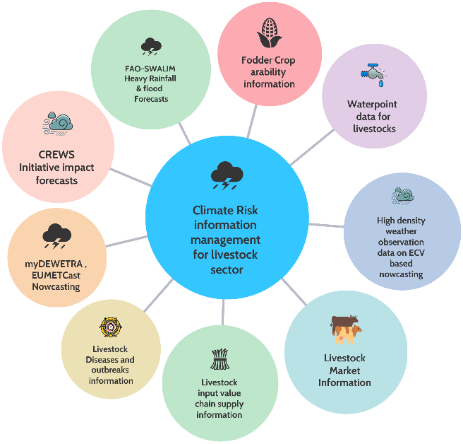

Figure 18: Sectoral risk information data collection

3.14.5 Improving risk knowledge of Civil Protection Committee(CPC)/Disaster management Committee :

Strengthening the risk knowledge of CPC/DMC structures is a priority for: (i) improving locality-level risk assessment; (ii) enhancing community risk knowledge and risk perception; and (iii) operationalizing end-to-end, community-based early warning systems. CPC/DMCs are uniquely positioned as trusted local actors who can facilitate routine risk profiling and serve as the primary interface between frontline communities and the national NMHEWS/MHEWS platform.

Mobile applications and web-based database interfaces should therefore be used to enable CPC/DMCs to function as key informants, routinely updating georeferenced information on local risk drivers, exposed elements, livelihood assets, critical services, and vulnerability conditions. This supports continuous risk knowledge management at community, municipality, and city levels and strengthens the basis for impact-based advisories and anticipatory action planning.

During impending multi-hazard events and at disaster onset when hazards are already interacting with the landscape CPC/DMCs should be digitally connected to the centralized MHEWS server to provide time-critical updates, including:

- community-level Loss and Damage (L&D) information and rapid impact observations;
- event situation updates (hazard evolution, hotspot locations, access constraints); and
- priority humanitarian needs and response gaps (who needs what, where, and when).

This two-way digital connectivity ensures that early warning information remains grounded in local realities, strengthens situational awareness for decision-makers, and enables coordinated preparedness, response, and early recovery actions at the last mile.

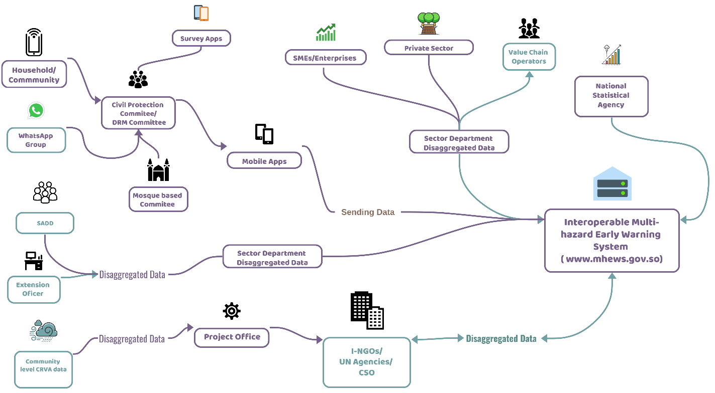
Figure 19 : Disaggregated data collection framework for collection of Age, sex, disability disaggregated data(SADD) , sector-level elements specific attribute data ( Source: Z M Sajjadul Islam)

Interpretation of the diagram :

The figure depicts a two-way, interoperable data-and-service ecosystem for an Interoperable Multi-hazard Early Warning System (MHEWS) (center-right, shown as www.mhews.gov.so). It illustrates how last-mile actors and sector institutions submit georeferenced and disaggregated data into the platform, and how the platform in turn supports risk knowledge, impact-based forecasting (IBF), and coordinated decision-making.

  - Last-mile community reporting and validation pathway

- Households/communities generate first-hand observations and incident updates through:
  - WhatsApp groups
  - Survey apps
  - MHEWS Mobile apps
- These inputs are routed through trusted local structures:
  - Civil Protection Committee / DRM Committee (CPC/DMC)
  - CSO, Clan, Mosque-based committees
- This layer acts as a community verification and coordination interface, improving credibility and timeliness of community-generated reports before they feed into the national platform.

2) Sector and local government risk data pipeline
Extension officers and community-level CRVA data contribute “Disaggregated Data,” including SADD (sex-, age-, disability-disaggregated) information.
- Sector departments (disaggregated data) aggregate these inputs and submit sector-specific datasets to the platform (e.g., agriculture, livestock, WASH, water resources, health).

3) Private sector and market/value chain intelligence (top-center to center)
- SMEs/Enterprises, the private sector, and value chain operators contribute operational market and value-chain signals (e.g., supply disruptions, price shifts, logistics constraints, service continuity indicators), feeding into sector department disaggregated data and onward into the MHEWS platform.

4) National statistical linkage and structured datasets (right side)
- The National Statistical Agency connects to the MHEWS platform, implying a pathway for authoritative baseline datasets and improved standardization of disaggregated statistics used for exposure/vulnerability profiling.

5) Humanitarian and development partner interface (bottom-center)
- Project Office and I-NGOs / UN Agencies / CSOs exchange “Disaggregated Data” with the MHEWS platform supporting:
  - anticipatory action planning,
  - response coordination,
  - PDNA/RPDNA inputs,
  - and harmonized risk knowledge products.

Currently, SoDMA and other sector departments conducts PDNA and post-disaster Loss and Damage (L&D) assessments largely through traditional, community-mediated approaches. Mosque Imams (often during Friday prayers), clan leaders, and community leaders commonly serve as grassroots informants, providing preliminary snapshots of losses and damages based on community reporting during prayer gatherings and local consultations.

This established practice can be strengthened and scaled by instrumenting it through an ICT-enabled, open-ended MHEWS platform. Under this model, CPC/DMC stakeholders would be enabled to function as structured primary informants by:

- establishing and moderating local WhatsApp groups and other community communication channels to harvest crowdsourced, time-critical information;
- submitting georeferenced event situation updates and localized L&D observations to the centralized MHEWS server via mobile applications and standardized reporting forms; and
- using the platform’s dashboards and planning modules to support preparation and continuous updating of local disaster preparedness, response, and early recovery plans.

This transformation preserves trusted community reporting pathways while improving speed, structure, traceability, and usability of information for impact-based forecasting, anticipatory action, and coordinated emergency management.

3.14.6 Improving risk knowledge of Humanitarian actors:

- Data-driven, risk-informed preparedness and humanitarian action planning depends on rapid access to reliable situation updates that reflect both (i) hazards already occurring and (ii) hazards likely to occur based on forecasts. This includes real-time and near-real-time information on evolving hazard conditions, disaster event status, anticipatory Loss and Damage (L&D) projections, and other operationally relevant datasets. An ICT-enabled analytics environment supported by automated workflows and decision-support algorithms can help translate CRVA repositories and impact forecasts into actionable triggers and quantified anticipatory L&D scenarios to inform early action and response planning.

Key requirements and operational applications include:

- Use multidimensional risk and vulnerability attributes for targeting: Humanitarian decision-making should be informed by element-level risk and vulnerability attributes (exposure, sensitivity, vulnerability, criticality), supported by geospatial analytics and GIS-based Multi-Criteria Decision Analysis (MCDA) to prioritize locations and populations most at risk.
- Integrate precision spatiotemporal impact forecasts with vulnerability analytics: By overlaying precision-level spatiotemporal impact forecasts onto MCDA-driven vulnerability layers, the system can rapidly project and categorize likely L&D consequences, producing ranked impact scenarios that support anticipatory action activation and response prioritization.
- Enable operational mapping for Standing Orders and coordinated action planning: The platform should generate geospatial operational maps and dashboards that support the implementation of Standing Orders/Standard Operating Procedures (SoD/SoP) and facilitate structured coordination through a 5W framework (Who does What, Where, When, and How). This enables humanitarian actors to:
- reduce duplication and overlapping interventions;
- identify gaps and underserved or hard-to-reach areas;
- prioritize assistance based on risk and impact evidence; and
- coordinate multi-agency response in a uniform and accountable manner at the last mile.
- This approach strengthens humanitarian actors’ risk knowledge by ensuring that preparedness and response decisions are guided by integrated hazard, exposure, vulnerability, and impact intelligence updated continuously through the interoperable MHEWS/IBF platform

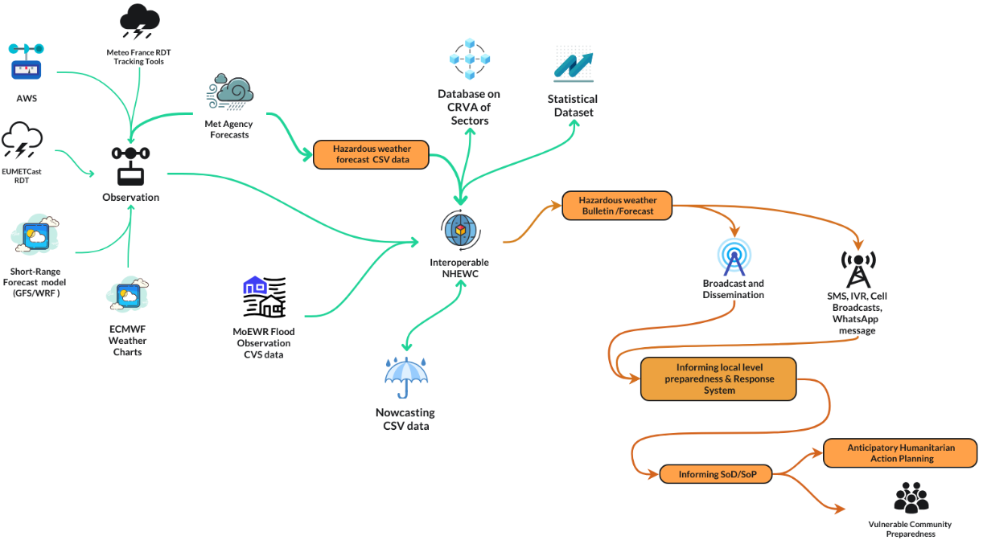
Figure 20 : Data flow diagram of informed humanitarian action

Interoperable NMHEWS/IBF operational workflow and dissemination chain:
Multi-source observation and forecast inputs (AWS, satellite/remote sensing, NWP forecast guidance, ECMWF products, flood observations, and meteorological agency forecasts) are ingested into an Interoperable NHEWC and combined with sector CRVA databases and statistical datasets to produce impact-oriented hazardous weather bulletins. These bulletins are disseminated through broadcast and digital channels (SMS/IVR/cell broadcast/WhatsApp) and feed local preparedness and response systems, Standing Orders/SOPs, and anticipatory humanitarian action planning to strengthen last-mile community preparedness.

3.14.7 Improving risk knowledge of entrepreneurs & Value Chain Operators

Entrepreneurs and value chain operators require timely, actionable weather and climate information because impending extreme weather events can disrupt daily business operations, input supply chains, transport and logistics, market access, and storage/processing systems. This is particularly critical in Somalia, where economic activity and household incomes are strongly dependent on crop agriculture, livestock, and related market systems, and where weather shocks can rapidly translate into supply shortages, price volatility, and localized Loss and Damage (L&D).
To strengthen risk knowledge and operational continuity, entrepreneurs and value chain actors should be enabled to understand how extreme weather conditions can affect:
- market value chains: market access constraints, price movements, reduced demand/supply, and trade disruptions;
- processing value chains: downtime of mills, abattoirs, cold-chain systems, and service interruptions;
- transport and storage: road/bridge access, port/landing site disruptions, storage damage (flooding, humidity), and spoilage risks; and
- workforce and service delivery: reduced labor mobility, safety constraints, and interruptions to utilities and communications.

Accordingly, the NMHEWS/IBF platform should provide value chain operators with precision-level impact forecasts and nowcasting services that translate hazard parameters into business-relevant implications (e.g., likely transport corridor disruption, storage risk, livestock heat-stress conditions, or irrigation shortages). This enables evidence-based operational decisions such as rerouting logistics, adjusting procurement and storage plans, protecting assets, and scheduling activities thereby minimizing L&D and supporting cost-effective anticipatory actions based on forecast lead times and estimated impacts.

3.14.8 Improving risk knowledge of Local Governments (City, Municipality, Urban councils) actors to deal with the climate crisis

Inclusive and risk-informed local development planning requires local governments, city corporations, municipalities, and urban councils to rely on tailored, climate-risk-informed tools and on routinely updated risk intelligence. Under Somalia’s increasingly harsh climate regime, landscapes are highly exposed to climate change-induced multi-hazards, placing water security, livelihood systems, and critical urban services under persistent stress. High-value and high-density urban areas, therefore, require precision- and point-based weather forecasts, supported by localized impact interpretation, to protect populations, infrastructure, and service continuity.

To strengthen urban climate governance, local governments should institutionalize climate and multi-hazard risk and vulnerability assessments and develop an operational repository of urban elements and GIS-based products, including a risk profile atlas. These tools should document and visualize how key urban elements are exposed and becoming increasingly vulnerable to hazards such as flooding (including flash floods), landslides (where applicable), dust and sandstorms, extreme heat, and other locality-specific multi-dimensional risks. The repository should include baseline georeferenced inventories of critical infrastructure and services, roads and bridges, drainage systems, water points and piped networks, solid waste systems, health and education facilities, power and telecom assets, markets, IDP concentrations, and other essential facilities linked to hazard layers and historical impact records.

GIS map-based multi-hazard products and a structured repository of urban assets and services provide a practical foundation for risk-informed local planning and investment prioritization. A risk dashboard that integrates vulnerability profiles, historical multi-hazard patterns, persistent climate risks, changing hazard recurrence, and near-term forecasts can support local government duty-bearers and planning desks to implement:

- risk-informed action planning and contingency planning;
- annual development programmes (ADPs) aligned to hazard hotspots and vulnerability drivers; and
- multi-year, multi-sector investment planning that strengthens urban resilience through climate-proofing of infrastructure, service continuity planning, and targeted risk reduction measures.

This approach enables local governments to translate early warning and risk knowledge into systematic local governance decisions that reduce Loss and Damage, improve preparedness, and strengthen resilience in urban centers.

3.14.9 Improving risk knowledge of Duty Bearer/Local Disaster Management Committee (DMC)/Civil Protection Committee :

CPC/DMC structures at the frontline can play a pivotal role in enhancing disaster risk awareness and preparedness among last-mile communities and households. An ICT-enabled approach anchored by an online geospatial risk atlas and a risk database containing element-specific attribute information should be made easily accessible to community members, last-mile actors, local stakeholders, and duty bearers. This enables practical understanding of persistent and emerging climate risks and vulnerabilities and supports community-level adaptation of livelihoods and protective behaviors in the face of compounding shocks.

The proposed system should operate as an open-ended, interoperable platform that combines online portals, mobile applications, and social networking tools to strengthen social and human capital, motivating communities to function as first responders and to manage disaster risk at neighborhood and community levels. Given Somalia’s high mobile penetration, CPC/DMCs can leverage these tools to facilitate continuous engagement, awareness raising, and coordinated preparedness actions.

The core function of the platform is to enable operational traceability through a 5W workstream framework (Who, What, Where, When, and How). This supports local coordination and accountability by allowing CPC/DMCs to track actions and resources, reduce duplication, identify response gaps, and prioritize hard-to-reach or underserved areas. Local CPC/DMC committees connected via WhatsApp, Telegram, and dedicated disaster alert applications should be able to interact directly with the online geospatial risk information portal and operational dashboards.

Through the interoperable MHEWS system, CPC/DMCs will also receive timely weather warnings and alerts and can translate these into localized preparedness, response, and early recovery actions. Concurrently, CPC/DMCs should be enabled to submit georeferenced risk information, incident updates, and Loss and Damage (L&D) observations to the central server using standardized mobile workflows. This two-way exchange improves situational awareness at all levels and strengthens next-level preparedness and response planning by ensuring that national systems are continuously informed by frontline realities.

4.0 Pillar 2 : Improving surface observation, Monitoring, and Forecasting

4.1 The existing hydro met services- Somalia faces daunting challenges in implementing the Pillar

Somalia faces significant technical and institutional constraints in meeting Pillar 2 requirements, particularly in relation to observation network coverage, operational continuity, and the upstream data inputs needed for reliable monitoring and forecasting. Addressing these gaps requires a structured, WMO-supported diagnostic and investment pathway that prioritizes Basic Meteorological Data (BMD) acquisition and sustainable operations.

a) Conduct National Hydromet Diagnostics (CHD) and observation network stock take
A Somalia-level Country Hydromet Diagnostics (CHD) assessment is required to systematically stocktake existing hydrometeorological stations, including:
- which stations are operational versus non-operational; the types of instruments installed;
- which weather and hydrological parameters are being observed; and whether data are collected, transmitted, quality-controlled, archived, and used operationally.
- The CHD should determine the minimum number and geographic distribution of surface observation stations and Automatic Weather Stations (AWS) needed to adequately capture Essential Climate Variables (ECVs) and to support priority hazard monitoring and forecasting.

b) GBON compliance assessment and network development planning
WMO should assess the operational status and performance of installed stations against GBON requirements, including:
- siting and exposure classification of stations; instrument functionality and calibration status;
- observation practices and procedures (including alignment with the Guide to Instruments and Methods of Observation); and data transmission reliability and timeliness.
- Based on findings, WMO should support the development of a GBON-compliant national observation network development plan with an implementation budget, tailored to Somalia’s arid climatology, landcover variability, and extensive coastal setting.

c) Strengthening observation-to-forecast value chain inputs
The diagnostic process should explicitly define Somalia’s operational requirements for:
- acquisition and operational use of EUMETCast atmospheric products and satellite-derived observations;
- access to and integration of ECMWF short-range forecast charts and datasets (as permitted);
- telemetry-based river level monitoring for flood early warning; and
- where relevant, buoy-based sea-surface observation for coastal hazards, storms, and cyclone-related impacts.

d) Closing service delivery gaps for priority hazards
The network upgrade strategy should prioritize observation and forecasting capabilities that directly strengthen warning services for Somalia’s key hazards, including:
- riverine and flash flooding;
- tropical cyclones/coastal storms;
- persistent and flash drought conditions.
- heatwaves;
- Overall, the above CHD and GBON-aligned assessment pathway should culminate in a practical upgrade strategy that improves the observation and detection mechanisms required for reliable monitoring, forecasting, and impact-based early warning service delivery.

4.1 Current forecasting mechanism of Somalia :

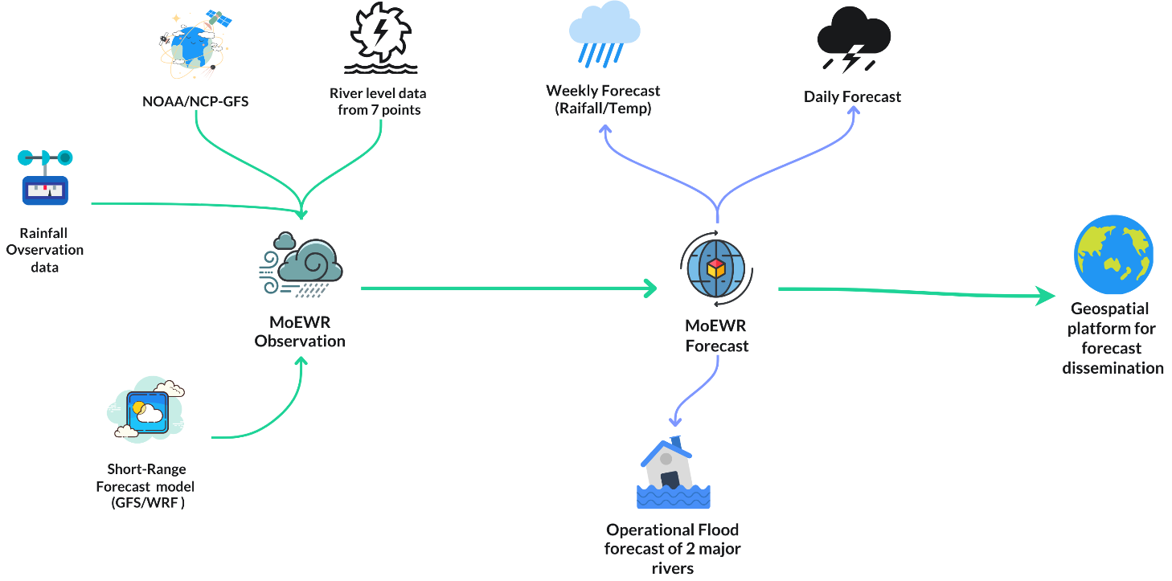
Figure 21 : Existing Forecasting Mechanism of Somalia

Currently, Somalia’s forecasting function is delivered through the national hydrometeorological technical working group under the Ministry of Energy and Water Resources (MoEWR). This working group operates largely as an ad hoc coordination and service delivery mechanism, supporting limited observation and forecasting activities. Within its current capacity, it produces daily and weekly products primarily rainfall and temperature updates and basic operational flood forecasts as reflected in Figure 21 (Current Forecasting Mechanism of Somalia).

4.2 Indicative challenges in national forecasting service delivery :

- Ad hoc forecasting governance and limited institutionalization: MoEWR leads an ad hoc hydrometeorological working group that operates largely independently and produces rainfall and flood forecast products disseminated primarily through the FAO-SWALIM web portal.
- Insufficient surface observations and limited ECV acquisition: Only a limited number of stations (including some AWS) provide rainfall observations. Essential Climate Variables (ECVs) are not systematically observed across the network, resulting in major gaps in surface observation datasets and constraining nowcasting, point-based forecasting, and forecast verification.
- High dependence on global models and limited national forecasting capability: Forecast production relies heavily on global and externally generated models (e.g., GFS/WRF). Somalia lacks a national facility capable of producing high-resolution, precision spatiotemporal daily forecasts and operational impact-relevant products.
- Absence of a comprehensive WMO-led diagnostic and upgrade pathway: A systematic diagnostic assessment of installed hydromet stations (coverage, operability, instrumentation, siting, data transmission, QC, and GBON compliance) has not yet been conducted, sustaining persistent gaps in observation capacity and limiting improvements in nowcasting and verification.
- Weak institutional arrangements for NMHS in an FCV context: Somalia has not yet established robust institutional arrangements for a functional National Meteorological and Hydrological Service (NMHS) organization within the prevailing FCV governance context, limiting authority, continuity, and service accountability.
- Limited formal partnerships and coordination across government levels: There is no effective national coordination structure supported by mandates, MoUs, or routine joint operational protocols linking federal, member state, and sector actors to collaboratively strengthen national hydrometeorological services.
- Policy and accountability gaps for sustained service delivery: SoDMA and MoEWR lack fully operational policies, programmatic mandates, and institutional accountability frameworks for improving observation networks, delivering routine short-range forecasts, monitoring hazards, detecting extreme events, and sharing outputs broadly with root-level stakeholders and sector departments as part of systematic risk mitigation.

4.3 Recommendations on improving the national forecasting service delivery:

To address the persistent constraints in partnership, collaboration, mandates, and coordination, Somalia should prioritize a structured consensus-building process to institutionalize national hydrometeorological service delivery. A practical and scalable solution is the implementation of an ICT-enabled, web-based interoperable system that can support multi-institutional collaboration for hydromet services, weather warnings, common alerting, and Impact-Based Forecasting (IBF).
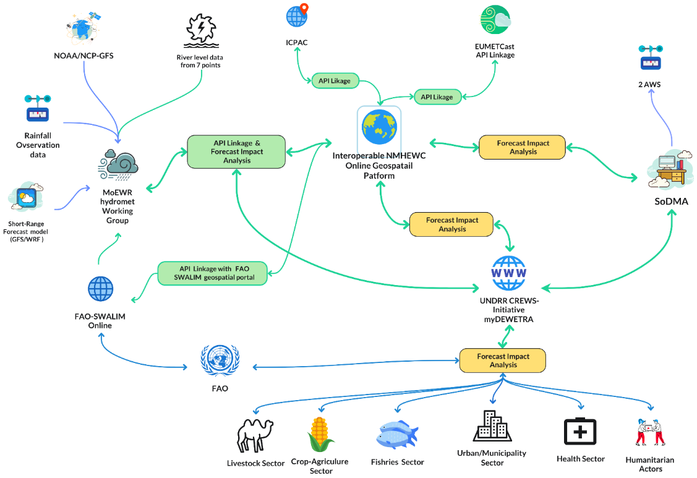
Figure 22 : Proposed interoperable NMHEWC system for all actors and stakeholders to work together

As illustrated in Figure 22 (Proposed interoperable NMHEWC system), the NMHEWC should be operationalized as a digitally connected hub with functional linkages to stakeholders through an online task management system, standardized procedures, and clear accountability for inputs and outputs.
The proposed interoperable model underscores that sector institutions must contribute data, analytical inputs, and operational collaboration to strengthen the end-to-end forecast-to-action value chain, including operational forecasting and impact forecasting. Priority recommendations include:
- Implement an ICT-based interoperable MHEWS/NMHEWC architecture: Establish an online platform that enables structured data ingestion, validation, analysis, product generation, approval workflows, and dissemination supported by role-based access and traceability to ensure that multiple actors can contribute to forecasting and early warning services in a coordinated manner.
- Strengthen homegrown short-range forecasting capacity: Build national capability to produce routine short-range forecasts (daily to weekly) with improved spatial and temporal resolution by leveraging CREWS-supported tools, training, and operational workflows. This includes strengthening forecast verification and operational procedures to improve reliability and user trust.
- Leverage the UNDRR-CREWS initiative for interoperable forecasting and EWEA: Utilize UNDRR-CREWS technical assistance to operationalize interoperable forecasting capability and strengthen Early Warning-based Early Action (EWEA) planning and implementation, including improved dissemination and decision-support products for sector actors and local authorities.
- Upgrade and expand FAO-SWALIM flood forecasting and warning services: Improve FAO-SWALIM’s current flood forecasting capability by strengthening model inputs, hydrological monitoring, and dissemination processes. Prioritize development of transboundary, data-driven flood forecasting and precision-level flood warnings for the Juba and Shabelle river basins, including upstream data-sharing arrangements and telemetry-based river monitoring where feasible.

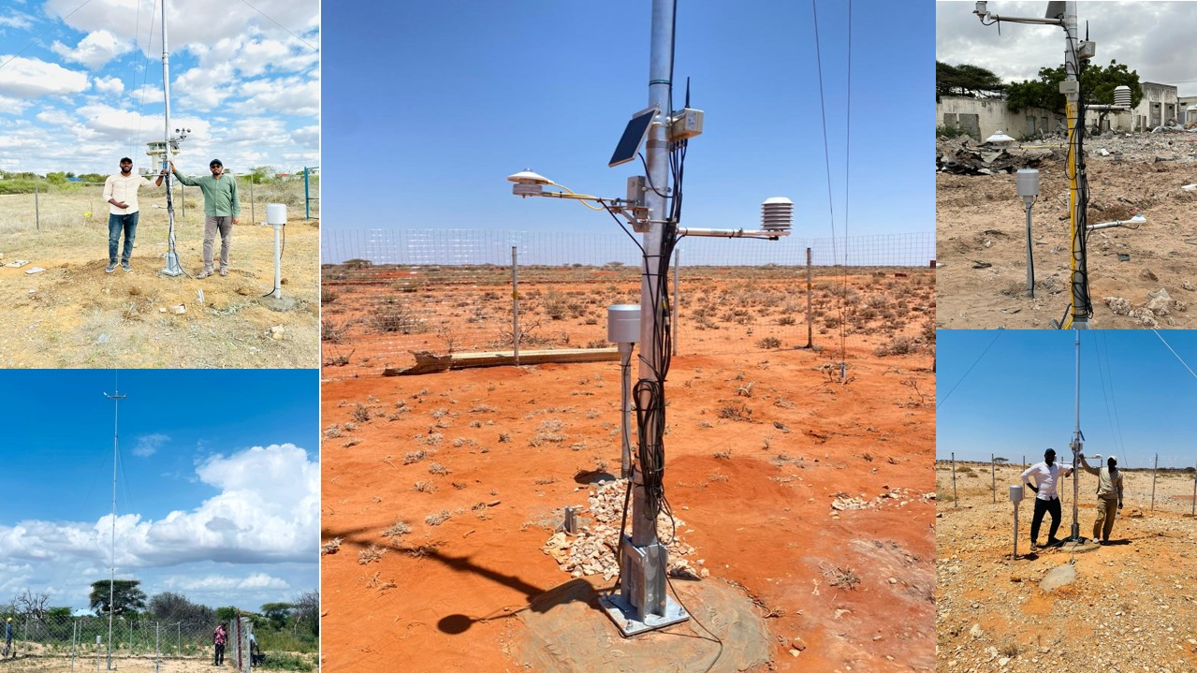

Figure 23: Some of the Hydro-met stations managed by the MoEWR

4.4 Recommendations on improving the sector-specific national forecasting service delivery :

To strengthen sector-specific forecasting and impact interpretation, Somalia should operationalize a hybrid approach that combines automated observations with structured crowdsourced reporting from last-mile stakeholders. This approach expands real-time situational awareness, improves detection of rapidly evolving hazards, and strengthens the IBF value chain for actionable advisories and early action.
- Mandate stakeholder participation in crowdsourced emergency reporting (state and non-state):
Establish district- and community-level crowdsourcing networks using mobile apps, web portals, WhatsApp, Telegram, Facebook, and structured reporting tools (KoboToolbox/ODK, SurveyMonkey or equivalent, GPS Logger, GPS Essentials). These networks should connect vulnerable groups and operational actors herders, smallholder farmers, communities, enterprises, CSO project teams, lead farmers, financial institutions, credit operators, mobile banking agents, insurance providers, and other relevant stakeholders to report onset weather conditions, element-level impacts, and event situation updates through interoperable NMHEWS applications and social networking tools.
- Institutionalize real-time tracking of hazard onset and evolving impacts:
Formalize the capture of human-reported observations and incident tracking for sudden-onset hazards that are already being monitored informally, including heavy rainfall-induced flash floods, sand and dust storms, thunderstorms, tornadoes, hailstorms, and other rapidly developing events. These reports should include geolocation, time stamps, hazard characterization, and observed impacts to support verification and impact analysis.
- Activate hybrid observation for convective and rapidly evolving systems:
Implement a hybrid , Sensor based observation mechanism (AWS , human-driven reporting) to support rapid detection and monitoring of convective storms and other fast-developing weather conditions, including damaging winds (extent and severity), sustained wind speed events, sand and dust storms, and localized extreme rainfall. This strengthens near-real-time monitoring and supports nowcasting and warning issuance.
- Deploy lightning detectors and complementary sensors near high-value elements:
Install lightning detection systems and other relevant AWS sensors to support Real-Time Detection (RDT) of convective activity and storm development near high-value and high-density elements such as cities and municipalities, improving rapid warning capability.
- Mandate trained volunteers for georeferenced event reporting:
Establish and task trained volunteer networks (including CPC/DMC focal points and community monitors) to remain alert during hazard seasons and to submit georeferenced incident and situation updates through standardized mobile workflows, supporting operational verification and improving the timeliness of warnings and response planning.

4.5 Recommendations on improving hydrometeorological services:

4.5.1 Establishment of an Independent National Meteorological Agency (NMA)

To sustain Pillar 2 implementation and improve national forecasting capability, Somalia should establish an independent National Meteorological Agency (NMA) mandated to operate as the national authority for meteorological services, supported by an integrated governance and financing model appropriate to the FCV context. The NMA should provide national leadership for observation network modernization, forecasting operations, and data governance, while maintaining formal operational linkages with SoDMA and sector ministries.
Key recommendations include:
- Joint operational governance and maintenance arrangements: Establish an operational framework in which key agencies MoEWR, SoDMA, MoAI, MoLFR, MoH, and MoFBE jointly support the NMA’s observation and service delivery functions. This should include coordinated responsibilities for upgrading existing hydromet stations to Realtime AWS dtrigven data ingestions; rehabilitating and automating manual stations; and installing and maintaining new AWS for the acquisition of Essential Climate Variables (ECVs).
- Formal linkages with regional and global operational centers: Develop formal technical and data exchange linkages with: WMO Regional Meteorological Centres (RMCs) and other WMO-designated specialized centers; regional and transboundary NMHS networks to strengthen upstream/downstream data sharing and improve forecasting for floods and severe weather.
- Provisioning of sustainable operational financing (NMHS budget line): Secure long-term operational budgets for NMHS functions (staffing, O&M, communications, calibration, spares, data systems, and continuity planning). Predictable financing is essential to avoid recurrent station downtime and to sustain 24/7 operational capability during hazard seasons.
- Installation and operationalization of satellite-based atmospheric observation capability: Operationalize real-time access to satellite and global forecast guidance through systems such as:
- PUMA 2025 satellite links and associated services; EUMETCast, ECMWF, and relevant European Met services products; complementary sources (e.g., NOAA and Indian Ocean monitoring products as applicable); and relevant networks supporting Basic Meteorological Data/Basic Hydro-Meteorological Data (BMD), including RBCN and hydrological observation networks such as GTN-R, where relevant.
- Strengthen national coordination and data exchange mechanisms: Improve national coordination for weather/climate information exchange by establishing: standardized data formats and metadata requirements; data submission and validation schedules; access rules and disclosure tiers (public vs restricted); and operational protocols linking MoEWR, SoDMA, sector ministries, and partners to the NMHEWS platform.
- MoUs and mandates for data sharing and operational collaboration: Develop and sign Memoranda of Understanding (MoUs) between federal ministries, sector departments, and key partners (including UN agencies, INGOs, and CSOs) to formalize: UNDP SOFF supported AWS observation network and impact data ingestions from the frontline; common alerting and dissemination responsibilities; validation roles during hazard events; and coordination arrangements for early action and response.
- Improve hydrological status and outlook services: Strengthen hydrological monitoring and outlook products by aligning national services with HydroSOS and leveraging CREWS-supported technical components and capacity building to improve flood forecasting readiness and drought monitoring.
- Deploy a GBON-compliant high-density AWS network:
Install and operate a network of GBON-standard AWS with adequate spatial density to observe ECVs across Somalia, including:
  - reliable telemetry/data transmission supported by UNDP SOFF, WMO ;
  - routine calibration and maintenance; and quality control and archiving systems that enable forecast verification and improved nowcasting.
- Integrate hybrid observation sources for nowcasting and impact monitoring:
Complement the formal network with structured “hybrid” observation inputs to improve real-time situational awareness and point-based services. This includes systematic, georeferenced reporting from:
  - livestock herders and smallholder crop-agriculture farmers, fishermen, agroforestry ;
  - marketplaces and value chain operators;
  - cities, municipalities, and towns;
  - ports and other high-value nodes; and agreed key performance indicators (KPIs) relevant to nowcasting and operational forecasts.

4.5.2 Improving homegrown short-range forecasting Capacity:

The table narrates how to improve forecasting capabilities as advised in the following.

Forecast product/input stream | Forecast input data | Data provider(s) | Forecast preparation (Met Agency / NMHEWC) | Impact forecast analytics (sector departments) | Forecast dissemination support
Atmospheric observations / ECVs (for routine forecasting and monitoring) | Essential Climate Variables (ECVs) and atmospheric observation products | - Installation of PUMA 2025; REST API Data acquisition form ECMWF (ERA5 / operational products as applicable), EUMETCast; NOAA-CPC (netCDF), ICPAC  - Access ECMWF-produced synoptic charts and gridded forecast parameters (access in netCDF) as a core forecast input stream for national short-range forecasting, nowcasting support, and downstream impact analytics. These datasets should be ingested via the NMHEWS integration layer into the operational data repository, standardized (metadata, projection, time-step), and made available to the Met Agency/NMHEWC forecasting team and sector departments for sector-specific interpretation and IBF workflows (subject to ECMWF access and data-use arrangements). | MoEWR (hydromet working group); SoDMA (CREWS-supported forecasting/analysis functions); regional forecasting institutes / RSMC guidance; SoDMA forecast analysis team | MoEWR; SoDMA; MoAI; MoLFR; MoH; MoFBE | National broadcasters (mandated by NCA); national telecom operators (mandated by NCA SMS/IVR/cell broadcast); MoEWR geospatial portal; SoDMA geospatial portal; central forecast portal (proposed: www.weather.gov.so);  Weather apps, warming apps, and alerting apps,  myDEWETRA platform
Operational flood forecasting | Flood model inputs and observations (AWS rainfall; river sensor/river level; NWP guidance) | GloFAS, Global Flood Monitor, Flood Risk (GAR); AWS; river sensor data; GFS/WRF guidance; GloFAS; ICPAC products. | FAO-SWALIM operational flood forecast unit; myDEWETRA Flood Risk (GAR) under CREWS; GloFAS products; ICPAC hydromet guidance | MoEWR; SoDMA; MoAI; MoLFR; MoH; MoFBE | National broadcasters (mandated by NCA); telecom operators (mandated by NCA); MoEWR/SoDMA portals (maps and bulletins); GloFAS flood dashboards; targeted dissemination to riverine districts via CPC/DMC networks
Nowcasting (0-6/12 hours; severe convective and rapid-onset events) | Rapid update of remote sensing and high-frequency observation products | Meteo-France RDT; EUMETCast RDT; myDEWETRA/GSMap; point-based AWS ECV observations (cities/municipalities/IDPs/towns); PUMA 2025 | MoEWR hydromet working group; SoDMA forecast analysis team / Situation Room | MoEWR; SoDMA; MoAI; MoLFR; MoH; MoFBE (interpretation of sector implications; hotspot verification) | Multi-channel rapid alerts: SMS/IVR/cell broadcast; WhatsApp/Telegram groups; national radio/TV cut-ins; municipal/city public address where available; NMHEWS app push alerts; CPC/DMC relay mechanisms
Impact forecasting (IBF hazard × exposure × vulnerability) | ECVs , NWP guidance , remote sensing , risk repository layers | Point-based AWS ECV data (cities/municipalities/IDPs/towns); myDEWETRA; PUMA 2025; ECMWF (ERA5/operational); EUMETCast; Meteo-France RDT; EU/global forecast models; NOAA-CPC (netCDF); ICPAC | MoEWR hydromet working group; SoDMA forecast analysis team / NMHEWC | MoEWR; SoDMA; sector ministries (MoAI, MoLFR, MoH, MoFBE) using CRVA repositories and element inventories for impact interpretation | Impact-based advisories and maps via: SoDMA/MoEWR portals; central forecast portal (www.weather.gov.so proposed); myDEWETRA; targeted dissemination to sectors and local governments; telecom/broadcaster dissemination (NCA-mandated); CPC/DMC and humanitarian partner distribution lists

4.5.3 Improving Impact Forecasting Capacity :

Develop capacity enactment plans for the IBF mandated NMHS organizations

Capacity Enactment Plan for IBF-Mandated NMHS Organizations This capacity enactment plan outlines the minimum institutional, technical, and operational requirements for NMHS/NMA and NMHEWC structures to deliver routine Impact-Based Forecasting (IBF) and translate forecasts into actionable advisories for sectors and last-mile stakeholders in Somalia’s FCV context.

- Objective and scope of IBF improvements :

Establish a functional IBF capability that integrates hazard forecasts, exposure/vulnerability, sector thresholds, and dissemination to produce decision-ready impact advisories and triggers for Early Warning-based Early Action (EWEA).

Scope: NMHS/NMA (forecast authority), NMHEWC (operations hub), MoEWR/SoDMA forecasting teams, and sector ministries (MoAI, MoLFR, MoH, MoFBE, WASH/water actors) as mandated impact interpretation partners.

- Minimum IBF operating model (end-to-end)

A. Inputs (data readiness)
- Hazard inputs: NWP guidance (e.g., GFS/WRF), satellite/RDT products, ECMWF charts/netCDF, river/flood monitoring data, and AWS observations where available.
- Context inputs: CRVA repositories, element inventories (georeferenced), SADD and baseline statistics, sectoral elements specific historical L&D records.
- Ground-truth inputs: CPC/DMC surveillance and structured surveys should be enabled through mobile applications, complemented where feasible by drone-based rapid assessment, and reinforced by stakeholder and value chain operator crowdsourced event reports that are geotagged and app-captured. All such community- and partner-generated observations should be ingested into the Online IBF Platform and validated through a role-based administration and data verification interface ensuring that submissions are quality-tagged (e.g., unverified/verified/confirmed), traceable to the submitting entity, and approved through designated validation structures before being published for operational use.

Deliverable: A standardized data ingestion and governance layer should be established to support IBF operations, comprising mobile-app reporting, IoT sensor feeds, and drone-derived rapid assessment inputs, integrated through a unified interface into the NMHEWS/IBF platform. This layer should include:
- a data catalog that defines each dataset/source, its custodian, access level, and intended operational use (IBF analytics, situational awareness, verification, L&D tracking);
- role-based responsibilities (who can submit, review, validate, approve, and publish);
- update frequency requirements (routine vs hazard-season vs event-onset reporting cadences);
- quality control (QC) and validation rules, including automated checks and human validation workflows; and
- filtered, purpose-built repositories that separate (i) IBF inputs (hazard, exposure, vulnerability, L&D), (ii) operational monitoring/nowcasting feeds, and (iii) public warning outputs, including CAP (Common Alerting Protocol) compliant alert records for standardized warning issuance and dissemination.

B. Impact analytics (IBF engine)
- Hazard thresholds mapped to sector impact thresholds (e.g., rainfall intensity , flood impacts; heat index , livestock stress).
- GIS overlay of hazard layers with exposure/vulnerability layers (sector elements).
- Simple Multi-Criteria Decision Analysis - MCDA/impact scoring to rank hotspots and estimate likely impact classes.

Deliverable: A repeatable “impact interpretation workflow” embedded in NMHEWC SOPs.

C. Products (decision support)
- Impact bulletins: Advisory on impending hazard, affected elements , severity class , recommended actions , lead time.
- Operational forecast maps: hotspot maps, risk ranking, affected populations/assets.
- Triggers: pre-agreed thresholds that activate anticipatory action and standing orders.
Deliverable: Standardized product templates, bilingual formats where needed, and sector-specific advisories.

D. Dissemination and feedback loop
- Multi-channel dissemination (telecom, broadcasters, apps, WhatsApp/IVR/SMS).
- Feedback capture (receipt confirmation, ground impacts, false alarm/verification).
Deliverable: SOPs and MoUs for dissemination accountability and feedback integration.

- Capacity enactment workstreams

Workstream 1 : Institutional mandate and governance
- Formalize NMHS/NMA authority to issue national forecasts/warnings and IBF advisories.
- Establish an IBF Technical Working Group and Sector Impact Cells (MoAI, MoLFR, MoH, MoFBE/WASH).
- Approve IBF data-sharing MoUs and publication rules (public vs restricted layers).
Outputs: mandate note, governance structure, MoUs, roles and responsibilities matrix.

Workstream 2 : Human resources and competency development

Core NMHEWC roles (minimum):
- Meteorologists/forecasters (shift-based), hydrologist/flood analyst, nowcasting specialist
- GIS/remote sensing specialist, impact analyst, risk communicator
- Data engineer/database admin, platform/ICT engineer

Training package (ToT , mentoring):
- IBF methods and thresholds; GIS overlay and MCDA; forecast verification
- CAP-style alerting and message design; sector advisory writing
- Operational shift procedures and incident lifecycle management
Outputs: competency framework, training calendar, surge roster.

Workstream 3 : CRVA and element registry enablement (sector preparedness)

- Define a national minimum dataset for sector element inventories (geolocation , attributes).
- Establish CRVA update cadence and validation (monthly baseline; weekly during hazard season).
- Link L&D reporting to the same element registry for learning and calibration.

Outputs: element schema, sector data templates, update protocol.

Workstream 4 : Impact thresholds and advisory triggers
- Co-develop sector thresholds with technical stakeholders (e.g., crop stress, livestock heat stress, WASH disruption).
- Define trigger levels for EWEA actions and standing orders (SoD/SoP).
Outputs: threshold library, trigger matrix (hazard × sector × severity × action).

Workstream 5 : Tooling and interoperability (platform readiness)
- Implement a geospatial portal and dashboards (role-based access, traceability).
- Enable ingestion of netCDF/gridded products and CSV point observations.
- Integrate crowdsourcing channels with QC tagging (unverified/verified/confirmed).
Outputs: operational IBF dashboard, APIs/data connectors, audit trail.

Workstream 6 : Operations, SOPs, and quality management
- SOPs for: forecasting cycle, impact analysis, approval, dissemination, incident tracking, after-action review.
- Forecast verification and post-event learning (monthly scorecards; event debriefs).
Outputs: SOP manual, verification reports, continuous improvement log.

- Phased rollout (capacity enactment sequence)

Phase 0-6 months: Minimum viable IBF
- Establish governance, SOPs, and launch 2-3 pilot hazards (flood, heat, drought).
- Operationalize sector impact cell for agriculture, livestock, WASH/water.
- Release first impact bulletins and hotspot maps; test dissemination and feedback.
Phase 6-18 months: Scale and institutionalize
- Expand observation inputs (hybrid reporting, priority AWS/river points).
- Expand sector registries and thresholds nationally; implement verification routines.
- Integrate IBF triggers into anticipatory action protocols and 5W dashboards.
Phase 18-36 months: Mature IBF service
- Full product suite (nowcast to seasonal risk outlooks) and stable O&M financing.
- Refine thresholds using L&D learning; stronger probabilistic products and uncertainty communication.

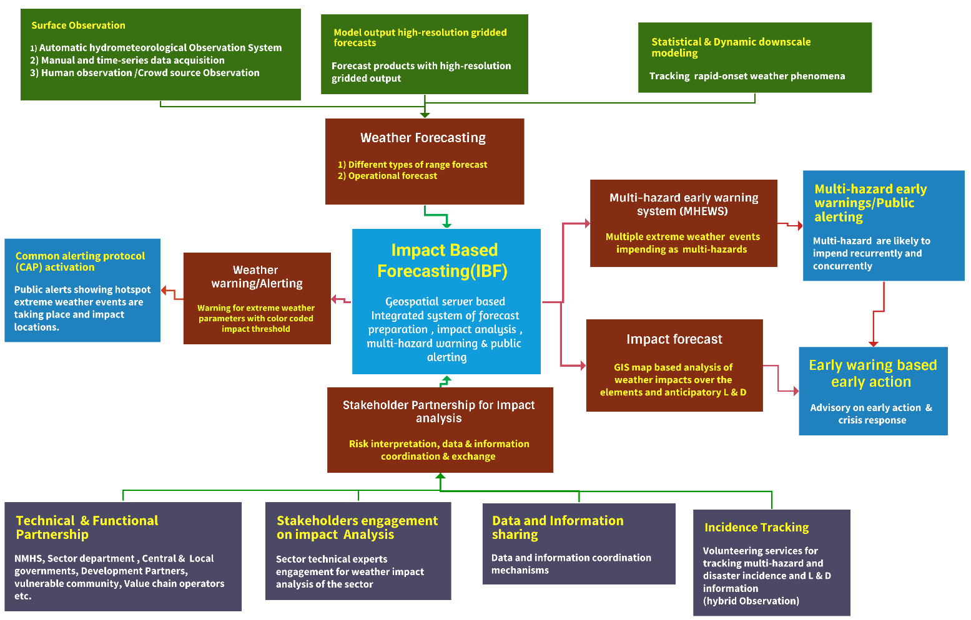
Figure 24 : Proposed Impact-based Forecasting (IBF) Framework

4.5.4 Improving Sector-level Impact Forecast and Operational Forecast:

Table: Forecast requirements for Somalia
Forecasts | Sector | Purpose | Comments
Seasonal forecasts, monthly forecasts, monthly, decal, weekly, at spatial and temporal scales | - Crop Agricultural Sector  - Water Sector  - Livelihood Food Security  - IDP Settlements  - WASH sector  - Fisheries sector | - Sector Preparedness Plan  - Risk-informed sector-level planning  - DRR, CCA Planning  - Livestock sector, Water Sector, WASH sector, crop-agriculture, livelihood, food security sector planning. | EAP, EWEA, EWAA, SoP, SoD, EA , FbF, IBF
Forecasting Rapidly Developing Thunderstorm (RDT), heavy rainfall, storm wind, tornadoes, Dust & sand storms | - Crop Agricultural Sector  - Water Sector  - Livelihood Food Security  - IDP Settlements  - WASH sector  - Fisheries sector | Thunderstorm-based operational forecasts (CAPE, trough, Airmass, Air-vapor, RH, lightning), what is the probability of heavy rainfall
Cyclone early warning system | - Crop Agricultural Sector  - Water Sector  - Livelihood Food Security  - IDP Settlements  - WASH sector  - Fisheries sector | - Impact forecast for cyclone early warnings  - Impact forecast for deep-sea fishing  - Impact forecast for Coastal City, a municipality for forecast-based emergency preparedness
Food security early warning | - Crop Agricultural Sector  - Water Sector  - Livelihood Food Security  - IDP Settlements  - WASH sector  - Fisheries sector | - Impact forecast for Food security Impact forecast
Famine early warning | - Crop Agricultural Sector  - Water Sector  - Livelihood Food Security  - IDP Settlements  - WASH sector  - Fisheries sector | Impact forecast for Famine
Drought early warning | - Crop Agricultural Sector  - Water Sector  - Livelihood Food Security  - IDP Settlements  - WASH sector  - Fisheries sector | Impact Forecast for Drought
Livestock sector early warning system | - Livestock sector | Impact forecast for Livestock

4.5.5 Improving the borehole/water monitoring system:

ICT-based borehole and water point monitoring for Somalia groundwater security
Strengthening Somalia’s groundwater monitoring is essential for protecting drinking water access under increasing rainfall variability, recurrent dry/hot spells, and drought conditions. While satellite-enabled automated monitoring is already being used for a limited subset of boreholes, expanding coverage and standardizing data acquisition are critical to determining the functional status of drinking water points nationwide and to strengthening early warning and anticipatory action for the water and WASH sectors.

Key rationale :
- In drought-prone and arid contexts, groundwater tables can decline rapidly, causing boreholes to become non-functional. Continuous monitoring of groundwater levels and water quality is therefore necessary to support water security, service continuity, and livelihoods.
- Monitoring data also enables forecasting and scenario analysis of extreme weather impacts on water supply systems, informing early action (e.g., water trucking triggers, rehabilitation prioritization, demand management).

Recommendations :
1) Expand groundwater table and water quality monitoring coverage
- Scale monitoring beyond limited sites by prioritizing boreholes in:
  - drought hotspot districts and IDP-serving systems;
  - high-demand urban and peri-urban corridors; and
  - strategically important rural water points supporting pastoral migration routes.

2) Install standardized instruments and define minimum parameters
- Install groundwater level instruments (e.g., pressure transducers/water level loggers) and basic water quality sensors or field-testing protocols.
- Establish a minimum parameter set, typically including:
  - water level (groundwater table depth), pumping status/run time (where feasible);
  - EC (salinity proxy), turbidity (where feasible), and periodic bacteriological testing through field kits/lab pathways;
  - functionality status (working/partially working/non-functional) and downtime reasons.
3) Automate data transmission to a central server through ICT tools
- Use telemetry options appropriate to the location and cost profile (cellular where available; satellite where required).
- Enable a mobile-app workflow for local operators/CPC/WASH teams to:
  - submit maintenance events, outages, and manual readings;
  - attach geotagged photos and notes; and
  - validate sensor anomalies through structured checklists.
4) Integrate borehole monitoring into NMHEWS/IBF decision support
- Ingest borehole monitoring data into the IBF platform as a water/WASH “impact layer” that supports:
  - drought impact monitoring (declining tables, rising salinity, increasing downtime);
  - trigger setting for anticipatory actions (e.g., pre-positioning fuel/spares, water trucking, rationing advisories); and
  - prioritization of rehabilitation and maintenance using risk ranking and service criticality.
5) Develop forecast-informed WASH and water sector advisories
- Use combined inputs rainfall outlooks, temperature anomalies, drought indices, and groundwater trends to generate:
  - early warnings for water point failure risk;
  - district-level water stress maps; and
  - operational advisories for WASH actors and local authorities.
This approach enables Somalia to move from episodic, reactive water-point reporting to a continuous, ICT-enabled monitoring system that supports early warning, anticipatory planning, and resilient water service delivery

4.5.6 Sector datasets for IBF impact analysis: Water points and WASH elements

Sector | Elements | Stakeholders / data custodians to provide datasets for forecast impact analysis | Tools for data collection and updates
Water points / Boreholes | - Drinking water boreholes  - Solar PV-powered water points | - MoEWR inventory and GIS location maps  - UNICEF WASH Cluster datasets; MICS; school WASH databases  - IOM DTM (population and displacement context)  - FAO borehole databases  - FAO automated monitoring (Iridium satellite-connected borehole monitoring where available)  - UNHCR, WFP, UNDP and other UN agencies (operational water point inventories where applicable)  - FAO-SWALIM (hydrological context layers)  - SoDMA (risk and emergency coordination layers)  - Sector links for impact interpretation: Agriculture development, Livestock department  - City corporations / municipalities  - INGOs/implementing partners (IPs) | - Mobile apps (standardized forms)  - GPS survey / geotagging  - App-based surveys (KoboToolbox/ODK)  - Sensor/telemetry feeds where installed (cellular/satellite)
WASH | Dug wells | - FAO dug well inventories  - MoEWR dug well inventories  - INGO/IP dug well databases  - CSO/NGO dug well inventories  - UNICEF WASH Cluster; MICS; school WASH databases  - IOM DTM  - UNHCR/WFP/UNDP and other UN agencies (where applicable) | - Mobile apps (standardized forms)  - GPS survey / geotagging  - KoboToolbox/ODK routine updates
WASH | Rainwater harvesting facilities | - MoEWR inventory and GIS maps  - UNICEF WASH Cluster; MICS; school WASH databases  - IOM DTM  - UNHCR/WFP/UNDP and other UN agencies  - City/municipality records; INGO/IP inventories | - Mobile apps  - GPS survey  - KoboToolbox/ODK routine updates
WASH | Open water bodies used for household treatment (community sources) | - MoEWR inventory and GIS maps  - UNICEF WASH Cluster; MICS; school WASH databases  - IOM DTM  - UN agencies operational datasets (UNHCR/WFP/UNDP) | - Mobile apps  - GPS survey  - KoboToolbox/ODK routine updates
WASH | Coastal desalination facilities (drinking water supply) | - MoEWR inventory and GIS maps  - UNICEF WASH Cluster; MICS; school WASH databases  - IOM DTM  - UN agencies operational datasets (UNHCR/WFP/UNDP)  - City/municipality and operator records (public/private) | - Mobile apps  - GPS survey  - KoboToolbox/ODK routine updates  - Operator logs (production/downtime) integrated via forms/API where feasible
WASH | Surface water treatment facilities (drinking water supply) | - MoEWR inventory and GIS maps  - UNICEF WASH Cluster; MICS; school WASH databases  - IOM DTM  - UN agencies operational datasets (UNHCR/WFP/UNDP)  - City/municipality utility records | - Mobile apps  - GPS survey  - KoboToolbox/ODK routine updates  - Facility operation logs (capacity/downtime) integrated via forms/API where feasible
WASH | Sanitation points (community and IDP level) | - MoEWR inventory and GIS maps  - UNICEF WASH Cluster; MICS; school WASH databases  - IOM DTM  - UN agencies operational datasets (UNHCR/WFP/UNDP)  - City/municipality sanitation records  - INGOs/IPs and CSOs implementing WASH | - Mobile apps  - GPS survey  - KoboToolbox/ODK routine updates  - Rapid assessment checklists during flood events

- Improving Crop Agricultural agro-climate forecasting and early warning :

Challenges
- High variability in precipitation patterns including recurrent dry spells and drought combined with high temperatures and water stress, accelerates land degradation and environmental stress. These conditions contribute to water shortages, reduced crop performance, and spillover impacts on livestock and livelihoods.
- Severe food insecurity and famine risk are strongly linked to climate variability and shocks, underscoring the need for robust agro-climate early warning and anticipatory action systems.

Recommendations
- Leverage UNDRR-CREWS to strengthen NMHS agro-climate services:
Use UNDRR-CREWS technical assistance to enhance the agro-climatic forecasting and early warning capacity of the NMHS functions delivered through SoDMA and MoEWR, including the development of sector-relevant agro-meteorological products and operational workflows.
- Develop and institutionalize CRVA methodology for the crop agriculture sector:
Establish a standardized Climate Risk and Vulnerability Assessment (CRVA) methodology, tools, and guidelines tailored to crop agriculture and livelihood systems. Conduct crop-sector CRVA and livelihood hazard/vulnerability assessments to generate actionable, georeferenced datasets that feed IBF analytics and advisories.
- Strengthen the Early Warning Early Action CBA linkage:
FAO, WFP, INGOs, and CSOs should jointly analyze and operationalize the links between early warning, early action, and community-based adaptation (CBA) so that anticipatory action triggers, adaptive livelihood measures, and DRM planning are aligned and mutually reinforcing.
- Localize and integrate FAO’s GIEWS for Somalia through the interoperable MHEWS platform:
FAO should localize the Global Information and Early Warning System on Food and Agriculture (GIEWS) for Somalia and anchor it within an ICT-enabled online database and geospatially interoperable MHEWS. This should connect smallholder farmers, vulnerable communities, value chain operators, sector departments, and non-state actors, supporting (at minimum) the following functions:
  - agro-climate monitoring and seasonal progress tracking;
  - crop condition and water stress surveillance (ground reports , remote sensing);
  - early warning triggers for dry spell/drought impacts on crops and livelihoods;
  - production and dissemination of localized agro-advisories (planting windows, irrigation scheduling, pest risk); and
  - feedback loops from farmers and extension networks to validate advisories and improve forecast usefulness.
The FAO needs to localize the Global Information and Early Warning System on Food and Agriculture (GIEWS) for Somalia and anchor GIEWS with an ICT-based online database and geospatial interoperable MHEWS, connecting smallholder farmers, vulnerable communities, value chain operators, state (sector department), and non-state actors for supporting the following;

- Crop Agriculture and Value Chain Elements Matrix for Agro-Climate IBF

Type of elements | Geolocation (Lat/Long) | Exposure (weather/climate parameters) | Risk (likely L&D pathways) | Vulnerability (coping/withstanding capacity) | Forecast & warning required | Impact forecast required | Responsible entities for forecasting / IBF
Crop agriculture sector (general cropland blocks) | Crop-land geolocation (field boundary or centroid) to track agricultural blocks | Rainfall anomaly, dry spell duration, Tmax/heat index, wind, storms, flood inundation, humidity (disease), evapotranspiration (ET) | Yield loss, crop failure, erosion/siltation, water shortage, pest/disease outbreak risk, infrastructure damage | Irrigation access, water storage, drought-tolerant varieties, soil health, access to inputs, labor, finance | Agro-meteorological forecast (daily); short-range operational forecast (1-7 days); weather warnings/CAP | Impact advisories: crop stress alerts; dry spell triggers; flood/erosion impact; pest/disease risk (where feasible) | MoEWR / NMHS (SoDMA-NMHEWC) for hazard forecasts & CAP; MoAI , FAO/WFP , INGOs/CSOs for impact interpretation, advisories, and outreach
Seedling nurseries / permanent seedling areas | GPS point/polygon of nursery sites | Heat stress, dry spell, wind damage, heavy rain/waterlogging, pest/disease conducive humidity | High mortality, transplant failure, nursery loss | Shade, irrigation reliability, protective structure, seed quality, pest control | Daily agro-forecast; nowcast alerts for storms/winds; CAP warnings | Nursery survival risk index; irrigation advisory; wind/storm protection advisory | NMHS for forecasts/CAP; MoAI/FAO for impact advisories; farmer reporting via apps
Sapling areas (permanent) | GPS of sapling zones | Heat/dry spell, wind, heavy rain/waterlogging | Sapling mortality, growth retardation | Water access, mulching, windbreaks, fencing, pest control | Daily agro-forecast; CAP | Sapling stress advisory; survival probability classes | NMHS , MoAI/FAO; farmer reporting via apps
Horticulture zones (vegetables, high-value crops) | GPS of horticulture plots | Heat spikes, humidity (disease), heavy rainfall, wind, hail | Quality loss, spoilage, disease outbreak, yield loss | Irrigation, protected cultivation, drainage, pesticide access, cold chain access | Daily agro-forecast; nowcasting for convection; CAP | Disease risk advisories; harvest timing; flood/waterlogging impact | NMHS , MoAI/FAO/WFP/partners; farmer reporting
Soil health / soil moisture monitoring points | Fixed GPS monitoring points (sentinel sites) | Dry spell length, ET, Tmax, rainfall deficit, wind | Crop stress escalation, reduced germination, land degradation | Soil organic matter, mulching, conservation practices, irrigation | Daily agro-forecast; dry spell alerts; CAP | Soil moisture stress classes; irrigation scheduling advisory | NMHS for hazard; MoAI/FAO for advisories; farmers/extension upload observations
Rainfed croplands (maize, paddy, etc.) | GPS of rainfed blocks | Rainfall onset/cessation, dry spells, heavy rainfall/flood | Germination failure, crop failure, flood damage, yield loss | Variety selection, planting calendar, soil water retention, access to extension | Daily agro-forecast; 7-14 day outlook; CAP | Planting window advisory; dry spell trigger; flood impact class | NMHS , MoAI/FAO/WFP; farmer reporting via apps
Irrigation-dependent crops | GPS of irrigated blocks , irrigation source | River level/flow risk, rainfall deficit, heatwaves, flood | Water shortage, irrigation disruption, crop stress, flood damage | Pump availability, fuel/power, canal condition, water governance, storage | Daily agro-forecast; flood warnings/CAP | Irrigation disruption risk; water shortage trigger; crop stress mapping | NMHS , MoEWR , MoAI/FAO; operators upload status
Agroforestry systems | GPS polygons of agroforestry blocks | Drought/heat, strong winds, storm damage | Tree mortality, reduced productivity, erosion | Species diversity, water access, protection | Daily agro-forecast; CAP | Agroforestry stress advisory; wind/storm damage risk | NMHS , MoAI/FAO; farmer reporting
Fruit gardens / orchards | GPS polygons of orchard blocks | Heat, humidity (fungal), wind, storms | Fruit drop, quality loss, disease, infrastructure damage | Irrigation, canopy management, pest control, protective measures | Daily agro-forecast; nowcast; CAP | Fruit drop risk; disease risk; harvest timing | NMHS , MoAI/FAO; farmer reporting

Value chain elements (agriculture-related)

Type of elements | Geolocation (Lat/Long) | Exposure (weather/climate parameters) | Risk (likely L&D pathways) | Vulnerability (coping/withstanding capacity) | Forecast & warning required | Impact forecast required | Responsible entities for forecasting / IBF
Input supplier depots | GPS of depots and service areas | Flooding, storms/winds, access disruption | Stock loss, delayed input supply, price spikes | Storage condition, contingency stocks, logistics redundancy | Operational forecast; CAP | Access disruption advisory; supply risk alert | NMHS for hazard; MoAI/partners for sector advisories; operators report disruptions
Wholesale/output markets | GPS of markets | Flooding, heat, storms | Market closure, spoilage, price volatility | Cold chain access, drainage, shelter, transport redundancy | Operational forecast; CAP | Market disruption advisory; price-risk early signal (optional) | NMHS , sector partners; operators report
Cold storage facilities | GPS points , capacity | Heatwaves, power disruption, flooding | Spoilage, downtime, stock loss | Backup power, insulation, drainage, maintenance | Operational forecast; CAP | Cold-chain risk alert; power outage contingency advisory | NMHS , local authorities/sector partners; operators report
Storage warehouses/godowns/silos (CSD) | GPS points , capacity | Flooding, humidity, storms | Stock damage, contamination, access disruption | Elevated storage, drainage, pest control, insurance | Operational forecast; CAP | Flood/stock risk advisory; access disruption alert | NMHS , sector partners; operators report
Certified seed agencies | GPS points | Flooding, heat, humidity | Seed viability loss, service disruption | Temperature control, packaging, backup power | Operational forecast; CAP | Seed storage risk advisory; logistics disruption | NMHS , MoAI/partners; operators report

Standard data contribution rule :
Farmers and value chain operators submit exposure/impact observations via mobile apps (geotagged, time-stamped).
- NMHS/NMHEWC (MoEWR/SoDMA) produces hazard forecasts and CAP warnings; MoAI/FAO/WFP and partners lead sector impact interpretation and agro-advisories using CRVA repositories.

4.5.7 Improving Water sector Operational & impact-based forecasting:

Indicative Challenges :
- Limited CRVA and sector repository: The water sector lacks systematic climate risk and vulnerability assessments and a dedicated repository for tracking and monitoring surface water bodies, groundwater conditions, rainfall variability, and hydrometeorological anomalies that drive water stress and service disruptions.
- Weak transboundary data exchange: There are no robust data-sharing MoUs with upstream Ethiopian and Kenyan hydrological and meteorological services for river flows, reservoir operations, groundwater levels, lake levels, and soil moisture conditions across shared catchments limiting lead time for flood and drought early warning.
- Absence of integrated hydro-meteorological early warning and forecasting: Operational and impact-based forecasting remains fragmented, with limited integration between hydrological monitoring, meteorological forecasting, and decision-support products for water resource management.

Recommendations (Water Sector EWS and IBF) :

Purpose and scope Objective: Establish a standardized Climate and Multi-Hazard Risk & Vulnerability Assessment (CRVA) methodology and a georeferenced, asset-based repository for the water sector that supports: baseline risk profiling (persistent risk and vulnerability), operational monitoring (functionality and climate stress), and Impact-Based Forecasting (IBF) with anticipatory action (hazard × exposure × vulnerability > likely disruptions and L&D).
Coverage: surface water systems (rivers, canals, lakes, reservoirs, wetlands); groundwater systems (monitoring points, boreholes, springs, wells); water service infrastructure (treatment plants, desalination plants, piped networks, pumping stations, storage); and community water points, especially those serving IDPs and vulnerable settlements.

4.5.7.1 Develop Climate Risk and Vulnerability Assessment (CRVA) workflow :

Step 1 : Define system boundary and assets: establish administrative boundaries (member state > district > settlement/IDP site) and compile/validate the water asset inventory (minimum datasets and schemas below).
Step 2 : Hazard characterization: classify priority hazards and extract parameters from forecast/monitoring sources, including drought/rainfall deficit (SPI/SPEI, rainfall anomaly, evapotranspiration proxies), flood/flash flood (river stage where available, catchment runoff indicators, extreme rainfall thresholds), cyclone/storm surge in coastal areas (wind and surge proxies, wave conditions where available), heatwave (max temperature thresholds affecting demand, pumping efficiency, water quality), and water quality risks (salinity intrusion in coastal areas, turbidity spikes during floods using proxy indicators).
Step 3 : Exposure analysis: identify assets/populations within hazard footprints (buffers, floodplains, coastal surge zones, drought-affected livelihood zones) and quantify exposed service demand (population served, IDP counts, seasonal variations).
Step 4 :Vulnerability analysis (asset-based): assess susceptibility and coping capacity using a standardized scoring rubric covering structural/technical vulnerability (design, redundancy, protection), operational vulnerability (O&M capacity, energy dependency, spare parts), institutional vulnerability (mandate, staffing, financing, data reporting), and social vulnerability (SADD, poverty, displacement status, access constraints).
Step 5 : Risk scoring and hotspot mapping: compute risk for each asset and service area using: Risk = Hazard likelihood/intensity × Exposure × Vulnerability ÷ Coping capacity; produce risk ranks (Very High/High/Medium/Low), district hotspot maps, hazard calendars, and “service disruption likelihood” maps (water point functionality risk).

4.5.8 Operationalize an integrated hydro-meteorological EWS through the interoperable MHEWS

FAO-SWALIM, MoEWR, and SoDMA should jointly operationalize an interoperable MHEWS for water-sector early warning by integrating surface-water stress monitoring (rainfall anomalies/runoff/river levels), groundwater and borehole tracking, and water-point functionality (including IDP/WASH infrastructure). The system should automate data ingestion with standardized geo-referenced, time-stamped datasets, apply basic QA/QC, and publish layers via REST APIs and OGC services for partner use. At minimum, it should produce routine daily/weekly hydromet summaries, flood risk bulletins, drought/water-stress advisories, and district-level water service disruption risk maps, with clear thresholds linked to anticipatory actions and multi-channel dissemination supported by role-based access, audit trails, and dissemination logs.

4) Establish transboundary hydrological data sharing arrangements
- Prioritize formal MoUs and operational protocols with Ethiopian and Kenyan NHMS/NMHS counterparts for:
  - upstream rainfall and flood signals;
  - river flow/level monitoring and reservoir releases;
  - soil moisture and catchment saturation indicators; and
  - agreed data exchange frequency during flood seasons.
- Implement structured “minimum transboundary dataset” requirements and escalation thresholds to protect downstream communities.

5) Align early warning with early action and community-based adaptation (CBA)
- FAO, WFP, INGOs, and CSOs should jointly analyze and operationalize the link between early warning > early action > CBA in water programming, including:
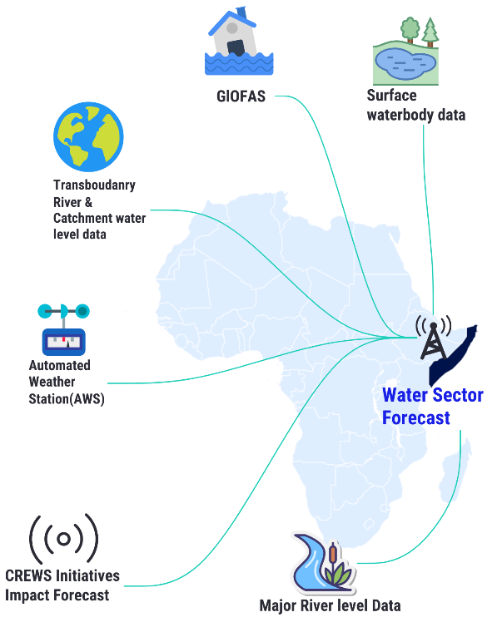
  - anticipatory maintenance/rehabilitation triggers;
  - pre-positioning of treatment chemicals/spares/fuel;
  - contingency water trucking planning; and
  - demand management and community advisories.

6) Anchor FAO drought services and related portals into NMHEWS/MHEWS
- Integrate the FAO drought portal into the interoperable MHEWS as a decision-support input for drought monitoring and water stress analysis, ensuring consistent use of geospatial layers and shared interpretation protocols.

7) Integrate GIEWS localization with water-sector early warning where relevant
- Localize FAO’s GIEWS for Somalia and anchor it within the ICT-based online database and geospatially interoperable NMHEWC/MHEWS so that water stress signals can be linked to food security risk and livelihood impacts particularly for irrigation-dependent cropping zones and drought-affected pastoral areas.

Figure 25: Water sector Operational & impact forecasting

4.5.9 Improving Livestock Sector Impact Forecasting

What are the indicative Challenges:

- No livestock-sector CRVA and element repository: There is limited climate risk and vulnerability assessment (CRVA) coverage and no comprehensive livestock element-specific repository (herd concentrations, grazing areas, migration routes, water points, animal health status) to support impact forecasting and anticipatory action planning.
- Escalating climate stress on pastoral systems: Precipitation variability, extreme temperatures, heatwaves, dry spells, recurrent drought, and drying water bodies contribute to rangeland degradation, water scarcity, and persistent stress on pastoral livelihoods, reducing herd productivity and resilience.
- Severe drought impacts on food security and herd health: Drought conditions reduce pasture and water availability, increasing morbidity, disease outbreaks, and mortality among livestock directly undermining household livelihoods and food security for pastoralists and agro-pastoralists.
- Distress sales, displacement, and livelihood erosion: Household-level food insecurity, famine risk, and internal displacement contribute to early livestock sales at unfavorable terms, eroding recovery capacity and reinforcing vulnerability cycles.
- Limited anticipatory decision support for livestock markets and protection measures: There is no robust weather- and climate-driven forecasting system that supports anticipatory actions such as early feed and water provisioning, herd movement planning, animal health preparedness, and cost-in-action decision-making (including early sale timing and pricing efficiency to reduce L&D).

Technical Recommendations :

1) Strengthen capacity for livestock-sector IBF products (warnings, CAP, advisories)
- CREWS-supported capacity building: Provide targeted training and operational mentoring for MoLFR and relevant institutions to develop and issue livestock-sector bulletins, including warnings, alerts, CAP-compliant messages, and impact advisories tailored to pastoral and agro-pastoral systems and livestock value chains.

  - Establish livestock-sector CRVA methodology and a vulnerable asset repository

Develop a standardized Climate and Multi-Hazard Risk & Vulnerability Assessment (CRVA) methodology and a georeferenced livestock asset repository to support baseline risk profiling, operational monitoring, and Impact-Based Forecasting (IBF) with anticipatory action. The repository should cover pastoral and agro-pastoral systems, including rangelands/grazing zones, seasonal mobility corridors, herd concentration areas, herd-relevant water points, animal health risks, veterinary and quarantine services, livestock markets, and feed supply nodes.

CRVA should follow a structured workflow: (1) define system boundaries and livestock livelihood units; (2) compile and validate an asset and service inventory; (3) characterize livestock-relevant hazards (drought/dry spells, heat stress, floods, dust storms, access constraints, and disease/outbreak risks); (4) assess exposure by overlaying assets and herds with hazard footprints; (5) score vulnerability and coping capacity (ecological, water, animal health, market, and institutional/community); (6) compute risk and produce hotspot maps and risk tiers; and (7) integrate results into IBF by defining forecast-linked triggers, early actions, and CAP-ready alert language.

Minimum datasets must be geo-referenced, time-stamped, uniquely identified, and maintained through standardized mobile reporting (KoboToolbox/ODK), offline-tolerant workflows, and a verification process managed by the livestock Technical Working Group. Core layers include: rangeland condition zones; migration corridors and concentration areas; herd-relevant water points and functionality status; animal health/outbreak indicators (with time-series logs); and market/service nodes (markets, veterinary points, quarantine, feed depots, transport hubs).
Operational outputs should include routine livestock stress and drought early warning maps, mobility corridor advisories, animal health risk alerts aligned to climate stress, market and destocking advisories, and district-level hotspot dashboards. Integration with NMHEWS should enable forecast overlays to generate color-coded impact thresholds, trigger early actions (feed/water support, veterinary surge, movement guidance, market interventions), and log CAP messages for dissemination and accountability. Deliverables should include: a livestock CRVA guideline, minimum dataset/schema handbook, national georeferenced livestock asset repository, livestock risk atlas, and an IBF integration SOP (validation, publishing roles, triggers, reporting cadence, and audit trails).

  - Operationalize early warning-early action linkages for livestock resilience:

An integrated Early Warning-Early Action (EWEA) mechanism for livestock resilience links NMHEWS early warning signals to trigger-based early actions, adaptive capacity measures, and CPC/DMC-led local DRM execution.

Components:
- Governance: MoLFR-led Livestock EWEA Technical Working Group aligned with NMHEWS/NMHEWC; defined roles for monitoring, impact interpretation, CAP/advisory drafting, activation, resource mobilization, and after-action review.
- Triggers (“stress ladder”): Standardized warning tiers (Watch/Alert/Emergency) based on measurable indicators (rainfall anomaly, heat stress, rangeland condition proxies, water-point functionality, disease signals, market distress), with polygon-based affected areas, time window, severity, and confidence.
- Early action packages (pre-agreed): Feed/water pre-positioning and borehole repair surge; veterinary surge (vaccination/treatment/surveillance/cold chain); mobility advisories (corridors, conflict-sensitive routing, grazing access); market/destocking guidance; targeted cash/voucher support via mobile money.
- Local operationalization: CPC/DMC and district extension services execute 5W plans (Who/What/Where/When/How) and provide geotagged field updates; national advisories are localized into standing orders.
- Delivery and accountability: Multi-channel dissemination (FM/TV, SMS/IVR/USSD, WhatsApp/Telegram); NMHEWS platform logs dissemination, action status, and audit trails; crowd reports follow a verification workflow (unverified>verified>disputed).
- Resilience loop: Evidence from repeated warning cycles informs medium/long-term investments (fodder banks, water infrastructure, rangeland restoration, diversification, risk financing/insurance) and continuous trigger refinement.

4) Promote and operationalize FAO’s PLEWS for Somalia within the IBF architecture

Promote and operationalize FAO’s Predictive Livestock Early Warning Information System (PLEWS) for Somalia as a core livestock IBF input by integrating NDVI-based vegetation condition analytics, edible biomass estimates (high-resolution satellite imagery plus ground-truthing), surface water availability indicators, and historical drought/impact baselines into the NMHEWS/IBF data layer. Convert PLEWS outputs into district-level and migration-corridor livestock stress advisories that include clear, actionable guidance for early action (e.g., feed/water pre-positioning, movement advisories, veterinary surge, and market/destocking alerts).

- Integrate PLEWS with GIEWS and anchor both within the interoperable NMHEWS/NMHEWC platform

Integrate FAO’s PLEWS with a Somalia-localized GIEWS and anchor both within the interoperable NMHEWS/NMHEWC platform through an ICT-enabled online database and geospatial services. This linkage should connect pastoralists and agro-pastoralists, vulnerable communities and CPC/DMC networks, livestock value chain operators, state actors (MoLFR and district extension services), and non-state actors (FAO, WFP, INGOs, CSOs). The integrated system should routinely generate livestock stress and drought early warning maps (pasture and water deficits), migration corridor advisories with conflict-sensitive guidance, heat- and water-stress-aligned disease/outbreak risk alerts, anticipatory action triggers (feed, water, vaccination, veterinary surge), and market/destocking advisories to reduce loss and damage and protect household food security.

5.5.10 Livestock Sector and Value Chain Elements Matrix for IBF

Type of elements | Geolocation (Lat/Long) | Exposure (weather/climate parameters) | Risk (likely L&D pathways) | Vulnerability (coping/withstanding capacity) | Forecast & warning required | Impact forecast required | Responsible entities for forecasting / IBF
Livestock sector (baseline element registry general) | Geolocation of grazing zones, herd concentration areas, migration corridors, and livestock water points | Heat (Tmax/heat index), dry spell length, rainfall deficit, drought indices, wind/dust storms, flood exposure (riverine/flash), humidity (disease conducive), water availability | Morbidity/mortality, reduced productivity (milk/meat), distress sales, migration pressure, conflict risks, disease outbreaks, water shortages | Water access, pasture availability, mobility options, supplementary feed access, veterinary coverage, shelter, market access, finance/insurance | Operational forecast (1-7 days); agro-climate outlooks (weekly/seasonal); CAP warnings (heat, drought alerts, storms, floods) | Livestock stress advisories (pasture/water deficit); heat stress risk; migration corridor advisories; disease risk alerts; destocking guidance (where feasible) | NMHS/NMHEWC (MoEWR/SoDMA) for hazard forecasts , CAP; MoLFR , FAO/WFP , INGOs/CSOs for livestock impact interpretation and advisories
Camel | Geolocation of permanent grazing areas , seasonal routes , key water points | Heatwaves, drought/dry spells, water point failure, dust storms | Weight loss, reduced productivity, dehydration risk, conflict over water/pasture | Water point availability, mobility, herd condition, access to vet support | Operational forecast; CAP; agro-climate outlooks | Camel stress risk class; water point stress alerts; route advisories | NMHS/NMHEWC , MoLFR/FAO; herders submit field reports via apps
Goats | Geolocation of goat herds/farms , grazing areas | Heat/drought, disease-conducive humidity, flood impacts on shelters | Morbidity, kid mortality, disease outbreaks, productivity loss | Shelter, supplementary feed, water access, vaccination coverage | Operational forecast; CAP; agro-climate outlooks | Small ruminant stress advisory; disease risk alerts; feed/water triggers | NMHS/NMHEWC , MoLFR/FAO; herders submit reports
Sheep | Geolocation of sheep herds/farms , grazing areas | Heat/drought, humidity and rainfall (parasites/disease), flood | Disease outbreaks, mortality, wool/meat productivity decline | Water access, grazing access, veterinary services | Operational forecast; CAP; agro-climate outlooks | Sheep stress and disease risk advisories | NMHS/NMHEWC , MoLFR/FAO; herders submit reports
Cattle (cows) | Geolocation of cattle farms , grazing areas , watering points | Heat stress, drought, water shortage, flood impacts | High heat-mortality risk, reduced milk yield, disease outbreaks | Shade/shelter, water access, feed availability, veterinary support | Operational forecast; CAP; agro-climate outlooks | Cattle heat stress index advisory; water shortage triggers; disease risk alerts | NMHS/NMHEWC , MoLFR/FAO; herders submit reports
Buffalo | Geolocation of buffalo farms , grazing areas | Heat/humidity, water shortage, flood exposure | High morbidity under heat stress, productivity loss | Water access and cooling availability, shelter | Operational forecast; CAP | Buffalo stress advisory (heat/water) | NMHS/NMHEWC , MoLFR/FAO; operators submit reports
Commercial poultry farms | GPS points of farm facilities, service population/production capacity | Heatwaves, storms/winds, flooding, and power disruption | Mortality spikes, disease risk, production loss, and infrastructure damage | Ventilation/cooling, backup power, biosecurity | Operational forecast; CAP; nowcast for storms | Poultry heat risk advisory; storm damage risk; power disruption contingency guidance | NMHS/NMHEWC for hazard/CAP; MoLFR , private sector for impact advisories; entrepreneurs submit reports
Other livestock varieties | GPS points/polygons as applicable | Same as above, tailored by species | Species-specific L&D pathways | Species-specific coping capacity | Operational forecast; CAP | Species-specific impact advisory | NMHS/NMHEWC , MoLFR/FAO

5.5.11 Livestock Value Chain Elements (market and service continuity)

Value chain elements | Geolocation (Lat/Long) | Exposure | Risk (service disruption/L&D) | Vulnerability | Forecast & warning required | Impact forecast required | Responsible entities
Input supplier depots (feed, vet drugs, water trucking suppliers) | GPS of depots , service areas | Flooding, storms, heat (storage), access disruption | Supply delays, price spikes, stock loss | Contingency stock, storage quality, logistics redundancy | Operational forecast; CAP | Access disruption alerts; supply risk advisories | NMHS/NMHEWC hazard/CAP; MoLFR/partners advisories; operators report disruptions
Livestock markets / wholesale markets | GPS of markets | Flooding, heat, storms | Market closure, transport disruption, distress sale volatility | Shelter, drainage, alternative routes | Operational forecast; CAP | Market disruption advisory; safe trading/transport windows (optional) | NMHS/NMHEWC , MoLFR/partners
Processing / storage facilities (slaughterhouses, chillers, hides/skins) | GPS points , capacity | Heat (cold chain), flooding, storms, power disruption | Spoilage, downtime, loss of value | Backup power, drainage, maintenance | Operational forecast; CAP | Cold-chain risk advisory; flood disruption alert | NMHS/NMHEWC , MoLFR/private sector
Storage godowns / silos (feed storage) | GPS points , capacity | Flooding, humidity, storms | Feed contamination/spoilage, access disruption | Elevated storage, pest control, drainage | Operational forecast; CAP | Feed storage risk advisories | NMHS/NMHEWC , MoLFR/partners

5.5.12 Improving the Fisheries Sector Impact Forecasting

Challenges :
- No baseline inventory and exposure registry: Limited inventories of fishing boats (by type/capacity), fishermen/fishing communities, landing sites, cold-chain assets, and critical safety/warning equipment (e.g., radios, life jackets, emergency beacons). This prevents targeted warnings and post-event accountability.
- Insufficient offshore operational forecasting for fishing: Lack of routine, tailored deep-sea/offshore operational forecasts (wind, wave, swell, visibility, storms) and limited mechanisms to deliver time-critical alerts to fishermen at sea.
- Weak safety and recovery preparedness: Limited availability and tracking of recovery equipment and emergency response readiness for marine incidents.

Recommendations :

1) Establish fisheries element inventories and a georeferenced repository (IBF prerequisite)
Establish a fisheries-sector, georeferenced inventory and repository as an IBF prerequisite by integrating fisheries assets, actors, and infrastructure into the NMHEWS/IBF platform. The repository should capture (i) fishing assets (boats/vessels with IDs, type/capacity, home port/landing site, and onboard communications), (ii) fishermen and organized groups (cooperatives and seasonal operating zones, using aggregated crew data where needed), (iii) landing sites and enabling infrastructure (jetties, markets, ice plants/cold rooms, fuel points, and repair yards), and (iv) safety and recovery equipment (VHF/HF radios, satellite phones, GPS units, life jackets, emergency beacons, rescue boats, and first-aid kits). Maintain the inventory through standardized mobile app/GPS surveys conducted by fisheries officers, cooperatives, port authorities, and implementing partners, with role-based verification and approval workflows embedded in the IBF platform to ensure data quality and accountability.
2) Build capacity to produce fisheries-specific warnings and CAP bulletins

Build fisheries-sector capacity to produce routine, actionable marine forecasts and CAP products through CREWS-supported training and mentoring. Establish an operational production line for 24-72 hour marine forecasts and 5-7 day outlooks focused on wind speed/gusts, wave height/period, swell direction, thunderstorms, and reduced visibility. In parallel, institutionalize fisheries hazard bulletins and CAP alerts for strong winds/high waves, squalls and thunderstorms, tropical cyclone advisories (where relevant), and coastal flooding/storm surge risk in coordination with hydromet partners.

3) Define fisheries impact thresholds and “go/no-go” advisory rules
Define and operationalize fisheries impact thresholds and simple “go/no-go” advisory rules by translating marine forecasts into enforceable decision guidance linked to boat types and operating zones. Establish clear thresholds such as “No-go” criteria for small boats under specified wind and wave conditions, “Proceed with caution” thresholds for medium vessels, and harbor/landing site advisories for surf, coastal flooding, and storm surge risk. Integrate these rules into the NMHEWS workflow so fishermen receive actionable safety guidance (go/no-go/caution and recommended actions) rather than raw weather variables.

4) Strengthen dissemination to fishermen at sea and coastal communities
Strengthen dissemination to fishermen at sea and coastal communities by implementing a multi-channel warning and advisory system aligned with fisheries operating realities. Use mobile app-based advisories, CAP alerts, SMS/IVR, and WhatsApp groups for landing sites and cooperatives; provide VHF radio bulletins through coastal stations where feasible; enable NMHEWS app push alerts with offline caching; and coordinate with telecom operators to deliver targeted coastal cell broadcast for time-critical alerts.

5) Integrate marine hazards into incident reporting and post-event learning
Integrate marine hazards into incident reporting and post-event learning by using the NMHEWS/NMHEWC platform to capture marine incident reports (capsizing, missing boats, near-misses), damage and loss statistics, and verification by port and fisheries authorities. Use these records for post-event review to refine impact thresholds, improve forecast usefulness, and strengthen marine safety planning.
Suggested responsible entities:
Forecast authority: NMHS/NMHEWC (MoEWR/SoDMA) for marine weather guidance and CAP issuance.
Sector impact interpretation and outreach: Fisheries ministry/department, port authorities, FAO and partners (as applicable), and fishing cooperatives for last-mile dissemination, incident reporting, and user feedback.

5.5.13 Improving the Health Sector Multi-Hazard Early Warning

Challenges
- Insufficient health facility inventories and GIS coverage: There is no consolidated, routinely updated georeferenced inventory (GIS maps) of hospitals, clinics, primary health care centers, and IDP health points to quantify service delivery capacity and exposure to hazards.
- Limited assessment of hazard impacts on health systems: The system lacks structured assessment of how extreme weather and multi-hazards affect public health functions (service continuity, surge needs, cold chain stability, referral pathways, and access constraints).
- Weak linkage between weather hazards and health risk intelligence: Without timely early warning for hazards such as heatwaves, high winds/dust storms, heavy rainfall, flash floods, and associated displacement, weather-sensitive diseases and outbreaks can escalate rapidly and produce significant morbidity and mortality.

Recommendations

  - Build a georeferenced health-sector asset and capacity repository (IBF prerequisite)

Build a georeferenced health-sector asset and service-capacity repository as an IBF prerequisite by integrating a national facility inventory into the NMHEWS/IBF platform. The repository should, at minimum, map all relevant service points—hospitals, rural and urban clinics, primary health care centers, maternity and family planning points, mobile clinics, and IDP health posts—and capture standardized attributes including catchment population, bed capacity, staffing levels, essential services, backup power/generator availability, cold-chain capacity, water supply reliability, and referral linkages. It should also record critical operational dependencies such as road access routes and bridge chokepoints, ambulance availability, communications equipment, and key medical supply chain nodes. Maintain the repository through routine mobile app/GPS surveys led by MoH teams in coordination with partners and local authorities, supported by role-based verification, audit trails, and approval workflows within the platform.

2) Integrate weather hazard early warning with public health risk interpretation (Health-IBF)
Integrate weather hazard early warning with public health risk interpretation by operationalizing a Health-Impact Based Forecasting (Health-IBF) workflow that systematically converts forecast hazards into health-relevant impact scenarios. This includes translating: (i) heatwaves into heat-illness and dehydration risk, excess mortality risk for vulnerable groups, and demand surges; (ii) dust and sandstorms into elevated respiratory morbidity and exacerbation of chronic conditions; (iii) heavy rainfall, flooding, and associated displacement into heightened waterborne disease risk, outbreak potential, and health facility access disruptions; and (iv) storms/high winds into risks of facility damage, injury spikes, and supply-chain/logistics interruptions. The workflow should produce routine, actionable outputs including health-sector impact advisories, facility-level risk ranking, and surge guidance covering staffing, supplies, cold-chain continuity, and referral routing under anticipated access constraints.

  - Deploy WHO EWARS and anchor it within NMHEWS decision support

Deploy WHO’s Early Warning, Alert and Response System (EWARS) and integrate it into the NMHEWS decision-support architecture to strengthen outbreak detection, alerting, surveillance, and reporting during extreme weather, conflict, and disaster events. EWARS outputs (alerts, syndromic signals, and case-threshold exceedances) should be technically linked to NMHEWS so the platform can generate combined hazard-health risk dashboards, activate early-action triggers (e.g., WASH measures, vector control, health supply and staffing mobilization), and support verification workflows and post-event learning to refine thresholds, response protocols, and forecasting-to-action linkages.

4) CREWS support for operational forecast products, CAP alerts, and impact forecasting

Under UNDRR-CREWS, strengthen NMHEWC and health-sector capacity to operationalize health-relevant forecasting-to-action products by: (i) routinely preparing and publishing operational forecast bulletins tailored to public health risks; (ii) issuing CAP-compliant alerts for hazards with direct health implications; and (iii) developing impact-based forecast outputs such as health risk maps, forecasts of health facility disruption, and access-constraint alerts to guide preparedness, surge planning, and anticipatory action.

5) Establish dissemination and preparedness protocols for the health sector
Establish standardized dissemination and preparedness protocols for the health sector by developing a health-specific SOP for distributing NMHEWS alerts and advisories to district health offices, IDP health partners, and ambulance/referral networks, and by attaching hazard-specific action checklists (e.g., heatwave, flood, dust storm) that specify minimum preparedness measures such as cold-chain protection, water supply contingencies, and rapid staffing/supply surge actions.

- Improving CAP, Operational Forecasts, and Impact Forecasts for Humanitarian Sectors

Challenges
- Siloed humanitarian planning and response: Humanitarian action is largely implemented through parallel UN Cluster, INGO, and CSO systems with limited shared operational picture, resulting in duplication, gaps, and inconsistent targeting.
- Overreliance on external forecast windows: Many actors depend on regional and European forecast products for anticipatory action planning, which can reduce localization, ownership, and last-mile translation into actionable guidance.
- Weak event monitoring and situational awareness: There is no systemic national structure for real-time hazard impact monitoring, event situation updates, ripple-effect tracking (secondary impacts), and structured L&D inventorying.
- Insufficient coordination for L&D data collection: State, non-state, and CSO actors are not consistently coordinated or mandated to collect and share standardized L&D data, limiting learning, verification, and calibrated impact thresholds.

Overall Recommendations on how to Improving CAP, Operational Forecasts, and Impact Forecasts for Humanitarian Sectors :

1) Institutionalize CAP and warning governance through the interoperable NMHEWS
Institutionalize CAP and warning governance through the interoperable NMHEWS by establishing a standardized national alerting architecture that includes CAP-compliant creation, approval, and publishing workflows (role-based issuance authority, audit trails, and version control), a national hazard warning classification scheme (severity/urgency/certainty) aligned with SOPs and dissemination roles, and integrated multi-channel dissemination (telecom operators, broadcasters, apps, WhatsApp, IVR, SMS, and cell broadcast) with receipt confirmation and feedback capture—resulting in a single authoritative alerting mechanism that humanitarian actors can subscribe to and operationalize consistently.

2) Build an operational forecast and IBF product suite tailored for humanitarian planning
Build an operational forecast and IBF product suite tailored for humanitarian planning by defining, within NMHEWS, a minimum humanitarian products package that includes: (i) operational forecasts—daily and 3-7 day bulletins covering rainfall, wind, heat, severe weather, and flood guidance where available; (ii) impact forecasts—hotspot maps, affected-population risk ranking, infrastructure and service-disruption risk layers (WASH, health, roads), and district-level severity classifications; and (iii) trigger matrices—forecast thresholds explicitly linked to pre-agreed anticipatory actions (e.g., water trucking, evacuation messaging, pre-positioning NFIs, deploying mobile clinics). This standardizes a national, consistent product line for humanitarian planning while allowing regional and global models to remain upstream inputs rather than parallel, uncoordinated decision baselines..

3) Establish a national event situation monitoring and L&D workflow

Establish a national event situation monitoring and Loss-and-Damage (L&D) workflow by implementing an incident lifecycle in NMHEWS that supports: (i) event onset reporting through crowdsourcing, CPC/DMC updates, and partner submissions; (ii) impact tracking using verified field observations and, where applicable, satellite-derived flood extent; (iii) ripple-effects monitoring (access constraints, displacement spikes, market disruption); and (iv) structured L&D inventorying that progresses from rapid initial estimates to RPDNA/PDNA. Data governance should include standardized, sector-specific georeferenced L&D forms; validation tiers (unverified/verified/confirmed); role-based review and publication workflows; and interoperability with cluster 5W reporting (who/what/where/when/how). The result is a single, trusted national situational picture to guide anticipatory action, response coordination, and early recovery planning.

  - Formalize coordination and mandates for L&D data sharing

Formalize coordination and mandates for L&D data sharing by establishing MoUs and SOPs among SoDMA, sector ministries, UN clusters, INGOs, and CSOs that define minimum L&D data fields, reporting timelines by hazard phase (onset/peak/post-impact), and clear validation responsibilities across district, state, and federal tiers. Link mandatory L&D reporting to operational decision-making—response prioritization, resource mobilization, and after-action learning—to reduce fragmentation and strengthen accountability for evidence-based response.

5) Leverage UNDRR-CREWS to operationalize capacity and quality management
Under UNDRR-CREWS support, institutionalize operational capacity and quality management by training NMHEWC and humanitarian stakeholders to develop and interpret impact forecasts, produce CAP alerts and operational forecast bulletins, and run simulation exercises (TTX) to test forecast-to-action workflows. Establish routine verification and performance review processes (e.g., lead time, false alarm ratio, and user usefulness feedback) to sustain national capability and increase trust in official forecast and alert products.

5.6 Establish a Hybrid Observation Network (AWS , Sector-level Technical Observer, Extension Officer, Value chain Operators, Crowdsourcing, and community )

  - Installation of a hybrid observation system
A hybrid observation network should be established to strengthen Somalia’s end-to-end early warning and impact-based forecasting (IBF) capability by combining instrumented monitoring (AWS and sector sensors) with structured crowdsourced reporting from last-mile actors. This approach enables improved situational awareness, faster detection of evolving hazards, better verification of forecasts, and continuous impact monitoring across sectors.

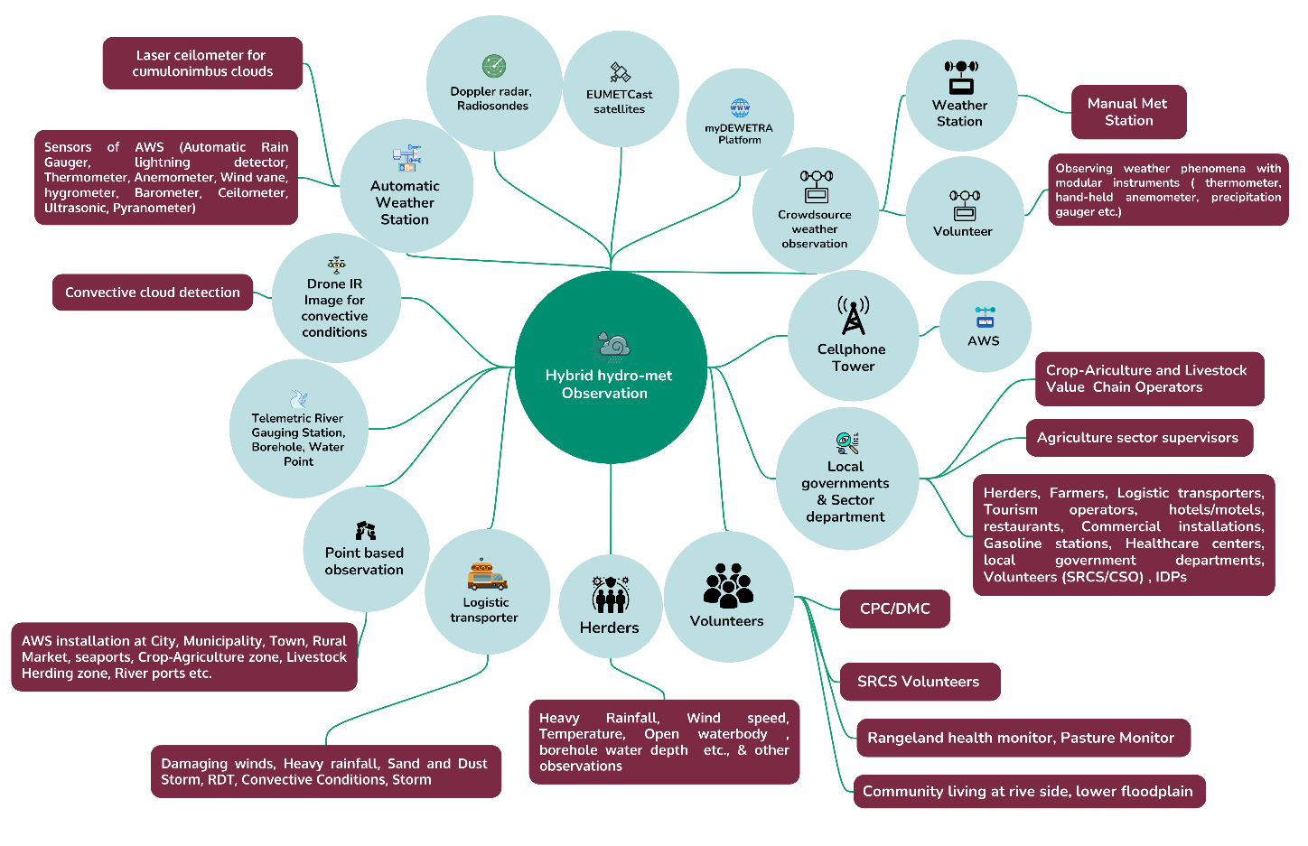
Figure 26 : Improving hybrid observation ( Source : Z M Sajjadul Islam)

The hybrid system should integrate the following observation and monitoring streams:

- Meteorological observations: Automated Weather Stations (AWS) to acquire essential climate variables (ECVs) and enable nowcasting, point-based forecasting, and forecast verification.
- Hydrological monitoring: River and flood-level sensors (including telemetry where feasible) to support flood forecasting and flood early warning for major catchments and urban flood hotspots.
- Groundwater and water point monitoring: Groundwater table sensors and borehole/drinking water point monitoring (functionality, yield/availability, and water quality flags), with routine telemetry or app-based updates.
- Surface water body monitoring: Monitoring of lakes, ponds, canals, and seasonal/perennial rivers to track surface water availability, stress conditions, and flood risk dynamics.
- Crop monitoring: Geo-referenced crop condition reporting (rainfed and irrigated blocks) supported by farmer app submissions and remote-sensing analytics to detect drought stress, waterlogging, and crop loss signals.
- Livestock monitoring: Pastoralist/herder observations on pasture condition, water access, herd health, morbidity/mortality, and migration pressures, captured via mobile reporting and integrated with vegetation/water indices.
- Productive sector value chain monitoring: Reporting from input suppliers, markets, storage facilities, cold chain assets, and processing facilities to monitor climate-induced disruption risks and ripple effects.
- Crowdsourced multi-hazard incident tracking: Community and stakeholder reporting on emerging hazards (flash floods, dust storms, strong winds, disease outbreaks, storm damage) using geotagged mobile forms and social-network harvesting (where governed).
- Event situation updates and disaster hotspot tracking: Real-time field updates of event progression, affected areas, access constraints, displacement signals, and priority needs, linked to an operational map dashboard.
- Loss and Damage (L&D) monitoring: Structured rapid L&D reporting (unverified/verified/confirmed) to support initial impact estimates, RPDNA/PDNA workflows, and continuous learning for improved thresholds and triggers.

.

5.0 Pillar 3 Implementation Strategy ( Warning dissemination and communication)

Risk communication and dissemination are the most time-critical components of the EW4ALL value chain. In Somalia’s FCV context, a robust risk communication system must be designed as an operational service, not a one-off messaging activity supported by resilient ICT infrastructure, standardized tools (CAP), clear governance (NCA mandates), and last-mile feedback loops.

Somalia’s high mobile penetration (as cited: 73% overall, with 83% urban, 72% IDP camps, and 55% rural) provides a strong foundation for multi-channel alert dissemination. Mobile money uptake and daily reliance on phones create an enabling environment for institutionalizing timely, trusted warning delivery. However, current SMS/IVR/cell broadcast services remain limited in scope and user experience, including insufficient support for multilingual audiences and accessibility requirements.
The following capacity-strengthening and operational recommendations are proposed.

  - Risk communication and Governance and accountability for dissemination

1.1 Designate a single authoritative alert originator
• NMHEWC (SoDMA) should be designated as the national authoritative alert originator, issuing warnings and alerts through a CAP-enabled workflow (draft > review > approve > publish).
1.2 NCA regulatory framework for mandatory alert carriage
• NCA should formalize dissemination compliance by issuing: mandatory carriage requirements for emergency alerts across telecom operators and broadcasters; minimum performance standards (delivery latency, availability, uptime); rules for zero-rated alert delivery (no user charges for receiving warnings); and defined responsibilities for testing, reporting, and audit.
1.3 MoUs and SOPs with broadcasters and telecom operators
• MoUs/SOPs should define: alert routing, escalation tiers, message prioritization, redundancy protocols, and post-event reporting.

  - CAP-enabled, multi-channel dissemination architecture
2.1 Common Alerting Protocol (CAP) as the backbone
• Implement CAP to standardize alert content, geotargeting, severity/urgency/certainty, multilingual rendering, and channel-specific formatting.
• Treat CAP records as the authoritative national archive for alert verification, auditability, and accountability.
2.2 Multi-channel “no single point of failure” dissemination
A national warning should be disseminated through multiple, redundant channels, including at minimum:
• Cell broadcast (preferred for immediate area-based alerts; no subscription required)
• SMS (fallback channel and targeted lists for institutions and duty bearers)
• IVR/voice messaging (critical for low literacy, accessibility, and remote populations)
• Radio/TV interrupt (mandatory broadcast for high-severity alerts)
• WhatsApp/Telegram groups (CPC/DMC and community coordination networks)
• Social media (official NMHEWC accounts with shareable graphics/audio)
• Community channels (mosques, community leaders, loudspeakers, local committees) for hard-to-reach and off-grid settings

  - Message design standards (understandability and actionability)
- Establish a standardized, CAP-aligned warning template across all dissemination channels so that every alert is clear, consistent, and actionable. Each warning should state: (i) what is happening (hazard type), (ii) where it will occur (precise geographic targeting), (iii) when it will occur (timing and expected duration), (iv) severity and expected impacts (impact framing, not only weather variables), (v) what to do now (specific protective actions), and (vi) the authoritative source plus a unique identifier or verification reference to reduce rumors and build trust.
- Ensure multilingual and accessibility compliance by issuing alerts in Somali and any additional relevant languages, using consistent terminology across products. Implement IVR/voice messaging for low-literacy audiences and provide simple icon/graphic formats for rapid comprehension. Apply inclusion requirements so messages are usable for IDPs, persons with disabilities, elderly populations, and remote pastoral communities.

  - Last-mile engagement and feedback loop

- Enable two-way communication so CPC/DMC, community leaders, farmers, herders, and value chain operators can (i) confirm receipt and understanding of alerts where feasible (e.g., “received/understood” prompts), (ii) submit geotagged local observations and impact reports, and (iii) flag misinformation and urgent needs for rapid follow-up.
- Route all inbound last-mile reports into the NMHEWS platform through a role-based validation workflow (unverified > verified > confirmed). This strengthens trust, improves situational awareness, and enables iterative updates to warnings, including timely corrections and “all clear” messages.

  - System resilience and cybersecurity requirements

To ensure warnings can still be issued during crisis onset, the NMHEWC/NMHEWS architecture should implement redundant hosting and backup connectivity, enforce secure data storage with role-based access control, and provide offline/low-bandwidth operational modes to maintain continuity during outages. The program should also institutionalize periodic penetration testing and resilience testing, including routine disaster-recovery drills to verify restore capability and operational readiness.

  - Capacity strengthening package (operational readiness)

Train NMHEWC and partners on CAP issuance workflows, message authoring, public communication, rumor management, and media engagement; conduct regular simulation exercises (TTX) with telecom operators, broadcasters, UN clusters, and CPC/DMC networks to test end-to-end forecast-to-alert-to-action procedures.

• SOPs and performance monitoring: Establish SOPs defining alert issuance timelines, approval chains, escalation rules, and update cadence (initial alert → updates → all clear); monitor KPIs including delivery time and success rate, geographic reach, community comprehension/feedback, false alarm ratio, missed-event analysis, and post-event performance reviews.

• Outcome: Secure, resilient, and functional IT systems, storage, and data-sharing strengthen NMHEWC’s ability to issue timely alerts during hazard onset and disseminate warnings through redundant channels (TV, radio, SMS, social media), improving preparedness and anticipatory risk management.

Ensuring that IT systems, data storage, and sharing mechanisms are secured, resilient, and functional is expected to enhance NMHEWC's capabilities to send alert warnings during the onset of hazards. Accessing hazard and forecast information from various source organizations would enable NMHEWC to disseminate warnings through multiple communication channels (TV, radio, SMS, and social media), anticipating impending risks. Capacity strengthening and risk communication are as follows;

5.1 Indicative Challenges of Warning Dissemination and Communication

  - Lack of terrestrial broadcasting (AM Radio / terrestrial TV)

The terrestrial broadcasting, especially AM radio, is typically the most accessible mass communication channel for remote, last-mile communities because it can reach wide geographic areas with basic radio sets and does not rely on mobile network coverage. In Somalia, AM radio broadcasting has been suspended due to fragility and conflict-related constraints. In parallel, FM coverage is inherently range-limited, leaving dispersed rural households and some coastal/offshore fishing communities without reliable access to daily weather bulletins, warnings, and emergency alerts. As a result, warning dissemination in hard-to-reach areas often depends on informal person-to-person transmission, including community leaders and mosque-based Imams, which is inconsistent, difficult to verify, and vulnerable to delays or message distortion.

Operational implication. Remote households and sea fishing boats face a structural information gap, reducing lead time for protective actions and weakening Pillar 3 effectiveness (warning dissemination) and Pillar 4 effectiveness (preparedness and response).

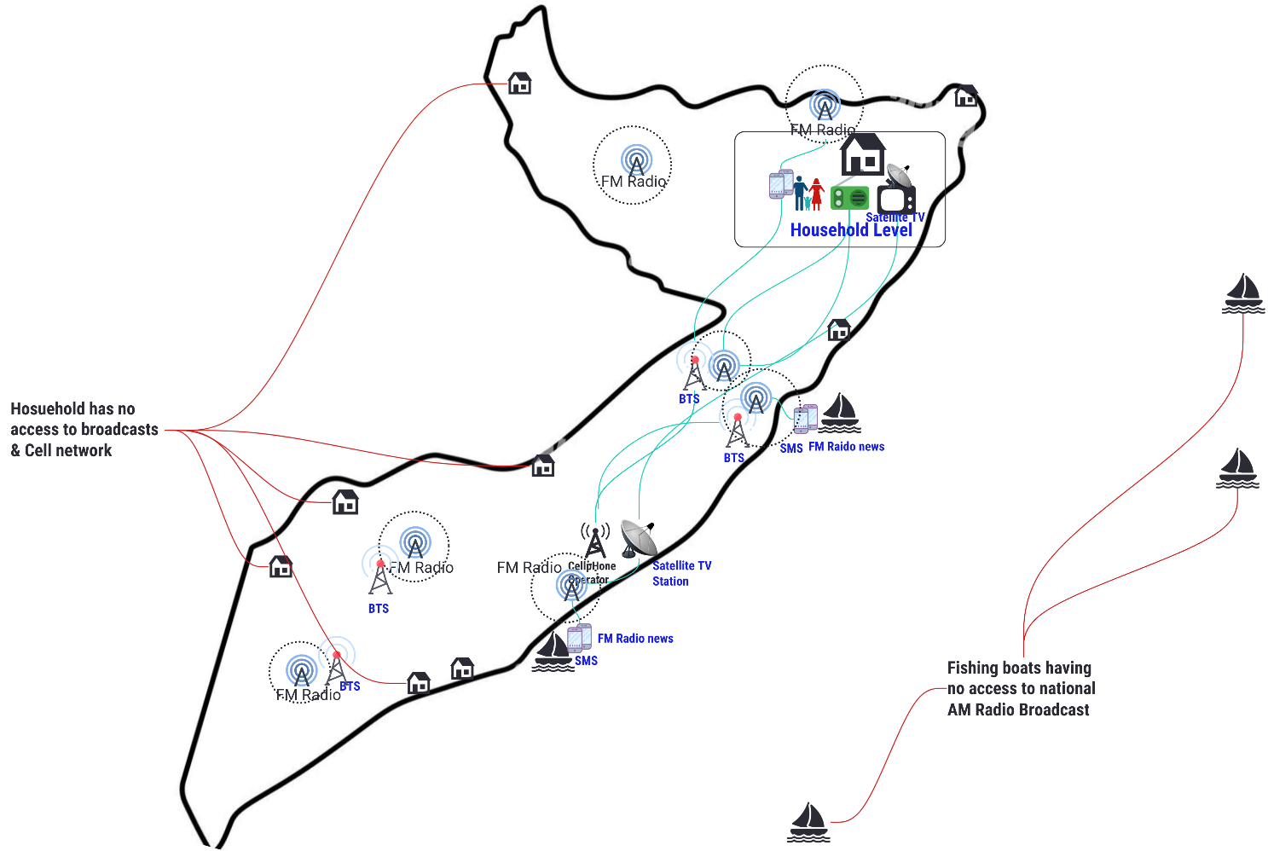
Figure 27 : Existing commercial FM radio services has some frequency limitations

Recommendations

A) Restore and expand national terrestrial broadcasting coverage
- The Federal Government and Federal Member States should prioritize the re-establishment and expansion of AM radio and terrestrial TV coverage to reach remote and hard-to-reach areas.
- Broadcasting expansion should be treated as a life-saving public good within the national early warning architecture, not as a purely commercial service.
B) Enforce emergency alert dissemination obligations through NCA and the Ministry of Communication
Until terrestrial broadcast coverage is restored at scale:
- The NCA and Ministry of Communication should issue and enforce clear regulatory obligations requiring mobile network operators to provide:
  - free-of-charge emergency dissemination services (SMS/IVR/cell broadcast) during hazard events; ensure performance standards for alert delivery (latency, geographic targeting, uptime); and routine testing and reporting to ensure readiness.
C) Mandate regular emergency bulletin broadcasting by national and private broadcasters
- Establish a policy mechanism (MoUs and/or regulatory directives) to require state-controlled and private broadcasters to:
  - carry emergency weather bulletins and hazard alerts at defined intervals; interrupt regular programming for high-severity CAP alerts; and coordinate messaging consistency with NMHEWC as the authoritative alert originator.
D) Formalize community relay mechanisms as a temporary redundancy layer
- While coverage gaps persist, formalize mosque/community relay channels through:
  - standardized, short alert scripts in Somali and relevant local languages; defined relay responsibilities for local committees/CPC/DMC; and basic tracking of dissemination (who relayed, where, and when) through mobile reporting where feasible.

  - Lack of a broadcasting policy framework, accountability, mandates, and SOPs for accessing and disseminating national forecasts and warnings

Somalia currently lacks an operational broadcasting policy and Standard Operating Procedures (SOPs) that define how broadcasters (state and private) should access authoritative national forecasts and disseminate routine bulletins and special warnings. Because a fully institutionalized National Meteorological Agency (NMA) is not yet operational, national forecast production remains limited (e.g., MoEWR hydromet services issuing primarily weekly/decadal rainfall outlooks). In the absence of a formal dissemination workflow, broadcasters often rely on third-party commercial tools (e.g., Windy, Ventusky, Zoom Earth) and broadcast weather information on an ad hoc basis. This results in inconsistent messaging, limited localization, and insufficient delivery of precision-level forecasts and special weather bulletins to the climate frontline undermining the EW4ALL value chain.

Operational implications.
- The public receives inconsistent and non-authoritative information, weakening trust and compliance.
- No guaranteed routine schedule exists for daily/weekly bulletins or emergency interrupt.
- Special warnings are not systematically issued, packaged, and broadcast, creating dangerous lead-time gaps.

Recommendations

A) CREWS-supported assessment and broadcaster SOP for forecast-to-broadcast operations
- UNDRR-CREWS should support a rapid but rigorous review of: (i) forecast quality, timeliness, and spatial/temporal resolution; (ii) warning thresholds and consistency of terminology; (iii) bulletin production capacity and standard formats; and (iv) current broadcaster practices, constraints, and readiness.
- Based on this review, CREWS should support development of a short, practical Broadcast SOP that defines:
- Authoritative sources: Define the authoritative alert originator (NMHEWC/SoDMA) and the routine product producers (MoEWR hydromet/NMHEWC operational desk), including interim arrangements until a National Meteorological Agency (NMA) is established.
- Products and schedule: Specify the product suite (daily routine bulletin where available, weekly outlook, seasonal outlook, and event-based special warnings), including mandatory broadcast windows and minimum broadcast frequency.
- CAP and warning packaging: Standardize CAP-based warning issuance (severity/urgency/certainty, geotargeting, validity times) and require a consistent “what/where/when/impacts/actions” script for all media channels.
- Approval and release workflow: Define a controlled workflow (draft > review > approval > release) with timestamps, version control, and clear responsibility for each step.
- Language and accessibility: Require multilingual delivery (Somali plus other relevant languages as needed), and accessibility formats such as IVR/voice scripts and simplified broadcast phrasing suitable for low-literacy audiences and vulnerable groups.

B) NCA SOP for multi-tier dissemination coordination down to district/community level

NCA should develop and enforce an SOP that operationalizes risk communication routing and local relay during emergencies (cyclones, flash floods, severe storms), including:
- Trigger-based escalation: Define severity thresholds and decision rules that require district-level activation and community relay, including timing relative to forecast lead time and CAP issuance.
- Roles and responsibilities: Assign clear duties to district administrations, CPC/DMC structures, CSOs/NGOs, mosque imams, community leaders, and youth/volunteer networks for dissemination, mobilization, and local coordination.
- Relay mechanisms: Standardize the relay pathways to ensure redundancy, including SMS/IVR/cell broadcast, WhatsApp/Telegram groups, radio/TV, mosque loudspeakers, and door-to-door relay where necessary for hard-to-reach and low-connectivity areas.
- Message integrity controls: Require standardized scripts, approved terminology, and CAP identifiers (unique alert ID and validity window) to reduce message distortion and misinformation as alerts are relayed.
- Feedback loop: Establish two-way reporting procedures for local confirmation of receipt and understanding, event situation updates, and priority needs reporting back to NMHEWS to support iterative warning updates and response prioritization.

C) Establish a structured “social journalism” mechanism as a complementary dissemination and verification layer

Develop an SOP-led, trained network of youth groups, local journalists, community volunteers, and “youth journalists” to disseminate verified warning content and provide real-time ground truthing through social networks (Facebook, YouTube, WhatsApp, Telegram).
Key safeguards to include in the SOP:
• Only CAP-linked or NMHEWC-approved content may be distributed as “official.”
• Apply verification protocols for incident reporting (geotagging, photo/video evidence where feasible, and validation tiers such as unverified > verified > confirmed).
• Enable misinformation reporting and rapid correction procedures, including issuance of corrected CAP-linked messages and removal/flagging of false content through partner channels.
  - Lack of NCA MoU with broadcasters (government and private) :

Somalia has a strong comparative advantage for warning dissemination: high mobile penetration (often cited near 80%) and wide availability of private FM radio and satellite TV services that effectively reach high-density settlements (cities and municipalities). This ecosystem can be leveraged to deliver routine weather bulletins and time-critical warnings. However, the National Communications Authority (NCA) has not yet established enforceable MoUs and mandates with national/state broadcasters, private/community broadcasters, telecom operators, and news agencies to ensure systematic carriage of daily forecasts and emergency warnings. Consequently, dissemination remains discretionary, fragmented, and inconsistent.

Recommendations

- NCA should urgently sign and operationalize MoUs (and associated regulatory directives) with national/state broadcasters, private/community broadcasters, telecom operators, and major news outlets to establish mandatory, reliable dissemination of routine bulletins and emergency CAP alerts. These MoUs should require carriage of daily/weekly weather bulletins, special advisories and warnings, and CAP-compliant alerts during emergencies.
- Minimum MoU/mandate clauses should include: (i) authoritative source and content integrity (NMHEWC/NMHS-originated alerts; third-party tools for visualization only); (ii) broadcast schedule and minimum frequency (fixed slots for routine bulletins and increased frequency during high-risk periods); (iii) emergency interruption and priority carriage (mandatory interrupt for high-severity alerts and congestion-priority routing); (iv) telecom obligations (zero-rated SMS/IVR/cell broadcast, geotargeting by district/municipality polygons, and delivery performance standards); (v) multilingual and accessibility requirements (Somali-first, additional languages as needed, voice/IVR options); (vi) testing, drills, and reporting (routine test alerts, simulation exercises, and dissemination logs); and (vii) compliance and enforcement (penalties, escalation procedures, and audit requirements).

  - NCA yet to develop Risk/Alert communication and dissemination system for urban dealers with cell phone, FM Radio, Internet, and Satellite TV access.

- NCA to establish an urban risk/alert communication and dissemination system.
NCA should develop and regulate an integrated dissemination framework for urban populations with access to cell phones, FM radio, the internet, and satellite/cable TV. The framework should define mandatory alert carriage, minimum dissemination frequency, emergency interruption rules for high-severity warnings, and performance monitoring (reach, delivery latency, proof-of-airing, and service continuity during emergencies).
- Establish a National Hydrometeorological Services Technical Working Group for CAP and IBF.
A standing technical working group should be organized to routinely analyze forecasts and nowcasting products, develop impact forecasts, and prepare CAP alerts for sudden-onset localized hazards likely in Somalia (e.g., RDT-triggered heavy rainfall, severe convective storms/tornado-like events, high winds, dust storms, and flash flooding). The working group should operate under standardized SOPs with clear roles for hazard analysis, impact interpretation, alert drafting, approval, issuance, and updates.
- Ensure CAP alerts are spatially and temporally specific and triggered by hybrid observations.
CAP alerts must be geotargeted (district/municipality polygons where feasible), time-bounded (validity windows), and aligned with severity/urgency/certainty classifications. Alerts and subsequent updates should be informed by the hybrid observation network (AWS on river/flood sensors, crowdsourced incident reports), enabling real-time detection, confirmation, escalation, and “all clear” messaging.
- Define local actors as mandatory disseminators and feedback providers, not independent CAP originators.
Local FM radio, satellite and cable TV operators, social network providers, and CPC/DMC committees should be mandated to carry and relay CAP alerts issued by the national authoritative originator (NMHEWC), and to: disseminate localized action guidance (evacuation routes, safe shelters, service access points) using approved scripts; and provide structured two-way feedback (incident reports, impact confirmation, urgent needs) into the NMHEWS platform for validation and situational awareness.

5.2 Developing a Common Alerting Protocol(CAP) :

A CAP-enabled alerting system should be established as the national standard for issuing, updating, and cancelling warnings. CAP will allow NMHEWC/NMHS to publish consistent, geotargeted, time-bounded alerts across multiple channels (cell broadcast, SMS, IVR, TV/radio, apps, and social media), while maintaining an auditable record for accountability and forecast verification.

5.2.1 Event situation updates to NMHEWC for next-action planning

NMHEWC should institutionalize a structured event situation update workflow within NMHEWS to enable real-time, standardized reporting from last-mile actors and partners. The workflow should capture geotagged incident reports, rapid loss-and-damage snapshots with validation tiers (unverified → verified → confirmed), access constraints, and priority needs/response gaps.
These situation updates should be used operationally to (i) update CAP alerts (escalate/de-escalate and adjust affected-area polygons), (ii) refine hotspot maps and impact-forecast outputs, and (iii) drive next-action planning using 5W tasking (who does what, where, when, and how).

5.2.2 NMHS/NMHEWC to monitor, detect, and issue CAP continuously

NMHS/NMHEWC should be mandated and operationally equipped to continuously monitor and detect hazards using hybrid observation networks (AWS, flood/river sensors, crowdsourced reports), nowcasting products and short-fuse triggers, and regional/global data hubs as guidance inputs.
CAP issuance should, at minimum, cover: (i) impending hazardous weather (e.g., heavy rainfall, flash flood risk, extreme heat, damaging winds, dust storms, and coastal hazards where relevant); (ii) updates and extensions as the threat evolves; and (iii) cancellations and “all clear” messages to prevent prolonged disruption and rumor cycles.

Each CAP alert should include: what is happening, where (geotargeted), when (validity window), severity/urgency/certainty, expected impacts, clear protective actions, and a unique source/identifier for verification and traceability.

5.2.3 Promote an end-to-end early warning system through mandated broadcasters and structured “live” risk programming

NCA should mandate FM radio and satellite TV broadcasters to support an end-to-end early warning system by running structured “live” risk programming during elevated-risk periods, while maintaining NMHEWC as the sole authoritative alert originator.
This should include scheduled live hazard information windows (routine in high-risk seasons and intensified during active events) where NMHEWC and sector experts explain the hazard, expected impacts, and protective actions, and where the public can submit observations via pre-defined channels (short codes, WhatsApp lines, and call-ins).
All broadcaster-sourced incident and condition reports must be routed into NMHEWS as “unverified” inputs; NMHEWC should validate and only then upgrade reports and use them to issue updates or revise CAP alerts. This creates a complete warning loop: detection > CAP alert > dissemination > community feedback > validation > update > action.

  - Mandating FV Radio, Satellite TV broadcasters to organize a Live show on multiple hazards for the collection of event situation :

Somalia’s high mobile penetration and strong use of telecom services create a viable foundation for a robust EW4ALL risk communication and dissemination system. However, dissemination remains constrained by gaps in terrestrial broadcasting coverage, weak regulatory mandates, limited SOPs, and fragmented coordination among NMHEWC, broadcasters, telecom operators, humanitarian actors, and last-mile stakeholders.

A CAP-enabled national warning architecture anchored in an interoperable NMHEWS should be established to standardize alert creation, approval, geotargeting, multilingual messaging, and multi-channel delivery (cell broadcast, SMS, IVR, radio/TV, social media, and community relay). NCA should operationalize enforceable MoUs/mandates with broadcasters and telecom operators to ensure mandatory carriage, emergency interruption, free emergency messaging (SMS/IVR/cell broadcast), performance monitoring, and routine drills.

To strengthen last-mile situational awareness, the system should institutionalize two-way communication through USSD/SMS reporting, CPC/DMC networks, and structured broadcaster “live hazard windows.” Live FM and satellite TV programming can serve as a crowdsourcing intake mechanism, but all public reports must be routed into NMHEWS as “unverified” until validated through hybrid observations and authorized partners preserving NMHEWC as the single authoritative CAP originator. This end-to-end loop (detection > CAP > dissemination >feedback > validation > update > action) improves preparedness, response coordination, and loss-and-damage tracking while reducing duplication and misinformation.

5.3 Interoperable risk communication and feedback system with NMHEWS ( CREWS Initiative Support )

With CREWS Initiative support, Somalia’s NMHEWS should implement an interoperable risk communication system that combines CAP-based authoritative alerting, multi-channel dissemination, and two-way feedback into a single operational workflow. NMHEWC/NMHS issues geotargeted, time-bounded CAP alerts and disseminates them through telecom channels (cell broadcast/SMS/IVR/USSD), broadcasters (FM radio, satellite/cable TV), social media, and community relay networks (CPC/DMC, mosque/community structures).

In parallel, the system captures real-time event situation updates and rapid L&D information from last-mile stakeholders via USSD/SMS short codes, CPC/DMC digital groups, partner reporting, and structured broadcaster live hazard programs. All public reports enter NMHEWS as “unverified” and are validated using the hybrid observation network and trusted partners before being used to update alerts, hotspot maps, and next-action planning. Governance is enforced through NCA MoUs/mandates to ensure mandatory alert carriage, performance monitoring, and consistent messaging while avoiding fragmented or conflicting alerts.
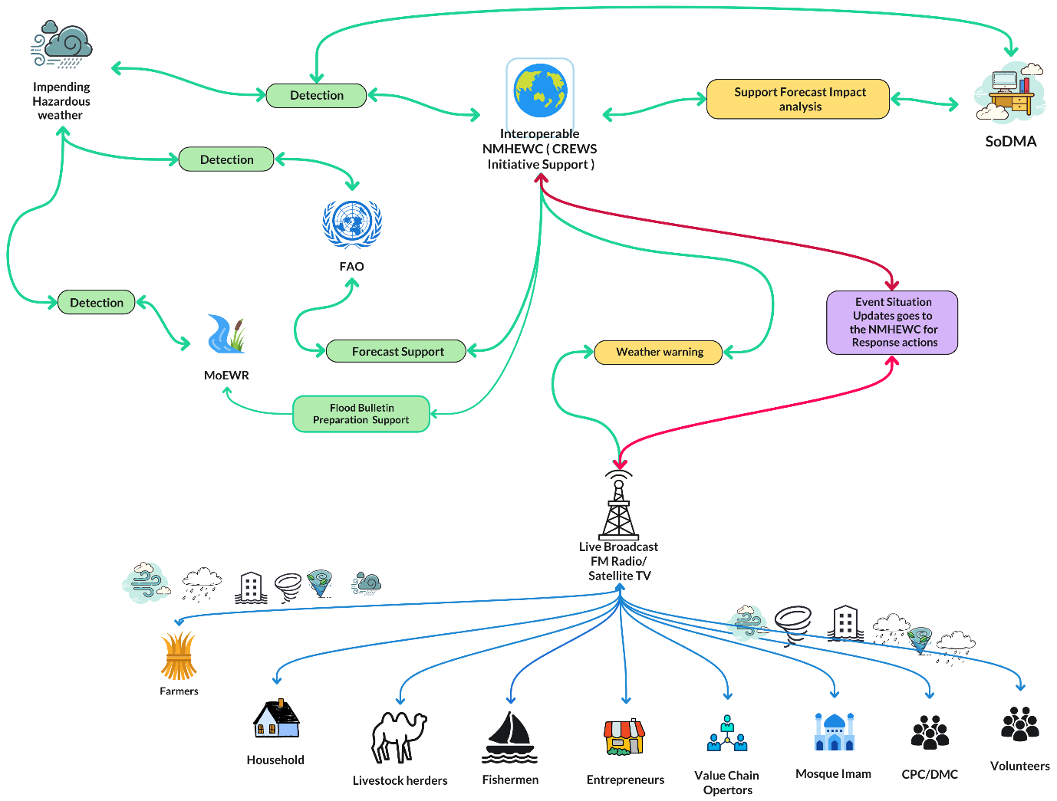
Figure 28: Live shows for capturing the ongoing event situation of the onset of disaster incidents on the ground ( Source : Z M Sajjadul Islam )

The diagram shows how hazard detection and forecast support inputs from MoEWR and FAO feed into the Interoperable NMHEWC for impact analysis and warning generation. Warnings are disseminated through live FM radio/satellite TV broadcasts to last-mile groups (farmers, households, herders, fishermen, entrepreneurs, value chain operators, mosque leaders, CPC/DMC, and volunteers). In parallel, last-mile stakeholders provide real-time event situation and loss-and-damage updates through the live broadcast and community networks, which are routed back to NMHEWC to support response actions and iterative warning updates.

5.4 Develop and disseminate a common alerting protocol (CAP) on imminent hazards, weather :
Developing and operationalizing the Common Alerting Protocol (CAP) is a critical downstream step in the integrated forecasting and early warning value chain. The workflow progresses from (i) observation/detection, to (ii) forecasting, and then to (iii) CAP alert issuance, where forecast signals are translated into actionable, location-specific warnings that reflect cascading impacts on communities and households. CAP-enabled warnings are the foundation for activating early action protocols, contingency mobilization, and forecast-based anticipatory action, provided that forecasts and impact assessments are sufficiently precise and timely.

5.4.1 CAP operational requirements for Somalia

NMHS/NMHEWC should analyze numerical weather prediction (NWP) outputs and operational forecasts, translate them into impact forecasts, and issue spatiotemporal CAP alerts for sudden-onset localized hazards that are likely to occur, including:
- RDT-identified heavy rainfall and convective storms (flash-flood risk)
- damaging winds and localized severe storms
- dust storms and reduced visibility hazards
- coastal hazards where relevant (e.g., cyclone-related impacts)

CAP alerts must be geotargeted (district/municipality polygons where feasible), time-bounded (validity windows), and continuously updated using the hybrid observation network (technology-based and human-driven sources), enabling escalation, de-escalation, and “all clear” messaging.

5.4.2 Dissemination channels and governance

- NMHS/NMHEWC should remain the single authoritative CAP originator to avoid conflicting alerts.
- CAP alerts should be disseminated through:
  - local FM radio, satellite and cable TV (mandatory carriage and emergency interruption rules),
  - telecom channels (cell broadcast, SMS, IVR),
  - social media and digital platforms (verified/official accounts), and
  - community relay networks (CPC/DMC, mosque/community systems).

Important governance clarification: local CPC/DMC should not independently “issue” CAP. Instead, CPC/DMC should be mandated to relay the official CAP and implement localized action guidance (evacuation, shelters, community mobilization) while providing two-way feedback into NMHEWS (event situation and L&D updates).

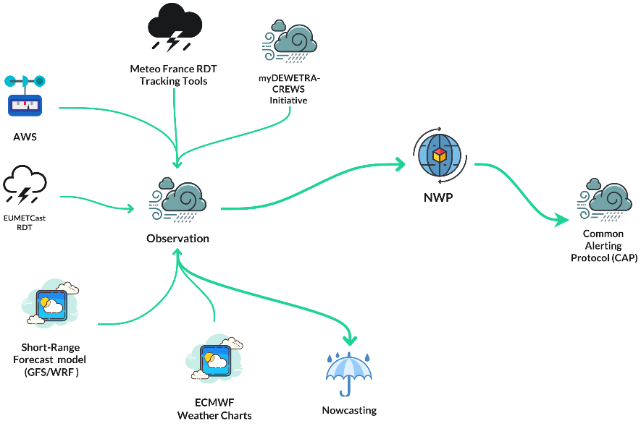
Figure 29: CAP Development Process

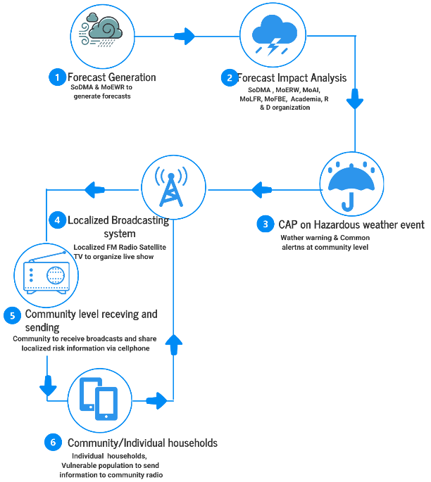

Figure 30: Event situation reporting

5.4.3 Figure 29 and Figure 30

- Figure 9/monitoring > forecast & impact analysis > CAP drafting > approval > dissemination > update/cancel > after-action review.
- Figure 30: Event Situation Reporting should depict the feedback loop:
community/CPC/partners > report intake (USSD/SMS/WhatsApp/call-ins) > NMHEWS validation tiers > situational dashboard > CAP updates and response actions.

5.4.4 Tools and channels for CAP dissemination and event reporting

CAP dissemination and event situation reporting can use a layered set of tools, including:
- Telecom: mobile and landline telephones; SMS; IVR; cell broadcast; USSD
- Internet/digital: e-mail; official web portals; smartphone apps; social platforms (Facebook, X/Twitter, WhatsApp, Telegram)
- Broadcast: radio/television and cable/satellite TV; digital signage where available
- Specialized redundancy: sirens (indoor/outdoor in priority sites); amateur radio; satellite direct broadcast; emergency drone radio (where feasible)

5.5 Improving terrestrial Broadcasting

NCA should undertake policy advocacy with the Ministry of Communication & Technology (MoCT) to resume terrestrial AM radio broadcasts at federal and member-state levels and to strengthen terrestrial broadcasting coverage as a core public warning capability. Terrestrial AM radio and terrestrial TV are essential for reaching dispersed rural populations, pastoralists, IDP-adjacent settlements, and coastal fishing communities, particularly where FM coverage is limited and where internet and smartphone access are inconsistent. Restoring AM radio is especially critical because it offers wide-area signal reach and supports low-cost reception through basic radios, including during power outages and network disruptions.

As part of this action, NCA and MoCT should establish a national framework and Standard Operating Procedures (SOPs) for mandatory carriage of daily weather bulletins, special weather warnings, and CAP-aligned emergency alerts through terrestrial broadcasters, including defined broadcast schedules, emergency interruption requirements for high-severity events, and minimum performance standards. The framework should prioritize coverage expansion for hazard-prone corridors, major river basins, high-risk drought and flood zones, coastal fishing areas, and other hard-to-reach locations, and should include resilient broadcast infrastructure provisions such as backup power for key transmission sites.

In parallel, NCA should mandate telecom operators to improve rural network coverage and operational resilience to strengthen targeted dissemination channels (SMS, IVR, and cell broadcast) and to support two-way community reporting. Terrestrial broadcasting and mobile dissemination should be treated as complementary systems: terrestrial AM/TV provides resilient one-to-many coverage for mass public warning, while mobile networks enable targeted alerts and feedback mechanisms for situational awareness and response coordination.
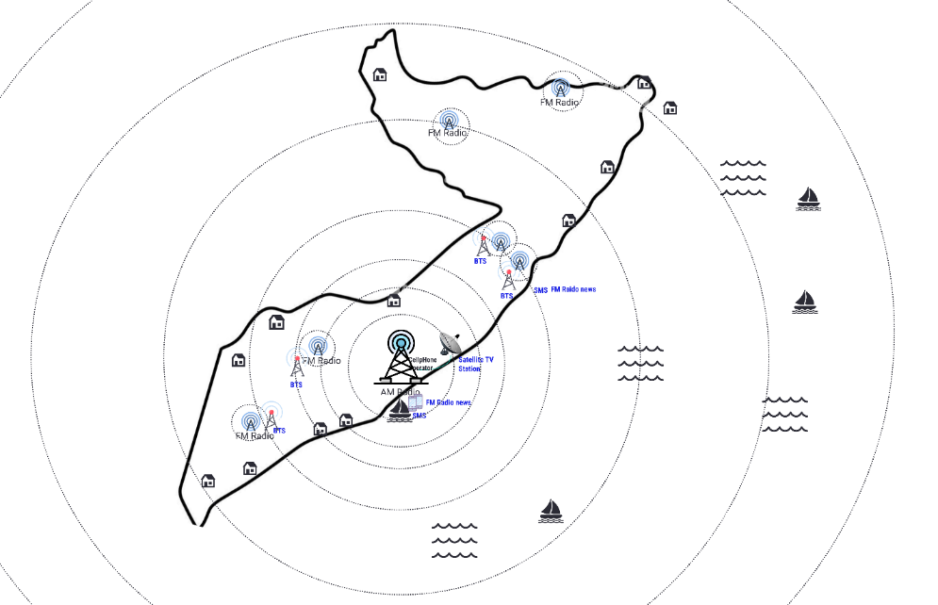

Figure 31 illustrates the intended expansion of terrestrial broadcasting coverage beyond current service areas to improve last-mile access to routine weather information and time-critical warnings.

5.6 Stakeholders’ responsibility metrics on Risk Communication and disaster Event situation updates

Stakeholders/Actors | Sector Ministry & departments | Responsibilities during normal time | Duties during the impending multi-hazard when EW is being issued | Duties when multi-hazard incidents are taking place with high impacts | Duties when a disaster has already started and L&Ds are being reported | Risk communication tools
State Actors | NCA | Coordinate NMHEWC and national broadcasters to ensure daily forecasts/bulletins are broadcast. | Coordinate dissemination of special weather bulletins with national broadcasters. | Coordinate national broadcasters’ newsroom to organize live shows for crowdsourced audiences to report current situation and incident/L&D updates. | Coordinate national broadcasters’ newsroom to organize live shows for crowdsourced audiences to report current situation and incident/L&D updates. | Web; broadcast coordination; telecom interfaces (SMS/IVR/cell broadcast); social media channels.
State Actors | SoDMA | Coordinate NCA and national broadcasters to ensure daily forecasts/bulletins are broadcast. | Coordinate NCA and national broadcasters for broadcasting special weather bulletins. | Coordinate NCA, district administration, and CPC/DMC to transmit situation updates to national broadcasters for wider dissemination. | Coordinate NCA, district administration, and CPC/DMC to transmit L&D updates for wider dissemination; update DesInventar; update web-based NMHEWS for wider dissemination. | NMHEWS geoportal; DesInventar; web; radio/TV; SMS/IVR/cell broadcast; social media; WhatsApp/Telegram groups (where applicable).
State Actors | MoEWR | Coordinate interoperable NMHEWC forecast processing so that NCA and broadcasters can access daily forecasts/bulletins on time. | Coordinate interoperable NMHEWC to analyze hazardous forecasts and develop special weather bulletins.Develop special bulletins on heavy rainfall and likely river flooding, flash floods, landslides, etc. | Coordinate interoperable NMHEWC and develop special bulletins on heavy rainfall and likely river flooding, flash floods, landslides, etc. | Coordinate SoDMA, district administration, CPC/DMC, and CSO consortium to collect and transmit L&D updates relevant to hydromet impacts. | NMHEWC/NMHEWS portals; forecast/bulletin products; web; radio/TV; SMS/IVR/cell broadcast; technical briefs.
State Actors | MoAI | Coordinate interoperable NMHEWC to ensure regular agroclimatic forecasts/bulletins are disseminated to smallholder farmers, promoters, market actors, rural households, CSOs, stakeholders, entrepreneurs, and value chain operators. | Coordinate interoperable NMHEWC so special weather bulletins for crop-agriculture sector elements are broadcast as warnings/alerts to target audiences. | Coordinate relevant stakeholders and ensure L&D data are sent via mobile apps to interoperable NMHEWC. | Coordinate relevant stakeholders and ensure L&D data are sent via mobile apps to interoperable NMHEWC. | Sector apps (e.g., Kobo/GPS tools); NMHEWS portal; SMS/USSD (if enabled); radio/TV; WhatsApp groups; web dashboards.
State Actors | MoLFR | Coordinate interoperable NMHEWC to broadcast regular agroclimatic forecasts and livestock value chain bulletins to herders, smallholders, commercial livestock operators, promoters, market actors, rural households, CSOs, stakeholders, entrepreneurs, and value chain operators. | Coordinate interoperable NMHEWC so special weather bulletins for livestock sector elements are broadcast as warnings/alerts to target audiences. | Coordinate relevant stakeholders and ensure L&D data are sent via mobile apps to interoperable NMHEWC. | Coordinate relevant stakeholders and ensure L&D data are sent via mobile apps to interoperable NMHEWC. | Sector apps; NMHEWS portal; SMS/USSD (if enabled); radio/TV; WhatsApp/Telegram; web dashboards.
State Actors | MoH | Coordinate interoperable NMHEWC so regular public health and WASH-related bulletins (and other relevant advisories) are broadcast. | Coordinate interoperable NMHEWC so weather warnings for public health and WASH are issued and broadcast. | Coordinate relevant stakeholders and ensure L&D data are sent via mobile apps to interoperable NMHEWC. | Coordinate relevant stakeholders and ensure L&D data are sent via mobile apps to interoperable NMHEWC. | Health/WASH reporting tools (e.g., EWARS where deployed); NMHEWS portal; web; radio/TV; SMS/IVR; social media; mobile apps.
State Actors | MoFBE | Coordinate NCA and interoperable NMHEWC so sea-fishermen can access forecasts/bulletins from fishing boats. | Coordinate NCA and interoperable NMHEWC so tropical storm depressions, development stages, and special marine weather bulletins are broadcast and communicated to fishing boats. | Coordinate fishing boats to follow storm warnings carefully and return/avoid offshore exposure in a timely manner. | Coordinate fishing boats and coastal stakeholders to provide updates on L&Ds. | Marine bulletins; radio/TV; SMS/IVR; satellite/cable TV; web; social media; NMHEWS portal; VHF/marine radio (where available).
Non-state actors | UN-HCT | Capacity development of stakeholders for improving risk communication. | Support SoDMA and NCA for improving risk communication. | Support SoDMA and NCA for incident tracking and collection of L&D information. | Support SoDMA and NCA for incident tracking and collection of L&D information. | Cluster coordination platforms; situation reporting; dashboards; partner communication channels; NMHEWS integration (where agreed).
Non-state actors | UN Clusters | Capacity development of stakeholders for improving risk communication. | Support SoDMA and NCA for improving risk communication. | Support SoDMA and NCA for incident tracking and collection of L&D information. | Support SoDMA and NCA for incident tracking and collection of L&D information. | Cluster IM tools; rapid assessment tools; 5W; dashboards; partner reporting lines; NMHEWS integration (where agreed).
Non-state actors | INGOs | Capacity development of stakeholders for improving risk communication. | Support SoDMA and NCA for improving risk communication. | Support SoDMA and NCA for incident tracking and collection of L&D information. | Support SoDMA and NCA for incident tracking and collection of L&D information. | Mobile data collection apps; partner reporting tools; WhatsApp/Telegram; dashboards; NMHEWS integration (where agreed).
Non-state actors | Local NGOs/CSOs | Capacity building of local stakeholders and CPC/DMC in end-to-end risk communication. | Coordinate local administration, CPC/DMC, communities, and mosque imams; keep them updated about impending multi-hazards. | Coordinate local administration, CPC/DMC, communities, and mosque imams; collect L&D information. | Coordinate local administration, CPC/DMC, communities, and mosque imams; collect L&D information. | Community networks; mobile apps (Kobo/GPS tools); WhatsApp/Telegram; radio call-ins; NMHEWS reporting interfaces (where enabled).
National broadcasters/media outlets, Telecom Operators | FM radio, satellite TV, cell phone operators, fixed-line companies, cable operators, national news outlets, etc. | Coordinate NCA and interoperable NMHEWC to access daily weather bulletins and broadcast/disseminate through appropriate channels. | Coordinate NCA and interoperable NMHEWC to access special weather bulletins, warnings, and alerts and broadcast/disseminate through appropriate channels. | Conduct special live shows so audiences can share incident and L&D information with the newsroom. | Sustain emergency coverage; relay validated updates; maintain dissemination logs and compliance reporting; support rumor control and consistent messaging. | Radio/TV/cable/satellite; SMS/IVR/cell broadcast; USSD (if enabled); web/news sites; social media; call centers/hotlines.

5.7 NCA Mandates National Broadcasters, News Outlets for dissemination
NCA should play a central regulatory and coordination role in institutionalizing a national forecast and warning dissemination system by mandating national broadcasters, news outlets, and telecommunications operators to carry official NMHEWS/NMHEWC products. This mandate should establish a predictable, standardized, and enforceable mechanism for broadcasting routine forecasts and for rapidly disseminating special bulletins, warnings, and CAP-aligned alerts during imminent and ongoing multi-hazard events.
Under an NCA-led national communication framework, NMHEWC (as the authoritative warning originator) should provide daily forecasts and routine bulletins to a designated dissemination hub accessible to broadcasters and licensed news outlets. When hazards are imminent, NMHEWC should issue special bulletins and CAP alerts with clear geotargeting, validity windows, severity levels, and protective action guidance. NCA should require broadcasters and news outlets to disseminate these products through scheduled programs and emergency interruption procedures, while ensuring multilingual delivery and consistent messaging across platforms.

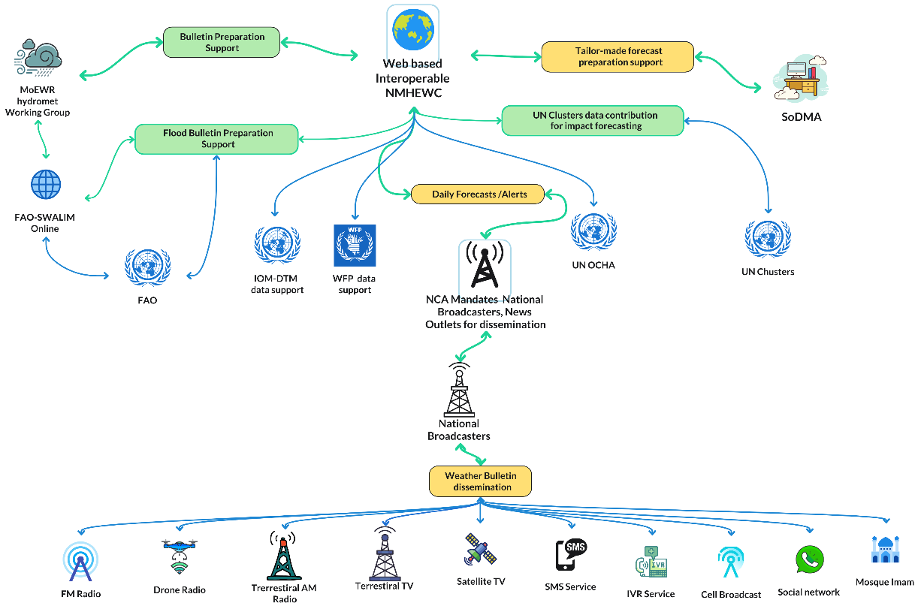
Figure 32 : Proposed NCA-led national communication framework ( Source : Z M Sajjadul Islam )

NCA should further require media outlets and telecom operators to maintain dissemination logs and performance reporting, including proof-of-airing, message reach metrics, and timeliness indicators, to ensure accountability. A structured feedback pathway should also be defined so that verified event situation updates collected by broadcasters (e.g., through live hazard shows) and local partners can be routed back to NMHEWS for validation and for iterative updates to bulletins and CAP alerts. Figure 32 presents the proposed NCA-led national communication framework that operationalizes these dissemination mandates and coordination processes.

5.8 UN Clusters data contribution for impact forecasting

The interoperable NMHEWS/MHEWS should be formally linked with the UN Cluster system to enable structured access to cluster datasets that are essential for impact forecasting, situational awareness, and forecast-based anticipatory action. This linkage should be established through a partnership framework between the Government (NMHEWC/SoDMA and relevant sector ministries), the UN (HCT and Clusters), and other stakeholders to strengthen coordination across DRM, DRR, and risk-informed development programming.

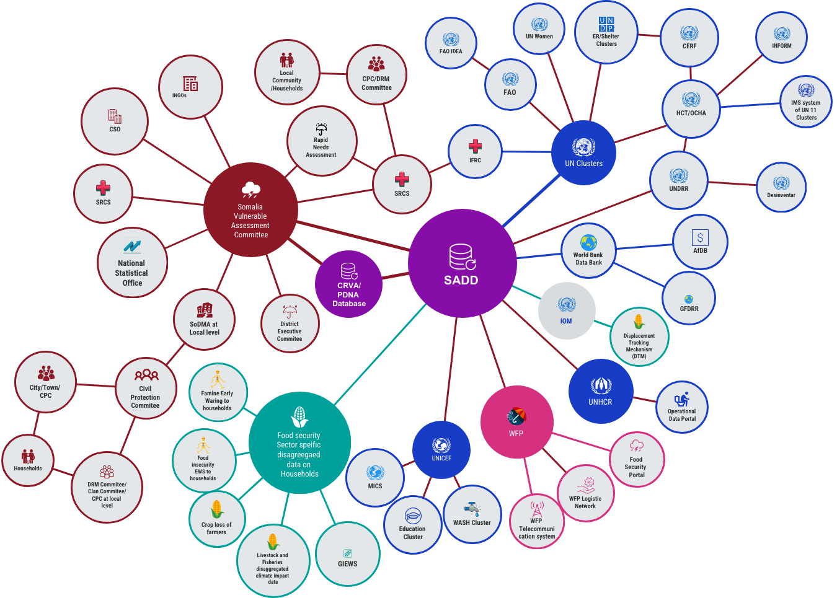
Figure 32 : Proposed UN Clusters data contribution for impact forecasting ( Source : Z M Sajjadul Islam )

To operationalize UN Cluster data contribution, the partnership should define: (i) a common data-sharing protocol and governance arrangements; (ii) data standards and minimum metadata requirements; (iii) role-based access controls; and (iv) quality assurance procedures for validation and update frequency. Cluster datasets should be integrated into NMHEWS as core baseline exposure and vulnerability layers to support impact-based forecasting, including georeferenced service delivery infrastructure, IDP and displacement data, WASH and health facility functionality data, food security and livelihood indicators, logistics access constraints, and response capacity inventories. These datasets should be accessible through interoperable mechanisms (REST APIs and/or scheduled data feeds) and maintained in an authoritative catalog to avoid duplication and inconsistent versions.

The UN HCT should lead the coordination effort to reduce the prevailing siloed approach by ensuring that clusters and implementing partners routinely contribute standardized datasets and rapid situation updates into NMHEWS during both normal periods and emergencies. This will strengthen national DRM institutional capacity by enabling joint analysis, harmonized risk communication, and a shared operational picture for anticipatory action planning, response prioritization, and early recovery decision-making.

5.9 Installation of hybrid surface observation and organizing a Live radio/TV show during Hazard spells is going

- Somalia should operationalize a hybrid surface observation and public reporting mechanism by integrating technology-based monitoring (AWS and targeted sensors) with structured crowdsourced field observations and live broadcast-based reporting during hazard spells. This arrangement should be formalized through NMHEWS-led Standard Operating Procedures (SOPs) and NCA mandates to ensure that event situation updates are collected in a consistent, georeferenced, and quality-controlled manner and are translated into timely warnings, impact updates, and response decision support.
- NCA, in coordination with NMHEWC/NMHS and national broadcasters, should mandate a crowdsourced information coordination mechanism during weather emergencies. This includes establishing a national and district-level crowdsourcing network using WhatsApp, Telegram, Facebook, and structured survey tools (KoboToolbox, SurveyMonkey) supported by GPS-enabled field reporting applications (GPS Logger, GPS Essentials or equivalent). The network should connect vulnerable herders, smallholder farmers, coastal fishermen, communities, CPC/DMC volunteers, stakeholders, enterprises, INGO project teams, lead farmers, financing institutions, credit operators, and insurance actors to collect risk information, support risk communication, and provide rapid event situation updates.
- The hybrid mechanism should enable systematic tracking of sudden-onset hazards (e.g., heavy rainfall, strong winds, thunderstorms, dust storms) that frequently generate immediate loss and damage, while also supporting ground-level monitoring of slow-to-medium onset hazards such as heatwaves, hot spells, and drought conditions. High-value urban elements (cities/municipalities) should be prioritized for enhanced instrumentation, including lightning detectors and other targeted sensors, to improve detection and short-lead warning of convective storms and severe weather impacts.
- To strengthen field observation capacity, modular basic instruments (thermometers, precipitation gauges, and handheld anemometers) should be distributed to designated volunteers, with clear reporting schedules, thresholds, and geolocation requirements. Crowdsourced volunteers should be mandated to remain alert during forecasted or emerging extreme weather conditions and to provide geotagged observations and impact updates to NMHEWS through approved channels. In arid and drought-prone contexts, the system should also capture georeferenced information on livestock access to drinking water and critical water point functionality during harsh weather conditions to support anticipatory action and rapid response planning ;
- Establish Constant Communication and Monitoring of Herders, Farmers, and Frontline Communities

Cellular service providers should be mandated, through NCA and relevant government authorities, to support constant, minimum-bandwidth digital connectivity for designated herders, emergency volunteers, MRCS/community volunteers, and other frontline informants. This should include provision of a limited free daily internet allowance for accredited volunteers in remote locations, and where required for operational continuity basic Android handsets for standardized field reporting to the IBF/NMHEWS platform. The objective is to sustain routine situational monitoring and ensure immediate transmission of time-critical observations during hazard spells and disaster onset.

Accredited herders and community volunteers should be formally tasked, under NMHEWS Standard Operating Procedures (SOPs), to provide rapid and structured updates through moderated WhatsApp groups and approved mobile reporting tools. Field updates should include geotagged observations and, where feasible, photographic evidence on: herd size and health conditions; forage availability and rangeland condition; campsite and settlement exposure to hazard-prone locations (e.g., floodplains and flash-flood channels, landslide- or debris-flow-prone slopes, and other high-risk terrain); localized multi-hazard manifestations; and the operational status and accessibility of livestock drinking water points. NMHEWS operators should periodically convene structured group discussions through these social network channels to reinforce reporting standards, improve completeness of observations, and ensure that urgent hazard signals are escalated immediately.

    - Conducting Live Radio Shows for Vulnerable Communities During Disaster Onset

During hazard spells and disaster onset, NCA, NMHEWC/NMHS, and broadcasters should coordinate to organize live radio talk shows preferably through restored AM radio services and, where available, city/municipality terrestrial stations to collect real-time situation and incident updates from remote communities. These live programs should be integrated with NMHEWS incident intake procedures so that incoming reports are captured, time-stamped, and georeferenced (where possible), and then validated through the hybrid observation network and trusted partners before being used for public updates. Broadcasters should be supported with standardized advisory scripts and guidance notes to ensure that programming includes clear protective action messages for herders, farmers, travelers, value chain operators, and other exposed groups.

    - Liaising With INGO and UN Agency-Supported Event Situation Updates

INGO and UN agency humanitarian and sector networks should be integrated into the NMHEWS/IBF event reporting workflow to provide structured event situation updates and sectoral impact information that supports CAP development and iterative warning updates. This linkage should align UN/INGO emergency preparedness and response protocols with IBF outputs and NMHEWS decision-support dashboards, enabling a shared operational picture for anticipatory action and response. The integrated reporting stream should include sector-relevant early warning indicators and alerts, including pasture condition status updates (e.g., “green pasture” and “dry pasture” alerts), forage and fodder crop failure signals due to drought, and related water and livelihood stress indicators, with clear geolocation references and update frequency requirements.

6.0 Pillar 4 : Improving Preparedness and Response Capabilities

6.1 Central Objectives for Improving Preparedness and Response Capabilities

- Improve multi-hazard-informed disaster risk management (DRM) systems at the local level.
- Build the capacity of DRM and DRR actors to design and implement risk-informed, forecast-based anticipatory action (AA).
- Mechanize and standardize anticipatory actions based on spatiotemporal-scale and precision-level early warnings and alerts.
- Strengthen local coordination mechanisms for Civil Protection Committees (CPC) and Disaster Management Committees (DMC) by enabling ICT tools-driven, interactive preparedness and lifesaving response planning.
- Implement an ICT tools-driven, interoperable NMHEWS online platform to support evidence-based preparedness and response decision-making and to hold stakeholders accountable for Pillar 4 actions.
- Deploy the interoperable NMHEWS platform to ensure collective accountability of all stakeholders state actors (government entities) and non-state actors (UN, INGOs, CSOs, academia) to affected populations (AAP), including measures to prevent duplication and overlapping interventions.
- Strengthen stakeholder capacity to assess post-disaster impacts and climate change impacts through improved Loss and Damage (L&D) data collection and enhanced capability to conduct PDNA and RPDNA at the local level.
- Improve disaster risk financing frameworks and develop forecast-based financing mechanisms to enable timely anticipatory action and response mobilization.

6.2 Recommendations on a Coherent Sector-Level Actionable Policy Framework
- Improve disaster risk management (DRM) action planning and reduce siloed preparedness, contingency, response, and recovery planning across federal, member-state, and district levels. Current DRM planning and interventions are fragmented across government entities, CSOs, and UN agencies, resulting in overlapping interventions in some locations and unmet needs in hard-to-reach areas. To address this, NMHEWC should deploy an interoperable online database, linked with mobile applications, to track DRM interventions in real time, map operational coverage, and identify People in Need (PiN) to support prioritized and coordinated action.
- Institutionalize and strengthen district (city/municipality) and community-level Civil Protection Committees (CPC) and Disaster Management Committees (DMC) using an ICT-enabled task management system. A structured CPC/DMC requires functional support from district administrations, city and municipality authorities, local INGOs and implementing partners, local NGOs, sector extension departments, charities, mosque imam-led committees, community volunteers, and youth groups. SoDMA-led NMHEWC should establish a governance database and role-based mobile applications to manage CPC/DMC structures, assign responsibilities, track Standing Orders during Disasters (SoDs), and enable timely coordination and reporting during emergencies.
- Facilitate implementation of Somalia’s Recovery and Resilience Framework (RRF) action plans through interoperable NMHEWS by enabling structured partnerships and shared planning tools. NMHEWS should support stakeholders in developing hazard-informed planning tools that align recovery, resilience, and risk reduction investments. This should include coordination with local NGOs/CSOs, local development committees, community structures, sector extension departments, local stakeholders, entrepreneurs, and market promoters to integrate DRM and DRR into local development processes. The system should provide hazard risk-informed tools to support city, municipality, and district governments in preparing DRM/DRR plans and should also support market value chain actors to develop value chain-level DRM/DRR planning and continuity measures.
- Support climate-vulnerable sector stakeholders at local level (crop agriculture, livestock, WASH, health, fisheries) by enabling hazard-informed scheme planning. NMHEWS should provide sector-relevant hazard information products, impact interpretation, and decision-support tools to enable local stakeholders to plan, prioritize, and implement anticipatory action, preparedness, response, and early recovery activities aligned with sectoral risks and vulnerabilities.

6.3 Improving Forecast-based Anticipatory Action Planning Capacity:

A core function of the interoperable NMHEWS is to enable coordinated, forecast-based anticipatory action (AA) planning across federal and member-state actors through a structured online platform. This capability should institutionalize how early warnings are translated into time-bound, location-specific, and sector-specific early actions before impacts escalate into disaster-level losses.
Under this approach, NMHEWS should serve as the national coordination backbone for anticipatory action by: (i) consolidating hazard forecasts and impact-based forecasts; (ii) linking forecast thresholds to pre-agreed triggers; (iii) assigning responsibilities to mandated institutions and partners; (iv) tracking readiness and implementation status through a task management workflow; and (v) maintaining a shared operational picture for decision-makers. This ensures that federal and state actors, sector ministries, district authorities, CPC/DMC structures, and humanitarian partners can act on the same evidence base and implement anticipatory measures in a synchronized manner.
The anticipatory action planning framework should be operationalized through Standard Operating Procedures (SOPs) that define hazard-specific triggers (e.g., rainfall thresholds, river-level thresholds, heat index thresholds, wind speed thresholds), escalation protocols, CAP-aligned public alerting requirements, and minimum early action packages for priority sectors (livestock, crop agriculture, WASH, health, fisheries, and urban services). NMHEWS should also integrate baseline exposure and vulnerability layers so that forecast information can be translated into projected impacts and prioritized actions at district, municipality, and community levels.

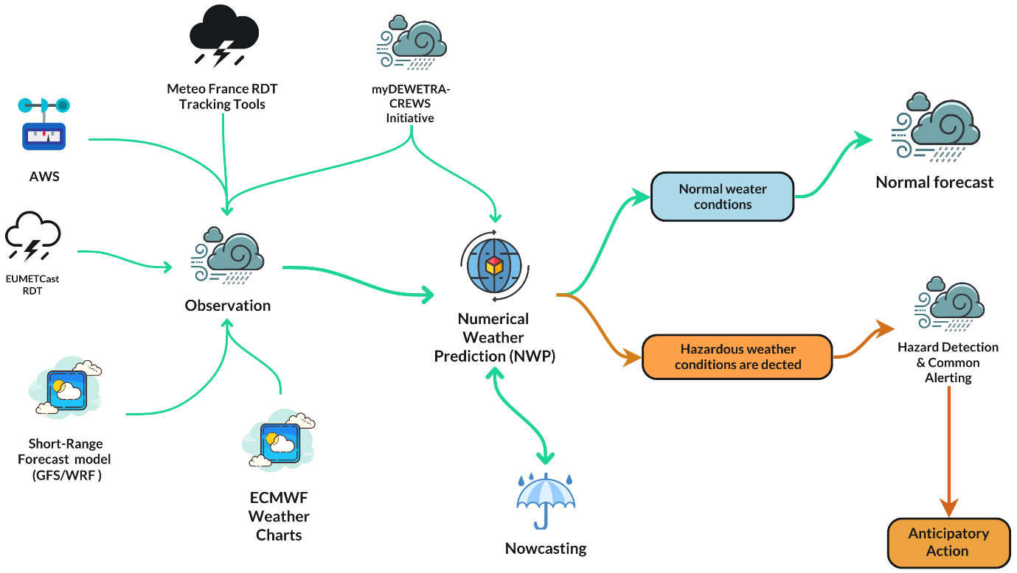
Figure 33 : Forecast-based Anticipatory Action Planning framework ( Source : Z M Sajjadul Islam )

Figure 33 presents the forecast-based anticipatory action planning framework, illustrating how hazardous weather conditions are monitored and analyzed, how triggers activate coordinated planning and pre-positioning, and how responsibilities are executed through an interoperable workflow to reduce loss and damage and strengthen preparedness and response performance.

6.4 Implementation functional Civil Protection Committee(CPC)/Disaster management Committee(DMC) :

Somalia should institutionalize functional Civil Protection Committees (CPC) and Disaster Management Committees (DMC) at district, municipality, and community levels to strengthen local disaster risk management, improve risk knowledge, and operationalize end-to-end, community-based early warning. CPC/DMC structures should serve as primary local key informants and first-line coordination mechanisms, directly linked to the interoperable NMHEWS through ICT tools and mobile applications.
CPC/DMC connectivity to NMHEWS should enable routine and emergency reporting of georeferenced risk and impact information, including: community-level Loss and Damage (L&D) updates; event situation reports during multi-hazard incidents; and prioritized humanitarian needs and response gaps. This two-way digital connectivity will ensure that warnings and advisories reflect local realities, improve situational awareness for national and sub-national decision-makers, and enable coordinated preparedness, response, and early recovery actions.
Currently, SoDMA and other sector departments conduct post-disaster L&D assessments using traditional community informants particularly mosque imams during Friday prayers providing a preliminary snapshot of impacts. This approach should be retained as a community engagement asset but upgraded into a structured, ICT-enabled reporting model under CPC/DMC leadership, supported by standardized reporting templates, validation workflows, and role-based access controls within NMHEWS.
Core CPC/DMC operational responsibilities linked to NMHEWS include:
- Send event situation updates: Provide immediate, geotagged reports on hazard onset, evolving impacts, and localized emergency conditions through approved mobile apps and moderated communication channels.
- Send local L&D updates: Submit structured, time-stamped L&D information (people affected, infrastructure damage, livelihood losses, service disruptions) to support rapid impact analysis, prioritization, and response mobilization.
- Develop and update local disaster preparedness, response, and early recovery plans: Use forecast-based triggers and risk information to prepare contingency actions, evacuation and shelter planning, resource mapping, and recovery priorities, and to coordinate local stakeholders under standing orders during emergencies.

6.5 Hazard risk-informed Humanitarian actions
Humanitarian actors require time-critical impact forecasts to plan forecast-based anticipatory action and immediate response, calibrated to the expected scale, intensity, duration, and geographic footprint of impending multi-hazards that are likely to generate Loss and Damage (L&D). In Somalia’s FCV context, ICT-enabled risk information management is essential to reduce fragmentation, improve operational coordination, and ensure that assistance reaches hard-to-reach locations without duplication or gaps.

An ICT-driven, georeferenced emergency management capability should be embedded within the interoperable NMHEWS to support humanitarian decision-making. This capability should integrate impact-based forecasts, baseline exposure and vulnerability layers, and real-time event situation updates to produce operational maps and prioritization outputs for response planning and early action. The system should enable humanitarian actors and local structures to translate forecast information into actionable measures such as pre-positioning supplies, scaling readiness, activating evacuation and shelter arrangements, and mobilizing targeted cash or in-kind interventions before impacts escalate.

To improve accountability and operational efficiency, NMHEWS should include a standardized, app-based 5W (Who, What, Where, When, and How) intervention planning and tracking module. This module should allow authorized partners to record planned and ongoing actions, geographical coverage, target groups, timelines, delivery modalities, and resource commitments. The 5W workflow should be used to prevent overlapping interventions, reduce duplication, and identify underserved and hard-to-reach areas in near real time, enabling uniform and needs-based mobilization of humanitarian assistance at the last mile

6.6 Improving the community-level volunteering network for emergency preparedness and Response mechanism

- Establish a structured coordination mechanism led by SoDMA, in partnership with the Somali Red Crescent Society (SRCS) and INGOs, to develop and sustain a community-level volunteering network for emergency preparedness and response.
- Build capacity to strengthen volunteer service delivery, including training on hazard awareness, first response protocols, community-based early warning dissemination, rapid assessment, referral pathways, and safety procedures.
- Mandate CSOs and implementing partners to apply the 5W (Who, What, Where, When, and How) framework in preparedness and response planning and tracking, to reduce duplication, improve coverage, and strengthen accountability.
- Require CSOs to develop DRM strategies that link emergency response operations with recovery planning and longer-term community resilience programming.
- Strengthen community capacity to implement risk reduction and resilience approaches, including DRR, climate change adaptation (CCA), nature-based solutions (NbS), and locally led adaptation (LLA), supported by practical community-level tools and guidance.
- Develop and apply a stakeholder coordination strategy to prevent overlapping DRR, CCA, NbS, and climate resilience initiatives at district, village, and community levels, including clear roles, geographic coverage mapping, and joint planning cycles.
- Establish an operational coordination structure for DRR, CCA, and NbS interventions at local level (district, village, community), aligned with CPC/DMC structures and linked to NMHEWS task management and reporting workflows.
- Enhance stakeholder capacity to implement evidence-based DRR, CCA, and NbS interventions at community level, including risk and vulnerability assessment, prioritization, and monitoring of results.
- Strengthen the quality and reach of local humanitarian and DRR interventions implemented by INGOs, NGOs, CSOs, and local governments through joint standards, coordination protocols, and shared situational awareness.
- Improve local government, SoDMA, CSOs engagement in humanitarian response planning and intervention processes, including participation in coordination fora, endorsement of local plans, and integration of response actions with recovery and resilience priorities.

    - Hazardous weather forecast bulletin

The hazardous weather forecast bulletin is an official, time-bound forecast product issued by the NMHEWC/NMHS to inform government entities, sector departments, humanitarian actors, CPC/DMC structures, and the public about impending hazardous weather and potential cascading multi-hazard impacts. The bulletin should include: hazard type and intensity; affected areas with clear geotargeting; forecast validity period; expected impact pathways (e.g., flash flooding, river flooding, wind damage, heat stress, dust storms); alert level classification; and recommended protective actions for priority sectors and vulnerable groups. The bulletin should be disseminated through NMHEWS channels and mandated broadcasters and telecom operators (web, radio/TV, SMS/IVR/cell broadcast, and social media), and should be updated whenever forecast confidence, hazard trajectory, or impact expectations change.

    - Civil Protection Committee (CPC) at the Local Level

The Civil Protection Committee at district, municipality, and community levels is the primary local coordination body for preparedness, early action, and first response. CPC/DMC structures should be formally connected to NMHEWS through mobile applications and moderated communication channels to receive official bulletins and CAP alerts, interpret localized implications, and provide two-way feedback to NMHEWC on evolving event situations and impacts. CPC membership should include local administration, community leaders, mosque imam-led committees, women and youth representatives, volunteers, and sector extension focal points. The CPC should function as the key local informant group for validating hazard impacts, reporting Loss and Damage (L&D), and supporting the prioritization of needs and response actions.

    - Civil Protection Committee Actions for Local Preparedness

Upon receipt of a hazardous weather forecast bulletin or CAP alert, the CPC should implement a structured local preparedness package, aligned with SOPs and forecast triggers. Priority actions include:
- Convene an immediate CPC coordination call/meeting and activate the local tasking plan with roles and responsibilities.
- Disseminate the official warning to households and vulnerable groups using all available channels (mosques, community volunteers, phone trees, WhatsApp groups, local radio, megaphones).
- Identify and map high-risk zones (floodplains, drainage channels, unstable slopes, exposed coastal areas) and issue localized advisories on avoidance and safe routes.
- Prepare and validate a list of People in Need (PiN) and priority vulnerable households (IDPs, elderly, persons with disabilities, female-headed households) for targeted support and evacuation assistance.
- Inspect and prepare emergency shelters, safe public buildings, and basic WASH arrangements; pre-position essential supplies where feasible.
- Coordinate with sector focal points to protect critical assets (water points, health posts, schools, markets, livestock watering points) and initiate sector-specific early actions.
- Establish an incident reporting routine to NMHEWS (geotagged updates, photos where feasible) and maintain regular situation updates during the hazard lifecycle.
- Prepare for immediate response actions if impacts occur, including first aid, rapid needs assessment, and referral to district/state and humanitarian partners, while documenting L&D for PDNA/RPDNA processes.

6.7 Improving Last-Mile Disaster Preparedness Capacity

Last-mile disaster preparedness depends on the availability and dissemination of precision-level forecasts through real-time channels (radio/TV and digital platforms), and on the ability of local institutions and households to translate early warnings into localized, forecast-based anticipatory actions. Effective preparedness requires timely mobilization of CPC/DMC structures, clear community guidance, and rapid household-level protective actions, including evacuation to safe ground and/or designated shelters when thresholds indicate life-threatening risk.
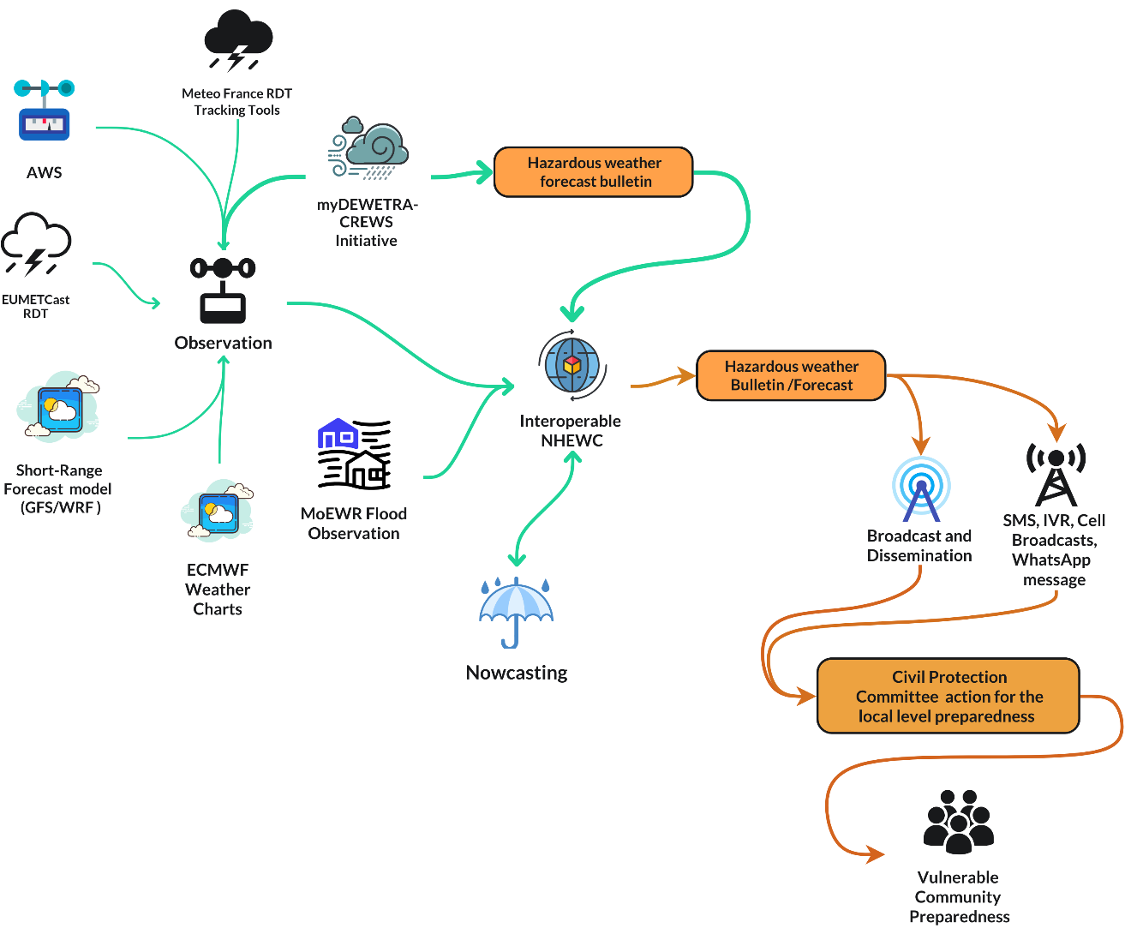
Figure 34 : Proposed Last-Mile Disaster Preparedness process ( Source : Z M Sajjadul Islam )

Under the proposed last-mile preparedness process, NMHEWS should issue impact-based forecasts and CAP-aligned alerts with clear geotargeting, timing, severity, and recommended actions. These products should be disseminated through mandated broadcasters and telecom operators, while CPC/DMC structures activate local preparedness SOPs, verify community risk hotspots, coordinate evacuation and shelter readiness, and report event situation updates and emerging impacts back to NMHEWS. This two-way workflow strengthens situational awareness, improves targeting of preparedness and response resources, and supports consistent messaging and community compliance.
Figure 34 illustrates the proposed last-mile disaster preparedness process, linking precision forecasts and real-time dissemination with CPC mobilization, localized anticipatory action planning, and household-level preparedness and evacuation actions to reduce Loss and Damage.

The following are the simple steps forward in the Somalian context to enhance local-level preparedness in the event of a rapid & sudden onset of impending hazardous weather conditions.

Precision Level Forecasts | Forecast Dissemination | Local Preparedness Support | Community Evacuation
Flood, Tropical Cyclone, Localized RDT and Heavy Rainfall Forecast and Early Warning | - Local broadcasters to broadcast special weather bulletins and weather warnings  • SMS, USSD services  - Customized MHEWS mobile apps for weather warning, alerting  • IVR and cell broadcasts (toll-free)  • WhatsApp messages for cascading group | - • Anticipatory action advisories based on localized vulnerability context (topography, drainage patterns, settlement location, and element-specific exposure).  • SoDMA, local administration, CSOs, and sector extension departments to issue Standing Orders and activate CPC/DMC using a 5W tasking approach (who does what, where, when, and how). | • Use localized vulnerability context (topography, flood pathways, shelter conditions, and proximity to risk zones) to identify priority households for evacuation.  • Implement assisted evacuation for People in Need (IDPs, elderly, persons with disabilities, pregnant women, female-headed households) and direct them to pre-identified safe shelters or safe ground.

Recommendations :
- A joint capacity-building programme should be implemented by the CSO consortium, UN Clusters and HCT actors, UN agencies, INGO-led implementing partners, and SoDMA to strengthen CPC/DMC committees at city, municipality, urban centre, town, village, and community levels. Training should cover practical competencies such as evacuation drills, first aid, rapid needs assessment, safety and security procedures, basic incident reporting, and community-based early warning dissemination.
- CPC/DMC committees should develop and institutionalize a local preparedness plan structured around the 5W framework (Who will do What, Where, When, and How). The plan should define clear roles, escalation procedures, minimum preparedness actions for priority hazards, resource mapping, and reporting requirements linked to NMHEWS.
- An emergency shelter group or committee should be established under CPC/DMC leadership to manage shelter identification, readiness assessment, access arrangements, WASH minimum conditions, crowd management, protection considerations, and shelter activation triggers during rapid-onset emergencies.
- CPC/DMC capacity should be strengthened in forecast-based emergency preparedness and response, including coordination of multi-stakeholder humanitarian action at community and household levels. This should include improving institutional capability to develop and implement Forecast-based Early Action Protocols (EAPs), aligned with NMHEWS triggers, CAP alerts, and sector-specific minimum action packages.
- Local broadcasters and news outlets should be mandated, through NCA and relevant authorities, to systematically enhance community risk knowledge and risk perception on priority hazards. These should include, at minimum: flash drought, hydrological and meteorological extremes, fluvial floods, flash floods, transboundary catchment overflow flooding, landslides, cyclones, convective heavy rainfall, tornadoes, thunderstorms, disease outbreaks, and earthquake-induced coastal tsunamis.

6.8 Improving Community-based Early Warning Capacity

Community-based early warning is an end-to-end early warning system operationalized at local level through a mechanized structure and defined procedures. It should integrate local broadcasters, CPC/DMC structures, local government administration and sector departments, local CSOs, local humanitarian action groups, the Somali Red Crescent Society, and other relevant actors to ensure that warnings are actionable, locally understood, and continuously updated as conditions evolve.

The process is triggered when hazardous weather is detected and forecasted at precision level, with a clear spatiotemporal scale and identification of likely high-impact areas. Upon trigger activation, NMHEWC issues special weather bulletins and CAP-aligned warnings/alerts. Local broadcasters and CPC/DMC structures disseminate these warnings immediately and repeatedly through accessible channels, while local authorities and partners activate preparedness SOPs, including evacuation support, shelter readiness, protection measures, and sector-specific early actions.
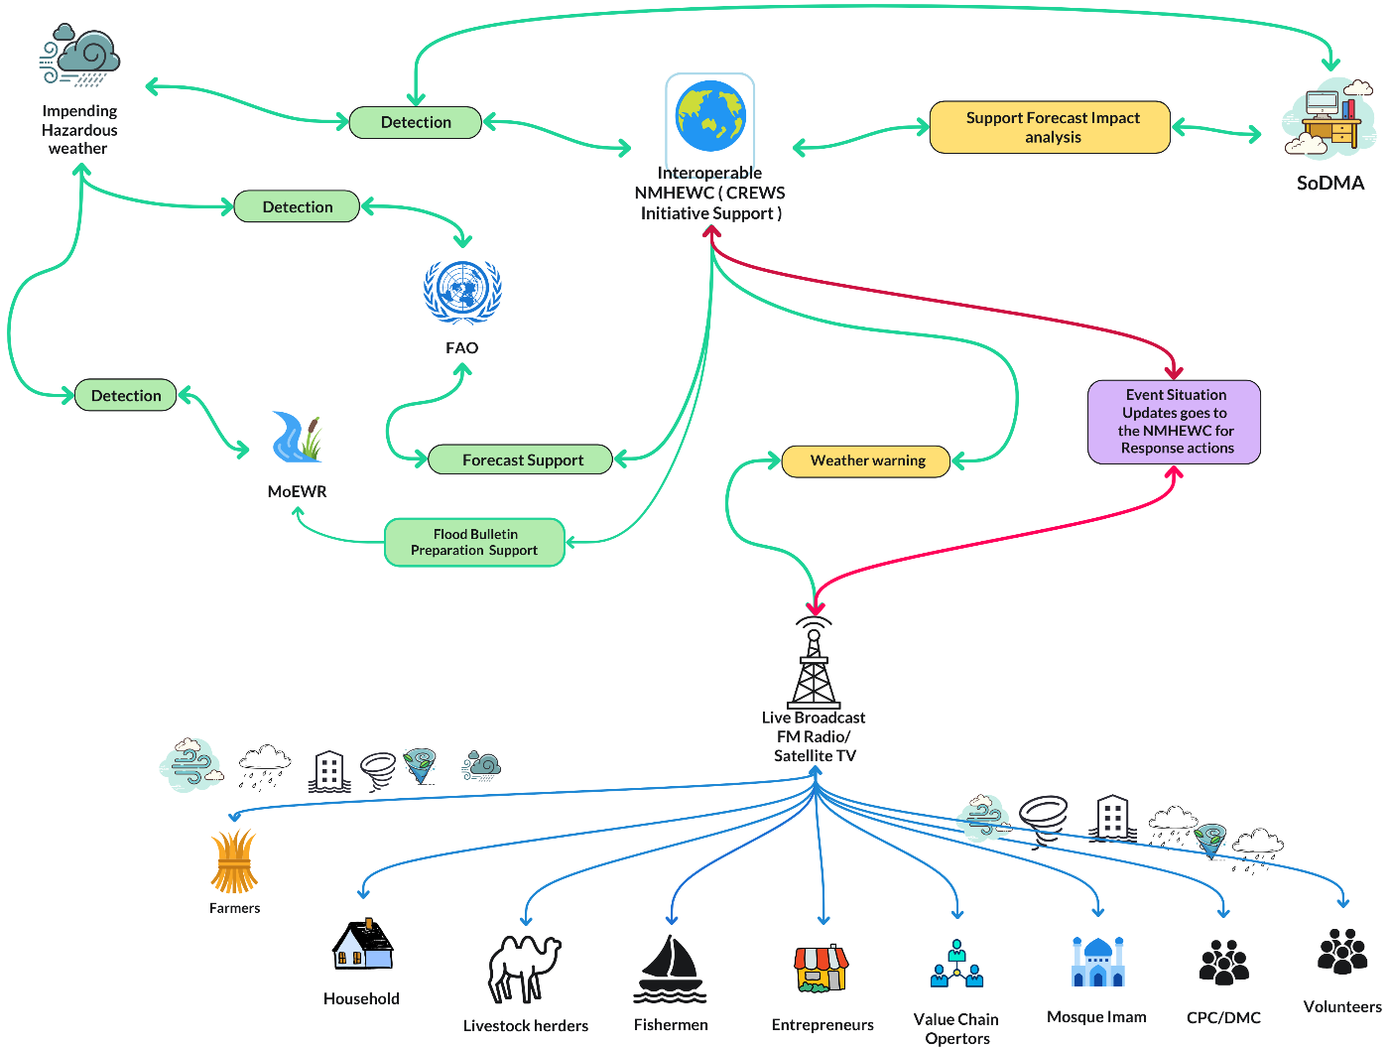
Figure 35 : Structure & process for improving Community-based Early Warning Capacity ( Source : Z M Sajjadul Islam )

As hazards begin to interact with the ground and impacts emerge, community-based early warning must transition into an interactive, two-way risk communication and situation reporting mechanism. Local broadcasters should organize live shows, live broadcasts, and moderated interactive discussions with CPC/DMC representatives and affected communities/households to capture real-time event situation updates, preliminary Loss and Damage (L&D) information, and priority humanitarian needs. These updates should be systematically documented, validated, and transmitted back to NMHEWC through the interoperable NMHEWS platform to strengthen situational awareness, refine warning messages, and support coordinated response and early recovery planning.

Figure 35 presents the proposed structure and process for improving community-based early warning capacity, demonstrating how precision forecasting, real-time dissemination, community feedback loops, and event situation reporting are integrated into a continuous end-to-end early warning and early action workflow.

Recommendations :
- A joint capacity-building programme should be delivered by the CSO consortium, UN Clusters and HCT actors, UN agencies, INGO-led implementing partners, and SoDMA to strengthen the operational readiness of: (i) national and local broadcasters and news agencies; and (ii) CPC/DMC committees at city, municipality, urban centre, town, village, and community levels. Training should focus on practical preparedness and response competencies, including evacuation drills, first aid, community-based early warning dissemination, incident reporting, and coordination protocols for rapid-onset emergencies.

- Local broadcasters and news outlets should be formally mandated, through NCA and relevant authorities, to strengthen community risk knowledge and risk perception by delivering regular and emergency programming on priority hazards. At minimum, covered hazards should include: flash drought, hydrological and meteorological extremes, fluvial floods, flash floods, transboundary catchment overflow flooding, landslides, cyclones, convective heavy rainfall, tornadoes, thunderstorms, disease outbreaks, and earthquake-induced coastal tsunamis.

6.9 How to develop the Anticipatory Action (AA) Framework

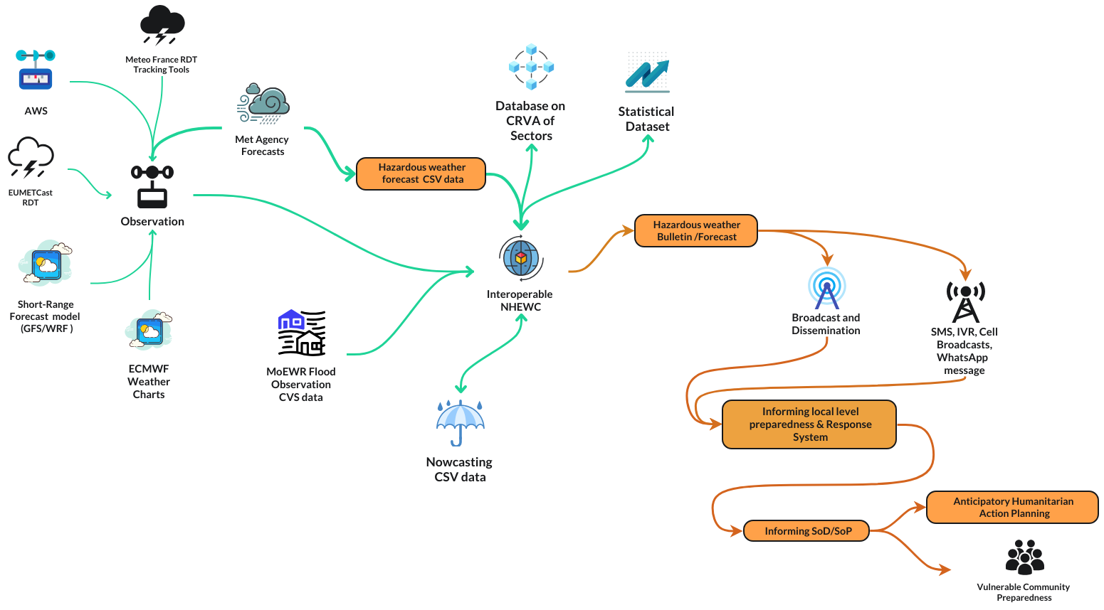

Figure 36 : Structure Anticipatory Action (AA) Framework ( Source : Z M Sajjadul Islam )

Step 1: Complete risk Baseline risk and vulnerability analysis.

- Develop a comprehensive repository of elements, sectors, livelihoods, and livestock-herding areas, including georeferenced exposure, sensitivity, vulnerability, and risk ranking for each priority element and location.
- Identify and prioritize the most significant hazards based on historical and projected Loss and Damage (L&D), frequency, intensity, magnitude, spatial footprint, and seasonality, and define the hazard ranking for Somalia’s context.
- Prepare a detailed risk atlas at state, regional, and district levels, including indicators and mapping of recurrent hazards (e.g., flash floods, drought, sand and dust storms, cyclones, heatwaves). The atlas should integrate risk, vulnerability, exposure, and sensitivity analysis for priority sectors, including livestock, crop agriculture, water, land, and soil.
- Develop sector- and locality-specific profiles that include physical and geographical characteristics, socioeconomic conditions, and coping capacity indicators, ensuring that the risk atlas supports operational planning, targeting, and prioritization.
- Develop Standard Operating Procedures (SOPs) for local governments to guide humanitarian preparedness, response, and climate risk management actions, aligned with national DRM frameworks and NMHEWS warning products.
- Develop and institutionalize Standing Orders on Disasters (SoDs) that define actors’ and stakeholders’ operational responsibilities for managing disaster emergencies at local level, including CPC/DMC activation and reporting requirements.
- Review risk-informed Local Development Plans (LDPs) and budgeting processes of local governments, including ongoing interventions, to assess alignment with hazard risk profiles and identify entry points for anticipatory action integration.
- Review the value chain operations of essential service sectors to identify vulnerabilities, critical nodes, and feasible anticipatory actions to reduce disruptions and minimize L&D during hazard periods

Step 2: Review Impact Forecasts and Short-Term Operational Forecasts (IBF)

- Review the latest impact-based forecasts (IBF) and short-term operational forecasts to determine which hazards are impending, where they are most likely to occur, and the expected spatiotemporal evolution of the event (location, timing, duration, and intensity).
- Analyze forecast lead times (e.g., 12-hour and 24-hour windows) to identify priority alert zones and the geographic extent of potential impacts, including hotspot mapping for high-risk districts, settlements, and livelihood zones.
- Overlay forecast hazard parameters with baseline exposure and vulnerability datasets to estimate the number and type of elements likely to be affected (people, critical infrastructure, water points, health facilities, croplands, livestock concentrations, markets, IDP sites, and transport corridors).
- Classify expected impacts against predefined severity thresholds (e.g., advisory, watch, warning, alert) and quantify anticipated Loss and Damage (L&D) indicators where feasible, using sector-specific impact functions and historical analogues.
- Estimate “impending risk” by combining forecast probability and intensity with exposure and vulnerability factors, and differentiate it from “persistent risk” driven by underlying structural vulnerabilities and residual conditions (e.g., degraded rangeland, depleted groundwater, weakened shelters, existing displacement).
- Produce a prioritized impact summary for decision-making that includes: expected hazard scenario; highest-risk locations; elements at risk; severity level; forecast confidence; and recommended anticipatory actions for CPC/DMC, sector departments, and humanitarian partners.

Step 3: Define the impact level by the impending extreme weather events induced hazard(s)

    - Consolidate and summarize the element-level risk ranking from the baseline repository and the IBF overlay outputs, and classify elements into priority tiers (Very High, High, Medium, Low) based on expected severity, exposure, vulnerability, and forecast confidence.
- Define the expected impact level for each priority hazard scenario by specifying:
- Hazard type and trigger (e.g., flash flooding from RDT-heavy rainfall, river flooding, cyclone winds, heatwave/dry spell).
- Geographic impact footprint (districts/settlements/IDP sites/livelihood zones).
- Element categories at risk (population groups, critical infrastructure, sector assets, and service systems).
- Severity thresholds (e.g., advisory/watch/warning/alert) and anticipated consequences (service disruption, asset damage, livelihood losses, displacement, and protection risks).
    - Determine the intervention type required for each high-risk element category, aligning actions with the impact level, such as:
- Early action and preparedness measures (pre-positioning, protective actions, shelter readiness, risk communication).
- Life-saving response measures (evacuation support, emergency WASH, health surge actions, rescue and first aid).
- Service continuity measures (protection of water points, clinics, supply chain nodes, and markets).
- Immediate early recovery actions (rapid repairs, debris clearance, restoration of basic services, and initial recovery support).
    - Specify the duration of support required by hazard type and impact scenario, including:
- Timebound preparedness window (e.g., 12-24 hours pre-impact; 24-72 hours for rapid-onset hazards).
- Response duration (e.g., 3-7 days for immediate lifesaving actions; longer if access constraints persist).
- Early recovery duration (e.g., 2-8 weeks depending on infrastructure damage, livelihood losses, and displacement).
- Sector-specific duration assumptions (e.g., WASH water trucking timelines, temporary health outreach duration, livestock feed and water support periods, and crop-input support cycles).

    - Produce an operational “Impact-to-Action” summary that links: (i) risk ranking; (ii) expected impact level; (iii) prioritized intervention type; and (iv) required duration and delivery modality for implementation planning and resource mobilization.

Step 4 : Analyze the IBF anticipatory advisory on loss and damage.

This step is led by the IBF Technical Working Group (TWG), comprising NMHS forecasters and sector representatives, who access the NMHEWS geospatial platform to interpret forecast outputs and translate them into an anticipatory Loss and Damage (L&D) scenario. The TWG analysis becomes a core evidence input to develop an Early Action Protocol (EAP), ensuring that anticipatory actions are triggered by precision-level impact forecasting and quantified, scenario-based consequences.
Key actions under this step:
- Access and validate IBF products: The TWG retrieves the latest operational forecasts, hazard layers, and IBF outputs from the geospatial platform, confirms forecast validity windows, confidence levels, and lead times, and identifies priority hazard scenarios requiring anticipatory action.
- Overlay hazard layers with exposure and vulnerability datasets: Using the platform, the TWG overlays forecast hazard intensity footprints (e.g., rainfall, wind, heat stress, flood extent) with baseline exposure and vulnerability layers (settlements, IDP sites, water points, croplands, livestock corridors, health facilities, markets, roads).
- Estimate anticipatory L&D scenarios: The TWG develops a structured anticipatory L&D scenario by estimating:
  - likely affected population groups and priority People in Need (PiN);
  - expected damage and service disruption for critical infrastructure and lifelines;
  - expected livelihood impacts (crop loss risk, livestock morbidity/mortality risk, water stress, market disruption);
  - likely displacement triggers and protection risks, where relevant.
- Apply sector impact thresholds and severity classifications: The TWG classifies impacts against agreed thresholds (e.g., advisory/watch/warning/alert), prioritizes hotspots, and identifies which elements exceed intervention thresholds requiring immediate anticipatory measures.
- Develop an anticipatory advisory package: The TWG produces a concise anticipatory advisory for decision-makers, including: hazard scenario summary; locations at highest risk; anticipated impacts and L&D estimates; recommended early actions by sector; timing and duration assumptions; and operational constraints (access, security, supply chain, communication limitations).
- Translate results into EAP inputs: The anticipatory advisory becomes the primary technical input for EAP development, including definition of triggers, pre-agreed early actions, target locations and populations, roles and responsibilities, minimum response packages, and monitoring and reporting indicators aligned with NMHEWS outputs and CPC/DMC field reporting.

The formula for impact estimation.

Estimated Impact Severity (by location and element) = [Impact forecast threshold overlay (color-coded hazard intensity by lead time) × Exposure of baseline elements (CRVA inventory, georeferenced)]
- [Physical vulnerability score and risk rank (element condition, fragility, criticality)]
- [Socioeconomic vulnerability score and risk rank (SADD, poverty, displacement, access constraints)]
− [Coping capacity score (preparedness, resources, services, early action readiness)]
Where, for each geographic unit (state/region/district/community) and each element category (population, infrastructure, sector assets):
- Hazard intensity and probability are derived from the IBF threshold class (e.g., green/yellow/orange/red/purple).
- Exposure is the count/extent of baseline CRVA elements intersecting the hazard footprint.
- Physical vulnerability and socioeconomic vulnerability are weighted indices producing risk ranks (Very High/High/Medium/Low).
- Coping capacity reduces the net impact estimate based on available measures and response readiness.
Outputs:
- Estimated affected elements (counts/asset types) by severity class
- Geographic impact zones ranked by expected impact (Very High/High/Medium/Low)
- Priority areas and elements for anticipatory action and EAP activation

Step 5: Develop an anticipatory L&D scenario:

a) Build an impact and severity checklist (by element and location)
- Define the hypothesis for the event (hazard type, lead time, affected footprint, intensity thresholds, and forecast confidence).
- Using the IBF overlay and CRVA baseline repository, produce a structured checklist that quantifies, by geographic unit (state/region/district/community) and by sector/element type:
  - Elements exposed (count/extent within the hazard footprint).
  - Sensitivity level (how strongly the element is affected by the hazard parameter).
  - Vulnerability level (physical and socioeconomic vulnerability ranking).
  - Risk rank (Very High / High / Moderate / Low) based on agreed thresholds.
- Summarize results as a severity index dashboard showing how many elements fall into each risk tier and where the highest concentrations occur (hotspots).

b) Produce detailed L&D scenario calculations in a structured worksheet
- Use an Excel-based computation sheet (or equivalent) to calculate anticipatory L&D scenarios from the checklist, with standardized fields:
  - Hazard scenario ID; forecast time window; location codes; element type; baseline quantity/value; vulnerability rank; coping capacity; severity class; expected impact assumption; projected L&D outputs.
- Apply predefined sector impact assumptions (damage ratios, service disruption multipliers, livestock morbidity/mortality assumptions, crop loss coefficients, water point failure probabilities) to generate consistent anticipatory estimates.
c) Estimate physical losses, financial losses, and investment needs for preparedness and risk reduction
- Quantify physical losses and damages (e.g., number of households affected, facilities disrupted, hectares of cropland at risk, livestock likely affected, water points likely to fail).
- Estimate financial L&D by applying unit costs or replacement/repair costs to the physical impact estimates (e.g., cost per shelter kit, water trucking per day, borehole repair cost, clinic supply cost, crop input cost, livestock feed/water cost).
- Determine the required preparedness and resilience investment needed to reduce anticipated impacts, including costs for:
  - early actions (pre-positioning, evacuation transport, temporary shelter readiness);
  - protective measures (reinforcement of shelters, flood barriers, drainage clearance);
  - service continuity (WASH, health surge capacity, backup power/communications);
  - sector-specific mitigation (fodder and water support for livestock, irrigation contingency, seed protection and replanting readiness).
- Present investment needs as a prioritized package aligned with severity tiers and geographic hotspots, showing how proposed measures reduce risk, vulnerability, exposure, and sensitivity over the hazard lifecycle.

Table : elements impact analysis.
Elements | Extremely high risk (Magenta alerted areas) ( % or number) | Very High risk (Red alerted areas)  ( % or number) | Medium Risk ( Orange alerted areas ) ( % or number) | Low Risk ( yellow alerted areas) ( % or number) | Exposed | Vulnerable | L & D area likely ( % or number) | Death tolls are likely ( % or number)

Step 6: Develop a Contingency Plan

- Formulate SOPs with a 5W tasking framework
Develop hazard- and sector-specific Standard Operating Procedures that define: who will do what, where, when, and how. SOPs should include activation triggers (forecast/CAP thresholds), escalation procedures, communication protocols, reporting schedules, and minimum action packages for CPC/DMC, sector departments, local government, and partners.
- Define required resources to protect life and critical assets
Prepare a resource plan that specifies the lifesaving and asset-protection requirements by location and severity tier, including shelter readiness, evacuation logistics, emergency WASH, health surge supplies, rescue/first aid kits, communications, fuel/power backup, and protection services. Include supply chain routes, storage locations, and last-mile distribution arrangements.
- Detail People in Need (PiN) and prioritize interventions for highest-risk elements
Using the anticipatory L&D scenario, quantify PiN by district/community and categorize priority groups (IDPs, elderly, persons with disabilities, pregnant and lactating women, female-headed households, children). Align interventions to risk ranking and severity (Very High/High/Moderate/Low) and specify targeting criteria and referral pathways.
- Establish rapid funding mechanisms and probable sources
Identify and document immediate financing options and decision pathways, including:
- internal sources (district/municipal contingency funds, member state allocations, federal emergency budgets, in-kind resources);
- external sources (UN pooled funds, CERF, NGO rapid response mechanisms, donor contingency windows, forecast-based financing/anticipatory action funds).
Define authorization processes, minimum documentation, and disbursement timelines linked to forecast triggers.
- Apply risk-based allocation of interventions and resources
Allocate resources based on severity tiers, geographic hotspots, and feasibility constraints (access, security, logistics). Define pre-positioning priorities, evacuation and shelter support priorities, and sector-specific early actions. Include a clear coordination and deconfliction mechanism (5W matrix) to avoid duplication and ensure coverage of hard-to-reach areas.
- Operationalize monitoring, reporting, and revision procedures
Set reporting templates, minimum indicators, and update cycles (e.g., 6-12 hourly during rapid-onset hazards) to incorporate field situation updates and L&D reporting into continuous refinement of the contingency plan.

Step 7: Select forecast based early actions

- Classify the hazard and define the operational risk window: Categorize the impending hazard by type, onset profile, intensity/magnitude, geographic scalability, and expected duration, then translate this into an operational timeline (pre-impact, impact, and immediate post-impact windows).
- Select early actions across the full risk-management cycle: Define a coherent package of actions covering pre-impact preparedness, protective measures during impact, and immediate post-impact stabilization, explicitly linked to forecast thresholds and prioritized by severity and feasibility.
- Prepare a risk-category investment menu: Develop hazard- and severity-tiered (Very High/High/Moderate/Low) investment options, specifying target groups/locations, unit packages, minimum standards, delivery channels, time sensitivity, and activation criteria.
- Define intervention modalities and delivery mechanisms: Specify, per action, the delivery pathway cash-based, in-kind, logistics/services, and relief/protection—selected based on access, market functionality, security, and speed.
- Assign executing stakeholders under a 5W action plan: Convert actions into a 5W operational plan (Who/What/Where/When/How) with clear roles for government, CPC/DMC, SRCS, UN clusters, INGOs/CSOs, and private-sector actors, including coordination and reporting requirements.
- Integrate resource, financing, and monitoring requirements: For each action, define resource needs, indicative costs, financing sources, procurement lead times, monitoring indicators, and reporting frequency, aligned with NMHEWS outputs, CAP messages, and CPC/DMC field reporting for adaptive management.

Step 8: Define the intervention process

- Define intervention based on the threshold and impact intensity of the impending extreme weather events. Following the 5W process for involving the actors.
- Define activities, budgets, and probable funding sources.
- Develop an M&E plan while the intervention is triggered to capture the progress to date.

Step 9: Event situation reporting.

Define trigger thresholds and activation rules
Establish clear intervention triggers based on forecast/CAP thresholds and impact intensity (e.g., advisory/watch/warning/alert), including: lead time (12/24/48 hours), confidence levels, and severity zones. Specify escalation and de-escalation rules and the authority responsible for activation (e.g., NMHEWC/TWG in coordination with SoDMA and NCA).

Operationalize the 5W coordination process
Translate triggers into an operational 5W action matrix that assigns responsibilities and ensures coordinated execution:
- Who: designated implementing actors (SoDMA, MoEWR, sector ministries, district administrations, CPC/DMC, SRCS, UN clusters, INGOs/CSOs, telecom/broadcasters).
- What: the agreed early action package(s) and minimum service standards.
- Where: the prioritized geographic hotspots and target groups (PiN), including IDP sites and hard-to-reach areas.
- When: timelines by phase (pre-impact mobilization, during-impact response, immediate post-impact stabilization).
- How: delivery modality (cash, in-kind, logistics, services), supply chain routes, distribution points, and reporting lines.

Define activities, budgets, and probable funding sources
For each action package, specify: activity descriptions, unit quantities, unit costs, total budget, and procurement/disbursement lead times. Identify financing pathways and probable sources, distinguishing:
- internal funding (district/municipal contingency funds, member state allocations, federal emergency budgets, in-kind contributions);
- external funding (UN pooled funds, CERF, donor contingency windows, NGO rapid response funds, forecast-based financing mechanisms).
Document approval steps, minimum documentation, and disbursement triggers linked to the forecast threshold.

Establish an M&E plan aligned to triggered interventions
Develop a rapid Monitoring and Evaluation plan that is activated when the intervention is triggered, including:
- objectives and expected outputs/outcomes by sector;
- key indicators (coverage, timeliness, quality, accountability to affected people, and risk reduction effects);
- data sources (NMHEWS platform reporting, CPC/DMC field updates, partner 5W reporting, hotline/feedback channels);
- reporting frequency (e.g., daily during rapid-onset events; weekly during slow-onset hazards);
- verification methods (spot checks, geotagged reporting, remote monitoring, partner validation);

Step 10: EAP approval and designation for risk finances

Convene an online approval consultation process (IBF Interoperable Online Platform)
Using the integrated web portal and geospatial platform, the Anticipatory Action (AA) process leadership (lead/co-leads), TWG members, key stakeholders, and local governments convene a structured online consultation to review the final EAP package. The platform should enable controlled access, versioning, and traceable comments.

Validate technical and operational readiness of the EAP
Confirm that the EAP is technically sound and operationally implementable, including: hazard triggers and thresholds; impact scenarios and severity tiers; targeting logic (PiN and priority locations); early action packages; SOPs and 5W responsibilities; implementation timelines; and monitoring/reporting requirements.

Finalize the EAP through an auditable approval workflow
The portal should support an approval chain with role-based permissions (drafting, technical validation, operational sign-off, and final endorsement). All revisions, comments, and decisions should be logged to ensure transparency and institutional accountability.

Designate available risk finance and confirm mobilization modalities
Identify and confirm the financing instruments that can be immediately mobilized once triggers are met, including:
- pre-arranged internal contingency resources (local government, member state, federal allocations);
- partner and humanitarian financing windows (UN, INGOs, pooled funds);
- forecast-based financing (FBF) mechanisms and anticipatory action funds.
Specify amounts, eligible expenditures, disbursement authority, and time-to-release benchmarks.

Determine additional funding requirements and funding gaps
Using the anticipatory L&D scenario and the selected early action package costs, quantify the total required budget, the available financing, and the residual funding gap. Categorize gaps by sector, geography, and time criticality (immediate vs. scale-up needs).

Issue a formal designation of financial responsibilities and triggers
Document which entity is responsible for releasing which funds, under what trigger conditions, and through which channel (cash transfer, procurement, logistics activation, partner sub-grants). Ensure alignment with the 5W matrix and the agreed EAP activation thresholds.

Confirm implementation launch conditions and coordination mechanisms
Upon EAP approval and finance designation, activate the implementation readiness posture: pre-positioning instructions, deployment orders, coordination schedules, reporting frequency, and feedback channels. The platform should provide automated notifications to executing agencies and local CPC/DMC structures when triggers are reached.

Step 11: Define activities on how to conduct constant Monitoring of forecasts and conduct humanitarian actions accordingly

Establish a continuous forecast monitoring function (24/7 or duty roster-based)
Assign NMHEWC/TWG analysts to maintain constant monitoring of operational forecasts and IBF outputs, including watch/warning/alert products, CAP updates, and hybrid observation inputs. Define duty rosters, escalation pathways, and minimum update frequency for rapid-onset and slow-onset hazards.

Define forecast update cycles and alert escalation rules
Specify standard update intervals (e.g., 6-12 hourly for rapid onset hazards; daily/weekly for slow onset hazards) and the decision rules for escalation/de-escalation of advisories. Ensure all changes in forecast severity, geographic footprint, or confidence are logged and communicated to EAP stakeholders through the platform.

Operationalize EAP-guided humanitarian action by designated focal agencies
Ensure that functional humanitarian focal agencies (INGOs, UN Clusters, SRCS, HCT, CSOs) implement actions strictly according to the approved EAP, including:
- activation of pre-agreed early action packages based on triggers;
- prioritization of PiN and highest-risk locations;
- alignment with SOPs and the 5W matrix to avoid duplication and gaps;
- real-time reporting of actions delivered and constraints encountered.

Confirm readiness measures prior to activation
Following EAP approval, implement readiness actions to ensure rapid execution once triggers are met:
- pre-position relief items and confirm distribution routes and staging areas;
- complete required trainings (CPC/DMC, volunteers, local partners, sector focal points);
- validate financial readiness (fund release procedures, mobile money channels, procurement approvals);
- validate logistics readiness (transport contracts, warehouse access, fuel, communications);
- conduct role-clarification briefings to ensure responsibilities are fully understood.

Define the Monitoring and Evaluation process for forecast-linked actions
Establish an M&E framework embedded in the IBF and AA platform that tracks both forecast evolution and response performance, including:
- forecast monitoring indicators (timeliness, frequency of updates, trigger attainment, spatial footprint changes);
- implementation indicators (coverage, timeliness, quality, adherence to SOPs, 5W compliance);
- accountability indicators (feedback uptake, complaints handling, community verification);
- impact indicators (reduced exposure, reduced losses, service continuity, avoided displacement where measurable).

Implement reporting, validation, and feedback loops through the platform
Require partners to submit standardized updates through the platform (including geotagged reports where feasible). Validate field updates via role-based data verification (CPC/DMC, district administration, sector departments, partners). Feed verified event situation updates and L&D reporting back into the NMHEWS/IBF workflow to refine advisories and guide scale-up decisions.

Conduct periodic operational reviews and after-action learning
During prolonged events, schedule regular operational review meetings (online) to reassess forecast trends, action coverage, constraints, and funding gaps. After the hazard cycle, conduct an after-action review to update triggers, early action menus, SOPs, and financing arrangements for future EAP iterations.

6.10 Improve the disaster risk financing system:

Improving Somalia’s disaster risk financing requires a policy and institutional shift from ad hoc emergency mobilization to a predictable, rules-based, and locally executable financing system. In the FCV context, this depends on building consensus between the Federal Government and Member State Governments to reform annual fiscal allocation mechanisms and to strengthen local revenue mobilization for disaster risk management (DRM) and anticipatory action.

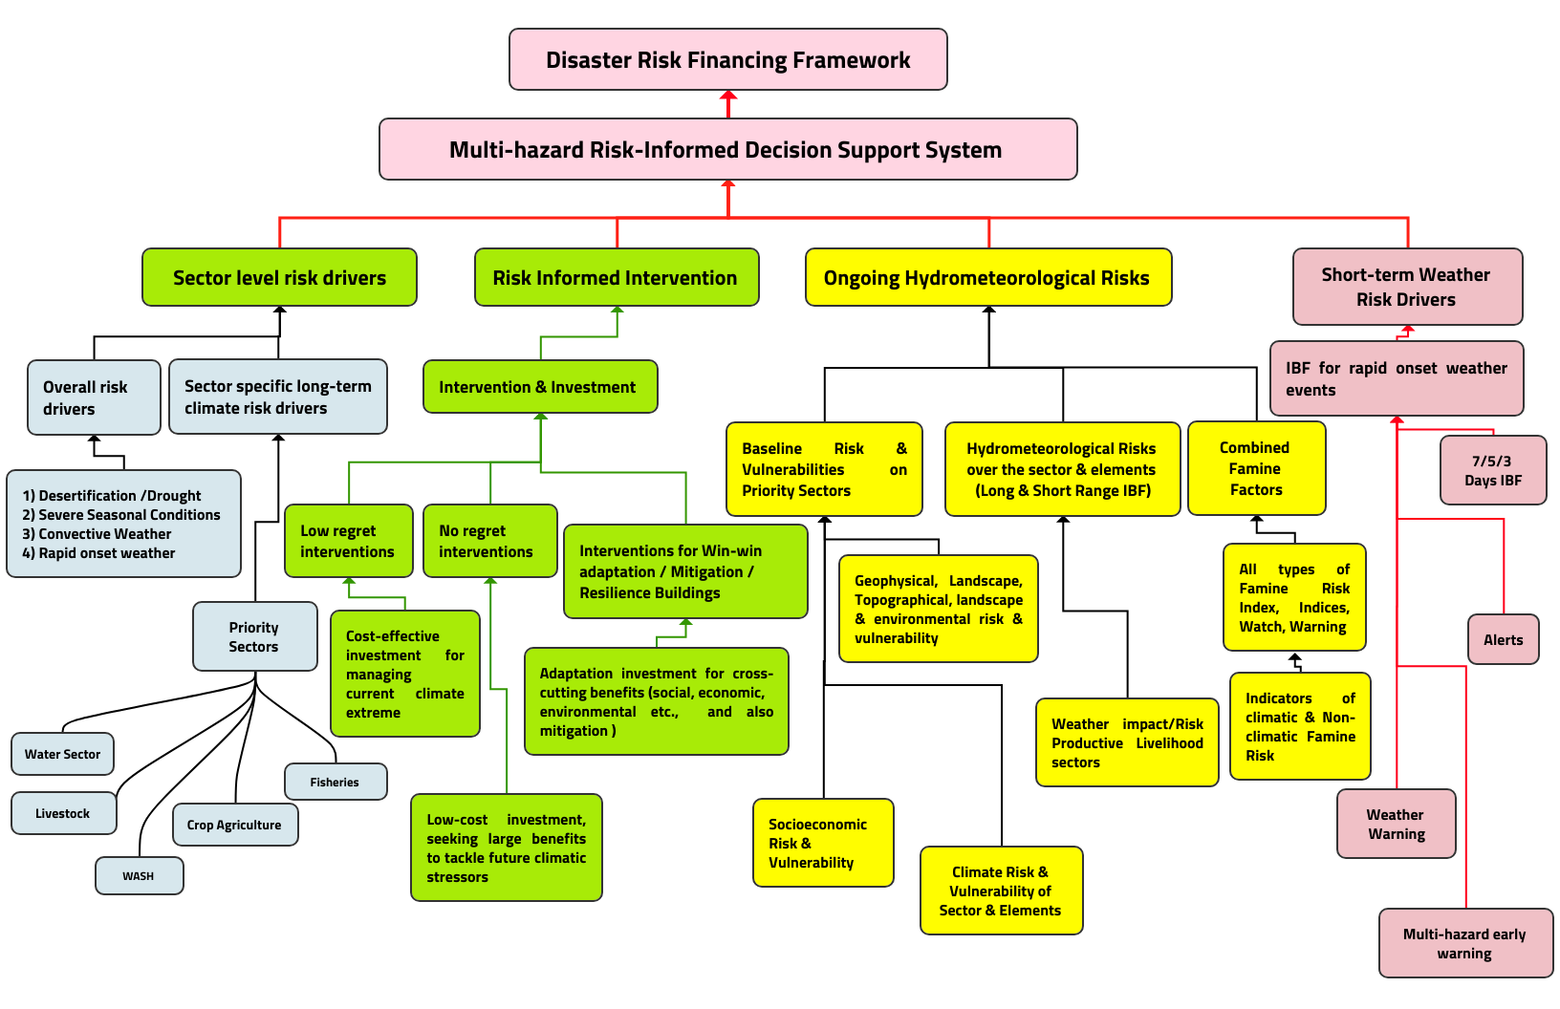
Figure 37: Proposed Disaster Risk Financing Framework ( Source : Z M Sajjadul Islam )

Key financing reforms and priorities:
- Establish a nationally agreed DRM financing architecture
Define a coherent framework that links federal, member state, and district financing roles for preparedness, response, early recovery, and resilience-building. This framework should align with EW4ALL implementation, NMHEWS operations, and forecast-based anticipatory action requirements.
- Reform annual budget allocation mechanisms for local DRM execution
Institutionalize dedicated budget lines for DRM at federal and member state levels, with predictable transfers to districts/municipalities. Allocate resources based on risk profiles (hazard frequency, exposure, vulnerability, and PiN) rather than only on historical spending or political bargaining.
- Increase local revenue mobilization and earmark a share for DRM
Strengthen municipal and district revenue systems and earmark a defined portion for local DRM preparedness, including CPC/DMC functionality, emergency shelter readiness, community-based early warning, evacuation preparedness, and maintenance of critical infrastructure and lifeline services.
- Create contingency financing and rapid disbursement windows
Establish pre-arranged contingency funds at federal and member state levels with clear release triggers linked to forecasts/CAP thresholds and IBF severity classes. Funds should be designed for rapid disbursement within operational timeframes required for anticipatory action.
- Integrate forecast-based financing (FBF) and anticipatory action funding
Link early action plans (EAPs) with pre-agreed financing instruments so that funding is automatically or rapidly released when forecast thresholds are met. This should include agreements with humanitarian financing mechanisms and partners to scale early action coverage.
- Improve institutional capacity for financial governance and accountability
Address weak technical capacity by strengthening public financial management for DRM: budgeting, procurement, tracking, auditing, and performance reporting. Implement transparent tracking of who funds what, where, and when, aligned with the 5W matrix.
- Strengthen coordination between government and humanitarian financing systems
Align government DRM financing mechanisms with UN cluster and INGO response financing to reduce duplication, close gaps, and ensure coverage of hard-to-reach areas. Create joint financing coordination forums to support coherence across preparedness, response, and recovery.
- Use risk analytics to guide allocation and investment decisions
Anchor fiscal reforms in risk-informed evidence produced by NMHEWS/IBF and CRVA repositories. Use risk ranking and hotspot mapping to prioritize high-return investments that reduce losses (e.g., water security, early warning dissemination, evacuation preparedness, protective infrastructure, and livelihood asset protection).

This approach enables Somalia to move from reactive, fragmented financing toward a structured disaster risk financing system that supports timely early action, improves local preparedness capacity, and enhances accountability to affected populations.

6.11 Supporting the implementation of risk-informed DRM and DRR
- Capacity building for improving NDMO(SoDMA ), Sector Ministries, and Local government-led stakeholders working in DRM, DRR, and CCA intervention.
- Develop a Forecast-based Risk Financing framework (Forecast-based anticipatory action) for supporting Forecast-based parametric risk insurance facility and early contingency preparations for the humanitarian action.
- Risk Informed Intervention: Somalia has a national disaster risk management policy (2020) and a Recovery and Resilience Framework (RRF), but still does not have a stakeholders’ mandate actionable plan to translate policy into actions for effective DRM at the local level. Lack of standard operating procedures (SoP) , Lack of national budget allocated for funding disaster risk management actions, Inadequate hazard risk-informed DRM plans, Inadequate integration and coordination, the Local community empowerment is limited, and Lack of clear roles and responsibilities of state actors and SoDMA as well.
- Develop a Risk Transfer mechanism and a forecast-based anticipatory action (AA) framework and action plan, and supporting risk-informed tools for harmonizing the following fund-based interventions of the Adaptation Fund, the African Development Bank, the EU Fund, the European Bank for Reconstruction and Development, the Global Environment Facility(GEF), the Green Climate Fund (GCF), and INGO-led development interventions

6.12 Improve DRM Planning at the local level :

- Develop a Cyclone Preparedness Plan (CPP) to raise awareness at every coastal district and community level about the impending cyclones and storms that are being forecasted.
- Develop a Flood/flash flood/landslide/heavy rainfall Preparedness Plan to raise awareness among vulnerable communities about impending floods, heavy rainfall, and flash floods that are forecasted.

Recommendations:

Improving Multi-hazard/Disaster Crisis Response Capacity - Undertake capacity building in Disaster emergency preparedness, response, and recovery planning. Initiate Institutional and stakeholder capacity building progarmme in Improving Institutional Capacity in Developing Forecast-based Early Action Protocol (EAP) Development, Improving stakeholder capacity in undertaking forecast-based anticipatory action (AA) planning and implementation capacity (Flash drought, hydrological, meteorological, Fluvial flood, flash flood, transboundary catchment overflow flooding, landslide, cyclone, convective heavy rainfall, tornadoes, thunderstorm, diseases/outbreaks, Earthquake-induced coastal Tsunami, etc.)

6.13 Gender responsive DRR framework :

- Community-level gender needs reporting and escalation: Clan leaders, proposed village-level headwomen, women members of CPC structures, and women’s social council representatives should systematically report the needs and priorities of women-headed households to the District CPC/DMC for inclusion in preparedness, response, and early recovery planning.
- Forecast-based GiHA protocol for high-risk groups: Develop a Gender in Humanitarian Action (GiHA) protocol that is explicitly forecast-triggered and tailored to women-headed households, single mothers, adolescent girls, and girl-headed households, including priority early actions, referral pathways, and protection safeguards.
- Sector and cluster-level gender action plans: Require every government sector department, humanitarian cluster, and local government sphere (city, municipality, district) to adopt and operationalize a gender action plan integrated into DRM/DRR, early warning, anticipatory action, and response planning cycles.
- Gender-focused national risk financing framework: The Ministry of Finance and Economic Affairs should develop a national disaster risk financing framework that includes mandatory, gender-responsive DRM/DRR budget allocations in each fiscal year, with clearly defined allocation categories benefiting women and vulnerable groups.
- Mandate local authorities’ risk-informed planning and budgeting: Local authorities should be mandated to integrate DRM/DRR and gender-responsive preparedness measures into their local development plans and budgets, recognizing that municipal budgets rely primarily on locally mobilized revenues and require dedicated earmarking for risk reduction and preparedness.
- Forecast-based early action messaging and rapid dissemination: Establish a protocol to translate impact forecasts into anticipatory loss-and-damage scenarios and clear early action triggers, and disseminate targeted warnings rapidly so women-headed households receive timely, actionable alerts.
- Public awareness and distance learning via national media: National broadcasters and media outlets should deliver regular, local-language risk education and distance-learning programming (radio/TV) focused on women’s preparedness, protective actions, safe evacuation, and access to services during hazards.
- Early warning-based advisories for women-headed households: Develop sector-specific anticipatory advisories and bulletins that communicate what women-headed households should do under specific early warning conditions (e.g., flood, cyclone, heatwave, drought), including practical steps, available services, and points of contact.
- Gender-responsive financing provisions reiterated: Ensure the national risk financing framework and annual DRM/DRR budget allocations explicitly include gender-based allocations, reporting requirements, and accountability mechanisms to verify that funding reaches women and other priority vulnerable groups.
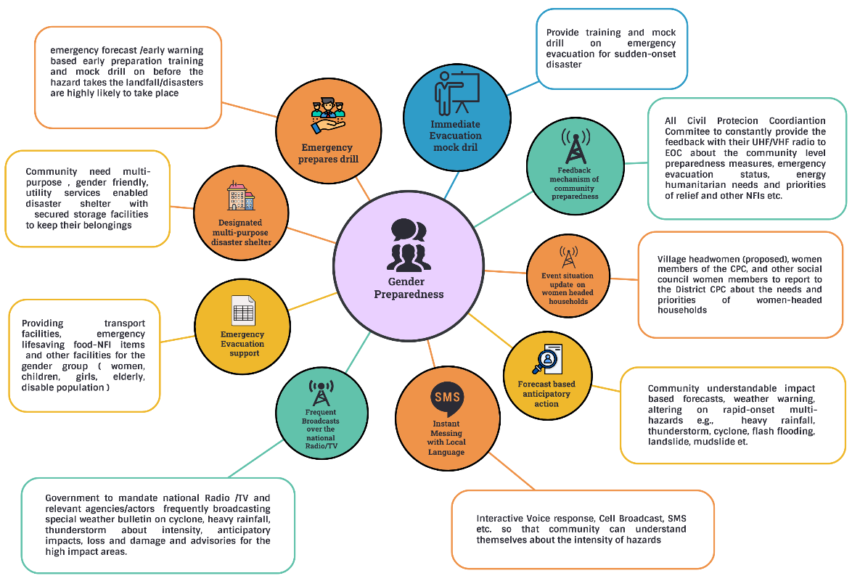

Figure 38 : Gender ( women, children, adolescents, and elderly) emergency preparedness framework at the last-mile
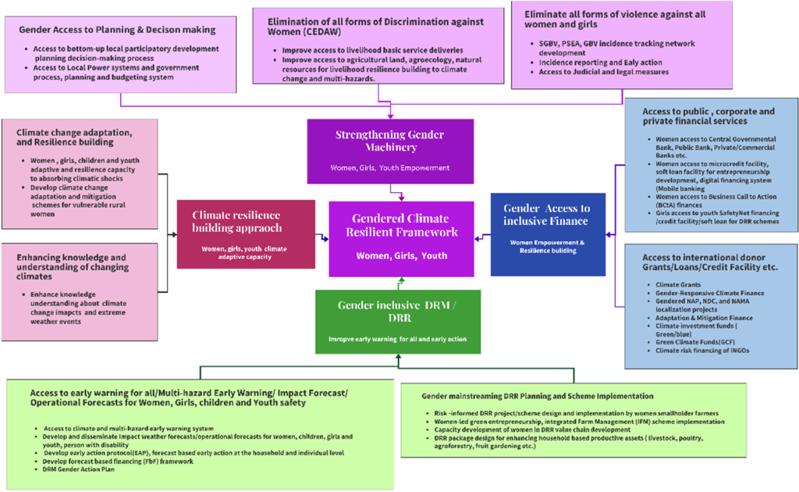
Figure 39: Gender responsive DRR framework

- Inadequate city and municipality-level planning and budget allocations for implementing community-level DRM/DRR schemes : Urban councils do not have a budget for financing DRM/DRR schemes for poor households
City corporations, municipalities, and urban councils generally lack dedicated DRM/DRR budget lines and risk-informed planning instruments to finance preparedness and resilience schemes for poor and vulnerable households. As a result, local governments have limited capacity to fund community-based early warning preparedness, evacuation readiness, risk reduction infrastructure, and household-level protective measures, and they remain largely dependent on humanitarian partners and CSO-led interventions. This financing gap perpetuates uneven coverage, weak accountability, and delayed risk reduction action at the last mile.

Recommendations :

Priority area | What to strengthen | Core actions | Key actors | Primary deliverables
Strengthen National DRM Framework | National policy, legal, and coordination foundations for DRM/DRR | Update/align DRM policy and legal instruments; define institutional mandates and interoperability standards; formalize national-to-local DRM governance and financing pathways | Federal Government, Member State Governments, SoDMA, sector ministries, Parliament/Justice entities, UN system | Updated DRM framework and regulations; national DRM governance architecture; operational SOPs and mandate instruments
Institutional Strengthening and Capacity Development | Institutional roles, staffing, competencies, and operational systems | Establish/strengthen NMHEWC functions; define minimum staffing profiles; create continuous training plans (forecasting, GIS, risk comms, PDNA/JNA/RNA, data management); institutionalize TWGs | SoDMA, MoEWR, MoAI, MoLFR, MoH, MoFBE, academia, UN agencies, INGOs | Capacity development plan; ToT curriculum; certified training cohorts; institutional TWG TORs
Improving Cyclone and Flood Forecasting and Early Warning | Forecasting value chain for cyclones, riverine and flash floods | Strengthen observation networks and transboundary data linkages; implement impact-based forecasting workflows; establish CAP production and dissemination protocols; integrate flood dashboards and situation reporting | MoEWR, SoDMA/NMHEWC, FAO-SWALIM, ICPAC/WMO support, telecoms, broadcasters | Flood/cyclone forecast SOPs; CAP templates; operational bulletins; impact forecast products and lead-time advisories
Improved Methodology, ICT tools, and stakeholder coordination for SADD | Consistent, disaggregated data (sex, age, disability) for risk analysis and response | Standardize SADD data dictionary; integrate SADD into Kobo/mobile apps and DRMIS; mandate SADD reporting in assessments and distributions; establish data QC and protection protocols | SoDMA, sector ministries, UN clusters, SRCS, INGOs/CSOs, statistics offices | National SADD standard and guidance; app forms and dashboards; routine SADD reporting protocol; data governance and QA procedures
Improve UN-Government-Multi-stakeholder coordination in DRM/DRR | Coherent coordination structures, shared situational awareness, and joint planning | Formalize coordination mechanisms between SoDMA and clusters; link DRMIS/NMHEWS to cluster datasets; standardize 5W reporting; create joint triggers and activation protocols for anticipatory action | SoDMA, UN-HCT, UN clusters, INGOs, SRCS, Member State authorities, CPC/DMC | Joint coordination SOP; integrated 5W system; shared situational dashboards; joint activation and escalation protocols
Community-level risk-informed gender development approach | Gender-responsive risk governance and local planning | Integrate gender analysis into CRVA and local DRM plans; support women’s participation in CPC/DMC; build gender-sensitive early warning communication and feedback loops | Local governments, CPC/DMC, women’s groups, CSOs, UN agencies, SoDMA | Gender-responsive local DRM plans; inclusive CPC/DMC membership guidance; community engagement and feedback protocols
SGBV tracking network and dissemination system (Proposed) | Safe referral, reporting, and early warning for protection risks | Establish survivor-centered referral pathways; deploy secure reporting channels (hotlines, coded SMS/USSD, trusted focal points); implement confidentiality and data protection protocols; coordinate with health and protection actors | MoH, protection actors, GBV sub-cluster, SRCS, CSOs, local authorities, telecom operators | SGBV referral and information-sharing SOP; secure reporting tools; protection alert workflow; service mapping and escalation guidance
Strengthen capacity for PDNA, JNA, RNA with gender screening | Assessment quality, speed, and gendered impact visibility | Standardize tools and training; embed SADD and GBV risk screening; use mobile data collection; establish joint assessment teams and QA; link outputs to financing and EAP triggers | SoDMA, sector ministries, UN clusters, SRCS, INGOs/CSOs, local governments | Harmonized assessment toolkits; trained joint teams; standardized templates; gender-sensitive assessment reports and dashboards
Develop Gender in Humanitarian Action (GiHA) Roadmap and Planning | Strategic direction for gender integration across preparedness and response | Define priorities, minimum standards, indicators, and accountability mechanisms; align with cluster plans and government DRM frameworks; define financing and monitoring arrangements | Government gender machinery, SoDMA, UN Women/UN agencies, clusters, INGOs/CSOs | GiHA roadmap; action plan with timelines; indicators and accountability framework; integration guidance for clusters and sectors
Multi-stakeholder/agency-coordinated GiHA process | Governance and operational mechanism for implementing GiHA | Establish a GiHA coordination platform; define roles and reporting; integrate GiHA into EAP activation, response planning, and M&E; ensure AAP and community feedback | SoDMA, UN-HCT, clusters, women’s organizations, SRCS, Member States | GiHA coordination TOR; meeting cadence and reporting; integrated GiHA in EAP/response workflows; feedback and accountability loop
Systematically maintain/update DRMIS at all administrative levels | Routine risk information management, incident tracking, and decision support | Implement role-based DRMIS governance; standardize datasets and update cycles; connect local reporting (CPC/DMC) to national dashboards; integrate L&D, 5W, and SADD; enforce QA and security | SoDMA, Member States, district administrations, CPC/DMC, sector ministries, UN clusters | DRMIS governance model; standardized update schedule; interoperable dashboards; verified incident/L&D/SADD datasets; routine performance reporting

Way forward

Considering the accelerating hydrometeorological risks and climate-humanitarian crises affecting Somalia and the wider Horn of Africa, the proposed ICT-driven, full-scale implementation of Early Warnings for All (EW4ALL) is positioned as a practical pathway to strengthen national climate and multi-hazard risk governance. An ICT-powered approach is expected to reduce persistent institutional barriers and procedural bottlenecks by translating coordination, mandates, and accountability into digitally enabled workflows. This will facilitate structured, interactive partnerships among federal and member-state institutions, sector ministries, non-state actors, and last-mile stakeholders, thereby improving the functionality of the multi-hazard early warning and disaster risk management ecosystem.

The ICT-powered EW4ALL approach is expected to operationalize and reinforce all EW4ALL pillar actions through: (i) stronger stakeholder engagement; (ii) improved frontline community capacity; (iii) participatory preparedness and response management; and (iv) digitally supported coordination mechanisms that enable more consistent risk information exchange. It is also expected to promote hybrid partnerships and collaborations that strengthen institutional capacity for surface observation systems, precision-level hydrometeorological forecasting, integrated early warning and alerting, and end-to-end risk communication and dissemination.

However, Somalia’s fragmented governance environment, characterized by political fragility, limited decentralization of risk governance, and a siloed approach to CSO-led DRM interventions, continues to constrain access to EW4ALL services and weakens system-wide interoperability. These factors present major implementation risks that must be addressed through system design, governance arrangements, and enforceable partnership mechanisms.

Accordingly, an ICT-driven climate and multi-hazard risk governance system can function as an enabling mechanism to digitally connect and bind relevant stakeholders remotely and at scale through mandated coordination, standardized operating procedures, and role-based accountability. By doing so, it can mitigate the effects of governance fragility and support the transition toward an ICT-enabled, stakeholder-partnered, inclusive national multi-hazard early warning system that strengthens risk-informed local development planning and service delivery.

If implemented with clear mandates, interoperable architecture, and enforceable accountability frameworks, the proposed ICT-driven DRM risk management system can help overcome the governance paradox by creating a digitally functioning, level-playing platform. This platform would support interconnected partnerships that hold sector actors, local government entities, CSOs, and frontline communities accountable to affected populations through transparent digital processes, thereby reducing fragmentation and enabling more timely, coordinated, and risk-informed action under Somalia’s FCV conditions.

----------------------------------------------------------------------------End-------------------------------------------------------------------------

Any comments and recommendations please email : Z M Sajjadul Islam EW4ALL Coordinator for Somalia
zmajjad@yahoo.com , WhatsApp :+ 88 01711 979179

Annexure 1 : Civil Protection Committee(CPC) / Disaster Management Committee (DMC)

- Municipality Civil Protection Committee(CPC) / Disaster Management Committee (DMC)

SL | Committee member | During normal time | Roles /responsibilities during a disaster emergency | Responsibilities for risk assessment | Responsibilities for L &D reporting
 | Local administration
 | Local Government representatives
 | Municipal Governor/chairman
 | Sector departments at the urban level
 | Clan Leader
 | NGO Consortium Representative
 | Imam of the Mosque
 | Traditional Elder/Leader
 | Somalia Red Cross agency
 | NGOs/CSO
 | University/Academia
 | Technical educational institutes
 | Informal Governing Institutions and Authorities
 | Private Sector
 | Religious elder
 | Religious Leader
 | University Student as a representative
 | Women representative
 | Urban Community leader
 | Urban Women-led organization
 | CSO representative
 | Health worker
 | Commercial herders
 | Commercial smallholder farmers
 | Veterinary technician
 | Medical Representative
 | Cold storage operator
 | Market Player
 | Local Poultry dealers/farmers
 | Local Livestock Dealer
 | Vegetables gardener
 | Local traders
 | Mobile wallet operators /Agent
 | Food Processing entrepreneurs
 | boreholes committee
 | Urban Utility service Operator
 | WASH Service Providers
 | Urban Broadcasters
 | Urban News Agency
 | Urban Youth Group
 | Urban Transport and Logistics Operators
 | Port Authority
 | Fishermen Committee

- Village level Civil Protection (CPC)
SL | Committee member | During normal time | Roles /responsibilities during a disaster emergency | Responsibilities for risk assessment | Responsibilities for L &D reporting
 | Traditional Elder/Leader
 | Clan Leader
 | Traditional Elder/Leader
 | Imam of the Mosque
 | Religious elder
 | Religious Leader
 | Agropastoralist
 | Pastoralists
 | Community leader
 | Village chief
 | Agropastoralist
 | Pastoralists
 | University Student representative
 | High School Youth representative
 | Secondary School Youth representative
 | Women representative
 | Community leader
 | CSO representative
 | Somalia Red Cross agency
 | Imam of the Mosque
 | Pastoralists
 | University Student representative
 | High School Youth representative
 | Secondary School Youth representative
 | Women representative
 | Representation of Women-Led Organization
 | Community leader
 | CSO representative
 | Somalia Red Cross agency
 | Women representative
 | Livestock herder
 | Farmers
 | Health worker
 | Family Planning technician
 | Veterinary technician
 | Medical Representative
 | Cold storage operator
 | Local fertilizer dealers
 | Local Poultry dealer/farmers
 | Local Livestock dealer
 | Fruit gender
 | Vegetables garden
 | Local traders
 | NGO worker
 | Village police
 | Private Sector service providers
 | Mobile Money Outlet
 | Fishermen
 | Redcross volunteers

Annexure 2: Somali Civil Society Organizations (CSO)
List of civil society organizations participated in the UPR Report:
Mogadishu
- Federation of Somali Journalists (FESOJ)
- Marginalized and Minority Groups (MCA)
- Humanitarian and Development Network / Cluster
- Persons with Disability Cluster
- Human Rights Cluster
- Women and Child Cluster consisting of:
- Northern Frontier Youth League (NoFYL)
- WARDI Relief Organization
- Somali Women and Child Care Association (SWCCA)
- Women Empowerment Development Organization (WEDO)
- Somali Young Feminist Network (SYFN)
- Humanitarian Cluster
- Ifrah Foundation
- Somali Health and Development Initiative (SOHDI)
- Somali Community Concern (SCC)
- Action for Women and Children Concern (AWCC Somalia)
- Women Pioneers for Peace and Life (HINNA)
- HIWA
- WOCCA
- Save Somali Women and Children (SSWC)
- Humanity & Inclusion Sustainable Advocates (HISA)
- Community Aid Action
- W (Women Empowerment Platform)
- Women and Youth Development Association (SOYDA)
- Witness Somalia
- Somali Youth Cluster consisting of:
- Somali Women Center for Equality and Inclusion (SWCEIN)
- De Martino Hospital
- Benadir Regional Administration
- Midnimo Youth Organization
- HYO Youth Organization
- Hope Generation
- National Generation
- Somali Youth Vision
- Hiraan Youth Organization
- Bulay Students Union
- Students Union
- Daryeel Bulsho Organization
- Medical Doctors Organaization
- Youth life for Somalia
- Hiran Aid Dev Foundation
- Somali Youth Action Network
- Somali Women and Child Development Organization (SWCDO)
- Ururka Dhalinyarda Daryeel
- Health Network
- Sustainable Action Against Disaster
- Aayotalis for Good Governance

Galmudug
- Galmudug Civil Society Actors
- Somalia Community Development Organization
- Central Regions Disability Organization
- Radio Gobolada Dhexe
- Integrated Youth and Relief Development Organization
- Gurad Legal Aid Association
- SSWC
- Towfiiq Umbrella Organization
- IIDA
HirShabelle
- HirShabelle Human Rights Center (SHRC)
- Hiiran Women Empowerment Organization (HWEO)
- Center for Protection, Relief & Development (CPRD)
- Hiran Youth Organization (H.Y.O)
- Middle Shabelle Youth Volunteers Corps (MISYVC)
- Middle Shabelle Women Union Organization
- Hiran Journalists Club (HJC)
- Relief, Resilience and Protection (RRP)
- Centre for Development & Child Rights
- Somali Disability for Advocacy and Protection Network (SDAPN)
- Somali Minority Groups Empowerment Network (SMGEN)
- Ururka Haweenka Farlibaax (UHF) / Farlibaax Women’s Organization (FWO)
- Middle Shabelle Journalists Association / Ururka Suxufiyiinta Shabellehe Dhexe
- Ururka Haweenka Gobalka Hiiraan / Hiiraan Woman’s Association
- Hiil Bulsho Inclusive Community Project (ICP)
Puntland
- Puntland Non-State Actors
- Office of Human Rights Defenders
- Puntland Relief Aid and Development Organization
- Gardafue Association Youth Action Network
- Karado Network
- Alnasar Women Network
- Puntland Nabadoon’s Association
- MAP
- Disability Centre
- Minority Group NGO
- Puntland Women Lawyers Association
South West State
- Somali South West Non-State Actors
- South West Human Rights Defender Network
- Allamagan Relief & Rehabilitation for Disabled People Organization
- Somali Children Welfare and Right Watch
- South West Somali Journalist Association
- Minoirty Groups
- Kanava Youth Development Center
- South Somali Youth Organization
- ISHA Human Rights Organization
- Southern Somali Intellectuals Council
- Somali Community Action Group
- BTSC Committee
- Danwadaag Community Group
- Irman Human Rights Organization
- Bay Safe & Development Organization
- Center for Education Research Peace & Development
- Baidoa Women Development Organization
- Bay Women Development Network
- Bay Youth Council
- Iftin Organization
- Iniskoy Peace and Development Organization
- Samakab Youth Development Organization
- Somali Hope Line for Civil Society Organization
- Ma’ani Vocational Training Center
- Action for Peace & Development Organization
- Somali Human Rights Association
- Rural African Women Development
- Khalif Huudow Human Rights Organization
- Waleweyn Human Rights
- Somali Sport Youth Development Organization
- Ayub NGO
Jubaland
- Jubaland Bar Association (JBA)
- Somali Women Solidarity Organization (SWSO)
- Return Elite Forum (Youth Group)
- Juba Aid, Peace and Development Organization (JAPDO)
- Northern Frontier Youth League (NFYL)
- Somali Community Concern (SCC)
- Jubaland Non-State Actors Association (JUNSAA)
- Motherland Somalia
- Wamo Relief and Rehabilitation Services (WRRS)
- Jubaland Journalist’s Association (JJA)
- Wajir South Development Association (WASDA)
- Somali Girls Umbrella for Development (SOGUD)
- WAWDA

Proposed by MoEWR

