Evidence-based Identification and Spatiotemporal Assessment of the Loss and Damage(L&Ds) in Coastal Satkhira & Flood Prone Kurigram Districts of Bangladesh

Developed by Z M Sajjadul Islam

Contents
1.0 Introduction: 3
2.0 Assessment Approach 3
2.1 Identify the structural gaps of the Government Cyclone disaster declaration process : 3
2.2 Assessment Preparation: 4
2.3 Conduct Desk review: 5
2.3.1 Desk Review and Data Acquisition Tasks 5
2.3.2 Preliminary tools preparations: 6
2.4 Data Collection Method 13
2.4.1 Geospatial data collection 14
3.0 Frontline community consultations methodology 14
4.0 Technical Approach and Methodology 15
4.1 Data Collection 15
4.2 Prepare CRVA Tools 17
4.2 Defining baseline risk and vulnerability conditions 24
4.2.1 Baseline scenario (risk and vulnerability mapping) 25
4.2.2 Estimation/statistics of food and livelihood elements likely to be damaged (forecast-based) 26

- Introduction:

Overview of Assignment :

Satkhira and Kurigram districts are significantly affected by persistent and recurrent climate risks and vulnerabilities. Satkhira, located along the edge of the Bay of Bengal, is exposed to multiple coastal hazards, while Kurigram, in northern Bangladesh, is highly susceptible to riverine flooding at the onset of the monsoon, driven by the Brahmaputra River system and upstream flows from the Tibetan Plateau. This study aims to promote geospatial-technology-based tools for assessing loss and damage resulting from both seasonal and recurring hydrometeorological hazards, as well as persistent climate-related exposure and vulnerability.

The assignment focuses on acquiring climate risk and vulnerability information primarily from field-based (primary) sources. Secondary datasets will be calibrated through ground-truthing and spot verification to ensure accuracy and suitability for customized analysis, prioritization, and presentation. A robust scientific methodology (as illustrated below) is proposed to validate the assessment process. The assessment intends to use open-source GIS tools to implement the proposed methods and produce mapping outputs.

Objective of the assignment.

The primary objective of this assignment is to devise and operationalize appropriate loss-and-damage (L&D) assessment tools for the selected study area. This includes: (i) acquiring data from both primary and secondary sources; (ii) establishing effective data collation and validation techniques; and (iii) applying geospatial-technology-based spatial analytics to quantify disaster impacts at the highest feasible resolution across key sectoral elements affected (i.e., assets and services that are lost and/or damaged).

The assignment will also outline systematic steps and procedures for assessing the post-disaster L&D context following an event. Given the geographical characteristics of the study locations, the proposed scientific methodology will focus on two hazard events, riverine flooding and storm-related impacts, to analyze and quantify L&D outcomes.

Due to time constraints, the study area has been narrowed to two highly vulnerable unions one in Kurigram and one in Satkhira. Reflecting their geographic settings, Satkhira represents a frontline of coastal vulnerability and is exposed to multiple coastal hazards, while Kurigram in northern Bangladesh experiences severe riverine flooding during the early monsoon period.

Given that this TOR on L&Ds assessment targeting two unions and the vulnerable sectors are prioritizing (e.g., housing, agriculture, WASH, roads, livelihoods) of the two given districts.

2.0 Assessment Approach

2.1 Identify the structural gaps of the Government Cyclone disaster declaration process :

Satkhira District is among the most climate-vulnerable locations globally due to its proximity to the Bay of Bengal and its flat, low-lying, highly fragmented coastal landscape. These characteristics make the district acutely exposed to coastal hazards, particularly cyclone-driven storm surge and saline intrusion. When a high-intensity cyclone makes landfall in or near Satkhira, the impacts can be severe: extensive damage to fragile coastal settlements and productive land, degradation of the Sundarbans, the world’s largest mangrove forest, and widespread inundation by saline water. Such storm-surge-driven salinity can cause significant losses to biodiversity, crops, and other livelihood assets and services.

Despite these risks, the existing cyclone early warning and response arrangements remain constrained by limited spatial and temporal precision. Current systems are often insufficiently “precision-guided” to indicate, with adequate lead time and geographic specificity, which coastal unions and settlements are most likely to experience landfall-adjacent impacts and the highest surge depths. In parallel, even when cyclones make landfall along the Bangladeshi coast, the formal government disaster declaration process can be delayed. These combined weaknesses, early-warning limitations, and delays in disaster declaration create multiple points of failure that can amplify losses and damage.

Accordingly, the assessment should identify and document critical failure points within Bangladesh’s disaster declaration roadmap, drawing on evidence from recent large-scale cyclone and fluvial flood events and aligning with established post-disaster assessment processes led by the Needs Assessment Working Group (NAWG).
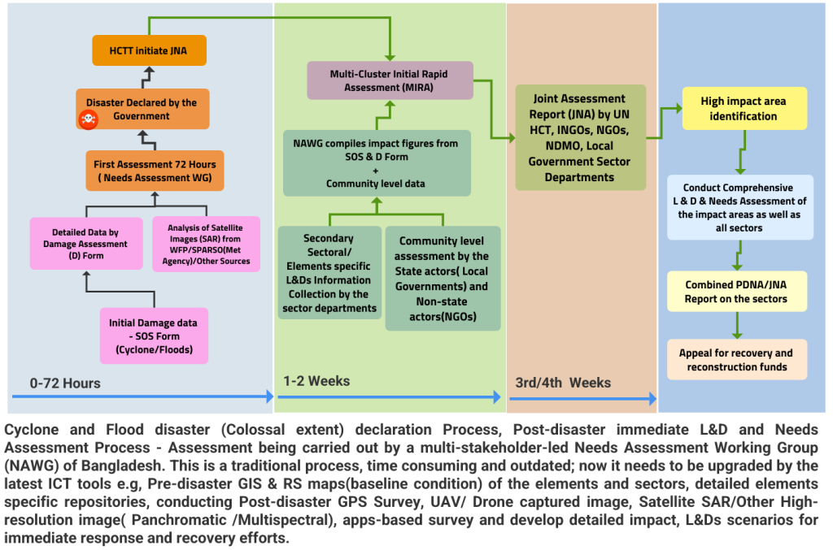
Figure: Cyclone disaster declaration process

The assessment should examine the real-time, data-driven cyclone-tracking and early-warning system currently in place, with a focus on its ability to generate timely, location-specific guidance that supports early action planning. This includes assessing how effectively the system can identify likely cyclone track corridors, probable landfall epicenters, and delineated buffer areas where destructive impacts, such as the anticipated trail of destruction, losses, and damages (L&D) to key elements, and other high-impact events are most likely to occur.

2.2 Assessment Preparation:

At the preliminary stage, the scoping of the assessment L&D aftermath disaster normally depends on the acquisition of overall impacts of the disaster, including the landfall from the JNA, to identify the high-impact areas, impact level, and other sectoral first-hand impressions of impacts trailed by the disaster.

- Analyzing the datasets ( Geospatial and statistical ), a scientific approach is being proposed for the
- Procedure for L&D of selected Unions of Kurigram and Satkhikhra, considering the past severe disaster.

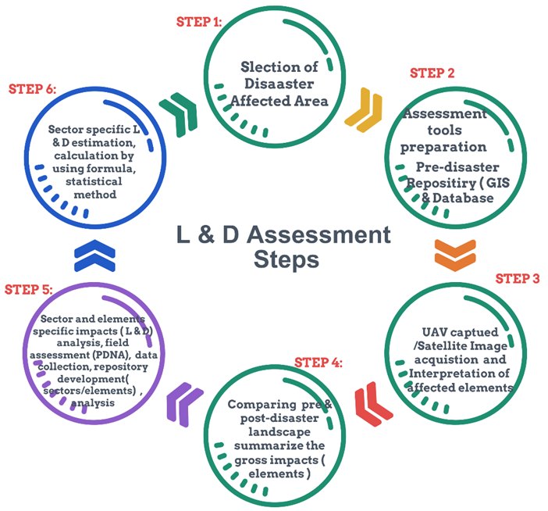

2.3 Conduct Desk review:

2.3.1 Desk Review and Data Acquisition Tasks

- Review secondary datasets (SADD, ASD, and poverty/demographics)
- Compile and review available secondary data on age- and sex-disaggregated poverty, demographic profiles, and socioeconomic indicators from:
  - National statistical systems and official publications
  - Local Government Institutions (LGIs)
  - Relevant sector departments (e.g., agriculture, health, water, disaster management)
  - Local stakeholders, development partners, and implementing actors

- Review existing risk and vulnerability assessments
- Collect and synthesize existing assessments on persistent and perennial climate/disaster risks and vulnerabilities conducted for the study area, including hazard, exposure, vulnerability, and capacity analyses.

- Acquire pre-disaster geospatial imagery and sector GIS layers
- Acquire and curate pre-disaster high-resolution satellite imagery and complementary geospatial datasets, including:
  - Aerial photographs and drone imagery (where available)
  - Sector-produced GIS base maps
  - Spectral and thematic layers such as agricultural land-use/land-cover, cropping patterns, and crop calendars/maps

- Review sectoral Information Management Systems (IMS) and local GIS inventories

- Review sectoral IMS and geospatial databases covering local-level elements, including:
  - Physical and infrastructure assets (transport, power, public facilities)
  - Socioeconomic and livelihood assets
  - Built environment and housing typologies
  - Natural resources and ecosystems
  - Water resources and water infrastructure
  - Commercial and market infrastructure
  - Value chain assets and operating elements (inputs, production, storage, transport, processing, trading)

- Map local economic functionaries and value-chain operating elements

- Identify and geolocate key economic actors and functional nodes, including:
  - Cooperatives, integrated farms, and smallholder farms
  - Value-chain operators and service providers
  - Critical “service trigger points” (e.g., aggregation centers, markets, cold storage, transport hubs)
  - Local economic performance indicators and operational dependencies relevant to disruption and recovery

2.3.2 Preliminary tools preparations:

2.3.2.1 Preparation/Customize GIS Maps:

Preparation and Customization of GIS Maps

- Core base layers and administrative framework
Dataset / Map Product | Source | Layer type | Mapping purpose | Primary uses/outputs | Tools
Administrative boundary & plot boundary map (Mouza, Ward, Union) | DLRS / SoB (as available) | Polygon | Establish an authoritative administrative and plot framework | Plotting all elements; Union/Mouza-level reporting; pre-crisis baseline | QGIS / ArcGIS Pro; PostGIS
Detailed Union/Upazila basemap (customized LGED basemap) | LGED + local verification | Mixed (polygon/line/point) | Create a complete “Local Government basemap” for CRVA and L&D | Insert missing elements; standardize IDs/attributes; prepare analysis-ready base | QGIS / ArcGIS Pro
Roads and connectivity networks (updated) | LGED + OpenStreetMap + satellite verification | Line | Represent access routes, evacuation routes, market access | Exposure mapping; emergency response routing; accessibility analysis | QGIS; OSM extract tools
Settlement/build-up footprints (updated) | Google Earth / satellite + OSM | Polygon | Capture settlement clusters and built environment | Exposure of households/services; hotspot mapping | QGIS; manual digitization

- Land cover / land use and imagery baselines

Dataset / Map Product | Source | Layer type | Mapping purpose | Primary uses / outputs | Tools
Land cover map (baseline) | Sentinel / Landsat | Raster + classified polygons | Establish baseline LULC classes | Crop/vegetation baseline; change detection; L&D attribution | Google Earth Engine; ERDAS / ArcGIS Pro
Land use map (detailed sector lens) | Sentinel/Landsat + field validation + secondary sources | Polygon | Identify agriculture, aquaculture, settlements, wetlands, etc. | Identify elements at risk; exposure by land use class | QGIS / ArcGIS Pro; GEE
High-resolution village/mouza imagery (pre-crisis) | Aerial photo / drone / Google Earth | Raster | Visual validation and micro-level feature capture | Digitize critical features; spot verification; baseline archiving | Drone processing suite + QGIS

- “Elements at risk” inventory layers (sectoral elements)

Dataset / Map Product | Source | Layer type | Mapping purpose | Primary uses / outputs | Tools
All sectoral elements layer (master inventory) | CRVA field survey + GPS apps + KoboToolbox + sector lists | Point/Polygon | Create the definitive element inventory (200+ elements) | L&D calculation; sector-wise exposure; PDNA-ready tables | KoboToolbox; QGIS/ArcGIS; PostGIS
Basic service delivery infrastructure | Sector departments + LGIs + field verification | Point/Polygon | Map health, education, WASH, admin services | Damage quantification; service disruption analysis | QGIS/ArcGIS; GPS apps
Commercial installations & marketplaces | Local markets, value-chain actors, OSM + field survey | Point/Polygon | Map market nodes and economic assets | Value-chain L&D; recovery prioritization | QGIS; Kobo; PostGIS
Emergency shelters & safe points | Local DM committees + field survey | Point | Identify shelters, evacuation points, assembly areas | SOD 5W tasking; evacuation planning | QGIS/ArcGIS; dashboard

- Multi-hazard exposure, incidence, and historical distribution maps

Dataset / Map Product | Source | Layer type | Mapping purpose | Primary uses / outputs | Tools
Past disaster distribution maps (multi-year) | Govt/NAWG reports + local records + community timeline | Polygon/Point | Summarize historical high-impact events | Identify persistent hotspots; trend analysis | QGIS; PostGIS
Multi-hazard exposure maps (current) | Remote sensing + CRVA + secondary hazard layers | Raster/Polygon | Classify hazard footprints and intensity classes | Overlay with elements at risk; severity zoning | QGIS/ArcGIS; GEE
Persistent impact maps (e.g., waterlogging days, salinity) | Time-series RS products + field validation | Raster | Quantify chronic/persistent hazards | Economic loss modeling; “deterioration/accumulation” analysis | GEE; ArcGIS Spatial Analyst

- Agriculture, fisheries, livestock, and value-chain thematic maps

Dataset / Map Product | Source | Layer type | Mapping purpose | Primary uses / outputs | Tools
Agriculture mapping (arable land, crop distribution, seasonality) | DAE + RS classification + field survey | Polygon | Baseline crop and plot-level agricultural elements | Crop-stage impact analysis; yield-loss proxies | GEE; QGIS/ArcGIS
Specialized agriculture layers (tolerant varieties, floating agriculture, lead farmers, input suppliers, AVC nodes) | DAE/private sector + community mapping | Point/Polygon | Map adaptive practices and value-chain operators | Targeted recovery; resilience investments | Kobo; QGIS; PostGIS
Fisheries & aquaculture mapping (pond/gher/baor/beel/khal/canal/lake; rice-fish) | DoF + RS + field validation | Polygon | Identify aquaculture and open-water elements | Physical damage + economic loss; exposure profiling | QGIS/ArcGIS; GEE
Livestock / integrated farms / cooperatives | DLS + local lists + field survey | Point/Polygon | Identify livestock assets and integrated systems | Sector L&D; livelihoods recovery design | Kobo; QGIS

- Utility and other service infrastructure maps (expandable list)

Dataset / Map Product | Source | Layer type | Mapping purpose | Primary uses / outputs | Tools
Utility services (e.g., biogas plants, energy/WASH points, service hubs) | LGIs + sector departments + field survey | Point | Capture service assets and trigger points | Damage assessment; continuity planning | Kobo; QGIS/ArcGIS

2.3.2.2 How these maps will be used for L&D calculations

- Build the pre-crisis baseline: administrative/plot layers + land cover/land use + element inventory.
- Generate hazard footprints and intensity: flood extent/duration, storm surge depth/extent, salinity classes, erosion-prone banks, persistent waterlogging days, etc.
- Overlay analysis: intersect hazard intensity layers with “elements at risk” layers to identify exposed/damaged elements and quantify by sector, Union, grid cell (e.g., 5 km × 5 km), and intensity class.
- Economic loss logic (especially for agriculture): incorporate variables such as:
  - number of waterlogging days; flood duration
  - crop growth stage (seedling/sapling/standing crop)
  - crop sensitivity and tolerance thresholds (days/% withstand capacity)
- Outputs: L&D tables (sector-wise), maps, and infographics for anticipatory action, PDNA inputs, and recovery planning.

Minimum QA/QC and standardization requirements

- Common coordinate reference system (CRS) across all layers and consistent scale rules (Union/Mouza).
- Unique IDs for each element, with a standardized attribute schema (sector, subtype, ownership, replacement value, vulnerability class, etc.).
- Metadata for every layer: source, date, resolution, processing steps, confidence rating.
- Ground-truthing / spot checks for critical layers (settlement footprints, key infrastructure, crop/aquaculture classes).

2.3.2.3 Synergy settings for pre- and post-disaster impacts

These tools establish “baseline-to-impact” linkages by aligning seasonality, sector calendars, and livelihood cycles with hazard timing. This enables systematic comparison of pre-crisis conditions vs. post-disaster scenarios, supporting attribution of impacts and quantification of L&D.

2.3.2.4 Synergy tools and application matrix

Dataset | Source | Layer | Mapping purpose | Uses
Prepare Plot boundary map (Mouza, Ward, Union) | DLRS/SOB | Plotting items over the map | Featuring most of the elements over the map | Pre-crisis scenarios on hand
Land cover map | Sentinel image, Landsat image, extracted from Google Earth. Aerial photograph image of village/mouza | Land use-based elements | Tools to identify the elements being impacted, lost, or damaged | Customize the typical GIS Base map developed by LGED with re-adjustment and insert the missing elements from the Google Earth image, OpenStreetMap map, and the latest satellite images. Extracting elements specific polygon layer/point features from open street maps with QGIS • Detailed Administrative base map of the study area: Prepare plot boundary  • Prepare detailed land cover and land-use maps (latest satellite image, and other secondary sources)
Prepare Detailed Union/Upazila Base map | Land use map showing elements of agriculture, crops (standing, newly planted) , fisheries ( pond, ger, case, lake, khal, beel ) , water bodies ( open, reserve, freshwater ), agroforestry, settlements, commercial installations, small holder farm lands, etc. | Tools to identify the elements being impacted, lost, or damaged | Prepare a Detailed Union/Upazila Base map | All sectoral elements on the map
Prepare multi-hazard and disaster incidence maps of the area. Prepare multi-hazard/disaster distribution maps summarizing the past few years of disasters and multi-hazard events that occurred over the areas. | Prepare a land use map | Existing land-based elements | Plotting the land component over the map | Tools to identify the agroecological resources being impacted, lost, and damaged
Past disaster distribution map | Showing high-impact disasters/multi-hazards of history | Common multi-hazard maps of the area | Determine the persistent impacts on the map | Overlaying disaster impact maps over the elements and determine the damage level. Calculate the economic loss by analyzing the variables of magnitude of disasters (number of waterlogging days ), type and duration of the growth of standing crops/seedling /sapling , sensitivity, and number of days/% of crops that a crop can withstand, etc.
Agriculture mapping | Showing arable lands, crop distribution of the cropping season, round-the-year vegetable/fruits production, Agri-plots on saline tolerant varieties, flood tolerant variety cropping. Location of Lead farmers, marginal farmers, AVC operators, input suppliers, DAE/Private horticulture, commercial seedling/sapling producers., IFM, IPM, INM, FYM stack layer farming, floating agriculture | Agricultural elements | Showing elements over map existing (pre-disaster) | Overlaying disaster impact maps over the elements and determine the damage level. Calculate the economic loss by analyzing the variables of magnitude of disasters ( no of water logging days ), type and duration of the growth of standing crops/seedling /sapling , sensitivity and no of days/% of crops crop can withstand etc.
Fisheries and livestock mapping | Fish pond, ger, open waterbody, case culture areas, beel, canal, khal, lake, aquaculture land ( paddy & fish culture ) , integrated farms etc. | Fish ponds | Showing elements over map existing (pre-disaster) | Determine the physical damage and economic loss of the elements overlapping the disaster impacts over map
Prepare maps on other utility services | Biogas plants, | Household cattle/livestock yard | Showing L&Ds of livestock population

- Synergy settings pre- & post disaster impacts :

Tool / Dataset | Process | Purpose / usability | Key outputs
Climate-sensitive cropping calendar (crop stages, planting/harvest windows, critical thresholds) | Compile from DAE/secondary sources; validate through community consultation | Link hazard timing (flood/waterlogging/salinity) with crop vulnerability by growth stage | Crop-stage exposure profiles; crop sensitivity rules (tolerance days/thresholds) for L&D estimation
Sectoral service calendars (e.g., WASH, water supply, freshwater availability especially Satkhira surface “sweet water”) | Desk review + stakeholder validation (LGIs, DPHE, WASH actors) | Identify seasonal service stress periods; assess post-disaster disruption and recovery sequencing | Seasonal service-risk matrix; priority restoration windows; sector-specific disruption indicators
Multi-hazard / disaster calendar (area-specific) | Desk review of historical events, magnitudes, and impacts; triangulate with local timelines | Compare historical hazard patterns and impact magnitude with current event conditions | Hazard seasonality profile; recurrence and severity trend narrative; benchmark for “expected vs observed” impacts
Historical L&D facts and figures repository (previous PDNAs/NAWG, sector assessments) | Synthesize historical assessments; standardize units/definitions for comparability | Compare historical L&D ranges with current scenario; contextualize “abnormal” losses | Comparative L&D tables; reference baselines; evidence for declaration/advocacy
Occupational / economic activity & value-chain operations calendar (markets, input supply, growth centers, vulnerable group livelihoods) | Conduct FGD/KII with producers, traders, service providers, vulnerable groups | Identify disruption points (“service trigger points”) and the timing of systemic value-chain losses | Value-chain seasonality and disruption map; critical dependency points; recovery sequencing priorities

How this supports L&D and decision-making

- Pre-crisis baseline: calendars define what “normal” should look like (production cycles, service availability, market operations).
- Post-disaster interpretation: overlay hazard timing and intensity to determine which elements were exposed at the most sensitive periods.
- Evidence generation: enables defensible comparison of baseline vs impact outcomes, improving reliability of sector-wise L&D estimation and supporting PDNA, recovery design, and policy communication.

2.3.2.5 Preparation of maps/tools from secondary data sources: Secondary data analysis matrix

Data type / dataset | Database / map outputs | Primary sources | Purpose / intended use
BBS HIES datasets | Poverty and socioeconomic profiles; poverty hotspot maps; household welfare indicators by Union/Upazila | BBS (HIES) | Establish baseline socioeconomic conditions; identify poverty intensity and correlate with exposure/risk layers for CRVA and L&D interpretation
Local socioeconomic datasets (VGD/VGF, poverty lists, social safety nets) | Vulnerability pocket mapping; beneficiary density maps; vulnerability index by ward/mouza | Union Parishad records; LGIs; relevant sector offices | Identify persistent socioeconomic vulnerability pockets; support targeting for anticipatory action and recovery programming
Relevant assessment studies and reports | Evidence compendium; historical L&D benchmarks; sector vulnerability summaries | Government/NAWG reports; NGOs; partners; academic studies | Triangulate CRVA results; compare historical impacts and establish “expected vs observed” L&D ranges
Local vulnerability pocket analysis | Livelihood-class maps (e.g., landless labor, smallholder, fisher, day labor); settlement vulnerability typologies | Local stakeholders (e.g., Oxfam/local NGOs), LGIs, community profiles | Identify and validate persistent vulnerability clusters by livelihood type and location; improve sampling design and prioritization
Age–sex-disaggregated demographic data | Demographic vulnerability maps; dependency ratios; vulnerable population density surfaces (children/elderly/PwD where available) | BBS Census; local records; sector databases | Identify population groups at higher risk from cyclones/storm surge and severe flooding; support evacuation planning, SOD 5W tasking, and targeted response
Value chain operators and economic functionaries | Pre-disaster functionality inventory; geolocated value chain nodes; liquidity/functionality baseline summary | Local market committees; LGIs; sector departments; private sector associations; community mapping | Identify how many value-chain operators were functional pre-disaster; quantify baseline economic activity/liquidity and assess systemic L&D due to disruption
Agriculture systems intelligence (crop/production factors) | Crop calendars; crop-stage sensitivity rules; input-supply dependency map; critical service trigger points | DAE officials; lead farmers; marginal farmers; AVC operators; input suppliers; private horticulture; commercial seedling/sapling producers | Identify determinants of agricultural loss (crop stage, tolerance thresholds, input constraints, irrigation/freshwater access, salinity/waterlogging sensitivity); strengthen crop-loss estimation and recovery design

2.3.2.6 Agriculture-focused secondary analysis (to be compiled through consultation)

In consultation with DAE officials, lead farmers, marginal farmers, AVC operators, input suppliers, and commercial producers, the secondary analysis will document the main factors affecting crop/agriculture outcomes, such as:
- Crop type and seasonal cropping pattern
- Growth stage at the time of hazard impact (seedling/sapling/standing crop)
- Salinity and waterlogging tolerance thresholds (days/percentage withstand capacity)
- Input availability and lead time (seed, fertilizer, pesticide, labor)
- Irrigation/freshwater access constraints (particularly in Satkhira)
- Market access disruptions and storage constraints
- Expected yield baseline vs observed outcomes (proxy where direct yield data is unavailable)

2.4 Data Collection Method

A) Statistical and attribute data collection
A.1 Secondary data collection (desk review and data collation)

Data source / type | Data category | Usability / purpose
Joint Needs Assessment (JNA) / Initial Assessment reports and NAWG sector datasets (facts, figures, rapid impact findings) | Event impact overview; priority sectors; affected population and geographic coverage | Scoping and validation for selecting the study area; establishing event context and initial impact assumptions
Baseline datasets from government and sector sources | DRR/CCA profiles; hazard/vulnerability studies; sector baselines; service infrastructure inventories | Establish pre-disaster baseline; calibrate CRVA indicators; support element inventory development and verification
BBS official statistics (HIES, Census, ASD datasets) | Socioeconomic indicators, income poverty, demographics (age–sex disaggregated), dependency indicators | Socioeconomic vulnerability profiling; vulnerability pocket identification; targeting and stratification for sampling
Local Government Institutions (LGIs) and local administrative records | Social protection registers (VGD/VGF), poverty lists, local infrastructure/service records | Identify vulnerable households and safety-net coverage; confirm local-level baseline conditions; triangulate with primary surveys
Ongoing/implemented DRR, CCA, livelihoods, food security, and development projects (within the study area) | Project coverage, interventions, beneficiary profiles, risk reduction assets | Understand existing capacities and risk-reduction measures; avoid duplication; inform recovery and resilience recommendations

A.2 Primary data collection (field-based CRVA and impact attributes)

Primary data will be collected from the study area using structured instruments and participatory approaches to generate element-wise exposure, vulnerability, and impact attributes across sectors.

i) Structured questionnaires (sector and element-specific)
- Tools: KoboToolbox-based survey forms (household and community modules)
- Coverage: sectoral and cross-sectoral elements, including:
  - Physical infrastructure (roads, bridges, embankments, public facilities)
  - Socioeconomic infrastructure and service facilities
  - Commercial / financial / value-chain assets and operators
  - Environmental and agroecological resources (cropping areas, wetlands, char land, etc.)
  - WASH and water resource infrastructure
  - Social and livelihood resources (assets, practices, coping mechanisms)
  - Utilities and other service delivery structures

ii) Participatory Rural Appraisal (PRA) and qualitative methods
To complement structured surveys and validate secondary datasets, PRA and qualitative methods will be conducted with affected communities and households, including:

- Transect walks (ground-truthing, element verification, hazard footprint interpretation)
- Household surveys (socioeconomic vulnerability and impact attributes)
- Focus Group Discussions (FGDs) (hazard history, seasonality, coping capacity, priority needs)
- Key Informant Interviews (KIIs) (Union Parishad, sector officers, DMC members, service providers, market actors, farmer/fisher leaders)

A.3 Data collation and quality assurance
- Secondary datasets will be harmonized and calibrated through ground-truthing and spot verification.
- Primary data will be validated via enumerator checks, GPS consistency checks, skip-logic controls in Kobo, and field supervisor verification.
- All datasets will be standardized for integration into the CRVA/L&D repository (unique IDs, consistent attribute schema, metadata for source/date/resolution).

2.4.1 Geospatial data collection

Geospatial data collection will combine satellite Earth observation products and UAV/drone imagery to generate high-resolution hazard footprints, impact layers, and baseline/reference maps for CRVA and L&D estimation.

A) Satellite data (Earth observation)
- Dataset: Latest high-resolution satellite imagery of the affected areas for impact analysis (pre-event and post-event where available).
- Purpose:
  - Delineation of hazard extent and intensity (e.g., flood extent/duration, storm surge inundation footprint, salinity-affected zones).
  - Detection of changes in land cover/land use and identification of damaged elements (crops, settlements, infrastructure, water bodies, wetlands).
  - Baseline-to-impact comparison to support spatial and temporal L&D analysis.
- Processing/Platforms (as applicable): Google Earth Engine, SNAP, ArcGIS Pro/QGIS, ERDAS IMAGINE, and other sector-relevant workflows.
B) Drone/UAV data
- Dataset: UAV/drone-captured imagery for targeted, very high-resolution impact assessment, including:
  - Aerial photographs (RGB orthomosaics)
  - Multispectral imagery (for vegetation/crop stress and land condition indicators)
  - Panchromatic imagery (for high-detail feature extraction where available)
- Purpose:
  - Micro-level mapping of damaged elements (housing clusters, embankments, roads, markets, ponds/shrimp ghers, crop plots).
  - Validation and calibration of satellite-derived classifications (ground truth support).
  - Generation of high-resolution basemaps for Union/Mouza-level element inventories and post-disaster evidence products.
C) Expected outputs
- Pre- and post-event imagery archive (organized by date, sensor/platform, and administrative unit)
- Classified hazard footprints and intensity layers (raster and vector)
- High-resolution orthomosaics (UAV) and derived feature layers for “elements at risk” mapping
- Metadata sheets documenting acquisition date/time, resolution, processing steps, and confidence level

3.0 Frontline community consultations methodology

Consultations will be conducted to validate baseline conditions, triangulate impact information, and collect stakeholder inputs on affected elements, initial damage scenarios, and sector-wise disruption. The process will also support coordination for data access, field verification, and operationalizing the CRVA/L&D tools at Union and Upazila levels.

Consultations and validation sessions with the sector technical department/extension officers to refine sector-wise parameters for CRVA and L&D estimation. Engagement will include Union/Upazila Parishads, disaster management committees (UDMC/WDMC/VDMC), Technical Working Group members, sector departments, and key local stakeholders (NGOs/CSOs/CBOs, BDCRS, volunteer groups, market actors, and vulnerable livelihood groups). Outputs will include validated impact assumptions, updated element inventories, and operational inputs for 5W coordination and SOD planning.

Consultation matrix

Mode of consultation | Target audience | Expected outcome
Formal consultation meeting | Union Parishad and Upazila Parishad (Chair/UNO, relevant standing committees) | Share baseline context and study approach; validate study area conditions; gather official impressions on impact severity, likely affected elements, preliminary damage scenarios, and approximate sector-wise economic loss ranges
KII / technical meeting | Technical Working Group (TWG) members; Union Disaster Management Committee (UDMC); Ward Level Disaster Management Committee; Village Disaster Management Committee (VDMC) | Validate hazard history, early warning and response mechanisms, and local risk governance; identify key “elements at risk,” critical service trigger points, and priority data sources for CRVA/L&D repository development
Stakeholder coordination meeting / KII | NGOs, CSOs, CBOs, BDCRS, women’s groups, community volunteer groups, social groups (charities, clubs), shelter management groups, emergency response/rescue/recovery groups, lifesaving service providers | Map stakeholder roles and capacities; collect operational insights on what failed/what worked; identify gaps and immediate priorities; support “5W” coordination logic for dashboard-driven SOD planning
Sector departmental meeting | Upazila-level sector departments (e.g., Agriculture/DAE, Fisheries/DoF, Livestock/DLS, DPHE/WASH, LGED, Health, Education, Social Welfare, Disaster Management) | Obtain sector baselines and administrative records; confirm exposure and damage profiles by sector; validate key infrastructure/service inventories; collect sector-specific parameters needed for L&D calculations
FGD / KII with occupational and economic groups | Farmers, fishers, livestock keepers, local SMEs, market actors, input suppliers, value-chain operators, WASH user groups, vulnerable livelihood groups | Document pre-disaster functionality vs. post-disaster disruption; quantify livelihood and value-chain losses; validate crop stage/seasonality and sensitivity thresholds; gather community-level impact narratives for triangulation

Cross-cutting expected outputs (all consultations)

- Triangulated baseline and initial impact estimates (by Union/Upazila and sector)
- Validation of affected element inventories and priority hotspots
- Sector parameters for L&D estimation (e.g., crop stage, sensitivity, service restoration timelines, market disruption points)
- Stakeholder mapping and role clarity to support dashboard-based 5W coordination and SOD operationalization
- Agreed access pathways for secondary datasets and arrangements for field verification

4.0 Technical Approach and Methodology

4.1 Data Collection

- Geospatial datasets

The assessment will compile and process multi-source geospatial data to generate hazard footprints, baseline land cover/land use, and exposure overlays:

- Sentinel-1 SAR imagery (C-band)
Primary dataset for flood extent and flood duration mapping during monsoon periods (cloud-penetrating).
Processing: SNAP and/or Google Earth Engine (GEE), including calibration, speckle filtering, terrain correction, and classification.

- Landsat 8/9 OLI (optical)
Used for salinity and vegetation condition analysis (e.g., NDSI, NDVI) and pre-/post-event comparison where cloud conditions allow.
Processing: GEE and/or ERDAS IMAGINE / ArcGIS Pro with atmospheric and radiometric corrections.

- Sentinel-2 MSI (optical, higher spatial resolution than Landsat)
Used for land cover/land use classification, vegetation/crop condition, and change detection (particularly in pre-monsoon windows).
Processing: GEE and/or desktop GIS/RS workflows.

- Google Earth and Google Earth Engine (platforms/tools)
  - Google Earth: visual interpretation, feature verification, and spot checks
  - GEE: time-series analysis, rapid classification, and scalable processing for flood/salinity/LULC products

- GIS base maps (secondary sources)
Administrative and infrastructure baselayers (e.g., Union/Upazila/Mouza boundaries, roads, settlements, service facilities) compiled from LGED/DLRS/SoB and other sector sources, supplemented by OpenStreetMap and satellite verification.
Integration environment: QGIS/ArcGIS Pro with storage in PostGIS/PostgreSQL as required for the repository and dashboard.

b) Statistical datasets
The assessment will compile and analyze statistical and administrative datasets to establish baselines, validate exposure/vulnerability patterns, and support sector-wise Loss & Damage (L&D) calculations.
Key datasets and sources
- CRA/CRVA and rapid assessment reports
Source: Union Parishad (UP), NGOs and local partners
Use: Baseline vulnerability profiling, identification of affected elements, triangulation of initial impact assumptions.
- Crop extent and cropping pattern data
Source: Department of Agricultural Extension (DAE)
Use: Pre-disaster agricultural baseline (crop area, crop type, seasonality), crop-stage sensitivity parameters, and validation of remote-sensing crop layers.
- Fisheries and aquaculture statistics (pond/gher/beel/open water)
Source: Department of Fisheries (DoF)
Use: Baseline inventory of aquaculture assets and production systems; valuation inputs for sector-wise L&D estimation.
- Administrative and sector records (multi-sector features)
Source: Upazila-level government departments (e.g., LGED, DPHE, Health, Education, Social Welfare, Disaster Management, Livestock)
Use: Infrastructure and service facility inventories; social protection coverage (as available); validation of “elements at risk” layers.
- Household-level socioeconomic statistics
Source: Bangladesh Bureau of Statistics (BBS) – HIES (and relevant census/SADD, ASD tables where available)
Use: Poverty and vulnerability baselines, age–sex disaggregation, and socioeconomic stratification for CRVA sampling and interpretation.
- Other relevant partner datasets
Source: NGOs/partners (e.g., Oxfam and others working locally)
Use: Vulnerability pocket identification, beneficiary/community profiles, and contextual triangulation for risk and impact narratives.

Usability for L&D calculation

These statistical datasets will be harmonized with the CRVA element inventory and geospatial hazard layers to support sector-wise L&D computations. In practice, the datasets will provide:
- Baseline quantities (e.g., crop area, number of ponds, service facilities, beneficiary counts)
- Unit values and parameters (replacement costs, production/yield proxies, input costs, service restoration timelines)
- Disaggregation and targeting logic (age–sex vulnerability, livelihood classes, poverty incidence)
L&D will be calculated using the agreed methodologies (e.g., ECLAC for multi-sector L&D and FAO D&L for agriculture-related sectors), with results summarized by sector and administrative unit (Union/Upazila) and, where applicable, by grid cell resolution.

4.2 Prepare CRVA Tools

Develop GIS-based administrative boundary maps for Local Government units to serve as the core spatial framework for the Climate Risk and Vulnerability Assessment (CRVA). All administrative-layer basemaps will be customized and enriched by integrating essential geospatial features across the landscape, including but not limited to:
- Physical infrastructure: roads, bridges, embankments, culverts, public facilities
- Communication and connectivity networks: road hierarchy, key routes, mobile/network service points (as available)
- Land use / land cover: agricultural land classification, built-up areas, vegetation, wetlands
- Built environment: settlement footprints, housing clusters, critical structures
- Basic service delivery infrastructure: health facilities, schools, WASH infrastructure, administrative offices
- Water resources: rivers, canals, ponds, wetlands, drainage networks, water bodies
- Socioeconomic and commercial infrastructure: markets, commercial installations, storage facilities, value-chain nodes
- Natural and environmental resources: forest/mangrove elements (where applicable), ecologically sensitive zones
- Emergency preparedness and response assets: cyclone/flood shelters, evacuation routes, safe points
- Service trigger points: key functional nodes that activate/enable services during normal operations and emergencies

These layers will be compiled and validated using a combination of remote sensing and Earth observation sources (including Google Earth Engine-derived products), high-resolution satellite imagery, and drone-captured imagery where available, supplemented by sectoral GIS datasets and local verification.
The final output will be a comprehensive, multi-layer GIS basemap designed to support household- and community-level mapping of climate and multi-hazard exposure, risks, and vulnerabilities, enabling high-resolution CRVA analysis and decision-ready visualization.
i) Robust Design of L & L&D Assessment Tools, Methodology, Guidelines, and Conducting the L & D Assessment works :
The assignment will develop and operationalize a comprehensive suite of Loss and Damage (L&D) assessment tools, methodologies, and implementation guidelines to quantify and document disaster aftermath impacts as well as recurrent, climate-change-driven losses across landscape elements. The tools will be designed to assess losses and damages affecting more than 200 sectoral and cross-sectoral elements, including livelihoods and livelihood assets, food security systems, water security, and human security outcomes across climate frontlines. The assessment will explicitly account for protracted climate change processes, recurrent hazard events, and their spillover, multidimensional impacts over time.

NMHEWC will apply an integrated ICT-enabled approach combining GIS, remote sensing, mobile/data-collection applications, and UAV/drone-based imagery to acquire and analyze climate risk, exposure, vulnerability, and impact attributes. Data will be generated through a combination of: (i) primary data collection from field surveys and participatory processes; and (ii) secondary data review from relevant institutions and sectoral sources. Secondary datasets and geospatial layers will be calibrated through systematic ground-truthing and spot verification to ensure accuracy and fitness for purpose, particularly for customized analysis, prioritization (“rationing”), and presentation of findings.

A robust scientific methodology (illustrated below) will guide tool development, data integration, validation, and analytical procedures to ensure methodological rigor, reproducibility, and decision-readiness. MHEWC intends to implement the proposed tools using open-source GIS and geospatial analytics platforms. :
1) Primary spatiotemporal data (georeferenced and time-stamped)
Acquisition of high-resolution, georeferenced spatiotemporal datasets using:
  - ICT-enabled GIS mapping tools
  - Latest remote sensing imagery (satellite-derived products)
  - GPS-enabled mobile applications for point/track capture
  - UAV/Drone-based imagery and, where feasible, LiDAR (Light Detection and Ranging) for elevation/terrain and built-environment profiling
2) Primary impact-attribute and socioeconomic data (field-based)
Collection of impact attributes through a strategic Community Risk and Vulnerability Assessment (CRVA), including:
  - Household- and community-level climate/disaster risk and vulnerability data (CRA/CRVA)
  - GPS-tagged capture of affected elements and service nodes using mobile GPS applications
  - Socioeconomic and household survey data collected digitally using KoboToolbox (including standardized questionnaires and enumerator protocols)
3) Secondary datasets (official statistics and administrative records)
Review and integration of secondary data sources, including:
  - Bangladesh Bureau of Statistics (BBS) datasets, including HIES
  - Age- and sex-disaggregated demographic and poverty datasets
  - Census data from the national statistical system
  - Local administrative and social protection datasets, such as:
    - VGD/VGF beneficiary lists and related registers from Union Parishad
  - Relevant assessment reports and studies undertaken by government, partners, and sector stakeholders (as available and applicable)

4) Geospatial and thematic data layers (multi-source)
Compilation and harmonization of geospatial datasets from:
The Loss and Damage (L&D) assessment tools will be designed to facilitate systematic calculation and reporting of L&D across Local Government sectors aligned with Bangladesh’s National Adaptation Plan (NAP), including (but not limited to): water resources; disaster risk management; social protection, safety, and security; agriculture; fisheries, aquaculture, and livestock; ecosystems, wetlands, and biodiversity; urban areas; and Local Government Institutions (LGIs).
To enable high-resolution and decision-ready assessments, MHEWC will develop Local Government GIS basemaps and integrated geospatial tools that combine: (i) climate and multi-hazard exposure, risk, and vulnerability (CRVA) layers; (ii) impact-based forecasting and early warning information; and (iii) spatial analytics to support L&D estimation at the highest feasible grid resolution. These outputs will also be structured to inform Post-Disaster Needs Assessments (PDNA) and other risk-informed sector planning and investment processes.
A suite of ICT-enabled Community-Based tools will be developed and deployed, including GIS mapping products, GPS-app-based field surveys, remote sensing and image analysis workflows, and KoboToolbox-based digital data collection. These tools will support community-level climate exposure, risk, and vulnerability assessment (CVRA/CRVA), multi-hazard risk mapping, and development of a structured repository (geodatabase) containing verified baseline and impact attributes.
In addition, MHEWC will develop an ICT-enabled geospatial dashboard and tailored data repository that consolidates CRVA and L&D datasets to support post-disaster recovery design. The system will enable systematic estimation of loss and damage across different hazard onsets—before impact (impending hazards), during landfall and interaction with ground-level elements, and after an event—thereby strengthening preparedness, rapid assessment, and recovery programming across affected areas.
ii) Conduct climate and multi-hazard exposure, risk, and vulnerability (CRVA) survey:
An updated CRVA baseline repository and context-specific assessment tools are essential prerequisites for categorizing and calculating element-specific exposure, risk, and vulnerability arising from impending transboundary and residual hydrometeorological, climatic, and non-climatic hazards with the potential for high impacts. Accordingly, MHEWC will conduct a Union-level CRVA survey using a structured sampling approach (e.g., a cluster sample survey) that reflects local landscape vulnerability and homogeneous socioeconomic conditions, including livelihood asset profiles, prevalence of income poverty, and related vulnerability determinants.
The CRVA will generate element-wise primary datasets for the sectoral and cross-sectoral elements already plotted in the Local Government GIS basemap. These datasets will be used to quantify and cluster exposure and vulnerability, enabling estimation of anticipatory loss and damage associated with impending multi-hazards, as well as persistent and residual risks that remain and intensify over time.
In parallel, MHEWC Limited will conduct a Kobo Toolbox-based socioeconomic household sample survey to capture poverty, livelihoods, and vulnerability characteristics at household and community levels. The sampling framework will be designed to ensure coverage of communities with broadly homogeneous socioeconomic and livelihood conditions, thereby strengthening comparability, representativeness, and analytical rigor of the CRVA outputs.
b) Develop CRVA database:
The CRVA repository database is to be developed with hybrid sources of information, e.g., primary data from the CRVA survey and the cluster household survey. Secondary data from multiple sources e.g. Statistical (HIES) datasets, age-sex disaggregated data, Statistical Census data, Socio-economic (Poverty data, VGD/VGF datasets from Local Governments ( entities), and other relevant assessment studies being undertaken. Other relevant datasets from the local-level livelihood interventions. Exclusive PRA process (FGD, KII, transact walk) to be conducted at the household level (sample survey of homogeneous socio-economic group, vulnerable community, sector-specific CRVA survey). CRVA is intended to capture climate and multi-hazard risks and vulnerabilities with summarized historical hazards and disaster repositories of the last 30 years from secondary sources.
i) Feeding local level Impending multi-hazard exposure, risk, and vulnerability by the Uapzila, Union & Ward Disaster Management Committee to the geospatial platform :
Mobile phone (Android) based WhatsApp group and GPS apps to be installed with oriented to the UDMC/WDMC members, local volunteers, vulnerable groups, NGO workforce, NGO running IGA groups etc. to provide the geocoded coordinates to project actual areas of the extent of flooding, flash flooding, storm surge, coastal flooding, salinity intrusion to livelihood assets, sudden onset tornadoes, heavy rainfall-induced loss and damages are likelihood and prevailing on the ground.
c) Develop GIS map-based online geospatial tools and evidence-based L&D calculations:
Since the intended L&D assessment tools and dashboard would be deployable to calculate L&D on the fly at the event of multi-hazard early warnings being issued. MHEWC Limited intended to develop a Geospatial online platform using OpenLayers and Leaflet tools. The Local Government Disaster Management Committee, National Civil Protection Committees, Village/Community/Ward level Disaster Management Committee, extension officers, NGO servicemen, lead farmers, and social volunteer groups to provide inputs of geocodes on the area of extents of prevailing hazards on the grounds and L&D figures to delineate and distribute on the geospatial online platform. Develop a High-resolution, lowest-level local government grid map (5km×5km) and show multi-hazard conditions impacting the elements to easily calculate the L&D of physical, socioeconomic, and financial assets at the local level.
d) Develop a geospatial platform :
To enable ICT-driven, evidence-based geospatial services, MHEWC will install and operationalize an open-source geospatial platform to host, manage, analyze, and disseminate CRVA and Loss & Damage (L&D) datasets. The platform will be built using a modular stack such as GeoNode, GeoServer, PostGIS/PostgreSQL, and web mapping libraries (Leaflet and/or OpenLayers) and will be configured to interface with desktop GIS environments (ArcGIS Pro and QGIS) for advanced editing and analysis workflows.
The system will support uploading and managing Union-level CRVA basemaps, including all mapped elements and their associated attribute information, and will enable layered visualization and spatial analytics at the highest feasible grid resolution. Key technical functions will include multi-layer overlay, querying, and grid-based aggregation of multi-hazard exposure, risk, vulnerability, and impact attributes, including (but not limited to):
- Coastal and hydro-climatic hazards: salinity intrusion zones, groundwater contamination/pollution areas, coastal inundation/water encroachment, river flooding, flash flooding, persistent waterlogging, and riverbank erosion
- Agriculture and land impacts: waterlogged agricultural land, char lands, standing crop loss, seeding and sapling loss, and other production-stage impacts
- Socioeconomic and infrastructure impacts: damage to socioeconomic infrastructure and service facilities
- Systemic and value-chain losses: disruption and systemic L&D across value-chain operating elements (inputs, production, storage, transport, processing, markets)
Overall, the geospatial platform will function as a repository and decision-support system for CRVA, impact-based analysis, and L&D calculation supporting rapid post-disaster assessment, PDNA inputs, and risk-informed sectoral planning.
e) Usability of evidence-based geospatial online/offline System for L & D assessment :
Facilitate dashboard-based government mechanism of climate/multi-hazards exposure, risk, and vulnerability by engaging Stakeholders :
The proposed geospatial, evidence-based platform will enable Local Government disaster management authorities to strengthen risk governance by operationalizing GIS-driven Standing Orders on Disaster (SOD) in response to locally issued early warnings for impending multi-hazards. The system will be designed as a robust, integrated “one-stop” solution architecture that supports coordinated decision-making, preparedness actions, and response planning across the local disaster management ecosystem.
A core function of the dashboard will be to digitize and operationalize the SOD by translating early warning triggers and risk layers into actionable coordination guidance based on the “5W” modality who will do what, when, where, and how. This will facilitate real-time tasking, role clarity, geographic targeting, and monitoring of preparedness and response actions at Union and community levels.
To ensure inclusivity and practical utility, the platform will be designed for multi-stakeholder access and engagement, including (as applicable):
- Local Disaster Management Committees and relevant government line departments
- NGOs and community-based livelihood/IGA groups
- Women’s groups and vulnerable population networks
- Civil Society Organizations (CSOs) and Community-Based Organizations (CBOs)
- Community volunteers, student brigades, local clubs, charities, and other social groups

Through controlled access, role-based views, and shared geospatial information, the platform will enable stakeholders to align preparedness and response actions with dynamic risk information thereby improving anticipatory decision-making, reducing coordination delays, and strengthening local-level disaster readiness.

f) Calculating the anticipatory of L&D onset of impending multi-hazards early warning being issued :
This component will establish an ICT- and geospatially enabled process to generate anticipatory (pre-impact) Loss & Damage (L&D) estimates when multi-hazard early warnings are issued. The approach integrates impact-based forecasting, high-resolution spatial analytics, and the CRVA baseline repository to produce decision-ready L&D summaries for preparedness, humanitarian action planning, PDNA inputs, and recovery design.
f.1 Data inputs and integration
Impact-based forecasts will be developed at 5 km × 5 km grid resolution (or finer where feasible) using the following inputs:
- Bangladesh Meteorological Department (BMD) forecast datasets (CSV and other machine-readable formats) and observation parameters
- BMD observation datasets of key weather variables (e.g., rainfall, wind speed/direction, temperature, pressure)
- Department of Agricultural Extension (DAE) agro-climatic and agriculture-relevant local datasets (Union/Upazila level, where available)
- Upazila and Union administrative basemaps for spatial overlay and reporting
- The CRVA baseline repository, linked to Union GIS maps and uploaded into the geospatial platform, including mapped elements and attributes (exposure, vulnerability, critical assets, livelihoods, value chain nodes, etc.)

All Union basemaps and CRVA element layers will be hosted in the geospatial platform to enable rapid overlay, querying, and automated analytics during warning activation.
f.2 Hazard footprint delineation during early warning activation
When a flood or cyclone early warning is issued, the system will delineate hazard footprints and intensity/severity zones by combining forecast data, historical parameters, and spatial models. This includes:
- Cyclone and storm impacts: analysis of cyclone track, intensity, probable landfall-adjacent impact zones, and storm surge influence areas
- Flood impacts: delineation of probable inundation extent and depth using forecast rainfall/river conditions and reference thresholds (e.g., HFL—Highest Flood Level, where applicable)
- Riverbank erosion: identification of riverbank stretches likely to erode or be washed out under projected flows and flood intensity
- Persistent/slow-onset impacts: mapping and classification of areas prone to prolonged waterlogging, salinity intrusion, and groundwater quality degradation where these are relevant to the event context.

Hazards will be classified and mapped by type and intensity, including (as applicable to the locality and season): salinity intrusion, groundwater pollution/contamination, coastal/riverine inundation, flash floods, river floods, riverbank erosion, persistent waterlogging in agricultural land, char land exposure, standing crop loss, seeding/sapling loss, damage to socioeconomic infrastructure, and systemic value-chain L&D due to disruption of operating elements..
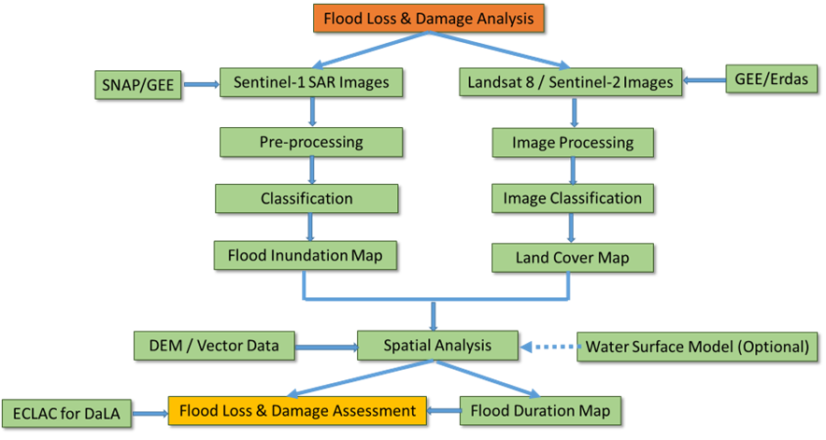
The above methodology will be applied to calculate Loss and Damage (L&D) for flood events in the Kurigram study area using satellite-based remote sensing and GIS analytics. The process will generate flood extent, land cover, and inundation duration outputs and integrate these with mapped “elements at risk” to estimate sector-wise damage and loss.
To extract flood extent, Sentinel-1 SAR imagery will be used to overcome cloud-cover constraints during the monsoon season. Flood-water classification will be performed using SNAP (Sentinel Application Platform) following standard preprocessing steps (e.g., radiometric calibration, speckle filtering, terrain correction, and geocoding). In parallel, Google Earth Engine (GEE) may be used to automate and validate flood extent mapping and to support rapid multi-date flood delineation.
To generate land cover/land use baselines, Landsat 8 or Sentinel-2 imagery from the pre-monsoon period will be used. Prior to classification (supervised and/or unsupervised), required corrections will be applied, including atmospheric, geometric, and radiometric corrections. These steps can be conducted in Google Earth Engine or desktop environments such as ERDAS IMAGINE, depending on data availability and processing requirements.
Once flood extent and land cover maps are produced, they will be integrated with vector datasets representing elements at risk (sectoral assets, infrastructure, livelihoods, and services). Using ArcGIS Spatial Analyst and relevant geoprocessing functions (e.g., overlay, intersect, zonal statistics, raster-to-vector conversion), inundated and damaged elements will be identified and quantified. Where multi-date imagery is available, a flood duration (inundation persistence) map will be developed from time-series flood extents to estimate inundation duration—particularly relevant for crop-specific impact assessment (e.g., paddy).
Following identification of inundated/damaged features, elements will be categorized sector-wise and L&D will be calculated using the ECLAC damage and loss methodology (developed by the UN Economic Commission for Latin America and the Caribbean). Sector-specific calculation procedures and assumptions are detailed in the relevant section of this inception report.
h) Loss and Damage Estimation for Storm Surge
The storm surge L&D estimation will follow the surge modeling workflow described in the methodology section, integrating return-period–based surge height estimation, inland surge decay modeling, and DEM-driven inundation depth/extent mapping. The resulting storm surge depth and extent layers will be overlaid with the Union-level CRVA element inventory to identify exposed and damaged elements and to generate sector-wise L&D summaries using the ECLAC damage and loss methodology.
Loss and Damage Estimation for Salinity Intrusion (Satkhira)
The above methodology will also be applied to estimate Loss and Damage (L&D) associated with salinity intrusion in the Satkhira study area. To identify salt-affected areas, Landsat 8 OLI (Operational Land Imager) satellite imagery will be used. Following required image corrections (e.g., radiometric and atmospheric corrections, and geometric alignment where applicable), relevant spectral indices will be computed using image processing software such as ERDAS IMAGINE or ArcGIS Pro, including:
- NDSI (Normalized Difference Salinity Index) to characterize salinity-related surface conditions
- NDVI (Normalized Difference Vegetation Index) to capture vegetation stress and productivity changes associated with salinity impacts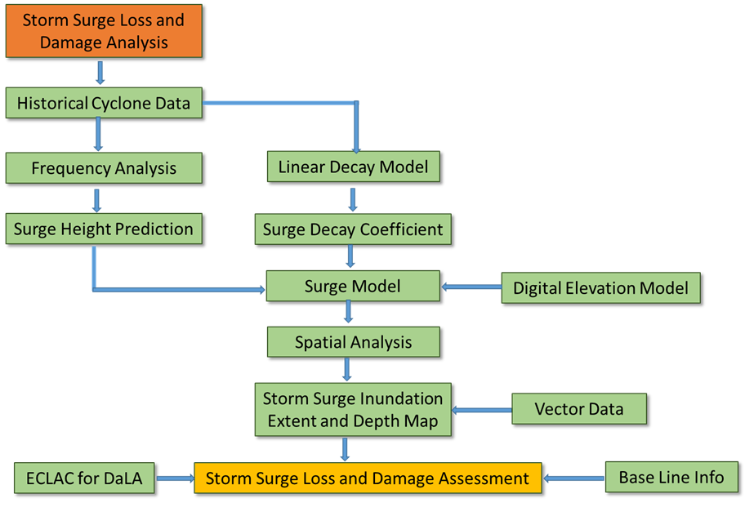
Salinity intensity classes will be derived from index values and spatial patterns. In general, higher NDSI values indicate higher salinity, while NDVI typically exhibits an inverse relationship (i.e., lower NDVI may indicate vegetation stress consistent with increased salinity), subject to local calibration and validation.
After generating salinity intensity and extent layers, these outputs will be integrated with vector datasets representing elements at risk (with a primary focus on crops and agriculture-related livelihood elements). Using ArcGIS spatial analysis tools (e.g., overlay/intersect, zonal statistics, raster reclassification), affected elements will be identified and quantified.
Finally, exposed/damaged elements will be categorized sector-wise and ECLAC’s damage and loss methodology will be applied to calculate sector-specific and aggregate L&D for salinity intrusion. Detailed sectoral calculation steps and assumptions will be provided in the corresponding section of the inception report.
Loss and Damage Estimation for Salinity
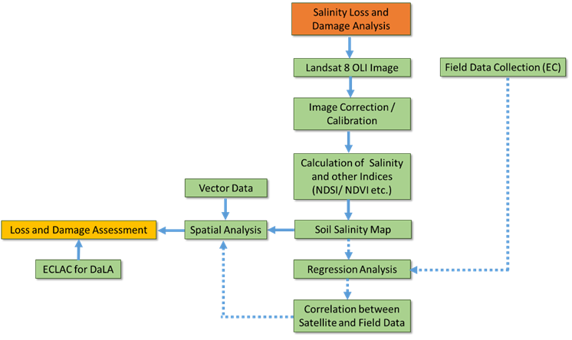
The above methodology will be used to calculate loss and damage (L&D) for Salinity Intrusion in Satkhira area. In this methodology, to identify salt affected area, Landsat 8 OLI (Operational Land Imager) satellite data will be used. After performing necessary correction in the image, different indices like NDSI (Normalized Difference Salinity Index), NDVI (Normalized Difference Vegetation Index) are calculated using Image processing software like Erdas Imagine or ArcGIS Pro. From indices values, intensity of Salinity can be assumed. If NDSI value is high, Salinity will be high. But for NDVI, this relationship will be reverse.
After getting the indices and soil salinity extent together with vector data (elements at risk), damaged elements (mainly crops) will be identified using ArcGIS platform. As elements at risk are identified, categorize the elements sector wise and apply ECLAC to calculate the loss and damage for salinity intrusion.

4.2 Defining baseline risk and vulnerability conditions

Baseline risk and vulnerability conditions will be established by integrating historical hazard evidence, geospatial analytics, and socioeconomic vulnerability profiling to produce a defensible “pre-crisis” reference against which anticipatory and post-event L&D can be compared.
1) Compile baseline datasets (hazard, exposure, vulnerability)
Hazard history
- Collect historical event information (floods, storm surge/cyclone, salinity intrusion, waterlogging, riverbank erosion, etc.) from NAWG/JNA reports, sector assessments, and local administrative records.
- Extract and standardize hazard magnitude indicators (e.g., flood extent/duration, highest flood level where available, cyclone track proximity, storm surge depth proxies, salinity intensity proxies).
Exposure and elements-at-risk
- Develop/validate the Local Government basemap and element inventory (sectoral assets, livelihoods, services, markets/value chain nodes, natural resources) with unique IDs and consistent attributes.
Socioeconomic vulnerability
- Compile BBS HIES/Census and age–sex disaggregated datasets, UP safety-net data (VGD/VGF), and livelihood-class information to map persistent socioeconomic vulnerability pockets.
2) Generate multi-hazard baseline maps (spatial distribution)
Produce baseline hazard layers and composite multi-hazard distribution maps over the GIS basemap:
- Event-wise and hazard-wise distribution layers (historical footprints and hotspots)
- Recurrence/frequency surfaces (where data permits)
- Intensity/severity classes (using consistent thresholds and legends)
3) Delineate historical impact areas and categorize vulnerability
Delineate impact-prone areas using historical evidence and classify them into three baseline categories:
- Most Vulnerable: high frequency and high intensity impacts; recurrent exposure; limited coping capacity; repeated losses.
- Moderately Vulnerable: moderate recurrence and/or moderate intensity; intermittent high impacts; partial coping capacity.
- Vulnerable: lower recurrence or lower intensity, but still exposed and affected under certain thresholds/events.
This categorization will be done at Union/ward/mouza level (and grid level where required) and verified through local consultations and field spot-checks.
4) Develop a baseline risk–vulnerability index (optional but recommended)
Create a simple, transparent index combining:
- Hazard score (frequency × intensity)
- Exposure score (density/value of elements at risk)
- Vulnerability score (poverty, livelihood sensitivity, age–sex vulnerability, service deficits)
- Capacity score (shelters, access routes, local preparedness assets), applied as a moderating factor
Outputs:
- Composite baseline risk map
- Union-wise vulnerability ranking for sampling prioritization and targeting
5) Validation and documentation
- Validate baseline categories via UDMC/VDMC consultations, sector department review, and community PRA (transect walks, FGDs).
- Document thresholds, data sources, and confidence levels for each hazard layer and vulnerability class.
Deliverables
- Multi-hazard baseline maps (hazard-wise and composite)
- Historical impact extent maps with vulnerability classes (Most/Moderate/Vulnerable)
- Union/Upazila vulnerability ranking tables and baseline narrative
- Metadata catalogue and QA/QC notes for reproducibility and auditability

4.2.1 Baseline scenario (risk and vulnerability mapping)

Develop a baseline scenario by producing a detailed spatial distribution of multi-hazards over the GIS basemaps and classifying areas into vulnerability/risk categories Most Vulnerable, Moderately Vulnerable, and Vulnerable based on hazard frequency, intensity, and observed impact severity.
Key outputs:
- Multi-hazard baseline maps (by hazard type and combined index) over Union/Upazila boundaries
- Vulnerability class maps (Most/Moderate/Vulnerable) with clear criteria and legends
- Baseline exposure summaries by sectoral elements (elements-at-risk inventory)
Historical impact delineation
Delineate historical hazard impact footprints and categorize affected areas using comparable impact classes Most Vulnerable, Moderately Vulnerable, and Vulnerable based on documented impacts from past events.
Key outputs:
- Historical impact extent maps (event-wise and composite)
- Impact-category maps showing recurrent hotspots and persistent risk pockets
- Comparative baseline vs. historical impact analysis to validate vulnerability zoning and refine CRVA sampling priorities

4.2.2 Estimation/statistics of food and livelihood elements likely to be damaged (forecast-based)

4.2.2.1 Anticipatory L&D estimation based on impending hazards

Conduct anticipatory Loss & Damage (L&D) calculations using forecasted and early-warning information for impending hazards (e.g., river flood, flash flood, waterlogging, tidal/storm surge, high winds, hailstorm, nor’wester, tornado). The analysis will:
- Delineate the probable hazard footprint and intensity/severity zones (extent and depth/velocity where applicable).
- Overlay hazard layers with the food and livelihood sector element inventory to quantify the number, area, and type of elements likely to be affected.
- Generate Union/Upazila summaries (and 5 km × 5 km grid summaries where applicable) to support anticipatory action planning.
Statistics of likely damaged elements (food/livelihood sector)
Produce forecast-based statistics of key elements likely to be damaged, including:
- Farmland area expected to be inundated/waterlogged/salinized
- Standing crops (by crop type and growth stage)
- Seedlings/saplings (nurseries, newly planted areas, homestead planting)
- Homestead gardens and household food production plots
- Fish ponds/ghers and aquaculture units (including integrated rice–fish systems where relevant)
Outputs will include tables and maps showing:
- affected area (hectares) and counts (units) by element type
- exposure by hazard intensity class
- sector-wise distribution by Union/Upazila and hotspot zones
Economic loss calculation (market-based valuation)
Estimate economic losses for the forecast-affected food and livelihood elements by applying appropriate valuation rules, including:
- Current market prices for crops (by crop type), fish, seedlings/saplings, and relevant inputs
- Replacement/rehabilitation costs for damaged ponds/ghers and productive infrastructure (where applicable)
- Crop-stage–sensitive loss logic (e.g., seedling vs. flowering vs. mature crop) and hazard-duration sensitivity (e.g., waterlogging days)
Deliverables:
- Anticipatory L&D datasets (sector-wise and Union/Upazila-wise)
- Maps and infographics for early action triggers, humanitarian planning, and PDNA-ready evidence
- Documentation of assumptions, unit prices, and calculation parameters used for transparency and reproducibility

3) Calculation/estimation/statistics of food and livelihood elements being damaged by the occurred hazard/disaster

Post-event (observed) damage statistics

Following the occurrence of a hazard/disaster (e.g., flood and/or storm surge), quantify the observed impacts on key food and livelihood elements by integrating field verification (CRVA surveys, GPS points, KoboToolbox data) with post-event remote sensing outputs (flood extent/duration, surge extent/depth, salinity intensity where relevant).
The analysis will produce statistics for:
- Farmland affected (area inundated/waterlogged/salinized)
- Standing crops affected (by crop type and growth stage)
- Seedlings/saplings damaged (nurseries and newly planted areas)
- Homestead gardens affected (household-level food production plots)
- Fish ponds/ghers affected (including integrated rice–fish systems where applicable)
Outputs will be summarized by Union/Upazila (and grid cell where required), including affected area, counts, and severity classes.
Element-specific economic loss calculation (market-based valuation)
Estimate economic loss for the damaged elements using current market prices and context-appropriate valuation parameters. The calculation will apply element-specific logic, including:
- Area-based valuation for farmland and crops (hectares × expected yield/proxy × market price), adjusted by crop stage and damage severity
- Unit-based valuation for seedlings/saplings and homestead garden components (number/unit × market price), adjusted by survival/replanting needs
- Aquaculture valuation for fish ponds/ghers (stock loss + feed/input loss + repair/rehabilitation costs where applicable), aligned with DoF baselines and field-reported loss proportions
Deliverables:
- Sector-wise and element-wise post-event damage tables (Union/Upazila-wise)
- L&D maps showing damaged elements and hotspots
- Infographics and PDNA-support summaries with documented assumptions, unit prices, and calculation parameters

