



Methodology, Tools, and Guidelines
on
Impact-Based Forecasting (IBF) for Mongolia
(New IBF Concept)
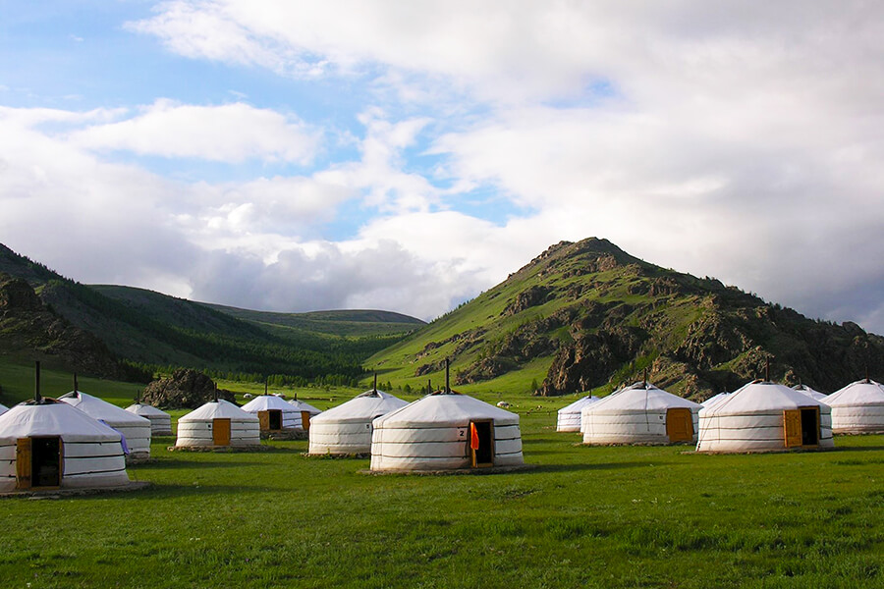

Developed by : Z M Sajjadul Islam

UNDP - International Consultant (Team Leader), Mongolia

Acronym

AI | Artificial Intelligence
ALAGaC/ | Administration of Land Affairs, Geodesy and Cartography
ALAMGaC | Agency for Land Administration and Management, Geodesy and Cartography
AWS | Automatic Weather Station
5W | Who will do what, where, when, and how
BTS | Base transceiver station
CRVA | climate risk and vulnerability assessment
CSV Excel file | comma-separated values
CAP | Common Alerting Protocol
CBO/CSO | Community-based organization / Community services organizations
CMA, | China Meteorological Administration
IBFWS | Impact-based Forecast and Warning Services
CRVA | Climate Risk and Vulnerability Assessment
DIMA | National Rangeland Monitoring Database
EM-DAT | Emergency Events Database
DCPC | Data Collection and Processing Center
DTM/DEM | Digital Terrain Models (DTM)/ Digital Elevation Models (DEM)
EAP | early action protocol
EOC | Emergency Operations Center
FAO | Food and Agriculture Organization
AM/FM Radio | Amplitude Modulation/Frequency Modulation
FBF | forecast based Financing
FTP | File Transfer Protocol
FGD | Focus Group Discussion
GIS | Geographic Information System
GPS | Global Positioning System
HCT | Humanitarian Country Team
HPC | high processing power computing
IBF | impact-based forecasting
ICS | Incidence Command System
ICT | Information and Communication Technology
IFRC | International Federation of Red Cross and Red
IM | Information Management
IP | Internet Protocol
I-NGOs | International /National Non-Governmental Organization
IRIMHE | Information and Research Institute of Meteorology, Hydrology, and Environment
IVR | Interactive Voice Response
JMA, | Japan Meteorological Agency
KMA | Korea Meteorological Administration
KII | Key Informant Interviews
KML/KMZ | Keyhole Markup Language
LEMA | Local Emergency Management Agency
L & D | Loss and Damage
MET | Ministry of Environment and Tourism
MIS | Management Information System
MHEWS | multi-hazard early warning system
MODIS | Moderate Resolution Imaging Spectroradiometer
MoED | Ministry of Economy and Development
MOU | Memorandum of understanding
MoFALI | Ministry of Food, Agriculture and Light Industry
MRCS | Mongolian Red Cross Society
NAMEM | National Agency Meteorology and the Environmental Monitoring
NDVI | Normalized difference vegetation index
NEC | National Emergency Commission
NEMA | National Emergency Management Agency
NMHS | National Meteorological and Hydrological Services
NOAA | National Oceanic and Atmospheric Administration
ODBC/JDBC | Open Database Connectivity/ Java Database Connectivity
PDNA | post-disaster damage, loss and needs assessment
NSO | National statistics office
PIU | Project Implementation Unit
PSTN | Public switched telephone network
REST | RESTful Application Programming Interface( API)
RIMES | Regional Integrated Early Warning System for Africa and Asia
R & D | Research & Development
SMS | Short Message/Messaging Service
SME | Small and Medium Enterprise
SoD | standing orders on disaster
TWG | Technical Working Group
WCS | Web Coverage Services
WMS | Web Map Service
WFS | Web Feature Service
WPS | Web programming service
UHF | Ultra-high frequency
UNDP | United Nations Development Programme
UNEP | United Nations Environment Programme
UNFPA | United Nations Population Fund
UNICEF | United Nations International Children's Emergency Fund
VHF | Very high frequency
WFP | UN World Food Program
WMO | World Meteorological Organization

Contents
1.0 Chapter : Introduction of Impact-Based Forecasting : 7
1.1 Importance of developing an integrated IBF platform : 7
1.2 Framework of Integrated Framework for Impact-Based Forecasting, Weather Warning and Alerting, and Multi-Hazard Early Warning Systems (MHEWS) 8
1.3 The expected benefits of an integrated IBF platform: 14
2.0 Chapter: Stakeholder Partnership & Communication 16
2.1 Rationale of Partnership ( both formal and virtual context) : 16
2.2 Data Coordination and Exchange Mechanism 17
2.3 Mandating partnership for data coordination, exchange, and risk communication 19
2. 4 Technical Working Group for forecast Impact analysis : 26
2.5 Process of translating traditional forecast/weather outlook to impact forecasts : 51
2.6 Defined roles of partners during multi-hazard emergencies : 55
2.7 Partnership capacity building Process : 67
2.7.1 Organize regular Workshop/Consultation/Seminar/Meetings to improve service delivery: 67
2.7.2 Removing the Barriers to Partnership Building: 67
2.7.3 Strengthening integrated partnerships for getting multi-hazard situation updates from the local level. 68
2.7.4 Improving IBF and warning systems efficiency and Efficacy. 68
3.0 Chapter: ICT Structures of integrated IBF Platform : 69
3.1 Implementation of Opensource Geospatial Platform : 69
3.1.1 Component of Opensource Geospatial Platform: 69
3.1.2 Installation of Geoserver : 71
3.1.3 Anchoring google mapping tools : 71
3.1.4 Installation and Configuring Surveying Apps. 71
3.1.5 Design and Deploy National Climate Risk and Vulnerability, Multi-hazard risk & L&Ds online database 72
3.1.6 Implementing Web converting common alerting protocol (CAP ) Hub : 72
3.2 Rationale of integrating ICT with the IBF platform : 73
3.3 Software & Tools Proposed for the ICT-integrated IBF Platform 74
3.4 IBF internal and external data acquisition and coordination system (maintaining data sensitivity and privacy). 76
3.4.1 Data workflow and data archive structures ( at IBF central level ) : 76
3.4.2 Integrated IBF ICT system : 77
3.4.3 Centralization of Database Archive and Services by IBF Platform 79
3.4.2.1 Develop databases with PostgreSQL server : 80
3.4.2.2 Impact forecast manufacturing tools, input datasets, and Process: 83
4.0 Chapter: Data Coordination and Exchange Mechanisms 88
4.1 Data Coordination and Exchange Mechanisms at Aimag level : 88
5.0 Chapter : Aimag Emergency Operations Center (EOC) / Situation Room 96
5.1 Mandating an Emergency Operations Center (EOC) / Situation Room at the Aimag Center: 97
5.2 Aimag level NAMEM human resources : 98
5.3 Structure of the Aimag EOC / Situation Room 99
5.4 Functions of EOC / Situation Room : 99
5.4.1 Technical Functions of EOC / Situation Room : 100
6.0 Chapter : IBF Forecasting Process 104
6.1 Undertake operational shift from traditional forecast to integrated Impact-based forecasting (IBF ) , warning, and alerting. 104
6.2 The IBF Value Chain: 106
6.3 IBF preparation and forecasting process (New methodology) : 107
6.4 Converting traditional forecast to IBF 126
6.4.1 Analyze impacts over the seasonal forecasts : 128
6.4.2 Processing monthly IBF : 128
6.4.3 Preparing medium-range Forecast : 131
6.4.4 Preparing short range Forecast : 132
6.4.5 The short-range forecasts usability : 133
6.5 Short range impact forecast preparation 135
7.0 Chapter : Operational Forecasts 137
8.0 Chapter : The multi-hazard early warning system 141
8. 1 Improved and hybrid weather observation mechanism : 144
8.2. Process of developing an Early Warning : 145
8.3 The multi-hazard early warning process: 147
8.4 Anchoring NEMA Early Warning System with IBF: 148
8.5 Integrated IBF, Warnings, Alerting, and energy hazard early warnings & Advisories : 148
8.6 Convective weather condition-induced hazards early warning : 154
8.7 Convective weather condition screening mechanism 158
8.8 Strong/Damaging Wind induced hazards warning : 162
8.9 Hazardous winter weather early warning : 165
8.10 Template: Winter weather emergency advisory 168
8.11 IBF Flood Impact Forecasting: 169
9.0 Chapter: Impact Forecasting and Warning for Livestock Sector : 172
9.1 Impact analysis methodology : 173
9.2 Risk repository development process : 180
9.3 Advisory on Integrated Pasture Monitoring System: 188
9.3 Alert and warning services for livestock & Crop agriculture 189
9.5 Develop dzud risk profile : 189
9.6 Web-based MIS system for Dzud risk management : 190
9.7 Develop Dzud Early warning protocol. 192

Executive Summary:

Mongolia faces rapidly evolving and highly variable weather and climate risks driven by complex interactions between global climate perturbations and diverse local geographic and climatic conditions, including the Gobi Desert, steppe ecosystems, mountainous terrain, and pronounced diurnal variability. These dynamics frequently generate high-impact hazards such as Dzud, severe winter storms, blizzards, damaging winds, drought, floods and flash floods, dust storms, and convective storms resulting in significant loss and damage to livelihoods, infrastructure, and socio-economic development. The agriculture and livestock sector, a major contributor to national GDP and rural well-being, is among the most affected, underscoring the need for actionable, last-mile climate information services that strengthen preparedness and enable early action.

This initiative outlines the development methodology, tools, and guidelines for Impact-Based Forecasting (IBF) tailored to Mongolia’s multi-hazard and climate risk environment, with a focus on vulnerable livestock, crop agriculture, and livelihood systems. The combined agricultural sector (livestock and crops) contributed 18.3 percent of GDP in 2022, yet increasingly variable and intensified extreme weather, particularly Dzud, continues to undermine rural, livelihood-based economies. At present, Mongolia’s early warning ecosystem remains insufficiently integrated and operationalized to consistently support the livestock sector in preparing for, responding to, and recovering from Dzud and other climate-induced disasters through end-to-end services that combine forecasting, warning, and common alerting.

The proposed IBF system is designed to address structural, process, and forecast product development gaps within NAMEM/IRIMHE by establishing a robust, ICT-enabled integrated platform. It also introduces a formal mechanism to link and mandate engagement from key partner institutions, enabling interactive and routine contributions to the system. Operationally, the IBF approach aligns forecasts of impending high-impact weather with baseline exposure, risk, and vulnerability information for elements on the ground, enabling structured impact estimation and targeted decision support.

Impact-Based Forecasting represents a paradigm shift from communicating “what the weather will be” to “what the weather will do.” It integrates hazard forecasts with exposure and vulnerability datasets, alongside real-time incident and situational evidence, to deliver decision-relevant advisories, warnings, and multi-hazard early warning services. For Mongolia, an integrated IBF system is envisaged as a one-stop platform aligned with the WMO transition toward impact forecasting, supporting implementation of the Sendai Framework and strengthening the availability and use of disaster risk information in climate-frontline contexts. The system is intended to enhance the utility of forecasts, enable early action protocols, and support Forecast-based Financing (FbF) by linking forecast thresholds to anticipatory actions and resource mobilization.

Operationally, the IBF value chain links: (i) seasonal and sub-seasonal outlook interpretation using climate normals and anomaly analysis; (ii) real-time monitoring and nowcasting; (iii) sector-specific impact analysis through threshold-based overlays of hazards with exposure and vulnerability datasets; (iv) dissemination of tailored advisories and warnings, including CAP-compatible alerting where applicable; and (v) continuous feedback, verification, and post-event learning through incident and loss-and-damage repositories. The approach emphasizes last-mile reach by enabling remote herders, volunteers, and sector technicians to report observations offline and transmit them when connectivity becomes available, supported by standardized SOPs, quality control, and validation protocols.

To decentralize services and ensure rapid, localized decision-making, the framework proposes operationalizing Aimag-level Emergency Operations Centers (EOC)/Situation Rooms jointly led by NAMEM and NEMA (LEMA), with participation from MRCS and sector departments. These EOCs would function as hubs for localized CRVA, risk repository development, impact interpretation, incident tracking, ICS/IAP coordination, and communication with the national IBF platform in Ulaanbaatar particularly critical during extreme events when physical access is constrained and emergency telecommunications may be the only reliable connectivity.

In summary, Impact-Based Forecasting for Mongolia offers a scalable and integrated pathway to translate complex hazards into actionable decisions. By strengthening observation networks, building climate risk and vulnerability baselines, enabling geospatial impact analysis, institutionalizing multi-stakeholder coordination, and linking forecasts to anticipatory actions and financing triggers, the proposed IBF system aims to reduce loss and damage, protect livelihoods and critical infrastructure, and support risk-informed development planning across Mongolia’s diverse climatic regions.

1.0 Chapter : Introduction of Impact-Based Forecasting :

The impact-based forecasting (IBF) is a technical & operational shift from traditional forecasting (‘what the weather will be ) to impact forecasting (‘what the weather can do’). It encompasses transformative and structural changes from the traditional forecasts to IT database & GIS tool-based analytics of color-coded thresholds of impacts, exposure, risks, vulnerabilities of the ground, anticipatory losses & damages likely to be impending over the forecast lead time. Therefore, the humanitarian community and vulnerable sectors will be informed about the impact level and be able to develop an early action protocol (EAP) for better preparedness. ICT-driven integrated impact-based weather forecasting, warning, alerting, and multi-hazard early warning system( MHEWS) is a WMO’s new approach to coming up with a one-stop solution to improved weather and climate information services starting from baseline climate risk and vulnerability assessment, risk repository, and atlas preparation so that any impending hazards weather events being well screened, predicted with spatiotemporal scale and anticipatory loss & damages (L & D) being well advised over the forecast lead-time until hazardous weather events being dissipated.

Traditional weather forecasting typically offers a limited view of conditions such as temperature, precipitation, wind speed, and other atmospheric variables. Impact-Based Forecasting (IBF) goes beyond this by explaining what those conditions are likely to do on the ground. For instance, an IBF forecast can indicate the expected frequency and intensity of hazardous events, the impact thresholds at relevant spatial and temporal scales, and the anticipated risks and vulnerabilities along with the likely loss and damages (L&D). It can also inform how to design an Early Action Protocol (EAP), support Early Warning Early Action (EWEA) through detailed contingency planning, and guide anticipatory budgeting to strengthen preparedness and response.

1.1 Importance of developing an integrated IBF platform :

Mongolia’s diverse and rapidly changing weather conditions make it essential to move beyond conventional forecasting. The proposed Impact-Based Forecasting (IBF) system is designed to address structural, process, and forecast product development gaps within NAMEM/IRIMHE by establishing a robust, integrated IBF platform. This methodology also creates a mechanism to formally link and require engagement from key partner institutions, enabling interactive contributions to the system.
Operationally, the IBF approach is intended to align and integrate impact calculations for impending high-impact weather with existing baseline risks and vulnerabilities of exposed elements on the ground.
Key components and requirements of the IBF process include:
- Core inputs: A readily available, sector-specific repository of baseline risk and vulnerability assessments; a corresponding database of risk and vulnerability attributes; and a GIS-enabled risk atlas to support forecast impact analysis.
- Real-time monitoring interface: An ICT-enabled platform for tracking hazardous conditions through crowdsourcing and hybrid ICT-based surface weather observations, including automated systems.
- Risk-informed sectoral planning tools: Weather- and climate-risk planning tools tailored to sector-specific needs.
- Service dashboard: A dashboard providing customized impending weather and climate information services to support sectoral planning and decision-making.
- Anticipatory action modules: Early Action Protocols (EAP), early warning-early action (EWEA) planning, anticipatory loss and damage scenarios, and tools to support humanitarian response planning and budgeting.
- Threshold-based warning and CAP alerting: GIS-based functionality to analyze threshold triggers, generate impact-based warnings, and develop standardized alerting protocols when severe weather is likely to escalate into a disaster.
- Multi-hazard services and direct communication: Capacity to deliver multi-hazard impact-based forecasts and warnings, enabling NMHS agencies to communicate directly with vulnerable communities, sectors, and end users via group-based applications and provide situational updates to support common alerting.
- Structured decision-support information: An IBF information system that integrates impact forecasting, hazard warnings, and tailored exposure and vulnerability data to identify risk, support humanitarian decision-making, and enable early action that reduces loss of life and damage.
- Clear distinction from traditional forecasts: While traditional forecasts describe expected weather (e.g., “70 mm/hour rainfall at a given location”), IBF links that hazard to exposed elements and vulnerabilities, translating the forecast into likely outcomes such as flooding and flash flooding impacts, threats to life, and damage to assets and infrastructure.
- Primary value proposition: IBF combines hazard forecasts (rainfall, wind, temperature extremes, etc.) with exposure (buildings, transport networks, population distribution) and vulnerability (susceptibility of people, property, and infrastructure), producing decision-relevant warnings.
- Societal benefit: By delivering an integrated, authoritative message across sectors and communities, IBF supports timely, appropriate action to protect lives and property.

1.2 Framework of Integrated Framework for Impact-Based Forecasting, Weather Warning and Alerting, and Multi-Hazard Early Warning Systems (MHEWS)

The integrated Impact-Based Forecasting (IBF) concept is designed to function as a one-stop platform for delivering weather and climate information services. In Mongolia, a robust IBF system would support the WMO-led global shift from traditional, hazard-only forecasting toward integrated impact forecasting that links prediction with warning, alerting, and people-centred Multi-Hazard Early Warning Systems (MHEWS), with strong emphasis on last-mile delivery to end users.

The proposed IBF system is also essential to advancing full implementation of the Sendai Framework, particularly by expanding access to MHEWS and strengthening the availability and operational use of disaster risk information and risk assessments in climate frontline contexts.

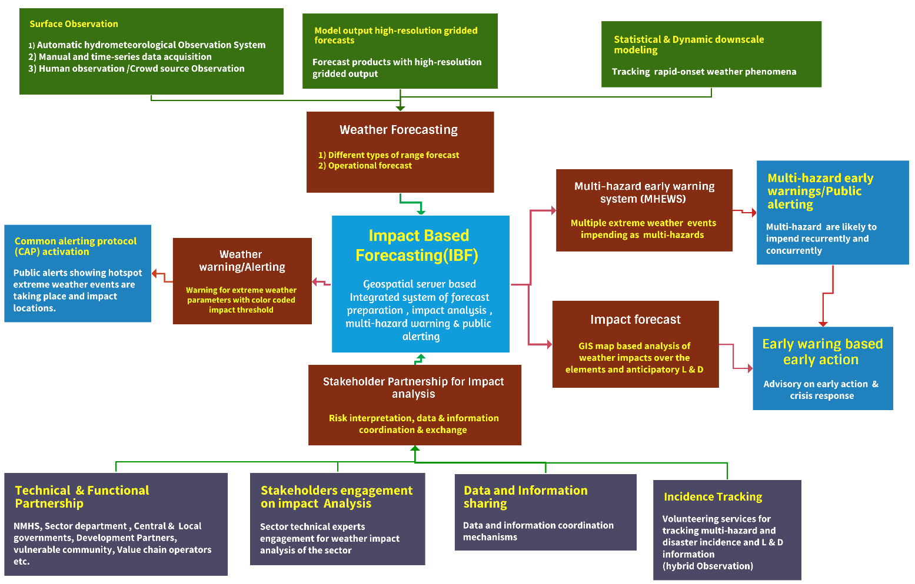
Figure 1: Framework of impact-based forecasting, warning, alerting, and MHEWS( Source: Z M Sajjadul Islam, UNDP-GCF)

- Key Components of the MHEWS Framework being integrated into IBF Platform :

- Surface hybrid observations to track land surface, atmospheric, and sea surface weather anomalies,
- Automatic hydrometeorological hybrid observation systems
- Manual observations and time-series data collection
- Human observations and
- crowdsourced data collection
- High-resolution forecast model outputs (gridded forecasts)
Forecast products with high-resolution gridded outputs to 1km resolution to track the last-mile anomalies, impacts of impending weather conditions
- Statistical and dynamic downscaling
Tracking rapid-onset weather phenomena with a high-resolution forecast (based on atmospheric and surface observation, ERA5 reanalysis forecast data )

- Forecasting and integrated Weather EWS
- Multiple forecast ranges (nowcasting, short-, medium-, and extended-range)
- Operational forecasting, weather warning, and CAP.

- Develop a high-end programme synchronizing from an AI-enabled risk repository database, weather anomalies, Geospatial Server-based elements at risk location, and provide impact output to be integrated into the IBF Platform. A geospatial-server-based integrated system for forecast production, impact analysis, multi-hazard warning, and public alerting. Develop an AI-enabled IBF impact engine that automatically synchronizes data from the risk/vulnerability repository, weather anomalies/forecast outputs, and GeoNode/GeoServer exposure layers (elements-at-risk locations). The system performs geospatial overlays and impact scoring to generate impact maps, statistics, and sector advisories, then publishes outputs to the IBF platform (with metadata, versioning, and access controls). These outputs can also feed multi-hazard warnings and CAP-based public alerting, creating a fully integrated workflow for forecast production, impact analysis, and dissemination.

- Warning, alerting, and response - Geospatial platform integrated Apps based common Alerting (CAP)
- Weather warning and alerting
Warnings for extreme weather parameters using colour-coded impact thresholds
- Multi-Hazard Early Warning System (MHEWS)
Multiple extreme weather events are developing or expected concurrently as compound/multi-hazard risks
- Multi-hazard early warnings and public alerting
Multi-hazard events may occur repeatedly and concurrently, requiring integrated public alerting
- Early warning-based early action
Actionable advisories to enable early action and crisis response management for the climate vulnerable sectors(livestock, crop agriculture, WASH, Water, agroforestry, Health, livelihood, and other value chain sectors)
- Impact analysis and coordination Impact forecast
GIS-based analysis of expected weather impacts on exposed elements, including anticipatory loss-and-damage considerations
- Stakeholder partnership for impact analysis
Risk interpretation, and data/information coordination and exchange

- Common Alerting Protocol (CAP) CAP hub installation & activation

A CAP Hub (Common Alerting Protocol Hub) is the central alerting “broker” that authors, validates, approves, publishes, and disseminates standardized warning messages (CAP 1.2) to multiple channels (Apps based Messaging, SMS, Unstructured Supplementary Service Data, cell broadcast, IVR, CAP Aggregator, Satellite Radio, FM/AM radio/TV, web, social media, apps) while also exposing APIs so the IBF/FBF platform can trigger and display alerts consistently.

6.1 ) Target operating model

The CAP Hub’s alert authoring module enables fast, consistent creation of CAP 1.2 alerts using hazard-specific templates (e.g., dzud, blizzard, extreme cold, flash flood, thunderstorm). Alerts can be produced manually via a web form by authorized issuers or automatically from IBF triggers (threshold exceedance, indices, polygons/admin units). The module supports multi-language messaging and embeds pre-approved protective actions aligned with EAPs/SOPs, ensuring alerts are clear, actionable, and suitable for last-mile dissemination.

Purpose
- Translate IBF triggers into CAP alerts: Convert IBF outputs impact thresholds, indices, geofenced polygons, and administrative-unit selections pinto compliant CAP 1.2 alert messages with standardized fields (event, severity, urgency, certainty, area, instructions).
- Rapid multi-channel dissemination: Deliver alerts quickly to frontline users, including herders, emergency responders, local government, value chain orators, and volunteers through the most effective channels available.
- Single source of truth and full alert lifecycle: Maintain one authoritative alert record covering issuance, updates, cancellations, and archiving to support auditability, accountability, verification, and continuous system learning.

Core workflow (end-to-end)

Inputs (IBF/observations/incidents) > CAP authoring/automation > validation > approval > dissemination > monitoring & update > archive

6.2 ) CAP Hub functional modules

a) Hazard-specific templates
- Pre-built CAP templates for priority hazards (e.g., dzud, blizzard, extreme cold, flash flood, thunderstorm, high wind/dust storm, heatwave).
- Each template includes standardized fields: event, headline, description, instruction/protective actions, severity/urgency/certainty, onset/expiry, and area.
- Supports predefined alert types: Watch / Warning / Advisory / Update / Cancellation (as defined by the national warning SOP).
- Manual authoring interface
- Web-based form for issuers to select: hazard type, affected area (polygon/admin unit), timing (onset/expiry), and impact narrative.
- Built-in helpers: drop-down lists, controlled vocabularies, and suggested protective actions to reduce errors and speed issuance.
- Automated authoring (IBF-triggered)
- Rules engine converts IBF outputs (threshold exceedance, indices, impact geospatial location, polygons, admin units) into draft CAP messages.
- Auto-populates key metadata: hazard classification, severity/urgency/certainty, affected area, validity period, and standard instructions.
- Flags “human-in-the-loop” checkpoints (e.g., extreme severity, large population exposure, conflicting signals) for mandatory review before publishing.
- Multi-language support
- Alerts produced in Mongolian , English (and additional languages if required) using parallel text fields.
- Central translation library for hazard phrases and protective actions to ensure consistent wording.
- Supports language selection by audience group (e.g., herders vs. responders vs. media).
- Pre-approved protective actions
- Action guidance aligned to EAPs, sector SOPs, and minimum safety standards.
- Tailored action sets by hazard and sector (e.g., livestock protection actions for dzud; evacuation and river crossing avoidance for floods).
- Clear “do-now” instructions optimized for last-mile delivery (short, specific, feasible under low connectivity).

- CAP validation and governance

This module ensures alerts are CAP 1.2 compliant, properly authorized, and fully traceable. It performs schema and content validation, applies a role-based approval workflow (issuer > approver > publisher) with escalation for high-severity cases, and (recommended) uses digital signing to guarantee authenticity and integrity. A complete audit trail records all actions, versions, and trigger evidence to support accountability, review, and learning.

- Geo-targeting

Precisely define who should receive an alert by translating IBF impact extents and administrative boundaries into CAP-compliant areas and targeted recipient groups so warnings reach the right people, in the right places, at the right time.

This module ensures alerts reach the correct locations and audiences by converting IBF impact extents into AI-driven CAP-compliant areas. It also supports polygon-based targeting from GeoNode/GeoServer layers, administrative-unit targeting using aimag/soum/bag codes and official boundaries, and targeted distribution lists (e.g., Herders, MRCS volunteers, EOC teams, Value chain operators, veterinary technicians) with optional geo-fenced routing so messages are delivered to the right users through the right channels.

- Dissemination connectors( automating national risk communication hub)

This module distributes CAP alerts through fully automated and multiple, redundant channels to ensure last-mile reach at any given time being simulated. It integrates with national automated alert hubs, communication and broadcasting channels, CAP aggregator & SMS gateways, telecom, cell broadcast, customized apps to the user-end for rapid mass warning, uses IVR/toll-free voice messaging for low-literacy or low-data users, and publishes alerts via email, web portals, social media, and app push notifications. It also provides feeds/APIs for radio/TV and partner systems, enabling alerts to be rebroadcast and consumed operationally, with delivery tracking and fallback options across channels.

- Public alert feed and API

This module publishes an authoritative public CAP feed endpoint so external users and aggregators can access the latest alerts (including updates/cancellations) by hazard, geography, and time. In parallel, it provides an authenticated API for the IBF/FBF dashboard to securely ingest alerts, display real-time alert status (draft > approved > published > updated/cancelled/expired), and retrieve full alert history for monitoring, verification, and learning.

6.3 ) Integration points with IBF/FBF

Data integration

The IBF/FBF trigger engine generates a structured package (hazard type, severity color, affected polygons/admin areas, validity/lead time, expected impacts, and recommended actions). The CAP Hub ingests it via API or message queue, maps it into CAP 1.2 fields, validates it, optionally routes it for human approval, and then publishes the finalized CAP alert to dissemination channels and to the IBF/FBF dashboard for real-time status display and archiving.

6.4 ) Practical mapping: IBF color codes → CAP parameters

Use a fixed translation from IBF color severity to CAP’s Severity-Urgency-Certainty to keep alerts consistent: Magenta → Extreme/Immediate/Observed-Likely, Red → Severe/Immediate-Expected/Likely, Orange → Moderate/Expected/Possible-Likely, Yellow → Minor/Future-Expected/Possible.

6.5 ) Deployment steps (implementation checklist)

Phase A Governance and SOP (mandatory before go-live)

Before go-live, formally assign the alerting authorities, establish SOPs for issuance/approval/escalation and update/cancel rules, standardize hazard taxonomy, CAP templates, protective actions, and set a routine test/drill plan with a clear public communication protocol.

Phase B: Infrastructure setup (high availability)

- High-availability deployment: Run the CAP Hub in primary, standby (failover) or active-active mode to avoid single points of failure.
- Core platform services: Provision and harden the required components-application server, database, message broker/queue, and monitoring & logging (with alerting on system health and delivery failures).
- Security baseline: Implement TLS encryption, MFA, role-based access control (RBAC), network segmentation, routine backups/restore testing, and reliable time synchronization (NTP) for accurate audit trails and message validity.

Phase C: Configure CAP profiles and geo-references
- Configure the CAP Hub with Mongolia-specific hazard/event codes, load official aimag/soum/bag geo-codes and gazetteer references, and define polygon ingestion/validation rules so impacted areas from IBF GeoNode/GeoServer can be reliably converted into CAP geotargeting (polygons and derived admin-unit lists).
Phase D : Channel integration
Connect the CAP Hub to all dissemination pathways-SMS (with delivery reporting), cell broadcast (telco policy, technical interface), IVR/hotlines (scripts and routing), automated web/social publishing, and partner feeds (MRCS, clusters, EOC, media)-so one approved CAP alert can be distributed consistently, tracked, and updated across channels.
Phase E : Testing and go-live
- Run CAP compliance tests (schema validation plus content/field checks).
- Conduct end-to-end drills: IBF trigger → CAP Hub generation/approval → dissemination (SMS/cell broadcast) → IBF/FBF dashboard display.
- Perform failover and performance testing, including peak-load scenarios typical of national-scale events.
- Execute a staged rollout: pilot in selected aimags, refine SOPs/integrations, then scale to national go-live.

Phase F Operations and continuous improvement
- Establish a 24/7 duty roster with clear on-call escalation paths for alert drafting, approval, publishing, and technical support.
- Track performance through operational analytics: channel delivery rates, estimated reach, acknowledgements/confirmations, false-alarm rate, update/cancel frequency, and lead time achieved versus target.
- Institutionalize after-action reviews (AARs) after major events/drills and use findings to refine templates, thresholds/trigger logic, geo-targeting rules, and dissemination lists (partners, responders, frontline users).

6.6 ) Minimum technical requirements (to include in the design doc)

The design doc should require a CAP Hub that supports CAP 1.2 authoring and validation, role-based approvals with full audit/version logs, polygon and admin-unit geo-targeting, minimum multi-channel dissemination (SMS , CB/IVR , web/API), two-way API integration with the IBF platform (trigger in, alert out/status/history), and a reliability/security baseline of high availability, backups/restore, and core cybersecurity controls (TLS, MFA, RBAC, segmentation, monitoring).

6.7) Interoperable National Meteorological-hydrological Services(NMHS) with sector-level technical experts integrated into IBF Platform

- Technical and functional partnerships
NEMA, LEMA, NMHS, Sector department( livestock, crop agriculture, water sector, hydrological, transport & communication, tourism, other value chain service providers of Mongolia ) technical experts, GIS & remote sensing specialists, sector ministries/departments; Academia, R & D Organization; central and local governments; development partners; vulnerable communities; value-chain operators

- Stakeholder engagement on impact analysis
Actively involve sector technical experts to assess, interpret, and validate sector-specific weather impacts, ensuring impact forecasts and advisories reflect real exposure, vulnerability, and operational realities on the ground.

- Data and information sharing
Establish structured data and information coordination mechanisms so partners can routinely contribute, access, and exchange forecasts, exposure/vulnerability datasets, and incident updates through agreed standards (formats, metadata), interfaces (APIs/GeoServices), and governance (roles, frequency, quality checks).

- Incident tracking
Enable volunteer-supported, hybrid observation to capture and transmit geolocated multi-hazard events, disaster incidents, and loss-and-damage evidence (photos/videos/brief notes) in near real time, feeding the IBF platform for situational awareness, warning refinement, and post-event analysis.

- key components of an Impact-Based Forecasting (IBF) framework organized end-to-end from data inputs to last-mile action and learning.

- Risk knowledge and baseline risk information
- Multi-hazard risk, exposure, and vulnerability databases (CRVA, risk atlases, element inventories)
- Historical event and loss-and-damage repositories (hazard footprints, hotspots, impacts)
- Sector-specific risk profiles and impact thresholds aligned to local contexts (aimag/soum/bag)
- Monitoring, detection, and forecasting
- Integrated observation systems: manual stations, AWS, hydrological gauges, radar/satellite, and crowdsourced field reports
- Forecasting chain across timescales (nowcasting, short-range, sub-seasonal, seasonal) including ensemble guidance
- Data quality control, calibration, assimilation, and continuous forecast verification
- Impact assessment and decision-support analytics
- Hazard-to-impact translation using GIS overlays of forecasts with exposure and vulnerability layers
- Threshold-based impact classification (e.g., green/yellow/orange/red) by sector and element
- Compound and cascading risk logic (e.g., heavy rain , saturated soil → landslide/flash flood risk)
- Scenario-based anticipatory loss-and-damage estimation to inform early actions
- Warning generation and Common Alerting Protocol readiness
- Standardized warning products: watches, warnings, updates, and all-clear messages
- CAP-compatible alert creation and aggregation, including event metadata (severity, urgency, certainty, location)
- Message standards focused on “what will happen, where, when, likely impacts, and what to do”
- Dissemination and last-mile communication
- Multi-channel dissemination: IBF web platform (GeoNode/GeoServer), SMS/IVR/cell broadcast, radio/TV, social media, and community networks
- Two-way communication channels for receiving field verification and incident updates (Kobo/QField, GPS apps, WhatsApp/Telegram)
- Offline-capable reporting and delayed synchronization for hard-to-reach areas
- Preparedness and response capability
- Integration with Aimag EOC/Situation Rooms and Incident Command System (ICS) operations
- Pre-agreed Early Action Protocols (EAPs) linked to forecast thresholds (EWEA/FbF/AA)
- Coordination protocols for partners (NEMA/LEMA, MRCS, MoFALI, sector departments, HCT, I-NGOs)
- Governance, SOPs, and institutional coordination
- Clearly defined roles, responsibilities, and escalation procedures across national and local levels
- Data-sharing agreements, access controls, and operational SOPs for routine and emergency modes
- Regular coordination forums (TWGs, briefings, after-action reviews) for continuous improvement
- System sustainability, performance monitoring, and learning
- Monitoring of warning performance (timeliness, accuracy, reach, user comprehension, action taken)
- Post-event evaluation, model/threshold refinement, and knowledge management
- Sustainable resourcing for ICT hosting, observation networks, staffing, and capacity development
- Governance and institutional arrangements
- Clear mandates for NMHS, DRM authority, sector ministries, local governments, and humanitarian partners
- Defined coordination structure (e.g., Steering Committee , Technical Working Groups)
- Standard Operating Procedures (SOPs) for routine operations and emergencies
- Legal/data-sharing instruments (MoUs), roles, and escalation protocols
- Hazard monitoring and observation system
- Surface observation network (manual stations, AWS, hydrological gauges)
- Remote sensing and radar/satellite monitoring for rapid-onset hazards
- Crowdsourced and community observations (photos/videos , geolocation , simple weather parameters)
- Data quality control, calibration, metadata standards, and maintenance plans
- Forecast production and modeling chain
- NWP and ensemble forecasts (short range to seasonal)
- Nowcasting tools for rapidly developing weather (0-6/12 hours)
- Downscaling (statistical/dynamical) to operational grid resolutions suitable for local decisions
- Forecast verification and bias correction routines (continuous improvement loop)
- Exposure, vulnerability, and baseline risk information
- Climate Risk and Vulnerability Assessment (CRVA) database and risk atlas
- Sectoral exposure inventories (livestock, crops, water systems, infrastructure, services)
- Socio-economic vulnerability datasets (disaggregated where feasible)
- Historical event repository (hazard footprints, impacts, loss and damage)
- Impact modeling and threshold definition
- Impact thresholds by hazard and sector (color-coded: green/yellow/orange/red)
- Translation rules from meteorological variables to sector impacts (e.g., grazing barriers, water stress, flood impacts)
- Compound/ cascading risk logic (e.g., heavy rain , saturated soil → landslide risk)
- Trigger sets aligned to Early Action Protocols (EAPs) and financing decisions (FbF/AA)
- Geospatial analytics and decision-support products
- GIS overlay analysis: forecast hazards , exposure , vulnerability
- Automated production of: impact maps, affected-area lists, hotspot layers, sector advisories
- Standard templates for outlooks, operational forecasts, and verification briefs
- Spatial products at administrative levels (aimag/soum/bag) and priority assets (point-based)
- Integrated ICT platform and data services
- Central database servers (e.g., PostgreSQL/PostGIS) and data pipelines
- GeoNode/GeoServer for publishing, discovery, access control, and archiving
- OGC/REST services (WMS/WFS/WCS/REST API) for partners (ArcGIS/QGIS integration)
- Automated archiving/versioning of CSVs, shapefiles, maps, bulletins, and incident records
- Warning, alerting, and Common Alerting Protocol readiness
- Multi-channel warning pipeline (web dashboards, EWS Apps, SMS/IVR/cell broadcast, radio/TV, social media)
- CAP-compatible alert generation and aggregation (where applicable)
- Message standards: “what, where, when, severity, likely impacts, actions”
- Decentralized operations and last-mile delivery
- Aimag-level EOC/Situation Room functions for localized interpretation and coordination
- Incident Command System (ICS) integration: situation reporting, IAP support, coordination calls
- Community and volunteer networks for two-way information flow and field verification
- Offline-capable reporting tools (Kobo/QField/GPS apps) and protocols for validation
- Capacity building and operational readiness
- Training for forecasters, sector analysts, GIS/data engineers, and EOC staff
- Simulation drills and seasonal readiness exercises
- Guidance notes for sector impact interpretation and advisory writing
- Helpdesk/operations support for platform users and partners
- Feedback, evaluation, and continuous improvement
- Post-event reviews: what was forecast vs. what occurred vs. what impacts occurred
- User feedback loop from herders, farmers, sector agencies, responders
- Refinement of thresholds, exposure assumptions, and impact models
- Performance metrics for timeliness, reach, comprehension, and actionability
- Sustainability and financing linkages
- Integration with anticipatory action/FbF decision protocols and triggers
- Budgeting for observation networks, ICT hosting, maintenance, and staffing
- Partner contribution model for data updates and joint products
- Data governance for privacy, security, and controlled access where required

1.3 The expected benefits of an integrated IBF platform:

- Enables high-resolution spatiotemporal forecasts, warnings, and alerts linked to anticipatory action: Impact-based forecasts and warnings provide a practical roadmap for preparedness, including local forecast-based Standing Orders(SoD)/Procedures for Disasters (SoP) and an Early Action Protocol (EAP), supporting last-mile households and communities to protect lives, property, and livelihoods.
- Improves decision-making for at-risk groups: IBF delivers actionable intelligence that helps local authorities, stakeholders, exposed communities, and sectoral actors make informed choices to reduce impacts from forecast extreme weather and climate events.
- Strengthens institutional collaboration: Developing and operationalizing IBF promotes sustained partnerships between National Meteorological and Hydrological Services (NMHS), disaster risk reduction and management institutions, sectoral agencies, and last-mile communities improving coordination before and during crises.
- Communicates uncertainty transparently: IBF explicitly conveys forecast uncertainty, enabling decision-makers to factor probabilities and confidence levels into selecting proportionate actions and allocating resources effectively.
- Enhances multi-stakeholder coordination: IBF encourages structured collaboration among NMHS agencies, DRM authorities, humanitarian organizations, and sector partners through shared data, interoperable workflows, and jointly agreed protocols.
- Improves efficiency of resource allocation: By focusing attention and resources on areas and groups with the highest expected impacts, IBF supports anticipatory budgeting and more efficient deployment of limited capacities.
- Promotes shared learning and continuous improvement: IBF depends on routine exchange of data, best practices, and situational updates before, during, and after events strengthening forecast quality, warning relevance, and operational response over time.
- Supports strategic planning and budgeting: Beyond immediate response, IBF can inform sectoral annual plans and associated budgets, raise awareness of recurring climate risks, mobilize resources for early action, and strengthen planning across agriculture, transport, health, energy, and water sectors.

2.0 Chapter: Stakeholder Partnership & Communication

Core objective :
The principal objective is to secure stronger stakeholder commitment by mandating coherent coordination among partners through a hybrid partnership mechanism for data and information coordination, exchange, and risk communication.

Partnership approach within IBF :
Impact-Based Forecasting (IBF) requires an ongoing, multi-functional, and proactive coordination process. A robust data-sharing paradigm is integral to IBF operations and must be systematically embedded across institutions. To operationalize this, stakeholders should be clearly classified by role, and responsibilities should be defined across the full hazard-to-impact timeline particularly for the onset and escalation of multi-hazards and disaster conditions.
Operational requirements
A state-of-the-art, ICT-enabled interface supported by artificial intelligence (AI) and IT program-driven functional systems should ensure:
- 24/7 operational proactiveness with strong traceability and accountability
- Interoperable data exchange across institutions for real-time situational awareness
- Impact-oriented analytics capable of estimating what the weather is likely to do on the ground, including anticipated impact levels
- Forecast-to-disaster escalation intelligence, including the intensity, frequency, and scalability of extreme weather parameters and the likelihood of turning into disaster conditions
- Risk communication workflows that translate technical outputs into clear, actionable messages for decision-makers and last-mile communities

Collectively, this partnership and communication framework ensures that technical forecasting capacity is matched by institutional readiness, shared protocols, and coordinated early action.

2.1 Rationale of Partnership ( both formal and virtual context) :

The IBF system includes essential features and service-delivery capabilities that institutionalize stakeholder connectedness and enable demand-driven services. From an engineering perspective, the platform is designed with robust, ICT-enabled architecture to ensure high operability, integrating multiple information sources, supporting recurring processing cycles, and producing outputs that rely on interactive collaboration among stakeholders nationwide.

Sector-specific impact analysis of hazardous weather parameters requires timely inputs from a wide range of actors, including NMHS institutions, sectoral ministries and departments, research and development organizations, academia, mandated partners, commercial stakeholders, herders, and vulnerable communities. Their contributions are necessary to ensure IBF products are accurate, relevant, and delivered in time to support early action.

To operationalize this collaboration, stakeholders should be formally mandated through Standard Operating Procedures (SoPs) that define a shared, time-critical partnership model across technical and operational domains. This includes agencies working in meteorology, climatology, hydrology, disaster risk management, local government, pre-disaster risk assessment, post-disaster damage and loss assessment, and needs assessment (PDNA), first responders, and last-mile community groups (including herders and other vulnerable populations).

Through these arrangements, the IBF platform promotes functional partnership by encouraging stakeholder access and use with a sense of ownership. This strengthens demand-driven weather and climate information service delivery, improves IBF-related data and information processes, enables development of informed tools, and supports emergency management decision-making for climate- and disaster-related risks.

Overall, the IBF process depends on a multi-layered and continuous coordination mechanism among all partners. This requires a structured data-sharing protocol, clear classification of stakeholder categories, and defined responsibilities for risk information coordination, impact interpretation, and management of baseline risks and vulnerabilities particularly during the onset and escalation of extreme weather events and associated disasters.

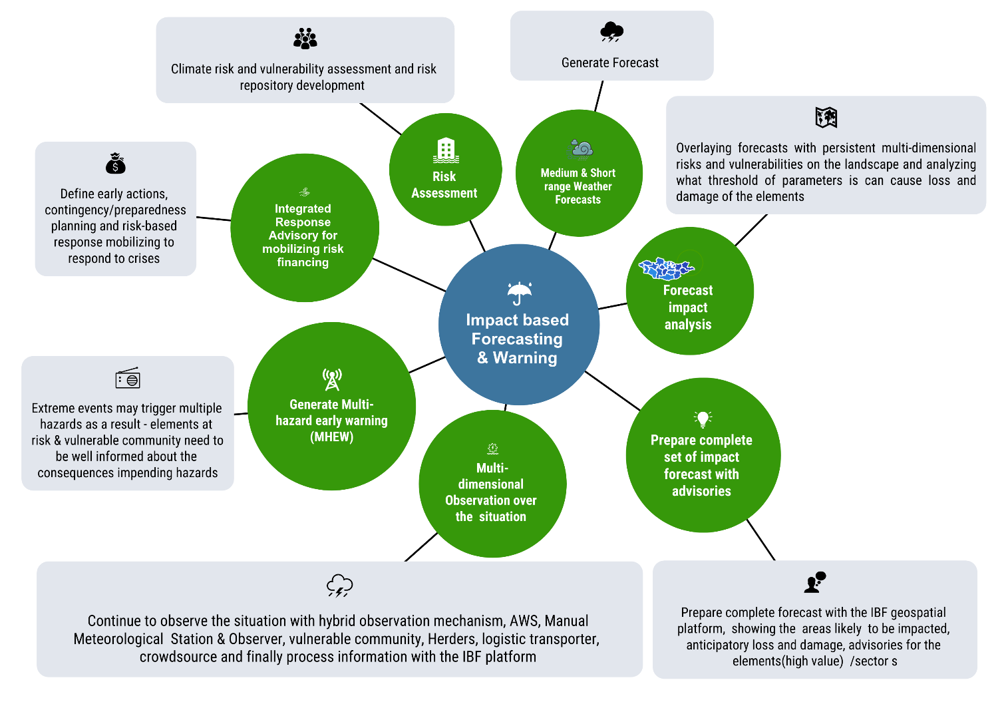
Figure 2: Integrated IBF system overview ( Source: Z M Sajjadul Islam, UNDP-GCF)

2.2 Data Coordination and Exchange Mechanism

The IBF workflow begins with analyzing the potential impacts of newly forecast extreme weather. However, effective IBF operations depend on multiple layers of information, most critically, comprehensive baseline risk and vulnerability datasets. In practice, the IBF process follows a sequence of interconnected functional steps:

- Baseline risk and vulnerability review: Conduct a background assessment of persistent risks and vulnerabilities embedded in the landscape, local weather and climate systems, and underlying environmental conditions.
- Exposure and sensitivity estimation: Assess how risk, vulnerability, exposure, and sensitivity of standing elements (Annexure 1) are likely to interact with the forecast hazard.
- Multi-hazard escalation interpretation: Determine how, and at what frequency and intensity, extreme weather may cascade into multi-hazard conditions.
- Event tracking and post-event accounting: Monitor hazardous events until dissipation and document the resulting trail of loss and damage (L&D) produced by localized disasters.

Given these steps, the IBF workflow (as outlined in Figures 3 and 4) is organized into multiple workstreams, each requiring active stakeholder engagement at every stage. The process relies on a structured input system that supports data capture, repositories, and archives of sector- and element-specific risk and vulnerability information to ensure that IBF outputs remain fit-for-purpose and operationally actionable.

- Baseline data inputs and institutional obligations

To sustain the IBF process, partners and stakeholders must be mandated to provide and routinely update their Climate Risk and Vulnerability Assessment (CRVA) data and related information. These inputs are essential to:

- validate persistent risk and vulnerability assumptions,
- update exposure and sensitivity profiles as conditions evolve, and
- ensure recurrent improvements in impact interpretation.

- Event repositories for rapid-onset and high-uncertainty hazards :

Rapidly changing weather systems characterized by high spatiotemporal variability and pronounced hourly/diurnal shifts require systematic documentation and archiving of high-impact events. For example, a cold-front-induced storm on 26 May 2008 caused extensive damage, resulting in 52 fatalities and the loss of approximately 600,000 livestock (UNDP, 2008). Such events underscore the need for herders, smallholder farmers, and sector agencies to receive tailored, CAP-enabled alerts for imminent sudden-onset hazards and, in parallel, to provide structured event situation updates to the online IBF platform (including Dzud tracking applications). Establishing and maintaining an event repository that captures high-impact scenarios and associated loss-and-damage (L&D) data provides a critical baseline for future impact analysis, forecast verification, and model calibration.

- Analyst workflow and “background checking.”

To ensure credible high-impact assessments, the IBF impact analysis team, including NWP experts, forecasters, agrometeorologists, meteorologists, and other relevant specialists, should conduct structured “background checks” using the impact database (CRVA and multi-hazard repositories). This entails reviewing historical events with comparable meteorological signatures, exposure configurations, and risk and vulnerability conditions. Such systematic reference analysis strengthens the quality, consistency, and defensibility of impact estimates and improves the translation of hazard forecasts into decision-relevant warnings disseminated to frontline users through the integrated IBF and CAP-enabled online platform.

- Two-way communication and continuous improvement

The IBF digital platform leverages the digital partnership mechanism (Figure 3) to enable two-way communication and iterative system strengthening. Stakeholders contribute:
- Baseline risk and vulnerability attributes from communities, including geolocated, element-level information; and
- Technical inputs to harmonize risk-informed tools that support sectoral planning both during emergencies and in routine operations beyond IBF implementation.
In return, partners benefit from improved services and are positioned to:
- Monitor the effectiveness of forecasts, warnings, and advisories;
- Provide structured feedback to refine thresholds, exposure assumptions, and impact models; and
- Support continuous improvement of IBF products, workflows, and operational protocols.

- Roles in risk communication and early action

Partners play central roles in both risk communication and the interpretation of impacts from forecasts and warnings. Key responsibilities should include:

- delivering anticipatory guidance tailored to vulnerable communities and sector actors,
- advising what actions to take before and during extreme events, and
- integrating partner-specific preparedness advice with IBF impact-based recommendations to support early action, readiness, and response.

Overall, the IBF data coordination and exchange mechanism is inherently collaborative and iterative. Its effectiveness depends on formalized partner obligations, standardized data-sharing protocols, routinely updated baseline datasets, and a sustained feedback loop that improves both technical accuracy and last-mile usability.

2.3 Mandating partnership for data coordination, exchange, and risk communication

The workflows required to operationalize partner interaction with the IBF platform, including weather and climate risk information communication, data exchange, and management of sector-specific risk and vulnerability repositories, are primarily administrative and governance functions. In this context, the National Agency of Meteorology and the Environmental Monitoring (NAMEM), the National Emergency Management Agency(NEMA), and have a pivotal joint responsibility to formally require partners to comply with agreed Standard Operating Procedures (SOPs) for information coordination and risk communication across all administrative levels, from local to national.

- Mandating sector departments to develop CRVA repositories and enable data harmonization
Sector departments should be mandated to conduct climate and weather risk and vulnerability analysis and maintain structured risk repositories. To harmonize external and internal CRVA datasets, particularly from UN agencies, INGOs, stakeholders, and sector departments, multiple data integration and management tools should be deployed. These include a hybrid online climate and multi-hazard spatial risk database management system and a geospatial CRVA atlas, with risk datasets anchored through REST-API/CSV pipelines and role-based access to an IBF PostgreSQL database integrated with geospatial platforms (e.g., GeoNode and GeoServer).

- Complementary data exchange tools may include online database/cloud-based data sharing applications, mobile apps,
For frontline and crowdsourced reporting, the system should consist of purpose-driven mobile applications, deployment of a Kobo Toolbox server and Kobo front-end apps, and other rapid collection channels such as SurveyMonkey, WhatsApp, Facebook, and similar platforms. These tools enable immediate capture of event situations from stakeholders and frontline areas, including circulated news and social journalism, and the collection of photos and video clips for multi-hazard updates, disaster incidence reporting, and operational alerting during ongoing hazardous events.

- Mandated CRVA implementation and sector-specific risk repository development
Key sectors such as livestock and crop agriculture, water resources, soil and land management, municipal and urban local governments (aimag, soum, bag), communications and transport, industry and mining, and private sector value-chain operators should be formally required to conduct Climate Risk and Vulnerability Assessments (CRVA) for their respective domains. These entities should share risk information with the IBF platform and contribute inputs to forecast impact analysis and routine event situation reporting.

- Mandated provision of weather and climate information services by NAMEM/IRIMHE
NAMEM/IRIMHE should continue to be mandated to produce core hydrometeorological services, including weather forecasts, warnings and alerts, surface weather observations, and climate information products. These outputs serve as primary hazard-layer inputs for the IBF system and related forecast-based financing processes.

- Mandated multi-hazard risk information collection and disaster incidence tracking led by NEMA/LEMA
NEMA and LEMA, as Mongolia’s nodal emergency management agencies, should lead multi-hazard risk information collection and disaster incidence tracking. This includes mandating local government actors, local humanitarian stakeholders, MRCS volunteers, and relevant local sector departments as well as community volunteers, herders, and field technicians to capture and report hazardous weather phenomena (e.g., thunderstorms/lightning, heavy rainfall, strong winds, dust storms/haze, cold rain, snowstorm onset, extreme cold and heat, winter storms, high-density snowfall). Reporting should include geolocation (latitude/longitude) and supporting evidence (photos and videos). The same mechanism should document ongoing multi-hazard and disaster incidence updates and emerging loss and damage information during the onset and progression of hazardous conditions. Local INGO and UN agency project offices can support coordination and facilitation of this reporting process.

- Weather-informed Dzud risk tracking and analysis (TWG mandate) A dedicated Technical Working Group (TWG) should be mandated to coordinate the livestock and crop agriculture sector in conducting Climate Risk and Vulnerability Assessments (CRVA), developing and maintaining a sectoral risk repository, and analyzing the impacts of extreme weather on sectoral elements (Annexure 1). As the specialist sector partner for Dzud-related impact analysis, the TWG should also assume the following responsibilities:
- Seasonal pasture biomass and rangeland condition datasets:
Acquire and consolidate datasets on seasonal pasture biomass and rangeland conditions, including data from rangeland health monitoring stations, photo-point monitoring sites, pasture biomass availability, boreal ecosystem grass/plant conditions, and commercial pasture/forage crop yield records.
- Repository of herder knowledge, coping capacity, and value-chain vulnerability:
Maintain an event register (diary-style repository) capturing herders’ indigenous knowledge, coping strategies, climate-tolerant livestock husbandry practices, and weather/climate risks and vulnerabilities across livestock value-chain operations to support impact analysis.
- Sustainable pasture management information system:
Establish and maintain a system for routine stock-taking, pasture budgeting (surplus/shortage), pasture productivity and ecological health monitoring, integrated farm management (IFM) practices, and DTM management while also logging how weather and climate drivers disrupt pasture and value-chain management.
- Continuous risk monitoring across the livestock value chain:
Systematically monitor and log weather- and climate-change-induced impact indicators across the full value chain. This evidence base is necessary to define Dzud indices covering both climatic and non-climatic dimensions and to track how individual indicators combine into compound Dzud risk factors.
- Formal collaboration for rangeland and agro-meteorological monitoring:
Institutionalize collaboration between the Land Administration Department (ALAGaC/ALAMGaC) and the Agrometeorological Research Division to implement rangeland health monitoring (including approximately 1,516 sites with photo-point tracking), biomass growth monitoring, vegetation type and coverage assessment, soil thawing/degradation tracking, soil health indicators (temperature, moisture), ice thickness, snow density, and pasture grazing barriers (e.g., impenetrable ice). Drought monitoring inputs (agricultural hydrometeorological and environmental) should be compiled on a weekly basis, with GIS maps routinely shared through the IBF platform for pasture/forage risk analysis.
- Household and livestock vulnerability profiling through digital surveys:
Conduct structured surveys (e.g., using customized mobile apps for Dzud tracking, KoboToolbox apps, GPS Essential apps, WhatsApp groups, and other social media channels) to digitally track herder socio-economic conditions, livestock holdings, livelihood assets, and relevant statistical datasets (e.g., HIES). This should include age- and sex-disaggregated vulnerability data for herder households, livestock age/class breakdowns (calf/young/mature), and livestock health/body-condition/weight metrics required for Dzud risk analysis.
- Rapid-onset hazard reporting by herders:
Establish a standardized mechanism for herders to record and report rapid-onset convective hazards (thunderstorms, heavy rainfall, lightning, hailstorms) using hazard-tracking mobile apps (e.g., Hazard Tracker, Kobo Toolbox, GPS Essential), WhatsApp groups, and other social media channels. Reports should be routed to the aimag EOC/situation room and the IBF central server through the IBF portal and/or integrated IBF mobile apps to support near-real-time risk and impact analysis.

    - Data and Information coordination with the IBF platform :
Partner-level CRVA database and information management (reference to Annexure 3 and the following chapter), including the required indicators and variables for livestock impact analysis, should be systematically linked to and uploaded into the IBF database server. These datasets constitute a core input to the IBF impact and risk analysis workflow.
Key requirements include:
- Archiving and maintaining core repositories:
Establish and maintain sector-element databases and structured repositories covering risk and vulnerability information, multi-hazard risk datasets, and disaster impact records, including loss and damage (L&D) databases.
- Mandating stakeholder operational profiling (5W):
Require partners to document and regularly update their operational footprint using the 5W framework (Who does What, Where, When, and How), including service delivery modalities, beneficiaries, vulnerable population groups, and how risk-informed tools are applied in sectoral development planning and decision-making.

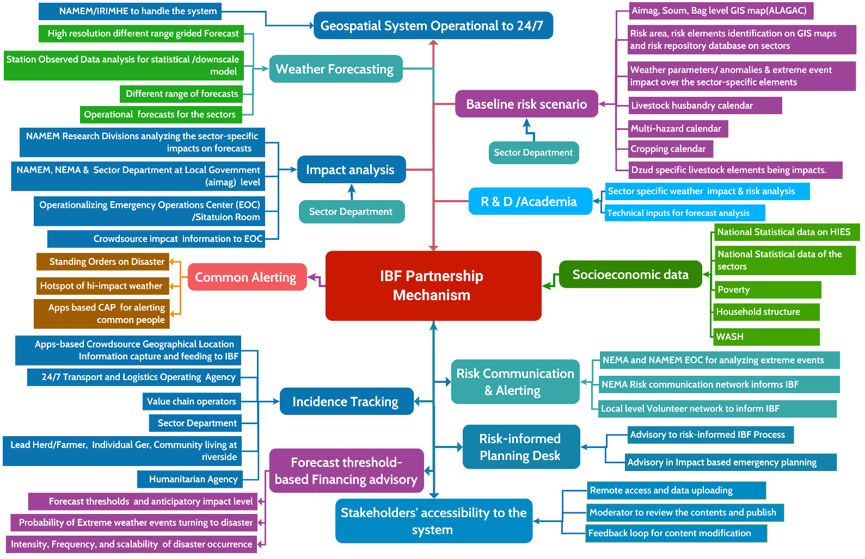

Figure 3: IBF Data coordination, exchange, and partnership mechanism ( Source: Z M Sajjadul Islam , UNDP-GCF)

Table 1: Partner’s Checklist and major role in the IBF Process
Partner | Technical actors | Major Role
IBF Technical Working Group (TWG) | TWG - Livestock Sector Impacts  Risk and vulnerability analysis for livestock-related weather and climate impacts. | Livestock sector impact forecasts  - Translate forecast hazards into livestock-relevant impacts (grazing barriers, wind chill stress, fodder/water access disruption, disease risk, mortality risk) and produce sector advisories and maps.
IBF Technical Working Group (TWG) | TWG - Dzud Risk Analysis, Early Warning, and Alerting  Dzud risk analysis; Dzud early warning products; Dzud alerting and dissemination. | Dzud early warning impact forecasts  - Generate Dzud risk/early warning products using combined indices (snow/ice, cold stress, pasture/biomass, drought legacy, access constraints) and issue stage-based warnings and early action triggers.
IBF Technical Working Group (TWG) | TWG - Crop Agriculture Sector Impacts  Risk and vulnerability analysis for crop agriculture impacts. | Crop agriculture sector impact forecasts  - Assess impacts on planting/growth/harvest cycles, frost/heat stress, precipitation anomalies, drought/flood risk, and produce crop advisories and outlook maps.
IBF Technical Working Group (TWG) | TWG - Soil and Land Sector Impacts  Risk and vulnerability analysis related to soil and land conditions (degradation, erosion, moisture stress, etc.). | Soil and land sector impact forecasts  - Analyze soil moisture/temperature, soil icing/thawing, erosion susceptibility, land degradation sensitivity, and produce risk maps for land management decisions.
IBF Technical Working Group (TWG) | TWG - Water and Hydrological Sector  Hydrometeorological monitoring/forecasting linkages, hydrological risk/impact analysis, and sector advisories. | Impact forecast preparation for the environmental sector
IBF Technical Working Group (TWG) | TWG - Environmental Sector Impacts  Risk and vulnerability analysis for environmental impacts (e.g., ecosystems, rangelands, biodiversity-relevant stressors). | Environmental sector impact forecasts  - Prepare impacts related to vegetation condition, drought status, wildfire risk, dust/haze conditions, ecosystem stress, and environmental hotspot monitoring outputs.
IBF Technical Working Group (TWG) | TWG - Weather Data Acquisition and Analysis (Multi-Source)  Data acquisition from multiple sources (station observations, AWS, crowdsourced observations); data quality control and analysis. | Weather data acquisition from hybrid sources (Figure 9)  - Integrate and quality-control data from:  - manual station observations  - AWS networks  - crowdsourced/community observations (geo-tagged photos/videos, simple parameters)  - other relevant national/regional/global sources  - Maintain time-series archiving and GIS-ready outputs for analysis
IBF Technical Working Group (TWG) | TWG - Rapidly Developing Weather Monitoring, Warning, and CAP  Monitoring and warning for rapid-onset weather phenomena; Common Alerting Protocol (CAP) implementation and workflows. | Data, warning, and alerting (cross-cutting)  - Weather data acquisition from hybrid sources (Figure 9)  (e.g., station observations, AWS, crowdsourced/community observations, and other relevant sources)  - Impact forecast-based warning and Common Alerting Protocol (CAP)  (translation of impact forecasts into warnings/alerts and CAP message generation)
IBF Technical Working Group (TWG) | TWG - Data Communications  Data transmission and connectivity (telemetry, networks, redundancy, reliability). | Impact forecast preparation for the priority sector
IBF Technical Working Group (TWG) | TWG - Geospatial Server and Service Development  Geospatial server architecture, service development, and delivery of map-based forecast/impact products. | Geospatial server and service development
IBF Technical Working Group (TWG) | TWG - Database Development, Data Coordination, and Exchange  Database design and management; data governance; coordination and exchange mechanisms (including access controls and standards). | Platform development and data management, Database development, data coordination, and exchange
Technical Partners | Government ministries and agencies  - Ministry of Food, Agriculture and Light Industry (MoFALI) - Livestock Department, research wings, and veterinary services  - Administration of Land Affairs, Geodesy and Cartography (ALAGAC)  - Relevant sector departments (as applicable)  - Social Welfare authorities  - National Registration and Statistical Office  - River Basin Authority  - Ministry of Health  - Ministry of Education and Science of Mongolia  Humanitarian and civil society  - Mongolian Red Cross Society (MRCS)  Research and technical institutions  - Forest Research and Development Centre  - Institute of Geography and Geo-ecology  - Drought Watch - Mongolia  - National University of Mongolia  - Mongolian University of Science and Technology  - Mongolian University of Life Sciences  Private sector / utilities  - Energy resource company | Spatial risk and vulnerability database and GIS information maps:  A georeferenced database and associated GIS layers that store and visualize exposure, risk, and vulnerability attributes for priority sectors and elements (e.g., Annexure 1) at aimag/soum/bag levels. The system enables map-based risk profiling, hotspot identification, impact-threshold overlays, and decision-support products for IBF, warnings, and early action planning.
Aimag Government, Sector Departments | Departments  - State Administration Department  - Legal Department  - Production, Trade, Agriculture and Environment Department  - Financial and Economic Policy Department  - Social Policy Department  - Environment and Agriculture Unit (livestock and crop agriculture)  Key roles / officers  - Head of the Governor’s Office  - Social Development Officer (education and healthcare)  - Agriculture and Environment Officer  - Social Care Officer (poverty reduction, employment, and social protection)  - Operations Officer  Other relevant institutions  - Border Protection Organization (BPO) | Conduct climate risk and vulnerability assessments, undertake forecast-based impact analysis, coordinate through the Incident Command System (ICS), and support the operationalization of an Emergency Operations Center (EOC) or Situation Room.
Government Sector Ministry / Departments | - CSoG - Cabinet Secretariat of the Government  - MoF - Ministry of Finance  - FRC - Financial Regulatory Commission of Mongolia  - IPTTA - Information, Post, Telecommunications and Technology Authority  - MAS - Mongolian Academy of Sciences  - MASM - Mongolian Agency for Standardization and Metrology  - MECS - Ministry of Education, Culture, and Science  - MoFALI - Ministry of Food, Agriculture and Light Industry  - MoET - Ministry of Environment and Tourism  - MSPL - Ministry of Social Protection and Labor  - NEMA - National Emergency Management Agency  - MoFA - Ministry of Foreign Affairs | - Conduct climate risk and vulnerability assessments  - Prepare forecast-based impact analyses  - Coordinate response actions through the Incident Command System (ICS)  - Establish and operationalize an Emergency Operations Center (EOC) / Situation Room
Partnership with WMO regional hubs | - Regional Forum partners (JMA, CMA, KMA)  - JMA - Japan Meteorological Agency  - CMA - China Meteorological Administration  - KMA - Korea Meteorological Administration  - DCPC (Beijing / Hong Kong)  (Designated Climate Prediction Centre - Beijing and Hong Kong)  - RIMES - Regional Integrated Multi-Hazard Early Warning System for Africa and Asia | Develop and apply regional climate model outputs and establish mechanisms for sharing climate outlooks with national and regional partners.
CBO/CSO | - Community service organizations  - Private sector entities  - Value chain operators  - Logistics and transport providers  - Multilateral organizations  - National committees  - Technical working groups (TWGs) | Conduct surveys to generate climate risk and vulnerability data, and communicate risk information to the Emergency Operations Center (EOC) or Situation Room for decision-making and response coordination.
Humanitarian Country Team | - Humanitarian coordination clusters (e.g., Early Recovery; Education; ETC (Emergency Telecommunications); Food Security; Health; Logistics; Nutrition; Protection; Shelter; WASH (Water, Sanitation and Hygiene) )  - Humanitarian Country Team (HCT) (e.g., UNDP, FAO, WFP, IFRC, WHO, WMO, UNHCR)  - Humanitarian actors (e.g., MRCS and NEMA volunteers)  - UNICEF Risk Communication and Community Engagement (RCCE) | Produce and maintain climate risk and vulnerability datasets, and establish routine risk information communication to the Emergency Operations Center (EOC) or Situation Room.
NEMA | - National Emergency Commission/NEC  - National Center for Communicable Diseases/NCCD,  - National Center for Public Health/NPHC etc.  - Institute of Astronomy and Geophysics (IAG) Emergency Operations and Warning Center of the National Emergency Management Agency (EOWC)  - National Center for Emergency and Disaster Relief (NCEDR) | - Operationalize the Incident Command System (ICS) during emergencies: Activate ICS procedures during crisis periods and ensure the command structure is formally linked with the Aimag EOC or Situation Room for coordinated operations and information flow.  - Deploy the military as first responders: Utilize military units as frontline responders for major hazards, including earthquakes, wildfires and forest fires, contagious disease events, snow and dust storms, and severe winter conditions.  - Share climate risk and vulnerability information: Ensure timely exchange of climate risk and vulnerability data among response actors to support common situational awareness and risk-informed decision-making.  - Conduct joint forecast impact analysis with the EOC/Situation Room: Collaborate with the Aimag EOC or Situation Room to interpret forecast hazards in terms of expected impacts and translate them into operational priorities and response actions  .
NEMA | - State Reserve Units  - Fuel Reserve Unit  - Food Reserve Unit  - Firefighting and Rescue Units  - Rescue Units and Teams  - Emergency Management Unit  - District Divisions  - Supply, Logistics, and Services Unit  - DDR Training Center  - Retraining and Rehabilitation Center  - Building No. 3 | Operational deployments (Tuvshuruuleh soum): Field operations are conducted through the search and rescue unit, the rescue and firefighting unit, and the state reserve unit, with a deployed strength of 68 personnel.  - Local administrative and policing support: Response operations are supported by local police agencies and local governors’ offices to ensure security, access, and coordination at the local level.  - National security coordination: Operational linkages are maintained with the National Police Agency (NPA) and the General Authority for Border Protection to support incident management, movement control, and cross-jurisdiction coordination as required.  - Surge capacity through active-duty forces: Emergency services can be reinforced through the deployment of approximately 9,000 active-duty troops, depending on event scale and severity.  - ICS as the national operational framework: Emergency management is guided by the National Incident Management System’s Incident Command System (ICS) platform, which Mongolia adopted in 2004 as the primary incident management approach.  - Public emergency service coverage: The system is intended to support multi-hazard public emergency services, including earthquakes, fires/forest fires, first aid, acute infectious diseases, snow and dust storms, Dzud-related dangers, and flood/water hazards.
National Media & Broadcasting network | Public broadcasters and broadcast associations  - Mongolian National Public Radio (AM/FM) and Television  - Mongolian TV Broadcasters Association  - National Radio / Community Radio networks  - National electronic media outlets  Telecommunications and network operators  - National optical fiber network and PSTN operators (Public Switched Telephone Network)  Government public information and oversight bodies  - Government Media and Public Relations Department (Cabinet Secretariat)  - Public Council under the IAAC  - Media and Information Council  Emergency and public health risk communication stakeholders  - National Emergency Commission (NEC)  - National Emergency Management Agency (NEMA)  - Ulaanbaatar Health Authority  - National Center for Public Health  - National Center for Communicable Diseases  Media professional bodies and industry associations  - Press Institute  - Mongolian Websites Association  - Mongolian Newspapers Association | - Disseminate emergency weather warnings: Ensure emergency weather warnings are issued and distributed rapidly through agreed channels to reach authorities, partners, and last-mile communities.  - Run live radio/TV programming during weather emergencies: Organize live radio and television shows during emergencies, including interactive segments with vulnerable communities to gather real-time situation updates and strengthen two-way communication.  - Disseminate impact forecasts to target audiences: Deliver impact-based forecasts and advisories in tailored formats to priority audiences (e.g., herders, sector agencies, local governments, humanitarian actors) to support timely early action.  - Integrate media monitoring into the IBF platform: Capture and upload relevant media-monitoring outputs news updates, photographs, and video clips into the IBF platform to enhance situational awareness and support impact verification.
Crowdsource | Communities and local administrative levels  - Herders (base camps / winter-spring camps, as applicable)  - Vulnerable climate-frontline communities (e.g., riverside settlements, lower floodplains, other high-risk locations)  - Aimag centres  - Soum centres  - Bag centres  Livelihoods and value chains  - Farmers (lead farmers / farmer groups)  - Value chain operators  - Commercial establishments (SMEs, enterprises, shops)  - Tourism operators (hotels, motels, restaurants)  - Fuel stations (gasoline/petrol pumps)  Transport, aviation, and logistics  - Logistics and transport providers (transporters)  - Aviation stakeholders (aviators / airport operators, as applicable)  Social services and critical institutions  - Educational institutions  - Healthcare centres  - Local government departments (service delivery and coordination roles)  Volunteers and community networks  - Volunteers (MRCS, LEMA, NEMA, and community volunteers)  - Digital communications and community mapping  - Social media operators / administrators  - OpenStreetMap community / collaborative mappers | - Multi-hazard event and situation reporting: Provide timely event reports and situation updates on ongoing and emerging multi-hazards.  - Real-time weather condition monitoring and updates: Monitor local weather conditions and routinely submit updates to the Aimag EOC and the IBF platform to support operational decision-making.  - Share local multi-hazard risk and vulnerability information: Contribute local-level risk and vulnerability information to strengthen baseline datasets and improve impact interpretation.  - Provide risk intelligence to ICS and link with EOC/Situation Room: Supply risk information to the Incident Command System (ICS) during emergencies and ensure coordination and information flow with the Aimag EOC or Situation Room.  - Share climate risk and vulnerability information: Ensure systematic sharing of climate risk and vulnerability data to support common situational awareness, early action planning, and coordinated response
Telecommunications network | - Mobile network operators (cellular providers)  - National telecommunications authority  - National electronic media outlets  - National optical fiber network and PSTN operators (Public Switched Telephone Network) | - Leverage mobile network infrastructure for AWS deployment: Use existing cell phone towers (BTS) as host sites for installing Automatic Weather Stations (AWS) and other weather monitoring instruments to expand observation coverage efficiently.  - Government-mandated emergency communication services: Require mobile network operators to provide free emergency communication services, including SMS, Interactive Voice Response (IVR), cell broadcasting, and toll-free calling via dedicated lines for frontline users (vulnerable communities, herders/farmers, community responders, emergency teams, logistics transporters, and volunteers) to enable rapid risk communication and data sharing.  - Support herder GPS tracking for operational needs: Provide limited free mobile internet/data at designated times to support the livestock department in tracking herder GPS locations for safety monitoring, targeted advisories, and emergency response coordination.  - Strengthen emergency dissemination and two-way risk communication: Ensure these telecom-enabled services are fully integrated into IBF/EOC workflows to improve warning dissemination, situational reporting, and last-mile connectivity during emergencies.
Social network | - Social network operators  - Crowdsource communication group- Facebook, WhatsApp, Telegram, Viber, CallPro Mongolia  - Collaborative mapping Qfield of OpenStreetMap, Open layer, survey 123,  - Online survey /data collection apps: Kobo Toolbox, survey monkey etc | - Social media for information sharing: Use social media platforms as structured channels for disseminating warnings and advisories, collecting situational updates, and sharing verified information with partners and communities.  - Crowdsensing through citizen reporting: Enable crowdsensing by allowing citizens via web portals or smartphone applications to register and share real-time observations, including through dedicated “citizen observatory” style applications for weather and hazard reporting.  - Collaborative mapping using open-source tools: Implement collaborative mapping workflows using tools such as QField and OpenStreetMap, supported by OpenLayers-based interactive web maps, to capture geolocated observations and maintain up-to-date, community-informed hazard and exposure layers.

2. 4 Technical Working Group for forecast Impact analysis :

To facilitate the IBF process, technical working groups (TWGs) and designated responsibilities need to be mainstreamed to set out a cross-functional IBF working modality. The table below outlines the workflows of TWGs.

Table 2: Technical Working Group for the IBF Impact Analysis

Technical working group for the IBF process | Partnering organizations | Member/Department | Responsibilities of the Technical Working Group (TWG) for contributing IBF process
TWG on NWP for high-resolution agrometeorological forecasts | Forecasting Division (IRIMHE/NAMEM) | - Forecasters  - Agrometeorologist  - Agricultural experts  - Rangeland experts  - Synoptic Engineers  - Meteorologist  - NWP Expert  - CAP Expert  - Data scientist  - Data archive team  - Livestock sector Expert | - Develop high-resolution NWP-based agrometeorological forecasts and associated weather warnings to detect and track sudden-onset hazards affecting the livestock sector.  - Produce forecast CSV outputs and technical briefings, delineate impact-threshold areas, and analyze threshold exceedance using GIS software at the national scale, while generating aimag/soum-level CSV and shapefiles to support localized impact forecasting.  - Upload all forecast datasets and products (CSV files, maps, and shapefiles) to the GeoNode server to enable other TWGs, partners, and end users to access, interpret, and apply the information for decision-making and early action.
TWG for Operational Forecast | Operational forecast team for the livestock sector (IRIMHE/NAMEM) | - Forecasters  - Synoptic Engineers  - Agrometeorology experts  - Rangeland health monitoring experts  - Forage crop production Cooperative society  - Data archive team  - Livestock sector Expert  - Expert herders | - Operational forecasting team function: Analyze anticipated livestock impacts from high-impact weather over the next 7-10 days (weekly/decadal), identifying which livestock types and areas are most at risk and what impacts may be triggered by seasonal anomalies and extreme parameters.  - Advisory function: Issue guidance on the expected adverse effects of weather, including practical, impact-based recommendations for herders and relevant sector actors.
TWG for Operational Forecast | MoFALI /Livestock Department and other research wings, veterinary service | - Livestock Department  - Veterinary department  - Breeding department | - Local-level sector department operations: Log in to the GeoNode server to access forecast maps and provide parameter-specific impact interpretation for hazards such as snowstorms/winter storms, heatwaves, cold rain, thunderstorms, and flood/landslide/mudslide linking these hazards to likely livestock impacts (e.g., sickness, mortality, starvation, disease outbreaks, weight loss, reduced mobility, and access constraints).  - Livestock adaptive management briefing: Provide practical briefings and advisories on livestock coping and adaptive management measures aligned to the forecasted conditions.  - Livestock management calendar development: Develop and maintain a livestock husbandry/management calendar (including seasonal activities and risk-sensitive actions), coordinated with the operational forecast team.  - Evidence base on hazard impacts: Document and analyze how traditional livestock husbandry is recurrently affected by natural hazards, capturing lessons and trends to strengthen preparedness and risk reduction.  - Weekly fodder/forage biomass monitoring: Collect fodder/forage biomass condition data on a weekly basis from 1,516 representative monitoring points, and provide updates for impact analysis and decision support.  - Grazing days and biomass availability calendar: Develop a calendar of livestock grazing days based on open/available biomass conditions and seasonal pasture accessibility.  - Weekly soil monitoring: Collect soil moisture and soil temperature data at weekly intervals to support agro-ecological interpretation and drought/Dzud-related analysis.  - Snow/ice thickness monitoring: Collect snow and ice thickness data from the same 1,516 monitoring points to assess grazing barriers and Dzud risk drivers.  - Soil thawing monitoring: Collect soil thawing and freeze-thaw condition data at local level to support rangeland accessibility and livestock stress analysis.  - Multi-hazard impact reporting: Capture and report multi-hazard impacts on livestock and crop agriculture to strengthen the event repository and support verification.  - Field coordination and communication: Establish WhatsApp groups connecting all relevant field-level technicians (the 1,516 monitoring network, soil data collectors, and field surveyors) to enable rapid reporting, quality control, and coordination with the aimag EOC/IBF platform.
TWG for Operational Forecast | Agrometeorological division(IRIMHE/NAMEM) | Agrometeorological division | - Work jointly with the operational forecasting team to align sector interpretations with forecast signals and thresholds.  - Recognize and document recurrent hazard impacts on traditional livestock husbandry to inform risk reduction and adaptive management.  - Collect weekly fodder/forage biomass condition data from 1,516 representative monitoring points.  - Develop and maintain a livestock husbandry calendar to guide seasonal management decisions.  - Develop a grazing-days calendar based on open biomass availability and pasture accessibility.  - Collect soil moisture and soil temperature data weekly to support pasture condition and drought/Dzud analysis.  - Collect snow/ice thickness data from the same 1,516 monitoring points to assess grazing barriers and Dzud drivers.  - Collect local-level soil thawing data to track freeze-thaw dynamics affecting rangeland accessibility and livestock stress.  - Record and report multi-hazard impacts on livestock and agriculture for impact analysis, verification, and event archiving.  - Establish WhatsApp groups for field coordination, linking all field-level technicians (1,516 monitoring network members, soil data collectors, and field surveyors) to enable rapid reporting, validation, and communication with the EOC/IBF platform
TWG for Operational Forecast | NEMA | - LEMA at aimag level (LEMA)  - Aimag /Soum level sector extension experts | NEMA/LEMA should provide emergency information management services and lead risk and vulnerability assessment functions, including the following core products and datasets:  - Multi-hazard risk, vulnerability, and exposure database  A structured repository covering exposed elements, vulnerability attributes, and risk indicators for priority hazards and sectors.  - Historical disaster event maps (extent polygons)  GIS layers showing the geographic extent and footprint of past disasters (where and how far the event affected).  - Historical disaster hotspot maps (GPS placemarks)  Point-based maps documenting where disasters occurred, with key attributes such as:  a) location and hazard type, and  b) impacts including fatalities, injuries, affected populations, and displacement figures.  - Multi-hazard risk atlas (national and aimag levels)  A standardized, map-based risk atlas consolidating hazard, exposure, and vulnerability layers for planning and decision support.  - Aimag-level GIS base maps of critical infrastructure and services  GIS basemaps showing key assets and facilities, including buildings and institutions, physical and socio-economic structures, Dzud response trigger points, emergency shelters (for livestock and people), marketplaces, NEMA office locations, hospitals and healthcare centres, emergency relief storage facilities, and commercial installations.  - Contingency planning templates and sample plans  Standardized samples/templates for contingency plans at national, aimag, and bag levels to enable consistent preparedness planning and rapid activation during emergencies.
TWG for Operational Forecast | The Administration of Land Affairs, Geodesy, and Cartography (ALAGAC) | - Urban development Expert  - Land Management Expert  - Geodesy and Cartography (Geospatial Services) for Urban planning  - Urban and town planner | - Provide authoritative geospatial data and services: ALAGAC/ALaMGAC should provide GIS shapefiles and enable access to the national geoportal (https://geoportal.nsdi.gov.mn), including interoperable services (REST API, WCS, WFS, WPS). Relevant base layers and thematic datasets should also be made available through the IBF GeoNode/GeoServer environment to support element-level risk and vulnerability analysis.  - Support impact interpretation using forecast overlays: Access the IBF geospatial platform to download forecast CSV outputs and conduct GIS-based overlays to assess the risk and vulnerability implications of impending extreme weather for urban land management systems and built environments.  - Conduct routine (non-emergency) risk profiling: During normal periods, undertake climate and multi-hazard risk and vulnerability assessments for urban and rural built infrastructure, installations, critical facilities, and utility service structures. Outputs should be incorporated into the risk repository and risk atlas for IBF and local development planning.  - Maintain an infrastructure and services exposure database: Develop and update a structured database of urban infrastructure and basic services, settlements, high-value elements, and critical utility networks and assets (e.g., power plants, substations/distribution points, district heating/hot water networks, electricity supply networks, and gas supply networks).  - Provide anticipatory, impact-based advisories: Based on high-impact forecasts and vulnerability baselines, provide anticipatory advisories on potential impacts to urban areas, settlements, land use and zoning functions, industry and enterprises, and continuity of urban service delivery and utility operations.
TWG for Operational Forecast | Aimag/Soum/Bag level agriculture and livestock department | - Agricultural office  - Livestock office | - Conduct CRVA for herder systems and grazing resources: Undertake CRVA covering herders’ camps, pasturelands, and permanent/seasonal grazing areas, as well as forage crop areas. Develop a structured database with geolocations (latitude/longitude) capturing: livestock numbers and types, transport/vehicles, livelihood assets, economic conditions, communication devices (Android phones, radio, TV, wireless, forecast radios), and season-wise camp locations.  - Develop a multi-hazard calendar for livestock impacts: Prepare a calendar identifying hazards and seasons most likely to affect livestock (e.g., Dzud drivers, extreme cold/heat, snow/ice grazing barriers, storms, drought).  - Maintain a daily livestock husbandry event calendar: Record day-to-day husbandry activities and operational decisions aligned with prevailing and forecast conditions.  - Track fodder and feeding-related crisis periods:  - Prepare a calendar of fodder crisis days.  - Record supplementary feeding days financed through insurance.  - Record supplementary feeding days financed privately.  - Maintain mortality records: Systematically inventory animal deaths, including date, location, suspected cause, and affected livestock class.  - Maintain 24/7 weather impact logs: Record impactful weather conditions affecting livestock continuously (daily/round-the-clock), including onset time, duration, severity, and observed impacts.  - Maintain disease and outbreak logs: Record daily livestock disease events and outbreak information, including symptoms, spread patterns, and response measures.  - Develop geospatial inventories and maps: Compile geolocated datasets and produce cartographic maps showing pasture biomass growth areas, feasible forage cropping zones, and natural water resource locations suitable for irrigation planning.  - Maintain all Annexure 4 registers and log sheets: Ensure routine updating, quality control, and archiving of all required logs/registers specified in Annexure 4.
TWG for Operational Forecast | Remote sensing division (IRIMHE/NAMEM) | - Agrometeorological division  - Climate Change division.  - Environmental Information Center | - Vegetation coverage maps (every 10 days)  Develop and publish decadal vegetation condition and anomaly products to support pasture and crop monitoring.  - Snow and icing maps  Produce maps on snow cover extent, snow density, snow thickness, and ground-icing thickness to assess grazing barriers and winter risk conditions.  - MODIS-based vegetation products  Prepare vegetation coverage and condition maps using MODIS satellite imagery (e.g., NDVI-based layers) for routine monitoring and seasonal comparisons.  - Drought monitoring maps  Produce maps for agricultural, meteorological, and hydrological drought conditions, including indicators and spatial extent for early warning and planning.  - Land and environment baseline maps  Maintain GIS layers/maps of environmental protection areas, reserve land/forests, agricultural land, and land cover classifications to support exposure baselines and impact overlays.
TWG for Operational Forecast | Environmental information divisions (IRIMHE/NAMEM) | - Agrometeorological division  - Climate Change division.  Environmental Information Center | 1) Define the hazard scenario (what, where, when)  - Ingest high-resolution gridded forecasts (e.g., 1-5 km) for relevant parameters: snowfall, temperature, wind, precipitation, heat index, etc.  - Derive event metrics by lead time: maxima/minima, accumulations (e.g., 24-72h), duration, and (if available) probability/ensemble spread.  2) Apply hazard thresholds (convert “forecast” to “hazard zones”)  - Classify each grid cell into impact-relevant thresholds (e.g., green/yellow/orange/red).  - Output a hazard-threshold layer (raster or polygon) for each parameter and time window.  3) Load baseline exposure layers (Annexure 1 elements)  Examples:  - Households/ger locations, population points, schools, clinics  - Livestock concentration, pasture areas, water points  - Roads/bridges, power lines, telecom, critical facilities  4) Load vulnerability and sensitivity attributes (CRVA/CERV)  - Use CRVA-derived indices and attributes (CVI or sector-specific vulnerability scores), such as:  - coping capacity, access constraints, poverty/vulnerability groups  - pasture condition/biomass, snow/ice grazing barriers  - infrastructure fragility, service criticality  5) Calculate impact (overlay , scoring or loss estimation)  A. Exposure count (minimum requirement)  - Intersect hazard zones with exposure layers and compute:  - number of elements affected (by red/orange/yellow)  - affected area (km²), length (km of road/power line), and population counts  B. Impact severity score (typical IBF approach)  Create a composite score per location/element:  - ImpactScore = f(HazardIntensity, Exposure, Vulnerability/Sensitivity)  Example (simple, transparent scoring):  - ImpactScore = w1*HazardIndex + w2*VulnerabilityIndex + w3*ExposureWeight  Then map to categories (Red/Orange/Yellow) based on agreed cut-offs.  C. Expected loss and damage (where valuation data exist)  - For each element:  - ExpectedLoss = AssetValue × DamageRatio(HazardIntensity, Vulnerability)  - Sum across elements for an aimag/soum/bag estimate and report ranges if uncertainty is high  6) Validate with real-time observations (improves credibility)  - Cross-check forecast signals with:  - AWS/manual stations, radar/satellite indicators (as applicable)  - crowdsourced geo-tagged reports (photos/videos/notes)  - Update impact zones and narrative as the event evolves.  7) Produce decision products (what users need)  - Maps: red/orange/yellow impact polygons with key exposed elements  - Tables: counts by aimag/soum/bag (people, livestock, facilities, road segments)  - Narratives: “what will happen, where, when, who/what is at risk, recommended actions”  - CAP-ready alert content: severity/urgency/certainty, area, instructions, validity times  8) Disseminate and archive (for audit and learning)  - Publish CSV/Shapefile/Map products to GeoNode/GeoServer with metadata and versioning.  - Archive bulletins, layers, and post-event L&D updates for verification and model calibration
TWG for Operational Forecast | MRCS ( Mongolian Recross Society) | - Community Volunteer  - Humanitarian Volunteers | - Integrate MRCS/IFRC Dzud risk management tools with the IBF platform to ensure interoperability of risk information, triggers, and early action workflows.  - Link MRCS emergency preparedness and response networks to the IBF risk communication network so that alerts, advisories, and operational updates can be shared through a common, coordinated platform.  - Enable MRCS volunteer support services through IBF access and reporting: leverage MRCS volunteer reach across the country to contribute real-time emergency information to the IBF platform, including event updates, tolls, loss-and-damage scenarios, and incidence records supported by geolocation, photos, video, placemarks, and brief technical notes.
TWG for Operational Forecast | FAO | FAO country project office/ field Unit/volunteer/stakeholder | - Anchor Early Warning-Early Action (EWEA) within the IBF platform to operationalize Dzud early warning and early action, including Forecast-based Financing (FbF) triggers and workflows.  - Integrate FAO Anticipatory Action (AA)/Forecast-based Financing (FbF) mechanisms with IBF to ensure forecast thresholds translate into defined early actions and resource mobilization.  - Conduct Dzud risk assessments of herders’ socio-economic conditions and integrate the results into the IBF risk and vulnerability database to strengthen targeting and prioritization.  - Assess livestock risk and vulnerabilities to impending extreme weather and high impacts and support the IBF team in interpreting sector-specific impacts of high-impact forecasts on livestock.  - Deploy FAO volunteer support to strengthen impact interpretation: Enable FAO volunteers to provide field-informed inputs on sensitivity, exposure, risk, and vulnerability during extreme events, including livestock management vulnerabilities and weather-related risk pathways.
TWG for Operational Forecast | HCT ( Humanitarian Country Team) | UN Agency project offices at Aimag level | - Integrate with IBF and FbF platforms to inform humanitarian coordination and strengthen response decision-making mechanisms.  - Establish functional linkages with IBF/FbF operations by contributing data, analyses, and technical inputs required by IBF and FbF teams and workflows.  - Provide analytical support on extreme weather impacts affecting climate-vulnerable sectors particularly livestock and agriculture and contribute to impact-based warnings and advisories related to climate and extreme weather.  - Assess and communicate climate and weather impacts across key domains, including:  (i) animal breeding, feeding, health, and husbandry practices;  (ii) pasture and rangeland management;  (iii) manure management;  (iv) plant production, crop protection, and crop health;  (v) soil health and fertility; and  (vi) public health implications.  - Provide inputs on the national e-agriculture strategy and pilot ICT-enabled solutions that strengthen monitoring and management of food systems and related value chains.
TWG for Operational Forecast | NSO ( National Statistical Organization) | Aimag/Soum level | Anchor NSO datasets via REST APIs to enable routine, automated access to updated NSO socio-economic vulnerability data, HIES datasets, and other sector-specific statistical databases, and integrate these feeds into the IBF data hub to strengthen risk and vulnerability analysis workflows.
TWG for Operational Forecast | WFP | Project office at Central & Aimag/Soum level | - Anchor WFP’s emergency management network with the IBF and FbF platforms to enable coordinated early warning, anticipatory action triggers, and response decision-making through shared risk information and operational communication channels.  - Support IBF for livestock risk management by contributing vulnerability and food-security-related analyses, prioritization of at-risk herder groups and areas, and operational inputs that strengthen impact interpretation and early action planning for livestock-related hazards (including Dzud).
TWG for Operational Forecast | UNDP | Project office at Central & Aimag/Soum level | Provide data, information exchange, and coordination support to enable assessment of extreme weather impacts on the livestock sector, including systematic analysis and interpretation of forecasted and observed weather impacts for decision-making and early action.
TWG for Operational Forecast | Livestock value chain operator | Country level | - Provide timely information and data on risks and vulnerabilities arising from impending extreme weather-induced multi-hazards and their impacts on livestock value chain operations.  - Maintain a track record of forecasted and unfolding multi-hazard impacts across livestock value chain functions (e.g., storage, input supply, processing).  - Maintain active linkage with the IBF platform to exchange geolocated information on extreme weather situations, risk conditions, livestock tolls, and sectoral loss-and-damage impacts.
TWG for Operational Forecast | Livestock feed processing industries | Country level | - Provide information and data on how livestock-output-dependent food processing industries (e.g., milk, meat, cashmere, leather) are affected by extreme weather conditions.  - Maintain a track record of impending and unfolding multi-hazard impacts across food processing value chain operations (storage, input supply, processing, and distribution).  - Maintain active linkage with the IBF platform to exchange geolocated information on extreme weather situations, operational risks, livestock-related supply disruptions, and loss-and-damage impacts affecting the processing cycle.
TWG for Operational Forecast | Commercial Forage crop cultivators | - Smallholder farmers  - Commercial agro-farms  - Pasture/forage crop production and supply groups  - Livestock herder groups  - Pasture management and utilization groups  - Rangeland health monitoring groups  - Local government  - Agriculture department  - Livestock department | - Provide climate risk and vulnerability data for crop agriculture, including weather impacts across the forage cultivation cycle.  - Provide a multi-hazard calendar covering key hazards and risk periods relevant to forage crop production.  - Provide information on selected perennial and annual forages (including oats and alfalfa). In Phase 2, focus on capacity building for maize silage production and other fodder conservation methodologies.
TWG for Dzud risk analysis and Dzud early warning, Dzud alerting | IRIMHE/NAMEM | - Forecasting Division  - NWP  - Remote sensing research div.  - Climate change research div.  - Environmental research div | - Maintain continuous coordination with TWGs: Share forecast CSV files, Shapefile, REST API forecast GeoJSON data and technical briefings, and issue updates on emergency weather warnings/alerts ahead of impending events.  - Operational data acquisition and processing: Acquire surface observation data, conduct calibration and assimilation, and upload processed datasets to PostgreSQL servers, FTP repositories, and other designated data hubs.  - Develop and operate nowcasting and rapid-update forecasting: Build algorithms for nowcasting services and emergency operational forecasts for rapidly developing weather; run statistical and dynamical downscaling models using real-time time-series data.  - Automate operational forecasting workflows: Run Linux cron jobs and scripts to generate routine emergency outlooks, watches, updates, and automated weather maps using real-time data streams from the hybrid observation system (Figure 9).  - Operationalize CAP and warning generation: Develop automated Common Alerting Protocol (CAP) outputs and weather warnings using IBF geospatial tools, services, APIs, and programmed workflows.  - Integrate live observations into warning maps and incident plotting: Develop algorithms that use live observation data to display real-time phenomena, generate nowcasting-based warnings, track prevailing conditions, and plot live incident reports on warning maps.  - Conduct routine extreme parameter review and impact analysis: Regularly review extreme weather parameters, projected intensity, and lead time; produce demand-driven forecasts (daily/operational, point-based, and high-value element-focused); develop anticipatory loss-and-damage scenarios; and issue sector-specific, color-coded impact warnings.  - Produce multi-hazard incidence and situation maps: Process crowdsourced incident reports to generate multi-hazard incidence maps reflecting severity, ground situation, and persistence of ongoing hazardous weather systems.  - Issue trend-based advisories: Review observation-based outlooks and provide advisories based on evolving trends and risk signals.  - Maintain livestock-sensitive indicator datasets: Acquire and manage key weather station indicators relevant to livestock impacts (temperature, precipitation, wind speed/direction, relative humidity, cold-front signals, convective conditions, dust/haze storms, snowstorms, and related parameters)
TWG for Dzud risk analysis and Dzud early warning, Dzud alerting | LEMA at aimag/soum/bag level | - Emergency response team  - Humanitarian & Emergency volunteers | - Provide operational situational support to IBF: Share energy and infrastructure situation updates, submit hazard incidence reports, and conduct rapid needs assessments for livestock during the onset of emergencies.  - Coordinate local humanitarian networks: Maintain and activate networks of humanitarian actors and volunteers at local level, and mandate timely reporting of observations and incident information to the IBF platform.  - Disseminate emergency warnings through NEMA channels: Use the established NEMA communication network to distribute emergency warnings and advisories to frontline communities and responders.
TWG for Dzud risk analysis and Dzud early warning, Dzud alerting | IRIMHE/NAMEM | Synoptic Engineer with NAMEM aimag /soum level (Table 4: Aiamg Team )  - Operational forecast team for the livestock sector (IRIMHE/NAMEM) | - Continuously review the forecast cycle and monitor livestock-sensitive weather parameters across the growing season, focusing on variables that directly affect livestock condition and management decisions.  - Issue impact-based warnings and advisories for forecast high-impact weather, describing anticipated effects across the livestock lifecycle and recommending practical early actions for herders and relevant agencies
TWG for Dzud risk analysis and Dzud early warning, Dzud alerting | MoFALI | MoFALI /Livestock Department and other research wings, veterinary service | - Livestock and camp geolocation database: Maintain a georeferenced database of herder camps and livestock assets to support point-based weather forecasts and seasonal analysis of pasture conditions, pasture shortage periods, livestock diseases, breeding cycles, veterinary services for weather-related disease risks, forage crop production zones, and areas of fodder/biomass degradation.  - Extreme weather impact register: Maintain standardized registers/log sheets documenting extreme weather parameters and conditions that affect livestock herding (e.g., intensity, duration, location, observed impacts).  - Fodder biomass mapping: Identify fodder/biomass areas and maintain mapped assessments of fodder biomass condition to support early action planning and feed supply decisions.  - Temperature impact monitoring for vulnerable classes: Track and interpret temperature stress impacts on calves and other vulnerable livestock classes (young/tender animals), including risk thresholds and protective actions.  - Fodder storage and water-access risk tracking: Monitor hay/fodder storage status and water access constraints, including situations where animals rely on snow as a water source, and the associated stress and health implications.  - Sudden-onset event logging and health linkages: Track rapid-onset hazards cold rain, convective thunderstorms, and high winds/dust storms and document related livestock health impacts (including disease risks and exposure pathways)
TWG for Dzud risk analysis and Dzud early warning, Dzud alerting | IRIMHE/NAMEM | - Agrometeorological division  - Remote sensing research division.  - Climate change research division.  - Environmental research division  - Forecasting & NWP Division  - Aimag LEMA/NAMEM | - Decadal (every 10 days) monitoring and warning products: Forage/pasture status, soil moisture conditions, soil icing, soil health conditions, soil thawing incidents, desertification warnings, and forage crisis warnings (time-series).  - Rangeland health condition: Every 10 days (time-series).  - Pasture biomass condition: Every 10 days (time-series).  - Drought and flash-drought conditions: Every 10 days (time-series).  - DroughtWatch Mongolia outputs: Every 10 days (time-series).  - Pasture degradation maps: Time-series products.  - Drinking water access points: Time-series datasets/maps.  - Livestock drinking water points and conditions: Season-specific monitoring and reporting.  - Herders’ pasture stock/destocking updates: Every 10 days (time-series).  - Seasonal agricultural cropping area maps: Time-series across seasons.  - Seasonal forage crop maps: Time-series across seasons.  - Nomadic ger locations and herd size (number of livestock): Geolocated datasets for exposure and impact analysis.
TWG for Dzud risk analysis and Dzud early warning, Dzud alerting | ALAGAC/ALAMGaC | The Administration of Land Affairs, Geodesy, and Cartography (ALAGAC) | - Maintain local multi-hazard incidence records: ALAGAC local offices should systematically document and update records of multi-hazard incidents occurring at local level, including date/time, location, hazard type, severity, and supporting evidence.  - Track impacts on basic infrastructure and services: Maintain an impact register for disruptions and damages to transport and logistics, emergency service trigger points, storage facilities, market infrastructure, and other essential services affected by extreme weather events.  - Track weather impacts on pasturelands and pasture management systems: Maintain records of impacts on designated pasture areas, pastureland utilization and management, user-group arrangements, and ongoing operational management issues linked to weather and climate stressors.  - Conduct GIS-based impact estimation: Use GIS tools to overlay forecast threshold zones with infrastructure/structure and element layers to estimate how many assets are likely to fall within red/orange/yellow impact zones during impending hazardous weather.  - Assess and document loss and damage: Analyze and record the loss-and-damage impacts on affected elements, including type of damage, functional disruption, estimated magnitude, and recovery implications, and integrate results into the IBF risk repository for verification and learning.
TWG for Dzud risk analysis and Dzud early warning, Dzud alerting | Local Government | Aimag/Soum/Bag level sector department | - Local Government (Aimag/Soum/Bag-level sector departments): Key responsibilities for IBF early warning and incident tracking  - Maintain herd-level incident records: Systematically document high-impact weather events and associated herd-level incidents, including date/time, geolocation, hazard type, severity, and observed impacts on livestock, grazing access, water points, and mobility.  - Track forage demand and availability during disaster onset: Maintain an updated record of forage/fodder stocks, access constraints, demand levels, and shortages, and report changes as conditions evolve during emergencies.  - Provide incident information to the IBF platform: Submit timely, geolocated incident and impact updates supported by short notes and, where feasible, photos/videos and placemark files (KML/KMZ/GeoJSON) to strengthen real-time situational awareness, refine warnings, and support loss-and-damage tracking.
TWG for Dzud risk analysis and Dzud early warning, Dzud alerting | IRIMHE/NAMEM | Remote sensing research division | - Forest fire incidence reporting: Capture and share forest fire occurrence data (time, location/placemark, affected area/extent, severity indicators, and supporting photos/notes) for integration into the IBF incident repository and warning workflow.  - Snow cover and snow thickness products: Produce and provide snow cover extent maps, snow thickness layers, and associated datasets (time-series where available) to support Dzud and winter hazard impact analysis.  - Drought incidence reporting (spatiotemporal): Provide drought occurrence and progression information with spatiotemporal detail (onset timing, duration, affected area/extent, intensity classification, and supporting indicators) to the IBF platform for drought early warning and impact assessment.
TWG for Dzud risk analysis and Dzud early warning, Dzud alerting | IRIMHE/NAMEM | - Environmental Information Division  - Agrometeorological Division, including:  - Agrometeorological Research Division  - Remote Sensing Research Division  - Climate Change Research Division  - Mongolian Drought Watch Team  - ALAGAC  - FAO  - Drought Watch Mongolia | Support IBF impact analysis for the environmental, agricultural, soil, and land sectors by routinely producing, processing, and publishing the following geospatial monitoring products (time-series where applicable), and integrating them into the IBF platform for overlay-based impact assessment:  1) Vegetation and pasture monitoring products (every 10 days)  - Vegetation coverage/condition maps (decadal products)  - Vegetation outlook maps (using MODIS Aqua/Terra-derived indicators)  - Pasture forecasting support layers, including:  - Pasture anomaly maps (departure from baseline conditions)  - Pasture biomass maps  - Pasture trend maps  - NDVI change maps showing percentage deviation from multi-year averages using 10-day NDVI composites (increase/decrease visualization for monitoring rangeland stress and recovery)  2) Drought monitoring products (every 10 days)  - Drought condition maps (decadal monitoring)  - Drought outlook maps (every 10 days) to support environmental monitoring and anticipatory planning  - General drought maps (severity/extent layers suitable for overlay with exposure and vulnerability baselines)  3) Snow and Dzud monitoring products  - Dzud-related snow cover maps (snow cover extent and seasonal dynamics)  - Snow cover maps using MODIS Terra/Aqua (e.g., ~250 m products where applicable), complemented with station-derived estimates such as:  - Average snow thickness (cm)  - Average snow density (g/cm³)  - These products support impact analysis across livestock, agriculture, transport, and livelihoods, particularly for winter grazing barriers and Dzud risk interpretation.  4) Wildfire and thermal anomaly monitoring (near real time: 1-24 hours)  - Wildfire incidence/hotspot tracking at 1-24 hour intervals using near-real-time feeds such as:  - FIRMS (Fire Information for Resource Management System) integrating sensors such as VIIRS (S-NPP/NOAA-20) and MODIS (Aqua/Terra) and other supported inputs  - Thermal anomaly web feeds/portals (e.g., day/night thermal anomaly monitoring) to strengthen environmental hazard situational awareness  5) Operational integration into IBF  - Convert outputs into GIS-ready layers (CSV/shapefile/raster as appropriate) and publish via GeoNode/GeoServer with metadata.  - Use these layers to support threshold-based overlays with sector exposure and vulnerability baselines, producing impact interpretation maps and briefings for warnings, advisories, and early action decision support.
TWG for Dzud risk analysis and Dzud early warning, Dzud alerting | Mongolian Recross Society | MRCS aimag level setup | Emergencies induced by high-impact weather conditions and incidence information:  Emergency situations triggered by severe or extreme weather (e.g., blizzards, snowstorms, floods, flash floods, convective storms, dust storms, heatwaves, cold waves, Dzud drivers) and the associated incidence information required for operational response such as geolocated incident reports, event severity, affected areas, exposed elements, casualties, disruptions, and loss-and-damage evidence (photos, videos, and situation notes) for integration into the IBF/EOC warning and decision-support process.
TWG for Dzud risk analysis and Dzud early warning, Dzud alerting | FAO at the country level | FAO Dzud early warning system | Anchor FAO early warning systems to the IBF platform to enable timely issuance of livestock-sector weather emergency alerts by integrating FAO risk monitoring and anticipatory action triggers with IBF forecasts, impact thresholds, and CAP-enabled dissemination workflows.
TWG for Dzud risk analysis and Dzud early warning, Dzud alerting | Humanitarian Country Team | HCT ( Humanitarian Country Team) | Anchor HCT/UNOCHA coordination mechanisms and INFORM risk analytics to the IBF platform to strengthen humanitarian situational awareness and enable timely issuance of livestock-sector weather emergency alerts by linking forecast thresholds with risk prioritization, response coordination, and CAP-enabled dissemination workflows.
TWG for Dzud risk analysis and Dzud early warning, Dzud alerting | NSO | NSO ( National Statistical Organization) at the country and local level | - Vulnerable herders: herder households meeting agreed vulnerability criteria (e.g., low coping capacity, high exposure, limited access to fodder/water, remoteness, poverty status, female-headed households, elderly/disabled members, high livestock sensitivity, prior losses).  - Number of livelihoods: the count of livelihood units dependent on livestock-based income, typically measured as:  - # of herder households (preferred and measurable), and optionally  - # of people dependent within those households (household members),  - # of livestock-dependent livelihood assets (e.g., herd size/classes) as supporting detail.  Suggested indicator format (database fields)  - Vulnerable herder households (No.)  - Vulnerable herder population (No.)  - Livelihoods at risk (No. of livestock-dependent households)  - Disaggregation: aimag / soum / bag; sex/age of household head; poverty/vulnerability category; primary livelihood type (cashmere/meat/dairy/mixed).
TWG for Dzud risk analysis and Dzud early warning, Dzud alerting | WFP | WFP project offices | - Integrate WFP near real-time monitoring outputs into IBF (e.g., mVAM-style remote monitoring via SMS/IVR/live calls and related food security trend indicators) to strengthen last-mile situational awareness during shocks.  - Leverage WFP analytics layers (e.g., HungerMap LIVE-type feeds) that combine publicly available streams (including weather and hazards) with WFP monitoring to support early warning and prioritization of at-risk areas and populations.  - Operationalize data exchange to IBF data hub via API-based ingestion (preferred) or scheduled extracts to the IBF database/GeoNode environment, ensuring: versioning, metadata, access controls, and aimag/soum-level aggregation for local EOC use.  - Align triggers with IBF/FbF decision workflows by mapping WFP food security indicators (consumption/coping/market stress, where available) to IBF hazard thresholds (red/orange/yellow) to generate joint “forecast , vulnerability” trigger matrices for anticipatory action.  - Support livestock-sector emergency issuance and coordination by contributing WFP-relevant impact interpretation (access constraints, market disruption, fodder/feed stress, delivery feasibility) to IBF briefings and CAP-ready alert packages when high-impact weather threatens herder livelihoods.
TWG for Dzud risk analysis and Dzud early warning, Dzud alerting | UNDP | UNDP project offices | Field-level experts (sector technicians, station observers, rangeland monitors, veterinary staff, MRCS/LEMA volunteers, and local implementing partners) strengthen IBF early warning by supplying validated, last-mile evidence and sector interpretation that improves impact estimation, warning credibility, and targeting.  1) Ground observations and situational updates (real time / daily)  - Report observed weather and hazard conditions (e.g., snowfall depth, wind impacts, icing, cold rain, dust storms, thunderstorm/hail).  - Submit geo-tagged photos/videos and brief situation notes to the aimag EOC/IBF platform.  - Provide rapid confirmations when forecast thresholds are being met or exceeded.  2) Incident and loss-and-damage (L&D) reporting  - Record multi-hazard incidents with geolocation (point/area extent), time, severity, and affected elements.  - Capture early L&D evidence: livestock deaths/illness, pasture access barriers, infrastructure disruptions, blocked roads, power outages, water point failures.  - Update incident progression until the event dissipates.  3) Sector exposure and vulnerability updates (weekly/decadal)  - Provide updated exposure information for Annexure 1 elements at local level (livestock counts/classes, camp/ger locations, water points, fodder stores, critical facilities).  - Supply CRVA inputs: coping capacity, remoteness/access constraints, vulnerable households, service gaps, preparedness status.  4) Impact interpretation and advisories (decision support)  - Translate hazards into “what it will do” for sector operations:  - livestock stress and mortality risk, disease outbreaks, fodder crisis  - crop/forage production risks, soil moisture and drought signals  - hydrological impacts and access constraints  - Recommend practical early actions tailored to local context and lead time.  5) Feedback and verification (continuous improvement)  - Provide structured feedback on warning usefulness, timing, and clarity.  - Support post-event review: compare forecast vs observed impacts; document drivers of under/overestimation.  - Contribute to refinement of thresholds, exposure assumptions, and vulnerability weights.  6) Data quality and coordination responsibilities  - Follow SOPs for data collection, formatting, and validation (minimum metadata: who/when/where/what).  - Coordinate with TWGs and aimag EOC/Situation Room for consistent reporting and escalation.  - Ensure sensitive information is shared under agreed access controls and protocols.
TWG for Dzud risk analysis and Dzud early warning, Dzud alerting | Private sector (Promoter ) | Livestock value chain operator | Provide geolocated information on any hazardous event affecting the livestock value chain by capturing and reporting the minimum operational details below (suitable for IBF/EOC use and for mapping in GeoNode/GeoServer).  Minimum geolocated incident report (IBF standard)  - Hazard type: (e.g., blizzard/snowstorm, icing, extreme cold/heat, dust storm, heavy rain/flash flood, thunderstorm/hail/lightning, wildfire smoke, disease outbreak linked to weather)  - Date/time (local): start time, last observed update  - Location: latitude/longitude (decimal degrees) and administrative unit (aimag/soum/bag), plus nearest landmark  - Area of extent: point or polygon; if unknown, estimate radius/affected km²  - Severity/threshold: observed intensity (e.g., cm snow, °C, wind speed, visibility) and whether it meets yellow/orange/red thresholds  - Value-chain function affected: grazing/mobility, water access, fodder supply, transport/logistics, markets, processing/storage, veterinary services  - Impacts observed or anticipated: livestock stress/illness/deaths, weight loss, starvation risk, blocked access, infrastructure damage, market disruption  - Evidence: photos/videos (with time), brief narrative note  - Immediate needs and actions taken: fodder, water trucking, shelter, veterinary support, evacuation, road clearance  - Reporter details: role/organization, contact channel (IP Telephone, Mobile Apps, WhatsApp/CallPro/Radio), verification status (unverified/verified)  Recommended formats for submission  - Point report: CSV row (lat, lon, hazard, time, severity, impacts, needs)  - Polygon report: KML/KMZ/GeoJSON/shapefile for affected area  - Mobile tools: Kobo Toolbox form, Survey123, QField/OpenStreetMap workflow, GPS Logger , photo upload
TWG for Dzud risk analysis and Dzud early warning, Dzud alerting | Promoter/SME | Livestock-related food processing industries | Provide geolocated information on any hazardous event affecting food processing industries (milk, meat, cashmere, leather, cold storage, slaughterhouses, dairies, warehouses) by submitting an IBF-ready incident report with the fields below.  Minimum geolocated incident report (food processing)  - Facility/industry type: dairy, slaughterhouse, meat processing, cashmere scouring, leather processing, cold storage, warehouse, feed mill, logistics hub  - Facility identifier: name (if shareable), ownership type (public/private), facility code (if available)  - Date/time (local): onset time, last update  - Location: latitude/longitude (decimal degrees) , aimag/soum/bag , nearest landmark/road  - Hazard type: flood/flash flood, blizzard/snowstorm, icing, extreme cold/heat, high wind/dust storm, wildfire smoke/ash, landslide/mudslide, power outage caused by weather, transport disruption  - Operational status: normal / reduced / halted; estimated downtime  - Damage/disruption details: inundation depth, structural damage, equipment failure, contamination risk, worker access constraints, blocked roads, communications failure  - Supply chain impacts: raw milk/meat/cashmere supply disruption, storage spoilage risk, cold-chain failure, input shortages (fuel, packaging, water), distribution interruption  - Public health/food safety risk: contamination, temperature excursion, sanitation/WASH interruption, waste disposal issues  - Loss and damage (initial): product loss (kg/l), equipment damage, financial estimate (if available), workforce affected  - Immediate needs: power backup, fuel, water, road clearance, pumps, generators, spare parts, temporary cold storage, veterinary/inspection support  - Evidence: geo-tagged photos/videos, short situation note  - Reporter and verification: organization/contact channel, verification status (unverified/verified)  GIS formats for submission  - Point (preferred): CSV row with lat/lon and attributes for GeoNode upload  - Area/extent (if relevant): polygon in KML/KMZ/GeoJSON/shapefile for flooded/blocked zones  - Mobile capture: KoboToolbox, Survey123/QField, GPS Logger , photo upload
TWG for Dzud risk analysis and Dzud early warning, Dzud alerting | Private sector (Promoter ) | Commercial Forage crop cultivators | Provide geolocated information on any hazardous event affecting food processing industries (milk, meat, cashmere, leather, cold storage, slaughterhouses, dairies, warehouses) by submitting an IBF-ready incident report with the fields below.  Minimum geolocated incident report (food processing)  - Facility/industry type: dairy, slaughterhouse, meat processing, cashmere scouring, leather processing, cold storage, warehouse, feed mill, logistics hub  - Facility identifier: name (if shareable), ownership type (public/private), facility code (if available)  - Date/time (local): onset time, last update  - Location: latitude/longitude (decimal degrees) , aimag/soum/bag , nearest landmark/road  - Hazard type: flood/flash flood, blizzard/snowstorm, icing, extreme cold/heat, high wind/dust storm, wildfire smoke/ash, landslide/mudslide, power outage caused by weather, transport disruption  - Operational status: normal / reduced / halted; estimated downtime  - Damage/disruption details: inundation depth, structural damage, equipment failure, contamination risk, worker access constraints, blocked roads, communications failure  - Supply chain impacts: raw milk/meat/cashmere supply disruption, storage spoilage risk, cold-chain failure, input shortages (fuel, packaging, water), distribution interruption  - Public health/food safety risk: contamination, temperature excursion, sanitation/WASH interruption, waste disposal issues  - Loss and damage (initial): product loss (kg/l), equipment damage, financial estimate (if available), workforce affected  - Immediate needs: power backup, fuel, water, road clearance, pumps, generators, spare parts, temporary cold storage, veterinary/inspection support  - Evidence: geo-tagged photos/videos, short situation note  - Reporter and verification: organization/contact channel, verification status (unverified/verified)
TWG for Agriculture sector( crop agriculture) impact (risk and vulnerability analyses ) | IRIMHE/NAMEM | - Agrometeorological research division  - Remote sensing research division  - Climate change research division | By using an Operational forecast for agriculture prepare risks and vulneraries of the sector;  - Crop calendar  - Hazard calendar  - Climate norms map  - Climate anomaly Map  - Historical anomaly track record of the season  - Corps planning decision-making based on Agroclimatic threshold based / severity.  - Calculate risk over crop cycle 0-90, 0-120 days.  - Determine the weather parameters that are likely to impact agriculture cropping in every growing season.  - Pasture and rangeland health monitoring every 10 days and mapping.
TWG for Soil and Land sector impact (risk and vulnerability analyses ) | IRIMHE/NAMEM | - Agrometeorological research division  - Remote sensing research division  - Climate change research division.  - Mongolian Drought watch team  - ALAGAC | - Prepare forecast for soil and land sector Using soil data from the station prepare soil sector climate risk map.  - Soil thawing map  - Soil temperature and moisture map  - Agroecology map
TWG for Soil and Land sector impact (risk and vulnerability analyses ) | The Administration of Land Affairs, Geodesy, and Cartography | The Administration of Land Affairs, Geodesy, and Cartography (ALAGAC) | Land cover map and soil /land classification map
TWG for Soil and Land sector impact (risk and vulnerability) analyses | Local Government at aimag/soum/bag level | Aimag/Soum/Bag level sector department | Soil degradation, Desertification maps
TWG for Soil and Land sector impact (risk and vulnerability) analyses |  | - Remote sensing division  - Environmental information divisions | Prepare drought map, vegetation cover map  Extreme weather impacts on environment and plant species
TWG for the water/hydrological sector (risk and vulnerability) analyses | The hydrological research division of IRIMHE/NAMEM | - Hydrological research division  - Forecasting and NWP division  - River Basin Authority  - Remote sensing division  Environmental information divisions | Impact analyses of hydrologic hazards flood, flash floods, landslide, mudslides, debris falls, water pollution, etc
TWG for environmental sector impact (risk and vulnerability analyses ) | - NAMEM  - ALAGAC  - MET | - Environmental information center  - Agrometeorological division  - Agrometeorological research division  - Remote sensing research division  - Climate change research division.  - Mongolian Drought watch team  - ALAGAC  - FAO  - Drought Watch Mongolia | Support IBF for analyzing the impacts of the environmental, agricultural, soil, and land sectors by processing and preparing the following tools ;  - Vegetation coverage map /information of every 10 days map  - Drought condition map of every 10 days map  - Drought map  - Dzud ( snow Cover) map  - Wildfire incidence of 1-24 hrs incidence tracking  - Vegetation coverage for pasture forecasting  - Pasture Anomaly map  - Pasture Biomass map  - Pasture Trend map  - Snow cover maps ( using MODIS terra-aqua ) map with 250m resolution with an average thickness of snow ( cm) and average density of snow ( g/cm cubic) from the station data. The map is useful for monitoring agriculture, livestock, transport, livelihood sectors, and dzud analysis.  - Taking support from the global domain on forest fire hotspot monitoring (web. )Fire Information for Resource Management System (FIRMS) with Landsat, VIIRS( S-NPP, NOAA 20, MODIS ( Aqua, Terra) Fire incidence of 1-24 hrs  - World Forest Fire Watch web-based on the thermal anomaly ( day & night ) acquired by MODIS aqua image on fire and a thermal anomaly  - Vegetation outlook on every 10 days map by using MODIS ( aqua) satellite image.  - Vegetation changes in % of values of multi-year average NDVI index subtracting by NDVI with 10 days average and representing with maps with maximum increase green color and max decrease in red color.  - A drought outlook map produces every 10 Days interval for supporting environmental monitoring.
TWG for Weather data acquisition( from multiple sources ( station Observation data, AWS, crowdsource source) data analysis | - NAMEM at the local level  - NEMA emergency communication team | - Climate change research division.  - Weather forecasting division | - Improve the observation capacity of existing manual meteorological stations.  - Install Automatic Weather Stations (AWS) to monitor high-value elements and priority locations.  - Strengthen flood and flash-flood early warning and alerting systems.  - Develop a crowdsourced data communication mechanism using open-source mapping tools and cloud services, including GeoNode/OpenLayers, Google Cloud services (as applicable), GPS Logger, GPS Essentials, and other survey/event capture and placemark tools to report impending and ongoing multi-hazard events.  - Establish and operationalize a dedicated NEMA emergency communications team to support rapid warning dissemination and two-way incident reporting.
TWG for rapidly developing weather conditions warning and common alerting protocol | - NAMEM | - NAMEM at HQ ( IBF Platform)  - NEMA at HQ  - LEMA/NEMA at aimag level | Using Google's public alerting system, CAP system alerting the hazardous impending events can potentially do loss and damage
Emergency weather warning | - NEMA | LEMA, NAMEM at aimag, soum level | NEMA/LEMA to provide emergency information management services and risk and vulnerability assessment.  - Multi-hazard risk, vulnerability, and exposure database  - Past Disaster event map ( area of extent where it occurred )  - Past Disaster Hotspot ( Placemark ) Map a) Where disaster occurred? b) How many people died, were injured, affected, or displaced? :  - Multi-hazard risk atlas ( National, Aimag Level)  - Aimag-wise GIS Base maps showing infrastructures (buildings, institutes, physical structures, socio-economic structures, dzud response trigger points, emergency shelters for livestock and population, marketplace, location of NEMA office building, Hospital, health care center, emergency relief storage facilities, commercial installation, )  - Sample of contingency plan for national level, Aimag, and Bag level
Emergency weather data collection and transmission to IBF | - Herders  - Farmers  - Logistic transporter  - Tourism operators, hotels, motels, restaurants  - Commercial installations  - Petrol pumps  - Healthcare centers, local governments departments  - Volunteers (MRCS/LEMA/NEMA)  - Aimag Center  - Soum Center  - Bag Center | - MRCS/NEMA/LEMA/NAMEM and Local government to maintain, and organize the functional group | - Mandate local herders to provide real-time weather observations, including current wind speed, temperature, cloud conditions, and precipitation status.  - Mandate designated authorities/groups at aimag, soum, and bag levels to submit real-time weather observations (wind speed, temperature, cloud conditions, precipitation conditions) through established reporting channels.  - Mandate key local operators and service providers including logistics transporters, tourism operators (hotels, motels, restaurants), commercial installations, petrol pumps, healthcare centres, local government departments, MRCS/LEMA/NEMA volunteers, responsible focal persons in the locality, and bag-level volunteers to provide real-time weather condition updates (wind speed, temperature, cloud conditions, precipitation status) during the onset and progression of extreme weather events causing impacts and damage
 | - MRCS | MRCS/NEMA/LEMA/NAMEM and Local government to maintain and organize the functional group and mandate primary data collection. | - Anchor MRCS/IFRC Dzud risk management tools within the IBF platform to ensure interoperability of risk information, triggers, and early action workflows.  - Link the MRCS emergency preparedness and response management network with the IBF risk communication network and platform to enable coordinated two-way information flow.  - Leverage MRCS volunteer coverage nationwide by integrating volunteer reporting into the IBF risk communication network, enabling contributions during emergencies on event developments, tolls, loss-and-damage scenarios, and incidence records supported by geolocation, photos, videos, incident placemarks, and brief technical notes.
 | - FAO | FAO/MRCS/NEMA/LEMA/NAMEM and Local government to maintain, and organize the functional group | - Anchor Early Warningd- Early Action (EWEA) within the IBF platform to strengthen Dzud early warning and operationalize early action linkages.  - Anchor FAO Anticipatory Action (AA)/Forecast-based Financing (FbF) mechanisms to the IBF platform so that forecast thresholds translate into pre-agreed early actions and resource mobilization.  - Conduct Dzud risk assessments of herders’ socio-economic conditions and integrate the findings into the IBF risk and vulnerability database for targeting and prioritization.  - Assess livestock risks and vulnerabilities to impending extreme weather and high impacts, and support the IBF team in interpreting sector-specific impacts of high-impact forecasts on livestock.  - Deploy FAO volunteer support to provide field-informed inputs on sensitivity, exposure, risk, and vulnerability during extreme events, including practical risk considerations for livestock management under adverse weather conditions.
 | - WFP | WFP/MRCS/NEMA/LEMA/NAMEM and Local government to maintain, and organize the functional group | - Integrated Early Warning System for Emergency Fodder (Livestock) and Emergency Food (Herder Households)  - Dual Early Warning System: Livestock Fodder Crisis and Herder Household Food Security  - Fodder-and-Food Early Warning System for Dzud and Climate Shocks  - Livestock Feed Security EWS and Herder Household Food Security EWS (IBF-linked)
 | - Land Administration | Local Offices | To report incidence of flooding, flash flooding, mudslides, debris fall, or avalanches to the IBF platform, use the following standard, geolocated incident information package (suitable for GeoNode/GeoServer ingestion and EOC/Situation Room operations).  a) Minimum incident report (mandatory)  - Hazard type: flood / flash flood / mudslide / debris fall / avalanche  - Date & time (local): onset time; last observed update  - Location: latitude/longitude (decimal degrees) , aimag/soum/bag , nearest landmark (road, bridge, river crossing, slope, settlement)  - Spatial footprint: point OR affected line/segment (road/river section) OR polygon; if unknown, provide an estimated radius/extent  - Severity: (yellow/orange/red) or qualitative (minor/moderate/severe) with observable metrics:  - flood depth (cm), flow speed (slow/fast), inundated area  - landslide/mudslide width/length, slope failure description  - avalanche size (small/medium/large), runout direction, debris thickness  - Trigger/driver (if known): heavy rainfall, rapid snowmelt, ice jam, river overflow, dam/embankment breach, slope saturation, earthquake, wind loading, etc.  b) Impacts (recommended but highly valuable)  - People: deaths, injuries, missing, displaced/isolated households  - Livestock: deaths, trapped, herd displacement, water access disruption  - Infrastructure: roads/bridges cut, rail damage, power/telecom outage, water supply disruption  - Assets affected: homes/ger, schools, clinics, markets, storage facilities, processing sites  - Accessibility: passable/impassable routes; nearest safe access point  c) Loss and damage (initial estimates)  - Structures affected (No.), area inundated (ha/km²), road length damaged (km)  - Livestock losses (No., by species/class if possible)  - Estimated economic loss (if available)  d) Evidence and verification  - Photos/videos: preferably geo-tagged; include time stamp  - Reporter: name/role/organization , contact channel (WhatsApp/CallPro/VHF)  - Verification status: unverified / partially verified / verified (by whom)  e) Immediate needs and actions  - Needs: rescue, evacuation, medical, shelter, road clearance, pumps, sandbags, power restoration, fodder/water, communications support  - Actions taken: who is responding and what has been done so far
 | - Aimag government | - Sector department offices  - Local Administration  - Pasture Management Group | Emergency fodder management measures should include pre-positioning and allocating reserve fodder to vulnerable herder households based on early-warning triggers, providing incentives to expand forage crop cultivation and fodder conservation, and ensuring access to livestock shelters and safe holding areas during severe weather events.  Core components :  1) Emergency fodder management  - Establish fodder early-warning triggers (e.g., pasture anomaly, snow/ice grazing barrier, drought indicators, market disruption).  - Maintain real-time fodder stock monitoring (household, community, aimag/state reserves).  - Activate rapid procurement and delivery mechanisms (framework contracts, transport routing, last-mile distribution).  2) Allocation of reserve fodder to herders  - Define eligibility criteria (vulnerability score, remoteness, herd composition, fodder deficit, prior losses).  - Apply allocation rules (kg per livestock unit, duration coverage, priority classes such as calves/weak animals).  - Use transparent distribution and tracking (geolocated beneficiary lists, delivery receipts, audit trail through IBF/EOC).  3) Incentives for forage crop cultivation and fodder conservation  - Provide input support (seed, fertilizer, fuel support, irrigation access where feasible).  - Promote fodder conservation technologies (haymaking, silage/maize silage, storage improvement, baling).  - Offer financial incentives (grants, vouchers, insurance premium support, buy-back schemes for fodder reserves).  - Target high-potential zones using GIS suitability layers (water access, cultivable land, market access).  4) Shelter and protection measures  - Identify and map livestock shelter sites (community shelters, barns, emergency holding areas).  - Ensure minimum shelter functionality (windbreaks, roofing, bedding, feed/water access, veterinary access).  - Pre-arrange emergency livestock movement plans (safe routes, staging points, coordination with EOC/ICS).  - Include temporary shelter materials and power/lighting for extreme events where relevant.
TWG for data communication | - NAMEM | - NAMEM at HQ ( IBF Platform) Department of Meteorological Communication and Information Division  - NEMA at HQ  - LEMA/NEMA at aimag level EOC/Situation room | - Coordinate with partners to collect sector-specific CRVA data: Maintain regular communication with relevant stakeholders to acquire and update local-level climate risk and vulnerability datasets for priority sectors and exposed elements, ensuring geolocation and standard metadata for IBF use.  - Collect and analyze local multi-hazard incidence data through crowdsourcing: Operate local communication channels and crowdsourced networks to capture incident reports (with geolocation, photos/videos, and situation notes), validate and analyze the data, and integrate results into the IBF platform for warning refinement and impact assessment.
TWG for data communication | NEMA | Local NEMA and LEMA office, technical unit, communication hub,  Installation | NEMA/LEMA should provide emergency information management services and conduct risk and vulnerability assessments by developing, maintaining, and sharing the following core datasets and planning products through the IBF platform:  - Multi-hazard risk, vulnerability, and exposure database: A structured, geolocated database of exposed elements, vulnerability attributes, and hazard risk layers for operational impact analysis and early warning.  - Past disaster event maps (extent polygons): GIS maps showing the spatial extent of historical disaster events, with event metadata (date, hazard type, magnitude, affected areas).  - Past disaster hotspot (placemark) maps: Point-based hotspot layers identifying where disasters occurred, including key impact attributes such as fatalities, injuries, affected population, and displaced persons.  - Multi-hazard risk atlas: National and aimag-level map products compiling priority hazard layers, vulnerability hotspots, exposure inventories, and risk classifications for planning and preparedness.  - Aimag-wise GIS base maps of critical infrastructure and services: Standard base maps that include buildings and institutions, physical and socio-economic structures, Dzud response trigger points, emergency shelters for livestock and people, marketplaces, NEMA office locations, hospitals and health centres, emergency relief storage facilities, and commercial installations.  - Contingency planning templates and samples: Standardized contingency plan formats for national, aimag, and bag levels, aligned with incident command planning requirements and IBF/FbF trigger-based early action protocols.
TWG for data communication | MRCS | - Local MRCS coordination Offices  - Volunteers | - Anchor MRCS/IFRC Dzud risk management tools within the IBF platform to align triggers, risk information, and early action workflows.  - Link the MRCS emergency preparedness and response management network with the IBF risk communication network and platform to enable coordinated two-way information exchange.  - Leverage MRCS volunteer reach nationwide by integrating volunteer reporting into the IBF risk communication network, enabling timely contributions during emergencies on evolving events, tolls, loss-and-damage scenarios, and incidence records supported by geolocation, photos, videos, incident placemarks, and brief technical notes.
TWG for data communication | FAO | Local Project Offices | - Anchor Early Warning-Early Action (EWEA) within the IBF platform to strengthen Dzud early warning and operationalize early action linkages.  - Anchor FAO Anticipatory Action (AA)/Forecast-based Financing (FbF) mechanisms to the IBF platform so forecast thresholds translate into pre-agreed early actions and resource mobilization.  - Conduct Dzud risk assessments of herders’ socio-economic conditions and integrate the results into the IBF risk and vulnerability database for targeting and prioritization.  - Assess livestock risks and vulnerabilities to impending extreme weather and high impacts, and support the IBF team in interpreting livestock-sector impacts from high-impact forecasts.  - Deploy FAO volunteer support to provide field-informed inputs on sensitivity, exposure, risk, and vulnerability during extreme events, including practical risk considerations for livestock management under adverse weather conditions.,
TWG for data communication | WFP | Local Project Offices | Emergency fodder early warning system (livestock) and emergency food early warning system (herder households) can be presented as two linked modules under the IBF platform one focused on livestock feed security, the other on household food security sharing the same hazard forecasts, geospatial basemaps, and communication channels.  1) Emergency Fodder Early Warning System for Livestock  Objective: Detect and communicate early signs of fodder deficit, grazing barriers, and livestock stress to trigger early action (EWEA/FbF/AA).  Core indicators  - Pasture condition: NDVI/biomass anomaly and trend (10-day)  - Grazing barriers: snow cover/depth, icing, soil icing/thawing, wind chill extremes  - Drought stress: soil moisture anomaly, drought indices and flash drought signals  - Fodder availability: household/community/aimag reserves, forage production shortfalls  - Access/logistics: road closures, market access constraints, transport feasibility  - Livestock stress: body condition, disease signals, abnormal mortality reports  Outputs  - Decadal/weekly fodder risk maps (aimag/soum/bag)  - Color-coded alerts (green/yellow/orange/red) and brief advisories  - Trigger matrix linking thresholds to early actions (pre-position fodder, water hauling, veterinary surge)  2) Emergency Food Early Warning System for Herder Households  Objective: Detect and communicate early signs of household food insecurity among herders during climate shocks, and trigger assistance.  Core indicators (minimum)  - Household food security proxies: rapid surveys (Kobo/phone), consumption and coping signals  - Market functionality: staple food prices, fuel prices, supply disruptions, market closures  - Livelihood stress: distress livestock sales, income disruption, debt/credit stress  - Access constraints: isolation due to snow/flood, communication outages  - Health/nutrition signals (where available): clinic trends, disease spikes  Outputs  - Weekly/decadal household food risk maps and bulletins  - Counts of vulnerable herder households/livelihoods at risk (disaggregated where possible)  - Trigger actions (cash/voucher, food assistance, mobile distribution, market support)  3) Shared IBF workflow (how they connect)  - Forecast hazard thresholds (snow/ice, cold, wind, drought, heavy precipitation)  - Overlay with exposure/vulnerability (herder camps, livestock density, pasture zones, market routes)  - Classify risk for fodder and household food (red/orange/yellow)  - Issue advisories/warnings through IBF risk communication channels  - Trigger early actions via EWEA/FbF/AA and track implementation outcomes
TWG for data communication | Land Administration | Local level offices | To submit incidence information on flooding, flash flooding, mudslides, debris fall, or avalanches to the IBF platform, capture and share the following standard, geolocated incident package (suitable for EOC/Situation Room operations and GeoNode/GeoServer mapping).  1) Minimum incident information (mandatory)  - Hazard type: flood / flash flood / mudslide / debris fall / avalanche  - Date & time (local): onset time; last update time  - Location: lat/long (decimal degrees) , aimag/soum/bag , nearest landmark (river crossing, bridge, road km marker, slope, settlement)  - Extent: point / line (road or river segment) / polygon (affected area). If unknown, provide an estimated radius or description of coverage.  - Severity: green/yellow/orange/red or minor/moderate/severe, with any observable metrics:  - Flood: water depth, flow speed, inundated area  - Mudslide/debris fall: width/length, debris thickness, blocked length of road/river  - Avalanche: size (small/medium/large), runout direction, affected slope/valley  2) Impact information (high priority)  - People: deaths, injuries, missing, displaced, isolated households  - Livestock: deaths, trapped, grazing/water access disrupted  - Infrastructure: roads/bridges/rail cut, power/telecom outage, water/WASH disruption  - Assets affected: homes/ger, schools, clinics, markets, storage facilities, processing sites  - Accessibility: passable/impassable routes; nearest safe access point  3) Initial loss-and-damage (L&D) estimates  - Structures affected (No.), area inundated (ha/km²), road length damaged/blocked (km)  - Livestock losses (No., by species/class if possible)  - Estimated economic loss (if available)  4) Evidence and verification  - Photos/videos: geo-tagged if possible, with timestamps  - Reporter: name/role/organization , contact channel (IP Telephone, WhatsApp/CallPro/VHF/UHF)  - Verification status: unverified / partially verified / verified (and by whom)
TWG for data communication | Aimag government | Local level offices | Emergency fodder management, reserve fodder allocation to herders, incentives for forage crop cultivation, and shelter support.  - Emergency fodder management  - Establish and maintain an aimag-level emergency fodder management plan linked to IBF/EOC triggers.  - Monitor fodder availability and demand (household, soum, private suppliers, aimag reserves) and update status during hazard periods.  - Activate rapid procurement and distribution arrangements (framework suppliers, transport routing, last-mile delivery).  - Allocation of reserve fodder to herders  - Maintain a registry of vulnerable herder households and livestock exposure (camp locations, herd size/classes, remoteness, coping capacity).  - Apply transparent eligibility and prioritization criteria for reserve fodder distribution (risk level, access constraints, livestock sensitivity).  - Document distribution with geolocation and receipts for accountability (quantity, beneficiary, date, delivery point) and upload summaries to IBF.  - Incentives for forage crop cultivation and fodder conservation  - Promote and support forage cultivation through targeted incentives (seed/fertilizer support, small grants/vouchers, irrigation access where feasible).  - Encourage fodder conservation (haymaking, silage, baling, improved storage) and coordinate extension support through agriculture/livestock departments.  - Identify priority cultivation zones using GIS suitability layers and seasonal outlooks, and coordinate with private producers and cooperatives.  - Shelter and livestock protection  - Identify, map, and maintain livestock shelters and safe holding areas (community shelters, barns, windbreak sites) and ensure minimum functionality.  - Pre-position shelter materials and supplies where necessary and develop contingency arrangements for emergency livestock movement.  - Coordinate shelter access and operations during emergencies with EOC/ICS and sector partners (NEMA/LEMA, MRCS, livestock services).  - Coordination and reporting (IBF/EOC linkage)  - Coordinate with soum and bag offices, sector departments, and volunteer networks for situation updates on fodder, shelter use, and access constraints.  - Provide regular status reports to the aimag EOC/Situation Room and IBF platform to inform warnings, early actions, and resource mobilization.
MoFALI /Livestock Department and other research wings, veterinary service | MoFALI | Livestock Department and other research wings, | Maintain a systematic track record of all extreme weather related impacts on the livestock sector, including geolocated evidence and time-series datasets to support IBF impact analysis, warning refinement, and post-event learning.  - Event and impact registry (core requirement):  - Log each extreme weather event affecting livestock (Dzud drivers, blizzards, icing, extreme cold/heat, drought, dust storms, cold rain/convective storms).  - Record where, when, hazard type, severity, and duration, linked to aimag/soum/bag and coordinates.  - Livestock impact documentation:  - Mortality and morbidity (by species and age/class), body condition loss, abortions/breeding disruption, disease outbreaks and veterinary caseload.  - Feed and water impacts (fodder shortage, grazing barriers due to snow/ice, water point failure, animals relying on snow).  - Exposure and vulnerability updates:  - Herd distribution and seasonal movement patterns; camp/ger locations and herd sizes (where available).  - Vulnerable herder household profiles relevant to livestock risk (coping capacity, remoteness, access constraints).  - Loss-and-damage (L&D) evidence for analysis and financing triggers:  - Quantified losses (livestock deaths, fodder losses, production losses in meat/milk/cashmere) and qualitative impact narratives.  - Photos/videos and incident placemarks to validate and support assessments.  - Data products for IBF integration:  - Standardized API , CSV and GIS layers (points/polygons) for incident locations, affected areas, and livestock impact intensity.  - Regular summaries for the IBF platform and aimag EOC/Situation Rooms for anticipatory action and response planning.  - Feedback and verification:  - Compare forecast thresholds with observed impacts to refine livestock impact models, indices, and early warning triggers.

2.5 Process of translating traditional forecast/weather outlook to impact forecasts :

NAMEM/IRIMHE has been entitled as a principal partner to prepare forecasts (e.g., long-range outlooks, anomalies, monthly, seasonal, yearly) relating to regional and global weather/climate factors affecting the technical analysis of trends, screening weather/Climate risk and vulnerability from the trends.

Types emergency functions | Prioritized activities (Traditional Forecast preparation ) | Data sources need to be archived | Responsible divisions | Input data for IBF forecasting
Weekly/Decadal outlook | - Prepare a complete outlook using designated templates and formats: Develop the full forecast/outlook product with standardized structure, including GIS-based analytics and map-supported narrative interpretation of hazards, anomalies, and expected impacts.  - Prepare forecast verification technical briefings: Produce verification notes that summarize what was forecast (including predicted anomalies), and compare it against climatic normals and observed station data, supported by spatiotemporal analysis and discussion of accuracy, bias, and impact relevance. | - Generate model outputs as 5 km grid-resolution products: Export forecast fields as standardized CSV files (grid-based) and corresponding GIS-ready maps for IBF impact overlay and dissemination.  - Produce downscaled model outputs: Run and publish downscaled forecasts (statistical and/or dynamical), ensuring consistent spatial/temporal resolution, metadata, and formats suitable for GeoNode/GeoServer archiving and partner access. | - Forecasting Divisions  - Numerical Weather Prediction (NWP) Division | Systematically archive weekly forecast/outlook CSV files, shape files, and API links so that, when forecast verification or investigation is required, these resources can be quickly retrieved from both the GeoNode server and the cloud-based repository.
Monthly outlook | - Acquire global-domain weather parameters (precipitation, temperature, wind) to support production of monthly forecast/outlook outputs.  - Run multi-model ensembles and generate higher-resolution model outputs (currently at ~27 km grid resolution, with a pathway for further downscaling where required).  - Prepare a complete monthly anomaly and trend analysis using GIS-enabled spatiotemporal assessment, and produce the full outlook package in the designated template/format with appropriate maps and narrative interpretation.  - Develop forecast verification technical briefings documenting what was forecast (including predicted anomalies) and comparing results against climatic normals and station observations, with spatiotemporal discussion of performance and implications for impact forecasting.  - Produce parameter-specific analyses as separate technical sections/products (e.g., precipitation, temperature, wind), including thresholds, geographic distribution, and sector relevance. | - Model outputs to 5km grid resolution CSV files, map  Downscale model output | NWP  Long-range forecasting division
Seasonal outlook | - Conduct multi-model ensemble forecasting and generate higher-resolution seasonal outputs (currently ~30 km grid resolution), with standardized gridded products for analysis and sharing.  - Prepare a complete monthly/seasonal assessment of anomalies and weather trends using spatiotemporal and GIS-based analysis, and produce the outlook package in the designated template/format with maps and narrative interpretation.  - Develop forecast verification technical briefings documenting what was forecast (including predicted anomalies) and comparing results against climatic normals and station observations, with spatiotemporal discussion of performance and implications.  - Produce parameter-specific analyses as separate sections/products (e.g., precipitation, temperature, wind), including anomaly interpretation, threshold relevance, and key geographic patterns. | - Model outputs to 5km grid resolution CSV files, map  Downscale model output | NWP  Long-range forecasting division
Yearly outlook | - Produce an annual atlas of weather anomalies and national climatology: Develop a year-by-year, map-based atlas illustrating Mongolia’s climatological baseline and observed anomaly patterns across key parameters.  - Analyze annual weather and climatological trends against climatic normals: Conduct comparative analysis of yearly conditions versus long-term climate norms, highlighting departures, persistence, and spatial distribution.  - Prepare a technical climatology profile for Mongolia: Compile a structured technical assessment of national climatology and anomaly characteristics, including comparative summaries by climatic region, season, and hazard-relevant parameters.  - Identify priority impact hotspots by sector and element: Map and summarize the areas, sectors, and exposed elements most affected by specific anomaly types, supporting risk screening, IBF impact interpretation, and planning of targeted interventions. | - Model outputs to 5km grid resolution CSV files, map  Downscale model output | NWP  Long-range forecasting division
Climatology of the season and yearly

- Utilizing forecast model data, surface observation time-series data, crowdsource observation data, and preparing weather warnings:

Types emergency functions | Responsible divisions | Prioritized activities
Operational forecasts for high-value elements (hazard-focused): Produce routine, short-range forecasts (e.g., 0-72 hours and 7-10 days) specifically tailored to high-value and high-exposure elements such as herder camps, livestock concentration areas, critical infrastructure, transport corridors, and key service installations highlighting hazardous thresholds (snowfall, wind, temperature extremes, precipitation intensity, dust storms, convective storms) and expected timing, location, and severity to support targeted warnings and early actions, | TWG | Operational forecast impact analysis is the process of translating routine forecasts into expected impacts on people, assets, and sector operations by combining hazard predictions with exposure, vulnerability, and real-time incident evidence.  - Ingest operational forecasts: Collect gridded/point forecasts (e.g., 0-72 hours, 7-10 days) for key parameters (temperature, wind, precipitation, snowfall, icing, heat stress, etc.).  - Apply thresholds: Classify forecast values into impact thresholds (e.g., green/yellow/orange/red) by hazard type and sector sensitivity.  - Overlay exposure layers: Map which elements and assets fall within threshold zones (herder camps, livestock density, water points, roads, clinics, markets, infrastructure).  - Incorporate vulnerability and CRVA data: Weight impacts by local vulnerability (remoteness, coping capacity, poverty, infrastructure fragility, pasture condition).  - Estimate impacts: Produce quantitative and qualitative impact estimates (e.g., livestock stress/mortality risk, fodder/water disruption, market access disruption, flood exposure).  - Validate with observations: Cross-check with station/AWS data and crowdsourced situation reports; update impact estimates through the event lifecycle.  - Produce deliverables: Generate impact maps, affected-area lists (aimag/soum/bag), technical briefings, and sector advisories for EOC/Situation Rooms and partners.  - Archive and learn: Record impacts and loss-and-damage evidence for post-event verification, model calibration, and improvement of thresholds and SOPs.
Nowcasting and weather alerts: Deliver near real-time monitoring and short-lead forecasts (minutes to 0-6/12 hours) to detect rapidly developing conditions (e.g., convective storms, damaging winds, blizzards, intense rainfall) and issue timely, location-specific alerts and updates through the IBF warning channels. | TWG | - Operational forecast impact analysis is the process of translating routine forecasts into expected impacts on people, assets, and sector operations by combining hazard predictions with exposure, vulnerability, and real-time incident evidence.  - Ingest operational forecasts: Collect gridded/point forecasts (e.g., 0-72 hours, 7-10 days) for key parameters (temperature, wind, precipitation, snowfall, icing, heat stress, etc.).  - Apply thresholds: Classify forecast values into impact thresholds (e.g., green/yellow/orange/red) by hazard type and sector sensitivity.  - Overlay exposure layers: Map which elements and assets fall within threshold zones (herder camps, livestock density, water points, roads, clinics, markets, infrastructure).  - Incorporate vulnerability and CRVA data: Weight impacts by local vulnerability (remoteness, coping capacity, poverty, infrastructure fragility, pasture condition).  - Estimate impacts: Produce quantitative and qualitative impact estimates (e.g., livestock stress/mortality risk, fodder/water disruption, market access disruption, flood exposure).  - Validate with observations: Cross-check with station/AWS data and crowdsourced situation reports; update impact estimates through the event lifecycle.  - Produce deliverables: Generate impact maps, affected-area lists (aimag/soum/bag), technical briefings, and sector advisories for EOC/Situation Rooms and partners.  - Archive and learn: Record impacts and loss-and-damage evidence for post-event verification, model calibration, and improvement of thresholds and SOPs.
Prepare weather warnings and multi-hazard early warnings: Develop and issue timely, threshold-based warnings that translate hazard forecasts into actionable messages, specifying what is expected, where, when, severity level (e.g., yellow/orange/red), likely impacts on priority sectors/elements, and recommended actions. Integrate real-time observations and incident reports to update warnings through the full event lifecycle and disseminate them via the IBF platform and agreed communication channels (EOC/Situation Room, CAP-compatible alerts, SMS/IVR/cell broadcast, radio/TV, and social networks). | TWG | - Develop programming scripts (e.g., Python/Java) and wireframes for multi-hazard monitoring and weather alerting: Build automated workflows to ingest forecast and observation data, apply hazard thresholds, generate impact classifications, produce maps/CSV outputs, and publish CAP-ready alerts through the IBF platform. Develop user-interface wireframes for dashboards, alert feeds, incident reporting, and sector-specific impact views.  - Develop forecast impact analysis capability: Design and operationalize the analytical pipeline that converts hazard forecasts into impact estimates by overlaying forecasts with exposure and vulnerability datasets, integrating real-time observations and incident reports, and generating decision-ready impact products (maps, affected-area lists, technical briefings, and advisories) for EOC/Situation Rooms and sector partners
Conduct research and analysis on impending multi-hazards that may trigger disasters: Perform systematic hazard diagnostics to identify emerging and compound-risk scenarios (e.g., snowstorm , wind , extreme cold, heavy rainfall , saturated soils , landslide risk, rapid snowmelt , ice jam , flooding), quantify threshold exceedance probabilities and spatiotemporal evolution, and translate findings into impact-relevant risk narratives and decision triggers for early warning, anticipatory action, and contingency planning. | TWG | Develop statistical and dynamical models for multi-hazard early warning: Design, calibrate, and operationalize forecasting models that combine real-time observations, NWP outputs, and historical climatology to predict hazardous conditions and compound events. This includes (i) statistical models for anomaly detection, threshold exceedance, bias correction, and rapid nowcasting; and (ii) dynamical/downscaling models to improve spatial and temporal resolution for localized warnings. Model outputs should generate hazard probabilities, lead times, and severity classifications (e.g., yellow/orange/red) and be integrated into the IBF platform to support sector-specific impact analysis, CAP-compatible alerts, and continuous verification and refinement.
Sector-specific operational forecasting: Produce operational forecasts tailored to priority sectors (e.g., livestock, crop agriculture, water/hydrology, soil/land, environment, energy and infrastructure) by combining hazard forecasts with sector exposure and vulnerability data to deliver location-specific thresholds, expected impacts, and recommended actions, and by publishing sector-ready products (maps/CSV layers/briefings) through the IBF platform for use by EOC/Situation Rooms and sector partners | TWG | Forecast impact analysis is the structured process of converting a weather/climate forecast into expected impacts on sectors, assets, and populations by combining forecast hazards with exposure, vulnerability, and real-time evidence.  - Input forecasts: ingest gridded/point forecasts (precipitation, temperature, wind, snowfall, icing, etc.) with lead time and uncertainty information.  - Define thresholds: apply hazard- and sector-specific impact thresholds (e.g., yellow/orange/red) based on historical impacts and operational guidance.  - Overlay exposure layers: intersect threshold zones with geolocated elements (herder camps, livestock density, water points, roads, schools, clinics, power lines, markets, processing sites).  - Integrate vulnerability (CRVA): weight impacts using vulnerability attributes (coping capacity, remoteness, poverty, infrastructure fragility, pasture condition, access constraints).  - Estimate likely impacts: generate quantitative/qualitative outputs who/what is at risk, where, when, and how severe (including anticipatory loss-and-damage scenarios where appropriate).  - Validate and update: compare against AWS/station observations and crowdsourced situation reports; revise impact estimates through the event lifecycle.  - Produce products: impact maps, affected-area lists (aimag/soum/bag), technical briefings, sector advisories, and CAP-compatible alerts for dissemination.  - Archive and learn: store forecasts, impact products, and observed outcomes for verification, model calibration, and threshold refinement.

2.6 Defined roles of partners during multi-hazard emergencies :

Partner | Department/  Division/Wing | Functional role | Coordination role | Data Collection & Exchange | IBF Process
NAMEM | Forecast Division | - The forecasting division's operational mundi would be like operationalizing air traffic control over the 24/7 mode to prepare forecasts.  - Constantly monitoring forecast parameters, synoptic conditions, and overall weather conditions over the lead-time forecasting duration/cycle.  - Forecast verification - Any given case of weather anomalies is much higher, fluctuating, and transforming to hazardous phenomena -then reflect the current situation with hourly, daily forecasts.  - Prepare operational forecasts for high-value elements (socio-economic sectors, communication, critical service delivery, urban, mining & industries, etc.)  - Prepare point-based forecasts. | Provide Technical support services to the sector-specific forecast impact analyzing team. | - Develop and upload high-resolution forecast datasets (CSV and shapefiles) at 5 km grid resolution or finer for ingestion into the IBF platform.  - Coordinate technically with NEMA, MRCS, HCT agencies (aimag level), international NGOs, and other IBF partners to collect and share information on hazard occurrences, including impacts, losses, and damages.  - Coordinate with sector departments to regularly acquire and update sector-specific exposure, risk, and vulnerability datasets (elements-at-risk by sector) for routine integration into the IBF platform.  - Establish an emergency communication protocol between NEMA and the NAMEM Forecasting Division and all relevant partners for information sharing and coordination when weather emergencies are declared. | Maintain IBF connectivity and perform the following functions  - Stay informed and responsive to risk communication updates  Remain alert to updates circulated through the risk communication network on impending and ongoing hazardous weather events.  - Continuously monitor the weather observation network  Maintain continuous monitoring of station-based observation networks.  - Continuously monitor ground observations and field evidence  Track ground-level, eye-observed conditions, including photographs, video clips, and manually recorded weather parameters.  - Continuously monitor crowdsourced reports and integrate them into IBF tools  Monitor crowdsourced photos and videos, hotspot reports captured through mapping applications, and location/placemark data (e.g., KML/KMZ and other formats), including geolocations. Validate and incorporate this information into the IBF warning and alerting tools using agreed event categories and thresholds.  - Establish emergency coordination calls with the EOC/Situation Room and partners  During emergencies, convene audio/video conference calls with the aimag-level EOC/Situation Room, meteorological observers, NEMA emergency teams and volunteers, MRCS volunteers, sector volunteers, remote herders, lead farmers, emergency logistics operators, aimag-level HCT agencies, international NGOs, and other relevant coordinating partners.
NAMEM | Long-range forecasting divisions/ Numerical Weather Forecasting Division and | - Prepare high-resolution monthly and seasonal forecasts in aimag-level CSV format, provide technical briefings at national and regional levels (countrywide, by weather/climate region, and by aimag), and upload products to the IBF platform and share them with aimag EOC/Situation Rooms.  - In coordination with the Forecasting, NWP, and Long-Range Forecasting divisions, prepare operational forecasts for high-value elements and value chains (e.g., livestock and agricultural value chains), as well as critical installations and structures (e.g., communications infrastructure, mines, industries, power plants, and heating systems). | - Provide forecast briefings, define and apply impact thresholds, interpret risk, and communicate outputs through the IBF platform.  - Provide technical support to sector-specific forecast impact analysis teams.  - Provide technical support to the aimag-level EOC/Situation Room to develop aimag-resolution impact forecasts for priority sectors and exposed elements. | Develop and upload CSV, Shapefile of the high-resolution forecasts ( at least 5 km grid resolution) | - Continuously monitor ground-level, eye-observed conditions, including photographs, video clips, and manually recorded weather parameters.  - Continuously monitor crowdsourced reports including photos and videos, hotspots captured through mapping applications, and georeferenced location/placemark data (e.g., KML/KMZ and other formats) and integrate validated information into categorized IBF warning and alerting tools.
NAMEM | Hydrological research division | - Download forecast datasets (CSV and GIS shapefiles) from the IBF GeoNode/GeoServer forecast links.  - Acquire hydrological monitoring data from relevant networks, including hydrological monitoring stations, river and runoff gauging stations, permafrost monitoring stations, and flood-level monitoring stations.  - Search and compile incident and situational information from IBF risk communication interfaces, crowdsourcing repositories, manually observed meteorological station datasets, and volunteer-provided reports on ongoing flooding (event location, severity/impact level, and loss-and-damage scenarios).  - Analyze forecast precipitation thresholds (red/orange/yellow), including intensity, frequency, and time-series accumulated rainfall totals, and validate against ground observations.  - Assess forecast impacts against exposed elements by estimating the likely impact level (quantitative where feasible), location, and identifying which elements fall within red, orange, and yellow threshold zones.  - Maintain heightened monitoring for convective development, including Doppler radar monitoring (Ulaanbaatar), satellite-based convective cloud signatures, signals from AWS networks, and manual/human observations from the field.  - Support the issuance of hydrological hazard warnings for convective rainfall-driven flash floods, river floods, landslides, and mudslides, and provide technical briefings to the IBF platform on impending hydrological hazards and potential disasters. | - Maintain interactive technical coordination with local-level partners to support routine monitoring, operation, and maintenance of all hydrological monitoring stations.  - Provide and maintain GIS layers (shapefiles) for river basins, catchment areas, river networks, and the current locations of hydrological monitoring and gauging stations. Identify and propose additional priority monitoring points along rivers, lakes, springs, and drainage networks for coverage by crowdsourced observers, including riverbank and flood-prone communities and other identified volunteers.  - Coordinate and communicate with ground-level meteorological stations, hydrological stations, and crowdsourced observers to ensure continuous data and information exchange. | Develop and upload CSV, GIS shapefile | - Establish and mobilize crowdsourcing-based hybrid monitoring mechanisms (Figure 9) to collect and transmit hydrological and related hazard information, including river runoff and water levels, flood levels, flash-flood conditions, affected areas and exposed elements, and reports of inundation, landslides/mudslides, avalanches, infrastructure collapse, waterlogging, and loss-and-damage evidence (photos and situational details).  - Maintain close coordination with the aimag-level EOC/Situation Room to provide technical support for GIS-based mapping and analysis of hydrological/water-sector risk and vulnerability assessments
NAMEM | Agrometeorological research division | - Develop and regularly update a time-series agrometeorological database and produce CSV files and GIS shapefiles for observations collected by field technicians, including: biomass conditions; soil thawing; soil dryness; soil moisture; soil water-holding capacity; live plant species; natural pasture growth areas; forage/pasture crop areas; agricultural drought-prone areas; meteorological drought-prone areas; hydrological drought-prone areas; irrigated and irrigation-accessible cultivable areas; and cropping maps.  - Log agricultural weather factors on a weekly basis across planting seasons, including crop types and crop- and season-specific weather parameters that influence crop performance, and develop corresponding GIS layers/maps.  - Produce GIS analytical maps for each observed dataset at bag/soum/aimag level and upload to the IBF platform.  - Develop and maintain baseline agro-environment layers at bag/soum/aimag level and upload to the IBF platform, including: agro-ecological zone maps, soil maps, land cover maps, and agriculture/cultivable area maps.  - Provide and upload CSV and GIS shapefiles for all 1,516 rangeland health monitoring stations, pasture monitoring points, soil moisture measurement stations, soil thawing and ground icing monitoring points, and agrometeorological stations, including their logged time-series data.  - Conduct GIS analysis (bag/soum/aimag level) of current pasture conditions based on the most recent field observations.  - Collect and update weekly datasets on soil ice and pasture/biomass conditions by engaging the 1,516 rangeland health monitoring stations, including indicators such as: percentage of area covered by ice; percentage still grazeable; and percentage decayed. Compile these into CSV files and GIS shapefiles to support impact analysis.  - Compile herder-specific resource and constraint datasets and produce CSV and GIS shapefiles, including: fodder storage and demand conditions and animal drinking-water stress/crisis conditions. | - Maintain regular communication with bag-, soum-, and aimag-level monitoring technicians/experts, sector volunteers, the Livestock Department, the Agriculture Department, ALAGAC, herders, lead farmers, smallholder commercial farmers, and commercial forage producers to support routine data collection and processing.  - Prepare sectoral impact forecasts for the livestock sector, crop agriculture sector, and soil/land sector, and upload products to the IBF GeoNode server.  - Prepare weekly Dzud situation updates and operational Dzud forecasts and upload them to the IBF GeoNode server.  - Analyze Dzud-contributing indicators and indices using weather, land, and ground-observation datasets (including weekly monitoring data) to produce a Dzud risk situation update map, and upload it to the IBF GeoNode server.  - Prepare seasonal Dzud maps (for the fall season and subsequent periods, as applicable) and upload them to the IBF GeoNode server.  - Prepare Dzud warning maps and situation reports by calculating aggregated/combined Dzud indices (reflecting overall Dzud severity), and upload them to the IBF GeoNode server | Develop and upload CSV , GIS shapefile
NAMEM | Environmental information Center | - Provide technical leadership and support to IBF teams on ICT services and IBF platform information management.  - Analyze extreme weather impacts on the environment, agriculture, soil, and land sectors by using and interpreting the 18 databases developed by EIC.  - . | Provide technical support for IBF functional process | Develop CSV, shape file, and upload to the IBF platform
NAMEM | Remote sensing division | - Snow cover monitoring maps (MODIS Terra/Aqua): Produce 250 m snow cover maps, complemented with station-derived average snow depth (cm) and snow density (g/cm³). These products support monitoring for agriculture, livestock, transport, livelihoods, and Dzud risk analysis.  - Near-real-time wildfire hotspot monitoring (global): Use NASA’s Fire Information for Resource Management System (FIRMS) to monitor active fires/hotspots using MODIS, VIIRS (Suomi NPP, NOAA-20), and Landsat, including last-24-hour incident layers and downloads.  - Thermal anomaly / fire watch (web-based): Monitor MODIS Thermal Anomalies/Fire detections (day/night) via web platforms and dashboards (e.g., Global Forest Watch Fires overlays).  - Vegetation outlook (10-day): Produce a 10-day vegetation outlook map using MODIS-derived vegetation indicators (as configured in your workflow).  - Vegetation anomaly mapping (10-day): Map percentage departure from the multi-year average NDVI (multi-year mean minus current 10-day NDVI), visualizing maximum increase in green and maximum decrease in red.  - Drought outlook (10-day): Produce a 10-day drought outlook map to support environmental monitoring and decision-making | Provide all remote sensing products and update to the IBF platform. | Develop CSV, shape file, and upload to the IBF platform
NAMEM | Climate change division | - Station maintenance and data acquisition: The Climate Change Division serves as the custodian for meteorological station maintenance and routine data acquisition from the national observation network.  - Climate normals mapping (30-year baseline): Conduct research and produce 30-year mean climate maps using station observations as the baseline for national climate normals.  - SPEI development: Develop the Standardized Precipitation Evapotranspiration Index (SPEI) using WMO-recommended tools and methodologies.  - Statistical downscaling and climate norm map production: Run statistical modelling on meteorological observations and generate high-resolution gridded outputs (approximately 1-25 km) using ANUSPLIN (with appropriate peripheral/initial condition datasets). Produce climate normal maps from the derived grids using NCL/NCAR Command Language.  - Sector-specific climate risk and vulnerability analysis: Undertake sector-focused risk and vulnerability assessments to inform climate-resilient project planning, using both forecast products and station-based observations.  - Multi-hazard GIS mapping and situation reporting (with NEMA): In collaboration with NEMA ICT/GIS teams, develop GIS maps and situation reports on prevailing high-impact hazards and associated impacts, including anticipatory and incident-based loss-and-damage analysis (e.g., multi-hazard incident location maps, hotspot maps, flood- and flash-flood-prone areas, current river discharge and flood levels).  - Favourable weather condition advisory: Provide seasonal assessments and advisories on favourable weather conditions for climate-sensitive sectors.  - Climate trend and variability projections: Produce seasonal climate change trend and variability projections to support impact analysis and long-term planning | Provide all spatiotemporal observation data acquisition from multiple sources( weather stations, automatic weather stations, weather posts, weather observers, technical volunteers, herders, health workers, community volunteers, lead farmers, sector departments, value chain operators, etc. all relevant partners | Constant monitoring of the data acquisition stations and data access governance to classified users. | Support forecast division over the data acquisition, and sector/stakeholders’ coordination by using the tools above ( forecast division)
NEMA | Local Emergency Management Agency (LEMA) | - NEMA responsibilities: NEMA conducts multi-hazard risk assessments, contingency planning, disaster emergency response, emergency risk communication, disaster risk management, and capacity-building activities.  - Aimag-level preparedness planning: Develop aimag-level Standing Orders for Disasters (SoD) and a 5W workplan (who will do what, when, where, how) to guide actions when high-impact forecasts are issued, ensuring that areas expected to experience high-threshold impacts are prioritized and protected.  - Emergency communications integration with IBF: Integrate NEMA’s emergency wireless communication loop with the IBF platform, including geolocation and mapping of incident placemarks and the sharing of incident photographs and related information to support warning and alerting. | - Establish a functional partnership with NEMA to position the IBF platform as a robust, risk-informed tool for Dzud emergency management and response and for broader sectoral development planning.  - Integrate NEMA ICT and GIS teams and emergency telecommunications systems (including wireless networks and volunteer support mechanisms) with the IBF platform to ensure timely flow of emergency information during hazard onset.  - Operationalize aimag-level multi-hazard emergency operations by enabling the IBF-supported Aimag EOC/Situation Room to function effectively.  - Establish data coordination and routine data contribution mechanisms for the IBF platform using IBF apps, communication tools, cloud services (e.g., Google Cloud as applicable), survey tools, hotspot placemarking apps, emergency service trigger points, and social networking channels (e.g., Facebook groups/pages, WhatsApp, Telegram, and X/Twitter groups).  - Enable coordinated interpretation of high impacts for aimag-level impact forecasting by delegating NEMA local offices (LEMA), NEMA stakeholders, and humanitarian actors to work with the aimag EOC/Situation Room.  - Anchor NEMA’s existing communication tool-based Early Warning System (EWS) (e.g., SMS/text messaging, IVR, cell broadcast, CallPro) to deliver warnings to herders and remote communities during emergencies, ensuring rapid activation and alignment with Forecast-based Financing (FbF) triggers.  - Integrate NEMA Post-Disaster Needs Assessment (PDNA) survey approaches with IBF-compatible workflows, strengthening survey methods with GPS/GIS tools for spatiotemporal impact analysis.  - Develop aimag-level GIS basemaps of critical infrastructure and services, including buildings and institutions; key physical and socio-economic structures; Dzud response trigger points; emergency shelters for livestock and people; marketplaces; locations of NEMA offices; hospitals and healthcare centres; emergency relief storage facilities; and commercial installations.  - Link Provincial Emergency Management Departments (EMDs) with the aimag-level EOC/Situation Room to strengthen coordination, information sharing, and operational response | - Support the preparation of high-impact forecasts at both central and aimag levels.  - Utilize CallPro IP telephony and PSTN services for emergency messaging and outbound/inbound emergency calls. | - Maintain continuous connectivity and operational readiness with the IBF platform.  - Stay alert to updates circulated through the risk communication network on impending and ongoing hazardous weather events.  - Continuously monitor the weather observation network, including all relevant station feeds.  - Continuously monitor ground-level, eye-observed conditions, including photographs, video clips, and manually recorded weather parameters.  - Continuously monitor crowdsourced reports including photos and videos, hotspots captured through mapping applications, and location/placemark data (e.g., KML/KMZ and other formats) with geolocations and integrate validated information into categorized IBF warning and alerting tools.  - During emergencies, convene emergency audio/video coordination calls with the aimag-level EOC/Situation Room, meteorological observers, NEMA emergency teams and volunteers, MRCS volunteers, sector volunteers, remote herders, lead farmers, emergency logistics operators, aimag-level HCT agencies, international NGOs, and other coordinating partners
Administration of Land Affairs, Geodesy and Cartography(ALAGAC) |  | - ALAGAC will access the IBF web-based GIS platform through ArcGIS and QGIS using standard geospatial services and APIs (e.g., REST, WCS, and WFS) to download and/or access all GIS shapefiles developed and maintained by ALAGAC.  - Using ALAGAC GIS shapefiles and forecast overlays, impact forecasters can estimate exposure by identifying and quantifying elements that fall within red, orange, and yellow threshold zones and anticipating likely impacts.  - By overlaying climate and multi-hazard risk information with ALAGAC land management, land cover, and land-use/utilization datasets, as well as relevant socio-economic feature layers, stakeholders can assess the risk and vulnerability of infrastructure, structures, and critical installations to inform impact forecasting and risk-informed decision-making. | - Develop risk and vulnerability information and GIS shapefiles on soil condition and degradation, land management, land cover, and land use.  - Develop and maintain GIS layers identifying flood-prone urban areas; vulnerable agricultural lands (pasture and crop); ecologically sensitive areas; and natural/environmental resources exposed to extreme weather events and climate change | - GIS shapefiles  - Land cover and land use GIS shapefiles  - ALAGAC attribute information database | Provide time series data and updates
Sector departments | Agriculture, livestock, water resource, soil and land management, environment, etc | Conduct climate risk and vulnerability assessment ( CRVA) and develop a CRVA repository of the sector. | Designate field technician with data collection template, or use Kobo-Toolbox for electronically developing risks and vulnerability information | Using IBF online surveying | Provide time series data and updates
Social Welfare sector | Sectoral data | Provide relevant data ( disaggregated) | Supply datasets on Social Welfare activities and source mobilization | Linking with IBF via crowdsource network | Provide time series data and updates
National Registration and Statistical Office |  | - Generate age- and sex-disaggregated data (ASDD) on socio-economic vulnerability to climate change. | - NSO will use crowdsourcing to develop local-level SOPs (aimag, soum, bag, and community) for electronic census and rapid data collection using tools such as KoboToolbox and SurveyMonkey. | Liking IBF platform with NSO data sharing services (ODBC/JDBC) and accessing time-series datasets | Provide time series data and updates
MRCS |  | - Access and use Household Income and Expenditure Survey (HIES) data and related datasets on socio-economic and critical basic infrastructure (e.g., household structures, water supply, WASH services, heating systems), including sector-disaggregated information on risk and vulnerability to multi-hazards. | - Integrate MRCS/IFRC emergency volunteer information services with IBF risk communication and public alerting tools to strengthen last-mile reporting and dissemination.  - Establish an ICT protocol that links MRCS volunteers with the IBF platform for structured information exchange during emergencies. |  | Provide time series data and updates
Forest Research and Development Centre |  | - Forest Resources data  - Forest fire  - Forest degradation  - Climate change impact. | The department developed and institutionalized a common data collection protocol to support database creation and ongoing maintenance. | - Linking with IBF via crowdsource network.  - IBF FTP server, data storage facility | Provide time series data and updates
National University of Mongolia |  | Conduct research and development (R&D) on the impacts of climate change and extreme weather on the agriculture and livestock sectors, as well as other socio-economic sectors. | Develop and maintain a pool of subject-matter experts to analyze forecasted weather impacts and produce sector-specific advisories. | Log into the IBF platform and provide technical notes on expected impacts of the impending forecast, aligned with the applicable impact thresholds. | Provide time series data and updates
Mongolian University of Science and Technology |  |  |  |  | Provide time series data and updates
Mongolian University of Life Sciences |  |  |  |  | Provide time series data and updates
Institute of Geography and Geo-ecology, MAS |  |  |  |  | Provide time series data and updates
River Basin  Administrations |  | - Climate change and extreme weather impacts on the hydrological reassures |  |  | Provide time series data and updates
Drought Watch-Mongolia |  | - Using remote sensing satellite images to determine drought factors in Mongolia | To provide real-time and wide-range drought information for disaster prevention and mitigation departments in Mongolia. | Provide GIS shapefile on the distribution of types of droughts, desertification trends, drought-related indicators, and indices for impact analysis | Provide time series data and updates
Ministry of Health |  | - Climate change and extreme weather impacts on human health. | Provide health-related statistics to aimag EOC/Situation room | GIS shape file of any health hazards related information. | Provide time series data and updates
Ministry of Education and Science of Mongolia |  | - R & D on climate change and extreme weather impacts | - | - | Provide time series data and updates
Energy resource company |  | - Provide information on large, medium, small, and micro-hydro projects, water reservoirs, water level and rainfall variability impacts on reservoir | - | - | Provide time series data and updates

Partnership capacity building Process :

2.7.1 Organize regular Workshop/Consultation/Seminar/Meetings to improve service delivery:

The IBF process requires interactive, coordinated collaboration among hydrometeorological forecasters, sector specialists, climate risk and vulnerability analysts, and disaster risk management (DRM) experts operating through an integrated system. Recurrent consultations are essential to strengthen the IBF process, refine information requirements, improve data quality and acquisition, and ensure timely access to real-time observation data, georeferenced event situation reports, and incident information core inputs for high-quality IBF products.

Regular online engagement modalities such as webinars, Facebook group/page discussions, and WhatsApp group discussions should be used to facilitate structured dialogue on data collection, analysis, and user requirements. These engagements should be complemented by workshops, surveys, interviews, and Technical Working Groups (TWGs) to translate stakeholder needs into operational impact-based forecasting requirements. It is essential to ensure end users (including herders and other climate-frontline communities) have a consistent mechanism to provide feedback and recommendations to improve forecast usefulness and service quality.

Feedback from monitoring, validation, and performance assessments by stakeholders involved in impact forecasting, weather warning, and Common Alerting Protocol (CAP) alerting should be systematically captured and incorporated into product and process improvements..

2.7.2 Removing the Barriers to Partnership Building:

- Mandate stakeholder contributions by requiring partners to proactively provide information and update it on a recurring basis.
- Facilitate recurring technical sessions on priority GIS maps and impact interpretation at different stages of high-impact forecast lead time and event lifecycle, including advisory, warning, and alert phases. Sessions should include hotspot plotting, documentation, and record-keeping for future reference.
- Provide an online data communication and sharing facility to enable timely exchange of datasets, maps, and situation updates.
- Continuously monitor stakeholder contributions and responsibilities, including tracking who is providing what information, when, and in what format.
- Enable offline-first field reporting so that volunteers and remote herders can capture information without network coverage and transmit it once connectivity is available.
- Use social networking channels for 24/7 information exchange, ensuring continuous communication and coordination during evolving situations.
- Maintain a robust networking platform that allows any trained volunteer to submit disaster incident information with geolocation.
- Ensure role clarity for all stakeholders, so each actor can easily understand responsibilities related to risk data capture, impact interpretation, technical briefings, information updates/uploads, and dissemination.
- Establish an online forum/community of practice where experts, specialists, and crowdsourced contributors can share inputs, exchange knowledge and intelligence, and document best practices on natural hazards.
- Operationalize process-centric Standard Operating Procedures (SOPs) for risk information communication, input data access, GIS-based interpretation, and direct uploading to the platform positioning IBF as a one-stop solution for forecast-to-action workflows.
- Provide timely, common, and consistent technical advice to government and emergency responders for civil contingencies and disaster response.
- Position IBF as a multi-hazard and climate-risk information management platform that supports risk-informed local development planning.
- Create an enabling environment for new service development to strengthen disaster preparedness and response.
- Establish a user feedback loop to systematically receive, document, and act on user comments and recommendations.
- Formalize stakeholder agreements on utility and cooperation, including shared definitions of what constitutes actionable information and joint approaches to analyzing and evaluating events to improve warning systems.

2.7.3 Strengthening integrated partnerships for getting multi-hazard situation updates from the local level.

Establish a mandated partnership protocol to acquire and transmit hazard incidence information from local and hard-to-reach areas, using IBF risk communication and crowdsourcing tools. This protocol will enable systematic nationwide incident tracking including from remote locations and strengthen the delivery of an integrated early warning system.

2.7.4 Improving IBF and warning systems efficiency and Efficacy.

The emphasis is on the utility of the forecast, not only the accuracy of the underlying meteorological or hydrological prediction. Because the IBF and warning system is intended to capture last-mile risk information, the current NAMEM/IRIMHE observation mechanisms are not sufficient to fully acquire hazard incidence information from highly localized and remote areas. The aimag-level EOC/Situation Room should be operational to facilitate last-mile communication so that, during the onset of multi-hazards, remote herders and households in gers can report emergency information in a timely manner

3.0 Chapter: ICT Structures of integrated IBF Platform :

Integrated ICT Structures for the IBF Platform: An integrated information and communication technology (ICT) enabled IBF platform is required to support impact forecasting, data coordination, partnership development, expert knowledge sharing, and sustained collaboration among stakeholders.
An ICT-enabled, open-source GIS platform is well suited to enable hybrid weather data acquisition (Figure 9), track extreme weather-induced multi-hazard incidents, support forecasting and impact analysis, and deliver classified, decision-relevant climate information services to end users and climate-frontline communities. This need is particularly acute in Mongolia, where weather patterns are highly diverse and strongly influenced by global climate perturbations (including land-sea-polar interactions) and local geographic and climatic contrasts (e.g., Gobi Desert, arid and semi-arid steppe, mountain systems, and terrain-driven microclimates). These conditions contribute to rapid seasonal and intraseasonal variability, accelerating anomalies, and pronounced diurnal swings in key weather parameters factors that can trigger compound and multi-hazard events across many localities.

3.1 Implementation of Opensource Geospatial Platform :

The functional paradigm of IBF is to establish a digital relationship among partners through simple, plug-and-play interfaces that enable sector departments and partners to directly access publicly available forecast data using open-source GIS tools (e.g., QGIS) and/or ArcGIS. Partners can then overlay forecast datasets (CSV and shapefiles) for key weather and multi-hazard variables such as snowfall, temperature, precipitation, wind, and related parameters with impact thresholds displayed in colour-coded zones (e.g., green, yellow, orange, red, pink). This enables spatiotemporal analysis of which sectors and exposed elements water resources, livestock, agriculture, soil and land management, infrastructure, and communications assets fall within each threshold zone and the likely magnitude and type of impacts.

It is therefore important that relevant Mongolian government agencies adopt an open-source geospatial platform to realize the benefits of data sharing, online mapping, flexibility, and cost efficiency through low-cost solutions. Where needed, this can be complemented by selected third-party services and APIs (e.g., Google Earth, Google Earth Engine, Leaflet, OpenLayers, and OpenStreetMap) that can be integrated with the IBF platform in a streamlined and low-friction manner, as illustrated in Figure 4 below.

3.1.1 Component of Opensource Geospatial Platform:

- Installation of Geonode Server

GeoNode is a web-based GIS application and platform for publishing and managing spatial data and web mapping services. It enables integrated handling of GIS datasets (including shapefiles), metadata management, and map visualization. Each dataset can be shared publicly or access-restricted so that only authorized users (e.g., designated partners or aimag EOC/Situation Room staff) can view or download it.

GeoNode also provides collaboration features such as user profiles, technical descriptions/narratives, file upload workflows, commenting, and rating that allow partners and users to contribute inputs quickly and support continuous improvement of data and map products
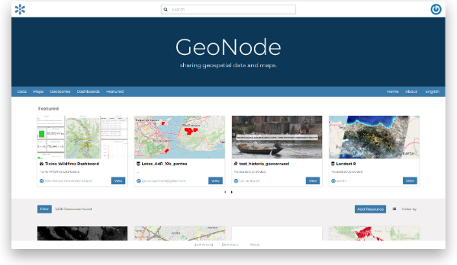

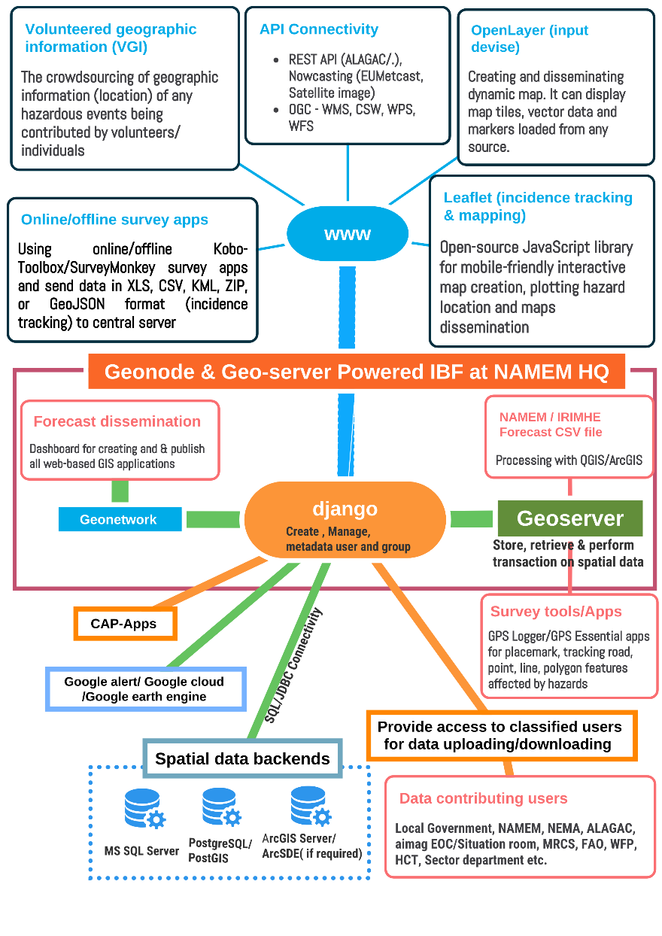

Figure 4 : ICT Structures for Developing the IBF Platform(Source: Z M Sajjadul Islam , UNDP-GCF)

3.1.2 Installation of Geoserver :

GeoServer is an open-source geospatial server. Implementing GeoServer significantly reduces the financial barrier to entry compared to proprietary GIS products, while providing a robust, standards-based foundation for enterprise geospatial services. Because it is open source, bug fixes and feature enhancements are developed transparently and are often delivered more rapidly than in closed software ecosystems.

GeoServer is a Java-based server that enables users to publish, view, and (where appropriately configured) edit geospatial data. Built around open standards from the Open Geospatial Consortium (OGC), GeoServer offers strong flexibility for map publishing and data sharing, supporting interoperable services such as Web Map Service (WMS) (and, where required, related OGC services).

GeoServer enables organizations to publish spatial information for broad internal and public use. Through its implementation of OGC standards, it can generate maps in multiple output formats and integrate seamlessly with common web mapping libraries and APIs (e.g., OpenLayers, Leaflet, Google Maps, Google Earth, Microsoft Bing Maps, Mapbox). It also supports interoperability with desktop GIS environments such as Esri ArcGIS and QGIS.

3.1.3 Anchoring google mapping tools :

- Google Earth (visualization and rapid situational review)
Use Google Earth as a visualization layer to review locations and validate incident and impact information. Through GeoServer/GeoNode publishing (including KML/KMZ outputs where configured), partners can open IBF layers in desktop GIS (QGIS/ArcGIS) and in Google Earth to support rapid impact interpretation, hotspot identification, and documentation of affected elements for dissemination through the IBF platform.

- Google Earth Engine (GEE) (satellite analytics for sector risk layers)
Use Google Earth Engine’s large satellite and geospatial data catalogue and analysis capabilities to produce sector-relevant layers (e.g., pasture biomass/condition, land cover/land use classifications, cultivable forage areas, water bodies and surface-water dynamics, soil/land degradation indicators, and drought-related metrics). These outputs can inform weather- and climate-related risk and vulnerability analysis and be published as GIS-ready products for the IBF platform.

- CAP-enabled public alert integration with Google surfaces (where partnership/eligibility applies)
Implement Common Alerting Protocol (CAP) generation in the IBF warning workflow so that alerts are consistently structured, geocoded, and action-oriented. Google’s Public Alerts partner integration guidance indicates that alert display is driven by CAP content (including location and key fields such as severity, urgency, certainty, and time attributes), enabling targeted presentation of alerts to relevant audiences on Google properties. http://www.google.org/publicalerts.

3.1.4 Installation and Configuring Surveying Apps.

a) OpenLayers-based web mapping tool
OpenLayers is a web-based client mapping (Web GIS) library that can be configured into lightweight surveying and incident-reporting applications. IBF volunteers/surveyors can use an OpenLayers-based tool to capture locations and map features in real time, attach photographs, and submit georeferenced placemarks to the IBF platform (via GeoServer/GeoNode) for publishing and analysis.

Typical configuration requirements

- Define standard feature templates (point/line/polygon) and attribute fields (event type, date/time, confidence, photos, notes).
- Enable GPS capture on mobile devices and enforce coordinate reference system consistency.
- Configure upload endpoints/workflows to publish collected features to GeoServer/GeoNode (or to a staging repository for validation prior to publishing).

- Kobo-toolbox apps, QField, Survey123, GPS Logger, and GPS Essentials apps are practical alternatives for field surveying and rapid incident reporting. They support capturing:
- Points (e.g., ger locations, herder base camps, weather-proof livestock shed, water points, hay/fodder storage facilities, incident points),
- Lines (e.g., road segments, vulnerable road sections, travel routes),
- Polygons (e.g., grazing areas, pasture areas, inundation extents).

These can be exported as KML/KMZ (and other supported formats, depending on the app) for integration into the IBF workflow.

Operational use case (IBF emergency workflow)

During an event, the IBF team (NAMEM HQ or an aimag EOC/Situation Room) can request volunteers to submit:
geolocated placemarks of herder/ger locations or grazing areas,

- geolocated incident locations (e.g., flood/flash flood sites),
- photos/videos linked to the location, via agreed channels such as customized mobile apps for data collection, WhatsApp group, etc., capturing event situation, impacts on elements, L&Ds, etc.

3.1.5 Design and Deploy National Climate Risk and Vulnerability, Multi-hazard risk & L&Ds online database

Deploy a web-based database and interface for storing, updating, and disseminating climate risk and vulnerability datasets and GIS layers.

3.1.6 Implementing Web converting common alerting protocol (CAP ) Hub :

  - Installation of CAP Hub Server for classified alerting to livestock’s herders :
Mongolia’s frontline risk environment includes approximately 71.2 million head of livestock (NSO 2022) and the interdependent livelihood and economic systems that rely on them herder communities, crop agriculture, water resources, tourism, fisheries, transport, and national communications networks. Extreme weather hazards, including winter snowstorms, blizzards/winter storms, dry spells, convective storms, and dzud, regularly cause large-scale livestock mortality, recurring fodder shortages, and significant disruption and damage across agriculture, transport and logistics, tourism, and value-chain operations. Cold-front-driven storms and cold rain events further amplify impacts by interrupting mobility and access, limiting service delivery, and constraining emergency response.
Despite the progress of NMHE/NAMEM forecasting and NEMA warning systems, persistent operational gaps remain: insufficiently timely operational forecasts, limited precision in impact-area delineation, and the absence of a standardized, common, and classified alerting mechanism that can issue consistent alerts to priority productive sectors at the national and sub-national levels.
To address these gaps, an IBF platform-integrated CAP Hub should be established and hosted within the NAMEM/NEMA Emergency Operations Center (EOC) as a core national alerting infrastructure. The CAP Hub should operate as a web-based application and connect to external systems through secure APIs, enabling automated generation and dissemination of CAP-compliant alerts based on forecast hazard thresholds and parameter-based triggers. Trigger logic should be programmatically implemented (e.g., using Python and/or NodeJS services) to translate forecast outputs into standardized CAP XML messages, supporting rapid, repeatable, and auditable alert issuance. In addition, installation of a CAP Aggregator is required to consolidate alerts from multiple sources, manage updates and cancellations, and distribute a single authoritative feed to downstream dissemination channels and partner platforms.
  - Installation of CAP Aggregator server:
Implements the national CAP Aggregator and Alert Hub hosted by NEMA/LEMA , IRIMHE, NAMEM, enabling automatic, standardized alerts over SMS, USSD, IVR, radio, TV, apps, and traditional channels (sirens, bells, megaphones). Ensures multilingual, disability-inclusive formats and establishes two-way feedback loops.
IBF CAP Aggregator is a service (often called a CAP hub) that collects CAP-formatted alerts from multiple official sources, applies basic processing (e.g., validation, de-duplication, normalization, authentication where applicable), and then republishes a unified feed/repository that downstream systems can consume (dashboards, apps, broadcasters, telecom gateways, web portals).
CAP Aggregator services
- Ingests CAP alerts from many publishers (NMHS, disaster management authority, sector agencies) via polling or push.
- Validates CAP structure/profile compliance and handles common formatting issues.
- De-duplicates and correlates updates/cancellations (CAP message “update” lifecycles) to maintain a clean “active alerts” set.
- Authenticates and/or signs messages (in architectures where authenticity is enforced).
- Stores and exposes alerts through APIs/feeds for subscribers (e.g., “active alerts,” “archive,” “by area,” “by hazard”).

Importance of CAP Aggregator services for IBF-MHEWS integrated architecture
- Single source of reliability: downstream channels (SMS/IVR/CB, radio/TV, web/app, partners) connect to one place instead of many.
- Consistent last-mile dissemination: CAP enables the same alert to drive multiple dissemination pathways, while your IBF layers (impact thresholds, exposure) remain in the GIS stack.
- Cross-border and multi-source situational awareness: aggregators can pull regional/global CAP feeds for context (useful for shared basins, smoke/air quality, transboundary hazards).

Common deployment patterns
- National CAP Aggregator / Alert Hub (recommended for NEOC/EOC): centralizes official alert publication and downstream distribution of weather warning and alerting.
- Classified Sector CAP Aggregator: consolidates sector alerts (e.g., herders/livestock, weather sector, hydrology, crop agriculture, transportation and communication, value chain operation, WASH, public health) and forwards to the national hub.

Some global examples
- IFRC Alert Hub CAP Aggregator is an open-source CAP aggregation service used to collect publicly available CAP feeds at scale.
- Esri’s “CAP Alerts Feed” is an example of an aggregated CAP layer published near real-time for mapping/visualization.
- FEMA IPAWS-OPEN is described as an “Alert Aggregator” that collects alerts, authenticates the sender, and makes alerts available to dissemination services.

Design a national CAP hub (NEOC) or a sector/aimag-level aggregator, can draft a short “CAP Aggregator module” description with inputs/outputs, interfaces (API/CAP feed), and minimum functional requirements aligned to IBF platform.

3.2 Rationale of integrating ICT with the IBF platform :

ICT System: The core principle of the IBF system is to shift from conventional forecasting focused on “what the weather will be” to impact-based services that explain “what the weather will do” and how it will affect people, assets, and livelihoods on the ground.

A fully functional system will ingest weather and related hazard inputs and process them through an ICT-enabled workflow that supports: (i) interpretation of weather-driven advisories; (ii) assessment of anticipated impacts; (iii) characterization of the severity of impending risks and vulnerabilities; and (iv) estimation of potential loss-and-damage scenarios. These outputs should be generated at higher spatial and temporal resolution and tailored to priority sectors, exposed elements, and climate-frontline communities
  - Real-time weather updates (spatial and temporal)

- Provide customized forecasts for defined target audiences (CAP Agregator).
- Maintain a national dashboard integrating multi-faceted climate and disaster risk information.
- Issue risk-informed advisories and sector-specific warnings.
- Produce operational forecasts that support Mongolia’s round-the-clock public and private operations.
- Provide timely spatial and temporal updates on ongoing extreme weather, linked to weather warnings, CAP-enabled alerts, MHEWS products, and local-level advisories.

  - Installation of a ground-level hybrid observation mechanism (Figure 9)

- Given the IBF system’s scope, ground impact capture, big-data processing, inclusive stakeholder participation, and continuous user updates, the platform should interface with a hybrid ground observation system (Figure 9) by engaging: communities, last-mile sector technicians, volunteers, and NEMA-designated technical and volunteer teams.
- Deploy and activate crowdsourcing-based observation mechanisms to improve the coverage and resolution of ground-level weather parameters and extreme-event characteristics, enabling stronger impact analysis (e.g., which elements are affected, where, and at what severity).

  - Weather-induced risk and vulnerability tracking, interpretation, and dissemination

A hybrid surface observation system (AWS, manual stations, and crowdsourced observations) provides comprehensive coverage to understand weather trends, extremes, frequency, and intensity. Using 10-day (decadal), monthly, sub seasonal, and seasonal anomalies, together with multi-hazard incident data, develop GIS-based analyses and maps at soum and aimag levels (supported by standardized base maps) to keep planning and operations desks informed. These products support planning, SOP development, and business continuity planning for upcoming seasons and years.

  - Multi-hazard incident and situation tracking and archiving

- Maintain a systematic record of how hazardous weather evolves into multi-hazards and disasters, including incident and loss-and-damage (L&D) information.
- Archive and disseminate all forecasting products, forecasts, outlooks, advisories, and corresponding interpretations of observed conditions.
- Use these datasets as key inputs for annual climatology, climate change analyses, and comprehensive reporting, incorporating both surface observations and regional/global model outputs.

  - Verification, retrofitting, and bias correction for dynamical downscaling

- Use comprehensive ground observations, weather phenomena, element- and sector-level impacts, and loss-and-damage scenarios to support model fitness assessment, forecast verification, and bias correction.
- Strengthen capability to develop and validate high-resolution statistical and dynamical downscaling, particularly for rapidly developing weather systems such as cold fronts; convective storms (heavy rain, thunderstorms, hail, lightning); severe snowstorms and blizzards; high-wind impacts; heatwaves; and sand/dust storm events that can result in significant human and livestock losses.

  - Effective risk communication and sectoral coordination

Institutionalize a culture of compliance and coordinated action among mandated stakeholders to ensure: routine provision of risk and vulnerability inputs; shared interpretation of forecast risk; and systematic data coordination and exchange across all relevant partners.

3.3 Software & Tools Proposed for the ICT-integrated IBF Platform
Table 3: Checklist of Software & Tools

SL | Software /Tools | Features | Usability
 | QGIS/ArcGIS | Desktop GIS software enables users to visualize, create, edit, manage, and analyze spatial data, and to produce maps and other cartographic products.. | - Forecast threshold, impact level, anticipatory loss, and damage estimation.  - Risk and vulnerability analysis, Risk area identification, impact calculation, estimation
 | Google Earth Pro | Desktop software used to visualize spatial data, satellite imagery, and maps, and to produce 3D images and videos for presentations and reports. | GIS shapefile Geospatial gazetteer/elements of the Google map.
 | Google Earth Engine | Google Earth Engine (GEE) is Google’s cloud-based platform for planetary-scale geospatial analysis. It combines a multi-petabyte catalog of satellite imagery and geospatial datasets with large-scale computing, enabling users to detect change, map trends, and quantify differences on Earth’s surface. | Google Earth Engine remote sensing satellite images useful for landscape, environmental, hydrological, landcover, geospatial, landscape, land use, natural resource management, risk and vulnerabilities analysis, and land use mapping by using a built-in cooking library.  - Anchoring earth engineer built-in features/tools with IBF.  - GEE is well suited for generating GIS-ready layers that strengthen impact analysis and risk mapping, such as:  - Vegetation condition and anomaly (NDVI) and rangeland/pasture condition monitoring  - Snow cover and seasonal snow dynamics mapping  - Drought-related monitoring using remote sensing indicators and time-series change detection  - Land cover / land use classification and exposure baselines for sector impact overlays
 | Real Flight using UAV(Drone ) | - UAV flights for geospatial data collection: Drones can be used for spatial data capture and aerial surveys to support land-use and vulnerability mapping, field data collection, climate risk and vulnerability assessments (CRVA), multi-hazard risk mapping, location tracking, and rapid situational mapping.  - Weather-focused drone use (specialized): Weather-capable drones can support monitoring of rapidly developing conditions, such as convective cloud development, and where equipped lightning-related detection/observation. | Mapping and data collection
 | Online Mapping and survey | Open Layer, QFiend, | Geospatial surveying tools are used to capture multi-hazard incidence and feed it into the IBF Online Platform.
 | Online survey | Kobo-Toolbox (Socioeconomic Surveying)  GIS Logger ( Placemark, geolocation capturing, road network surveying )  GPS Essential | Socioeconomic Surveying of herders, community, sectoral elements, sectoral progress review, elements geolocation capturing with GPS coordinates, etc essential for the IBF impact analysis and FBF decision support.
 | PostgreSQL / PostGIS | Open-source database management, with an extension of PostGIS - Spatial database extender for accessing geospatial databases. | Open-source database management, with an extension of PostGIS - Spatial database extender for accessing geospatial databases.
 | Geonode & Geoserver | Open-source online mapping and map sharing platform. Having interfaces with Web Map Service (WMS), Web Feature Service (WFS), and Web Coverage Service (WCS), among others. | Online mapping facility, mapping services with QGIS and ArcGIS software
 | ArcGIS Server (Subscription/licensing required) | ArcGIS Server is a back-end server software component of ArcGIS Enterprise that makes your geographic information available to others in your organization and, optionally, anyone with an internet connection. This is accomplished through GIS services, which allow a server computer to receive and process requests for information sent by other devices | ESRI Enterprise GIS mapping and WebGIS solution https://enterprise.arcgis.com/en/

IBF internal and external data acquisition and coordination system (maintaining data sensitivity and privacy).

3.4.1 Data workflow and data archive structures ( at IBF central level ) :
The ICT structure of the IBF system relies on clustered back-end database servers to deliver database services. GeoNode and GeoServer operate through an integrated workflow that combines relational database management with online mapping services. For IBF purposes, GeoNode and GeoServer provide an online map publishing environment in which forecast datasets (primarily CSV outputs) are processed in QGIS/ArcGIS to generate impact forecast layers, which are then published through standard geospatial service interfaces (e.g., WFS/WCS and related processing services as applicable) via GeoNode/GeoServer.
Once impact forecast maps are generated, technical narratives describing anticipated impacts and threshold-based severity are attached and disseminated online through the IBF platform. In this way, the IBF system functions as an integrated mechanism for forecast impact analysis and publishing through an online GIS environment. The GeoNode/GeoServer architecture, supported by a relational database, can also programmatically ingest and retrieve data from multiple sources and generate outputs for users.
To enable an independent workflow with recurring updates, a dedicated data hub should be deployed to support routine data synchronization, reduce data-exchange bottlenecks and bureaucratic delays, and centralize archival storage. Centralized, well-governed data archiving and exchange provides a more reliable and trusted solution for operational forecasting, impact analysis, and dissemination.

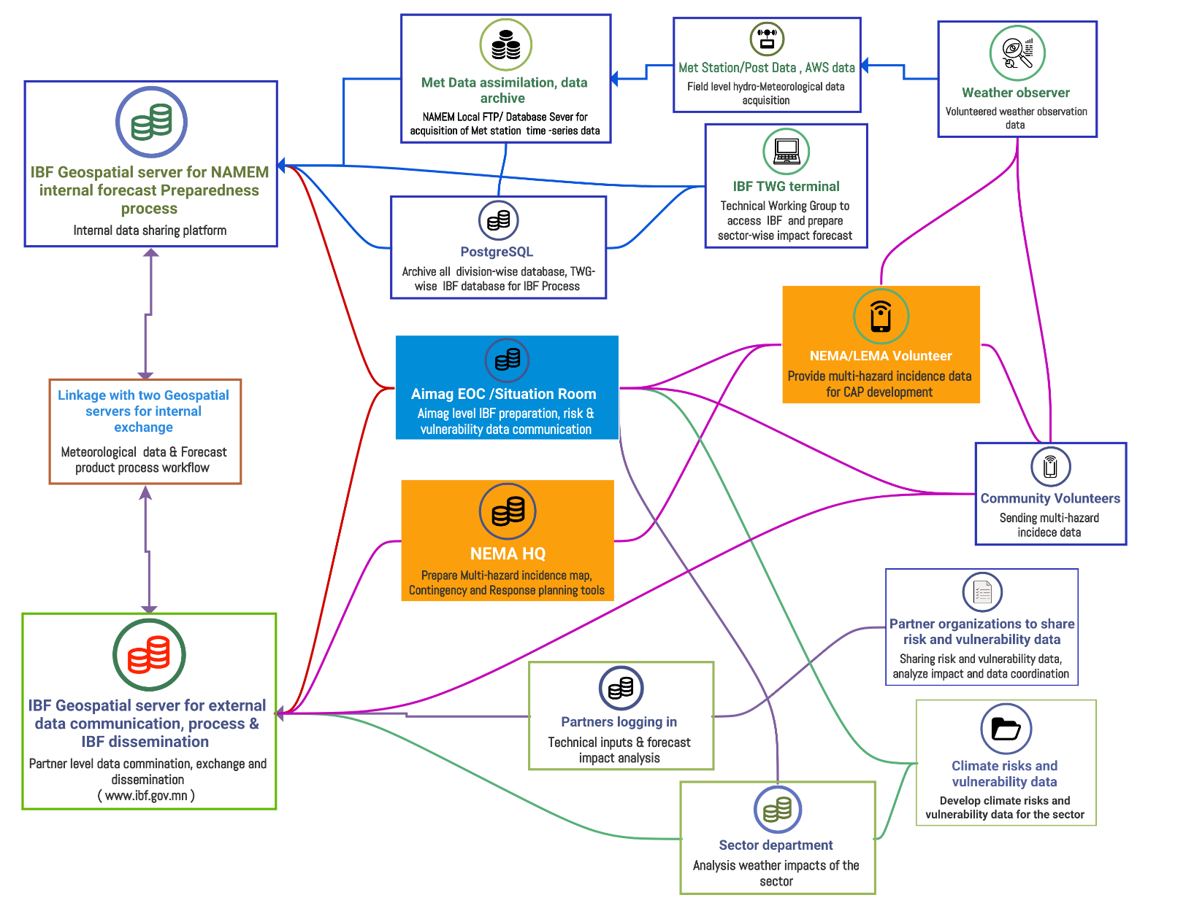
Figure 5: The typical architecture and data flow diagram of the IBF Open-Source platform (Source: Z M Sajjadul Islam, UNDP-GCF)

To ensure weather data security, the IBF ICT structure is designed around two integrated geospatial platforms (GeoNode/GeoServer). As illustrated in Figure 3, two NAMEM/IRIMHE geospatial server environments operate in parallel: an internal server that supports internal data organization, assimilation, storage, and day-to-day workflows for the research and operational divisions; and an external GeoServer that publishes web-based geospatial services for dissemination and serves as an interface for receiving and integrating stakeholder-contributed data.
a)Diagnose existing System :
Currently, NAMEM has a Microsoft Windows-based intranet system installed for acquiring local meteorological datasets from the met station and weather posts, which are transmitted through an FTP server. The data are then calibrated, assimilated, and processed, and made available to the local area network (LAN) via intranet web services. The integrated IBF system is intended to be upgraded to an automated system.

3.4.2 Integrated IBF ICT system :
The Integrated IBF ICT System is an end-to-end, ICT-enabled architecture that ingests multi-source hydrometeorological and ground-impact information, transforms it into impact-based forecasts and risk products, and disseminates warnings, advisories, and CAP-enabled alerts to decision-makers and last-mile users through a unified digital platform.

  - Purpose and functional shift
- Shift from “what the weather will be” to “what the weather will do,” by integrating hazard forecasts with exposure, vulnerability, and incident evidence to generate actionable guidance.
- Support real-time operations, anticipatory action, and post-event learning through structured data capture, analysis, publication, and archiving.

  - Core architecture (major modules)

a) Hybrid data acquisition and ingestion (Figure 9)
- Automated feeds from observation networks (AWS and manual stations).
- Community- and volunteer-supported reporting (photos/videos, geolocations, hotspot capture, KML/KMZ, survey tools).
- Sector datasets (exposure, vulnerability, assets, basemaps) provided through mandated partnerships.
b) Data hub and database services
- Centralized relational , spatial database (e.g., PostgreSQL/PostGIS) to store:
  - observations, gridded forecasts, thresholds,
  - exposure/vulnerability layers,
  - incident and loss-and-damage records,
  - metadata, version history, and audit trails.
- Scheduled synchronization workflows for recurring uploads (CSV, shapefiles, rasters).
c) Processing and analytics
- Forecast processing and downscaling workflows (statistical/dynamical as applicable).
- Impact analysis routines: overlay of thresholds (red/orange/yellow/green) with sector elements to quantify exposure and likely impacts.
- Verification and learning: event archives, post-event validation, bias correction inputs.
d) Geospatial publishing and collaboration layer
- GeoServer , GeoNode (integrated with the spatial database) to:
  - publish GIS services (e.g., WMS/WFS/WCS and REST endpoints),
  - manage datasets, metadata, permissions, and partner collaboration,
  - provide map visualization, narratives, comments, and versioned products.
e) Warning, alerting, and dissemination
- CAP origination and/or aggregation services aligned to national protocols.
- Multi-channel dissemination integration: web portal, dashboards, messaging platforms, telecom gateways, radio/TV adapters, and EOC/Situation Room workflows.
f) Dual-platform security model (Figure 3)
To address data security and operational separation, the system can run on two concurrent geospatial environments:
- Internal IBF geospatial environment: internal data organization, assimilation, storage, research/operations workflows.
- External IBF geospatial environment: web-based public/partner services, stakeholder data acquisition, dissemination products.
g) Field and partner interfaces (plug-and-play)
- Desktop GIS (QGIS/ArcGIS) for overlay analysis and product generation from CSV/shapefiles.
- Mobile data capture and surveys (KoboToolbox, GPS tools, hotspot apps) with offline-first capability for remote areas.
- Social and coordination channels (WhatsApp/Telegram/Facebook groups) as operational communications layers linked to structured intake and validation rules.
h) Operational requirements (non-functional)
- Availability and performance: high-throughput ingestion and rapid map/service publishing during emergencies.
- Access control: role-based permissions for partners (e.g., aimag EOC/Situation Room access).
- Data governance: naming/versioning standards, metadata completeness, quality control, and validation prior to public release.
- Resilience: backups, disaster recovery, and reliable archiving to support investigations and audits.

i)Automated data acquisition from a hybrid observation system ( figure 9)
- Automated Weather Stations (AWS): Automated acquisition of real-time meteorological parameters from the national AWS network.
- Community-operated modular instruments: Data collection through modular weather instruments managed by remote communities to extend coverage in hard-to-reach areas.
- Crowdsourced nested ground observations: Deployment of a crowdsourcing-based observation layer by positioning modular instruments to achieve the highest feasible grid-compatible density of ground observations.
- Crowdsourced incident and loss-and-damage reporting: Collection of multi-hazard incident reports and associated loss-and-damage statistics from crowdsourced contributors.
.

3.4.2.1 Required data workflow for an integrated IBF process :
The integrated impact forecasting and warning system should be designed to operate through programmatic linkages across multiple ICT applications. The proposed IBF system is an ICT-enabled process governed and sustained by structured partner interaction, including routine data sharing, validation, interpretation, and dissemination.
1) Core data inputs for forecasting and monitoring
The IBF workflow requires real-time (time-series) surface observations, eye-observed weather phenomena, and statistical and dynamical downscaling outputs to anticipate hazardous events. These inputs must be available at sufficient spatiotemporal resolution to support operational modelling and analysis.

For high-impact hazards such as severe cold, heavy/dense snowfall, strong winds, snowstorms, and related compound events, the system must continuously track how conditions evolve across the forecast lifecycle and lead times. This includes monitoring shifts in intensity, frequency, and spatial extent, and estimating how long damaging conditions may persist before dissipating.

2) Hazard evolution analysis across the event lifecycle
A key requirement is the ability to analyze:
- movement and fluctuation of hazardous conditions over time,
- escalation and de-escalation of impact levels,
- the “back-and-forth” dynamics of rapidly changing weather systems,
- persistence and potential duration of impacts.
This ensures forecasts and warnings remain aligned with actual evolving conditions and supports timely updates to advisories and alert levels.

3) Impact analysis using ground-level risk and vulnerability data
Automatic Weather Station (AWS) datasets are essential for:
- nowcasting algorithms,
- statistical modelling,
- dynamical downscaling for rapidly developing weather conditions.
In parallel, crowdsourced situational updates are required to quantify and contextualize impacts, including loss and damage (L&D) and operational disruptions. To enable these functions, the IBF platform must be equipped with ICT infrastructure such as:
- databases and data pipelines (for large datasets),
- data capture applications (surveys, hotspot reporting, GPS tools),
- interfaces to crowdsourcing networks and social communication channels,
- mechanisms to receive, validate, store, and retrieve evidence (photos, video, geolocations).

4) Risk and vulnerability analysis for sectors and elements
Risk and vulnerability assessments should be informed by:
- historical and recent weather synopses at national and local levels (aimag, soum, bag),
- spatiotemporal observation datasets,
- georeferenced situation reports (photos/videos),
- incident tracking and L&D records.
These datasets support sector- and element-level analysis (e.g., livestock, agriculture, water, infrastructure) and improve the accuracy and utility of impact-based products.

5) Archiving, traceability, and dissemination
Tailor-made risk-informed datasets, GIS-based interpretation maps, and technical narratives must be systematically archived and routinely disseminated. This strengthens:
- operational continuity,
- transparency and auditability for forecast investigations,
- learning and refinement of thresholds and models,
- cross-sector planning and preparedness.

6) Support to Forecast-Based Financing (FbF)

The IBF workflow should directly support FbF by ensuring that:
- risk-informed historical baselines and evidence are readily available,
- GIS-based interpretation maps and scientific/technical justifications are regularly updated and accessible,
- materials can be rapidly packaged for anticipatory decision-making, multi-hazard contingency planning, and pre-arranged financing triggers.

These outputs also serve as strong advocacy tools for early resource mobilization ahead of impending extreme weather events.

3.4.3 Centralization of Database Archive and Services by IBF Platform

1) Operationalizing the IBF Database Server for partner-level data coordination and exchange
The objective of this process is to digitally link partners and stakeholders through a mandated, automated mechanism for data generation, coordination, and exchange. A robust IBF process requires a real-time, interactive, and fully functional data coordination and exchange framework. The cross-functional workflow should be designed to operate automatically wherever possible, minimizing recurring manual processes and reducing delays in data sharing and integration.

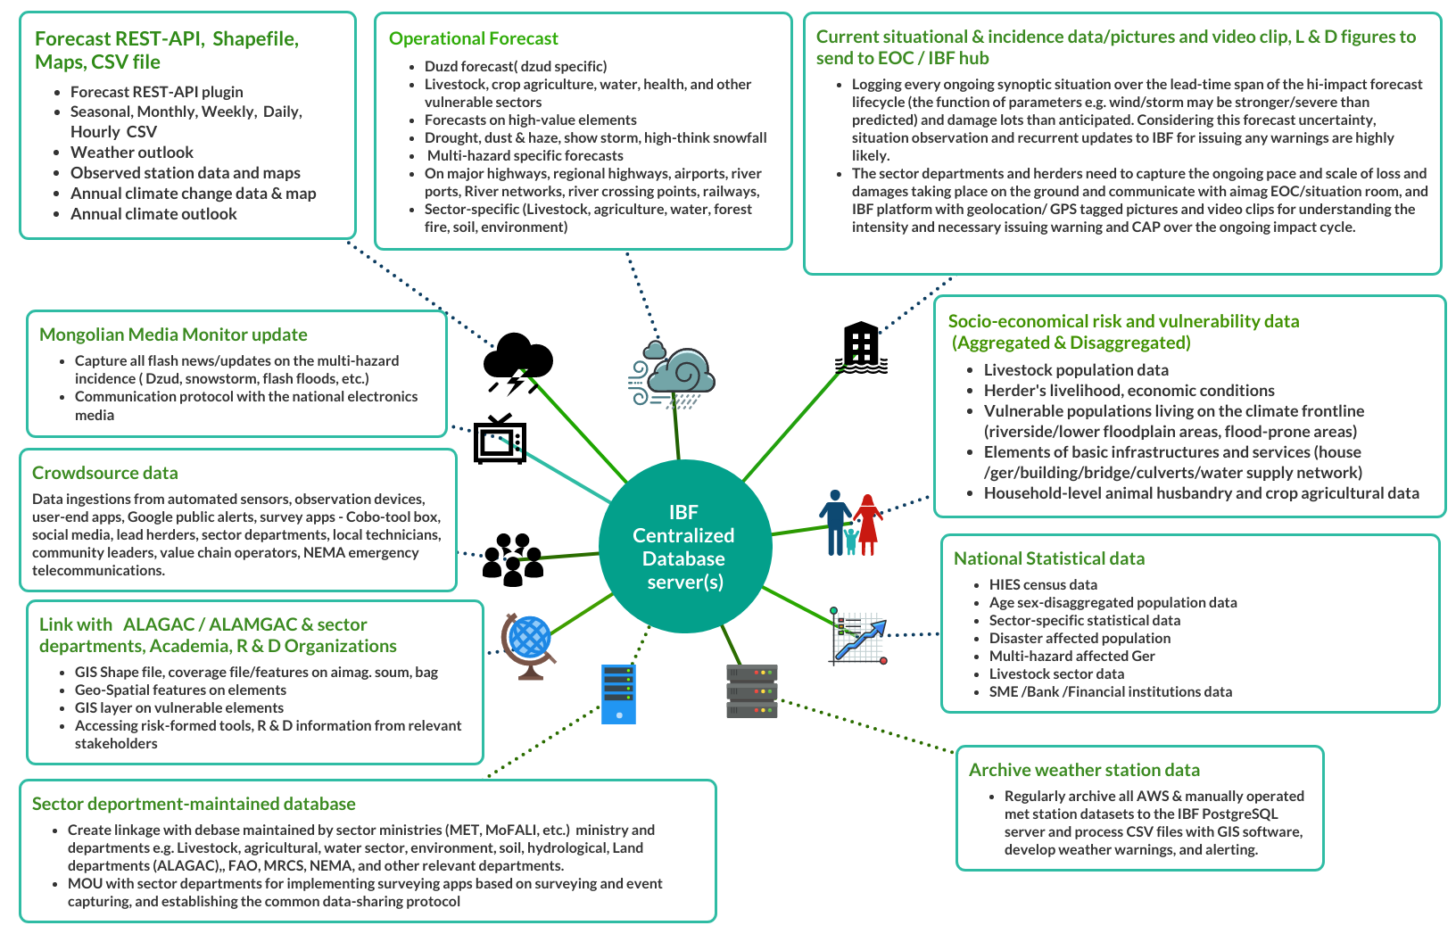
Figure 6: IBF Database Server for Partner-Level Data Coordination and Exchange Mechanism (Source: Z. M. Sajjadul Islam, UNDP-GCF)
The diagram illustrates the database architecture, data field types, core components, data acquisition pathways, and methodologies required to systematically capture, coordinate, exchange, and report data to a centralized IBF platform..

3.4.2.1 Develop databases with PostgreSQL server :

Types of databases/archives | Data processing and ICT systems | Input and Output Methodology
National met agency weather data ( AWS/Manual/Post ) on time series needs to be archived | Data archiving and routine data ingestion requirements  - Archive all processed weather-parameter datasets in the appropriate SQL database servers (e.g., PostgreSQL/MySQL) to support time-series analysis and retrospective investigations.  - Store all operational products including CSV files, forecast images, and GIS shapefiles in the GeoNode server at regular intervals to ensure discoverability, version control, and future access. | - Database system for automated archiving: A database-driven workflow to automatically store and version datasets and products (e.g., observations, forecasts, maps, and metadata) on a scheduled basis.  - Manual archiving via service interfaces/APIs: Manual upload and publication of datasets and map products using APIs and geospatial services such as REST, WCS, WFS, and WPS.
Short-range forecast data archive | All CSV files, forecast image files, and GIS shapefiles should be systematically archived on the GeoNode server at regular intervals. | Integrated system for automatic archiving:  A unified, database-driven workflow that automatically ingests, versions, and archives IBF datasets and products (e.g., time-series observations, forecast CSVs, images, and GIS layers) on a scheduled basis, and publishes them to the IBF platform (GeoNode/GeoServer) with appropriate metadata and access controls to enable future retrieval, verification, and audit.
National Statistical data | - NSO datasets can be accessed routinely by:  - Downloading datasets from the NSO portal (1212.mn) on a scheduled basis.  - Downloading relevant Excel/CSV files from 1212.mn and uploading/ingesting them into a PostgreSQL/MySQL database through a defined data pipeline.  - Signing an MoU with NSO to ensure local-level surveys include guidance and requirements for capturing geolocations of surveyed elements (where feasible and appropriate). | - Data transfer via ODBC connectivity: Copy/synchronize datasets through ODBC connections with designated departmental database servers.  - Manual data collection and ingestion: Collect datasets in Excel/CSV format and upload/ingest them into the SQL server.
Population, households (ger), and socio-economic sector risk and vulnerability data (aggregated and disaggregated) | - Using KoboToolbox survey applications, NSO, NEMA, NAMEM, sector departments, and partner I-NGOs should conduct surveys to generate disaggregated datasets on sectors, exposed elements, and specific risks and vulnerabilities, with outputs configured to synchronize directly to the server. | Stakeholders should use survey applications such as KoboToolbox, GPS Logger (for capturing GPS locations and placemarks), and GPS Essentials to geotag photographs of vulnerable elements.
Capturing and archiving current situational and incident data (including photos and video clips) and associated loss-and-damage figures. | - Enable authorized uploads to GeoNode/GeoServer so remote volunteers, sector department technicians, field-level experts, humanitarian actors, and other approved users can submit georeferenced incident and impact information directly to the IBF platform.  - Establish social media and messaging groups (e.g., Facebook, X/Twitter, Telegram, WhatsApp) to allow individuals such as logistics operators, students, researchers, herders, value chain operators, farmers, and other community members to share event photos, incident geocoordinates (latitude/longitude), impact notes, and loss-and-damage figures. These inputs will strengthen situational awareness, response planning, and operational decision-making. | Social networks can be widely used for crowdsourcing data collection
Database on Loss and damage(L&D) statistics, scenarios, pictures, and videos. | Develop a PostgreSQL database and integrate it with the GeoNode/GeoServer environment, including user access controls that enable authorized users to upload documents, photos, and videos to support risk interpretation and impact analysis. | All impacts, L & D datasets to store with SQL server for risk-informed tools development
Operational Forecast | - Using the GeoNode REST API and direct connections from QGIS/ArcGIS, users can create forecast-based spatial layers (e.g., coverages and shapefiles) and develop needs-based maps.  - Using QGIS/ArcGIS, users can develop forecast shapefiles and publish them by adding them as layers and/or by connecting to the GeoNode server to upload and register the datasets for sharing and dissemination | Develop an operational forecast GIS map by using a forecast CSV file ( Annexure 5) and upload it to geonode server for dissemination to the public.
All forecast bulletins and maps should be systematically archived within the IBF platform (GeoNode and GeoServer). | - Using QGIS/ArcGIS desktop applications connected to the GeoNode server (via REST/API services), users can create and publish a shapefile for each forecast and store it on GeoNode for systematic archiving and end-user access.  - Sector departments can access forecast maps and shapefiles for further analysis, generate sector-specific risk layers and interpretations, and upload the resulting shapefiles back to GeoNode for sharing and operational use.  - NEMA can produce GIS maps to support disaster preparedness, response planning, and contingency planning using QGIS/ArcGIS and the IBF geospatial services. | Using REST, WCS, WFS, and WPS API the experts/specialists can directly archive their forecast products ( GIS shapefile, CSV, GIS maps, technical narratives, etc.) and can directly upload to geonode server.
Crowdsourced data can be captured using QField (integrated with the GeoNode server), KoboToolbox, and web mapping/data capture tools such as GeoExt, ExtJS, OpenLayers, and Leaflet. Data can be formatted and exchanged using standards such as GeoJSON and submitted via ArcGIS/QGIS APIs and services to the GeoNode server for storage, validation, and publishing | Connect to the GeoNode server using open-source tools such as GeoExt, ExtJS, OpenLayers, and GeoJSON-based applications. These components can be integrated with the GeoNode API to build rich, desktop-like web GIS applications for data capture, visualization, and map-based analysis. | Volunteers of the different organizations
Google Public Alerts is a Google service that displays official emergency alerts (including weather- and multi-hazard alerts) on Google surfaces (such as Search and Maps) when those alerts are provided by authorized alerting agencies and meet Google’s technical requirements.  Common Alerting Protocol (CAP) is an open, non-proprietary XML standard used to structure and exchange public warning messages so they can be disseminated consistently across multiple channels and systems.  How Google Public Alerts uses CAP for multi-hazard alerts  To appear on Google Public Alerts, an alerting authority typically:  - Generates a CAP feed (often from a database/workflow that turns warning information into CAP).  - Ensures the CAP conforms to OASIS CAP v1.2 plus Google’s CAP profile and additional requirements (Google’s “Google Public Alerts CAP v1.0” requirements).  - Includes geographic targeting (area definition) and operational fields such as urgency/severity/certainty and valid times so Google can display the alert to relevant users.  - Uses testing capability (publishing CAP alerts with <status>Test</status>) for end-to-end verification.  Google provides developer guidance on creating and submitting CAP alerts, including best practices and validation expectations.  Why this matters in an IBF-MHEWS context  - IBF impact maps (threshold zones) , CAP alerts work well together: you publish impact-threshold layers via GeoNode/GeoServer (WMS/WFS/WCS) while CAP carries the official warning message and geotargeting for public alerting.  - A CAP aggregator/hub can consolidate alerts from multiple sources and distribute them to multiple dissemination services. Practical next step (designing the solution)  If your intent is “IBF generates the impact zones, CAP publishes the warning,” then your minimum architecture is:  - IBF GIS stack (GeoNode/GeoServer) for layers and map services, and  - CAP origination , (optional) CAP aggregator to issue/route the official multi-hazard alerts to Google Public Alerts and other channels. | Develop a common alerting protocol on multi-hazards | Configure Google Public alert for live(real-time) alerting of the multi-hazard incidence hotspot ( just prevailing hazardous conditions at the local level ) location.
Google Cloud | Partner-level data sharing and exchange tool | Web-based Google Clouds
Volunteered geographic information (VGI) for incidence tracking by the volunteers/general people | - The crowdsourcing of geographic information addresses(location) of any hazardous events, where geospatial data is contributed by volunteers/individuals (on the fly) by WPS and WFS  - VGI can be seen as an extension of critical and participatory approaches to geographic information systems. Some examples of this phenomenon are WikiMapia, OpenStreetMap,

3.4.2.2 Impact forecast manufacturing tools, input datasets, and Process:

Organization /Partners | Data type | Data capturing/Processing tools | Forecast Data accessing & sharing protocol | Data Process for IBF platform
NAMEM | Forecast CSV file, GIS shapefile | - High-performance computing (HPC) Supercomputers for preparing 1-5 km gridded forecasts outlook/CSV.  - The weather station data calibration, assimilation, and processing software show the current weather situation prevailing on the ground. | The CSV files of long-range, medium-range, and short-range forecasts/outlook/watch/advisories and NWP output are to be made available at the IBF platform and subsequently give access to aimag EOC/Situation room experts, sectoral department technical partners, academia, hydro-meteorological R & D organizations, scientists, sector specialist ( water, livestock, agriculture, soil & land, etc.,) to be engaged for sector-specific impact/risk/vulnerability/sensitivity when hihg0imapct weather be forecasted and need impact analysis ( High-resolution gridded data ) for the sector and elements | Connecting from desktop QGIS/ArcGIS software to Geonode server with WCS, WFS, REST API and creating maps on impact forecasts, and impact analysis.
NAMEM/  IRIMHE | - Station observed times-series weather station/ weather-post/human observer/telematic station and other gauzing, observation points, etc datasets to be collected, assimilated, and processed. All that data to upload to the PostgreSQL server for programming automatically and developing Common Alerting Protocol (CAP) / MHEWS ( on flash floods, heavy participation, heatwave, snowstorm, etc ) for the common people. | - Programming with Google public alert, GitHub code, ArcGIS disaster alerts (https://www.esri.com/en-us/arcgis/products/arcgis-geoevent-server ).  - Third-party CAP using GitHub coding.  - Programming with Google Earth engine for geospatial risk analysis, landcover mapping, agricultural planning, etc.  - Remtoe sensing ERDAS Imagine, ER Mapper etc sofware  - Mike 11 for flood risk mapping  - Other paid software NAMEM is currently using for impact analysis and risk mapping. | Geonode and geoserver integrated IBF geospatial platform deployment for the total IBF process.  (www.ibf.gov.mn www.weather.gov.mn ) | Connecting from desktop QGIS/ArcGIS software to Geonode server with WCS, WFS, REST API and creating maps on impact forecasts
- NEMA at HQ  - LEMA at aimag/soum/bag level  - NAMEM/NEMA running EOC/Situation room at aimag level | Field-level technicians, and volunteers, aimag EOC to use mobile apps and Prepare CSV/kmz/kml files of Geolocation/Placemark where critical and emergency response services are required. | - GPS data logger and GPS essential apps of disaster incidence hotspot location (kmz/kml) and pictures.  - Using QField( QFieldSync plugin) and QGIS installed in Android devise and prepare a survey area GIS shapefile of disaster incidence hotspot location   - Open layer  - VGI tools  - KoboTool box installed with android device for giving input the details about the survey required for response planning.  - Survey123 of ArcGIS platform ( subscription required) | Using QGIS/ArcGIS software, process the incidence data, create a shapefile, and directly upload and create a map with narratives to the geonode server for public access. | Connecting from desktop QGIS/ArcGIS software to Geonode server with WCS, WFS, REST API, and creating maps on multi-hazard incidence, situation alert map
ALAGAC/ ALAMGaC ( land administration department ) | Provide access to necessary Shapefile/kmz/kml file by delineating the impact areas that are likely from the CSV forecast file e.g. flood-prone, flash flood-prone, water logging, landside areas, drought-prone areas, land use /land cover, etc, and quantitative anticipatory L & D data | - QGIS/ArcGIS desktop software and accessing the geospatial server(IBF).  - Field technical/surveyor to install GPS data logger and GPS essential apps of disaster incidence hotspot location (kmz/kml) and pictures.  - Using QField( QFieldSync plugin) and QGIS installed in android devise and prepare survey area GIS shapefile of disaster incidence hotspot location.  - Open layer with Android mobile mapping  - VGI tools with android mobile mapping  - Kobo Toolbox to be installed with android device for giving input the details about the survey required for response planning ( with geolocation).  - Survey123 of ArcGIS platform ( subscription required) | Using QGIS/ArcGIS software process the incidence data, crate shapefile, and directly upload and create a map with narratives to geonode server for public access. | Connecting from desktop QGIS/ArcGIS software to Geonode server with WCS, WFS, REST API and creating maps
NAMEM/NEMA running EOC/Situation room at aimag level | - Develop Aimag/Soum/bag level GIS base maps with GIS shapefile ( annexure 5.)  - Conduct climate risk and vulnerability Assessment (CRVA) and develop GIS shapefile, GIS maps on CRVA atlas.  - Conduct field survey with QField, GPS data logger and GPS essential, KoboTool box, etc., apps, capture sector-specific risk and vulnerability(Ger/camp location, pasture area, degraded area, water access points etc.) datasets( excel/dbf/csv)  - Excel sheet on anticipatory loss and damage calculations and narratives of impacts over the forecast thresholds. | Analyze weather forecast CSV file of designated aimag with ArcGIS/QGIS software and analyze detailed risk, vulnerability, exposure, anticipatory loss, and damage impact calculations with ArcGIS/QGIS software. | Using QGIS/ArcGIS software process the incidence data, crate shapefile, and directly upload and create map with narratives to geonode server for public access. | Connecting from desktop QGIS/ArcGIS software to Geonode server with API’s -WCS, WFS, REST API, and creating maps.
Sector Department at aimag/UB level | - Develop Aimag/Soum/bag level GIS base maps with GIS shapefile ( annexure 5 )  - Conduct climate risk and vulnerability Assessment (CRVA) and develop GIS shapefile, GIS maps on CRVA atlas.  - Conduct field survey with QField, GPS data logger and GPS essential, KoboTool box, etc. apps, capture sector-specific risk and vulnerability(Ger/camp location, pasture area, degraded area, water access points etc.) datasets( excel/dbf/csv)  Excel sheet on anticipatory loss and damage calculations and narratives of impacts over the forecast thresholds. | Analyze weather forecast CSV file of designated aimag with ArcGIS/QGIS software and analyze detailed risk, vulnerability, exposure, anticipatory loss, and damage impact calculations with ArcGIS/QGIS software | Using QGIS/ArcGIS software process the incidence data, crate shapefile, and directly upload and create map with narratives to geonode server for public access. | Connecting from desktop QGIS/ArcGIS software to Geonode server with WCS, WFS, REST API, and creating maps.
R & D organizations and academia | Develop a repository on research elements impacted by extreme weather events/climate change ( plant species, soil health, soil type, land type, livestock complexities on extreme weather, zoonotically affected diseases, human health, water quality, pollution, agriculture cropping, desertification, drought tolerant agriculture/plant species etc. ). | - Logging on to geonode server and analyzing the weather forecasts and accessing the forecasts maps  - Analyses the extreme weather parameters temperature, extreme cold temperate, snowstorm, winter storm, strong winds, cold & warm front, heavy rainfall, hailstorm, etc. parameters of spatiotemporal scale effects on forecasted areas and provide a technical briefing on anticipatory impacts, L & D of the elements any logging on to geonode server and write | Using QGIS/ArcGIS software process the incidence data, crate shapefile, and directly upload and create a map with narratives to geonode server for public access. | Connecting from desktop QGIS/ArcGIS software to Geonode server with WCS, WFS, REST API, and creating maps.
NEMA volunteers, MRCS volunteers,  Logistic transporter, herders, rangeland health monitor, pasture photo point monitor, sector department technicians, weather observer, land administration technician,  Crowdsource and other useful volunteers | - Placemark - CSV, kmz, kml files  - GPS-tagged pictures, video clips | GPS data logger and GPS essential, google maps, VGI android apps and capture the placemark and some narratives of the hazard events | - | Use IBF big data sharing platform, Google Drive, WhatsApp group, Facebook group etc., and upload files
National Broadcasting Agencies/ news media outlets ( discussed next chapter) | Communicating any news updates and video clips of multi-hazards with IBF media monitoring tools/ platform | Risk information(news, video clips, pictures) communication with IBF media monitor tools/ platform | Uploading news, video clips, and pictures to the IBF data-sharing platform | MoU with the broadcasters and news outlets for recurrent news updates

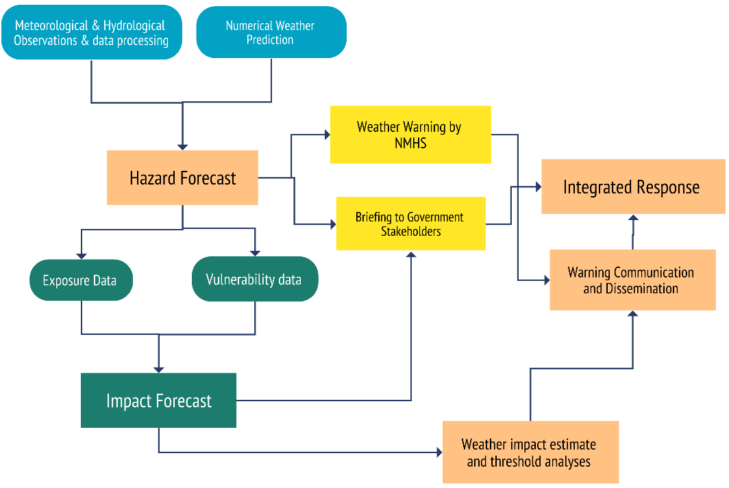
Figure 7 : National hydrometeorological service (NMHS) workflow diagram for IBF(Source: Z M Sajjadul Islam, UNDP-GCF)

4.0 Chapter: Data Coordination and Exchange Mechanisms

4.1 Data Coordination and Exchange Mechanisms at Aimag level :

The objectives of this exclusive coordination and exchange mechanism are to strengthen the IBF's pivotal roles in establishing and improving dataflows required for ongoing forecast impact analysis, weather warning, alerting, multi-hazard early warning, severe weather forecasts dissemination, facilitating interactive and effective communication, functioning coordination for exchange of disaster emergency data and information on on-set disaster events at the local level, and subsequently preparing early action protocol(EAP), early warning early actions and event situation report on the occasion of disaster being declared by the government.
The IBF mandate is to Improve the disaster risk management governance at multiple levels following through the top-down & bottom-up approach with the following technical objectives :
- Delegating process, guidelines, strategies to aimag/soum/bag local government ( EOC /situation room at aimag), NHMS organizations (NEMA, Met Agency, vulnerable sector departments, hydrological organizations, local governments ) on conducting multi-hazards risk & vulnerabilities analysis, the repository of multi-hazard risk database & corresponding GIS Map at all administrative level.
IBF at the UB needs to delegate and propagate strategy, process, and activities to conduct comprehensive risk and vulnerability assessment at national, regional/aimag /soum/bag level and to develop risk repository and informed tools which are essentially required for having risk scenario/phenomena, GIS multi-hazard risk & vulnerability distribution map readily available in hand. These mandatory tools are necessary for impact analysis of the multi-hazard triggered by extreme weather events.
- Develop GIS base map on aimag/soum/bag jobs to aimag EOC( Situation room) for supporting IBF hub :

IBF forecasting team to supply the forecast CSV files on a regular interval. The synoptic engineer/forecasters at aimag EOC ( Situation room) need to call a briefing session over the supplied CSV /forecasted map and organize forecast briefings about the high impact of impending hazards over the sectors, sectoral elements, herders, livestock, etc.

Interpret impacts of weather with GIS maps of aimag : IBF central( NAMEM HQ) to delegate responsibilities to aimag level emergency operations center ( EOC) /Situation room for preparing impact forecasts ahead of 5 days and giving the threshold of 5 days amount of precipitation accumulation with the projection of rainfall color-coded level of warnings and advisories, temperature anomalies, advisories of strong winds and other multi-hazards.

- Functioning EOC/Situation room under SOP:

- Establish a coherent coordination mechanism over the standing orders on disaster (SoD) for the engagement of stakeholders at the local level.
- Conduct multi-hazard risk screening, assessment of disaster damage and needs, data capture, and information coordination.
- Utilizing an open-source GIS platform( geonode and geoserver) Aimag EOC/Situation room to remain operational in risk screening, data & information capture, and coordinating the datasets, and information to NAMEM HQ.

- Developing & conducting interactive forums over the social networks

- Utilize the social networking platform for inclusive interactive participation of audiences.
- Taking feedback from stakeholders, focal points, and vulnerable communities for further customization and improvement of products and services for meeting the demand.
- The development, access, and use of the best science and new ICT technologies underpin all components of multi-hazard early warning systems.
- The feedback that learning from good practices of understanding & receiving early warnings by the vulnerable community from the remote & hard-to-reach areas.
- Strengthening the Early Warning for Early Action (EWEA) chain, taking on an impact-based forecasting approach in early warning to enable organizations and communities to formulate understandable and actionable messages and take respective preparedness and response measures.
- Upgrading the web portal for customization to capture disaster event information at the up-to-date level.

- AWS weather station set up with telecommunication BTS for uninterrupted data transmission: Singing MoU with cell phone companies and using their BTS for installing a few instruments and using the network for data transmission.

Figure 8 : The typical architecture and data flow diagram of the IBF Open-Source platform (Source: Z M Sajjadul Islam, UNDP-GCF)

- Crowdsourced observation :
The crowdsourced observation can play a significant role as an informal weather station observer while supplying them weather parameter observation instruments e.g. thermometers, handheld anemometers, rain/snow gauging instruments (modular, handheld ), and those are installed at tourist resorts, community houses, offices buildings at the riverside ( lower flood plain areas), the permanent settlement at hard reach areas, logistics transporter, herders, livestock office, agricultural office, forest office( forest ranger), local government office, and fixed installations ( telephone/ cell phone towers), etc.
On the other hand, volunteer groups are mandated to provide weather and hazard incidence information via Android phone apps to the IBF server. On many occasions, comprehensive ground-level observations are required to understand what type of impact and L & D are taking place on the ground, the potentiality of turning impending extreme weather events into multi-hazards( e.g., severe cold temperate and winter storms), and induced disaster on the ground, the extended lead-time for dissipation, etc. The crowdsourced network is to be utilized to capture up-to-date incidence and scenarios of the trail of damage level and extent areas where extreme/hazardous events are prevailing, the magnitudes and intensity, and the level of impacts over the livelihoods and elements.
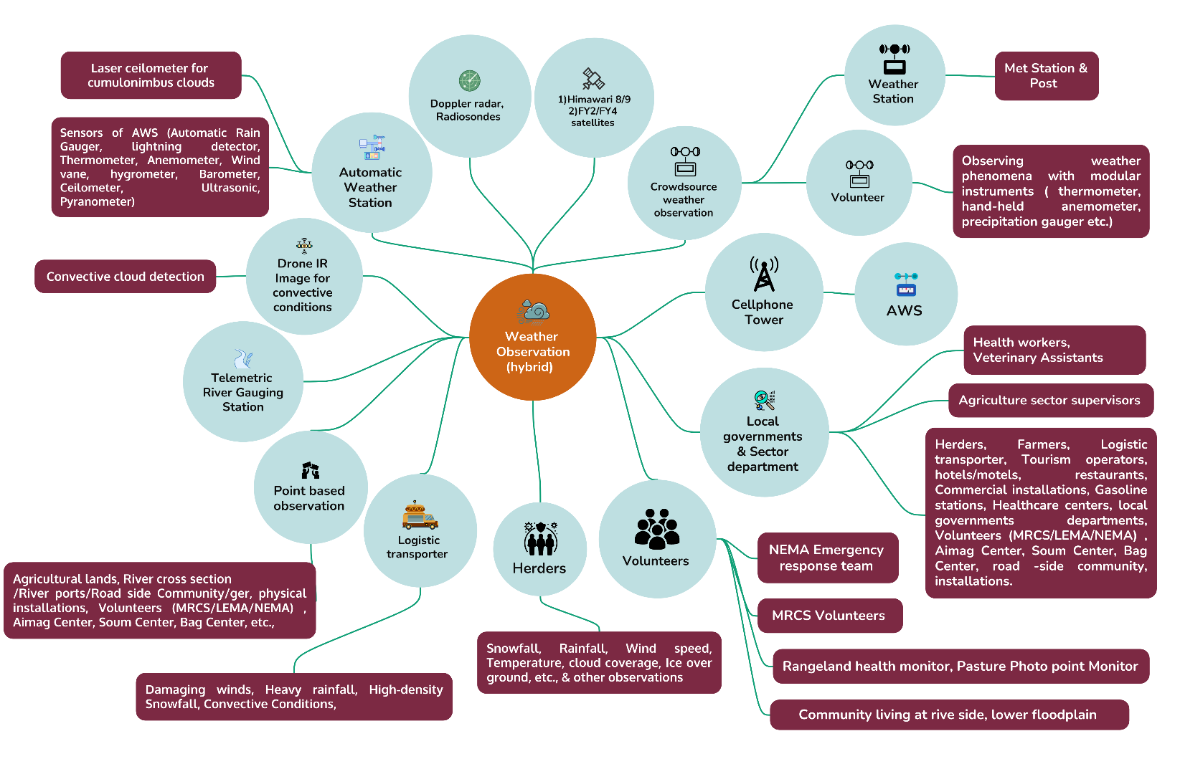
Figure 9 : Proposed hybrid - high-density, nested, and crowdsource-based surface weather observation and incidence monitoring system(Source: Z M Sajjadul Islam, UNDP-GCF)

Crowdsourced observation should function as a strong communication channel by enabling “social journalism” that expands the coverage of field observations and informs the NMHS about the scale, intensity, frequency, and spatial patterns of impacts, including loss-and-damage (L&D) facts and figures. This volunteer-driven, social observation process can track evolving conditions and provide timely inputs for real-time early warning and alerting across the full lifecycle of extreme and hazardous weather events. It also strengthens situational awareness by documenting incident locations, impact severity, and L&D scenarios as conditions unfold over large geographic areas.
The IBF Technical Working Group (TWG) should organize and manage the crowdsourced observation team, conduct orientation and basic training, and provide the necessary applications and tools to enable structured information feeds. The table below illustrates the ICT tools and processes of the IBF system, emphasizing open-source, interactive mechanisms for information access, contribution, and sharing.

Table 4: In situ and Crowdsourced impending hazard observation tools and Techniques :
Crowdsourced observation of the events | Designated observer | Devices & apps to be utilized | Types of data need to send IBF platform | Interactive crowdsource data collection tools
Herder camp location (base camp and other seasonal camps) | Herders / Community | - Field observation instruments: Thermometers, handheld anemometers, and rain/snow gauges.  - Mobile data collection applications, GPS Logger, KoboToolbox, GPS Essentials, Leaflet, OpenLayers, and QField.  - Google Cloud applications: Cloud-based storage and sharing tools for uploading and exchanging field data (photos, videos, KML/KMZ, survey outputs). Mobile apps, UHF/VHF Radio receiver at the community level.  - Pasture Data collection 1516 rangeland health monitoring sites. Photo-point monitoring for grazing management impacts: ALMGaC operates a photo-point monitoring system | Share geolocation data, photos from the hazard site, descriptive notes on impacts, and loss-and-damage information for affected elements. | Mobile apps, social networks ( WhatsApp group, Viber, Telegram, Facebook Page/Group, community Radio station, local news agency, sector departments etc ( Figure 9)
Livestock forage shortage | - Herders  - Pasture management committee  - Rangeland health monitor
High-density snowfall and thick snow over the ground | - Herders  - Pasture management committee  - Rangeland health monitor  - Aimag, Soum, Bag centers
Depth of Icing over the biomass pastureland | - Herders  - Pasture management committee  - Rangeland health monitor  - Community
Avalanche | - Herders  - MRCS volunteers  - LEMA/NEMA volunteers and emergency rescue teams  - Sector department technicians  - Rangeland health monitors  - Weather station observers  - Logistics operators (drivers) | - Use real-time detection in critical corridors (roads, rail, settlements).  - Use cameras for confirmation where visibility allows.  - Use Sentinel-1 SAR mapping to build event inventories and improve model verification and seasonal reporting.  - Publish detections as geolocated points/polygons to GeoNode/GeoServer and trigger threshold-based warnings/CAP alerts through the IBF dissemination chain.  - Detects moving snow mass reliably day/night and in all weather, typically focused on known avalanche paths or corridors; can also provide dynamics such as velocity depending on radar type.  - Infrasound detection (single sensors or arrays)  - Detects low-frequency sound waves generated by avalanches and can operate in poor visibility; commercial and research systems report detection over multi-kilometre ranges depending on terrain and setup.  - Seismic (geophones) / seismo-acoustic systems  - Detects ground vibration signatures; commonly combined with infrasound to improve reliability and localization in complex terrain.  - Fixed optical cameras (time-lapse/real-time) with automated detection (optional)  - Useful for confirmation and situational awareness, but performance is constrained by visibility; ML methods are increasingly used to automate detection in ground-based imagery.
Flooding | - Riverbank and lower floodplain communities  - Herders  - MRCS volunteers  - LEMA/NEMA volunteers and emergency rescue teams  - Sector department technicians  - Rangeland health monitors  - Weather station observers  - Aimag centres  - Soum centres  - Bag centres | In-situ hydrological monitoring (fastest confirmation at local scale)  - Stream/river gauges (streamgages): fixed stations that measure water level (stage) and derive discharge/streamflow using site-specific rating curves core for flood detection and verification.  - Water-level sensors at bridges/culverts:  - Non-contact radar level sensors (robust during debris-laden floods; measure distance to water surface).  - (Often complemented by pressure/ultrasonic sensors where appropriate selection depends on debris, icing, and site access.)  - Rain gauges and snow measurements: to detect intense rainfall and rapid snowmelt drivers that precede river rise (especially critical for flash flooding).  2) Meteorological driver detection (what triggers floods)  - Weather radar (where available): detects high-intensity rainfall cells for short-lead flood/flash-flood triggering.  - Satellite precipitation products: provide rainfall estimates where radar coverage is limited (commonly used as forcing for global/continental flood monitoring models).  3) Remote sensing flood mapping (spatial extent of inundation)  - SAR (Synthetic Aperture Radar), especially Sentinel-1: strong for flood extent because it works day/night and through clouds, enabling rapid inundation mapping.  - Optical satellite imagery (Sentinel-2/Landsat/MODIS): useful for mapping where cloud conditions allow; often used for situational reporting and damage/impact interpretation.  - UAV/drone mapping: high-resolution mapping of inundation, embankment breaches, blocked drainage, and localized impacts (useful for critical sites and post-event assessments).  4) Automated/global flood monitoring products (near real-time “detection layers”)  These are useful as baseline situational awareness and for areas with sparse gauges:  - NASA near real-time global flood products (flood mapping delivered rapidly after satellite overpass).  - NASA Global Flood Monitoring System (GFMS): model-driven flood detection/intensity using satellite precipitation as forcing.  - Copernicus EMS Rapid Mapping: on-demand event mapping for disasters (including floods), delivering geospatial products for response.  - Copernicus GloFAS , Global Flood Monitoring (GFM): combines global flood forecasting with an operational near real-time flood monitoring component based on Sentinel-1 SAR processing.  5) Crowdsourced and field evidence (last-mile detection and impact confirmation)  - Mobile reporting (photos/videos , GPS), structured surveys (e.g., KoboToolbox), and hotspot mapping: strengthens coverage in remote areas and provides loss-and-damage evidence and “what is happening now” confirmation. Evidence-based crowdsourcing is widely used to complement physical sensors and official monitoring.  6) Operational integration for IBF (turn detection into action)  - Ingest and archive observations, satellite flood layers, and incident reports into the SQL/PostGIS data hub.  - Publish flood layers (extent polygons, depth grids, exposed elements) via GeoNode/GeoServer services for partners.  - Trigger warnings/alerts using defined thresholds and, where applicable, issue CAP-enabled public alert products aligned with national protocols.
Thunderstorms are likely | - Herders  - Aimag, soum, and bag centres  - MRCS volunteers  - LEMA/NEMA teams and volunteers  - Sector department technicians  - Rangeland health monitors  - Weather station observers  - Logistics transport providers (drivers)  - Riverbank and lower floodplain communities | 1) Weather radar (Doppler radar)  - Detects convective cells via reflectivity (storm intensity/structure) and Doppler velocity (wind shear, rotation, gust fronts).  - Key outputs for detection/nowcasting: cell tracking, echo tops, VIL, hail signatures, storm motion, severe indicators.  2) Lightning detection systems  - Ground-based lightning networks (national/regional sensors) detect and locate cloud-to-ground and (often) intra-cloud lightning in near real time.  - Useful outputs: strike location/time, flash rate, “lightning jump” signals for rapid intensification, verification of active thunderstorms.  3) Satellite (geostationary , polar-orbiting)  - Detects convective initiation and evolution using cloud-top temperature, rapid cooling rates, overshooting tops, and anvil expansion.  - Strong value where radar coverage is limited; supports wide-area monitoring, especially for remote regions.  4) Surface observation networks (AWS , manual stations)  - Detect thunderstorm-related signatures: pressure jumps, wind gusts, temperature drops, heavy rainfall, hail reports, and visibility reduction.  - Essential for ground truth and for linking “hazard” to “impact” in IBF.  - Specialized / supplementary tools (high value in IBF)  5) Electric field mill (EFM) / atmospheric electricity sensors  - Measures changes in the near-surface electric field to indicate lightning potential and electrification trends near critical sites.  6) Automated camera / sky imager , human observation  - Visual confirmation of storm base, shelf clouds, hail, and damage; useful for last-mile validation (limited by visibility and night conditions unless IR-capable).  7) Acoustic infrasound / thunder sensors (limited deployments)  - Can support detection/confirmation in specific settings, but usually secondary to lightning , radar.  8) Crowdsourced reporting (photos/videos , GPS)  - Confirms the impacts of thunderstorms (hail size, wind damage, flash flooding, lightning impacts) and extends coverage into areas without dense instrumentation.  - Recommended “minimum operational stack” for IBF/MHEWS  - Radar (where available) , lightning detection , satellite, AWS/manual observations, supplemented by crowdsourced geotagged reports.  - Publish detected cells/strike density/impact reports as points/polygons to GeoNode/GeoServer, and trigger threshold-based advisories/warnings (and CAP alerts where applicable).
Thunderstorm just started | - Herders  - Aimag, soum, and bag centres  - MRCS volunteers  - LEMA/NEMA volunteers and emergency rescue teams  - Sector department technicians  - Rangeland health monitors  - Weather station observers  - Logistics operators (drivers)
Convective weather conditions developed | Weather observers, Herders, MRCS, LEMA/NEMA, NAMEM technicians, sector department technicians, Rangeland health monitors, Weather station observers,  Logistic transporters (drivers), river port operators, Fuel stations, roadside settlements, farmers, value chain operators, fishermen |  | - Sharing geolocation, pictures of hazards side, description notes on impacts, loss and damage of any elements
Heavy rainfall started | Weather observers, Herders,  Aimag/Soum & Bag centers, MRCS, LEMA/NEMA, NAMEM technicians, sector department technicians, Rangeland health monitors, Weather station observers,  Logistic transporters (drivers), river port operators, Fuel stations, roadside settlements, farmers, value chain operators, fishermen
Heatwave | Weather station observers, Herders, MRCS, LEMA/NEMA, NAMEM technicians, sector department technicians, Rangeland health monitors, Weather station observers,  Logistic transporters (drivers), river port operators, Fuel stations, roadside settlements, farmers, value chain operators, fishermen | - Water-level measuring telemetry sensor/scale  - Field observation automated sensors instruments: Thermometers, handheld anemometers, and rain/snow gauging instruments | - Sharing geolocation, pictures of hazards side, description notes on impacts, loss and damage of any elements
Snowstorm started | Weather station observers, Aimag, Soum, Bag centers , Herders, MRCS, LEMA/NEMA, NAMEM technicians, sector department technicians, Rangeland health monitors, Weather station observers,  Logistic transporters (drivers), river port operators, Fuel stations, roadside settlements, farmers, value chain operators, fishermen | - Android GPS Logger  - GPS Essential apps for location  - Map layer apps  - Leaflet apps  - VGI apps  Google cloud apps | - Sharing geolocation, pictures of hazards side, description notes on impacts, loss and damage of any elements
Vehicle stranded, structure collapsed, water control structure damaged, road damaged | Logistic transporters, Herders, MRCS, LEMA/NEMA volunteers/emergency rescuers, NAMEM technicians, community volunteers | - Android GPS Logger  - GPS Essential apps for location  - Map layer apps  - Leaflet apps  - VGI apps  Google cloud apps | - Sharing geolocation, pictures of hazards side, description notes on impacts, loss and damage any elements
Strong winds(wind speed exceeds 24 m/s in the mountainous areas and 28 m/s in the plains, is a catastrophic weather phenomenon) , dust storms, and snow storms. |  | - Android GPS Logger  - GPS Essential apps for location  - Map layer apps  - Leaflet apps  - VGI apps  Google cloud apps | - Sharing geolocation, pictures of hazards side, description notes on impacts, loss and damage any elements

- Mandating aimag/soum for conducting risk and vulnerability survey (CRVA) and Repository/ Database/ atlas development :
Develop baseline risk and vulnerability tools.

- Loss-and-damage and socio-economic vulnerability repository
Develop and maintain a repository of historical loss-and-damage scenarios and socio-economic vulnerability data, including household structure characteristics, coping capacity, disaggregated vulnerable population groups, exposed livelihood assets, elements-at-risk inventories, geolocations, and associated vulnerability attributes.
- Infrastructure damage and recurrent hotspot repository
Develop a repository of past infrastructure damage scenarios and georeferenced hotspot locations that are recurrently affected.
- Elements exposure, risk, and vulnerability repository (Annexure 1)
Develop a repository covering exposure, risk, and vulnerability profiles for all elements inventoried in Annexure 1, linked to geolocation and relevant attributes.
- Flood- and landslide-induced infrastructure L&D and hotspot repository
Develop a repository of flood- and landslide-induced loss/damage and hotspot locations for physical infrastructure, including communications and other critical structures.
- Riverbank and drainage erosion hotspot repository
Develop a repository of hotspot locations related to riverbank and drainage-channel erosion, including riverbank erosion; road and rail line erosion/damage; road washouts; paved-road flooding; road/rail segment inundation; and damage to built-up/built-in structures and infrastructure.
- Flood risk and evacuation planning maps
Develop flood-prone area risk maps and identify safe evacuation areas, including flood-proof and stable high ground, and the locations of flood shelters designated for evacuation.

Chapter : Aimag Emergency Operations Center (EOC) / Situation Room

An aimag centre is the most functional subnational government structure at the provincial level and serves as the administrative hub for frontline local government entities approximately 330 soums and 1,630 bags. Many central government services have been decentralized to the aimag level, and all 21 aimags are connected to national communications infrastructure, including telecommunications networks and optical fiber connectivity.
At the aimag level, the principal executive authority is the Governor. Governors represent the State and report to the corresponding higher-level Governors. The aimag (and city) Governor is nominated by the respective khural and appointed by the Prime Minister. Each aimag Governor’s Office typically includes, in addition to the Governor and Vice-Governor, the following functional units and officers:
- State Administration Department
- Legal Department
- Production, Trade, Agriculture, and Environment Department
- Financial and Economic Policy Department
- Social Policy Department
- Environment and Agriculture (livestock and crop agriculture) function
- Head of the Governor’s Office
- Social Development Officer (education and health)
- Agriculture and Environment Officer
- Social Care Officer (poverty reduction, employment, and social care)
- Operations Officer
During critical hazardous weather such as snowstorms, blizzards, floods, and flash floods physical access to hard-to-reach and remote areas can be severely constrained, and local communication networks may be disrupted or fail entirely. Under such conditions, emergency radio and telecommunications systems (notably those managed by NEMA) may become the only viable means of reaching isolated communities and individuals at risk.
In this context, IBF trigger mechanisms supported by anticipatory impact assessments and indicative loss-and-damage estimates are intended to enable early action under Forecast-based Financing (FbF) by activating predefined protocols linked to high-impact forecasts and mobilizing resources for vulnerable herders, remote communities, and exposed sectoral elements. To operationalize these triggers and accelerate resource mobilization, Mongolia requires an IBF-informed FbF decision-support dashboard that supports rapid risk-financing decisions during the early onset of extreme weather events.

Mandating an Emergency Operations Center (EOC) / Situation Room at the Aimag Center:

- The aimag-level EOC/Situation Room should serve as a decentralized and localized mechanism for conducting CRVA; developing and updating risk repositories and databases; preparing and maintaining a GIS-based risk atlas; and coordinating the collection, collation, tailoring, and dissemination of localized weather and climate information services. Given that climate-frontline populations and exposed elements are geographically dispersed across soums and bags, local governments are well positioned to lead delegation, coordination, and sector-integrated CRVA processes, localized impact analysis based on forecasts, and forecast verification activities.
- Aimag-level NEMA, NAMEM, MRCS, and sector departments should jointly operationalize the EOC to support impact forecast preparation, weather warning and alerting, incident tracking, operationalization of the Incident Command System (ICS), multi-hazard hotspot tracking, and activation of the crowdsourcing network for weather and impact information collection, with structured reporting to the centralized IBF platform in Ulaanbaatar.
- The EOC’s functional approach should reflect Mongolia’s four climatic regions, recognizing that weather patterns and associated impacts vary significantly by region. To address this meteorological diversity and spatially varying risk and vulnerability profiles, the IBF system requires localized CRVA datasets aligned with region-specific impact pathways, alongside high-resolution gridded forecasts provided to aimag authorities to assess potential impacts across the full aimag-soum-bag geography.
- The EOC should capture real-time ground conditions and track multi-hazard incidents throughout the lifecycle of high-impact forecasts, including the progression of impacts, severity levels, and associated loss-and-damage to exposed elements. The EOC should also maintain records of cascading or post-disaster effects (e.g., outbreaks of disease or pandemic-related impacts) affecting humans, livestock, and other vulnerable elements.
- The EOC should be mandated to provide tailored decision-support tools to response teams during disaster onset, including rapid collection of incident and situation updates and crisis information to enable timely decisions and effective communication with local, national, and external stakeholders.
- The EOC should be operationally linked to the IBF early warning system through a common online platform to enable real-time communication, data exchange, and coordinated dissemination.
- The EOC should use technology and applications that allow responders and partners to report incidents via mobile devices, including GPS locations and supporting imagery, to strengthen situational awareness and improve response coordination.

5.2 Aimag level NAMEM human resources :
Typically, manpower varies from 45 - 100 depending on the size and economic performance of aimag . For functioning the IBF - the whole team, other sector departments, local stakeholders need collaborative activities.
Table 5: NAMEM Aiamg Team
Province name | Position / All/
Province name | Position / All/ | Number
Meteorological office for Bayan-Olgii | General director | 1
Meteorological office for Bayan-Olgii | Head of Finance | 1
Meteorological office for Bayan-Olgii | Head of Meteorology and environment division | 1
Meteorological office for Bayan-Olgii | Head of Information and service division | 1
Meteorological office for Bayan-Olgii | Synoptic engineer | 1
Meteorological office for Bayan-Olgii | Coordinator of Archive and Information | 1
Meteorological office for Bayan-Olgii | Engineer for Network technology | 1
Meteorological office for Bayan-Olgii | Engineer for Cloud seeding | 1
Meteorological office for Bayan-Olgii | Engineer for weather and climate | 1
Meteorological office for Bayan-Olgii | Senior engineer for weather and climate | 1
Meteorological office for Bayan-Olgii | Engineer for Agrometeorology | 1
Meteorological office for Bayan-Olgii | Manager for Laboratory of nature environment | 1
Meteorological office for Bayan-Olgii | Engineer for water technology | 1
Meteorological office for Bayan-Olgii | Engineer for researching frost | 1
Meteorological office for Bayan-Olgii | Senior engineer for researching frost | 1
Meteorological office for Bayan-Olgii | Sinoptic engineer | 4
Meteorological office for Bayan-Olgii | Senior engineer for weather and climate | 1
Meteorological office for Bayan-Olgii | Senior engineer for Agrometeorology | 1
Meteorological office for Bayan-Olgii | Senior manager for Laborotary of nature environment | 1
Meteorological office for Bayan-Olgii | Senior engineer for water technology | 1
Meteorological office for Bayan-Olgii | Senior coordinator of Archive and Information | 1
Meteorological office for Bayan-Olgii | Senior engineer for Aviation meteorology | 1
Meteorological office for Bayan-Olgii | Seniour engineer for Cloud seeding | 1
Meteorological office for Bayan-Olgii | Manager for Laborotary of nature environment | 1
Meteorological office for Bayan-Olgii | Seniour engineer | 7
Meteorological office for Bayan-Olgii | Engineer for Aviation meteorology | 2
Meteorological office for Bayan-Olgii | Engineer for Network | 1
Meteorological office for Bayan-Olgii | Engineer for Shift work | 4
Meteorological office for Bayan-Olgii | Observer for Sagsai-Buyant water post | 1
Meteorological office for Bayan-Olgii | Paymaster | 1
Meteorological office for Bayan-Olgii | Document/human resources officer | 1
Meteorological office for Bayan-Olgii | Driver | 1
Meteorological office for Bayan-Olgii | Guard | 1
Meteorological office for Bayan-Olgii | Clearer | 1
Total |  | 47

5.3 Structure of the Aimag EOC / Situation Room

Typically, the aimag (province) serves as the nerve centre of Mongolia’s local governance system, hosting decentralized sector departments, services, and key installations. At the aimag level, NAMEM and NEMA (through LEMA) will jointly operate the Situation Room/Emergency Operations Center (EOC) to deliver decentralized preparedness, coordination, and response functions for impending hazardous weather emergencies.
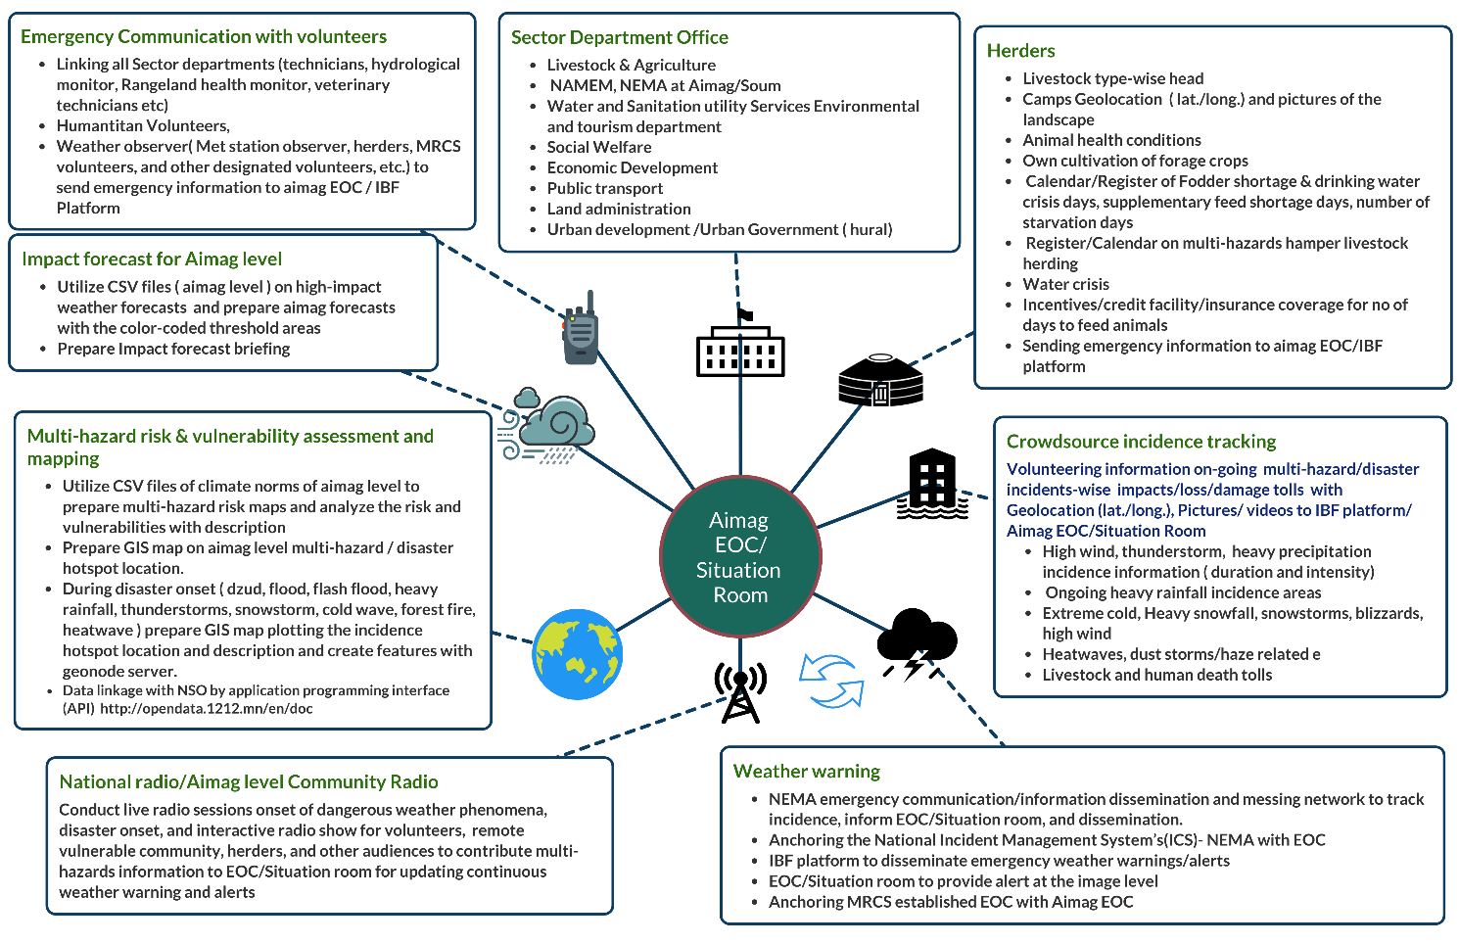
Figure 10: Aimag level IBF functionaries, data coordination structures of the EOC/situation room(Source: Z M Sajjadul Islam, UNDP-GCF)

Functions of EOC / Situation Room :

a) During normal (non-emergency) periods
- Establish IBF baseline prerequisites: Maintain a comprehensive ground-level risk and vulnerability repository and a GIS-based risk atlas covering the elements listed in Annexure 1.
- Develop sector risk and incident databases: Sector departments should develop and routinely update a climate risk and vulnerability database, multi-hazard risk profiles for sectoral elements, and a disaster incidence database. These datasets should identify priority vulnerable pockets that require focused IBF analysis and facilitate translation of hazard forecasts into impact forecasts.
- Maintain element-specific exposure and sensitivity repositories: Prepare and update repositories describing sectoral element exposure, risk, vulnerability, and sensitivity (e.g., crop agriculture, livestock, livelihoods, water resources, natural resources). These datasets should enable precision impact assessment under weather extremes such as extreme cold/heat, snowstorms, damaging winds, precipitation anomalies, and temperature anomalies.

- At the onset of hazardous weather events
- Crowdsourced data collection for emergency management: Coordinate with aimag-level volunteers to communicate response priorities, gather real-time situational awareness, and support operational decision-making for FbF activation.
- Strengthen hazard detection and monitoring: Through an effective hybrid observation system and a nested volunteer network, enable the EOC/Situation Room to collect and relay multi-hazard information from remote and hard-to-reach areas.
- Establish a crisis information management database (MIS): Develop and maintain a crisis information management system and a continuously updated multi-hazard incident database.
- Develop and operationalize Standard Operating Procedures (SOPs): Prepare SOPs for aimag government actors, sector departments, and stakeholders to guide data and information coordination, reporting pathways, and decision triggers during emergencies.
- Develop Incident Action Plans (IAPs): Continuously monitor evolving conditions and prepare emergency response plans and IAPs to manage disaster situations. Issue IBF products supported by anticipatory, assumption-based (hypothesis-driven) impact and loss-and-damage assessments to enable early action under FbF and mobilize resources for remote victims, vulnerable herders, communities, and exposed sectoral elements. To trigger FbF rapidly, Mongolia requires a well-defined, risk-informed protocol that can be activated at the earliest onset of extreme weather events.
- Activate emergency communications and frontline dissemination: During severe conditions such as snowstorms, blizzards, floods, and flash floods when physical access is constrained and local networks may fail, activate emergency radio, wireless, and telecommunications tools as primary channels to reach people at risk and to maintain operational coordination.

- Comprehensive support for post-disaster response and recovery
- Mandate joint EOC operations by aimag NEMA (LEMA) and NAMEM to capture post-disaster loss-and-damage (L&D) scenarios and quantify affected populations, including those in hard-to-reach areas.
- Conduct joint Post-Disaster Needs Assessments (PDNA) to support rehabilitation planning, mobilize recovery financing, and inform risk-informed local development planning.

Technical Functions of EOC / Situation Room :

      - Aimag-level forecast impact analysis
- The core technical responsibility is to analyze sector impacts particularly forest and environmental impacts using high-resolution (1-5 km) gridded forecasts provided by NAMEM Headquarters.
- Crowdsourced information coordination and emergency data gathering
Mandate and operationalize a structured crowdsourcing mechanism during weather emergencies by establishing an aimag-level crowdsourcing network using tools such as Freeswitch caller apps, IP telephony apps, Mobile apps, Group WhatsApp, Telegram, Facebook, CallPro, KoboToolbox, SurveyMonkey, Suevey 123, Qfield etc . The network should connect vulnerable herders and communities, relevant stakeholders, enterprises, I-NGO projects, lead farmers, financing institutions, credit operators, and insurance companies to support risk information collection, risk communication, and event situation reporting.
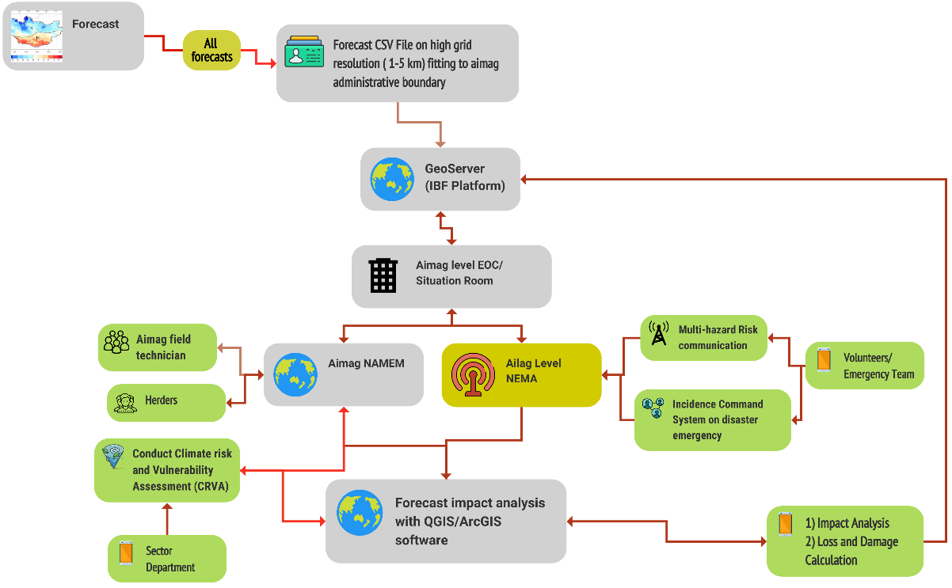
Figure 11: Forecast impact analysis of the Aimag level(Source: Z M Sajjadul Islam, UNDP-GCF)

Key technical functions include:
- Track multi-hazard conditions and impacts on the ground, including strong/damaging winds, cold/warm fronts, forest fires, thunderstorms, dust storms, snowstorms, blizzards, and heavy rainfall capturing prevailing conditions, evolving situations, and loss-and-damage figures.
- Conduct ground-level monitoring of slow- and medium-onset hazards, such as heatwaves, drought, snow/ground icing, and cold waves.
- Activate hybrid observations for rapid detection and tracking of convective systems and fast-developing weather, including: storm extent and wind impacts; sustained wind speeds; snowfall depth and intensity; extreme cold conditions; and dust storm development.
- Distribute modular observation instruments (e.g., thermometers, precipitation gauges, handheld anemometers) to herder households (gers) and designated volunteers to increase last-mile observation density.
- Install lightning detectors and other AWS sensors at high-value locations and critical nodes (aimag/soum/bag centres and other priority sites) to strengthen real-time detection capability.
- Mandate crowdsourced volunteers to remain alert and report weather emergency information, including geolocation-tagged photos, notes, and basic measurements when extreme conditions are imminent or unfolding.
- Collect geolocated information on livestock drinking-water access constraints during harsh weather conditions to support targeted response planning and prioritization.
. Establish Constant communication and monitoring of the herders/farmers/frontline community :
- Mandating cell phone companies for leveraging herders( volunteers) a free internet hour in every day to herders/emergency volunteers, remotely located MRCS, community volunteers, and another android phone for sending emergency data/information to IBF for updates.
- Mandate Herders/volunteers to provide quick updates of weather conditions to WhatsApp group: mandate herders for Sending sample pictures of herd size and health conditions, forage conditions, camp side conditions ( vulnerable to hazards - avalanche/floods/flash floods/landslide/debris fall/mudslide ?), landscape pictures of pastureland, the water access point for drinking water, etc.
- Organize group discussions with social network groups and ask herders for Sending pictures of multi-hazards anytime they face an emergency shelter.

Conducting live radio show for the vulnerable community during disaster onset
- Coordinating with national AM radio or Aimage-level AM radio broadcasts and organizing live radio talk shows to get situation and incidence updates from remote communities.
- Support national radio team for preparing broadcast advisories for herders travelers, value chain operators, herders, farmers, etc.
Liaising with NEMA-driven incidence command system (ICS ) for the event situation updates
- Incidence command system (ICS) : national & level, anchoring and integrating ICS with IBF, humanitarian network, sector network, NEMA CAP etc
- Anchoring NEMA emergency preparedness and response with IBF
- Pasture alert
- Forage shortage alert

      - Mandate Crowdsource information coordination and information gathering during weather emergencies:

Developing aimag level crowdsource network ( WhatsApp, Telegram, Facebook, CallPro, Kobo-toolbox, survey monkey, GPS logger, GPS essential) connecting all vulnerable herders, community, stakeholders, enterprises, I-NGO projects, lead farmers, financing institutions, credit operators, insurance companies, etc., for collecting risk information, risk communication, event situation updates, etc.
- Tracking of every multi-hazard on the ground e.g. strong winds, damaging winds, cold front, warm front, forest fire, thunderstorm, , dust Strom, strong winds, snowstorm, blizzards, heavy rainfall, etc. induced prevailing cold front conditions, ongoing situation, loss & damage figures.
- Conduct ground-level observations of any slow-medium onset hazards heatwave, drought, snow icing, cold wave, etc.
- Activating hybrid observations for instantly tracking a convective weather system /rapidly developing weather conditions in any given season, damaging winds ( area of extent) induced storm, constant windspeed, snowstorm, thick of snowfall, coldest temperate, dust storms, etc., monitoring,
- Providing modular weather instruments e.g. thermometer, precipitation gauging, and hand-held anemometer to be given to every ger, volunteer.
- Setting up lighting detector and other AWS sensors to high-value elements ( aimag/soum/bag center)
- Mandating crowdsourced volunteers to remain alerted to provide weather emergency information( to the network with geolocation) in given cases of extreme weather events are likely to impend or just started.
- Provide geolocation of livestock access to drinking water in harsh weather conditions

      - Establish Constant communication and monitoring of the herders/farmers/frontline community :
- Mandating cell phone companies for leveraging herders( volunteers) a free internet hour in every day to herders/emergency volunteers, remotely located MRCS, community volunteers, and another android phone for sending emergency data/information to IBF for updates.
- Mandate Herders/volunteers to provide quick updates of weather conditions to WhatsApp group: mandate herders for Sending sample pictures of herd size and health conditions, forage conditions, camp side conditions ( vulnerable to hazards - avalanche/floods/flash floods/landslide/debris fall/mudslide ?), landscape pictures of pastureland, the water access point for drinking water, etc.
- Organize group discussions with social network groups and ask herders for Sending pictures of multi-hazards anytime they face an emergency shelter.

      - Conducting live radio show for the vulnerable community during disaster onset
- Coordinating with national AM radio or Aimage-level AM radio broadcasts and organizing live radio talk shows to get situation and incidence updates from remote communities.
- Support national radio team for preparing broadcast advisories for herders travelers, value chain operators, herders, farmers, etc.

      - Liaising with NEMA-driven incidence command system (ICS ) for the event situation updates
- Incidence command system (ICS) : national & level, anchoring and integrating ICS with IBF, humanitarian network, sector network, NEMA CAP etc
- Anchoring NEMA emergency preparedness and response with IBF
- Pasture alert
- Forage shortage alert

6.0 Chapter : IBF Forecasting Process

Rapid climate variability globally and particularly in Mongolia has made weather patterns increasingly dynamic and spatially heterogeneous. Weather conditions can change rapidly (every 15-30 minutes, hourly, and across diurnal cycles), generating highly eventful spatiotemporal hazard patterns. These conditions can trigger multiple hazards, including diverse forms of Dzud, flooding and flash flooding, drought, and severe winter events such as snowstorms, blizzards, and heavy snowfall. The resulting impacts can impose significant loss-and-damage costs on livelihoods and socio-economic sectors. Given Mongolia’s strong dependence on livestock and agriculture, climate extremes pose a substantial risk to economic performance and community resilience.

To address these challenges, Mongolia requires a strengthened meteorological and forecasting system capable of responding to rapid hourly and diurnal variability. This includes upgrading forecasting operations; closing observation gaps through expanded automated weather station (AWS) coverage; deploying standalone, modular, and handheld instruments at the frontline; capturing higher-density weather and incident datasets; developing and operationalizing algorithms and dynamical downscaling capabilities to track sudden-onset phenomena; and improving NWP and operational forecasting for high-value elements and priority sectors.

6.1 Undertake operational shift from traditional forecast to integrated Impact-based forecasting (IBF ) , warning, and alerting.

Mongolia’s agriculture sector, particularly livestock, one of the country’s largest contributors to GDP, is among the hardest hit by increasingly variable and extreme weather patterns. As a result, robust, effective, and high-precision real-time climate information services have become essential for climate-resilient sector development planning, budgeting, selection of climate-adaptive investments and schemes, and strengthening the rural economy.

However, the existing forecasting system covering observation networks, data acquisition, processing, and real-time warning remains insufficient to meet the requirements for decentralized and localized, sector-specific operational forecasting, impact-informed warnings, and a fully operational multi-hazard early warning system. These capabilities are critical to provide decision-relevant tools that enable forecast-based financing, risk-informed local development, and sectoral planning.

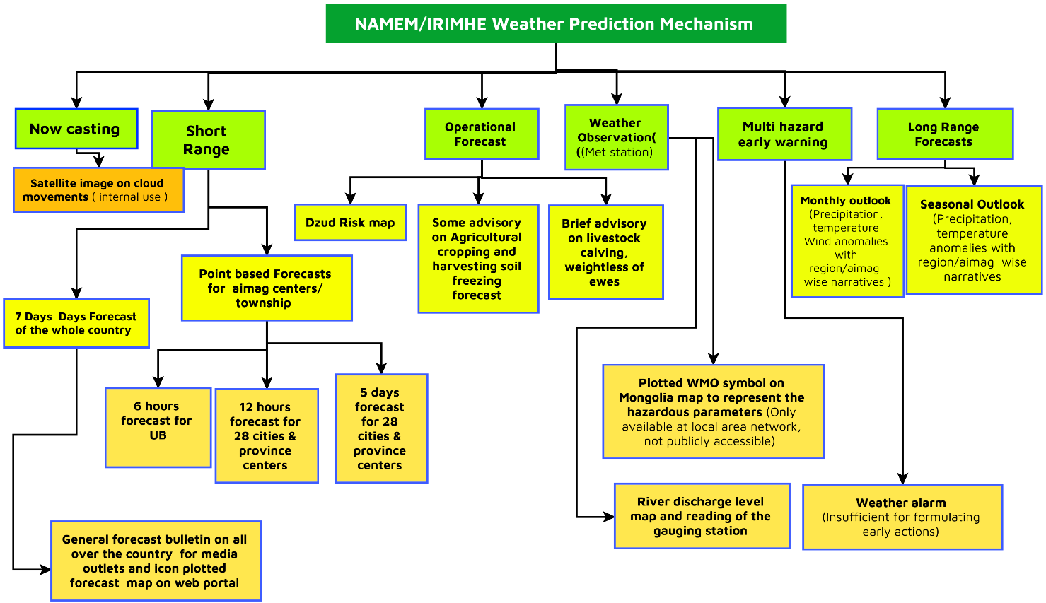
Figure 12: Current set of forecasting mechanism ( MANEM)

Transitioning from traditional, centrally produced “whole-country” forecasts to decentralized, local-level impact-based forecasting (IBF) requires an operational redesign of the full forecast value chain. The shift is not only about improving meteorological accuracy; it is about creating an end-to-end process that consistently translates hazards into localized, actionable impacts and supports warning-to-action decision-making.

Operational shifts in the forecast value chain (process highlights)

- Governance and mandate
- Establish clear institutional roles for national and subnational actors (e.g., NAMEM HQ as hazard producer; aimag EOC/Situation Room as impact interpretation and coordination node).
- Formalize partner data-sharing and operational protocols (SOPs, data standards, responsibilities, escalation pathways).
- Data acquisition and observation modernization
- Expand from station-only observations to a hybrid observation system (AWS , manual stations , crowdsourced ground truth).
- Implement automated ingestion, QC, and time-series archiving to support real-time decision needs.
- High-resolution hazard production
- Move from generalized national products to high-resolution gridded forecasts suitable for local interpretation (e.g., 1-5 km where feasible).
- Improve nowcasting and rapid-update capabilities for fast-evolving hazards (convective storms, blizzards, flash floods).
- Impact modeling and thresholding
- Define sector- and element-specific impact thresholds (red/orange/yellow/green) using exposure, vulnerability, and sensitivity datasets.
- Operationalize impact analysis workflows (forecast overlays, exposure counts, risk scoring, scenario narratives).
- Localized interpretation and decision support
- Enable aimag-level teams to tailor forecasts into location-specific impact statements, maps, and advisory actions aligned to local context.
- Integrate forecast interpretation with Incident Command System (ICS) workflows and EOC decision cycles.
- Warning and alerting integration
- Shift from “forecast dissemination” to warning-to-action products: advisories, warnings, and CAP-enabled alerts.
- Ensure multi-channel delivery (EOC briefings, telecom, broadcast, social platforms, partner networks) with last-mile reach.
- Operational coordination and feedback loop
- Establish continuous two-way flows: local incident reports and ground impacts feed back to forecasters; forecaster updates inform local actions.
- Capture user feedback systematically (herders, volunteers, sector agencies) to improve utility and clarity.
- Verification, learning, and improvement
- Implement routine forecast verification using observed conditions and incident/L&D records.
- Use post-event reviews (including PDNA) to refine thresholds, datasets, SOPs, and model bias corrections.

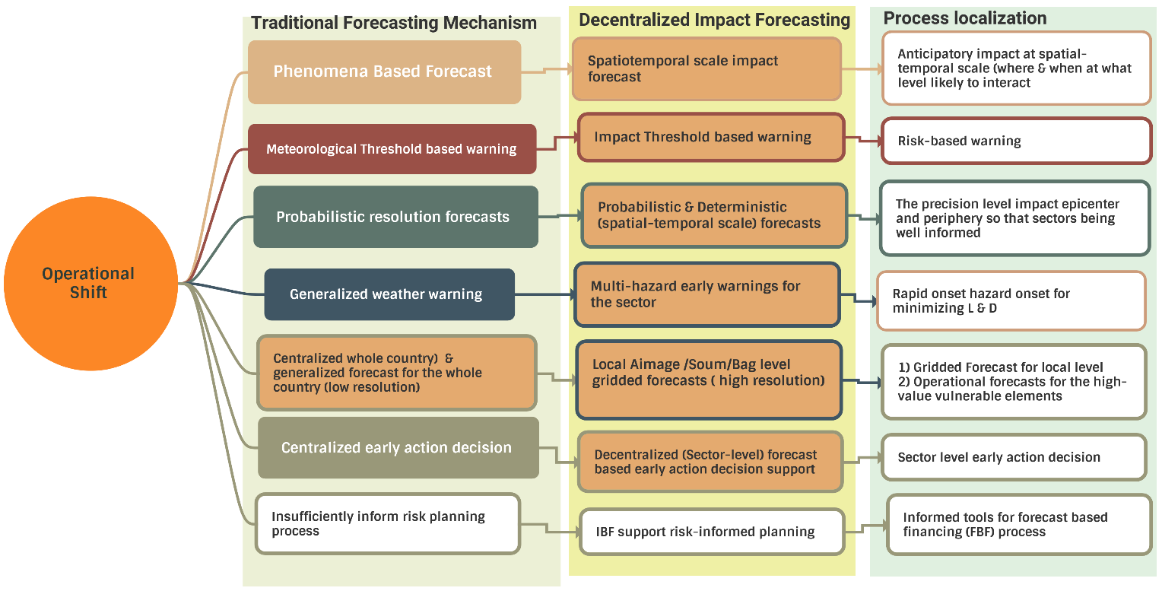
Figure 13: Operational shift from traditional forecasting to IBF process (Source: Z M Sajjadul Islam, UNDP-GCF)

6.2 The IBF Value Chain:

In Mongolia, where multi-hazard and climate vulnerabilities are pronounced particularly in remote and hard-to-reach areas there is a growing need for demand-driven weather and climate information services that go beyond conventional forecasts. An impact-based forecasting (IBF) platform is therefore envisaged to provide localized, actionable warning services aligned to sector needs and last-mile realities.

The proposed IBF structure comprises a multi-faceted, ICT-enabled value chain that links: high-resolution forecast generation, risk and vulnerability data integration, sector-specific impact analysis, and warning and advisory production to support anticipatory action and rapid decision-making. This end-to-end process is designed to strengthen early action protocols and enable timely forecast-based financing (FbF) mobilization for vulnerable communities and exposed socio-economic sectors.

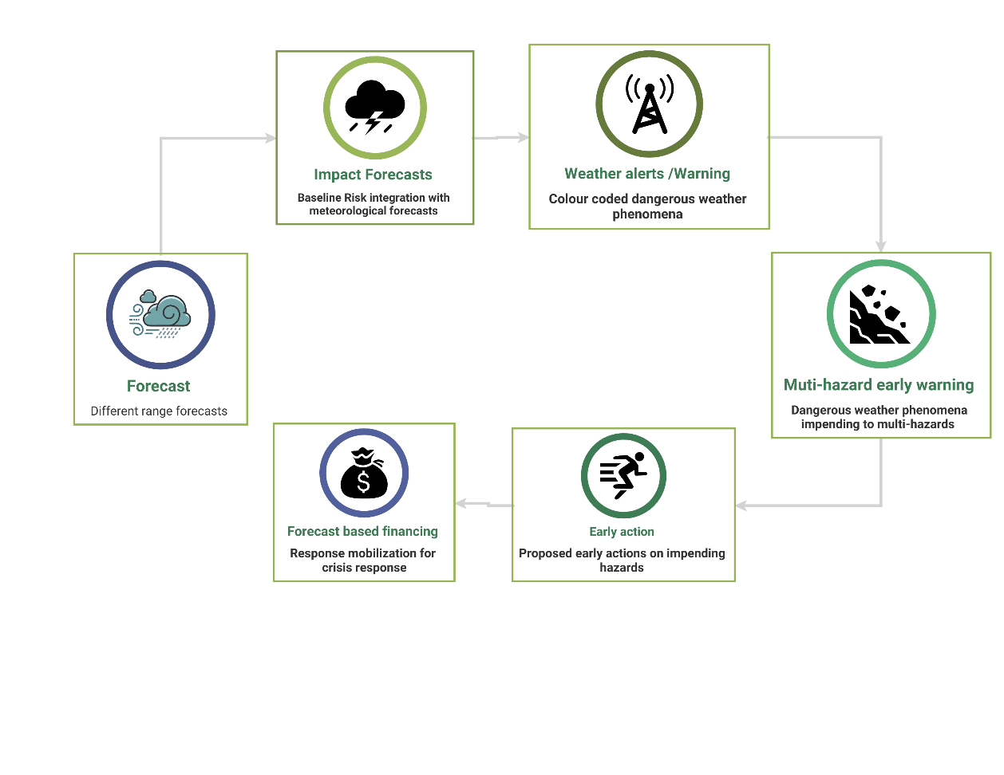
Figure 14 : IBF value chain (Source: Z M Sajjadul Islam, UNDP-GCF)

Requirement for long-rage weather outlook for initiating the IBF process :

The first step of the IBF process is to produce a seasonal forecast and provide an overview of expected seasonal variability and anomalies at an appropriate spatiotemporal scale. This outlook should be systematically reviewed to identify forecast anomalies, interpret their corresponding threshold levels, and diagnose which anomalies may lead to impending hazards.
The IBF Technical Working Group (TWG) should analyze the forecast REST-API, CSV outputs and determine impact thresholds for priority sectors to support preparedness and sustainable sectoral planning. IBF-based weather information services are intended to inform anticipatory decisions by clarifying when and at what intensity a hazard is likely to interact with the ground, where impacts may occur, which elements are exposed, and what level of anticipatory loss and damage may be expected. This supports early preparedness actions for hazards such as heavy rainfall and flood risk, or rainfall deficits that may lead to drought conditions.

Methodology :

- Interpret baseline climate risk scenarios (30-year climate norms) and analyze forecast-parameter anomalies using GIS software, applying colour-coded thresholds (red, orange, yellow) to map the spatial extent of areas likely to be affected.
- Prepare an aimag/soum/bag checklist for locations falling within each threshold zone, quantify projected precipitation and temperature departures relative to climate norms, and estimate the elements likely to be affected positively (favourable conditions) or negatively (adverse conditions).
- Produce operational forecasts and climate information services for priority sectors, including agriculture, livestock, water resources, and soil/land management.
- Conduct GIS-based anticipatory assessments of gross exposure, sensitivity, risk, and vulnerability for priority-sector elements.
- Organize seasonal outlook briefings to present the forecast, discuss expected seasonal patterns and anomalies, and align stakeholders on interpretation and preparedness actions.
- Scan the seasonal outlook and communicate plausible scenarios by outlining a range of potential climate conditions and shifts that may occur during the season ahead..

6.3 IBF preparation and forecasting process (New methodology) :

Step 1 : Prepare baseline weather /climate risk, vulnerability, and exposure database

A baseline Climate Exposure, Risk, and Vulnerability (CERV) repository is a foundational prerequisite for Impact-Based Forecasting (IBF) and forecast-impact analysis. The repository should be developed through an ICT-enabled, participatory Climate Risk and Vulnerability Assessment (CRVA) process involving local governments, sector department technical staff, partner agencies, field technicians, herders, farmers, value-chain operators, and other community stakeholders.
The resulting CRVA database and GIS atlas will enable calculation of a Climate Vulnerability Index (CVI) for:
(i) the priority elements listed in Annexure 1, and
(ii) defined geographic units (aimag/soum/bag) and key landscape types supporting consistent risk screening, targeting of vulnerable areas and groups, and the design of anticipatory actions.
.

1) CRVA implementation approach

1.1 Institutional arrangement
- Establish an aimag-level CRVA team led by NAMEM technical staff and comprising sector department officials, field technicians, NEMA/LEMA technical experts, volunteers, and aimag/soum/bag local government representatives.
- Adopt a single, harmonized Annexure 1 “elements checklist” as the reference taxonomy for all sectors (unique IDs, definitions, minimum attributes).

1.2 Assessment modules

- Geophysical/biophysical vulnerability assessment
  - Terrain/topography, drainage, soil type, erosion susceptibility, desertification-prone zones, floodplain delineation, landslide susceptibility, snow/ice exposure, wind exposure.
- Socio-economic vulnerability assessment
  - Poverty, livelihood assets, dependency ratios, disability status, literacy/education, access to services, market connectivity, transport isolation, coping capacity.
- Exposure assessment
  - Spatial inventories (points/lines/polygons) of people, livelihoods, services, and assets (high-value elements) with standardized attributes.

- Database structure (recommended minimum schema)

2.1 Core reference tables
- Admin units: aimag/soum/bag codes, names, geometry.
- Element registry (Annexure 1): element_type, unique element_id, sector, geometry type, owner/operator, criticality, replacement value proxy (if used).
- Hazard catalogue: hazard types (winter storms, blizzards, floods/flash floods, drought/heat, dust storms, etc.), thresholds, seasonality.
2.2 The CRVE “engine” tables
- Exposure table: element_id, admin_unit, population/asset quantity (count/ha/km), service coverage, seasonal status.
- Sensitivity table: element_id (or element class), sensitivity score/class by hazard (e.g., crop stage sensitivity to heat/drought; pasture sensitivity to snow depth).
- Adaptive capacity / coping table: element_id or community unit, access to fodder/water/storage, income diversity, distance to services, contingency capacity.
- Vulnerability table: computed vulnerability score/class (by hazard and season).
- Risk table: hazard probability/severity × exposure × vulnerability (by lead time and season), with versioning per forecast cycle.
2.3 Operational tables (for IBF)
- Hotspots/placemarks: hotspot_id, name, coordinates, admin codes, element links, threshold exceedance history.
- Incident/situation reports: event_id, time, location, hazard type, observed impacts, validation status (agency / crowdsourced / verified).
- Calendars: monthly/seasonal calendars for hazards, livelihood cycles, animal husbandry practices, cropping stages, market/value-chain cycles.

- GIS atlas outputs (what the repository should produce)

- Exposure atlases (by sector): livestock density, cropland and crop stages, water points, lifeline services, transport corridors, telecom towers, markets, schools/clinics.
- Vulnerability atlases: sensitivity and coping-capacity maps by hazard type.
- Risk atlases: seasonal and monthly risk surfaces; hotspot maps for early warning and IBF triggers.
- CVI outputs: CVI by element class and by aimag/soum/bag, with documented weighting and update rules.

- Socio-economic data acquisition (minimum protocol)

4.1 Data sources and methods
- Administrative/statistical datasets: NSO and other official datasets for population, poverty, education, disability, and service access.
- Field-based participatory collection: focus group discussions (FGDs), key informant interviews (KIIs), and household surveys to capture coping capacity and livelihood assets at local scale.
- Geospatial profiling: map poverty, vulnerable age groups, and at-risk settlements in hazard-prone zones (flood, landslide, waterlogging, strong wind impact areas).

4.2 Disability and vulnerability indicators (example evidence base)
Evidence from ADB project documentation for Mongolia highlights substantial inclusion gaps for children with disabilities: among children aged 6-18, almost half are unable to read compared to 4% of children without disabilities; and among children aged 3-5, about 64% are not attending kindergarten versus 32% among children without disabilities.
ADB poverty/social analysis also notes that households with a person with disability experience poverty at more than double the rate of households without disability (indicator-level evidence suitable for vulnerability weighting).
For population counts, an official national report referencing NSO end-2018 data reports 105.6 thousand people with disabilities (use latest NSO where available for baseline updates).

- How this baseline repository supports IBF (technical linkage)

Once the CERV repository exists, forecast-impact analysis becomes systematic:
- Ingest forecast hazards (monthly/seasonal and short-range) and threshold exceedance footprints.
- Overlay with exposure to count assets/people/land within affected zones.
- Apply vulnerability functions (sensitivity , coping capacity) to derive impact levels.
- Publish IBF outputs: color-coded impact thresholds, hotspot lists, and anticipatory L&D ranges for preparedness and early action.

- Governance and update cycle (practical)

- Baseline update (annual): exposure inventories, vulnerability layers, CVI.
- Seasonal update: calendars, pasture/crop stage layers, water point status.
- Operational update (daily/weekly): incident reports, hotspot status, and forecast-cycle risk tables.
- Implement basic QA/QC: versioning, metadata, and validation status for crowdsourced and field reports.

- Analyze of historical climate risk and vulnerability assessment (CRVA)
GIS tools-based analysis | Purpose
- Develop GIS maps of historical disasters: Produce geospatial maps of past disasters showing hotspot locations, the extent of impacted areas, and the main types of damage and losses. | • Develop a multi-hazard disaster risk atlas (aimag-soum-bag), compiling historical hazard incidence, hotspot locations, impacted extents, and documented loss and damage.
- Post-event analysis and forecast verification: Use GIS software to analyze past disasters and multi-hazard events by overlaying observed weather data, synoptic charts, and forecast outputs to assess forecasting accuracy and support systematic forecast verification. | • Verify past forecasts and analyze forecasting gaps, including limitations in observations, data assimilation, and model performance.
- Guidelines for historical disaster mapping (aimag/soum/bag level): Develop practical guidelines for producing historical disaster location and impact maps using standardized administrative boundary layers (aimag/soum/bag shapefiles), in coordination with sector departments, NAMEM, NEMA, MRCS, and aimag/soum/bag local government actors. The guidelines should include a method for analyzing causes of human and livestock tolls and quantifying Loss and Damage (L&D). | • Develop guidelines for producing multi-hazard risk maps using standardized aimag GIS boundary coverage (aimag/soum/bag shapefiles) and agreed mapping conventions.
• Multi-stakeholder consultation and atlas development: Organize multi-stakeholder consultations to agree on standards, datasets, roles, and validation procedures, and to develop a consolidated historical disaster risk atlas. | • Produce aimag-level GIS disaster incidence maps showing the spatial distribution, frequency, seasonality, and severity of multi-hazard events.

- Conduct agriculture sector-specific risk assessment and repository development

CERVA Process of Crop Agriculture | Purpose & output
Agriculture sector - process for assessing exposure, risk, and vulnerability (IBF baseline inputs)
- Stakeholder consultation and regular inventory (FGD-based)  Organize consultation meetings/FGDs with the following groups to routinely inventory weather-related exposure, risks, and vulnerabilities affecting agriculture:  - Herders, lead farmers, smallholder farmers, and agricultural value-chain operators (input suppliers, market actors, processing industries)  - Cooperatives and producer groups  - Haymaking groups, rangeland health monitoring groups, and soum/bag local government representatives  - Other value-chain operators and agriculture input suppliers  - Key informant interviews (KII) for technical and geographic risk profiling  Conduct KIIs with agriculture sector project implementers, research institutions, and development organizations to identify high-risk areas where multi-hazard incidence is recurrent and to validate local drivers of loss and damage.  - Cropping-cycle impact inventory (spatiotemporal)  Prepare a spatially and temporally resolved inventory of weather anomaly impacts across the full crop cycle, including:  - Seedling and sapling stages  - Planting/plantation  - Irrigation and water stress periods  - Harvesting and post-harvest handling  - Risk, vulnerability, and exposure database linked to GIS  Develop an agriculture-focused risk, vulnerability, and exposure database linked to GIS layers to delineate multi-hazard exposure, risk, and vulnerability zones. Include element-wise risk ranking (by crop type, crop stage, and production system).  - Observation and forecast requirements assessment  Through FGDs and KIIs, identify:  - The minimum observation requirements (station density, 15-min/hourly reporting, rainfall intensity, soil moisture, wind, temperature, etc.) needed to track agriculture-related anomalies  - The high-resolution forecast products required for last-mile impact forecasting (spatial resolution and temporal update frequency)  - Multi-hazard calendar (monthly/seasonal)  Develop a monthly and seasonal multi-hazard calendar for each locality to track recurrent hazards affecting agriculture (e.g., heat/drought, cold spells, frost, heavy rainfall/flooding/waterlogging, hail, damaging winds, dust storms).  - Cropping calendar and anomaly tracking  Develop and maintain a cropping calendar covering planting windows, growth stages, and harvest periods, linked with a historical record of weather anomalies and impacts.  - Risk logging across the crop lifecycle  Establish a standardized system for logging weather-related impacts across the crop lifecycle (event type, timing, location, intensity, exposed elements, observed impacts, and estimated L&D) to support forecast verification and refinement of IBF thresholds. | - Inventory agriculture-sector exposure, risk, and vulnerability: Maintain a systematic inventory of agriculture-sector exposure, vulnerability, and risk to extreme weather-induced multi-hazards that recur and repeatedly affect production systems and value chains.  - Establish an accessible CERVA/sensitivity repository: Develop and maintain a readily accessible repository database of risk, vulnerability, exposure, and sensitivity layers at aimag/soum level to support forecast-impact analysis for issued forecasts (including IBF products, advisories, and early warnings).

- Conduct livestock sector-specific disasters.

CERVA Process of livestock | Purpose & output
Livestock sector - process for assessing exposure, risk, and vulnerability (IBF baseline inputs)
- Stakeholder consultation and regular inventory (FGD-based)  Organize consultation meetings/FGDs with the following groups to routinely inventory weather-related exposure, risks, and vulnerabilities affecting the livestock sector:  - Herders, lead farmers, smallholder farmers, commercial herders, and livestock value-chain operators (input suppliers, market actors, processing industries)  - Livestock-related cooperative groups  - Haymaking groups, rangeland health monitoring groups, and soum/bag local government cooperative bodies  - Livestock insurance and credit operators; technical support service providers at bag/soum/aimag level (husbandry, breeding, veterinary services)  - Other livestock value-chain operators and input suppliers  - Key informant interviews (KII) for technical and geographic risk profiling  Conduct KIIs with livestock-sector project implementers, research institutions, and development organizations to identify recurrent multi-hazard hotspots and validate drivers of livestock loss and damage.  - Herders’ livestock impact logbook/app (daily diary across the husbandry cycle)  Design a standardized log sheet/calendar/register or app-based tool for herders to record weather anomaly-related impacts across the livestock husbandry lifecycle, including:  - Breeding and calving/calf rearing  - Feeding and grazing constraints (diurnal changes and sudden shocks)  - Drinking water access constraints  - Disease outbreaks, treatment actions, and recovery patterns  - Mortality events and near-miss events  - Observations of animal behavior and coping capacity under rapidly changing conditions  - Animal health monitoring log linked to weather factors  Design a second logbook/app module to record animal health conditions shortly after exposure to extreme weather, including:  - Feeding vs non-feeding days  - Weight loss / body condition score changes  - Disease symptoms/infections and treatment  - Weather factors associated with deterioration or recovery  - Grazing and feeding capacity calendar  Maintain a seasonal calendar tracking:  - Grazing days, pasture-available days, and non-feeding days  - Weather drivers that caused grazing restrictions (snow depth, icing, wind chill, dust storms, extreme heat, heavy rain)  - Fodder access and market-price tracking  Maintain a log to record:  - Fodder market prices (time series)  - Days of supplementary feeding and emergency pasture use  - Corresponding non-feeding days and the weather conditions that constrained grazing  - Livestock water access and infrastructure functionality tracking  Log water-access constraints, including:  - Days with drinking-water stress due to weather-related depletion or system failure  - Geolocation of deep tube wells and animal water points  - Functional/non-functional status, with cause attribution where possible (e.g., freezing, depletion, power failure)  - Livestock management calendar and weather anomaly record  Develop a livestock management calendar and track records of relevant weather events, including:  - Snowfall/snowstorm/blizzard days, icing days, high-wind days  - Rainy days, cold-rain days, heatwave/hot-day sequences  - Dry spell/drought indicators, thunderstorms/convective events, heavy rainfall days  - Dust/haze days, wildfire/grassfire days  Include dzud-type day tracking where applicable.  - Seasonal movement (otori/transhumance) risk assessment  Assess and log risks and vulnerabilities associated with seasonal movement in pursuit of pasture, including:  - Movement risks (route exposure, transport barriers, sudden storms)  - Animal health risks and disease transmission risk during movement  - Weather-related constraints and incident records for impact analysis  - Snow depth, icing, and dzud-condition logging  Maintain a standardized log (register/app) to record:  - Snow depth, density indicators (if available), and impenetrable ice days  - Daily tracking of dzud conditions (including combined/compound conditions)  - Livestock CRVE database linked to GIS  Develop a livestock-focused risk, vulnerability, and exposure database linked to GIS to delineate multi-hazard exposure and vulnerability areas, including livestock-element-wise risk ranking (species, age classes, production system, shelter access, water access).  - Observation and forecast resolution requirements (last-mile IBF)  Through FGDs and KIIs, determine the required:  - Downscaling needs (statistical/dynamical)  - Spatial resolution (bag/soum level)  - Temporal resolution (15-min/hourly/6-hourly/daily)  to support last-mile impact-based forecasts, warnings, and advisories. | - Inventory livestock-sector exposure, risk, and vulnerability: Maintain a systematic inventory of livestock-sector exposure, vulnerability, and risk to extreme weather-induced multi-hazards that recur and repeatedly affect herding systems and livestock value chains.  - Establish an accessible CERVA/sensitivity repository: Develop and maintain a readily accessible repository database of risk, vulnerability, exposure, and sensitivity layers at aimag/soum level to support forecast-impact analysis for issued forecasts (including IBF products, advisories, and early warnings).  - Aimag-level multi-hazard livestock risk maps: Produce aimag-wise multi-hazard-prone area maps showing key livestock-related elements, including livestock paddocks, climate-proof livestock shelters, drinking-water facilities near paddocks, deep tube-well access points, and open surface-water bodies (perennial, seasonal, and dried).

- Conduct WASH sector-specific disaster.

CERVA Process of WASH | Purpose & output
WASH sector - tools and assessment procedures (baseline CERVA inputs for IBF)
1) Tools and approach  - Stakeholder consultation (FGD): Organize consultation meetings/FGDs with WASH stakeholders, surface-water management actors, water service providers, water users, rural herders, and ger communities.  - Field verification (KII , transect walks): Conduct KIIs and transect walks to the most vulnerable sites for stocktaking and ground-truthing.  - Baseline database development: Develop a baseline WASH CRVE database using structured Excel/Access templates (standard IDs, geocodes, and attributes).  - Risk mapping: Produce risk maps in GIS at aimag/soum/bag scales (hazard exposure, vulnerability classes, and hotspot placemarks).  2) Assessment procedures (what to inventory, map, and log)  2.1 Surface waterbody inventory and stress tracking  - Inventory all surface water bodies at bag/soum/aimag level, including rivers, canals, ponds, excavated rainwater-harvesting ponds, drainage canals, reservoirs, and other water storage structures.  - Classify each water body as perennial, seasonal, or dried, and maintain a risk log of:  - Weather drivers (e.g., drought/hot days, heavy rainfall/flooding, freezing, dust/silt inputs)  - Timing and duration of stress  - Trends of conversion (perennial → seasonal; seasonal → dried) and associated climate/weather conditions  2.2 Water quality and contamination risk inventory  - Identify and map water bodies affected by:  - Flash floods and river floods (contamination and debris loading)  - Landslides/mudslides (sediment and turbidity)  - Siltation and debris deposition after heavy rainfall  - Mineralization of surface and groundwater  - Groundwater pollution sources (point and diffuse sources)  - Log contamination incidents with date/time, geolocation, suspected driver, and users affected.  2.3 Groundwater and water-service infrastructure inventory (functionality logging)  - Inventory mechanized tube wells, dug wells, and deep tube wells with geo-coordinates and standardized attributes (capacity, power source, operator, service population/livestock, seasonal reliability).  - Maintain a risk log capturing:  - Type of stress (depletion, freezing, power failure, mechanical failure, contamination)  - Functional vs non-functional status (with dates and cause)  - Frequency and duration of outages or reduced yield  2.4 Water-use mapping and climate-stress linkage  - Inventory surface water bodies by primary use: irrigation, industrial water use, livestock drinking, domestic supply.  - Log the underlying weather/climate factors affecting availability and usability:  - Pollution, siltation, reduced depth/flow in river networks  - Groundwater recharge impacts and declining water table risks  2.5 Institutional KIIs for recurrent-risk hotspot identification  Conduct KIIs with:  - Hydro basin/lake authorities  - River Basin Authorities (RBAs) and River Basin Councils (RBCs)  - Surface-water management authorities  - Integrated water resources development authorities  - Surface and groundwater research and development organizations  To identify recurrent extreme-weather hotspots, vulnerable infrastructure clusters, and systemic bottlenecks (governance, maintenance, financing, access).  2.6 Utility service impact tracking (drinking water and public WASH facilities)  - Maintain track records of extreme weather impacts on:  - Drinking water supply services (source, treatment, distribution, access)  - Public WASH facilities (schools, clinics, markets, roadside facilities, shelters)  - Maintain daily/monthly logs of weather-related impacts (service disruption, contamination events, infrastructure damage, repair actions).  2.7 Indicative risk logging (frequency and intensity)  - Establish an indicative risk log that records extreme weather events affecting WASH assets with:  - Event type, intensity, duration  - Affected assets and users  - Severity classification (color-coded if aligned with IBF)  - Verified vs unverified status (source reliability) | - Inventory water-sector exposure, risk, and vulnerability: Maintain a systematic inventory of water-sector exposure, vulnerability, and risk to extreme weather-induced multi-hazards that recur and repeatedly affect water resources and water service delivery systems.  - Establish an accessible CRVE/sensitivity repository: Develop and maintain a readily accessible repository database of risk, vulnerability, exposure, and sensitivity layers at aimag/soum level to support forecast-impact analysis for issued forecasts (including IBF products, advisories, and early warnings).

- Conduct CERVA of the urban sector

c | Urban sector - tools and assessment procedures (baseline CERVA inputs for IBF) | Purpose & output
 | Urban sector
 | 1) Tools and approach  - Stakeholder consultation (FGD): Organize consultation meetings/FGDs with urban local governments at aimag, soum, and bag levels.  - Mobile data collection (Android app): Use Android app-based tools to capture geolocations and placemarks of climate-vulnerable urban elements (with standardized attributes and photo evidence where feasible).  - Municipal GIS layers: Utilize municipal/urban land-use and land-planning maps and integrate them into the IBF/MHEWS geodatabase.  - Field verification (KII , transect walks): Conduct KIIs with urban service sectors and key stakeholders, and complete transect walks in frequently affected hotspots to validate exposure and impact pathways.  - Baseline database development: Develop the baseline CRVE database using structured Excel/Access templates (unique IDs, geocodes, minimum attributes).  - Risk mapping: Produce risk maps using GIS at aimag/soum/bag scales to delineate multi-hazard exposure, vulnerability, and hotspot zones.  2) Assessment procedures (what to build, map, and rank)  2.1 Develop an urban multi-layer GIS base map  Develop a municipal/urban GIS base map integrating key layers, including:  - Administrative boundaries (aimag/soum/bag and municipal boundaries)  - Communication network layers (telecom nodes, towers, key links)  - Land cover and land-use layers  - Physical infrastructure layers (roads, bridges, public buildings, markets, warehouses)  - Installed structures and facilities (schools, clinics, emergency shelters, service centers)  - Utility service networks (power, water supply, heating, sanitation/drainage)  - Settlement typologies (ger areas, dense built-up zones, peri-urban areas)  - Other locally relevant high-value elements  Use this base map to identify and register elements that have significant exposure, vulnerability, and risk.  2.2 Risk and vulnerability ranking by hazard type  Conduct element-wise risk and vulnerability ranking against priority urban hazards, such as:  - Floods and flash floods  - Landslides and mudslides  - Waterlogging and drainage failure  - Avalanches (where relevant)  - Severe winds/dust storms (where relevant)  - Extreme cold/heat impacts on utilities and health (where relevant)  For each element, record:  - Exposure magnitude (people served, asset criticality, service dependency)  - Sensitivity and susceptibility drivers (location, design standard, drainage context, slope/soil)  - Coping capacity and redundancy (backup power, alternative routes, repair capacity)  - Observed historical impacts (incident records, damage types, recurrence) | - Developing risk and vulnerability atlas in urban areas.  Develop and maintain a readily accessible repository database of risk, vulnerability, exposure, and sensitivity layers at aimag/soum/bag level to support forecast-impact analysis for issued forecasts (including IBF products, advisories, and early warnings).

- Conduct CERVA of the Soil Sub- sector

CERVA Process of Soil sector | Purpose & output
Soil sector
Tools :  - Develop soil and land-cover baseline maps: Produce standardized soil type and land-cover maps at national, aimag, soum, and bag levels (with consistent classification, metadata, and administrative linkages).  - Geo-referenced soil risk and degradation inventory: Maintain a geolocated inventory of climate drivers and weather parameters that affect soil health and contribute to soil degradation, enabling spatial interpretation and analysis (e.g., heat and drought stress, wind erosion, intense rainfall/erosion, freeze-thaw impacts, and salinization risks where relevant). | - Complete risk and vulnerability atlas on soil and Land cover.  - Develop and maintain a repository database and atlas of soil and land indicators covering soil fertility, soil water-holding capacity, land cover, and agro-ecological zones to support analysis of weather impacts on soil conditions. Aimag-level NAMEM offices can produce and update aimag- and soum-wise soil maps as part of this baseline.
  Elements | Identify the weather factors that affect soil quality in Mongolia | GIS shape file of Geolocation
  Trend of desertification | Underlying weather factors (event-scale to seasonal)  - Temperature extremes: extreme cold, heatwaves/hot days, large diurnal temperature range  - Precipitation variability: delayed onset, early cessation, prolonged dry spells, below/above-normal rainfall  - Heavy precipitation characteristics: high-intensity rainfall (mm/hr), short-duration bursts, multi-day accumulations  - Snow and ice conditions: snowfall intensity, snow depth/duration, snow density, icing/freezing rain, persistent snow cover  - Wind regime: strong/damaging winds, wind chill, blowing snow, dust/sand mobilization, reduced visibility  - Atmospheric instability: convective storms, thunderstorms, hail, lightning (severe convective outbreaks)  - Cold/warm fronts and synoptic shifts: rapid frontal passages, troughs, high-pressure persistence, abrupt weather transitions  - Hydro-meteorological antecedents: saturated soils, low soil moisture, snowmelt timing, frozen ground, river ice conditions  Underlying climate-change factors (multi-year trends and shifts)  - Warming trend: higher average temperatures and more frequent/intense hot extremes; shorter recovery periods between extremes  - Increased evaporative demand: higher evapotranspiration (ET0) driving faster soil moisture depletion and pasture/crop stress  - Greater rainfall variability: more frequent extremes (both deficits and heavy rainfall), shifting seasonality, and higher uncertainty in timing  - Compound and cascading extremes: more frequent hot-dry (heatwave , drought) and wet-cold (rain/snow , cold) combinations that increase losses  - Cryosphere and cold-season shifts: altered snow/ice processes affecting water availability, winter hazards, and spring runoff dynamics  - Land-atmosphere feedbacks: vegetation stress and land degradation reinforcing heat, drying, and dust generation (positive feedback loops) | Geolocation, GIS Shape file
  Semi-arid soil | Soil degradation is the decline in soil’s physical, chemical, and biological functions, reducing its capacity to support vegetation, regulate water, store carbon, and sustain livelihoods. In Mongolia’s semi-arid and steppe contexts, degradation often develops as a combined outcome of climate stress (heat, drought, wind) and land-use pressure (overgrazing, land disturbance).  Primary degradation pathways  Moisture decline and drying: persistent rainfall deficits, increased evapotranspiration, prolonged hot days, reduced infiltration and water-holding capacity.  Wind erosion and dust generation: loss of topsoil and fine particles, nutrient stripping, surface crusting, reduced fertility.  Water erosion and gully formation: intense rainfall, flash flooding, and runoff on vulnerable soils and slopes; loss of topsoil and soil structure.  Compaction and reduced infiltration: trampling, machinery, repeated use near water points and settlements; higher bulk density, lower infiltration and root penetration.  Organic matter decline: reduced biomass inputs, accelerated decomposition under warming, removal/burning of residues; reduced nutrient cycling and aggregate stability.  Salinization/alkalinization (site-specific): where poor drainage, high evaporation, or irrigation mismanagement concentrates salts.  Biological degradation: reduced microbial activity, reduced soil biodiversity, weakened nutrient cycling and soil resilience. | Geolocation , GIS Shape file
  Grazing land | On grazing land (rangeland), soil health is primarily degraded by extreme weather through a small number of dominant mechanisms: (i) loss of protective vegetation/ground cover, (ii) erosion by wind or water, (iii) compaction and reduced infiltration, and (iv) organic matter and nutrient decline. The extreme weather types below are the most consequential because they directly activate these mechanisms.  Extreme weather types that degrade soil health on grazing land  1) Prolonged hot days and heatwaves  How it degrades soil  - Accelerates soil moisture depletion (higher evapotranspiration), leading to drying and reduced biological activity.  - Causes vegetation stress and dieback, reducing ground cover and exposing soil to erosion.  - Reduces soil organic matter inputs (less biomass), weakening aggregate stability.  Typical degradation outcomes  - Lower water-holding capacity, increased bare soil, increased dust generation risk, advancing desertification in vulnerable areas.  2) Drought and extended dry spells (including flash drought)  How it degrades soil  - Sustained moisture deficit reduces plant growth and root density, weakening soil structure.  - Increases soil crusting and reduces infiltration when rains return.  - Creates bare patches that become wind-erosion sources.  Typical degradation outcomes  - Pasture biomass decline, soil fertility decline (nutrient cycling slowdown), and higher erosion susceptibility.  3) Strong/damaging winds (often compounded by dry conditions)  How it degrades soil  - Direct wind erosion removes fine particles, topsoil, and nutrients.  - Increases sand/dust mobilization, further abrading surface structure.  - Exposed soils near camps/water points are especially vulnerable.  Typical degradation outcomes  - Loss of topsoil and nutrients, reduced fertility and productivity, and intensified dust storm generation.  4) Intense rainfall and heavy precipitation events  How it degrades soil  - Generates high runoff, causing sheet/rill erosion and gullying, especially on slopes or compacted soils.  - Washes away fine particles and organic matter; deposits silt elsewhere (redistribution).  - Can create crusting after drying, further reducing infiltration.  Typical degradation outcomes  - Topsoil loss, reduced infiltration, altered microtopography, and longer-term productivity decline.  5) Flash floods and river flooding (where grazing land overlaps floodplains)  How it degrades soil  - Causes scouring, bank erosion, and stripping of topsoil.  - Leaves silt/sand deposits that can smother vegetation and change soil properties.  - Can introduce contamination where upstream pollution sources exist.  Typical degradation outcomes  - Vegetation loss, altered soil texture, pasture quality decline, and reduced grazing suitability.  6) Freeze-thaw cycles and rapid winter-spring transitions  How it degrades soil  - Freeze-thaw can weaken aggregates and promote surface slaking.  - When combined with snowmelt or rain-on-frozen-ground, runoff increases sharply, driving erosion.  - Spring winds over thawing, dry surfaces increase erosion risk.  Typical degradation outcomes  - Surface instability, increased erosion during melt/rain events, and reduced early-season pasture recovery.  7) Snow-related extremes (deep snow, icing, rain-on-snow)  How it degrades soil (indirect but important)  - Prolonged snow/icing reduces grazing access and concentrates animals in limited areas, increasing trampling/compaction around shelters and water points.  - Rain-on-snow and rapid melt can produce saturated conditions and erosion.  Typical degradation outcomes  - Compaction hotspots, reduced infiltration, and localized severe degradation near high-use areas. | Geolocation , GIS Shape file
  Steppe forest ecosystems | The root cause of significant drying last decades by what type of weather parameters and Climate change factors | Geolocation , GIS Shape file
  Desertification areas | Weather factors contribute for desertification | Geolocation , GIS Shape file
  - Soil drying factors. | Underlying weather and climate change factors | Geolocation , GIS Shape file
  - Soil properties decline. | Underlying weather and climate change factors | Geolocation , GIS Shape file
  - Morphological characteristics | Underlying weather and climate change factors | Geolocation , GIS Shape file
  - Soil horizon thickness | Underlying weather and climate change factors | Geolocation , GIS Shape file
  - Soil thawing | Underlying weather and climate change factors | Geolocation , GIS Shape file
  - Wetland decline | Underlying weather and climate change factors | Geolocation , GIS Shape file
  Soil Water holding capacity and wilting point, Soil organic content, Soil infiltration rate and bulk density | Underlying weather and climate change factors | Geolocation , GIS Shape file
  Steppe soil | Underlying weather and climate change factors | Geolocation , GIS Shape file
  Middle steppe soil | Underlying weather and climate change factors | Geolocation , GIS Shape file
  South steppe soil | Underlying weather and climate change factors | Geolocation , GIS Shape file
  Floodplain soil | Underlying weather and climate change factors | Geolocation , GIS Shape file
  Soil organic matter | Underlying weather and climate change factors | Geolocation , GIS Shape file

- Conduct CRVA of the WASH ( Water, sanitation, and hygiene) sector.

 | CRVA Process of WASH sector | Purpose & output
 | WASH sector
 | Water and Sanitation utility Services  Drinking Water  - Database on infrastructures and utility services being damaged, hampered and impacted by extreme weather events and historical disasters.  - Hotspot mapping with the extent of areas where loss and damage occurred.  - Extreme weather events and changing climate impact Infrastructures and utility service delivery channels.  Local map, list of utility services installed, people served, and functional & non-functional supply points. | - Complete risk and vulnerability atlas on WASH sub-sectors  - Developing risk, vulnerability, exposure, and sensitivity repository database readily available for analyzing the impacts over issued forecasts at aimag/soum /bag level.
Public WASH

- Public WASH ( Water and sanitation and health), hygiene, street cleaning, waste removal Infrastructures development
- Improvement & Maintenance Utility services
- Database on WASH structures and utility services being damaged, hampered and impacted by extreme weather events and historical disasters already occurred.
- Hotspot mapping with the extent of areas where loss and damage occurred.
- Indicative Risk logging on extreme weather events being impacted with frequency and intensity.
- Extreme weather events and changing climate impacts on WASH structures and utility service delivery channels.
- Local map, list of utility services installed, people served, and functional & non-functional supply points.
- Track record of extreme weather events induced impacts level over the utility services relating to Public WASH facility.
  - Maintain daily/monthly logs of weather events' impacts on the WASH facility.
- Indicative Risk logging on extreme weather events being impacted with frequency and intensity.

Health - Primary Healthcare

- Risk logging of types of health hazards based on extreme weather events.
- List and location maps of service trigger points
- Keep a track record of diseases, outbreaks caused by extreme weather events.

- Record keeping of types of Hazards impacts livestock: Aimage EOC(Situation room) will be responsible for developing multi-hazards event calendars, placemarks of the geolocation of hazard indecent place, inventory of impact level, loss, and damage.

Table 6 : Monthly hazard calendar to be maintained by priority sectors
Hazard | Month Name |  |  |  |  |  |  |  |  |  |  |  |  |  |  |  |  |  |  |  |  |  |  |  |  |  |  |  |  |  |  | Death tools of livestock /L & D
Days of the month | 1 | 2 | 3 | 4 | 5 | 6 | 7 | 8 | 9 | 10 | 11 | 12 | 13 | 14 | 15 | 16 | 17 | 18 | 19 | 20 | 21 | 22 | 23 | 24 | 25 | 26 | 27 | 28 | 29 | 30 | 31
Extreme cold days ( -30c to -50c and above)
Severe Cold days ( -20c to -30c and above)
Snowstorm days
Gale force wind
Dust storm
Tornadoes
Thunderstorm /nor wester
Dry spells
Hot Spells
Heavy rainfall & Flooding
Landslide
Wild/Forest fire
Lightening
Snowstorm
Winter Strom
Thick of snowfall
Blizzards
Flood/flash floods/landslide/mudslide/debris fall/Avalanches
drought,
heavy snow, ice
storms and wind,
extreme overgrazing
summer drought
Heavy drought in late summer followed by intense snow storms

- Prepare Aimag wise GIS map:

- Produce aimag baseline GIS maps: Develop standardized aimag-level basemaps covering key geographic and physical features, socio-economic layers, communications and transport networks, and river/drainage systems to serve as the reference layer for IBF impact analysis.
- Register herder camps with geolocated placemarks: Establish a field process for voluntarily collecting camp locations from herders and frontline service providers (veterinary technicians, health workers, credit operators, and other regularly visiting support staff). Record each camp as a GIS placemark and assign a unique identifier (e.g., Ger/Camp ID).
- Build a camp-level attribute database: Digitize and maintain a GIS attribute table linked to each camp placemark, including livestock numbers by type/class and other core livelihood indicators required for exposure and vulnerability analysis.
- Develop rangeland health monitoring GIS layers: Generate aimag- and soum-level rangeland health monitoring maps by using the DIMA database outputs. Publish and routinely update rangeland status layers on the IBF GeoNode as GIS shapefiles for weekly, bi-monthly, and monthly reporting.
- Prepare land use and pasture biomass maps: Produce land use/land cover (LULC) maps highlighting pasture biomass growth zones, dry steppe, desert steppe, and desert areas. These layers should support sustainable grazing management, overgrazing control, and seasonal pasture planning.
- Map historical high-mortality Dzud locations: Compile and map geolocations of camps and areas with high livestock mortality during major Dzud periods (e.g., 2000-2003 and 2010), creating a historical hotspot layer for risk calibration and scenario planning.
- Develop seasonal pasture and fodder atlas products: Produce aimag/soum seasonal maps showing pasture condition, forage crop areas, and pasture degradation (monthly/seasonal time series). Package these into an atlas profile to support fodder-cropping risk analysis, pastureland vulnerability assessment, and operational decision-making.
- Add geophysical and environmental vulnerability layers: Integrate topography, geomorphology, soil/environmental sensitivity, and other physical vulnerability layers to strengthen multi-criteria risk modeling and improve impact interpretation.
- Inventory combined drought-Dzud risk phenomena: Develop a composite drought-Dzud risk layer for animal husbandry by integrating drought indicators, pasture condition, snow/ice constraints, and historical impact patterns, enabling combined risk tracking and prioritization for early action

Step 2 : Prepare short-range weather forecast CSV /shapefile :
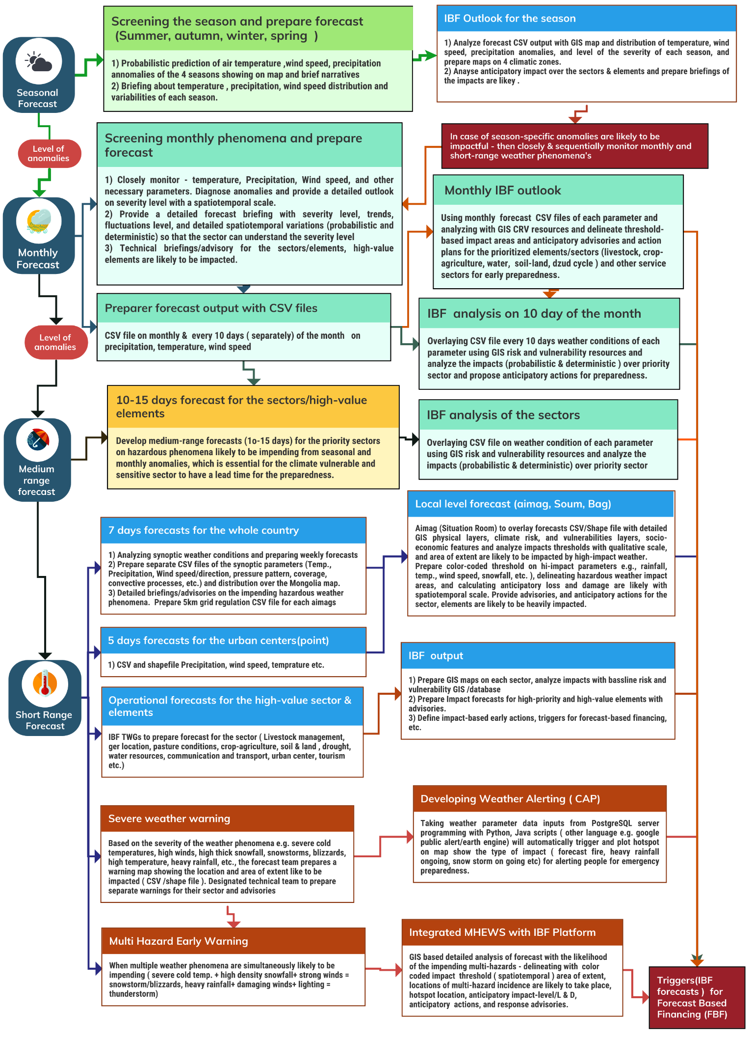
Figure 15 : Preparing short-range weather forecast CSV /shapefile(Source: Z M Sajjadul Islam, UNDP-GCF)
.

- Prepare CSV /shapefile of the hazardous forecast parameter(s) likely to impend a hi-impact, e.g., heavy snowfall/precipitation, severe cold temperature.
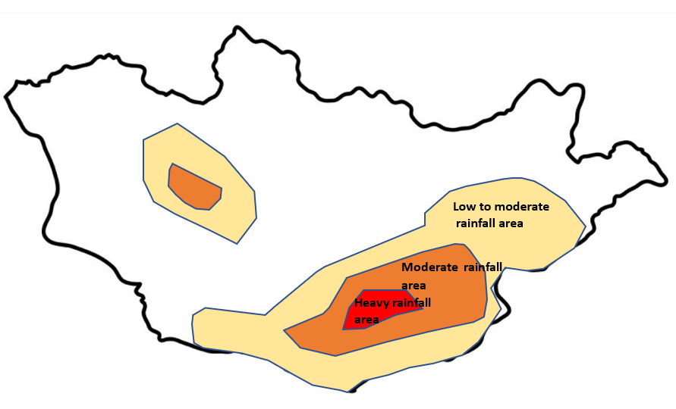
Figure 16 : Sample Forecast threshold map

Step 3: Review of already developed Climate risk and vulnerability from the baseline repository that is archived with the IBF geospatial portal :

  - Tool preparation - GIS layers (Annexure 5)
Prepare and validate the GIS layers required to conduct the baseline review and overlay analysis:
a) Baseline risk and vulnerability survey layers
- CRVA-derived GIS maps and shapefiles capturing element-level and community-level vulnerability attributes.
b) Physical exposure layers
- Physical infrastructure and asset layers (e.g., roads, bridges, buildings, critical facilities, utility networks, markets, shelters), including relevant physical geography where needed.
c) Socio-economic vulnerability layers
- Poverty and deprivation layers, disability and vulnerable-group distributions, and geolocated herder ger/basecamp locations.
d) Land and natural resource layers
- Pasture and rangeland health condition layers, land use/land cover layers, drought layers, and mapped locations/access points for drinking water sources.

These layers should be checked for geolocation accuracy, attribute completeness, metadata, and version/date, and confirmed as accessible through the IBF portal services (GeoNode/GeoServer) for use in impact forecast overlays.

  - Methodology: Impact analysis over the geographic location and severity of the weather parameters( spatiotemporal ) with GIS software :
- GIS overlay and multi-variable risk computation:
Overlay the forecast coverage layer (shapefile/CSV grid converted to polygons) onto the baseline GIS layers (elements inventory, CRVA risk/vulnerability attributes, and socio-economic structures such as ger/basecamp locations, pasture/grazing zones, vulnerable populations, remoteness, access constraints). Use the combined layers to compute and update exposure, vulnerability, risk score, and risk ranking for each element using multi-variable analysis.
- Quantify elements within severity (red/orange/yellow) zones:
Identify the red threshold extent (and other classes where required) and calculate how many elements fall inside the red area, disaggregated by element type, sector, administrative unit (aimag/soum/bag), and vulnerability class reflecting each element’s built-in exposure, vulnerability, and prior risk ranking.
- Prioritize high-risk elements and estimate anticipatory impacts:
Generate a checklist of the highest risk-ranked elements based on historical risk and vulnerability data, then combine this with the forecasted threshold intensity (e.g., rainfall amount within red zones) to estimate anticipatory impacts and likely loss-and-damage scenarios. Produce sector-relevant advisories and recommended early actions focused on these priority elements and locations.
Step 4: Screening rapidly developing weather conditions ( convective weather system, downscale model based on updated data and develop warning and CAP )

- Rapid-onset weather screening (convective systems):
Establish an operational process to continuously detect and track rapidly developing convective systems (e.g., thunderstorms, hail, lightning, intense rainfall, damaging winds) using updated observations (AWS, radar/satellite where available, station reports, and crowdsourced field updates). Run rapid-update nowcasting and short-lead prediction workflows to generate spatiotemporal hazard footprints and update them throughout the event lifecycle.

- Downscaling and rapid-update modeling for fronts:
Apply statistical and dynamical downscaling to cold and warm fronts that may develop in spring, summer, and autumn, using the latest assimilation-ready data. Produce high-resolution forecasts that capture timing, intensity, and geographic extent, including thresholds relevant to impacts (wind, precipitation intensity/accumulation, temperature drops, snow/rain phase changes).

- Operational forecasts for high-value elements:
NAMEM should provide spatiotemporal operational forecasts tailored to high-value and high-exposure elements particularly livestock systems (herder camps, grazing zones, water points) and urban settlements/infrastructure with clear expected timing and severity.

- Warning and CAP generation:
Translate forecast outputs into impact-based warnings (e.g., yellow/orange/red) and generate CAP-compatible alerts that specify: what is happening, where, when, severity/urgency/certainty, likely impacts, and recommended actions. Disseminate through the IBF platform and agreed channels (EOC/Situation Room, SMS/IVR/cell broadcast, broadcast media, social networks), with scheduled updates and an all-clear protocol.
).

Step 5: Establish a nested high-impact situational observation system:

During prolonged, compound extremes such as extreme cold, strong winds, and snowstorms persisting for days or weeks multiple secondary hazards can emerge simultaneously (e.g., icing, livestock mortality risk, isolation, infrastructure failure, localized drifting snow, water access disruption). In these conditions, station observations and model outputs alone are insufficient to capture event evolution and localized impacts at the precision needed for effective IBF.
A nested, hybrid surface observation system is therefore essential to enable integrated forecasting and warning by combining:
- Core meteorological and hydrological observations (manual stations, AWS, river gauges),
- Targeted high-value element monitoring (livestock concentration zones, settlements, transport corridors, critical services), and
- Structured crowdsourced situational reporting (geo-tagged photos/videos, simple measured parameters, impact notes from herders, volunteers, sector technicians).
This nested observation design strengthens real-time situational awareness, supports rapid forecast updates and verification, and enables simultaneous triggering of multi-hazard early warnings and CAP-compatible alerts alongside impact forecasts protecting livestock, livelihoods, crop agriculture, and critical services through timely early action and response coordination.
.

Step 6: Capturing geolocation of ongoing hazardous weather-induced multi-hazard incidence, hotspots/location of loss, and damage are taking place and data for situation reporting:

When multiple hazardous weather events occur simultaneously and escalate, impacts can intensify rapidly and generate significant Loss and Damage (L&D). Without timely early warning, preparedness, and response actions, such compound events can quickly evolve into large-scale disasters.

To address this risk, a high-density hybrid observation system (Figure 9) that combines meteorological monitoring with structured hazard-incidence reporting should be implemented to capture geolocated, near real-time information on: (i) ongoing multi-hazard occurrences, (ii) hotspots where losses and damages are already occurring, and (iii) locations at elevated risk of imminent impacts. This geolocation-based data acquisition is essential for producing reliable event situation reports, triggering common alerting, and strengthening operational multi-hazard early warning and response decision-making.
.

Step 7: Issue Multi-hazard early warning necessarily

Multiple hazardous weather events may be impending or already prevailing and can rapidly escalate into compound, multi-hazard situations. Severe cold, high-density snowfall and snowstorms, convective storms (thunderstorms/heavy rainfall/lightning/hail), and damaging winds can cause significant livestock and human losses, disrupt sector value chains, and interrupt essential services.

Therefore, the IBF/MHEWS system should issue multi-hazard early warnings whenever threshold conditions are met or escalating conditions are observed.

Step 8: Preparer Operational forecasts for sectors

Hybrid observation and daily operational warning production:
Implement the high-density hybrid observation system (Figure 9) and generate daily operational sector forecasts for high-value elements exposed to high-impact and sudden-onset hazards. Use these forecasts to produce daily weather warnings and Common Alerting (CAP-ready) outputs targeted to the most vulnerable and high-exposure elements as part of routine operations.
Roadmap for coordination and anticipatory action:
Develop and maintain an emergency coordination roadmap that clearly defines stakeholders, roles and responsibilities, escalation triggers, communication protocols, and sector-specific anticipatory actions to minimize impacts and reduce Loss and Damage (L&D).

Converting traditional forecast to IBF

- Review Long-range Forecasting :

- Review Seasonal Outlook :

The technical function of an IBF system begins with the production of long-range outlooks, which serve as the primary input for forecast-impact analysis. Long-range forecasts should describe the expected weather conditions for the upcoming season and provide an early assessment of the likely implications for climate-sensitive, high-value sectors and elements, including livestock, urban settlements, crop agriculture, and water, soil, and land management.

Seasonal forecasts can be used to screen three-month anomalies across Mongolia and to indicate whether conditions are expected to be above normal, below normal, or near normal, together with an initial estimate of anticipated impact levels and broad-scale Loss and Damage (L&D) implications. Based on this screening, the IBF system should issue anticipatory advisories to guide preparedness planning and support adaptation and mitigation measures.

Monthly forecasts within the season are then used to more closely monitor evolving atmospheric conditions particularly temperature, precipitation, and wind speed and to refine the impact narrative as signals strengthen and lead times shorten.

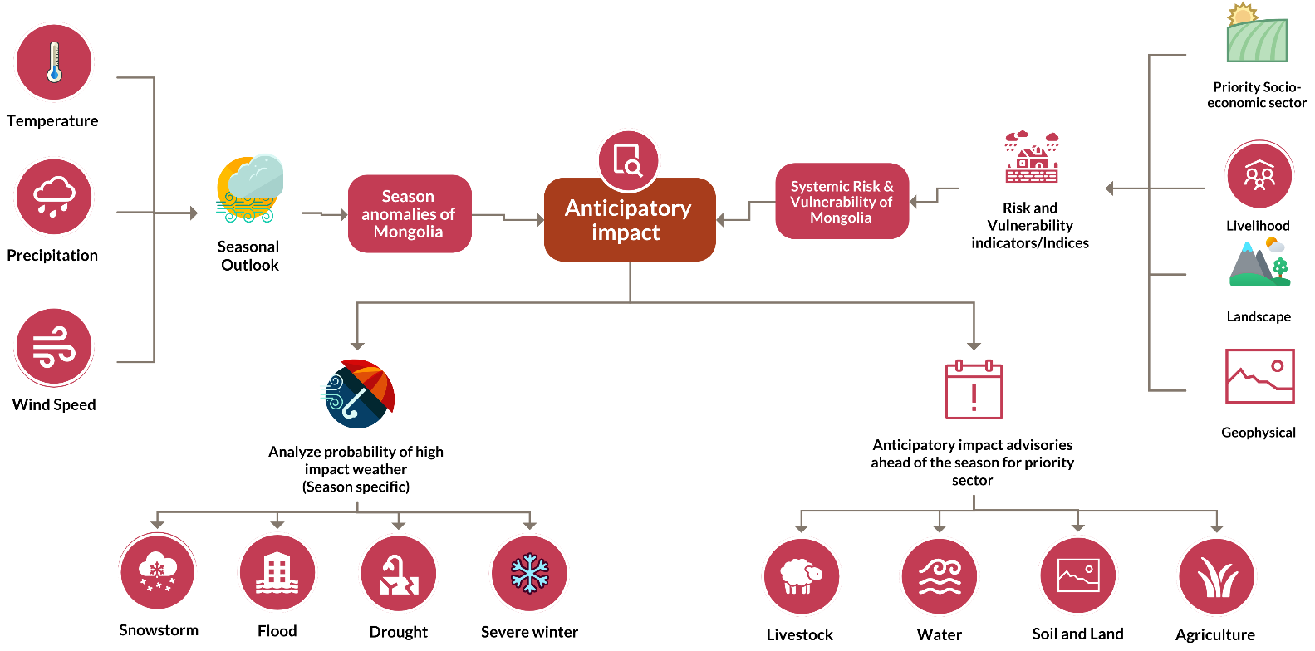

Figure 17 : Workflow of the current forecasts to transfer to impact-based forecasts(Source: Z M Sajjadul Islam, UNDP-GCF)

For the monthly and seasonal outlooks, IRIMHE applies a multi-model and ensemble (MME) approach to produce two routine products: a monthly outlook and a seasonal outlook.

At present, the NAMEM/IRIMHE forecasting workflow is primarily point-based, targeting urban centers and townships, and provides 7-day forecasts nationwide for variables such as precipitation, temperature, wind speed, and sunshine duration. In addition, the seasonal outlook focuses on temperature and precipitation, while the monthly outlook includes temperature, precipitation, and wind speed, produced at approximately 27 km grid resolution.

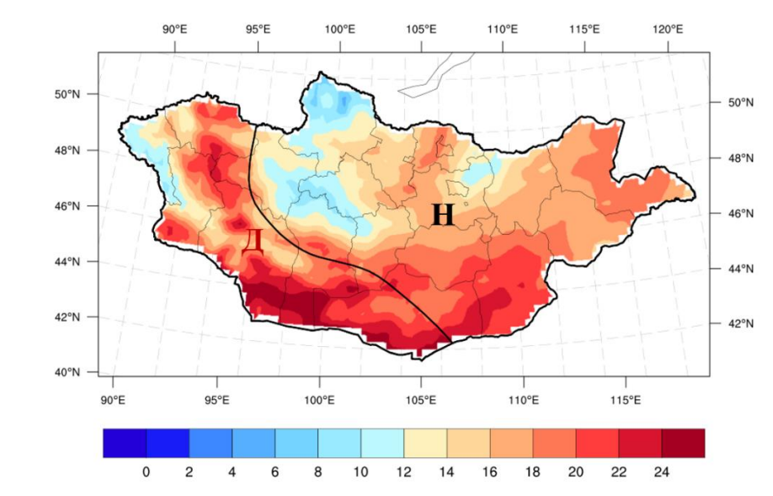 | 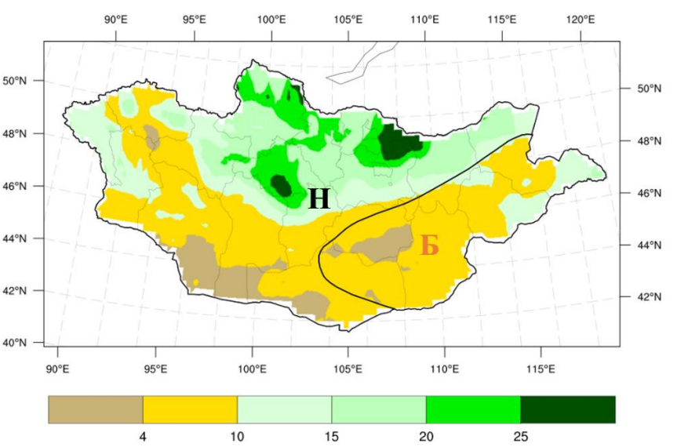
Temperature | Precipitation

The accompanying maps present color-coded thresholds showing the spatial distribution of forecast temperature and precipitation across the country. Using the associated CSV outputs in GIS software, the Technical Working Group (TWG) can analyze the anticipated impacts for the coming month and season at appropriate spatiotemporal scales, including where conditions may deteriorate and which sectors/elements may be affected.

These monthly and seasonal IBF products should serve as a primary upstream input to short-range forecasting, helping forecasters and sector users interpret emerging signals and anticipate weekly weather patterns in advance.

Season | Type of anomalies | Determine what type of impacts/hazards are anticipated over the season & month | What would be the season preparedness /advisories for the priority sector
Summer | Spatiotemporal distribution of Temp/Precipitation/Wind speed like to incase | Heavy rainfall, floods/flash floods, Hot spell, dry spell, thunderstorms, damaging windstorms | What type of gross preparedness will undertake herders /farmers, livestock /agri-value chain operators
 | Spatiotemporal distribution of Temp/Precipitation/Wind speed is like to be normal near normal & normal
 | Spatiotemporal distribution of Temp/Precipitation/Wind speed like to decrease | the intensity of the Agri, hydrological, and hydrological droughts
Autumn | Spatiotemporal distribution of Temp/Precipitation/Wind speed like to incase | Heavy rainfall, floods/flash floods, dry spell, thunderstorm, damaging windstorms, Cold front thunderstorms | What type of gross preparedness will undertake herders /farmers, livestock /agri value chain operators
 | Spatiotemporal distribution of Temp/Precipitation/Wind speed is like to be normal near normal & normal
 | Spatiotemporal distribution of Temp/Precipitation/Wind speed like to decrease | the intensity of the Agri, hydrological, and meteorological droughts
Winter | Extreme cold temperatures, strong winds, high precipitation(snowfall), | Snowstorms, blizzards, extreme cold temp, high thick snowfall, | What type of gross preparedness will undertake herders /farmers, livestock /agri value chain operators
Spring | Fluctuations/anomalies of temperature, wind speed, precipitation, | Fastest onset multi-hazards ( cold front, warm front, cold rain, high winds, thunderstorm) | What type of gross preparedness will undertake herders /farmers, livestock /agri value chain operators

6.4.1 Analyze impacts over the seasonal forecasts :

- Climate baseline and anomaly mapping: Using GIS software, compare Mongolia’s baseline climate scenarios (30-year climate norms) with forecast fields to identify anomalies and visualize color-coded threshold exceedances across the areas likely to be impacted.
- Administrative checklist and severity quantification: Prepare a checklist of bags and soums falling within each color-coded threshold zone, quantify the projected precipitation amounts and temperature severity (high/low) relative to climate norms, and identify elements likely to be affected both positively and negatively.
- Sector-focused operational services: Prepare operational forecasts and climate information services for priority sectors, including agriculture, livestock, water resources, and soil/land management.
- Anticipatory exposure and vulnerability assessment: Produce a rapid, anticipatory assessment of exposure, sensitivity, risk, and vulnerability for priority-sector elements within the forecast anomaly zones.
- Seasonal outlook briefings: Organize briefing sessions on the season ahead to discuss expected seasonal patterns, anomaly signals, degree-day implications, and sector relevance.
- Seasonal scanning and scenario framing: Conduct an overall scan of the seasonal outlook to communicate a range of plausible climate conditions and changes that may occur during the upcoming season

6.4.2 Processing monthly IBF :

Forecast file | Parameter | Baseline risk and vulnerabilities |  |  | Impending multi-hazards
 |  | Risk and vulnerability GIS repository and risk atlas | Distribution of socioeconomic vulnerability | Sector-specific elements are falling into risk and vulnerability | If lead time in impending hazardous conditions is prolonged, then what would be the impact?
Seasonal /Monthly  forecast | Temperature above normal | - GIS maps and databases of high-value elements (exposure inventories and georeferenced asset layers)  - Susceptibility, sensitivity, risk, and vulnerability layers for high temperatures and hot days (by sector and location)  - Drought maps (meteorological, agricultural, and hydrological, where applicable)  - Time-series pasture biomass and rangeland health maps (trend, anomaly, and seasonal condition monitoring)  - Water and hydrological resource maps (rivers, basins, wells/water points, reservoirs, streamflow indicators)  - Agro-ecological zone maps (production systems, crop suitability, pasture zones, and seasonal constraints) | Atlas of the distribution of poverty population, poor herders(income poverty, livelihood assets, animal husbandry management logistics, and capacity, etc.) | - Climate risk and vulnerability assessment and repository for priority sectors, including livestock, agriculture, water resources, soil health, environment and natural resources, and drought risk.  - High-temperature risk indicators capturing sensitivity, exposure, risk, and vulnerability for key elements across the priority sectors.  - Crop agriculture phenology and stage-based risk profiling, covering: seedling, sapling, planting, flowering/pollination, growth, and harvesting stages.  - Drought incidence monitoring, including occurrence, duration, severity, and spatial extent.  - Forest cover mapping and monitoring, including extent, condition, and change trends | - If hot days are prolonged,  - multi-hazard would be triggered? Agricultural, ecological, and meteorological droughts.
 | Extreme cold temperature | - Elements sensitive to extreme cold temperatures:  Assess the number of exposed elements likely to experience extreme cold impacts, such as crop yield loss, delayed or stagnated maturity, pest manifestation, and stagnation of plant growth, resulting in reduced yields.  - At-risk livelihood and environmental elements:  Assess the number of elements at risk of livestock illness (including weak calves and mortality), soil moisture loss and declining soil health, desertification, and degradation of pasture biomass.  - Water and energy resource impacts:  Assess the number of affected elements associated with icing/freezing of surface water bodies, groundwater depletion, and downstream effects such as reduced hydropower generation.  - Prolonged deep snow impacts:  Assess the number of exposed elements affected by thick, persistent snow cover, including pasture biomass degradation, reduced vegetation cover, and damage to standing crops, seedlings, and saplings during crop plantation periods. | - Atlas of poverty and vulnerable livelihoods: Spatial atlas of poverty distribution, including poor herder households (income poverty, livelihood assets, animal husbandry management capacity, logistics constraints, and coping capacity).  - Hard-to-reach area indicators: Accessibility and remoteness indicators (distance to services, terrain constraints, seasonal isolation, and response reach).  - Seasonal transport and communication indicators: Season-wise status and reliability indicators for transport corridors and communication networks (e.g., winter passability, flood season disruption risk, outage frequency).  - Economic activity areas: Spatial layers identifying key economic zones and activity centers (markets, production hubs, mining/industrial sites, tourism nodes, and trade/logistics corridors). | - Sectoral vulnerability and large-scale anticipatory impact estimation: Identify which types of agriculture, livestock systems, water resources and related structures, soil and land systems, natural and environmental resources, and physical infrastructure (communications, transport, and logistics) are vulnerable to high temperatures, and conduct a large-scale anticipatory estimation of likely impacts.  - Anticipatory water resource impacts (map-based estimation): Use spatial analysis to estimate the extent of surface water bodies likely to dry up, potential groundwater depletion, and downstream consequences such as reduced hydropower generation.  - Anticipatory land and production impacts: Estimate likely degradation of pasture biomass and vegetation cover, as well as impacts on standing crops and vulnerable crop stages (seedlings and saplings) during plantation periods. | If extreme and severe cold days are prolonged, then what type of multi-hazard would be triggered, and the consequences
 | Heavy precipitation | Determine how many elements are vulnerable to heavy rainfall and flash flooding, including possible impacts such as crop damage and reduced yields. ( Annexure7.a:  ) | - GIS maps and geodatabase showing the distribution of flood-prone areas and the aimag, soum, and bag centers vulnerable to flash flooding, including estimates of the population exposed and overall flood risk and vulnerability.  - Substandard housing and basic utility services: households and business premises with structural and service-related vulnerabilities to flooding.  - Socioeconomic vulnerability: populations living in poverty, including low-income herder households (income poverty, livelihood assets, animal husbandry practices, access to logistics/inputs, and adaptive capacity).  - Vulnerability indicators for hard-to-reach areas, including exposure of agricultural land, ger settlements, pasturelands, and standing crops located in low-lying floodplain zones.  - Seasonal indicators for transport and communications, reflecting variability in access and service continuity by season.  - Economic activity zones, identifying areas where flooding could disrupt production, trade, services, and local livelihoods. | Determine how many elements across agriculture, livestock, water resources and related structures, soil and land systems, natural and environmental resources, communications infrastructure, and transport/logistics networks are vulnerable to high temperatures, and what is the large-scale anticipatory estimate of their likely impacts (Annexure 7.b) | Anticipatory Loss and Damage (L&D) estimates for impending heavy precipitation events (Annexure 7.c,  Annexure7.d  )
 | Less precipitation | Assess how many elements are sensitive to negative rainfall variability (below-normal rainfall) and therefore at risk of impacts such as crop yield loss, delayed/stagnated maturity, pest outbreaks, growth suppression, soil fertility decline, flash drought, and desertification. | - Atlas of poverty and vulnerable herder populations: Spatial atlas showing the distribution of poor populations and vulnerable herder households, including indicators of income poverty, livelihood assets, animal husbandry management logistics, and coping capacity.  - Hard-to-reach area indicator: Accessibility and remoteness indicator(s), capturing distance to services, terrain constraints, seasonal isolation, and response reach.  - Seasonal transport and communication indicators: Season-wise indicators on the functionality, reliability, and disruption risk of transport corridors and communication networks.  - Economic activity areas: Spatial layers identifying key economic activity zones (markets, production hubs, logistics corridors, mining/industrial sites, and tourism nodes). | Using forecast high-temperature thresholds and sector vulnerability layers, we quantify exposed and vulnerable elements by aimag/soum/bag and estimate anticipatory impacts at large scale, including crop yield loss risk, pasture biomass reduction, livestock heat stress, water-resource stress, and disruption risk to transport and communication systems  (Annexure7.e ) | Prolonged hot days (i.e., sustained heatwave conditions) rarely act alone. They typically interact with and amplify other hazards, producing compound and cascading multi-hazards. Understanding these linkages is central to IBF because the same heat episode can trigger different impact pathways depending on antecedent moisture, vegetation condition, and exposure(Annexure7.f )

6.4.3 Preparing medium-range Forecast :

Given Mongolia’s diverse and rapidly changing weather conditions, a medium-range forecast (Figure 18) with a 10-15 day lead time is needed to bridge the gap between monthly outlooks and weekly forecasts. This product would provide early directional guidance to priority sectors by indicating where weather anomalies and potentially hazardous conditions are likely to develop in the weeks ahead, thereby strengthening preparedness.

Such a medium-range forecast would enable priority sectors and humanitarian agencies to plan earlier and more effectively by supporting preparedness planning, humanitarian programming, and the initiation of anticipatory action planning for impending hazards.

6.4.4 Preparing short range Forecast :
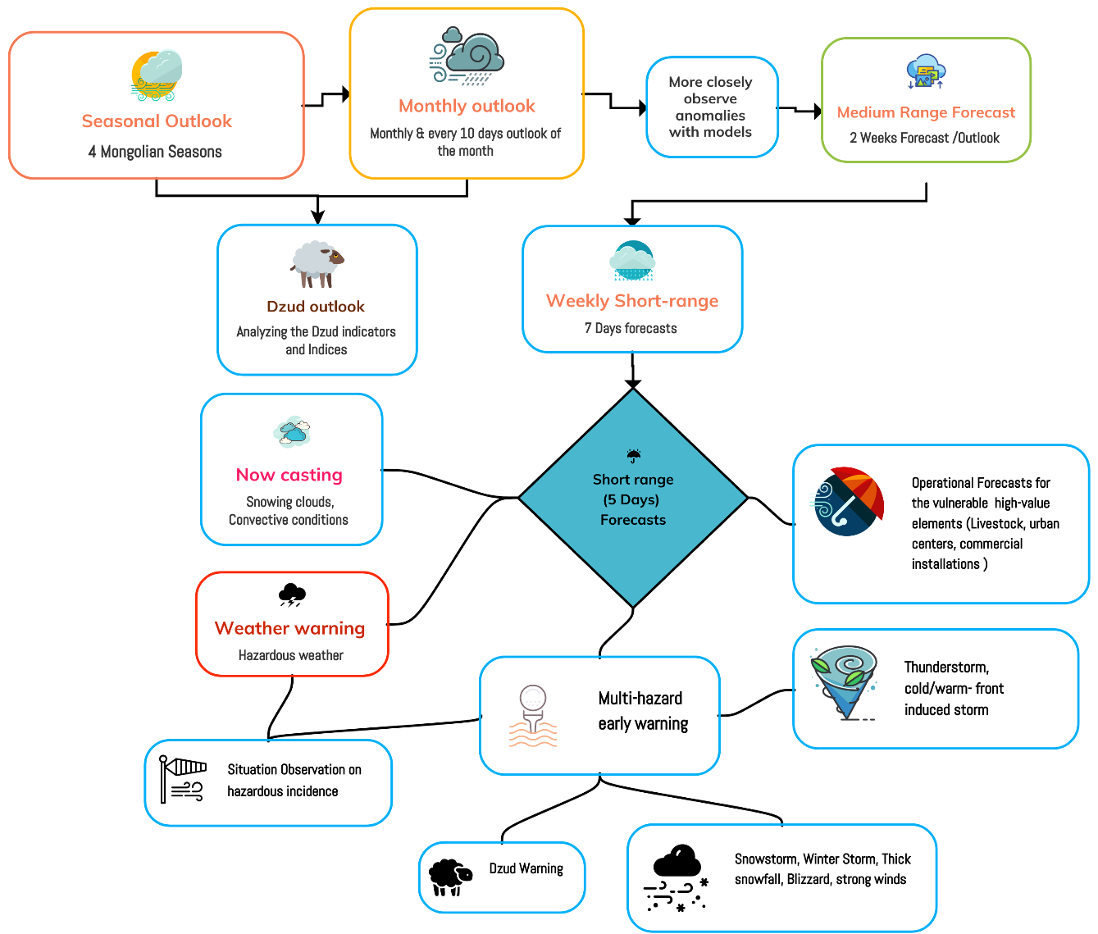
Figure 18: Short-range forecast workflow and integrated IBF ( applicable for winter season ) (Source: Z M Sajjadul Islam, UNDP-GCF)

NAMEM is currently developing short-range forecasts by integrating outputs from multiple prediction approaches, including four dynamical models, eight classical statistical methods, and a two-model ensemble, to produce guidance for 3-day and 5-day ranges and to extend forecasting to a total of 7 days. In addition, outputs from up to 21 statistical methods/models can be incorporated into the short-range forecast development process.

However, given Mongolia’s rapidly changing and strongly diurnal weather regime where conditions can vary substantially within hours the IBF process requires a more robust forecasting cycle and the capability to deliver real-time, high-resolution monitoring and situational updates. To effectively track rapidly developing weather that can escalate into sudden-onset hazards, the forecasting-to-IBF chain must be strengthened through upgraded high-density hybrid ground-surface observations (Figure 9) and improved traceability of real-time model outputs into the IBF platform. This will support continuous screening and updating for high-impact phenomena such as heavy rainfall and flash flooding, thunderstorms, hail, lightning, snowstorms, high/damaging winds, blizzards, heatwaves, dust/haze storms, cold front driven storms (spring/early summer), and cold rainfall.

6.4.5 The short-range forecasts usability :

Types of weather synopsis considered for weekly short-range forecasts prepared by the forecasting division | Climate Season | Hazard specific interpretation | Usability for IBF Analysis | End users
Temperature (⁰C) | Winter | Alerting severe cold days aimag/soum level over the next 7 days | Duration and impact levels associated with the coldest winter temperatures (seasonal severity) across key elements:  - Livestock and herder livelihoods: Impacts on fodder availability, pasture biomass and grazing access; increased livestock cold stress and mortality risk; and disruptions across associated supply chains (standing forage/crops, seedlings and saplings, storage/warehousing, and wholesaling).  - Agriculture: Temperature-driven impacts on biomass production, pasture condition, standing crops, seedlings and saplings, and downstream systems such as storage/warehousing and wholesaling, including risks to winter protection measures and post-harvest handling.  - Lifeline services and essential supplies: Increased risk of service disruption and operational stress on hot water provision, surface-water access for livestock, deep tube wells, and room-heating systems; heightened coal demand for isolated/scattered gers, markets, and other settlements/installations.  - Market operators: Business interruptions due to reduced supply, constrained access, higher heating and logistics costs, and reduced consumer mobility during peak cold periods.  - SME business continuity: Reduced operating capacity and higher costs (heating, staffing, logistics), particularly for enterprises dependent on transport access and stable utilities.  - Transport and communications: Disruption risks affecting waterways and transport networks (national highways, paved roads, and secondary routes), with knock-on impacts on logistics, connectivity, and service delivery.  - People’s mobility: Constraints on travel to urban centers, wholesale markets, schools, and essential services, particularly during the most severe cold episodes and associated hazardous conditions. | - Herders and herder households (including ger communities)  - Farmers and agricultural producers  - Agriculture sector agencies (crop, pasture, livestock services)  - Sector departments and line agencies (aimag/soum sector departments)  - Transport sector authorities and operators (roads, rail, aviation where relevant)  - Logistics and freight transporters (including delivery and supply-chain operators)  - Urban utility service departments (power, water, heating, sanitation)  - Communication network operators (telecom and critical ICT services)  - Travelers and road users  - Tourism operators (hotels, motels, restaurants, tour companies)  - Commercial installations and business operators (markets, warehouses, industrial sites)  - Petrol stations and fuel distribution points  - Healthcare facilities (clinics, hospitals, emergency medical services)  - Local government departments (aimag, soum, bag administrations)  - Aimag centers, soum centers, and bag centers (as priority geographic focal points)  - Volunteers and humanitarian partners (MRCS, LEMA, NEMA and community-based volunteers)  - Mining operators  - SMEs and enterprise operators
Temperature (⁰C) | Spring | Alerting severe weather for the spring season | Seasonal duration and impact levels associated with prevailing temperature severity across key elements:  - Livestock and associated supply chains: Impacts on fodder availability, pasture biomass, and grazing conditions; stress on standing forage/crops, seedlings and saplings; and disruptions to storage/warehousing, wholesaling, and livestock-related logistics.  - Agriculture (including agricultural drought impacts): Temperature-driven and drought-related impacts on biomass production, pasture condition, standing crops, seedlings and saplings, and downstream systems such as storage/warehousing and wholesaling.  - Lifeline services and essential supplies: Risks of disruption to hot water provision, surface-water access for livestock, and deep tube well operations; increased household and community heating demand; and higher coal consumption requirements for isolated/scattered gers, markets, and other settlements/installations.  - Market operators: Business continuity risks due to reduced production/availability, supply-chain disruptions, and higher operating costs linked to temperature extremes.  - SME operations: Operational disruption and reduced productivity, particularly for weather-sensitive facilities and enterprises dependent on logistics and stable utilities.  - Transport and communications: Disruption risks across waterways and road networks (national highways, paved roads, and secondary routes), with knock-on impacts on connectivity, delivery schedules, and service access.  - People’s mobility: Constraints on travel to urban centers, wholesale markets, schools, and essential services, particularly during peak temperature stress periods
Temperature (⁰C) | Summer | Alerting severe weather for the summer season
Temperature (⁰C) | Autumn | Alerting severe weather for the Autumn season | Extreme events and impact level.
Precipitation (mm) | Winter | Alerting moderate to high snowfall/cold rain impact at aimag/soum level over the next 7 days | Extreme events and impact levels  - Cold rain / snowfall: Assess and communicate the expected impact level on key elements and sectors (e.g., livestock grazing and health, pasture and standing crops, transport and mobility, power and communications, and public safety).  - Cold rainfall: Assess and communicate the expected impact level on key elements and sectors, including exposure-related risks, infrastructure and service disruption, and livelihood impacts.
Precipitation (mm) | Spring | Alerting moderate to high cold rain/ snowfall | Extreme events and impact levels  - Cold rain / snowfall: Assess and communicate the expected impact level on key elements and sectors (e.g., livestock grazing and health, pasture and standing crops, transport and mobility, power and communications, and public safety).  - Cold rainfall: Assess and communicate the expected impact level on key elements and sectors, including exposure-related risks, infrastructure and service disruption, and livelihood impacts.
Precipitation (mm) | Summer | Alerting high to heavy rainfall | Extreme events and impact level;  - Heavy rainfall impacts the level of the elements /sectors
Precipitation (mm) | Autumn | Alerting high to heavy rainfall | Extreme events and impact level;  - Heavy rainfall impacts the level of the elements /sectors
Wind Speed ( m/s), | Winter | Alerting moderate to high wind impact at aimag/soum level over the next 7 days | Expected duration and severity of impacts from medium-to-high winds combined with extreme cold over the next 7 days, affecting the following elements:  - Livestock and grazing: Reduced grazing access and efficiency; increased cold stress and risk of cold-related injury; disruption of normal daily herd movement and feeding patterns.  - Agriculture: Potential impacts on pasture biomass, standing crops, seedlings and saplings; increased risk to storage/warehousing and agricultural supply chains (including wholesaling and handling).  - Lifeline services and essential supplies: Disruption risks to hot water supply and surface-water access for livestock; operational constraints for deep tube wells; increased heating demand and fuel (coal) consumption for dispersed ger households, markets, and other settlements/installations.  - Market operators: Business interruption risk due to weather-related access constraints, reduced mobility, and higher operating costs (heating and logistics).  - Small and medium enterprises (SMEs): Service disruption and reduced operating capacity, particularly for weather-exposed facilities and those dependent on transport and communications.  - Transport and communications: Increased likelihood of disruptions across waterways and road networks (national highways, paved roads, and secondary routes), with knock-on effects on deliveries and connectivity.  - People’s mobility: Constraints on travel to urban centers, wholesale markets, schools, and essential services, with heightened safety risks during peak wind/cold periods.
Wind Speed ( m/s), | Spring |  | High Wind Impacts over the season
Wind Speed ( m/s), | Summer |  | High wind Impacts over the season
Wind Speed ( m/s), | Autumn |  | High wind Impacts over the season
Wind direction( NW) | Winter |  | Wind direction over the vulnerable sector

6.5 Short range impact forecast preparation

- Heavy snowfall/precipitation analysis :

Following the IBF process outlined above develop a color-coded threshold of precipitation over the geographical areas that are likely to receive the cumulative amount of rainfall ( mm/ hour/12 hourly/24 hourly)

- Anticipatory impact illustration scale :

- Likelihood of occurrence is classified into five levels: very unlikely, unlikely, moderately likely, likely, and very likely. “Likelihood” refers to the probability that, within the period considered, either a new disaster risk will emerge or the situation will deteriorate significantly.
- Potential impact is classified into five levels: negligible, minor, moderate, severe, and critical. Impacts should be assessed in terms of both magnitude (the number of potentially affected people and/or the geographical extent of impacts on agriculture, livelihoods, and food security) and severity (the seriousness of impacts on agriculture/livestock, livelihoods, and food security, particularly in the context of pre-existing vulnerability and food insecurity).

7.0 Chapter : Operational Forecasts

Mongolia’s highly variable spatiotemporal conditions and unstable weather patterns create substantial impacts on key sectors and livelihoods. As illustrated in Figure 19, many of Mongolia’s multi-hazards are sudden onset, requiring forecasts that are both timely and locally actionable. Operational weather forecasting tailored to climate-vulnerable frontline sectors can therefore serve as an effective climate information service, strengthening sector-level preparedness against impending hazards.
To enhance decision support for high-value elements and priority sectors, NAMEM should implement demand-driven Ensemble Prediction Systems (EPS) for operational seasonal forecasting, producing probabilistic guidance that reflects forecast uncertainty and supports targeted preparedness planning.

Table: Sector and High-value events specific operational forecast :

Operational Forecast | Tools | Usability | Technical requisites for IBF
Winter weather / cold weather products  - Extreme Cold Warning / Advisory  - Severe Snowstorm Watch / Warning  - Heavy Snow (High Snow Accumulation) Watch / Warning  - Winter Storm Watch / Warning  - Blizzard Watch / Advisory / Warning  - Winter Weather Advisory  - Wind Chill Watch / Advisory / Warning  - Storm Warning  - Wind Chill Advisory / Warning | a) Establish real-time data acquisition from meteorological stations and crowdsourced sources.  b) Develop algorithms and models to produce operational forecasts for weather anomaly events | - Sustainable animal husbandry and preparedness for severe winter-induced multi-hazards  - Early preparedness for livelihood activities (herding, transport, market access)  - Early preparation to prevent zoonotic disease outbreaks in livestock (surveillance, vaccination readiness, veterinary outreach)  - Livestock sheltering and water provisioning (shelter reinforcement, access to unfrozen water sources)  - Strengthened livestock sector management (fodder planning, herd movement planning, emergency protocols)  - Early stocking of essential supplies (fodder, fuel, medicines, communications backups) | - NAMEM/IRIMHE Numerical Weather Prediction (NWP) to develop algorithms for the production of each of the operational forecasts
Spring weather  - Cold front Watch, warning  - Cold- front induced cold storm warning  - Cold rainfall watches & warning  - Strong & damaging winds Watch, Warning, Advisory  - Severe Thunderstorm Watch, Warning  - Dust/haze storm watch and warning  - Severe Weather Statement  - Special Weather Statement  - Tornado Watch, Warning | - Real-time data acquisition: Establish real-time data acquisition from meteorological stations and crowdsourced sources.  - Indicator and index development: Develop operational indicators, algorithms, and indices to characterize and monitor weather events.  - Downscaling for high-value elements: Develop and operationalize statistical and dynamical downscaling models to produce high-resolution guidance for high-value elements.  - Severe weather production pipeline: Develop algorithms supported by statistical and dynamical downscaling to produce severe weather event tracking, watches, forecasts, and warnings (e.g., damaging winds and flood/flash flood hazards), with tailored advisories for high-value elements such as urban areas, markets, built-up installations, emergency service networks, communication networks, and priority livelihood sectors including livestock and agriculture.
Summer severe weather :  - Convective weather condition watch  - Convective weather induced heavy rainfall watch and warning.  - Lighting watch and warning  - Severe Thunderstorm Watch, Warning  - River Flooding/ Flash Floods Watch Warning  - Hydrological Outlook  - Flash Flood Watch, Warning  - Drought(agricultural, meteorological , hydrological ) watches and warning  - Heatwave watch and warning.  - Forest fire watch and warning | - Real-time data acquisition and very short-range forecasting: Establish real-time data acquisition from meteorological stations and crowdsourced sources, and develop indicators, algorithms, and indices to track evolving weather events and generate very short-range forecasts for sudden-onset and rapidly developing hazards.  - Downscaling to support high-value elements: Develop and operationalize statistical and dynamical downscaling to produce higher-resolution guidance tailored to high-value elements and localized decision needs.  - Severe weather tracking, watches, forecasts, and warnings: Develop algorithms supported by statistical and dynamical downscaling to produce tracking, watch, forecast, and warning products for severe weather events (e.g., damaging winds and flood/flash flood hazards). These products should be targeted to high-value elements, including urban areas, markets, built-up installations, emergency service networks, communication networks, and priority livelihood sectors such as livestock and agriculture
Autumn severe weather :  - Damaging Winds / Gale force wind(strong wind gust) watch and warning  - Early snowfall watch and warning  - Convective weather condition watch  - Convective weather induced heavy rainfall watch and warning.  - Cold rain watch /warning  - Convective Thunderstorm  - Tornadoes /nor wester  - Dust storm | - Real-time data acquisition and very short-range forecasting: Establish real-time data acquisition from meteorological stations and crowdsourced sources, and develop indicators, algorithms, and indices to track evolving weather events and generate very short-range forecasts for sudden-onset and rapidly developing hazards.  - Severe weather tracking and warning production (downscaling-enabled): Develop algorithms and apply statistical and dynamical downscaling models to produce tracking, watch, forecast, and warning products for severe weather events (e.g., damaging winds, cold front-induced storms, floods/flash floods). These products should be tailored to protect high-value elements, including urban areas, marketplaces, built-up infrastructure, gers, emergency utility service networks, communication networks, livestock and agriculture systems, logistics operators, and the tourism sector.
Misc  - Weather advisory, warning for the highway, regional highway, and rural road network.  - Weather advisory, warning for the river crossing point river navigation point.  - Air quality  - Dense Smoke Advisory | Real-time acquisition of weather and non-weather data from meteorological stations and crowdsourced sources should be used to develop operational indicators, algorithms, and indices. These should be integrated with statistical and dynamical downscaling models to track, monitor, and forecast weather hazards affecting communication networks, supporting targeted watches, advisories, and early warnings.
Livestock and agriculture - operational forecasts, watches, and advisories  - Operational forecasts for crop calendars  - Operational forecasts during planting/plantation periods  - Operational forecasts during harvest periods  Pasture condition and production monitoring  - Pasture condition updates every 10-15 days and monthly  - Pasture crop yield watch, forecasts, and advisories  - Pasture anomaly watch  - Pasture biomass watch  - Pasture trend watch  - Pasture carrying capacity watch  - Watch and advisories on pasture biomass degradation  Livestock performance and risk monitoring  - Advisory/watch on sheep weight-gain profiles  - Livestock density watch  - Livestock body condition watch, warnings, and advisories  - Winter-spring grazing capacity forecasts  - Operational forecasts for livestock water adaptation (water availability and stress conditions)  Crop-specific forecasts and phenology  - Wheat and potato forecasts and advisories  - Forecasts of wheat growth stages (timing of key phenological stages)  - Vegetation and drought-related indicators  - Vegetation cover (NDVI) watch and advisories  - Soil moisture watch, warnings, and advisories  Evapotranspiration / drought index monitoring (e.g., SPEI watch)  Precipitation monitoring  - Watch of precipitation days and cumulative precipitation amounts (by dekad/month/season as appropriate) | Real-time acquisition of weather and non-weather data from meteorological stations and crowdsourced sources should be used to develop operational indicators, algorithms, and indices. These should be integrated with statistical and dynamical downscaling models to track, monitor, and forecast weather hazards affecting livestock and crop agriculture, and to support targeted watches, advisories, and early warnings.

- Statistical & Dynamical downscaling Model-based operational forecasts :

- NAMEM NWP division to develop operational forecasts by developing Ensemble Prediction Systems (EPS) for the high-value elements.
- Season-specific Dzud operational forecasts and combined dzud operational forecasts

- Operational forecasts for rapidly developing weather conditions :

Convective-scale Ensemble Prediction Systems (EPS) and convective-scale NWP typically run at 1-4 km grid spacing over relatively small domains are designed to explicitly represent convective processes. These models can therefore predict convective systems and support forecasts of key storm details, including the likely location, timing, and intensity of thunderstorms.
EPS is particularly relevant at convective scales because convective instability introduces additional sources of forecast uncertainty that are not adequately resolved in lower-resolution models and that evolve on much shorter timescales. By sampling this uncertainty, convective-scale EPS provides more robust guidance for short-range forecasting and nowcasting, including probabilistic information that can be translated into impact-based warnings.

- Point-based Operational forecasts for rapidly developing weather conditions :

- Point-based heavy rainfall forecasts to identify locations (aimag, soum, and bag centers) where intense rainfall may trigger flash flooding.
- Point-based snowstorm, blizzard, extreme temperature, and cold-wave forecasts to identify locations (aimag and soum centers) where severe winter conditions are likely to develop.
- Point-based damaging-wind forecasts for aimag, soum, and bag centers to support short lead-time warnings and impact prevention.
- Point-based thunderstorm and hailstorm forecasts for aimag, soum, and bag centers to support convective hazard warnings.
- Point-based heatwave forecasts for aimag, soum, and bag centers to support health, livestock, and agriculture advisories.
- Agro-ecological zone-based operational forecasts to provide sector-relevant guidance tailored to local production systems and exposure conditions.

8.0 Chapter : The multi-hazard early warning system

Mongolia’s geographic setting as a landlocked country, together with its highly diverse geological, topographical, environmental, physiographic, and geomorphic conditions, contributes to exceptionally varied weather and climate patterns. This diversity reflects: (a) distinct landscape and topographic regimes across the country, and (b) differentiated climatic influences across major zones, often characterized as western, Khangai, central, and eastern Mongolia. In addition, Mongolia’s proximity to the Great Gobi Desert and the extensive mountain systems, coupled with northern influences from the vast Siberian region, helps drive rapid atmospheric variability often changing markedly on hourly and diurnal timescales. These combined factors increase exposure to sudden-onset hazards and reinforce Mongolia’s high climate vulnerability.

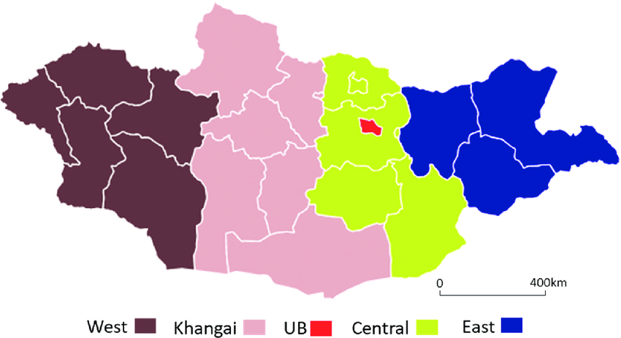 | 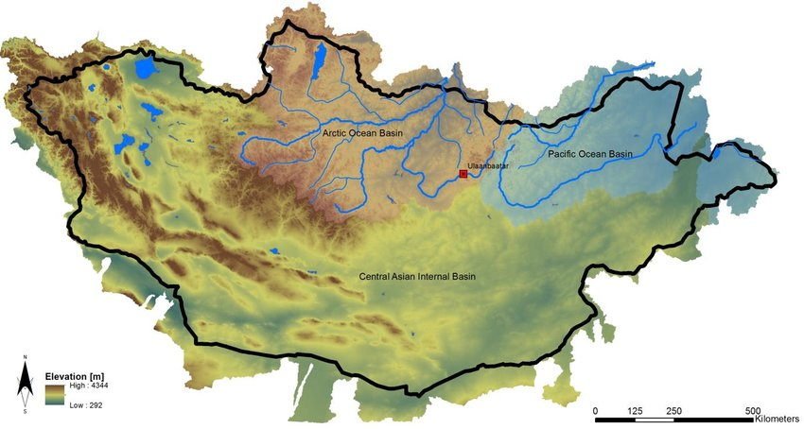
Mongolian climate region. | Mongolian Topography

Extreme weather observation and forecasting at local spatiotemporal scales, together with multi-hazard early warning, require a high-density hybrid surface observation system (Figure 9) using modern sensor technologies to track ground-level multi-hazard events, disasters, and incidents under Mongolia’s rapidly changing weather conditions. In spring and autumn and at times even in summer diurnal variability can be so pronounced that “four seasons” may be experienced within a single day. Under these conditions, generalized “one-size-fits-all” forecasting and impact analysis are insufficient. Mongolia therefore needs a diversified suite of weather and climate information services, including long-, medium-, and short-range forecasts; sectoral impact forecasts; operational forecasts for high-value elements; weather warnings and advisories; and a fully integrated Multi-Hazard Early Warning System (MHEWS).

To better track rapidly developing weather, NAMEM should upgrade surface meteorological observation to support 15-minute measurement cycles. Core deployable instruments should measure key parameters including pressure, temperature, moisture, wind, and radiation. For hydrological applications, additional instruments are required to measure precipitation amount and type (rain/snow), particle size distribution, and soil heat and moisture content. Recent advances in GNSS/GPS also enable estimation of atmospheric water vapour from single surface-based receivers. Modular and mobile instruments potentially deployable through volunteers, herders, communities, and selected commercial sites can further expand coverage. Where feasible, turbulence/flux measurements can support monitoring of exchanges of heat, momentum, and moisture between the atmosphere and the surface.

Mongolia’s seasonal hazard regime reinforces the need for these upgrades. Winter is severe and often produces the highest intensity and frequency of extreme events. Spring is diverse and diurnally variable, with sudden reversions to harsh winter-like conditions that disrupt outdoor activities and can persist into the pre-summer period. Summer and autumn also exhibit high variability and compound risks, including droughts, hot spells and dry spells, convective thunderstorms, heavy rainfall and flooding, dust and sandstorms, wildfires, and dzud-related impacts. These rapidly changing and diverse surface patterns are strongly shaped by Mongolia’s land cover heterogeneity and complex topography, meaning traditional observation networks are insufficient to diagnose evolving weather systems and to develop high-resolution climate norms.

As indicated by the hydrometeorological multi-hazard calendar and the incidence pattern of disaster events (Figure 19), many high-impact conditions are highly spatiotemporal, often sudden onset, and capable of rapidly inducing disasters. Comprehensive predictability cannot be achieved through time-series numerical weather prediction (NWP) alone. A nested, high-density hybrid observation system (Figure 9), supported by automated quality control, calibration, and data assimilation and complemented by recurrent statistical and dynamical downscaling during periods of elevated risk is essential for improving the forecasting process and meeting the requirements of Impact-Based Forecasting (IBF).

In addition, effective MHEWS depends on integrating these hybrid observations (Figure 9) with real-time situation monitoring (including crowdsourced reporting), hazard and disaster incidence tracking, anticipatory Loss and Damage (L&D) estimation, and early-warning-triggered early action design. Together, these components strengthen decision-making and enable more timely, targeted humanitarian response mechanisms.

The extreme weather conditions observation /forecasting (local spatiotemporal scale) and muti-hazard early warning required hybrid and high-density surface ( figure 9) observations( latest sensors based) to track the ground-level multi-hazard events, disasters, and incidents, because of very rapidly changing weather settings. Diurnal weather conditions in Spring, Autumn, and sometimes summer season look at all 4 seasons reflecting in a single day. As a result, generalized (one size fitting for all) weather forecast and forecast impact analysis is insufficient and Mongolia needs to provide a variety of weather infuriation services, e.g., Long, medium, and short-range weather forecasts, impact forecasts for the sectors, operational forecasts for high-value elements, weather warning, advisory, multi-hazard early warning system, etc.

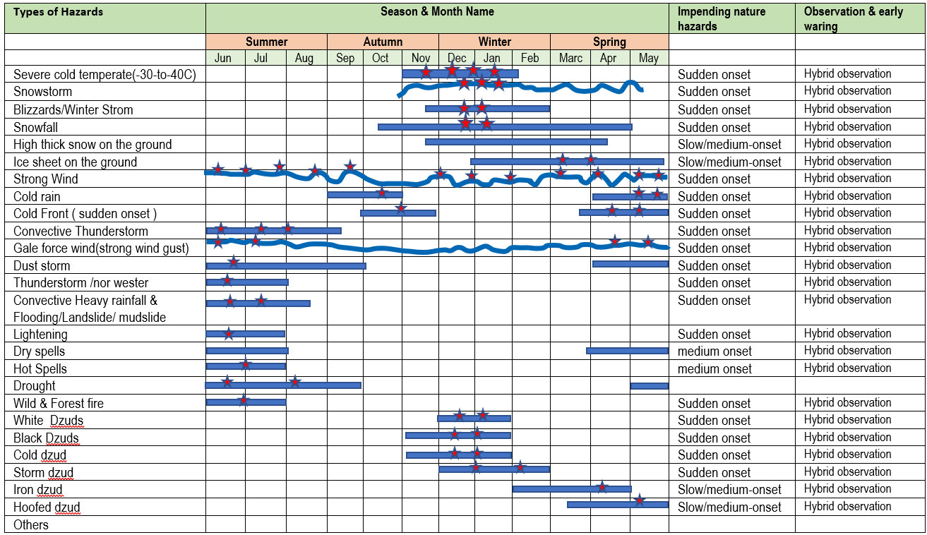
Figure 19 : Calendar of trends of multi-hazards and incidence of disaster

For tracking rapidly developing weather conditions, NAMEM needs to upgrade its Surface-meteorology observational instruments to measure every 15 minutes weather conditions over the surface. The most commonly deployable instruments are to monitor weather parameters such as pressure, temperature, moisture, wind, and radiation. For hydrological applications, additional instruments may be deployed to measure the amount, type, and size distribution of rain and snow, as well as the heat and water content of the soil. The latest advancements in GPS technology have also allowed for estimates of atmospheric water vapor to be obtained from a single surface-based receiver( mobile and modular to be handled by the volunteers, herders, community, commercial installations, etc. for measuring atmospheric turbulence are also sometimes used to monitor the exchange (or flux) of heat, momentum, and moisture between the atmosphere and the Earth's surface.

Table : Examples of multi-hazards induced disaster Impacts
Hydrometeorological Hazard | Cascading hazards | Primary impacts | Secondary impacts
Extreme cold temperatures | - Cold wave | - Danger to human and livestock health  - Damage to and loss of crops | - Low temperatures exacerbate existing health conditions.  - Weight loss, sick and death tolls of livestock
Snowstorm | - Snow drift  - Avalanche  - Thick snow over the communication and transport network  - Thick snowfall over the ground( pastureland, agricultural and etc.) | - Transport networks inoperable  - Damage to property from the weight of snow  - Pasture inaccessible  - Crop damage  - Weight loss, sick and death tolls of livestock | - Loss of livestock  - Loss of services: power, water, communications  - Loss of livelihood  - Access to health care, education, food, and medical supplies  - Loss of industrial production  - Road traffic collisions
Heavy Rain | - Flash floods  - River floods  - Landslides and mudslides  - Debris/rockfalls  - Excessive erosion  - Flooding impacts (flash flooding, river flooding, and waterlogging)  - Silt and sediment deposition  - Water pollution and contamination  - Damage to structures and disruption of basic services (e.g., roads, power, communications, water supply)  - Damage to pasture, standing crops, agricultural land, and low-lying floodplain areas | - Damage to property and infrastructure  - Crop damage and livestock losses  - Fatalities due to drowning  - Topsoil loss and degradation  - Damage to buildings and household assets (including gers), commercial installations, urban infrastructure, and disruption of basic services  - Damage to specific crops, particularly tubers  - Hazardous travel conditions (reduced safety and mobility disruptions) | - Houses inhabitable.  - Loss of services: power, water, communications, health care  - Health issues/deaths:  - waterborne diseases etc.  - Loss of livelihood  - Loss of industrial production  - Displacement/Migration:  - long and short term
Strong Wind | - Damaging winds and waves | - Threat to life from flying debris  - Damage to property, buildings, and other man-made structures  - Damage to or uprooting of trees, forests, and orchards  - Destruction of standing crops, especially staple grains  - Hazardous travel conditions  - Dangerous river conditions (rapid rises, strong currents, debris-laden flows)  - Damage to and disruption of transport networks (e.g., trees blocking rail lines and roads, ferry ports becoming inaccessible) | - Disruption or loss of essential services (power, water supply, communications)  - Loss of livelihoods and income sources  - Injuries  - Damage to the power distribution line, thatched houses, ger houses standing crops, livestock shed  - Homes becoming uninhabitable
Icing over the ground | - Ice accretion on cables | - Damage to power lines  - Power outages  - Transport networks becoming inoperable  - Damage to crops | - Road traffic collisions  - Loss of services: power, water, communications  - Access to health care, education, food, and medical supplies
Thunderstorm |  | - Damage to property  - Risk to life and serious injury  - Severe crop losses  - Water shortages  - Hazardous driving conditions  - Losses of crops and livestock  - Power outages  - Delays and disruption to rail and air travel | - Loss of services, power, communications  - Loss of livelihood
Low rainfall( Drought) | - Droughts  - Desertification  - Dust storms | - Loss of biomass | - Loss of livelihood(agriculture )  - Loss of livestock  - Soil erosion  - Food shortages  - Increased hunger and malnutrition  - Disease  - Displacement/Migration:
High temperatures | - Heatwave | - Danger to human and livestock health  - Power outages  - Interruptions to public transport (rail) | - High temperatures exacerbate existing health conditions.  - Death

8. 1 Improved and hybrid weather observation mechanism :

- Radar and alternative convective monitoring: Doppler radar mosaics provide high-quality inputs for convective monitoring and prediction, but they are costly to expand and maintain. As a complementary option, mobile or drone-based radar can be deployed in limited areas to observe convective structures and support short-range monitoring where fixed radar coverage is unavailable.
- Enhanced lightning detection and lightning-density analytics: Strengthen lightning detection networks and routinely compute lightning density and its temporal evolution as predictors for storm intensity classification and subsequent development. Lightning observations also offer strong value for verification ranging from direct verification of lightning-focused forecasts to indirect verification through confirmation and tracking of predicted thunderstorm cells.
- Crowdsourced thunderstorm observations: Integrate structured, crowdsourced data ingestions from hazard tracking apps (e.g., snow storm, cold storm, hail, gusts, thunder, visibility reduction, localized flooding) to improve situational awareness and provide ground-truth for nowcasting and warning updates, particularly in remote areas.
- FY-4 (CMA) Geostationary Lightning Imager / Lightning Mapping Imager (LMI): Utilize FY-4 LMI total-lightning products, which provide storm-scale lightning monitoring with approximately 6 km resolution at the sub-satellite point, to support convective initiation detection, rapid intensification monitoring, and warning decision support.
- Satellite-based cloud diagnostics for nowcasting: Upgrade NAMEM’s nowcasting capability by operationally integrating geostationary satellite products for cloud monitoring, including:
- Himawari-8 for cloud mask identification and analysis,
- Himawari-9 for cloud visualization and cloud-type classification, and
- FY-2/FY-4 imagery for cloud identification, cloud motion, convective cloud monitoring, and dust-storm detection.
- Nowcasting algorithm upgrades for convective hazards: Enhance nowcasting algorithms to track convective rainfall, lightning, thunderstorms, and associated high-impact phenomena (including damaging winds and, where relevant, tornado-like events) using multi-source inputs such as temperature, wind, dew point, precipitation, and lightning supported by satellite, lightning, radar (where available), and surface observations.
- .
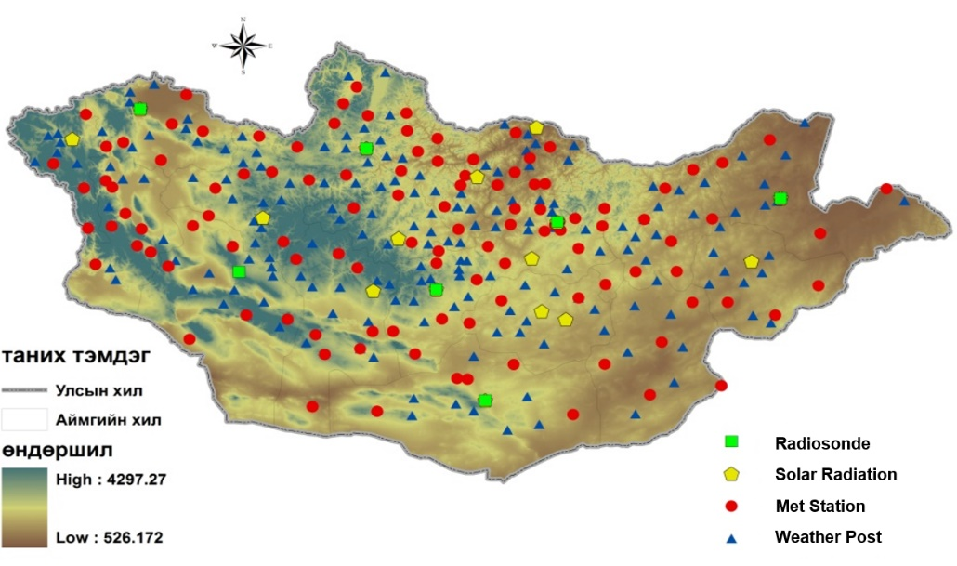
Figure 20 : Distribution of Meteorological stations ( existing weather stations/weather posts)
Figure 21 : Proposed hybrid - high-density, nested, and crowdsource-based surface weather observation and incidence monitoring system(Source: Z M Sajjadul Islam, UNDP-GCF) .

Table: Extracting Impact Indicators from seasonal forecasts :

Category | Level | Meaning | Applicable to impending hazards
Green | 0 | No Elevated Risk
Yellow | 1 | Low Risk | Snowstorm, Winter storm, Cold front induced storm, Thunderstorm, heatwave, flood, flash floods
Orange | 2 | Moderate Risk | Snowstorm, Winter storm, Cold front induced storm, Thunderstorm, heatwave, flood, flash floods
Red | 3 | Very High Risk | Snowstorm, Winter storm, Cold front induced storm, Thunderstorm, heatwave, flood, flash floods
Magenta | 4 | Extremely High Risk | Snowstorm, Winter storm, Cold front induced storm, Thunderstorm, heatwave, flood, flash floods

8.2. Process of developing an Early Warning :

Building on the multi-hazard incidence patterns and stressed timespans identified above (Figure 19), Mongolia needs to shift from traditional weather forecasting toward a modern Multi-Hazard Early Warning System (MHEWS) that delivers real-time alerting to frontline, climate-vulnerable herders, farmers, and communities. A robust, integrated Impact-Based Forecasting (IBF) and MHEWS framework offers a substantive pathway to reduce uncertainty and strengthen decision-making for Mongolia’s highly variable and rapidly evolving hazardous weather.
In practice, an IBF system should be integrated with an autonomous, ICT-driven process that converts forecasts and observations into actionable, impact-focused warnings. A recommended process is outlined below.
Step 1 - Anchor impact forecasting with lead time
Initiate the early warning process by producing an impact forecast at an appropriate lead time (e.g., D-7 to D-1, or shorter for rapidly evolving hazards). This step establishes the preliminary risk picture by linking forecast hazards to exposure and vulnerability, enabling early prioritization of areas and elements likely to experience Loss and Damage (L&D).
Step 2 - Screen real-time conditions using hybrid observations
Deploy a high-density hybrid observation system (Figure 9) to continuously monitor prevailing conditions and screen whether forecast signals are materializing into multi-hazard situations. Real-time, spatiotemporal monitoring should focus on identifying escalation triggers (e.g., strengthening fronts, convective initiation, instability changes, rapid wind increases, visibility reduction, heavy precipitation onset).
Step 3 - Generate and disseminate emergency warnings, advisories, and response guidance
When critical conditions are confirmed or intensifying, generate hazard warnings and advisories that communicate:
- Where and when impacts are likely (spatiotemporal scale),
- What elements are at risk (livelihoods, livestock, transport, utilities, settlements),
- The expected severity level (color-coded thresholds), and
- An indicative estimate of anticipated L&D (current and potential hotspots/placemarks).
These products should inform the humanitarian program cycle by indicating the level and type of response that should be mobilized, including preparedness measures, contingencies, and early actions aligned to forecast confidence and impact severity.
Step 4 - Programmatic triggering and mapping of impacts and hotspots
Operationalize the IBF system through an automated workflow that:
- Plots current and anticipated L&D over maps,
- Identifies placemarks/hotspots where impacts are occurring or likely,
- Updates risk zones and confidence levels as new data arrive, and
- Generates decision-ready advisories for early action and contingency planning.

Step 5 - Deploy automated public alerting and Common Alerting Protocol (CAP)
Because many hazardous weather events in Mongolia are sudden onset and can escalate rapidly (e.g., convective storms triggering flash floods), CAP-based alerting should be operationalized as an automated ICT process. CAP messages should be generated programmatically (e.g., via scripts and services) and disseminated through multiple channels, including mobile networks, radio, television, and public alerting platforms (e.g., Google Public Alerts or equivalent dissemination partners), ensuring rapid delivery to last-mile communities.
Core objective
Across all steps, the primary duty of the IBF-enabled early warning process is to provide timely, localized forecasts and warnings that reduce casualties and protect livelihoods and assets especially when conditions are intensifying and hazards are likely to develop with limited lead time.

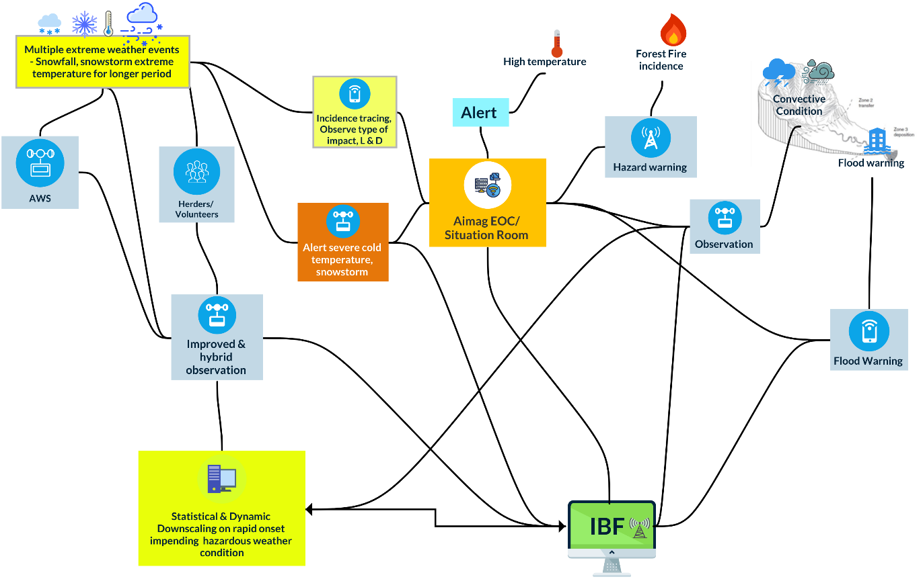

Figure 22 : Nowcasting, hourly & daily IBF to provide a multi-hazard early warning (Source: Z M Sajjadul Islam, UNDP-GCF)

8.3 The multi-hazard early warning process:

- Improving nowcasting to hourly IBF on hazardous weather phenomena :
Mongolia’s high-impact weather conditions can change rapidly and exhibit strong diurnal variability, driven by features such as cold and warm fronts, troughs, convective development, CAPE fluctuations, and shifts in high-pressure systems. In some cases, “four seasons” may be experienced within a single day, and hazards can develop suddenly with limited lead time. Under current conditions, the observation and forecasting system for hourly and daily hazardous weather at very local scales still contains a degree of uncertainty. As a result, frontline livelihood sectors particularly those most climate-vulnerable are disproportionately exposed to loss and damage due to forecast uncertainty.
To reduce this risk, high-density weather monitoring and prediction capabilities should be upgraded, and the overall predictability framework should be strengthened through robust instrumentation and operational integration. In particular, nowcasting the analysis and forecast of weather for the next few hours as part of a seamless prediction system requires significant improvement to support timely, localized, impact-based warnings.
- Develop Automated nowcasting workflow to facilitate hourly impact forecast :
As NAMEM’s new HPC (supercomputing) capacity continues to improve, implementing a parallel high-density hybrid observation system (instrument-based and crowdsourced; Figure 9) will strengthen NAMEM’s ability to deliver more accurate data acquisition and more effective data assimilation at higher temporal and spatial resolutions. This will improve representation of complex physical processes, enhance model initialization, and enable precision hourly forecasting and nowcasting at bag level. These advances will help frontline, climate-vulnerable herders and communities better understand rapidly varying weather phenomena on minute-by-minute, hourly, and diurnal timescales through integrated atmospheric and surface-level diagnostics (e.g., tracking fronts, convective development, and instability indicators such as CAPE).

8.4 Anchoring NEMA Early Warning System with IBF:

Mongolia’s Early Warning Systems (EWS) are functional and disseminate information on seismic activity and weather forecasts through multiple channels, including the Internet, mobile phone services, and national radio and television. NEMA issues warning messages to aimags and soums; however, reaching remote herder communities remains a persistent challenge. Several EWS components have been developed jointly with other stakeholders.
Mongolia also operates an Earthquake Disaster Warning System, funded by the Government of Mongolia, which disseminates alerts via siren towers in Ulaanbaatar as well as television and radio networks. If the primary system becomes inoperable, a mobile control center is activated. Satellite-connected earthquake sensor devices provide an additional backup, and warnings may also be delivered through mobile phone service providers and radio stations.
Integrating NEMA’s existing EWS within an Impact-Based Forecasting (IBF) platform, giving NEMA Official roll-based access to administer the CAP warning process, warning approval, EAP approval, and other Early Warning Process. The warning messages should be upgraded from hazard-only messaging to impact-based, color-coded threshold messaging that clearly states: where and when impacts are expected, which elements are at risk (e.g., herder households, livestock, transport corridors, utilities), and the anticipated Loss and Damage (L&D) severity. This improves prioritization, enables anticipatory action, and increases the operational usefulness of alerts for decision-makers and last-mile communities.
Anchoring/linking the following web applications with the IBF platform.
- A platform for Real-time Impact and Situation Monitoring (PRISM) : Geospatial portal for https://prism-mongolia.org/
- Disaster Spatial Information System https://map.nema.gov.mn/ https://map.nema.gov.mn/map/

8.5 Integrated IBF, Warnings, Alerting, and energy hazard early warnings & Advisories :

Extreme weather events | IBF | Warning | Alerting | Emergency hazard(s) early warnings (multi-hazards) | Advisory
Extreme cold temperate(-30 to - 40C) | 7/5 days ago, issue IBF by narrating color-coded thresholds with quantitative impact level and corresponding areas with anticipatory impacts on ……….elements and anticipatory amount on L & D. | Enhance routine daily forecasts by using color-coded thresholds to more accurately estimate the level of Loss and Damage (L&D) across relevant spatial and temporal scales. | Severely impacted areas where specific elements are expected to be heavily affected over very short time windows (hourly, 6-hourly, or daily). | a) A high probability of extreme cold temperatures can trigger one or more hazards and lead to significant Loss and Damage (L&D).  b) Provide MHEWS outputs using color-coded thresholds linked to expected L&D levels.  c) Issue emergency preparedness advisories and recommend appropriate anticipatory humanitarian actions. | - Issue separate advisories (IBF, weather warnings/alerts, and MHEWS) that explicitly communicate anticipated impacts and expected Loss and Damage (L&D).  - Provide preparedness and contingency guidance for at-risk communities and priority sectors.  - Recommend early actions proportional to the expected severity/magnitude and anticipated L&D.  - Specify anticipatory impacts and required humanitarian support, clarifying who should act, where, when, and how, including target groups, geographic areas, timing windows, and response modalities.
Extreme cold temperate(-30 to - 40C) | Extreme coldest ( -40c and above )temp. | Extreme coldest ( -40c and above )temp.
Extreme cold temperate(-30 to - 40C) | Severe coldest ( -30c to -40c)temp. | Severe coldest ( -30c to -40c)temp.
Extreme cold temperate(-30 to - 40C) | Coldest Temperature ( -20c to -30c)temp. | Coldest Temperature ( -20c to -30c)temp.
Extreme cold temperate(-30 to - 40C) | Moderate Cold Temperature ( -10c to -20c)temp. | Moderate Cold Temperature ( -10c to -20c)temp.
Snowstorm | At D-7 to D-5, issue an IBF that narrates color-coded thresholds linked to quantitative impact levels, identifies the corresponding at-risk areas, and summarizes anticipatory impacts on key elements along with an indicative estimate of anticipated Loss and Damage (L&D). | Color-coded thresholds should be defined and communicated at appropriate spatial and temporal scales (spatiotemporal scale). | Issue daily alerts identifying placemarks/hotspots where snowstorms may develop on short notice. | - A high probability of snowstorms may result in significant Loss and Damage (L&D).  - Provide MHEWS outputs using color-coded thresholds linked to expected L&D levels.  - Issue emergency preparedness advisories and recommend appropriate anticipatory humanitarian actions.
Blizzards/Winter Strom | Provide a D-7 to D-5 advisory identifying which areas are likely to be affected (by color-coded threshold) and the expected level of Loss and Damage (L&D) in each area. | Color-coded thresholds should be applied at spatiotemporal, short-range intervals (hourly, 6-hourly, and daily) to clearly communicate expected impact severity and anticipated Loss and Damage (L&D). | Issue daily alerts identifying placemarks/hotspots within areas at high risk of severe impacts from blizzards or winter storms. | - A high probability of blizzards/winter storms may result in significant Loss and Damage (L&D).  - Provide MHEWS outputs using color-coded thresholds linked to expected L&D levels.  - Issue emergency preparedness advisories and recommend appropriate anticipatory humanitarian actions.
High-density snowfall | Color-coded thresholds should indicate where anticipated snowfall intensity (g/mm³) is expected, and summarize the potential impacts including which elements may be affected (e.g., grazing conditions, damage to standing pasture/crops, livestock mortality by species, and disruption of communications at specified placemarks) with the impact level, location, and expected amount clearly stated for each area. | Color-coded thresholds should be applied at appropriate spatiotemporal scales (hourly, 6-hourly, and daily) to communicate the expected scale of impacts and anticipated Loss and Damage (L&D). | Issue daily alerts identifying placemarks/hotspots where high-density snowfall and storm conditions are likely in the affected areas. | A high probability of high-density snowfall may result in significant Loss and Damage (L&D).
High thick snow on the ground | Color-coded thresholds should indicate the anticipated snowfall range (cm) by area, and describe the likely impacts on key elements such as grazing conditions, damage to standing pasture/crops, livestock mortality by species, and potential communications disruption at specified placemarks clearly stating the impact level, location, and expected snowfall amount for each zone. | Color-coded thresholds should be defined at spatiotemporal scales (hourly, 6-hourly, and daily) and clearly indicate expected impact severity and anticipated Loss and Damage (L&D). | Issue alerts identifying placemarks where heavy snowfall accumulation is expected within the next [duration]. | Issue warnings on the hazards associated with deep, persistent snow cover and the expected level of Loss and Damage (L&D).
The ice sheet on the ground | Color-coded thresholds should indicate the anticipated ice coverage areas and ice thickness range (mm), and describe the potential impacts on key elements such as grazing conditions, damage to standing pasture/crops, livestock mortality by species, and possible communications disruption at specified placemarks clearly stating the impact level, location, and expected ice thickness (mm) for each zone. | Color-coded thresholds should be applied at very short-range spatiotemporal scales (daily/24-hour alerts) and clearly communicate expected impact severity and anticipated Loss and Damage (L&D). | Issue daily alerts identifying placemarks/hotspots where high-density ice sheets are prevailing. | Issue warnings on the hazard(s) associated with thick ground ice and the expected level of Loss and Damage (L&D).
Strong Winds | Color-coded wind-speed thresholds (m/s ranges) should identify the areas likely to be impacted by strong winds and describe the potential impacts on key elements such as grazing conditions, damage to standing pasture/crops, livestock losses by type, and possible communications disruption at specified placemarks clearly stating the impact level, location, and expected wind speed for each zone. | Color-coded thresholds should identify areas likely to experience high winds within short-range windows (daily/24-hour alerts), and specify the corresponding impact thresholds and anticipated Loss and Damage (L&D) for each area. | Issue daily alerts identifying placemarks/hotspots where high winds (m/s) are likely to occur and where they are currently occurring. | Warn of the hazard(s) that strong winds may trigger and the expected level of Loss and Damage (L&D).
Damaging Winds / Gale force wind(strong wind gust) | Color-coded wind-speed thresholds (m/s ranges) should identify the areas likely to be impacted by damaging winds and describe the potential impacts on key elements such as grazing conditions, damage to standing pasture/crops, livestock losses by type, and potential communication disruptions at specified placemarks clearly stating the impact level, location, and expected wind speed for each zone. | Color-coded thresholds should identify areas expected to experience damaging winds within short-range windows (daily/24-hour warnings), and specify the corresponding impact thresholds and anticipated Loss and Damage (L&D) for each area. | Issue daily alerts identifying placemarks/hotspots where damaging winds (m/s) are likely to occur and where they are currently occurring. | Issue warnings on the hazard(s) that damaging winds may trigger and the expected level of Loss and Damage (L&D).
Cold rain | Sudden-onset hazard events can be anticipated through operational forecasting. | Color-coded thresholds should identify areas expected to experience cold rain (mm) within short-range windows (minutes, 1-hourly, 3-hourly, 6-hourly, daily, and 24-hour warnings), and specify the corresponding impact thresholds and anticipated Loss and Damage (L&D) for each area. | Issue daily alerts identifying placemarks/hotspots where cold rain (mm) is likely to occur and where it is currently occurring. | Issue warnings on the hazard(s) associated with cold rain and the expected level of Loss and Damage (L&D).
Cold Front ( sudden onset ) induced storm ( spring) | Sudden-onset hazard events can be forecast operationally. | Color-coded thresholds should identify areas expected to be affected by cold front-induced storms within very short-range windows (minutes, 1-hourly, 3-hourly, 6-hourly, daily, and 24-hour warnings), and specify the corresponding wind-speed impact thresholds (m/s) and anticipated Loss and Damage (L&D) for each area. | Issue daily alerts identifying placemarks/hotspots where cold front-induced storms (m/s) are likely to occur. | Issue warnings on the hazard(s) associated with cold fronts and the expected level of Loss and Damage (L&D).
Convective Thunderstorm | Sudden onset hazard events can be predicted by the operational forecast | Color-coded thresholds should identify areas expected to be affected by convective thunderstorms within very short-range windows (minutes, 1-hourly, 3-hourly, 6-hourly, daily, and 24-hour warnings), and specify the corresponding wind-speed impact thresholds (m/s) and anticipated Loss and Damage (L&D) for each area. | Alert placemarks/hotspots where thunderstorms and associated winds (m/s) are likely to occur, using tiered update frequencies (minutes, 1-hourly, 3-hourly, 6-hourly, daily, and 24-hour updates) appropriate to the forecast lead time and risk level. | Issue warnings on the hazard(s) associated with convective thunderstorms and the expected level of Loss and Damage (L&D).
Tornadoes /nor wester | Sudden onset hazard events can be predicted by the operational forecast | Color-coded thresholds should identify areas expected to be affected by cold front-induced storms within very short-range windows (minutes, hourly, and 6-hourly warnings), and specify the corresponding wind-speed impact thresholds (m/s) and anticipated Loss and Damage (L&D) for each area. | Alert placemarks/hotspots where tornadoes and associated winds (m/s) are likely to occur, using tiered update frequencies (minutes, 1-hourly, 3-hourly, 6-hourly, daily, and 24-hour updates) appropriate to the forecast lead time and risk level. | Issue warnings on the hazard(s) associated with tornadoes and nor’wester events and the expected level of Loss and Damage (L&D).
Dust storm | Sudden onset hazard events can be predicted by the operational forecast | Color-coded thresholds should identify areas expected to be affected by dust storm-induced conditions within very short-range windows (hourly to 6-hourly warnings), and specify the corresponding wind-speed impact thresholds (m/s) and anticipated Loss and Damage (L&D) for each area. | Alert placemarks/hotspots where dust storms and associated winds (m/s) are likely to occur, using tiered update frequencies (minutes, 1-hourly, 3-hourly, 6-hourly, daily, and 24-hour updates) appropriate to the forecast lead time and risk level. | Issue warnings on the hazard(s) associated with dust storms and the expected level of Loss and Damage (L&D).
Convective Heavy rainfall causing Flooding/Landslide/ mudslide | Sudden onset hazard events can be predicted by the operational forecast | Color-coded thresholds should identify areas expected to experience heavy rainfall and flooding within very short-range windows (minutes, 1-hourly, 3-hourly, 6-hourly, daily, and 24-hour warnings), and specify the corresponding impact thresholds (e.g., rainfall rate/accumulation in mm/hr or mm, and any relevant wind thresholds in m/s) along with the anticipated Loss and Damage (L&D) for each area. | Alert placemarks/hotspots where heavy rainfall (mm/hr) is likely to occur, using tiered update frequencies (minutes, 1-hourly, 3-hourly, 6-hourly, daily, and 24-hour updates) appropriate to the forecast lead time and risk level. | Warnings should highlight likely multi-hazards such as flash floods, river floods, waterlogging, landslides, mudslides, and debris/rockfalls identify the affected locations/placemarks, and indicate the expected level of Loss and Damage (L&D).
Lightening | Sudden-onset hazard events can be forecast using operational prediction systems. |  | Alert placemarks/hotspots where lightning is likely to occur, using tiered update frequencies (minutes, 1-hourly, 3-hourly, 6-hourly, daily, and 24-hour updates) appropriate to the forecast lead time and risk level. | -
Dry spells | Analyze appropriate parameters and prepare an IBF that applies color-coded thresholds to identify impacted areas and quantify expected conditions, and that describes potential impacts on key elements such as grazing, damage to standing pasture/crops, livestock losses by type, and possible communication disruptions at specified placemarks clearly stating the impact level, location, and expected magnitude for each zone. | Color-coded thresholds should identify areas experiencing or likely to experience dry spell conditions, and specify the corresponding impact thresholds and anticipated Loss and Damage (L&D) for each area. |  | -
Heatwave | Issue an IBF that applies color-coded high-temperature thresholds to identify areas likely to be impacted, and summarize anticipated impacts on key elements such as grazing conditions, damage to standing pasture/crops, livestock losses by type, and potential communication interruptions at specified placemarks clearly stating the impact level, location, and expected temperature magnitude for each zone. | Color-coded thresholds should identify areas experiencing or likely to experience heatwave conditions, and specify the corresponding impact thresholds and anticipated Loss and Damage (L&D) for each area. |  | Warning about Heatwave can cause L & D .
Drought | Issue an IBF that applies color-coded thresholds to identify areas likely to be impacted by drought (meteorological, agricultural, and hydrological), and summarizes expected impacts on key elements such as grazing conditions, standing pasture/crops, livestock losses, and agricultural yield reduction clearly stating the impact level, location, and expected magnitude for each zone. | Color-coded thresholds should identify areas experiencing or likely to experience drought conditions, and specify the corresponding impact thresholds and anticipated Loss and Damage (L&D) for each area. |  | Warning about drought can cause L & D .
Wild & Forest fire | It can be addressed through an Impact-Based Forecast (IBF) and can also be predicted using operational forecasting. | Develop color-coded heatwave risk thresholds to identify areas at elevated risk of forest-fire ignition and spread, supported by very short-range warnings issued at tiered update frequencies (minutes, 1-hourly, 3-hourly, 6-hourly, daily, and 24-hour). Each alert should include quantitative impact thresholds (including wind speed in m/s) and an anticipatory Loss & Damage (L&D) estimate. | Alerting placemark/hotspot where Wild & Forest fire likely to occur, alerting frequencies (minutes/1hr/3hr/6hourly/daily/24hrs) | Warning about drought can cause L & D .
White Dzud | a) weather variables/indicators/indices, and  b) non-weather (“on-set”) variables/indicators/indices (animal husbandry capacity, pasture condition, feeding/forage and storage capacity, etc.),  to calculate White Dzud intensity and display color-coded severity thresholds on a map (daily/6-hourly/weekly as required). |  | Alert placemarks/hotspots where white dzud conditions are likely and could cause severe Loss and Damage (L&D). | Issue warnings for likely multi-hazards such as flash floods, river flooding, waterlogging, landslides, mudslides, and debris/rockfalls identifying the affected locations/placemarks and the expected level of Loss and Damage (L&D)..
Black Dzud | a) weather variables/indicators/indices, and  b) non-weather variables/indicators/indices,  to develop a Black Dzud impact-area risk map and issue an Impact-Based Forecast (IBF) for Black Dzud.. |  | Issue alerts identifying placemarks/hotspots where black dzud conditions are likely and could cause severe Loss and Damage (L&D). | Issue warnings for likely multi-hazards such as flash flooding, river flooding, waterlogging, landslides, mudslides, and debris/rockfalls clearly identifying the affected locations/placemarks and the expected level of Loss and Damage (L&D).  .
Cold dzud | a) weather variables/indicators/indices (notably temperature and wind speed), and  b) non-weather variables/indicators/indices,  to develop a Cold Dzud impact-area risk map and issue an Impact-Based Forecast (IBF) for Cold Dzud. |  | Issue alerts identifying placemarks/hotspots where cold dzud conditions are likely and could cause severe Loss and Damage (L&D). | Issue warnings for likely multi-hazards such as flash floods, river floods, waterlogging, landslides, mudslides, and debris/rockfalls clearly specifying the affected locations/placemarks and the expected level of Loss and Damage (L&D)..
Storm dzud | a) weather variables/indicators/indices, and  b) non-weather variables/indicators/indices,  to develop a Storm Dzud impact-area risk map and issue an Impact-Based Forecast (IBF) for Storm Dzud. |  | Issue alerts identifying placemarks/hotspots where storm dzud conditions are likely and could cause severe Loss and Damage (L&D). | Warnings should cover likely multi-hazards such as flash flooding, river flooding, waterlogging, landslides, mudslides, and debris/rockfalls and clearly indicate the affected locations/placemarks and the expected level of Loss and Damage (L&D)..
Iron dzud | a) weather variables/indicators/indices, and  b) non-weather variables/indicators/indices,  to develop an Iron Dzud impact-area risk map and issue an Impact-Based Forecast (IBF) for Iron Dzud.. |  | Issue alerts identifying placemarks/hotspots where iron dzud conditions are likely and could cause severe Loss and Damage (L&D). | Warning about multi-hazards e.g. flash floods, fiver floods/ water logging/ landslide /mudslide /debris fall the ground location /placemark and level of L & D are likely.
Hoofed dzud | a) weather variables/indicators/indices, and  b) non-weather variables/indicators/indices,  to develop a Hoofed Dzud impact-area risk map and issue an Impact-Based Forecast (IBF) for Hoofed Dzud. |  | Issue alerts identifying placemarks/hotspots where hoofed dzud conditions are likely and could cause severe Loss and Damage (L&D). | Warning about multi-hazards e.g. flash floods, fiver floods/ water logging/ landslide /mudslide /debris fall the ground location /placemark and level of L & D are likely.
Combined dzuds | Analyze all dzud drivers and develop a stepwise algorithm that sequentially integrates each dzud factor to produce a single Combined Dzud Severity score, suitable for impact-based forecasting (IBF) and anticipatory action. |  | Issue alerts identifying placemarks/hotspots where combined dzud conditions are likely and could cause severe Loss and Damage (L&D).

8.6 Convective weather condition-induced hazards early warning :

Convective weather events in Mongolia are occurring more frequently and with increasing impact, consistent with broader global, regional, and local climate change influences. These events including convective thunderstorms, short-duration heavy rainfall, and lightning cause substantial damage to herders’ livestock-based livelihoods, with remote rural communities often experiencing the most severe effects due to sudden onset and limited coping capacity. The resulting losses can include both livestock and human casualties, underscoring the need for more effective early warning services from NAMEM.
To strengthen screening, tracking, and early warning for high-impact convective weather (Figure 9), Mongolia requires a high-density, hybrid surface observation network, with instruments strategically installed at high-value and high-exposure elements. The current network 137 weather stations, 181 weather posts, and existing hydrological gauging stations remains insufficient to adequately monitor localized convective hazards and support timely, impact-based warnings.

- Tools and process :

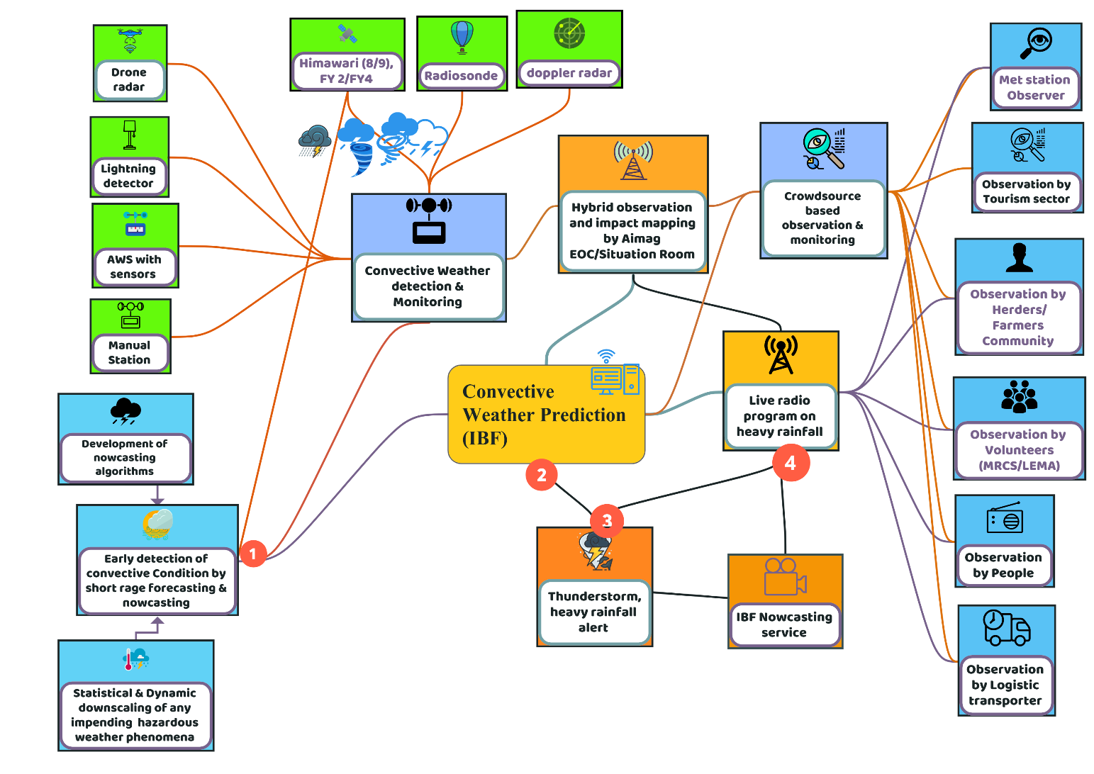

Figure 23 : Convective weather condition-induced hazards early warning system(Source: Z M Sajjadul Islam, UNDP-GCF)

- Baseline risk review

- Multi-hazard risk calculation for convective rainfall impacts:
Assess baseline risk associated with convective rainfall-induced flash flooding, including related hazards such as flash floods, landslides, mudslides, and rockfall/debris flows, to support risk-informed forecasting and early warning.
- Exposure mapping of people and critical movement corridors:
Map exposed and high-priority areas, including cities, towns, ger settlements, markets, and other population concentrations, as well as highways and key transport corridors where mobility is frequent and essential.
Table : Screening of rapidly developing convective weather conditions:
Tools | Automatic Weather Station | Nowcasting
Dynamical /Statistical downscaling ( grided data) over the special area of interest ( determining rapidly developing weather conditions ) | - Installation of an Automated Weather Observing System (AWOS): Deploy AWOS at priority locations to provide continuous, high-frequency measurements of key surface parameters (e.g., wind, temperature, humidity, pressure, visibility, and present weather) to support operational nowcasting and early warning.  - Installation of an All-Weather Precipitation Accumulation Gauge (AWPAG): Install all-weather precipitation accumulation gauges to measure precipitation totals reliably across seasons and precipitation types (rain/snow/mixed), improving real-time accumulation monitoring and supporting flood and winter-weather impact assessment.  - Installation of temperature/dew point sensor hygrothermometer.  - Develop short-range forecasting, Rapid Update Cycle (RUC), which provides NWP-based forecasts at the 0-6h timescale updated every 15-60 min  - Snow depth sensor (most common): measures snow depth on the ground (typically ultrasonic or laser).  - Snow presence / snow cover sensor: detects whether snow is present on the surface (yes/no or fractional cover).  - Precipitation type sensor (rain-snow discriminator): identifies whether precipitation is rain, snow, mixed, or freezing rain.  - Snow water equivalent (SWE) sensor: estimates the water content of the snowpack (e.g., snow pillow/pressure sensor).  - Laser-based snowfall sensor (snowfall onset detector)  Detects the onset of snowfall (and often snowmelt) using a laser measurement principle.  - Laser precipitation disdrometer (rain/snow type and intensity sensor)  Measures falling hydrometeors (rain/snow/hail) by capturing particle size and fall speed, enabling precipitation-type classification and intensity/rate estimates.  - Present weather and visibility sensor (forward-scatter, snow-capable)  Detects present weather codes (including snow) and visibility impacts using optical scattering and (often) fall-speed discrimination.  - Installation of a laser-based snowfall detection sensor to identify snowfall onset and support nowcasting of snowfall intensity and associated visibility impacts. | Develop an integrated, modular algorithm suite that produces rapidly updating (0-6 hour), impact-based guidance for severe convection (damaging winds, heavy rainfall/flash flooding, hail where relevant, frequent lightning). The design should fuse environmental diagnostics (NWP) with real-time storm observations (satellite, lightning, radar where available, and surface/AWS).
Analyze the most updated IR image of Himawari-8/9 satellites, FY 2/FY4 satellites and provide nowcasting services through the IBF platform | - Acquisition of temperature and dew point in degrees Fahrenheit/ Celsius, present weather, icing, lightning, sea level pressure, and precipitation accumulation | Nowcasting weather inputs (satellite and lightning)  - FY-4 (CMA) Geostationary Lightning Imager / Lightning Mapping Imager (LMI):  Continuous total-lightning monitoring (in-cloud and cloud-to-ground) from the FY-4 geostationary platform. The LMI spatial sampling at/near the sub-satellite point is typically reported on the order of ~7-8 km (about 7.8 km at nadir), supporting rapid identification of convective initiation and intensification.  - Himawari-8 geostationary imagery (JMA) / Himawari Standard Data (HSD):  Use HSD as the primary, rapid-update geostationary imagery stream for operational nowcasting. Baseline operations provide full-disk imagery every 10 minutes (with higher-frequency sector scans available for defined areas), enabling continuous monitoring of cloud growth and evolution.  - Himawari-8 cloud mask and cloud analysis:  Apply Himawari-8 products for cloud masking (cloud/no-cloud discrimination) and related cloud analysis to support convective screening and dust monitoring.  - Himawari-9 imagery for visualization and cloud-type identification:  Use Himawari-9 imagery for cloud visualization and cloud-type classification, consistent with the same baseline observation timeline (including 10-minute full-disk cadence).  - FY-2 / FY-4 imagery-derived nowcasting fields (as applicable):  Leverage FY-2/FY-4 image sequences for:  - Cloud convergence and identification  - Cloud motion (e.g., cloud-motion vectors / tracking)  - Convective cloud monitoring  - Dust storm detection and tracking
Acquisition of heavy rainfall, thunderstorm, hailstorm, etc. data from AWS instrument | - Automatic Rain Gauger  - Automatic lightning detector  - Automatic Thermometer  - Automatic Anemometer  - Automatic Wind vane  - Automatic Hygrometer  - Automatic Barometer  - Automatic Ceilometer  - Automatic Rain gauge  - Automatic Ultrasonic  - Automatic Pyranometer | IBF platform to disseminate nowcasting services by providing the above tools and information services.

- Algorithm development for the Severe convective high-impact forecasting and nowcasting :

Develop and operationalize an integrated algorithm suite to detect, track, and predict severe convective hazards (damaging winds, large hail, intense rainfall/flash flooding, frequent lightning) on 0-6 hour lead times.
1) Inputs and data fusion
- NWP fields: CAPE/CIN, shear, moisture convergence, PWAT, frontal/boundary diagnostics, precipitation guidance.
- Satellite: cloud type, cloud-top temperature/height trends, overshooting tops, microphysics proxies, CI indicators.
- Radar (if available): reflectivity/echo-top trends, cell intensity/structure, radial velocity for wind signatures.
- Lightning: flash rate, lightning density, lightning jump indicators.
- Surface/AWS and hydrology: gusts, pressure jumps, temperature drops, rain gauges, river/flash-flood response (where available).
- Fuse all sources to a common grid/time step with automated QC and latency controls.
2) Core algorithm modules
A. Convective screening and initiation (0-2 h)
- Identify “watch areas” where instability , trigger overlap.
- Detect convective initiation using multi-sensor signals (cloud-top cooling, first lightning, first radar echoes, convergence lines/outflows).
B. Storm object identification and tracking
- Segment storms into “objects” (cells/clusters) from radar/satellite/CRR.
- Track movement, growth/decay, splitting/merging; estimate motion vectors and uncertainty envelopes.
C. Severity diagnosis and rapid intensification
- Generate severity probabilities using predictors such as:
  - CAPE/CIN (Convective Inhibition), deep-layer shear, low-level moisture
  - radar intensity/echo-top growth (where available)
  - lightning density trends and lightning jump metrics
  - cloud-top cooling rate / overshooting-top detection
- Flag rapid intensification when multiple indicators exceed thresholds within short time windows.
D. High-impact hazard nowcasts (0-6 h)
- Produce hazard-specific guidance:
  - Damaging wind: gust potential and outflow boundary tracking; wind-threat polygons.
  - Heavy rain/flash flooding: CRR and accumulation nowcasts; exceedance probabilities for rainfall thresholds.
  - Hail: storm-top/microphysics proxies plus shear/instability; hail-risk classification (if supported by data).
  - Lightning: short-term lightning risk and “frequent lightning” warnings based on density trends.
- Blend extrapolation nowcasts (0-2 h) with NWP-informed evolution (2-6 h).
3) Impact-based thresholds and messaging logic
- Convert meteorological guidance into action triggers (e.g., “risk to herders/field workers,” “transport visibility,” “localized flash flooding in urban drainage”).
- Define alert levels (Advisory/Watch/Warning) linked to objective thresholds and confidence.
4) Verification, calibration, and continuous improvement
- Build an event archive (severe and non-severe cases).
- Verify against observations and impact reports; track POD, FAR, CSI, lead time, and reliability for probabilities.
- Recalibrate thresholds by season and region; document updates and version control.
5) Implementation and operations
- Automate production pipelines, dashboards, and polygon generation.
- Ensure resilience (fallback modes if radar/lightning is unavailable).
- Provide training and SOPs for forecasters and EOC partners.

8.7 Convective weather condition screening mechanism

Method | Pre-convective environment tracking | Convective Initiation tracking | Mature Convective Storm tracking
Nowcasting relies on high-frequency observations to detect initiation, intensification, and movement of hazardous weather on 0-6 hour lead times. Core sensor types include:  - Weather radar (single-site and mosaics): Real-time monitoring of storm structure, intensity, precipitation cores, and cell tracking (critical for convective storms, heavy rain, hail, and damaging winds).  - Geostationary satellite imagery (VIS/IR/WV): Continuous monitoring of cloud development, cloud-top cooling, overshooting tops, and convective initiation especially valuable where radar coverage is limited.  - Lightning monitoring (space-based and ground-based networks): Total lightning and lightning density trends for identifying convective initiation and rapid intensification, and for lightning risk warnings.  - Automatic Weather Stations (AWS) and surface networks: Rapid detection of wind gusts, pressure changes, temperature drops, precipitation onset, and gust fronts; supports impact-based warnings and verification.  - Upper-air observations and vertical profiling (radiosonde, wind profilers, sodar/lidar where available): Improved diagnosis of instability, moisture, and wind shear to support severity assessment and short-term forecast adjustments.  - Hydro-meteorological sensors (rain gauges, river gauges, soil moisture sensors): Real-time detection of intense rainfall and runoff response for flash flood nowcasting and warning escalation.  - Visibility and present weather sensors (airports/transport corridors): Detection of reduced visibility due to blowing dust/sand, fog, or snow high relevance for transport safety warnings.  - Crowdsourced and impact reports (structured): Verified reports from field staff, road authorities, herders, and local administrations to confirm impacts and refine warning areas. | Operational nowcasting and short-range forecasting can be strengthened by integrating the following data streams:  - NWP outputs and analyses: Model fields used for situational awareness, short-range guidance, and as background fields for data assimilation (e.g., wind, temperature, humidity, stability indices, precipitation, and boundary-layer structure).  - Aircraft-based measurements: In situ observations from commercial or research aircraft (e.g., wind, temperature, turbulence, and sometimes humidity) to improve depiction of the lower and mid-troposphere particularly valuable near airports and along flight corridors.  - UAV/Glider sensor observations: Targeted, high-resolution vertical profiles and transects of wind, temperature, humidity, and pressure to fill observational gaps and capture mesoscale gradients (fronts, jets, low-level inversions, mountain-valley circulations).  - Drone-based weather radar (or radar-on-drone / mobile radar platforms): Rapid-deploy observations to monitor convective development, precipitation structure, storm evolution, and localized hazardous winds where fixed radar coverage is limited or unavailable.  - Synoptic and surface observations from meteorological stations: Routine monitoring of core parameters, including:  - Wind speed/direction and gusts  - Air temperature and dew point / relative humidity  - Sea-level pressure / pressure tendency  - Precipitation type and amount  - Visibility and present weather (fog, blowing dust/snow)  - Snow depth / snow cover (where measured) | - Radar, UAV/drone observations, and lightning data: Integrate radar-based storm structure and intensity information (where available) with UAV/drone observations and lightning activity to monitor convective development and rapid intensification.  - Cloud type: Classify cloud types to distinguish convective clouds from stratiform cloud decks and to support convective screening.  - Cloud-top temperature and height: Track cloud-top cooling and estimated cloud-top height as indicators of strengthening updrafts and deepening convection.  - Cloud microphysics: Monitor microphysical properties (e.g., glaciation signals, effective particle size proxies, hydrometeor phase) to infer precipitation efficiency and hail potential where appropriate.  - Convective initiation (CI): Detect and flag areas where convection is initiating using multi-sensor signatures (rapid cloud-top cooling, boundary-layer convergence, first lightning, and radar echoes).  - Optimal cloud analysis: Produce an integrated cloud analysis that combines satellite, radar (if available), and model background to generate consistent cloud field products (coverage, phase, top properties) for nowcasting.  - Convective cloud outflows: Identify and track outflow boundaries (gust fronts) that can trigger new convection, generate damaging winds, and rapidly shift local conditions (temperature, wind, visibility). | Monitor and nowcast mature convective storms, integrate multi-sensor indicators of storm structure, intensity, rainfall output, and electrical activity:  - Radar and lightning data: Use radar (reflectivity/velocity where available) to track storm cells, intensity trends, and precipitation cores, and combine with lightning observations to confirm active deep convection and rapid intensification signals.  - Cloud type classification and storm tracking: Apply cloud-type classification and object-based storm tracking to follow storm evolution, including cell splitting/merging and movement across warning areas.  - CRR (Convective Rainfall Rate) product: Use the CRR precipitation rate product to monitor convective rainfall intensity and identify areas at risk of short-duration, high-impact rainfall and flash flooding.  - Lightning density: Track lightning density and its temporal trends to assess storm vigor and support intensity-based warning updates.
 | Convective Cloud Outflows | Various parameters were calculated to characterize the size distributions, including rainfall rate, liquid water content, and median volume diameter.
Analyze CAPE(Convective Available Potential Energy)- CAPE quantifies atmospheric instability the amount of buoyant energy available to accelerate an air parcel upward if convection initiates. Higher CAPE generally supports stronger updrafts and a greater potential for thunderstorms (and, depending on other factors, severe weather). | Convective available potential energy (CAPE)
Lightning detection networks (for nowcasting and convective screening)  Lightning detection provides a high-frequency, storm-scale indicator of convective initiation and intensification. Operationally, lightning data are used to (i) confirm thunderstorm development, (ii) monitor rapid storm strengthening, and (iii) support short lead-time warnings when combined with radar, satellite imagery, and NWP diagnostics | - Geostationary Lightning Imager / Lightning Mapping Imager (GLI/LI/LMI) from regional geostationary satellites: Use total-lightning products from regional GEO missions to continuously detect and map in-cloud and cloud-to-ground lightning at storm-scale resolution (typically ~4.5-10 km at/near the sub-satellite point, depending on the instrument). These data support convective initiation monitoring, storm intensification assessment, and short-lead nowcasting when combined with radar and NWP.  - Regional GEO lightning sensors (e.g., GOES-R GLM, MTG Lightning Imager, FY-4A Lightning Mapping Imager) to provide continuous total-lightning monitoring for storm intensity classification and nowcasting. | - Total lightning observations: Measure total lightning activity at an approximate 6 km spatial resolution at the satellite sub-point to support convective storm monitoring and nowcasting.  - Lightning density as an intensity indicator: Compute lightning density and track its temporal evolution as a predictor for storm intensity classification and potential storm development.  - Verification and situational awareness for convection: Make systematic use of radar mosaics and radiosonde observations where available (including mobile or drone-supported platforms, if applicable) to evaluate and refine convective and precipitation forecasts.
Development of own nowcasting algorithms.  Developing in-house nowcasting algorithms should focus on producing 0-6 hour, rapidly updating, impact-oriented guidance by fusing NWP, satellite, radar (if available), lightning, and surface observations.  1) Define scope, hazards, and performance targets  - Target hazards (e.g., damaging winds, heavy rain/flash flooding, hail, blizzard/blowing snow, dust/sandstorms).  - Define operational requirements: update frequency (e.g., 5-15 minutes), warning lead time, spatial resolution, latency limits, and acceptable false-alarm rates.  2) Establish the data foundation (multi-sensor ingestion and QC)  - Ingest: AWS/surface data, radar mosaics, satellite imagery/products, lightning networks, rain gauges/river gauges, radiosonde/NWP fields.  - Implement automated quality control: range checks, temporal consistency, spatial buddy checks, and missing-data handling.  - Harmonize data on a common grid and time step.  3) Build the algorithm stack (core modules)  A. Detection and classification  - Detect convection initiation, blowing dust/sand, blowing snow, or high-wind corridors using sensor-specific features (e.g., cloud-top cooling, radar reflectivity trends, lightning density, gust observations, visibility sensors).  - Classify event type and intensity using rule-based logic or supervised ML.  B. Tracking and short-term prediction  - Cell/object tracking (storm cells, dust plumes, snow bands) using optical flow or object-based tracking.  - Extrapolation nowcasts (0-2 hours) blended with NWP (2-6 hours) to reduce drift and improve evolution.  C. Impact-based thresholds  - Convert meteorological predictors into impact likelihood using locally calibrated thresholds:  - Wind gust thresholds linked to infrastructure and transport impacts  - Visibility thresholds for road/aviation risk (dust/blowing snow)  - Rainfall rate/accumulation thresholds for flash flood potential  - Produce probabilistic outputs where possible (e.g., 30/60/90% likelihood of exceeding thresholds).  4) Calibration and verification (continuous improvement)  - Create a hindcast archive of past events and “non-events.”  - Verify against observations and impacts (road closures, accidents, livestock losses, utility outages).  - Track skill metrics: POD, FAR, CSI, lead time, bias, reliability diagrams (for probabilities).  - Recalibrate thresholds seasonally and by region (steppe/desert-steppe vs mountain valleys).  5) Operationalization and dissemination  - Integrate outputs into the forecast desk workflow (dashboards and automated situational summaries).  - Standardize products: watch polygons, 0-2 hr nowcast maps, 0-6 hr blended guidance, impact bullets.  - Define decision rules and escalation triggers for issuing or upgrading warnings.  6) Governance, documentation, and sustainment  - Version control, documented assumptions, reproducible training/verification, and clear ownership for maintenance.  - Routine reviews after major events to update logic and thresholds. | High-resolution nowcasting and cumulative rainfall modeling (NAMEM-NWP)  NAMEM-NWP employs high-resolution nowcasting and numerical modeling tools such as cumulative rainfall/precipitation accumulation products to support operational forecasting and early warning. Examples include:Dynamical downscaling (MM5): Dynamical downscaling using MM5 improves the representation of the spatial and temporal variability of key parameters (notably wind and temperature) across Mongolia.  Regional forecast modeling (5 × 5 km): Regional weather forecast models operating at a standard 5 × 5 km horizontal resolution provide operational forecasts with lead times of up to three days.  Rainfall/precipitation accumulation products (multi-resolution): Precipitation accumulation maps are generated at 9 km, 5 km, 3 km, and 1 km grid spacing using model outputs to produce 1-6 hourly accumulated precipitation distributions, supporting assessment of highly localized flooding potential.  High-resolution WRF cumulative rainfall (1 km): The WRF model is used to predict cumulative precipitation at 1 km spatial resolution to better capture localized rainfall maxima and associated flood risk. | - Tracking convective rainfall, lighting, and thunderstorm ( temperature, wind, dew point temp, participation, lighting, etc.)  - Calculate various weather parameters were calculated to characterize the size distributions, including rainfall rate, liquid water content, and median volume diameter

- Anticipatory loss and damage assessment :

Hazard | Agriculture | Settlement | Commercial installations | Livestock | Communication network
Heavy rainfall | Standing crops | UB, Aimag center, soum center, bag center | Marketplace | Herders’ tender livestock(calf) | Damage Road network
 | Seedling | Towns | Processing industries | Ger | Damage and waterlogging of the earthen road/paved road,
 | Sapling | Soum town | SME/Enterprise | Livestock shed | Damage structures at the River crossing points
 |  | Bag settlements | Warehouse | Waterlogging of pastureland
 |  | Other installations

8.8 Strong/Damaging Wind induced hazards warning :

Wind is one of the most influential meteorological parameters in Mongolia and frequently shapes the overall weather system across all seasons. Seasonal wind speeds at ridge-crest locations vary across the country, with distinct differences between eastern/central Mongolia and western Mongolia. Eastern and central ridge-crest sites tend to show a seasonal wind distribution similar to plains and other low-elevation areas. Wind speeds peak commonly in April-May and again in October-November. The diurnal (time-of-day) wind pattern is strongly controlled by elevation and local topography, and can change rapidly due to mountain-valley circulations and terrain channeling.

Observed/Reported damaging wind conditions
- In Altai, Tonkhil, and Sharga soums (Govi-Altai Province) and Jinst soum (Bayankhongor Province), wind speeds reportedly fluctuated between 18-24 m/s (wind chill reported around −17°C) and reached 28-30 m/s (wind chill reported around −24°C).
- Damaging winds occur in spring, summer, autumn, and winter.
- Wind speed can vary sharply within a day. Herders report that mornings may appear calm, leading to livestock being taken out for grazing; however, conditions can deteriorate rapidly, with sudden changes occurring within 30-40 minutes, sometimes resulting in livestock mortality.

Key wind-induced impacts and compounding hazards
- Blowing snow and snowdrifts under strong winds can reduce visibility to below 0.5 km (as reported by herders), creating dangerous travel conditions.
- Poor visibility and severe wind conditions have led to road closures and disruption of movement between cities in multiple areas.
- Strong winds combined with winter conditions can cause livestock to run indiscriminately, increasing separation, injury, exhaustion, exposure, and overall stress on herds and herders.

Operational implications for early warning
- Short lead time is common: damaging wind episodes may intensify within 30-40 minutes, requiring rapid updates (nowcasting) and frequent warning refresh cycles.
- Location-specific messaging is essential: ridge crests, open steppe/desert-steppe corridors, and terrain-channelled valleys may experience markedly different wind behavior than nearby settlements.
- Compound-risk framing improves action: warnings should explicitly link wind thresholds to visibility reduction (blowing snow/dust), road safety, and livestock exposure/stampede risk, rather than issuing wind-only messages.

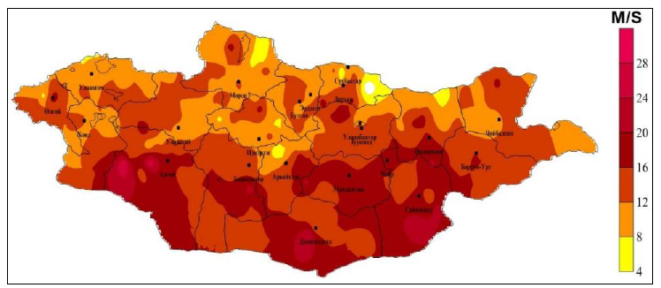
Figure 24: High wind speed between 6 May - 13 May 2019. (Map: NAMEM)

1) Tools and process :
- Trigger-based advanced modeling: Run statistical and dynamical downscaling when there is an increased likelihood of anomalies, to track the evolution of an impending event. The NWP division remains on alert to continuously analyze model guidance and observational trends.
- Baseline CRV and wind-risk mapping: Maintain access to baseline CRV information collected by aimag EOCs and develop GIS-based risk maps identifying strong wind-prone areas.
- Socio-economic and sectoral risk assessment: Assess socio-economic impacts and prioritize sector-specific risks and vulnerabilities related to wind hazards.
- Event situation reporting with GIS: Produce GIS maps for event situation reports documenting winter weather-related disasters that have already occurred.
- Multi-hazard enabling factors mapping: Maintain GIS maps and risk information on geophysical, geological, geomorphological, and hydrometeorological factors that influence and intensify strong wind-induced hazards in Mongolia.
- Exposure and vulnerability assessment of key elements: Assess exposure, risk, and vulnerabilities of the elements listed in Annex 1 that are affected by winter hazards.
- Forecast algorithm and model development: Develop and validate algorithms and models using Mongolia-specific wind speed characteristics to strengthen damaging-wind forecasting capability.

Wind-hazard tracking and early warning mechanism :

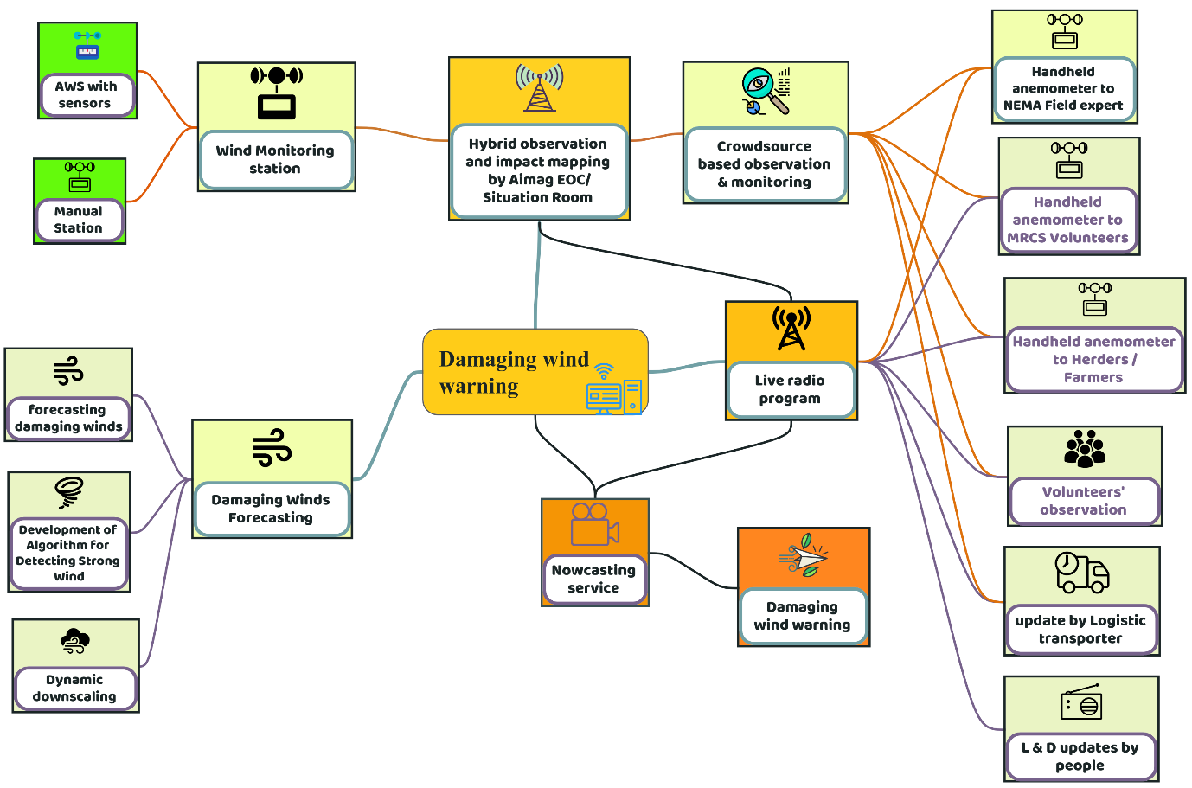
Figure 25: Wind-hazard tracking and early warning mechanism(Source: Z M Sajjadul Islam, UNDP-GCF).

Table: Impacts by damaging winds
Wind-induced hazards | Elements | Impacts | Hybrid ( climatic & non-climatic) observation ( figure 9)
Strong winds in Mongolia can trigger and intensify several hazards, particularly during the cold season. High wind speeds can rapidly produce sudden-onset winter storms, worsen extreme cold conditions, and increase wind chill (the “feels-like” temperature). Winds can also drive blowing snow and dust, leading to reduced visibility and travel disruption.  Key wind-related hazards include:  - Sudden-onset winter storms  - Intensified extreme cold conditions (due to wind exposure)  - Severe wind chill (increased “feels-like” cold)  - Snowstorms (including blowing/drifting snow)  - Cold front-induced storms  - Dust storms  - Poor visibility (from blowing snow or dust) | Exposed sectors  - Livestock and pastoral livelihoods  - Agriculture  - Rural settlements  - Urban centers  - Tourism facilities  - Small and medium enterprises (SMEs)  - Transport and communications infrastructure  Typical damages and losses  - Power and utility infrastructure: damage to power lines and related equipment  - Housing and shelters: damage to gers and other structures; damage to livestock shelters  - Livestock impacts: direct injury or mortality; stress and productivity losses  - Agricultural impacts: damage to standing pasture forage/crops and exposed soils  - Transport safety: reduced visibility and unstable road conditions leading to accidents  Human and animal safety risks  - Cold fronts, winter storms, snowstorms, and dust/sandstorms pose major human and animal safety risks in Mongolia and can be fatal, potentially affecting around 71.2 million lives. Impacts include losses of livestock, harm to herding livelihoods, disruption to the cashmere industry, increased traffic and transport accidents, and serious exposure-related health effects for both herders and animals. | Direct impacts  - Transport accidents and disruptions driven by strong crosswinds, blowing dust, and reduced visibility.  - Topsoil and nutrient loss from agricultural land under high winds, which can reduce future crop productivity and accelerate land degradation.  Wind climatology and spatial patterns  - The steppe and desert-steppe zones are among the windiest areas, with reported annual average wind speeds of 4-6 m/s.  - Mountain regions (Altai, Khangai, Khuvsgul, and Khentii) typically experience lower average winds, around 1-2 m/s, while mountain valleys and other areas are often 2-3 m/s.  - Prevailing winds are most commonly westerly, northwesterly, and northerly.  - Wind behavior is strongly influenced by local orography and landscape, and mountain-valley breeze systems can occur frequently.  Dust and sandstorm characteristics  - Mongolian dust storms are a notable source of regional “yellow dust” transport.  - Sandstorms occur on the order of ~10 days per year in some mountain areas (Altai, Khangai, Khuvsgul, Khentii).  - Seasonality is pronounced: approximately 61% of dust storms occur in March, while around 7% occur in summer.  Drivers and aggravating factors for dust generation  - Physiographic/topographic conditions at ground level  - Soil type and soil properties  - Mining areas and disturbed surfaces  - Pastureland degradation, broader land degradation, and desertification  - Road and surface erosion, including arable-land soil erosion  - Deforestation and other land-cover changes  - Soil pollution and dusting linked to environmental impacts and human activities  Longer-term environmental consequences  - Pasture degradation and reduced soil ecological function  - Soil health degradation, including loss of organic matter and fertility, increasing vulnerability to future wind erosion and drought impacts | A hybrid observation approach integrates climatic monitoring (meteorological and environmental measurements) with non-climatic information (exposure, vulnerability, and impact indicators) to strengthen preparedness and decision-making for damaging winds.  - High-density observations: Expand and integrate observation networks to capture spatial variability in wind and related hazards (e.g., automatic weather stations, remote sensing, and targeted monitoring in wind-prone steppe and desert-steppe areas).  - Nowcasting and operational forecasting for damaging winds: Use real-time data assimilation and short lead-time forecasting to issue timely alerts and regularly updated forecasts, linked to impact thresholds such as peak gusts, reduced visibility from blowing dust/snow, and transport safety risk.

Strong wind forecast - contribution by Local Team :

8.9 Hazardous winter weather early warning :

Winter in Mongolia usually sets in in early November and continues for about 110 days, often lasting into March. Snow may fall as early as September and again in November, but the most intense snowfalls typically occur in the first part of November. January is generally the coldest month. In the mountainous Khangai region, average winter temperatures can drop to around −35°C. In some areas, snow cover can remain on the ground for as long as 150 days.

Extended snow cover, severe cold, and strong winds can rapidly trigger sudden winter hazards such as snowstorms, winter storms, blizzards, cold waves, and cold front-driven cold storms. These winter weather hazards can lead to significant loss and damage especially to livestock and other climate-sensitive sectors so timely and reliable early warning is critical.

Winter weather-induced hazards in Mongolia
- Extreme cold temperatures
- Heavy snowfall
- Snowstorms
- Extreme cold (wind chill)
- Blizzards (snow accompanied by strong winds and reduced visibility)
- Freezing rain/drizzle
- Multi-factor Dzud conditions (compound events that restrict grazing and limit access to forage)
- Cold front-induced storms

1) Tools and process :
- Baseline data collection and risk mapping: Develop GIS climatology layers for Mongolia (30-year mean), including spatial distributions of extreme cold zones, heavy snowfall zones, snowstorm-prone areas, high snow-depth zones, and snow/ice-ground risk areas.
- MODIS snow and ice mapping for Dzud analysis: Use MODIS-based snow (Snow-map) and ice (Ice-map) algorithms to compute the Normalized Difference Snow Index (NDSI) and produce separate snow-extent and ice-extent maps to support Dzud risk assessment.
- Socio-economic and sectoral vulnerability assessment: Conduct assessments of socio-economic vulnerability and priority sector exposure to winter hazards, incorporating CRVA indicators and baseline risk repositories.
- Event-based winter disaster situational mapping: Produce GIS event situation reports that map winter weather-related disasters already occurring (hazard footprints, affected locations, and impact attributes).
- Geophysical and hydro-meteorological risk intensifiers: Develop GIS layers and risk information describing geophysical, geological, geomorphological, and hydrometeorological factors that amplify winter hazard impacts (e.g., terrain, drainage, wind corridors, land surface conditions).
- Historical exposure and vulnerability profiling: Assess historical winter hazard impacts to quantify exposure, risk, and vulnerability of key elements (Annexure 1), including recurring hotspots and high-loss zones.
- Winter hazard forecasting and early warning algorithms: Develop algorithms and high-resolution modeling workflows to track impending winter hazards, supporting short-range operational forecasting, threshold-based warnings, and impact-based early warning services
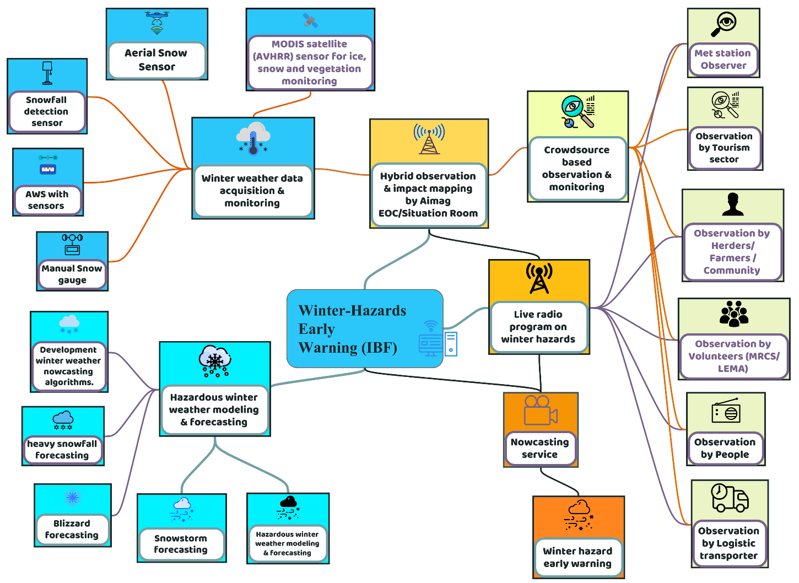
Figure 26 : Winter hazard early warnings(Source: Z M Sajjadul Islam, UNDP-GCF).

Table : Extreme winter weather impacts for the priority sectors
Hazard | Livestock | Agriculture | Water | Soil and Land
- Extreme cold temperatures: Sustained very low temperatures that increase cold stress and livestock mortality risk, particularly for young, weak, and pregnant animals.  - Heavy snowfall: High snowfall accumulation that restricts grazing access, blocks movement, and increases feed and water constraints.  - Snowstorms: Snowfall events often accompanied by strong winds, causing rapid deterioration of field conditions and operational disruption.  - Extreme cold (wind chill): Combined low temperatures and strong winds that sharply increase effective cold exposure, elevating risks of hypothermia and frostbite.  - Blizzards (snow , strong winds , poor visibility): Severe conditions characterized by blowing snow and near-zero visibility, affecting mobility, sheltering, and emergency response access.  - Freezing rain/drizzle: Rain or drizzle that freezes on contact, creating ice crusts that block grazing, increase slipping injuries, and damage infrastructure.  - Multi-Dzud factor (compound drivers): Combined and cascading factors snow/ice barriers, extreme cold, wind chill, and feed/water shortages that collectively escalate Dzud severity.  - Cold front-induced storms: Rapid-onset storms triggered by cold fronts that can cause abrupt temperature drops, strong winds, and snow, increasing forecast and response urgency. | Dzud risk drivers can cause large-scale losses: These factors contribute directly to Dzud severity and, under extreme conditions, can result in the loss of millions of livestock.  - Pasture degradation and feed shortages amplify mortality risk: Pasture degradation and seasonal shortages reduce carrying capacity and feed availability, increasing the likelihood of widespread livestock deterioration and high mortality.  - Rapid-onset hazards increase livestock and human tolls: Sudden-onset events such as heavy snowfall, snowstorms, blizzards, cold rain, and severe storms can quickly escalate impacts, taking a significant toll on both livestock and affected populations | - Standing crops and pasture damage: Damage to crops in the field and degradation of pasture resources, reducing available forage and affecting agricultural productivity.  - Food insecurity: Increased risk of food insecurity due to disrupted production, reduced yields, and impacts on household livelihoods and purchasing power.  - Seedling/sapling damage and delayed planting: Damage to young plants and seedlings, delays in planting schedules, and subsequent reductions in crop establishment and yields, potentially leading to overall crop yield losses. | Frozen water bodies including lakes, rivers, and waterways can disrupt water access and interrupt waterway-based transport and communication routes. | Soil thawing

Considering winter multi-hazard risks, the integrated IBF and multi-hazard early warning platform should provide the following winter information services (warnings, watches, and advisories) to support anticipatory action and last-mile preparedness:
- Blizzard Warning
- Winter Storm Warning
- Ice Storm Warning
- Winter Storm Watch
- Winter Weather Advisory
- Lake-Effect Snow Warning
- Snow Squall Warning
- Heavy Snow Warning
- Snow Advisory
- Blowing Snow Advisory
- Snow and Blowing Snow Advisory
- Extreme Cold Watch
- Extreme Cold Warning
- Lake-Effect Snow Watch
- Freezing Rain Advisory
- Blizzard Watch

8.10 Template: Winter weather emergency advisory

Advisory :

Winter weather emergency :

Circular 01
Warning Issue Date: 2023-[____]
Validity Period: [Start Date/Time] to [End Date/Time]
Warning Area: Nationwide (with priority focus on specified aimags/soums)

Winter Storm Warning
Valid: 10:00 AM Sunday to 6:00 PM Monday, 02 December 2023
What (Expected Hazard Conditions)
A winter storm is expected.
- Total snowfall accumulation: 10-16 inches (approximately 25-40 cm)
- Wind gusts: up to 25 m/s
Where (Threshold-Based Alert Areas)
The most severe impacts are expected in north-western Arkhangai and surrounding areas. The following threshold-based alert levels apply:
- Red Alert: 20-25 cm of heavy, dense snow expected (high-impact zone)
  - Aimag(s): [____]
  - Soum(s): [____]
- Orange Alert: 15-20 cm of snowfall expected (elevated-impact zone)
  - Aimag(s): [____]
  - Soum(s): [____]
- Yellow Alert: 0-10 cm of snowfall expected (moderate-impact zone)
  - Aimag(s): [____]
  - Soum(s): [____]
When (Timing)
From 10:00 AM Sunday to 6:00 PM Monday (Mongolia time).
The worst conditions are expected during daytime on Sunday.
Impacts / Anticipatory Loss and Damage (L&D)
- Livestock may face frostbite and cold injury
- Increased risk of hypothermia and cold-stress illness, especially among weak animals
- Elevated likelihood of calf mortality, particularly in newborn and young animals
- Potential disruption to grazing access, herding mobility, and feed/water supply, especially in red and orange zones

Prepared Actions (Early Action Guidance)
Herders are advised to keep livestock in warm, sheltered conditions, use protective coverings (e.g., jackets) where appropriate, provide high-energy feed, and closely monitor animals for early signs of illness or weakness.
- Red (High-Impact) Zones: Suspend all outdoor activities.
- Orange (Elevated-Impact) Zones: Restrict travel to emergencies only. If short-distance travel is unavoidable, carry a winter survival kit; if stranded, remain with the vehicle.
Road Condition Updates
The latest road snow conditions can be accessed through the IBF web-based weather hazard early warning system and disseminated through national AM radio broadcasts.

8.11 IBF Flood Impact Forecasting:

Current context : In Mongolia, approximately 20-60% of annual runoff is generated during spring flooding, depending on geographic location. However, the majority of annual runoff often 70-80% is produced by summer rainfall floods. Rainfall-driven flooding typically occurs when daily rainfall exceeds 40-110 mm, although flood magnitude is shaped by multiple interacting factors, including rainfall intensity and duration, terrain (relief), vegetation cover, and antecedent soil moisture conditions. The main rainfall season generally extends from mid-June to mid-September, with several distinct peaks.
Historical records indicate that major flood events occurred in 1613, 1623, 1695, 1696, 1701, 1715, 1716, 1830, 1838, and 1868 (D. Tsedevsuren, 1987). In eastern Mongolia, flood discharge in the Khalkhin Gol River reached approximately 300-400 m³/s in 1985, while rainfall floods along the Selenge River during 1971-1973 produced peak discharges of roughly 2,000-4,000 m³/s. One of the most significant modern rainfall floods occurred in 1966 in the Tuul River basin. On 10-11 July 1966, 103.5 mm of rainfall was recorded in the Ulaanbaatar area about 43% of annual precipitation triggering major flooding in the Tuul River and its tributaries, including the Selbe and Uliastai rivers
Flood Risk, Vulnerability, and Exposure Assessment :

Conduct a comprehensive flood risk assessment based on historic flood hazard data and delineate flood risk areas, develop a flood risk map, calculate Risk in river catchment areas, and analyze Land use patterns over the basin and/downstream areas.
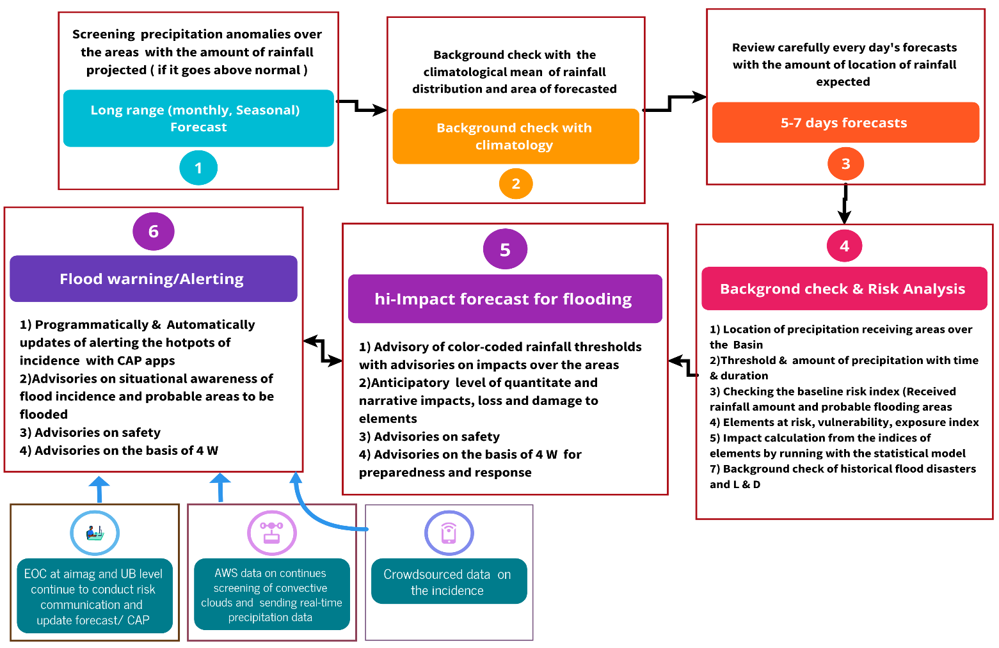

Figure 27 : Flood impact forecasting process (Source: Z M Sajjadul Islam, UNDP-GCF)

- Develop a Mongolia-appropriate flood impact assessment model: The hydrological authority should design a flood impact assessment model tailored to Mongolia’s conditions, using key hydro-morphological inputs (river typologies, DEM/DTM, drainage networks, rainfall regimes, and other relevant parameters). The model should generate a Flood Risk Index (FRI) by integrating a Flood Hazard Index (FHI) with an Infrastructure Vulnerability Index (VI) to quantify and map expected impacts.
- Address rainfall variability and observation bias in flood-prone area identification: Flood-prone areas should be identified nationwide, recognizing that rainfall variability shifts across high-evapotranspiration zones and semi-arid/arid environments and that convective systems can develop under diverse atmospheric and land-surface conditions. Current observation coverage is spatially biased toward airports and urban centers, which may not adequately represent high-risk flood zones.
- Strengthen basin-periphery rainfall monitoring and support accumulation-driven modeling: Install rainfall gauging stations strategically around basin peripheries where rainfall accumulation is most likely to trigger runoff into drainage and river systems. To compensate for limited observations and capture basin response, develop a “virtual” flood modeling approach that incorporates 1-10 day rainfall accumulation and estimates the likely extent of catchment inundation

- Developing a hydrological and flood risk and vulnerability calculating model/hypothesis based on Mongolian context :
- Develop the flood risk and vulnerability model foundation (hydrology and terrain): The Hydrological Research Division should design a flood risk and vulnerability model using core hydrological and morphological inputs, including river and drainage networks, DEM-derived terrain and flow pathways, river and waterbody discharge/water levels, existing flood-control and water-retention structures (reservoirs, embankments, retention basins), integrated water resources management context, precipitation regimes, snow/ice melt conditions, and known heavy-precipitation hotspots.
- Build a statistical flood risk-vulnerability model tied to rainfall intensity thresholds: Develop a statistical model that links flood likelihood and severity to heavy rainfall intensity classes (e.g., 30-50 mm/hr, 50-70 mm/hr, and ≥70 mm/hr). Estimate flooding intensity by integrating: the spatial extent of rainfall, runoff generation potential, drainage direction and channel capacity, floodplain exposure, and the number and type of elements located in low-lying or flood-prone areas that could be impacted, damaged, or lost.
- Compute rainfall accumulation and persistence metrics: Calculate total rainfall accumulation over relevant windows (e.g., 6-hour, 12-hour, 24-hour, multi-day, and multi-week) and incorporate intensity and frequency metrics to capture compounding rainfall effects that increase runoff and flood probability.
- Calculate and map the Flood Risk Index (FRI) and identify exposed elements: Compute a Flood Risk Index (FRI) and map risk zones in GIS. The FRI should be derived by combining a Flood Hazard Index (FHI) with a Vulnerability Index (VI) (e.g., building/infrastructure vulnerability, socio-economic vulnerability). Use the resulting risk classes to identify and profile the exposed elements listed in Annexure 5, supporting threshold-based impact mapping and anticipatory loss-and-damage estimation.

- Define spatial and temporal domains for modeling: Begin by specifying the geographic area (spatial extent) and time window (temporal period) for the WRF/WRF-Hydro datasets to be generated and downloaded. Once these boundaries are set, download and configure the complete WRF-WRF-Hydro data-generation package for Windows-based systems.
- Automate ingestion of WRF rainfall outputs into the IBF geospatial platform: Configure the workflow so that cumulative rainfall forecasts generated by the WRF mesoscale numerical prediction system are automatically transferred into the IBF geospatial environment. WRF outputs provide hourly, three-dimensional, gridded meteorological datasets suitable for operational analysis.
- Map the spatial distribution of peak-day cumulative rainfall: From model outputs, generate maps showing the spatial distribution of cumulative rainfall on the highest rainfall day to identify priority impact zones.
- Produce multi-resolution rainfall accumulation products: Calculate rainfall accumulation products from NAMEM model outputs at 9 km, 5 km, 3 km, and 1 km grid spacing. Generate 1-, 3-, and 6-hour precipitation accumulation distribution maps to support analysis of highly localized flooding potential.
- Validate 1 km rainfall fields against station observations: Analyze cumulative rainfall predicted at 1 km resolution and compare grid points nearest to meteorological stations to assess model performance and bias.
- Ground-truth using observed station accumulations and downscale for local decision-making: Compute rainfall accumulation from station observations for immediate ground-truthing of model predictions. Use these verified datasets to refine high-resolution products and generate bag-, soum-, and aimag-level rainfall accumulation projections required for localized flood forecasting and impact assessment

- Impact analysis for the Floods

- Seasonal/climatology diagnosis: Monitor seasonal and monthly outlooks for above-normal rainfall anomalies, including forecast totals and affected regions. Validate the signal through baseline climatology for the area of interest, review historical anomalies from prior long-range outlooks, and cross-check against the country’s annual climatology.
- Hydro-geomorphological and vulnerability context review: Assess the season’s hydro-morphological setting, current water-body levels, drainage capacity, and local flood pathways. Cross-check the area’s risk and vulnerability indices to identify the elements most likely to be impacted.
- Short-range precipitation tracking (5-7 days): Monitor 5-7 day forecasts to estimate projected cumulative precipitation over the area of interest and neighboring upstream/downstream areas.
- Model execution and downscaling: The forecast division runs the appropriate forecast model and downscales precipitation outputs to a 5 km grid. Convert model outputs into two forecast CSV deliverables: (i) national coverage and (ii) aimag/soum-specific subsets for areas under heavy precipitation risk.
- Impact forecasting activation and GIS processing: The impact forecasting team at NAMEM headquarters and at aimag level led by the hydrological research division, activates the “flood and heavy rainfall” impact forecasting workflow. Using ArcGIS/QGIS, the team processes the forecast CSVs against national and aimag shapefiles to begin impact forecast production.
- GIS layer acquisition via geospatial services: Import required GIS layers from GeoNode/GeoServer using REST APIs and OGC services (WCS/WFS), and load all relevant shapefiles into desktop GIS environments.
- Impact overlay and threshold-based analysis: Overlay forecast CSV precipitation fields onto relevant GIS layers risk and vulnerability elements, socio-economic vulnerability layers, sector-specific layers, and gazetteer point features (e.g., OpenStreetMap and Google Maps APIs), as well as customized layers from ALAGaC/ALAMGaC and sector agencies. Quantify precipitation-threshold exceedance and generate color-coded impact maps for key elements (townships, communication networks, settlements, agricultural land), including anticipatory loss-and-damage scenarios.
- Flood and landslide predictability assessment: Incorporate physiographic, topographic, ecological, environmental, soil, and land-surface conditions to estimate flood probability and potential landslide susceptibility.
- Landscape-linked vulnerability assessment: Evaluate element-level risk and vulnerability in relation to landscape vulnerability (e.g., slope, drainage density, soil saturation propensity, erosion potential).
- Distribution of vulnerable population groups: Map aimag/soum/bag-level distributions of vulnerable population groups to support targeted warnings and response prioritization.
- Flood vulnerability modeling and classification: Develop a flood vulnerability model that categorizes exposed elements by expected exposure, risk, and vulnerability classes to support operational decision-making, warning issuance, and early action planning.

- Providing flood warning & alerting :

- IBF hydrological technical working group to remain operational for situational awareness.

- Run statistical and dynamical downscaling for precipitation: Apply statistical and dynamical downscaling models to improve the spatial and temporal resolution of precipitation forecasts, enabling localized assessment of heavy rainfall risk.
- Use satellite time-series analysis for convective monitoring: Analyze time-series satellite imagery to detect and track convective development, including cloud-top characteristics from IR imagery and cloud movement, and issue synoptic updates on the likelihood of heavy rainfall.
- Continuously monitor rainfall using dense ground observations: Maintain comprehensive monitoring through ground-based observation systems (Figure 9), including AWS rain gauges and sensors for cloud/lighting activity, dew point temperature, wind velocity, air temperature, humidity/RH, pressure, and other relevant parameters. Use these data to estimate the probability of consecutive rainfall at appropriate spatial and temporal scales.
- Activate hydrological operations during heavy rainfall forecasts: When heavy rainfall is forecast, the IBF hydrological team should shift into operational mode to provide continuous updates on rainfall status and cumulative totals, while concurrently running flood forecasting models for downstream exposed elements.
- Acquire real-time runoff and water-level data: Collect real-time datasets on runoff levels, drainage channel flooding levels, and water levels of major water bodies using AWS, telemetric river gauges, and flood-level monitoring stations.
- Enable Aimag EOC impact mapping and information intake: The Aimag EOC should compile multi-source field information to produce impact maps. Data can be transmitted via NEMA wireless systems, MRCS/FAO/WFP and other I/NGO networks, mobile BTS-enabled reporting, affected ger/settlement reporting, logistics operators, and other volunteer groups integrated within the hybrid observation system (Figure 9).
- Ingest crowdsourced “big data” for situational awareness: Collect and integrate crowdsourced data through survey tools (e.g., KoboToolbox), public alert feeds (e.g., Google Public Alerts where applicable), social media, lead herders, sector department technicians, community leaders, value chain operators, and NEMA emergency telecommunications to strengthen real-time situational awareness and impact verification

- IBF TWG to develop the following advisories and information services:
- Develop situation reports on flooding :
- Develop weather advisories on flood.
- Landslide warning/advisories
- Mudslide warning/advisories

9.0 Chapter: Impact Forecasting and Warning for Livestock Sector :

Mongolia currently has approximately 71.2 million livestock, and the livestock sector accounted for about 25% of GDP in 2021. Large-scale livestock mortality during Dzud events typically results from a combination of extreme climatic conditions and wider ecological and socio-economic stressors such as degraded soil health, reduced pasture biomass productivity, agricultural and water constraints, and disruptions across the livestock value chain. These interacting pressures reduce the resilience of animal husbandry systems and herder livelihoods. Expanding impact-based weather information services, including anticipatory impact assessment, is therefore essential to reduce barriers to actionable early warning and preparedness.

Given Mongolia’s highly variable weather changing hourly, diurnally, and week-to-week across seasons, and often manifesting as rapid-onset hazards effective impact forecasting for high-density livestock areas requires coordinated engagement across multiple actors. This includes NMHS professionals (forecasters, meteorologists, agrometeorologists), livestock and agriculture specialists, humanitarian agencies, value chain operators, and, critically, marginalized herder communities managing livestock at the last mile. The diagram below illustrates Dzud as the dominant livestock-loss hazard and indicates the operational scale at which the IBF mechanism should be implemented across NMHS and sector partners
.

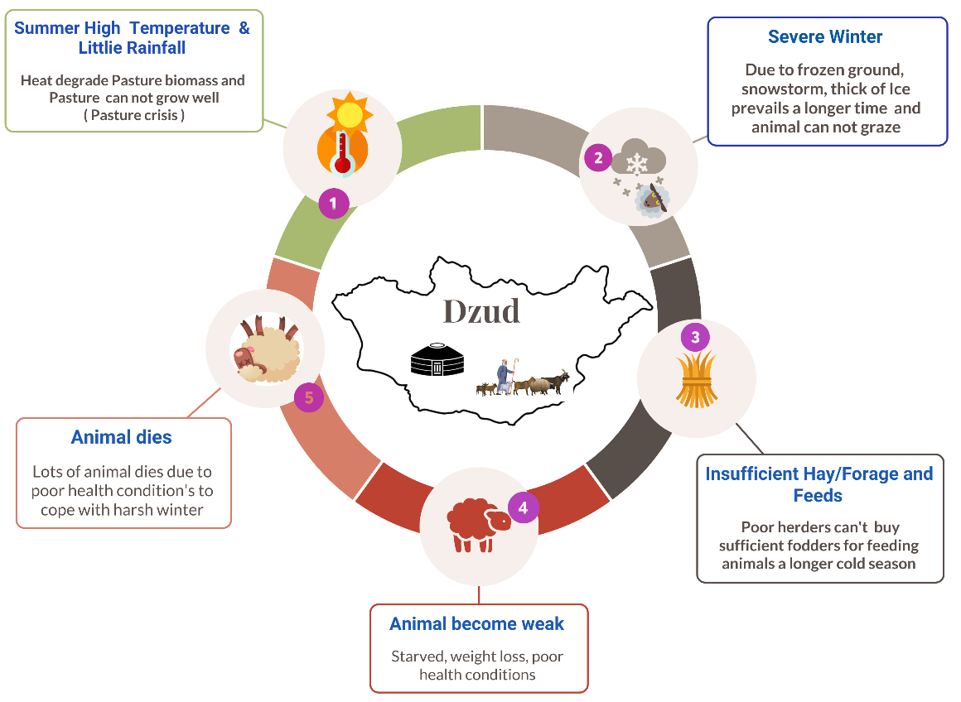

Figure 28: Traditional Dzud factor diagram (Source: Z M Sajjadul Islam, UNDP-GCF)

For analyzing the high impact on livestock and agriculture, to some extent, following the methodology being proposed ;

9.1 Impact analysis methodology :

Climate information services needed for sustainable livestock management :

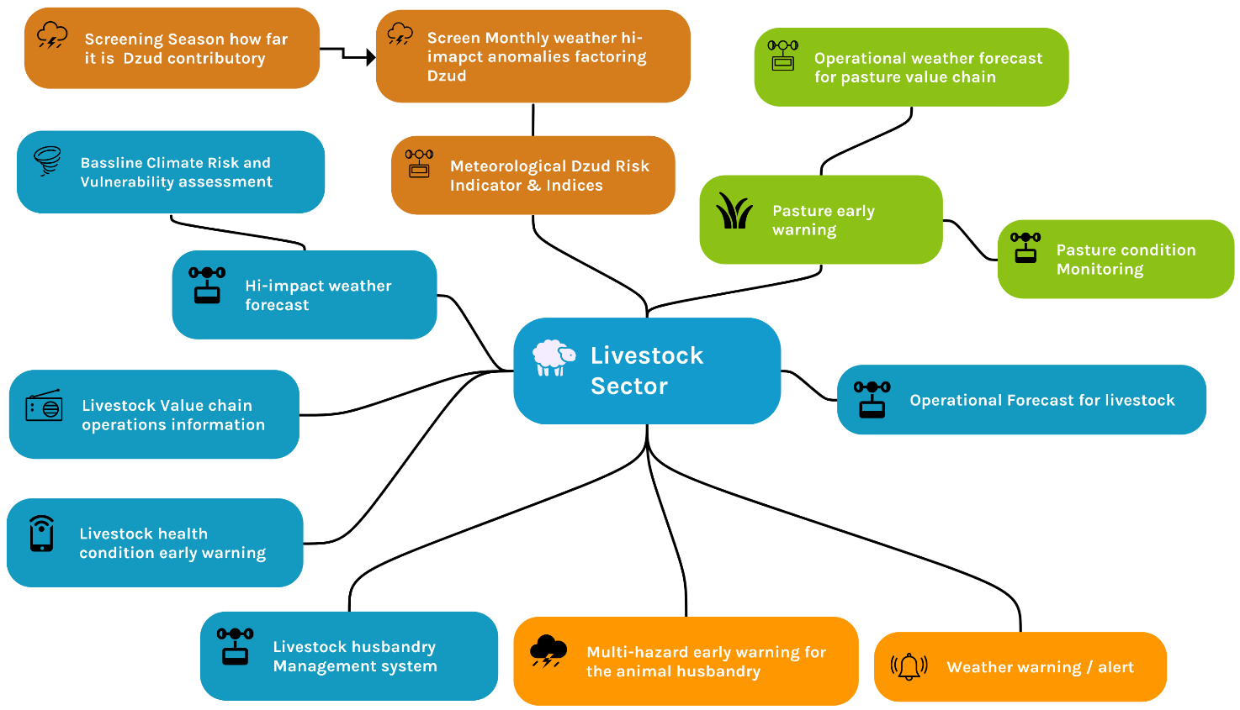

Figure 29 : Climate information services needed for sustainable livestock management.

Step 1 : Prepare baseline weather /climate risk, vulnerability, and exposure database on the type of livestock and climatic region of Mongolia.

- Assessment of Physical vulnerability: Based on the Annexure 1 elements checklist.
- Assessment of Socio-economic vulnerability: Using NSO statistical datasets identify the vulnerable age group ( children, old age, and disabled population ) and GIS mapping with spatial analysis showing poverty, vulnerable age group and underprivileged group, herders livelihood assets, livestock number, herd management tools, etc,
- Base map showing all physical features: Following the GIS layer checklist with Annexure 4
- Aimage-wise multi-hazard-prone area map: Showing livestock paddock, climate-proof livestock shelter, drinking water facility point near the paddock, deep tube well water access point, open-source water body ( perennial, seasonal, dried ), etc.
- Prepare Aimag-wise GIS map: Develop The base map showing all physical layers, socio-economic layers, networks, rivers, etc.
- Geolocate camps and register placemarks: Conduct surveys to capture camp locations, create placemarks, and tag each ger/camp with a unique identifier. Enable voluntary geolocation submissions from herders and regularly visiting frontline personnel (veterinary technicians, health workers, credit operators, and other support staff).
- Develop camp-level GIS attribute datasets: Plot camp locations and build GIS attribute files capturing livestock numbers and other key livelihood variables linked to each camp record.
- Use mobile networks for emergency reporting: Leverage cell phone connectivity to enable herders to submit emergency information and situation updates through agreed reporting channels.
- Produce rangeland health GIS maps (aimag/soum): Develop GIS maps at aimag and soum levels showing rangeland health monitoring status.
- Integrate DIMA outputs with IBF GeoNode: Utilize the DIMA database and publish relevant GIS shapefiles to the IBF GeoNode server to generate rangeland health monitoring status products on weekly, bi-monthly, and monthly cycles.
- Land use and pasture biomass mapping: Maintain land-use maps that identify pasture biomass growth areas, supporting pasture management tools to reduce overgrazing risk and inform grazing allocation decisions.
- Historical mortality geolocation and profiling: Compile geolocated records of camp locations and associated livestock mortality during major Dzud and extreme events (e.g., 2000-2003 and 2010), to support hotspot analysis and historical risk profiling.
- Monthly/seasonal pasture and forage atlases: Develop soum/aimag-level monthly and seasonal maps of pasture condition, forage crop areas, and pasture degradation. Compile these into atlas-style profiles to support fodder cropping risk and vulnerability assessment and pastureland risk analysis.
- Integrate environmental and terrain vulnerability layers: Incorporate geographic, geophysical, topographical, and environmental vulnerability layers to improve spatial interpretation of Dzud and drought impacts.
- Inventory combined drought-Dzud risk in animal husbandry: Systematically document compounded drought and Dzud risk phenomena affecting livestock husbandry, linking hazard signals with pasture conditions, exposure, vulnerability, and observed impacts.

Step 2 : Forecast products required for livestock sector impact analysis.

Prepare short-range (1-5/7 day) and operational forecasts that explicitly analyze severe weather parameters likely to develop into high-impact events (e.g., heavy snowfall/precipitation, severe cold temperatures, strong winds/blizzards, freezing rain/icing). Translate the forecast hazards into livestock-sector impacts by:

- Identifying hazard severity and timing: Specify expected onset, peak period, duration, and spatial extent of each high-impact parameter.
- Applying impact thresholds: Classify forecast conditions against predefined thresholds (e.g., snowfall depth, wind chill, icing risk) to assign impact levels.
- Assessing sector impacts: Estimate likely impacts on grazing access, pasture usability, feed and water availability, shelter needs, animal body condition, disease risk, mobility/migration constraints, and potential mortality risk disaggregated by livestock type and vulnerable groups (e.g., lambs, calves, pregnant animals, newly shorn sheep).
- Issuing actionable advisories: Provide clear recommended early actions (feed supplementation, sheltering, relocation to higher ground/sheltered areas, veterinary readiness, water-point management, and logistics planning) aligned with IBF/EAP requirements.
- Delivering operational updates: Update forecasts frequently during rapidly evolving conditions using AWS observations and ground reports to support nowcasting, situational awareness, and timely warning dissemination

Step 3: Impact analysis over the geographic location and severity of the weather parameters( spatiotemporal ) with GIS software :

Tools: GIS layer ( annexure 5 ) :
- Baseline risk and vulnerability layers (survey-based): GIS maps and shapefiles derived from surveys that capture baseline risk and vulnerability attributes for relevant elements and sectors.
- Physical GIS layers: Core physical and infrastructure layers (e.g., administrative boundaries, terrain/topography, hydrology, roads, settlements, and critical facilities) used as base maps for spatial analysis.
- Socio-economic GIS layers: Spatial datasets representing poverty and vulnerability characteristics, including distributions of disabled populations and geolocated herder ger/basecamp locations.
- Pasture and environmental resource layers: Pasture maps; rangeland health condition layers; land use and land cover maps; drought maps; and maps of drinking water sources and livestock water access points.

Methodology: Overlay the forecast CSV outputs onto the relevant GIS base layers (risk, exposure, and vulnerability layers of key elements) and use color-coded precipitation intensity thresholds to quantify expected impacts on livestock husbandry elements, as summarized in the table below. This involves:
- Converting forecast CSV values into spatial layers (points/grids) and aligning them with administrative boundaries and analysis units.
- Classifying precipitation intensity into threshold categories (e.g., Green/Yellow/Orange/Red/Magenta) and delineating exceedance zones.
- Intersecting threshold zones with exposure layers (e.g., herder camps, pasture units, livestock concentrations, water points, and related infrastructure).
- Applying baseline vulnerability and sensitivity attributes (from CRVA/survey layers) to estimate impact severity for each livestock husbandry element.
- Aggregating results by aimag/soum/bag and generating summary maps and statistics (percent exposed, percent vulnerable, estimated impact levels) to support advisories, early action decisions, and anticipatory loss-and-damage scenarios.

Figure 30 : Convective precipitation impact map

Table: Impact analysis matrix

Season | Hi-impact weather | Impact over Livestock | Impact over Grazing /pasture availability | Impact over the Water access point | Impact over Hay/fodder storage | Impact over Value chain services
Summer | Hot days/heat wave | - The tender animal( Calf) likely gets dehydrated  - In hot conditions likely to suffer from vector-borne disease.  - Likelihood of suffering from zoonotic/vector-borne diseases | Reducing of soil moisture and pasture growth | - Likelihood …no/volume of waterbody drying of the Surface waterbody.  - Depletion of groundwater table ………areas | Tender pasture dry/degraded and damaged….. locations | Veterinary services for zoonotic/vector-borne diseases
Summer | Convective heavy rainfall/thunderstorm | Ger like to damage and wash-out of……..riverside/locations | - Likelihood of Water logging at pastureland in …….locations  - Flash flood pastureland…….locations. | Likelihood of polluting flood water and mudslide | Likelihood of Water logging to lower floodplain pasture land and damaging …..areas/acres of pasture. | Service was disrupted due to communication failure
Summer | Dust storm | Death of livestock | - Damaging standing pasture | Likelihood of polluting drinking water sources | Damaging pasture | Service was disrupted due to lower visibility and communication failure
Autumn | Cold front induced storm | - Death of livestock being early combed/ sheared wools.  - Likelihood to be perished by server cold storm | Damaging standing pasture |  | Likelihood of damaging storage facilities | Service was disrupted due to communication failure
Autumn | Cold rain | Death of livestock just combed/ sheared wools | Damaging standing pasture |  | Likelihood of damaging storage facilities | Service was disrupted due to communication failure
Autumn | Thick snowfall | Weight loss, falling sickness of calves | Damaging standing pasture | Likelihood of inaccessible water access points/resource | Likelihood of Damaging storage facilities | Service was disrupted due to communication failure
Winter | Snowstorm | Likelihood Weight loss, falling sickness of the calf. | Thick snow cover and damaging grazable standing pressure | Likelihood of inaccessible to the animal drinking water point | Likelihood of damaging storage facilities | Service was disrupted due to hazardous weather
Winter | Extreme cold temperature | Reduce body temperature, sickness of animal, Weight loss, zoonotic disease | Animals cannot graze for ……………..days and supplemental feeds/hays are required | Likelihood of inaccessible water access points/ waterbody not utilizable | Depletion of storage hays. Destocking of Supplement pasture | Service disrupted due
Spring | Cold front-induced storm | - Death of livestock being early combed/ sheared wools.  Likelihood to be perished by server cold storm | Damaging standing pressure |  | Likelihood of damaging storage facilities | Service was disrupted due to communication failure
Spring | Dust storm | Death of livestock | Damaging standing pasture | Likelihood of polluting drinking water sources | Damaging pasture | Death of livestock

Table : Anticipatory impact estimation

Hazard |  | Rick and Vulnerability |  |  |  | Weather Thresholds | Total Impacts
 | Elements | Risk | Vulnerability | Exposure | Elements Standing conditions
Heavy rainfall ( mmm/hr) | Wheat | • Crop impact (flash flood): Heavy rainfall is expected to trigger flash flooding, and up to 50% of cropped area is likely to be damaged in the affected locations. | Expected damage to gers from flooding and waterlogging: Approximately 20% of gers are likely to be affected by flooding and waterlogging. Where local flood-control structures exist, damages may be reduced; however, even with improved drainage and protective water-control walls, around 20% may still experience damage. | Heavy rainfall impact on wheat: Approximately [__]% of the wheat fields may be affected by heavy rainfall in the impacted areas. | - Growth stage -sensitive to waterlogging  - waterlogging is likely to damage the crops | Over 30mm/hourly rainfall forecasted over…….location | - Over 50% of standing crops are likely to be damaged,  - ….mt/per…..acres yield loss per/acres …….(volume)
High thick snowfall ( cm/hour) | Pastureland | • Pasture impact (snow cover): Approximately 95% of pastureland is expected to be covered by thick snowfall (~[__] cm/day), which will significantly restrict grazing access. | Household feed storage capacity: Only 30% of herder households have adequate forage/hay/feed stocks to cover approximately one month, indicating limited buffering capacity for prolonged adverse conditions. | Snowfall coverage: Snowfall has occurred across about 60% of the region. | 10% of pasture are grazable over the …….days | Over ……….cm of the thickness of snowfall are forecasted | Approximately …….% areas are not grazable
Snowstorm ( m/s or km/h) | Livestock | • Livestock impact (nutrition, health, mortality): An estimated [__] herder households and [__] animals are likely to experience weight loss due to the forecast weather conditions and fodder shortages over the next [__] days. Approximately [__]% may become sick (including frostbite-related conditions), and [__]% are at risk of mortality if protective actions are not implemented. | Vulnerability profile of affected herders: Within the total herder population, economically well-off herders are relatively less exposed to livelihood shocks, while vulnerable herders (those with limited assets and feed reserves) are more likely to be disproportionately impacted by the forecast hazards. | Duration and affected areas: The following geographic areas are expected to experience snowfall for [__] days/hours, during the period [start date-end date] (or [month/week], if preferred). | % of Livestock are likely to lose the weight

Use GIS software to overlay color-coded extreme-weather impact thresholds

( Magenta, Red, Orange, Yellow, Green) across all exposed elements and quantify the expected impacts by calculating percent risk, percent vulnerability, percent exposure, and percent sensitivity for each element class. The analysis should translate threshold exceedance into anticipatory loss-and-damage (L&D) estimates by:
- Classifying hazard intensity by threshold level (Green → Yellow → Orange → Red → Magenta) and delineating the corresponding impact zones.
- Intersecting threshold zones with exposure layers (e.g., livestock camps, settlements, infrastructure, cropland, pasture, water points) to compute the percentage of exposed elements within each threshold category.
- Applying vulnerability and sensitivity attributes (from CRVA databases) to derive percentage vulnerability and sensitivity for each exposed element within each threshold zone.
- Producing composite impact metrics (risk = hazard × exposure × vulnerability, adjusted by sensitivity/capacity) and aggregating results by administrative unit and sector.
- Estimating anticipatory L&D by associating each threshold category with predefined damage functions or impact coefficients (e.g., expected mortality, weight loss, crop damage, service disruption), generating sector- and location-specific L&D scenarios for early action planning.

Step 4: Prepare an advisory for the impact forecasts.

Annexure template Annexure 6 for Winter weather emergency advisory

Step 5: Tracking multi-hazards over the ongoing hazardous weather conditions likely to impend as multi-hazards.

- Rapid screening and alerting for fast-developing weather: Continuously monitor rapidly evolving weather systems (e.g., convective storms) using frequently updated observations and model outputs. Apply short-lead downscaling/nowcasting to generate timely warnings and issue CAP-compliant alerts.
- Dynamic downscaling of frontal systems for operational forecasting: Run dynamical downscaling for cold and warm fronts expected to affect Mongolia particularly in spring, summer, and autumn to produce high-resolution spatiotemporal forecasts. Use these outputs to deliver operational forecasts for high-value elements (e.g., livestock and urban settlements) and to track evolving hazardous conditions.
- High-density ground observation and crowdsourced reporting: Expand a high-density Automated Weather Station (AWS) network and complement it with herder-based crowdsourced observations of essential parameters (e.g., air temperature, snowfall thickness including wet snow/cold rain conditions, wind speed, and other locally observed indicators). Ensure these data are geolocated, time-stamped, and integrated into IBF/nowcasting workflows for real-time situational updates and impact interpretation

Step 6: Establish a nested high-impact Situational observation network with AWS system :

When multiple extreme weather hazards occur at the same time such as extreme cold, damaging winds, and snowstorms persisting for up to two weeks compound, multi-hazard conditions rapidly develop on the ground. In these situations, routine forecast cycles may not fully capture the evolving severity and localized impacts, making near-real-time field updates essential.

To address this, a high-density AWS observation network should capture critical ground-level weather parameters and feed them into the IBF system through automated data ingestion pipelines. These observation streams should support nowcasting, and continuously update geospatial event situation portals with impact attributes, including livestock health status (e.g., sick animals), mortality records, loss-and-damage (L&D) information, and herd-condition monitoring reported by herders through mobile applications.

In parallel, a multi-hazard early warning mechanism including Common Alerting Protocol (CAP) alerts targeted to herders should be activated alongside impact-based forecasts to enable timely protective actions, strengthen situational awareness, and reduce livestock losses.

Step 7: Capturing geolocation of incidence, loss, and damage data for situation reporting:

Capturing geolocation of incident, loss, and damage data for situation reporting

Objective: Establish a standardized, georeferenced incident reporting workflow that captures what happened, where, when, to whom/what, and with what severity, so that IBF/FBF dashboards, GeoNode layers, and EOC situation reports can be updated in near real time.

1) Minimum dataset to capture for every report
A. Geolocation (mandatory)
- Latitude/Longitude (WGS84, decimal degrees)
- Administrative unit: aimag, soum, bag
- Place name / nearest landmark (optional but recommended)
- Location type: herder camp/ger, pasture, road segment, bridge, river crossing, market, clinic, school, power line, etc.
- Positional accuracy (GPS accuracy or “estimated”)
B. Time (mandatory)
- Event start date/time (local)
- Observation/report time (local)
- Status: ongoing / stabilized / ended
C. Hazard and trigger context
- Hazard type(s): snowstorm, blizzard, extreme cold, dust storm, hail, flash flood, cold rain, etc.
- Severity class (IBF threshold color): magenta/red/orange/yellow/green (or local equivalent)
- Forecast reference (optional): forecast cycle ID, warning/circular number, lead time
D. Impacts and Loss & Damage (L&D)
Capture numbers , units, disaggregated where possible:
People
- Injured / missing / displaced / affected households
- Access constraints: isolated, road blocked, telecom down
Livestock
- Dead (by species/age class if possible: sheep, goat, cattle, horse, camel; calf/lamb/kid)
- Sick/injured (frostbite, hypothermia, disease outbreak)
- Body condition / weight loss indication (qualitative rank if not measurable)
- Non-feeding / non-grazing days (estimate)
Assets & services
- Gers damaged, shelters collapsed, fodder stores damaged
- Water points frozen/dry; distance to water
- Roads/bridges blocked/damaged; power/heat interruption
- Crop damage (area, growth stage, waterlogging, hail)
Economic
- Estimated loss (local currency), if feasible
- Market disruption: feed price spikes, access to vets/inputs
E. Evidence and verification
- Photos/videos (with timestamp; optional geotag)
- Reporter identity category: herder, vet technician, soum officer, MRCS volunteer, sector staff
- Verification status: unverified / verified by local authority / verified by EOC
- Source channel: Kobo/app/WhatsApp/phone/radio/field visit

2) Reporting channels and how to geotag
Preferred (structured)
- Mobile form (KoboToolbox / custom IBF app): auto GPS, required fields, media upload
Secondary (semi-structured)
- WhatsApp/Telegram groups: use a fixed message template and require “Send Location” pin
- SMS/USSD: capture code , admin unit; GPS optional (use cell-tower or nearest placename fallback)
Fallback (unstructured)
- Phone/radio reports: operator enters into a form; geolocation via gazetteer search , map click

3) Standard message template (for WhatsApp/SMS)
INCIDENT REPORT
- Location: [Send GPS pin OR lat,long] | Aimag-Soum-Bag: ___
- Time observed: ___ | Event status: ongoing/ended
- Hazard: ___ | Severity (color): ___
- Impacts: People affected ___ HH; Injured ___; Displaced ___
- Livestock: Dead ___ (species breakdown ___); Sick ___; Non-feeding days ___
- Assets: Gers damaged ___; Shelter/fodder/water/roads/power issues ___
- Photos/video: yes/no (attach)
- Reporter: herder/vet/soum officer/volunteer; Contact: ___
- Verification: unverified/verified by ___

4) Data pipeline into situation reporting and mapping
- Ingest (Kobo/API/WhatsApp operator entry)
- Validate (required fields, GPS range checks, duplicates, photo timestamps)
- Classify (hazard code, severity/threshold, sector tags)
- Store (PostgreSQL/PostGIS incident table , media links)
- Publish
  - GeoServer/GeoNode layer: “Active Incidents” , “L&D Summary”
  - Dashboard widgets: counts by aimag/soum, severity, livestock deaths, blocked roads
- Update lifecycle
  - CAP “update/cancel” linkage (if tied to alerts)
  - Incident status changes tracked with versioning (who updated, when)

Step 8 : Multi-hazard early warning

Outlined in Chapter 7

Step 9: Preparer Operational forecasts for livestock and analyze the threshold of severity with a lead time

Input Indicators and Variables for livestock impact analysis. Annexure 3: Input Indicators and Variables for Livestock Impact Analysis

Step 10: Preparer dzud MIS system and dzud early warning system

Illustrated in figure 31

Risk repository development process :

- Prepare Grazing, feeding, and drinking water Calendar :
Prepare a month-by-month herder calendar to support severity-based triggers for mobilizing emergency finance, using high-impact weather levels and predefined impact thresholds. The calendar should capture the following information domains:
- Weather factors (snow-related grazing barriers): Record the extent and duration of pasture areas covered by snow, including snow depth conditions that restrict grazing access.
- Socio-economic constraints (feed affordability): Document periods when households are unable to purchase sufficient fodder, forage, or commercial feeds due to income constraints, price spikes, or market access limitations.
- Drinking water crisis indicators: Maintain seasonal records of nearby water sources and their status, and document the distance/time required to access deep tube wells from grazing areas.
- Weather drivers affecting water access: Record weather conditions that directly influence water availability and access (e.g., freezing of water points, drought-driven depletion, extreme cold, heavy snowfall blocking routes).
- Herd size and exposure: Track herd size (livestock population) for each herder household to quantify exposure and to scale severity thresholds and assistance requirements.
- Define required weather information and service needs for water crisis management: Identify what weather information (e.g., temperature thresholds for freezing, precipitation deficits, wind and access constraints) and what service delivery mechanisms (alerts, advisories, mapping of functional water points, logistics support) are required to anticipate and manage water crises effectively.

Types of elements | Month Name |  |  |  |  |  |  |  |  |  |  |  |  |  |  |  |  |  |  |  |  |  |  |  |  |  |  |  |  |  |  | Total days
 | 1 | 2 | 3 | 4 | 5 | 6 | 7 | 8 | 9 | 10 | 11 | 12 | 13 | 14 | 15 | 16 | 17 | 18 | 19 | 20 | 21 | 22 | 23 | 24 | 25 | 26 | 27 | 28 | 29 | 30 | 31
• Biomass pasture condition and composition: Record pasture biomass status and basic species composition as contextual indicators (typically 12-30 plant species in dry steppe and 12-20 species in desert steppe), including notes on forage quality and availability. |  | C | O | V | E | R |  |  |  |  | B | Y |  | S | N | O | W |  |  |  |  |  |  |  |  |  |  |  |  |  |  | 30  Days
• Reserved hay/fodder stocks: Track quantities of reserved hay and fodder at household, PUG, and soum reserve levels, including storage location and estimated days of coverage. |  |  |  |  |  |  |  |  |  |  |  |  |  |  |  |  |  |  |  |  |  |  |  |  |  |  |  |  |  |  |  | 9  Days
• Supplementary commercial feed availability: Record access to and use of commercial supplementary feeds (type, quantity, procurement source, price, and frequency of use). |  |  |  |  |  |  |  |  |  |  |  |  |  |  |  |  |  |  |  |  |  |  |  |  |  |  |  |  |  |  |  | 6  Days
• Non-feeding days: Monitor and document the number of days livestock are unable to feed adequately due to grazing barriers, feed shortages, or severe weather conditions. |  |  |  |  |  |  |  |  |  |  |  |  |  |  |  |  |  |  |  |  |  |  |  |  |  |  |  |  |  |  |  | 15  Days
• Drinking water crisis indicators: Track livestock drinking-water access constraints, including water point availability, freezing/depletion status, distance/time to water, and duration of water shortages.

- Livestock event calendar ( monthly) :
Preparing every moth-wise calendar by the herders which is required for preparing the severity triggers for mobilizing emergency finances based on high-impact weather level and impact thresholds.
Items | Month Name |  |  |  |  |  |  |  |  |  |  |  |  |  |  |  |  |  |  |  |  |  |  |  |  |  |  |  |  |  |  | Total number
 | 1 | 2 | 3 | 4 | 5 | 6 | 7 | 8 | 9 | 10 | 11 | 12 | 13 | 14 | 15 | 16 | 17 | 18 | 19 | 20 | 21 | 22 | 23 | 24 | 25 | 26 | 27 | 28 | 29 | 30 | 31
• Mortality due to inadequate shelter: Number of animals (including calves) that die because camps/ger sites lack weatherproof livestock shelters, leading to cold stress, hypothermia, exposure, or related complications.
• Disease-related mortality: Death tolls attributable to diseases and outbreaks, with diagnosis/suspected cause recorded where possible.
• Multi-hazard-related mortality: Death tolls caused by hazard events such as hailstorms, cold rain, flash floods, dust storms, blizzards, and other extreme weather incidents, linked to event date and geolocation.
• Migration-related mortality: Death tolls associated with seasonal or emergency migration of camps/herds (e.g., exhaustion, exposure during transit, delayed access to feed/water, accidents), with route/location recorded where possible.
• Calf-rearing and neonatal mortality: Calf deaths associated with calving/rearing conditions, including inadequate shelter, insufficient feeding, disease exposure, and weather stress during early life stages.
• Other causes: Any additional causes not captured above (e.g., predation, accidents, poisoning, infrastructure incidents), recorded with details and supporting notes.

- Analyzing socio-economic elements :
- Develop a disease and outbreak calendar: Maintain a geolocated inventory of disease and outbreak incidents by location and time, and assess the weather conditions and environmental factors that contribute to disease emergence and spread.
- Develop a sudden-onset hazard calendar linked to livestock losses: Prepare a calendar of rapid-onset hazardous weather events that frequently cause livestock tolls such as thunderstorms, cold fronts, and dust storms capturing event timing, geolocation, and associated impacts.
- Incorporate socio-economic vulnerability drivers: Integrate socio-economic factors poverty, remoteness, limited communications, and logistical/mobilization constraints into vulnerability profiling and risk interpretation.
- Conduct statistical relationship analysis: Apply correlation and regression analysis to quantify relationships among drivers (e.g., extreme weather severity, pasture availability) and outcomes (e.g., livestock mortality, distress sales of livestock) to understand how shocks push households toward actions aimed at minimizing loss and damage (L&D).
- Track value-chain inputs, prices, and market access: Monitor livestock input supplies (feed, veterinary products), input and output price trends, market access constraints, and overall value-chain functionality to inform risk and response planning.
- Assess livestock husbandry capacity and enabling infrastructure: Maintain data on livestock numbers and key husbandry capacities, including transport/logistics, paddock availability, access to warm shelters for extreme cold (e.g., −30°C to −40°C and below), livestock water access, and hay/fodder storage facilities.
- Produce pasture shortage forecasts: Develop and disseminate forecasts of pasture shortages based on biomass conditions, drought indicators, grazing pressure, and seasonal outlooks.
- Provide operational advisories for humanitarian delivery to hard-to-reach areas: Issue weather advisories and real-time situational information that support safe and timely delivery of humanitarian assistance to remote herder households and communities, coordinating with relevant government mechanisms (e.g., MLSP) and considering fodder market prices and value-chain constraints.
- Track feed stocks and emergency reserves: Monitor herder household animal feed stocks and soum-level emergency reserves to support targeting, early action decisions, and contingency planning.

- Maintain Livestock database for common situational alerting :

- Maintain an exposure and impact database: Establish and routinely update a database that tracks exposure to harsh weather (drought, heavy rainfall, extreme temperatures, snow) and quantifies impacts on vulnerable households and livestock. For example, by February 2023, around 13,000 households were reportedly at risk of losing their livelihoods due to Dzud and were categorized as vulnerable.
- Targeted supplementary feed assistance with timelines: Provide supplementary hay and concentrated feed to selected vulnerable households/herders according to a defined distribution timeline and transparent targeting criteria.
- Emergency kits and continuity of essential services: Deliver emergency care kits and animal-support inputs, and ensure supplementary food supplies for children in dormitories. Maintain essential health services for herder households in Dzud-risk areas to reduce preventable illness and loss of life during Dzud periods.
- Restock essential medicines in Dzud-risk health facilities: Ensure health facilities in Dzud-prone locations maintain sufficient stocks of essential medicines and supplies to sustain uninterrupted service delivery for herder communities.
- Expand access to primary healthcare for vulnerable herders: Strengthen outreach and service provision to improve vulnerable herders’ access to primary healthcare, prioritizing hard-to-reach and Dzud-affected areas.

- Improve health care services for the herders' facility.

- Ensure reproductive healthcare in hard-to-reach areas during emergencies: Provide continuity of reproductive and maternal healthcare services for women and girls, as well as essential child health services, in remote and hard-to-reach locations during extreme weather and Dzud-related emergencies.
- Support mental health and psychosocial wellbeing of herder households: Deliver mental health and psychosocial support (MHPSS) services for herders and herder households in Dzud-affected, hard-to-reach areas, including referral pathways for severe cases.
- Strengthen emergency care and rescue capacity at local levels: Improve emergency medical care, first response, and rescue services at soum and bag levels, with a focus on remote and hard-to-reach communities, to reduce preventable morbidity and mortality during extreme events.

- Prepare operational forecast/ multi-hazard early warning for livestock husbandry.

- Short-range operational forecasting and actionable advisories for the livestock sector: Provide frequent short-lead forecast updates that also contextualize longer-duration seasonal extremes. Translate forecasts into end-user advisories that guide immediate actions and preparedness across livestock husbandry, including support to the Camp Coordination and Camp Management (CCCM) sector for managing population movements and enabling Forecast-based Financing (FbF) early actions (e.g., cash transfers and in-kind support such as hay, fodder, and livestock vitamins).
- March-April livestock early warning as a priority climate-sensitive window: Strengthen operational forecasts and early warning services for March-April, a highly climate-sensitive breeding period when adverse weather can lead to substantial livestock losses. For context, by early February 2023, approximately 416,560 livestock reportedly perished due to prolonged malnutrition and cold stress.
- Seasonal migration, zoonotic disease prevention, and displacement risk monitoring: Provide watch/advisory services that support seasonal migration planning and monthly monitoring for zoonotic disease risks, including Displacement Tracking Matrix (DTM) updates, risk-group monitoring, and profiling of vulnerable groups in displacement sites.
- Information management products for displacement and vulnerability analysis: Implement systematic data collection, analysis, and dissemination of information products, including DTM-based reports, vulnerability analyses, IDP demographic profiles, case details on displacement incidents, and site management reports.
- Advisories for forage crop cultivation and feed resilience: Provide advisory guidance on forage and fodder production options suited to arid and semi-arid areas, emphasizing lower water-demand crops and conservation methods. Examples include maize (for silage), wheat, Napier grass, sorghum, alfalfa, legumes, grains, and corn, aligned with local agroecological conditions and seasonal risk outlooks.

- Linking Pasture/rangeland related datasets DIMA with IBF Platform :

- Rangeland monitoring data compilation and management: Soum technicians collect primary rangeland monitoring data annually. Aimag engineers conduct quality control and upload validated datasets into the National Rangeland Monitoring Database (DIMA), drawing on observations from 1,516 rangeland health monitoring sites.
- Photo-point monitoring for grazing management impacts: ALMGaC operates a photo-point monitoring system to assess grazing management impacts. The system covers approximately 4,200 sites across different Pasture User Groups (PUGs) in 278 soums, representing a range of seasonal pasture areas.

- Inventorying hazard types and their impacts on livestock: The Aimag EOC (Situation Room) should be responsible for developing multi-hazard event calendars, maintaining georeferenced placemarks of incident locations, and systematically recording impact levels, loss, and damage using the hazard calendar as the core tracking tool.

Table : Monthly hazard calendar to be maintained by herders
Hazard | Month Name |  |  |  |  |  |  |  |  |  |  |  |  |  |  |  |  |  |  |  |  |  |  |  |  |  |  |  |  |  |  | Death tools of livestock /L & D
Days of the month | 1 | 2 | 3 | 4 | 5 | 6 | 7 | 8 | 9 | 10 | 11 | 12 | 13 | 14 | 15 | 16 | 17 | 18 | 19 | 20 | 21 | 22 | 23 | 24 | 25 | 26 | 27 | 28 | 29 | 30 | 31
Extreme cold days ( -30c to -50c and above)
Severe Cold days ( -20c to -30c and above)
Snowstorm days
Gale force wind
Dust storm
Tornadoes
Thunderstorm /nor wester
Dry spells
Hot Spells
Heavy rainfall & Flooding
Landslide
Wild/Forest fire
Lightening
Snowstorm
Winter Strom
Thick of snowfall
Blizzards
Flood/flash floods/landslide/mudslide/debris fall/Avalanches
drought,
heavy snow, ice
storms and wind,
extreme overgrazing
summer drought
Heavy drought in late summer followed by intense snow storms

Table : Seasonal hazard calendar (to be maintained by herders )

Types of Hazards | Month Name |  |  |  |  |  |  |  |  |  |  |  | Impacts | Loss and damage/death tolls of animals
 | Summer |  |  | Autumn |  |  | Winter |  |  | Spring
 | Jun | Jul | Aug | Sep | Oct | Nov | Dec | Jan | Feb | Marc | Apr | May
Black Dzuds
White Dzuds
Combined dzud
Storm dzud
Iron dzud
Gale force wind
Dust storm
Tornadoes
Thunderstorm /nor wester
Dry spells
Hot Spells
Heavy rainfall & Flooding
Landslide
Wild/Forest fire
Lightening
Snowstorm
Early snowing and thawing, frozen as ice cover
Winter Strom
Thick of snowfall
Blizzards
Flood/flash floods/landslide
/mudslide/debris all/Avalanches
Others

Table : Monthly herder/animal husbandry value chain calendar to be maintained by herders
herder/animal husbandry value chain | Month Name |  |  |  |  |  |  |  |  |  |  |  |  |  |  |  |  |  |  |  |  |  |  |  |  |  |  |  |  |  |  | Required climate and value chain information
Days of the month | 1 | 2 | 3 | 4 | 5 | 6 | 7 | 8 | 9 | 10 | 11 | 12 | 13 | 14 | 15 | 16 | 17 | 18 | 19 | 20 | 21 | 22 | 23 | 24 | 25 | 26 | 27 | 28 | 29 | 30 | 31
Meat sale
Milk sale
Animal Sale
Cashmere sale
Skin sale
Process Dairy’s
Price on Agricultural Products (monthly)

Table: Monthly Pasture Calendar to be maintained by herders
Pasture type | Month Name |  |  |  |  |  |  |  |  |  |  |  |  |  |  |  |  |  |  |  |  |  |  |  |  |  |  |  |  |  |  | Required climate and value chain information
Days of the month | 1 | 2 | 3 | 4 | 5 | 6 | 7 | 8 | 9 | 10 | 11 | 12 | 13 | 14 | 15 | 16 | 17 | 18 | 19 | 20 | 21 | 22 | 23 | 24 | 25 | 26 | 27 | 28 | 29 | 30 | 31
Types of pasture
Hay
Agricultural residues
Crop forage
Cereal feeds
Vitamins
Other Feeds
observed High-thick snow days hampered grazing
observed Snowstorm days hampered grazing
observed Extreme cold days hampered grazing
Impenetrable Ice over the ground hampered grazing
Cold front-induced hampered grazing
Animal insemination
Animal insemination
Fallow land
Number and utilization of wells
Techniques readiness for soil cultivation and sowing
Irrigation point
Techniques readiness for hay work
Haymaking, pasture, and grassland protection 9. Techniques readiness for crop 5. Intensified animal husbandry
The available seed for forage cropping
Fodder collection/harvest time:
Determining the weather and climatic factors, Drought factors of fodder/hays yielding loss and animal weight loss ( case 2009 of drought factors for fodder reduction)
Determining climatic /weather factors, and multi-hazard factors for impacting fodder yields
Determine the factors affecting the dramatic growth of livestock and pasture stress.
Aimag/soum/bag Wise fodder livestock /fodder rational,( livestock and pasture carrying capacity)
Hazar/disaster-related casualties of herds/livestock

Table : Monthly disease and outbreaks calendar to be maintained by herders
disease and outbreaks | Month Name |  |  |  |  |  |  |  |  |  |  |  |  |  |  |  |  |  |  |  |  |  |  |  |  |  |  |  |  |  |  | Required climate and value chain information
Days of the month | 1 | 2 | 3 | 4 | 5 | 6 | 7 | 8 | 9 | 10 | 11 | 12 | 13 | 14 | 15 | 16 | 17 | 18 | 19 | 20 | 21 | 22 | 23 | 24 | 25 | 26 | 27 | 28 | 29 | 30 | 31
Meat sale
Milk sale
Animal Sale
Cashmere sale

- Screening high-impact Weather related Mortality ( season-wise) :

- Fodder shortage early warning (Watch/Warning): Issue graded alerts to flag emerging or imminent fodder shortages, based on feed availability indicators, pasture biomass trends, and projected demand.
- Season-specific forage shortage alerts (Watch/Warning): Provide seasonal forage shortage watch/warning products aligned with seasonal grazing and forage production cycles, reflecting expected deficits and timing.
- Weather-related disease early warning (Watch/Warning): Issue alerts for increased disease risk linked to forecast weather conditions (e.g., cold stress, wet conditions, dust exposure), supporting preventive veterinary measures.
- Water shortage/crisis early warning (Watch/Warning): Provide watch/warning products for declining access to drinking water for livestock and communities, incorporating seasonal availability and forecast stressors.
- High wind and dust early warning (Watch/Warning): Issue alerts for strong wind and dust/haze events that may disrupt grazing, transport, and animal health, including guidance on protective measures.
- Dzud risk and severity alert using medium-range forecasts (Watch/Warning): Provide an early alert of potential Dzud onset and severity using medium-range forecasts, integrating hazard outlooks with exposure and vulnerability indicators to support anticipatory action.

- Herder’s pasture-related migration and mandate of pasture access rules/laws

- Review Dzud Severity Index at sub-national levels: Regularly assess and validate the Dzud Severity Index for each aimag, soum, and bag to identify priority hotspots, track changes over time, and guide early action decisions.
- Assess strong wind-induced hazards affecting livestock management: Conduct a targeted assessment of strong wind-related hazards (e.g., windstorms, blowing snow, dust storms, wind chill escalation) and analyze how they may hamper livestock management, including grazing access, sheltering, mobility, feed delivery, and increased risks of cold stress, disease, and mortality.

- Advisory for setting up Camp ( based on season and pasture availability) : Based on the Aimag GIS risk and vulnerability maps.

- Sheep and Goat Combing/ shearing weather advisory/alert (operational forecasts) :

- Post-event advisory (after severe weather): Once adverse conditions have passed, advise herders to move sheep and goats to paddocks with adequate shelter and to continue supplementary feeding.
- Cold-risk alerts for four weeks after shearing: Issue cold-weather alerts for at least four weeks following shearing. Shorn animals are highly vulnerable to cold stress, so supplementary feeding should begin before a forecast storm arrives when a sheep-weather alert is issued.
- Action during an alert occurring mid-shearing: If a weather alert is received while shearing is underway, discontinue shearing unless all newly shorn animals can be housed under shelter. If an alert arrives at the end of shearing, prioritize sheltering as many shorn animals as possible and provide hay throughout the adverse period. After the weather clears, relocate animals to sheltered paddocks and continue supplementary feeding.
- Extreme/severe cold advisory: When extreme cold is forecast, issue an advisory emphasizing the need for weatherproof livestock shelters to prevent cold injury, hypothermia, illness, frostbite, and long-term debilitation. Highlight elevated risks for both newborn and adult animals, including mortality.
- Impact example for contextual risk messaging: Use recent events (e.g., March 2023 heavy snow and strong winds) as contextual examples in advisories, noting that pregnant animals may face increased stress and miscarriage risk under severe winter conditions

9.3 Advisory on Integrated Pasture Monitoring System:

Herds typically migrate seasonally in search of better grazing conditions, often in response to pasture degradation from overgrazing, drought, and other extreme weather events (Humphrey and Sneath, 1999). Herders rely on their understanding of seasonal water and snow availability, as well as the location and condition of pasture resources, to decide when and where to move livestock across traditional seasonal grazing areas.

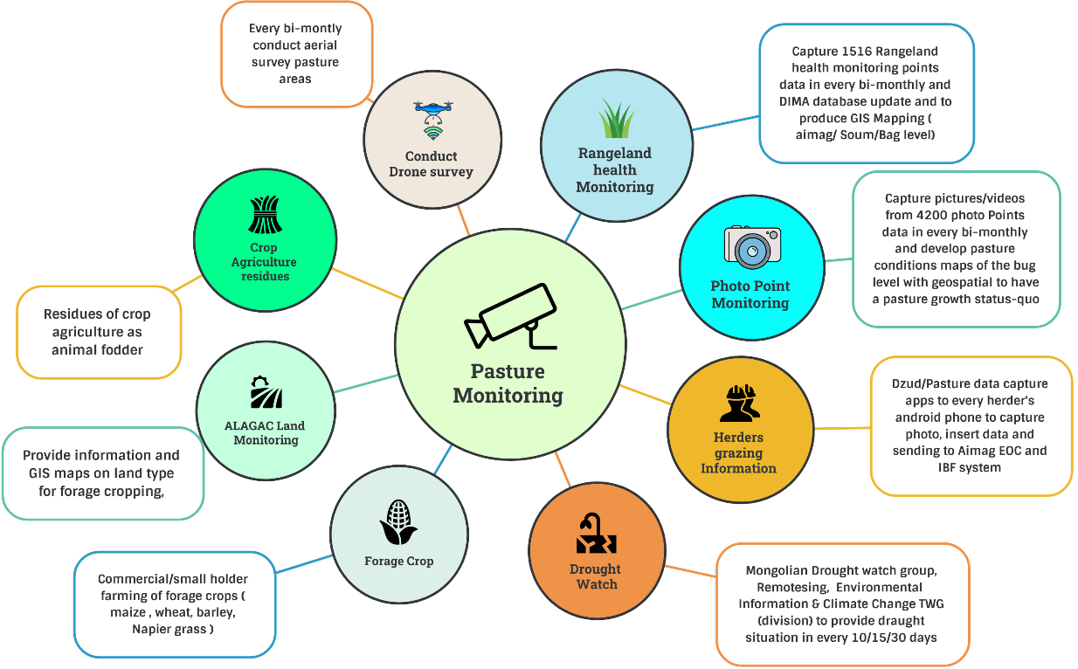
Figure 32 : Integrated Pasture monitoring system (Source: Z M Sajjadul Islam, UNDP-GCF)

Alert and warning services for livestock & Crop agriculture

- Heavy rainfall advisory/alert :
- Continue supplementary feeding after the event: Maintain supplementary feeding for up to one week after the adverse weather, as rainfall can reduce feed palatability. Without supplements, sheep may not meet their nutritional requirements.
- Prepare for relocation and targeted sheltering: Be ready to move animals to sheltered sheds or higher ground if very heavy rainfall and flooding are likely. Sheep may be reluctant to move once they are wet and cold, so prioritize providing shelter to the most vulnerable groups particularly ewes, lambs, and newly shorn animals..

- Strong/damaging wind(watch/advisory/alert) :
- Cold front weather (watch/advisory/alert) (spring, autumn ) :
- High temperatures (watch/advisory/alert):
- Drinking water crises, (watch/advisory/alert)
- Water uses advisories :
- Frequent heavy snowfall (watch/advisory/alert):
- Drying up of rivers and springs, and fewer drinking water resources(watch/advisory/alert) :
- Severe drought (watch/advisory/alert):
- Impacts of meteorological drought (watch/advisory/alert) :
- Impacts of hydrological drought (watch/advisory/alert) :
- Occurrence of river Floods/ flash Floods (watch/advisory/alert):
- Heatwave (watch/advisory/alert):
- Weather advisories over the breeding:

9.5 Develop dzud risk profile :

- Develop bi-monthly and monthly Dzud Risk profile:
- Develop Dzud risk integration protocol :

Table : Tracking weather anomalies of over the indicators being considered for dzud risk ranking /mapping :

Indicators | Acquisition of data(Parameters on climatic/non-climatic ) | Inputs for Impact forecasting & Operational Forecasting
Summer condition; | Temperature | Current temperature impacts on the type of livestock and livestock husbandry
Summer days; | Number of hot days | Distribution of the number of hot days with GIS map and develop
Pasture carrying capacity; | Pasture height/growth and Number of animals grazing days | GIS maps of pasture carrying the capacity status of the week/10 days/30 days
livestock density; | Number of livestock per community /bag/size of pastureland | GIS map on camp and grading location
livestock body conditions; | Gross health conditions and weight loss of animals | GIS maps on the distribution of livestock health conditions( based on livestock location data)
Biomass of pasture measured in 1516 sites representing all ecological zones: | Every 10 days observation of the pasture growth ( height and density) from the National Rangeland Monitoring Database ( DIMA) by NAMEM | Every 10/15 days prepare GIS maps on Rangeland's health status
Anomaly precipitation; | Number of rainy/precipitation days and amount | Number of precipitation days and accumulation ( mm) 10 days/monthly, seasonal, yearly
Anomaly temperature; | Tmax , Tmin and Tmean the weekly/decadal
Develop drought index | Yearly drought index
Snow depth | Show the depth of the running week | Precision level GIS maps by using data from the met station, volunteers, and crowdsource in daily 10days accumulations of thickness
Snow cover days | Number of snowing days
Snow density | Snow kg per m-3 | Precision level GIS maps by using snow thickness data every 10 days.
Thick Icy ground | Herders provide the grazing location covered by the thick ice. Difficulties of livestock to reach grass and Injuries of animals. | GIS map’s thick icy location of the pasture grazing areas every 10 days
Severe Cold temperatures | Acquisition of Severe Cold temperatures from the herder’s location, met stations, and high-value elements. | GIS maps on distribution of cold wave ( aimag, soum level )

- Develop bi-monthly and monthly Dzud Risk profile: Dzud risk integration process: Tracking weather anomalies of over the selected indicators being considered for dzud risk ranking /mapping.
- Provide combined dzud watch, warning, and outlook ( figure 31).

9.6 Web-based MIS system for Dzud risk management :

Develop a comprehensive Dzud risk assessment by designing a season-specific Dzud risk mapping algorithm based on the schematic diagram below. The diagram presents the seasonal Dzud risk assessment approach, the associated tools and datasets, and the workflow for producing an integrated, combined Dzud risk assessment.

This approach relies on weather indices and indicators to track season-specific Dzud conditions. To operationalize the process, a web-based software solution should be deployed and configured to interface with the IBF platform, enabling ingestion and processing of required datasets including weather variables, socio-economic information, and the national CRVA repository. The proposed web-based Dzud Management Information System (Dzud MIS) will serve as an enterprise-level platform for large-scale Dzud monitoring and management in Mongolia, supported by an appropriate MIS database architecture

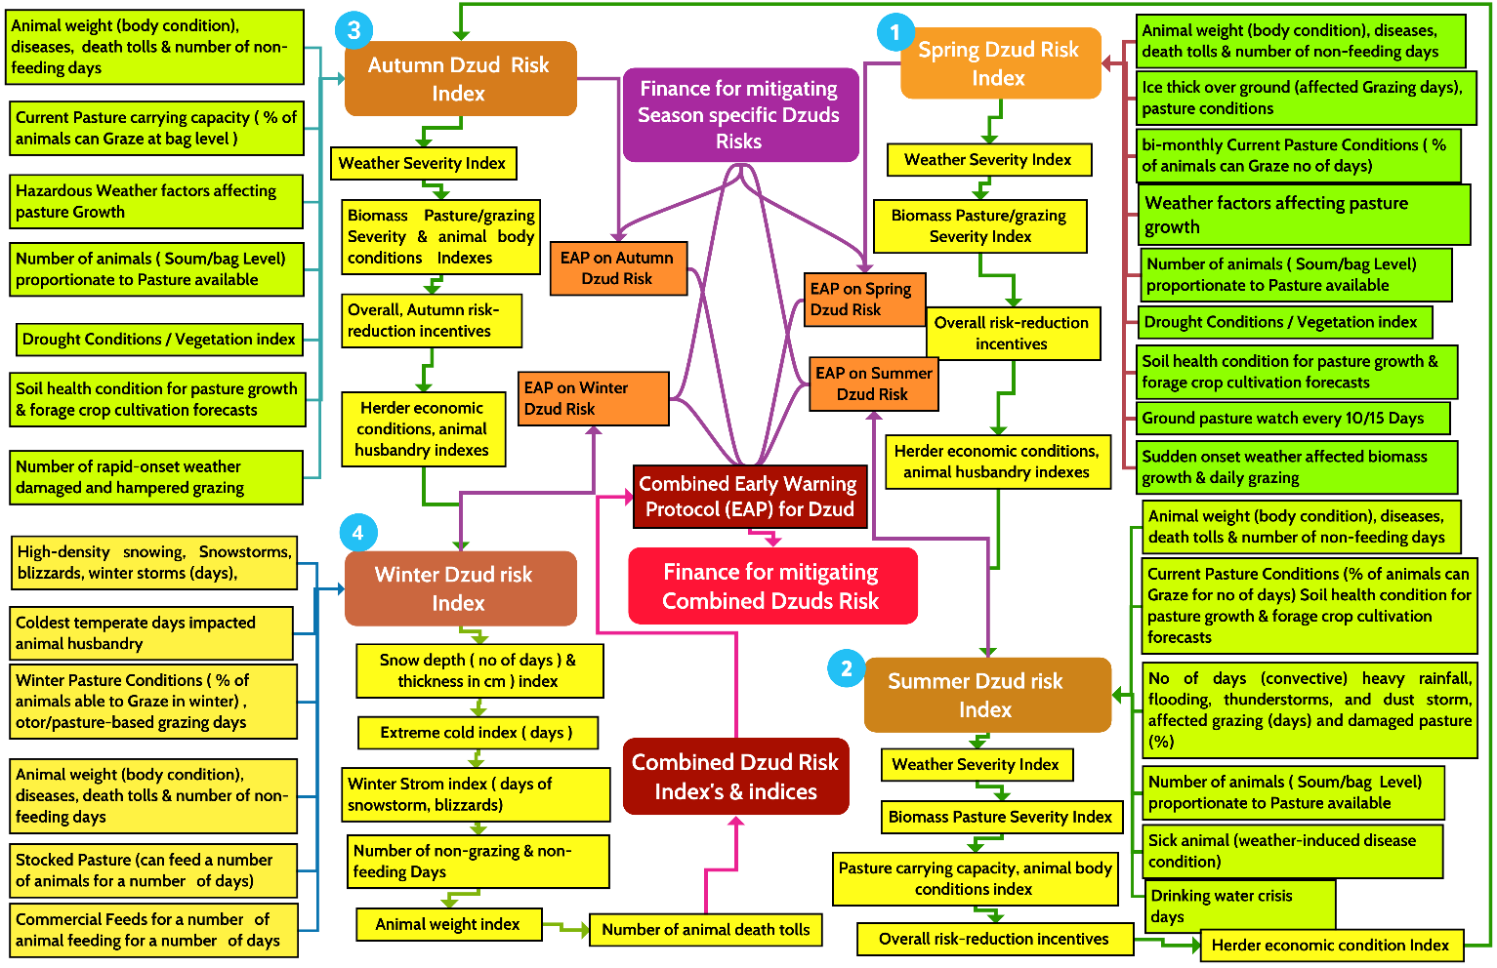

Figure 31 : Season-specific & combined dzud risk assessment and prediction system, and develop combined dzud early action protocol (EAP) (Source: Z M Sajjadul Islam, UNDP-GCF)

A figure can be developed to illustrate the stepwise process for Dzud risk assessment, seasonal Dzud risk indexing, and the development of a combined Dzud Early Action Protocol (EAP). At each step, field-level seasonal risk indicators are compiled and analyzed using GIS-based Multi-Criteria Decision Analysis (MCDA) to generate integrated Dzud risk indices and composite severity classifications.

9.7 Develop Dzud Early warning protocol.

Season | Variable | Indexes/Indices to investigate | Season-specific dzud watch, severity warning and advisory | Status of season-specific dzud early warning
Spring | - Spring high-impact weather and grazing disruption: Monitor spring-season high-impact conditions cold fronts, convective thunderstorms, strong wind-induced storms, cold rain, heavy rainfall, wet snow, and hailstorms and assess how these events disrupt normal grazing and herding operations.  - Operational forecast coverage for spring livestock and pasture risks: Track the number of operational forecasts issued during the spring season that address animal husbandry risks and biomass pasture conditions, including short-lead updates for rapidly changing hazards.  - • Livestock condition and welfare indicators: Record animal body condition and body weight, sickness incidence, and the number of non-feeding days to quantify stress and deterioration during the season.  - Animal mortality tracking with causes: Maintain animal death toll records and, where possible, classify causes of death based on inventory documentation to strengthen impact analysis and threshold refinement.  - Ground icing impacts on grazing accessibility: Monitor and document thick ground ice conditions and evaluate their effects on pasture access, grazing feasibility, and livestock mobility.  - Ground-truthed pasture usability at the lowest administrative level: Estimate and report current pasture condition as the percentage of animals that can graze effectively, benchmarked against local livestock numbers at the lowest administrative unit.  - Short- and medium-range IBF for livestock and forage systems: Produce impact-based forecasts for the medium and short range that identify hazards likely to affect animal husbandry, pasture growth, grazing access, and forage cropping decisions during spring.  - Soil health and land-surface drivers: Track how rainfall variability, temperature, evapotranspiration, vegetation indices, and surface hydrology affect soil health, and incorporate these factors into seasonal risk interpretation for pasture and cropping systems.  - Carrying-capacity gap analysis: Quantify biomass pasture carrying-capacity gaps at the lowest administrative level by comparing available biomass and pasture accessibility against livestock population-driven feed demand | - Operational forecast coverage: Record the number of operational forecasts issued to reduce risk in the livestock and crop agriculture sectors.  - Spring weather anomaly and severity indices: Develop and apply indices to track spring-season anomalies and determine seasonal severity, including temperature, precipitation, wind speed, relative humidity, dew point temperature, evapotranspiration rate, agricultural drought and flash-drought indicators, convective conditions/localized storms, and hydrometeorological drought measures.  - Animal body condition: Monitor livestock body condition using measurable indicators, including percentage weight loss.  - Non-grazing days: Capture and rank non-grazing days to reflect grazing access constraints and severity at local levels.  - Pasture carrying capacity and grading days: Estimate and rank pasture carrying capacity and “grading days” to indicate adequacy of forage resources relative to grazing demand.  - Soil moisture and pasture growth ranking: Track and rank soil moisture conditions and pasture growth levels to support spring grazing management and seasonal agricultural decision-making. | Based on the selected indexes and indices, a spring-season Dzud Watch, severity warning, and advisory protocol can be developed. The framework should integrate a set of core indicators that collectively describe hazard severity, livestock condition, grazing access constraints, pasture adequacy, and observed impacts. The following indices should be investigated and combined:  - Weather Severity Index: Captures the intensity, persistence, and spatial extent of spring-season hazardous conditions (e.g., temperature and precipitation anomalies, strong winds, cold fronts, convective storms, and related extremes).  - Animal Body Condition Severity Index: Measures livestock stress and deterioration, including percentage weight loss and other body-condition indicators, disaggregated where possible by livestock type and age/class.  - Non-Grazing Days Index: Quantifies the number and duration of days when grazing is constrained due to snow/ice cover, wet conditions, storm events, or other access limitations.  - Pasture Availability Index: Assesses usable pasture and grazing accessibility, incorporating biomass conditions and the proportion of animals able to graze effectively at the local level.  - Animal Death Toll Index: Tracks livestock mortality, preferably disaggregated by livestock type and age/class and linked to recorded causes of death where available.  - Biomass Pasture Carrying Capacity Index: Compares available pasture biomass against livestock feed demand to identify carrying-capacity adequacy or deficits at the lowest administrative level.  These indices can be operationally combined to define graded alert levels (Dzud Watch → Dzud Warning → Severe Warning) and to generate advisories that specify expected impacts and recommended early actions | Dzud risk management online software ( enterprise solution) / MIS system for providing information services on Dzud watch, severity warning and advisory for the season
Summer | - Summer high-impact weather and sector impacts: Monitor summer high-impact conditions wind, precipitation, and temperature anomalies; warm-front activity; convective thunderstorms; hailstorms; convective heavy rainfall; strong wind-induced storms; high temperatures and heatwaves; and dry spells and assess their effects on biomass pasture conditions, grazing access, and animal husbandry outcomes.  - Operational forecast coverage across relevant hazards: Track the number of operational forecasts issued for these conditions, including products supporting animal husbandry, surface hydrology, hydrometeorological and agricultural drought monitoring, heatwave risk, wildfire risk, and crop agriculture planning.  - Livestock condition and impact indicators: Record animal body condition and body weight, sickness incidence, number of non-feeding days, and mortality (including cause-of-death information from inventories where possible) to quantify impacts and refine thresholds.  - Drought impacts on pasture growth: Monitor drought conditions and evaluate how moisture stress affects pasture growth, biomass availability, and forage supply during the season.  - Ground-based pasture usability at the lowest administrative level: Estimate and report current pasture condition as the proportion (percentage) of animals able to graze effectively, benchmarked against local livestock numbers and grazing pressure at the lowest administrative unit.  - Short- and medium-range IBF for livestock and forage systems: Produce short- and medium-range impact-based forecasts for hazards likely to disrupt animal husbandry, pasture growth, grazing access, and forage cropping decisions.  - Soil health drivers and seasonal monitoring: Track soil health impacts associated with rainfall variability, temperature, evapotranspiration, vegetation indices, and surface hydrology, and integrate these into seasonal risk interpretation for pasture and cropping systems.  - Carrying-capacity gap analysis: Quantify biomass pasture carrying-capacity gaps at the lowest administrative level by comparing available pasture biomass to livestock population-driven feed demand and projected seasonal stress | - Operational forecast coverage: Track the number of operational forecasts issued to reduce risk for the livestock and crop agriculture sectors.  - Spring anomaly and severity indices: Develop and apply indices to monitor spring-season anomalies and determine weather severity, including temperature, precipitation, wind speed, relative humidity, dew point temperature, evapotranspiration rate, agricultural drought and flash-drought indicators, convective conditions/localized storms, and hydrometeorological drought measures.  - Animal body condition: Monitor livestock body condition indicators, including percentage weight loss.  - Non-grazing days: Record and rank non-grazing days to reflect grazing access constraints and severity.  - Pasture carrying capacity and grading days: Estimate pasture carrying capacity and rank “grading days” to indicate adequacy of pasture resources relative to grazing demand.  - Soil moisture and pasture growth ranking: Track and rank soil moisture conditions and pasture growth levels to support grazing management and seasonal agricultural planning | Based on the selected indexes and indices, a Spring Dzud Watch-Warning-Advisory package can be structured as an operational protocol that translates monitoring signals into graded alerts and recommended early actions. The framework should combine the following indicator groups:  1) Core indicator groups to investigate  - Weather severity: Spring-season anomaly and extremes indices (e.g., temperature variability, late cold spells, precipitation deficit/excess, strong winds, convective storms, evapotranspiration stress, agricultural/flash drought and hydrometeorological drought indicators).  - Animal body condition severity: Indicators such as percentage weight loss, observed weakness, illness stress markers, and reduced mobility, disaggregated by livestock type and age/class where possible.  - Non-grazing days: Number of days grazing is constrained by weather, surface conditions, pasture accessibility, or feed scarcity tracked and trend-analyzed over time.  - Pasture availability: Measures of usable pasture and grazing accessibility (e.g., percent of animals that can graze, pasture anomaly/biomass signals, local pasture accessibility constraints).  - Animal mortality: Animal death tolls, preferably disaggregated by livestock type, age/class, and suspected cause (from inventories).  - Biomass pasture carrying capacity: Carrying-capacity adequacy/deficit based on biomass availability versus livestock demand at the lowest administrative level.  2) Structuring the Dzud Watch-Warning levels  A graded protocol can be developed by combining the indicators above into severity classes, for example:  - Dzud Watch (Early Concern): Weather severity increasing and/or pasture availability declining, with early signs of body-condition deterioration and a rising number of non-grazing days.  - Dzud Warning (High Risk): Sustained adverse weather severity and clear pasture/carrying-capacity deficits, increasing non-grazing days, measurable body-weight loss, and early mortality signals.  - Dzud Severe Warning / Emergency Advisory: Extreme or persistent conditions with significant pasture/carrying-capacity shortfalls, prolonged non-grazing periods, widespread body-condition decline, and escalating mortality.  3) Advisory content aligned with indicators  For each alert level, advisories should specify:  - the dominant drivers (weather, pasture, livestock condition),  - the likely impacts over the next 7-10 days and 2-4 weeks,  - recommended early actions (feed supplementation, grazing adjustments, destocking options, veterinary support, shelter/water measures),  - priority locations and vulnerable groups.  This structure ensures that spring Dzud monitoring is evidence-based, comparable across areas, and directly linked to actionable early warning and early action decisions | Dzud risk management online-software ( enterprise solution) / MIS system for providing information services on Dzud watch, severity warning and advisory for the season
Autumn | - Autumn high-impact weather and sector impacts: Monitor autumn-season high-impact conditions temperature, wind, and precipitation anomalies; strong wind-induced storms; early snowfall; cold-front passages; and convective events and assess their effects on biomass pasture conditions, normal grazing access, and animal husbandry outcomes.  - Operational forecast coverage for autumn hazards: Track the number of operational forecasts issued for these conditions, including products supporting livestock husbandry and crop agriculture decision-making.  - Livestock condition and impact indicators: Record animal body condition and body weight, sickness incidence, number of non-feeding days, and mortality (with causes captured through inventories where possible) to quantify impacts and refine thresholds.  - Drought impacts on pasture growth: Monitor drought conditions and their influence on pasture growth, biomass availability, and seasonal forage supply.  - • Ground-truthed pasture usability at the lowest administrative level: Estimate and report the current pasture condition as the proportion (percentage) of animals that can effectively graze at the lowest administrative unit, relative to local livestock numbers and grazing pressure.  - Short- and medium-range IBF for husbandry and forage systems: Produce short- and medium-range impact-based forecasts for hazards likely to affect husbandry, pasture growth, grazing access, and forage cropping decisions during the season.  - Soil health and land-surface drivers: Track how soil health conditions respond to rainfall variability, temperature, evapotranspiration, vegetation indices, and surface hydrology, and integrate these factors into risk interpretation for pasture and cropping systems.  - Carrying-capacity gap analysis: Quantify biomass pasture carrying-capacity gaps at the lowest administrative level by comparing pasture biomass availability against the local livestock population and projected feed demand | - Operational forecast coverage: Track the number of operational forecasts issued to reduce risk for the livestock and crop agriculture sectors during the spring season.  - Spring weather anomaly and severity indices: Develop and apply indices to monitor spring anomalies and determine seasonal severity, including temperature, precipitation, wind speed, relative humidity, dew point temperature, evapotranspiration rate, agricultural drought and flash-drought indicators, convective conditions/localized storms, and hydrometeorological drought measures.  - Animal body condition: Monitor livestock body condition using measurable indicators, including percentage weight loss.  - Non-grazing days: Record and rank non-grazing days to reflect constraints on pasture access and grazing feasibility.  - Pasture carrying capacity and grading days: Estimate pasture carrying capacity and rank “carrying-capacity grading days” to indicate adequacy of pasture resources relative to grazing demand.  - Soil moisture and pasture growth ranking: Track and rank soil moisture conditions and pasture growth levels to inform spring grazing management and crop planning | Based on the relevant indexes and indices, a Spring Dzud Watch, severity warning, and advisory framework can be developed to support early warning and early action. The system should investigate and combine the following indicator groups:  - Weather severity: Indices capturing spring-season anomalies and extremes (e.g., temperature variability, late cold spells, precipitation deficits/excess, strong winds, convective storms, evapotranspiration-driven stress, agricultural/flash drought indicators).  - Animal body condition severity: Measures of livestock stress and deterioration, including percentage weight loss and observed health condition indicators.  - Non-grazing days: Counts of days when grazing is constrained by weather, land-surface conditions, or pasture access limitations.  - Pasture availability: Indicators of pasture usability and biomass availability relative to local livestock demand, including spatial variation at the lowest administrative level.  - Animal mortality: Death-toll indicators, ideally disaggregated by livestock type/age class and linked to recorded causes where possible.  - Biomass pasture carrying capacity: Measures of carrying-capacity adequacy and deficit, comparing available biomass to required feed demand and grazing pressure.  These indicators can be integrated into a graded spring Dzud monitoring protocol that supports watch/warning levels and produces operational advisories aligned with predefined early action measures | Dzud risk management online-software ( enterprise solution) / MIS system for providing information services on Dzud watch, severity warning and advisory for the season
Winter | - Winter-season high-impact weather and livestock impacts: Track winter high-impact conditions such as temperature, wind, and precipitation anomalies; winter storms; snowstorms; blizzards; extreme cold; and high-density snowfall and assess their effects on animal husbandry and biomass pasture conditions.  - Operational forecast coverage and feed management actions: Monitor and document the number of operational forecasts issued for these conditions, along with associated preparedness and management actions, including hay/forage stocking and destocking, herder-specific feed strategies, and seasonal husbandry adjustments.  - Livestock condition and impact indicators: Maintain records on animal body condition and weight, sickness incidence, number of non-feeding (starvation) days, and mortality (including cause-of-death information captured through inventories).  - IBF for short- and medium-range livestock-relevant hazards: Produce and apply short- and medium-range impact-based forecasts for hazards likely to affect animal husbandry, pasture growth, grazing access, and forage cropping during the season.  - Land-surface condition monitoring: Track and integrate soil ice conditions, soil thawing dynamics, and related land-surface indicators that influence pasture accessibility and winter risk severity | - Operational forecast coverage: Track the number of operational forecasts issued to reduce risk for the livestock and crop agriculture sectors.  - Winter extreme-weather indices: Define and apply relevant indices/indicators to monitor and classify winter-season extreme weather conditions.  - Animal body condition: Monitor animal body condition using measurable indicators, including percentage body-weight loss.  - Non-grazing days: Record and rank non-grazing days to reflect access constraints to pasture and grazing conditions.  - Hay/forage stocking and destocking: Track and rank stocking and destocking status of hay, forage crops, and pasture resources as a preparedness and coping indicator.  - Animal non-feeding days: Record the number of days animals are unable to feed (starvation/non-feeding days) as a direct impact indicator.  - Animal mortality: Track animal death tolls, preferably disaggregated by livestock type, age/class, and cause where possibl | Based on the relevant indexes and indices, a winter Dzud Watch, severity warning, and advisory package can be developed for the winter season. The protocol should investigate and combine the following indicators:  - Weather severity: Indices capturing winter hazard intensity and persistence (e.g., extreme cold, wind chill, snowfall intensity/duration, blizzard conditions, icing risk).  - Animal body condition severity: Measures of livestock body condition deterioration, including percentage weight loss and observed health stress indicators.  - Non-grazing / non-feeding days: Indicators reflecting days when animals cannot access grazing or feed adequately due to snow/ice barriers, severe cold, or mobility constraints.  - Herder-specific feed management (stocking/destocking): Indices capturing availability and use of hay, forage crops, pasture resources, and supplementary feeds, including stocking/destocking dynamics at household level.  - Animal mortality: Death toll indicators, preferably disaggregated by livestock type and age/class, and linked to recorded causes where available.  These indicators can be combined into a season-specific Dzud monitoring framework that supports graded watch/warning levels and the issuance of operational advisories aligned with early action measures | Dzud risk management online-software ( enterprise solution) / MIS system for providing information services on Dzud watch, severity warning and advisory for the season

Based on Figure 31 (Dzud Watch) and the associated risk warning and advisory mechanisms together with the variables, indices, and index sets presented in the table above a season-specific early warning protocol and a consolidated Dzud Early Action Protocol (EAP) can be developed.

…………………………………………End…………………………………………………….

Please send your comments to Team Leader , Z M Sajjadul Islam (UNDP-GCF) at zmsajjad@gmail.com , WhatsApp : +88 01711 979179

https://openlayers.org/
https://leafletjs.com/
https://developers.google.com/public-alerts/reference/google-cap-requirements
Proposed IBF web-based platform ( www.weather.gov.mn , www.ibf.gov.mn)
WMO Guidelines for Nowcasting Techniques, 2017 edition
Local team to develop algorithm , defining weather variables(dzud/operational forecasts ), develop indexes , indices for the sector specific operational forecast, short-rage weather forecasts, tracking multi-hazards etc.

