Roadmap for Implementation of Early Warning for All (EW4ALL) Initiative 2024-2027/2030
(Revised version)

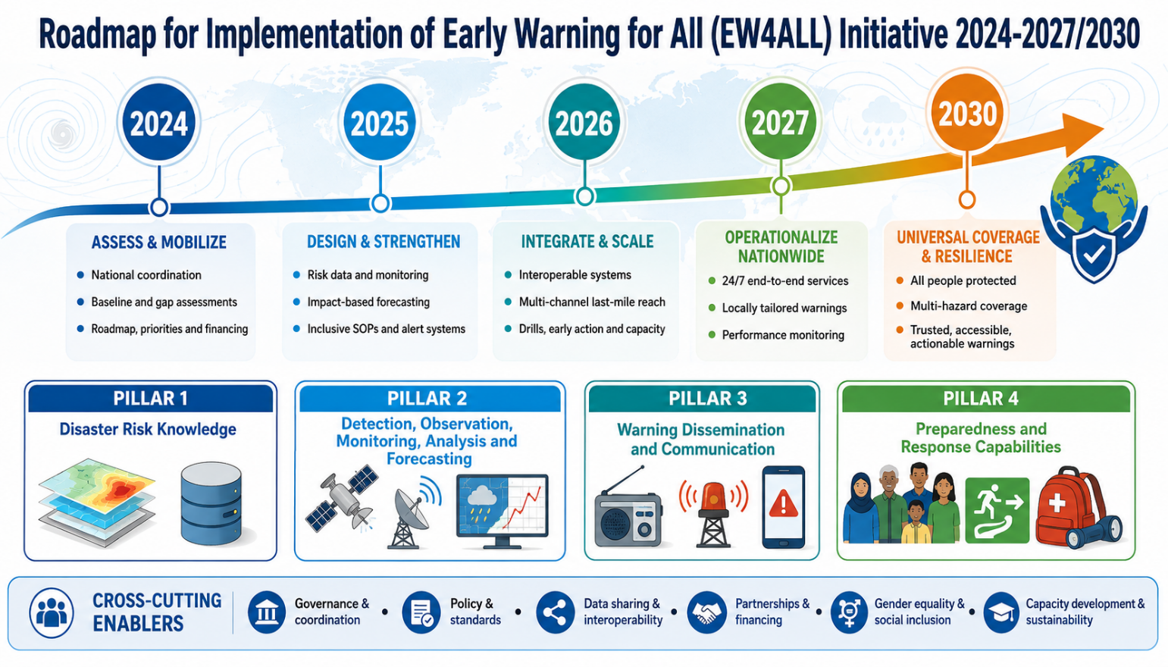

Building Disaster Resilient Communities in Somalia

Designed and developed by: Z M Sajjadul Islam
Coordinator of Early Warning for All (EW4ALL) for Somalia
Dated: December 2024

Contents
Executive Summary 6
1.0 Introduction: EW4ALL 7
1.1 Vision EW4ALL 7
1.2 Principles EW4ALL 8
1.2 Goals and Objectives EW4ALL 8
1.4 Rationale of National Multi-hazard Early Warning Center (NMHEWC) installation 10
1.5 SoDMA/NDMO EW4ALL initiative 11
2.0 Somalian multi-hazard, disaster phenomena & climate change trend 12
2.1 Somalian current climate projection: 15
2.2 Climate trends, impacts, and Stressors 15
3.0 Pillar Specific Goal, Outcome, and Workplan 17
3.1.1 Pillar 1 Gap Identification on Disaster Risk Knowledge 18
3.1.2 Step forward to close the gap of Pillar 1 Disaster Risk Knowledge 23
3.1.3 Proposed key actions for closing the indicated gaps: Disaster Risk Knowledge 23
3.1.4 The Roadmap Ahead for Pillar 1: Improved Disaster Risk Knowledge Management System 29
3.1.5 Work Plan for Pillar 1 34
3.2 Roadmap Pillar 2: Observation, monitoring, analysis, and forecasting 36
3.2.1 Pillar 2 Gap Identification: Observation, monitoring, analysis, and forecasting 37
3.2.2 Step forward to close the inactive gaps on Pillar 2 : Observation, monitoring, analysis, and forecasting 43
3.2.3 Proposed Roadmap for Pillar 2 : Observation, monitoring, analysis, and forecasting 47
3.2.4 Work Plan for Pillar 2 : Observation, monitoring, analysis, and forecasting 53
3.3 Roadmap Pillar 3: Warning dissemination and communication 57
3.3.2 Proposed essential action for closing Pillar 3 gaps. 59
3.3.3 The roadmap for Pillar 3 : Enhancing effective dissemination and communication 64
3.3.4 Workplan Pillar 3 : Warning dissemination and communication 68
3.4 Roadmap Pillar 4: Preparedness and response capabilities. 72
3.4.1 Indicative Gaps on Pillar 4 -Preparedness and response capabilities. 72
3.4.2 Roadmap outlined actions for closing the Gaps on Pillar 4 by 2027 and beyond 75
3.4.3 Roadmap ahead for Pillar 4 by 2027 and beyond 79
3.4.4 Work Plan for Pillar 4 (Preparedness, timely responses and early actions) 83
4.0 Monitoring & Evaluation Plan of EW4ALL Pillars 87
5.0 Concluding summary & Recommendations 98

Acronym

AA | Anticipatory Action
AM | Amplitude Modulation
AMM | Africa Media Monitor
APIs | Application programming interfaces
ARC | African Risk Capacity
AWD | Acute Watery Diarrhea
AWS | automated weather station
BCPs | Business Continuity Plans
CAP | Common Alerting Protocol
CB | Cell-Broadcast
CBDRM | Community-Based Disaster Risk Management
CBO | Community-based organization
CBS | Central Bank of Somalia
CCA | Climate Change Adaptation
CCM | Convention on Cluster Munitions
CIMA | International Centre for Environmental Monitoring
CPC | Civil Protection Committee
CREWS | Climate Risk and Early Warning Systems
CRVA | climate risk and vulnerability assessments
CSO | Civil Services Organization
DDMT | Disaster Management Team
DFID | Department for International Development, Government of the United Kingdom
DINA | Drought Impact and Needs Assessment
DM | Disaster Management
DMA | Disaster Management Agency
DMC | Disaster Management Committee
DRM | Disaster Risk Management
DRMCG | Disaster Risk Management Coordination Group
DRR | Disaster Risk Reduction
DTM | Displacement Tracking Matrix
DTS | Disaster Tracking System
EOC | Emergency Operation Centre
ETT | Emergency Tracking Tools
EW | Early Warning
EW4ALL | Early warning for all
FAO | Food and Agriculture Organization
FEWSNET | Famine Early Warning Systems Network
FGS | Federal Government of Somalia
FM | Frequency Modulation
FSNAU | Food Security and Nutrition Analysis Unit
GDP | Gross domestic product
GIS | geographic information system
GMAS | Global Multi-hazard alert system
GPS | The Global Positioning System
GSM | Global System Mobile
GTOS | Global Terrestrial Observing System
HC | Humanitarian Coordinator
HCT | Humanitarian Country Team
HPC | High-performance Computer
ICPAC | IGAD Climate Prediction and Applications Centre
ICS | Incident Command System
ICT | Information and Communications Technology
IDP | Internally Displaced Person
IDRR | International Day for Disaster Reduction
IFAD | International Fund for Agricultural Development
IFRC | International Federation of Red Cross and Red Crescent Societies
IGAD | Intergovernmental Authority on Development
IGADD | Intergovernmental Authority on Drought and Development
LITK | local, indigenous and traditional knowledge
ILK | Indigenous and local knowledge
INGO | International Non Government Organization
IOM | International Organization for Migration
IPCC | Intergovernmental Panel on Climate Change
ITCZ | Inter-Tropical Convergence Zone
ITU | International Telecommunication Union
L & D | Loss and Damage
LB-SMS | Location-based SMS
LCG-DER | local coordination group on disaster emergency response
LNHAs | Local National Humanitarian Actors
LNNGOs | Local and National NGOs
MoEWR | Ministry of Energy & Water Resources
MoHADM | Ministry of Humanitarian Affairs and Disaster Management
MTR | Midterm Review
NAPA | National Adaptation Plan of Action
NCA | National Community Authority
NDMF | National Disaster Management Fund
NDMO | National Disaster Management Agency
NDRMC | National Disaster Risk Management Council
NDVI | Normalized Difference Vegetation Index
NMHEWC | National Emergency Operations Centre
NGO | Non-Government Organization
NMHEWC | National Multi-Hazard Early Warning Centre
NMHSs | National Meteorological and Hydrological Services
NSO | National Statistical Office
OCHA | Office for the Coordination of Humanitarian Affairs
OI | Officer In-charge
OPM | Office of the Prime Minister
PDNA | post-disaster loss, damage, and needs assessment
Q&A | Questions and answers
RPDNA | Rapid Post-Disaster Needs Assessment
RS | Remote Sensing
RMC | Regional Meteorological Center
RSMCs | Regional Specialist Meteorological Center
SADD | sex, age, disability disaggregated data
SDG | Sustainable Development Goals
SDRMCG | Somalia Disaster Risk Management Coordination Group
SFDRR | Sendai Framework on Disaster Risk Reduction
SMS | Short Message Service
SNDMP | Somalia National Disaster Management Policy
SNDP | Somalia National Development Plan
SODMA | Somalia Disaster Management Agency (NDMO)
SOP | Standard Operating Procedure
SRCS | Somalia Red Crescent Society
SWALIM | Somalia Water and Land Information Management
SWALIM | Somalia Water and Land Information Management
TWG | Technical Working Group
UAV | Unmanned Aerial Vehicle
UHF | Ultra-high frequency
UN | United Nations
UNCCA | United Nations Convention against Corruption
UNCDF | UN Capital Development Fund
UNDP | United Nations Development Programme
UNDRR | United Nations Office for Disaster Risk Reduction
UNFPA | United Nations Population Fund
UNHCR | United Nations High Commissioner for Refugees
UNICEF | United nations international children's emergency fund
UNRCO | United Nations Resident Coordinator Office
UNV | UN Volunteers
VAC | Vulnerability Assessment Committee
VHF | Very high frequency
WASH | Water, sanitation and hygiene
WFP | UN World Food Programme
WHO | World Health Organization
WMO | World Meteorological Organization

Executive Summary

Early Warnings for All (EW4ALL) a global initiative to ensure that everyone on Earth is protected by early warnings by 2027 is being fast-tracked into action on the ground. The UN Secretary-General released an action plan for this initiative in November 2022, emphasizing the urgent need to support the most vulnerable first.

The United Nations Development Program (UNDP) supported the Somalia Disaster Management Agency (SoDMA) /National Disaster Management Organization(NDMO) in facilitating the design and drafting of a Roadmap for implementing the Early Warning for All (EW4ALL) Initiative in Somalia.

While governments play a crucial role in driving action on early warning services for their citizens, adopting a "whole-of-society" approach that involves all stakeholders, including civil society and the private sector, can better strengthen and sustain early warning services.

It's equally important to recognize that disasters and climate change affect people differently based on gender, age, and other factors. Therefore, an intersectional approach is required to ensure that the early warning services are inclusive, responsive, and equitable. By involving all sectors of society and taking an intersectional approach, early warning services can be more effective in protecting vulnerable populations from the impacts of disasters and climate change.

As these events become increasingly frequent and intense, efforts to build resilience and coping capacities are crucial. Climate change is also a major driver of conflict in Somalia, for example, as declining groundwater levels drive up water prices and increase the likelihood of conflict over water and access to livelihoods. Multi-hazard early warning systems (MHEWS) linked to early actions are key to Somalia’s efforts to manage risks, enhance adaptation, and build resilience.

The National Multi-Hazard Early Warning Centre (NMHEWC) was established to provide adequate and timely warnings of possible risks posed by hazards. However, the country lacks a robust early warning system infrastructure that enables policy and institutional environments for the dissemination of warnings.

In this context, the SoDMA/NDMO calls for the national Rollout of the Early Warnings for All (EW4All) initiative, finalizing the gap analysis, and agreeing on a roadmap to consolidate and extend the coverage of MHEWS, empowering and enabling early action by individuals and communities, especially those most in need.

1.0 Introduction: EW4ALL

Somalia’s increasing exposure to climate- and weather-related hazards requires risk-informed tools that can translate climate information into climate-proof planning, stronger disaster risk management (DRM) governance, and end-to-end early warning services. In practical terms, this means strengthening the institutional and technical capacities to generate and use thematic forecasts, weather warnings, and public alerting that enable government, communities, and partners to anticipate, prepare for, respond to, and recover from extreme events.

Somalia is already experiencing significant loss and damage from human-induced climate change, with hydrometeorological hazards recurrently disrupting the country’s productive base particularly agriculture and livestock. Agriculture (including livestock) is identified as Somalia’s largest employer and second-largest commodity export sector. Nearly one-fourth of the population are agropastoralists, with smallholder farming accounting for approximately 80% of total crop production and 70% of marketed produce. More than 60% of the population depends on livestock, which contributes approximately 40% to national GDP.

Losses and damages arise from rapid-onset events such as floods, heatwaves, and storms as well as protracted droughts and slow-onset climatic shifts. Direct economic loss and damage to Somalia’s agriculture sector between 2000 and 2021 is estimated at US$5.68 billion, of which about half US$2.84 billion could be attributable to climate change (equivalent to an average of 5% of agricultural GDP over the period). This implies average climate-attributable livestock and crop loss and damage of about US$129 million per year.

Somalia’s recent history also demonstrates how climate extremes can trigger cascading systemic impacts. From 2008 to 2011, drought conditions in the Horn of Africa contributed to heightened and persistent food insecurity; combined with conflict, low incomes, rising commodity prices, marginalization, and constrained humanitarian access, these shocks are estimated to have pushed 17% of the population in southern and central Somalia into famine conditions.

At the macro-fiscal level, the scale of shocks is substantial. Average direct economic impacts from droughts and floods are estimated at 7.9% of GDP between 2000 and 2021 (excluding the 2010 drought event), with about 3.3% of GDP plausibly attributable to climate change. Including the 2010/2011 drought, which led to estimated economic damages of over US$4 billion, climate-attributable losses rise to 8.4% of GDP. Over the same period, climate-attributable direct losses and damages are estimated to equal 86% of government revenues on average (excluding the 2010 drought event), underscoring the imperative for anticipatory risk management and resilience investment.

Against this backdrop, Somalia intends EW4All to function as a centre of excellence for operationalizing sustainable development through evidence-based, risk-informed decision-making supporting policymakers with actionable information for planning, budgeting, and project implementation, and strengthening national risk finance policy and advocacy to better access global risk finance mechanisms.

The EW4All Roadmap (2024-2027 and beyond) sets out the pathway to implement the EW4All pillars and evolve a people-centred multi-hazard early warning system (MHEWS) that links hazard monitoring and forecasting to warning dissemination and risk-informed early action, thereby strengthening DRM/DRR and climate change adaptation outcomes. This requires an enabling environment through a clear law or policy framework, fit-for-purpose institutional arrangements, and well-defined roles and standard operating procedures that ensure a seamless workflow from monitoring and forecasting to public alerting and early action.

Early warning systems are a proven, cost-effective measure: global evidence indicates they save lives, reduce economic losses, and can deliver nearly a tenfold return on investment yet major gaps persist, particularly in translating warnings into risk-informed early action at scale.

Vision EW4ALL

The National EW4ALL roadmap envisions that by 2027, all Somali people will be protected by a robust, government-led multi-hazard early warning system.

1.2 Principles EW4ALL
The following principles underpin Somalia’s Roadmap for EW4ALL Implementation and reflect the spirit of disaster risk governance for Somalia. The core principles serve as the basis of the EW4ALL Initiative and guide the implementation of critical functions of the country’s National Multi-Hazard Early Warning System (NMHEWS).

Accountability : All government and non-governmental parties should be held accountable for the early warning information and predictions they produce.

Credibility : Early warning information and analysis must come from credible sources and earn the trust and confidence of their users.

Do no harm : All parties shall endeavor not to cause damage or suffering due to their actions regarding DRM/early warning.

Ethical : DRM/early warning operations and decision-making shall always be guided by ethics and values that accept and respect the primacy of human life and human dignity.

Impartiality : Early warning information, analysis, and decisions should be based on objective data without bias, prejudice, discrimination, or a preference to benefit one group or community.

Leaving no one behind : EWS shall address the concerns, needs, and inclusion of the most vulnerable social groups, including women, youth, children, people with disability, and the elderly.

Neutrality : Early warning information, analysis, and decisions do not take sides and shall be conducted regardless of the political, faith, identities, or social background of the people or communities under the coverage of EWS.

People-centered and community-oriented : EWS should seek to preserve and include local and ‘traditional’ perspectives and Indigenous knowledge to strengthen community ownership. It should be developed in collaboration with the end-users, and the disaster-affected people shall communicate and understand its impacts. It needs to be more people-oriented with a focus on last-mile outreach.

Transparency :EWS should be transparent, allowing public access to early warning data and knowledge products. Both at federal and regional levels, EWS should be located within government structures and operate within a clear legal framework, with the spirit of accessing the information as a credible source for public benefit.

Goals and Objectives EW4ALL
Early Warnings for All (EW4All) is structured around four pillars that together constitute an effective, people-centered, end-to-end Multi-Hazard Early Warning System (MHEWS). The overarching purpose of this Roadmap is to identify Somalia’s current gaps across the four EW4All pillars and to define practical measures to close those gaps, strengthening national systems so that early warnings consistently translate into timely, risk-informed early action, particularly for the most vulnerable.
Accordingly, the Roadmap aims to achieve the following objectives:
- Improve disaster risk knowledge and management (Pillar 1 - led by UNDRR)
  - Strengthen risk knowledge and risk governance capacities of national institutions, sector stakeholders, and frontline communities.
  - Enhance institutional capacity for multi-hazard risk assessment, including improved methodologies, staffing, and coordination mechanisms.
  - Establish or strengthen a national risk repository and associated risk data standards, governance protocols, and interoperability arrangements.
  - Improve access to, and use of, risk data and tools to develop impact-based early warning products and decision-support information services that connect hazards to likely consequences.
- Improve detection, observation, monitoring, analysis, and forecasting (Pillar 2 - led by WMO)
  - Expand Somalia’s access to improved weather and climate observation data and strengthen the observation network to better support forecasting and impact analysis.
  - Improve access to and use of global and regional forecasting products (e.g., from Global Producing Centres, Regional Specialized Meteorological Centres, and relevant regional climate services) to strengthen national forecasting performance.
  - Formulate and implement national hydrometeorological plans, strategies, and (where required) enabling legislation for hydromet observation, data management, and acquisition of Essential Climate Variables (ECVs).
  - Strengthen systems for data calibration, quality control, collation, archiving, and attribution to support credible forecasting and verification.
  - Enhance the National Multi-Hazard Early Warning Centre (NMHEWC) with improved capability in innovative forecasting, nowcasting, and prediction (including hazard-specific modelling and operational workflows).
- Improve warning dissemination and communication (Pillar 3 - led by ITU)
  - Strengthen national and sub-national capacities across the risk communication value chain, including translation of forecasts into clear, actionable, localized warnings.
  - Establish and operationalize common alerting arrangements (message standards, approval workflows, alert levels, and redundancy protocols) to enable consistent public warning issuance.
  - Strengthen the operational coordination and interoperability among NMHS/NMHEWC, SoDMA/NDMO, sector institutions, local stakeholders, and community systems to deliver a people-centred warning system that reaches last-mile populations through appropriate channels and formats.
- Strengthen preparedness and response capabilities (Pillar 4 - led by IFRC/FAO/SRCS)
  - Enhance the disaster preparedness and response capacity of SoDMA/NDMO, local government authorities, local non-state actors, and communities to ensure warnings lead to timely, protective action.
  - Strengthen institutional and community instructional capacity in DRM, DRR, and resilience-building, including drills, simulation exercises, and the integration of early action protocols into local planning and service delivery.
  - Improve coordination mechanisms and operational readiness (roles, SOPs, triggers, resources, and surge arrangements) to support anticipatory action and rapid response aligned with warning levels.

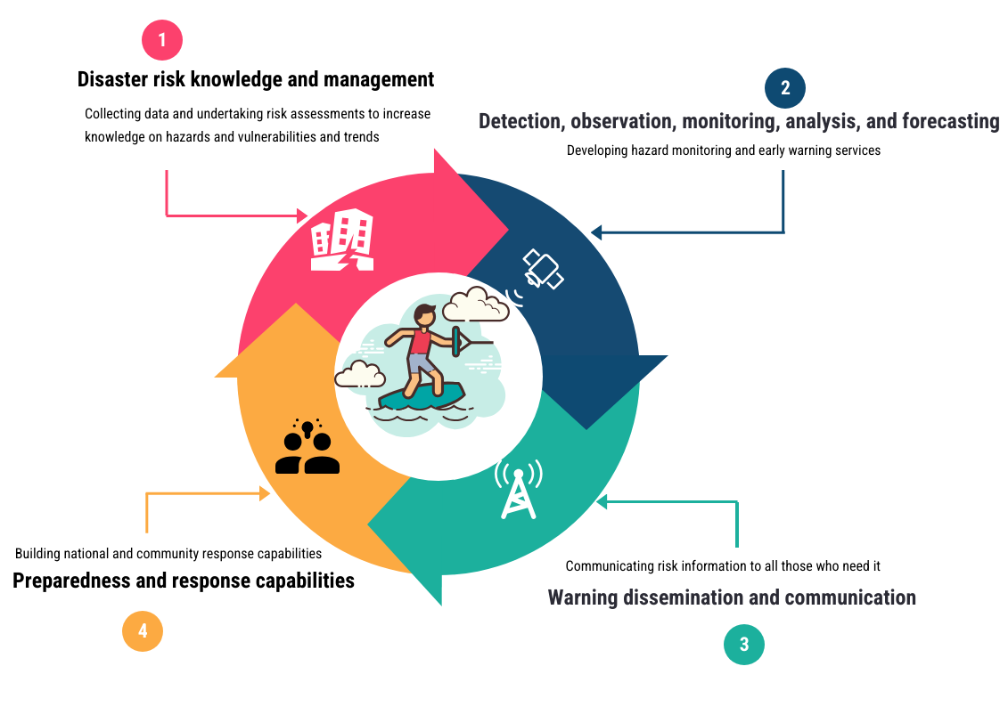
Figure 1: Early Warning for All (EW4ALL) objective

1.4 Rationale of National Multi-hazard Early Warning Center (NMHEWC) installation

The National Multi-Hazard Early Warning Center (NMHEWC) was established in 2019 pursuant to an executive order issued by the Office of the Prime Minister (OPM) and is led by a joint inter-ministerial committee comprising the OPM and the Ministry of Humanitarian Affairs and Disaster Management (MoHADM). The Center was created to provide a single, nationally recognized platform to coordinate and lead major emergency responses and to ensure that responses to future disasters and emergencies are coordinated, timely, and efficient. Its broader intent is to strengthen institutional capacity across government for holistic disaster risk management, including preparedness, response coordination, and early action.

SoDMA/NDMO is entrusted with executing the NMHEWC’s operational modality and functions under the governance and strategic direction of the Honorable Prime Minister. Positioning the NMHEWC under the auspices of the OPM is intended to strengthen its convening authority and leadership across all ministries and agencies with DRM responsibilities, and to improve coordination with Federal Member States (FMS) as well as with UN agencies, development partners, and humanitarian actors.

The NMHEWC’s rationale is further reinforced by the current operational landscape in Somalia, where emergency response and DRM actions are frequently implemented through ad-hoc, parallel, or fragmented mechanisms across state institutions and non-state actors. The NMHEWC provides the institutional anchor to synchronize and harmonize government-led emergency management with humanitarian and DRM actions undertaken by UN agencies, INGOs, NGOs, and CSOs. In this role, SoDMA/NDMO serves as the pivotal networking and coordination node bringing together key representatives from federal and member state institutions, donor communities, UN agencies, INGOs/NGOs, civil society organizations, private sector actors, and financial institutions to establish a more coherent and effective model for national emergency management and early warning-early action coordination.

1.5 SoDMA/NDMO EW4ALL initiative

On October 15, 2023, H.E., the President of the Federal Republic of Somalia, nominated the Somalia Disaster Management Agency (SoDMA) as the right national focal institution to lead the EW4All initiative at the national level.

In collaboration with the UNDP Somalia country office, the EW4ALL initiative is now operationalized under the leadership of SoDMA. The National Multi-Hazard Early Warning Center (NMHEWC) is already operational under SoDMA, positioning the institution as the most effective way to continue coordinating the scaling-up of the EW4All Initiative into action at the national level.

On November 15 - 16, 2023, SoDMA held a national consultation to launch Early Warnings for All (EW4All) in partnership with the United Nations Resident Coordinator Office (UNRCO) and the United Nations Country Team (UNCT) and in technical cooperation with UNDRR, World Meteorological Office (WMO), and International Telecommunication Union (ITU) as global co-leads for the Secretary-General's EW4All initiative.

Affirming Somalia's commitment to the objectives and spirit of EW4All, national government stakeholders, in partnership with UN country teams led by UNDP, came forward to articulate priorities and gaps to be addressed across the four EWS pillars.

On June 9-10, 2024, a workshop was held in Mogadishu to finalize the gap analysis and develop a national roadmap for implementing the Early Warning for All (EW4ALL) Initiative in Somalia, marking the rollout of the initiative.

The Roadmap for Early Warning for All (EW4ALL) builds on the country’s existing National Multi-Hazard Early Warning System (NMHEWS) and is concurrent with Somalia’s commitment to the Sendai Framework for Disaster Risk Reduction (2015-2030).

Critically, the Roadmap development process has been accompanied by a systematic reform initiative to align it with Article 3, paragraph 6, and Article 7, paragraph 2, of Law 17/2016, which establishes the Somali Disaster Management Agency (SoDMA). These Articles state the clear responsibility of SODMA to gather information and report on disasters and the risks facing the country, and to send out early warnings in collaboration with organizations inside and outside the country working on these activities. This is a positive step towards elevating the portfolio of SODMA, strengthening the Agency’s role by creating a functioning National Multi-Hazard Early Warning System. It will also provide the agency with an extended mandate to effectively coordinate DRM endeavors with multiple stakeholders, including regional and Federal Member State (FMS) government bodies, representatives of civil society organizations, and National Red Crescent Societies. The arrangement of this Roadmap also expects to promote local community participation and raise public awareness about disaster risk reduction and management. It is hoped that this Roadmap will foster the development of robust collaborations among key early warning stakeholders and establish a coordination mechanism that brings together the EW4ALL Pillar leads and relevant stakeholders.

The roadmap is also expected to facilitate the implementation of the EW4ALL Initiative in Somalia and enhance coordination, accountability, and enforcement of inter-jurisdictional and regional early warning systems and initiatives.

The critical undertaking here is for the Government of Somalia to develop a national EW4All Roadmap 2024-2027, with support from the UN agencies and global EW4All Pillar leads.

2.0 Somalian multi-hazard, disaster phenomena & climate change trend

Somalia’s natural and human geography is strongly shaped by its harsh climate and high exposure to hydrometeorological hazards. The country lies at the eastern extremity of the Sahel belt and is predominantly arid to semi-arid, with large areas receiving under 200 mm of rainfall annually, while totals are higher in parts of the northern highlands and southern regions. Mean daily maximum temperatures exceed 30°C across much of the country, moderating in higher-elevation northern areas and in some coastal locations influenced by offshore currents.

This climatic baseline, combined with high rainfall variability, drives recurrent drought and flood risk. Riverine flooding is concentrated along the Juba and Shabelle river systems in southern Somalia, while flash flooding is more common in the north along ephemeral watercourses. Recent seasons illustrate the compounding nature of extremes drought conditions linked to poor rainy-season performance can be rapidly followed by severe flooding during subsequent rainfall events, intensifying humanitarian needs and eroding coping capacity.

Climate risk is closely intertwined with poverty and vulnerability in Somalia, affecting livelihoods, food security, displacement patterns, and access to basic services. Climate variability and extremes can widen inequities and deepen vulnerability particularly where households are highly dependent on climate-sensitive livelihoods and where insecurity limits mobility, service delivery, and humanitarian reach. These dynamics make Somalia’s risk profile “systems-based”: hazards translate into impacts through exposure (settlements, farms, grazing areas, river corridors), sensitivity (water scarcity, degraded rangelands, fragile services), and limited adaptive capacity (poverty, displacement, constrained access to finance and services).

.

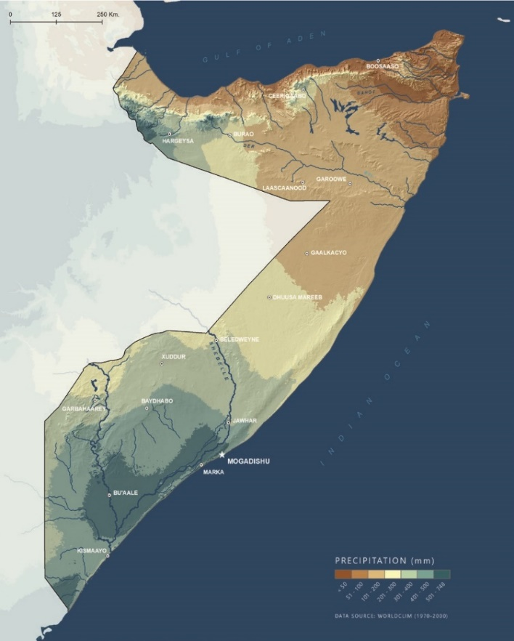 | 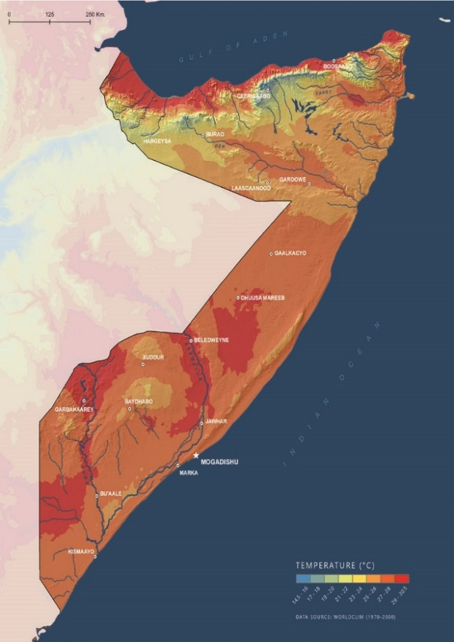
Figure 2: Total annual rainfall  Source: Original calculations based on TerraClimate | Figure 3: Average temperature  Source: Original calculations based on TerraClimate

Cyclone vulnerability: Somalia has the longest coastline in mainland Africa, at 3,333 kilometers (km), and is exposed to Indian Ocean cyclones. The map below shows the recurrence of cyclone disasters over the last 40 years. Any given category of tropical storm and surges hither is likely to do colossal damage the high-density settlements and other high-value elements.
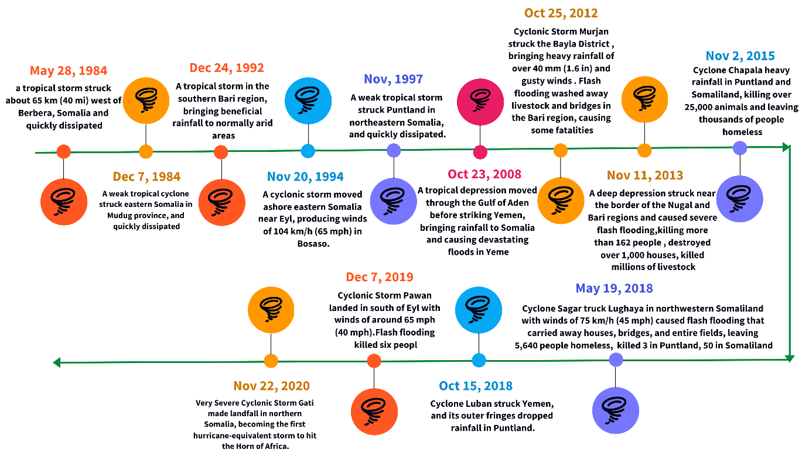
Figure 4 : Track record of cyclonic landfall over the Somalian coast from 1984-2020, Source: Wikipedia 2024

The country's riverine communities are particularly at risk of flooding. They could face a potential loss of property and livestock, destruction of WASH facilities, and damage to crops. Around 1.5 million hectares of land along the Juba and Shabelle rivers are at high risk of being inundated by flood waters, as shown on maps.
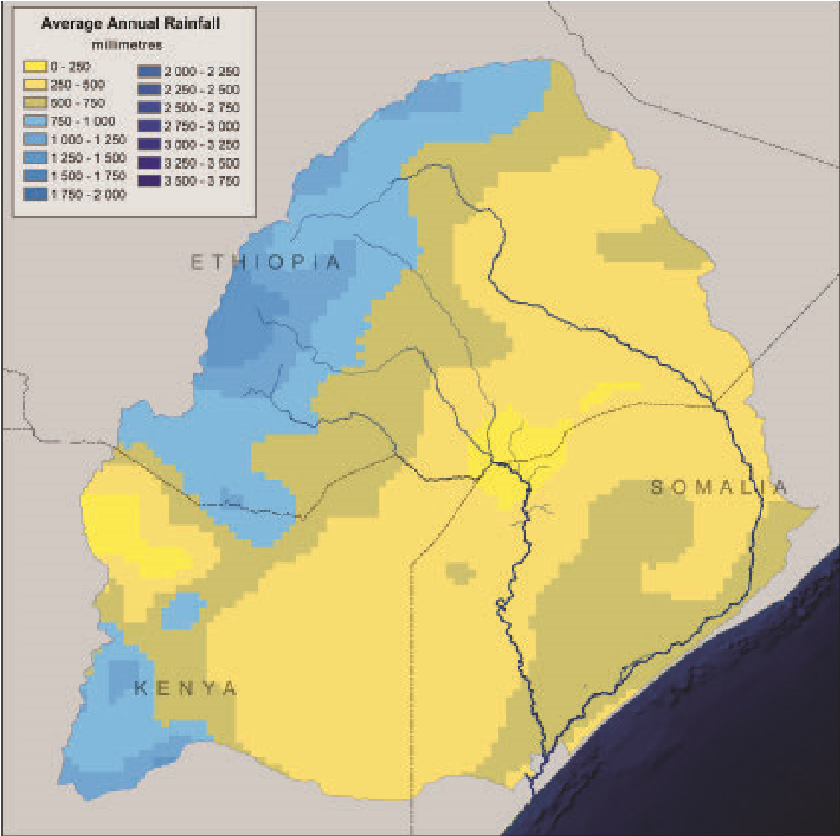 | 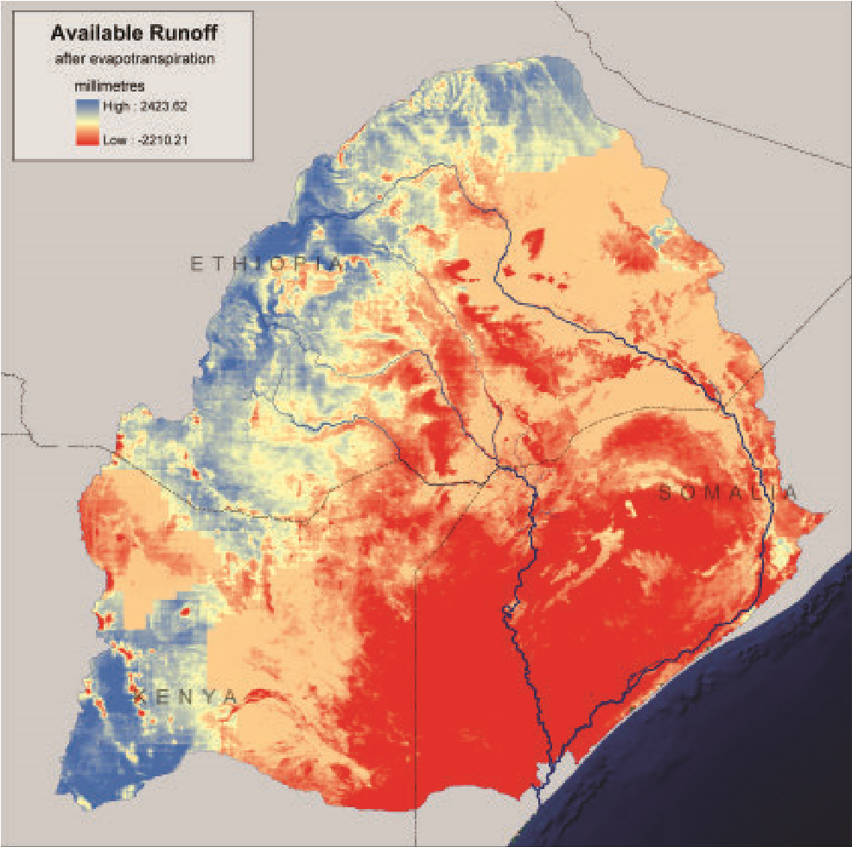
Figure 5 : Map: Juba-Shabelle river basin average annual rainfall, Source: UNEP 2010. | Figure 6 : Map : Juba-Shabelle river basin modeled available runoff, Source: UNEP 2010.

Table 1: Summary of Somalia’s climate risks with magnitude and trend measures for the sectors
Sector | Risk | Frequency
Climate disaster | Drought | Frequent
 | Fluvial floods | Frequent
 | Coastal flooding | Occasional
 | Tropical Storm | Frequent
Agriculture and livestock | Locusts | Rare
 | Crop stress | Chronic
 | Agricultural pests and diseases | Occasional
 | Heat stress on livestock | Chronic
 | Fodder crisis | Chronic
 | Livestock and pest and diseases | Chronic
Natural resources | Heat stress | Chronic
 | Vector-borne disease | Chronic
 | Gastrointestinal disease | Chronic
Infrastructure and services | Degradation of infrastructures | Chronic
 | Disruption of energy supply | Chronic
 | Disruption of water supply | Chronic
Source Somalia climate risk review, World Bank 2023

Figure 7: Somalia Disaster events (1975-2024) : Source EM-DAT Apr 2024 ( 48 years Disaster incidence dataset for Somalia)

Over the past 48 years, statistics of disaster events show that most of the disaster events are rapid and sudden onset (floods, cyclones, diseases, outbreaks), and simultaneously slow, protracted droughts are also severe and recurrent, occurring as hydrometeorological and agricultural droughts every single year. These essentially contributed to the loss and damage of livelihood and productive sectors. Fundamentally, the above graph signifies the essentiality of a functional early warning system put in place. Climate change-induced internal and external displacement intensifies demographic and socioeconomic risk factors.

Hydro-meteorological data gathering, monitoring, and forecasting in real-time tracking, exchange of information, and forecasting are limited due to an insufficient number of automatic hydro-meteorological stations on the ground, manual data reading and data transmission difficulties, regular operation and maintenance support, and the limited capacity of its systems in hydrological forecasting. For Somalia to have robust weather forecasting and impact-based EWS, real-time monitoring systems for meteorological and hydrological conditions must be strengthened by automating existing stations and installing new automated stations. This includes but is not limited to the development of real-time transmission of data for flood monitoring through expanding the spatial coverage of hydro-meteorological stations and upgrading the current quality and timeliness of the information.

WMO has conducted an Early Warnings Rapid Assessment for all 30 priority countries, including Somalia. The assessment highlighted the capacity and gaps across Pillar II, encompassing governance and institutional setting, observation infrastructure, warning services, MHEWS operations, and financial and technological enablers. The main preliminary conclusion was the acute lack of observation, forecasting, and warning capacity.

Somalia’s current disaster risk monitoring and forecasting practice is carried out mainly by SWALIM, NMHEWC, and the Ministry of Energy & Water Resource (MoEWR), leading organizations in forecasting climatic and hydro-meteorological conditions. These Institutions are reportedly part of the agencies responsible for providing weather observation, monitoring, and forecasting for EW purposes.

In addition, it is encouraging to note that Somalia has reasonably cooperated with ICPAC as the Regional Center of Excellence for Climate Services to help enhance its capacity to detect, monitor, and forecast disasters.

2.1 Somalian current climate projection:

Somalia's average and extreme surface air temperatures across all regions are slightly higher, and increases occur in the northern ( above figure)and inland areas of the country. Nationwide, annual average temperatures are projected to increase by almost 1°C by the early century and by 1.5°C to 2°C by mid-century, with February and March exhibiting the highest potential increases. Annual maximum temperatures are also projected to increase across Somalia through mid-century, with the highest increases occurring in the country's northwestern region. Similarly, nationwide averages show that annual maximum temperatures could increase by almost 1°C by the 2030s and nearly 2°C by mid-century.

Projections indicate small increases in precipitation totals across Somalia, with slightly higher increases occurring during October, November, and December. Nationwide, annual precipitation totals are projected to increase by approximately 15 mm by the early century and by approximately 50 mm by mid-century. However, models show potential for both increases and decreases at both time horizons. Climate change is projected to drive increasing interannual variability in precipitation patterns, thereby intensifying the extremes of wetter and drier years.

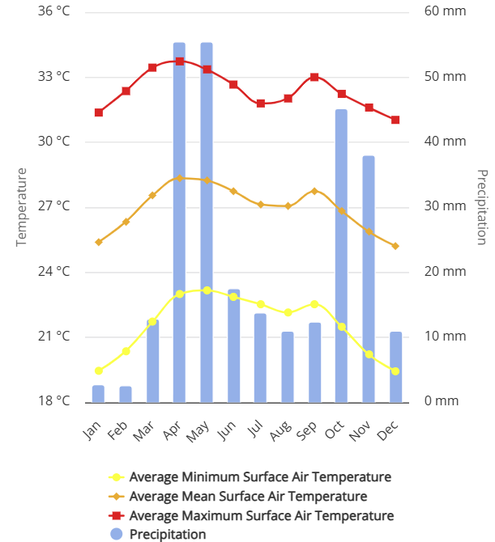
Climate projections indicate expected increases in annual average temperature between 2040-2060, yielding an increase in average air temperature, very hot days, drought frequency, and drought intensity.. Flood intensity and frequency are also expected to increase in Somalia, and rising sea level is expected to affect Somalia’s coastal communities through coastal erosion, seawater intrusion into freshwater systems, and changes in marine habitat health. Resilience and food security investments in these locations must consider and adapt to changing conditions to reduce potential risks posed by climate change.

2.2 Climate trends, impacts, and Stressors

Somalia is arid and semi-arid, with two seasonal rainfall seasons, as shown in the figure below. The climate in Somalia is influenced by several factors, including the Inter-Tropical Convergence Zone (ITCZ), monsoonal winds and ocean currents, jet streams, such as the Somali Jetstream or Somali Current, tropical cyclones, and conditions in the neighboring Indian Ocean and Red Sea (UN, 2020).

Figure 8: Monthly climatology of average minimum surface air temperature, average mean surface temperature, average maximum surface temperature & precipitation 1991-2022 Somalia

Temperature. The annual mean temperature is close to 30°С throughout the country. Average monthly temperatures reach their maximum during April through June. June to September are the hottest months in the north, while December to March marks the hottest weather for the south. Since the 1960s, a warming trend has been observed in Sub-Saharan Africa. The mean annual temperature is 26.91°C (1901-2016).

Precipitation. Precipitation is generally low nationwide, with high spatial and temporal variability. The average annual rainfall is about 200 mm in most of the country. The northern maritime plains are extremely hot and arid, with an average annual rainfall of less than 200 mm. Rainfall in the south is higher at approximately 400 mm and highest in the southwest, with around 700 mm annually (FAO, 1995). The mean annual precipitation is 265.44mm (1901-2016).

Seasons. Somalia is generally arid and semi-arid with bimodal rainfall. The rainfall is influenced by the Inter-Tropical Convergence Zone (ITCZ), the north-south movement, monsoonal winds and ocean currents, and tropical cyclones, which result in two rainy seasons and two dry seasons in a year:

a. The “Gu” rainy season starts as early as the second half of March. Precipitation intensifies in April across the country, except for the northeastern coastline, which receives the least rainfall during this season. Relatively wet and hot conditions prevail, Gu being considered the rainiest season in the country. Occasionally, the Gu season extends into June or July because of the Haggai rains, which are produced by the onset of moist onshore winds.
b. The dry “Hagaa” dry season runs from July to September and is associated with cool sea breezes from the Indian Ocean, which result in light coastal rains in July and August. The Southwest monsoon dominates, bringing relatively cool conditions, with showers along the coast but dry inland.
c. A shorter duration and fewer amounts of precipitation from October to the end of November characterize the “Deyr” light rainy season.

d. January to March is the most extended dry season, known as “Jilaal”. This season results from ITCZ emerging from the dry Arabian Peninsula.

Observed change. With regard to precipitation, despite inconsistent trends for the Sub-Saharan region as a whole, East Africa has been experiencing precipitation increases in the northern part. There is a decrease in rainfall in the southern region.

3.0 Pillar Specific Goal, Outcome, and Workplan

Global climate change is increasingly perturbing atmospheric and oceanic systems, generating more frequent and severe anomalies in weather and climate patterns worldwide. In Somalia, multi-hazard risks and vulnerability dynamics are mounting due to the country’s hydrometeorological and geographic setting and the convergence of multiple risk factors. These include El Niño-associated increases in rainfall and flooding, La Niña-linked prolonged drought, and exposure to tropical storms and storm surges along Somalia’s extensive Indian Ocean coastline. In this context, robust hazard tracking, real-time monitoring, and forecasting capacities are essential to enable timely, people-centered early warnings and risk-informed early action.
Under the auspices of the Honorable Prime Minister, SoDMA/NDMO has been entrusted with the full-scale national implementation of all four pillars of EW4All in Somalia, ensuring coordinated leadership, whole-of-government alignment, and effective engagement with federal member states, communities, and partners.
3.1 Pillar 1: Disaster Risk Knowledge
Somalia’s disaster risk landscape is shaped by the convergence of multiple, mutually reinforcing risk drivers: protracted poverty, recurrent climate and weather extremes, climate change, conflict-related risks, and persistent livelihood vulnerability. These factors heighten exposure and sensitivity to hazards and constrain coping and adaptive capacity. The escalating climate crisis further compounds vulnerability through increasingly variable and less predictable weather patterns, amplifying the frequency and severity of droughts, floods, and associated secondary impacts on food security, displacement, and public health.

In this context, strengthening disaster risk knowledge is a prerequisite for effective EW4All implementation and for ensuring that warnings translate into timely, risk-informed early action, particularly for frontline and vulnerable communities. Guided by the Sendai Framework for Disaster Risk Reduction, and aligned with the UN Secretary-General’s call for universal protection through early warning systems by 2027, Somalia is prioritizing the institutionalization of EW4All governance and the systematic closure of risk knowledge gaps across institutions, stakeholders, and communities. SoDMA/NDMO, as the national nodal agency for EW4All implementation, is entrusted with leading coordination and ensuring that risk information and early warning services reach at-risk populations, enabling informed preparedness measures and protective actions ahead of extreme and hazardous events.

Operational focus under Pillar 1 (risk knowledge) includes:

- Establish or strengthen an inclusive and participatory national multi-hazard risk assessment framework that integrates hazard, exposure, vulnerability, and capacity data. The framework should be multisectoral, stakeholder-driven, and responsive to last-mile needs.
- Develop a standards-based, interoperable online national risk data repository with role-based access. The platform should enable national and local government institutions, relevant stakeholders, and vulnerable communities to contribute and update data, supporting evidence-based planning and impact-based forecasting and warning products.
- Strengthen hydro-met nodal agencies’ (SoDMA’s, MoEWR, NCA) ICT infrastructure and operational capacity to support disaster risk governance and enable the real-time collection, management, analysis, and reporting of incident updates, impacts, losses, and damages.
- Produce actionable risk profiles and maps at national and subnational levels to guide planning, targeting, prioritization, resource allocation, and last-mile warning coverage.
- Institutionalize risk governance responsibilities and action-planning requirements across all levels of government, including local authorities. The framework should ensure meaningful stakeholder engagement and community participation, strengthen community-level risk knowledge, and integrate gender, age, disability, displacement status, literacy, and language considerations into risk communication so that warnings are accessible, understandable, and actionable for all population groups.

3.1.1 Pillar 1 Gap Identification on Disaster Risk Knowledge

Gaps identified through the previously organized Early Warnings for ALL inception workshops, National workshops, and stakeholder meetings in Somalia.

3.1.1.1 Indicative Gaps in Disaster Risk Knowledge Management Governance:

A multi-hazard risk repository and a risk knowledge bank are precursors to the instrumentalization of the EW4ALL systemic functionality, in which Somalia needs to make significant progress.
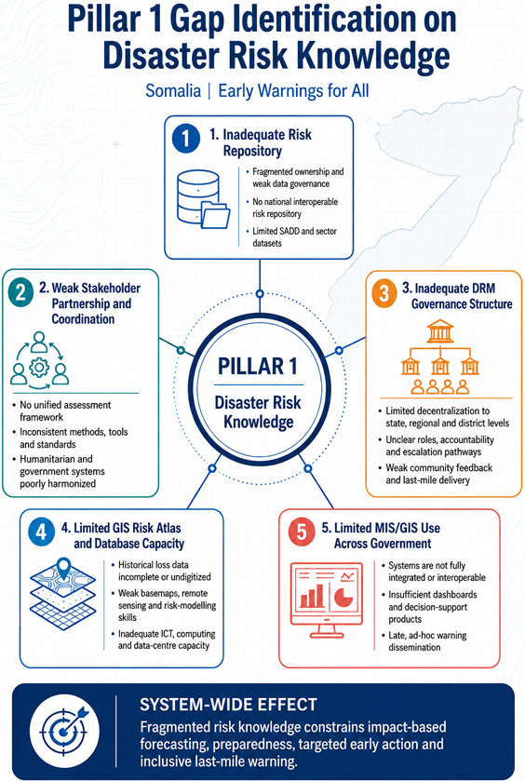

- Inadequate Risk Repository:
Somalia’s national capacity to generate, standardize, and institutionalize disaster risk knowledge remains constrained by the absence of a coherent risk repository architecture and agreed governance arrangements for multi-sector risk and vulnerability assessment. Key gaps include:
1) Institutional arrangements and coordination gaps
- SoDMA/NDMO and MoHADM require a formal, nationally endorsed mechanism such as a Vulnerability Assessment Committee (VAC) / Taskforce with representation from sector ministries, technical agencies, FMS counterparts, academia, and key non-state stakeholders to coordinate risk assessment, validation, and publication.
- There remains insufficient consensus across state institutions, humanitarian actors, UN agencies, INGOs, national NGOs, and CSOs on common approaches for risk assessment, data collection protocols, and the use of locally sourced climate and vulnerability data.
- The UN cluster system is not yet fully harmonized with government DRM and development frameworks, limiting the integration of humanitarian risk analysis with national risk governance and state-led coordination.
2) Data systems and statistical capacity constraints
- National statistical systems and data-clearinghouse functions remain underdeveloped for routine census and household surveys and for producing standardized, interoperable datasets for risk analysis.
- Collection of sex-, age-, and disability-disaggregated data (SADD) is limited, reducing the ability to develop intersectional vulnerability profiles and to target early warning dissemination and early actions effectively.
- Data governance issues such as fragmented ownership, inconsistent metadata standards, and weak quality assurance undermine the reliability and comparability of risk datasets across institutions and partners.
3) Sectoral coverage gaps affecting risk mapping and profiling
The Roadmap identifies the need to establish clear mandates and accountability for institutions and stakeholders to systematically collect and maintain disaggregated climate risk and vulnerability datasets across priority sectors, including: Agriculture and agroforestry, Water resources and WASH, Livestock, fisheries, and pastoral systems, Physical infrastructure, communications, and transport corridors, Municipalities and urban centres, commercial hubs, and markets, Human settlements and housing, including displacement-affected areas.
Strengthening these datasets is essential to enable credible multi-hazard risk mapping, risk and vulnerability profiling, and the development of an operational national risk repository that supports impact-based forecasting, risk communication, and targeted early action.
Roadmap implication :
A nationally governed, interoperable risk repository underpinned by a VAC/Taskforce, agreed methods and standards, and routine production of SADD and sectoral risk datasets will allow Somalia to shift from fragmented, project-based risk analysis toward an institutionalized, government-led risk knowledge system that supports EW4All implementation and aligns humanitarian risk information with national DRM and development planning.

- Inadequate stakeholder Partnership and coordination: The Roadmap is intended to foster the policy actions, mandates, and harmonization of internal and external resources required to strengthen institutional ICT systems and to build enabling capacity for disaster risk assessment and risk knowledge management. This includes establishing adequate consensus among state actors, humanitarian stakeholders, UN agencies, INGO and local NGO consortia, and CSOs on common approaches to risk assessment and the systematic collection and use of locally sourced climate data.

To reduce fragmentation and improve comparability of risk information, the Roadmap further calls for the coordination of external, state, and non-state actors under a unified framework supported by standardized methodologies, tools, and guidelines for climate risk and vulnerability assessments and for post-disaster loss, damage, and needs assessments (including PDNA-aligned processes) at both national and sub-national levels..

- Inadequate Disaster Risk Management Governance Structure: Somalia’s DRM governance architecture remains constrained by limited decentralization of SoDMA/NDMO (under MoHADM) to regional, state, and district levels. This reduces the government’s ability to operationalize a people-centred, end-to-end early warning system at the “last mile” and weakens the consistency of risk governance across Federal Member States and districts.

DRM governance gaps:

- Insufficient sub-national institutional presence and mandate: Limited establishment and resourcing of SoDMA/NDMO structures at state, regional, and district levels constrains routine risk management functions and emergency coordination.
- Weak vertical coordination and accountability: Roles, decision-rights, and escalation pathways between federal institutions, FMS, and district authorities are not consistently defined or operationalized, leading to ad-hoc coordination during crises.
- Limited capacity for risk communication and dissemination: Without decentralized DRM focal points and trained teams, risk information does not reliably translate into localized warnings, tailored messaging, and inclusive dissemination across communities.
- Gaps in community-based early warning delivery: The absence of structured sub-national mechanisms undermines community engagement, feedback loops, preparedness planning, and the implementation of early actions aligned with alerts.
- Roadmap implication
The Roadmap should prioritize establishing and empowering decentralized DRM governance structures through formal mandates, staffing, training, SOPs, and resourcing so that SoDMA/NDMO can:
- govern and coordinate disaster risk management functions at sub-national level;
- lead coherent risk communication and information dissemination; and
- operationalize a community-based early warning system that is locally owned, inclusive, and capable of triggering early action before shocks escalate.

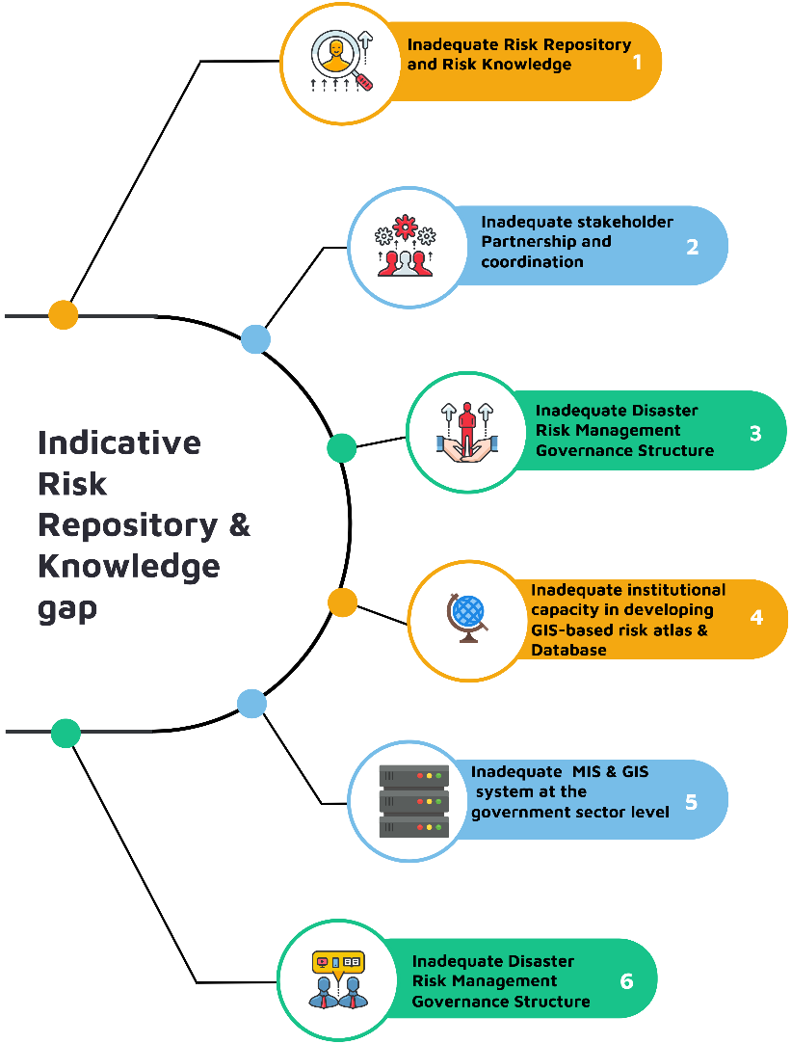
Figure 9 : Indicative gaps of Pillar 1
- Inadequate institutional capacity in developing GIS-based risk atlas & Database:

Somalia’s ability to generate and sustain GIS-based multi-hazard risk intelligence risk atlases, basemaps, and interoperable geospatial databases remains constrained by legacy data limitations, uneven institutional capacity, and weak enabling infrastructure. These constraints reduce the availability of evidence-based tools needed for preparedness, anticipatory action, and coordinated humanitarian response planning.

Key gaps:

1) Incomplete and fragmented historical datasets
- Sector-level digital data collection only began around 2007; earlier records were largely paper-based, and significant historical disaster loss and damage (L&D) datasets remain undigitized, unstandardized, or not integrated into an authoritative repository.
- Data fragmentation across sectors and institutions limits comparability and undermines consistent trend analysis and risk profiling.
2) Weak geospatial basemaps and risk atlas coverage
- SoDMA and sector departments lack a unified, routinely updated national geospatial database and harmonized GIS basemap that can support multi-hazard risk mapping.
- District-level basemaps are inadequate in many locations, restricting the ability to generate localized vulnerability profiles, exposure layers (settlements, infrastructure, services), and actionable risk atlases for decision-making.
- As a result, risk atlases and GIS-based tools are insufficient for guiding disaster preparedness, contingency planning, and humanitarian response targeting.
3) Limited remote sensing and climate-risk modelling capability
- SoDMA capacity to acquire, process, and use satellite remote sensing and meteorological datasets for climate risk modelling is limited.
- Constraints include limited skills, inconsistent access arrangements, and a lack of standardized workflows for integrating earth observation with in-situ observations and sector datasets.
4) ICT and computational infrastructure constraints
- Inadequate data centre capacity, limited high-processing-power hardware, and insufficient specialized software constrain:
  - Among the government sector departments, the MoEWR has the GIS mapping expertise, but the nodal agency SoDMA still lacks the capability to produce professional-grade GIS analytics and geospatial data management;
  - weather data processing and integration;
  - data calibration, collation, and quality control;
  - meteorological data analysis; and
  - climate and impact modeling for multi-hazard risk products.
5) Weak last-mile warning dissemination and coordination
- Early warning messages are often disseminated late and inconsistently through ad-hoc channels (e.g., word of mouth or informal texting by leaders/local officials), with limited standardization, redundancy, or feedback loops reducing trust, reach, and actionability.
- The Disaster Risk Management Coordination Group (DRMCG) structure and processes are insufficiently defined or operationalized to ensure coordinated analysis, message clearance, and harmonized dissemination across institutions and partners.

- Inadequate MIS & GIS application at the government department level:

Somalia’s disaster risk knowledge management is constrained by limited application and interoperability of Management Information Systems (MIS) and Geographic Information Systems (GIS) across SoDMA/NDMO and sector departments. This weakens the government’s ability to maintain authoritative risk datasets, produce routinely updated risk intelligence, and support evidence-based preparedness, response planning, and risk-informed development decisions.

Key gaps:

1) Legacy data limitations and incomplete datasets
- Sector-level digital data collection began around 2007; earlier records were largely paper-based, and some historical disaster loss and damage (L&D) datasets remain missing, undigitized, or not integrated into institutional databases.
- Inconsistent standards and weak data governance reduce comparability across sectors and constrain trend analysis and vulnerability profiling.
2) Limited MIS/GIS system installation, integration, and use
- SoDMA and sector departments lack fully functional, integrated MIS and GIS platforms that can support routine risk information management, analysis, and reporting.
- A coherent national geospatial database and harmonized GIS basemap remain underdeveloped, and district-level basemaps are inadequate in many areas limiting localized risk analysis and the production of actionable risk products.
3) Weak risk atlas and decision-support products
- The absence of complete exposure and vulnerability layers and insufficient GIS analytical capacity constrain the development of a national multi-hazard risk atlas and risk dashboards.
- As a result, government and partners lack sufficiently informed tools for disaster preparedness, contingency planning, and humanitarian response targeting.
4) Insufficient remote sensing and climate-risk modeling capacity
- SoDMA’s capacity to acquire and apply satellite remote sensing and meteorological datasets for hazard monitoring and climate-risk modeling is limited, including constraints in skills, access arrangements, and operational workflows.
5) ICT and computational infrastructure constraints
- Inadequate data centre infrastructure and insufficient high-performance hardware/software constrain:
  - GIS data processing and spatial analytics;
  - weather data processing, calibration, and collation;
  - meteorological data analysis and forecast verification; and
  - climate and impact modeling to support multi-hazard risk products and impact-based warnings.
6) Weak dissemination systems and coordination processes
- Early warning messages are often disseminated late and inconsistently, relying on ad-hoc channels (e.g., informal text messages and word of mouth via leaders/local officials), with limited standardization, redundancy, or feedback loops.
- The Disaster Risk Management Coordination Group (DRMCG) structure and processes are insufficiently defined or operationalized to ensure coordinated risk analysis, message clearance, and harmonized dissemination across institutions and partners.

3.1.2 Step forward to close the gap of Pillar 1 Disaster Risk Knowledge

SoDMA/NDMO and partners will address the identified gaps by strengthening Somalia’s end-to-end hydrometeorological early warning capacity, installing and activating robust observation and monitoring systems, improving real-time data transmission and management, and upgrading forecasting and meteorological analysis functions within SoDMA-NMHEWC to deliver demand-driven services. Core actions through 2027 (with consolidation to 2030) include: adopting a national hydro-met observation network plan and governance framework; upgrading and expanding automatic meteorological and hydrological stations with reliable telemetry and O&M systems; establishing an integrated data pipeline for QA/QC, archiving, and access; strengthening NMHEWC operational forecasting/nowcasting, hydrological forecasting, and impact-based products; operationalizing forecast-to-action triggers and decision-support tools for priority hazards and sectors; investing in enabling ICT infrastructure and processing capacity; building sustainable human capacity and financing for operations; and deepening regional collaboration (notably with ICPAC and WMO-linked products) to improve forecast skill and localization.

A multi-hazard risk repository and a risk knowledge bank are precursors to the instrumentalization of the EW4ALL systemic functionality, a step Somalia needs to take to make significant progress.

3.1.3 Proposed key actions for closing the indicated gaps: Disaster Risk Knowledge

Proposed Activities | Enablers/Actors/stakeholders
  - Improve multi-hazard/Disaster L & D database management system
- Develop a UNDRR-DesInventar technical team-approved data collection template to systematically inventory all past priority hazard events, capture and attribute associated loss-and-damage statistics, and upload the corresponding L&D datasets and event attributes into the DesInventar online system. | Government Lead Agency :  - SoDMA  EW4ALL Pillar Lead :  - UNDRR, WMO  Technical Support: CREWS Initiative
- Establish and operationalize a multi-hazard early warning Situation Room within the National Multi-Hazard Early Warning Centre (NMHEWC), equipped with the necessary ICT systems and tools (hardware and software) to strengthen disaster risk knowledge, enable impact-based forecasting and analysis, and provide integrated operational support for Somalia’s EW4All implementation portfolio. | Government Lead Agency :  - SoDMA  EW4ALL Pillar Lead :  - UNDRR, WMO  Technical Support: CREWS Initiative
- Enhance SoDMA’s institutional capacity to systematically maintain and update the Disaster Risk Management Information System (DRMIS) using collected sector-level risk datasets, and to periodically validate and upload disaster loss-and-damage (L&D) records to the DesInventar database. Establish dedicated MIS and GIS Units within climate-vulnerable sector departments to systematically inventory, georeference, and maintain disaster loss-and-damage (L&D) datasets, enabling routine tracking, impact analysis, and evidence-based planning and response. | Government Lead Agency :  - SoDMA  EW4ALL Pillar 1 Lead :  - UNDRR, WMO  Technical Support: CREWS Initiative  - UN Agency: OCHA, UN Clusters (CCM, Early Recovery, Education, Emergency Telecommunication, Food Security, Health, Logistics, Nutrition, Protection, Shelter, and WASH clusters)  - HCT/Individual UN Agency (UNDRR, UNDP, IOM, UNICEF, UNHCR, WFP, FAO, UN Women, UNFPA, WHO, IFAD, ITU, UN Volunteers, UNCDF etc.)  CSOs:  - National NGOs Consortium  - International NGOs Consortium  - CSOs (Local charities, trust, clubs, non-profit organization etc.)  - Regional Actor: IGAD-ICPAC, African Risk Capacity (ARC)
- Design and implement an institutional strengthening programme to enhance SoDMA/NDMO and relevant sector institutions’ capacity in disaster risk information management, including data governance, risk analytics, GIS/MIS workflows, quality assurance, reporting, and operational use of risk information for early warning and early action.  - Negotiate and sign formal MoUs/agreements between SoDMA/MoHADM and key partners to secure structured access, interoperability, and routine data exchange for proactive impact forecasting and early warning decision support. Priority counterparts include: UN agencies and INGO partners; FAO-SWALIM; IOM-DTM; UNHCR Operational Data Portal; WFP (food security) and WFP logistics/telecommunications networks; WASH Cluster databases; CREWS Initiative; CIMA Research Foundation (myDEWETRA); ICPAC forecasts/outlooks; Education Cluster databases; UNICEF-MICS; World Bank (GFDRR, Databank); UNOCHA-INFORM; FSNAU & FAO IDEA; IFRC Anticipatory Action Hub; USAID-FEWS NET; and other relevant national and regional systems ensuring these tools and facilities are operationally integrated to inform timely, risk-informed early action. | Government Lead Agency :  - SoDMA  EW4ALL Pillar Lead :  - UNDRR, WMO
- Sign a formal MoU between SoDMA/MoHADM and UN agencies to institutionalize UN Cluster (11 clusters) support to SoDMA for strengthening national risk information governance, including agreed arrangements for conducting joint Post-Disaster Needs Assessments (PDNA), Climate Risk and Vulnerability Assessments (CRVA), and standardized Loss-and-Damage (L&D) assessments and reporting. | Government Lead Agency :  - SoDMA  EW4ALL Pillar Lead :  - UNDRR, WMO
  - The Institutional Strengthening programme on multi-hazard and Climate Risk and Vulnerability Assessment ( CRVA) at the Local Level
- Establish and operationalize a new Vulnerability Assessment Committee (VAC) / Technical Taskforce structure at national, sub-national, local, and community levels to lead comprehensive vulnerability assessments. This structure will also formalize stakeholder coordination and engagement mechanisms to ensure consistent participation, data sharing, validation, and joint decision-making across government institutions, humanitarian and development partners, civil society, and the private sector. | Government Lead Agency :  - SoDMA  EW4ALL Pillar Lead :  - UNDRR, WMO  Technical Support: CREWS Initiative  UN Agency: OCHA, UN Clusters (CCM, Early Recovery, Education, Emergency Telecommunication, Food Security, Health, Logistics, Nutrition, Protection, Shelter, and WASH clusters). HCT/Individual UN Agency (UNDRR, UNDP, IOM, UNICEF, UNHCR, WFP, FAO, UN Women, UNFPA, WHO, IFAD, ITU, UN Volunteers, UNCDF etc.)  - CSOs: National NGOs Consortium, International NGOs Consortium  Regional Actor: IGAD-ICPAC, African Risk Capacity (ARC)
- Implement an institutional strengthening programme for climate-vulnerable sector departments and the Vulnerability Assessment Committee (VAC) / Technical Taskforce to operationally use ICT-enabled tools such as GIS basemaps, UAV/drone imagery, mobile data collection applications, survey platforms, and GPS devices to systematically gather georeferenced multi-hazard incidence data, disaster hotspot information, and disaster loss-and-damage (L&D) datasets from community and local levels, and to conduct rapid PDNA (RPDNA), climate risk and vulnerability assessments (CRVA), and sector-level risk assessments.. | Government Lead Agency :  - SoDMA  EW4ALL Pillar Lead :  - UNDRR, WMO  Technical Support: CREWS Initiative  UN Agency: OCHA, UN Clusters (CCM, Early Recovery, Education, Emergency Telecommunication, Food Security, Health, Logistics, Nutrition, Protection, Shelter, and WASH clusters). HCT/Individual UN Agency (UNDRR, UNDP, IOM, UNICEF, UNHCR, WFP, FAO, UN Women, UNFPA, WHO, IFAD, ITU, UN Volunteers, UNCDF etc.)  - CSOs: National NGOs Consortium, International NGOs Consortium  - Regional Actor: IGAD-ICPAC, African Risk Capacity (ARC)
- Implement a comprehensive capacity-building programme for the Vulnerability Assessment Committee (VAC) / task force, sector department TWGs, community volunteers, mosque-based committees, local NGOs, community leaders, local stakeholders and service providers, value-chain operators, and private-sector actors to systematically collect and verify loss-and-damage (L&D) information within the first 1 hour, 6 hours, 12 hours, and 24 hours after a disaster, and to transmit standardized, georeferenced L&D data to the NMHEWC Situation Room for real-time situational awareness and decision-making. | As above
- Strengthen stakeholder capacity to conduct sector-level climate and multi-hazard exposure, risk, and vulnerability assessments across priority productive and service sectors, including agriculture, livestock, fisheries, agroforestry, environment, WASH and water resources, infrastructure and basic services, housing and settlements, food security and livelihoods, and enterprise/entrepreneurship ensuring results inform risk profiling, impact-based early warning products, and risk-informed planning and investment. | As above
- Enhance the disaster risk knowledge and practical assessment capacity of CPC/DMC structures and communities by institutionalizing an inclusive, participatory vulnerability assessment process using tools such as transect walks, focus group discussions (FGDs), community meetings, and religious/community gatherings to capture local risk perceptions, hazard history, exposure and vulnerability patterns, and locally feasible early actions, and to feed validated community risk information into sub-national and national risk profiling and early warning services. | As above
- Establish and operationalize community climate knowledge networks linking NMHEWC with national and local communication and knowledge actors (radio, TV, news outlets, web portals and mobile applications, national media platforms, academic and research institutions, practitioners, and professional associations) to strengthen community engagement in hazard, vulnerability, and risk assessment, and to implement a coordinated community vulnerability assessment strategy that supports inclusive risk communication and locally actionable early warning services. | As above
- Establish and strengthen the capacity of local-level VAC/community structures to routinely review, validate, and update risk data covering hazards, exposure, vulnerability, and coping capacity and to maintain systematic reporting mechanisms for transmitting updated datasets to NMHEWC to support real-time situational awareness, risk profiling, and impact-based early warning services. | As above
- Strengthen the capacity of non-state actors including CSOs, local NGOs, private-sector actors, community-based organizations, media, and professional associations on EW4All concepts, roles, and operational procedures to enable coordinated, reliable support to national and sub-national early warning services, risk communication, and early action implementation. | As above
  - Enhance institutional capacity across SoDMA/NDMO, NMHEWC, and relevant sector departments to effectively deploy and use ICT-enabled tools (e.g., UAV/drone platforms, mobile applications, digital survey tools, GPS devices), geospatial systems (GIS maps, geodatabases, tailored multi-hazard maps, and a national risk atlas), and remote sensing datasets for risk interpretation. This will enable the routine production of tailored, data-driven decision-support products that strengthen risk profiling, impact analysis, preparedness planning, and EW4All operational delivery.
- Enhance the capacity of Technical Working Groups (TWGs) and sector technical experts to effectively use GIS, remote sensing (RS), and GPS tools in conducting sector and sub-sector level risk and vulnerability assessments across agriculture, water resources, livestock, fisheries, food security, WASH, public health, infrastructure and communications, rural development, planning, and related sectors so that assessments generate georeferenced, decision-ready outputs for risk profiling, impact-based early warning products, and targeted preparedness and response planning. | As above
- Enhance stakeholder capacity to deploy and use mobile applications and GIS/GPS-enabled survey tools for primary data collection, and to apply big-data analysis platforms, GIS mapping, open-source mapping tools, UAV/drone mapping, and satellite/earth observation mapping to systematically collect, integrate, analyze, and visualize all key risk data elements (hazard, exposure, vulnerability, capacity, and impacts) for multi-hazard risk profiling and decision support. | As above
- Build sector departments’ capacity to establish and manage integrated GIS/MIS databases and to develop high-quality multi-hazard distribution maps and associated risk attribute layers (hazard, exposure, vulnerability, and impact indicators), enabling routine risk profiling, planning, and operational decision support for early warning and early action. | As above
- Develop and operationalize an online geospatial risk information system that makes locally sourced disaster risk data and information readily available and accessible to the public through an online GIS platform. This will include structured engagement of sector ministries and departments to strengthen the type and quantity of risk data collected, ensure routine updates and validation, enable ongoing analysis and visualization, and publish publicly accessible, user-friendly risk products (maps, dashboards, and summaries) that support risk awareness, preparedness, and risk-informed decision-making.. | As above
- Revisit and update the types, thresholds, and coverage of early warning indicators to ensure they are fully aligned with national and sub-national disaster mitigation plans, emergency response plans, and early action/anticipatory action plans, including clear trigger levels and decision rules that translate monitoring and forecasts into timely, risk-informed action.. | As above
  - trengthen the capacity of institutions and stakeholders to systematically acquire, manage, and analyze data on Somalia’s critical hazards including geographic extent, magnitude, intensity, frequency, and probability and to integrate this with community-level socioeconomic vulnerability information, including routine collection and use of sex-, age-, and disability-disaggregated data (SADD), to improve multi-hazard risk profiling, targeting, and inclusive early warning and early action planning.
- Methodology, tools, and guidelines on SADD data collection | As above
    - Stakeholder engagement plan, SoP for SADD data collection
    - Conduct community vulnerability assessments(socioeconomic) with systematic collection of gendered climate risk data, gender-disaggregated attributes, and the vulnerability of gender groups (women, girls, boys, children, elderly, disabled population) separately.
- Enhance institutional and stakeholder capacity in Hazard assessments based on historical data, scientific models, and Indigenous and local knowledge (ILK) is conducted for the five major hazards | As above
- Develop Climate risk and vulnerability-related repositories on hazards, vulnerabilities, coping capacity, and risk at all levels, including state and non-state actors, government and public offices, CSOs, CBOs, NGOs, and communities. | As above
- Develop SADD monitoring tools and networks to ensure the SADD and sectoral disaggregated data collection | As above
- Develop data collection methodology, ICT tools, Apps, guidelines, and processes for the collection and analysis of the data created and adhered to, ensuring comparative analysis, improved predictability, and sustained impact. | As above
- Develop and availability of hazard, vulnerabilities, capacity, and risk datasets at all levels, including state and non-state actors, government and public offices, and communities. | As above
- Establish, maintain, and modernize centralized and decentralized knowledge and information management government databases. | As above
- Develop a repository of historical data sets on all past priority hazards (e.g., geographical extent, magnitude, intensity, disease transmissibility, frequency, probability, return periods). | As above
- Develop risk knowledge products with multiple local languages to comprehensively understand hazards and cascading hazardous events. | As above
- Develop Hazard maps (dynamic and layered when possible) to identify the geographic areas (e.g., land cover, places, population characteristics) that could be affected by priority hazards. Analyze impacts on critical infrastructure and secondary risks associated with these impacts, evaluated for all priority hazards. | As above
- Conduct an assessment of vulnerabilities of critical economic sectors at the national level for all priority hazards. | As above
- Integration of indigenous knowledge in risk assessment for all priority hazards. Results of risk assessments are integrated into local risk management plans in a clear and easy-to-understand language. | As above
- Develop data architecture and repository (including but not limited to a GIS) established and operational to store all event/disaster and risk information. | As above
- Inventorying all past priority hazard events and attributing the loss and damage statistics. For example, from sources like DesInventar, post-disaster needs assessment (PDNA), etc. | As above
  - Improve multi-hazard/Disaster Risk formation management Governance system
- Develop historical climate data (30 years), analyze Climate norms and projections of Somalia to define the meteorological mean and support forecast (parameters, e.g., temperature and precipitation distribution, relative humidity, sunshine hours, wind patterns), sea level change, and a meteorological map and sectoral climate impact analysis. | As above
- Develop tailormade climate datasets (total sunny days, solar irradiance datasets, wind velocity, relative humidity, precipitation) for NDC interventions support, e.g., wind power, Solar PV system, solar thermal system, rainwater harvesting system installation. | As above
  - Develop a Sectoral disaggregated data hub to support DRR, NAP, NbS (Nature-based), locally led solutions, WASH, Health, Food Security, Livelihood Security, etc.
- Develop tailormade sectoral disaggregated datasets on crop agriculture, land use map & attribution information, agricultural activity, crop, livestock population distribution data, pasture, biomass resource, waterbody, water point, soil moisture, soil fertility, irrigation data repository development form supporting NAP localization and adaptive interventions e.g., Biogas/Bio-digester, IFM, FYM, INM, rainwater harvesting, windmill/wind power, Solar PV system, biomass energy, organic farming, extension services of productive sectors). Develop climate norms for Somalia (meteorology). | As above
- Develop community-level DRM/DRR/CCA plans based on community-level climate risk and livelihood vulnerabilities, along with the vulnerabilities of the community landscape context, and finally integrate all those issues in community-based impact weather forecasting. | As above
- Impact forecasting: Develop GIS Shapefile of Districts, develop attribute information of element and repository, overlay hazard distribution layer, and conduct GIS analysis to quantify exposed people, services, and critical infrastructure conducted and mapped for all relevant hazards, as well as any compounding risks, at the local level in both rural and urban areas and vulnerable sectors. | As above
- Integration of local and Indigenous knowledge (ILK) for coping strategies | As above
  - Enhance the capacity of the sector departments & stakeholders (NGO, CSO, CBO, local religious institute) for collecting sector-level disaggregated attribute information and SADD.
- Capacity building of stakeholders in developing tools, methodology for conducting SADD information collection, database development, and informed tools development | As above
- Enhance institutional capacity strengthening program for the National Statistical Agency, SoDMA, NMHEWC, Vulnerability Assessment Committee (VAC), climate-vulnerable sector department, etc., to conduct assessments of SADD, socioeconomic, and sectoral disaggregated climate risk and vulnerability data supporting gendered DRM, DRR, and climate actions from the local level. | As above
  - Establish the Sector Department-level MIS/GIS system for sector-level operational data analysis and informed tools development
- SoDMA technical support for sector department/government duty bearer for GIS software installation, configuration, development, maintenance, update, and management of the climate and multi-hazard information system | As above
- Installing a SoDMA-level online geospatial portal and online DRMIS system will give the sector department access to risk information data updates. | As above
  - Harmonize data/information coordination, partnership, and exchange mechanism signing agreements with partners
- Enhance SoDMA's roles in improving stakeholder coordination and exchange mechanisms in climate data and information exchange at the institution level for risk knowledge sharing, sector and sector-level elements specific forecast impact analysis, and anticipatory action planning. | As above
- Sign an MOU between SoDMA-MoHADM and transboundary countries (Ethiopia, Kenya) for data exchange on observed weather parameters, forecasts/outlook, river basin/catchment flow/river level data, climate norms data of those countries, climate projects, and multi-hazard atlas and elements attribute information. | As above
- Sign MOU between SoDMA-MoHADM with regional multi-hazard early warning tools/network/risk knowledge hub and synchronizing with Somalia EW4ALL System. | As above
- SoDMA-MoHADM MoU with the Government sector department for risk information sharing | As above
  - Improve early warning information exchange and interoperability among institutions
- Data on hazards, vulnerabilities, capacity, and risk are available at all levels, including state and non-state actors, government and public offices, and communities. | As above
- Establish, maintain, and update knowledge and information management government databases. | As above
- Develop hazard maps (dynamic and layered when possible) to identify the geographic areas (e.g., land cover, places, population characteristics) that could be affected by priority hazards. | As above
  - Systemically promote DesInventar for and track, maintain, and update disaster impact data/losses and damages records
- Enhance SoDMA capacity to roll out the improvements of the DesInvetar repository to ensure data quality, enrich quantity, utilize a new prototype, explore data needs, authenticate sources, improve data governance, engage sector ministry public information platform, and coordinate data platform for improving Loss and Damage Tracking System for Somalia. | As above
- Establish a new tracking system with governments, development partners, and users. The system aims to strengthen understanding of losses and damages, related cascading hazards and events, and the analysis and use of data for policy and decision-making. | As above
- Establish a tracking system for hazardous events, disaster losses, and damages, with data disaggregated by sex, age, disability, sector, and geography. Historical disaster impact data for all priority hazards by industry (e.g., geographical extent, magnitude, intensity, frequency, etc.) are to be inventoried. | As above
  - Installation of the Early Warning effectiveness & efficacy related community feedback mechanism
- Installation of online apps for community feeds on early warning effectiveness and efficiency | As above
  - Initiate mass awareness and knowledge raised about impending multi-hazards; promote climate education at all levels (academic, community level, formal and informal education)
- Undertake comprehensive mass education, inclusivity of risk knowledge in Primary/Secondary School curriculum, awareness campaign, and distance learning about raising the risk knowledge of impending multi-hazards, extreme weather events, and disasters onset. | As above

3.1.4 The Roadmap Ahead for Pillar 1: Improved Disaster Risk Knowledge Management System

By 2027/2030, the development of enhanced institutional and stakeholder capacity in risk repositories. Comprehensive multi-hazard and climate risk repository, risk atlas, tailored tools for informed decision-making, and improved household and community capacity to better prepare for impending multi-hazards. An extensive, automated disaster risk information and knowledge base is intended to be made available and used for all dimensions of disaster risk, including hazards, exposure, vulnerability, and enhanced capacity at the household, community, and stakeholder levels.

Pillar 1 outcomes: By 2027/2030, comprehensive risk knowledge and stakeholders' capacity in multi-hazard exploration, risk, and vulnerability assessment capacity.
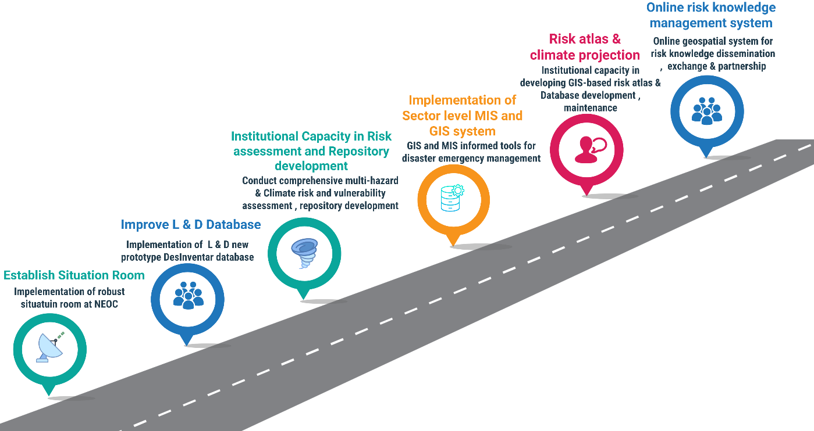
Figure 10 : Proposed Roadmap of Pillar 1
  - The characteristics of key hazards the country is exposed (e.g., geographical extent, magnitude, intensity, frequency, probability), including possible cascading hazardous events, are analyzed, historical data evaluated, and potential future risks assessed.
    - Situation room established at National Multi-Hazard Early Warning Centre (NMHEWC)
    - Hazard assessments based on historical data, scientific models, and ILK are conducted for the top 5 hazards (or hazards responsible for 90% of past L&D), no less than 5 years old.
    - New Methodology, ICT tools, Guidelines developed, risk & Vulnerability assessments (CRVA) conducted for the top 5 hazards (or hazards responsible for 90% of past L&D).
    - Mobile-based data collection and big data analysis tools and platforms, GIS mapping, open-source mapping, drones, and satellite mapping are used to collect and analyze all risk data elements.
    - Risk repositories developed on hazards, vulnerabilities, coping capacity, and risk are available at all levels, including state and non-state actors, government and public offices, CSOs, CBOs, NGOs, and communities.
    - Monitoring tools and networks are established to ensure the tracking of all national priority hazards.
    - Data collection methodology, ICT tools, Apps, guidelines, and processes are developed for the collection and analysis of the data produced and adhered to, ensuring comparative analysis, improved predictability, and sustained impact.
    - Enhanced capacity of Technical Taskforce, Technical Working Group (TWG), and Vulnerability Assessment Committee (VAC) for conducting CRVA, collection of disaggregated sectoral data, socioeconomic data, and Disaster loss and damages sectoral data
    - Data on hazards, vulnerabilities, capacity, and risk are available at all levels, including state and non-state actors, government and public offices, and communities.

  - National multi-hazard and climate risk repository data-based (CRVA repository database, risk atlas of District GIS base map, CRVA tailor-made informed tools (dynamic and multi-hazard, when possible) are developed.
    - Risk repository data-based (CRVA repository database, risk atlas of District GIS base map, CRVA tailor-made informed tools (dynamic and multi-hazard, when possible) are developed.
    - Multi-hazard exposure, risk, and vulnerability distribution. District GIS base maps are developed.
    - Detailed database elements, specific exposure, risk, and vulnerabilities, coping capacity, etc., are developed and linked with the geospatial map for forecast impact analysis.
    - Locally sourced data and information about disaster risk are readily available and accessible to the public through online GIS platforms.
    - Mandated responsibilities of sectoral ministries/departments to improve the type and quantity of data collection, regular updates, subsequent analysis, and publicly accessible. Historical data is evaluated to characterize all priority hazards, e.g., geographical extent, magnitude, intensity, disease transmissibility, frequency, probability, and return periods.

1.3. Historical climate data is analyzed, and Climate norms (climatology) are developed.
    - Historical climate data archived, processed, calibrated, and developed climate norms (30 years of climatology) for Somalia. Baseline climatology was designed to compare forecast anomalies and impact forecasting.
    - Weather and Climate anomalies on Socioeconomic and environmental impact analyzed with climate projections. Essential climate variables (ECV): Temperature, precipitation, wind patterns, and sea-level change are developed at the national and local level and updated every 5 years, e.g., have implications on health services, agri-food systems, displacement, etc. (aligned with UNFCCC reporting, NDCs, NAPs)
    - The interaction of hazards and vulnerabilities is evaluated and shared on a timely basis to determine the risks each region or community faces and verify their integration into EWS and DRR plans.

  - The DesInventar database rolled out at the sector level. Disaster impact data/losses and damages are systematically tracked and recorded, aligned with Sendai and SDG targets and indicators.
    - A New prototype of the online DesInventar was rolled out at SoDMA. A new tracking system for hazardous events, disaster losses, and damages has been established, with the capability to track data disaggregated by sex, age, disability, sector, and geography.
    - Risk Knowledge Enhanced in Somalia
    - Availability of historical disaster impact data for all priority hazards by sector (e.g., geographical extent, magnitude, intensity, frequency, etc.)
    - All priority hazardous events are recurrently recorded and connected, and loss and damage reports are regularly produced.
    - Established, maintained, and modernized centralized and decentralized knowledge and information management databases, both offline and online.

  - Improved multi-hazard/Disaster L&D database management system.
    - Established a multi-hazard early warning situation room at the National Multi-Hazard Early Warning Centre (NMHEWC), with an ICT system, tools(hardware/software) for improving disaster risk knowledge, an impact forecasting facility, and supporting EW4ALL portfolios of Somalia.
    - Enhanced SoDMA's capacity to systematically maintain/update the Disaster Risk Management Information System (DRMIS) from collected sector-level risk data and periodically update the DesInventer database (L & D).
    - Established MIS and GIS Unit in the sector department (climate vulnerable) for systematic inventory and track recording of disaster L&D dataset(georeferenced) for impact analysis
    - Strengthened Institutional capability on disaster risk information management.
    - Anchored UNOCHA, UN Clusters (11 clusters) support with SoDMA for improving risk information governance (Conducting joint PDNA, CRVA, L&D assessment)

  - Strengthened Institutional capability on multi-hazard & Climate Risk and Vulnerability Assessment ( CRVA) at the Local Level
    - Established the new structure of the vulnerability assessment committee (VAC)/Technical Taskforce at national, subnational, local, and community levels for comprehensive vulnerability assessment. Established stakeholder coordination and engagement structure and conducted risk assessment. Conducted survey with mobile apps, Survey apps, GPS tools, etc., for gathering georeferenced multi-hazard incidence data, disaster hotspot data, Disaster L & datasets from the community/local level, conducted RPDNA, CRVA, and sector-level
    - Enhanced capacity of VAC, Technical task force, sector department-level TWG, Community volunteers, Mosque-based committee, local NGOs, Community leaders, local stakeholders, local service providers, value chain operators, private sectors, etc., in gathering L&D information in the first hour/6hrs /12hrs/24 hours after disaster strikes and sending L&D data to the Situation room at the National Multi-Hazard Early Warning Centre (NMHEWC).
    - Enhanced CPC/DMC and Community-level disaster risk knowledge on the inclusive, participatory vulnerability assessment process, e.g., transact walk, FGD, community meetings, religious gatherings, etc.
    - Established community climate knowledge networks through Radio, TV, News outlets, web portals, mobile apps/web portals, national media outlets, academic/institutions, practitioners, professional associations, and NMHEWC: local community hazard, vulnerability, and risk assessment engagement and vulnerability assessment strategy.
    - Enabled local-level VAC/community capacity to regularly review and update risk (hazard, vulnerability, exposure, and capacity) data, which is established, maintained, and sent to NMHEWC.

  - Enhanced capability of nonstate actors/stakeholders on EW4ALL initiatives for operational support

  - Enhanced institutional capacity using ICT tools for risk interpretation and tailormade and data-driven tools for decision-making support.

    - Enhanced the capacity of the Technical Working Group (TWG), Sector technical expert in the utilization of Geographic Information System (GIS), Remote Sensing (RS), and Global Positioning System (GPS) in productive sector & sub-sector level risk and vulnerability assessment (Agriculture, Water, livestock, Fisheries, Food Security, WASH, Public health, Infrastructure and Communication, Rural Development, Planning, etc.)
    - Enhanced stakeholder capacity in Apps, GIS/GPS survey tools based on primary data collection, big data analysis tools and platforms, GIS mapping, open-source mapping, drones, and satellite mapping, which collect and analyze all risk data elements.
    - Enhanced the sector department's capacity in the GIS /MIS database and developed distribution maps and risk attributes of significant multi-hazards.
    - Developed an online system (geospatial). Locally sourced data and information about disaster risk are readily available and accessible to the public through online GIS platforms.
    - Strengthened Partnership and engagement of sectoral ministries/departments in the quantity of data collection, regular updates, subsequent analysis, and public accessibility.
    - The types and numbers of early warning indicators need to be revisited, considering disaster mitigation plans, emergency response plans, and early action plans.

  - Strengthened institutional/stakeholder capacity in data acquisition of critical hazards, including community socioeconomic vulnerability, SADD, and sector-level disaggregated data collection.

    - Methodology, tools, and guidelines; stakeholder engagement plan; SoP on SADD data collection on demographic population, sector-level disaggregated dataset
    - Enhanced institutional and stakeholder capacity in Hazard assessments based on historical data, scientific models, and Indigenous and local knowledge (ILK) is conducted for the five significant hazards.
    - Developed Climate risk and vulnerability-related repositories on hazards, vulnerabilities, coping capacity, and risk at all levels, including state and non-state actors, government & public offices, CSOs, CBOs, NGOs, and communities.
    - Developed SADD monitoring tools and networks to ensure the SADD and sectoral disaggregated data collection
    - Established, maintained, and modernized centralized and decentralized knowledge and information management government databases, historical data set on all past priority hazards (e.g., geographical extent, magnitude, intensity, disease transmissibility, frequency, probability, return periods).
    - Developed risk knowledge products with multiple local languages to help the community understand hazards and cascading hazardous events.
    - Developed Hazard maps (dynamic and layered when possible) to identify the geographic areas (e.g., land cover, places, population characteristics) that could be affected by priority hazards. Analyze impacts on critical infrastructure and secondary risks associated with these impacts, evaluated for all priority hazards.
    - Conduct an assessment of vulnerabilities of critical economic sectors at the national level for all priority hazards.
    - Integration of indigenous knowledge in risk assessment for all priority hazards. Results of risk assessments are integrated into local risk management plans in a clear and easy-to-understand language.
    - Develop a data architecture and repository (including, but not limited to, a GIS) that is established and operational to store all event/disaster and risk information.
    - Inventory all past priority hazard events and attribute the loss and damage statistics. For example, from sources like DesInventar, post-disaster needs assessment (PDNA), etc.

  - Improved multi-hazard/Disaster Risk formation management Governance system

    - Developed historical climate data (30 years), analyzed Climate norms and projections of Somalia to define the meteorological mean and support forecast (parameters, e.g., temperature and precipitation distribution, relative humidity, sunshine hours, wind patterns), and sea level change, were analyzed, and a meteorological map development and sectoral climate impact analysis
    - Developed tailormade climate datasets (total sunny days, solar irradiance datasets, wind velocity, relative humidity, precipitation) for NDC interventions support, e.g., wind power, Solar PV system, solar thermal system, rainwater harvesting system installation.
    - Developed Sectoral disaggregated data hub to support DRR, NAP, NbS (Nature-based), locally led solutions, WASH, Health, Food Security, Livelihood Security, etc.
    - Developed tailormade sectoral disaggregated datasets on crop agriculture, land use map & attribution information, agricultural activity, crop, livestock population distribution data, pasture, biomass resource, waterbody, water point, soil moisture, soil fertility, irrigation data repository development form supporting NAP localization and adaptive interventions e.g., Biogas/Bio-digester, IFM, FYM, INM, rainwater harvesting, windmill/wind power, Solar PV system, biomass energy, organic farming, extension services of productive sectors).
    - Develop climate norms for Somalia (meteorology).
    - Developed community-level DRM/DRR/CCA plans based on community-level climate risk and livelihood vulnerabilities, along with the vulnerabilities of the community landscape context, and finally integrated all those issues in community-based impact weather forecasting.
    - NMHS capability in Impact forecasting for sectors and vulnerable communities
    - Database developed local and Indigenous knowledge (ILK) for coping strategies.

  - Strengthened the Sector Department-level MIS/GIS system for sector-level operational data analysis and informed tools development

    - Harmonized data/information coordination, partnership, and exchange mechanism signing agreements with partners
    - Improved early warning information exchange and interoperability among institutions

  - Systemically promoted disaster L & D DesInventar online system, and L&Ds events are tracked, information updated, and maintained disaster impact data/losses statistics

  - Community feedback mechanism established, online feedback apps installed, and the community accessed for giving their feedback on Early Warning effectiveness & efficacy

    - Enhanced Community risk understandability capacity and risk knowledge enhanced, the community able to provide disaster event situation updates by using cell phone apps

  - Initiated mass awareness and knowledge raised about impending multi-hazards; promoted climate education at all levels (academic, community level, formal and informal education)

  - Developed inventories at one local level in rural, urban, and coastline areas, risk vulnerability, and disaggregated data
    - Enhanced stakeholder capacity in conducting disaggregated data collection survey data on all elements are being exposed to, vulnerable and elements at risks e.g., socioeconomic elements, people, household Inventories & databases of exposed infrastructure, exposed crop agriculture, livestock, water point, waterbody, fisheries, marketplace, physical installations, communication infrastructures, basic utility services, WASH structures, etc
    - The methodology was developed, the impact assessed, rural/urban infrastructure and basic service delivery structures, community and socioeconomic systems, and sectoral elements specific to persistent and residual cascading vulnerability and coping capacity were valued.
    - Analyzed potential impacts and stress-testing of critical infrastructure
    - Inventoried Compound risks (e.g. urbanization and land use) identified and evaluated (Advanced capability, to be considered if relevant)
    - A risk knowledge online portal was launched to disseminate information on risk drivers at the national level, such as urbanization, food production, infrastructure, demographics, and land use patterns.

  - Local and Indigenous knowledge (ILK) integrated into risk assessments

    - Systematically integrate Indigenous and Local Knowledge (ILK) into multi-hazard risk and vulnerability assessments by establishing structured mechanisms to document, validate, and apply community knowledge (e.g., hazard history, environmental indicators, seasonal patterns, coping strategies, and locally feasible early actions). This will be done through participatory methods and engagement with elders, pastoralist/agropastoralist groups, women’s networks, community leaders, and other knowledge holders, ensuring ILK complements scientific data and improves the relevance, accuracy, and community ownership of risk profiling, early warning messages, and early action planning.

Work Plan for Pillar 1
SL | Milestone | Timeline  (Note: Q - Quarter of 3 months) |  |  |  |  |  |  |  |  |  |  |  |  |  |  |  |  |  |  |  |  |  |  |  |  | Responsibility |  | Budget  USD / LCU | Budget  Source
 |  | 20  24 | 2025 |  |  |  | 2026 |  |  |  | 2027 |  |  |  | 2028 |  |  |  | 2029 |  |  |  | 2030 |  |  |  | Lead | Support
 |  | Q4 | Q1 | Q2 | Q3 | Q4 | Q1 | Q2 | Q3 | Q4 | Q1 | Q2 | Q3 | Q4 | Q1 | Q2 | Q3 | Q4 | Q1 | Q2 | Q3 | Q4 | Q1 | Q2 | Q3 | Q4
 | The situation room is established and functional Situation room at the National Multi-Hazard Early Warning Centre (NMHEWC) . |  |  |  |  |  |  |  |  |  |  |  |  |  |  |  |  |  |  |  |  |  |  |  |  |  | MoHADMSoDMA/  UDNRR | Sector ministry & Department,  UN-Cluster, I-NGO Consortium, National NGO Consortium, IFRC/SRCS, IGAD-ICPAC, ARC |  | UNDRR, UNDP, GCF, SIDA, ECHO, DIFD, USAID
 | UNDRR-DesInventar online L&D tracking system as the national L&D repository rolled out as a national L&D repository |  |  |  |  |  |  |  |  |  |  |  |  |  |  |  |  |  |  |  |  |  |  |  |  |  | SoDMA/  UDNRR | Sector ministry & Department,  UN-Cluster, I-NGO Consortium, National NGO Consortium, IFRC/SRCS, IGAD-ICPAC, ARC |  | UNDRR, UNDP, GCF, SIDA, ECHO, DIFD, USAID  EU
 | Strengthened institutional capacity in vulnerability assessment (VAC) |  |  |  |  |  |  |  |  |  |  |  |  |  |  |  |  |  |  |  |  |  |  |  |  |  | MoHADM/  SoDMA | As above
 | CRVA, muti-hazard risk assessment, was conducted at the Urban center, District, Village, and community levels, and at the frontline, etc., a risk repository was developed, and risk knowledge was enhanced |  |  |  |  |  |  |  |  |  |  |  |  |  |  |  |  |  |  |  |  |  |  |  |  |  |  | As above
 | Enhanced institutional capacity in ICT /Geospatial tools-based data analysis and tailormade risk integration in the decision-making process |  |  |  |  |  |  |  |  |  |  |  |  |  |  |  |  |  |  |  |  |  |  |  |  |  |  | As above
 | Improved multi-hazard/Disaster Risk formation management Governance system at SoDMA and other sector-level |  |  |  |  |  |  |  |  |  |  |  |  |  |  |  |  |  |  |  |  |  |  |  |  |  |  | As above
 | Strengthened sector-level capacity in multi-hazard risk knowledge management, risk repository, and tailormade informed tools development |  |  |  |  |  |  |  |  |  |  |  |  |  |  |  |  |  |  |  |  |  |  |  |  |  |  | As above
 | Strengthened the capacity of state and non-state actors for sector-level operational data analysis and informed tools development capacity |  |  |  |  |  |  |  |  |  |  |  |  |  |  |  |  |  |  |  |  |  |  |  |  |  |  | As above
 | Established decentralized SADD and disaggregated data collection mechanism and enhanced risk knowledge repository |  |  |  |  |  |  |  |  |  |  |  |  |  |  |  |  |  |  |  |  |  |  |  |  |  |  | As above
 | Strengthened stakeholder partnership in risk data & information coordination and exchange mechanism |  |  |  |  |  |  |  |  |  |  |  |  |  |  |  |  |  |  |  |  |  |  |  |  |  |  | As above
 | Improved early warning information exchange and interoperability among institutions |  |  |  |  |  |  |  |  |  |  |  |  |  |  |  |  |  |  |  |  |  |  |  |  |  |  | As above
 | Vulnerable communities and stakeholders have access to the online geospatial risk portal and attribute database management system in Somalia |  |  |  |  |  |  |  |  |  |  |  |  |  |  |  |  |  |  |  |  |  |  |  |  |  |  | As above
 | Established a tailored risk repository data hub for informing decisions, strategy, planning & implementation of DRR, NAP, NbS (Nature-based solution), locally led solutions, WASH, Health, Food Security, and Livelihood Security projects. |  |  |  |  |  |  |  |  |  |  |  |  |  |  |  |  |  |  |  |  |  |  |  |  |  |  | As above
 | Developed inventories at the local level in rural, urban, and coastline areas, risk vulnerability, and disaggregated data |  |  |  |  |  |  |  |  |  |  |  |  |  |  |  |  |  |  |  |  |  |  |  |  |  |  | As above
 | Local and Indigenous knowledge (ILK) integrated into risk assessments |  |  |  |  |  |  |  |  |  |  |  |  |  |  |  |  |  |  |  |  |  |  |  |  |  |  | As above
 | Strengthened the Sector Department-level MIS/GIS system for sector-level operational data analysis and informed tools development |  |  |  |  |  |  |  |  |  |  |  |  |  |  |  |  |  |  |  |  |  |  |  |  |  |  | As above
 | Harmonized data/information coordination, partnership, and exchange mechanism signing agreements with partners |  |  |  |  |  |  |  |  |  |  |  |  |  |  |  |  |  |  |  |  |  |  |  |  |  |  | As above
 | Improved early warning information exchange and interoperability among institutions |  |  |  |  |  |  |  |  |  |  |  |  |  |  |  |  |  |  |  |  |  |  |  |  |  |  | As above
 | Systemically promoted disaster L&D DesInventar online system and L&Ds events are tracked, information updated, and maintained disaster impact data/losses statistics |  |  |  |  |  |  |  |  |  |  |  |  |  |  |  |  |  |  |  |  |  |  |  |  |  |  | As above
 | Community feedback mechanism established, online feedback apps were installed, and the community accessed for giving their feedback on Early Warning effectiveness & efficacy |  |  |  |  |  |  |  |  |  |  |  |  |  |  |  |  |  |  |  |  |  |  |  |  |  |  | As above

3.2 Roadmap Pillar 2: Observation, monitoring, analysis, and forecasting

Due to inadequate institutional capacity, Somalia has limited hydrometeorological data collection, monitoring, real-time tracking, and forecasting. The country’s GBON-aligned observation capacity remains constrained by an insufficient number of automated hydrometeorological stations, persistent challenges with manual data reading and transmission, and gaps in routine operations and maintenance support. Although approximately 140 manual weather stations are being installed, many are not consistently transmitting weather parameters due to the lack of regularly salaried technicians and data readers to record observations (often hourly), difficulties in relaying data to SWALIM hydro-met offices, O&M resource constraints, and limited power access in remote areas.
As a result, real-time hydrometeorological monitoring, information exchange, and forecasting remain limited both because of the low density of automated stations and because national systems for hydrometeorological forecasting are still developing. It is, however, important to note that UNDP has supported the Ministry of Energy and Water Resources (MoEWR) in installing automated weather stations, which provides a foundation for scaling up national observation capacity.
To establish a robust, GBON-compliant surface observation network, Somalia needs to upgrade existing manual stations and deploy high-density, integrated “one-stop” observation solutions combining Automated Weather Stations (AWS) and automated hydrological river-level gauging stations with resilient telemetry options such as Iridium satellite connectivity for off-grid and out-of-mobile-network locations. This expansion should be informed by initial assessments of points of failure associated with earlier manual station installations, with an emphasis on redundancy and 24/7 operational continuity.
In parallel, Somalia requires an installed capability to acquire satellite-based, near-real-time atmospheric data and an operational meteorological monitoring mechanism able to process multiple forecast horizons including routine operational forecasts and impact-based forecasts tailored to vulnerable populations and critical sectors.
Somalia also continues to lag in full institutional forecasting capability. While a national hydromet technical working group is undertaking ad-hoc flood-level forecasting tasks, these efforts remain limited in the absence of standardized hydrogeological information gathering, institutionalized forecasting workflows, and sustained meteorological prediction capacity. A dedicated Situation Room to be established with UNDRR Pillar 2 support is therefore critical to strengthen operational forecasting capability and manage an expanded surface observation network in a coordinated, round-the-clock manner.
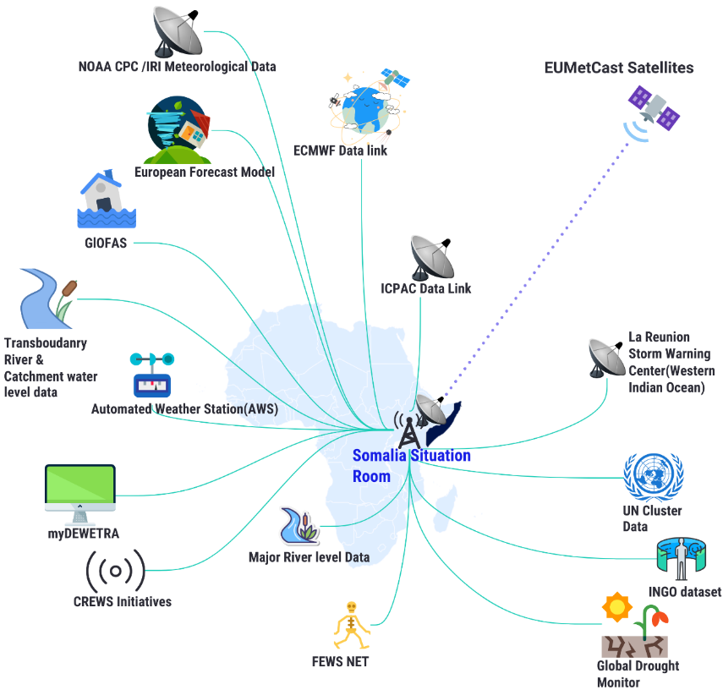
Figure 11: Proposed weather observation and monitoring network should illustrate the tools and components
Somalia needs to strengthen the weather observation and monitoring network, which is being proposed in Figure 11, to strengthen national observation, monitoring, and forecasting capabilities, including the end-to-end flow from surface and satellite observations through data management and analysis to forecasting and operational decision support.
Impact-based forecasting further requires a structured approach that combines hazard, exposure, and vulnerability information to identify risk and support informed decision-making. This may involve quantitative hazard-impact modeling to estimate likely impacts, complemented by structured interpretation based on the documented experience of emergency management stakeholders and observed impacts from past events.
Various reports indicate that Somalia’s current disaster risk monitoring and forecasting practice relies heavily on hydrometeorological data generated by multiple institutions, particularly FAO SWALIM, NMHEWC, and MoEWR, which remain the primary organizations supporting weather observation, monitoring, and forecasting functions for early warning purposes.
Impact-based forecasting requires a structured approach that integrates hazard, exposure, and vulnerability information to determine risk and support informed decision-making. Potential impacts can be assessed through quantitative hazard-impact models that describe the processes leading to loss and disruption, and through structured interpretation based on the documented experience of emergency management stakeholders and observed impacts from past events.
Available reports indicate that Somalia’s disaster risk monitoring and forecasting practices rely heavily on hydrometeorological information generated by multiple institutions, most notably FAO SWALIM, the National Multi-Hazard Early Warning Centre (NMHEWC), and the Ministry of Energy and Water Resources (MoEWR) as the primary actors providing weather observation, monitoring, and forecasting inputs for early warning purposes. It is also encouraging that Somalia has maintained cooperation with ICPAC as the regional climate services center, which can further strengthen national capacity to detect, monitor, and forecast hazards through access to regional products and technical collaboration.
To enable robust weather forecasting and an operational impact-based early warning system, Somalia must strengthen real-time monitoring systems for meteorological and hydrological conditions by automating existing stations and installing new automated stations, alongside institutional and regulatory measures. Priority actions include, but are not limited to:
- Improve real-time data transmission for flood monitoring by expanding the spatial coverage of hydrometeorological stations and upgrading the quality and timeliness of observations and data flows.
- Strengthen institutional collaboration and data integration among MoEWR, SoDMA/NMHEWC, and FAO SWALIM, and align national datasets with regional and global products through sustained cooperation with regional climate services and by leveraging EW4All and the Global Framework for Climate Services.
- Establish standardized data exchange protocols across organizations and administrative levels, including procedures for station data management, interoperability, and maintenance of accurate records to support real-time monitoring of meteorological and hydrological hazards.
- Enhance hydrometeorological service capacity for last-mile early warning delivery, including downscaling and tailoring forecasts, improving forecasting accuracy, and strengthening historical records of past events for calibration and verification.
- Leverage ongoing legal reform opportunities to establish norms, mandates, and institutional requirements that strengthen disaster monitoring, analysis, forecasting, and impact prediction tools and methods, including accountability for operations and maintenance and data continuity.

3.2.1 Pillar 2 Gap Identification: Observation, monitoring, analysis, and forecasting
Gaps have been identified through the previously organized Early Warnings for ALL inception workshops, national workshops, and stakeholder meetings. The following are the key indicate gaps being identified:

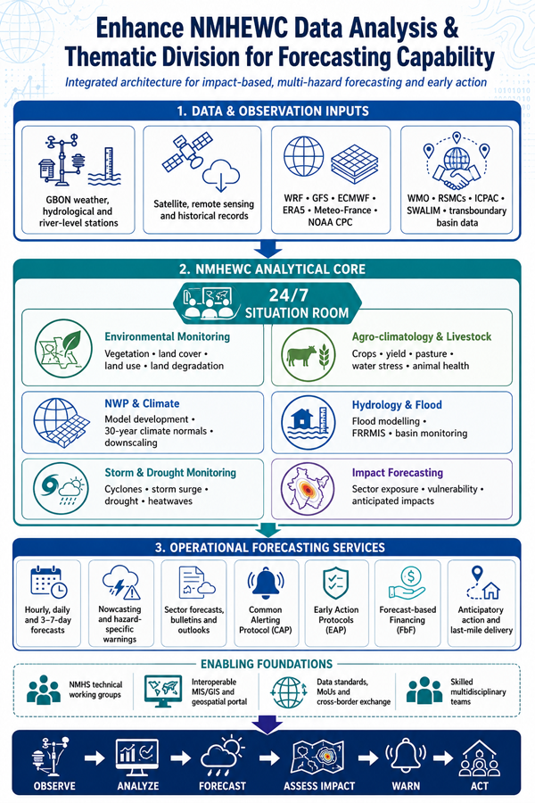

- Institutional, Systemic and operational capacity gaps in climate risk governance
Key Pillar 2 gaps were identified through EW4All inception workshops, national workshops, and stakeholder consultations. The most critical gaps relate to institutional, systemic, and operational capacity for climate risk governance, specifically:

    - Institutional, systemic, and operational capacity gaps in climate risk governance
- Weak enabling environment: Limited legal and policy frameworks and insufficient institutional mechanisms to support sustained observation, monitoring, analysis, and forecasting functions.
- Absence of a fully functional National Meteorological Agency (NMA): No full-fledged national meteorological institution is operational; parallel functions are undertaken on an ad hoc basis by a Hydromet Technical Working Group (TWG) with limited mandate, staffing, and capability.
- Limited sustainability of donor-supported investments: Inadequate inter-ministerial and sectoral mechanisms to mainstream, institutionalize, and finance externally supported interventions beyond project timeframes particularly for climate monitoring, risk assessment, and resilience-building.
- Operational weaknesses in station management and data workflows: Hydromet services are run ad hoc, with insufficient coordination and technical/operational support for station operations, observation parameter collection, data transmission, and quality assurance; overall institutional capacity (including NMHS-type organizational structures and staffing) remains limited.
- Insufficient warning service standards: The Ministry responsible for water resources provides some warnings, but coverage, timeliness, standardization, and operational protocols remain inadequate and do not meet the minimum expectations for EW4All implementation in Somalia.

- Inadequate weather observation over the land, surface, atmosphere, and ocean.
- Limited financial and technological capacity for NMHS establishment and operations: Somalia lacks adequate financing and technological resources to establish and sustain designated National Meteorological and Hydrological Services (NMHS) entities with clear mandates to monitor meteorological and hydrological conditions, generate downscaled forecasts, and issue standardized warnings for hydrometeorological hazards.
- Insufficient automation and real-time data acquisition capability: The observation network remains inadequately automated, with limited tools and operational processes to acquire real-time observation data. This is compounded by limited access to remote sensing datasets, weak data quality control systems, and insufficient monitoring capacity to support reliable forecasting and warning services..

- Inadequate capacity gap in surface and atmosphere observation and monitoring:

- Somalia’s ability to deliver reliable surface and atmospheric observation, monitoring, and operational forecasting is constrained by significant human-resource, systems, and coordination deficits. Key gaps include:
- Insufficient technical workforce: There is an inadequate pool of specialized experts, including forecasters, meteorologists, synoptic engineers, numerical weather prediction (NWP) experts, short-, medium-, and long-range forecasters, observation data analysts, GIS and remote sensing programmers, software engineers, data scientists, hydrologists, and flood modelers.
- Limited operational and maintenance capacity for observation networks: Technical expertise is insufficient for routine weather parameter reading (including manual observations where applicable), station operation, preventive maintenance, calibration, and hydrological runoff monitoring. Existing surface and terrestrial observation stations are often under-resourced, partially functional, or require upgrading and sustained maintenance support.
- Fragmented coordination and weak integration of external technical support: Coordination, collaboration, and harmonized approaches remain limited for capturing and integrating outputs from interventions implemented by INGOs, national NGOs, external R&D organizations, academia, and researchers. ICT-enabled collaboration mechanisms to consolidate and institutionalize these contributions are weak or absent.
- Inadequate ICT-enabled tools for climate risk governance and assessments: Government sector departments and local government levels lack fit-for-purpose ICT and geospatial tools, including MIS/GIS platforms and CRVA assessment toolkits (e.g., GIS basemaps at the lowest administrative levels, UAV/drone applications, mobile data-collection apps, survey tools, GPS devices, and crowdsourced data platforms) required for systematic climate risk governance.
- Weak capacity to collect and report disaster incidence and impact information: SoDMA, relevant actors, and local government have limited capacity to systematically collect disaster incidence data and provide timely situation updates with quantitative statistics on impacts, sector-specific loss and damage, affected area extent, and the number/type of exposed and impacted elements.
- Insufficient point-based observation and forecasting for critical exposed assets: Observation density and analytical capability are inadequate to support localized, point-based monitoring and forecasting for high-value and sensitive elements such as settlements and urban centres, municipalities, functional marketplaces, cropland, and essential utility and service infrastructure..

- Inadequate river level observation and hydro-meteorological data acquisition from the transboundary hydtomet network and flood forecasting and early warning:
- Somalia’s flood forecasting and early warning capacity particularly for the Shabelle and Juba river systems is constrained by limited transboundary data access and weak river monitoring infrastructure. Key gaps include:
- Insufficient transboundary data-sharing agreements and operational coordination: Functional arrangements with upstream/transboundary countries (notably Ethiopia and Kenya) remain inadequate for routine sharing of meteorological parameters and hydrological basin data required to generate reliable, real-time flood forecasts and warnings for the Shabelle, Juba, and other relevant basins. The consequences of this gap are significant; for example, the 2019 Shabelle River floods reportedly displaced approximately 500,000 people and damaged extensive cropland, illustrating the importance of upstream data for anticipatory action.
- Inadequate hazard monitoring infrastructure for transboundary risks: There is limited monitoring capacity and infrastructure to support systematic tracking of transboundary and cross-regional multi-hazards, including floods, cyclones, landslides, droughts, epidemics/pandemics, and other relevant geological hazards. The absence of an integrated monitoring network and shared operational protocols weakens early warning lead time, forecast accuracy, and coordinated response planning

- Lack of data gathering on public health, diseases, and outbreaks:

Somalia’s multi-hazard early warning capacity is limited by gaps in the systematic collection and sharing of public health, disease, and outbreak data, particularly for health impacts triggered or amplified by extreme weather events. Key gaps include:
- Poor coordination of data exchange on weather-related health impacts: Information sharing on public health fatalities and morbidity linked to extreme events is not consistently coordinated, despite increasing risks of waterborne and vector-borne diseases such as cholera and malaria following floods, drought-related water scarcity, and disruptions to WASH and health services.
- Fragmented health data ecosystem led by multiple actors: The sector data and information-sharing network for acquiring datasets from health service providers is dispersed across both state and non-state actors including sector departments, INGOs/CSOs, and private-sector providers, without a unified, interoperable mechanism for routine aggregation, standardization, and use for early warning and anticipatory action.

- Hybrid weather observation gap for providing nowcasting and event situation updates for rapid onset hazards

Somalia lacks a sufficiently integrated hybrid observation capability combining surface-based instruments, remote sensing, and real-time reporting to support reliable nowcasting and near-real-time situation updates for rapid-onset hazards. Key gaps include:
- Insufficient near-real-time observation coverage: Limited density and automation of surface observations, combined with weak telemetry and station uptime, reduces the ability to detect and track fast-evolving events (e.g., flash floods, severe storms, strong winds).
- Limited integration of satellite, radar-equivalent products, and ground truthing: Constraints in routinely acquiring and operationally integrating satellite-based products and ground observations prevent the production of timely nowcasts and event monitoring updates.
- Weak event situational awareness workflows: There are limited standard operating procedures, tools, and staffing to produce rapid event situation reports (what is happening now, where, and who/what is affected) and to update warnings as conditions evolve.
- Limited community and partner reporting channels: Mechanisms to integrate field observations and crowdsourced reports (from local authorities, volunteers, private sector operators, and humanitarian partners) into the NMHEWC Situation Room are underdeveloped, limiting real-time confirmation and impact reporting.

- Inadequate Observation & Monitoring of the Environmental sector:
Somalia’s ability to monitor environmental conditions and climate-related degradation is constrained by limited access to and coverage of terrestrial and ecosystem monitoring systems. Key gaps include:
- Limited terrestrial and ecosystem monitoring networks: Insufficient accessibility to, and functionality of, monitoring networks needed to track degradation of the built environment and natural resources, including land and rangeland condition, soil and vegetation health, and ecosystem stress.
- Weak aquatic and marine monitoring capacity: Limited systems to monitor aquatic and marine biodiversity and coastal ecosystem dynamics, constraining the ability to detect and respond to climate- and hazard-driven impacts along Somalia’s extensive coastline.
- Insufficient agroecology and hydrological impact monitoring: Gaps in agroecological monitoring (crop condition, rangeland productivity, land degradation indicators) and inadequate surface hydrological impact monitoring networks reduce the evidence base for drought/flood risk assessment, environmental early warning, and impact-based decision support.
- Inadequate Observation & Monitoring of the Agricultural sector:
Somalia’s capacity to monitor agricultural conditions and climate impacts remains limited, reducing the ability to anticipate and manage drought, flood, heat, and other weather-related risks affecting food systems and livelihoods. Key gaps include:
Insufficient use of remote sensing and weak ground-truthing: Remote-sensing data are not used systematically, and surface observation networks for agriculture are inadequate to monitor crop conditions and agroecological dynamics. This constrains monitoring of soil health degradation, agroforestry systems, land and rangeland condition, land-cover change, and desertification processes, as well as the onset and evolution of agricultural drought (including flash drought), prolonged drought, and water stress.
- Limited integrated monitoring of crop and hazard stressors: Current monitoring is insufficient to reliably track critical agricultural risk indicators, including crop performance, pest manifestations, hydrological and meteorological drought conditions, dry spells, shrinking and drying of perennial water bodies, groundwater depletion, inoperable boreholes, heatwaves, high winds, windstorms, sandstorms, hailstorms, rapidly developing thunderstorms and intense rainfall, and progressive soil degradation.
- Inadequate Observation & Monitoring of the Livestock sector:
- Insufficient hybrid observation and monitoring capacity for the livestock sector: Somalia’s large livestock economy estimated at roughly 56.9 million head (about 1.0M camels, 5.3M cattle, 30.9M goats, and 13.6M sheep) is increasingly affected by climate variability and extreme weather at the local level, resulting in significant livestock mortality and productivity losses. Monitoring of animal health impacts linked to hazards such as heatwaves, dry spells, dust storms, drought, and flooding remains inadequate.
- Limited ICT-enabled rangeland and pasture monitoring for livestock early warning: The use of ICT and geospatial tools (e.g., GIS-based monitoring, Kobo/other digital survey platforms, GPS-enabled data collection, and georeferenced herder/herd databases) is insufficient to systematically track pasture and rangeland condition, pasture health and carrying capacity, grazing patterns, forage production, agricultural residue availability, and pasture yield loss thereby constraining the development and dissemination of timely livestock-sector early warning products.
- Underutilization of livestock disease surveillance and alert systems: Existing animal health information platforms such as FAO’s GLEWS, the Animal Disease Information System (ADIS), and the World Animal Health Information System (WAHIS) are not yet utilized or integrated sufficiently to support routine alerting and decision support for the livestock sector.
- Limited climate-risk-informed livestock value chain resilience measures: Climate risk-informed planning and “climate-proofing” of local livestock value chain processes remain inadequate, limiting opportunities to protect and strengthen rural livelihoods under increasing climate stress.
- Inadequate disaster risk governance system:

- Weak enabling legal and policy framework for NMHS and MHEWS delivery: Legislative and regulatory frameworks are insufficient to mandate designated organizations (e.g., NMHS-type entities) to monitor, forecast, and issue warnings for hydrometeorological hazards. Where legislation exists, it often does not define clear roles and responsibilities across all institutions involved in the national MHEWS, nor does it institutionalize systematic inter-agency data exchange protocols. These gaps are compounded by weak governance mechanisms and limited financial and technological capacity.
- Inadequate local disaster risk governance and operational management systems: Local-level systems for hazard and disaster monitoring, warning and public alerting, hotspot tracking, and incident reporting are underdeveloped, limiting timely situational awareness and decision-making.
- Absence of standard operating procedures (SOPs): There is a lack of standardized SOPs governing observation, forecasting, warning issuance, information-sharing, event escalation, and coordination across actors and administrative levels.
- Insufficient SoDMA institutional setup and operational networks: SoDMA’s operational capacity remains constrained by the absence of a structured multi-hazard incident reporting and hotspot tracking network and limited event-based situation reporting mechanisms.
- Limited domestic financing for DRM: A dedicated national budget line for disaster risk management actions is lacking or insufficient, undermining the sustainability of observation networks, early warning services, and preparedness measures.
- Data limitations and underutilization: Available information is often incomplete, not timely, or not routinely applied for planning and operational decision-making.
- Weak integration and coordination across actors: Coordination arrangements and interoperability between institutions and partners are insufficient, resulting in parallel systems and fragmented service delivery.
- Insufficient community empowerment: Community-level mechanisms and capacities to engage in risk monitoring, receive and interpret warnings, and implement early actions are limited.
- Unclear institutional roles and responsibilities: Mandates and accountability across institutions, from national to local, are not consistently defined or operationalized, creating gaps and duplication in MHEWS functions.

3.2.2 Step forward to close the inactive gaps on Pillar 2 : Observation, monitoring, analysis, and forecasting

To address the gaps identified above and advance the installation and activation of a robust national weather observation and monitoring system, strengthening forecasting and meteorological data analysis, and enhancing SoDMA-NMHEWC capacity to deliver demand-driven forecasting in Somalia, the following interrelated core actions have been identified for implementation by 2027, with consolidation and scale-up through 2030:

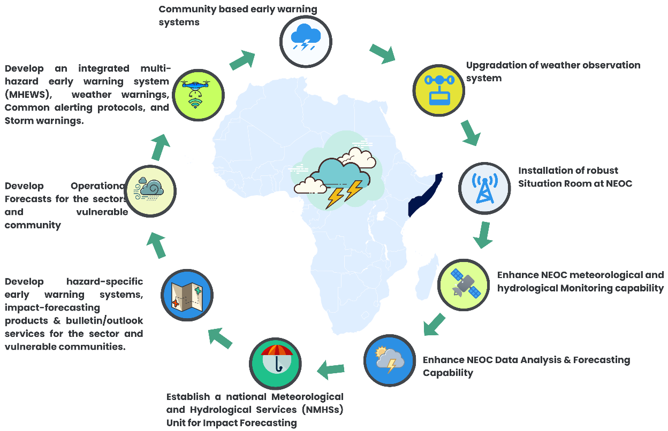
Figure 12: Step forward to close the inactive gaps on Pillar 2
  - Upgradation of the weather observation system

    - Conduct Country Hydro-met Diagnostics (CHD) assessments, determine the geographically positioned number of basic surface observation stations and automatic weather stations (synoptic capability) for acquiring Essential Climate Variables (ECVs) and atmospheric observation, telemetry, river level monitoring, and sea-surface observation, and develop a strategy for system upgradation.
    - Upgrading existing manual observation stations and installing basic Global Basic Observing Network (GBON) quality observation infrastructure for quality and Iridium satellite data transmission facilities for redundant data acquisition.
    - WMO needs to conduct an assessment of the operational status of all installed Hydro-met observation stations in Somalia and identify GBON (Global Basic Observing Network) standard, operational capacity, and type of instruments installed for the kinds of weather parameters data acquisition, review the sitting classification for the surface observations on stations on land, procedure for updating the guide to instruments and methods of observation, etc., and provide the necessary technical assistance and diagnostic reports for upgrading stations to GBON standards.
    - Develop a GBON compliance National observation network development plan with budgets based on the Somalian landscape, arid climatology, landcover types, and elongated vast sea proximity context, determine to identify and address type of observation, forecast model, impact-based forecasting, climate and hydrometeorological outlooks are being required for Somalia and close the service delivery capacity gaps for priority hazards, such as heatwaves, floods, tropical cyclones, persistent and flash droughts etc.,
    - Review: FAO-SWALIM installed 140(some of the Ministry of Agriculture of MoEWR) out of some of the manual met stations, and most of them did not send met data. UNDP 40 stations belong to MoEWR / FAO-SWALIM for maintenance, relying on the UNDP installed by the Nigerian Met Agency
    - Upgrade all manual weather stations (140) to automatic weather stations (AWS) with GBON standards.
    - Establish linkage with the WMO regional specialized meteorological centers (RMC).
    - Establish linkage with regional and transboundary NMHS organizations/networks.
    - Provisioning long-term operational budgets of the National Meteorological and Hydrological Services (NMHSs)
    - Installation of real-time satellite-based atmosphere observation systems, Preparation for the Use of Meteo-sat in Africa (PUMA) 2025 satellite links (EUMETCast, ECMWF, European Met services, NOAA, Indian Ocean network, The Regional Basic Climatological Network (RBCN), Global Terrestrial Network - Rivers (GTN-R), etc. for the acquisition of Basic Hydro-Meteorological Data (BMD).
  - Installation of a robust Situation Room at NMHEWC/MHEWC:
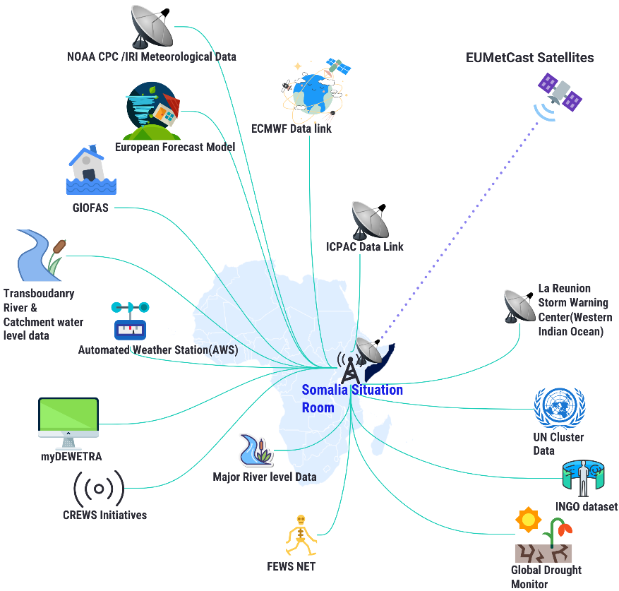
    - Enhance the capacity of the land, surface, satellite-based atmospheric observation, and ocean surface network with a situation room for weather observation, monitoring, and improving the multi-hazard early warning whole value chain deliverability capability.
    - Linking Preparation for the Use of Meteosat in Africa (PUMA) 2025 satellite links (EUMETCast, ECMWF, European Met services, NOAA CPC/IRI/netCDF data , Indian Ocean La Reunion TWC network, The Regional Basic Climatological Network (RBCN), Global Terrestrial Network - Rivers (GTN-R). etc., for the acquisition of Basic Hydro-Meteorological Data (BMD).
    - Anchor CREWS Initiatives forecasting facility with the Situation Room
    - Anchor CIMA Research Foundation Developed myDEWETRA for forecast preparation and impact forecast analysis.
    - Anchor RIMES forecasting services with situation room
  - Anchor FEWSNET, Global Drought Monitor
  - Anchor UNOCHA INFORM tools FAO-SWALIM, IOM-DTM (Displacement Tracking matrix), UNHCR(Operational data portal), WFP( Food Security ), WFP Logistic network/telecommunication system, WASH Cluster database, CREWS Initiative, ICPAC forecast/outlook, UNICEF Education Cluster Database, UNICEF-MICS, World Bank ( GFDRR, Databank), UNOCHA -INFORM, Food Security and Analysis Unit (FSNAU) & IDEA of FAO, IFRC-Anticipatory Hub, USAID-FEWSNET, etc., for input device for impact forecast production support.
  - Enhance NMHEWC meteorological and hydrological Monitoring capability:

    - Installation of high-performance computing (HPC) for data calibration, collation, and analysis. The creation and maintenance of climate data repositories, short-range forecast model running, need-based data customization, operational forecasting, etc.
    - MoU with regional early warning network, data and technology exchange, transboundary advocacy and action, tripartite agreements for data exchange, etc.
    - Enhanced NMHEWC/NMHS capacity and expanded climate monitoring network.
    - Enhance NMHEWC capacity in Climate System Monitoring, Climate Change Detection and Attribution, Climate Research, Operational Climate Prediction, Impacts, Vulnerability and Adaptation, Climate Applications and Services,
    - Installation of thematic Divisions at NMHEWC to improve the Forecasting System and Institutional Capacity.
  - Enhance NMHEWC Data Analysis & Thematic Division for Forecasting Capability

    - Establish Environmental Monitoring Division: Vegetation, land cover, land use, land degradation.
    - Establish Agro-climatology Division. Develop an operational forecast for agroclimatic and weather impacts on standing crops/yield, etc.
    - Establish forecasting division: Establish a forecasting team and develop capacity in forecast product development. Development of hourly forecast, daily forecast, 3-day, 4-day, 5-day, and 7-day forecast, developing sector-specific operational forecasts, developing weather warning and nowcasting service, developing standard alerting protocol (CAP), developing forecast-based early action protocol (EAP), developing forecast-based anticipatory action.
    - Establish Numerical Weather Prediction (NWP) & Climate Division: Develop a meteorological model and climate norms for 30 years.
    - Establish impact forecasting Division: Develop impact forecasts for the sector (Agriculture, livestock, water resource, crop and yield, agroforestry, rangeland and pasture, water stress, environment, and natural resources, food security and famine, WASH, health, diseases and outbreaks, human settlements).
    - Develop a forecast-based financing (FbF) protocol for the sector to mobilize ex-ante and ex-post finance for climate adaptation and resilience building.
    - Establish Flood Forecasting and Warning Center (FFWC) : Data linkage with transboundary basin database system
    - Establish storm monitoring and warning center: Establish data linkage with the National Storm Warning Center (SWC), enhance storm monitoring capacity, and link with the La Reunion storm warning center.
    - Establish Famine Early Warning Division: Anchor FEWS NET at NMHEWC
    - Establish a drought monitoring system: Anchor global and regional drought monitoring systems.
    - Establish Livestock monitoring division: Link headers/nomads with mobile apps to enable them to fetch information on livestock updates/disease and outbreaks, fodder/pasture crises, water crises, animal health, etc. Anchor Livestock Disease Surveillance and Information Systems (FAO GEWS), Animal Disease Information System (ADIS), and World Animal Health Information System (WAHIS) for alerting the livestock sector.
    - Develop and access global forecasting dataset models for forecast preparation: Weather Research and Forecasting (WRF), Global Forecast System (GFS), European Centre for Medium-Range Weather Forecasts (ECMWF) , Meteo France, NOAA CPC, Other European forecast models
    - Accessing ECMWF real-time forecast data, ‎ECMWF Reanalysis v5 (ERA5) data sets, weather charts, synoptic charts, and short & extended-range forecast data for forecast preparation.
    - Establish data linkage with WMO programs and initiatives (such as the Tropical Cyclone Programme, Severe Weather Forecasting Programme, and Flood Forecasting Guidance System), RSMCs to access advisories on severe weather and specific hazards affecting the countries and territories in their region.
    - Enhancing NMHS capacity for RSMC hazard advisories and guidance bolsters the need to expand these programs' geographical coverage and the range of hazard products provided to foster EWS capacity of priority hazards.
    - Deploying FAO SWALIM’s Flood Risk and Response Management Information System (FRRMIS) for flood monitoring, information sharing and dissemination in NMHEWC. Flood monitoring in the basin has been improved through SWALIM’s FRRMIS for flood monitoring, information sharing, and dissemination.

  - Establish a national Meteorological and Hydrological Services (NMHSs) Unit at NMHEWC and develop impact-forecasting and bulletin/outlook services:

    - Establish NMHS Division at NMHEWC: Establish TWGs with hydrological, water resource engineer, geographer, geologist, hydrologist, meteorologist, flood modeler, synoptic engineer, etc., for hydrological and meteorological forecast model development.
    - Develop a forecast-based financing (FbF) protocol for the sector to mobilize ex-ante and ex-post finance for climate adaptation and resilience building.
    - Review the data collation, calibration, process capacity, and capacity gaps and develop recommendations on improving capacity, technology, tools, processes, forecasting product development, bulletin, and outlook development.
    - Installation of GBON-compliant integrated hydrological, river level data, weather observation stations, and the real-time monitoring of meteorological and hydrological hazards.
    - Strengthening data sharing functional linkage through an agreed MoU with IGAD -ICPAC
    - Upgrading/transforming SWALIM coordinated the hydrometer technical working group(TWG) to an independent NMHS division at SoDMA-NMHEWC.
    - Enhance the capacity of technical experts of climate-vulnerable sector departments (Agriculture, livestock, Fisheries, Marine Resources, water, WASH, Transport, Health, Education, settlements, transport, and communication, etc.) on GIS-based impact analysis of forecasted impending extreme weather and analysis of the anticipatory impacts of multi-hazards that are likely to be impending.
    - Develop a standard and protocol for data exchange procedures among different organizations at multiple levels. Harmonize and integrate with the Global Framework for Climate Services.
    - Enhance NMHEWC weather and climate forecasting and hydrometeorological services and boost early warning and early action services based on existing weather and climate forecasts. This includes downscaling and customizing estimates , improving forecasting accuracy, and historical records of past events linkages between climate forecasting information services and emergency coordination centers.
    - Establishment of a national disaster database and information-sharing mechanisms.
    - The systematization of cross-boundary data-sharing mechanisms and monitoring services, including a closer link to the Intergovernmental Authority on Development (IGAD) and the African Union (AU).
    - Establish End-to-end coordination and collaboration on the warning, data monitoring, sharing, and forecasting process.
    - Capacity-building training for hydrologists and engineers to build the necessary human resources capacity to develop and operate future forecasting systems.

  - Develop a hazard-specific (major hazards) early warning system, impact-forecasting products, and bulletin/outlook services for the sector and vulnerable communities.

    - Develop a Daily, hourly, daily 3-days, 4-day, 5-days, and 7-days forecast
    - Develop sector-specific operational forecasts (productive sectors e.g., Agriculture, livestock, Fisheries and Marine Resources, water, WASH, Transport, Health, Education, settlements, transport, and communication, etc.)
    - Develop weather warning and nowcasting service, developing common alerting protocol (CAP), developing forecast-based early action protocol (EAP), and developing forecast-based anticipatory action.
    - Develop impact forecasts for the sector (Agriculture, livestock, water resources, crop and yield, agroforestry, rangeland and pasture, water stress, environment and natural resources, food security and famine, WASH, health, diseases and outbreaks, human settlements).
    - Develop a forecast-based financing (FbF) protocol for the sector to mobilize ex-ante and ex-post finance for climate adaptation and resilience building.
    - Develop flood forecasting and warnings for vulnerable sectors, communities, and elements.
    - Develop cyclone and storm surge early warning.
    - Develop the Famine early warning and anticipatory action protocol.
    - Develop drought, water stress, heatwave, early warning, and anticipatory action protocol.
    - Develop an impact forecast/operational forecast for Livestock (diseases/outbreak)

  - Develop Operational Forecasts for the sectors.

    - Develop much-needed operational forecasts for the livestock, Crop, and Agriculture sectors, the fisheries (Marine and inland) sector, the food security sector, the infrastructure and basic service delivery sector, the housing and settlement sectors, the livelihood sector, and the water sector, among others.

  - Develop an integrated multi-hazard early warning system (MHEWS) for rapid-onset multi-hazards, such as weather warnings, Common alerting protocols, and Storm warnings.
    - Develop an integrated multi-hazard early warning system (MHEWS) protocol for rapid-onset multi-hazards, such as weather warnings, Common alerting protocols, and Storm prediction from the hybrid observation.
    - Anchoring FAO-SWALIM, IOM-DTM (Displacement Tracking matrix), UNHCR Operational data portal, WFP( Food Security ), WFP Logistic network/telecommunication system, WASH Cluster database, CREWS Initiative, CIMA Research Foundation myDEWETRA, ICPAC forecast/outlook, Education Cluster Database, UNICEF-MICS, World Bank ( GFDRR, Databank), UNOCHA -INFROM, Food Security and Analysis Unit (FSNAU) & IDEA of FAO, IFRC-Anticipatory Hub, USAID-FEWSNET, Greater Horn of Africa Climate Outlook Forum (GHACOF)etc., for feeding information in integrated multi-hazard early warning system (MHEWS & impact forecasting support.
    - Enhance SWALIM’s Flood Risk and Response Management Information System (FRRMIS) for flood monitoring, information sharing, and dissemination.
    - Develop a standard and protocol for data exchange procedures among organizations at multiple levels. This includes developing a network of weather stations and maintaining accurate data records to enhance real-time monitoring of meteorological and hydrological hazards.
    - Enhancing the capacity of hydrometeorological services to boost early warning services so they reach the last mile based on existing weather and climate forecasts. This may include downscaling and customizing forecasts, as well as improving the accuracy of forecasting, by leveraging historical records of past events.
    - Formulate methodological framework and establish SoP for improving disaster monitoring, analysis, forecasting, and impact prediction tools and methods.
    - Interface design with Geospatial portal to anchor UN-Agency & INGO running MIS/GIS repository/attribute datasets, disaggregated datasets for impact forecasting, and tailor-made climate risk-informed tools development to support sectoral planning.
    - Enhance the Situation Room of Situation room at National Multi-Hazard Early Warning Centre (NMHEWC). to develop integrated impact forecasting, weather warning, alerting, and a dashboard of the integrated multi-hazard early warning system (MHEWS) as a center of excellence for robust NMHEWC round-the-clock operational mundi.
    - Enhance the capacity of the impact-forecasting division to develop impact forecasts for the climate-vulnerable sectors, develop climate risk-informed tailored tools to support local-level climate sectoral planning, provide thematic planning support for NAP, NDC, and NbS localization, and support sector/livelihood in risk-informed DRR, CCA, and NbS scheme design and implementation.

3.2.3 Proposed Roadmap for Pillar 2 : Observation, monitoring, analysis, and forecasting

Goal: By 2027/2030, the capacity for weather observation, climate monitoring, impact forecasting of prioritized hazards, and analysis of their potential impacts is enhanced and optimized, upgrading existing hydro-met observations and deploying robust technologies, tools, and global weather information systems.
Policy Goal: Establish an enabling policy and institutional setting to strengthen national capacity for observation, monitoring, analysis, and forecasting, while improving sectoral coordination and accountability for climate monitoring and early warning governance.
Programmatic Goal: Strengthened institutional programmatic capacity in installing high-density weather observation, hazard, and climate monitoring and prediction, numerical weather prediction (NWP), short-range forecast modeling, and weather impact forecasting for the sector and community level.
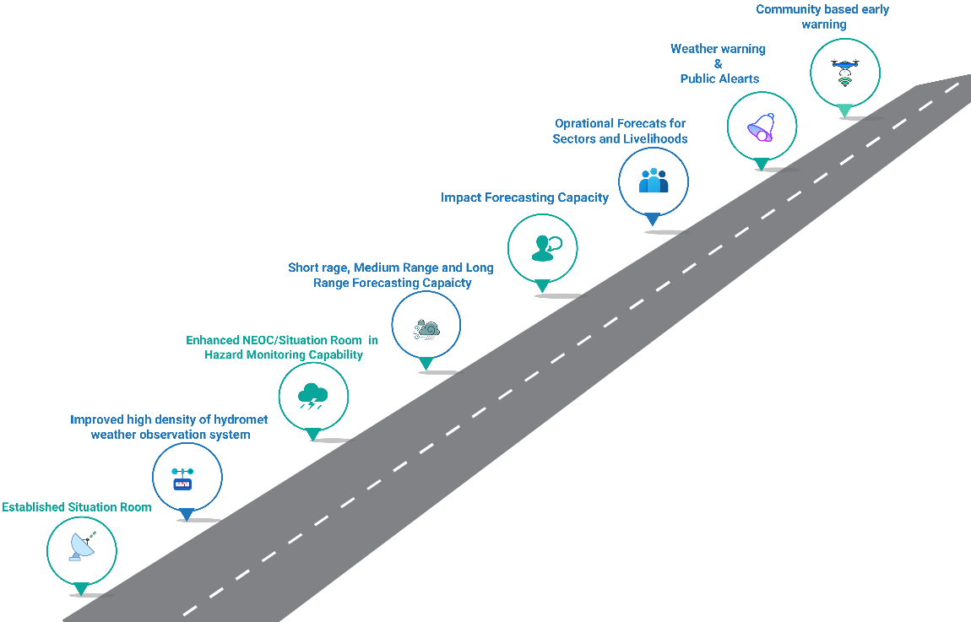
Figure 13: Proposed Roadmap for Pillar 2

Roadmap & Outcome
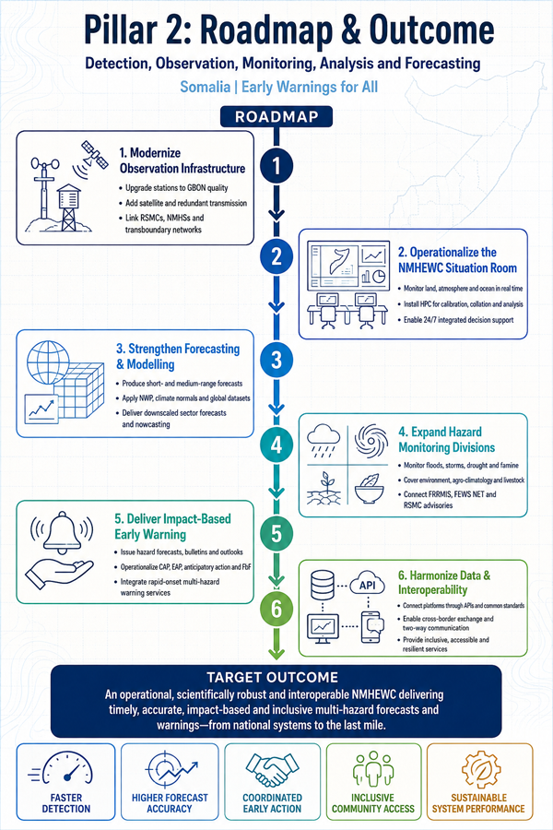
  - Improved high-density of hydro-met weather observation system

    - Upgraded existing manual observation stations and installed of basic Global Basic Observing Network (GBON) quality observation infrastructure for quality and Iridium satellite data transmission facilities for redundant data acquisition.
    - Established data linkage with the WMO regional specialized meteorological centers (RSMC).
    - Established data linkages with regional and transboundary NMHS organizations/networks.
    - Established real-time satellite-based atmospheric observation systems, installations of PUMA (Preparation for the Use of Meteosat in Africa) 2025 satellite links (EUMETCast, ECMWF, European Met services, NOAA, Indian Ocean network, The Regional Basic Climatological Network (RBCN ), Global Terrestrial Network - Rivers (GTN-R), etc., for the acquisition of Basic Hydro-Meteorological Data (BMD).
    - Strengthened institutional capacity in harmonizing long-term operational budgets of the National Meteorological and Hydrological Services (NMHSs)
1.2 Robust Situation Room at NMHEWC installed and operational:

    - Enhanced SoDMA, MoEWR, NCA institutional capacity in installing and operationalizing the national Situation Room and acquisition of the datasets land surface, satellite-based atmospheric observation, and ocean surface) network with a situation room for weather observation, monitoring, and improving the multi-hazard early warning whole value chain deliverability capability. Developing a forecast-based early action protocol (EAP), developing a forecast-based anticipatory action.

  - Enhanced NMHEWC /NMHEWC/Situation Room capacity in meteorological, hydrological Monitoring and forecasting

    - Installed high-performance computing (HPC) for data calibration, collation, and analysis.
    - Enhanced capacity of forecasting division in weather parameter climate data repositories, short-range forecast model running, need-based data customization, operational forecasting, etc.
    - Agreed consensus with climate monitoring network, regional early warning network, data and technology exchange protocol, transboundary river level and catchment data, tripartite agreements for data exchange, etc.
    - Enhanced NMHEWC capacity in Climate System Monitoring, Climate Change Detection and Attribution, Climate Research, Operational Climate Prediction, Impacts, Vulnerability and Adaptation, Climate Applications and Services,
    - Installed thematic Divisions at NMHEWC to improve the Forecasting System and Institutional Capacity. Establish impact forecasting Division: Establish Flood Forecasting and Warning Center (FFWC): Data linkage with the transboundary basin database system, Establish storm monitoring and warning center, Establish Famine Early Warning division, Anchored FEWS NET at NMHEWC , Established drought monitoring system, Anchored global and regional drought monitoring system, Established Livestock monitoring division
    - Established a functional forecasting division and enhanced national forecasting capacity in short- and medium-range forecasts, developing sector-specific operational forecasts, developing weather warning and nowcasting service, developing common alerting protocol (CAP), Established Numerical Weather Prediction (NWP) & Climate Division: Developed a meteorological model and climate norms for 30 years.
    - Develop and access global forecasting dataset models for forecast preparation: Weather Research and Forecasting (WRF), Global Forecast System (GFS), European Centre for Medium-Range Weather Forecasts (ECMWF), Meteo France, NOAA CPC, Other European forecast models
    - ECMWF real-time forecast data - ‎ECMWF Reanalysis v5 (ERA5) data sets, weather charts, synoptic charts, and short & extended-range forecast data for forecast accessed for forecast manufacturing.

  - Enhanced NMHEWC in Hazard Monitoring Capability

    - Established data linkage with WMO programs and initiatives (such as the Tropical Cyclone Programme, Severe Weather Forecasting Programme, and Flood Forecasting Guidance System), RSMCs to access advisories on severe weather and specific hazards affecting the countries and territories in their region.
    - Established data linkage with the Western Indian Ocean Storm Warning Center at La Reunion, enhanced storm monitoring capacity and warning.
    - Anchored RSMC hazard advisories and guidance bolsters the need to expand these programs' geographical coverage and the range of hazard products to foster EWS capacity of priority hazards.
    - FAO SWALIM’s Flood Risk and Response Management Information System (FRRMIS) was deployed for flood monitoring, information sharing, and dissemination in NMHEWC . Flood monitoring in the basin has been improved through SWALIM’s FRRMIS for flood monitoring, information sharing, and dissemination.
    - Established Environmental Monitoring Division: Vegetation, land cover, land use, land degradation.
    - Established Agro-climatology Division and operational forecast for agroclimatic and weather impacts on standing crops/yield, etc.

  - Established a national Meteorological and Hydrological Services (NMHSs) Unit at NMHEWC and impact forecasting and bulletin/outlook services supported risk-informed anticipatory action:

    - Established NMHS Division at NMHEWC
    - Develop an integrated multi-hazard early warning system (MHEWS) for rapid-onset multi-hazards, such as weather warnings, Common alerting protocols, and Storm warnings.
    - Enhanced capacity in early action protocol development
    - Enhanced capacity in forecast-based anticipatory action planning.
    - Enhanced capacity in forecast-based financing (FbF) protocol developed for the sector, ex-ante and ex-post finance mobilized for climate adaptation and resilience building.
    - Enhanced NMHEWC capacity and Developed hazard-specific (significant hazard) early warning system, impact-forecasting products, and bulletin/outlook services for the sector and vulnerable communities.
    - Develop an integrated multi-hazard early warning system (MHEWS) protocol for rapid-onset multi-hazards, such as weather warnings, Common alerting protocols, and Storm prediction from the hybrid observation.

  - Strengthened institutional capacity in early warning data collection, analysis, and exchange modalities among federal line ministries/ sectorial offices and regional bodies has been harmonized.

    - Key agencies' capacities for detection, monitoring, analysis, and forecasting were mapped, data sharing was completed, and the enhanced capacity of actors and the forecast value chain improved.
    - The GIS maps and risk atlases developed by the UN Agency, INGOs, and sector departments are linked with situation room geospatial platforms through the application programming interface (API).
    - EUMETCast satellite consortium weather forecast domain PUMA installed, weather and meteorological Detection, Monitoring, Analysis, and Forecasting of the robust and comprehensive legal framework is established.
    - Data-sharing strategies and protocols with the regional meteorological center, NMHS organizations, and Forecasting forum are established.
    - The Existing federal hydro met EWS technical working group was strengthened (federal inter-ministerial EWS, disaster management council, and regional governments' early warning platforms were guaranteed to be reconstituted).
    - Enhanced capacity building for all subjects involved in forecasting and monitoring issues is guaranteed.
    - Monitoring standardized tools and networks reviewed and enhanced, improving tracking of all national priority hazards.
    - WMO tools and standards are adopted for data /information coordination, an exchange mechanism consensus is established, and an online system is designed to ensure data transmission and distribution facilities.
    - NMHEWC/Situation room is linked with a transboundary observation network for real-time hydrometeorological data acquisition.
    - The Interactive Voice Response (IVR) system is strengthened,
    - Automation and customizing the message for sectors involving conflict data are in place. Available global datasets for monitoring are utilized, and they assist in modeling/identifying hotspots.

  - Early warning data automation, modeling, and forecasting among sectoral offices were harmonized and improved.

    - Technology-based hydrometeorological data services, including grassroots meteorological services, are established/improved and made available to the public.
    - Hydro-metrological data and metadata are available for validation, research, and other purposes.
    - Existing hydro-meteorological monitoring/forecast tools (including real-time stations) with a better resolution are in place and made available for users.
    - Model outputs are calibrated and validated, and data analysis and processing, modeling, prediction, warning generation, and dissemination are all based on accepted scientific and technical methodologies and protocols.
    - A Forecast-based model for riverine/flash flood monitoring and forecasting is available and accessible.
    - The Interactive Voice Response (IVR) system is strengthened, and the central digital platform is linked through the application programming interface (API) from sectoral offices.
    - Automation and customizing the message for sectors involving conflict data are in place. Available global datasets for monitoring are utilized, and they assist in modeling/identifying hotspots.
    - An agreed threshold is in place for analyzing the occurrence of hazards, such as composite/overlay analysis.

  - Early warning information exchange and interoperability among early warning sectors improved.

    - Systems for warning and forecast archiving are in place for all priority hazards.
    - Two-way communication mechanisms for early warning data producers and inter- and intra-sectoral information exchange improved.
    - Early warning data collection and analysis are gender sensitive and inclusive of socially vulnerable groups (children, people with disability, and older people).
    - Early warning information and guidance are easily accessible and understandable to all community members, including those with low literacy or limited digital access.
    - Establish robust data-sharing protocols and communication channels between agencies and countries to facilitate swift response coordination.
    - Simulation exercises and drills are regularly conducted to test the effectiveness of early warning systems and response plans.
    - Enhance public awareness and education campaigns to empower communities with the knowledge and skills to prepare for and mitigate emergencies.
    - Sustainable financing mechanisms are in place to support the long-term operation and maintenance of early warning systems.
    - Foster collaboration and knowledge exchange between scientific institutions, government agencies, private sectors, and stakeholders.
    - Early warning systems incorporate traditional and indigenous knowledge, practices, and communication channels.
    - Develop specialized training programs for personnel responsible for monitoring, analyzing, and acting on early warning signals.
    - Ensure redundancy and resilience in critical communication and infrastructure networks to maintain operability during crises.
    - Early warning systems are supported by comprehensive monitoring, evaluation, and learning (MEL) frameworks support early warning systems.
    - Early warning systems are aligned with and contribute to regional and global early warning initiatives and frameworks.
    - Early warning systems are underpinned by robust and regularly updated risk assessments and hazard mapping.
    - Development and implementation of standardized protocols for data sharing and interoperability.
    - Early warning systems are designed to be equitable, inclusive, and responsive to the diverse needs of the population

3.2.4 Work Plan for Pillar 2 : Observation, monitoring, analysis, and forecasting
SL | Milestone | Timeline |  |  |  |  |  |  |  |  |  |  |  |  |  |  |  |  |  |  |  |  |  |  |  |  | Responsibility |  | Budget  USD / LCU | Budget  Source
 |  | 20  24 | 2025 |  |  |  | 2026 |  |  |  | 2027 |  |  |  | 2028 |  |  |  | 2029 |  |  |  | 2030 |  |  |  | Lead | Support
 |  | Q4 | Q1 | Q2 | Q3 | Q4 | Q1 | Q2 | Q3 | Q4 | Q1 | Q2 | Q3 | Q4 | Q1 | Q2 | Q3 | Q4 | Q1 | Q2 | Q3 | Q4 | Q1 | Q2 | Q3 | Q4
 | Installed & operational robust Automatic Weather System (AWS) complying with Global Basic Observing Network (GBON) standards |  |  |  |  |  |  |  |  |  |  |  |  |  |  |  |  |  |  |  |  |  |  |  |  |  | SoDMA, UDNRR  WMO, | MoEWR , FAO-SWALIM, ICPAC, Sector ministry & Department, TWG hdyromet service, Civil Aviation |  | UNDRR, UNDP, GCF, SIDA, ECHO, DIFD, USAID
 | Established & functional Situation Room at NMHEWC |  |  |  |  |  |  |  |  |  |  |  |  |  |  |  |  |  |  |  |  |  |  |  |  |  | SoDMA  UDNRR  WMO  ICPAC | As above
 | AWS instrumentalized quality Forecasting data acquisition on Essential Climate Variables (ECVs) |  |  |  |  |  |  |  |  |  |  |  |  |  |  |  |  |  |  |  |  |  |  |  |  |  | SoDMA  UDNRR  WMO  ICPAC | As above
 | Established linkage with the regional specialized meteorological center. |  |  |  |  |  |  |  |  |  |  |  |  |  |  |  |  |  |  |  |  |  |  |  |  |  | SoDMA  UDNRR  WMO  ICPAC | As above
 | Established accessibility to real-time satellite-based atmosphere observation systems |  |  |  |  |  |  |  |  |  |  |  |  |  |  |  |  |  |  |  |  |  |  |  |  |  | SoDMA  UDNRR  WMO  ICPAC | As above
 | Installed and operational robust Situation Room at NMHEWC |  |  |  |  |  |  |  |  |  |  |  |  |  |  |  |  |  |  |  |  |  |  |  |  |  | SoDMA  UDNRR  WMO  ICPAC | As above
 | Enhanced NMHEWC meteorological and hydrological Monitoring capability |  |  |  |  |  |  |  |  |  |  |  |  |  |  |  |  |  |  |  |  |  |  |  |  |  | SoDMA  UDNRR  WMO  ICPAC | As above
 | Enhanced NMHEWC Data Analysis & Forecasting capability |  |  |  |  |  |  |  |  |  |  |  |  |  |  |  |  |  |  |  |  |  |  |  |  |  | SoDMA  UDNRR  WMO  ICPAC | As above
 | Established & Functional Environmental Monitoring Division |  |  |  |  |  |  |  |  |  |  |  |  |  |  |  |  |  |  |  |  |  |  |  |  |  | SoDMA  UDNRR  WMO  ICPAC | As above
 | Established & functional forecasting Division |  |  |  |  |  |  |  |  |  |  |  |  |  |  |  |  |  |  |  |  |  |  |  |  |  | SoDMA  UDNRR  WMO  ICPAC | As above
 | Established & functional forecasting Division |  |  |  |  |  |  |  |  |  |  |  |  |  |  |  |  |  |  |  |  |  |  |  |  |  | SoDMA  UDNRR  WMO  ICPAC | As above
 | Established & Functional Agro-climatology Division |  |  |  |  |  |  |  |  |  |  |  |  |  |  |  |  |  |  |  |  |  |  |  |  |  | SoDMA  UDNRR  WMO  ICPAC | As above
 | Numerical Weather Prediction (NWP) & Climate Division |  |  |  |  |  |  |  |  |  |  |  |  |  |  |  |  |  |  |  |  |  |  |  |  |  | SoDMA  UDNRR  WMO  ICPAC | As above
 | Established & Functional Establish impact forecasting Division |  |  |  |  |  |  |  |  |  |  |  |  |  |  |  |  |  |  |  |  |  |  |  |  |  | SoDMA  UDNRR  WMO  ICPAC | As above
 | Established a functional Flood forecasting and warning center (FFWC) |  |  |  |  |  |  |  |  |  |  |  |  |  |  |  |  |  |  |  |  |  |  |  |  |  | SoDMA  UDNRR  WMO  ICPAC | As above
 | Established a functional storm monitoring and warning center |  |  |  |  |  |  |  |  |  |  |  |  |  |  |  |  |  |  |  |  |  |  |  |  |  | SoDMA  UDNRR  WMO  ICPAC | As above
 | Established a Functional Famine early warning division: |  |  |  |  |  |  |  |  |  |  |  |  |  |  |  |  |  |  |  |  |  |  |  |  |  | SoDMA  UDNRR  WMO  ICPAC | As above
 | Established a functional drought monitoring system |  |  |  |  |  |  |  |  |  |  |  |  |  |  |  |  |  |  |  |  |  |  |  |  |  | SoDMA  UDNRR  WMO  ICPAC | As above
 | Established a functional Livestock monitoring division |  |  |  |  |  |  |  |  |  |  |  |  |  |  |  |  |  |  |  |  |  |  |  |  |  | SoDMA  UDNRR  WMO  ICPAC | As above
 | Enhanced capacity in integrated multi-hazard early warning system (MHEWS) for rapid onset multi-hazards -weather warning Common alerting protocol, Storm warning |  |  |  |  |  |  |  |  |  |  |  |  |  |  |  |  |  |  |  |  |  |  |  |  |  | SoDMA  UDNRR  WMO  ICPAC | As above
 | Established a Functional National Meteorological and Hydrological Services (NMHSs) Unit & capability of impact-forecasting products and bulletin/outlook services for the sectors |  |  |  |  |  |  |  |  |  |  |  |  |  |  |  |  |  |  |  |  |  |  |  |  |  | SoDMA  UDNRR  WMO  ICPAC | As above
 | Established a Functional National Meteorological and Hydrological Services (NMHSs) Unit at NMHEWC and developed impact-forecasting products and bulletin/outlook services: |  |  |  |  |  |  |  |  |  |  |  |  |  |  |  |  |  |  |  |  |  |  |  |  |  | SoDMA  UDNRR  WMO  ICPAC | As above
 | Strengthened intuitional programmatic capacity in installing high-density weather observation, hazard and climate monitoring and prediction, numerical weather prediction (NWP), short-range forecast modeling, and weather impact forecasting for the sector and community level. |  |  |  |  |  |  |  |  |  |  |  |  |  |  |  |  |  |  |  |  |  |  |  |  |  | SoDMA  UDNRR  WMO  ICPAC | As above
 | Enhanced NMHEWC capacity in demand-driven weather forecasts, outlook, and bulletin for the sectors and community. |  |  |  |  |  |  |  |  |  |  |  |  |  |  |  |  |  |  |  |  |  |  |  |  |  | SoDMA  UDNRR  WMO  ICPAC | As above
 | Early Warning data collection, analysis, and exchange modalities among federal line ministries/ sectorial offices and regional bodies have been harmonized and strengthened. |  |  |  |  |  |  |  |  |  |  |  |  |  |  |  |  |  |  |  |  |  |  |  |  |  | SoDMA  UDNRR  WMO  ICPAC | As above
 | Early warning data automation, modeling, and forecasting among sectorial offices harmonized and improved. |  |  |  |  |  |  |  |  |  |  |  |  |  |  |  |  |  |  |  |  |  |  |  |  |  | SoDMA  UDNRR  WMO  ICPAC | As above
 | Early warning information exchange and interoperability among early warning sectors improved |  |  |  |  |  |  |  |  |  |  |  |  |  |  |  |  |  |  |  |  |  |  |  |  |  | SoDMA  UDNRR  WMO  ICPAC | As above

3.3 Roadmap Pillar 3: Warning dissemination and communication
Risk communication and warning dissemination are among the most critical links in the EW4All value chain. They must function reliably and at scale to ensure frontline communities receive timely, understandable, and actionable information on impending extreme weather and associated multi-hazards before impacts occur. Somalia is well-positioned to leverage mobile connectivity: an estimated 73% of the population has access to a mobile phone (approximately 83% in urban areas, 72% in IDP camps, and 55% in rural areas). The widespread adoption of mobile money enabled by strong telecommunications networks creates an additional platform advantage that can be aligned with policy and programmatic measures to expand public dissemination of early warning information.
Despite this opportunity, current SMS/IVR/cell broadcast services are limited in coverage and usability, and they do not adequately serve multilingual audiences. Somalia’s telecommunications regulator, the National Communications Authority (NCA), is uniquely positioned to facilitate collaboration between alerting institutions and information providers. Because the NCA regulates telecommunications, ICT, and broadcasting, it can set guidelines and regulations that enable timely, standardized, and wide-reaching dissemination of alerts and warnings.
Effective implementation of EW4All Pillar 3 (warning dissemination and communication) requires a strong policy and institutional framework. Policy, programmatic support, and operational protocols should be anchored to the NMHEWC to strengthen end-user delivery of early warning services. Establishing a conducive enabling environment, including clear regulations, strategies, and institutional workflows, is therefore a prerequisite for translating the Roadmap into a functioning national dissemination system.
At present, UN agencies, INGOs, and national NGOs maintain significant risk information assets, including tailored risk repositories, GIS-based maps, attribute datasets, and disaggregated sector datasets collected through systematic household and community surveys. However, SoDMA/NMHEWC lacks a formalized online data-sharing interface and mandated protocols to harmonize these multi-stakeholder information streams under EW4All. To address this, the government, through SoDMA/NMHEWC, should establish standardized data exchange protocols and an open, secure, and scalable ICT architecture that enables interactive workflows and routine digital coordination. Such a platform should support formal information coordination mechanisms and define mandates for source organizations to transmit relevant datasets to NMHEWC, including SADD, sector-specific GIS layers, and disaggregated risk and vulnerability attributes for climate and multi-hazard repositories.
NMHEWC should then disseminate risk information and warning messages through multiple channels, mobile SMS, television, radio, social media, and other electronic pathways to diverse end users, including ministries, federal member states, districts, development partners, NGOs, and communities. This requires urgent formalization through MoUs between SoDMA and key actors (including the NCA) and the development of standard operating procedures (SOPs) covering data coordination, information exchange, message clearance, and dissemination responsibilities.
A robust institutional and policy ecosystem is essential to support EW4All implementation in Somalia and to establish an operational MHEWS policy framework that ensures effective last-mile delivery. SoDMA’s partnerships between NMHEWC and ministries, development actors, and the private sector are expected to reinforce MHEWS implementation, provided these relationships are institutionalized through agreed roles, protocols, and shared service standards.
Finally, ensuring IT systems, data storage, and sharing mechanisms are secure, resilient, and continuously operational will strengthen NMHEWC’s ability to issue alerts at hazard onset. Access to hazard and forecast information from multiple sources will enable NMHEWC to disseminate warnings through varied channels in anticipation of emerging risks. Capacity strengthening in risk communication is also essential both for producing effective public awareness materials and for implementing federal, district, and community notification mechanisms. Training NMHEWC staff, relevant agencies, and community actors on MHEWS will strengthen operational readiness and improve early action during emergencies. Sustained community engagement is central to building trust, tailoring warnings to local contexts and languages, ensuring correct interpretation of critical messages, and adequately resourcing preparedness and evacuation procedures.
Indicative Pillar 3 gaps identified through inception workshops, national workshops, and stakeholder consultations include the following:
    - Pillar 3 Indicative gaps : Warning dissemination and communication
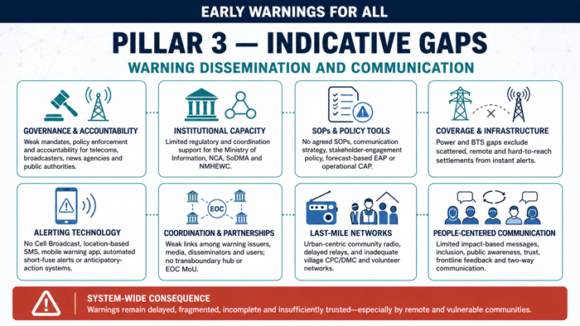
- Inadequate mandates, policy actions, and reinforcement to hold telecom service providers, broadcasters, and news agencies accountable for dissemination and communication, involving key actors such as national telecommunications and disaster management agencies, scientific and technical agencies, military and civil authorities, media organizations, businesses in vulnerable sectors, community-based organizations, and international agencies.
- The Ministry of Information and NCA lack essential support to adequately regulate mobile and telephone operators, broadcasters, and news agencies, and coordinate national risk communication and dissemination actions.
- Currently, there is a lack of SoP on risk communication and dissemination, a dissemination system of community radio in large urban-centric areas, and other methods such as social networks, people-to-people warning dissemination, etc., which have some time delays and inefficiency factors for keeping informed of the frontline actual situation timely for lifesaving.
- Due to the slower pace of power transmission and distribution to the last mile, Cell phone BTS expansion is still being hindered by power access over the scattered settlements in hard-to-reach areas; therefore, dispersed settlements are out of instant messaging services.
- On the supply side, there is a lack of NMHS-developed & administered forecast-based EAP, Common altering protocol, communication and dissemination strategy, and stakeholder engagement policy in risk communication.
- Inadequate partnership between information providers, warning dissemination organizations, and users
- The gap analysis encompasses an inclusive and people-centered approach, incorporating existing local networks, infrastructure networks, and services. It also evaluates the quality and trust in adopting the Common Alerting Protocol (CAP) and assesses the impact-based early warning messages. Furthermore, it examines the public's and other stakeholders' awareness of the authority’s issuing warnings and the level of trust in their messages.
- Lack of an agreed MoU with the transboundary risk communication hub/situation room/EOC
- Lack of a risk communication hub at the NMHEWC /SoDMA level
- Inadequate warning dissemination mandates and coordination structures for national broadcasters, media outlets, news agencies, etc., on timely and accurate
- Lack of a mobile app-based community-based early warning dissemination, risk communication, and feedback system.
- Lack of precise functions, roles, and responsibilities of each actor in the warning dissemination process, enforced through government policy or legislation at all levels.
- Inadequate governance structure, enforcement of policies and legislation, and mandates for risk communication.
- Absence of warning communication systems reaching the entire population.
- The non-existence of Cell-Broadcast (CB) and location-based SMS (LB-SMS), agreements with the private sector, and standardized alerting protocols such as CAP.
- Lack of coordination between the warning issuers, the media, and other stakeholders
- Absence of professional CPC/DMC at the village and community level, and inadequate volunteer networks to relay the alerts to communities.
- Lack of impact-based early warning messages and automated systems for anticipatory humanitarian action.
- Lack of feedback mechanisms highlights the urgent need for the implementation of communication strategies to enhance effectiveness.
- Lack of automated systems to mitigate impacts in events with a short timeframe to react.
- Partial public awareness necessitating support for the dissemination process.

3.3.2 Proposed essential action for closing Pillar 3 gaps.
To step forward to effective warning dissemination and communication in Somalia, the following interrelated core actions were identified and intended to be implemented by 2027/2030:
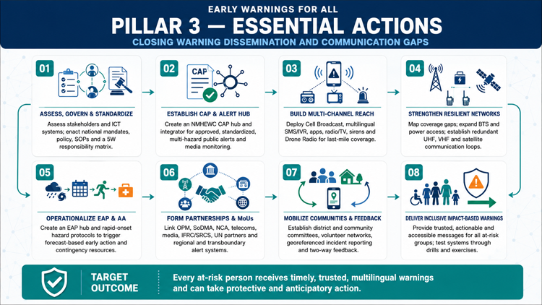
  - Establish early warning communication and dissemination strategies, actionable policy and strategies, and SoP

Proposed action | Enabler /stakeholders
- Conduct baseline assessment on relevant stakeholders e.g., national communication authority, government information ministry/department, , Cell phone Company national broadcasters( Radio, TV), Private broadcasters( Private TV, Community Radio), News agency ( online, offline), foreign news agency, INGOs, NGOs and other CSO level risk communication enabler at the different level, identify gaps, and finally develop early warning communication and dissemination strategies, actionable policy and strategies and SOP.  - Review existing ICT strategies, policies, and legislation related to the national broadcasting system, risk communication, and dissemination channels to keep the last-mile community informed and alerted.  - Establish an agile national and local early warning communication system structure, process, dissemination strategies, and forecast-based and early warning-based anticipatory action (AA) communication strategy at every administrative /local level.  - Establish comprehensive functional infrastructure networks and early warning dissemination services, and propose a communication network to bridge the last-mile communication gap.  - Establish community-level real-time risk communication & dissemination channel(Cell phone-SMS/IVR/Cell Broadcast, Radio/TV broadcasts, Siren, Drone Radio) for reaching out to end users, capturing feedback ( to Local SoDMA/NMHEWC-Situation room)  - Strategy, SoP development on mass communication, community education, awareness raising about extreme weather events' frequency, intensity, and antipolarity, L&D level of the types of impending hazards, preparedness (emergency evacuation), disaster response, and how to save lives and properties, local service providers, and local coordination group on disaster emergency response (LCG-DER).  - Establish and promote knowledge-sharing platforms among industry practitioners, students, academics, and others for early warning learning.  - MOU with transboundary Ethiopian and Kenyan EOC, NMHS, and Met Agency for feeding a real-time early warning and risk communication system  - MOU with global and African regional Multi-hazard alert systems ( GloFAS, FEWS NET, Drought Monitor, La Reunion Tropical Storm Warning Center, CREWS Initiative, RIMES, Food insecurity EWS, EUMETCast, etc.) to keep NMHEWC updated about transboundary and Horn of Africa (HoA) forecast and warnings.  - Developed administrative level functional Risk communication system - Develop key stakeholder map for all administrative levels and levels, develop standing orders of (5W matrix who will do what, when, where, how ) for disaster over risk communication, and SOP with operational aspects of disaster disaster-specific risk communication strategy  - Develop online web portal and mobile apps based on a 5W matrix-driven risk governance system for all stakeholders/actors/DRM committees with digital Mobile Apps based on Community engagement at multi-hazard incidents, L&D reporting.  - Established Common alerting protocol (CAP) with anticipatory impacts ( for productive sectors, e.g., agriculture, standing crops, livestock, fisheries, agroforestry, drinking water crisis & availability, WASH, food security, Market value chain update, and food supply, famine and hunger, public health epidemics, disease, and outbreaks, etc.  - Develop a forecast-based risk communication strategy under the CAP/weather warning protocol by IFRC/SRCS.  - Develop a communication network, portfolio, tools, and mobile apps for the first responder group (IFRC/SRC) of reporting primary L&Ds/impacts for triggering emergency humanitarian response with georeferenced location of incidents and attribute L&Ds/Impact information sending via mobile apps to NMHEWC & District level EOC.  - Building a national Risk communication stakeholders’ network at the district and community level for giving feedback, incident reports, and event situation updates to District EOC/NMHEWC | - Office of Prime Minister ( OPM)  - National Communications Authority (NCA), Somalia  - ITU  - IGAD-ICPAC  - WMO Africa  - WFP  - NMHEWC/Situation Room of SoDMA  - SoDMA offices at national and other administrative level  - ICS -Defense  - Police network  - GSM Cell phone companies  - National Telecom Operator  - government control National/State Broadcasters (radio, TV)  - Private broadcasters ( TV, Community Radio , social network group operators)  - National News outlets (offline, online  - UN Agencies - Implementing interventions (IOM -DTM, FAO SWALIM etc. )  - IFRC(Anticipation hub)  - Somalian Red Cross Society  - FAO-GTOS  - Sector departments
- Identify the risk communication gap at the district and community level; develop a GIS-based map on cell phone coverage areas and not-covered areas with settlements; identify households/settlements in hard-to-reach areas; and create a thematic GIS map on spoken languages. | - National Communications Authority (NCA), Somalia  - ITU  - GIS/IT Unit/sector of Ministry-level sector departments  - FAO-GTOS  - SoDMA  - INGO ICT team/GIS Section  - Somalia Journalist Association  - UN Agency Cluster system  - OCHA-IT/GIS Team  - UN Agency IT/GIS Section  - HCT Country ( UN Agency)
- Develop risk communication and development strategies for people leaving hard-to-reach areas with zonation of multilingual settlement distribution. | - SoDMA  - ITU  - NCA-Somalia  - ICS -Defense  - Police network  - Cell phone companies  - National Telecom Operator  - government control of National/State Broadcasters (radio, TV )  - Private broadcasters ( TV, Community Radio, social network group operators)  - National News outlets(offline, online)  - Somalia Journalist Association  - UN Agencies - FAO GCOS & GTOS  - IFRC/Somalian Red Cross Society  - GIS/IT Unit/sector of Ministry-level sector departments  - FAO-SWALIM  - SoDMA  - INGO ICT team/GIS Section  - UN Agency Cluster system  - OCHA-IT/GIS Team  - UN Agency IT/GIS Section  - HCT Country ( UN Agency)

  - Installation of early warning (EW) sirens and loudspeaker systems at villages and the community level for automatically alarming
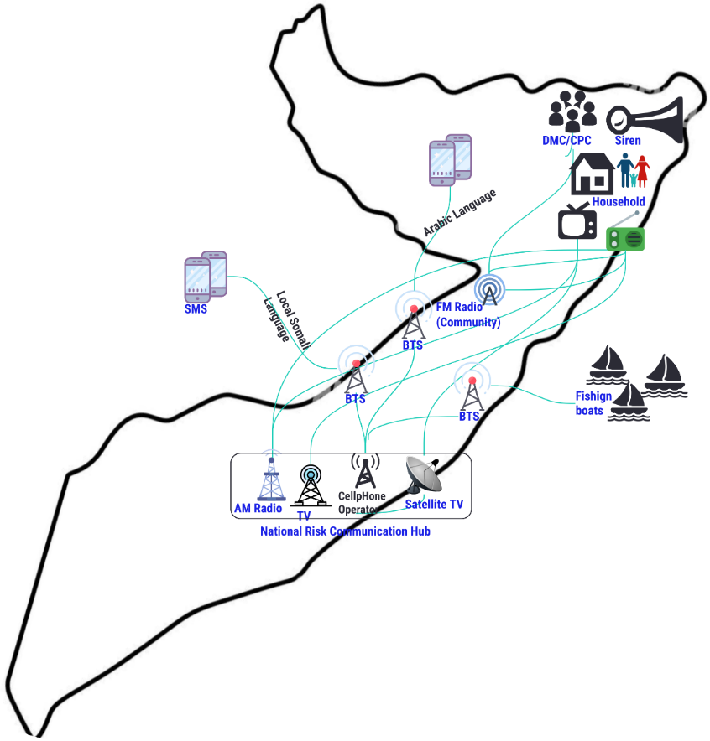
Figure 14: Last-mile community alerting system & process(proposed)

  - Develop national early warning dissemination & Common alerting protocol (CAP) protocol.
    - Develop CAP on rapid-onset multi-hazards that are likely to be impeding in a short period (Tropical storm, flood, Flash flood, landslide, mudslide, heavy rainfall, rapidly developing thunderstorm, tornadoes, hailstorm, etc.).
    - Developing Mobile apps for the dissemination of CAP
    - Develop mobile apps to capture community/DRM committee feedback about emergency preparedness and response gaps.

  - Develop an Early Action Protocol (EAP) hub for immediately planning forecast-based early action and contingency mobilization to support emergency humanitarian actions.
    - Developing Early Action Protocol (EAP) on rapid onset hazardous events, e.g., Tropical storms, floods, Flash floods, landslides, mudslides, heavy rainfall, rapidly developing thunderstorms, tornadoes, hailstorms, etc.)
    - Develop a national media monitoring team at the NMHEWC level for events situation capture and dissemination of CAP.
    - Anchoring the Global Multi-hazard Alert System (GMAS), Pacific Disaster Center -Disaster Alert, Jakarta-based Indian Ocean Tsunami alerts, and developing CAP on geological hazards, e.g., earthquakes in the Indian Ocean and Tsunami impacts over the vast, elongated Somali coast.
    - Anchoring Africa Media Monitor (AMM) for gathering multi-hazard incidence reports, accurate information tracking to support the development of Impact forecasting, and common alerting about transboundary floods, landslides, and IGAD region spells of droughts insert.
    - Develop national and district-level CPP committees for cyclone disaster preparedness, early warning campaigning, emergency evacuation, and response support.
    - Enhanced capacity of NMHS experts, NMHEWC, Forecasters, impact forecasts for developing EAP, EWEA, AA at the district level
    - Cyclone Preparedness Plan (CPP), at every district level and community level
    - Develop national and district-level CPP committees for cyclone disaster preparedness, early warning campaigning, emergency evacuation, and response support.

  - Establish and functional, comprehensive Early warning dissemination hub and mechanism:
    - Consensus building/MoU between the Ministry of Communication, Somalia News Network, such as the National Communications Authority, National AM Radio, National TV, licensed MNOs, licensed private broadcasters (Community radio/Private TV), etc., for mandating disaster emergency bulletin broadcasting every 15/30/60 minutes during cyclone and flood disaster onset.
    - Enhance the EOC dissemination hub by developing every weather warning bulletin for broadcasting through a hybrid dissemination channel.
    - Enhance the capacity of the national EOC to develop forecast-based CAP by analyzing the transboundary catchment area rainfall accumulation amount, hourly/daily precipitation amount, and runoff data of river channels, and develop CAP for flood warnings, CAP for cyclone warnings, Flash floods, and landslides.
    - Enhance National Storm Early Warning System Capacity - develop storm capacity - data linkage with La --Reunion Storm Warning Center (Western Indian Ocean)
    - Promote the Common Alerting Protocol (CAP) and establish an Alert Hub under NMHEWC with SOP and protocol with IFRC, SRC, INGOs/CSO, etc.
  - Installation and customization of Communication systems and equipment
    - Building an uninterrupted national emergency communication network Loop (UHF, VHF, Iridium Phone) for sustaining on the onset of a cyclone disaster
    - Communicate and disseminate all priority hazards according to the specific needs of specific groups and provide warning services to all diverse groups of the population at risk (including women, the elderly, and people with disabilities living in cities or rural areas).
    - All priority hazards with relevant behaviors/characteristics are subjected to regular system-wide tests, evaluations, and exercises for the warning system(s).
    - The needs of MHEWS users, including needs influenced by levels of vulnerability, are researched and understood for all priority hazards.
  - Impact-based early warnings communicated effectively to prompt action.
    - Impact-based warning messages indicate risks and provide actions (including last-mile connectivity). They are easily understood by outlining the phases and the level of actions by the responsible groups or bodies.
    - Enhance and support state-of-the-art communication and dissemination systems, public awareness,
    - Warning communication strategies ensure coordination across warning issuers and national, subnational, and local dissemination channels.

  - Develop national early warning dissemination & standard common alerting protocol ( CAP).

Proposed action | Enabler /stakeholders
- Develop a nationwide warning dissemination protocol: develop policy, mandate, strategies, and SoP on who will do what and how, which delivery channel, and how and when to disseminate real-time/instant early warning messages to the end users in every remote corner of Somalia. | - Office of the Prime Minister  - Ministry of Information /Department  - ITU  - NMHEWC  - National Communications Authority (NCA), Somalia  - National Contingency Planning Committee  - Regional/County Disaster Preparedness Committees  - Coordination Structures at the Federal Level  - Disaster Risk Management Coordination Group (DRMCG)  - SoDMA at national and other administrative level  - ICS -Defense  - Police network  - Cell phone companies  - government control National/State Broadcasters (radio, TV)  - Private broadcasters (TV, Community Radio, social network group operators)  - National News outlets (offline, online  - UN Agencies - Implementing interventions (IOM -DTM, FAO SWALIM etc.)  - IFRC(Anticipation hub)  - Somalian Red Cross Society
1.7.2 Develop a Technical Working Group (TWG) to develop a weather warning and common alerting protocol (CAP) hub, CAP integrator for public alerts and being approved by the Office of the Prime Minister and SoDMA | - Office of the Prime Minister  - SoDMA  - Cell phone companies  - Government control of National/State Broadcasters (radio, TV)  - Private broadcasters (TV, Community Radio, social network group operators)  - National News outlets (offline, online)  - UN Agencies - interventions (IOM -DTM, FAO SWALIM etc.)  - IFRC(Anticipation hub)  - Somalian Red Cross Society  - IFRC (Anticipation hub)  - Somalian Red Cross Society  - National Meteorological & Hydrological Services Organization (NMHS)  - National TWG on hydromet ( MoEWR)  - FAO-SWALIM  - ICS -Defense  - Police network  - INGO ICT team/GIS Section  - UN Agency Cluster system  - OCHA-IT/GIS Team  - UN Agency IT/GIS Section  - HCT Country ( UN Agency)  - Local National Humanitarian Actors (LNHAs)  - Local and National NGOs (LNNGOs)  - Somali NGO Consortium
- Develop risk communication and dissemination strategies for people in hard-to-reach (out-of-cell phone network) areas with multilingual settlement distribution. Cell Phone companies must develop a BTS IP map/BTS-HLR Map and cluster those with local language-based geographic zonation. They should also develop multilingual SMS services to disseminate messaging across each language zone for broader reach.  - Develop Phone IVR/Cell broadcast message for respective language zones as push-based common alerting protocol. | - Cell phone companies  - SoDMA  - ITU  - NCA-Somalia  - ICS -Defense  - Police network  - National Telecom Operator  - government control of National/State Broadcasters (radio, TV)  - Private broadcasters (TV, Community Radio, social network group operators)  - National News outlets (offline, online  - UN Agencies - FAO GCOS and GTOS  - IFRC/Somalian Red Cross Society  - GIS/IT Unit/sector of Ministry-level sector departments  - FAO-SWALIM  - SoDMA  - INGO ICT team/GIS Section  - UN Agency Cluster system  - OCHA-IT/GIS Team  - UN Agency IT/GIS Section  - HCT Country ( UN Agency)
- Installation of Early Warning effectiveness & efficacy related community feedback mechanism online apps for community feeds on early warning effectiveness and efficiency | - SoDMA  - NCA-Somalia

3.3.3 The roadmap for Pillar 3 : Enhancing effective dissemination and communication
The roadmap Pillar 3 aims to close the gaps and overcome challenges by promoting more effective communication and dissemination systems by 2027/2030 (including the development of last-mile risk communication connectivity), where communities and people at risk have access to instant warnings messages, public alerts through communication devices and stakeholder level strong coordination of information exchange at the stakeholder level is in place at national, regional, and local levels.
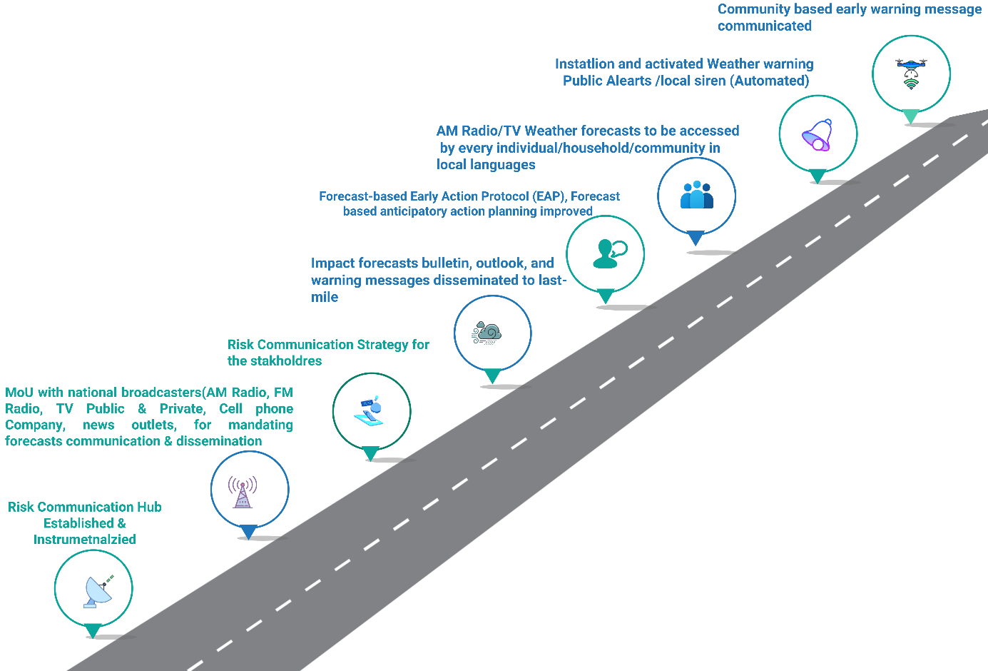
Figure 15: The roadmap for Pillar 3

To improve effective dissemination and communication services, the following goals and milestones are proposed to be implemented by 2027/2030.

3.1 Governance, functions, roles, and responsibilities of each actor in the warning dissemination process are enforced through government policy or legislation at all levels and included in the warning communication strategies and standard operating procedures.
3.1a Formulated ICT strategies, policies, and legislation related to the national broadcasting system, risk communication, and dissemination channels to inform and alert the last-mile community.
3.1b. Implemented that each actor's functions, roles, and responsibilities in the warning dissemination process are enforced through government policy or legislation at all levels and included in the warning communication strategies and standard operating procedures.
3.1c. Risk communication governance improved - regular coordination, planning, and review meetings between the warning issuers, the media, and other stakeholders
3.1d. Established coordination across warning issuers and national, subnational, and local dissemination channels.
3.1e. A holistic early warning communication strategy (including social media engagement, communication guidelines, etc.) was developed and strengthened.
3.1f. Indigenous EW community practices are embedded in ‘modern’ communication and dissemination channels. 3.1g. The MoU agreed to strengthen collaboration with the National Communications Authority to establish ICT business continuity plans to ensure the rapid recovery of telecommunication services in times of disaster.
3.1h. The National Communications Authority reviewed the MNO’s business continuity plans.
3.1i. The Legal, policy, and institutional frameworks for DRM and DRR, as well as Telecom/ICT regulation for disaster risk management, are in place.
3.1j. Somalia signed and ratified the Tampere Convention, and coordinated and collaborated with international agencies
3.1k. The National Emergency Telecommunications Plan has been updated by 2027.
3.1. Inclusion and people-centered approach, including through existing local networks.
3.2a. Professional and volunteer networks established to ensure the last-mile dissemination of early warnings widely
3.2b. Face-to-face EWS learning and other knowledge-sharing platforms are established and promoted among industry practitioners, students, academics, and other stakeholders.
3.2c. Strengthened human capacity, performance management, and operational efficiency within MHEWC to improve performance and foster innovation
3.2d. Enhanced capacity of technical personnel and quality inputs for EW4ALL. Training and support are provided for the staff of MHEWC and other relevant ministries responsible for warnings to enhance the effectiveness of warning dissemination and communication services.
3.2e. Communication strategies are evaluated, and feedback mechanisms are in place to verify that warnings have been received in a timely and at the precision level
3.2f. Formulated and mandated regulations, guidelines, and tools for digital inclusion and accessibility in emergency communications and alert dissemination. The National Communications Authority developed and adopted.
3.2. Infrastructure networks, EW dissemination services, and equipment are in place and functional.
3.3a. Early Warning (EW) sirens and loudspeaker systems are installed in villages and communities, and they are automatically alarmed and alerted.
3.3b. National Communications Authority to assess last-mile connectivity coverage to know which population groups can be reached by different services, including mobile-cellular, satellite, and radio services
3.3c. Warning messages are disseminated to the entire population, including seasonal populations and those in remote locations, through multiple communication channels (satellite and mobile-cellular networks, social media, flags, sirens, public address systems, etc.)
3.3d. Mobile operators activate SMS, IVR, and Cell broadcasts. Every language zone mobile user can access local language-based services.
3.3e. Networked, partnered with all service providers (e.g., mobile-cellular, satellite television broadcasters, radio broadcasters, amateur radio broadcasters, social media actors, etc. ) to disseminate warnings to the last mile.
3.3f. Early warning infrastructure and systems are tested, maintained, and upgraded to ensure resilience, redundancy, and functionality, with backup systems and processes in place.
3.3g. The geospatial web platform offers integrated impact forecasting, weather warnings, and weather alerts for visualization and dissemination of warnings.
3.3h. Types of required early warning information dissemination systems identified by the National Communications Authority (including cell broadcast, CAP, radio, TV, mobile, electronic signs, etc) in collaboration with SoDMA.
3.3i. The budget requirement for early warning information dissemination systems is calculated and assigned.
3.3j. The public emergency communication system is to be identified by the National Communications Authority.
3.3k. The operational budget for the public emergency communication system is provisioned.
3.3l. Enhanced capacity of cell phone companies, risk communication hubs, MNOs, radio/TV broadcasters, and other stakeholders, and improved dissemination of impending multi-hazards in the local language.
3.3m. A vulnerability analysis of DRM's critical telecom/ICT infrastructure has been developed.
3.3n. A business continuity plan (BCP) is in place for risk communication during a disaster emergency.
3.3. Improved Access to Quality and Trusted Multi-Hazard Early Warning Information
3.4a. The Common Alerting Protocol (CAP) for public alerts is implemented and adopted for warning messages to ensure that alerts sent by alerting agencies to MHEWC and across various channels are standardized and consistent, thereby avoiding confusion and reinforcing the message in the local language.
3.4b. Past hazard and multi-hazard risk thresholds tracked, benchmarked, and calibrated for impact forecasting of impending multi-hazards
3.4c. Established a partnership collaboration between the National Communications Authority, SoDMA, and telecommunication service providers for operationalizing the bulk SMS, wider and cell broadcasting of early warning information
3.4. Inclusion and people-centered EW4ALL approach, including through existing local networks.
3.5a. Impact-based early warning messages should communicate risk clearly and provide advice on actions that can be taken to reduce risks
3.5b. Enhanced capacity of the risk communication hub in developing emergency weather bulletins (e.g., flood, mudslide, convective rainfall, flash floods, fire, and tropical cyclone).
3.5c. A national risk communication protocol was developed to support emergency preparedness and response actions (e.g., preemptive evacuation of people and assets, activation of AA in target locations, mapping higher ground, deploying rescue boats, and opening fire-truck gates, etc.).
3.5d. The public and other stakeholders are aware of which authorities issue the warnings and trust their message (e.g. Imams and faith groups).

  - Establish early warning communication and dissemination strategies, actionable policy and strategies, and SoP
3.5a. Establish an agile national and local early warning communication system structure, process, dissemination strategies, and forecast-based and early warning-based anticipatory action (AA) communication strategy at every administrative /local level

  - Develop an Early Action Protocol (EAP) hub for immediately planning forecast-based early action and contingency mobilization to support emergency humanitarian actions.

  - Mobile apps-driven Impact-based early warnings communicated.

  - National early warning dissemination & standard alerting protocol ( CAP) protocol. Developed and communicated with the frontline community through mobile apps.

3.3.4 Workplan Pillar 3 : Warning dissemination and communication
SL | Milestone | Timeline |  |  |  |  |  |  |  |  |  |  |  |  |  |  |  |  |  |  |  |  |  |  |  |  | Responsibility |  | Budget  USD / LCU | Budget  Source
 |  | 20  24 | 2025 |  |  |  | 2026 |  |  |  | 2027 |  |  |  | 2028 |  |  |  | 2029 |  |  |  | 2030 |  |  |  | Lead | Support
 |  | Q4 | Q1 | Q2 | Q3 | Q4 | Q1 | Q2 | Q3 | Q4 | Q1 | Q2 | Q3 | Q4 | Q1 | Q2 | Q3 | Q4 | Q1 | Q2 | Q3 | Q4 | Q1 | Q2 | Q3 | Q4
 | Risk communication systems and equipment are in place and become functional |  |  |  |  |  |  |  |  |  |  |  |  |  |  |  |  |  |  |  |  |  |  |  |  |  | SoDMA  ITU  IFRC  UNDP  WMO | NCA, Cell Phone operators |  | ITU  , UNDP, GCF, SIDA, ECHO, DIFD, USAID  EU
 | Each actor's governance, functions, roles, and responsibilities in the warning dissemination process are enforced through government policy or legislation at all levels and included in the warning communication strategies and standard operating procedures. |  |  |  |  |  |  |  |  |  |  |  |  |  |  |  |  |  |  |  |  |  |  |  |  |  | SoDMA/  NCA  ITU  IFRC  UNDP  WMO | NCA, Cell Phone operators, , National Telecom Operator, government control National/State Broadcasters (radio, TV), Private broadcasters ( TV, Community Radio , social network group operators), National News outlets (offline, online
 | Established Infrastructure networks and EW dissemination services and equipment are in place and functional |  |  |  |  |  |  |  |  |  |  |  |  |  |  |  |  |  |  |  |  |  |  |  |  |  | SoDMA  ITU  IFRC  UNDP  WMO | As above
 | Established early warning communication and dissemination strategies, actionable policy and strategies, and SoP |  |  |  |  |  |  |  |  |  |  |  |  |  |  |  |  |  |  |  |  |  |  |  |  |  | SoDMA  ITU  IFRC  UNDP  WMO | As above
 | Formulated Effective EW Information Communication and Dissemination implementation plan |  |  |  |  |  |  |  |  |  |  |  |  |  |  |  |  |  |  |  |  |  |  |  |  |  | SoDMA  ITU  IFRC  UNDP  WMO | As above
 | Activated national early warning dissemination & common alerting protocol (CAP) protocol for the public alerts |  |  |  |  |  |  |  |  |  |  |  |  |  |  |  |  |  |  |  |  |  |  |  |  |  | SoDMA  ITU  IFRC  UNDP  WMO | As above
 | Installed and activated Early Warning (EW) sirens and loudspeaker systems in villages and communities being automatically alarmed |  |  |  |  |  |  |  |  |  |  |  |  |  |  |  |  |  |  |  |  |  |  |  |  |  | SoDMA  ITU  IFRC  UNDP  WMO | As above
 | Enhanced understandability of alerting messages reaches all those at risk, allowing them to take the necessary actions to save lives and livelihoods and to support longer-term resilience |  |  |  |  |  |  |  |  |  |  |  |  |  |  |  |  |  |  |  |  |  |  |  |  |  | SoDMA  ITU  IFRC  UNDP  WMO | As above
 | MHEWC has access to the Rapid Alert Notification System for rapid-onset disasters in the local language |  |  |  |  |  |  |  |  |  |  |  |  |  |  |  |  |  |  |  |  |  |  |  |  |  | SoDMA  ITU  IFRC  UNDP  WMO | As above
 | Improved Access to Quality and trusted Multi-Hazard Early Warning Information |  |  |  |  |  |  |  |  |  |  |  |  |  |  |  |  |  |  |  |  |  |  |  |  |  | SoDMA  ITU  IFRC  UNDP  WMO | As above
 | Developed an Early Action Protocol (EAP) hub at SoDMA to immediately plan forecast-based early action and contingency mobilization to support emergency humanitarian actions. |  |  |  |  |  |  |  |  |  |  |  |  |  |  |  |  |  |  |  |  |  |  |  |  |  | SoDMA  ITU  IFRC  UNDP  WMO | As above
 | Established and functioned country-early warning dissemination hub and mechanism |  |  |  |  |  |  |  |  |  |  |  |  |  |  |  |  |  |  |  |  |  |  |  |  |  | SoDMA  ITU  IFRC  UNDP  WMO | As above
 | State-of-the-art communication and dissemination systems enhance and support public awareness, mindset, and understanding of warning messages and early actions. |  |  |  |  |  |  |  |  |  |  |  |  |  |  |  |  |  |  |  |  |  |  |  |  |  | SoDMA  ITU  IFRC  UNDP  WMO | As above
 | Early Warning communication strategies and standard operating procedures (SOPs) established for governance, functions, roles, and responsibilities for early warning information, communication, and dissemination |  |  |  |  |  |  |  |  |  |  |  |  |  |  |  |  |  |  |  |  |  |  |  |  |  | SoDMA  ITU  IFRC  UNDP  WMO | As above
 | Established comprehensive functional infrastructure networks and early warning dissemination services and equipment |  |  |  |  |  |  |  |  |  |  |  |  |  |  |  |  |  |  |  |  |  |  |  |  |  | SoDMA  ITU  IFRC  UNDP  WMO | As above
 | People-centered EW4ALL through local networks in place |  |  |  |  |  |  |  |  |  |  |  |  |  |  |  |  |  |  |  |  |  |  |  |  |  | SoDMA  ITU  IFRC  UNDP  WMO | As above
 | Multi-lingual Push warning messages system developed, customized, and being disseminated to each language zones via SMS, Cell broadcast, IVR, Radio/TV |  |  |  |  |  |  |  |  |  |  |  |  |  |  |  |  |  |  |  |  |  |  |  |  |  | SoDMA  ITU  IFRC  UNDP  WMO | As above
 | Agreed Census building/MoU between the Ministry of Communication, broadcasters, Somalia News Network, National Communications Authority, National AM Radio, National TV, licensed MNOs, licensed private broadcasters (Community radio/Private TV), etc., for mandating disaster emergency bulletin broadcasting at every 15/30/60 minute during the cyclone and flood disaster onset. |  |  |  |  |  |  |  |  |  |  |  |  |  |  |  |  |  |  |  |  |  |  |  |  |  | SoDMA  ITU  IFRC  UNDP  WMO | As above
 | Enhanced capacity of NMHEWC- dissemination hub in developing every weather warning bulletin for broadcasting through a hybrid dissemination channel |  |  |  |  |  |  |  |  |  |  |  |  |  |  |  |  |  |  |  |  |  |  |  |  |  | SoDMA  ITU  IFRC  UNDP  WMO | As above
 | An agreed-upon MoU between the National Communications Authority and Cellphone, PSTN, and other private channels mandates the development of a BTS/HLR zonation-based local language-based push SMS, classified IVR, and Cell broadcast benignly accessed by cell phone users. |  |  |  |  |  |  |  |  |  |  |  |  |  |  |  |  |  |  |  |  |  |  |  |  |  | SoDMA  ITU  IFRC  UNDP  WMO | As above
 | Enhanced SoDMA capacity in developing Impact-based early warnings and being communicated effectively to trigger anticipatory action. |  |  |  |  |  |  |  |  |  |  |  |  |  |  |  |  |  |  |  |  |  |  |  |  |  | SoDMA  ITU  IFRC  UNDP  WMO | As above
 | Risk communication Strategy developed and functional |  |  |  |  |  |  |  |  |  |  |  |  |  |  |  |  |  |  |  |  |  |  |  |  |  | SoDMA  ITU  IFRC  UNDP  WMO | As above
 | All priority hazards are communicated and disseminated according to the specific needs of specific groups, and all diverse groups of the population at risk (including women, the elderly, and people with disabilities living in cities or rural areas) are provided with warning services |  |  |  |  |  |  |  |  |  |  |  |  |  |  |  |  |  |  |  |  |  |  |  |  |  | SoDMA  ITU  IFRC  UNDP  WMO | As above
 | Increased national capabilities for effective, authoritative emergency alerting for all media and all hazards. |  |  |  |  |  |  |  |  |  |  |  |  |  |  |  |  |  |  |  |  |  |  |  |  |  | SoDMA  ITU  IFRC  UNDP  WMO | As above

3.4 Roadmap Pillar 4: Preparedness and response capabilities.

Somalia is accelerating the decentralization of SoDMA’s institutional footprint to strengthen local-level disaster risk management and service delivery. The country faces compounding crises driven by hydrometeorological extremes and other contextual stressors. During the October-December 2023 (Deyr) rainy season, El Niño-associated heavy rainfall and flooding affected over 1.24 million people, displaced more than 456,800, and caused at least 32 deaths, according to Somali authorities and humanitarian reporting.

In this context, SoDMA is prioritizing a stronger operational presence and the timely implementation of preparedness measures and anticipatory actions to minimize loss and damage. Somalia’s hazard profile is shaped by the El Niño-Southern Oscillation (ENSO), where El Niño episodes can intensify rainfall and flooding risks, while La Niña conditions are associated with prolonged drought stress. Combined with exposure to Indian Ocean storm systems, these recurrent rapid- and slow-onset hazards reinforce the need for a decentralized, risk-informed preparedness and response system that actively engages communities, stakeholders, and local authorities.

At the same time, Somalia requires a more effective, hazard-informed humanitarian response architecture that is operationally linked to early warning and public alerting. When response arrives after impacts are already materializing, the opportunity to save lives and protect livelihoods is reduced. Consequently, the linkage between early warning/alerts and anticipatory actions must be institutionalized as an interactive operational cycle where forecasts and triggers directly activate pre-agreed early actions and pre-positioned support at national and sub-national levels.

Somalia’s disaster risk management policy recognizes the importance of addressing underlying risk drivers through early action, including development-oriented measures implemented before disasters occur. However, delivery capacity, particularly human resourcing at the frontline, remains limited relative to need. This increases the urgency of establishing forecast-based allocations of disaster risk finance, including forecast-based financing (FBF) instruments, to enable anticipatory preparedness and response actions that protect lives and assets. Operationally, this requires mainstreaming risk finance into national and sub-national planning and budgeting cycles so that financing can be released based on objective forecast thresholds and early action plans, aligned with life-saving humanitarian priorities and last-mile needs.

3.4.1 Indicative Gaps on Pillar 4 -Preparedness and response capabilities.

Other than the last inception workshop, national works, stakeholder consultation, etc., some gaps have been identified, including the following indicative gaps in pillar 4.
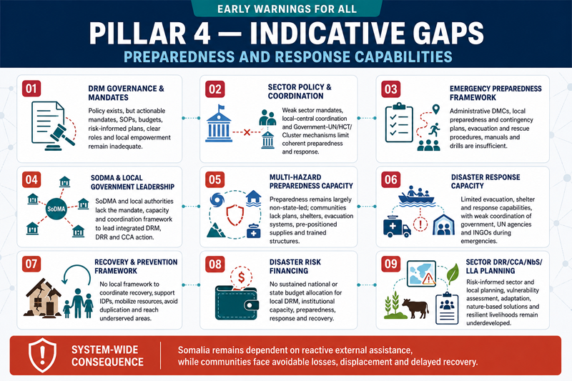

- Lack of Disaster Risk Management (DRM) Framework and mandates:

Somalia has a national disaster risk management policy (2020) and a Recovery and Resilience Framework (RRF) but still does not have a stakeholders' mandate actionable plan to translate policy into actions for effective DRM at the local level. Lack of standard operating procedures (SoP) , Lack of national budget allocated for funding disaster risk management actions, Inadequate hazard risk-informed DRM plans, Inadequate integration and coordination, the Local community empowerment is limited and Lack of clear roles and responsibilities of state actors and SoDMA as well.

- Lack of coherent sector-level actionable policy framework: There is a Lack of mandates and policy actions for state actors to endeavor disaster preparedness and emergency response management. Coordination gap between central sector ministry & department and local level actors. Inadequate disaster risk reduction governance system that effectively translates its priorities into concrete steps and practical action, focusing on prevention, preparedness, and mitigation. Inadequate disaster risk reduction is prioritized in other government policies and programs. Lack of stakeholder coordination and partnership framework mandates for devising emergency response mechanisms. International organizations, local and international NGOs, religious organizations, foreign government agencies /donors, and UN agencies carry out most emergency disaster preparedness and response. However, local government entities do plan peripheral roles. Inadequate government sectoral coordination framework and policy advocacy capacity to develop a Government-UN coordination mechanism in disaster risk management, anchoring the UN HCT and UN Cluster system with SoDMA for coordinated emergency response management and bridging the emergency preparedness and response gap at the local level.

- Lack of Disaster Emergency Preparedness Framework, actionable plan and mandates:

Inadequately established disaster management committee (DMC) at the administrative layer. Lack of good government leadership (Federal, State, and District levels) to significantly enhance the effectiveness of disaster response by multiple agencies by providing a coherent and coordinated framework that facilitates faster and more efficient delivery of response based on local needs. Lack of emergency preparedness action plan at the community, village, district, and municipality levels. Lack of flood and cyclone and other multi-hazard preparedness plan, designing contingency plans at district, provincial, and central levels of governance; Development of evacuation, rescue plans, manuals, and simulation exercises.

- Inadequate SoDMA and Local government-led DRM, DRR, and CCA coordination framework:

SoDMA, a local government sector department, has limited coordination among government and other actors at different levels, which poses daunting challenges to effective DRR implementation in Somalia. Despite having already formulated a policy framework for climate preparedness, there are hurdles in the local level DRM, DRR, and CCA planning and intervention process due to a lack of actionable policy and stakeholders' mandates.

- Inadequate multi-hazard preparedness Capacity:

Somalia needs a huge paradigm shift from a non-state actors-driven (INGO, NGO, UN Agency, CSO) crisis response management system to a state-actors and multi-stakeholder-driven emergency crisis response management system effectively managed by SoDMA and Local government actors, which is urgent for enhancing institutional capacity.

There is a lack of community-level emergency preparedness plans, contingency plans, evacuation plans, shelter management plans, and pre-positioning relief items to save lives and properties.

The heavily decentralized SoDMA and Local government extension to the district level can play pivotal roles in enhancing community-led preparedness for the fastest-onset multi-hazards (cyclones, flash floods, landslides, mudslides, etc.). The full-scale implementation of pillar 4 depends on effectively implementing other pillars and interactively supporting DRM interventions.

- Inadequate Disaster Response Capacity:

The local government and SoDMA do not have an emergency evacuation plan or disaster shelter to save lives from impending cyclonic hazards. There is also a lack of coordination measures between SoDMA and local government for anchoring INGOs and UN Agencies in emergency response.

- Inadequate Disaster Recovery and Prevention Framework:

Somalia has the highest number of IDPs, primarily induced by the multi-hazards and conflicts. The displaced community's livelihoods depend heavily on nature-based solutions (subsistence agriculture, livestock, and fisheries). Still, due to poor DRM governance at the local level, government actors are insignificantly involved in the local-level disaster recovery efforts. Due to a lack of a local Disaster Recovery and Prevention Framework, the SoDMA and local government actors cannot mainstream the non-state actors-driven post-disaster and recovery practices with the local government planning system. Somalia needs a multi-stakeholder coordinated disaster recovery and prevention framework for the effectiveness of resource mobilization, identifying intervention gaps and strategies for avoiding overarching interventions, and extending interventions to the hard-to-reach areas.

- Lack of disaster risk financing framework:
Lack of national annual fiscal budgetary allocation for funding disaster risk management actions at the local level. Federal government regional member states are faced with a Lack of budgetary allocation from the national budget to implement disaster risk management activities. The government agencies at the national and state levels have inadequate technical capacity due to poor funding.

- Lack of sector-level DRR/CCA/NbS/NbA/LLA plan :
Somalia’s local-level disaster risk reduction (DRR) and climate change adaptation (CCA) planning remains insufficient for effective community resilience building. Local government and SoDMA structures need to strengthen and institutionalize DRR planning at community, village, and district levels. Protracted poverty, the climate crisis, recurrent multi-hazard events, and internal conflict have increased displacement and heightened dependence on climate-sensitive livelihoods particularly agriculture, livestock, and fisheries.
ENSO-driven extremes associated with El Niño and La Niña continue to erode productivity in key livelihood assets (standing crops, livestock, agroforestry systems, and fisheries), in part because warning services are not consistently timely, localized, or actionable. Moreover, risk-informed tools are not yet adequately embedded in routine sector service delivery and value-chain support, limiting the ability of sector departments to anticipate impacts and act early.

To address these gaps, sector departments should develop and implement locally appropriate DRR, CCA, and adaptation solutions including nature-based solutions (NbS), nature-based adaptation (NbA), ecosystem-based adaptation (EbA), and locally led adaptation (LLA) to strengthen community resilience. This requires comprehensive risk and vulnerability assessments across priority sectors, identification of feasible risk reduction measures, and the establishment of community-based planning and budgeting systems that mainstream DRR/CCA and locally led adaptation into local development and service delivery processes.

3.4.2 Roadmap outlined actions for closing the Gaps on Pillar 4 by 2027 and beyond

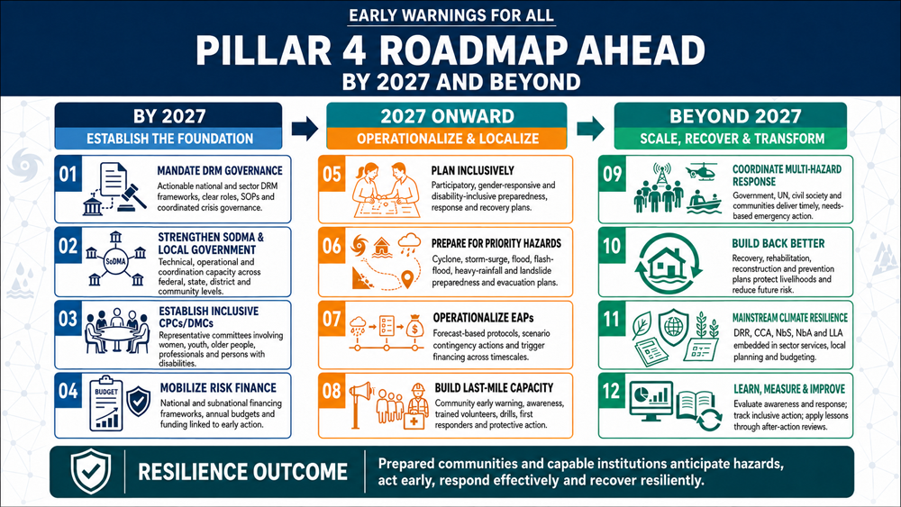
Proposed action | Enabler /Actors/stakeholders
  - Improving Crisis response management governance system
- Conduct capacity and technology needs assessment in order to capacitate in Disaster Risk Management (DRM) Planning system.  - Conduct assessment of stakeholder (state, non-state actors) mapping for multi-hazard risk management plan (Flood, flash flood, landslide, drought, tropical storm, pandemic/diseases/outbreaks)  - Develop a disaster emergency management framework action plan (stakeholder roles and responsibilities)  - Develop Disaster Management Plan (Federal Ministry level(Federal member state level), Sector Ministry level/ Sector department level, Local Government level /Sector Extension Department (at Region, Province, District level), etc., roles and responsibilities during crisis response, mandated, resource allocation, etc.)  - Develop standing orders on disasters, clearly defining the roles and responsibilities of stakeholders /actors.  - Develop standard operating Procedures ( SoP) of SoDMA at the local level | 1) State:  - Office of Prime Minister (PMO)  - MoHADM, SoDMA, DMA  - Federal Government’s Sector Ministries, Federal member state,  - Local Government (Region/Province, District)  UN Agency:  - CSOs (Local charities, trust, clubs, non-profit organization etc.)  - UN Agency: OCHA, UN Clusters (CCM, Early Recovery, Education, Emergency Telecommunication, Food Security, Health, Logistics, Nutrition, Protection, Shelter, and WASH clusters)  - HCT/Individual UN Agency (UNDRR, UNDP, IOM, UNICEF, UNHCR, WFP, FAO, UN Women, UNFPA, WHO, IFAD, ITU, UN Volunteers, UNCDF etc.)  CSOs:  - National NGOs Consortium  - International NGOs Consortium  - Regional Actor: IGAD-ICPAC, African Risk Capacity (ARC)
  - Improving Multi-hazard/Disaster Crisis response capacity
- Develop Institutional and stakeholder capacity in Disaster emergency preparedness, response, and recovery planning.  - Develop Institutional and stakeholder capacity in Disaster.  - Improving Institutional Capacity in Developing Forecast-based Early Action Protocol (EAP) Development  - Improving stakeholder capacity in undertaking forecast-based anticipatory action (AA) planning and implementation capacity (Flash drought, hydrological, meteorological, Fluvial flood, flash flood, transboundary catchment overflow flooding, landslide, cyclone, convective heavy rainfall, tornadoes, thunderstorm, diseases/outbreaks, Earthquake-induced coastal Tsunami, etc.) | Government:  - MoHADM, SoDMA, DMA  - Federal Government’s Sector Ministries, Federal member states,  - Local Government (Region/Province, District)  NGOs:  - National NGOs Consortium  - International NGOs Consortium  CSOs:  - National NGOs Consortium  - International NGOs Consortium  - CSOs (Local charities, trusts, clubs, non-profit organizations, etc.)  - Private sector  - Local service providers  - Utility service providers  - Extension officers/Technician  - Value chain operators  - Commercial entrepreneurs  - Smallholder farmers  - Agrobusiness value chain operators  UN Agency:  - UN Agency: OCHA, UN Clusters (CCM, Early Recovery, Education, Emergency Telecommunication, Food Security, Health, Logistics, Nutrition, Protection, Shelter, and WASH clusters)  - HCT/Individual UN Agency (UNDRR, UNDP, IOM, UNICEF, UNHCR, WFP, FAO, UN Women, UNFPA, WHO, IFAD, ITU, UN Volunteers, UNCDF etc.)  Regional Actor: IGAD-ICPAC, African Risk Capacity
  - Improving last-mile Disaster Preparedness Capacity
- Establish civil protection committee (CPC)/ Disaster Management Committee (DMC) at City, Municipality, Urban Center, Town, Village, and Community level committees (Represented by Different age groups, professional groups, sector-level extension officers, youth, elderly, disabled population, women, students, etc.) | - Local Government (Region/Province, District)  - National NGOs Consortium  - International NGOs Consortium  - CSOs (Local charities, trusts, clubs, non-profit organizations, etc.)  - UN Agency: OCHA, UN Clusters (CCM, Early Recovery, Education, Emergency Telecommunication, Food Security, Health, Logistics, Nutrition, Protection, Shelter, and WASH clusters)  - HCT/Individual UN Agency (UNDRR, UNDP, IOM, UNICEF, UNHCR, WFP, FAO, UN Women, UNFPA, WHO, IFAD, ITU, UN Volunteers, UNCDF, etc.).
    - Develop CPC/DMC level Plan for every sphere of the communities (with 5 W responsibilities, who will do what, where, when, and how)
    - Establish an emergency shelter group/committee.

    - Capacity development of CPC/DMC in forecast-based emergency preparedness and response, and conducting multi-stakeholder-led humanitarian action at the community and household level, such as evacuation drills, first aid, etc.
    - Improving Institutional Capacity in Developing Forecast-based Early Action Protocol (EAP) Development
    - Improving stakeholder capacity in undertaking forecast-based anticipatory action planning (Flash drought, hydrological, meteorological, Fluvial flood, flash flood, transboundary catchment overflow flooding, landslide, cyclone, convective heavy rainfall, tornadoes, thunderstorm, diseases/outbreaks, Earthquake-induced coastal Tsunami, etc.)
    - Capacity development of local CSO/stakeholder, CPC/DMC, vulnerable community in major disasters (fluvial flood, flash flood, landslide, drought, tropical storm & storm surge) management at the local level

- Enhance SoDMA and Local Government sectoral DRM/DRR capacity at the local level | Above mentioned actors
- Improving SoDMA -Stakeholder/CSO Coordination for Recovery and Resilience Framework  - Establish a cross-sectoral governance structure involving key institutions.  - Develop an early recovery framework for the community.  - Enhance SoDMA capacity in: Enhancing disaster preparedness for effective response and to “Build Back Better” in recovery, rehabilitation, and reconstruction.  - Establish Public and private partnerships in local-level preparedness and response intervention.  - Enhance SoDMA capacity to develop and implement standardized response protocols, train emergency response teams, coordinate with partners, and cooperate inter-agency.  - Establishing a River Basin Committee (RBC) will ensure the involvement of communities in the development and implementation of an EWS.  - Establish a national implementation committee.  - Establish Provincial implementation committees.  - Establish River basin committees.  - Risk-informed integrated rural development planning.  - Strengthening Gendered Risk Finance Framework  - Improving district-level disaster risk governance functionaries (District executive council, sector clusters, Technical Working groups, Civil protection Committee) for DRM /DRR-related service deliveries  - Capacity development of state actors/sector departments, local revenue mobilization, fiscal decentralization, and budgetary allocations for the district level  - Improving Gender Responsive Disaster Preparedness and Response Plan  - Improving stakeholder coordination for developing collective accountability to the affected population (AAP) and initiating gendered humanitarian action (GiHA) and DRR at the local level.  - SoDMA capacity enhancing the Risk-informed Early Action Partnership | - The above-mentioned actors
  - Improving Community-based Early Warning Capacity
- Develop community-level risk communication and dissemination strategy/Mandate (engaging local CPC/DMC and local broadcasters (Community Radio, central AM Radio, TV) for local awareness. Organize live shows/live broadcasts and interactive discussions with CPC/DRMC and community/households with event situation updates, assessments of primary L&D, humanitarian needs and priorities, etc., and report back to NMHEWC.  - Enhance community risk knowledge, preparedness, and response capacity, utilize human and social capital for risk mitigation, save productive assets based on weather alerts, and raise awareness about impending multi-hazards and disasters.  - Develop a Cyclone Preparedness Plan (CPP) to raise awareness at every coastal district and community level about the impending cyclones and storms that are being forecasted.  - Develop a Flood/flash flood/landslide/heavy rainfall Preparedness Plan to raise awareness among vulnerable communities about impending floods, heavy rainfall, and flash floods that are forecasted. | CPC/DMC at village and community level  CSOs:  - National NGOs Consortium  - International NGOs Consortium  - CSOs (Local charities, trusts, clubs, non-profit organizations, etc.)  - Private sector  - Local service providers  - Utility service providers  - Extension officers/Technician  - Value chain operators  - Commercial entrepreneurs  - Smallholder farmers  - Agribusiness value chain operators  UN Agency:  - UN Agency: OCHA, UN Clusters (CCM, Early Recovery, Education, Emergency Telecommunication, Food Security, Health, Logistics, Nutrition, Protection, Shelter, and WASH clusters)  - HCT/Individual UN Agency (UNDRR, UNDP, IOM, UNICEF, UNHCR, WFP, FAO, UN Women, UNFPA, WHO, IFAD, ITU, UN Volunteers, UNCDF etc.)  Regional Actor: IGAD-ICPAC, African Risk Capacity
  - Improving community-level volunteering network for emergency preparedness and Response mechanism
- Coordination structure of SoDMA, Somalian Red Cross Society (SRCS), and INGOs to establish a local community-level volunteering network for emergency preparedness and response mechanism.  - Capacity building for improving volunteering service delivery.  - Mandate CSOs to work with the 5W matrix for effective disaster preparedness and response service delivery, develop DRM strategies, and link NS response operations with recovery and community resilience work. | - SRCS  - Above-mentioned actors
  - Improving SoDMA /Local Government technical and operational disaster repose capacity
- Establish a local community-level volunteering network for emergency preparedness and response mechanisms.  - Capacity building for improving volunteering service delivery. | - The above-mentioned actors
- Improving Lack of Government Coordination Structure of crisis response | Above mentioned actors
- Improving SoDMA -Stakeholder/CSO coordination for Recovery and Resilience Framework (RRF) for actions | - The above-mentioned actors
  - Improve risk-informed local level ( District/Village/Community) DRR ,CCA, NbS, NbA, LLA inclusive planning and budgeting capacity
    - Enhance SoDMA and Local Government capacity in risk-informed DRR, CCA, NbS, LLA community-inclusive participatory planning and budgeting system and intervention process.
- Improving community-level volunteering network for emergency preparedness and response mechanism | Above mentioned actors
- Establish a local community-level volunteering network for emergency preparedness and response mechanisms.  - Capacity building for improving volunteering service delivery. | - The above-mentioned actors
- Improve community capacity to DRR ,CCA, NbS, NbA, LLA | Above mentioned actors
- Develop a stakeholder coordination strategy to avoid overlapping local-level DRR,CCA, NbS, and climate resilience-building initiatives.  - Develop DRR,CCA, NbS coordination structure for local level( District, Village, Community) coordination in interventions  - Enhance stakeholder capacity in risk-informed and evidence-based DRR, CCA, and NbS interventions at the community level.  - Enhance local-level humanitarian and DRR interventions by INGOs, NGOs, CSOs, and local governments.  - Enhance community capacity in DRR, CCA, and NbS  - Enhance local government /SoDMA engagement in Humanitarian Response Planning and intervention process. | - The actors mentioned above
- Develop disaster risk finance framework for national and subnational level | The actors mentioned above
- Develop an intended action plan over the next 5 years for closing the indicative preparedness and response gaps at the local level  - Develop coordination structure, SP, and capacity building of CSOs for implementing cash-for-work interventions at the community level | The actors mentioned above

3.4.3 Roadmap ahead for Pillar 4 by 2027 and beyond

Pillar 4: Areas of Action for Effective Preparedness, Timely Response, and Early Action
The roadmap Pillar 4 aimed to close the indicative gaps and overcome challenges by promoting more effective engagement of the community, local shareholders, actors, state, and other non-state actors to develop a new paradigm of Effective Preparedness, Timely Response, and Early Action mechanisms to be established by 2027 and beyond for frontline communities, building better disaster aftermath and post-disaster resilience.

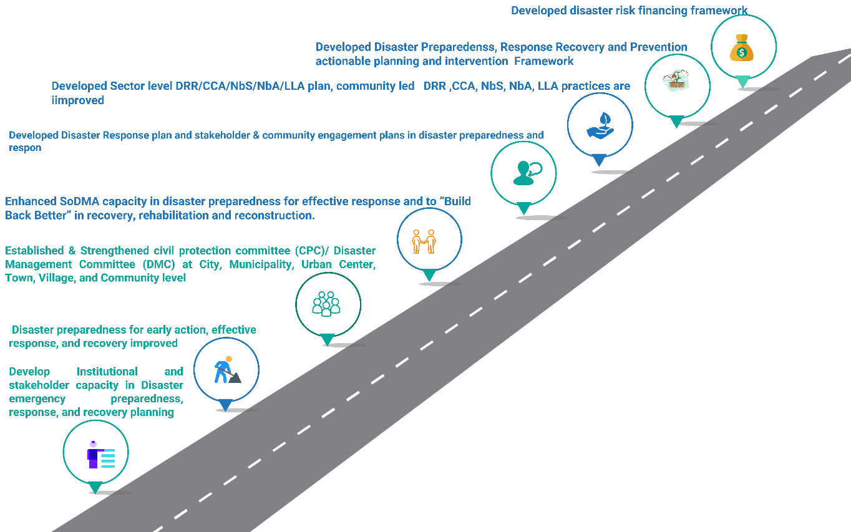
Figure 16: The roadmap for Pillar 4

Goal-specific Outcome: To achieve the defined pillar 4 goal-centric areas of Action for Effective Preparedness, Timely Response, and Early Action, the following milestones are intended ;

  - Disaster preparedness for early action, effective response, and recovery improved

    - Disaster preparedness measures, including response plans, developed in a participatory and gender-responsive manner
    - Disaster preparedness measures, including response plans, practiced.
    - Disaster preparedness measures, including response plans, account for the needs of people with vulnerabilities.
    - Multi-hazard risk assessments utilized to develop and design evacuation and recovery strategies.
    - Communities’ ability to respond effectively to early warnings assessed and enhanced, particularly women and people in vulnerable conditions.
    - Capacity to prepare, understand warning messages, and take early action is enhanced.
    - Contingency planning is developed scenario-based following forecasts or likely scenarios across timescales.
    - Early action and response options across time and geographical scales are linked to the provision of funding to support them for all priority hazards.
    - Community-based organizations, including youth groups and women’s organizations, lead public awareness and education campaigns for all priority hazards.
    - Percentage of women correctly identifying what actions should be taken for all priority hazards.
    - Previous emergency and disaster events and responses were analyzed, and lessons learned were incorporated into preparedness and response plans.
    - Previous emergency and disaster events and responses analyzed, and lessons learned incorporated into capacity-building strategies.
    - Public awareness strategies and programs are evaluated regularly and updated as required.
    - Drills and exercises conducted with first responders and the community.
    - Population at risk acted as a priority hazard when an alert was received.
    - Early warnings align with risk information, particularly with the WDRP and other Urban Initiatives.
    - After-action reviews of preparedness, response, and early action practices fostered and strengthened at community, regional, and national levels.

  - Improved Crisis Response Management Governance System
  - Improved Multi-hazard/Disaster Crisis Response Capacity
  - Improved last-mile disaster preparedness capacity
  - Develop Institutional and stakeholder capacity in Disaster preparedness, response, and recovery planning.
  - Enhanced SoDMA and Local Government sectoral DRM/DRR capacity at the local level
  - Improved Institutional Capacity in Developing Forecast-based Early Action Protocol (EAP) Development
  - Established civil protection committee (CPC)/ Disaster Management Committee (DMC) at City, Municipality, Urban Center, Town, Village, and Community level committees (Represented by Different age groups, professional groups, sector-level extension officers, youth, elderly, disabled population, women, students, etc.)
  - Developed Cyclone Preparedness Plan (CPP), raised awareness at every coastal district and community level about the impending cyclone and storm surge being forecasted.
  - Developed Flood/flash flood/landslide/heavy rainfall Preparedness Plan, raised awareness for vulnerable communities about the impending flood, heavy rainfall, and flash floods are being forecasted.
  - Enhanced SoDMA capacity in disaster preparedness for effective response and to “Build Back Better” in recovery, rehabilitation, and reconstruction.
  - Improved Community-based early warning capacity and community-led DRR ,CCA, NbS, NbA, LLA practices are improved
  - The community-level volunteering network for emergency preparedness and Response mechanisms and the frontline community’s post-disaster livelihood are being improved.
  - Improved SoDMA /Local Government technical and operational disaster repose framework of action and interventions at the local level
  - Disaster risk finance framework for national and subnational level Developed and disaster risk finance mobilization efforts being facilitated.
  - Developed and mandated actionable Disaster Risk Management (DRM) Framework and sector-level plan for better stakeholder coordination and community-based DRM services
  - Developed and mandated an actionable coherent sector level actionable disaster preparedness, response, and recovery framework and sector department are well coordinated to Disaster
  - SoDMA has a disaster Emergency Preparedness Framework, actionable plan, and mandates:
  - SoDMA and local government-led DRR/CCA/NbS/NbA/LLA coordination framework.
  - Strengthened stakeholder, CPC/DMC/Taskforce and community multi-hazard preparedness Capacity:
  - Developed Disaster Response plan and stakeholder & community engagement plans in disaster preparedness and response
  - Developed Disaster Recovery and Prevention Framework and action plan
  - Developed disaster risk financing framework :
  - Developed Sector-level DRR/CCA/NbS/NbA/LLA plan :

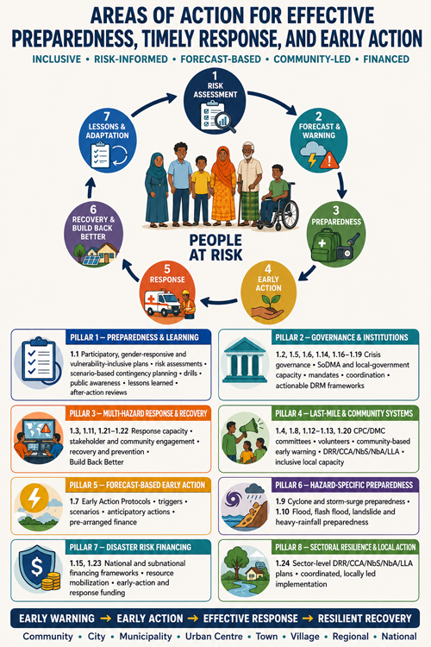

3.4.4 Work Plan for Pillar 4 (Preparedness, timely responses and early actions)
SL | Milestone | Timeline |  |  |  |  |  |  |  |  |  |  |  |  |  |  |  |  |  |  |  |  |  |  |  |  | Responsibility |  | Budget  USD / LCU | Budget  Source
 |  | 20  24 | 2025 |  |  |  | 2026 |  |  |  | 2027 |  |  |  | 2028 |  |  |  | 2029 |  |  |  | 2030 |  |  |  | Lead | Support
 |  | Q4 | Q1 | Q2 | Q3 | Q4 | Q1 | Q2 | Q3 | Q4 | Q1 | Q2 | Q3 | Q4 | Q1 | Q2 | Q3 | Q4 | Q1 | Q2 | Q3 | Q4 | Q1 | Q2 | Q3 | Q4
 | Improved Crisis response management governance system at national, federal state, state, district and village level |  |  |  |  |  |  |  |  |  |  |  |  |  |  |  |  |  |  |  |  |  |  |  |  |  | IFRC, REAP  OCHA, FAO, WFP | OPM, MoHADM, SoDMA, DMA  UN Agency, HCT, UN Clusters, CSOs -National NGOs Consortium, International NGOs Consortium, IGAD-ICPAC, African Risk Capacity (ARC) |  | UNDP, GCF, SIDA, ECHO, DIFD, USAID  EU  GCA,
 | Disaster preparedness for early action, effective response, and recovery actions are improved |  |  |  |  |  |  |  |  |  |  |  |  |  |  |  |  |  |  |  |  |  |  |  |  |  | As above | As above
 | Actionable Disaster Risk Management Policy, Laws, mandates, and Strategies are in place, stakeholder coordination improved |  |  |  |  |  |  |  |  |  |  |  |  |  |  |  |  |  |  |  |  |  |  |  |  |  | As above | As above
 | Governance structure established for coherent coordination between national, Federal, State and District and local levels |  |  |  |  |  |  |  |  |  |  |  |  |  |  |  |  |  |  |  |  |  |  |  |  |  | As above | As above
 | Established a cross-sectoral DRM g key institutions are engaged in DRM process |  |  |  |  |  |  |  |  |  |  |  |  |  |  |  |  |  |  |  |  |  |  |  |  |  | As above | As above
 | Strengthened sector ministry and duty bearer capacity in multi-hazard risk-informed preparedness and response, recovery, prevention and rehabilitation planning, intervention design and implementation process. |  |  |  |  |  |  |  |  |  |  |  |  |  |  |  |  |  |  |  |  |  |  |  |  |  | As above | SoDMA, DMA  UN Agency, HCT, UN Clusters, CSOs -National NGOs Consortium, International NGOs Consortium, IGAD-ICPAC, African Risk Capacity (ARC)
 | Disaster Preparedness for Early Action, effective response, and recovery improved |  |  |  |  |  |  |  |  |  |  |  |  |  |  |  |  |  |  |  |  |  |  |  |  |  | As above | As above
 | Enhanced SoDMA capacity in forecast-based early action planning and response management at the local level |  |  |  |  |  |  |  |  |  |  |  |  |  |  |  |  |  |  |  |  |  |  |  |  |  | As above | As above
 | Disaster preparedness measures, including response plans, developed in a participatory and gender-responsive manner. |  |  |  |  |  |  |  |  |  |  |  |  |  |  |  |  |  |  |  |  |  |  |  |  |  | As above | As above
 | Established civil protection committee (CPC)/ Disaster Management Committee (DMC) at City, Municipality, Urban Center, Town, Village, and community levels (Represented by Different age groups, professional groups, sector-level extension officers, youth, elderly, disabled population, women, students, etc.)
 | Strengthen the last-mile disaster preparedness capacity of stakeholders and community |  |  |  |  |  |  |  |  |  |  |  |  |  |  |  |  |  |  |  |  |  |  |  |  |  | As above | As above
 | Improved Government DRM preparedness and response, multi-stakeholder coordination, Structure, and process for crisis response management at the local level strengthened |  |  |  |  |  |  |  |  |  |  |  |  |  |  |  |  |  |  |  |  |  |  |  |  |  | As above | As above
 | Enhanced SoDMA capacity in gender responsive disaster preparedness for effective response and to “Build Back Better” in recovery, rehabilitation, and reconstruction. |  |  |  |  |  |  |  |  |  |  |  |  |  |  |  |  |  |  |  |  |  |  |  |  |  | As above | As above
 | Disaster preparedness measures, including preparedness, response, and forecast-based contingency plans, were developed in a participatory and gender-responsive mannered |  |  |  |  |  |  |  |  |  |  |  |  |  |  |  |  |  |  |  |  |  |  |  |  |  | As above | As above
 | Improved community-level volunteering network for emergency preparedness and response mechanism ( gender participatory ) |  |  |  |  |  |  |  |  |  |  |  |  |  |  |  |  |  |  |  |  |  |  |  |  |  | As above | As above
 | Enhanced SoDMA and Local Government sectoral DRM/DRR capacity at the local level |  |  |  |  |  |  |  |  |  |  |  |  |  |  |  |  |  |  |  |  |  |  |  |  |  | As above | As above
 | Emergency preparedness plan informed by Impact Based Forecasting & Warning Services (IBFWS) |  |  |  |  |  |  |  |  |  |  |  |  |  |  |  |  |  |  |  |  |  |  |  |  |  | As above | As above
 | Community access to Impact-Based Forecasting & Warning Services (IBFWS) for emergency preparedness |  |  |  |  |  |  |  |  |  |  |  |  |  |  |  |  |  |  |  |  |  |  |  |  |  | As above | As above
 | Improved Community-based early warning capacity and community understandability of impending multi-hazards |  |  |  |  |  |  |  |  |  |  |  |  |  |  |  |  |  |  |  |  |  |  |  |  |  | As above | As above
 | The capacity to prepare, and understand warning messages and take early action is enhanced |  |  |  |  |  |  |  |  |  |  |  |  |  |  |  |  |  |  |  |  |  |  |  |  |  | As above | As above
 | Improved last-mile disaster preparedness capacity |  |  |  |  |  |  |  |  |  |  |  |  |  |  |  |  |  |  |  |  |  |  |  |  |  | As above | As above
 | Improved SoDMA /Local Government technical and operational disaster repose framework |  |  |  |  |  |  |  |  |  |  |  |  |  |  |  |  |  |  |  |  |  |  |  |  |  | As above | As above
 | Improved community-level volunteering network for emergency preparedness and response mechanism |  |  |  |  |  |  |  |  |  |  |  |  |  |  |  |  |  |  |  |  |  |  |  |  |  | As above | As above
 | Strengthened public-private partnerships for enhancing technical and financial capacities of forecast-based community preparedness to impending multi-hazards & disaster |  |  |  |  |  |  |  |  |  |  |  |  |  |  |  |  |  |  |  |  |  |  |  |  |  | As above | As above
 | Prepared Cyclone Preparedness Plan (CPP), raised awareness at every coastal district and community level about cyclone & storm surge |  |  |  |  |  |  |  |  |  |  |  |  |  |  |  |  |  |  |  |  |  |  |  |  |  | As above | As above
 | Increased community awareness and capacity to respond to early warnings through simulations, drills, and educational campaigns |  |  |  |  |  |  |  |  |  |  |  |  |  |  |  |  |  |  |  |  |  |  |  |  |  | As above | As above
 | Improved community-level volunteering network for emergency preparedness and Response mechanism, and the frontline communities’ post-disaster livelihood is being built better.
 | Improved access for women to Gender in Humanitarian Action(GiHA) |  |  |  |  |  |  |  |  |  |  |  |  |  |  |  |  |  |  |  |  |  |  |  |  |  | As above | As above
 | Improved stakeholder Coordination and partnership in Preparedness and Response management |  |  |  |  |  |  |  |  |  |  |  |  |  |  |  |  |  |  |  |  |  |  |  |  |  | As above | As above
 | Disaster Preparedness for Early Action, effective response and recovery improved |  |  |  |  |  |  |  |  |  |  |  |  |  |  |  |  |  |  |  |  |  |  |  |  |  | As above | As above
 | Improved community-based early warning capacity and community led DRR ,CCA, NbS, NbA, LLA practices are improved |  |  |  |  |  |  |  |  |  |  |  |  |  |  |  |  |  |  |  |  |  |  |  |  |  | As above | As above
 | Develop a disaster risk finance framework for the national and subnational level |  |  |  |  |  |  |  |  |  |  |  |  |  |  |  |  |  |  |  |  |  |  |  |  |  | As above | As above
 | Improved risk-informed local level (District/Village/Community) DRR/CCA/NbS planning and budgeting capacity |  |  |  |  |  |  |  |  |  |  |  |  |  |  |  |  |  |  |  |  |  |  |  |  |  | As above | As above
 | Improved last-mile disaster response capacity |  |  |  |  |  |  |  |  |  |  |  |  |  |  |  |  |  |  |  |  |  |  |  |  |  | As above | As above
 | Standardized planning and response protocols were developed. |  |  |  |  |  |  |  |  |  |  |  |  |  |  |  |  |  |  |  |  |  |  |  |  |  | As above | As above
 | Activated Standardized response protocols, trained emergency response teams, and coordinated with partners |  |  |  |  |  |  |  |  |  |  |  |  |  |  |  |  |  |  |  |  |  |  |  |  |  | As above | As above
 | Develop disaster risk finance framework for national and subnational level |  |  |  |  |  |  |  |  |  |  |  |  |  |  |  |  |  |  |  |  |  |  |  |  |  | As above | As above
 | Enhance last-mile community resilience to disaster |  |  |  |  |  |  |  |  |  |  |  |  |  |  |  |  |  |  |  |  |  |  |  |  |  | As above | As above
 | Improved Community based early warning capacity
 | Enhanced community/household-based to DRR/CCA/NbS scheme implementation capacity |  |  |  |  |  |  |  |  |  |  |  |  |  |  |  |  |  |  |  |  |  |  |  |  |  | As above | As above
 | Established disaster risk finance farmwork for DRR |  |  |  |  |  |  |  |  |  |  |  |  |  |  |  |  |  |  |  |  |  |  |  |  |  | As above | As above
 | Enhanced disaster preparedness and humanitarian action capacity ( Methodology tools and guidelines on Early Action Protocol (EAP) , Forecast early action /Humanitarian Action, Forecast-based financing (FBF) at sector level, national and local level (Gender inclusive) |  |  |  |  |  |  |  |  |  |  |  |  |  |  |  |  |  |  |  |  |  |  |  |  |  | As above | As above
 | Established climate risk finance gender-responsive farmwork for DRR ,CCA, NbS, NbA, LLA practices |  |  |  |  |  |  |  |  |  |  |  |  |  |  |  |  |  |  |  |  |  |  |  |  |  | As above | As above
 | Developed and mandated actionable coherent sector-level disaster preparedness, response and recovery framework and the sector departments are well coordinated to disasters

4.0 Monitoring & Evaluation Plan of EW4ALL Pillars
Pilar | Goal | Milestone  (2024-2030) | Baseline | Target Value | Means of Verification | Frequency | Responsible entities | Reporting  (where will be reported)
Pillar1 | By 2027, a comprehensive and automated disaster risk information and knowledge base will be available and constructed for all dimensions of disaster risk, including hazards, exposure, vulnerability, and capacity at household, community, and organizational levels.
Pillar1 |  | Rolled out UNDRR-DesInventar online L & D tracking system as the national repository |  | 100% Sector interactively accessing and providing L & D dataset to DesInventar of the L & D statistics/attributes | % of authorized actors/stakeholders utilizing the new prototype of the online DesInventar database | Quarterly | SoDMA, UNDRR | SoDMA
Pillar1 |  | Strengthened institutional capacity in vulnerability assessment (VAC) |  | 100% of stakeholders having Vulnerability assessment capacity | - % of stakeholders, entities, and actors received VAC training  - % of stakeholders, entities, and actors conducted vulnerability assessment (VA) | Quarterly
Pillar1 |  | VAC was conducted at the Urban center, District, Village, and community levels, and a risk repository was developed; frontline risk knowledge was enhanced & analyzed, historical data was evaluated, and potential future risks were assessed |  | 100% entities/Local Govt. units targeted by 207/2030 | VA conducted % of local entities | Quarterly
Pillar1 |  | Enhanced institutional capacity in ICT/MIS /Geospatial tools-based data analysis and tailormade risk integration in decision-making. Hazard maps (dynamic and multi-hazard, when possible) are developed that identify the geographical areas/people that could be affected by hazards |  | GIS/MIS/ICT tools installed above 100% entities by 207/2030 | - % entities having GIS//MIS/ICT setup  - Types of tools being developed | Quarterly
Pillar1 |  | Improved multi-hazard/Disaster Risk information management Governance system at SoDMA and other sector-level |  | 100% of sector departments having a Disaster risk information system/database by 207/2030 | % sector department having Disaster risk information system/database | Quarterly
Pillar1 |  | Strengthened sector-level capacity in multi-hazard risk knowledge management, and Climate impact projections are developed |  | 100% of the sector departments developed a Disaster Risk Atlas | % sector departments having Disaster risk atlas | Quarterly
Pillar1 |  | Strengthened the capacity of state and non-state actors for sector-level operational data analysis and informed tools development capacity |  | 100% sector department /stockholders capturing hazard risk data and developing informed tools for monitoring of sectoral elements | % sector department /stockholders capturing hazard risk data and developing informed tools for monitoring of sectoral elements | Quarterly
Pillar1 |  | Established decentralized SADD and disaggregated data collection mechanism and enhanced risk knowledge repository |  | Enhanced capacity above 100% sector department /stockholders on SADD & disaggregated data collection and enhanced risk knowledge repository | % sector department /stockholders capturing SADD & disaggregated data and capability on developing risk repository | Quarterly
Pillar1 |  | Strengthened stakeholder partnership in risk data & information coordination and exchange mechanism and improved early warning information exchange and interoperability among institutions |  | 100% sector department /stockholders networked and partnered for risk-information coordination and exchange mechanism of the vulnerable sectors, e.g., agri-food sector- crops, livestock, forestry, fisheries, aquaculture for top 5 hazards (hazards responsible for 90% of past L&D in the sector) | % sector department /stockholders networked and partnered for risk-information coordination and exchange mechanism | Quarterly
Pillar1 |  | Vulnerable communities and stakeholders have access to the online geospatial risk atlas portal and attribute database management system in Somalia |  | 100% of sector departments/stockholders utilize the NMHEWC-developed online geospatial risk atlas portal and attribute database management system, with contents on local, indigenous, and traditional knowledge (LITK) integrated for Somalia | % sector department /stockholders utilizing online geospatial risk atlas portal and attribute database management system for Somalia | Quarterly
Pillar1 |  | Established a tailored risk repository data hub for informing decisions, strategy, planning & implementation of DRR, NAP, NbS (Nature-based solution), locally led solutions, WASH, Health, Food Security, and Livelihood Security related projects |  | 100% of sector departments/stockholders accessing risk repository data hubs | % sector department /stockholders accessing risk repository data hubs | Quarterly
Pillar2 | By 2027, capacity for weather observation, detection, monitoring and forecasting of major hazards and analysis of their potential impacts enhanced and optimized
Pillar2 |  | Installed & operational robust Automatic Weather System (AWS) complying with Global Basic Observing Network (GBON) standards |  | High-density GBON standards AWS installed over the high-value elements for point forecasting and warning | % high value elements covered under AWS, observed and provided point forecasting and warning for saving lives and assets | Quarterly
Pillar2 |  | Installed the Situation Room at NMHEWC, Operational for robust service delivery |  | Full-scale implementation of the Situation Room at NMHEWC and supported observation, hazard tracking, monitoring, and forecasting | % sector department /stockholders / vulnerable community being warned by the situation room developed impact forecasts | Quarterly
Pillar2 |  | Forecasting data acquisition of Essential Climate Variables (ECVs) from AWS instrumentalized |  | High-density AWS is able to capture ECVs | % geographic extent of areas being buffered by the AWS surveillance | Quarterly
Pillar2 |  | Established a linkage with the regional specialized meteorological center. |  | The NMHEWC Situation Room/EOC has access to all WMO regional specialized meteorological centers. | The number of WMO regional RSMCs/RCCS is linked to the Situation Room/EOC. | Quarterly
Pillar2 |  | Established accessibility to real-time satellite-based atmosphere observation systems by installation of PUMA 2025, MeteoSat, and Enhanced NMHEWC meteorological and hydrological Monitoring capability |  | Situation room/NMHEWC has a satellite linkage with EUMETCast satellites | Number of regional satellite links, weather images, and datasets are being accessed by the Situation room/NMHEWC /EOC | Quarterly
Pillar2 |  | Enhanced NMHEWC Data Analysis & Forecasting capability |  | Capacity of NMHEWC Data Analysis & Forecasting capability | Products and services being produced by EOC/Situation Room | Quarterly
Pillar2 |  | Established & Functional Environmental Monitoring Division |  | Capacity of NMHEWC in Environmental Monitoring | Types and number of forecast products for Environmental Monitoring | Quarterly
Pillar2 |  | Established & functional forecasting Division |  | Capacity of NMHEWC in the different range forecasting | Types and number of range forecasting products bulletin, outlook produced | Quarterly
Pillar2 |  | Established & Functional Agro-climatology Division |  | Capacity of NMHEWC in Environmental Monitoring | Types and number of forecast products for Environmental Monitoring | Quarterly
Pillar2 |  | Established & Functional Numerical Weather Prediction (NWP) & Climate Division |  | Capacity of NMHEWC in Numerical Weather Prediction(NWP) & Climate Monitoring | Types and number of Numerical Weather Prediction(NWP) products bulletin, outlook produced | Quarterly
Pillar2 |  | Established & Functional: Establish Impact Forecasting Division |  | Capacity of NMHEWC in impact forecasting | Types and number of impact forecasting products bulletin, outlook produced | Quarterly
Pillar2 |  | Established a functional Flood Forecasting and Warning Center (FFWC) |  | Capacity of NMHEWC in FFWC activation | Performance report on FFWC | Quarterly
Pillar2 |  | Established a functional storm monitoring and warning center |  | Capacity of NMHEWC in storm monitoring and warning | Performance report on Effectiveness, efficacy, and performance of storm monitoring and warning services | Quarterly
Pillar2 |  | Established & Functional Famine Early Warning Division: |  | Capacity of NMHEWC in Famine Early Warning | Performance report on the Effectiveness, efficacy, and performance of the Famine Early Warning | Quarterly
Pillar2 |  | Established & Functional drought monitoring system |  | Capacity of NMHEWC in Environmental Monitoring | Performance report on Effectiveness, efficacy, and performance of the Famine Early Warning | Quarterly
Pillar2 |  | Established a functional Livestock monitoring division |  | Capacity of NMHEWC in Livestock Monitoring & Forecasting | Performance report on Effectiveness, efficacy, and performance of Famine early warning | Quarterly
Pillar2 |  | Early Warning data collection, analysis, and exchange modalities among federal line ministries/ sectorial offices and regional bodies harmonized &strengthened. |  | Capacity of NMHEWC in forecast coordination | Performance report on Effectiveness, efficacy, and performance of the Famine Early Warning | Quarterly
Pillar2 |  | Enhanced capacity in integrated multi-hazard early warning system (MHEWS) for rapid-onset multi-hazards -weather warning, common alerting protocol, Storm warning |  | The capacity of NMHEWC in the development of an integrated multi-hazard early warning system (MHEWS) for rapid-onset multi-hazards- weather warning, common alerting protocol, Storm warning | Performance report on Effectiveness, efficacy, and performance of integrated multi-hazard early warning system (MHEWS) for rapid onset multi-hazards -weather warning Common alerting protocol, Storm warning | Quarterly
Pillar2 |  | Established & Functional National Meteorological and Hydrological Services (NMHSs) Unit & capability of impact-forecasting products and bulletin/outlook services for the sectors |  | Full-scale engagement of all sectoral experts in NMHSs in impact forecasting | Performance report on the Effectiveness, efficacy, and performance of NMHSs' developed products and services | Quarterly
Pillar2 |  | Established & Functional National Meteorological and Hydrological Services (NMHSs) Unit at NMHEWC and developed impact-forecasting products and bulletin/outlook services: |  | Capacity of NMHEWC in NMHSs in impact forecasting | Performance report on the Effectiveness, efficacy, and performance of NMHSs' developed products and services | Quarterly
Pillar2 |  | Strengthened institutional programmatic capacity in the installation of high-density weather observation, hazard, and climate monitoring and prediction, numerical weather prediction (NWP), short-range forecast modeling, and weather impact forecasting for the sector and community level. |  | Capacity of NMHEWC in Forecast Value Chain Development | Performance report on the Effectiveness, efficacy, and performance of the forecast value chain being developed | Quarterly
Pillar2 |  | Enhanced NMHEWC capacity in demand-driven weather forecasts, outlook, and bulletin for the sectors and community. |  | NOEC produced Sufficient demand-driven weather forecasts, outlooks, and bulletins for the sectors and community. | Type and number of demand-driven weather forecasts, outlooks, and bulletins for the sectors and community. | Quarterly
Pillar2 |  | Early warning data automation, modeling, and forecasting among sectoral offices harmonized and improved. |  | Capacity of NMHEWC in the development of the meteorological model | Performance report on Effectiveness, efficacy, and performance of storm monitoring and warning services | Quarterly
Pillar2 |  | Early warning information exchange and interoperability among early warning sectors improved |  | Capacity of NMHEWC in Early warning information exchange and interoperability | Performance report on Effectiveness, efficacy, and performance of Early warning information exchange and interoperability | Quarterly
Pillar3 | By 2027, effective communication and dissemination systems (including the development of last mile/end user connectivity) improved, deployment of MHEWS, people exposed to risk receive advance warnings through information dissemination channels made at national, regional, and/or District levels.
Pillar3 |  | Governance, functions, roles, and responsibilities of each actor in the warning dissemination process are enforced through government policy or legislation at all levels and included in the warning communication strategies and standard operating procedures. |  | Actionable policies and strategies are being implemented and utilized for effective warning communication and standard operating procedures. | Number of stakeholders who adopted SOP | Quarterly
Pillar3 |  | Infrastructure: GBON standard observation networks and EW dissemination services, and equipment are in place and functional |  | Robust surface observations are operational | The number of Robust surface observations is operational | Quarterly
Pillar3 |  | Established early warning communication and dissemination strategies, actionable policy and strategies and SOP |  | The risk communication and dissemination system is being standardized by SoP | Performance of SoP | Quarterly
Pillar3 |  | Formulated an Effective EW Information Communication and Dissemination implementation plan |  | Successfully implemented the Effective EW Information Communication and Dissemination implementation plan for facilitating risk communication | % of local stakeholders having access to risk communication | Quarterly
Pillar3 |  | Activation of the national early warning dissemination & common alerting protocol (CAP) protocol. |  | Full-scale implementation of CAP for public alerts is being accessed by 100% of the population | % population having access to CAP | Quarterly
Pillar3 |  | Activated Early Warning (EW) sirens and loudspeaker systems are installed at villages and communities, and are automatically alarmed |  | Full-scale implemented Early Warning (EW) sirens and loudspeaker systems in villages and communities are alarmed automatically, and more than 80 % get warned by the siren | % population having access to sirens and loudspeaker systems | Quarterly
Pillar3 |  | Established National Media Monitor at NMHEWC |  | Functional Media Monitor at NMHEWC | Media Monitor at NMHEWC performance report | Quarterly
Pillar3 |  | MHEWC has access to the Rapid Alert Notification System for rapid-onset disasters |  | Full-scale implementation of MHEWC for accessibility to the Rapid Alert Notification System for rapid onset disasters | MHEWC performance report | Quarterly
Pillar3 |  | Developed an Early Action Protocol (EAP) hub at the Situation Room of SoDMA to immediately plan forecast-based early action and contingency mobilization to support emergency humanitarian actions. |  | Full-scale implementation of the Early Action Protocol (EAP) hub at the Situation Room. | Number of Early Action Protocols (EAP) | Quarterly
Pillar3 |  | State-of-the-art communication and dissemination systems enhance and support public awareness, mindset, and understanding of warning messages and early actions. |  | 100% of the Population has awareness, mindset, and understanding of warning messages in the local language | % Population having awareness, mindset, and understanding of warning messages in the local language | Quarterly
Pillar3 |  | Early Warning communication strategies and standard operating procedures (SOPs) established for governance, functions, roles, and responsibilities for early warning information, communication, and dissemination |  | Full-scale implemented Early Warning communication strategies and standard operating procedures (SOPs) | Warning communication strategies and standard operating procedures (SOPs) | Quarterly
Pillar3 |  | Installed comprehensive functional infrastructure networks and early warning dissemination services and equipment |  | Functional early warning dissemination services and equipment | Performance review monitoring report | Quarterly
Pillar3 |  | People-centered EW4ALL through local networks. |  | 100% of the population has access to EW4ALL through local networks. | % of the population having access to EW4ALL through local networks. | Quarterly
Pillar3 |  | Multi-lingual warning messages customized and disseminated to target language-specific zones via SMS, Cell broadcast, IVR, Radio/TV |  | 100 % of the population has access to EW messages in their own languages | % of the population having access to EW messages in their own languages | Quarterly
Pillar3 |  | Agreed consensus /MoU between the Ministry of Communication, broadcasters, Somalia News Network, National Communications Authority, National AM Radio, National TV, licensed MNOs, licensed private broadcasters (Community radio/Private TV), etc., for mandating disaster emergency bulletin broadcasting every 15/30/60 minutes during the onset of cyclones and floods. |  | Agreed consensus /MoU between the Ministry of Communication, broadcasters, Somalia News Network, National Communications Authority, National AM Radio, National TV, licensed MNOs, licensed private broadcasters (Community radio/Private TV), etc., for bridging the last-mile dissemination gap | Agreed consensus /MoU | Quarterly
Pillar3 |  | Early warning, dissemination of multi-lingual alerting, use of existing global networks, and increased capacities for emergency alerting |  | Early warning is being developed in all local languages | Number of local language messages | Quarterly
Pillar3 |  | Enhanced capacity of NMHEWC- dissemination hub in developing every weather warning bulletin for broadcasting through hybrid dissemination channel |  | Full-scale NMHEWC/Situation room capacity in the development of every weather warning bulletin for broadcasting through a hybrid dissemination channel | Type of weather warning bulletin for broadcasting through hybrid dissemination channel | Quarterly
Pillar3 |  | MoU between National Communications Authority to Mandate Cellphone, PSTN, and other private channels to develop a BTS/HLR zonation-based local language-based push SMS, classified IVR, and Cell broadcast benignly accessed by cell phone users. |  | Agreed consensus /MoU between National Communications Authority to Mandate Cellphone, PSTN, and other private channels to develop a BTS/HLR zonation-based local language-based push SMS, classified IVR, and Cell broadcast benign accessed by cell phone users. | Types of Consensus/MoU | Quarterly
Pillar3 |  | Enhanced SoDMA capacity in developing Impact-based early warnings and being communicated effectively to trigger anticipatory action. |  | NMHEWC full capacity in Impact-based forecast products and being communicated effectively to trigger anticipatory action. | Types and numbers of Impact-based forecast products and being communicated effectively to trigger anticipatory action. | Quarterly
Pillar3 |  | Risk communication Strategy developed and is functional |  | Types and number of Robust strategies on Risk communication products, bulletin, outlook, and Strategy developed | Types and number of Robust strategies on Risk communication products, bulletin, outlook, and Strategy developed | Quarterly
Pillar3 |  | All priority hazards are communicated and disseminated according to the specific needs of specific groups, and all diverse groups of the population at risk (including women, the elderly, and people with disabilities living in cities or rural areas) are provided with warning services |  | Types and number of demand-driven forecasting products developed by NMHEWC | Types and number of demand-driven forecasting products developed by NMHEWC | Quarterly
Pillar3 |  | Increased national capabilities for effective emergency alerting for all media and all hazards. |  | All news broadcasters and news agencies effectively communicated/disseminated warnings to the masses | Types and number of broadcasters and news agencies effectively communicated/disseminated warnings to the masses | Quarterly
Pillar 4 | By 2030, the roadmap visualizes enhanced and stronger institutional capabilities for forecast-based emergency preparedness and response mechanisms in place
Pillar 4 |  | Improved Crisis response management governance system at the national and sub-national level |  | - SoDMA extended to 60% Districts  - 100% District administration having capacity in DRM/DRR  - 100% Districts having the capacity to develop disaster preparedness and response plan | - DRM/DRR/CCA Plan  - Number of districts having disaster preparedness and response plan | Quarterly | SoDMA  Sector Department at the District level | MoHADM
Pillar 4 |  | Signed draft MoU with key national stakeholders |  | 90% stakeholder/local development actors / humanitarian actors having the capability to develop forecast disaster preparedness and response, DRR/CCA action | % stakeholder/local development actors / humanitarian actors having the capability to develop forecast disaster preparedness and response, DRR/CCA action | Quarterly
Pillar 4 |  | Actionable Disaster Risk Management Policy, Laws, mandates, and Strategies are in place, stakeholders’ coordination improved |  | 100% stakeholder/local development actors / humanitarian being mandated and accountable to the emergency preparedness and response mechanism | % stakeholder/local development actors / humanitarian being mandated and accountable to the emergency preparedness and response mechanism | Quarterly
Pillar 4 |  | Risk Management governance structure established for coherent coordination between national, regional, and local levels for the implementation of DRM/DRR/CCA/ NbS interventions at the local level |  | 100% stakeholder/local development actors / humanitarian being mandated and accountable to implement DRM/DRR/CCA/ NbS interventions at the local level | % stakeholder/local development actors / humanitarian being mandated and accountable to implement DRM/DRR/CCA/ NbS interventions at the local level | Quarterly
Pillar 4 |  | Established a cross-sectoral DRM governance structure; key institutions are engaged in the DRM process |  | 100% sector departments in coordination loop | Above 100% sector departments in coordination loop | Quarterly
 |  | Developed and mandated an actionable, coherent sector-level disaster preparedness, response, and recovery framework, and sector departments are well coordinated to Disaster |  | 100% of actionable disaster preparedness, response, and recovery framework and sector departments are well coordinated to Disaster | Above 100% sector departments in coordination loop | Quarterly
Pillar 4 |  | Improved capacity of actors/stakeholders in developing local risk regimes and landscape context-specific preparedness and response plans to encompass pre-, during, and post-disaster phases from prevention to recovery and rehabilitation. |  | 100% organization /stakeholder /actors having capacity in developing local risk regimes & landscape context-specific preparedness and response plans to encompass pre-, during, and post-disaster phases from prevention to recovery and rehabilitation. | % organization /stakeholder /actors having capacity in developing local risk regime & landscape context-specific preparedness and response plans to encompass pre-, during, and post-disaster phases from prevention to recovery and rehabilitation. | Quarterly
 |  | Strengthened sector ministry and duty bearer capacity in multi-hazard risk-informed preparedness and response, recovery, prevention and rehabilitation planning, intervention design and implementation process. |  | 100% sector ministry and duty bearer capacity in multi-hazard risk-informed preparedness and response, recovery, prevention, and rehabilitation planning, intervention design, and implementation process is increased. | % sector ministry and duty bearer capacity in multi-hazard risk-informed preparedness and response, recovery, prevention, and rehabilitation planning, intervention design, and implementation process is increased. | Quarterly
Pillar 4 |  | Enhanced capacity of stakeholders/actors in developing Forecast-based Disaster Preparedness, planning anticipatory Early Action, effective response, and recovery improved |  | 100% organization /stakeholder /actors’ capacity in developing Forecast Disaster Preparedness, planning anticipatory Early Action, effective response and recovery | % organization /stakeholder /actors’ capacity in developing Forecast Disaster Preparedness, Planning, anticipatory Early Action, effective response, and recovery | Quarterly
Pillar 4 |  | Enhanced SoDMA capacity in forecast-based early action planning and response management at the local level |  | Full-scale SoDMA forecast deliverability capacity | Full-scale SoDMA forecast deliverability capacity | Quarterly
Pillar 4 |  | Disaster preparedness measures, including response plans, developed in a participatory and gender-responsive manner. |  | 100% sector-level DRM/DRR/CCA plans are being developed in an inclusive, participatory way and are gender-responsive | % sector-level DRM/DRR/CCA plans are being developed in an inclusive, participatory way, and are gender-responsive | Quarterly
Pillar 4 |  | Strengthen last-mile disaster preparedness capacity of stakeholders and community |  | 100% local actors/stakeholders/CPC/DMC/  CSOs last-mile able to develop support local emergency preparedness and response | % local actors/stakeholders/CPC/DMC/  CSOs last-mile able to develop and support local emergency preparedness and response | Quarterly
Pillar 4 |  | Improved Government Coordination Structure of crisis response |  | % government sector departments are well coordinated with NMHEWC and Situation Room for interactive risk communication | % government sector departments are well coordinated with NMHEWC and Situation Room for interactive risk communication. | Quarterly
Pillar 4 |  | Improved community level volunteering network for last-mile disaster preparedness capacity and response mechanism ( gender participatory ) |  | % 100 villages and communities are being supported by community volunteering services to get them prepared for tackling impending hazards in a timely manner. | % villages and communities are being supported by community volunteering services to get them prepared for tackling impending hazards in a timely manner. | Quarterly
Pillar 4 |  | Improved SoDMA, Local Government, Local level DMC/CPC capacity on Multi-hazard/Disaster Crisis response |  | % 100 villages and communities are being supported DMC/CPC for managing disaster crisis response | % villages and communities are being supported by DMC/CPC for managing disaster crisis response | Quarterly
Pillar 4 |  | Enhanced SoDMA and Local Government sectoral Risk-informed DRM/DRR service delivery capacity at the local level |  | 100% Local Government and Sector Department, SoDMA having Risk-informed DRM/DRR service delivery capacity at the local level | % Local Government and Sector Department, SoDMA, having Risk-informed DRM/DRR service delivery capacity at the local level | Quarterly
Pillar 4 |  | Emergency preparedness plan informed by Impact-Based Forecasting & Warning Services (IBFWS) |  | 100% of Local Governments and Sector Departments, SoDMA, having Risk-informed Emergency preparedness planning capacity at the local level | % Local Government and Sector Departments, SoDMA has a Risk-informed Emergency preparedness planning capacity at the local level | Quarterly
Pillar 4 |  | Community access to Impact-Based Forecasting & Warning Services (IBFWS) for emergency preparedness |  | 100% of frontline communities having access to IBFWS for emergency preparedness planning and response services | % frontline communities having access to IBFWS for emergency preparedness planning and response services | Quarterly
Pillar 4 |  | Improved Community-based early warning capacity and community understandability of impending multi-hazards, and enhanced Capacity to prepare and understand warning messages and take early action are enhanced |  | 100% of frontline communities having an understanding of impending multi-hazards | % frontline community having an understanding of impending multi-hazards | Quarterly
Pillar 4 |  | Improved community-level volunteering network for emergency preparedness and response mechanism. |  | 100% of frontline communities having an understanding of impending multi-hazards | % frontline community having an understanding of impending multi-hazards | Quarterly
Pillar 4 |  | Strengthened public-private partnerships for enhancing technical and financial capacities of forecast-based community preparedness for impending multi-hazards & disasters. |  | 100% local private sectors/entrepreneurs/service providers/value operators being partnered with other stakeholders/actors for enhancing the technical and financial capacities of forecast-based community preparedness to impending multi-hazards & disasters. | % local private sectors/entrepreneurs/service providers/value operators being partnered with other stakeholders/actors for enhancing technical and financial capacities of forecast-based community preparedness to impending multi-hazards & disasters. | Quarterly
Pillar 4 |  | Prepared Cyclone preparedness Plan (CPP), raised awareness at every coastal district and community level about cyclone & storm surge |  | SoDMA /local stakeholder established CPP volunteers for supporting cyclone preparedness and response | SoDMA /local stakeholder established CPP volunteers for supporting cyclone preparedness and response | Quarterly
Pillar 4 |  | Increased community awareness and capacity to respond to early warnings through simulations, drills, and educational campaigns |  | Enhanced capacity, awareness of %100 of households having emergency evacuation and preparedness drill | Enhanced capacity, awareness of %of households having emergency evacuation and preparedness drill | Quarterly
Pillar 4 |  | Improved access for women to Gender in Humanitarian Action(GiHA) |  | 100% women-led organization inclusivity with GiHA | % women-led organization inclusivity with GiHA | Quarterly
Pillar 4 |  | Established climate risk finance and gender-responsive farmwork for DRR,CCA, NbS, NbA, LLA practices |  | 100% frontline community having an understanding of household-level implementation of subsistent DRR,CCA, NbS, NbA, LLA schemes. | % frontline community having an understanding of household-level implementation of subsistent DRR ,CCA, NbS, NbA, LLA schemes. | Quarterly
Pillar 4 |  | Develop disaster risk finance framework for district and village level (SMEs, Green banking, credit facility, cash for work, cash grants etc.) |  | Persistent disaster risk finance framework and inclusive risk finance mechanism for BBB and community resilience | Persistent disaster risk finance framework and inclusive risk finance mechanism for BBB and community resilience | Quarterly
Pillar 4 |  | Improved risk-informed local level (District/Village/Community) DRR/CCA/NbS planning and budgeting capacity |  | 100 % local stakeholders, CSOs having capacity in Risk-informed community-based DRR/CCA/NbS planning and budgeting and enhanced capacity to disaster | % local stakeholders, CSOs having capacity in Risk-informed community based DRR/CCA/NbS planning and budgeting and enhanced capacity to disaster | Quarterly
Pillar 4 |  | Standardized planning and response protocols were developed. |  | 100 % local stakeholders, CSOs having capacity in Risk-informed community-based Standardized planning and response protocols were developed. | % local stakeholders, CSOs having capacity in risk-informed community-based standardized planning and response protocols were developed. | Quarterly
Pillar 4 |  | Activated Standardized response protocols, trained emergency response teams, and coordinated with partners |  | 100 % local stakeholders, CSOs having capacity in developing Standardized response protocols, emergency response teams, coordinated response to disaster | % local stakeholders, CSOs having capacity in developing Standardized response protocols, emergency response teams, coordinated response to disaster | Quarterly
Pillar 4 |  | Enhanced disaster preparedness and humanitarian action capacity ( Methodology tools and guidelines on Early Action Protocol (EAP) , Forecast-based early action /Humanitarian Action, |  | 100 % local stakeholders, CSOs having the capacity for humanitarian action capacity | % local stakeholders, CSOs having capacity for humanitarian action capacity | Quarterly
Pillar 4 |  | Enhanced SoDMA, stakeholders/actors' capacity on mobilizing the Forecast-based financing (FBF) instrumenting at the sector level, national and local level |  | 100 % local stakeholders, CSOs having capacity on mobilizing the Forecast-based financing (FBF) instrumenting at the sector level, national and local level | % local stakeholders, CSOs having capacity on mobilizing the Forecast-based financing (FBF) instrumenting at sector level, national and local level | Quarterly

5.0 Concluding summary & Recommendations

Somalia’s EW4All Roadmap provides a structured pathway to close critical gaps in multi-hazard early warning and early action by strengthening the full end-to-end value chain: risk knowledge, observation and forecasting, warning dissemination, and preparedness/response. The Roadmap responds to a risk environment defined by recurrent droughts and floods, rapid-onset hazards, displacement, conflict-affected vulnerabilities, and climate-driven livelihood stress. It positions SoDMA/NDMO and NMHEWC under the convening authority of the Office of the Prime Minister as the national coordination anchor to harmonize currently fragmented systems, integrate partner capacities, and shift from ad-hoc responses to institutionalized, risk-informed anticipatory action.

The Roadmap’s central proposition is that Somalia can substantially reduce loss and damage by (i) building an authoritative, inclusive risk repository and risk atlas; (ii) establishing a GBON-aligned observation and monitoring backbone combined with satellite-based data and operational forecasting; (iii) deploying a people-centred, multilingual, multi-channel public alerting and risk communication system; and (iv) ensuring warnings reliably activate locally led early actions supported by forecast-based risk finance and decentralized DRM delivery. The Roadmap explicitly prioritizes the most vulnerable through a whole-of-society and intersectional approach, ensuring that early warning services are accessible, actionable, and equitable for women, children, older persons, persons with disabilities, IDPs, rural pastoralists, and other at-risk groups.

Prioritize the “system enablers” that unlock every pillar: legal mandates, SOPs, decentralized delivery, data governance, and sustainable financing, while simultaneously scaling high-impact operational capabilities: a functional NMHEWC Situation Room, a resilient GBON-aligned observation network with real-time telemetry, standardized data exchange, and a national public alerting framework. Implemented together, these measures will convert early warnings into consistent, inclusive early action that protects lives and livelihoods and enables risk-informed development through 2027 and beyond.

………………………………………………………………………………………………..
Copyright © Z M Sajjadul Islam, Coordinator of Early Warning for All (EW4ALL) for Somalia, Email: zmsajjad@gmail.com

Work Bank FAO Rebuilding Resilient and Sustainable Agriculture in Somalia 2018
docs.wfp.org/api/documents/WFP-0000138262/download/?_ga=2.255784655.659630207.1690576625-1308116390.1689688509, page 41
https://climateknowledgeportal.worldbank.org/country/somalia

